1.1 Cost objects
Chapter 1 · section 1.1

Fill every gap. Each word list holds one word more than there are gaps.
Chapter 1, section by section
Each stage leads to the next.
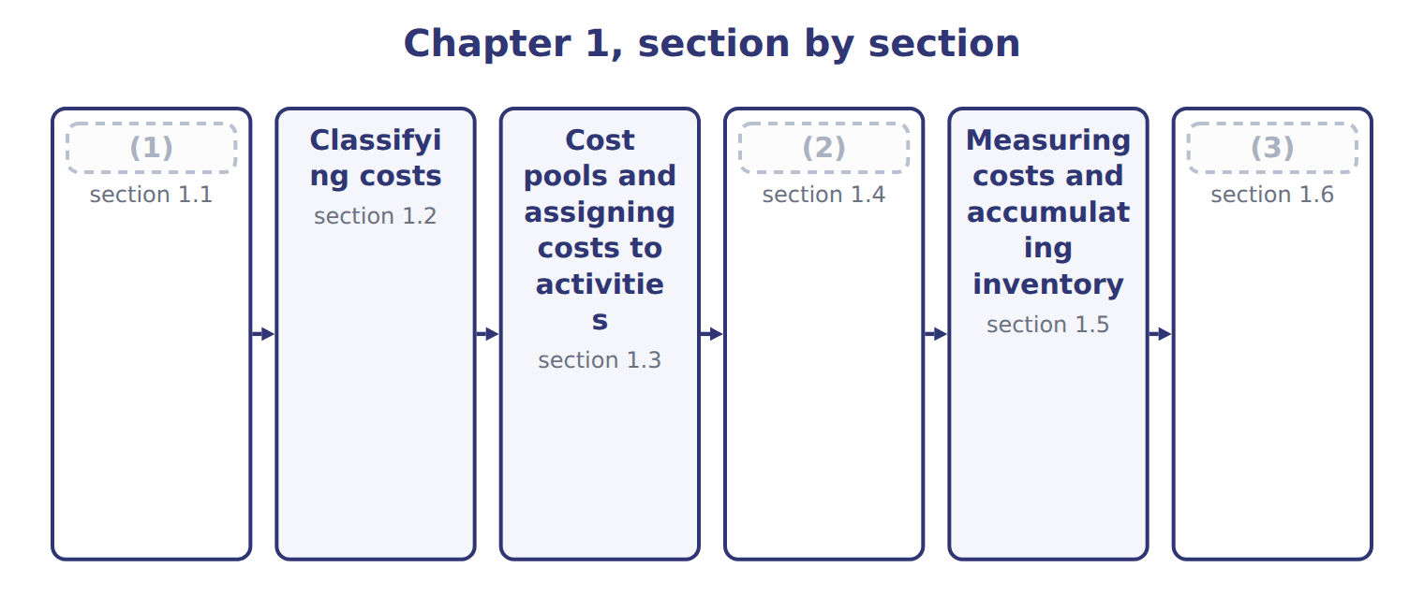
word list
Cost objects · Extended Example 1A: Tahini & Spreads, full ye · cost pool · Cost drivers

Summary 1 gaps 4–10
A cost object is (4) for which a (5) cost is measured. At Orontes it can be a division, a product line, one (6) job, a customer such as Barada (7) , or an activity such as machine setups. (8) choose cost objects to answer (9) . What does job T-0303 cost? Is the halva line (10) ? How much does it cost to serve Barada? Each question needs a different cost object. The same cost can be treated differently for different cost objects.
word list
separate · product · Wholesale · profitable · private-label · Managers · questions · anything

Answer key · 1.1 Cost objects

1 Cost objects | 6 private-label
2 Cost drivers | 7 Wholesale
3 Extended Example 1A: Tahini & Spreads, full ye | 8 Managers
4 anything | 9 questions
5 separate | 10 profitable

the summaries in full
Summary 1 A cost object is anything for which a separate cost is measured. At Orontes it can be a division, a product line, one private-label job, a customer such as Barada Wholesale, or an activity such as machine setups. Managers choose cost objects to answer questions. What does job T-0303 cost? Is the halva line profitable? How much does it cost to serve Barada? Each question needs a different cost object. The same cost can be treated differently for different cost objects.

1.2 Classifying costs
Chapter 1 · section 1.2

Fill every gap. Each word list holds one word more than there are gaps.
Summary 1 gaps 1–9
A direct cost can be (1) to a cost object in an (2) way. An indirect cost cannot, so it must be (3) . The (4) of the tahini line is indirect for one job, but direct for the Tahini & Spreads division. A second (5) matters for the statements. Product costs are direct materials, direct labor and manufacturing overhead; they go to (6) first. Period costs are selling and (7) costs; they are expensed when incurred. Two totals appear often in exam (8) . Prime cost is direct materials plus direct labor. (9) cost is direct labor plus manufacturing overhead: the cost of turning materials into products.
word list
economical · supervisor · allocated · classification · administrative · through · traced · inventory · questions · Conversion

Worked example: classifying Tahini & Spreads costs

Summary 2 gaps 10–12
Notice that supervision, (10) and the Quality Lab charge are product costs but (11) : they reach the job only through overhead. (12) to Barada is a period cost, even though it relates to a sale.
word list
manufacturing · Delivery · indirect · depreciation

Worked example: classifying ten Tahini & Spreads costs
Every item belongs to exactly one group.
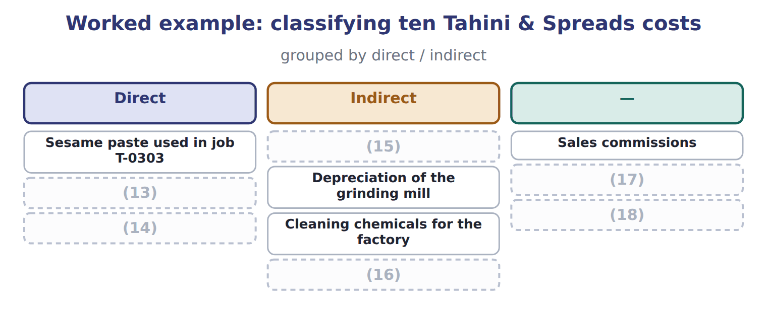
word list
Head-office salaries · Quality Lab charge to the division · Wages of operators working on job T-0303 · Delivery of goods to Barada · Cleaning chemicals for the factory · Jars and labels for job T-0303 · Factory supervisor's salary

It is not the U.S. product cost used for inventory.

The English this section uses, and its Arabic
Each term sits against what it means.
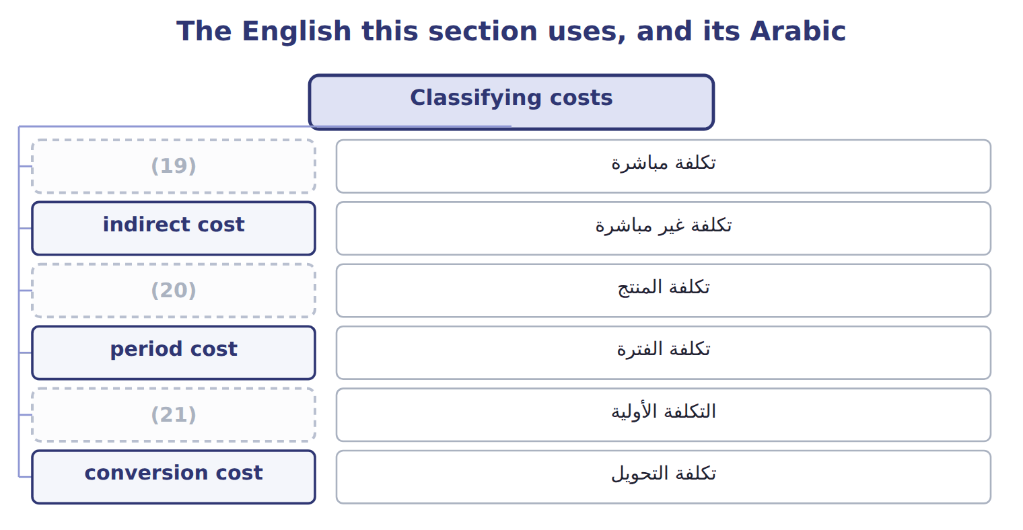
word list
conversion cost · direct cost · prime cost · product cost

The English this sheet uses, and its Arabic
English (exam term) | Arabic
direct cost | تكلفة مباشرة
indirect cost | تكلفة غير مباشرة
product cost | تكلفة المنتج
period cost | تكلفة الفترة
prime cost | التكلفة الأولية
conversion cost | تكلفة التحويل

Answer key · 1.2 Classifying costs

1 traced | 12 Delivery
2 economical | 13 Jars and labels for job T-0303
3 allocated | 14 Wages of operators working on job T-0303
4 supervisor | 15 Factory supervisor's salary
5 classification | 16 Quality Lab charge to the division
6 inventory | 17 Head-office salaries
7 administrative | 18 Delivery of goods to Barada
8 questions | 19 direct cost
9 Conversion | 20 product cost
10 depreciation | 21 prime cost
11 indirect

the summaries in full
Summary 1 A direct cost can be traced to a cost object in an economical way. An indirect cost cannot, so it must be allocated. The supervisor of the tahini line is indirect for one job, but direct for the Tahini & Spreads division. A second classification matters for the statements. Product costs are direct materials, direct labor and manufacturing overhead; they go to inventory first. Period costs are selling and administrative costs; they are expensed when incurred. Two totals appear often in exam questions. Prime cost is direct materials plus direct labor. Conversion cost is direct labor plus manufacturing overhead: the cost of turning materials into products.
Summary 2 Notice that supervision, depreciation and the Quality Lab charge are product costs but indirect: they reach the job only through overhead. Delivery to Barada is a period cost, even though it relates to a sale.

1.3 Cost pools and assigning costs to activities
Chapter 1 · section 1.3

Fill every gap. Each word list holds one word more than there are gaps.
Summary 1 gaps 1–5
A cost pool is a group of (1) costs that are (2) together. Instead of assigning every (3) bill and every (4) salary one by one, Orontes groups indirect costs into pools, such as machine operations, batch setups, quality testing and facility costs. Tahini & Spreads uses one (5) pool today: all its overhead is applied with machine hours.
word list
supervisor's · individual · electricity · plantwide · assigned · salaries

Summary 2 gaps 6–8
Assignment then (6) in two stages. First, resources such as salaries and power are assigned to the (7) that use them. Second, each pool is assigned to jobs and (8) with its own base.
word list
happens · products · conversion cost · activities

The English this sheet uses, and its Arabic
English (exam term) | Arabic
cost object | هدف التكلفة
cost pool | مجمع التكلفة

Answer key · 1.3 Cost pools and assigning costs to activities

1 individual | 5 plantwide
2 assigned | 6 happens
3 electricity | 7 activities
4 supervisor's | 8 products

the summaries in full
Summary 1 A cost pool is a group of individual costs that are assigned together. Instead of assigning every electricity bill and every supervisor's salary one by one, Orontes groups indirect costs into pools, such as machine operations, batch setups, quality testing and facility costs. Tahini & Spreads uses one plantwide pool today: all its overhead is applied with machine hours.
Summary 2 Assignment then happens in two stages. First, resources such as salaries and power are assigned to the activities that use them. Second, each pool is assigned to jobs and products with its own base.

1.4 Cost drivers
Chapter 1 · section 1.4

Fill every gap. Each word list holds one word more than there are gaps.
Summary 1 gaps 1–10
A cost driver is a (1) that causes a cost to change. Grinding (2) takes machine time, so machine hours drive grinding power and (3) . A new (4) needs a setup, so the number of (5) drives setup costs. The link must be (6) . Sales (7) may move with factory power costs, but (8) more at higher prices does not cause more power use. A driver chosen only (9) it moves with the cost can give wrong product costs when (10) change. Drivers work at different levels. A volume-based cost driver rises with each unit or hour. Other drivers rise with batches, with the number of products, or not at all, as with facility costs.
word list
revenue · because · recipe · setups · conditions · maintenance · products · factor · selling · sesame · causal

Types of cost drivers at Orontes
Driver type | Cost moves with | Orontes example | Causal link
Volume-based (unit level) | Rises with each unit or hour | Machine hours in grinding; direct labor hours | (11)
Batch level | (12) | Number of setups for a new recipe | Strong for setup and cleaning costs
Product-sustaining | (13) | Number of private-label recipes | Strong for design and label costs
Facility level | Does not move with activity | (14) | Weak: an allocation, not a cause

word list
Strong for machine and energy costs · Strong for design and label costs · Rises with the number of products · Rises with each batch or order · Square meters of factory space

Correlation is not causation

Summary 2 gaps 15–16
A (15) may offer a base that moves closely with the cost but does not cause it, such as sales revenue for factory power. (16) the base that causes the cost.
word list
Choose · question · volume-based

The English this section uses, and its Arabic
Each term sits against what it means.
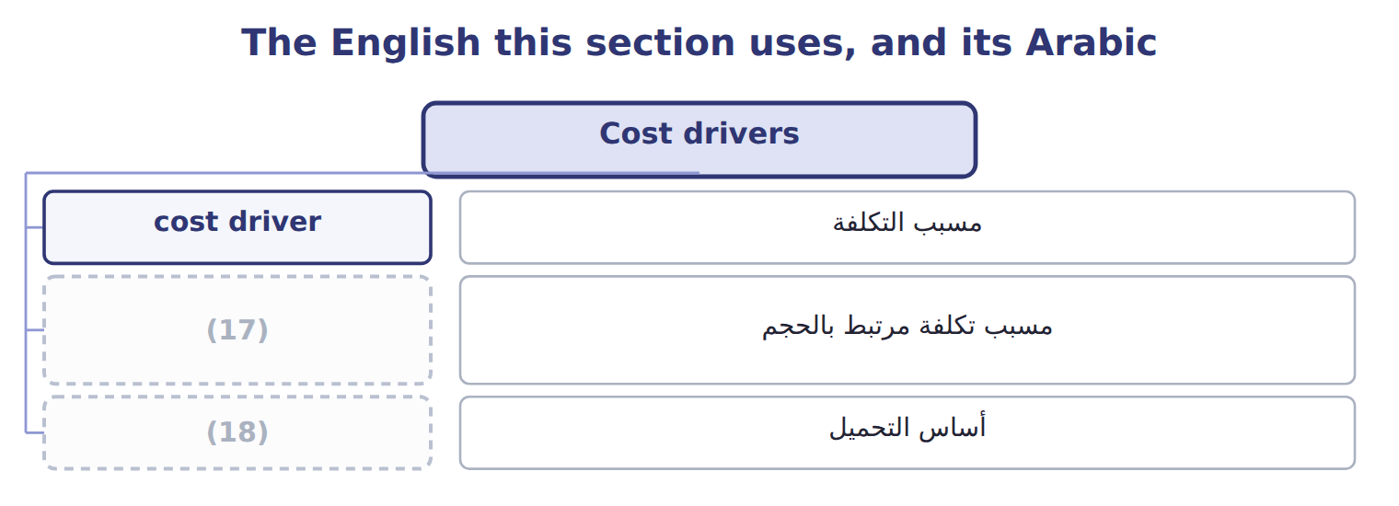
word list
indirect cost · volume-based cost driver · allocation base

The English this sheet uses, and its Arabic
English (exam term) | Arabic
cost driver | مسبب التكلفة
volume-based cost driver | مسبب تكلفة مرتبط بالحجم
allocation base | أساس التحميل

Answer key · 1.4 Cost drivers

1 factor | 10 conditions
2 sesame | 11 Strong for machine and energy costs
3 maintenance | 12 Rises with each batch or order
4 recipe | 13 Rises with the number of products
5 setups | 14 Square meters of factory space
6 causal | 15 question
7 revenue | 16 Choose
8 selling | 17 volume-based cost driver
9 because | 18 allocation base

the summaries in full
Summary 1 A cost driver is a factor that causes a cost to change. Grinding sesame takes machine time, so machine hours drive grinding power and maintenance. A new recipe needs a setup, so the number of setups drives setup costs. The link must be causal. Sales revenue may move with factory power costs, but selling more at higher prices does not cause more power use. A driver chosen only because it moves with the cost can give wrong product costs when conditions change. Drivers work at different levels. A volume-based cost driver rises with each unit or hour. Other drivers rise with batches, with the number of products, or not at all, as with facility costs.
Summary 2 A question may offer a base that moves closely with the cost but does not cause it, such as sales revenue for factory power. Choose the base that causes the cost.

1.5 Measuring costs and accumulating inventory
Chapter 1 · section 1.5

Fill every gap. Each word list holds one word more than there are gaps.
A cost system answers two questions.
Cost measurement and accumulation methods
Question | Method | What it does | Taught in
Measurement | (1) | Actual DM, DL and actual overhead | Chapter 5
 | (2) | Actual DM and DL + applied overhead | Chapters 5, 6
 | Standard costing | (3) | Chapters 5, 18
Accumulation | Job order costing | (4) | Chapter 6
 | Process costing | (5) | Chapter 7
 | Activity-based costing | (6) | Chapter 12
 | (7) | Costs recorded at trigger points | Chapter 17

word list
Chapter 6 · Normal costing · Actual costing · Standard quantities and prices · Costs collected by department · Costs collected by job · Costs collected by activity · Backflush costing

Summary 1 gaps 8–14
Whatever the method, a (8) product costs move (9) three inventory (10) . Raw materials inventory holds materials not yet used. Work in process holds (11) finished goods. Finished goods inventory holds (12) goods not yet sold. Sold goods move to cost of goods sold. The cost of goods manufactured is the cost of the goods finished in the period: beginning work in process plus (13) costs added, less ending work in process. The (14) Example shows the whole flow for one year.
word list
questions · partly · Extended · through · manufacturing · manufacturer's · accounts · completed

Classify halva costs

The first two are done. Classify the rest, with one batch as the cost object.

Your turn: classify halva line costs (complete the blanks)
Every item belongs to exactly one group.
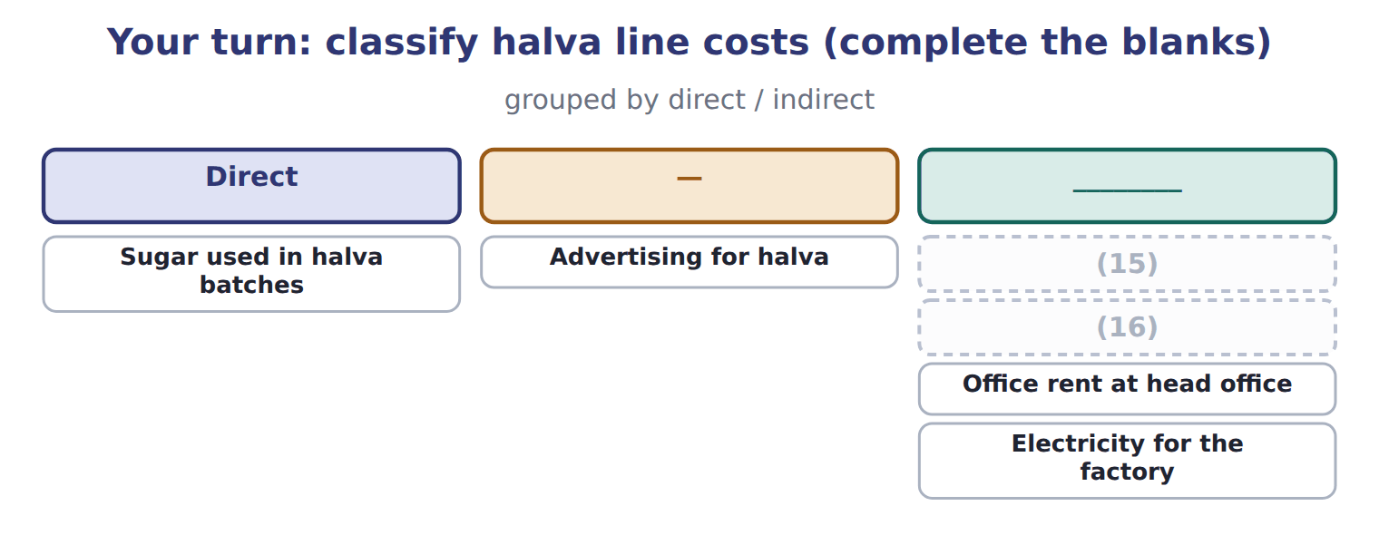
word list
Wages of halva line operators · Maintenance of the halva mixer · Office rent at head office

The English this section uses, and its Arabic
Each term sits against what it means.
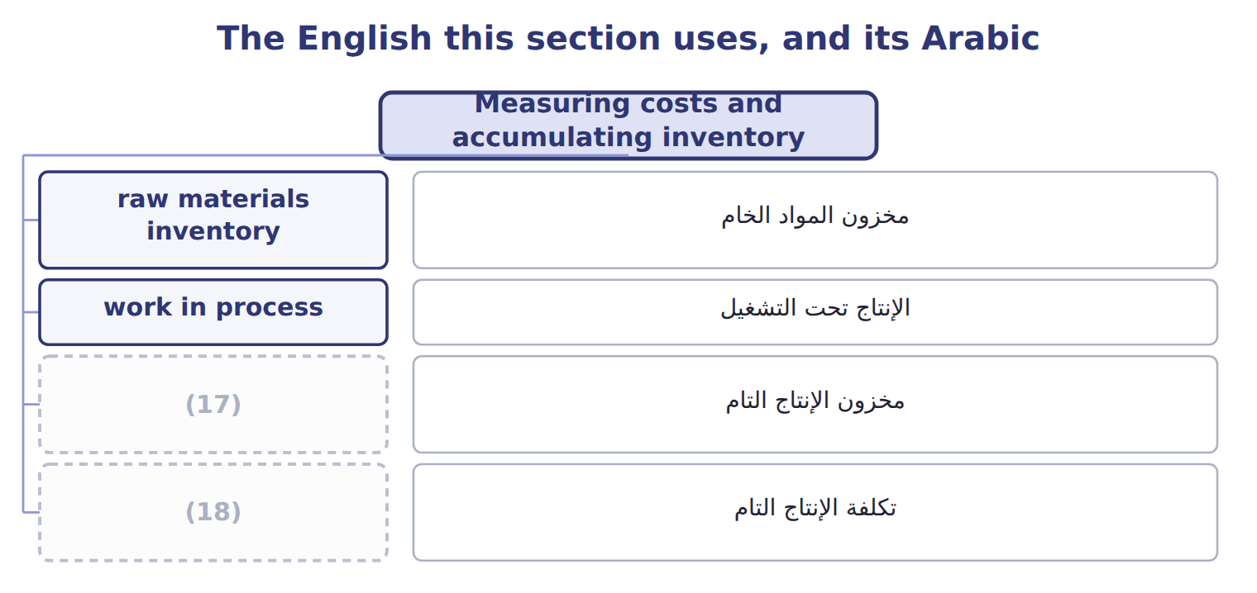
word list
finished goods inventory · cost of goods manufactured · مخزون المواد الخام

The English this sheet uses, and its Arabic
English (exam term) | Arabic
raw materials inventory | مخزون المواد الخام
work in process | الإنتاج تحت التشغيل
finished goods inventory | مخزون الإنتاج التام
cost of goods manufactured | تكلفة الإنتاج التام

Answer key · 1.5 Measuring costs and accumulating inventory

1 Actual costing | 10 accounts
2 Normal costing | 11 partly
3 Standard quantities and prices | 12 completed
4 Costs collected by job | 13 manufacturing
5 Costs collected by department | 14 Extended
6 Costs collected by activity | 15 Maintenance of the halva mixer
7 Backflush costing | 16 Wages of halva line operators
8 manufacturer's | 17 finished goods inventory
9 through | 18 cost of goods manufactured

the summaries in full
Summary 1 Whatever the method, a manufacturer's product costs move through three inventory accounts. Raw materials inventory holds materials not yet used. Work in process holds partly finished goods. Finished goods inventory holds completed goods not yet sold. Sold goods move to cost of goods sold. The cost of goods manufactured is the cost of the goods finished in the period: beginning work in process plus manufacturing costs added, less ending work in process. The Extended Example shows the whole flow for one year.

1.6 Extended Example 1A: Tahini & Spreads, full year 2027
Chapter 1 · section 1.6

Fill every gap. Each word list holds one word more than there are gaps.
Summary 1 gaps 1–12
This example (1) one full year of costs through the (2) and into the (3) income statement. The (4) are exam-core: questions often ask for cost of goods manufactured or cost of goods sold. The entries are for depth. On (5) 1, 2027 Tahini & Spreads held raw materials of $130,000, work in process of $180,000 and finished goods of $420,000. Materials: (6) $3,260,000; direct materials used $3,000,000; indirect materials $240,000. Labor: direct labor $1,800,000; indirect labor $480,000. Other factory overhead: service department charges $690,000; (7) $840,000; utilities and other costs $740,000. Overhead (8) : 92,000 machine hours × $30 = $2,760,000. (9) balances: work in process $690,000; finished goods $1,380,000. Sales and period costs: sales $8,700,000; selling expense $610,000; (10) expense $390,000. (11) product costs from period costs. Record the entries, post them, (12) the schedule of cost of goods manufactured and the income statement, and check that the balances tie.
word list
prepare · applied · entries · January · follows · Separate · schedules · depreciation · administrative · purchases · accounts · division's · Year-end

Summary 2 gaps 13–18
Total (13) costs = $3,000,000 + $1,800,000 + $2,760,000 = $7,560,000. Cost of goods manufactured = $180,000 + $7,560,000 − $690,000 = $7,050,000. Cost of goods sold = $420,000 + $7,050,000 − $1,380,000 = $6,090,000. (14) overhead = $240,000 + $480,000 + $2,270,000 = $2,990,000, so overhead is (15) by $230,000. (16) 1 to 8 are product costs; entry 9 records the period costs, which never touch (17) . The (18) totals $36,650,000 on both sides.
word list
journal · materials · underapplied · inventory · Actual · Entries · manufacturing

Extended Example: general journal, FY2027
No. | Account (detail) | Debit | Credit
1 | (19) | 3,260,000
 | (20) |  | 3,260,000
2 | (21) | 3,000,000
 | Manufacturing Overhead Control | 240,000
 | Raw Materials Inventory |  | 3,240,000
3 | Work-in-Process Inventory | 1,800,000
 | Manufacturing Overhead Control | 480,000
 | (22) |  | 2,280,000
4 | (23) | 2,270,000
 | Service Department Charges |  | 690,000
 | (24) |  | 840,000
 | Accounts Payable |  | 740,000
5 | Work-in-Process Inventory | 2,760,000
 | Manufacturing Overhead Applied |  | 2,760,000
6 | (25) | 7,050,000
 | Work-in-Process Inventory |  | 7,050,000
7 | (26) | 8,700,000
 | Sales Revenue |  | 8,700,000
8 | Cost of Goods Sold | 6,090,000
 | Finished Goods Inventory |  | 6,090,000
9 | (27) | 610,000
 | (28) | 390,000
 | Cash and Payables |  | 1,000,000
 | Totals | 36,650,000 | 36,650,000

word list
Wages Payable · Accounts Payable · Accumulated Depreciation · Raw Materials Inventory · Finished Goods Inventory · Work-in-Process Inventory · Direct materials · Manufacturing Overhead Control · Administrative Expense · Accounts Receivable · Selling Expense

Raw materials close at $150,000, work in process at $690,000 and finished goods at $1,380,000.

Extended Example: cost of goods manufactured, cost of goods sold and operating income
The bars are drawn to scale.
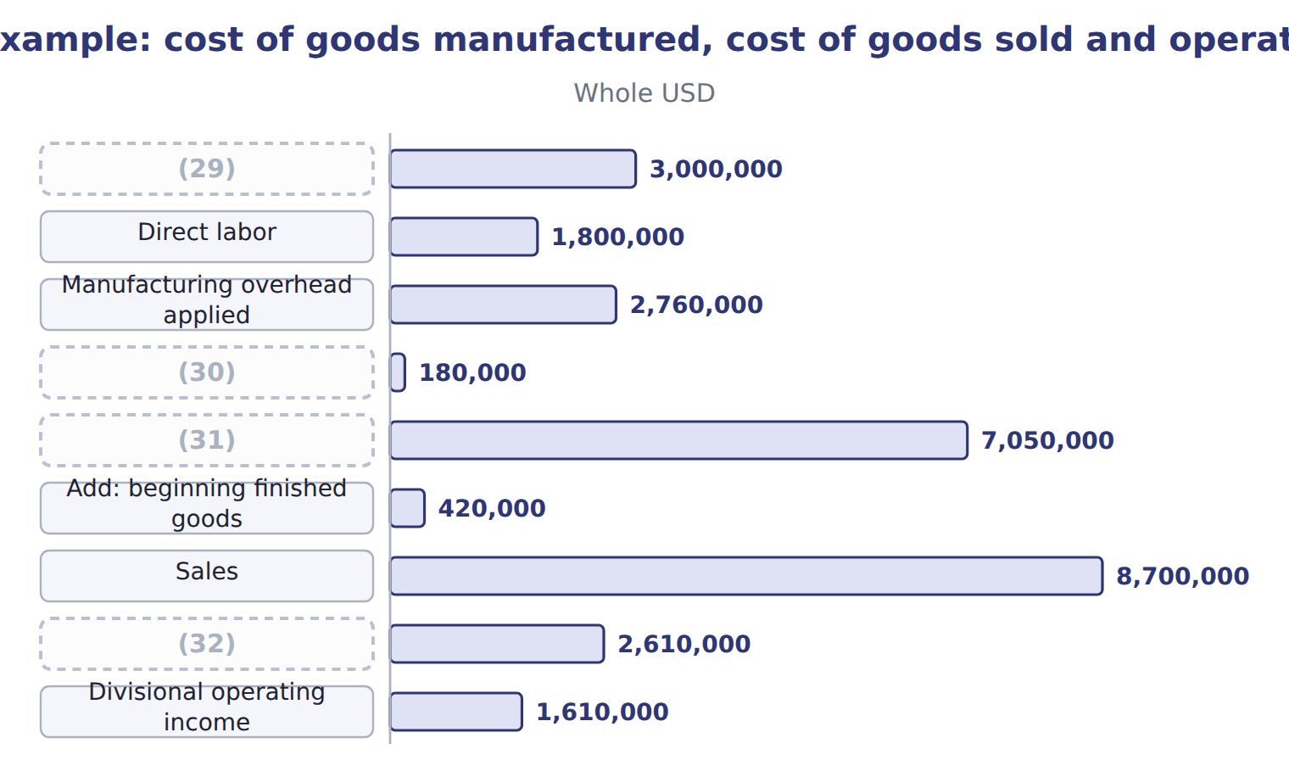
word list
Cost of goods manufactured · Add: beginning WIP · cost pool · Gross margin · Direct materials used

Everything ties

Summary 3 gaps 33–36
Total debits = total (33) = $36,650,000. Raw materials: $130,000 + $3,260,000 − $3,240,000 = $150,000. Work in process: $180,000 + $7,560,000 − $7,050,000 = $690,000. (34) goods: $420,000 + $7,050,000 − $6,090,000 = $1,380,000. (35) work in process = direct materials $300,000 + direct labor $114,000 + applied (36) $276,000.
word list
manufactured · Ending · credits · overhead · Finished

Exam view

Summary 4 gaps 37–39
Expect a list of costs and (37) balances, and a request for cost of goods (38) or cost of goods sold. Sort product from period costs first; then apply the two (39) formulas.
word list
inventory · schedule · utilities · manufactured

Exam view
Halva line · April–June 2027 (actual costs, whol | Amount
Sesame | 180,000
(40) | 60,000
(41) | 40,000
Line operators' wages | 120,000
(42) | 30,000
Depreciation of halva equipment | 45,000
(43) | 25,000
Indirect materials | 10,000
Sales commissions | 35,000
Advertising | 20,000
Head-office salaries | 50,000
Delivery to customers | 15,000
(44) | 25,000 / 40,000
(45) | 30,000 / 45,000
Sales | 700,000

word list
Sugar and flavors · Factory supervision · Finished goods: beginning / ending · Jars · Factory utilities · Work-in-Process Inventory · WIP: beginning / ending

Item — Answer
Item | Answer
Maintenance of the halva mixer | Indirect; product cost
Wages of halva line operators | (46)
Office rent at head office | (47)
Electricity for the factory | Indirect; product cost

word list
Tahini & Spreads · FY2027 · Not a production cost; period cost · Direct; product cost

Cost — Category
Every item belongs to exactly one group.
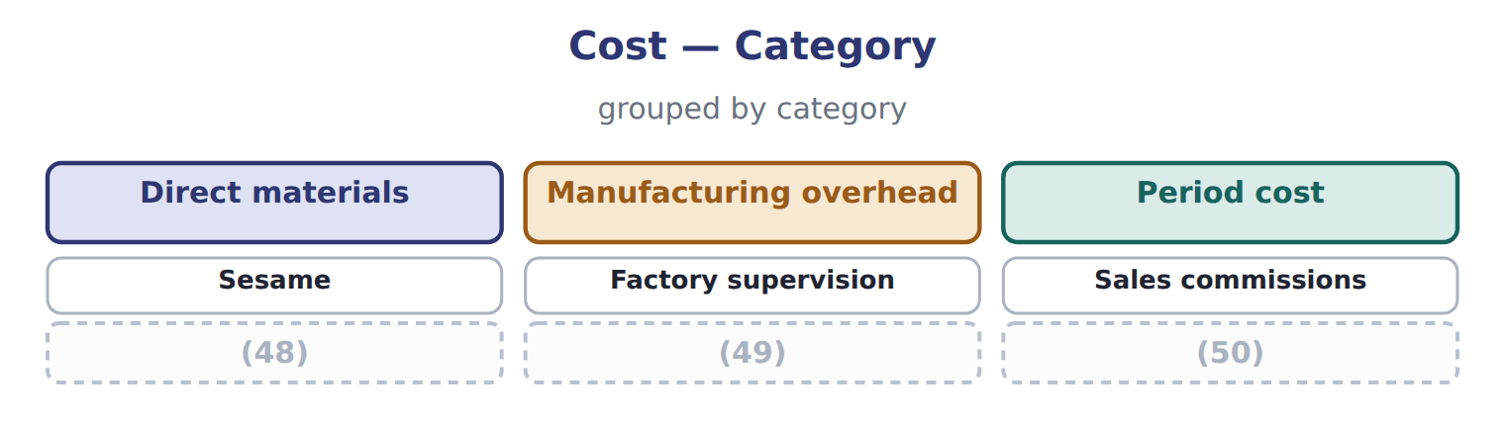
word list
Factory utilities · Jars · cost driver · Head-office salaries

The English this section uses, and its Arabic
Each term sits against what it means.
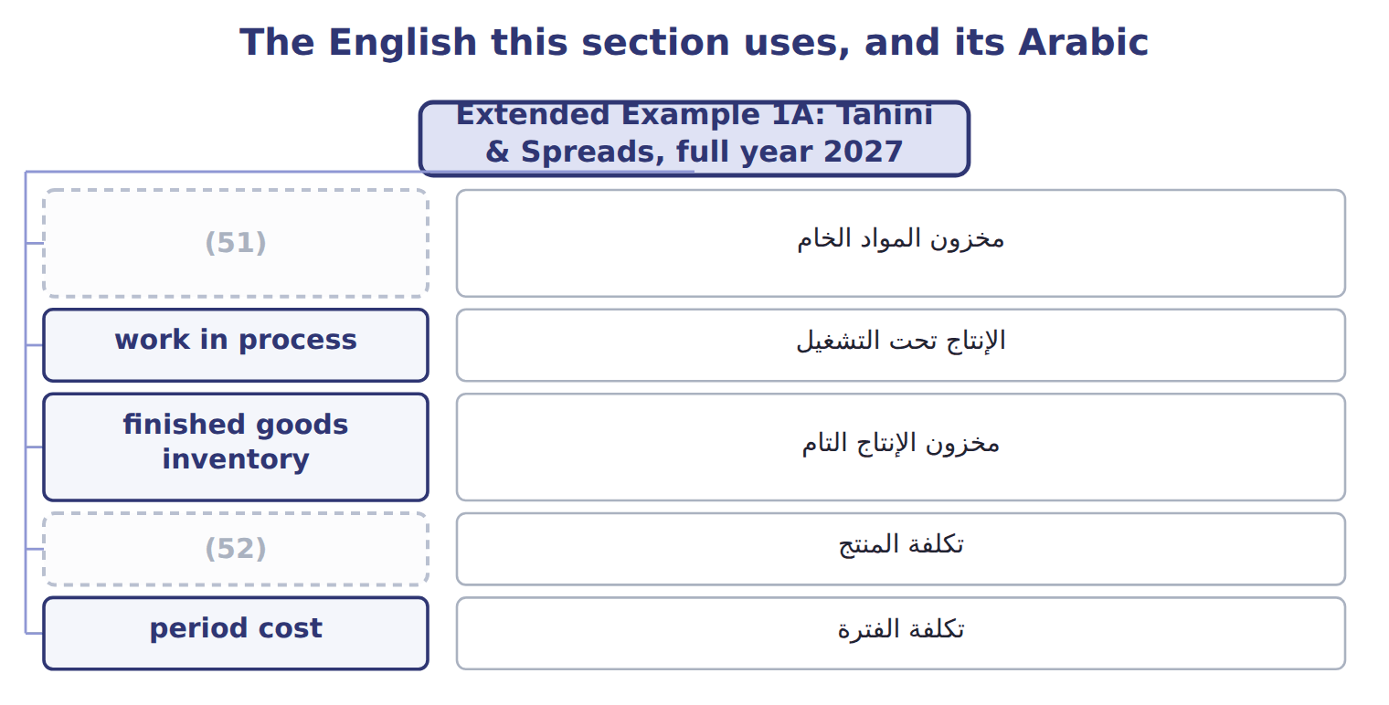
word list
product cost · raw materials inventory · مخزون الإنتاج التام

The English this sheet uses, and its Arabic
English (exam term) | Arabic
raw materials inventory | مخزون المواد الخام
work in process | الإنتاج تحت التشغيل
finished goods inventory | مخزون الإنتاج التام
product cost | تكلفة المنتج
period cost | تكلفة الفترة

Answer key · 1.6 Extended Example 1A: Tahini & Spreads, full year 2027

1 follows | 27 Selling Expense
2 accounts | 28 Administrative Expense
3 division's | 29 Direct materials used
4 schedules | 30 Add: beginning WIP
5 January | 31 Cost of goods manufactured
6 purchases | 32 Gross margin
7 depreciation | 33 credits
8 applied | 34 Finished
9 Year-end | 35 Ending
10 administrative | 36 overhead
11 Separate | 37 inventory
12 prepare | 38 manufactured
13 manufacturing | 39 schedule
14 Actual | 40 Sugar and flavors
15 underapplied | 41 Jars
16 Entries | 42 Factory supervision
17 inventory | 43 Factory utilities
18 journal | 44 WIP: beginning / ending
19 Raw Materials Inventory | 45 Finished goods: beginning / ending
20 Accounts Payable | 46 Direct; product cost
21 Work-in-Process Inventory | 47 Not a production cost; period cost
22 Wages Payable | 48 Jars
23 Manufacturing Overhead Control | 49 Factory utilities
24 Accumulated Depreciation | 50 Head-office salaries
25 Finished Goods Inventory | 51 raw materials inventory
26 Accounts Receivable | 52 product cost

the summaries in full
Summary 1 This example follows one full year of costs through the accounts and into the division's income statement. The schedules are exam-core: questions often ask for cost of goods manufactured or cost of goods sold. The entries are for depth. On January 1, 2027 Tahini & Spreads held raw materials of $130,000, work in process of $180,000 and finished goods of $420,000. Materials: purchases $3,260,000; direct materials used $3,000,000; indirect materials $240,000. Labor: direct labor $1,800,000; indirect labor $480,000. Other factory overhead: service department charges $690,000; depreciation $840,000; utilities and other costs $740,000. Overhead applied: 92,000 machine hours × $30 = $2,760,000. Year-end balances: work in process $690,000; finished goods $1,380,000. Sales and period costs: sales $8,700,000; selling expense $610,000; administrative expense $390,000. Separate product costs from period costs. Record the entries, post them, prepare the schedule of cost of goods manufactured and the income statement, and check that the balances tie.
Summary 2 Total manufacturing costs = $3,000,000 + $1,800,000 + $2,760,000 = $7,560,000. Cost of goods manufactured = $180,000 + $7,560,000 − $690,000 = $7,050,000. Cost of goods sold = $420,000 + $7,050,000 − $1,380,000 = $6,090,000. Actual overhead = $240,000 + $480,000 + $2,270,000 = $2,990,000, so overhead is underapplied by $230,000. Entries 1 to 8 are product costs; entry 9 records the period costs, which never touch inventory. The journal totals $36,650,000 on both sides.
Summary 3 Total debits = total credits = $36,650,000. Raw materials: $130,000 + $3,260,000 − $3,240,000 = $150,000. Work in process: $180,000 + $7,560,000 − $7,050,000 = $690,000. Finished goods: $420,000 + $7,050,000 − $6,090,000 = $1,380,000. Ending work in process = direct materials $300,000 + direct labor $114,000 + applied overhead $276,000.
Summary 4 Expect a list of costs and inventory balances, and a request for cost of goods manufactured or cost of goods sold. Sort product from period costs first; then apply the two schedule formulas.

