9.1 Two ways to cost inventory
Chapter 9 · section 9.1

Fill every gap. Each word list holds one word more than there are gaps.
Chapter 9, section by section
Each stage leads to the next.
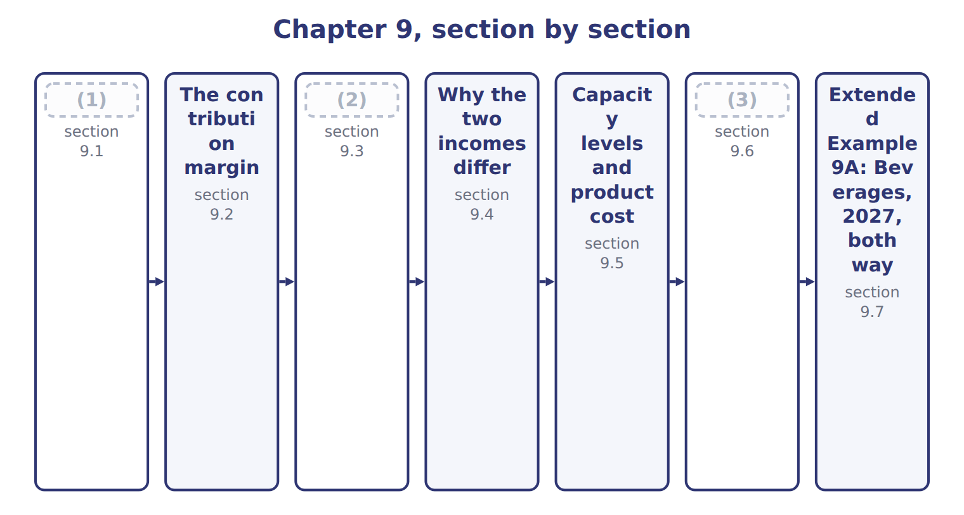
word list
Two income statements for the same year · Practical capacity and capacity management · Why the two incomes differ · Two ways to cost inventory

Summary 1 gaps 4–9
Absorption costing, also called full costing, treats all manufacturing costs as product costs, (4) fixed manufacturing overhead. Variable costing, also called (5) costing, treats only variable manufacturing costs as product costs; fixed manufacturing overhead is a (6) cost. That is the only difference. Both methods treat (7) , labor and variable overhead as product costs, and both (8) all selling and (9) costs. So a case costs $12.60 under absorption costing and $10.60 under variable costing. The difference is the fixed overhead rate of $2.00 a case.
word list
including · expense · administrative · materials · selling · period · direct

Product cost per case under the two methods
Beverages juice case | Absorption | Variable costing
(10) | $9.00 | $9.00
(11) | $0.60 | $0.60
Variable MOH | $1.00 | $1.00
Fixed MOH | $2.00 | — (period cost)
Product cost per case | $12.60 | $10.60

word list
production-volume variance · Direct labor · Direct materials

Summary 2 gaps 12–13
U.S. GAAP and IFRS require (12) costing for external reporting and tax. Variable costing is an internal tool: it is not allowed in the published (13) .
word list
statements · absorption · published

The English this sheet uses, and its Arabic
English (exam term) | Arabic
absorption costing | التكاليف الكلية
variable costing | التكاليف المتغيرة

Answer key · 9.1 Two ways to cost inventory

1 Two ways to cost inventory | 8 expense
2 Two income statements for the same year | 9 administrative
3 Practical capacity and capacity management | 10 Direct materials
4 including | 11 Direct labor
5 direct | 12 absorption
6 period | 13 statements
7 materials

the summaries in full
Summary 1 Absorption costing, also called full costing, treats all manufacturing costs as product costs, including fixed manufacturing overhead. Variable costing, also called direct costing, treats only variable manufacturing costs as product costs; fixed manufacturing overhead is a period cost. That is the only difference. Both methods treat materials, labor and variable overhead as product costs, and both expense all selling and administrative costs. So a case costs $12.60 under absorption costing and $10.60 under variable costing. The difference is the fixed overhead rate of $2.00 a case.
Summary 2 U.S. GAAP and IFRS require absorption costing for external reporting and tax. Variable costing is an internal tool: it is not allowed in the published statements.

9.2 The contribution margin
Chapter 9 · section 9.2

Fill every gap. Each word list holds one word more than there are gaps.
Summary 1 gaps 1–4
The contribution margin is sales minus all variable costs, both (1) and selling. It is the (2) left to cover fixed costs and then (3) profit. Per unit, it is price minus variable cost per unit. A case of juice sells for $20.00. Variable costs are $10.60 to make it and $1.20 to sell it, so each case (4) $8.20. The contribution margin ratio is $8.20 ÷ $20.00 = 41%.
word list
contributes · amount · provide · manufacturing · variable

Worked example: Beverages contribution margin, 2027

On 830,000 cases sold, the total is $6,806,000.
Worked example: Beverages contribution margin, 2027
Beverages · FY2027 · 830,000 cases sold | Per case | Total
Price | $20.00 | 16,600,000
(5) | ($10.60) | (8,798,000)
(6) | ($1.20) | (996,000)
Contribution margin | $8.20 | 6,806,000
Contribution margin ratio | 41% | 41%

word list
downward demand spiral · Variable manufacturing cost · Variable selling cost

Summary 2 gaps 7–10
Do not (7) it with gross margin. Gross margin deducts full product cost, (8) fixed overhead, but not variable selling costs. Contribution margin is the basis of (9) analysis and short-run decisions such as special orders (Book 3). The exam uses both terms in the same (10) .
word list
including · cost-volume-profit · analysis · question · confuse

The English this sheet uses, and its Arabic
English (exam term) | Arabic
contribution margin | هامش المساهمة
contribution margin ratio | نسبة هامش المساهمة

Answer key · 9.2 The contribution margin

1 manufacturing | 6 Variable selling cost
2 amount | 7 confuse
3 provide | 8 including
4 contributes | 9 cost-volume-profit
5 Variable manufacturing cost | 10 question

the summaries in full
Summary 1 The contribution margin is sales minus all variable costs, both manufacturing and selling. It is the amount left to cover fixed costs and then provide profit. Per unit, it is price minus variable cost per unit. A case of juice sells for $20.00. Variable costs are $10.60 to make it and $1.20 to sell it, so each case contributes $8.20. The contribution margin ratio is $8.20 ÷ $20.00 = 41%.
Summary 2 Do not confuse it with gross margin. Gross margin deducts full product cost, including fixed overhead, but not variable selling costs. Contribution margin is the basis of cost-volume-profit analysis and short-run decisions such as special orders (Book 3). The exam uses both terms in the same question.

9.3 Two income statements for the same year
Chapter 9 · section 9.3

Fill every gap. Each word list holds one word more than there are gaps.
Summary 1 gaps 1–11
The absorption statement uses the gross margin format. Cost of goods sold is at full cost, and the (1) variance is added when production falls short of the (2) . Selling and (3) costs follow. The variable costing statement uses the contribution format. Variable costs come first, then the contribution margin, then all fixed costs, (4) the full $1,800,000 of fixed (5) overhead. Use absorption costing for the published (6) and for pricing that must cover all costs. Use variable costing for internal (7) : it shows how (8) moves with sales volume. Variable costing has another benefit: (9) cannot raise income by (10) for inventory. Its limits are that it is not allowed (11) , and it can make fixed costs look less important than they are.
word list
including · denominator · externally · production-volume · producing · manufacturing · costing · profit · statements · managers · decisions · administrative

The English this section uses, and its Arabic
Each term sits against what it means.
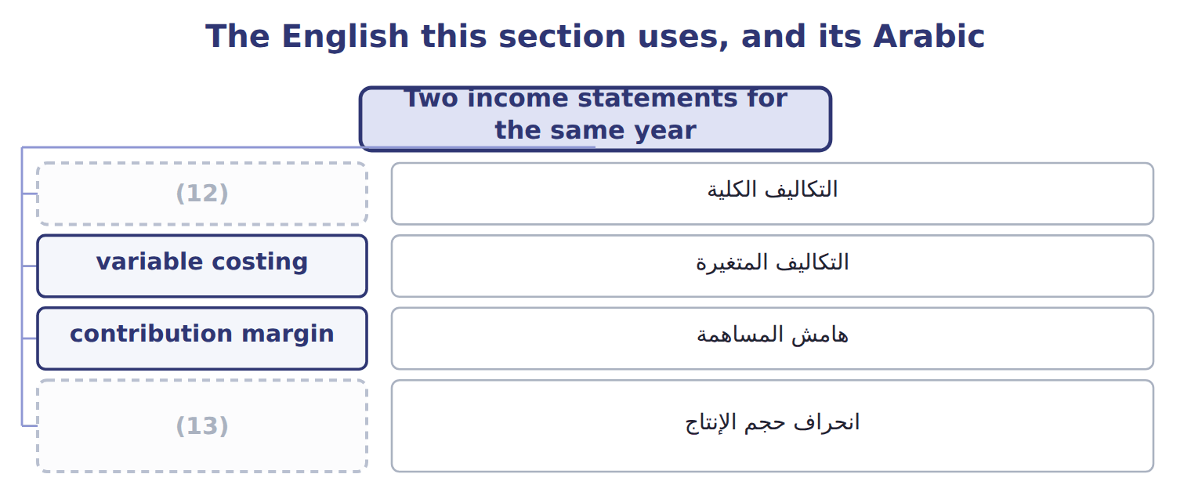
word list
absorption costing · normal capacity · production-volume variance

The English this sheet uses, and its Arabic
English (exam term) | Arabic
production-volume variance | انحراف حجم الإنتاج

Answer key · 9.3 Two income statements for the same year

1 production-volume | 8 profit
2 denominator | 9 managers
3 administrative | 10 producing
4 including | 11 externally
5 manufacturing | 12 absorption costing
6 statements | 13 production-volume variance
7 decisions

the summaries in full
Summary 1 The absorption statement uses the gross margin format. Cost of goods sold is at full cost, and the production-volume variance is added when production falls short of the denominator. Selling and administrative costs follow. The variable costing statement uses the contribution format. Variable costs come first, then the contribution margin, then all fixed costs, including the full $1,800,000 of fixed manufacturing overhead. Use absorption costing for the published statements and for pricing that must cover all costs. Use variable costing for internal decisions: it shows how profit moves with sales volume. Variable costing has another benefit: managers cannot raise income by producing for inventory. Its limits are that it is not allowed externally, and it can make fixed costs look less important than they are.

9.4 Why the two incomes differ
Chapter 9 · section 9.4

Fill every gap. Each word list holds one word more than there are gaps.
Summary 1 gaps 1–8
The difference comes only from fixed overhead held in inventory. When inventory rises, absorption costing (1) some fixed overhead to next year, so its income is (2) . When inventory falls, it (3) fixed overhead from (4) years, so its income is lower. In 2027 Beverages' inventory rose from 40,000 to 60,000 cases. The difference in income is the (5) in inventory times the fixed rate: $40,000, the extra fixed overhead left in (6) inventory. (7) that in 2028 Beverages (8) 800,000 cases and sells 840,000. Inventory falls, and absorption income is $80,000 lower than variable costing income.
word list
higher · produces · releases · costing · Suppose · change · ending · earlier · defers

Inventory change and the two incomes
Inventory change | Operating income | Beverages
Production > sales (inventory rises) | (9) | 2027: +20,000 cases → +40,000
Production < sales (inventory falls) | Absorption < variable | (10) : (40,000) cases → (80,000)
Production = sales | Equal | (11)

word list
No fixed MOH enters or leaves inventory · Absorption > variable · Which method shows higher income? · Suppose 2028

Difference = change in units × fixed rate

Summary 2 gaps 12–14
Absorption income − variable income = (ending − (12) inventory units) × fixed (13) overhead per unit, when the rate is the same in both years. Do not use variable costs or (14) costs in this formula.
word list
inventory · manufacturing · beginning · selling

Reconcile 2028

Find the income difference and say which method shows higher income.
Your turn: reconcile the two incomes for 2028 (complete the blanks)
Suppose: Beverages FY2028 | Value
Cases produced / sold | (15)
Change in inventory (cases) | (40,000)
Fixed MOH per case | $2.00
Absorption − variable operating income | ________
Which method shows higher income? | ________

word list
Absorption > variable · 800,000 / 840,000

Answer key · 9.4 Why the two incomes differ

1 defers | 9 Absorption > variable
2 higher | 10 Suppose 2028
3 releases | 11 No fixed MOH enters or leaves inventory
4 earlier | 12 beginning
5 change | 13 manufacturing
6 ending | 14 selling
7 Suppose | 15 800,000 / 840,000
8 produces

the summaries in full
Summary 1 The difference comes only from fixed overhead held in inventory. When inventory rises, absorption costing defers some fixed overhead to next year, so its income is higher. When inventory falls, it releases fixed overhead from earlier years, so its income is lower. In 2027 Beverages' inventory rose from 40,000 to 60,000 cases. The difference in income is the change in inventory times the fixed rate: $40,000, the extra fixed overhead left in ending inventory. Suppose that in 2028 Beverages produces 800,000 cases and sells 840,000. Inventory falls, and absorption income is $80,000 lower than variable costing income.
Summary 2 Absorption income − variable income = (ending − beginning inventory units) × fixed manufacturing overhead per unit, when the rate is the same in both years. Do not use variable costs or selling costs in this formula.

9.5 Capacity levels and product cost
Chapter 9 · section 9.5

Fill every gap. Each word list holds one word more than there are gaps.
Summary 1 gaps 1–9
The fixed overhead rate (1) on the capacity level in the denominator. Theoretical capacity (2) the plant never stops. Practical capacity allows for normal breaks and (3) . Normal capacity is (4) use over several years. Master-budget capacity is this (5) plan. The (6) the denominator, the higher the product cost. For a case of juice, full cost (7) from $12.10 at theoretical capacity to $12.85 at master-budget capacity. The choice also (8) the statements. A larger denominator applies less fixed overhead per case, which gives a larger (9) variance and lower inventory values. For the published statements Orontes uses normal capacity, as ASC 330 requires.
word list
smaller · year's · production-volume · average · ranges · depends · several · maintenance · assumes · changes

The English this section uses, and its Arabic
Each term sits against what it means.
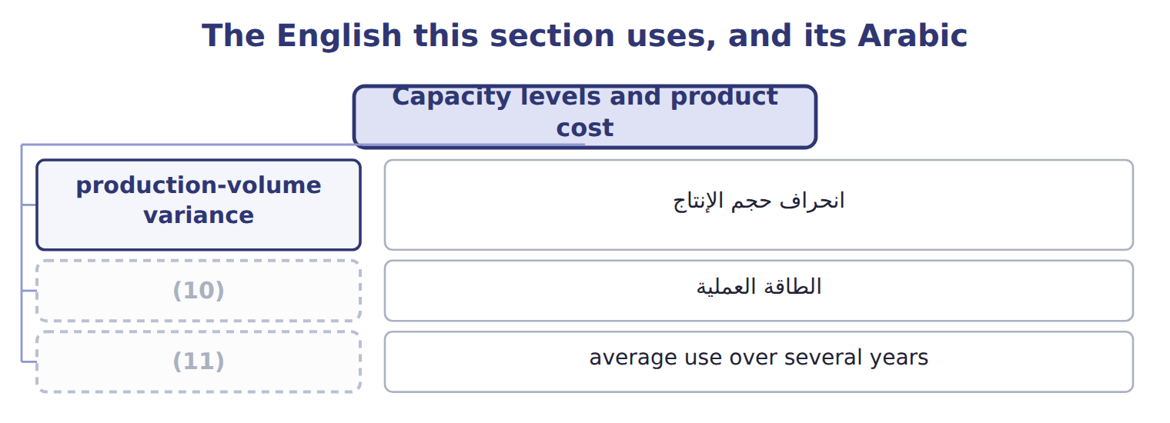
word list
practical capacity · normal capacity · unused capacity

The English this sheet uses, and its Arabic
English (exam term) | Arabic
practical capacity | الطاقة العملية
normal capacity | الطاقة العادية

Answer key · 9.5 Capacity levels and product cost

1 depends | 7 ranges
2 assumes | 8 changes
3 maintenance | 9 production-volume
4 average | 10 practical capacity
5 year's | 11 normal capacity
6 smaller

the summaries in full
Summary 1 The fixed overhead rate depends on the capacity level in the denominator. Theoretical capacity assumes the plant never stops. Practical capacity allows for normal breaks and maintenance. Normal capacity is average use over several years. Master-budget capacity is this year's plan. The smaller the denominator, the higher the product cost. For a case of juice, full cost ranges from $12.10 at theoretical capacity to $12.85 at master-budget capacity. The choice also changes the statements. A larger denominator applies less fixed overhead per case, which gives a larger production-volume variance and lower inventory values. For the published statements Orontes uses normal capacity, as ASC 330 requires.

9.6 Practical capacity and capacity management
Chapter 9 · section 9.6

Fill every gap. Each word list holds one word more than there are gaps.
Summary 1 gaps 1–12
Many managers use practical capacity for (1) reports. The (2) carries only the cost of the capacity it uses, and the cost of idle capacity is shown on its own as (3) capacity. In 2027 the (4) line could fill 1,000,000 cases but (5) 850,000. At $1.80 of fixed (6) per case of practical capacity, 150,000 idle cases cost $270,000. That figure tells managers what the spare capacity costs, so they can seek more sales or (7) capacity. Practical capacity also (8) pricing. If prices follow full cost at a (9) budget volume, unit cost rises, prices rise and demand falls again: a (10) demand spiral. Practical capacity has (11) . It must be (12) , and the published statements still need normal capacity. So Orontes keeps practical capacity for management reports and adjusts to normal capacity for the statements.
word list
estimated · reduce · bottling · internal · limits · published · filled · unused · protects · downward · product · overhead · falling

The English this section uses, and its Arabic
Each term sits against what it means.
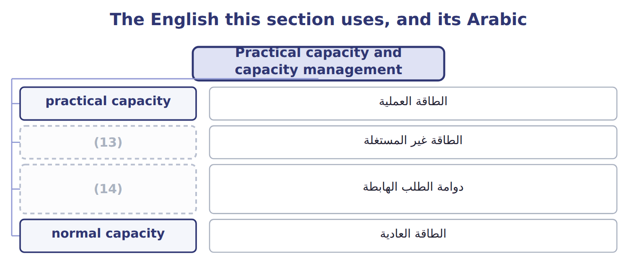
word list
unused capacity · الطاقة غير المستغلة · downward demand spiral

The English this sheet uses, and its Arabic
English (exam term) | Arabic
unused capacity | الطاقة غير المستغلة
downward demand spiral | دوامة الطلب الهابطة

Answer key · 9.6 Practical capacity and capacity management

1 internal | 8 protects
2 product | 9 falling
3 unused | 10 downward
4 bottling | 11 limits
5 filled | 12 estimated
6 overhead | 13 unused capacity
7 reduce | 14 downward demand spiral

the summaries in full
Summary 1 Many managers use practical capacity for internal reports. The product carries only the cost of the capacity it uses, and the cost of idle capacity is shown on its own as unused capacity. In 2027 the bottling line could fill 1,000,000 cases but filled 850,000. At $1.80 of fixed overhead per case of practical capacity, 150,000 idle cases cost $270,000. That figure tells managers what the spare capacity costs, so they can seek more sales or reduce capacity. Practical capacity also protects pricing. If prices follow full cost at a falling budget volume, unit cost rises, prices rise and demand falls again: a downward demand spiral. Practical capacity has limits. It must be estimated, and the published statements still need normal capacity. So Orontes keeps practical capacity for management reports and adjusts to normal capacity for the statements.

9.7 Extended Example 9A: Beverages, 2027, both ways
Chapter 9 · section 9.7

Fill every gap. Each word list holds one word more than there are gaps.
Summary 1 gaps 1–12
This example (1) the year under both methods, follows finished goods and cost of goods sold, and shows how income (2) to production. The statements and the reconciliation are (3) ; the entries are for depth. Units: opening (4) 40,000 cases; (5) 850,000; sold 830,000; closing 60,000. Costs per case: variable manufacturing $10.60; fixed overhead $2.00 at normal (6) ; variable selling $1.20; price $20.00. Fixed costs: manufacturing overhead $1,800,000; selling and (7) $2,100,000. Record production and sales under each method, (8) finished goods and cost of goods sold, prepare both statements and (9) the incomes. (10) : fixed overhead applied 850,000 × $2.00 = $1,700,000; (11) variance $100,000; operating income $2,946,000. Variable costing: (12) margin $6,806,000 − fixed costs $3,900,000 = $2,906,000. Reconciliation: (60,000 − 40,000) × $2.00 = $40,000. Only the treatment of fixed overhead differs.
word list
compare · responds · inventory · administrative · closing · contribution · capacity · records · Absorption · reconcile · exam-core · produced · production-volume

Extended Example: absorption costing journal, 2027
No. | Account (detail) | Debit | Credit
1 | (13) | 1,800,000
 | Various accounts |  | 1,800,000
2 | Finished Goods Inventory | 10,710,000
 | (14) |  | 9,010,000
 | Fixed MOH Applied |  | 1,700,000
3 | Cost of Goods Sold | 10,458,000
 | (15) |  | 10,458,000
4 | Fixed MOH Applied | 1,700,000
 | (16) | 100,000
 | Fixed MOH Control |  | 1,800,000
 | (17) | 24,768,000 | 24,768,000

word list
Finished Goods Inventory · Various accounts · Cost of Goods Sold · Fixed MOH Control · Variable manufacturing costs · Totals

Extended Example: variable costing journal, 2027
No. | Account (detail) | Debit | Credit
1 | (18) | 1,800,000
 | Various accounts |  | 1,800,000
2 | (19) | 9,010,000
 | (20) |  | 9,010,000
3 | Cost of Goods Sold | 8,798,000
 | Finished Goods Inventory |  | 8,798,000
 | (21) | 19,608,000 | 19,608,000

word list
Fixed MOH Applied · Fixed MOH Expense · Finished Goods Inventory · Totals · Variable manufacturing costs

Summary 2 gaps 22–24
Ending (22) goods are $756,000 under absorption and $636,000 under variable costing. Variable costing income does not move. Absorption income rises by $2.00 for each extra case (23) , which is why absorption income alone can reward (24) .
word list
statements · finished · produced · overproduction

Everything ties

Summary 3 gaps 25–27
Finished goods difference: $756,000 − $636,000 = 60,000 × $2.00. (25) difference: $504,000 − $424,000 = 40,000 × $2.00. (26) difference: $2,946,000 − $2,906,000 = $40,000 = the change in fixed overhead held in (27) .
word list
Income · operating · Opening · inventory

Exam view

Summary 4 gaps 28–30
Expect (28) , sales and cost data, and a request for income under one method or the (29) between them. Find the change in (30) units first; multiply by the fixed overhead rate to reconcile.
word list
production · difference · reconcile · inventory

Exam view
Halva line · FY2027 (whole USD) | Data
Selling price per tray | $6.00
Variable manufacturing cost per tray | $2.40
(31) | $0.30
(32) | 360,000
(33) | 400,000 trays
Fixed selling and administrative | 150,000
(34) | 380,000 / 350,000

word list
Fixed manufacturing overhead (budget = actual) · Variable selling cost per tray · Trays produced / sold (no opening inventory) · Normal capacity (denominator) · Selling price per tray

Item — Answer
Item | Answer
Absorption − variable operating income (2028) | (35)
Which method shows higher income? | Variable costing, because inventory falls and absorption costing releases fixed overhead from earlier years.

word list
Product cost under both methods · (40,000) × $2.00 = (80,000)

Halva cost — Category
Halva cost | Category
Sesame and sugar | Product cost under both methods
Depreciation of the halva line | Product cost under absorption only
Variable selling cost | (36)
Variable manufacturing overhead | (37)
Fixed administrative salaries | Period cost under both methods
Halva line supervisor | (38)

word list
Product cost under both methods · Product cost under absorption only · Period cost under both methods · (40,000) × $2.00 = (80,000)

The English this section uses, and its Arabic
Each term sits against what it means.
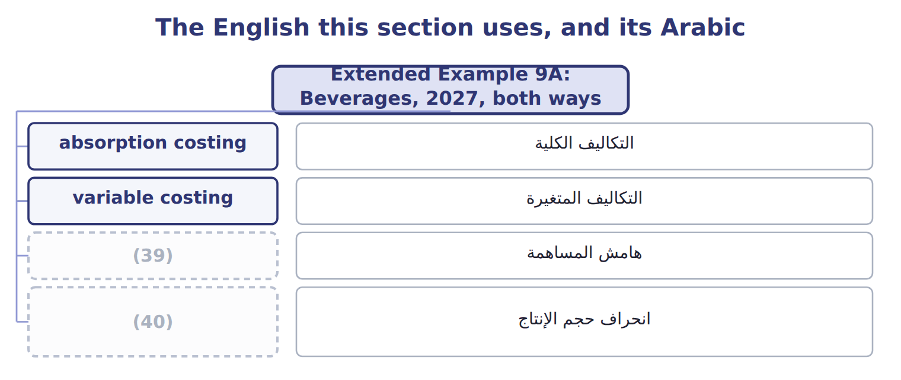
word list
التكاليف المتغيرة · contribution margin · production-volume variance

The English this sheet uses, and its Arabic
English (exam term) | Arabic
absorption costing | التكاليف الكلية
variable costing | التكاليف المتغيرة
contribution margin | هامش المساهمة
production-volume variance | انحراف حجم الإنتاج

Answer key · 9.7 Extended Example 9A: Beverages, 2027, both ways

1 records | 21 Totals
2 responds | 22 finished
3 exam-core | 23 produced
4 inventory | 24 overproduction
5 produced | 25 Opening
6 capacity | 26 Income
7 administrative | 27 inventory
8 compare | 28 production
9 reconcile | 29 difference
10 Absorption | 30 inventory
11 production-volume | 31 Variable selling cost per tray
12 contribution | 32 Fixed manufacturing overhead (budget = actual)
13 Fixed MOH Control | 33 Normal capacity (denominator)
14 Variable manufacturing costs | 34 Trays produced / sold (no opening inventory)
15 Finished Goods Inventory | 35 (40,000) × $2.00 = (80,000)
16 Cost of Goods Sold | 36 Period cost under both methods
17 Totals | 37 Product cost under both methods
18 Fixed MOH Expense | 38 Product cost under absorption only
19 Finished Goods Inventory | 39 contribution margin
20 Variable manufacturing costs | 40 production-volume variance

the summaries in full
Summary 1 This example records the year under both methods, follows finished goods and cost of goods sold, and shows how income responds to production. The statements and the reconciliation are exam-core; the entries are for depth. Units: opening inventory 40,000 cases; produced 850,000; sold 830,000; closing 60,000. Costs per case: variable manufacturing $10.60; fixed overhead $2.00 at normal capacity; variable selling $1.20; price $20.00. Fixed costs: manufacturing overhead $1,800,000; selling and administrative $2,100,000. Record production and sales under each method, compare finished goods and cost of goods sold, prepare both statements and reconcile the incomes. Absorption: fixed overhead applied 850,000 × $2.00 = $1,700,000; production-volume variance $100,000; operating income $2,946,000. Variable costing: contribution margin $6,806,000 − fixed costs $3,900,000 = $2,906,000. Reconciliation: (60,000 − 40,000) × $2.00 = $40,000. Only the treatment of fixed overhead differs.
Summary 2 Ending finished goods are $756,000 under absorption and $636,000 under variable costing. Variable costing income does not move. Absorption income rises by $2.00 for each extra case produced, which is why absorption income alone can reward overproduction.
Summary 3 Finished goods difference: $756,000 − $636,000 = 60,000 × $2.00. Opening difference: $504,000 − $424,000 = 40,000 × $2.00. Income difference: $2,946,000 − $2,906,000 = $40,000 = the change in fixed overhead held in inventory.
Summary 4 Expect production, sales and cost data, and a request for income under one method or the difference between them. Find the change in inventory units first; multiply by the fixed overhead rate to reconcile.

