10.1 Why allocate service department costs
Chapter 10 · section 10.1

Fill every gap. Each word list holds one word more than there are gaps.
Chapter 10, section by section
Each stage leads to the next.
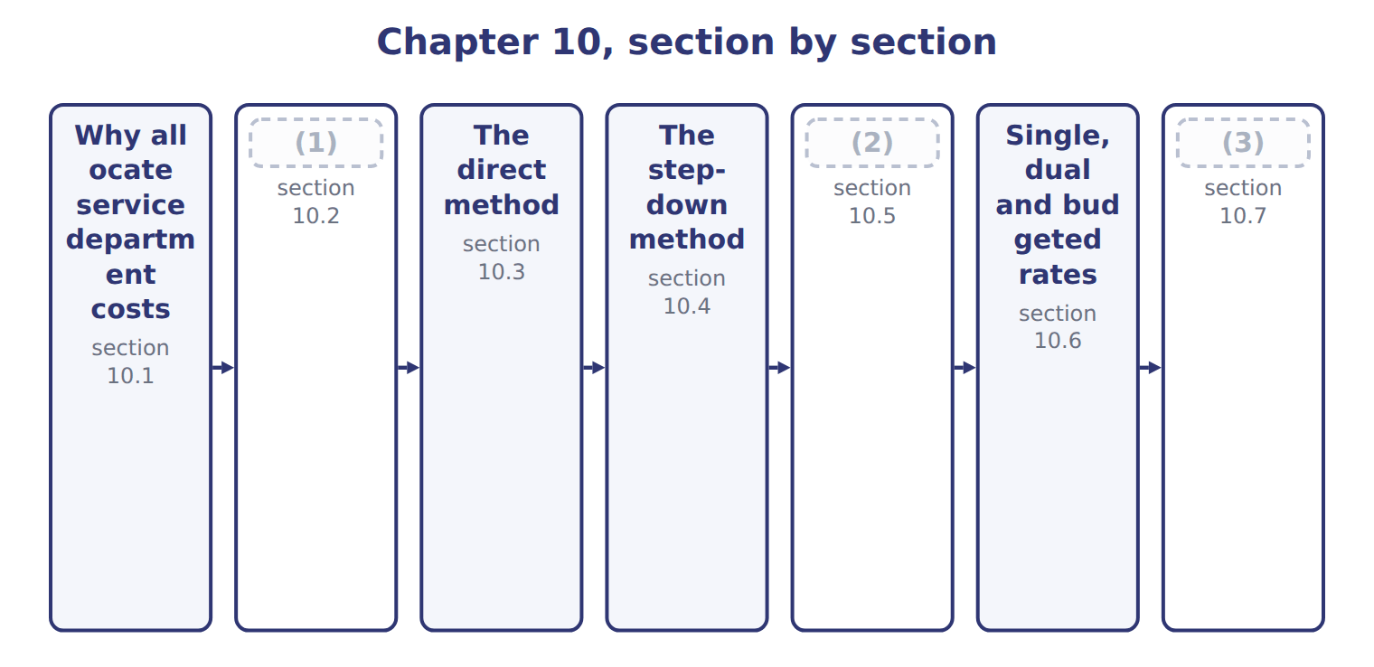
word list
The reciprocal method · Why allocate service department costs · Extended Example 10A: Orontes allocates 2027 s · Choosing allocation bases

Summary 1 gaps 4–10
A service department (4) other departments but does not make products: at Orontes these are (5) , IT, the Quality Lab and HR. A (6) department works on the products: the Oils, Tahini & Spreads and Beverages divisions. Service costs are (7) for three reasons. Products must carry their full cost for (8) and pricing. Users become (9) when a service has a price. And (10) can compare an internal service with an outside supplier. Service departments also serve each other.
word list
careful · production · managers · Beverages · allocated · inventory · Maintenance · supports

The English this sheet uses, and its Arabic
English (exam term) | Arabic
service department | مركز الخدمات
production department | مركز الإنتاج

Answer key · 10.1 Why allocate service department costs

1 Choosing allocation bases | 6 production
2 The reciprocal method | 7 allocated
3 Extended Example 10A: Orontes allocates 2027 s | 8 inventory
4 supports | 9 careful
5 Maintenance | 10 managers

the summaries in full
Summary 1 A service department supports other departments but does not make products: at Orontes these are Maintenance, IT, the Quality Lab and HR. A production department works on the products: the Oils, Tahini & Spreads and Beverages divisions. Service costs are allocated for three reasons. Products must carry their full cost for inventory and pricing. Users become careful when a service has a price. And managers can compare an internal service with an outside supplier. Service departments also serve each other.

10.2 Choosing allocation bases
Chapter 10 · section 10.2

Fill every gap. Each word list holds one word more than there are gaps.
Summary 1 gaps 1–4
The base should follow cause and effect: the (1) that makes the service (2) spend money. Maintenance is (3) on maintenance hours, the Quality Lab on test hours and HR on (4) . Where no causal base exists, managers use benefit received or ability to bear, but these are weaker.
word list
allocated · department · headcount · divisions · activity

Allocation bases for the four service departments
Service department | Allocation base | Why
Maintenance | (5) | Hours of work cause the cost
IT | Share of systems use | (6)
Quality Lab | (7) | Each test uses lab time
HR | Headcount at $200 a person | (8)

word list
Share of maintenance hours (long-run plan) · Hours of work cause the cost · Test hours at $40 an hour · Users, devices and tickets drive the cost · Hiring, payroll and training follow people

Summary 2 gaps 9–11
Quality Lab and HR serve only the (9) , so their costs go (10) to them: $400,000 at $40 a test hour and $312,000 at $200 a person. The methods below deal with (11) and IT, which serve each other.
word list
divisions · Maintenance · Quality · straight

Answer key · 10.2 Choosing allocation bases

1 activity | 7 Test hours at $40 an hour
2 department | 8 Hiring, payroll and training follow people
3 allocated | 9 divisions
4 headcount | 10 straight
5 Share of maintenance hours (long-run plan) | 11 Maintenance
6 Users, devices and tickets drive the cost

the summaries in full
Summary 1 The base should follow cause and effect: the activity that makes the service department spend money. Maintenance is allocated on maintenance hours, the Quality Lab on test hours and HR on headcount. Where no causal base exists, managers use benefit received or ability to bear, but these are weaker.
Summary 2 Quality Lab and HR serve only the divisions, so their costs go straight to them: $400,000 at $40 a test hour and $312,000 at $200 a person. The methods below deal with Maintenance and IT, which serve each other.

10.3 The direct method
Chapter 10 · section 10.3

Fill every gap. Each word list holds one word more than there are gaps.
Summary 1 gaps 1–4
The (1) method ignores the (2) that service departments give each other. Each service (3) cost is shared among the (4) departments only, in proportion to their use. It is simple and common, but it is least accurate when service departments serve each other a lot.
word list
production · direct · services · original · department's

Worked example: the direct method

Summary 2 gaps 5–6
Maintenance's shares to the (5) are 50, 20 and 10, a total of 80, so Oils (6) 50/80 of $880,000.
word list
receives · divisions · unallocated

Worked example: the direct method
The parts add up to the total; the bars are to scale.
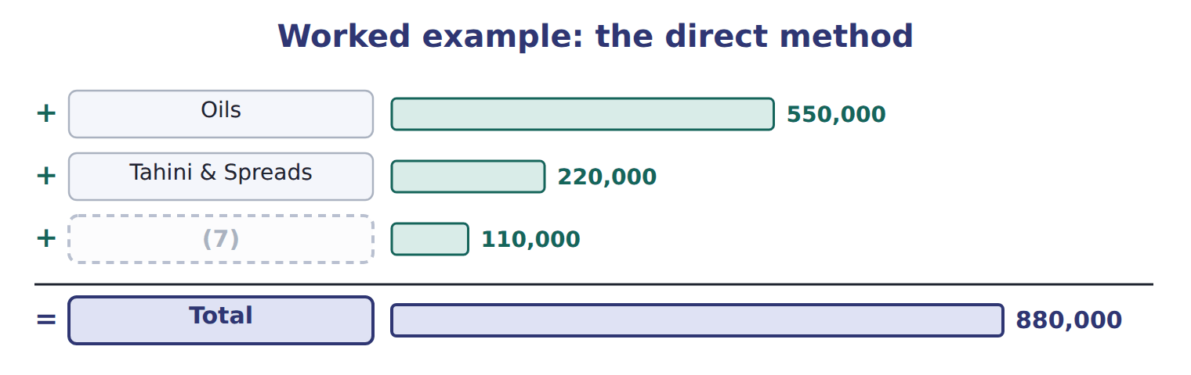
word list
budgeted rate · Beverages

Summary 3 gaps 8–9
The shares are rescaled to the production (8) only. Using the original (9) would leave part of the cost unallocated.
word list
percentages · rescaled · departments

The English this sheet uses, and its Arabic
English (exam term) | Arabic
direct method | الطريقة المباشرة

Answer key · 10.3 The direct method

1 direct | 6 receives
2 services | 7 Beverages
3 department's | 8 departments
4 production | 9 percentages
5 divisions

the summaries in full
Summary 1 The direct method ignores the services that service departments give each other. Each service department's cost is shared among the production departments only, in proportion to their use. It is simple and common, but it is least accurate when service departments serve each other a lot.
Summary 2 Maintenance's shares to the divisions are 50, 20 and 10, a total of 80, so Oils receives 50/80 of $880,000.
Summary 3 The shares are rescaled to the production departments only. Using the original percentages would leave part of the cost unallocated.

10.4 The step-down method
Chapter 10 · section 10.4

Fill every gap. Each word list holds one word more than there are gaps.
Summary 1 gaps 1–5
The step-down method recognizes some (1) links. Service departments are allocated one at a time. A department that has been allocated (2) nothing back. Start with the department that (3) other service departments the most. Orontes starts with (4) : $176,000 goes to IT, so IT's pool becomes $576,000. IT is then shared among the (5) only.
word list
receives · serves · service-to-service · Maintenance · Orontes's · divisions

The step-down method: Maintenance first, then IT
The parts add up to the total; the bars are to scale.
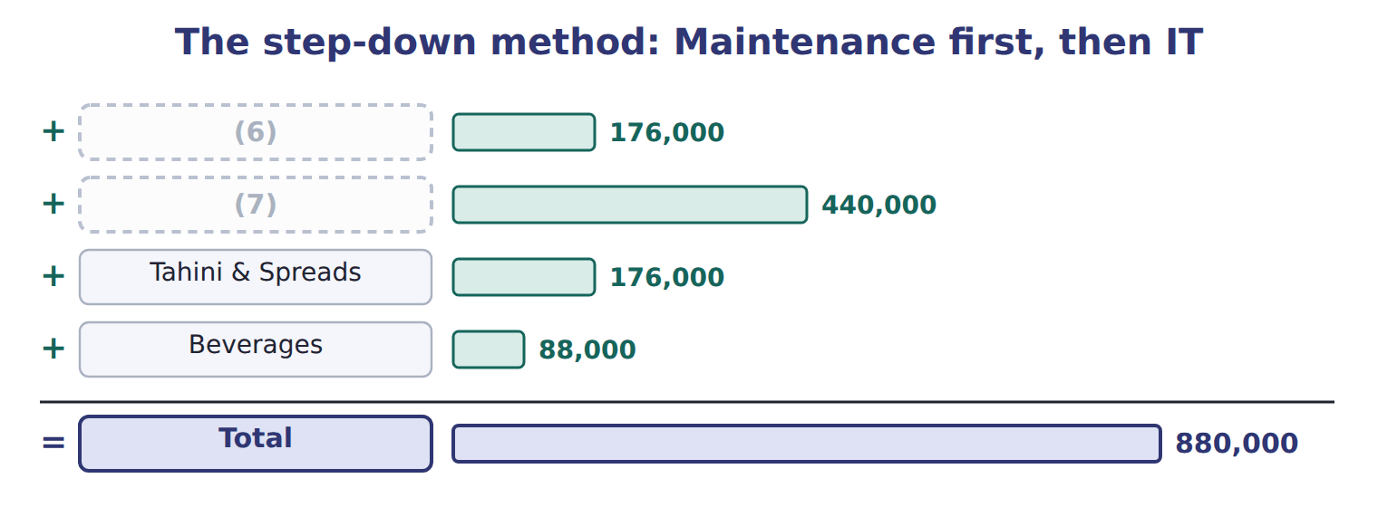
word list
IT (first receives from Maintenance) · Oils · direct method

Summary 2 gaps 8–9
Step-down is (8) policy method. It is more accurate than the direct method, but the order matters and the link from IT back to (9) is still ignored.
word list
allocates · Maintenance · Orontes's

Use the new pool

Summary 3 gaps 10–11
The second (10) allocates its own cost plus what it (11) in step 1: $576,000, not $400,000.
word list
department · received · step-down

The English this sheet uses, and its Arabic
English (exam term) | Arabic
step-down method | طريقة التوزيع التنازلي

Answer key · 10.4 The step-down method

1 service-to-service | 7 Oils
2 receives | 8 Orontes's
3 serves | 9 Maintenance
4 Maintenance | 10 department
5 divisions | 11 received
6 IT (first receives from Maintenance)

the summaries in full
Summary 1 The step-down method recognizes some service-to-service links. Service departments are allocated one at a time. A department that has been allocated receives nothing back. Start with the department that serves other service departments the most. Orontes starts with Maintenance: $176,000 goes to IT, so IT's pool becomes $576,000. IT is then shared among the divisions only.
Summary 2 Step-down is Orontes's policy method. It is more accurate than the direct method, but the order matters and the link from IT back to Maintenance is still ignored.
Summary 3 The second department allocates its own cost plus what it received in step 1: $576,000, not $400,000.

10.5 The reciprocal method
Chapter 10 · section 10.5

Fill every gap. Each word list holds one word more than there are gaps.
Summary 1 gaps 1–5
The reciprocal method recognizes all (1) links. Write one equation for each service (2) : its total cost is its own cost plus its share of the other's total. Solving the two equations gives (3) a total of $1,000,000 and IT $600,000. These totals are larger than the original costs because they include the services (4) . Each (5) then takes its share of both totals.
word list
service-to-service · exchanged · original · division · Maintenance · department

The reciprocal method: equations and allocation
Reciprocal method | Result
Maintenance equation | (6)
IT equation | I = 400,000 + 0.20 M
Substitute and solve | (7)
Oils: 50% of M + 20% of I | 620,000
Tahini & Spreads: 20% of M + 40% of I | 440,000
Beverages: 10% of M + 20% of I | 220,000
Total to divisions | 1,280,000

word list
I = 400,000 + 0.20 M · M = 880,000 + 0.20 I · M = 1,000,000; I = 600,000

It is the most accurate method but needs algebra, or matrix methods for many departments.
The English this sheet uses, and its Arabic
English (exam term) | Arabic
reciprocal method | طريقة التوزيع التبادلي

Answer key · 10.5 The reciprocal method

1 service-to-service | 5 division
2 department | 6 M = 880,000 + 0.20 I
3 Maintenance | 7 M = 1,000,000; I = 600,000
4 exchanged

the summaries in full
Summary 1 The reciprocal method recognizes all service-to-service links. Write one equation for each service department: its total cost is its own cost plus its share of the other's total. Solving the two equations gives Maintenance a total of $1,000,000 and IT $600,000. These totals are larger than the original costs because they include the services exchanged. Each division then takes its share of both totals.

10.6 Single, dual and budgeted rates
Chapter 10 · section 10.6

Fill every gap. Each word list holds one word more than there are gaps.
Summary 1 gaps 1–10
A (1) method charges one rate per hour for fixed and variable service costs (2) . When users need fewer hours than planned, the fixed cost is (3) over fewer hours, and one (4) change moves cost to the (5) . A (6) method charges variable cost on (7) use and fixed cost on the capacity each user planned for. Orontes charges Maintenance at a (8) rate of $40 per hour plus fixed shares of $560,000, so users do not pay for (9) overspending. The dual rate (10) $860,000 and left only the $12,000 spending difference in Maintenance. The single rate left $47,000, which mixes that spending difference with $35,000 of idle capacity.
word list
others · single-rate · user's · charged · difference · spread · together · dual-rate · Maintenance's · budgeted · actual

Maintenance charges: dual rate compared with single rate
Maintenance: actual cost 872,000 | Dual rate (budgeted) | Single rate ($110 per hour)
Fixed Maintenance cost | (11) | with variable cost at one rate on actual hours
Variable Maintenance cost | (12) | included in the single rate
Amount charged to users | 860,000 | 825,000
Left in Maintenance | 12,000 (spending only) | (13)

word list
actual hours × budgeted $40 · included in the single rate · on long-run capacity shares: 560,000 · 47,000 (spending 12,000 + unused capacity 35,000)

Complete the dual-rate charges

Complete the other two.
Your turn: dual-rate Maintenance charges (complete the blanks)
The bars are drawn to scale.
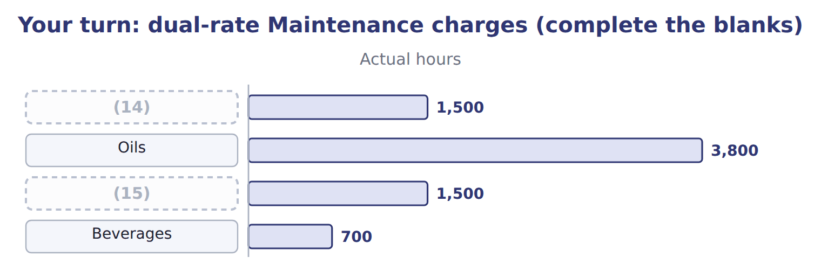
word list
IT · Tahini & Spreads · step-down method

The English this section uses, and its Arabic
Each term sits against what it means.
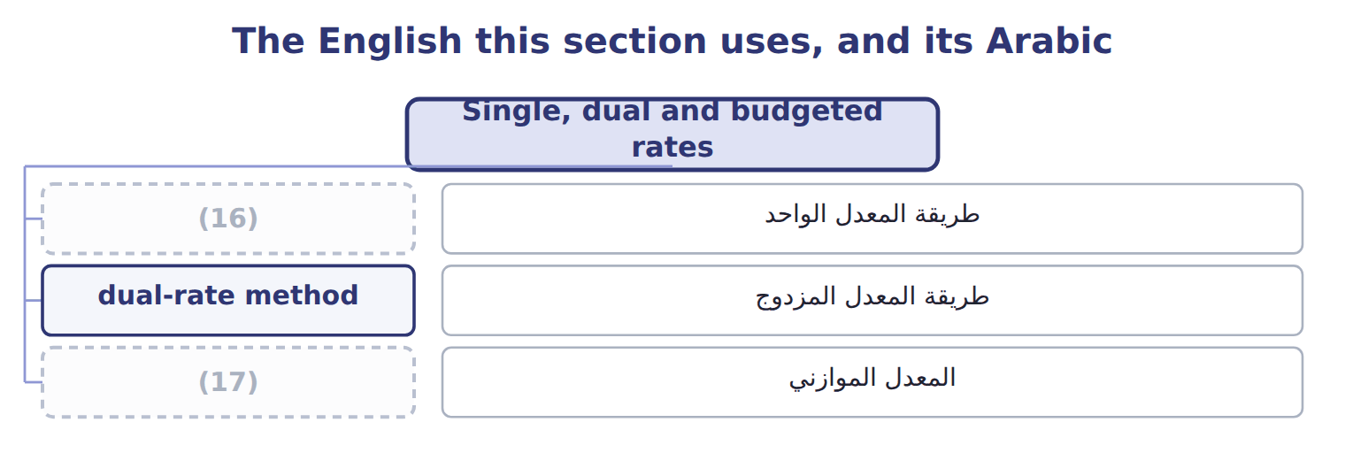
word list
step-down method · single-rate method · budgeted rate

The English this sheet uses, and its Arabic
English (exam term) | Arabic
single-rate method | طريقة المعدل الواحد
dual-rate method | طريقة المعدل المزدوج
budgeted rate | المعدل الموازني

Answer key · 10.6 Single, dual and budgeted rates

1 single-rate | 10 charged
2 together | 11 on long-run capacity shares: 560,000
3 spread | 12 actual hours × budgeted $40
4 user's | 13 47,000 (spending 12,000 + unused capacity 35,000)
5 others | 14 IT
6 dual-rate | 15 Tahini & Spreads
7 actual | 16 single-rate method
8 budgeted | 17 budgeted rate
9 Maintenance's

the summaries in full
Summary 1 A single-rate method charges one rate per hour for fixed and variable service costs together. When users need fewer hours than planned, the fixed cost is spread over fewer hours, and one user's change moves cost to the others. A dual-rate method charges variable cost on actual use and fixed cost on the capacity each user planned for. Orontes charges Maintenance at a budgeted rate of $40 per hour plus fixed shares of $560,000, so users do not pay for Maintenance's overspending. The dual rate charged $860,000 and left only the $12,000 spending difference in Maintenance. The single rate left $47,000, which mixes that spending difference with $35,000 of idle capacity.

10.7 Extended Example 10A: Orontes allocates 2027 service costs
Chapter 10 · section 10.7

Fill every gap. Each word list holds one word more than there are gaps.
Summary 1 gaps 1–10
This example (1) all four service (2) with the policy methods, records the entries and ties the result to the charges used in earlier chapters. The (3) table is exam-core; the entries are for depth. Service costs: Maintenance $880,000; IT $400,000; Quality Lab $400,000; HR $312,000; total $1,992,000. Policy: (4) for Maintenance then IT; Quality Lab on test hours; HR on (5) . Allocate Maintenance, then the (6) IT pool, then Quality Lab and HR. Record each step, check that every service (7) closes, and compare each (8) total with its monthly charge. Oils (9) $888,000, Tahini & Spreads $690,000 and (10) $414,000. Divided by twelve, these are the monthly service charges used in, 6 and 8.
word list
headcount · Beverages · allocation · departments · division's · enlarged · allocates · entries · account · step-down · receives

Extended Example: 2027 service allocation by division
The parts add up to the total; the bars are to scale.
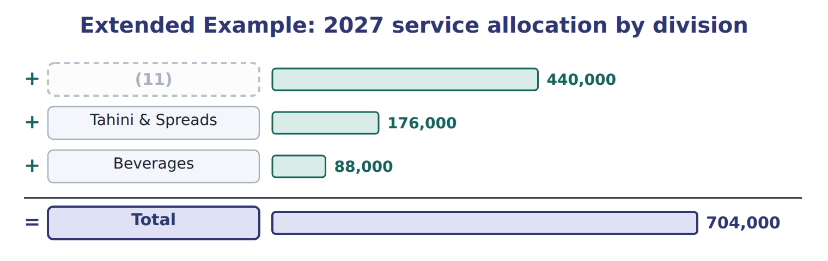
word list
Beverages · Oils

The journal totals $4,160,000 on each side.

Extended Example: service allocation journal, 2027
No. | Account (detail) | Debit | Credit
1 | (12) | 880,000
 | (13) | 400,000
 | Quality Lab | 400,000
 | (14) | 312,000
 | (15) |  | 1,992,000
2 | IT Department | 176,000
 | MOH Control - Oils | 440,000
 | MOH Control - Tahini | 176,000
 | MOH Control - Beverages | 88,000
 | Maintenance Department |  | 880,000
3 | MOH Control - Oils | 144,000
 | (16) | 288,000
 | MOH Control - Beverages | 144,000
 | IT Department |  | 576,000
4 | MOH Control - Oils | 200,000
 | MOH Control - Tahini | 104,000
 | MOH Control - Beverages | 96,000
 | (17) |  | 400,000
5 | (18) | 104,000
 | MOH Control - Tahini | 122,000
 | (19) | 86,000
 | HR Department |  | 312,000
 | (20) | 4,160,000 | 4,160,000

word list
Quality Lab · Various accounts · MOH Control - Beverages · MOH Control - Tahini · HR Department · step-down method · Totals · Maintenance Department · IT Department · MOH Control - Oils

Every service department account closes to zero, and each division's overhead account holds its share.
Everything ties

Summary 2 gaps 21–22
Allocated: $888,000 + $690,000 + $414,000 = $1,992,000, all (21) cost. IT pool: $400,000 + $176,000 from (22) = $576,000. Tahini: $690,000 is twelve months of the charge in the.
word list
Divided · Maintenance · service

Exam view

Summary 3 gaps 23–25
Expect two service and two production departments with (23) . For the direct method, (24) to production departments. For (25) , use the enlarged pool. For the reciprocal method, write the two equations and solve before allocating.
word list
percentages · rescale · step-down · Quality

Exam view
Levant Distribution · FY2027 | Cost | To IT | To Fleet | To Warehouse | To Delivery
Fleet Maintenance (S1) | 216,000 | 20% | — | 40% | 40%
(26) | 120,000 | — | 20% | 50% | 30%

word list
IT (S2) · step-down method

Item — Answer
Item | Answer
Tahini & Spreads | (27)
Beverages | Variable 28,000; total 84,000

word list
Levant Distribution · FY2027 · Variable 60,000; total 172,000

Department — Category
Every item belongs to exactly one group.
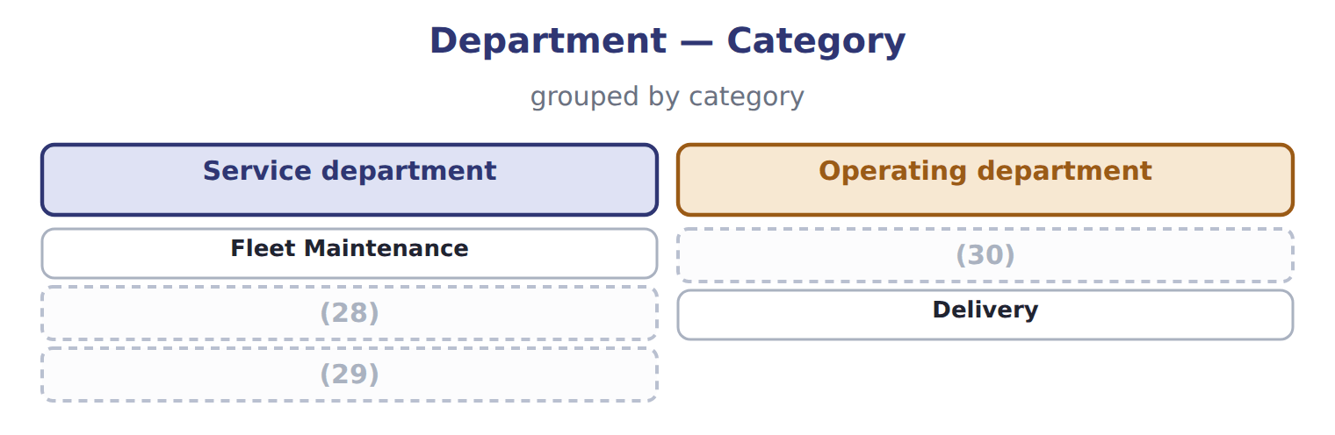
word list
Warehouse · Payroll office · IT · dual-rate method

The English this section uses, and its Arabic
Each term sits against what it means.
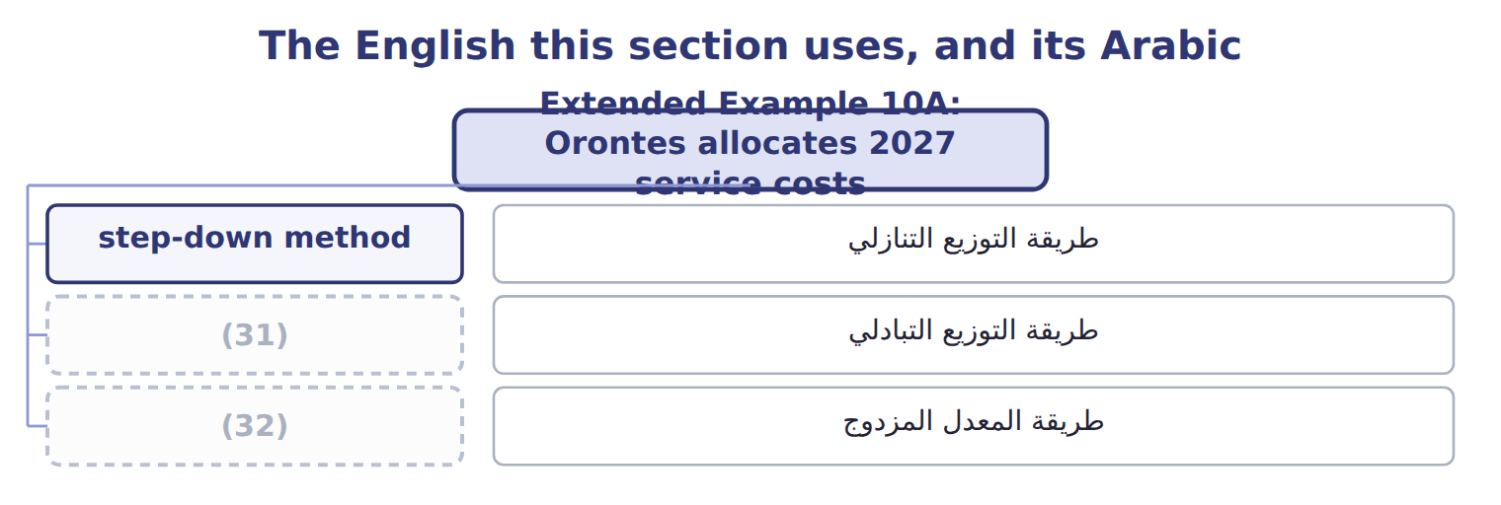
word list
dual-rate method · direct method · reciprocal method

The English this sheet uses, and its Arabic
English (exam term) | Arabic
step-down method | طريقة التوزيع التنازلي
reciprocal method | طريقة التوزيع التبادلي
dual-rate method | طريقة المعدل المزدوج

Answer key · 10.7 Extended Example 10A: Orontes allocates 2027 service costs

1 allocates | 17 Quality Lab
2 departments | 18 MOH Control - Oils
3 allocation | 19 MOH Control - Beverages
4 step-down | 20 Totals
5 headcount | 21 service
6 enlarged | 22 Maintenance
7 account | 23 percentages
8 division's | 24 rescale
9 receives | 25 step-down
10 Beverages | 26 IT (S2)
11 Oils | 27 Variable 60,000; total 172,000
12 Maintenance Department | 28 IT
13 IT Department | 29 Payroll office
14 HR Department | 30 Warehouse
15 Various accounts | 31 reciprocal method
16 MOH Control - Tahini | 32 dual-rate method

the summaries in full
Summary 1 This example allocates all four service departments with the policy methods, records the entries and ties the result to the charges used in earlier chapters. The allocation table is exam-core; the entries are for depth. Service costs: Maintenance $880,000; IT $400,000; Quality Lab $400,000; HR $312,000; total $1,992,000. Policy: step-down for Maintenance then IT; Quality Lab on test hours; HR on headcount. Allocate Maintenance, then the enlarged IT pool, then Quality Lab and HR. Record each step, check that every service account closes, and compare each division's total with its monthly charge. Oils receives $888,000, Tahini & Spreads $690,000 and Beverages $414,000. Divided by twelve, these are the monthly service charges used in, 6 and 8.
Summary 2 Allocated: $888,000 + $690,000 + $414,000 = $1,992,000, all service cost. IT pool: $400,000 + $176,000 from Maintenance = $576,000. Tahini: $690,000 is twelve months of the charge in the.
Summary 3 Expect two service and two production departments with percentages. For the direct method, rescale to production departments. For step-down, use the enlarged pool. For the reciprocal method, write the two equations and solve before allocating.

