11.1 Joint products, by-products and scrap
Chapter 11 · section 11.1

Fill every gap. Each word list holds one word more than there are gaps.
Chapter 11, section by section
Each stage leads to the next.
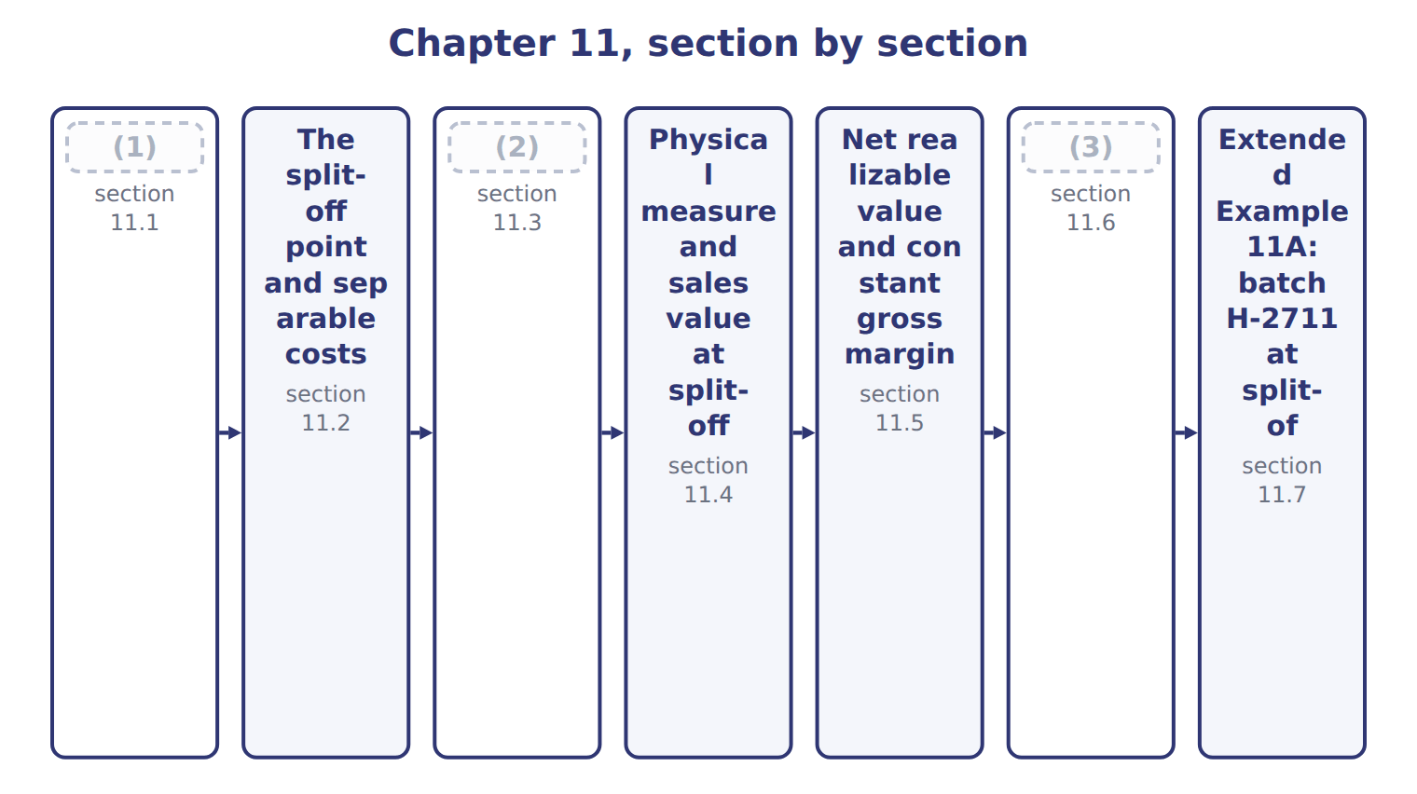
word list
sales method (by-products) · Accounting for by-products · Joint products, by-products and scrap · Benefits, limitations and further processing

Summary 1 gaps 4–8
Joint products are two or more products from the same process, each with (4) sales value. (5) oil (EVOO) and virgin oil (VOO) are joint products: the press runs to make both. A by-product comes from the same process but has a small sales value (6) with the joint products. (7) , the olive cake left after (8) , is a by-product. Scrap has even less value.
word list
sharply · pressing · Extra-virgin · compared · significant · Pomace

Joint products, by-products and scrap
Output | Test | Oils example | Accounting
Joint product | Significant sales value; a main reason to run the process | EVOO and VOO | (9)
By-product | (10) | Pomace (olive cake) | NRV reduces joint cost, or income when sold
Scrap | Very small value; often sold for a token amount | (11) | Credit to overhead or income

word list
Small sales value compared with the joint products · Share of joint cost · Filter residue · split-off point

Summary 2 gaps 12–13
The test is (12) value, and it can change. If pomace prices rose (13) , Orontes might treat it as a joint product and give it a share of joint cost.
word list
by-product · relative · sharply

The English this sheet uses, and its Arabic
English (exam term) | Arabic
joint products | المنتجات المشتركة
by-product | المنتج العرضي

Answer key · 11.1 Joint products, by-products and scrap

1 Joint products, by-products and scrap | 8 pressing
2 Accounting for by-products | 9 Share of joint cost
3 Benefits, limitations and further processing | 10 Small sales value compared with the joint products
4 significant | 11 Filter residue
5 Extra-virgin | 12 relative
6 compared | 13 sharply
7 Pomace

the summaries in full
Summary 1 Joint products are two or more products from the same process, each with significant sales value. Extra-virgin oil (EVOO) and virgin oil (VOO) are joint products: the press runs to make both. A by-product comes from the same process but has a small sales value compared with the joint products. Pomace, the olive cake left after pressing, is a by-product. Scrap has even less value.
Summary 2 The test is relative value, and it can change. If pomace prices rose sharply, Orontes might treat it as a joint product and give it a share of joint cost.

11.2 The split-off point and separable costs
Chapter 11 · section 11.2

Fill every gap. Each word list holds one word more than there are gaps.
Summary 1 gaps 1–7
The split-off point is where the joint products become separately (1) . All costs before it are joint costs: olives, crushing labor and crushing (2) , $1,400,000 for the batch. Costs after split-off that (3) to one product are separable costs. Bottling adds $468,000 to EVOO and (4) adds $32,000 to VOO. Joint costs cannot be traced to one product, however hard (5) try. Any split is an (6) . Separable costs can be traced, and they matter for every later (7) .
word list
by-product · belong · managers · filtering · overhead · identifiable · decision · allocation

The English this section uses, and its Arabic
Each term sits against what it means.
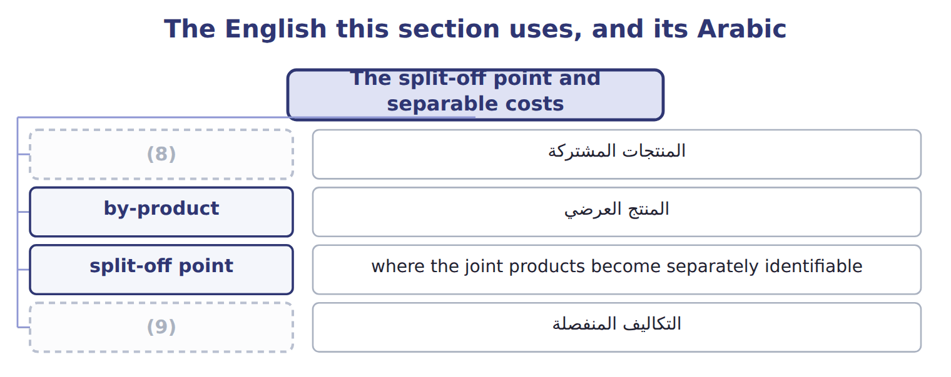
word list
sell-or-process-further decision · joint products · separable costs

The English this sheet uses, and its Arabic
English (exam term) | Arabic
split-off point | نقطة الانفصال
separable costs | التكاليف المنفصلة

Answer key · 11.2 The split-off point and separable costs

1 identifiable | 6 allocation
2 overhead | 7 decision
3 belong | 8 joint products
4 filtering | 9 separable costs
5 managers

the summaries in full
Summary 1 The split-off point is where the joint products become separately identifiable. All costs before it are joint costs: olives, crushing labor and crushing overhead, $1,400,000 for the batch. Costs after split-off that belong to one product are separable costs. Bottling adds $468,000 to EVOO and filtering adds $32,000 to VOO. Joint costs cannot be traced to one product, however hard managers try. Any split is an allocation. Separable costs can be traced, and they matter for every later decision.

11.3 Accounting for by-products
Chapter 11 · section 11.3

Fill every gap. Each word list holds one word more than there are gaps.
Summary 1 gaps 1–8
Under the production method, the by-product's net (1) value is recorded as (2) at split-off and deducted from joint cost. (3) sells for $120,000 with $20,000 of (4) costs, so its NRV is $100,000 and the joint products share $1,300,000. Under the sales method, (5) is recorded at split-off. The joint products share the full $1,400,000, and the by-product's net (6) is other income when it is sold. Over time both (7) give the same total income. The production method (8) the by-product's value with the batch; the sales method is simpler. Orontes uses the production method.
word list
matches · realizable · nothing · revenue · recorded · Pomace · inventory · disposal · methods

Sous-produit

Do not translate 'by-product' as 'secondary product' in an exam answer: the accounting is different.
By-products: production method and sales method
 | Production method | Sales method
When is value recorded? | (9) | When the by-product is sold
Joint cost to allocate | (10) | 1,400,000
Where does the value go? | (11) | Other income in the period of sale
Main benefit | Matches the by-product's value to the batch | (12)

word list
Lower cost of the joint products · sales value at split-off method · 1,400,000 − 100,000 = 1,300,000 · Simple; no inventory to track · At split-off, as inventory at NRV

The English this sheet uses, and its Arabic
English (exam term) | Arabic
production method (by-products) | طريقة الإنتاج للمنتجات العرضية
sales method (by-products) | طريقة المبيعات للمنتجات العرضية

Answer key · 11.3 Accounting for by-products

1 realizable | 7 methods
2 inventory | 8 matches
3 Pomace | 9 At split-off, as inventory at NRV
4 disposal | 10 1,400,000 − 100,000 = 1,300,000
5 nothing | 11 Lower cost of the joint products
6 revenue | 12 Simple; no inventory to track

the summaries in full
Summary 1 Under the production method, the by-product's net realizable value is recorded as inventory at split-off and deducted from joint cost. Pomace sells for $120,000 with $20,000 of disposal costs, so its NRV is $100,000 and the joint products share $1,300,000. Under the sales method, nothing is recorded at split-off. The joint products share the full $1,400,000, and the by-product's net revenue is other income when it is sold. Over time both methods give the same total income. The production method matches the by-product's value with the batch; the sales method is simpler. Orontes uses the production method.

11.4 Physical measure and sales value at split-off
Chapter 11 · section 11.4

Fill every gap. Each word list holds one word more than there are gaps.
Summary 1 gaps 1–4
The physical measure method shares joint cost in (1) to a physical (2) , such as liters. It is (3) and needs no (4) . But it ignores value: a liter of VOO takes the same share as a liter of EVOO, which sells for much more.
word list
quantity · prices · simple · proportion · follows

Worked example: physical measure

EVOO is 130,000 of the 200,000 liters, or 65%.
Worked example: physical measure method
Physical measure method | Liters | Share | Joint cost allocated
EVOO | 130,000 | 65% | 845,000
(5) | 70,000 | 35% | 455,000
(6) | 200,000 | 100% | 1,300,000

word list
Calculation · Total · VOO

Summary 2 gaps 7–9
The sales value at split-off (7) shares joint cost in (8) to each product's market value at split-off. It (9) the idea that costs are shared by ability to bear them. It needs a market price at split-off, which not every product has.
word list
follows · method · ability · proportion

Sales value at split-off

Share the net joint cost of $1,300,000.
Your turn: sales value at split-off (complete the blanks)
Sales value at split-off | Calculation | Sales value | Joint cost allocated
EVOO | (10) | 1,352,000 | ________
VOO | 70,000 × $3.90 | 273,000 | ________
Total |  | 1,625,000 | 1,300,000

word list
Joint cost allocated · 130,000 × $10.40

The English this sheet uses, and its Arabic
English (exam term) | Arabic
physical measure method | طريقة المقياس المادي
sales value at split-off method | طريقة القيمة البيعية عند نقطة الانفصال

Answer key · 11.4 Physical measure and sales value at split-off

1 proportion | 6 Total
2 quantity | 7 method
3 simple | 8 proportion
4 prices | 9 follows
5 VOO | 10 130,000 × $10.40

the summaries in full
Summary 1 The physical measure method shares joint cost in proportion to a physical quantity, such as liters. It is simple and needs no prices. But it ignores value: a liter of VOO takes the same share as a liter of EVOO, which sells for much more.
Summary 2 The sales value at split-off method shares joint cost in proportion to each product's market value at split-off. It follows the idea that costs are shared by ability to bear them. It needs a market price at split-off, which not every product has.

11.5 Net realizable value and constant gross margin
Chapter 11 · section 11.5

Fill every gap. Each word list holds one word more than there are gaps.
Summary 1 gaps 1–5
The net (1) value method uses each (2) final sales value minus its separable costs. It works when there is no market price at (3) . It is (4) policy method. The constant (5) percentage method first finds the gross margin of the whole batch, 28%. It then gives each product the joint cost that makes its own margin the same 28%.
word list
split-off · product's · gross-margin · constant · realizable · Orontes's

NRV and constant gross-margin methods, step by step
The bars are drawn to scale.
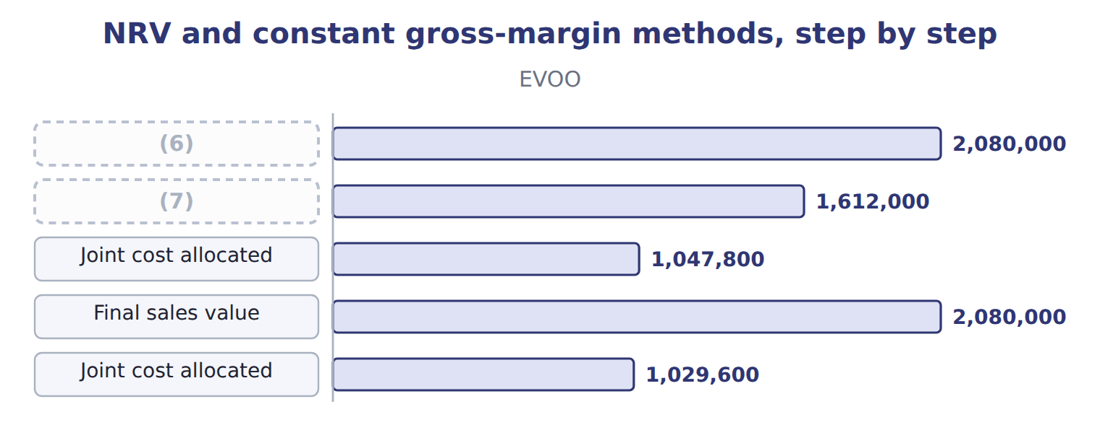
word list
NRV at split-off · sales method (by-products) · Final sales value

Each shares the same $1,300,000; they differ only in how much each product carries.
Final sales value, not NRV

Summary 2 gaps 8–9
In the constant (8) method, apply the margin to final sales value, then deduct separable costs. (9) it to NRV gives the wrong joint cost.
word list
gross-margin · Applying · product's

The English this section uses, and its Arabic
Each term sits against what it means.
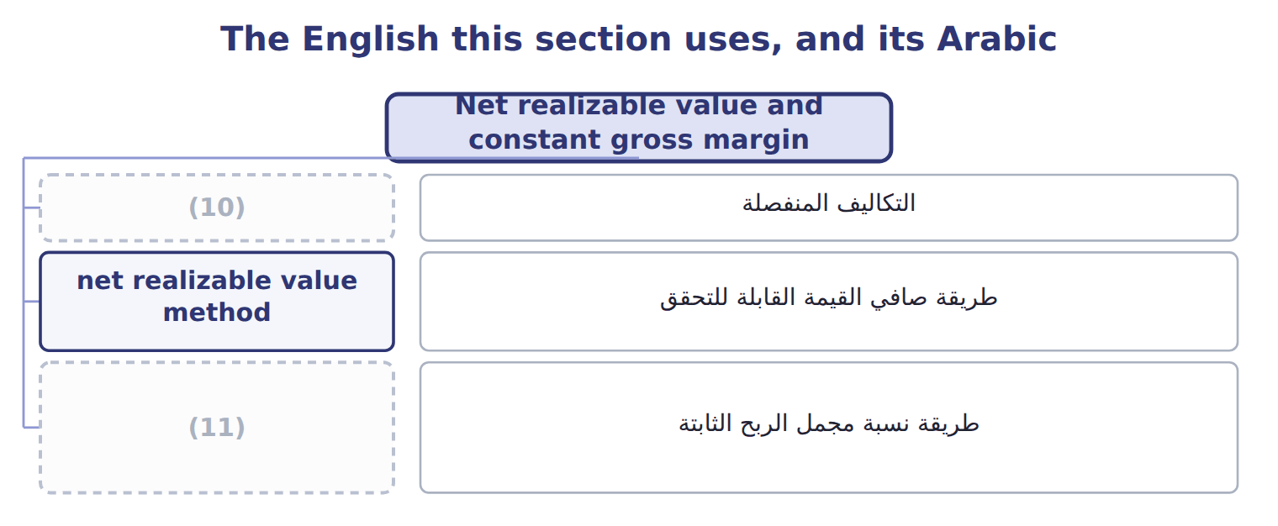
word list
physical measure method · constant gross-margin percentage method · separable costs

The English this sheet uses, and its Arabic
English (exam term) | Arabic
net realizable value method | طريقة صافي القيمة القابلة للتحقق
constant gross-margin percentage method | طريقة نسبة مجمل الربح الثابتة

Answer key · 11.5 Net realizable value and constant gross margin

1 realizable | 7 NRV at split-off
2 product's | 8 gross-margin
3 split-off | 9 Applying
4 Orontes's | 10 separable costs
5 gross-margin | 11 constant gross-margin percentage method
6 Final sales value

the summaries in full
Summary 1 The net realizable value method uses each product's final sales value minus its separable costs. It works when there is no market price at split-off. It is Orontes's policy method. The constant gross-margin percentage method first finds the gross margin of the whole batch, 28%. It then gives each product the joint cost that makes its own margin the same 28%.
Summary 2 In the constant gross-margin method, apply the margin to final sales value, then deduct separable costs. Applying it to NRV gives the wrong joint cost.

11.6 Benefits, limitations and further processing
Chapter 11 · section 11.6

Fill every gap. Each word list holds one word more than there are gaps.
Each method changes reported product margins.
Product gross margins under each method
The bars are drawn to scale.
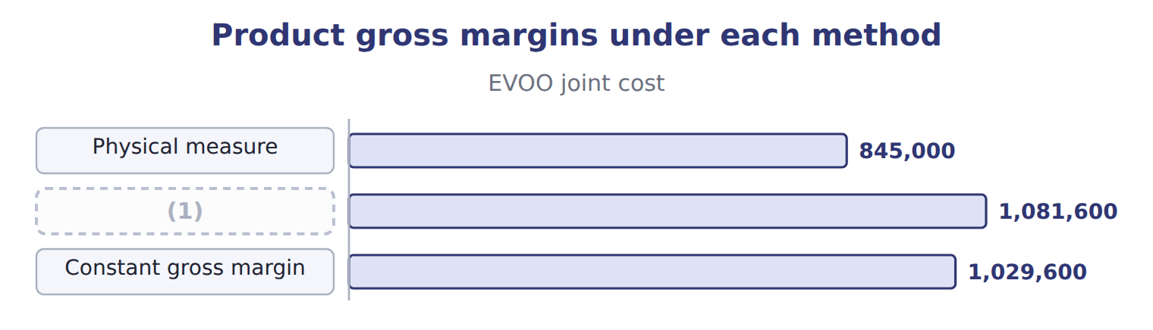
word list
net realizable value method · Sales value at split-off

Summary 1 gaps 2–8
The (2) measure method is simple but (3) value. Sales value at split-off is fair and simple but needs split-off prices. NRV works (4) split-off prices but depends on (5) of separable costs. (6) gross margin gives every product the same margin, which may hide real (7) . No (8) should drive a decision to sell at split-off or process further. That decision compares the extra revenue with the separable cost only; the joint cost is the same either way.
word list
estimates · without · Constant · allocation · separable · ignores · differences · physical

Sell at split-off or process further?
Sell at split-off or process further? | EVOO: bottle | VOO: filter
Sales value if processed further | 2,080,000 | 420,000
(9) | (1,352,000) | (273,000)
Incremental revenue | 728,000 | 147,000
(10) | (468,000) | (32,000)
(11) | 260,000 | 115,000
Joint cost | irrelevant | irrelevant

word list
Separable (incremental) cost · Sales value at split-off · physical measure method · Gain from processing further

The English this section uses, and its Arabic
Each term sits against what it means.
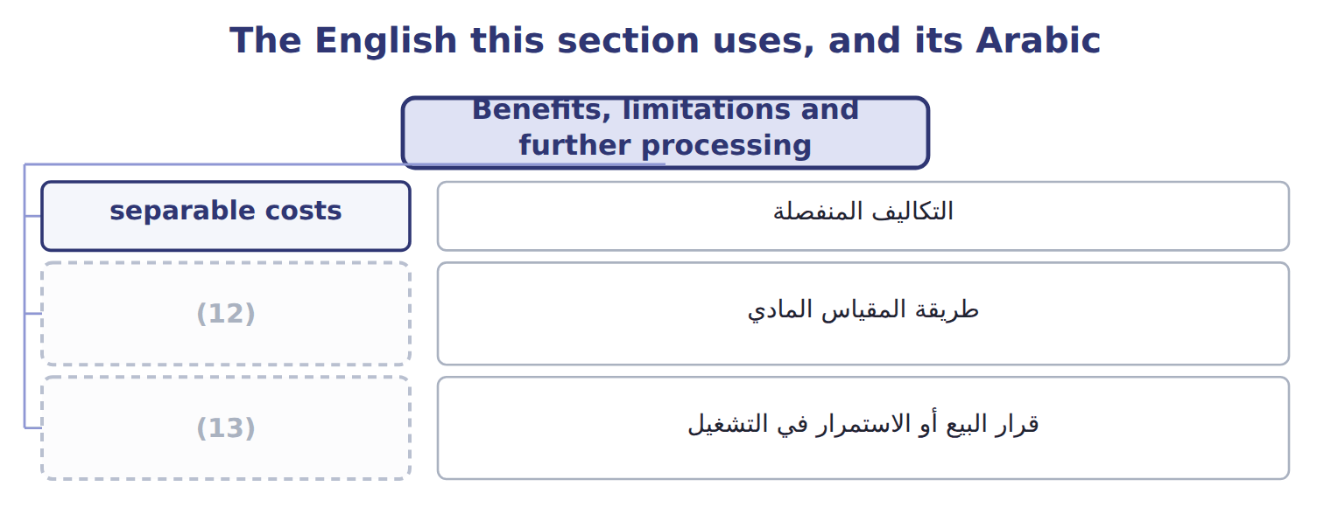
word list
sell-or-process-further decision · physical measure method · طريقة المقياس المادي

The English this sheet uses, and its Arabic
English (exam term) | Arabic
sell-or-process-further decision | قرار البيع أو الاستمرار في التشغيل

Answer key · 11.6 Benefits, limitations and further processing

1 Sales value at split-off | 8 allocation
2 physical | 9 Sales value at split-off
3 ignores | 10 Separable (incremental) cost
4 without | 11 Gain from processing further
5 estimates | 12 physical measure method
6 Constant | 13 sell-or-process-further decision
7 differences

the summaries in full
Summary 1 The physical measure method is simple but ignores value. Sales value at split-off is fair and simple but needs split-off prices. NRV works without split-off prices but depends on estimates of separable costs. Constant gross margin gives every product the same margin, which may hide real differences. No allocation should drive a decision to sell at split-off or process further. That decision compares the extra revenue with the separable cost only; the joint cost is the same either way.

11.7 Extended Example 11A: batch H-2711 at split-off
Chapter 11 · section 11.7

Fill every gap. Each word list holds one word more than there are gaps.
Summary 1 gaps 1–10
This example records the split-off of batch H-2711 twice, once for each (1) method, and (2) the results. The (3) are exam-core; the (4) are for depth. (5) : EVOO 130,000 liters; VOO 70,000 liters; pomace 400,000 kg at $0.30, with $20,000 of (6) costs. (7) : NRV method for the joint (8) ; production method for pomace. Record the joint cost, split it at split-off under the production method, record the pomace sale, then (9) with the sales method and compare. Production method: net joint cost $1,300,000; EVOO $1,047,800; VOO $252,200. EVOO per liter: $1,047,800 ÷ 130,000 = $8.06, the (10) cost used. Sales method: joint cost $1,400,000 on the same NRVs; EVOO $1,128,400; VOO $271,600.
word list
disposal · entries · products · transferred-in · Outputs · by-product · Policy · allocations · repeat · results · compares

Extended Example: production method journal
No. | Account (detail) | Debit | Credit
1 | WIP - Crushing | 1,400,000
 | (11) |  | 1,000,000
 | (12) |  | 120,000
 | Manufacturing Overhead Applied |  | 280,000
2 | (13) | 100,000
 | WIP - Bottling | 1,047,800
 | Finished Goods - VOO | 252,200
 | (14) |  | 1,400,000
3 | (15) | 120,000
 | Pomace (By-product) Inventory |  | 100,000
 | Cash |  | 20,000
 | (16) | 2,920,000 | 2,920,000

word list
Accounts Receivable · Cash · Pomace (By-product) Inventory · Totals · Raw Materials Inventory · WIP - Crushing · Wages Payable

Extended Example: sales method journal
No. | Account (detail) | Debit | Credit
1 | WIP - Crushing | 1,400,000
 | (17) |  | 1,000,000
 | Wages Payable |  | 120,000
 | (18) |  | 280,000
2 | (19) | 1,128,400
 | Finished Goods - VOO | 271,600
 | WIP - Crushing |  | 1,400,000
3 | Accounts Receivable | 120,000
 | (20) |  | 20,000
 | (21) |  | 100,000
 | Totals | 2,920,000 | 2,920,000

word list
Raw Materials Inventory · WIP - Bottling · Other Income - By-product · physical measure method · Manufacturing Overhead Applied · Cash

Summary 2 gaps 22–23
The joint (22) carry $100,000 more cost under the sales (23) , and pomace adds the same $100,000 to other income. Total income over time is the same.
word list
volumes · products · method

Extended Example: the two by-product methods compared
Batch H-2711, NRV method | Production method | Sales method
Joint cost allocated to EVOO | 1,047,800 | 1,128,400
(24) | 252,200 | 271,600
Pomace inventory at split-off | 100,000 | none
(25) | none | 100,000
(26) | the same | the same

word list
Total effect on income over time · Joint cost allocated to VOO · Other income when pomace is sold · Joint cost allocated to EVOO

Everything ties

Production method: $100,000 + $1,047,800 + $252,200 = $1,400,000. Sales method: $1,128,400 + $271,600 = $1,400,000. Batch margin: sales $2,500,000 − costs $1,800,000 = $700,000, or 28%.
Exam view

Summary 3 gaps 27–30
Expect a joint cost, two or three (27) with volumes and prices, and (28) a by-product. (29) the by-product NRV first if the (30) method is used. Then build the base for the method asked, and never include joint costs in a process-further decision.
word list
sometimes · Deduct · production · products · disposal

Exam view
Tahini & Spreads · sesame processing · FY2027 | Data
Joint cost of sesame processing | 500,000
Tahini base: 60,000 kg | $6.00/kg at split-off; $8.00/kg as jarred tahini after 60,000 of further cost
Sesame oil: 20,000 liters | (31)
Sesame hulls: 50,000 kg | $0.20/kg; no disposal cost; production method

word list
$7.00/liter at split-off; sold at split-off · Other income when pomace is sold

Item — Answer
Item | Answer
EVOO | (32)
VOO | 273,000 ÷ 1,625,000 × 1,300,000 = 218,400

word list
Floor sweepings sold for a few dollars · 1,352,000 ÷ 1,625,000 × 1,300,000 = 1,081,600

Output — Category
Every item belongs to exactly one group.
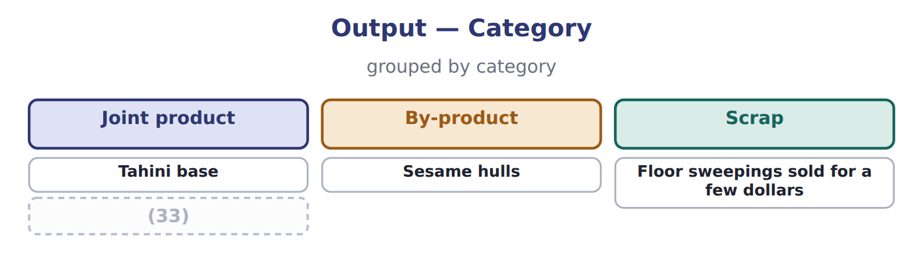
word list
Sesame oil · sell-or-process-further decision

The English this section uses, and its Arabic
Each term sits against what it means.
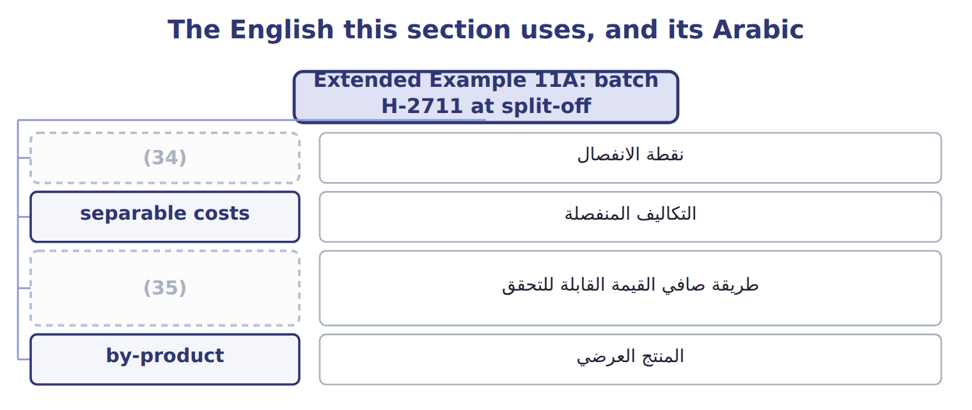
word list
sales method (by-products) · split-off point · net realizable value method

The English this sheet uses, and its Arabic
English (exam term) | Arabic
split-off point | نقطة الانفصال
separable costs | التكاليف المنفصلة
net realizable value method | طريقة صافي القيمة القابلة للتحقق
by-product | المنتج العرضي

Answer key · 11.7 Extended Example 11A: batch H-2711 at split-off

1 by-product | 19 WIP - Bottling
2 compares | 20 Cash
3 allocations | 21 Other Income - By-product
4 entries | 22 products
5 Outputs | 23 method
6 disposal | 24 Joint cost allocated to VOO
7 Policy | 25 Other income when pomace is sold
8 products | 26 Total effect on income over time
9 repeat | 27 products
10 transferred-in | 28 sometimes
11 Raw Materials Inventory | 29 Deduct
12 Wages Payable | 30 production
13 Pomace (By-product) Inventory | 31 $7.00/liter at split-off; sold at split-off
14 WIP - Crushing | 32 1,352,000 ÷ 1,625,000 × 1,300,000 = 1,081,600
15 Accounts Receivable | 33 Sesame oil
16 Totals | 34 split-off point
17 Raw Materials Inventory | 35 net realizable value method
18 Manufacturing Overhead Applied

the summaries in full
Summary 1 This example records the split-off of batch H-2711 twice, once for each by-product method, and compares the results. The allocations are exam-core; the entries are for depth. Outputs: EVOO 130,000 liters; VOO 70,000 liters; pomace 400,000 kg at $0.30, with $20,000 of disposal costs. Policy: NRV method for the joint products; production method for pomace. Record the joint cost, split it at split-off under the production method, record the pomace sale, then repeat with the sales method and compare. Production method: net joint cost $1,300,000; EVOO $1,047,800; VOO $252,200. EVOO per liter: $1,047,800 ÷ 130,000 = $8.06, the transferred-in cost used. Sales method: joint cost $1,400,000 on the same NRVs; EVOO $1,128,400; VOO $271,600.
Summary 2 The joint products carry $100,000 more cost under the sales method, and pomace adds the same $100,000 to other income. Total income over time is the same.
Summary 3 Expect a joint cost, two or three products with volumes and prices, and sometimes a by-product. Deduct the by-product NRV first if the production method is used. Then build the base for the method asked, and never include joint costs in a process-further decision.

