18.1 Cost standards in budgeting
Chapter 18 · section 18.1

Fill every gap. Each word list holds one word more than there are gaps.
Chapter 18, section by section
Each stage leads to the next.
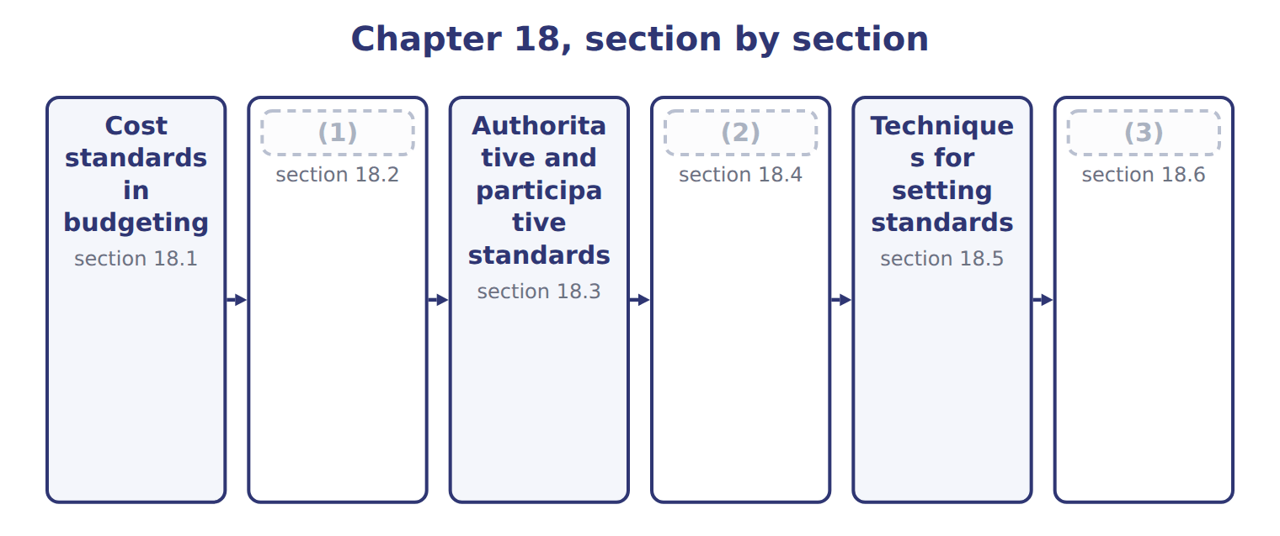
word list
Extended Example 18A: the juice standard cost · Techniques for setting standards · Steps in setting direct material and direct la · Ideal and currently attainable standards

Summary 1 gaps 4–7
A standard is the (4) cost of one unit of output under efficient (5) . The standard cost card lists, for one unit, the standard (6) and the standard price of every input. (7) are built from the card: standard cost per unit times planned units.
word list
quantity · efficient · Budgets · conditions · expected

Worked example: the June production budget

Each input's standard quantity and price are multiplied by the planned cases.

Worked example: the June 2028 production budget from standards
The bars are drawn to scale.
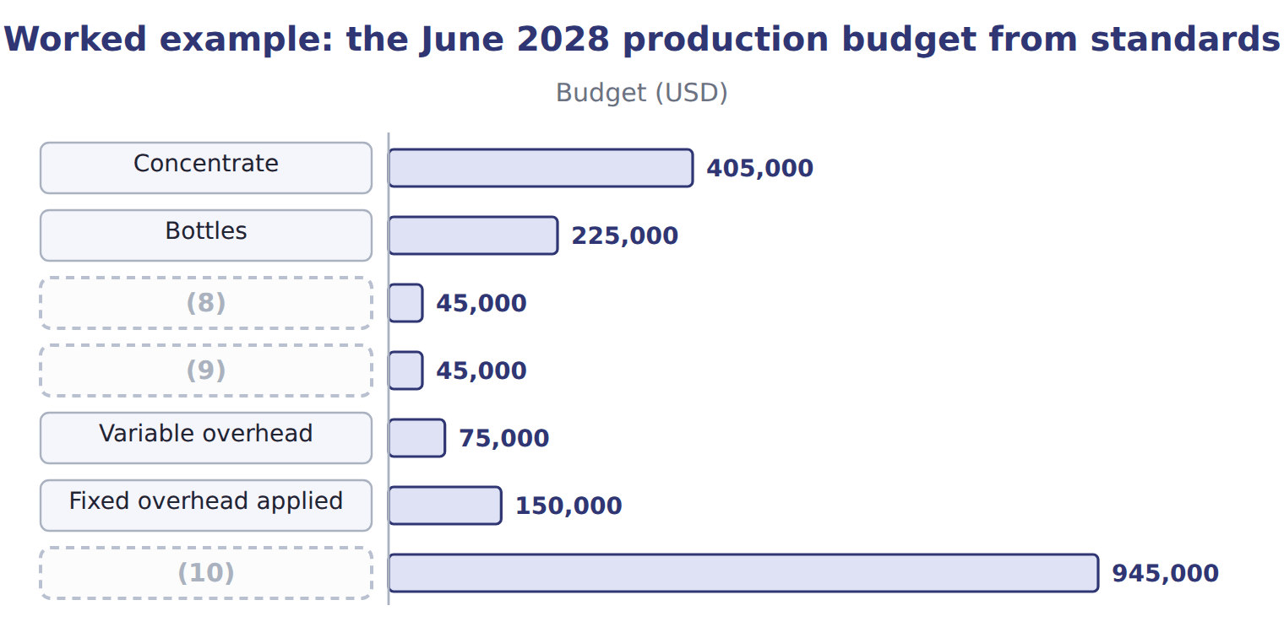
word list
normal loss · Caps and carton · Standard cost of June production · Direct labor

Summary 2 gaps 11–13
The same standards later measure (11) . When June ends, actual costs are compared with the standard cost of the actual output; the (12) are variances, the subject of Book 3. Standards must (13) be reviewed each year, as prices and methods change.
word list
therefore · performance · quantity · differences

The English this sheet uses, and its Arabic
English (exam term) | Arabic
standard cost card | بطاقة التكلفة المعيارية

Answer key · 18.1 Cost standards in budgeting

1 Ideal and currently attainable standards | 8 Caps and carton
2 Steps in setting direct material and direct la | 9 Direct labor
3 Extended Example 18A: the juice standard cost | 10 Standard cost of June production
4 expected | 11 performance
5 conditions | 12 differences
6 quantity | 13 therefore
7 Budgets

the summaries in full
Summary 1 A standard is the expected cost of one unit of output under efficient conditions. The standard cost card lists, for one unit, the standard quantity and the standard price of every input. Budgets are built from the card: standard cost per unit times planned units.
Summary 2 The same standards later measure performance. When June ends, actual costs are compared with the standard cost of the actual output; the differences are variances, the subject of Book 3. Standards must therefore be reviewed each year, as prices and methods change.

18.2 Ideal and currently attainable standards
Chapter 18 · section 18.2

Fill every gap. Each word list holds one word more than there are gaps.
Summary 1 gaps 1–6
An ideal standard assumes perfect (1) : no waste, no rest, no (2) . A (3) attainable standard allows for normal loss, rest, setups and normal (4) . It is hard but (5) for a trained team working (6) . For juice labor, the ideal is 0.040 hours a case; the standard set is 0.050 hours. Budgets and product costs use attainable standards; the ideal shows how much waste is still left to remove.
word list
downtime · conditions · breakdowns · possible · perfect · currently · efficiently

Ideal and currently attainable standards for juice labor
 | Ideal (theoretical) | Currently attainable (practical)
Allowances | None: perfect conditions | (7)
Juice labor per case | 0.040 hours | (8)
Labor cost per case | $0.48 | $0.60
Best use | (9) | Budgets, product costs and judging performance

word list
Shows the direction of improvement (Chapter 16) · 0.040 hours · 0.050 hours · Normal loss, rest, setups, normal downtime

The English this sheet uses, and its Arabic
English (exam term) | Arabic
currently attainable standard | المعيار الممكن التحقيق حاليًا

Answer key · 18.2 Ideal and currently attainable standards

1 conditions | 6 efficiently
2 breakdowns | 7 Normal loss, rest, setups, normal downtime
3 currently | 8 0.050 hours
4 downtime | 9 Shows the direction of improvement (Chapter 16)
5 possible

the summaries in full
Summary 1 An ideal standard assumes perfect conditions: no waste, no rest, no breakdowns. A currently attainable standard allows for normal loss, rest, setups and normal downtime. It is hard but possible for a trained team working efficiently. For juice labor, the ideal is 0.040 hours a case; the standard set is 0.050 hours. Budgets and product costs use attainable standards; the ideal shows how much waste is still left to remove.

18.3 Authoritative and participative standards
Chapter 18 · section 18.3

Fill every gap. Each word list holds one word more than there are gaps.
Summary 1 gaps 1–8
An (1) standard is set by management or engineers alone. A (2) standard is set with the people who must meet it. The juice labor standard (3) as an engineers' proposal of 0.045 hours a case. The line (4) pointed out that the proposal had no time for cleaning between runs. After the (5) , the division set 0.050 hours. (6) builds acceptance, because people help set the target. The risk is padding: people may ask for easy (7) . Management keeps the final (8) and checks the result against activity studies and history.
word list
Participation · supervisors · standards · authoritative · against · decision · participative · started · discussion

Authoritative and participative standards
 | Authoritative (imposed) | Participative
Who sets it | (9) | Managers with the people who must meet it
Juice labor example | (10) | Line supervisors added cleaning time: 0.050 hours
Strength | Fast; uses expert knowledge | (11)
Risk | (12) | Loose standards if people pad them; slower

word list
Management or engineers · Realistic; people accept and own the standard · Engineers proposed 0.045 hours · Loose standards if people pad them; slower · Resistance if people see it as unfair

The English this sheet uses, and its Arabic
English (exam term) | Arabic
authoritative standard | المعيار المفروض (السلطوي)
participative standard | المعيار التشاركي

Answer key · 18.3 Authoritative and participative standards

1 authoritative | 7 standards
2 participative | 8 decision
3 started | 9 Management or engineers
4 supervisors | 10 Engineers proposed 0.045 hours
5 discussion | 11 Realistic; people accept and own the standard
6 Participation | 12 Resistance if people see it as unfair

the summaries in full
Summary 1 An authoritative standard is set by management or engineers alone. A participative standard is set with the people who must meet it. The juice labor standard started as an engineers' proposal of 0.045 hours a case. The line supervisors pointed out that the proposal had no time for cleaning between runs. After the discussion, the division set 0.050 hours. Participation builds acceptance, because people help set the target. The risk is padding: people may ask for easy standards. Management keeps the final decision and checks the result against activity studies and history.

18.4 Steps in setting direct material and direct labor standards
Chapter 18 · section 18.4

Fill every gap. Each word list holds one word more than there are gaps.
Summary 1 gaps 1–2
Each input needs two (1) : a quantity standard and a price standard. For labor they are (2) the time standard and the rate standard.
word list
residue · standards · called

Worked example: the concentrate price standard

Summary 2 gaps 3–4
The (3) list price is $0.88 a liter. The division deducts the quantity discount and adds freight and the cost of (4) and testing.
word list
without · receiving · supplier's

Worked example: the concentrate price standard
Concentrate | Per liter
List price per liter | $0.88
(5) | $(0.04)
(6) | $0.05
Add: receiving and testing | $0.01
(7) | $0.90

word list
Add: freight to Amman · Add: receiving and testing · Price standard per liter · Less: quantity discount

Summary 3 gaps 8–10
The (8) standard starts from the net (9) in one case and allows for normal loss, such as tank residue and spillage on the line. (10) waste is not included; it will show as a variance.
word list
quantity · follows · Abnormal · concentrate

The concentrate quantity standard

Complete the two blank rows.

Your turn: the concentrate quantity standard (complete the blanks)
Every item belongs to exactly one group.
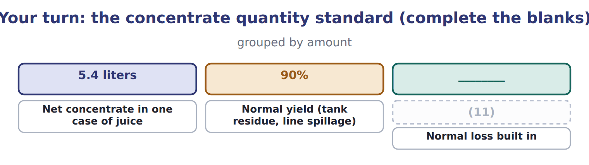
word list
Normal yield (tank residue, line spillage) · Quantity standard (net ÷ yield)

The labor standard follows the same logic. The result is $0.60 a case.
The direct labor standard for juice
Juice direct labor | Amount
Basic time per case (time study) | (12)
Rest and personal allowance | (13)
Setup and cleaning allowance | 0.004 h
Normal downtime allowance | (14)
Time standard per case | 0.050 h
Wage per hour | $10.00
Payroll taxes and benefits per hour | $2.00
Rate standard per hour | $12.00
Direct labor standard per case | $0.60

word list
0.040 h · 0.004 h · 0.002 h · activity analysis

Complete price and quantity standards

Summary 4 gaps 15–17
Exam options often use the list price, or the net (15) without normal loss, or the wage without (16) . The correct (17) includes all normal costs of getting the input ready for use.
word list
quantity · standard · supplier's · benefits

The English this section uses, and its Arabic
Each term sits against what it means.
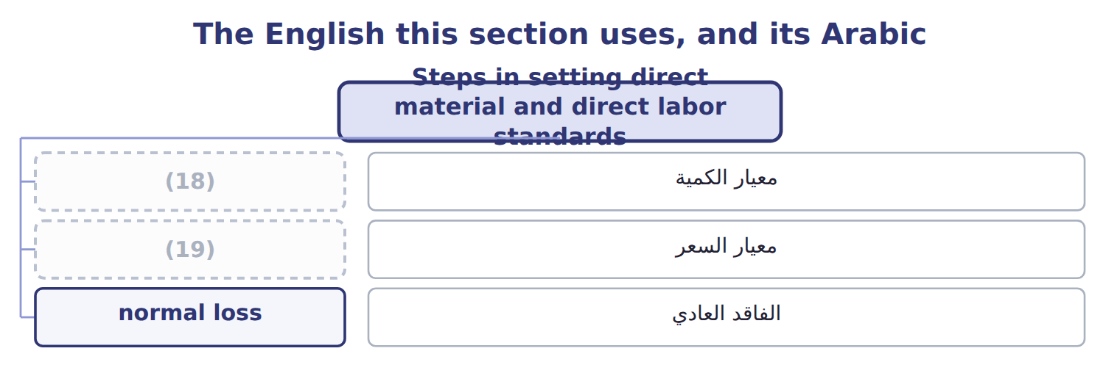
word list
activity analysis · price standard · quantity standard

The English this sheet uses, and its Arabic
English (exam term) | Arabic
quantity standard | معيار الكمية
price standard | معيار السعر
normal loss | الفاقد العادي

Answer key · 18.4 Steps in setting direct material and direct labor standards

1 standards | 11 Quantity standard (net ÷ yield)
2 called | 12 0.040 h
3 supplier's | 13 0.004 h
4 receiving | 14 0.002 h
5 Less: quantity discount | 15 quantity
6 Add: freight to Amman | 16 benefits
7 Price standard per liter | 17 standard
8 quantity | 18 quantity standard
9 concentrate | 19 price standard
10 Abnormal

the summaries in full
Summary 1 Each input needs two standards: a quantity standard and a price standard. For labor they are called the time standard and the rate standard.
Summary 2 The supplier's list price is $0.88 a liter. The division deducts the quantity discount and adds freight and the cost of receiving and testing.
Summary 3 The quantity standard starts from the net concentrate in one case and allows for normal loss, such as tank residue and spillage on the line. Abnormal waste is not included; it will show as a variance.
Summary 4 Exam options often use the list price, or the net quantity without normal loss, or the wage without benefits. The correct standard includes all normal costs of getting the input ready for use.

18.5 Techniques for setting standards
Chapter 18 · section 18.5

Fill every gap. Each word list holds one word more than there are gaps.
Summary 1 gaps 1–6
Activity (1) sets a standard by studying how the work should be done: time and motion studies, recipes and (2) tests. The juice time study found a basic time of 0.040 hours a case. (3) data uses past results. Over the last twelve months, labor (4) 0.056 hours a case, and the best month reached 0.052. (5) is quick and real, but it copies past waste. Good practice combines both (6) .
word list
Historical · techniques · engineering · practice · averaged · analysis · History

Activity analysis and historical data compared
 | Activity analysis | Historical data
How | (7) : time and motion studies, recipes, engineering tests | Average past results, adjusted for known changes
Strength | (8) | Quick and cheap; based on real results
Weakness | (9) | Copies past waste and inefficiency
Juice example | Time study: 0.040 h + allowances | (10)

word list
Takes time and expertise · Builds the standard from how the work should be done · Study each step · Average past results, adjusted for known changes · 12-month average 0.056 h; best month 0.052 h

The English this sheet uses, and its Arabic
English (exam term) | Arabic
activity analysis | تحليل الأنشطة

Answer key · 18.5 Techniques for setting standards

1 analysis | 6 techniques
2 engineering | 7 Study each step
3 Historical | 8 Builds the standard from how the work should be done
4 averaged | 9 Takes time and expertise
5 History | 10 12-month average 0.056 h; best month 0.052 h

the summaries in full
Summary 1 Activity analysis sets a standard by studying how the work should be done: time and motion studies, recipes and engineering tests. The juice time study found a basic time of 0.040 hours a case. Historical data uses past results. Over the last twelve months, labor averaged 0.056 hours a case, and the best month reached 0.052. History is quick and real, but it copies past waste. Good practice combines both techniques.

18.6 Extended Example 18A: the juice standard cost card
Chapter 18 · section 18.6

Fill every gap. Each word list holds one word more than there are gaps.
Summary 1 gaps 1–6
This example puts every standard on one card and shows where each (1) came. (2) : 5.4 liters net ÷ 90% yield = 6.0 liters, at $0.90 a liter. Bottles, caps and carton: from the Jordan Glass and supplier (3) . (4) labor: 0.050 hours at $12.00 an hour. (5) : 0.02 machine hours at the variable and fixed rates from the. The total is $12.60 a case, the standard used (6) Book 2.
word list
contracts · Direct · throughout · Concentrate · Bottles · Overhead · number

Extended Example: the juice standard cost card
Input | Quantity | Price | Cost | Source
Concentrate | 6.0 liters | $0.90 | $5.40 | (7)
Bottles | 12 | $0.25 | $3.00 | Jordan Glass contract
Caps and carton | 1 | $0.60 | $0.60 | (8)
Direct labor | 0.050 h | $12.00 | $0.60 | (9)
Variable overhead | (10) | $50.00 | $1.00 | (11)
Fixed overhead | 0.02 MH | $100.00 | $2.00 | Overhead budget (Chapter 8)
Standard cost per case |  |  | $12.60

word list
0.02 MH · Supplier quote + yield study · Supplier contract · Time study + payroll · Overhead budget (Chapter 8) · standard cost card

Everything ties

Exam view

Summary 2 gaps 12–14
Expect a list price, (12) , freight, a net quantity, a yield, a basic time with (13) and a wage with benefits. Build each price and quantity standard in full, (14) , and add the lines to get the standard cost per unit.
word list
discounts · allowances · supplier · multiply

Exam view
Tahini jar standard: data | Amount
Sesame paste list price per kg | $2.40
Quantity discount per kg | $(0.10)
Freight per kg | $0.15
Receiving and testing per kg | $0.05
Net sesame in one 500 g jar | (15)
Normal yield | 96%
Jar and lid | $0.35
Basic filling time per jar | (16)
Rest and personal allowance | 0.001 h
Cleaning allowance | 0.001 h
Wage per hour | $12.50
Payroll taxes and benefits per hour | $2.50

word list
0.48 kg · 0.010 h · 0.001 h

Item — Answer
Item | Answer
Quantity standard | (17)
Normal loss built in | 6.0 − 5.4 = 0.6 liters

word list
5.4 ÷ 90% = 6.0 liters · Assumes no waste, breaks or downtime

Statement — Category
Statement | Category
Assumes no waste, breaks or downtime | (18)
Allows for normal loss and rest breaks | (19)
Set by the engineers without asking the filling team | Authoritative
Set together with the filling team | (20)
Shows the direction for kaizen | Ideal

word list
Participative · Currently attainable · Ideal · Fixed overhead

The English this section uses, and its Arabic
Each term sits against what it means.
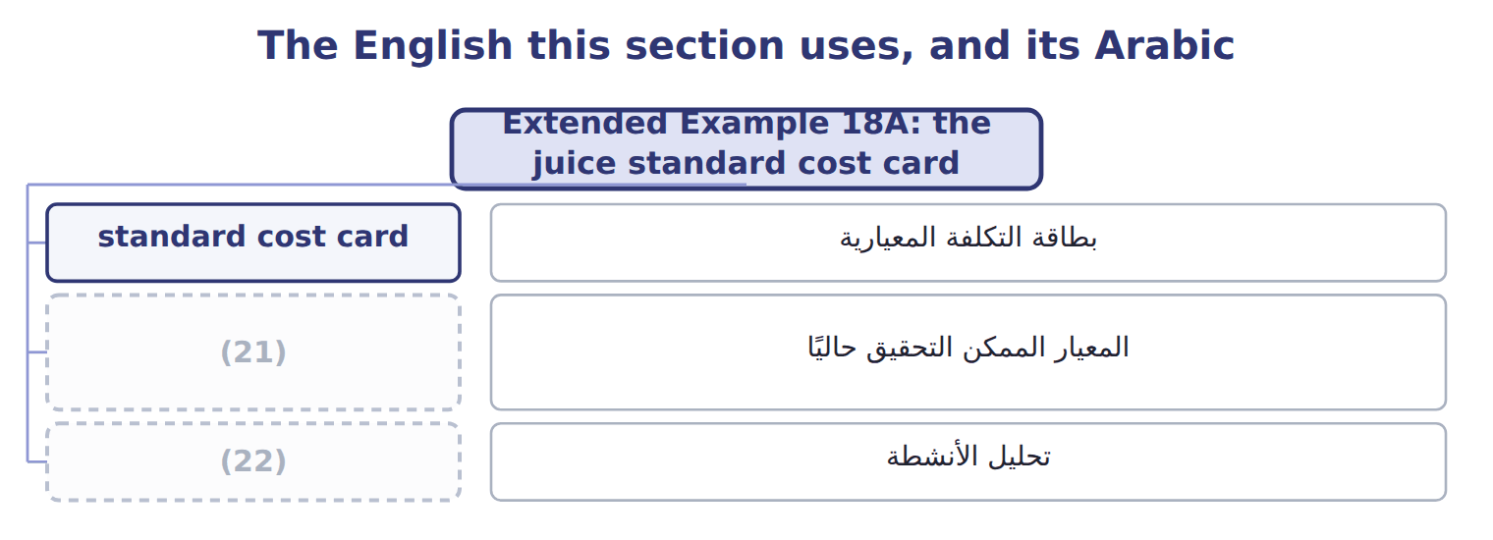
word list
activity analysis · standard cost card · currently attainable standard

The English this sheet uses, and its Arabic
English (exam term) | Arabic
standard cost card | بطاقة التكلفة المعيارية
currently attainable standard | المعيار الممكن التحقيق حاليًا
activity analysis | تحليل الأنشطة

Answer key · 18.6 Extended Example 18A: the juice standard cost card

1 number | 12 discounts
2 Concentrate | 13 allowances
3 contracts | 14 multiply
4 Direct | 15 0.48 kg
5 Overhead | 16 0.010 h
6 throughout | 17 5.4 ÷ 90% = 6.0 liters
7 Supplier quote + yield study | 18 Ideal
8 Supplier contract | 19 Currently attainable
9 Time study + payroll | 20 Participative
10 0.02 MH | 21 currently attainable standard
11 Overhead budget (Chapter 8) | 22 activity analysis

the summaries in full
Summary 1 This example puts every standard on one card and shows where each number came. Concentrate: 5.4 liters net ÷ 90% yield = 6.0 liters, at $0.90 a liter. Bottles, caps and carton: from the Jordan Glass and supplier contracts. Direct labor: 0.050 hours at $12.00 an hour. Overhead: 0.02 machine hours at the variable and fixed rates from the. The total is $12.60 a case, the standard used throughout Book 2.
Summary 2 Expect a list price, discounts, freight, a net quantity, a yield, a basic time with allowances and a wage with benefits. Build each price and quantity standard in full, multiply, and add the lines to get the standard cost per unit.

