14.1 Why overhead needs its own variances
Chapter 14 · section 14.1

Fill every gap. Each word list holds one word more than there are gaps.
Chapter 14, section by section
Each stage leads to the next.
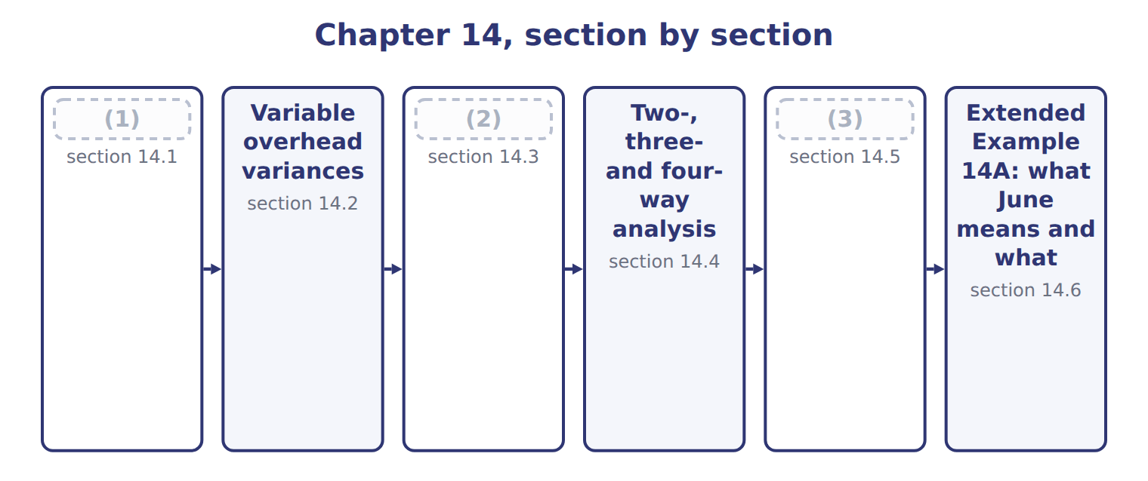
word list
Analysing variances and acting on them · Why overhead needs its own variances · Fixed overhead variances · Variable overhead variances

Summary 1 gaps 4–10
Variable overhead behaves like a (4) : it changes with a driver, here (5) hours, so it has both a (6) variance and an efficiency variance. Fixed overhead does not (7) with activity, so it (8) have an efficiency variance in the same sense. Fixed overhead still produces a second variance, but of a (9) kind: because the fixed rate assumes a (10) level of activity, producing more or less than that volume changes how much fixed overhead is absorbed.
word list
efficiency · spending · machine · material · change · cannot · different · denominator

How variable and fixed overhead differ
Overhead | Examples (Chapter 7) | Standard | Variances it can have
Variable overhead | Power, supplies, maintenance | (11) | Spending and efficiency
Fixed overhead | (12) | $150,000 a month | Spending, and a volume effect on absorption

word list
Power, supplies, maintenance · Supervision, depreciation, insurance · $50.00 a machine hour

Answer key · 14.1 Why overhead needs its own variances

1 Why overhead needs its own variances | 7 change
2 Fixed overhead variances | 8 cannot
3 Analysing variances and acting on them | 9 different
4 material | 10 denominator
5 machine | 11 $50.00 a machine hour
6 spending | 12 Supervision, depreciation, insurance

the summaries in full
Summary 1 Variable overhead behaves like a material: it changes with a driver, here machine hours, so it has both a spending variance and an efficiency variance. Fixed overhead does not change with activity, so it cannot have an efficiency variance in the same sense. Fixed overhead still produces a second variance, but of a different kind: because the fixed rate assumes a denominator level of activity, producing more or less than that volume changes how much fixed overhead is absorbed.

14.2 Variable overhead variances
Chapter 14 · section 14.2

Fill every gap. Each word list holds one word more than there are gaps.
The three-column frame of, with machine hours as the input.
Worked example: variable overhead in June

Summary 1 gaps 1–3
The variable overhead (1) variance compares actual overhead with the standard rate applied to the hours worked: $71,000 − 1,460 × $50.00 = $2,000 (2) . The variable overhead (3) variance values the extra hours at the standard rate: $1,000 unfavorable.
word list
spending · compares · favorable · efficiency

Worked example: the variable overhead variances for June
Variable overhead, June 2028 | Amount
Cases produced | 72,000
Standard machine hours allowed (0.02 a case) | 1,440
Actual machine hours | 1,460
Standard variable overhead rate | $50.00 an hour
Actual variable overhead | 71,000
Spending variance | (4)
Efficiency variance | (1,460 − 1,440) × 50.00 = 1,000 U
Total | (5)

word list
71,000 − 1,460 × 50.00 = 2,000 F · fixed overhead spending variance · 1,000 F

Summary 2 gaps 6–8
The two (6) make the $1,000 (7) . Note what each (8) : spending is about the rate paid for power and supplies; efficiency is about machine hours, so it follows the same cause as the labor efficiency variance.
word list
variance · measures · favorable · together

The English this sheet uses, and its Arabic
English (exam term) | Arabic
variable overhead spending variance | انحراف إنفاق التكاليف غير المباشرة المتغيرة
variable overhead efficiency variance | انحراف كفاءة التكاليف غير المباشرة المتغيرة

Answer key · 14.2 Variable overhead variances

1 spending | 5 1,000 F
2 favorable | 6 together
3 efficiency | 7 favorable
4 71,000 − 1,460 × 50.00 = 2,000 F | 8 measures

the summaries in full
Summary 1 The variable overhead spending variance compares actual overhead with the standard rate applied to the hours worked: $71,000 − 1,460 × $50.00 = $2,000 favorable. The variable overhead efficiency variance values the extra hours at the standard rate: $1,000 unfavorable.
Summary 2 The two together make the $1,000 favorable. Note what each measures: spending is about the rate paid for power and supplies; efficiency is about machine hours, so it follows the same cause as the labor efficiency variance.

14.3 Fixed overhead variances
Chapter 14 · section 14.3

Fill every gap. Each word list holds one word more than there are gaps.
Summary 1 gaps 1–2
Fixed overhead uses a (1) middle column: the budget, which is the same at any volume. The left gap is the fixed overhead spending variance; the right gap is the (2) variance.
word list
variance · different · production-volume

Worked example: fixed overhead in June

Summary 2 gaps 3–4
Spending: $152,000 − $150,000 = $2,000 unfavorable. (3) : $150,000 − 1,440 hours × $100.00 = $6,000 unfavorable, which is the 3,000 cases below the (4) volume × $2.00 a case.
word list
division · denominator · Production-volume

The fixed overhead variances

Complete the blank rows.
Your turn: the fixed overhead variances (complete the blanks)
Fixed overhead, June 2028 | Amount
(5) | 150,000
(6) | 1,500 machine hours
Fixed overhead rate | $100.00 an hour ($2.00 a case)
Actual fixed overhead | 152,000
(7) | 144,000
Spending variance | ________
(8) | ________

word list
Denominator volume (75,000 cases) · Applied: 1,440 hours × $100.00 · Production-volume variance · denominator level · Budgeted fixed overhead for the month

Summary 3 gaps 9–11
The (9) variance is not a (10) of cost control. Nobody spent $6,000 too much: the (11) simply produced fewer cases than the volume assumed when the rate was set, so less fixed overhead was absorbed into products.
word list
measure · overhead · division · production-volume

No fixed overhead efficiency variance

Summary 4 gaps 12–13
Fixed overhead has a spending variance and a (12) variance, and nothing else. An answer that reports a fixed overhead (13) variance has borrowed a variance that does not exist.
word list
efficiency · borrowed · production-volume

The English this section uses, and its Arabic
Each term sits against what it means.
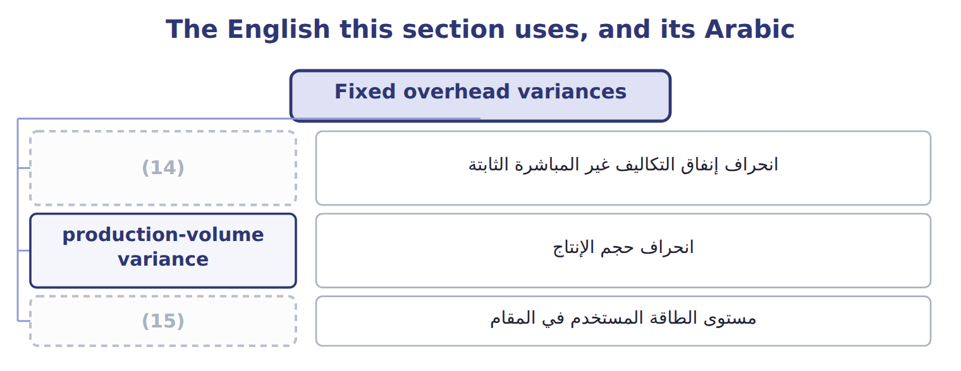
word list
corrective action · denominator level · fixed overhead spending variance

The English this sheet uses, and its Arabic
English (exam term) | Arabic
fixed overhead spending variance | انحراف إنفاق التكاليف غير المباشرة الثابتة
production-volume variance | انحراف حجم الإنتاج
denominator level | مستوى الطاقة المستخدم في المقام

Answer key · 14.3 Fixed overhead variances

1 different | 9 production-volume
2 production-volume | 10 measure
3 Production-volume | 11 division
4 denominator | 12 production-volume
5 Budgeted fixed overhead for the month | 13 efficiency
6 Denominator volume (75,000 cases) | 14 fixed overhead spending variance
7 Applied: 1,440 hours × $100.00 | 15 denominator level
8 Production-volume variance

the summaries in full
Summary 1 Fixed overhead uses a different middle column: the budget, which is the same at any volume. The left gap is the fixed overhead spending variance; the right gap is the production-volume variance.
Summary 2 Spending: $152,000 − $150,000 = $2,000 unfavorable. Production-volume: $150,000 − 1,440 hours × $100.00 = $6,000 unfavorable, which is the 3,000 cases below the denominator volume × $2.00 a case.
Summary 3 The production-volume variance is not a measure of cost control. Nobody spent $6,000 too much: the division simply produced fewer cases than the volume assumed when the rate was set, so less fixed overhead was absorbed into products.
Summary 4 Fixed overhead has a spending variance and a production-volume variance, and nothing else. An answer that reports a fixed overhead efficiency variance has borrowed a variance that does not exist.

14.4 Two-, three- and four-way analysis
Chapter 14 · section 14.4

Fill every gap. Each word list holds one word more than there are gaps.
The four variances can be reported in groups.
The same overhead variance in four, three and two parts
Every item belongs to exactly one group.
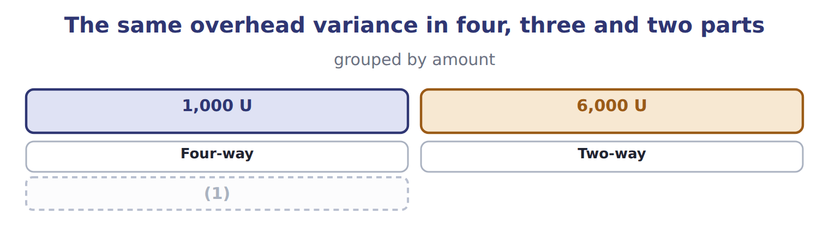
word list
Four-way · Three-way

Summary 1 gaps 2–5
In the (2) analysis the two spending (3) are combined; here they cancel, which shows why the four-way analysis is more useful. In the two-way analysis (4) except volume is called the budget or (5) variance. Whichever grouping is used, the total is the same.
word list
variances · everything · three-way · controllable · combined

Proof: actual overhead less applied overhead
Proof, June 2028 (USD) | Amount
Actual variable overhead | 71,000
(6) | 152,000
Total actual overhead | 223,000
(7) | 72,000
(8) | 144,000
(9) | 216,000
Total overhead variance (under-applied) | 7,000 U

word list
Applied fixed overhead (1,440 hours × $100.00) · Total applied overhead · Actual fixed overhead · Applied variable overhead (1,440 hours × $50.00) · Spending (variable + fixed)

Answer key · 14.4 Two-, three- and four-way analysis

1 Three-way | 6 Actual fixed overhead
2 three-way | 7 Applied variable overhead (1,440 hours × $50.00)
3 variances | 8 Applied fixed overhead (1,440 hours × $100.00)
4 everything | 9 Total applied overhead
5 controllable

the summaries in full
Summary 1 In the three-way analysis the two spending variances are combined; here they cancel, which shows why the four-way analysis is more useful. In the two-way analysis everything except volume is called the budget or controllable variance. Whichever grouping is used, the total is the same.

14.5 Analysing variances and acting on them
Chapter 14 · section 14.5

Fill every gap. Each word list holds one word more than there are gaps.
A variance report is the start of a conversation, not its conclusion.
Five questions before recommending an action
Step (C.1.s) | What to ask
1. Is it significant? | Compare with the rule of Chapter 11 (5% of the (1) figure)
2. What caused it? | Separate price from quantity, and the plan from the result
3. Who controls the cause? | A world price rise is not the plant's responsibility
4. Is it linked to another variance? | A favorable price beside an (2) usage usually has one cause
5. What action follows? | Remove the cause, change the (3) , or accept it and explain

word list
standard · Separate · budgeted · unfavorable

Summary 1 gaps 4–8
Deciding on an action before knowing the cause is the (4) fault in variance (5) , and so is acting on a variance whose cause nobody in the division controls. A favorable variance also (6) a question. A favorable (7) variance that came from skipping (8) is not good news; it has moved cost into a later month.
word list
commonest · spending · deserves · reporting · maintenance · controls

The English this sheet uses, and its Arabic
English (exam term) | Arabic
corrective action | الإجراء التصحيحي

Answer key · 14.5 Analysing variances and acting on them

1 budgeted | 5 reporting
2 unfavorable | 6 deserves
3 standard | 7 spending
4 commonest | 8 maintenance

the summaries in full
Summary 1 Deciding on an action before knowing the cause is the commonest fault in variance reporting, and so is acting on a variance whose cause nobody in the division controls. A favorable variance also deserves a question. A favorable spending variance that came from skipping maintenance is not good news; it has moved cost into a later month.

14.6 Extended Example 14A: what June means and what to do
Chapter 14 · section 14.6

Fill every gap. Each word list holds one word more than there are gaps.
Summary 1 gaps 1–2
This example takes the four overhead (1) to the review meeting and turns them into (2) .
word list
variances · Remember · decisions

Extended Example: causes and recommended actions for June
Variance | Amount | Likely cause | Recommended action
VOH spending | (3) | Cheaper power tariff agreed in May | Keep the tariff; check that quality has not suffered
VOH efficiency | 1,000 U | The long changeover ran the machines 20 hours longer than the standard | (4)
FOH spending | (5) | Unplanned repair to the filling line | Plan preventive maintenance in the quiet quarter
Production-volume | 6,000 U | 3,000 fewer cases than the normal volume, so less fixed overhead was absorbed | (6)

word list
2,000 F · 6,000 U · A sales matter, not a plant one: no plant action · Shorten changeovers (Book 2, Chapter 15) · 2,000 U

Summary 2 gaps 7–9
Only two of the four led to (7) inside the plant. The (8) spending variance is kept but watched; the volume variance is passed to the sales (9) of, because the plant cannot sell cases.
word list
favorable · action · discussion · spending

Everything ties

Summary 3 gaps 10–11
Variable overhead: $2,000 favorable + $1,000 (10) = $1,000 favorable, the figure. All four: $223,000 actual − $216,000 applied = $7,000 (11) .
word list
under-applied · unfavorable · decisions

Exam view

Summary 4 gaps 12–14
Expect actual overhead, actual hours, the standard rates, the output produced and the (12) volume. Work out the standard hours allowed first, then apply the four (13) . Remember that the (14) variance uses the standard hours allowed, never the hours worked.
word list
formulas · because · denominator · production-volume

Exam view
Tahini & Spreads overhead, one month | Data
(15) | 110,000
Standard machine hours a jar | 0.02
Standard variable overhead rate | $25.00 an hour
(16) | 80,000
Normal volume used for the fixed rate | 100,000 jars (2,000 machine hours)
(17) | 2,260
(18) | 55,000
Actual fixed overhead | 83,000

word list
Actual machine hours · Budgeted fixed overhead for the month · Jars produced · Actual variable overhead · Variable overhead efficiency variance

Item — Answer
Item | Answer
Fixed overhead spending variance | (19)
Production-volume variance | $150,000 − 1,440 × $100.00 = $6,000 unfavorable (3,000 cases × $2.00)

word list
$152,000 − $150,000 = $2,000 unfavorable · Unplanned repair to the filling line

Variance — Category
Every item belongs to exactly one group.
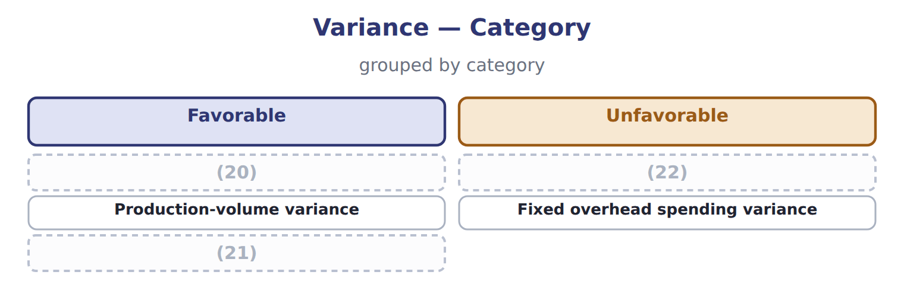
word list
fixed overhead spending variance · Variable overhead spending variance · Variable overhead efficiency variance · Total overhead variance

The English this section uses, and its Arabic
Each term sits against what it means.
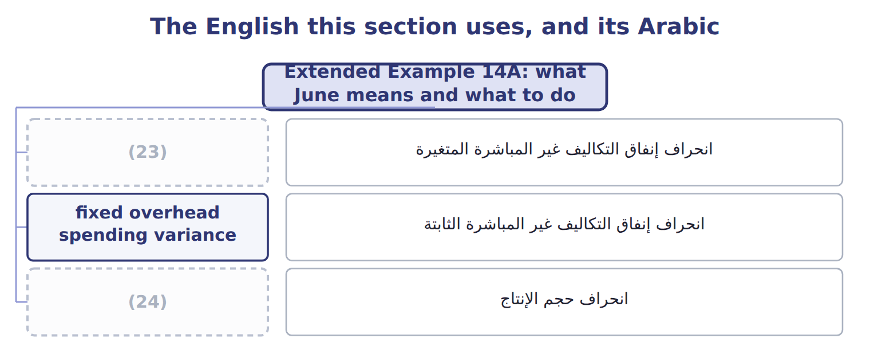
word list
fixed overhead spending variance · variable overhead spending variance · production-volume variance

The English this sheet uses, and its Arabic
English (exam term) | Arabic
variable overhead spending variance | انحراف إنفاق التكاليف غير المباشرة المتغيرة
fixed overhead spending variance | انحراف إنفاق التكاليف غير المباشرة الثابتة
production-volume variance | انحراف حجم الإنتاج

Answer key · 14.6 Extended Example 14A: what June means and what to do

1 variances | 13 formulas
2 decisions | 14 production-volume
3 2,000 F | 15 Jars produced
4 Shorten changeovers (Book 2, Chapter 15) | 16 Budgeted fixed overhead for the month
5 2,000 U | 17 Actual machine hours
6 A sales matter, not a plant one: no plant action | 18 Actual variable overhead
7 action | 19 $152,000 − $150,000 = $2,000 unfavorable
8 favorable | 20 Variable overhead spending variance
9 discussion | 21 Total overhead variance
10 unfavorable | 22 Variable overhead efficiency variance
11 under-applied | 23 variable overhead spending variance
12 denominator | 24 production-volume variance

the summaries in full
Summary 1 This example takes the four overhead variances to the review meeting and turns them into decisions.
Summary 2 Only two of the four led to action inside the plant. The favorable spending variance is kept but watched; the volume variance is passed to the sales discussion of, because the plant cannot sell cases.
Summary 3 Variable overhead: $2,000 favorable + $1,000 unfavorable = $1,000 favorable, the figure. All four: $223,000 actual − $216,000 applied = $7,000 under-applied.
Summary 4 Expect actual overhead, actual hours, the standard rates, the output produced and the denominator volume. Work out the standard hours allowed first, then apply the four formulas. Remember that the production-volume variance uses the standard hours allowed, never the hours worked.

