17.1 Measures, goals and feedback
Chapter 17 · section 17.1

Fill every gap. Each word list holds one word more than there are gaps.
Chapter 17, section by section
Each stage leads to the next.
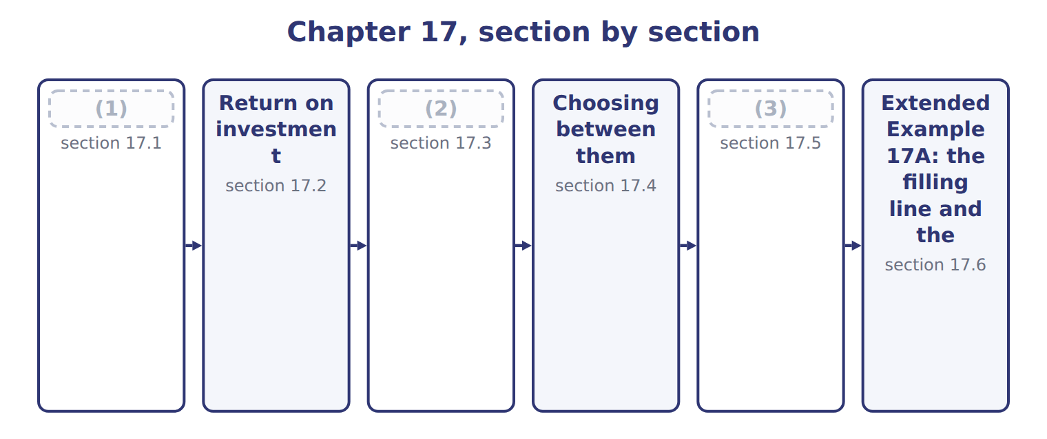
word list
Residual income · Measures, goals and feedback · required rate of return · What goes into the figures

Summary 1 gaps 4–8
A (4) measure changes (5) , so it must point at what the strategy asks for. A (6) told to grow in the Gulf and (7) only on cost will not grow in the Gulf. (8) must also arrive in time to act on. A variance report that reaches the plant six weeks after the month it describes cannot change the decision that caused it.
word list
behavior · performance · variance · Feedback · division · judged

What a good performance measure needs
What a good measure needs (C.3.a) | Why | At Orontes
Related to strategy | (9) | Chapter 1 set a return objective; ROI measures it
Timely feedback | (10) | Monthly variance reports (Chapter 11), quarterly ROI
Within the manager's control | Judge on what the manager decides | (11)
Few and clear | (12) | Chapter 18 builds a balanced set

word list
A result that arrives too late cannot change a decision · The measure should reward what the plan asks for · Too many measures divide attention · Controllable margin (Chapter 15), not allocated costs · return on sales (operating margin)

Answer key · 17.1 Measures, goals and feedback

1 Measures, goals and feedback | 7 judged
2 Residual income | 8 Feedback
3 What goes into the figures | 9 The measure should reward what the plan asks for
4 performance | 10 A result that arrives too late cannot change a decision
5 behavior | 11 Controllable margin (Chapter 15), not allocated costs
6 division | 12 Too many measures divide attention

the summaries in full
Summary 1 A performance measure changes behavior, so it must point at what the strategy asks for. A division told to grow in the Gulf and judged only on cost will not grow in the Gulf. Feedback must also arrive in time to act on. A variance report that reaches the plant six weeks after the month it describes cannot change the decision that caused it.

17.2 Return on investment
Chapter 17 · section 17.2

Fill every gap. Each word list holds one word more than there are gaps.
Summary 1 gaps 1–3
Return on (1) (ROI) is operating income divided by the operating assets used to earn it. For (2) : $3,180,000 ÷ $12,000,000 = 26.5%. ROI splits into two parts that managers can act on (3) .
word list
warehouse · separately · Beverages · investment

Worked example: the three divisions

Summary 2 gaps 4–5
Oils earns a (4) margin than Tahini & (5) but turns its assets over twice as fast, so its ROI is higher.
word list
Spreads · thinner · manager

Worked example: ROI for the three divisions
The bars are drawn to scale.
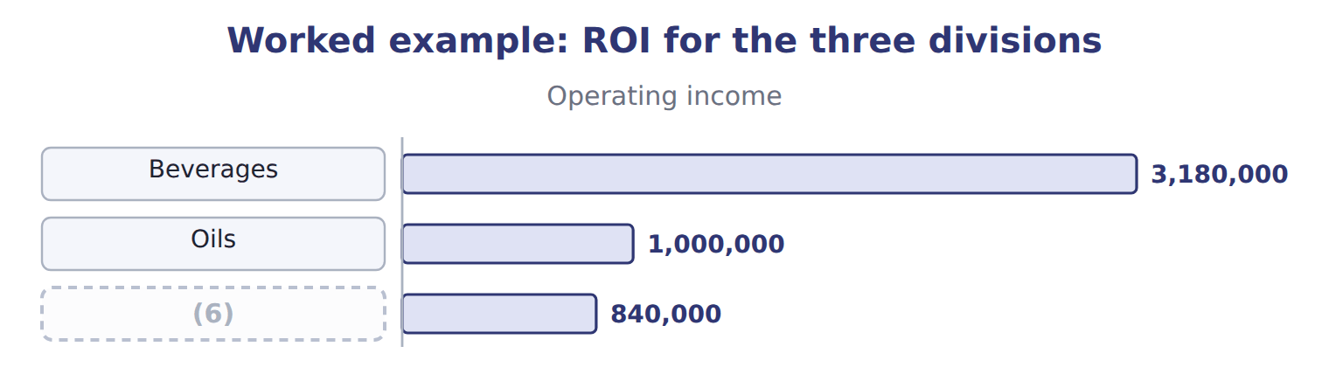
word list
residual income (RI) · Tahini & Spreads

The Tahini & Spreads ROI

Summary 3 gaps 7–10
Complete the blank cell. (7) ROI means asking which part moved. A (8) can raise ROI by earning more on each sale or by using fewer assets, and the second route is open to abuse: selling a (9) raises ROI (10) earning a cent more.
word list
selling · manager · Reading · without · warehouse

The English this section uses, and its Arabic
Each term sits against what it means.
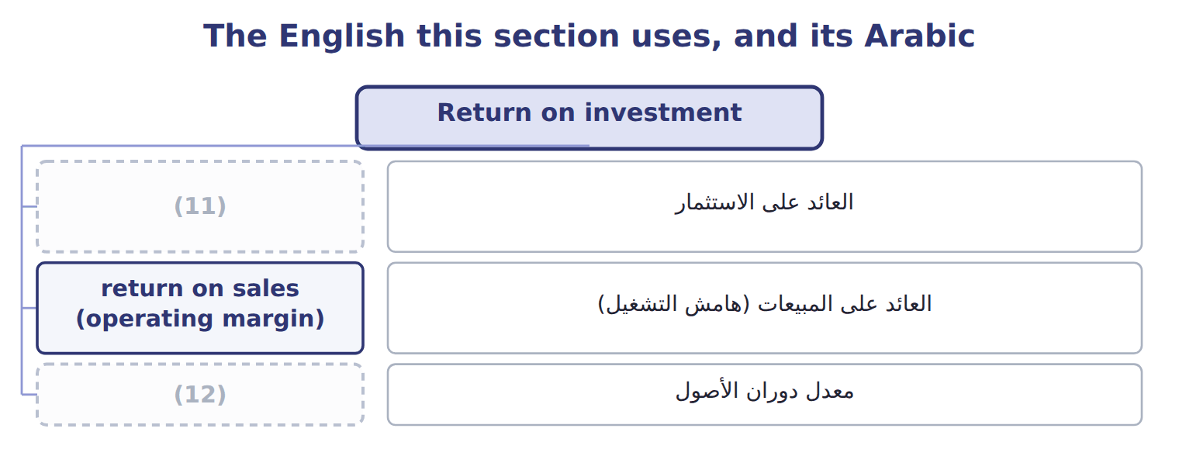
word list
required rate of return · return on investment (ROI) · asset turnover

The English this sheet uses, and its Arabic
English (exam term) | Arabic
return on investment (ROI) | العائد على الاستثمار
return on sales (operating margin) | العائد على المبيعات (هامش التشغيل)
asset turnover | معدل دوران الأصول

Answer key · 17.2 Return on investment

1 investment | 7 Reading
2 Beverages | 8 manager
3 separately | 9 warehouse
4 thinner | 10 without
5 Spreads | 11 return on investment (ROI)
6 Tahini & Spreads | 12 asset turnover

the summaries in full
Summary 1 Return on investment (ROI) is operating income divided by the operating assets used to earn it. For Beverages: $3,180,000 ÷ $12,000,000 = 26.5%. ROI splits into two parts that managers can act on separately.
Summary 2 Oils earns a thinner margin than Tahini & Spreads but turns its assets over twice as fast, so its ROI is higher.
Summary 3 Complete the blank cell. Reading ROI means asking which part moved. A manager can raise ROI by earning more on each sale or by using fewer assets, and the second route is open to abuse: selling a warehouse raises ROI without earning a cent more.

17.3 Residual income
Chapter 17 · section 17.3

Fill every gap. Each word list holds one word more than there are gaps.
Summary 1 gaps 1–2
Residual income (RI) is (1) income less a capital charge: the required rate of return (2) by the investment base.
word list
required · multiplied · operating

Worked example: residual income for the three divisions

Beverages: $3,180,000 − 12% × $12,000,000 = $1,740,000.
Worked example: residual income for the three divisions
The bars are drawn to scale.
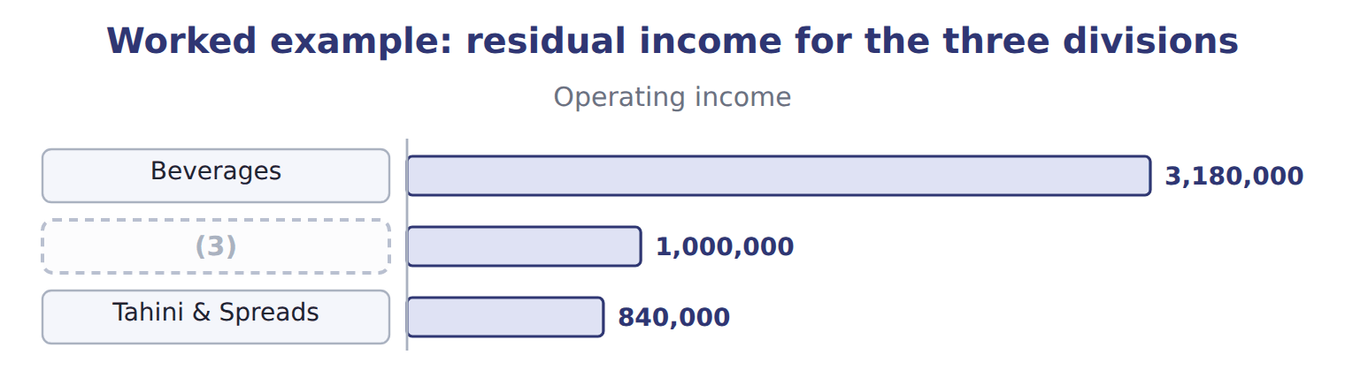
word list
Oils · suboptimization

The Tahini & Spreads residual income

Summary 2 gaps 4–7
Complete the blank cell. (4) income is an amount, not a (5) , so a large division will usually show more of it than a small one. Beverages earns $1,740,000 against $120,000 for Tahini & Spreads, but that (6) says more about size than about (7) .
word list
multiplied · Residual · performance · percentage · comparison

The English this section uses, and its Arabic
Each term sits against what it means.
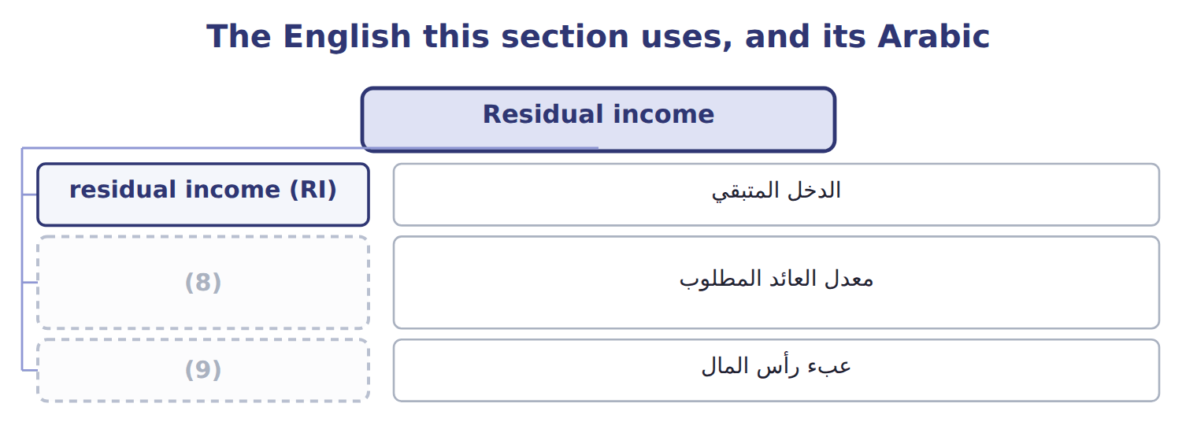
word list
capital charge · required rate of return · residual income (RI)

The English this sheet uses, and its Arabic
English (exam term) | Arabic
residual income (RI) | الدخل المتبقي
required rate of return | معدل العائد المطلوب
capital charge | عبء رأس المال

Answer key · 17.3 Residual income

1 operating | 6 comparison
2 multiplied | 7 performance
3 Oils | 8 required rate of return
4 Residual | 9 capital charge
5 percentage

the summaries in full
Summary 1 Residual income (RI) is operating income less a capital charge: the required rate of return multiplied by the investment base.
Summary 2 Complete the blank cell. Residual income is an amount, not a percentage, so a large division will usually show more of it than a small one. Beverages earns $1,740,000 against $120,000 for Tahini & Spreads, but that comparison says more about size than about performance.

17.4 Choosing between them
Chapter 17 · section 17.4

Fill every gap. Each word list holds one word more than there are gaps.
Summary 1 gaps 1–5
The two (1) can disagree, and the (2) is the reason both exist. (3) is offered the (4) project: $2,500,000 of assets earning $450,000 a year, a return of 18.0%. The project earns well above the 12% the company requires, but below the 26.5% the division already earns, so accepting it pulls the (5) ROI down to 25.0%.
word list
division's · disagreement · measures · filling-line · Beverages · against

Worked example: the project under both measures

Summary 2 gaps 6–7
Under ROI the manager (6) a project the company wants; under (7) income the manager accepts it, because $450,000 exceeds the $300,000 capital charge by $150,000.
word list
suboptimization · rejects · residual

Worked example: the filling line under ROI and residual income
Beverages and the filling line | Division now | The project | Division after
Operating income | 3,180,000 | 450,000 | 3,630,000
(8) | 12,000,000 | 2,500,000 | 14,500,000
ROI | 26.5% | 18.0% | 25.0%
(9) | 1,440,000 | 300,000 | 1,740,000
Residual income | 1,740,000 | 150,000 | 1,890,000

word list
Operating assets · Residual income · Capital charge at 12%

This is suboptimization: a decision that improves one measure while harming the company.
Benefits and limitations of ROI and residual income
Measure (C.3.i) | Benefits | Limitations
ROI | A (10) , so divisions of different size can be compared | Can lead a manager to reject a project that earns more than the required return
Residual income | Accepts every project above the required return, so no suboptimization | An amount, so a large (11) will always show more than a small one
Both | (12) | Both can be improved by cutting assets rather than by earning more

word list
residual income (RI) · Need an agreed investment base and income measure · percentage · division

Compare the project with the required return

Summary 3 gaps 13–14
A project should be judged against the required rate of return, not against the (13) current ROI. Any project above the required return raises (14) income and makes the company better off.
word list
division's · residual · project

The English this section uses, and its Arabic
Each term sits against what it means.
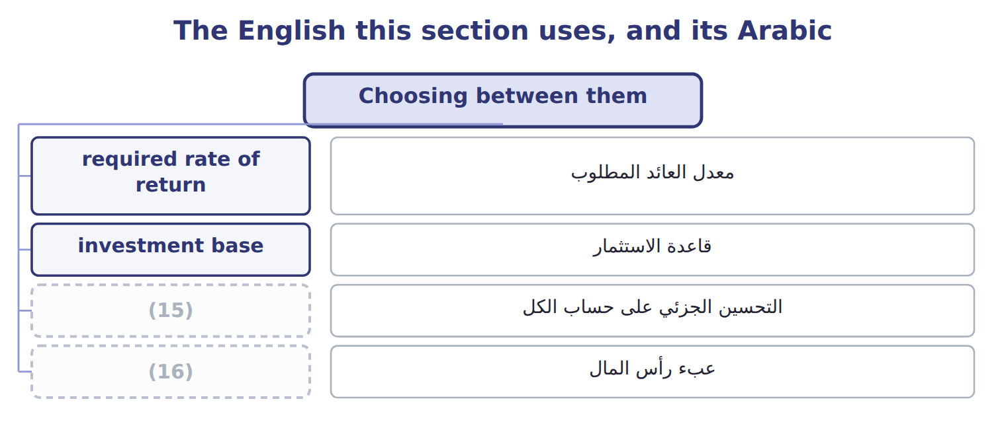
word list
capital charge · suboptimization · قاعدة الاستثمار

The English this sheet uses, and its Arabic
English (exam term) | Arabic
suboptimization | التحسين الجزئي على حساب الكل
investment base | قاعدة الاستثمار

Answer key · 17.4 Choosing between them

1 measures | 9 Capital charge at 12%
2 disagreement | 10 percentage
3 Beverages | 11 division
4 filling-line | 12 Need an agreed investment base and income measure
5 division's | 13 division's
6 rejects | 14 residual
7 residual | 15 suboptimization
8 Operating assets | 16 capital charge

the summaries in full
Summary 1 The two measures can disagree, and the disagreement is the reason both exist. Beverages is offered the filling-line project: $2,500,000 of assets earning $450,000 a year, a return of 18.0%. The project earns well above the 12% the company requires, but below the 26.5% the division already earns, so accepting it pulls the division's ROI down to 25.0%.
Summary 2 Under ROI the manager rejects a project the company wants; under residual income the manager accepts it, because $450,000 exceeds the $300,000 capital charge by $150,000.
Summary 3 A project should be judged against the required rate of return, not against the division's current ROI. Any project above the required return raises residual income and makes the company better off.

17.5 What goes into the figures
Chapter 17 · section 17.5

Fill every gap. Each word list holds one word more than there are gaps.
Both measures depend on two numbers that accounting policy can move.
Income policies that reduce comparability
Policy (C.3.j) | Effect on measured income | What to do
Revenue recognition | A division (1) revenue earlier reports more income now | Compare only divisions using the same policy
Development spending | One division capitalises it, another expenses it | (2)
Depreciation method | Straight line against an accelerated method changes income and assets | (3)
Allocated common costs | The allocation changes reported income but not performance | (4)

word list
Use one group policy for internal reporting · recognising · Adjust before comparing, or agree one policy · accelerated · Measure on the segment margin (Chapter 15)

Summary 1 gaps 5–10
A division that recognises revenue earlier, or expenses (5) that another (6) , will report different income for identical work. (7) then measures the policy, not the (8) . The group (9) fixes one set of policies for internal reporting, even where local (10) differ. Levant reports under IFRS in Jordan, but its figures are restated to group policy before any division is compared. The investment base is just as open to question.
word list
therefore · expenses · statements · capitalises · performance · Comparison · development

Policies that change the investment base
Policy (C.3.k) | Effect on the investment base | What to do
Inventory method | FIFO and weighted average give different inventory and cost of sales | (11)
Joint asset sharing | The shared cold store of Chapter 15 serves two divisions | (12) the asset on the same basis as its cost, or exclude it from both
Gross or net book value | (13) | Net book value flatters divisions with old assets
Leased assets | (14) | Follow one rule across all divisions
Idle or non-operating assets | (15) | Exclude it from the investment base

word list
A leased plant may or may not appear in the base · Land held for sale is not used to earn operating income · FIFO and weighted average give different inventory and cost of sales · Beverages: 26.5% on net book value, 15.9% on gross · Allocate · Agree one method for internal measurement

Summary 2 gaps 16–22
The last one matters most. (16) shows 26.5% on net book value but only 15.9% on the gross cost of $20,000,000, because its plant is partly (17) . A division with old assets looks better than one that has just invested, which (18) exactly the (19) the company wants. Each of these choices can be (20) , and none of them is about (21) . What matters is that every division uses the same one, and that the basis is stated with the (22) .
word list
discourages · inventory · investment · depreciated · figures · defended · Beverages · performance

Ask what the base contains

Summary 3 gaps 23–25
Before (23) two divisions, ask whether both use the same (24) method, the same treatment of shared assets, and the same basis for property. A difference in any of them makes the comparison (25) .
word list
investment · inventory · comparing · meaningless

Answer key · 17.5 What goes into the figures

1 recognising | 14 A leased plant may or may not appear in the base
2 Adjust before comparing, or agree one policy | 15 Land held for sale is not used to earn operating income
3 Use one group policy for internal reporting | 16 Beverages
4 Measure on the segment margin (Chapter 15) | 17 depreciated
5 development | 18 discourages
6 capitalises | 19 investment
7 Comparison | 20 defended
8 performance | 21 performance
9 therefore | 22 figures
10 statements | 23 comparing
11 Agree one method for internal measurement | 24 inventory
12 Allocate | 25 meaningless
13 Beverages: 26.5% on net book value, 15.9% on gross

the summaries in full
Summary 1 A division that recognises revenue earlier, or expenses development that another capitalises, will report different income for identical work. Comparison then measures the policy, not the performance. The group therefore fixes one set of policies for internal reporting, even where local statements differ. Levant reports under IFRS in Jordan, but its figures are restated to group policy before any division is compared. The investment base is just as open to question.
Summary 2 The last one matters most. Beverages shows 26.5% on net book value but only 15.9% on the gross cost of $20,000,000, because its plant is partly depreciated. A division with old assets looks better than one that has just invested, which discourages exactly the investment the company wants. Each of these choices can be defended, and none of them is about performance. What matters is that every division uses the same one, and that the basis is stated with the figures.
Summary 3 Before comparing two divisions, ask whether both use the same inventory method, the same treatment of shared assets, and the same basis for property. A difference in any of them makes the comparison meaningless.

17.6 Extended Example 17A: the filling line and the two measures
Chapter 17 · section 17.6

Fill every gap. Each word list holds one word more than there are gaps.
This example takes the project decision to the board.
Extended Example: what each measure tells the manager
Measure | Before | After | What the manager does
ROI | 26.5% | 25.0% | (1) : the manager rejects the project
Residual income | 1,740,000 | 1,890,000 | Rises by 150,000: the manager accepts the project
The company's view | (2) | 18.0% | The project earns more than the required return: it should go ahead

word list
Falls by 1.5 points · required return 12% · Tahini & Spreads ROI

Summary 1 gaps 3–6
ROI falls by 1.5 (3) , which the manager will resist; residual income rises by $150,000, which is the (4) gain. The board approved the line, and changed how the (5) manager is judged: residual income for (6) decisions, ROI for comparing divisions. Both are reported each quarter.
word list
reported · investment · company's · points · Beverages

Everything ties

Summary 2 gaps 7–8
Beverages ROI 17.7% × 1.50 = 26.5%; the (7) margin comes. Project: $450,000 − $300,000 = $150,000 added to (8) income.
word list
residual · suboptimization · segment

Exam view

Summary 3 gaps 9–11
Expect (9) income, an investment base and a (10) return, then a project with its own income and investment. (11) ROI and residual income before and after, and say which measure leads to the decision the company wants.
word list
required · Calculate · operating · segment

Exam view
Tahini & Spreads: a proposed investment | Amount
Division operating income for the year | 840,000
(12) | 6,000,000
Required rate of return | 12%
(13) | 1,000,000
(14) | 130,000

word list
Extra operating income it would earn each year · Division operating assets · $840,000 ÷ $6,000,000 = 14.0% · Investment in the new line

Item — Answer
Item | Answer
Tahini & Spreads ROI | $840,000 ÷ $6,000,000 = 14.0%
Tahini & Spreads residual income | (15)

word list
The project raises the division's residual income · $840,000 − 12% × $6,000,000 = $120,000

Statement — Category
Statement | Category
The project returns more than the required rate of return | Supports accepting
The project would lower the division's return on investment | Supports rejecting
The project raises the division's residual income | Supports accepting
The company earns more than its cost of capital on the new assets | (16)
The manager's bonus is based on return on investment | (17)

word list
Supports accepting · Residual income · Supports rejecting

The English this section uses, and its Arabic
Each term sits against what it means.
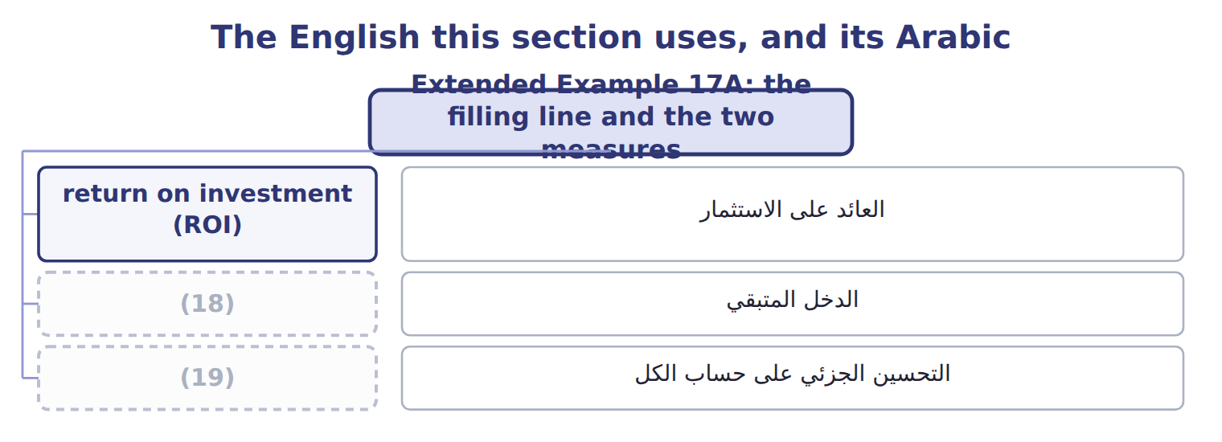
word list
suboptimization · investment base · residual income (RI)

The English this sheet uses, and its Arabic
English (exam term) | Arabic
return on investment (ROI) | العائد على الاستثمار
residual income (RI) | الدخل المتبقي
suboptimization | التحسين الجزئي على حساب الكل

Answer key · 17.6 Extended Example 17A: the filling line and the two measures

1 Falls by 1.5 points | 11 Calculate
2 required return 12% | 12 Division operating assets
3 points | 13 Investment in the new line
4 company's | 14 Extra operating income it would earn each year
5 Beverages | 15 $840,000 − 12% × $6,000,000 = $120,000
6 investment | 16 Supports accepting
7 segment | 17 Supports rejecting
8 residual | 18 residual income (RI)
9 operating | 19 suboptimization
10 required

the summaries in full
Summary 1 ROI falls by 1.5 points, which the manager will resist; residual income rises by $150,000, which is the company's gain. The board approved the line, and changed how the Beverages manager is judged: residual income for investment decisions, ROI for comparing divisions. Both are reported each quarter.
Summary 2 Beverages ROI 17.7% × 1.50 = 26.5%; the segment margin comes. Project: $450,000 − $300,000 = $150,000 added to residual income.
Summary 3 Expect operating income, an investment base and a required return, then a project with its own income and investment. Calculate ROI and residual income before and after, and say which measure leads to the decision the company wants.

