Table of Contents

B1.3 · Unit 3 · The Best Voice in the Room
English Animated · Making the Case · a university campus, Melbourne Student's Book pages 50–71 · 22 pp · ~11 hours

Part 0 · The Big Picture ◆ A · THE WORLD
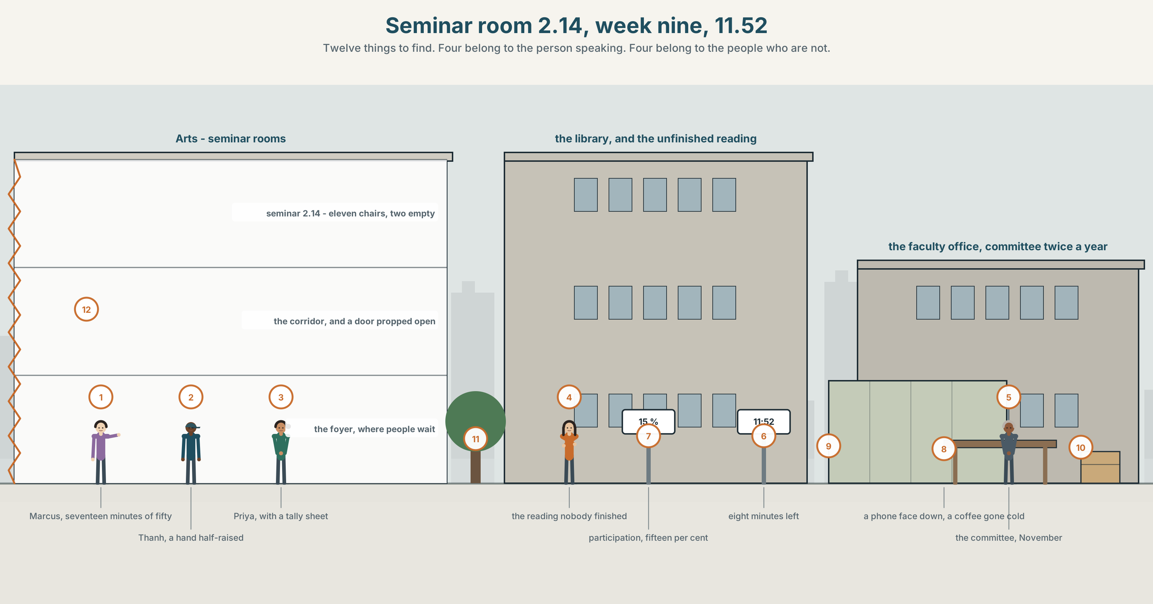{width=6.6in}
Seminar room 2.14, week nine, 11.52 — Twelve things to find. Four belong to the person speaking. Four belong to the people who are not.

Is disagreement useful?
By the end of this unit you can write and speak an argument that concedes properly before it disagrees.
◆ A · THE WORLD | A seminar room where one person is right more often than anybody else
◆ B · THE SYSTEM | contrast and concession: although · despite · however · whereas · 24 words for argument and dissent · 21 concession forms · the intonation of a concession
◆ C · THE PERFORMANCE | An argument that gives the other side its best version first

0A · Find it
Find twelve things in this picture. Four of them belong to the person speaking. Four belong to the people who are not.
a hand half-raised and lowered again · a clock at 11.52 · a laptop with nothing typed since 11.20 · a seminar table with two empty chairs on one side · a whiteboard with one word on it · a reading nobody finished · a phone face down · a tutor's tally sheet · a door propped open · a coffee gone cold · a person leaning back out of the circle · a notebook with a question written and crossed out

0B · Guess it
Two of the twelve are the same person's silence, shown twice. Which, and what is the difference between the two silences?

0C · Say it ⏺
Record forty-five seconds. Describe a conversation where somebody was right and you stopped arguing anyway. Say why you stopped. You will record it again at the end of this unit.

Part 1 · Vocabulary Lab 1 ◆ B · THE SYSTEM
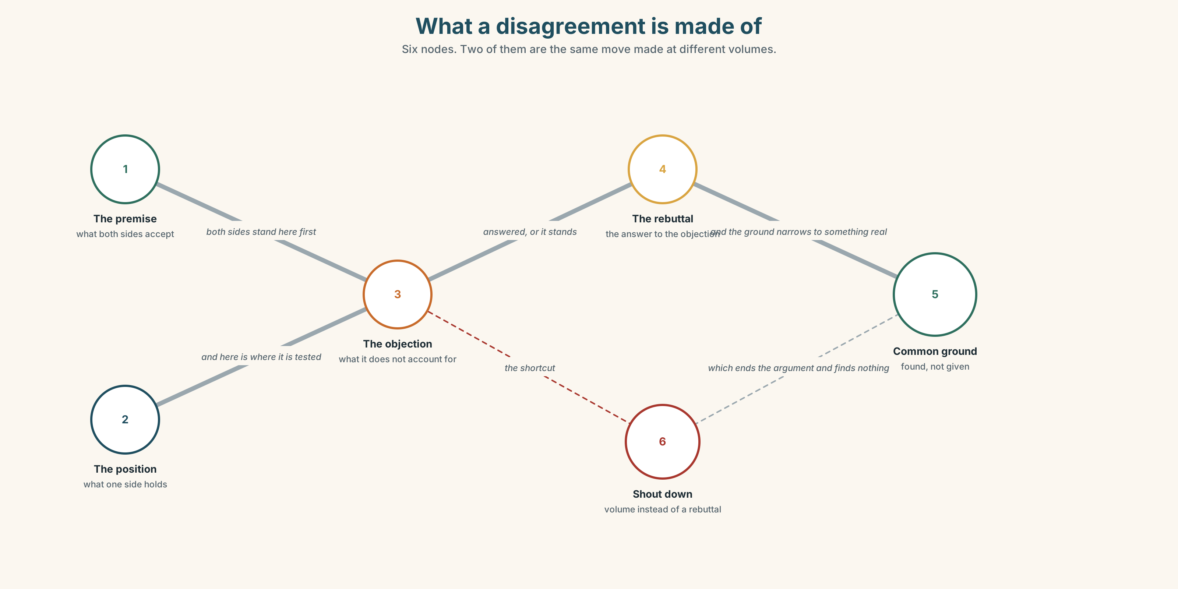{width=6.6in}
What a disagreement is made of — Six nodes. Two of them are the same move made at different volumes.

1A · Meet — the words of a disagreement
argument · debate · dissent · objection · position · premise · rebuttal · compromise · agreement
- Which two of these can be a thing you hold rather than a thing you make?
- A rebuttal answers something. What?
- Dissent and objection: which one is usually about a decision, and which about a direction?
- What is the difference between a premise and a position?
An argument in this unit is not a row. It is a set of reasons arranged so that somebody else can follow them, and the ordinary English word carries both meanings without warning you.

1B · Sort — the room, the argument, or the person?
dominate · defer · silence · take a position · the floor · common ground · talk over · concede the point · play devil's advocate
Three columns. Two of them belong in more than one. Say which and why.

1C · Meet — the phrase that does most of the work
c common ground
Not agreement. The part of the ground you are both standing on before the disagreement starts.
- Why is naming it first a stronger move than naming it last?
- Find the common ground between: we should ban cars from campus and we should build a second car park.

1D · Collocation Lab
take | a position · a view · the point
concede | the point · a round · ground
the floor | hold ~ · give up ~ · take ~
common ground | find ~ · establish ~ · lose ~
Which of these can you do to somebody, and which only with them?

1E · The fixed expressions
f I take your point. — I have understood it and I am about to disagree. f That is not what I said. — the sentence that stops a misquotation, and it has to be said calmly or it sounds like the thing it is denying.
Where would each one fall in a four-turn exchange?

1F · Own it
The four phrasal verbs of a disagreement.
back down · hold back · shout down · come round
- Which two are about volume, and which two about time?
- Who does shout down describe — the loud one, or the room?
- Hold back has two meanings here. Give both.
- Write one sentence in which somebody does come round without ever saying they were wrong.

Part 2 · Listening ◆ A · THE WORLD
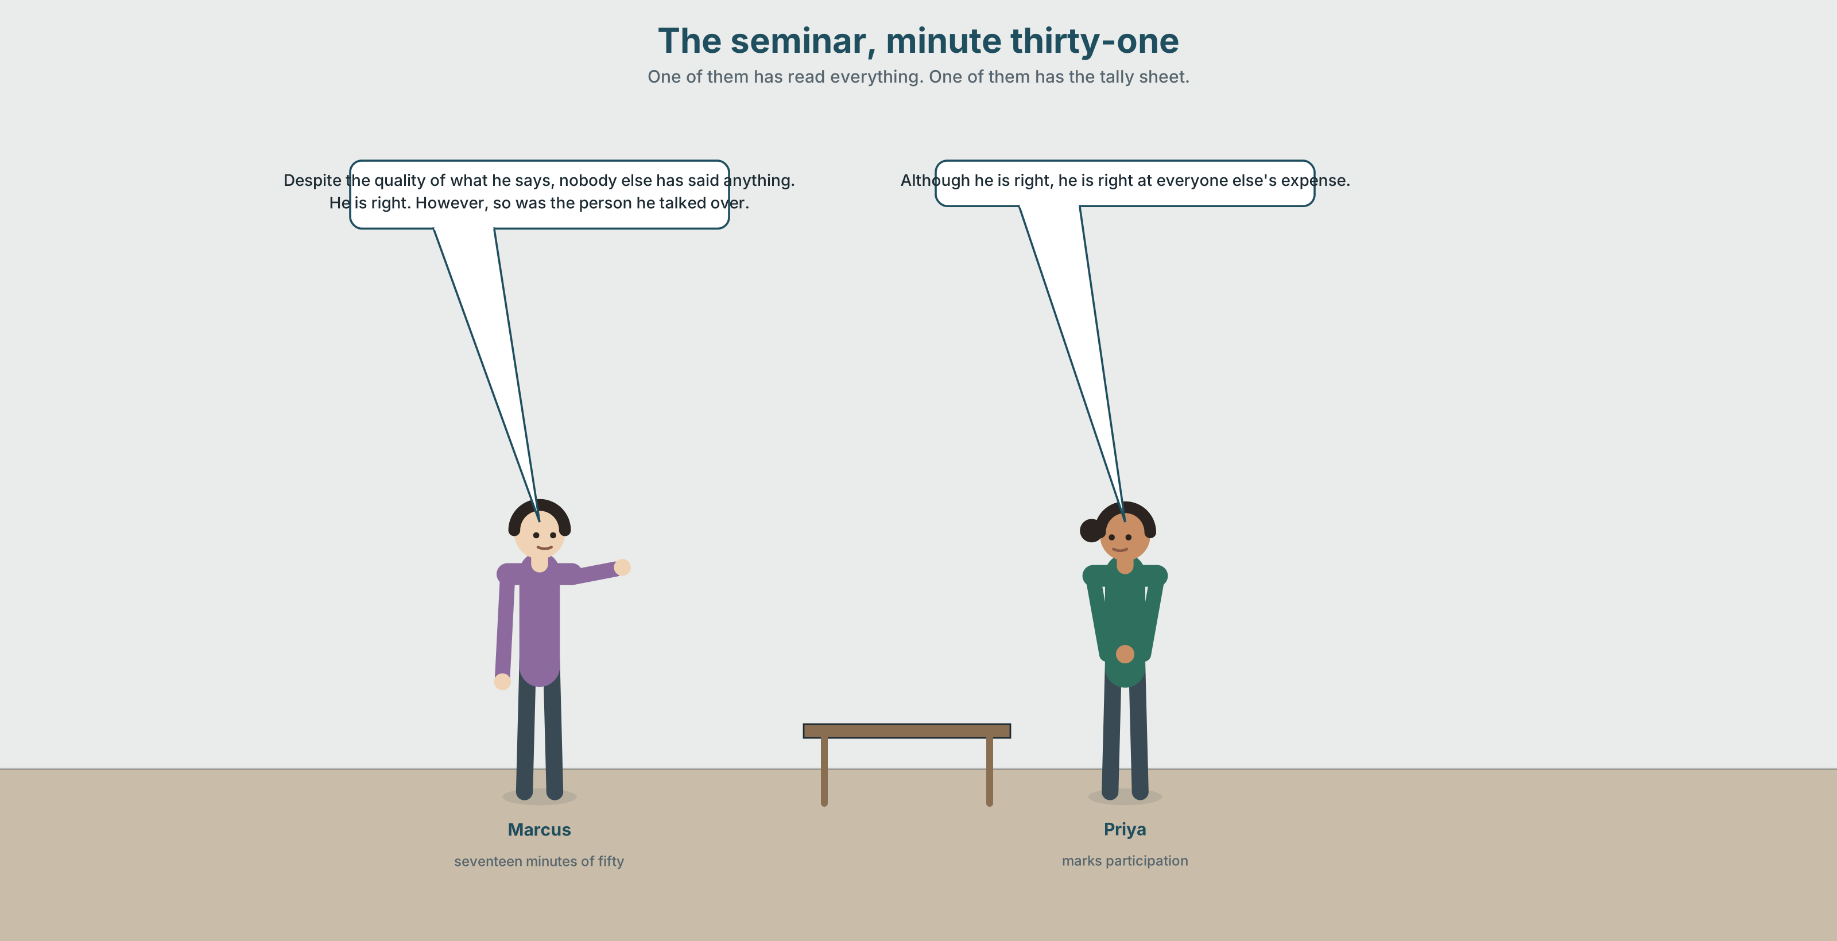{width=6.6in}
The seminar, minute thirty-one — One of them has read everything. One of them has the tally sheet.

2A · Fifty minutes, one voice 🔊 Track 3.1
Before you listen. Priya tutors a first-year seminar and marks participation. Guess: how many of the eleven students speak in a fifty-minute class?
Listen once. One question. What is the seminar about, and who decides?
Listen again. Complete the table.
 | Minutes spoken | Times interrupted | Times they interrupted
Marcus
Thanh
the rest
Listen again. Choose the best answer.
- Marcus is usually right / usually wrong / hard to say.
- Priya intervenes twice / once / not at all.
- Thanh does not speak / speaks once / speaks twice.
- The seminar reaches a conclusion / a compromise / neither.
Noticing. Four sentences from the recording.
- Although he is right, he is right at everyone else's expense.
- Despite the quality of what he says, nobody else has said anything.
- He is right. However, so was the person he talked over.
- Marcus argues; Thanh writes. Whereas one of those is graded, the other is not.
All four concede something before they disagree. Which of the four concedes the most?

2B · Decoding clinic 🔊 Track 3.2
Thirty seconds of Priya. Four jobs.
- How many concession words can you count?
- In although he is right, which word carries the stress?
- Catch the two numbers.
- She says one thing twice with different intonation. What changes?
Transcripts, page 152.

Part 3 · Grammar Lab 1 ◆ B · THE SYSTEM

Conceding before you disagree

3A · Notice
Look at the four sentences in Part 2.
- In sentence 1, which half is the concession and which is the point?
- In sentence 2, what follows despite — a clause or a noun phrase?
- Rewrite sentence 3 as one sentence using although. What punctuation changes?
- Sentence 4 uses whereas. Could you use although instead? What would be lost?
- Try "Although he is right, but he is loud." What is wrong with it?

3B · See
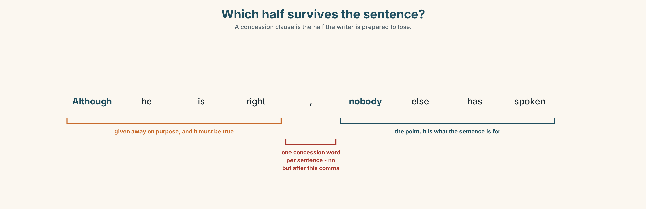{width=6.6in}
Which half survives the sentence? — A concession clause is the half the writer is prepared to lose.

3C · Know
 | Followed by | Example
although / though | a clause | Although he is right, nobody else spoke.
despite / in spite of | a noun or -ing | Despite being right, he lost the room.
however / nevertheless | a new sentence | He is right. However, so was Thanh.
whereas | a clause, for a parallel | Marcus argues, whereas Thanh writes.
yet / still | a clause, joined | He is right, yet nobody agrees.
One concession word per sentence. English does not allow although… but… or despite… however…. The second one is the one to delete. ✗ Although he is right, but he is loud. ✓ Although he is right, he is loud.
Though goes where although goes, and in one more place: the end. He is right. He is loud, though. — informal, and extremely common in speech.
Whereas is not a concession at all. It sets two things side by side without saying either is a problem. Although says the first one is in the way of the second.
Why it matters. An argument that concedes nothing reads as if it has not understood the other side. An argument that concedes in the wrong clause gives away the thing it meant to keep.

3D · Use — controlled
(1) __________ Marcus is right more often than anybody in the room, the room has stopped talking. (2) __________ his accuracy, the seminar has eleven people in it and two of them have spoken since week three. He prepares, he reads, and he is not rude. (3) __________ , an argument is not only a set of true statements. Priya marks participation, (4) __________ the department marks essays, and the two numbers have stopped agreeing. (5) __________ of the grade, Thanh has not spoken since week two. He is right too, on paper, (6) __________ nobody in the room has heard him be right. (7) __________ , somebody has to decide whether that is a problem with Marcus or with the format.

3E · Use — guided
Join each pair with the word in brackets. Two of them need a change of word class.
- He is right. Nobody else has spoken. (although)
- The quality of his argument. The room has gone quiet. (despite)
- Marcus speaks for nineteen minutes. Thanh speaks for forty seconds. (whereas)
- She knows it is a problem. She has not intervened. (yet)
- He prepares properly. He takes the whole hour. (in spite of)

3F · Use — open
In pairs. Defend a position you do not hold, in six sentences, three of which must concede something real before they disagree. Your partner's job is to catch any concession that is not a real one.

3G · Error autopsy
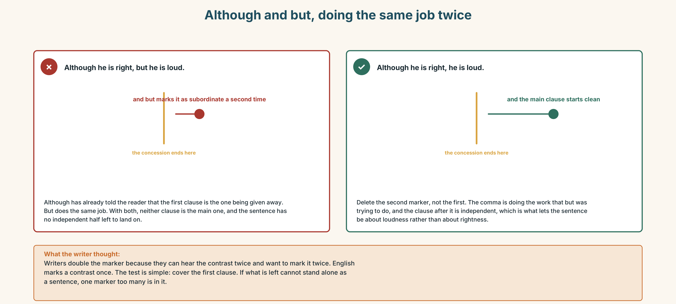{width=6.6in}
Although and but, doing the same job twice — Although and but, doing the same job twice
Read both versions. Then say which clause the writer actually meant to keep.

3H · Check — eight items
- ______ he is right, nobody else has spoken. (clause)
- ______ being right, he lost the room. (-ing)
- He is right. ______ , so was Thanh. (new sentence)
- Marcus argues, ______ Thanh writes. (parallel)
- ______ of the grade, Thanh has not spoken. (noun phrase)
- ✗ Although he is right, but he is loud. → correct it.
- He is right, ______ nobody agrees. (joined clause)
- He is loud, ______ . (end position, informal)
0–4 → Workbook pp. 14–17. 5–6 → Part 6. 7–8 → page 63.

Part 4 · Speaking ◆ C · THE PERFORMANCE

4A · Fluency starter — concede it
One learner states a position. The next must say the strongest thing they can for it, then disagree. The chain breaks on a concession that is not real.

4B · The functional core — disagreeing well
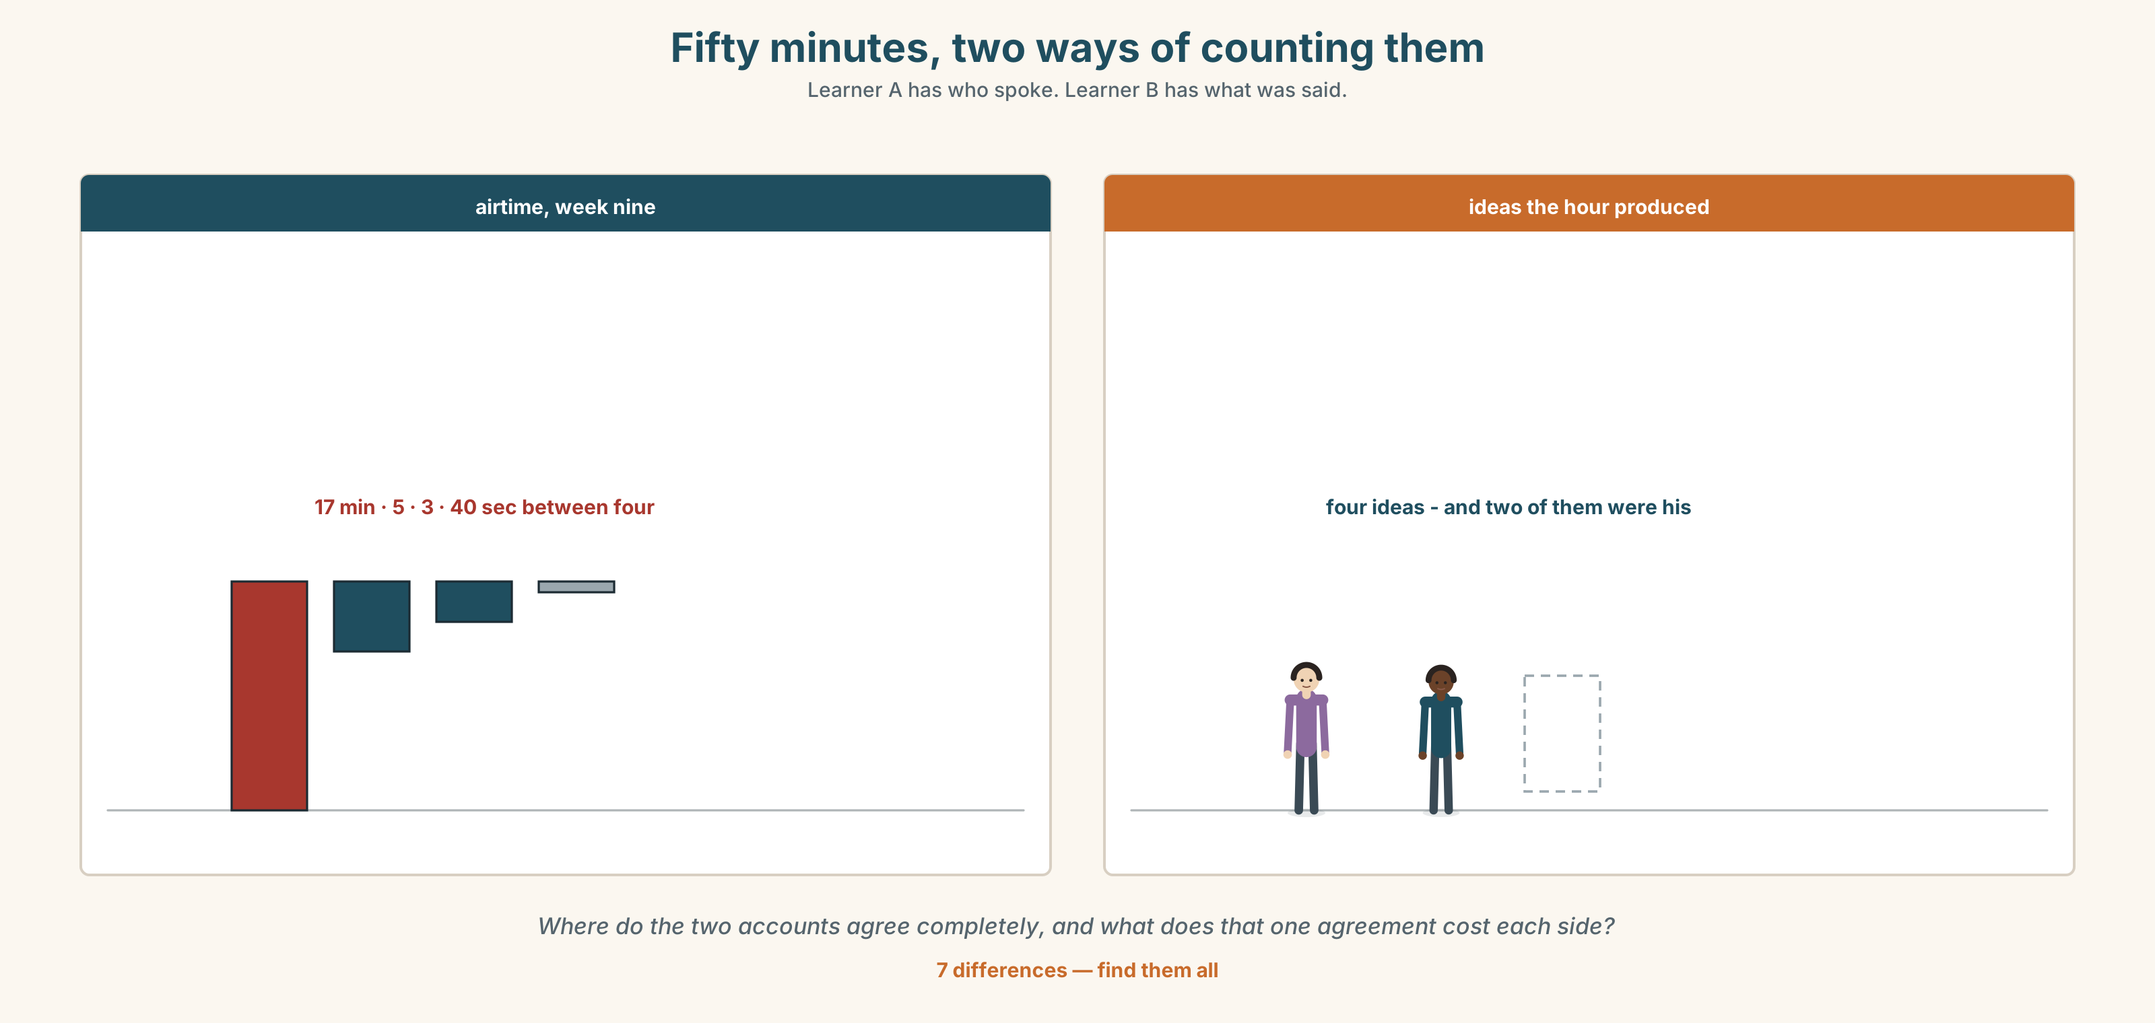{width=6.6in}
Fifty minutes, two ways of counting them — Learner A has who spoke. Learner B has what was said.
Language Bank
the real concession | To be fair, … · Admittedly, … · Granted, … · Up to a point, yes.
the limit of it | That said, … · Even so, … · All the same, … · And yet …
the point | The thing it does not account for is… · On the other hand, …
the repair | I take your point. · That is not what I said.
Information gap. Learner A has Marcus's three best arguments. Learner B has the three objections nobody got to make. Find the one place where they agree completely.

4C · The performance — three minutes ⏺
Argue a position you do not hold. Three minutes. You must include:
the strongest version of the other side, stated first · one real concession · the exact point where you stop agreeing · what would change your mind
Record it.

4D · Observer
One person listens for one thing: was the concession a real one, or a sentence shaped like one?

4E · Three criteria
☐ Did I state the other side at its strongest before I disagreed? ☐ Is there exactly one concession word per sentence? ☐ Did I name what would change my mind?

Part 5 · Reading ◆ A · THE WORLD

5A · Predict
A report extract, titled "Participation: a note on measurement." What do you expect it to recommend? Two sentences.

5B · Read — two minutes and a quarter

FACULTY OF ARTS · TEACHING QUALITY REVIEW · EXTRACT 4 OF 11 Participation: a note on measurement
Participation is worth fifteen per cent of the mark in sixty-one of our units. In fifty-eight of those, the published criterion is some version of contributes regularly to seminar discussion. We asked eleven tutors what they record. Nine record nothing during the class and reconstruct a figure in week twelve.
We then recorded airtime in nine seminars. The distribution is not unusual and it is not defensible. In a seminar of eleven students over fifty minutes, the top speaker took a median of 17 minutes and the bottom four took a median of 40 seconds between them. The top speaker was the same person in all nine weeks in seven of the nine groups.
Admittedly, airtime is a crude measure and nobody has proposed grading it directly. Still, it is the only measure we have of a thing that carries fifteen per cent of a mark, and it says that in most of our seminars the grade is being distributed on a quantity that four students in eleven have almost no access to.
The obvious objection is that the quiet students could speak and choose not to. That is true up to a point. It is also true that in every group we observed, the gap between the top speaker and the rest widened between week three and week nine, which is not what a free choice usually does.
We are not recommending that tutors intervene. Intervention in a seminar is a blunt instrument and the tutors who do it most are not the ones with the best participation spread. We are recommending that the criterion be rewritten, because contributes regularly to seminar discussion is a description of a behaviour and what we say we are assessing is a capacity.
One tutor, asked what she would do, said: "I would mark the question they ask, not the number of times they open their mouth. And yet I know exactly who would lose by that too."

5C · Comprehension — eight questions
- How many units carry a participation mark, and what is it worth?
- What do nine of the eleven tutors actually record, and when?
- Give the two airtime medians.
- What does the report concede about airtime as a measure, and what does it say anyway?
- What is "the obvious objection", and how is it answered?
- What happens between week three and week nine, and why is that significant?
- Why does the report not recommend intervention?
- What does the last tutor say she would do, and what does she immediately admit?

5D · Vocabulary in context
Guess from the text. Then check.
not defensible · a crude measure · a blunt instrument · the participation spread · a capacity rather than a behaviour

5E · The counter-text
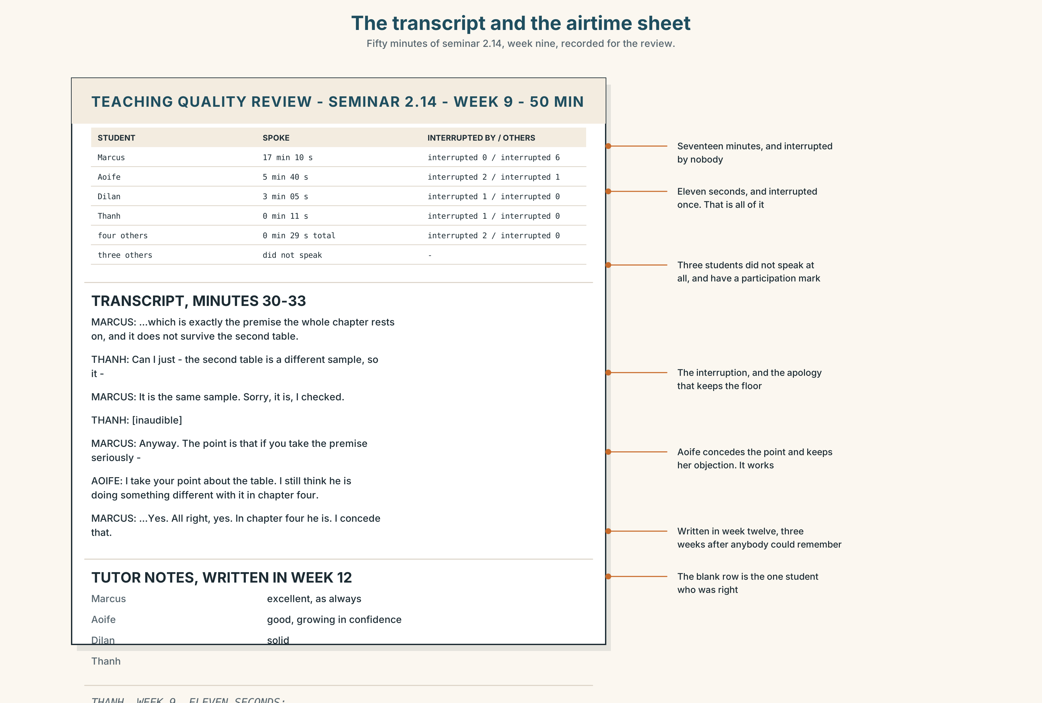{width=6.6in}
The transcript and the airtime sheet — Fifty minutes of seminar 2.14, week nine, recorded for the review.
Read the seminar transcript extract and the airtime sheet, and answer.
- How long does each of the four named students speak?
- Where does Marcus interrupt, and where is he interrupted?
- One student speaks once, for eleven seconds. What does she say, and what happens next?
- Find the one moment where somebody concedes the point properly.
- The sheet has a row the tutor left blank. Which, and why might she have?

5F · Two texts
The report says the gap widens between week three and week nine. The transcript shows one student being talked over twice in week nine.
Do the two facts explain each other? Three sentences.

Part 6 · Vocabulary Lab 2 ◆ B · THE SYSTEM

The words that buy you the right to disagree

6A · Sort — how much does each one concede?
Three columns: a lot · a little · none at all.
admittedly · granted · to be fair · up to a point · that said · even so · all the same · nevertheless · nonetheless · on the other hand · and yet · still

6B · Chunk completion
- ______ be fair , he had read the whole thing and nobody else had.
- Up to a ______ , yes — and then it stops being true.
- That ______ , the room has eleven people in it.
- Even ______ , somebody has to go first.
- All the ______ , I would rather be right than quiet.
- On the ______ hand , the quiet students are not being stopped.

6C · Two that are almost the same
nevertheless · nonetheless
Interchangeable in almost every context. Nonetheless is very slightly more formal and slightly more common in writing. If you can only learn one, learn nevertheless.
Use each one once, in a sentence about the report in Part 5.

6D · Two verbs that concede
p allow that · p grant that
I allow that he prepares properly. · I grant that the measure is crude.
Both are formal, both take a clause, and both are the written equivalent of fair enough.
Rewrite three sentences from Part 5B using one of them.

6E · The fixed expression
f And yet.
It can be a whole sentence. Say the strongest case for something, stop, and write it.
Write the sentence before it and the sentence after it.

6F · Contrast Clinic
Eight items. Four are wrong. Correct them and say what the rule is.
- Although he is right, but nobody agrees.
- Despite he is right, nobody agrees.
- In spite of being right, he lost the room.
- Marcus speaks a lot, whereas Thanh is quiet.
- He is right, however nobody agrees.
- Though, he is right.
- He is loud. He is right, though.
- Nevertheless of the evidence, she did nothing.

Part 7 · Pronunciation & Fluency Lab ◆ B · THE SYSTEM

The intonation of a concession
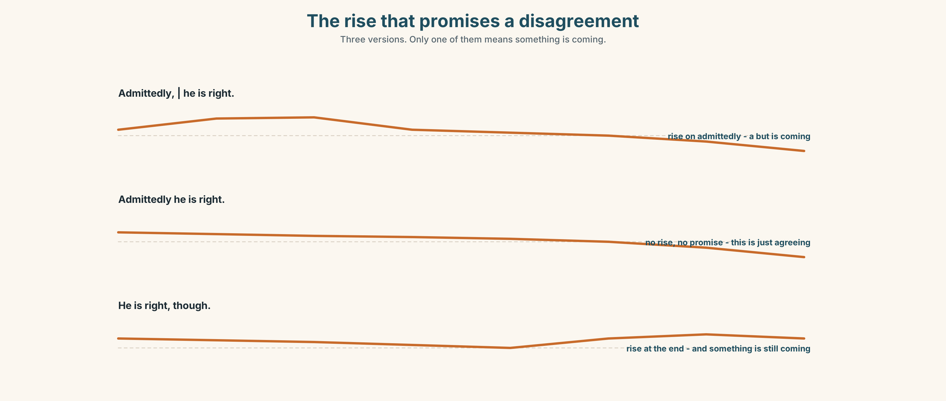{width=6.6in}
The rise that promises a disagreement — Three versions. Only one of them means something is coming.

7A · Hear 🔊 Track 3.3
Admittedly, ↗ | he is right. ↘ The rise on admittedly is a promise. Something is coming.
Now the same words with no rise:
Admittedly he is right. ↘ Nothing is coming. It is just an agreement, and it sounds like giving up.

7B · Say
Say both. Then say this one three times, faster:
Granted, up to a point, and even so — no.

7C · Make it mean something
Say these two:
He is right, though. (and that is the end of it) He is right, though… (and something is coming)
One word, two jobs. Which is which?

7D · Fluency 30 ⏺
Thirty seconds: four concessions, each with the rise, each followed by a disagreement. Three times, faster, keeping the rise.

Part 8 · Writing ◆ C · THE PERFORMANCE

An argument that concedes · 180 words
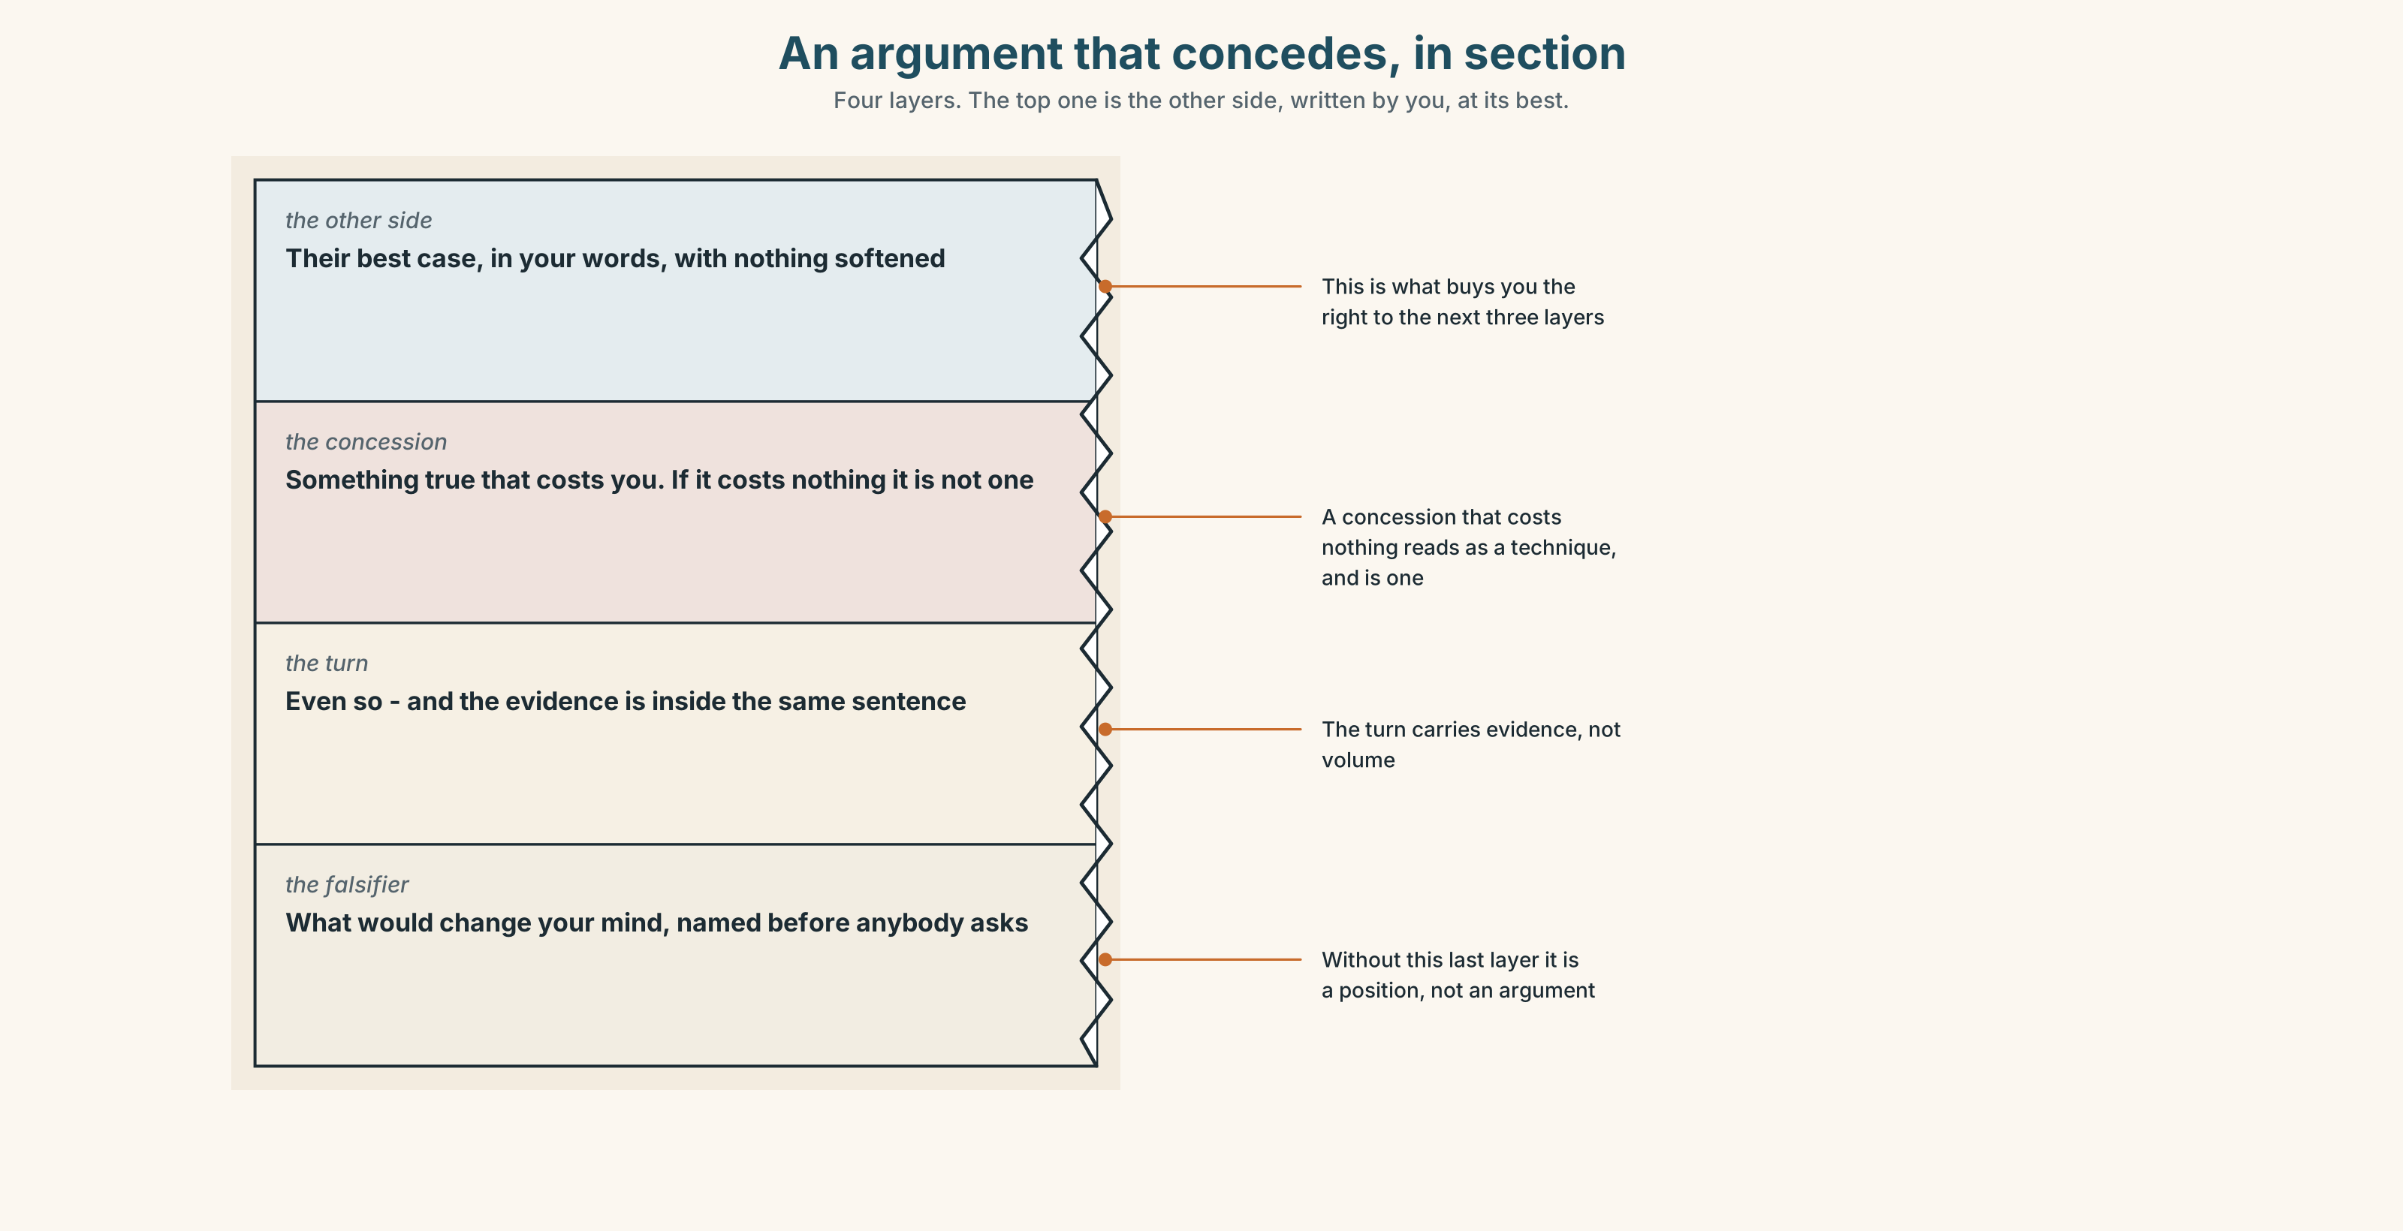{width=6.6in}
An argument that concedes, in section — Four layers. The top one is the other side, written by you, at its best.

8A · Read the model
Marcus has read every text and he is right more often than I am. That is not in dispute and I am not going to pretend it is. [the other side at its strongest, in the writer's own voice]
Admittedly, nobody is stopping the rest of us. The door is not locked and there is no rule about who speaks. [the concession, and it is a real one — it costs the writer something]
Even so, the gap between him and the rest widened every week from week three, and a gap that widens is not a gap people are choosing. [the turn, with the evidence inside the sentence]
What would change my mind is a group where the gap stayed flat. I have not seen one, and I have been in four. [the falsifier — what evidence would move the writer]
Questions about the writer's choices:
- The first paragraph gives Marcus his best case. What does the writer buy with it?
- The concession in paragraph two is true. Why is it not enough on its own?
- The last paragraph names what would change the writer's mind. What would an argument without that line be?

8B · The anti-model
While it is of course true that all students should feel able to contribute, it is also the case that some students are naturally more vocal than others. There are arguments on both sides and the issue is a complex one that deserves further consideration by all stakeholders.
Correct English, and it concedes nothing because it claims nothing. Name the three moves it is using to avoid taking a position.

8C · Plan
the other side at its strongest → a real concession → the turn, with evidence → what would change your mind

8D · Write — 180 words

8E · Peer review — three criteria
☐ Is the other side stated at its strongest, before any disagreement? ☐ Does the concession cost the writer something? ☐ Is there a falsifier — something that would change the writer's mind?

8F · Write it again · 8G · Publish
On the wall, beside the one it is arguing with.

Part 9 · The File ◆ A · THE WORLD + C · THE PERFORMANCE

CULTURE FILE · Time, Lateness and Waiting
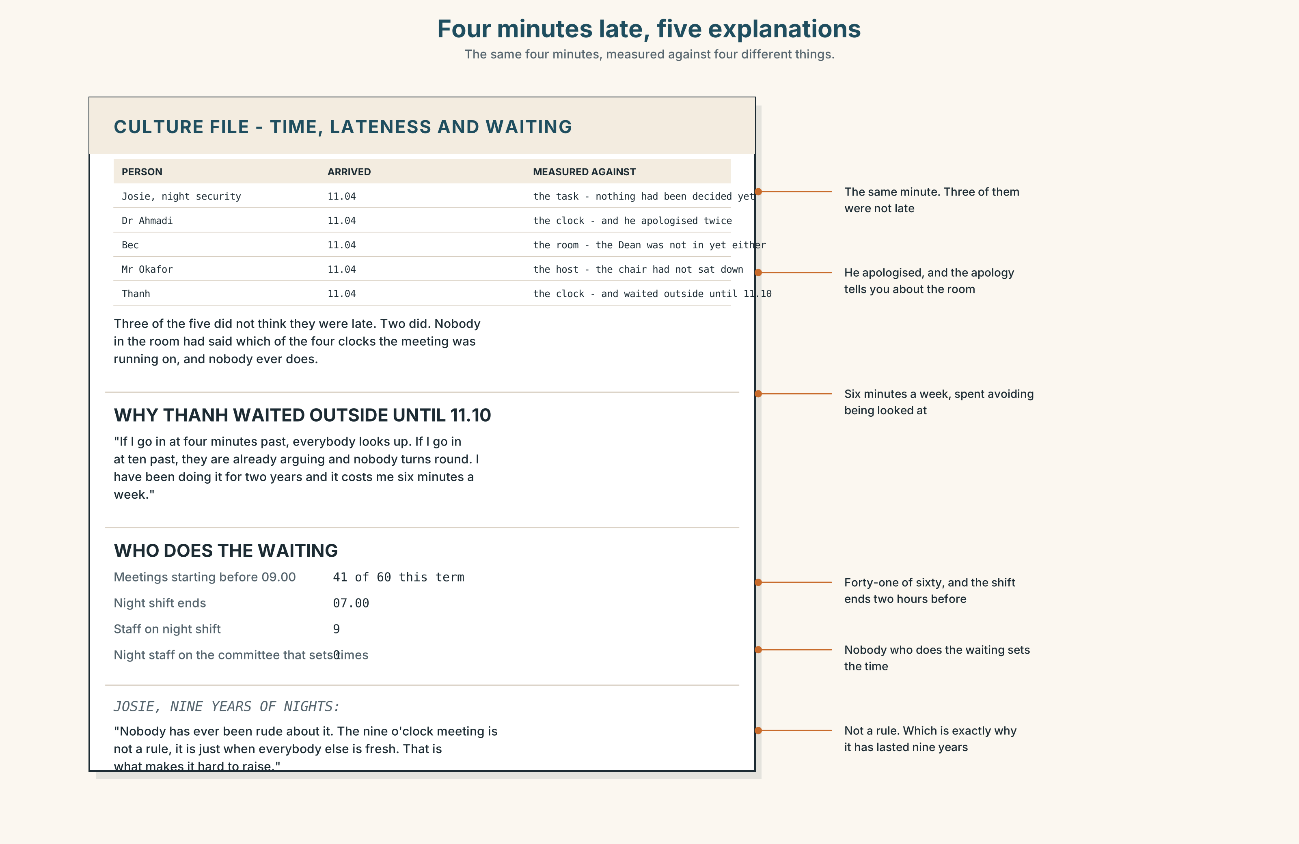{width=6.6in}
Four minutes late, five explanations — The same four minutes, measured against four different things.

9A · Four minutes late 🔊 Track 3.4
Five people describe arriving four minutes after a meeting started. Listen.
- Which two think they are on time?
- Which one apologises, and what does the apology tell you about the room, not the person?
- One of them was waiting outside for six minutes before going in. Why?

9B · What lateness is measured against
the clock — the meeting starts at eleven the room — the meeting starts when the people who matter are in it the task — the meeting starts when there is something to decide the host — the meeting starts when the host says so
Which of the four is your default? Which was your parents'?

9C · Waiting is not neutral
Josie has worked nights for nine years. She has been in nine o'clock meetings after a shift that ended at seven.
Who in an organisation does the waiting, and is it the same people who set the time?

9D · Your turn
In fours. Twelve minutes. Each person describes a time they waited for somebody and what they decided it meant. Then: were you right?

9E · Transfer
Time the first four minutes of your next class or meeting. What happens in them, and who is not there for it? Bring one sentence.

Part 10 · Mediation & Interaction ◆ C · THE PERFORMANCE
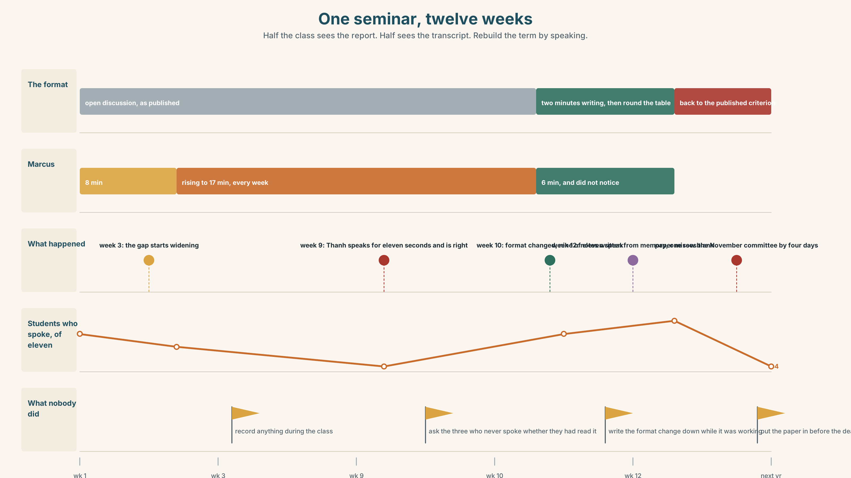{width=6.6in}
One seminar, twelve weeks — Half the class sees the report. Half sees the transcript. Rebuild the term by speaking.

10A · Relay
Half the class sees the report. Half sees the transcript. Rebuild the seminar by speaking. Twelve minutes.

10B · Simplify
Explain the airtime finding to a first-year who has just been told they will be graded on participation. Five sentences only.
Plan: what is measured → what it actually records → what happened over nine weeks → what it means for them → what they can do on Tuesday

10C · Compress
The report extract into forty words, keeping the concession.

10D · Online
Write one message to Priya: you agree the format is the problem, you do not think Marcus should be silenced, and you are proposing one specific change to one seminar.

10E · Your language
Does your language concede with a word, or with a tone? Say admittedly, he is right, but in both languages. Which needs more words, and which can do it with intonation alone?

Part 11 · The Decision ◆ C · THE PERFORMANCE

The best voice in the room, or the ten who are not using theirs
Marcus speaks for seventeen of fifty minutes and is usually right. Four students have spoken for forty seconds in total across nine weeks. Priya has to mark all eleven on participation.
- Intervene. Cap contributions, go round the table, direct a question by name. It works immediately and it takes something from the person who prepared.
- Let it run. Mark what is said, not how often. Marcus earns his mark and the four get what the format gave them.
- Change the format. Written first, spoken second — everyone writes two minutes, then reads theirs aloud. Nobody is capped and nobody starts from nothing.

11A · The evidence
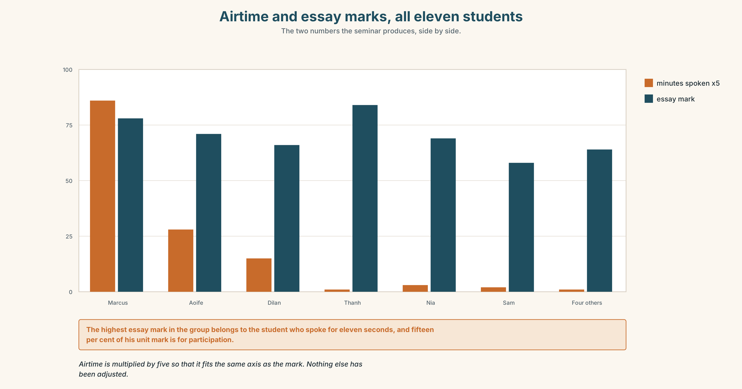{width=6.6in}
Airtime and essay marks, all eleven students — The two numbers the seminar produces, side by side.
- The report and the transcript from Part 5 — and the row the tutor left blank.
- The chart — airtime and essay marks for all eleven students.
- The voice. Thanh, thirty seconds: "I have the answer about forty seconds after the moment has gone. I am not nervous and I am not unprepared. I am slow in the way that writing is slow, and the seminar is the one part of this degree that is not."

11B · Talk about it
In fours. Everybody speaks twice. Use the frame.
______ (concession), ______ . And yet ______ .
Words you can use: argument · dissent · objection · position · premise · compromise · common ground · dominate · defer · the floor

11C · Decide
Write three sentences. Choose, say why, and name what it costs.
I think Priya should ______________________ , because ______________________ . What this costs is ______________________ .

11D · Model decision
Change the format. Two minutes of writing before any discussion, then round the table once, reading what you wrote. It is the only one of the three options that does not require Priya to make a judgement about a person in front of the room, and the only one that gives the slow students the thing they are actually short of, which is not courage but time. Marcus loses four minutes of the hour. He will not notice.

11E · The Reveal
What happened. Priya changed the format in week ten. In the two remaining seminars, the number of students who spoke went from four to nine and from four to eleven. The median contribution was shorter and, on her own marking, better.
Marcus's airtime fell from seventeen minutes to six. He came round to it in the second week, having spent the first one visibly annoyed, and said afterwards that he had not known most of the group had read the text.
The faculty did not adopt it. The criterion still says contributes regularly to seminar discussion, because changing it requires a committee that meets twice a year and the paper missed the November meeting by four days.
The format change worked in two weeks. The sentence that caused the problem is still there, and it will be there next year, because of a deadline nobody argued about.
Was it the right decision? Say why — and say what should happen to the criterion.

Part 12 · Landing ◆ all three lines

12A · Recycle — twelve items
- ______ he is right, nobody else has spoken.
- ______ being right, he lost the room.
- He is right. ______ , so was Thanh.
- Marcus argues, ______ Thanh writes.
- ______ of the grade, Thanh has not spoken.
- He is right, ______ nobody agrees.
- He is loud, ______ . (end position)
- I ______ your point.
- That is not what I ______ .
- She finally ______ round.
- He will not ______ down.
- We found some common ______ .

12B · Consolidate
Three columns, from memory: concession words taking a clause · concession words taking a noun · concession words starting a new sentence.

12C · Can-do, with evidence
☐ I can state the other side at its strongest before disagreeing. Evidence: 4C, 8D ☐ I can use although, despite, however and whereas without doubling up. Evidence: 3H, 6F ☐ I can hear and produce the rise that marks a concession. Evidence: 7D ☐ I can name what would change my mind. Evidence: 8D, 11C

12D · Replay ⏺
Record 0C again. Listen to both. What have you got that you did not have in week one?

12E · Glossary — forty-five items, as a map
THE ARGUMENT · argument · debate · dissent · objection · position · premise · rebuttal · compromise · agreement THE ROOM · dominate · defer · silence · the floor · talk over · shout down · hold back THE MOVES · take a position · concede the point · play devil's advocate · common ground · back down · come round WHAT PEOPLE SAY · I take your point · that is not what I said CONCEDING, ONE CLAUSE · although · though · whereas · yet · still · and yet · nevertheless · nonetheless CONCEDING, A NOUN · despite · in spite of CONCEDING, A SENTENCE · however · admittedly · granted · even so · all the same · that said · up to a point · to be fair · on the other hand CONCEDING, A VERB · allow that · grant that

12F · Next
Unit 4 · Why is it done this way?

