Table of Contents

B1.3 · Unit 4 · The Garden That Has Two Jobs
English Animated · Making the Case · a university campus, Melbourne Student's Book pages 72–93 · 22 pp · ~11 hours

Part 0 · The Big Picture ◆ A · THE WORLD
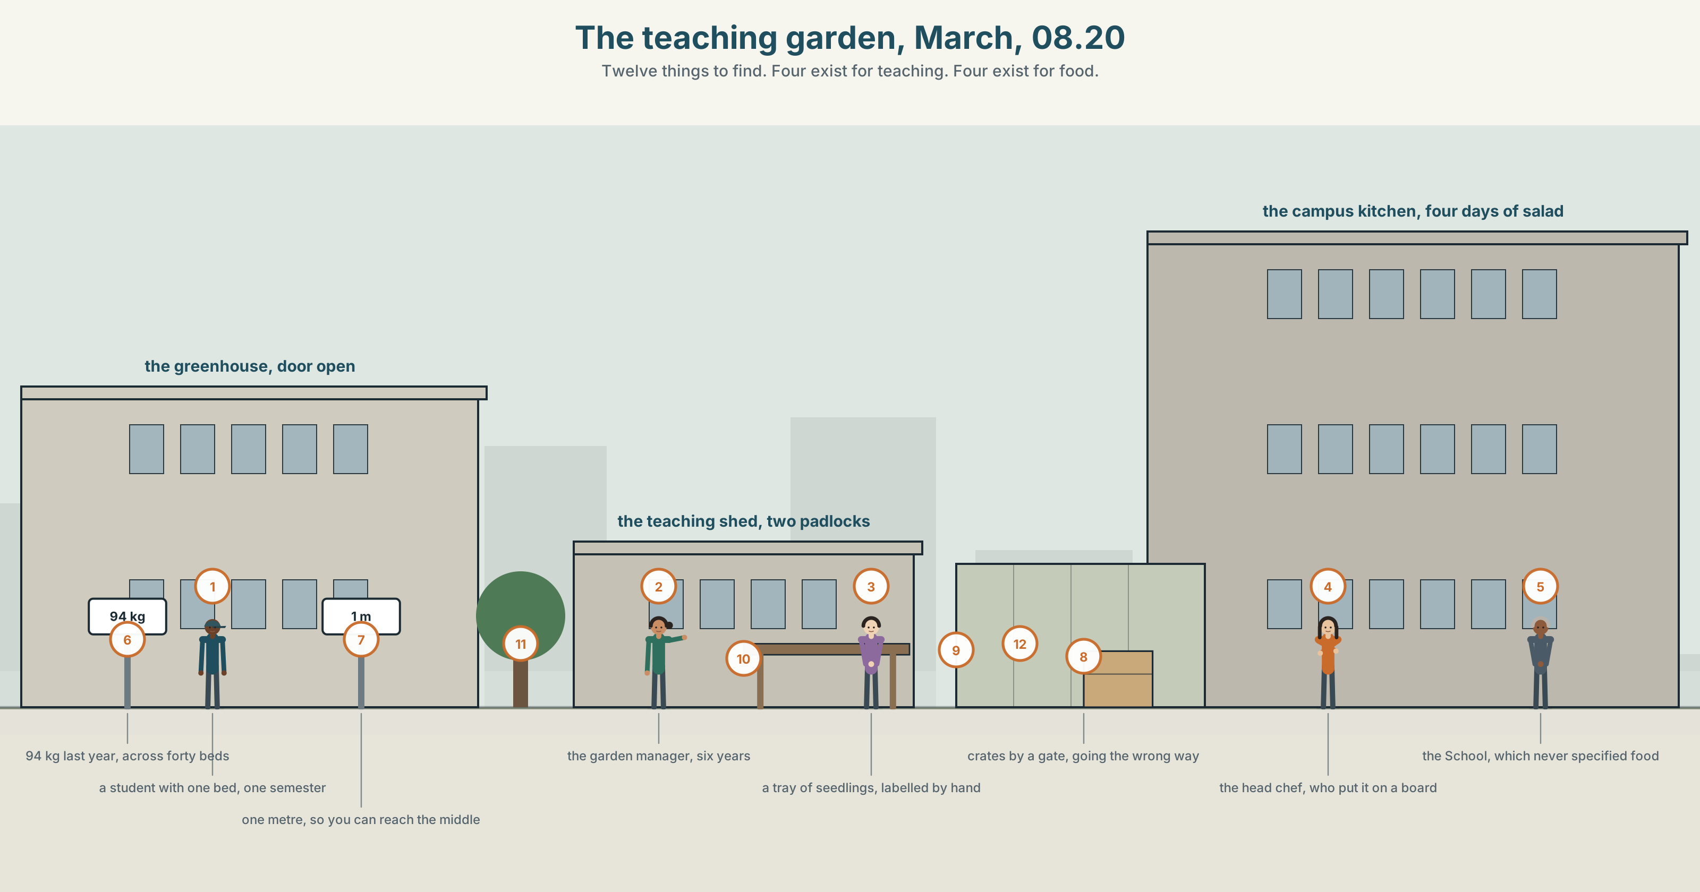{width=6.6in}
The teaching garden, March, 08.20 — Twelve things to find. Four exist for teaching. Four exist for food.

Why is it done this way?
By the end of this unit you can explain a design decision and the reasoning behind it.
◆ A · THE WORLD | A garden that two departments both believe they own, for two different reasons
◆ B · THE SYSTEM | purpose, reason and result: so that · in order to · such … that · 24 words for process, design and intention · 21 causal forms · stress on the purpose clause
◆ C · THE PERFORMANCE | An explanation that gives the reason, not only the rule

0A · Find it
Find twelve things in this picture. Four of them exist for teaching. Four exist for food.
a bed divided into twelve small squares · a bed of one crop, forty metres long · a sign with twelve latin names on it · a water butt with a tap at the wrong height · a compost bay built from pallets · a path worn where there is no path · a greenhouse with the door open · a tray of seedlings labelled by hand · a stack of crates by a gate · a bench facing the wrong way · a hose running to nowhere · a shed with two padlocks on it

0B · Guess it
One of the twelve was built for one purpose and is used for the other. Which, and how can you tell?

0C · Say it ⏺
Record forty-five seconds. Describe something near you that was designed for one job and is used for another. Say what was lost in the swap. You will record it again at the end of this unit.

Part 1 · Vocabulary Lab 1 ◆ B · THE SYSTEM
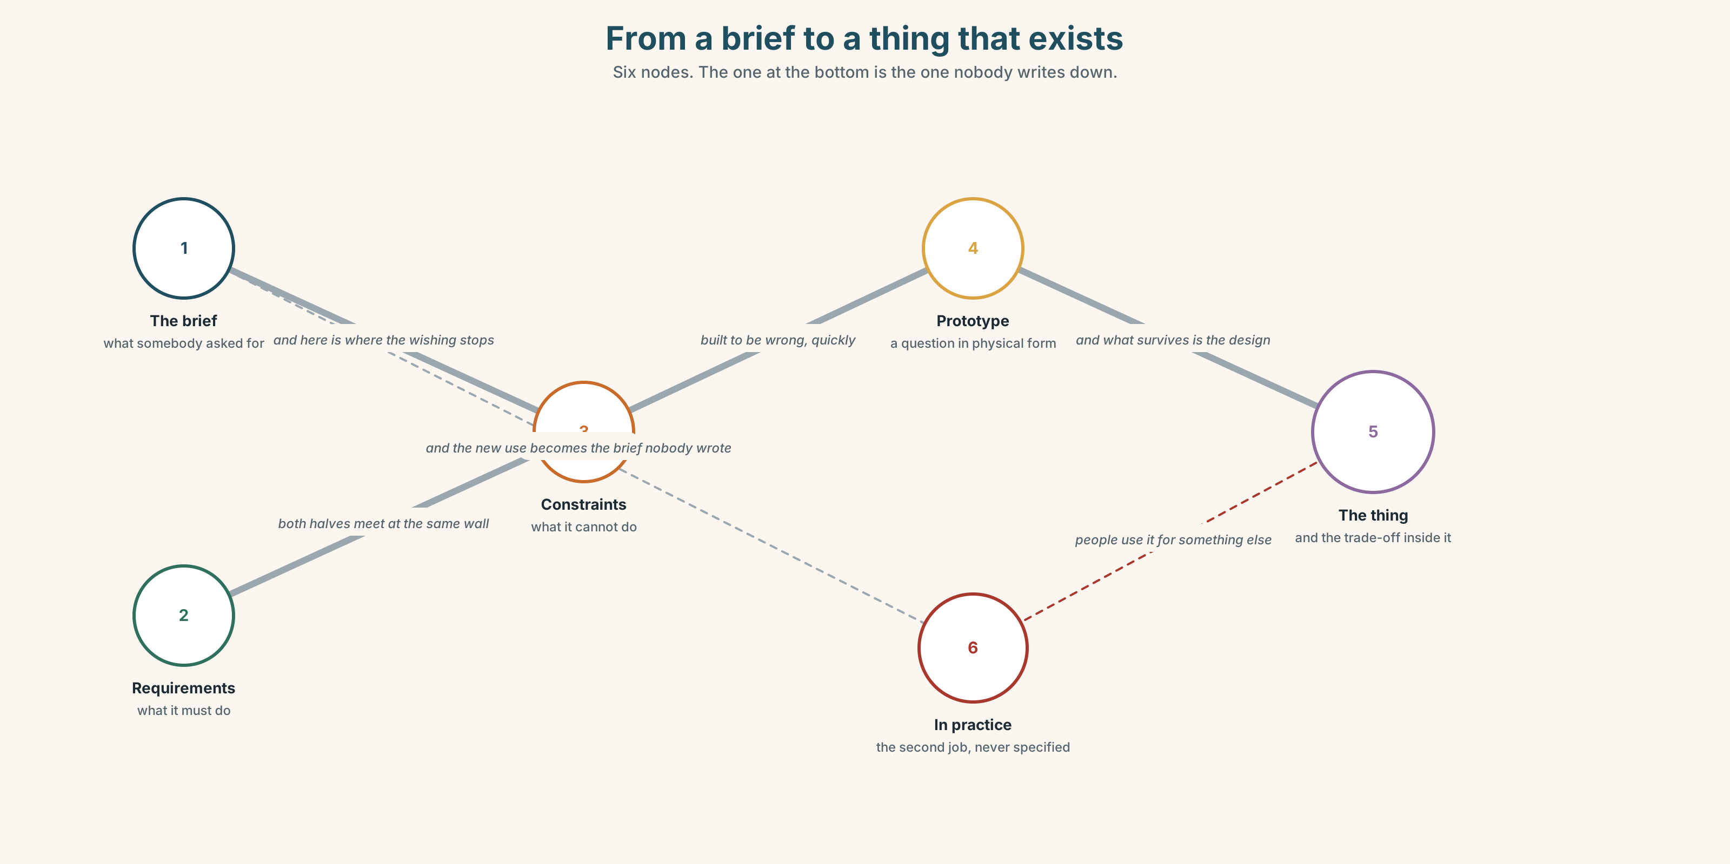{width=6.6in}
From a brief to a thing that exists — Six nodes. The one at the bottom is the one nobody writes down.

1A · Meet — the words of a design decision
purpose · intention · rationale · specification · requirement · constraint · trade-off · prototype
- Which two of these are written down before anything is built?
- What is the difference between a purpose and a rationale?
- Constraint and requirement: which one says what it must do, and which what it cannot?
- Why is a trade-off not a failure?
A prototype is not a small version of the thing. It is a question asked in physical form, built to be wrong, and the whole value of it is how fast you find out.

1B · Sort — the garden, the document, or the decision?
yield · plot · harvest · curriculum · a design brief · in practice · by design · at the expense of · the whole point
Three columns. Two of them belong in more than one. Say which and why.

1C · Meet — the phrase that does most of the work
c a trade-off
Two things you want, and a quantity of one that can only be bought with the other.
- Name the trade-off in a bus timetable.
- Why is there is no trade-off here almost always a sign that somebody has not measured one of the two sides?

1D · Collocation Lab
serve | a purpose · a function · a need
by design | not by accident · ~ rather than by habit
the whole point | ~ of it · miss ~
at the expense of | gained ~ · built ~
Which two of these are usually said about somebody else's decision?

1E · The fixed expressions
f That was never the idea. — said when a thing is being judged against a purpose it never had. f It does one of them well. — the most useful sentence in this unit, and the hardest to say about your own work.
Which one is a defence and which is a concession?

1F · Own it
The four phrasal verbs of making something.
set out to · end up · scale down · build in
- Which two describe the gap between the plan and the result?
- What do you build in that you cannot add later?
- Scale down and make smaller: what does scale down add?
- Write one sentence in which somebody set out to do one thing and end up doing another.

Part 2 · Listening ◆ A · THE WORLD
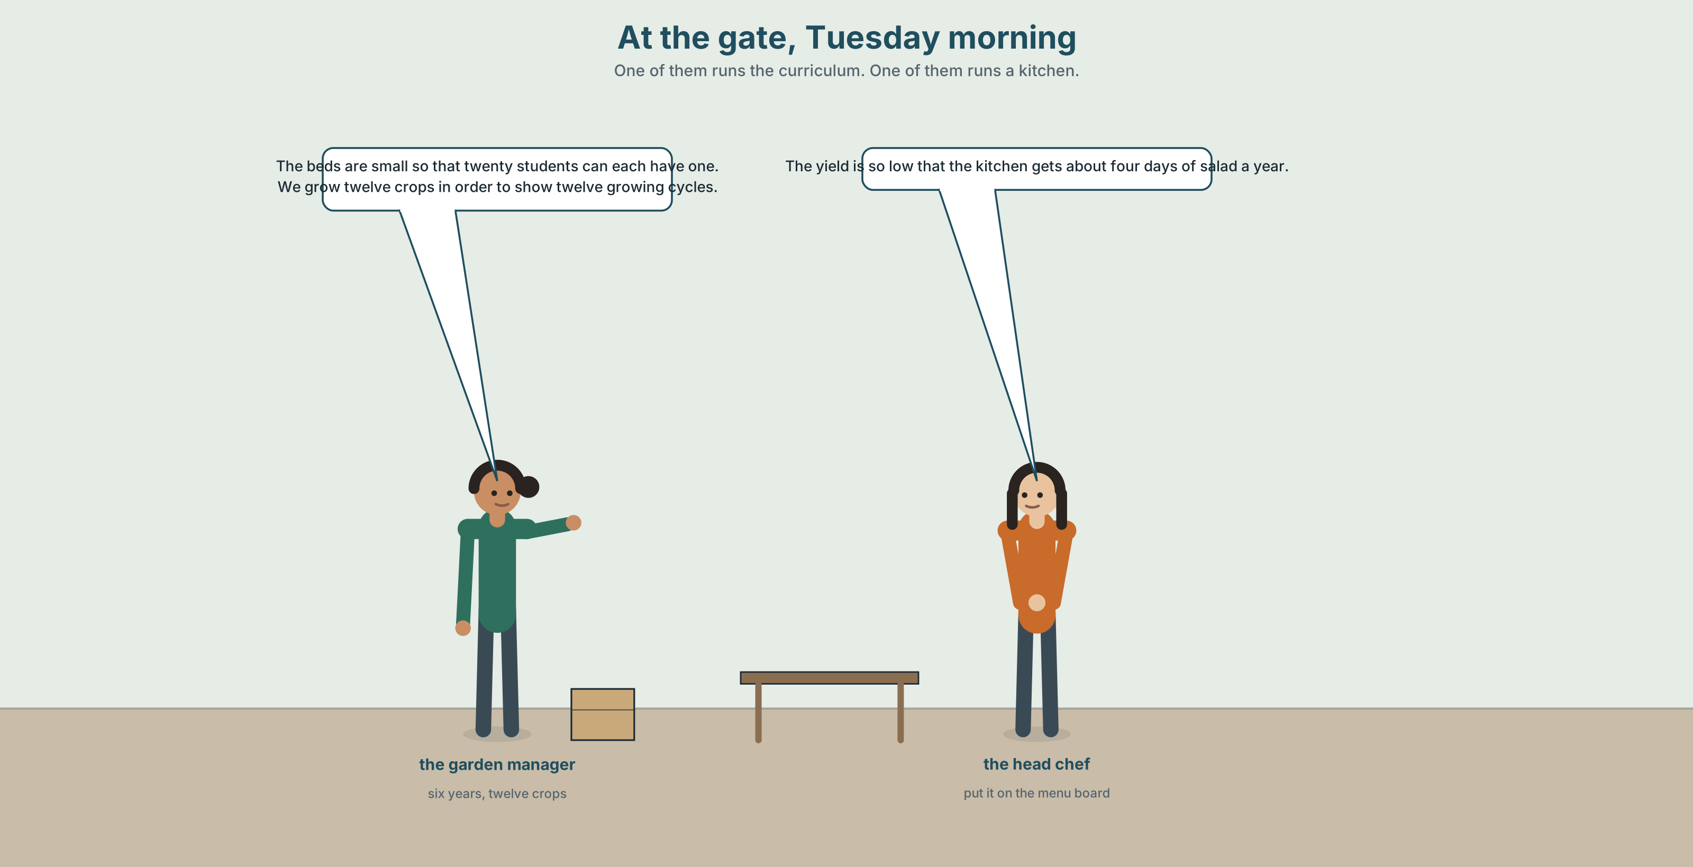{width=6.6in}
At the gate, Tuesday morning — One of them runs the curriculum. One of them runs a kitchen.

2A · Two beds, two reasons 🔊 Track 4.1
Before you listen. The garden has been run by the School of Agriculture for six years. The campus kitchen has started taking from it. Guess: what is the argument about?
Listen once. One question. What does each side want the garden to produce?
Listen again. Complete the table.
 | Teaching garden | Food garden
bed size
number of crops
kilos per year
Listen again. Choose the best answer.
- The twelve small squares exist for yield / for teaching / for both.
- The kitchen wants more crops / fewer crops / the same crops.
- The two uses are compatible / incompatible / compatible at a small scale.
- Somebody has already scaled down / scaled up / changed nothing.
Noticing. Four sentences from the recording.
- The beds are small so that twenty students can each have one.
- We grow twelve crops in order to show twelve growing cycles.
- The yield is so low that the kitchen gets about four days of salad a year.
- It was built as a classroom, and owing to that, it feeds nobody.
All four give a reason. Which of the four gives a result instead of a purpose?

2B · Decoding clinic 🔊 Track 4.2
Thirty seconds of the garden manager. Four jobs.
- How many purpose clauses can you count?
- In so that twenty students can each have one, which word is stressed?
- Catch the two quantities.
- She says so twice, meaning two different things. Which two?
Transcripts, page 153.

Part 3 · Grammar Lab 1 ◆ B · THE SYSTEM

Purpose, reason and result

3A · Notice
Look at the four sentences in Part 2.
- In sentence 1, does so that give a purpose or a result?
- In sentence 3, does so … that give a purpose or a result? How do you know?
- Rewrite sentence 2 with so as to. What changes, and what cannot change?
- Sentence 4 uses owing to. Rewrite it with because. Which is more formal?
- Try "The beds are small in order to students can have one." What is wrong with it?

3B · See
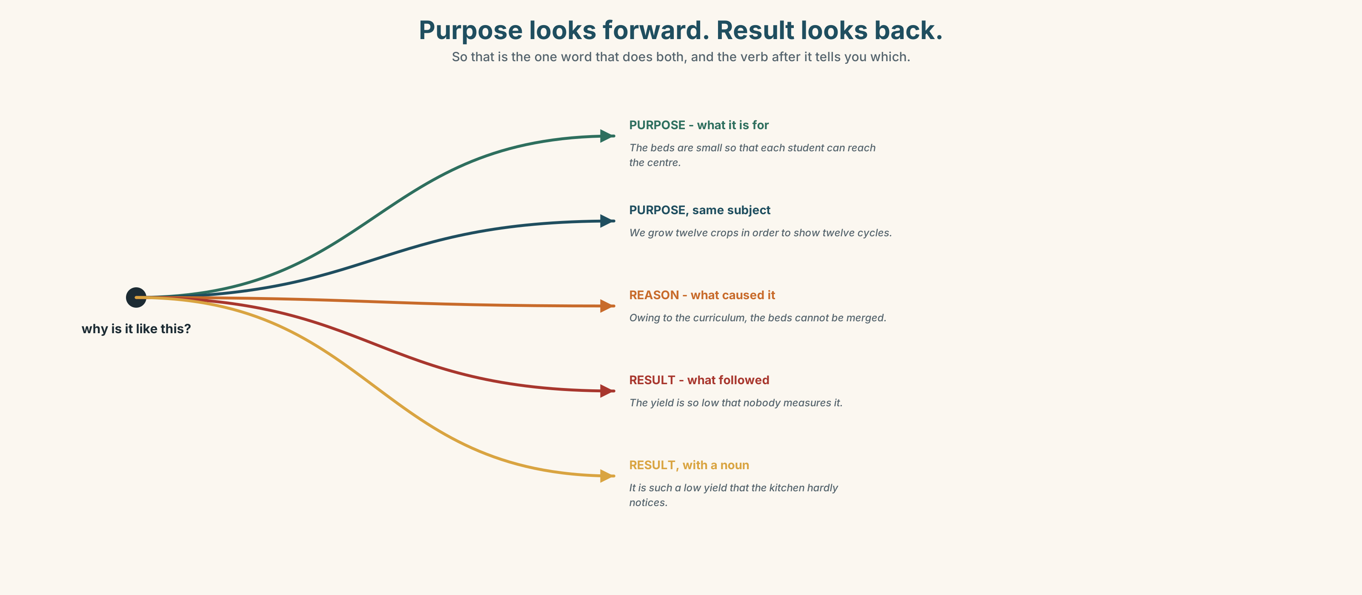{width=6.6in}
Purpose looks forward. Result looks back. — So that is the one word that does both, and the verb after it tells you which.

3C · Know
 | Takes | Example
so that | a clause, usually with can / will / would | The beds are small so that each student has one.
in order to / so as to | an infinitive, same subject | We grow twelve crops in order to show twelve cycles.
so … that / such … that | adjective / noun + result | The yield is so low that nobody notices.
because / since / as | a clause, giving a reason | Since the beds are small, the yield is low.
owing to / due to | a noun phrase | Owing to the bed size, the yield is low.
Purpose looks forward. Result looks back. So that is the one that can do either, and the verb tells you which: so that students can learn is a purpose, so that nobody noticed is a result.
In order to needs the same subject in both halves. ✗ The beds are small in order to students can have one. ✓ The beds are small so that students can have one. ✓ We made the beds small in order to give each student one.
so + adjective, such + noun. so low that… · such a low yield that… — the article moves, and that is the whole difference.
Why it matters. An explanation that gives the rule and not the reason cannot be argued with, improved, or applied anywhere else.

3D · Use — controlled
The twelve squares were laid out (1) __________ each student could manage a plot alone. Twelve crops were chosen (2) __________ demonstrate twelve different growing cycles within one academic year. The result is a garden with (3) __________ a small bed for each crop (4) __________ no crop reaches the quantity a kitchen can use. The total harvest last year was (5) __________ small (6) __________ the campus kitchen recorded it as four days of salad. (7) __________ to the curriculum, the beds cannot be merged, and that is not an oversight.

3E · Use — guided
Rewrite each one with the structure in brackets. Two of them need a new subject.
- The beds are small. Each student can have one. (so that)
- We planted twelve crops. We wanted to show twelve cycles. (in order to)
- The yield is very low. The kitchen hardly notices it. (so … that)
- The yield is very low. The kitchen hardly notices it. (such … that)
- The curriculum requires twelve crops. The beds cannot be merged. (owing to)

3F · Use — open
In pairs. Explain a design decision in something you both use, in six sentences, three of which must give a purpose and one a result. Your partner's job is to ask why once more than you have an answer for.

3G · Error autopsy
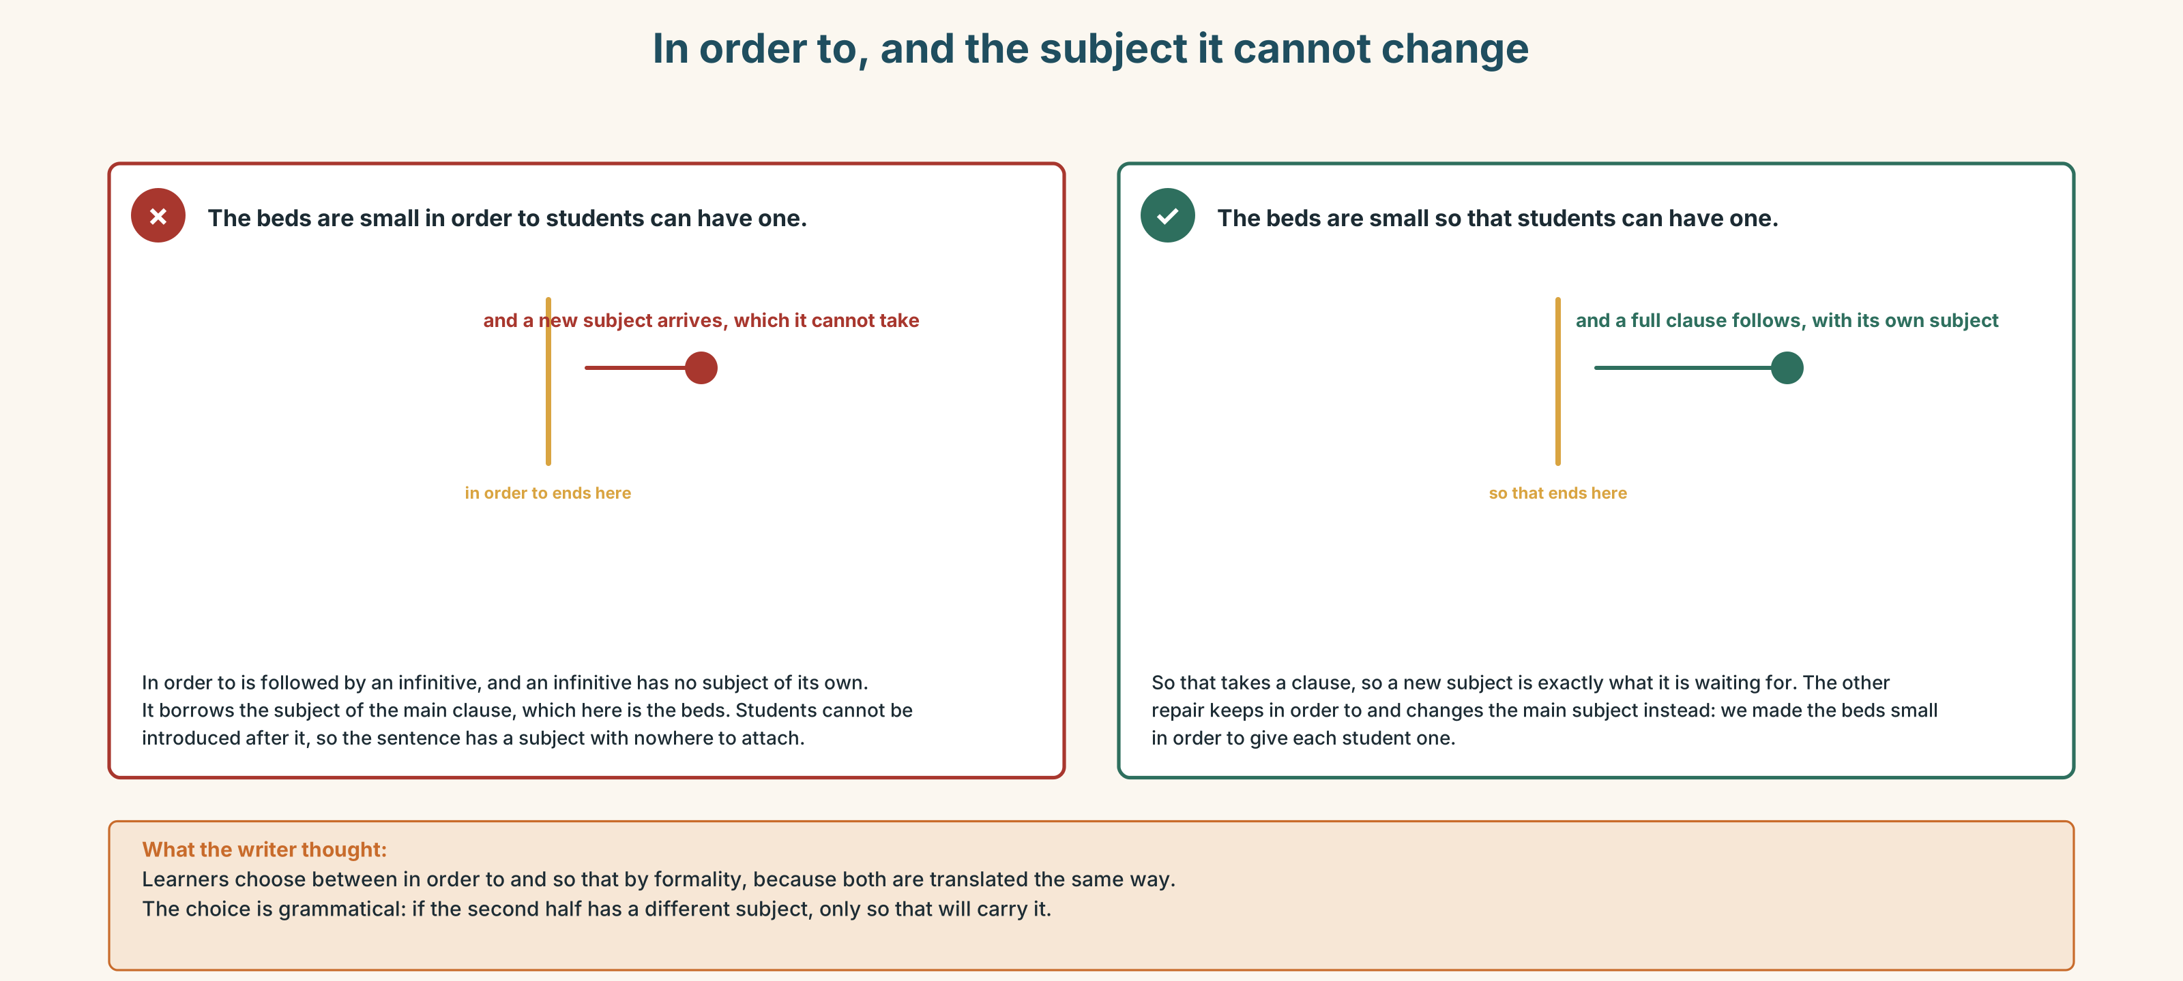{width=6.6in}
In order to, and the subject it cannot change — In order to, and the subject it cannot change
Read both versions. Then say which one could appear in a design brief.

3H · Check — eight items
- The beds are small ______ each student can have one. (purpose, clause)
- We planted twelve crops ______ show twelve cycles. (purpose, infinitive)
- The yield is ______ low ______ nobody notices. (result, adjective)
- It is ______ a low yield ______ nobody notices. (result, noun)
- ______ to the curriculum, the beds cannot be merged. (noun phrase)
- ✗ The beds are small in order to students can have one. → correct it.
- We built it ______ as to test one thing at a time. (purpose, infinitive)
- The beds are small; ______ , the yield is low. (result, formal)
0–4 → Workbook pp. 18–21. 5–6 → Part 6. 7–8 → page 85.

Part 4 · Speaking ◆ C · THE PERFORMANCE

4A · Fluency starter — one more why
One learner states a design decision. The next asks why. Five levels, and the chain breaks when somebody says that is just how it is done.

4B · The functional core — explaining a decision
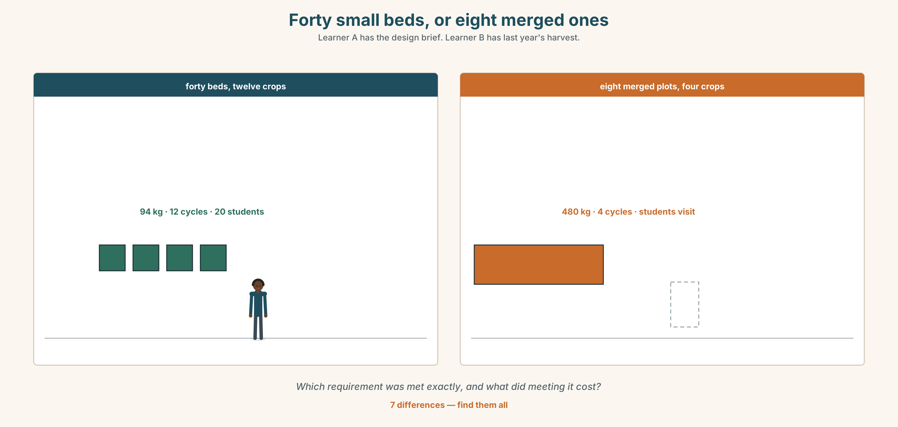{width=6.6in}
Forty small beds, or eight merged ones — Learner A has the design brief. Learner B has last year's harvest.
Language Bank
the purpose | It is there so that… · with a view to… · for the sake of…
the constraint | We had to work with… · The specification said…
the trade-off | …at the expense of… · We gained X and lost Y.
the result | The result being… · which is why it is there · and that led to…
Information gap. Learner A has the original design brief. Learner B has last year's harvest figures. Find the one requirement that was met exactly and still produced the wrong outcome.

4C · The performance — three minutes ⏺
Explain a design decision, in anything. Three minutes. You must include:
what it was for · what constrained it · the trade-off, named as a trade-off · one thing you would do differently and why
Record it.

4D · Observer
One person listens for one thing: was a reason given, or only a rule restated?

4E · Three criteria
☐ Did I give the purpose before the rule? ☐ Did I name a trade-off, with both sides of it? ☐ Could somebody apply my reasoning to a different problem?

Part 5 · Reading ◆ A · THE WORLD

5A · Predict
An explainer, titled "Why the beds are a metre square." What do you expect the last paragraph to concede? Two sentences.

5B · Read — two minutes and a quarter

SCHOOL OF AGRICULTURE · TEACHING GARDEN · NOTE FOR NEW STAFF Why the beds are a metre square
Every bed in the teaching garden is one metre by one metre. New staff ask about this roughly once a semester, usually in the form of a suggestion that we merge them.
The beds are a metre square so that one student can reach the centre of a bed from any edge without stepping on the soil. That is the whole rationale, and it is not about yield. A student who steps on a bed compacts it, and a compacted bed teaches the wrong lesson for the rest of the year because everything planted in it does slightly worse for a reason the student cannot see.
Twelve crops are grown in order to show twelve growing cycles inside one academic year. Three of the twelve are chosen specifically because they fail reliably in Melbourne. A student who has only grown things that work has not learned to read a plant.
The consequence of both decisions is a yield so low that it is not worth measuring. Last year the garden produced 94 kilograms of food. The campus kitchen uses that in about four days. We know this and it has never been a problem, because the garden was never specified as a food source.
It has become one. The kitchen started taking from the garden two years ago, without a decision being made anywhere, in the way that these things start. It is now on a menu board. The kitchen has asked whether we could grow "more of the things people actually eat", which is a reasonable question with an unreasonable answer: we could, and the garden would stop doing what it was built for within one season.
The honest position is this. At the scale of a teaching garden the two purposes are compatible because the food is incidental. At any scale the kitchen would find useful, they are not. It does one of them well.

5C · Comprehension — eight questions
- What question do new staff ask, and in what form?
- Why are the beds a metre square? Give the reason, not the rule.
- What does a compacted bed teach, and why is it hard to see?
- Why are three of the twelve crops chosen because they fail?
- What was the yield last year, and how long does the kitchen use that in?
- How did the kitchen start taking from the garden?
- What is "a reasonable question with an unreasonable answer"?
- What exactly is the honest position in the last paragraph?

5D · Vocabulary in context
Guess from the text. Then check.
compacts it · reliably · incidental · never specified as · within one season

5E · The counter-text
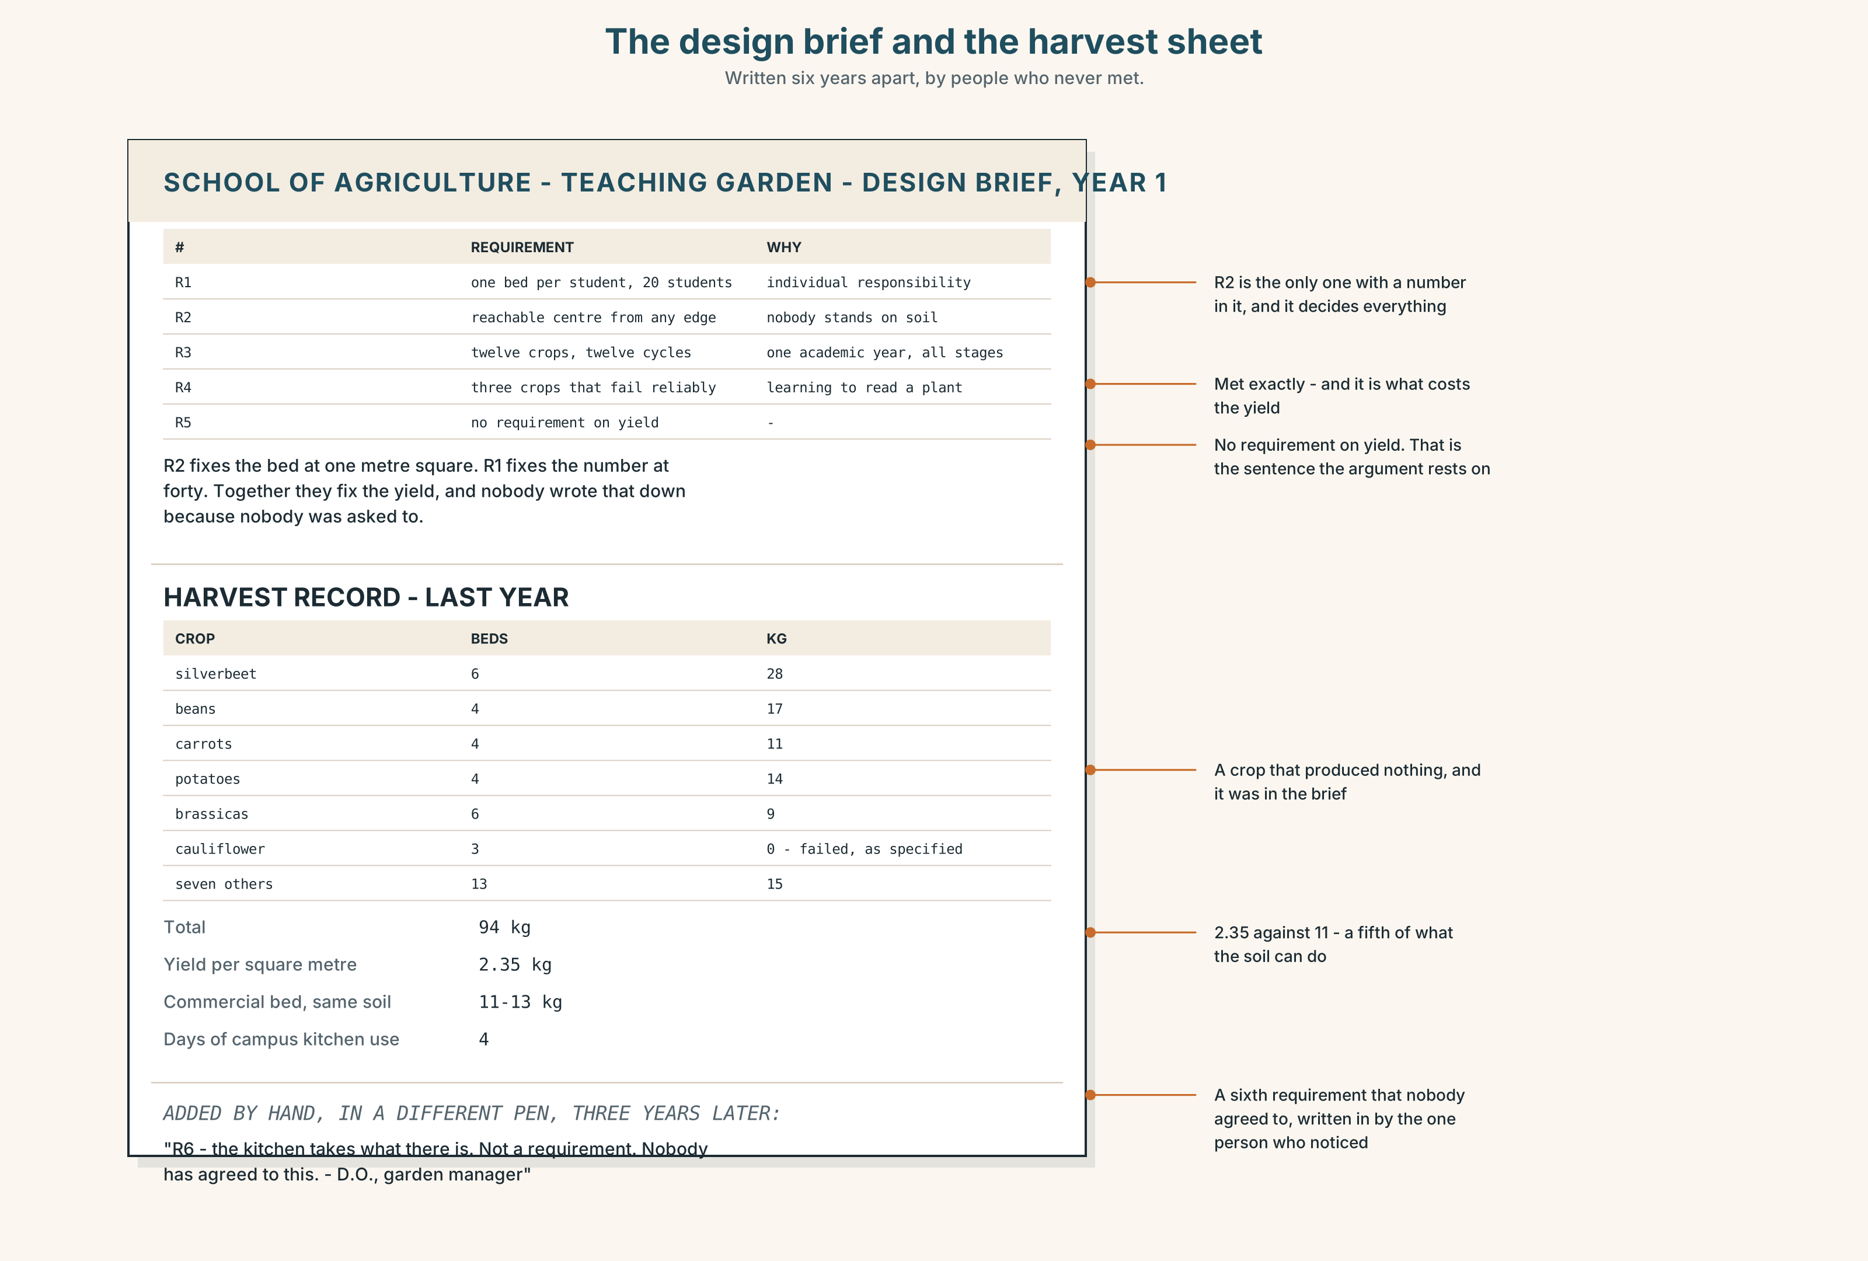{width=6.6in}
The design brief and the harvest sheet — Written six years apart, by people who never met.
Read the design brief and the harvest figures, and answer.
- What were the five original requirements?
- Which requirement was met exactly, and what did meeting it cost?
- What is the yield per square metre, and how does it compare with a commercial bed?
- Which crop failed, and was that a failure?
- One line of the brief has been added by hand, later. Which, and by whom?

5F · Two texts
The brief says the garden must demonstrate twelve growing cycles. The kitchen wants more of the things people actually eat.
Is there a version of the garden that does both? Three sentences.

Part 6 · Vocabulary Lab 2 ◆ B · THE SYSTEM

The words that carry a reason

6A · Sort — purpose, reason, or result?
Three columns.
so that · in order to · so as to · such that · because · since · as · therefore · thus · hence · consequently · whereby · owing to

6B · Chunk completion
- With a ______ to merging them next year, we measured every bed.
- For the ______ of the argument, assume the kitchen is right.
- The result ______ , nobody measures the harvest at all.
- So ______ to test one variable, we planted three beds identically.
- Such ______ no crop reaches a usable quantity.
- In ______ to show twelve cycles, we need twelve crops.

6C · Three that mean therefore
therefore · thus · hence
All three are formal and all three are results. Thus is the most literary, hence the most compressed — it can take a noun phrase alone: hence the twelve beds.
Write one sentence with each, about the garden.

6D · The one that joins a rule to its reason
c whereby
A system whereby each student manages one bed.
Formal, and it introduces the mechanism rather than the purpose. Rewrite two sentences from Part 5B using it.

6E · The fixed expression
f Which is why it is there.
The sentence that closes an explanation. It only works if what came before it was a reason.
Write the two sentences before it.

6F · Contrast Clinic
Eight items. Four are wrong. Correct them and say what the rule is.
- The beds are small in order to students can reach the middle.
- The beds are small so that students can reach the middle.
- The yield is such low that nobody notices.
- It is such a low yield that nobody notices.
- Owing to the yield is low, the kitchen looked elsewhere.
- Owing to the low yield, the kitchen looked elsewhere.
- We planted twelve crops so as to showing twelve cycles.
- The beds cannot be merged; hence the twelve crops.

Part 7 · Pronunciation & Fluency Lab ◆ B · THE SYSTEM

Where the stress falls in a purpose clause
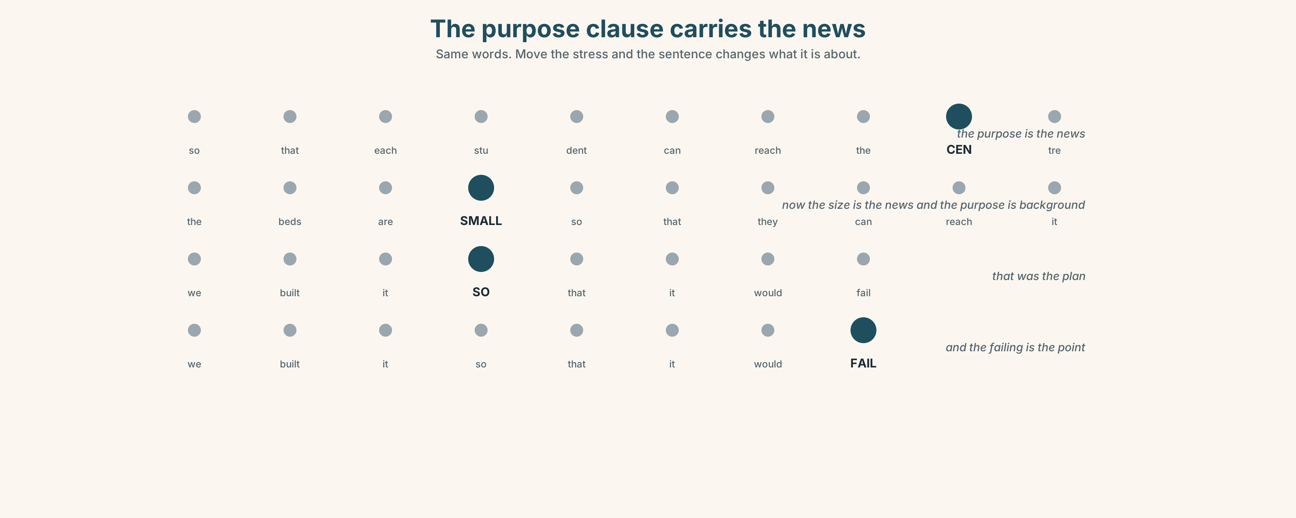{width=6.6in}
The purpose clause carries the news — Same words. Move the stress and the sentence changes what it is about.

7A · Hear 🔊 Track 4.3
The beds are small | so that each student can reach the CENTRE . The purpose clause carries the new information, and the stress is at the end of it.
Now with the stress moved:
The beds are SMALL so that each student can reach the centre. Now the size is the news, and the purpose has become background.

7B · Say
Say both. Then say this one three times, faster:
We planted twelve crops in order to show twelve cycles.

7C · Make it mean something
Say these two:
We built it SO that it would fail. (that was the plan) We built it so that it would FAIL . (and the failure is the point being made)
One sentence, two jobs. Which is which?

7D · Fluency 30 ⏺
Thirty seconds: four sentences, each with a purpose clause, each stressed at the end. Three times, faster, keeping the stress where it belongs.

Part 8 · Writing ◆ C · THE PERFORMANCE

A design rationale · 180 words
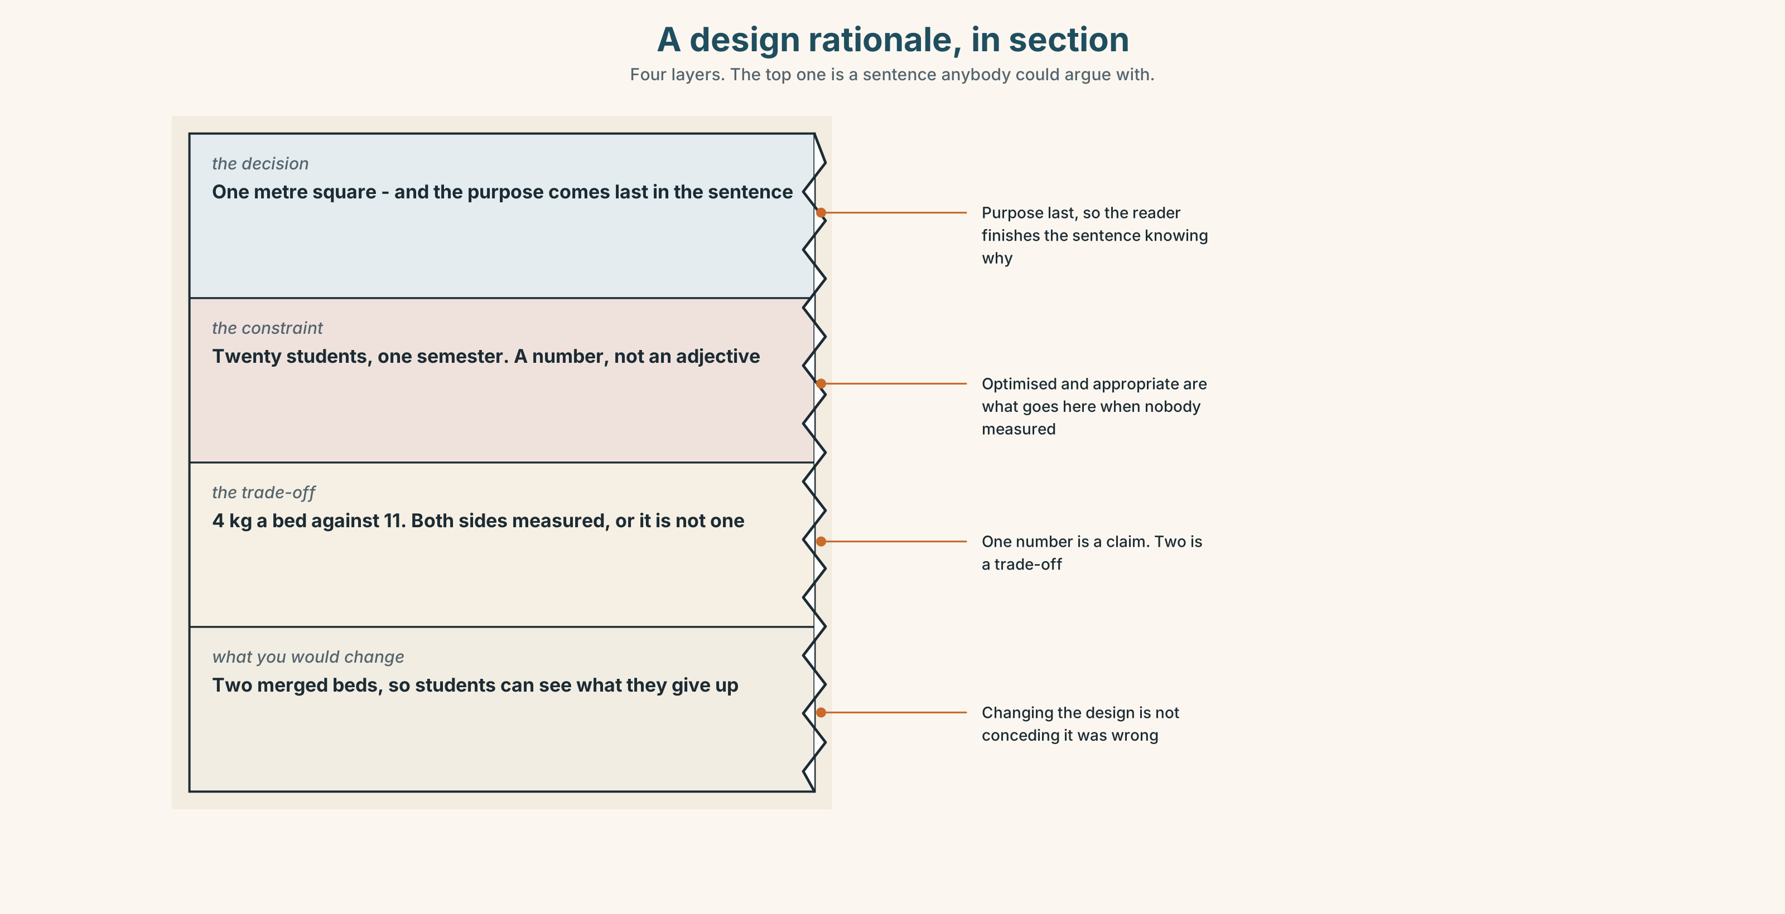{width=6.6in}
A design rationale, in section — Four layers. The top one is a sentence anybody could argue with.

8A · Read the model
Every bed is one metre square so that a student can reach the centre from any edge without standing on the soil. [the decision and its purpose, in one sentence, with the purpose last]
The constraint was the number of students, not the amount of land: twenty students, one bed each, one semester. [the constraint, named as a number]
This was bought at the expense of yield. A metre-square bed produces about four kilograms a year, which is roughly a fifth of what the same soil would produce in a merged plot. [the trade-off, with both sides measured]
If I were specifying it again I would build two merged beds at the far end, so that students could see what they are giving up. [what would change, and the reason is a teaching reason]
Questions about the writer's choices:
- The purpose comes at the end of the first sentence. Why not at the beginning?
- The trade-off is given with both numbers. What would one number alone be worth?
- The last paragraph changes the design. Is it conceding that the original was wrong?

8B · The anti-model
The teaching garden has been designed in accordance with pedagogical best practice and reflects the School's commitment to experiential learning. Bed dimensions have been optimised to deliver an effective student experience while maintaining appropriate sustainability outcomes.
Correct English, and nobody could rebuild the garden from it. Name the three things it has replaced with adjectives, and say what optimised is hiding.

8C · Plan
the decision, with its purpose → the constraint, as a number → the trade-off, both sides measured → what you would change and why

8D · Write — 180 words

8E · Peer review — three criteria
☐ Is there a purpose, not only a rule? ☐ Is the trade-off given with both sides measured? ☐ Could a stranger rebuild the thing from this?

8F · Write it again · 8G · Publish
On the wall, beside the thing it describes.

Part 9 · The File ◆ A · THE WORLD + C · THE PERFORMANCE

WORK FILE · The Client Problem
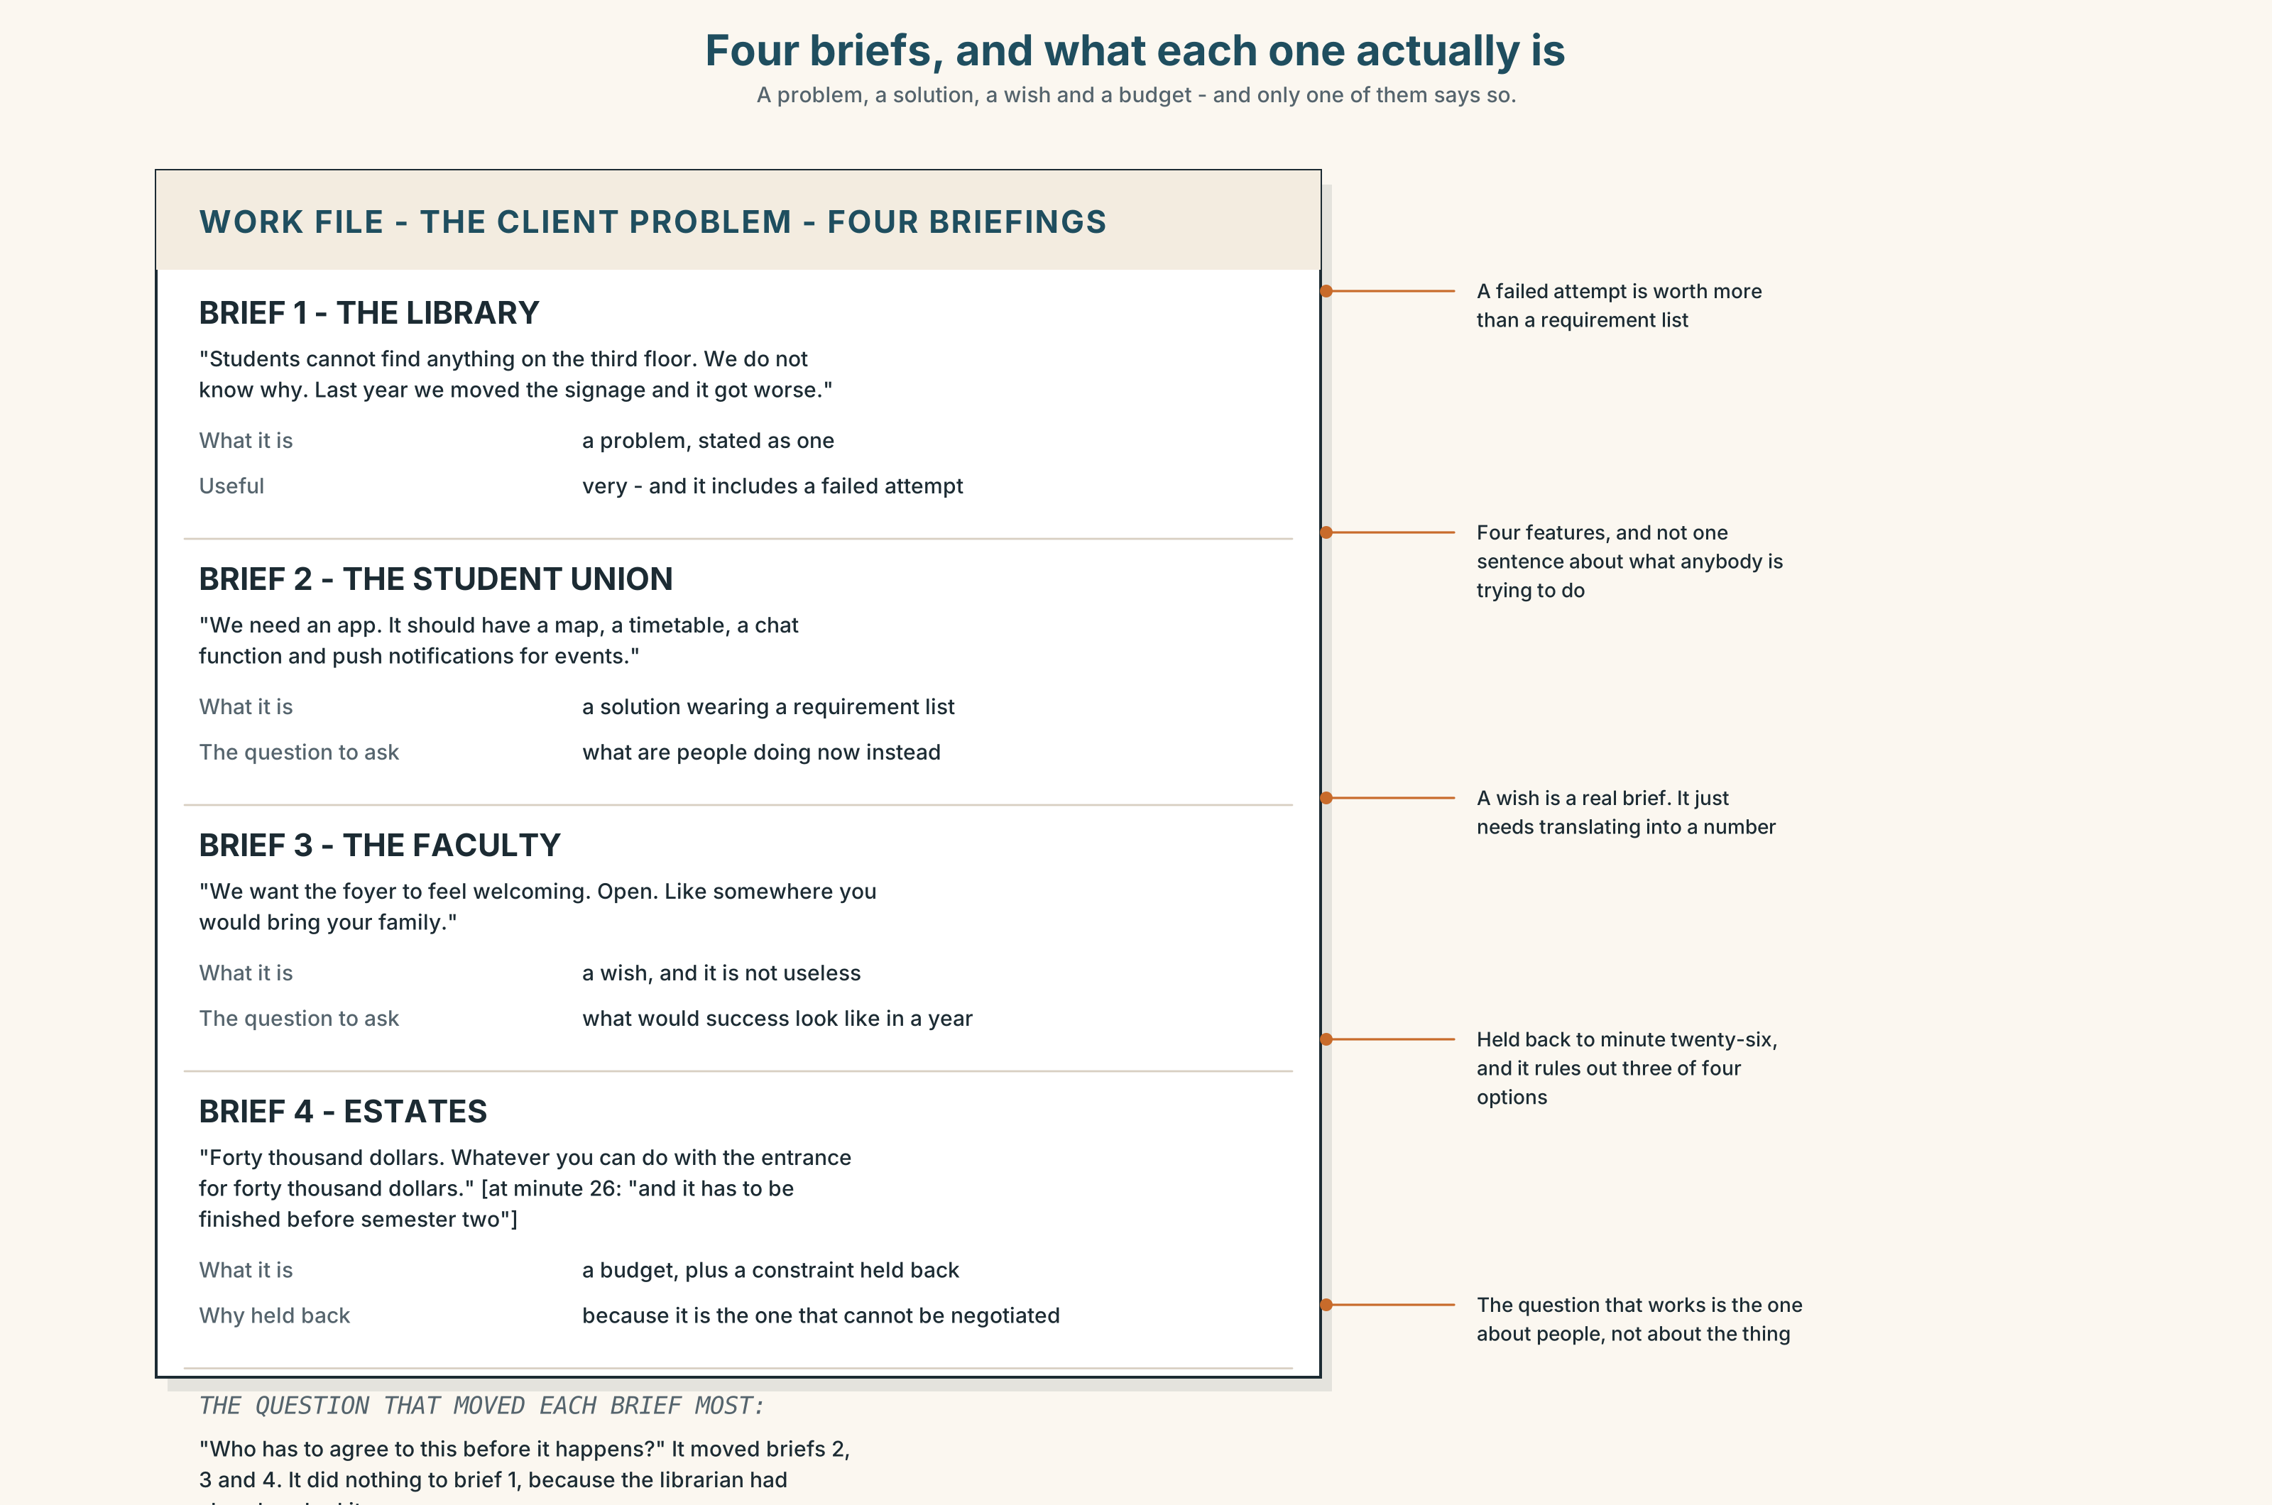{width=6.6in}
Four briefs, and what each one actually is — A problem, a solution, a wish and a budget - and only one of them says so.

9A · What the client asked for 🔊 Track 4.4
Four short briefings. Listen.
- Which client knows what they want, and which knows what they do not want?
- Which of the four briefs contains a solution disguised as a requirement?
- One brief has a constraint the client did not mention until the end. Which, and why then?

9B · Four things a brief can be
a problem — here is what is wrong; you tell us what to build a solution — here is what to build; we have already decided a wish — here is what we want it to feel like a budget — here is what we can spend; work backwards
Which of the four is most often disguised as another, and which is hardest to argue with?

9C · Asking the question that annoys the client
Which of these would you use, and when?
- "What would success look like in a year?"
- "What have you already tried?"
- "If you could only have one of these five, which?"
- "Who has to agree to this before it happens?"

9D · Your turn
In fours. Twelve minutes. One person is the client and briefs a change to something on your campus. Everybody else must ask one of the four questions and nothing else. Then: which question moved the brief most?

9E · Transfer
Find a sign, a form or a rule near you and ask what it was for. Bring the answer, or the fact that nobody knows.

Part 10 · Mediation & Interaction ◆ C · THE PERFORMANCE
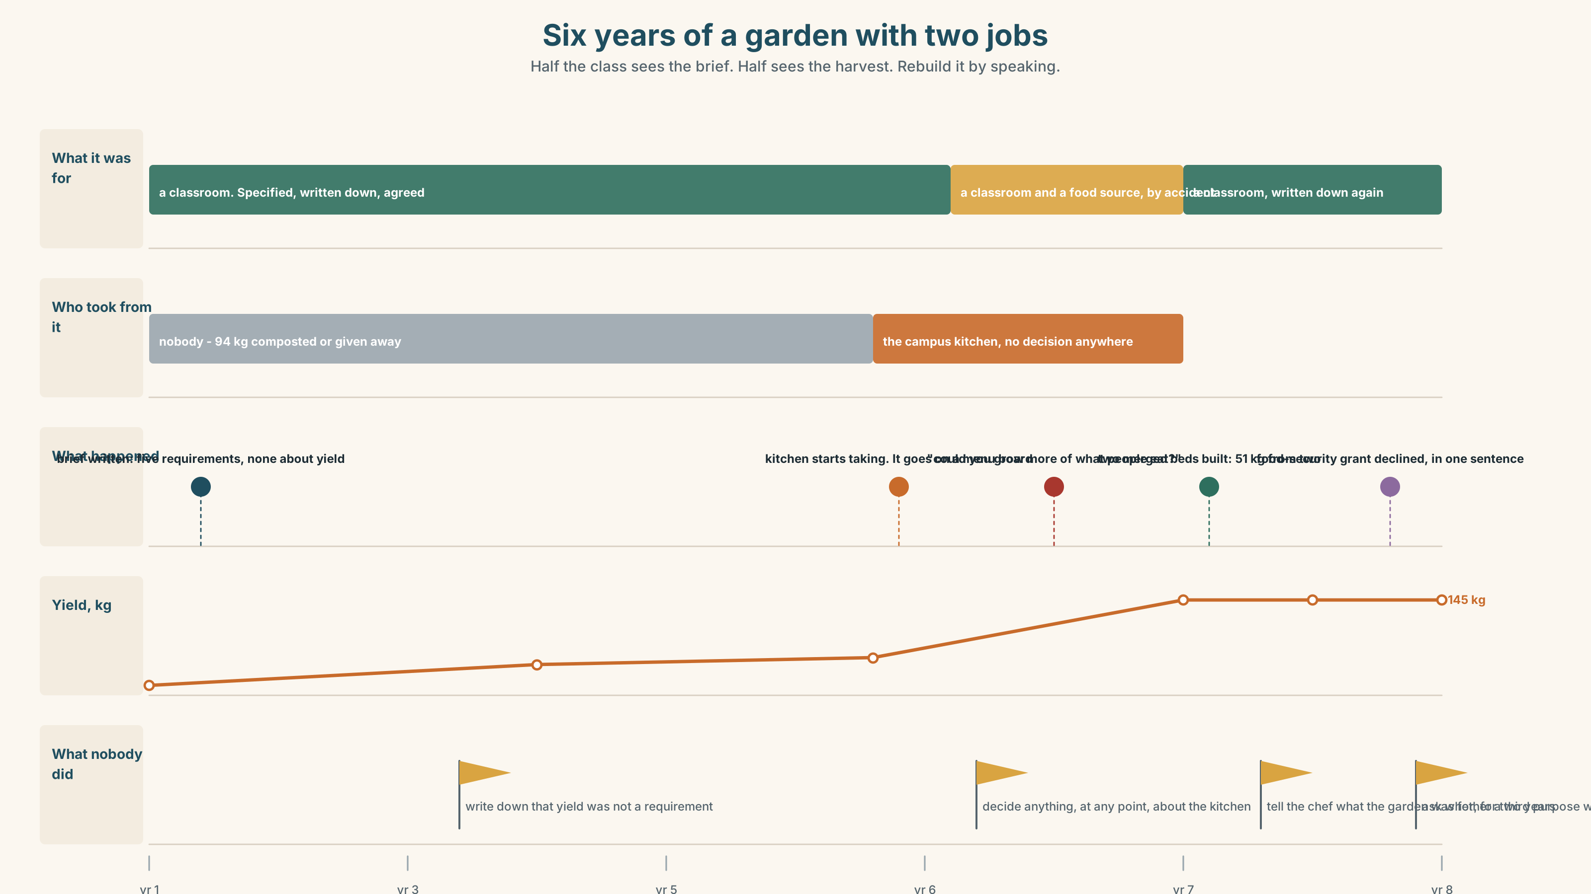{width=6.6in}
Six years of a garden with two jobs — Half the class sees the brief. Half sees the harvest. Rebuild it by speaking.

10A · Relay
Half the class sees the design brief. Half sees the harvest figures. Rebuild the garden by speaking. Twelve minutes.

10B · Simplify
Explain the metre-square decision to somebody who has just asked why you do not merge the beds. Five sentences only.
Plan: what the bed is for → what a student does in it → what happens if it is bigger → what that costs in food → what the garden is not

10C · Compress
The explainer in Part 5B into forty words, keeping the trade-off.

10D · Online
Write one message to the campus kitchen: you understand the request, you can name exactly what it would cost, and you are proposing one specific experiment for one season.

10E · Your language
Does your language separate purpose from result the way English does? Say so that nobody would notice and so that nobody noticed in both languages. Which distinction survives?

Part 11 · The Decision ◆ C · THE PERFORMANCE

A classroom, or a market garden
The garden produced 94 kg last year across 40 metre-square beds. A merged plot on the same land would produce about 480 kg. The kitchen uses 94 kg in four days and 480 kg in nineteen.
- Keep it as a classroom. Twelve crops, forty beds, twenty students a semester. The kitchen takes what there is and nobody calls it a food source.
- Convert it. Four crops, merged plots, five times the yield. Students visit it rather than run it, and three of the twelve growing cycles disappear from the curriculum.
- Split it. Half classroom, half production. Half the beds, half the yield, and a boundary that will move every year in whichever direction has the louder advocate.

11A · The evidence
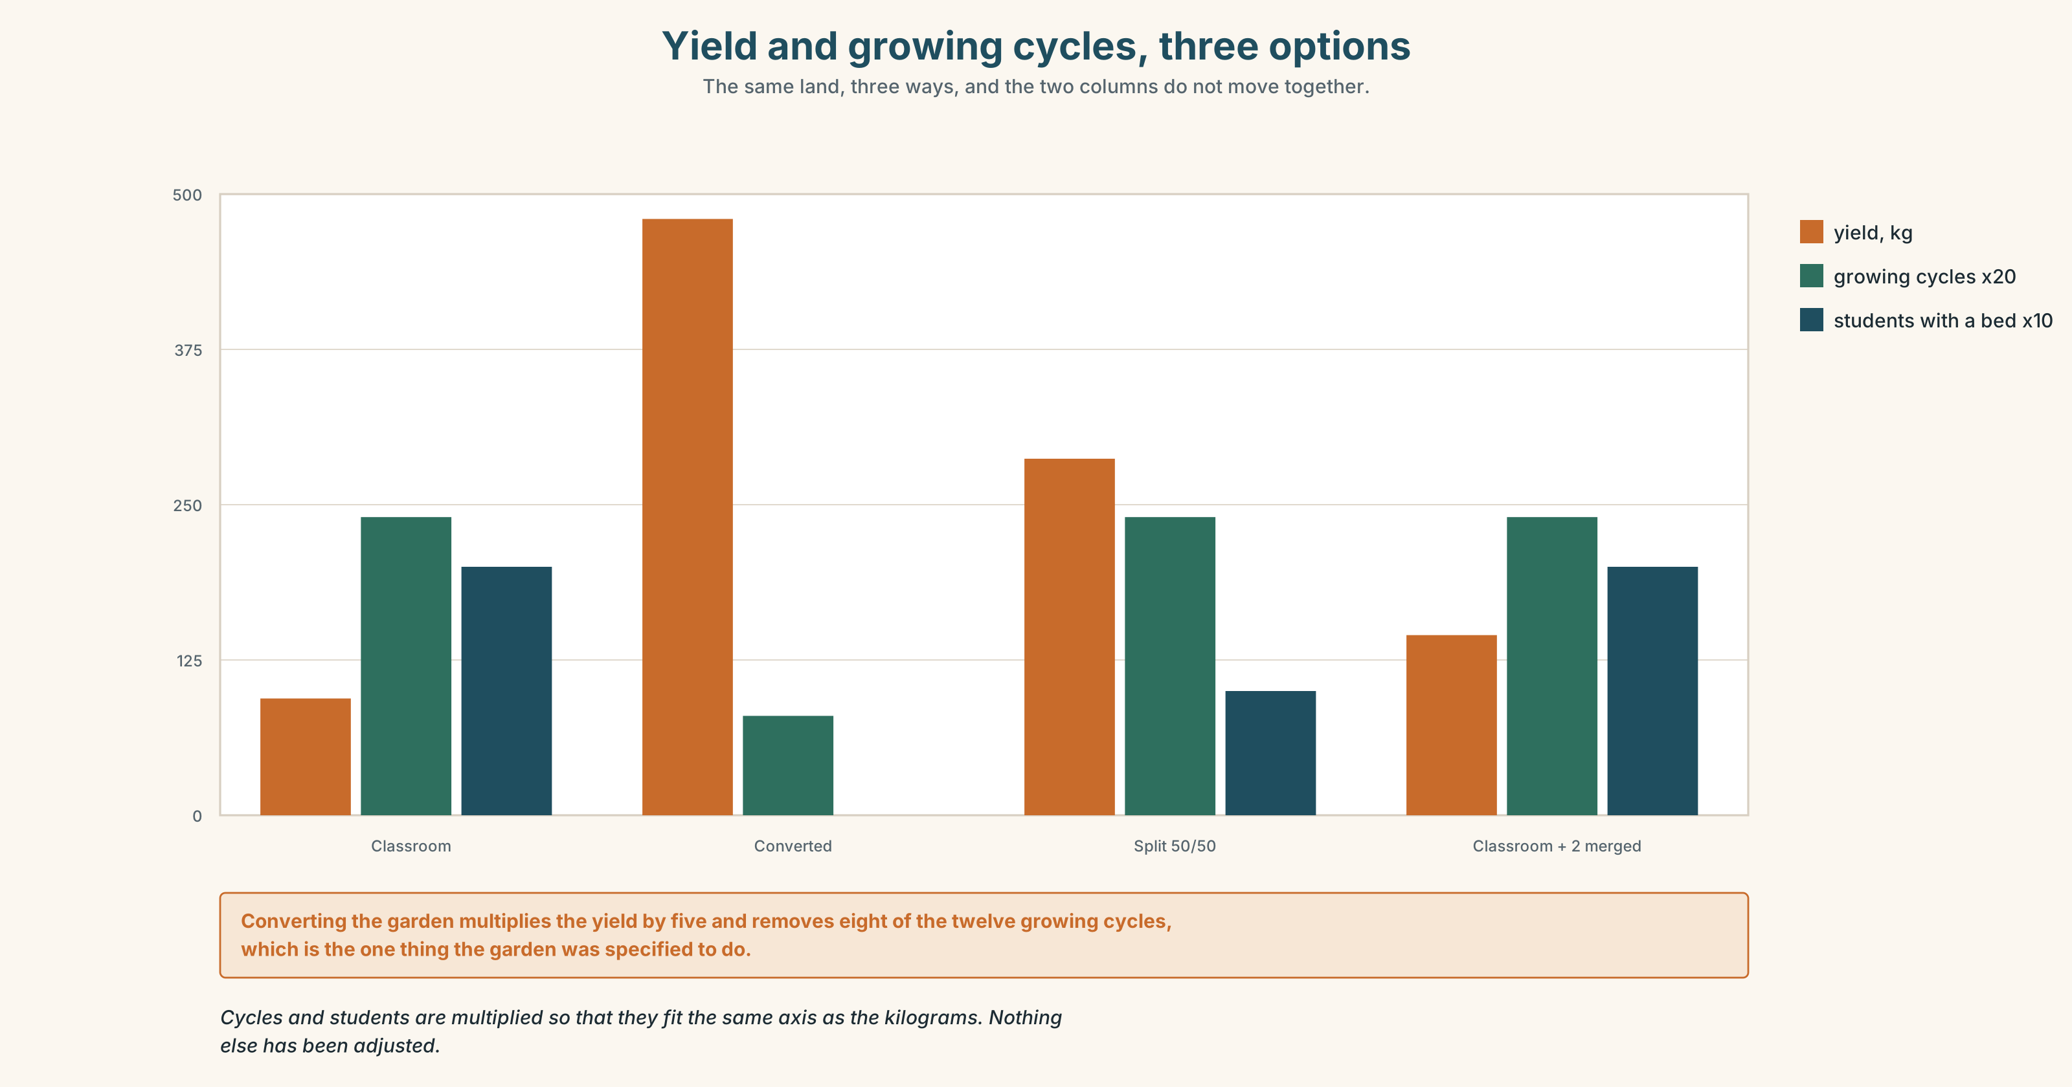{width=6.6in}
Yield and growing cycles, three options — The same land, three ways, and the two columns do not move together.
- The brief and the harvest sheet from Part 5E — and the line added by hand.
- The chart — yield per square metre, and growing cycles taught, for each option.
- The voice. A third-year, thirty seconds: "I killed a bed of brassicas in second year by standing on it in March. Nobody told me I had. I worked it out in September from the yield, and I have never stood on soil since. You cannot teach that in a merged plot, because in a merged plot nobody would ever have known it was me."

11B · Talk about it
In fours. Everybody speaks twice. Use the frame.
It was built so that ______ . In practice ______ , which is why ______ .
Words you can use: purpose · rationale · constraint · trade-off · specification · yield · plot · harvest · curriculum · by design

11C · Decide
Write three sentences. Choose, say why, and name what it costs.
I think the School should ______________________ , because ______________________ . What this costs is ______________________ .

11D · Model decision
Keep it as a classroom and build two merged beds at the far end, as the model in 8A suggests. The merged beds are not a compromise between the two purposes; they are part of the first one. A student who has managed a metre square and then seen what the same soil does at scale has learned the trade-off rather than been told it. The kitchen gets about twelve extra kilos, which is nothing, and that is also part of the lesson.

11E · The Reveal
What happened. The two merged beds went in. They produced 51 kilograms between them, which is more than half of what the other forty beds produced together, and the figure is now on the wall of the teaching shed where every student sees it in week one.
The kitchen stopped taking from the garden the following year, not because anybody asked but because the head chef read the explainer and said she had not realised the garden was a classroom. The menu board was changed in an afternoon.
Two years later the School was asked to double the garden for a food-security grant. They said no, and the sentence they used in the application was it does one of them well, which the funder quoted back approvingly in a rejection letter.
The two beds taught the thing the garden could not say. The chef changed a menu board because somebody finally wrote down what the garden was for.
Was it the right decision? Say why — and say what the School should do about the grant.

Part 12 · Landing ◆ all three lines

12A · Recycle — twelve items
- The beds are small ______ each student can reach the middle.
- We planted twelve crops ______ show twelve cycles.
- The yield is ______ low ______ nobody notices.
- It is ______ a low yield ______ nobody notices.
- ______ to the curriculum, the beds cannot be merged.
- We built it ______ as to test one thing.
- The beds are small; ______ , the yield is low.
- A system ______ each student manages one bed.
- We ______ out to build a classroom.
- We ______ up with a market garden.
- They ______ it down to twenty beds.
- You have to ______ that in at the start.

12B · Consolidate
Three columns, from memory: purpose forms · reason forms · result forms.

12C · Can-do, with evidence
☐ I can explain a decision by its purpose, not its rule. Evidence: 4C, 8D ☐ I can use so that, in order to and so … that correctly. Evidence: 3H, 6F ☐ I can name a trade-off with both sides measured. Evidence: 8D, 11C ☐ I can stress a purpose clause where the new information is. Evidence: 7D

12D · Replay ⏺
Record 0C again. Listen to both. What have you got that you did not have in week one?

12E · Glossary — forty-five items, as a map
THE DESIGN · purpose · intention · rationale · specification · requirement · constraint · trade-off · prototype · a design brief THE GARDEN · yield · plot · harvest · curriculum THE MOVES · set out to · end up · scale down · build in · by design · in practice · the whole point · serve a purpose · at the expense of WHAT PEOPLE SAY · that was never the idea · it does one of them well PURPOSE · so that · in order to · so as to · with a view to · for the sake of REASON · because · since · as · owing to · whereby RESULT · so · such · such that · therefore · thus · hence · consequently · the result being · lead to · bring about · which is why it is there

12F · Next
Unit 5 · What is the point exactly?

