Handout 1.1
Who the statements are for
Primary users · what makes information useful · five verbs the exam uses precisely
CYCLE A | Who the statements are written for

ORIENT Two minutes, alone, from what you already know.

1. A bank is deciding whether to lend to a company for five years. In one sentence, what is the single question the bank most wants the statements to answer?

2. A company publishes one set of statements that many different readers use at the same time, rather than a separate report for each reader. Those statements are called:
A. general-purpose financial statements
B. special-purpose reports
C. internal management reports
D. regulatory filings

MODEL Read the panel before you answer anything. Do not memorise it — you are about to be asked to take it apart.

Who reads financial statements, and what each reader needs
User | Decision | Key question | Statements used most
Investors (shareholders) — PRIMARY | Buy, hold or sell shares | Will the company create future cash flows and returns? | Income statement, cash flows, balance sheet
Lenders (banks, bondholders) — PRIMARY | Lend, renew or stop a loan | Can the company pay interest and repay the principal on time? | Cash flows, balance sheet
Other creditors (suppliers) — PRIMARY | Sell on credit, set credit terms | Will the company pay its bills when due? | Balance sheet (short-term items), cash flows
Employees and unions | Stay, negotiate pay | Is the company stable and profitable? | Income statement
Customers | Sign long-term contracts | Will the company continue to supply us? | Balance sheet, income statement
Governments and regulators | Tax, oversight, statistics | Does the company follow the rules and pay its taxes? | All statements and notes
Managers (internal) | Plan and control operations | Not a primary user: can use internal reports | Internal management reports
Three of these readers are marked PRIMARY. The rest are users too.
READ THE MODEL Every answer is somewhere in the panel. Find it, do not recall it.

3. How many of the readers in the panel are marked PRIMARY?

4. Which reader’s key question is about being paid when the bills fall due?

5. Which two readers rely most on the statement of cash flows together with the balance sheet?

6. Managers appear in the panel, but not as a primary user. Write the reason the panel itself gives.

7. Every reader in the panel uses the income statement more than any other statement. T / F
TAKE A ROLE | One reader each. Answer only from your reader’s column, then fill the row together.
INVESTOR | LENDER | SUPPLIER | REGULATOR
Why might you still buy shares in a company that made a loss this year? | The company is very profitable but has almost no cash. Do you renew the loan? | You are asked for 90-day credit terms. What do you look at first? | What do you look at that none of the other three reads closely?

INVENT THE RULE Write it in your own words. The book’s wording is in the key — compare afterwards, do not copy first.

8. Using the panel, write the rule that decides who counts as a primary user.
use every one of these words: resources · investors · lenders · creditors
The primary users are , and .
They are primary because they give the company and cannot .

Two readers, one difference
A bank lending for five years | The company’s own finance manager
Reads the published statements. | Reads the published statements too.
Cannot demand a special report. | Can ask for any internal report.
Is it a primary user? | Is it a primary user?
Both read the same statements. Write the one difference that makes only one of them a primary user.

APPLY No help on this move.

9. Which group is a primary user of general-purpose financial statements?
A. The company’s managers | C. The company’s board of directors
B. The company’s internal auditors | D. Existing and potential lenders
10. Under the U.S. conceptual framework, the objective of general-purpose financial reporting is to provide useful information mainly to:
A. the board of directors and senior management
B. government statisticians and tax authorities
C. existing and potential investors, lenders and other creditors
D. the company’s employees and trade unions
11. A bank is deciding whether to renew a five-year loan. Which information will the bank find MOST useful?
A. The highest and lowest share price during the year
B. The company’s ability to generate cash to pay interest and repay principal
C. The number of products the company sells
D. The names of the company’s major shareholders
CHECKPOINT 12. Name the three primary users, and say in one clause why managers are not among them.

If you could not answer it: redo the READ THE MODEL questions of cycle A, with the panel in front of you.

CYCLE B | What makes the information useful

ORIENT One question, from the cycle you have just done.

13. A lender wants to know whether a company can repay a loan. Would a figure for last year’s sales help that decision? Answer yes or no, and add three words saying why.

MODEL One figure. The levels in it are the whole point: two qualities rank above the other four.

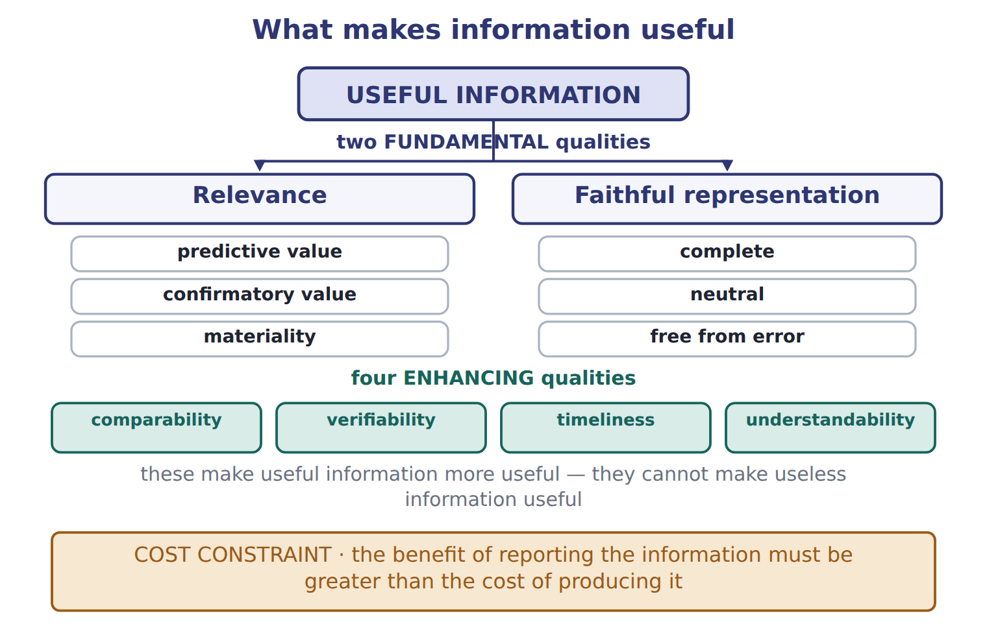
READ THE MODEL All six answers are in the figure.

The two fundamental qualities are and .
16. The figure puts three things under relevance. Name them.

17. The figure puts three things under faithful representation. Name them.

18. How many enhancing qualities does the figure show, and what does the line beneath them say they cannot do?

19. The band at the foot of the figure is not a quality at all. What is it, and what does it weigh against what?

20. Comparability ranks equally with relevance in the figure. T / F
WORK IN PAIRS | Answer the next item alone first, then compare with your partner.
If you disagree: go back to the figure and find the level each word sits on. The level settles it.
INVENT THE RULE

21. Write what each of the two fundamental qualities asks of a number.
use every one of these words: decision · claims · complete · neutral
Relevance asks: could this number change a ?
Faithful representation asks: does this number show what it to show?

One company, two faults
Report A | Report B
Last year’s sales, measured exactly and audited. | A forecast of next year’s cash, written by the sales team to look good.
The reader is deciding whether to lend for five years. | The reader is deciding whether to lend for five years.
Complete, neutral, free from error — but does it bear on the decision? | It bears on the decision — but is it neutral?
Each report fails one of the two fundamental qualities. Name which quality each one fails, and say why neither report is useful on its own.

APPLY

22. Information helps an investor forecast next year’s cash flows. This information has:
A. predictive value | C. comparability
B. verifiability | D. timeliness
23. Two companies use the same accounting methods, so an analyst can compare their results. This quality is called:
A. relevance | C. faithful representation
B. verifiability | D. comparability
24. A company leaves a small amount out of its statements because including it could not change any reader’s decision. Name the idea that permits this, and say which fundamental quality it belongs to.

CHECKPOINT 25. Which two qualities are fundamental, and which four are only enhancing?

If you could not answer it: redo the READ THE MODEL questions of cycle B with the figure open.

CYCLE C | Five verbs the exam uses precisely

ORIENT

26. A company explains its revenue policy in the notes rather than on the face of a statement. Is that policy presented or disclosed?

MODEL One item’s life, in five stages.

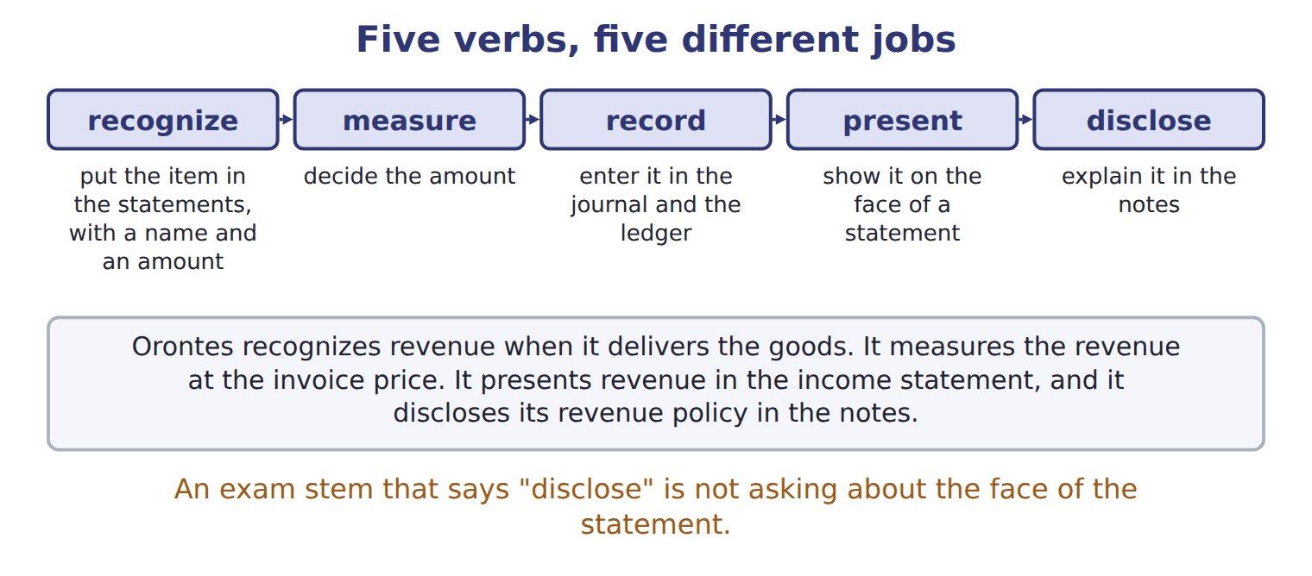
READ THE MODEL

27. Write the letter of the meaning beside each verb.
A decide the amount of the item | D show the item on the face of a statement
B explain the item in the notes to the statements | E enter the item in the accounts, in the journal and the ledger
C include the item in the statements, with a name and an amount

27. recognize
28. measure
29. record
30. present
31. disclose

32. Which one of the five verbs is the only one that does not put anything in the statements themselves?

APPLY

Orontes revenue when it delivers the goods. It the revenue at the invoice price. It revenue in the income statement, and it its revenue policy in the notes.
37. An exam stem asks what a company must DISCLOSE about a policy. The answer must therefore be about:
A. the face of the balance sheet | C. the journal entry
B. the notes to the statements | D. the amount chosen
CHECKPOINT 38. Which verb means to decide the amount, and which means to explain the item in the notes?

If you could not answer it: redo the matching item in cycle C.

FROM MEMORY | Close the earlier pages first.
39. Rebuild the qualities figure. Write the two fundamental qualities, the three parts under each, the four enhancing qualities and the constraint at the foot. Close the earlier pages first.
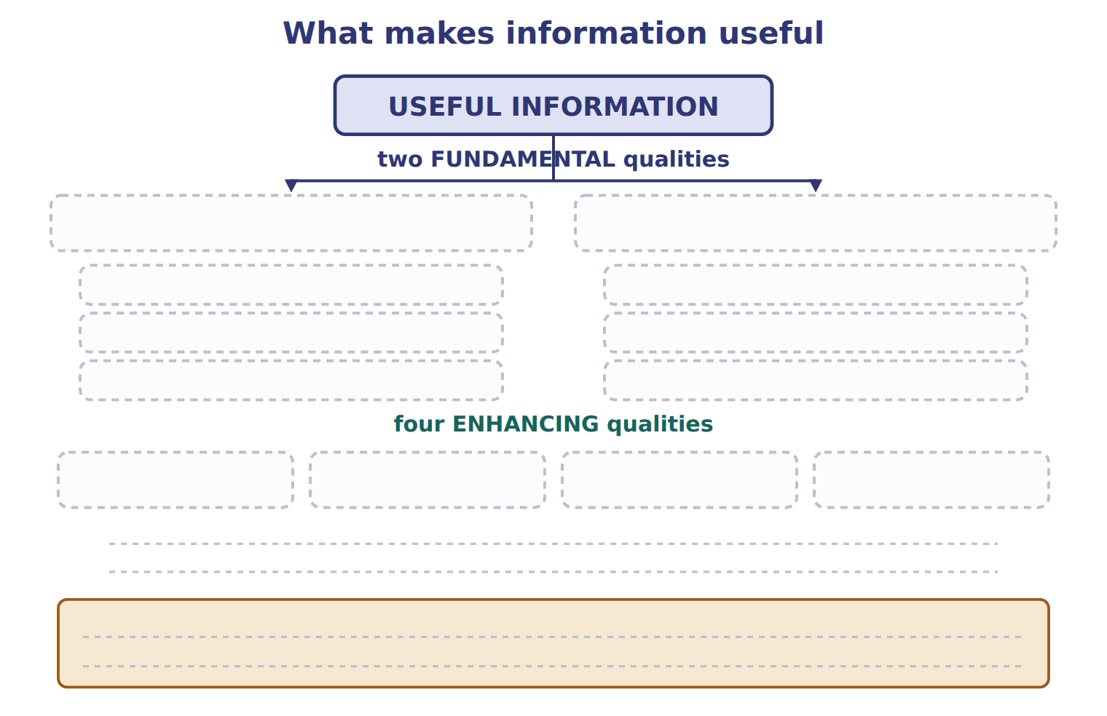
TEACH IT BACK | Write it for a classmate who missed this session — not for the marker.
40. In three or four sentences, explain who general-purpose financial statements are written for, and why the company’s own manager is not one of those readers.
every one of these words must appear: primary users · resources · special reports · management accounting

Handout 1.2
The elements, and the equation
Ten elements · assets = liabilities + equity · what a transaction does to both sides
60 SECONDS | Answer from memory. Do not look anything up.
1. The three primary users are | 4. Materiality belongs under which fundamental quality?
2. The two fundamental qualities are | 5. Is a manager a primary user?
3. Which verb means "explain it in the notes"? | 6. Which quality lets you compare two companies?

CYCLE A | Ten elements, and the line that divides them

ORIENT From what you already know. Two minutes.

1. Orontes sells olive oil, which is its ordinary business. It also sells an old delivery truck, which is not. Both bring money in. Guess: does the book give those two the same name?

MODEL Ten elements. One column is the book’s own definition; read the definitions, not the names.

The ten elements of the FASB conceptual framework
Element | What the book says it is | An example from Orontes
Asset | a present right of an entity to an economic benefit | cash, accounts receivable, inventory, equipment
Liability | a present obligation of an entity to transfer an economic benefit | accounts payable, notes payable, wages payable
Equity | the residual interest in the assets after the liabilities are deducted | the owners’ claim on what is left
Revenue | from the company’s central, ongoing operations | selling olive oil
Expense | from the company’s central, ongoing operations | paying the plant workers
Gain | from peripheral or incidental events | selling an old delivery truck for more than its carrying amount
Loss | from peripheral or incidental events | the same sale at less than the carrying amount
Investments by owners | increase equity | buying new shares
Distributions to owners | decrease equity | a dividend
Comprehensive income | the total change in equity from sources other than owners | met in full in Chapters 3 and 15
Three of these describe the balance sheet at one date. The rest describe changes during a period.
READ THE MODEL

2. Which three elements describe the balance sheet at one date?

3. Two elements share the words "central, ongoing operations". Name them.

4. Two elements share the words "peripheral or incidental". Name them.

5. The definition of equity does not describe a thing the company owns. Copy the four words that say what it is instead.

6. A distribution to owners is one of the ten elements. T / F
INVENT THE RULE

7. Write the test that decides whether money coming in is revenue or a gain.
use every one of these words: central · ongoing · revenue · peripheral
If the money comes from the company’s operations, it is .
If it comes from a or incidental event, it is a .

Two sales by the same company, on the same day
Orontes sells olive oil to a supermarket | Orontes sells its old delivery truck
This is what Orontes exists to do. | Orontes is not in the truck business.
The amount received is 300. | The truck sold for more than its carrying amount.
Revenue, or gain? | Revenue, or gain?
Name each one, and write the single word in the definitions that decides between them.

APPLY

8. Which item is an expense?
A. A cash dividend paid to shareholders
B. Wages paid to plant workers
C. Repayment of a bank loan
D. Purchase of a new bottling line
CHECKPOINT 9. Which two elements come from central, ongoing operations, and which two come from peripheral events?

If you could not answer it: redo the READ THE MODEL questions of cycle A with the panel in front of you.

CYCLE B | The equation that never tips

ORIENT

10. A company has assets of 500 and liabilities of 320. What is left over for the owners?

MODEL One figure. The beam is not decoration: the two pans are the two sides of the equation, and the stack on the right is the point.

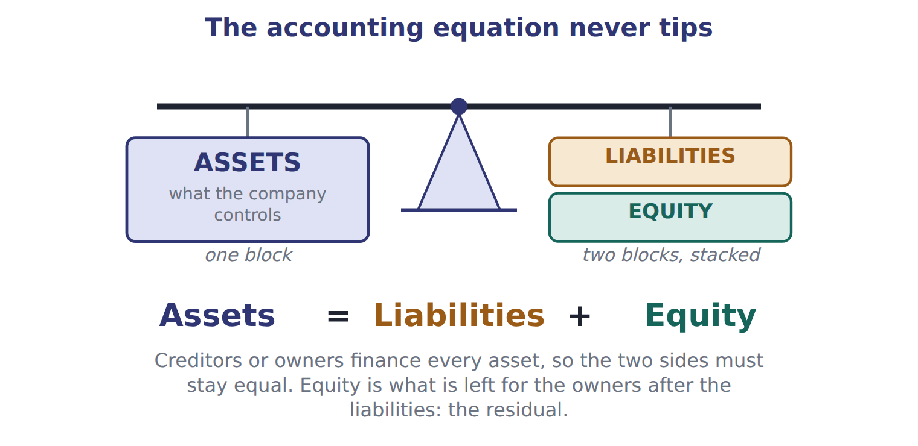
READ THE MODEL

11. How many blocks sit on the left pan, and how many on the right?

The equation under the beam reads: = + .
15. The figure gives a reason why the two sides must stay equal. Write it in your own words.

16. Which word in the figure says that equity is what is left over rather than a thing the company holds?

WORK IN PAIRS | Answer the next item alone, then compare.
If you disagree: rearrange the equation on paper. Whoever can write the rearranged form is right.
INVENT THE RULE

17. Write the equation three ways: solved for each of its three parts.
use every one of these words: assets · liabilities · equity · two
Assets = + Liabilities = − Equity = −
The equation holds after every transaction because every transaction has at least effects.

Two companies, one difference
Levant Foods | Barada Trading | Cedar Imports
Assets 500 | Assets 500 | Assets 500
Liabilities 320 | Liabilities 100 | Liabilities 500
Equity ? | Equity ? | Equity ?
Fill in all three. The assets are identical, so write the one sentence that explains why the owners’ claim is not.

APPLY

18. A company has total assets of 500 and total liabilities of 320. What is its equity?
A. 180 | C. 500
B. 320 | D. 820
19. A company has assets of 900 and liabilities of 350. It then borrows 100 in cash and declares and pays a cash dividend of 40. What is total equity after these transactions?
A. 450 | C. 550
B. 510 | D. 610
CHECKPOINT 20. A company’s assets rise by 800 and its liabilities rise by 800. By how much does equity change?

If you could not answer it: redo the contrasting cases in cycle B.

CYCLE C | What a transaction does to the equation

ORIENT

21. Orontes pays 1,200 cash for a bottling line. Cash falls. Does anything else on the left pan rise?

MODEL Four transactions, worked. The last column is the one to watch.

Four transactions and what each does to the equation
Issue shares for cash 1,500 | assets +1,500 and equity +1,500 — both sides rise
Borrow cash on a note 800 | assets +800 and liabilities +800 — both sides rise
Buy a bottling line for cash 1,200 | assets +1,200 and −1,200 — one asset becomes another, nothing else moves
Pay wages in cash 40 | assets −40 and equity −40 — an expense reduces the owners’ claim

READ THE MODEL

22. Which of the four transactions leaves total assets unchanged?

23. Which of the four changes equity without any cash leaving the owners’ side? Give the transaction and say whether equity rose or fell.

24. Borrowing 800 in cash increases the company’s equity. T / F

PREDICT FIRST | Before you answer the next two items, write what you expect a cash dividend to do to assets and to equity.
what I think will happen | what the figures actually show
A dividend declared but not yet paid moves liabilities and equity, and leaves assets alone until the cash goes out.

APPLY

25. A company issues common stock for cash. What is the effect on the accounting equation?
A. Assets increase and equity increases.
B. Assets increase and revenue increases.
C. Assets increase and liabilities increase.
D. There is no effect on the equation.
26. Which transaction changes total assets but does NOT change total equity?
A. Borrowing cash from a bank
B. Paying wages in cash
C. Selling goods on credit at a profit
D. Buying equipment for cash
CHECKPOINT 27. Name one transaction that changes total assets without changing equity, and one that changes equity without changing total liabilities.

If you could not answer it: redo the worked trace at the start of cycle C and read the right column aloud.

FROM MEMORY | Close the earlier pages first.
28. Rebuild the beam. Label both pans, write the equation underneath, and add the one sentence that says why the two sides must stay equal.
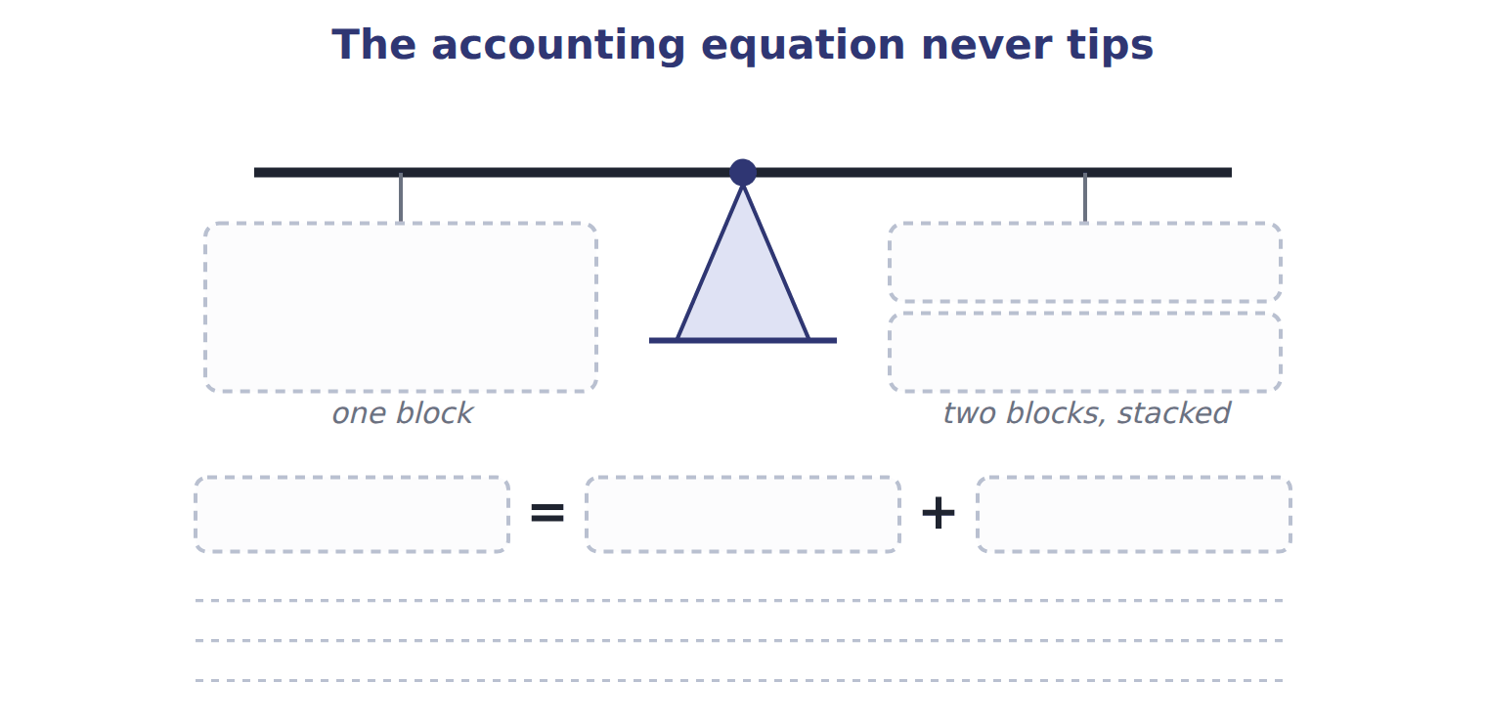
TEACH IT BACK | Write it for a classmate who has just learned the word "equity" — not for the marker.
29. In three or four sentences, explain why equity is called a residual and why the equation can never be out of balance.
every one of these words must appear: residual · assets · liabilities · finance

Handout 1.3
Inside equity
Contributed capital and retained earnings · the dividend trap · words that look familiar and are not
60 SECONDS | Answer from memory. Do not look anything up.
1. Assets = liabilities + | 4. A gain comes from which kind of event?
2. Equity is the ______ interest in the assets | 5. Name one element that decreases equity
3. Revenue comes from which kind of operations? | 6. Does borrowing cash change equity?

CYCLE A | Equity has two parts, and they fill up differently

ORIENT

1. Two ways money can end up in the owners’ claim: the owners put it in, or the company earns it and keeps it. Which of the two depends on the company trading profitably?

MODEL One figure. Follow the two branches first, then the five arrows on the right.

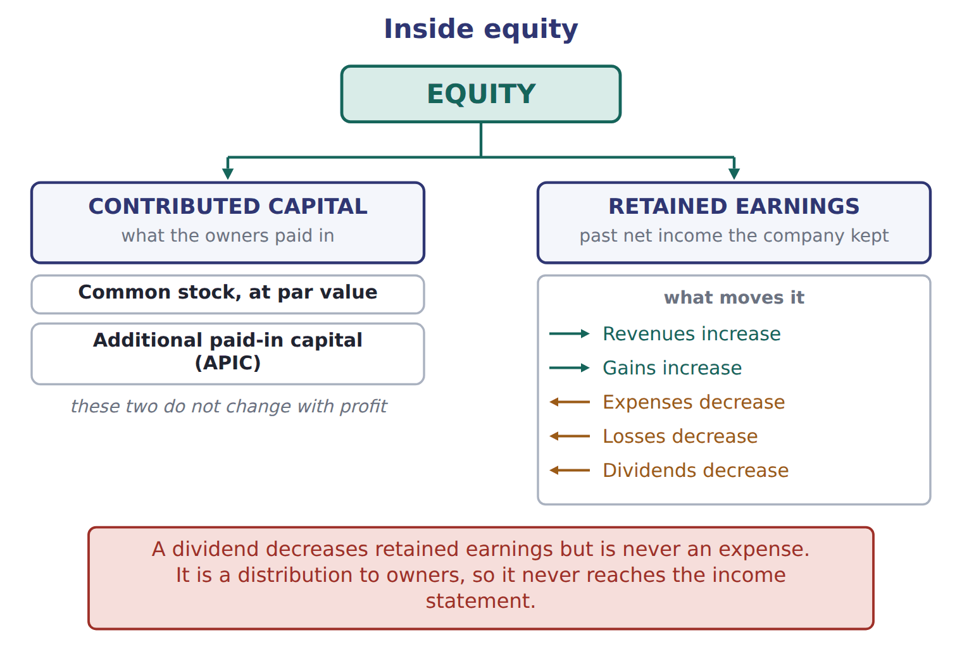
READ THE MODEL

2. Equity splits into two boxes in the figure. Name both.

3. Contributed capital itself holds two accounts. Name them.

4. The figure shows two things that increase retained earnings and three that decrease it. List all five.

5. Which of the five is NOT an expense, even though it reduces retained earnings?

6. A profitable year increases common stock. T / F
INVENT THE RULE

7. Write the test that decides which part of equity an amount belongs to.
use every one of these words: owners · contributed capital · earned · retained earnings
If the amount came from the , it goes to .
If the company it and did not pay it out, it goes to .

Two amounts of 1,400 in the same company
Shares issued above par | A profitable year
Owners paid 15 a share for 1 par shares. | The company earned it by selling olive oil.
The 14 above par, times 100,000 shares. | No dividend was paid out of it.
Which equity account? | Which equity account?
Both amounts sit inside equity. Name the account each belongs to, and write the one question that tells them apart.

APPLY

SORT THEM | Write each item under the equity account it belongs to.
the items: the par value of shares issued · the amount paid above par value · last year’s net income that was kept · a dividend declared · this year’s loss
Common stock | Additional paid-in capital | Retained earnings

CHECKPOINT 11. Which part of equity does a profitable year increase, and which part does issuing shares increase?

If you could not answer it: redo the READ THE MODEL questions of cycle A with the figure in front of you.

CYCLE B | The dividend trap

ORIENT

12. Wages reduce retained earnings. A dividend reduces retained earnings. Only one of the two also reduces net income. Which?

MODEL The board declares a dividend of 50 on January 31, payable on February 15. Here is what happens, and when.

One dividend, two dates
Jan 31 · the board declares 50 | retained earnings fall by 50, and a liability of 50 is created
Jan 31 · net income | unchanged — a dividend is not an expense
Jan 31 · cash | unchanged — nothing has been paid yet
Feb 15 · the dividend is paid | the liability of 50 goes, and cash falls by 50
Feb 15 · retained earnings | unchanged — they already fell in January, on declaration

READ THE MODEL

13. On which of the two dates do retained earnings fall?

14. On which of the two dates does cash fall?

15. What is created on January 31 that did not exist before?

16. Net income for January is 50 lower because of the dividend. T / F
WORK IN PAIRS | Answer the next item alone first, then compare.
If you disagree: find the row in the trace that names the date. The date settles it.
INVENT THE RULE

17. Write why a dividend reduces the owners’ claim without ever being an expense.
use every one of these words: distribution · owners · retained earnings · income statement
A dividend is a to , not a cost of .
So it reduces but never appears in the .

Two payments of 40 and 50, in the same month
Wages of 40 paid to plant workers | A dividend of 50 declared for shareholders
Who receives it? The workers. | Who receives it? The owners.
Is it a cost of earning this year’s revenue? | Is it a cost of earning this year’s revenue?
Does net income change? | Does net income change?
Answer all three rows for both. Then write the single word that separates a cost of earning from a distribution of what was earned.

APPLY

18. The board declares a cash dividend that will be paid next month. What is the effect immediately after the declaration?
A. Expenses increase and net income decreases.
B. Liabilities increase and equity decreases.
C. Assets decrease and equity decreases.
D. There is no effect until the dividend is paid.
19. Paying a dividend that was declared last month reduces retained earnings again. T / F

CHECKPOINT 20. A dividend is declared in January and paid in February. In which month do retained earnings fall, and in which month does cash fall?

If you could not answer it: redo the worked trace at the start of cycle B, reading the dates aloud.

CYCLE C | Words that look familiar and are not

ORIENT

21. In a CMA question, does the word "stock" mean shares or goods held for sale?

MODEL Four traps the book names, and the English the exam expects instead.

Four words that mislead a reader coming from Arabic or French
The familiar word | What it suggests | What the exam means
stock | in French and British English, goods held for sale | shares: common stock, a stock dividend. Goods for sale are inventory
income | Arabic دخل, any money coming in | net income is what remains after expenses; the gross amount from sales is revenue
charges | French charges, meaning expenses | in English, charges usually means fees. Expenses are expenses
balance | French la balance, the trial balance | the balance sheet is a statement of position; the trial balance is a different document

READ THE MODEL

22. Write the letter of the exam term beside each familiar word.
A shares | C what remains after expenses
B expenses | D a statement of position at one date

22. stock
23. income
24. charges
25. balance

26. A question says a company holds 400 of "stock". If it is a CMA question, what is being held?

MODEL The same items under IFRS. The ideas are the same; only the names differ.

The same item, two names
U.S. GAAP (used on the exam) | IFRS
balance sheet | statement of financial position
income statement | statement of profit or loss
common stock | share capital (ordinary shares)
additional paid-in capital | share premium
accounts receivable | trade receivables
net income | profit

APPLY

27. A Jordanian company’s IFRS statements show share premium of 400. Under U.S. GAAP, the same item is called:
A. retained earnings. | C. additional paid-in capital.
B. common stock. | D. treasury stock.
Under IFRS the balance sheet is called the , and net income is called .
CHECKPOINT 30. Give the U.S. GAAP name for share premium, and the IFRS name for the balance sheet.

If you could not answer it: redo the matching item in cycle C and read the two-name panel again.

FROM MEMORY | Close the earlier pages first.
31. Rebuild the equity figure. Show both branches, the two accounts inside contributed capital, and all five arrows into and out of retained earnings.
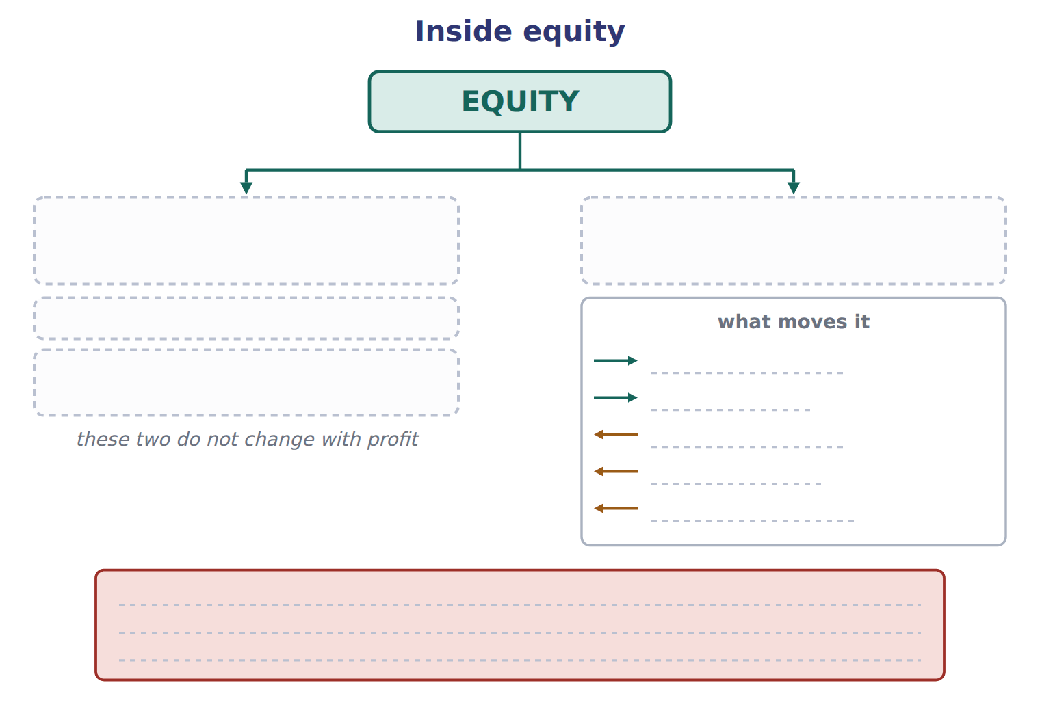
TEACH IT BACK | Write it for a new colleague — not for the marker.
32. In three to five sentences, explain why a cash dividend reduces retained earnings but does not appear in the income statement.
every one of these words must appear: distribution · owners · expense · retained earnings · net income

Handout 1.4
Debits and credits
Left and right · the normal balance · contra accounts · the road from a document to a statement
60 SECONDS | Answer from memory. Do not look anything up.
1. Equity splits into which two parts? | 4. The IFRS name for additional paid-in capital is
2. Does a dividend reduce net income? | 5. Assets = liabilities +
3. Revenue comes from which kind of operations? | 6. A gain comes from which kind of event?

CYCLE A | Debit is a side, not a verdict

ORIENT

1. Your bank tells you it has credited your account after you paid money in. From the bank’s point of view, what has the bank now got that it did not have before?

MODEL One figure. Read the two columns, then the strip at the foot — the strip is the memory aid that makes the columns unnecessary.

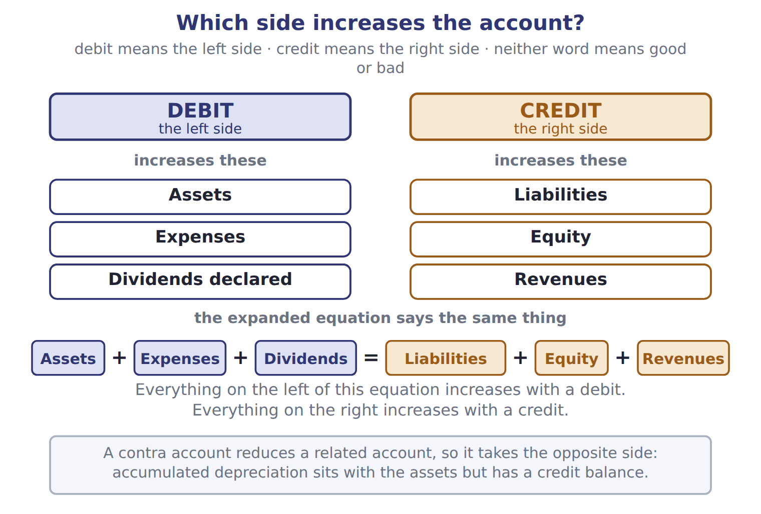
READ THE MODEL

2. Which side does the figure say a debit is, and which side is a credit?

3. The figure lists three account types that increase with a debit. Name all three.

4. And three that increase with a credit. Name all three.

The expanded equation in the figure reads: Assets + + = Liabilities + + .
9. A debit always increases an account. T / F
WORK IN PAIRS | Answer the next item alone, then compare.
If you disagree: write the expanded equation out. Whichever side the account sits on settles it.
INVENT THE RULE

10. Write the one-line rule that the expanded equation gives you, so you never have to memorise six account types.
use every one of these words: left · right · debit · credit
Everything on the of the expanded equation increases with a .
Everything on the of it increases with a .

Two accounts that both go up by 300
Accounts receivable rises by 300 | Sales revenue rises by 300
Which side of the expanded equation is it on? | Which side of the expanded equation is it on?
So which entry raises it? | So which entry raises it?
Both rise in the same transaction. Say which is debited and which is credited, and name the rule that decides.

APPLY

11. Which account normally has a debit balance?
A. Accounts payable | C. Prepaid rent
B. Sales revenue | D. Additional paid-in capital
SORT THEM | Write each account under the side that increases it.
the items: Inventory · Notes payable · Wages expense · Sales revenue · Common stock · Dividends declared
increases with a DEBIT | increases with a CREDIT

CHECKPOINT 14. Which side of the expanded equation increases with a debit, and name one account type on that side that is not an asset.

If you could not answer it: redo the READ THE MODEL questions of cycle A with the figure in front of you.

CYCLE B | The normal balance, and the accounts that invert it

ORIENT

15. Cash is an asset. On which side of a cash account would you expect to find its balance?

MODEL Two accounts, side by side. The shaded half of each is the side that increases it.

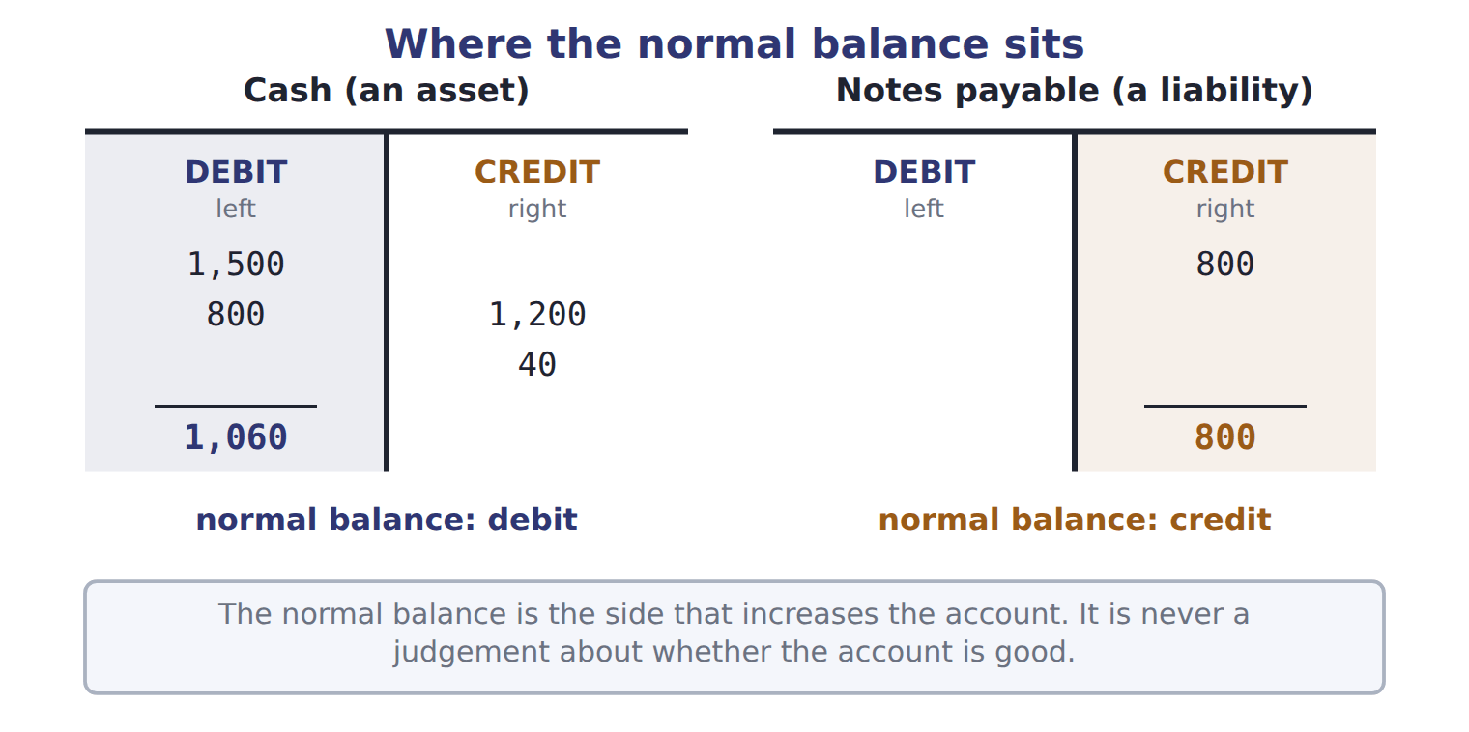
READ THE MODEL

16. The cash account shows 1,500 and 800 on one side and 1,200 and 40 on the other. Which side holds the balance of 1,060, and what is 1,500 + 800 − 1,200 − 40?

17. The notes payable account has its balance on the opposite side from cash. Which side, and why does the figure call that normal?

18. Write the sentence in the figure that says what the normal balance is NOT.

MODEL One more rule, in words rather than a figure: a contra account.

Accounts that sit with one group and behave like the other
Contra account | What it reduces | Its balance | Where it sits
Accumulated depreciation | Equipment | credit | with the assets
Allowance for credit losses | Accounts receivable | credit | with the assets
A contra account reduces a related account, so it takes the opposite normal balance.
INVENT THE RULE

19. Write what makes a contra account different from a liability, given that both carry a credit balance.
use every one of these words: reduces · asset · obligation · outside
A contra account a related account, so it belongs with the it reduces.
A liability is an to transfer an economic benefit to somebody the company.

Two credit balances in the same trial balance
Accumulated depreciation 900 | Notes payable 1,800
What does it reduce? | What does it reduce?
Does the company owe it to anyone? | Does the company owe it to anyone?
Where does it belong? | Where does it belong?
Both have credit balances. Fill in all three rows and then write the question that separates a contra-asset from a liability.

APPLY

20. Which account normally has a credit balance?
A. Prepaid rent | C. Cost of goods sold
B. Accumulated depreciation | D. Dividends declared
21. Accumulated depreciation is BEST described as:
A. a liability for future asset replacement.
B. a contra-asset account with a credit balance.
C. an expense of the current period.
D. a reduction of retained earnings.
CHECKPOINT 22. Name the two contra accounts in this cycle, say what each one reduces, and give the side each one’s balance sits on.

If you could not answer it: redo the contrasting cases in cycle B.

CYCLE C | Where a transaction actually goes

ORIENT

23. A trial balance adds up: total debits equal total credits. Does that prove every entry was put in the right account? Answer yes or no.

MODEL Five stops, in order.

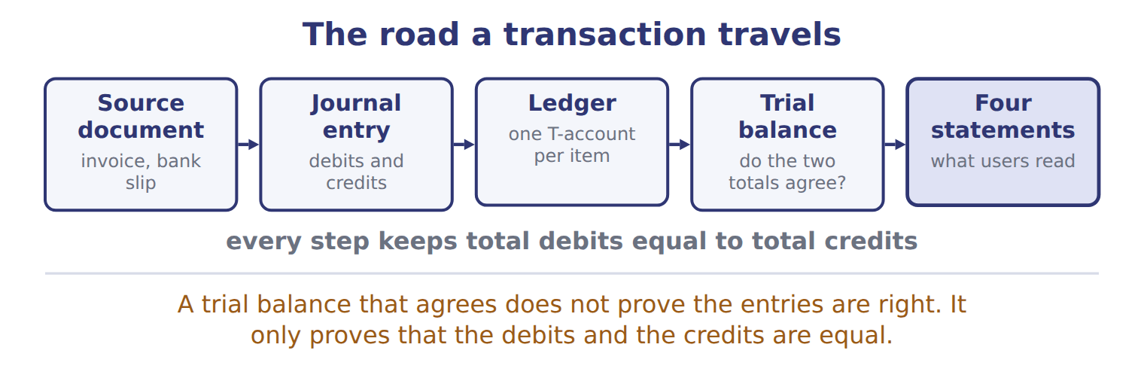
READ THE MODEL

24. Name the five stops in the order the figure gives them.

25. Which stop holds one T-account per item?

26. Copy the warning the figure gives about a trial balance that agrees.

ERROR HUNT | Four statements about the road a transaction travels. Mark each one right, or write what is wrong with it. (items 27 to 30)
the solution as written | right, or what is wrong with it
a | The ledger comes before the journal entry.
b | A trial balance that agrees proves no account was misclassified.
c | Every step keeps total debits equal to total credits.
d | The source document is produced after the statements.

CHECKPOINT 31. Put these in order: ledger, source document, trial balance, journal entry, four statements.

If you could not answer it: redo the READ THE MODEL questions of cycle C.

FROM MEMORY | Close the earlier pages first.
32. Rebuild the debit and credit figure. Write the three account types in each column and the full expanded equation at the foot.
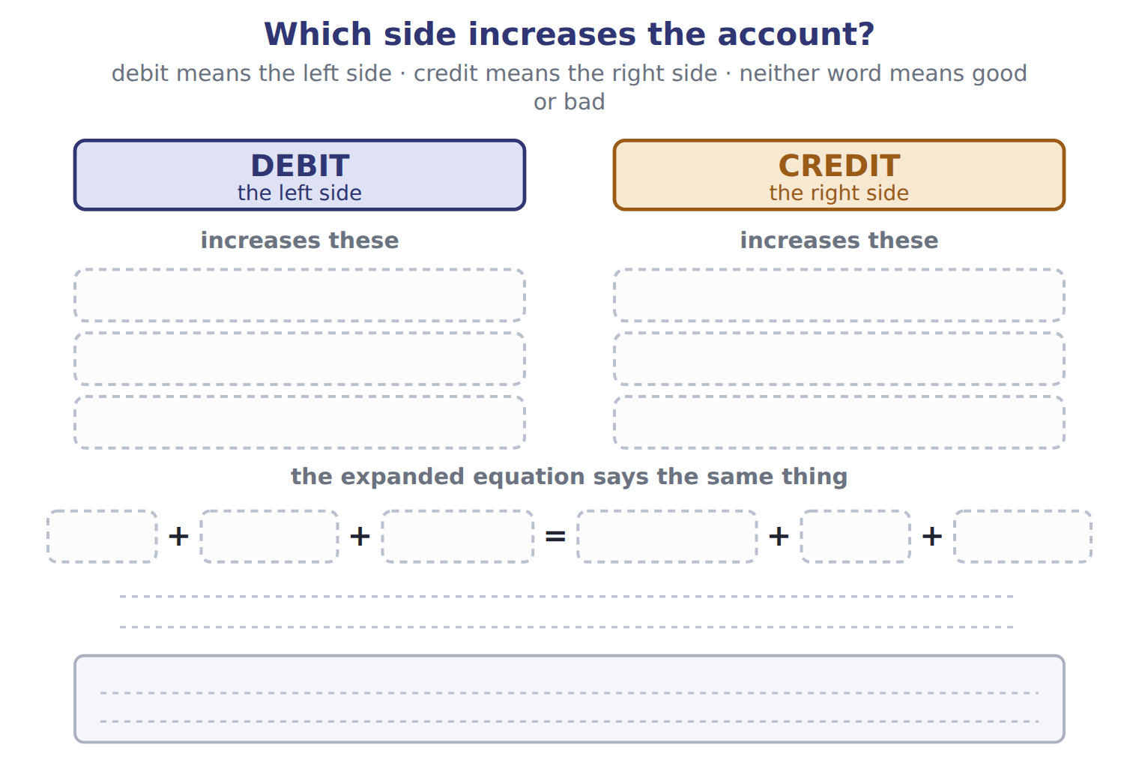
TEACH IT BACK | Write it for a student who thinks debit means "bad" — not for the marker.
33. In three or four sentences, explain what debit and credit actually mean and how to work out which one increases an account.
every one of these words must appear: left · right · normal balance · expanded equation

Handout 1.5
Six transactions in January
Reading a journal entry · the effect of each one · the three mistakes the exam keeps testing
60 SECONDS | Answer from memory. Do not look anything up.
1. Debit is which side? | 4. What does a trial balance prove?
2. Which side increases a liability? | 5. Dividends declared increase with a debit or a credit?
3. Name one contra-asset account | 6. The first stop on the road is the

CYCLE A | Reading a journal entry

ORIENT

1. A company sells shares with a par value of $1 each for $15 each. How much of the $15 is par, and how much is above par?

MODEL Six entries, as Orontes actually wrote them. Amounts are in USD 000.

Orontes Foods, Inc. — journal entries for January 2025
# | Date | Account | Debit | Credit
1 | Jan 2 | Cash | 1,500
 |  | Common stock |  | 100
 |  | Additional paid-in capital |  | 1,400
2 | Jan 5 | Cash | 800
 |  | Notes payable (long-term) |  | 800
3 | Jan 10 | Equipment | 1,200
 |  | Cash |  | 1,200
4 | Jan 18 | Accounts receivable | 300
 |  | Sales revenue |  | 300
 |  | Cost of goods sold | 180
 |  | Inventory |  | 180
5 | Jan 31 | Wages expense | 40
 |  | Cash |  | 40
6 | Jan 31 | Retained earnings (dividends declared) | 50
 |  | Dividends payable |  | 50
 |  | Totals | 4,070 | 4,070
Check each entry for yourself: the debits equal the credits.

What each entry was for
# | What Orontes did
1 | Issued 100,000 new shares of $1 par common stock for $15 per share, in cash.
2 | Borrowed cash from Levant Commerce Bank on a 5-year note at 6% interest.
3 | Bought a new bottling line for the Amman plant and paid cash.
4 | Sold olive oil to GreenBasket Supermarkets on credit. The goods had cost Orontes less than the selling price.
5 | Paid January wages to plant workers in cash.
6 | The board declared a cash dividend, payable on February 15.

READ THE MODEL

2. Entry 1 credits two accounts. Name both, and give the amount against each.

3. Entry 4 is really two entries at once. Write what each half records.

4. Which entry debits an account that has the word "expense" in its name, and for how much?

5. Entry 6 debits retained earnings. Which account does it credit, and what kind of account is that?

6. What are the two totals at the foot, and what does their being equal tell you?

WORK IN PAIRS | Answer the next item alone, then compare.
If you disagree: add the debit column and the credit column again. The arithmetic settles it.
INVENT THE RULE

7. Write the rule that decides how a share issue above par is split between two equity accounts.
use every one of these words: par · above · additional paid-in capital
Common stock is credited only with the value.
Everything received that goes to .

The same 1,500 of cash, arriving two ways
Entry 1 · shares issued for cash | Entry 2 · cash borrowed on a note
Who gave the cash? The owners. | Who gave the cash? A bank.
Which side of the equation rises? | Which side of the equation rises?
Is any of it revenue? | Is any of it revenue?
Both bring cash in and neither creates revenue. Write the one word that names what both of them are, and say why that word is not "income".

APPLY

8. Orontes buys a bottling line for 1,200 in cash. Which journal entry is correct?
A. Debit Cash 1,200; credit Equipment 1,200
B. Debit Equipment expense 1,200; credit Cash 1,200
C. Debit Equipment 1,200; credit Notes payable 1,200
D. Debit Equipment 1,200; credit Cash 1,200
CHECKPOINT 9. Entry 4 debits accounts receivable 300 and credits sales revenue 300. Why does it also debit cost of goods sold 180?

If you could not answer it: reread entries 4 and 5 in the journal panel of cycle A.

CYCLE B | The same six transactions, as effects

ORIENT

10. Orontes received 1,500 from shareholders and 800 from a bank in January: 2,300 of cash. How much of that 2,300 is revenue?

PREDICT FIRST | Before you turn to the grid: Orontes made a net income of 80 in January. Write what you expect the change in cash to be.
what I think will happen | what the figures actually show
Cash actually rose by 1,060. Net income and the change in cash are very different numbers, and that is the accrual basis at work.

MODEL The same six transactions, with the five totals each one moves.

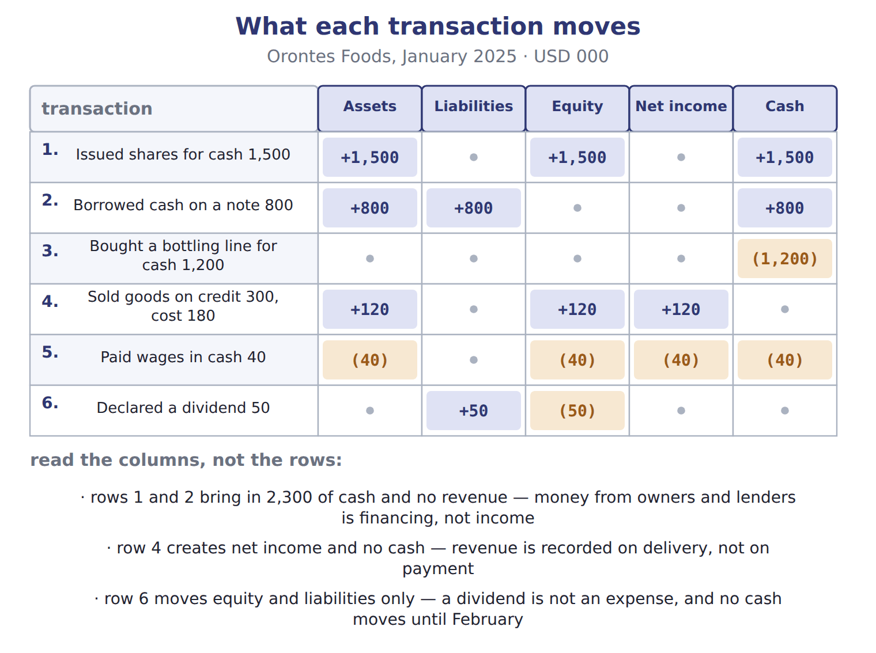
READ THE MODEL

11. Which transactions move cash but create no net income?

12. Which single transaction creates net income but moves no cash, and how much net income?

13. Row 6 moves two of the five columns. Which two, and in which direction?

14. Add the equity column. What is the net change in equity for January?

15. Add the net income column. What was January’s net income?

INVENT THE RULE

16. Write why net income and the change in cash are not the same number.
use every one of these words: hands · earned · incurred · accrual basis
Cash moves when money changes .
Net income moves when revenue is and expenses are , whatever the cash does.

The same company, the same month, two numbers
Net income for January | The change in cash for January
Revenue 300, cost of goods sold 180, wages 40. | An operating outflow, an investing outflow, a financing inflow.
Which events does it count? | Which events does it count?
What is the figure? | What is the figure?
Both describe January. Answer both rows for each, then write the one sentence that explains why two correct numbers differ so far.

APPLY

Complete the grid. Two rows are done; write + , − or 0 in every empty cell, and give the amount where there is one.
Transaction | Assets | Liabilities | Equity | Net income
Borrowed cash on a note 800 | +800 | +800 | 0 | 0
Paid wages in cash 40 | (40) | 0 | (40) | (40)
Issued shares for cash 1,500
Bought a bottling line for cash 1,200
Sold goods on credit 300, cost 180
Declared a dividend 50

CHECKPOINT 21. January’s net income was 80 and cash rose by 1,060. Name the basis of accounting that makes those two numbers differ.

If you could not answer it: reread the three notes under the effect figure in cycle B.

CYCLE C | Three mistakes the exam keeps testing

ORIENT

22. Buying equipment for cash is an expense of the month in which it is bought. T / F

MODEL The three the book names, with the right answer beside each.

Three classic mistakes
The mistake | What is actually true
Treating a dividend as an expense | It reduces retained earnings, not net income.
Treating cash from borrowing or from issuing shares as revenue | It is financing.
Treating equipment bought for cash as an expense today | One asset becomes another. The cost becomes an expense later, through depreciation.

READ THE MODEL The panel above holds the answer to every line below.

ERROR HUNT | A colleague has described January to the owner. Mark each line right, or write what is wrong with it. (items 23 to 27)
the solution as written | right, or what is wrong with it
a | "We took in 2,300 of revenue from the share issue and the bank loan."
b | "The 1,200 bottling line is a January expense, so it reduced our profit."
c | "The 50 dividend reduced our net income for January."
d | "We recorded 300 of revenue even though the customer has not paid."
e | "Wages of 40 reduced both cash and equity."

CHECKPOINT 28. Name the three mistakes, in one clause each.

If you could not answer it: reread the three-mistake panel and redo the error hunt in cycle C.

FROM MEMORY | Close the earlier pages first.
29. Rebuild the effect grid for the six January transactions. Fill every cell with + , − or 0, and give the amounts.
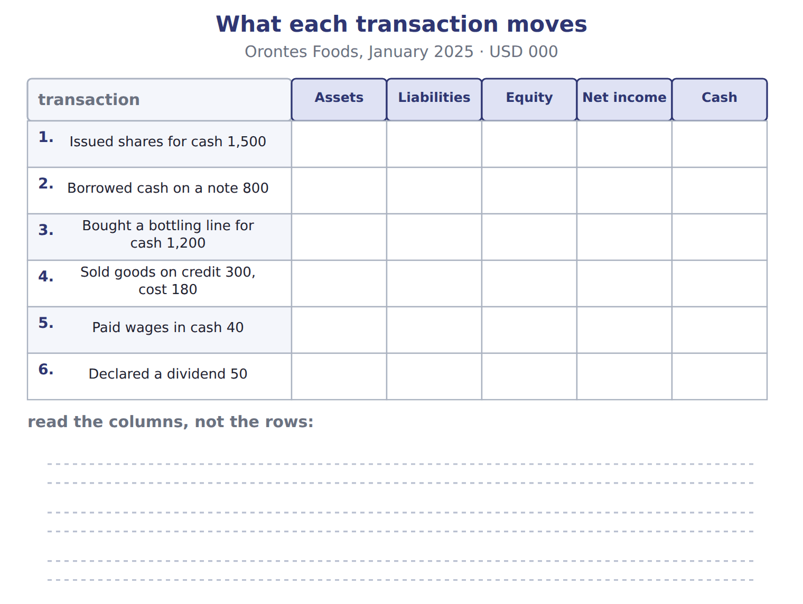
TEACH IT BACK | Write it for the owner of the company, who is not an accountant — not for the marker.
30. In three or four sentences, explain how the company can have made a profit of only 80 while its cash rose by 1,060.
every one of these words must appear: financing · revenue · accrual basis · net income

Handout 1.6
February, with the scaffolding removed
Three rows worked, three rows yours · the four adjustments the accrual basis creates
60 SECONDS | Answer from memory. Do not look anything up.
1. Cash from a bank loan is revenue: true or false? | 4. Net income for January was
2. A dividend reduces which equity account? | 5. Which entry records the cost of goods sold?
3. Revenue is recorded when the goods are | 6. One asset becoming another changes total assets by

CYCLE A | Three worked, three yours

ORIENT

1. A customer pays you today for goods you will deliver next month. Have you earned revenue today? Answer yes or no.

MODEL Six transactions from February. The first three are worked for you, with the reasoning beside each.

Orontes Foods — February 2025 (USD 000)
# | Date | What happened | Amount
1 | Feb 3 | Paid a supplier for olives bought on credit in January. | 150
2 | Feb 8 | Collected part of the January receivable from GreenBasket Supermarkets. | 200
3 | Feb 10 | Paid 12 months of warehouse rent in advance. | 24
4 | Feb 12 | A Dubai hotel group paid cash in advance for pastries that Orontes will deliver in March. | 60
5 | Feb 15 | Paid the dividend declared on January 31. | 50
6 | Feb 28 | Recorded one month of interest on the bank note. Orontes has not paid it yet. | 4

Rows 1 to 3, worked
Row 1 · Dr Accounts payable 150; Cr Cash 150 | the supplier is paid, so a liability goes and cash goes with it: assets (150), liabilities (150), equity 0, net income 0
Row 2 · Dr Cash 200; Cr Accounts receivable 200 | one asset becomes another, so no total moves: assets 0, liabilities 0, equity 0, net income 0
Row 3 · Dr Prepaid rent 24; Cr Cash 24 | cash is paid before the benefit is used, so it buys an asset: assets 0, liabilities 0, equity 0, net income 0

READ THE MODEL

2. Rows 1, 2 and 3 all move cash, and not one of them changes net income. Write the reason in your own words.

3. Row 3 pays 24 of cash and total assets do not change. What did the 24 of cash become?

4. Row 2 increases Orontes’ revenue by 200. T / F
APPLY Rows 4 to 6 now, with no worked model beside them. Write the entry and the effects for each.

Complete all three rows: the journal entry, then the four effects.
Row | Journal entry | Assets | Liabilities | Equity | Net income
4 · hotel pays 60 in advance
5 · the 50 dividend is paid
6 · interest of 4 is owed

WORK IN PAIRS | Compare your three rows with your partner’s.
If you disagree: the row that differs is the one to argue about. Settle it by asking whether anything was earned or incurred, not by asking where the cash went.
CHECKPOINT 8. Row 4 brings 60 of cash in. Why is none of it revenue in February?

If you could not answer it: redo row 4 of the APPLY grid in cycle A.

CYCLE B | Four adjustments, and the two that get confused

ORIENT

9. Cash paid before the benefit is used creates something on the balance sheet. Is it an asset or a liability?

MODEL Two questions generate all four. Read the column headings and the row headings before you read the boxes.

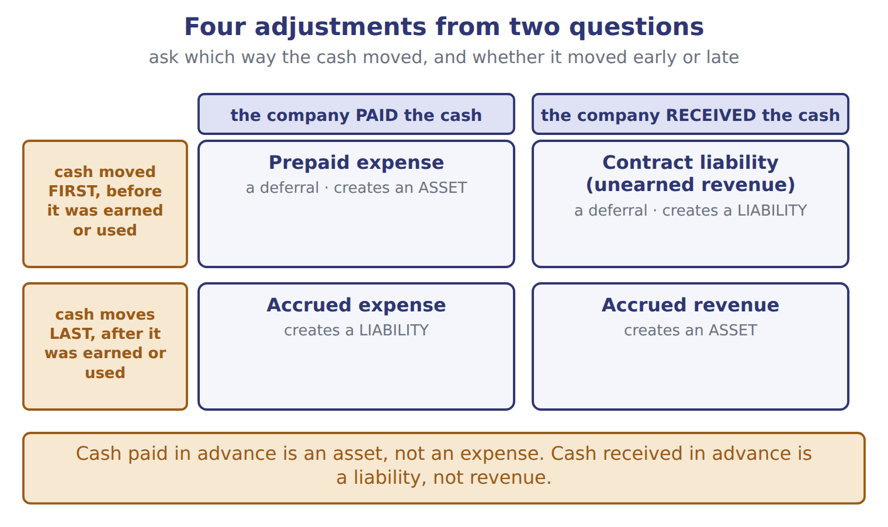
The same four, with the February row each one matches
Type | What happens | The February row it matches | It creates
Prepaid expense (deferral) | Cash is paid before the expense is incurred. | row 3, rent in advance | an asset
Contract liability, or unearned revenue (deferral) | Cash is received before the revenue is earned. | row 4, the hotel pays in advance | a liability
Accrued expense | The expense is incurred before cash is paid. | row 6, interest owed on the bank note | a liability
Accrued revenue | Revenue is earned before cash is received or billed. | none in February — studied in Chapter 11 | an asset

READ THE MODEL

10. Which two of the four create a liability?

11. Which two create an asset?

12. In which two does the cash arrive or leave BEFORE the revenue is earned or the expense incurred?

13. Which of the four has no February example in the panel, and where does the book say it is studied?

INVENT THE RULE

14. Write the test that tells a prepaid expense from a contract liability, given that both begin with cash moving.
use every one of these words: paid · asset · received · liability
If the company the cash, it has bought a future benefit, so it records an .
If the company the cash, it still owes goods or services, so it records a .

Two payments of cash in the same week
Orontes pays 24 for a year of warehouse rent | A hotel pays Orontes 60 for March pastries
Who paid? Orontes. | Who paid? The customer.
What does Orontes now have coming to it? | What does Orontes now owe?
Asset or liability? | Asset or liability?
In both, cash moves before anything is earned or used. Say which each one creates, and write the single question that decides.

APPLY

15. On December 28, a customer pays Orontes 60 for goods that Orontes will deliver in January. What does Orontes report at December 31?
A. A liability of 60
B. Revenue of 60
C. An asset of 60 and revenue of 60
D. Nothing until the goods are delivered
16. On February 10, Orontes pays 24 for 12 months of warehouse rent in advance. How does the payment appear immediately after it is made?
A. As an asset of 24
B. As an expense of 24
C. As a liability of 24
D. It is not recorded until the end of the month.
SORT THEM | Write each one under the balance-sheet item it creates.
the items: rent paid in advance · cash received for goods not yet delivered · interest incurred but not yet paid · revenue earned but not yet billed
creates an ASSET | creates a LIABILITY

CHECKPOINT 19. Cash received in advance is a ______, and cash paid in advance is an ______. Fill both gaps.

If you could not answer it: redo the contrasting cases in cycle B.

FROM MEMORY | Close the earlier pages first.
20. Rebuild the four-adjustment grid. Label both column headings, both row headings, and write in each box what it is called and whether it creates an asset or a liability.
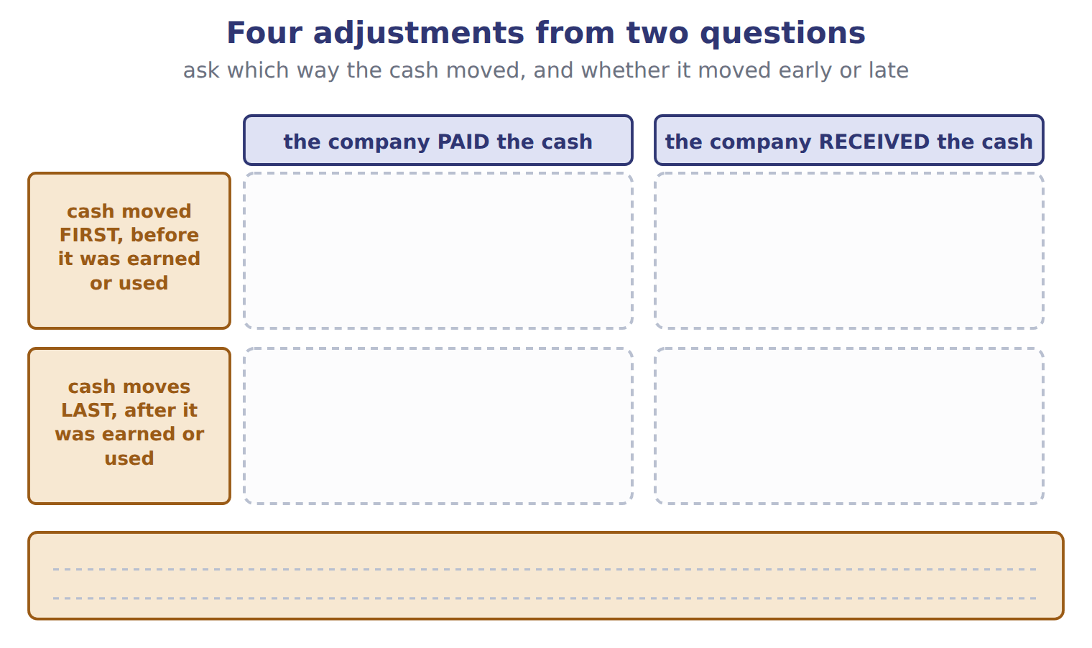
TEACH IT BACK | Write it for a classmate who says "if the cash moved, record it" — not for the marker.
21. In three or four sentences, explain why the movement of cash does not by itself tell you whether to record revenue or an expense.
every one of these words must appear: earned · incurred · deferral · accrual

Handout 1.7
The accrual basis, and matching
One sale on two bases · three ways to match an expense to a revenue
60 SECONDS | Answer from memory. Do not look anything up.
1. Cash received in advance creates a | 4. Revenue is recorded when the goods are
2. Cash paid in advance creates an | 5. Which basis does U.S. GAAP require?
3. Interest owed but unpaid is which kind of adjustment? | 6. Does paying a supplier change net income?

CYCLE A | One sale, two bases, two different years

ORIENT

1. Orontes delivers goods on December 20 and is paid on January 15. Under which basis of accounting would the sale belong to the later year?

MODEL One sale, drawn on two timelines. The dashed line is the year end.

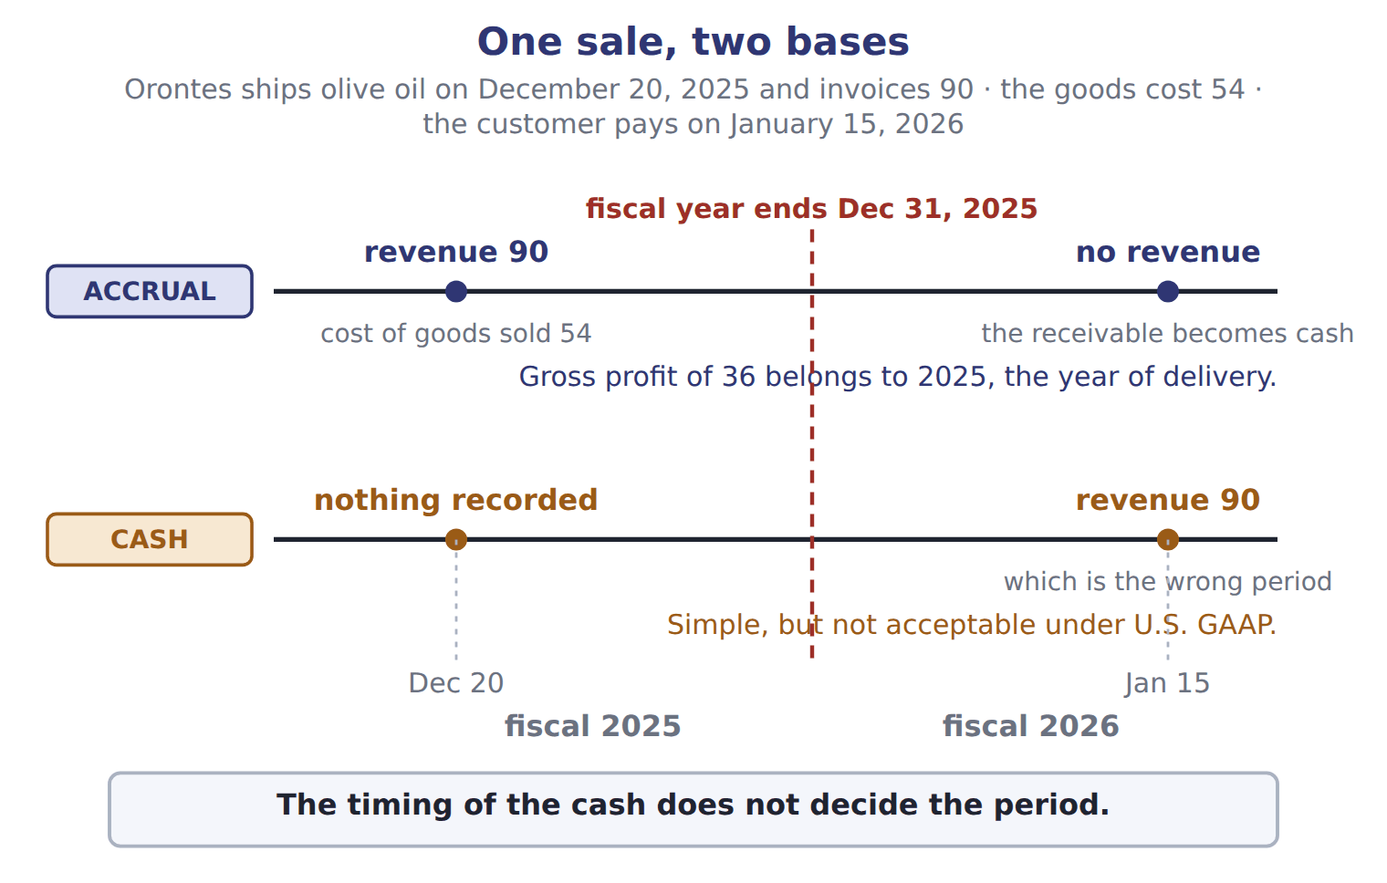
READ THE MODEL

2. On the accrual timeline, what does Orontes record on December 20, and for how much?

3. On the accrual timeline, what does the January 15 payment change?

4. On the cash timeline, in which fiscal year does the revenue of 90 fall, and what does the figure call that year?

5. What gross profit does the accrual basis put in 2025, and how is it worked out?

6. Copy the sentence in the band at the foot of the figure.

WORK IN PAIRS | Answer the next item alone first, then compare.
If you disagree: put a finger on the dashed year-end line and ask which side of it the delivery happened on. The delivery settles it.
INVENT THE RULE

7. Write what the accrual basis uses instead of the cash date to decide the period.
use every one of these words: earns · delivers · incurs · accrual basis
Revenue is recorded when the company it, that is, when it the goods or services.
An expense is recorded when the company it.

The same 90, recorded in two different years
Accrual basis | Cash basis
Delivery: December 20, 2025. | Delivery: December 20, 2025.
Cash: January 15, 2026. | Cash: January 15, 2026.
Which year gets the 90? | Which year gets the 90?
Is it acceptable under U.S. GAAP? | Is it acceptable under U.S. GAAP?
Only one fact differs between the two columns: which event the basis watches. Name that event for each, and answer both questions.

APPLY

8. Orontes ships goods on December 20, 2025 and invoices 90. The goods cost 54. The customer pays on January 15, 2026. The fiscal year ends on December 31. How much revenue does Orontes report for fiscal 2025?
A. 0 | C. 54
B. 36 | D. 90
9. The cash basis is acceptable under U.S. GAAP for published financial statements. T / F
CHECKPOINT 10. Which event does the accrual basis watch to decide the period, and which event does the cash basis watch?

If you could not answer it: redo the READ THE MODEL questions of cycle A with the two timelines in front of you.

CYCLE B | Three ways to match an expense to a revenue

ORIENT

11. A bottling line will be used for years. Can its whole cost sensibly be matched to this year’s sales? Answer yes or no.

MODEL The matching principle, and the three ways the book applies it.

Record expenses in the same period as the revenues they help to produce
The way | When it is used | The Orontes example
Cause and effect | the cost links directly to one sale | cost of goods sold, recorded at the same time as the sales revenue
Systematic and rational allocation | the cost helps many periods | depreciation, spreading a bottling line over the years of use
Immediate recognition | the cost has no clear link to future revenue | most advertising, and office salaries
The three ways differ in how tightly the cost is tied to a particular sale.
READ THE MODEL

12. Write the letter of the way each cost is matched.
A cause and effect | C immediate recognition
B systematic and rational allocation

12. Cost of goods sold
13. Depreciation of the Amman bottling line
14. Advertising for a new product
15. Rent for the head office

16. Which of the three ways ties a cost to one identified sale?

17. Which of the three is used when no link to future revenue can be found at all?

INVENT THE RULE

18. Write what the matching principle matches expenses to — and what it does not match them to.
use every one of these words: revenues · cash payment · matching principle
Expenses are recorded in the same period as the they help to produce.
They are not matched to the that pays for them.

Two costs of 300 in the same year
Goods that cost 300 and were sold in March | Advertising that cost 300, run in March
Can you name the sale this cost helped? | Can you name the sale this cost helped?
Which way of matching? | Which way of matching?
When is it an expense? | When is it an expense?
Fill in all three rows for both. Then write the question that decides between cause and effect, and immediate recognition.

APPLY

19. Which cost is matched to revenue by cause and effect?
A. Depreciation of the Amman bottling line
B. Advertising for a new product
C. Cost of goods sold
D. Rent for the head office
20. Which statement about the matching principle is correct?
A. Expenses are recognized in the period in which they are paid.
B. Revenues are recognized in the period in which cash is received.
C. All costs are capitalized as assets until related revenue is earned.
D. Expenses are recognized in the same period as the revenues they help to produce.
CHECKPOINT 21. Name the three ways of applying the matching principle, and give one example of each.

If you could not answer it: redo the matching item in cycle B with the panel open.

FROM MEMORY | Close the earlier pages first.
22. Rebuild the two timelines. Mark December 20, the year end and January 15, and write on each timeline what is recorded and when.
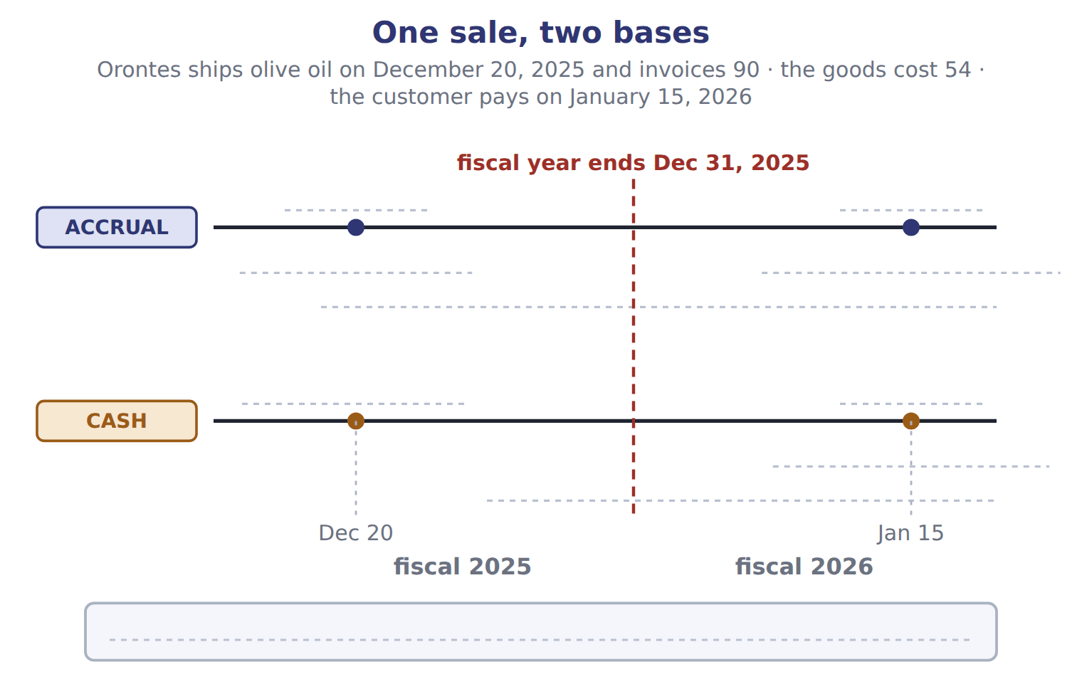
TEACH IT BACK | Write it for a shopkeeper who keeps books on the cash basis — not for the marker.
23. In three or four sentences, explain what would change if the shop moved to the accrual basis, and why U.S. GAAP insists on it.
every one of these words must appear: earned · incurred · period · matching

Handout 1.8
Who writes the rules
FASB, SEC, PCAOB, IASB · the Codification and how it is amended
60 SECONDS | Answer from memory. Do not look anything up.
1. Which basis does U.S. GAAP require? | 4. Cash paid in advance creates an
2. Matching matches expenses to | 5. Equity is the ______ interest in the assets
3. Depreciation uses which way of matching? | 6. A dividend reduces which equity account?

CYCLE A | Four bodies, four different jobs

ORIENT

1. One of these four bodies does not write accounting rules at all: FASB, SEC, PCAOB, IASB. Guess which, and say in three words what it does instead.

MODEL Two systems, side by side, and one body set apart at the foot.

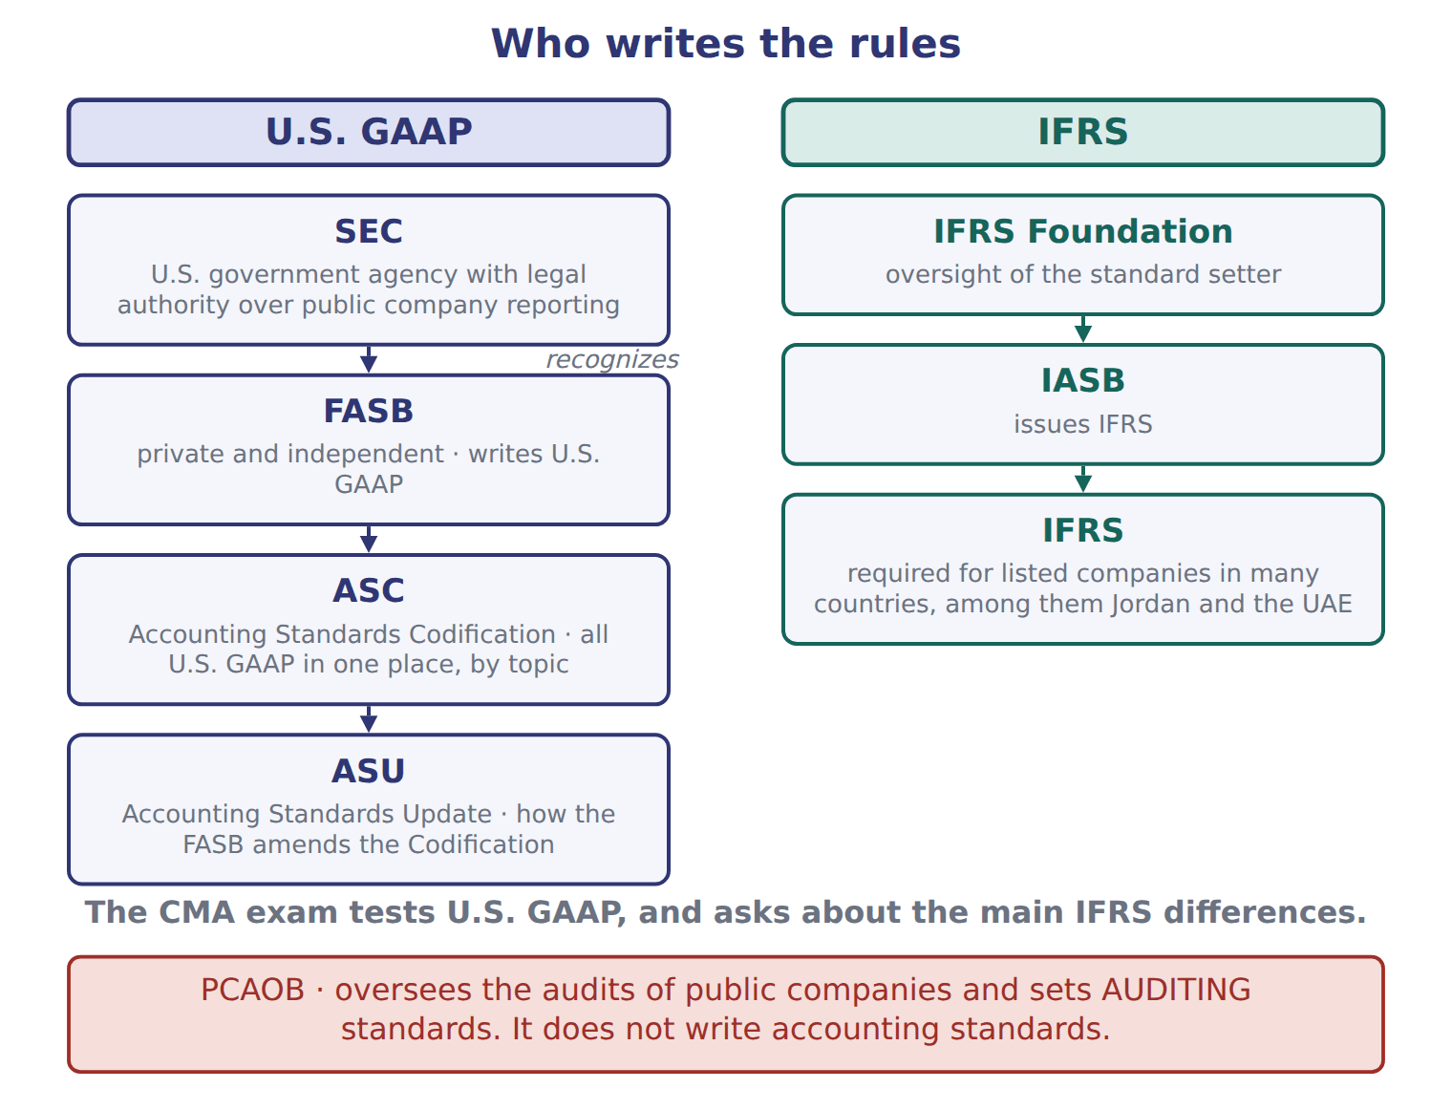
READ THE MODEL

2. Which body writes U.S. GAAP, and where does it keep it?

3. The figure puts the SEC above the FASB. What does the word beside that arrow say the SEC does?

4. What is an ASU, and what does it change?

5. Which body issues IFRS, and which organization oversees it?

6. Copy the sentence in the red band at the foot of the figure.

MODEL The same four bodies, in a sentence each.

Four bodies, four jobs
Body | What it is | What it does
FASB | private and independent | writes U.S. GAAP and keeps it in the Accounting Standards Codification
SEC | a U.S. government agency | has legal authority over the financial reporting of public companies, and recognizes the FASB as the standard setter
PCAOB | an oversight board | oversees the audits of public companies and sets auditing standards — not accounting standards
IASB | the board of the IFRS Foundation | issues IFRS

INVENT THE RULE

7. Write the difference between having the legal authority over reporting and writing the standards.
use every one of these words: SEC · FASB · public · recognizes
The has legal authority over the reporting of companies.
The writes the standards, because the first body it as the standard setter.

Two bodies whose names both contain "board"
FASB | PCAOB
Private or governmental? | Private or governmental?
Writes which kind of standards? | Writes which kind of standards?
Where does its output live? | Where does its output live?
Fill in all three rows for both. Then write the one word that separates what the two of them produce.

APPLY

8. Which organization writes U.S. GAAP?
A. The FASB | C. The PCAOB
B. The SEC | D. The IASB
9. Which statement is TRUE?
A. The PCAOB writes U.S. GAAP for public companies.
B. The IASB writes U.S. GAAP for companies that also report under IFRS.
C. The ASC contains IFRS for U.S. companies.
D. The SEC has legal authority over public company reporting and recognizes the FASB as the standard setter.
SORT THEM | Write each job under the body that does it.
the items: writes U.S. GAAP · issues IFRS · sets auditing standards · legal authority over public company reporting · maintains the Codification · issues Accounting Standards Updates
FASB | SEC | PCAOB | IASB

CHECKPOINT 14. Name the body that writes U.S. GAAP, the body with legal authority over public company reporting, and the body that sets auditing standards.

If you could not answer it: redo the READ THE MODEL questions of cycle A with the figure in front of you.

CYCLE B | The Codification, and what the exam actually tests

ORIENT

15. If every U.S. accounting rule is kept in one place, organized by topic number, what does that one place make easy that a pile of separate standards would not?

MODEL How a U.S. rule is stored, and how it changes.

From a decision to a rule a company must follow
The FASB decides a rule should change | the FASB is the standard setter the SEC recognizes
The FASB issues an Accounting Standards Update (ASU) | an ASU is the instrument that amends the Codification
The Codification is amended | the ASC is the single source of authoritative nongovernmental U.S. GAAP
A company looks the rule up by topic number | ASC 606 covers revenue; ASC 842 covers leases
For a company that reports to the SEC, SEC rules also apply | for SEC registrants, SEC rules are also part of authoritative GAAP

READ THE MODEL

16. Which topic number covers revenue, and which covers leases?

17. What does the trace call the ASC, in five words?

18. An ASU is a separate rulebook that sits beside the Codification. T / F
WORK IN PAIRS | Answer the next item alone, then compare.
If you disagree: find the row in the trace that names the instrument. The row settles it.
MODEL What the exam does with all this.

What the CMA exam tests
The exam tests | U.S. GAAP
The exam also asks about | the main differences between U.S. GAAP and IFRS
Many countries require IFRS for listed companies | among them Jordan and the United Arab Emirates
Both systems rest on | a conceptual framework: the users, the elements and the qualities of useful information

APPLY

19. The IFRS term share premium has the same meaning as the U.S. GAAP term:
A. retained earnings | C. net income
B. common stock | D. additional paid-in capital
The FASB keeps all U.S. GAAP in the , and amends it by issuing an .

CHECKPOINT 22. Which rules does the CMA exam test, and what else does it ask about?

If you could not answer it: reread the panel at the end of cycle B.

FROM MEMORY | Close the earlier pages first.
23. Rebuild the rule-maker figure. Draw both columns in order, and put the fourth body where it belongs, with the reason it is set apart.
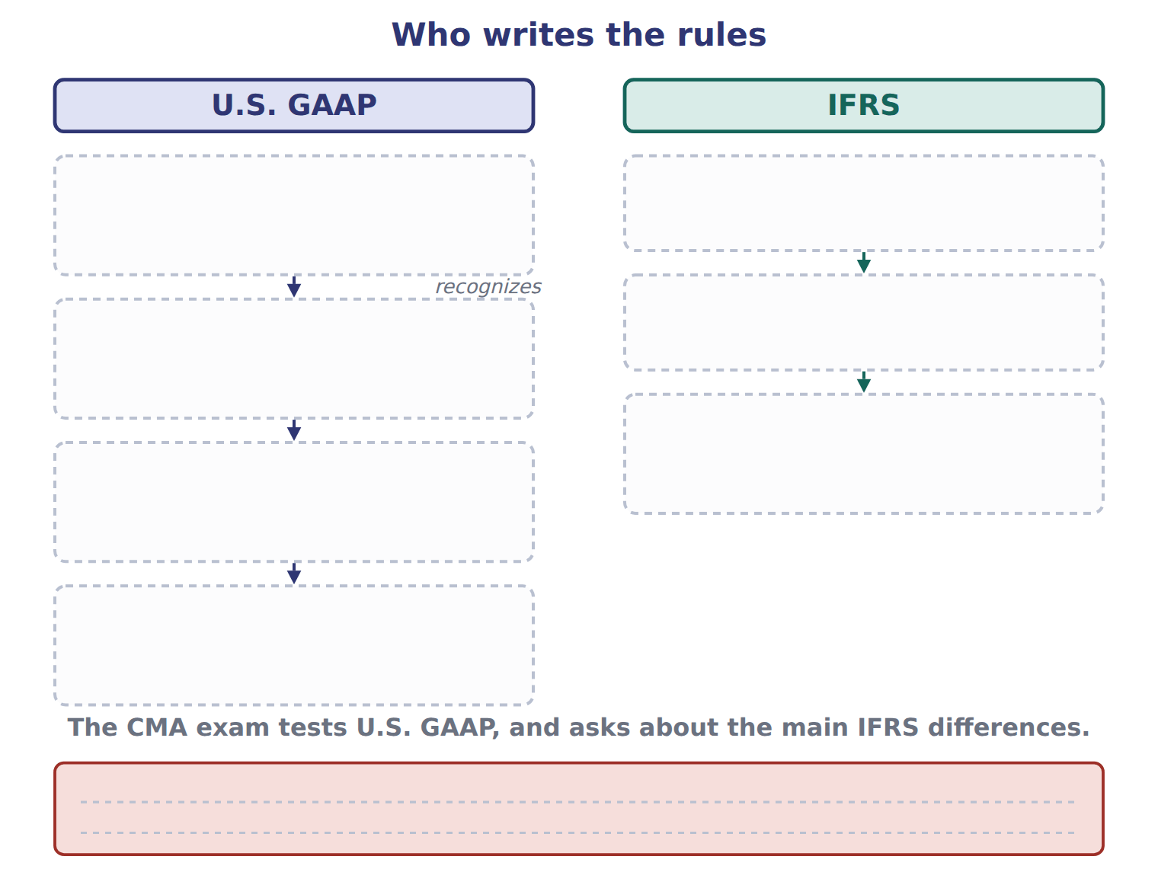
TEACH IT BACK | Write it for a student who has only ever studied IFRS — not for the marker.
24. In three or four sentences, explain which body writes the rules the CMA exam tests, where those rules are kept, and what this means for someone trained on IFRS.
every one of these words must appear: FASB · Codification · IASB · conceptual framework

Handout 1.9
The four statements, and how they link
One at a date, three for a period · net income into retained earnings · the change in cash
60 SECONDS | Answer from memory. Do not look anything up.
1. Which body writes U.S. GAAP? | 4. Revenue is recorded when the goods are
2. What does an ASU amend? | 5. Matching matches expenses to
3. Which body sets auditing standards? | 6. Share premium is the IFRS name for

CYCLE A | Four statements, four questions

ORIENT

1. "What the company owns today" and "what the company earned over the year" are different kinds of fact. Which of the two needs a single date rather than a span of time?

MODEL Four statements. The right-hand column is the one the exam tests hardest.

Each statement answers a different question
Statement | The question it answers | Time
Balance sheet | What does the company have and owe, and what is the owners’ claim? | at a date
Income statement | How did the company perform? | for a period
Statement of changes in equity | Why did each equity account change? | for a period
Statement of cash flows | Where did cash come from, and where did it go? | for a period

READ THE MODEL

2. How many of the four cover a period, and how many report at a single date?

3. Write the letter of the statement that answers each question.
A Balance sheet | C Statement of changes in equity
B Income statement | D Statement of cash flows

3. Where did cash come from, and where did it go?
4. How did the company perform?
5. Why did each equity account change?
6. What does the company have and owe?

7. Which statement would you read to find out why retained earnings are not what they were a year ago?

INVENT THE RULE

8. Write the test that sorts a statement into "at a date" or "for a period".
use every one of these words: has · owes · date · changed · period
If the statement reports what the company and , it is at a .
If it reports what over time, it is for a .

Two statements of the same company, same year
Balance sheet | Statement of cash flows
Cash 1,050. | Net change in cash 1,060.
Is that a total for the period, or a position? | Is that a total for the period, or a position?
At a date, or for a period? | At a date, or for a period?
Both are about cash. Answer both questions for each, and write the one word that separates a position from a flow.

APPLY

9. Which statement reports amounts at a single date?
A. The income statement | C. The statement of changes in equity
B. The balance sheet | D. The statement of cash flows
10. Which statement explains why retained earnings changed during the year?
A. The statement of changes in equity | C. The statement of cash flows
B. The balance sheet | D. The income statement
CHECKPOINT 11. Which single statement reports at a date, and what do the other three have in common?

If you could not answer it: redo the matching item in cycle A with the panel open.

CYCLE B | The two links

ORIENT

12. Net income is the bottom line of one statement. Guess which equity account it ends up inside.

MODEL The four statements again, this time with the two links drawn.

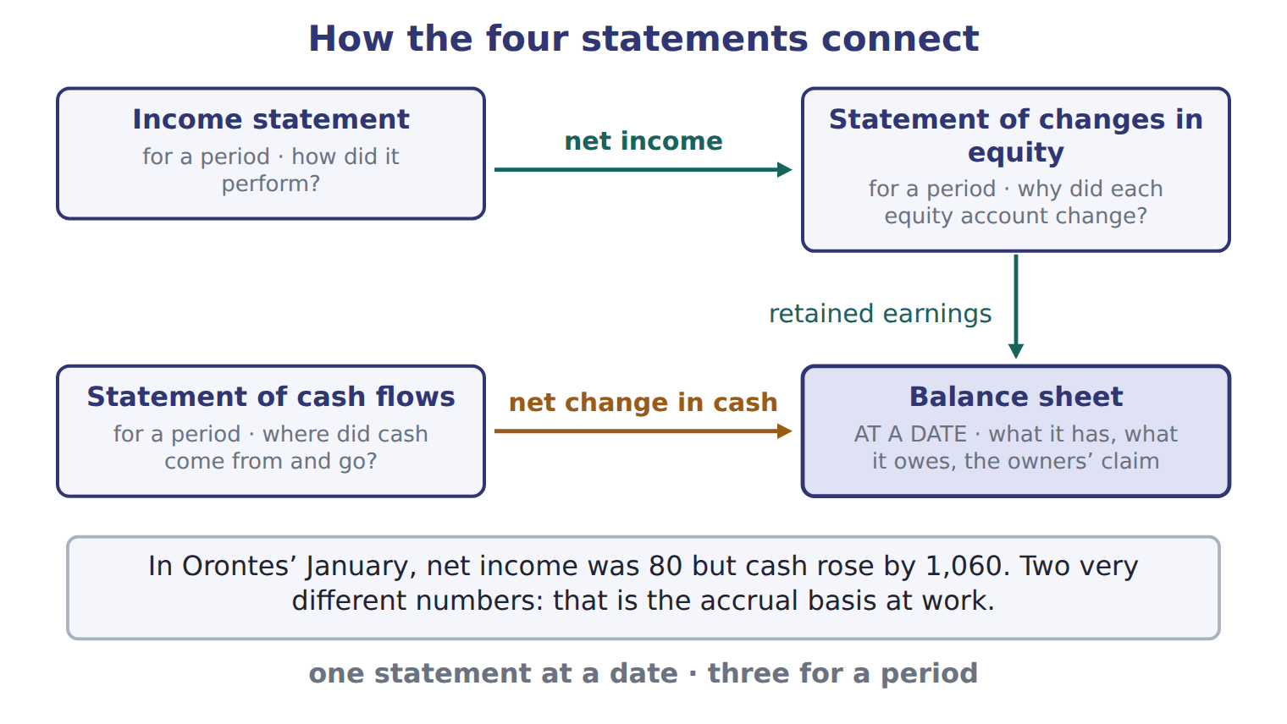
READ THE MODEL

13. The first link carries one figure from the income statement. Name the figure and say where it lands.

14. The second link carries a figure from the statement of cash flows. Name it and say what it explains.

15. Which of the four boxes in the figure is drawn as the one both links arrive at?

16. The band under the figure gives two numbers for the same month. Write both, and say what the difference between them is evidence of.

PREDICT FIRST | Before the next move: January’s net income was 80 and the dividend declared was 50. Write what you expect the change in retained earnings to be.
what I think will happen | what the figures actually show
Retained earnings rose by 30: net income of 80 less the dividend of 50.

INVENT THE RULE

17. Write the two links as two sentences.
use every one of these words: net income · retained earnings · cash
flows into in the statement of changes in equity.
The net change in explains the balance on the balance sheet.

Two figures that both come out of the same January
Net income 80 | Net change in cash 1,060
Which statement reports it? | Which statement reports it?
Which equity account does it end up in? | Which balance sheet line does it explain?
Does it say where the cash went? | Does it say whether the company traded profitably?
Answer all three rows for each, then write the one sentence that says why a reader needs both figures and not just one.

APPLY

18. Net income for the period flows directly into:
A. the cash balance on the balance sheet.
B. retained earnings in the statement of changes in equity.
C. total liabilities.
D. common stock.
Complete the reconciliation of January for Orontes, using the figures given.
Line | Amount
Sales revenue | 300
less cost of goods sold | 180
less wages expense | 40
Net income
less dividend declared | 50
Increase in retained earnings

And the other link. Complete the change in cash for January.
Line | Amount
Operating outflow | (40)
Investing outflow | (1,200)
Financing inflow | 2,300
Increase in cash

CHECKPOINT 22. Name the two links, and say which statement both of them arrive at.

If you could not answer it: redo the READ THE MODEL questions of cycle B with the figure in front of you.

FROM MEMORY | Close the earlier pages first.
23. Rebuild the figure. Draw all four statements, mark which one is at a date, and draw both links with the figure each one carries.
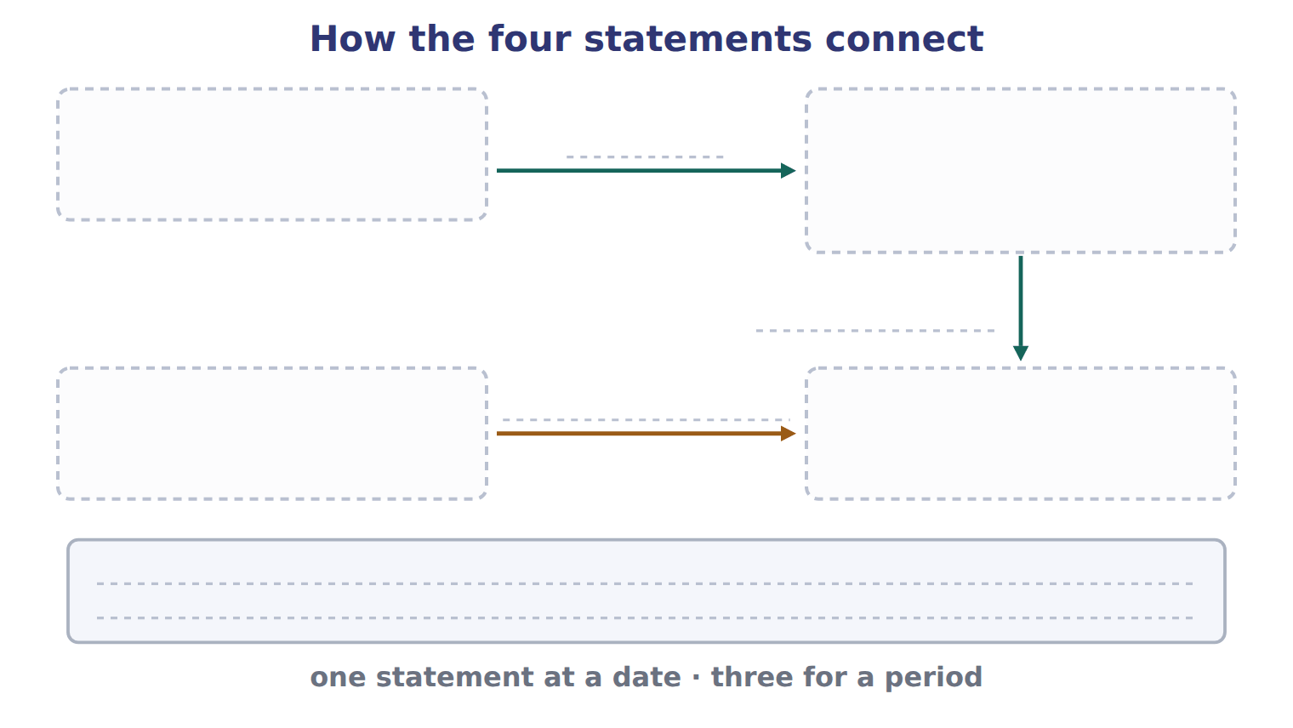
TEACH IT BACK | Write it for an investor who has only ever looked at profit — not for the marker.
24. In three or four sentences, explain why reading the income statement alone is not enough, using Orontes’ January as the example.
every one of these words must appear: net income · cash · balance sheet · period

Handout 1.10
Reading a trial balance
Barada Wholesale, Inc. · classify every line, then pull four figures out of it
60 SECONDS | Answer from memory. Do not look anything up.
1. Which statement reports at a date? | 4. A contra account reduces a
2. Net income flows into which equity account? | 5. Dividends declared increase with a debit or a credit?
3. Accumulated depreciation has which normal balance? | 6. What does a trial balance prove?

CYCLE A | Every line has a category

ORIENT

1. Two accounts in a trial balance carry credit balances but are not liabilities and not equity. What are such accounts called?

MODEL A real trial balance. Everything in this handout comes out of it, so keep this page open.

Barada Wholesale, Inc. — trial balance, December 31, 2025 (USD 000)
Account | Debit | Credit
Cash | 1,050
Accounts receivable | 300
Allowance for credit losses |  | 20
Inventory | 420
Prepaid rent | 24
Land | 936
Equipment | 4,200
Accumulated depreciation |  | 900
Accounts payable |  | 380
Dividends payable |  | 50
Notes payable (long-term) |  | 1,800
Common stock |  | 600
Additional paid-in capital |  | 1,900
Retained earnings, January 1 |  | 1,000
Dividends declared | 50
Sales revenue |  | 3,100
Cost of goods sold | 1,860
Wages expense | 520
Depreciation expense | 300
Interest expense | 90
Totals | 9,750 | 9,750
A trial balance lists every account balance and checks that total debits equal total credits.
READ THE MODEL

2. What are the two totals, and what does their agreement prove?

3. Which two accounts in this trial balance are contra-asset accounts?

4. One account name in the list contains a date. Which, and why does the date matter?

5. Which line is an equity account that is reduced rather than increased by its debit balance?

APPLY

SORT THEM | Write each account under its category. Every one of these eight is in the trial balance above.
the items: Prepaid rent · Land · Dividends payable · Additional paid-in capital · Sales revenue · Interest expense · Allowance for credit losses · Accumulated depreciation
Asset | Contra-asset | Liability | Equity | Revenue | Expense

12. Which two accounts in this trial balance are contra-asset accounts?
A. Allowance for credit losses and dividends payable
B. Accumulated depreciation and notes payable
C. Allowance for credit losses and accumulated depreciation
D. Dividends declared and accumulated depreciation
CHECKPOINT 13. Name the two contra-asset accounts in this trial balance and say what each one reduces.

If you could not answer it: redo the sorting item in cycle A with the trial balance open.

CYCLE B | Four figures, with less help each time

ORIENT

14. To find net income from a trial balance, which two kinds of account do you need, and what do you do with them?

MODEL Four jobs a trial balance is used for, and which lines each one takes.

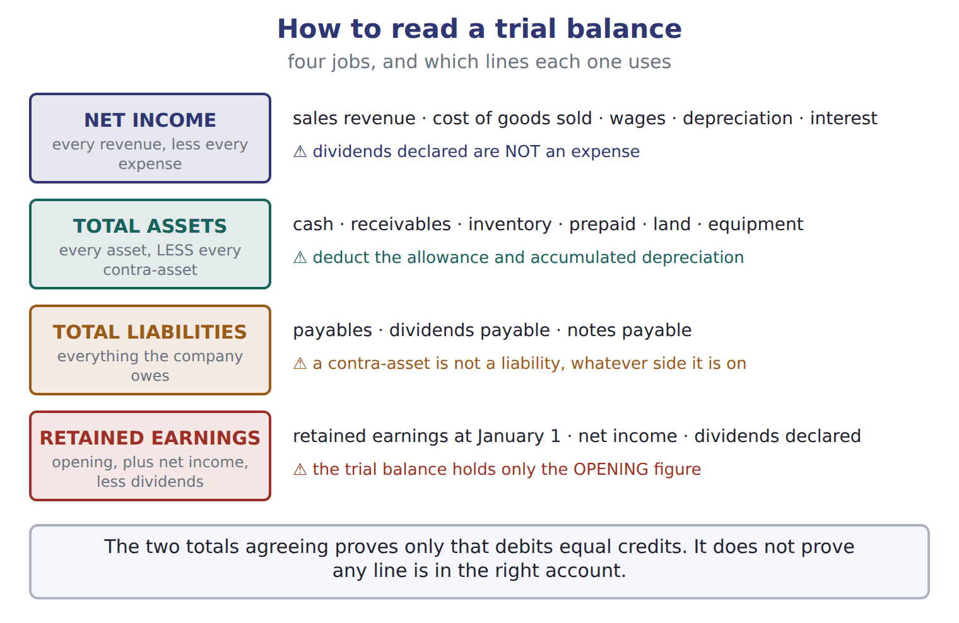
READ THE MODEL

15. Which of the four jobs is the only one that SUBTRACTS some of the lines it uses?

16. Which line does the figure warn is NOT an expense?

17. The figure says the trial balance holds only the OPENING figure for one account. Which account?

MODEL The first job, worked in full, with the reason for each line.

Barada’s net income for 2025 (USD 000)
Sales revenue 3,100 | the only revenue account in the trial balance
less cost of goods sold 1,860 | an expense, matched to those sales by cause and effect
less wages expense 520 | an expense of the period
less depreciation expense 300 | an expense: systematic and rational allocation
less interest expense 90 | an expense of the period
Net income 330 | 3,100 − 1,860 − 520 − 300 − 90. Dividends declared are NOT in this list: a dividend is not an expense

APPLY The second figure, with the lines named but the work left to you.

Complete Barada’s total assets at December 31, 2025. Watch the two lines that are subtracted.
Line | Amount
Cash | 1,050
Accounts receivable | 300
less allowance for credit losses | (20)
Inventory | 420
Prepaid rent | 24
Land | 936
Equipment | 4,200
less accumulated depreciation | (900)
Total assets

WORK IN PAIRS | Compare your total with your partner’s before you go on.
If you disagree: if you differ, check whether both of you deducted the two contra-asset lines. That is where the difference almost always is.
APPLY The last two figures, with no lines given at all.

19. After closing, what are Barada’s retained earnings at December 31, 2025? Show your working.

20. After closing, Barada’s retained earnings at December 31, 2025 are:
A. 330 | C. 1,280
B. 1,000 | D. 1,330
21. What are Barada’s total liabilities at December 31, 2025? Show your working.

22. Check your own work: add total liabilities to total equity and compare with total assets. Write both figures and say whether the equation holds.

CHECKPOINT 23. Which two lines of a trial balance must be SUBTRACTED when you add up total assets?

If you could not answer it: redo the total-assets grid in cycle B, marking the two contra-asset lines before you add.

FROM MEMORY | Close the earlier pages first.
24. Rebuild the four-jobs figure. Name each job, say which lines it uses, and write the trap beside it.
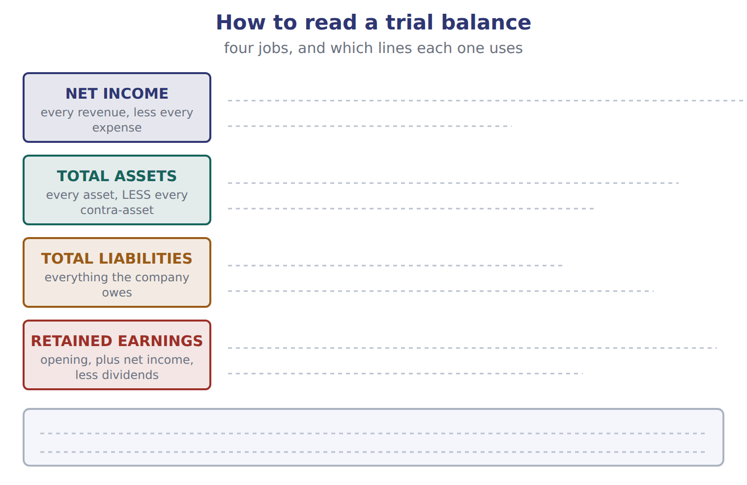
TEACH IT BACK | Write it for a colleague who has to extract figures from a trial balance for the first time — not for the marker.
25. In four or five sentences, explain the order to work in, and the one trap that costs most marks.
every one of these words must appear: revenues · expenses · net income · contra-asset · retained earnings

Handout 1.11
Reading the question
Four stem words that change the answer · the language of effects · words that mislead
60 SECONDS | Answer from memory. Do not look anything up.
1. Total assets: do you add or deduct accumulated depreciation? | 4. Cash received in advance creates a
2. Net income flows into | 5. A dividend reduces which equity account?
3. Which body sets auditing standards? | 6. Debit is which side?

CYCLE A | Four words that change the answer

ORIENT

1. A question ends "… which of the following is NOT true?". How many of the four options are true?

MODEL Four wordings the exam uses, and what each one is instructing you to do.

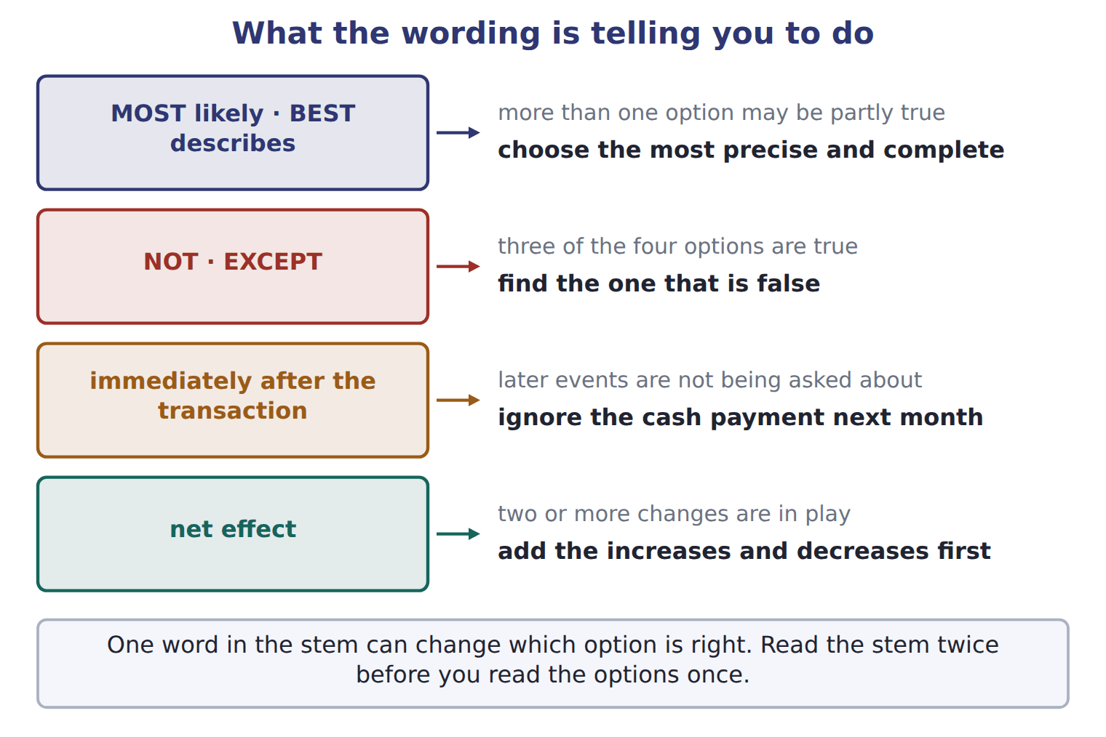

The same four, in a line each
The wording | What it is telling you to do
MOST likely, or BEST describes | more than one option may be partly true — choose the best one
NOT, or EXCEPT | three options are true — find the one that is false
immediately after the transaction | ignore later events, such as the cash payment next month
net effect | add the increases and the decreases together before you answer

READ THE MODEL

2. Write the letter of the instruction beside each wording.
A three options are true; find the false one | C more than one may be partly true; choose the best
B add the increases and decreases together first | D ignore later events

2. MOST likely
3. EXCEPT
4. immediately after the transaction
5. net effect

6. Which of the four wordings tells you that a later cash payment is irrelevant?

APPLY The same facts, asked four ways. Answer all four.

7. The board declares a dividend of 50, payable next month. What is the effect IMMEDIATELY AFTER the declaration on assets?

8. Orontes issues shares for 1,500 and buys equipment for 1,200 in cash. What is the NET EFFECT on total assets?

9. Which of the following is NOT true of a cash dividend declared but not yet paid?
A. It reduces retained earnings.
B. It creates a liability.
C. It reduces net income.
D. It leaves cash unchanged until payment.
10. Accumulated depreciation is BEST described as:
A. an account with a credit balance
B. a contra-asset account with a credit balance
C. an account related to equipment
D. an account in the trial balance
CHECKPOINT 11. A stem says BEST describes and all four options are true. What is the question actually asking you to compare?

If you could not answer it: redo the matching item in cycle A.

CYCLE B | Saying what a transaction did

ORIENT

12. Equity was 1,000 and is now 2,530. Complete both: equity increased BY ______, and increased TO ______.

MODEL Five patterns, with the book’s own examples.

The language of effects
The pattern | An example
debit X, credit Y | Debit Equipment, credit Cash.
X is debited (or credited) for an amount | Cash is debited for 1,500.
an increase IN the item; an increase OF the amount | an increase in assets of 2,380
increase BY the change; increase TO the new total | Equity increased by 1,530.
The effect of this transaction is to increase … and decrease … | the shape most exam stems use

READ THE MODEL

Using the book’s patterns: there was an increase assets 2,380.
15. Rewrite "Cash was debited 1,500" using the pattern the panel gives.

16. "Equity increased to 1,530" and "equity increased by 1,530" mean the same thing. T / F
ERROR HUNT | Five sentences written by a student. Mark each right, or write what is wrong with it. (items 17 to 21)
the solution as written | right, or what is wrong with it
a | Debit Equipment, credit Cash.
b | There was an increase of assets in 2,380.
c | Equity increased to 1,530, from 1,000 to 2,530.
d | Cash is debited for 1,500.
e | The net effect of the share issue and the equipment purchase is to increase assets by 1,500.

CHECKPOINT 22. Fill both gaps: an increase ____ liabilities ____ 850.

If you could not answer it: reread the language-of-effects panel in cycle B.

CYCLE C | Words that mislead a reader coming from Arabic

ORIENT

23. One Arabic word is used for two different accounting items: one that reduces an asset, and one the company owes. Give the English name for each.

MODEL Three habits to unlearn.

Three words that mislead
The word | What it is used for | What to write in English
استهلاك | used in the Gulf for depreciation, but it also means consumption; Levant texts often say اهتلاك and Egyptian texts إهلاك | always depreciation
مخصص | one word for two different things: something that reduces an asset, and something the company owes | an allowance reduces an asset; a provision is a liability
credit, as your bank uses it | your bank credits your account when it receives your money, because the bank now owes you | that is the bank’s view — do not use banking habits to guess the accounting side

READ THE MODEL

24. Whatever the regional spelling, what single English word should always be written for the wearing out of a long-lived asset?

25. Which of the two — an allowance or a provision — sits with the assets?

26. Your bank credits your account when you pay money in. Explain in one sentence why that does not tell you anything about which side to use in your own books.

APPLY

27. A U.S. GAAP answer refers to the amount set aside against receivables that may not be collected. Which name should be used?
A. reserve for bad debts | C. provision for receivables
B. allowance for credit losses | D. depreciation of receivables
SORT THEM | Write each item under what it is.
the items: allowance for credit losses · accumulated depreciation · a provision · dividends payable
reduces an asset | is a liability

CHECKPOINT 30. Give the English the exam wants for an amount that reduces receivables, and say what word must never be used for it.

If you could not answer it: reread the three-words panel in cycle C.

FROM MEMORY | Close the earlier pages first.
31. Rebuild the stem figure. Write all four wordings and, beside each, what it instructs you to do.
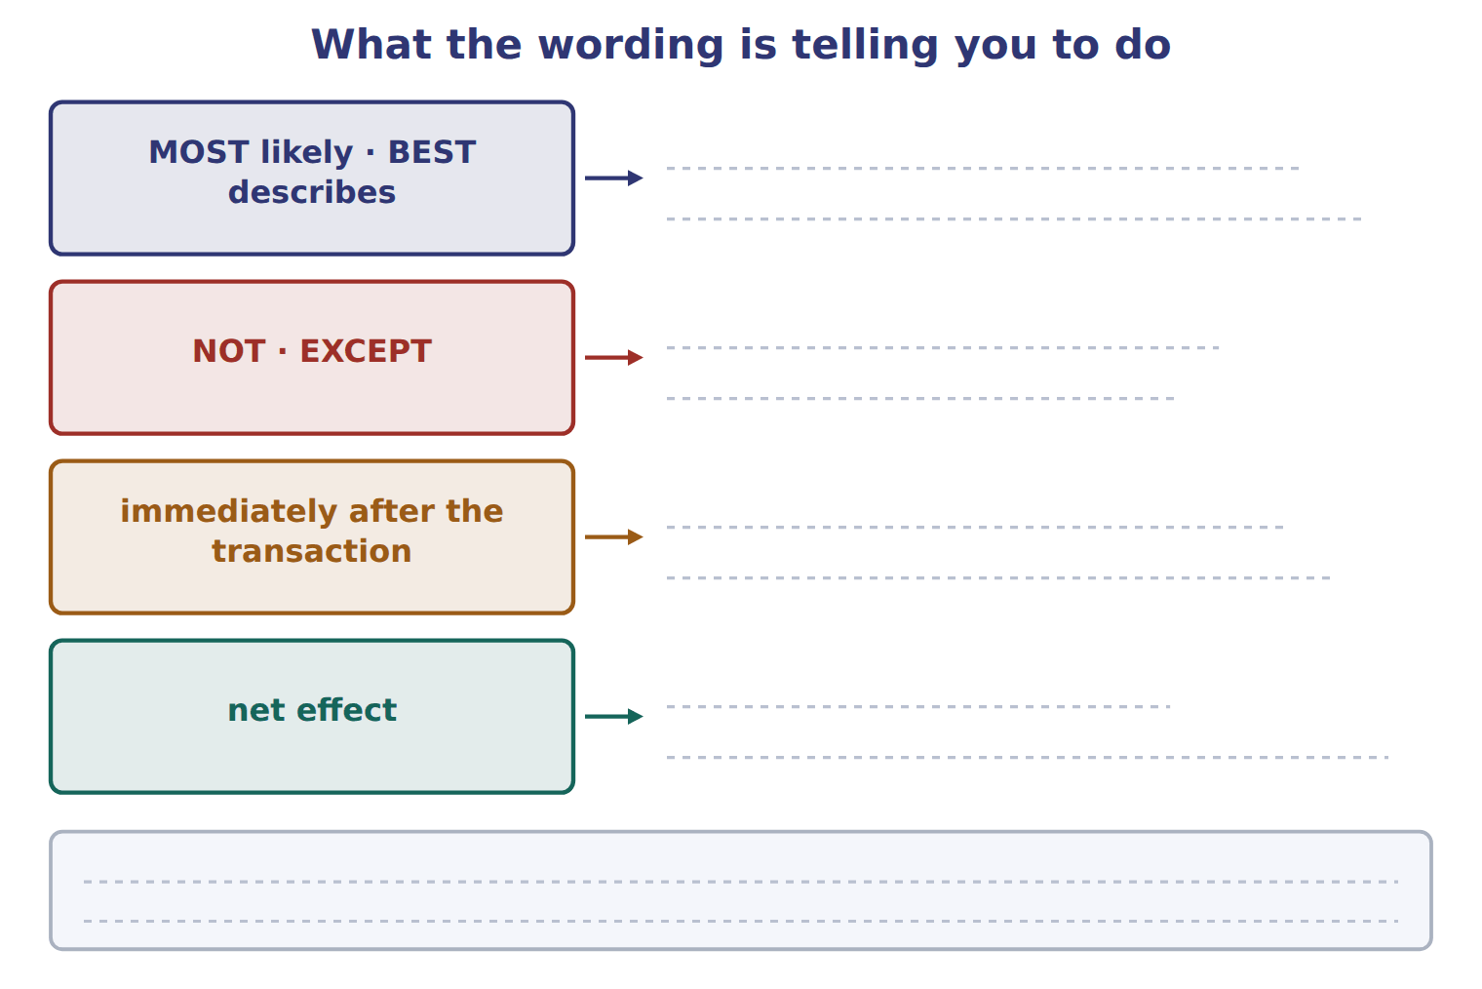
TEACH IT BACK | Write it for a classmate who loses marks on wording rather than on accounting — not for the marker.
32. In three or four sentences, explain what to do when a stem says EXCEPT, what to do when it says immediately after, and why "BEST describes" is not a trick.
every one of these words must appear: EXCEPT · immediately after · BEST · precise

Handout 1.12
The whole chapter
The map · mixed practice with the topics shuffled · one written explanation
60 SECONDS | Answer from memory. Do not look anything up.
1. The three primary users are | 5. Which body writes U.S. GAAP?
2. Equity = assets − | 6. Which statement reports at a date?
3. Debit increases which three account types? | 7. A dividend reduces which equity account?
4. Which basis does U.S. GAAP require? | 8. Cash received in advance creates a

CYCLE A | How the seven topics depend on each other

ORIENT

1. Everything in this chapter ends at one place. Name it.

MODEL The chapter as a map. The arrows are dependencies: what you have to understand before what.

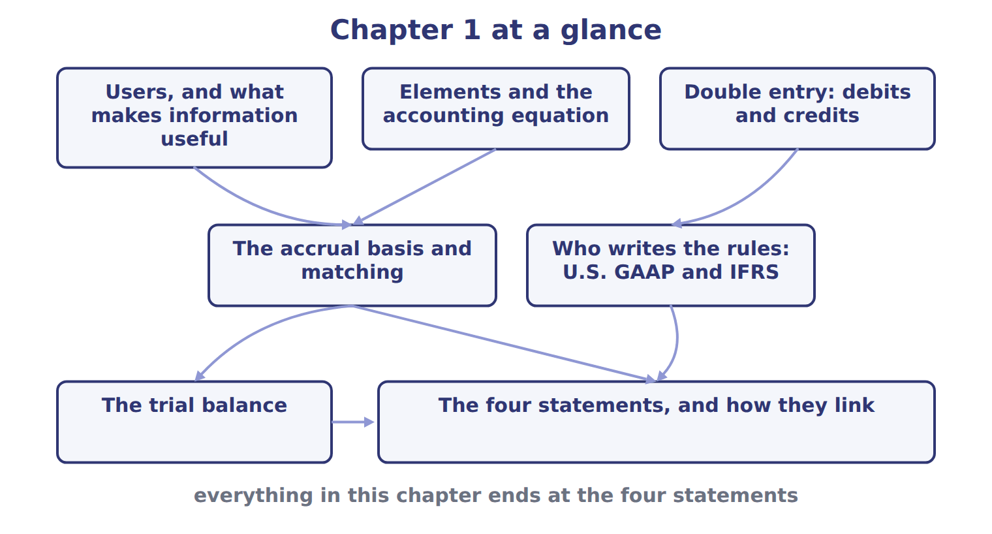
READ THE MODEL

2. Which two topics feed into the accrual basis and matching?

3. Which topic feeds into "who writes the rules"?

4. Which box does the trial balance point into?

5. Pick any one arrow on the map and write, in one sentence, why the topic at its tail has to come first.

The chapter in one worked transaction
Orontes sells olive oil on credit for 300, costing 180 | a revenue and an expense, both from central ongoing operations
Dr Accounts receivable 300; Cr Sales revenue 300 | equal debits and credits, so the equation stays in balance
Dr Cost of goods sold 180; Cr Inventory 180 | the cost is matched to the revenue it produced, by cause and effect
Recorded in the month of delivery, not of payment | the accrual basis decides the period, not the cash
Net income rises by 120, and so does equity | net income flows into retained earnings, which the balance sheet then carries
Cash does not move at all | which is why the statement of cash flows is a separate statement

INVENT THE RULE

6. Write the chapter in two sentences: what the statements are built from, and what decides the period an item falls in.
use every one of these words: elements · accounting equation · accrual · earned · incurred
The statements are built from , which the links as assets = liabilities + equity.
The basis puts revenue in the period it is and an expense in the period it is .

Two topics, and what each one settles
Elements and the accounting equation | The accrual basis and matching
What does it settle? | What does it settle?
Which statement does it describe? | Which statement does it describe?
Does it say anything about WHEN an item is recorded? | Does it say anything about WHEN an item is recorded?
Answer all three rows for each. Then write the one sentence that says why a company needs both and not one or the other.

CHECKPOINT 7. Name the two topics that have to be understood before the accrual basis makes sense.

If you could not answer it: redo the READ THE MODEL questions of cycle A with the map in front of you.

CYCLE B | Mixed practice — the topics deliberately shuffled

ORIENT From here the questions do not come in topic order. Decide what each one is about before you answer it.

8. Write, in two or three words each, the topic that each of the next eight questions will be about once you have read it. Do this after you answer them, as a check.

The six topics these questions are drawn from
Topic | The question it answers
Users and the qualities | who the statements are for, and what makes a number useful
Elements and the equation | what the statements are built from
Double entry | which side of an account increases it
The accrual basis and matching | which period an item falls in
Who writes the rules | which body produces what, and where it is kept
The four statements | what each one reports, and how they join up
Name the topic of each question below before you answer it.
APPLY

9. A company has assets of 900 and liabilities of 350. It then borrows 100 in cash and declares and pays a cash dividend of 40. What is total equity after these transactions?
A. 450 | C. 550
B. 510 | D. 610
10. Which statement explains why retained earnings changed during the year?
A. The statement of changes in equity | C. The statement of cash flows
B. The balance sheet | D. The income statement
11. Comprehensive income is the total change in equity from sources other than owners. T / F
12. Orontes receives 800 in cash from a bank on a five-year note. Immediately after, which pair of totals has risen?
A. assets and equity | C. assets and revenue
B. assets and liabilities | D. liabilities and equity
13. Which of the following is NOT a fundamental quality of useful information?
A. relevance | C. comparability
B. faithful representation | D. materiality
14. A company pays 24 for twelve months of rent in advance. What is the NET EFFECT on total assets immediately after the payment?
A. an increase of 24
B. a decrease of 24
C. no change
D. it depends on when the rent is used
15. Which account would you expect to find with a credit balance in a trial balance?
A. Prepaid rent | C. Inventory
B. Dividends declared | D. Allowance for credit losses
16. Which body’s standards does the CMA exam test, and which body’s does it ask you to compare them with?
A. FASB, and the IASB | C. IASB, and the FASB
B. SEC, and the PCAOB | D. PCAOB, and the SEC
WORK IN PAIRS | Compare all eight answers with your partner before you read any key.
If you disagree: for each one you disagree on, say which topic the question belongs to first. Most disagreements turn out to be about the topic rather than the answer.

CHECKPOINT 17. Of the eight questions you have just answered, which one did you find hardest to place in a topic? Name the topic it belonged to.

If you could not answer it: go back to the MODEL move of cycle A and find the box on the map that the question belonged in.

FROM MEMORY | Close the earlier pages first.
18. Rebuild the chapter map from memory. Draw all seven boxes and the arrows between them.
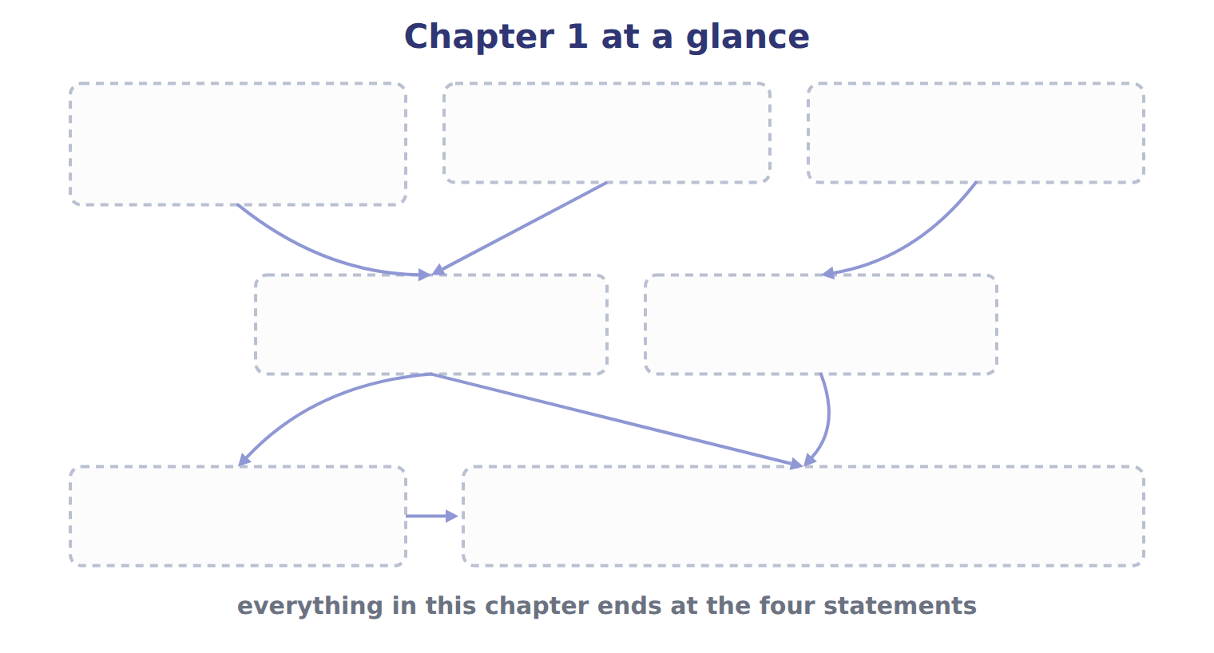
TEACH IT BACK | Write it for a student starting this chapter tomorrow — not for the marker.
19. In five or six sentences, write the whole chapter: who the statements are for, what they are built from, how a transaction is recorded, what decides the period, who writes the rules, and how the four statements join up.
every one of these words must appear: primary users · elements · accounting equation · debits · accrual basis · net income

