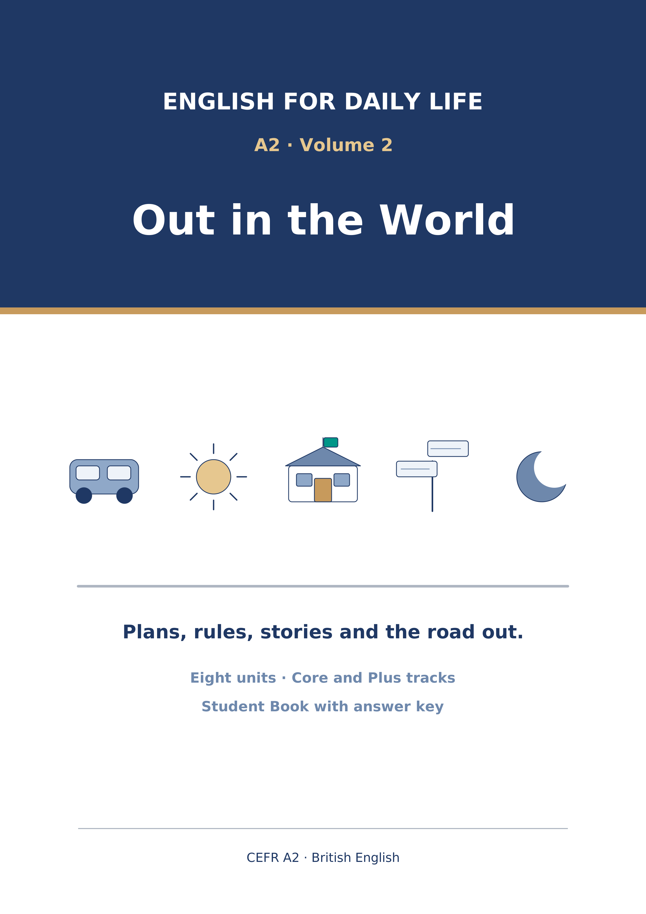
English for Daily Life
A2 · Volume 2 · Out in the World
How to use this book
Every unit has the same ten parts in the same order, so after Unit 1 you always know where you are.
[CORE] is the Warm Up and Parts 1–6. Everybody does these.
[PLUS] is Parts 7–9. They are there when you are ready for them, and optional when you are not. Part 10 is for everybody.
Almost every exercise opens with item 0, already answered. It is the worked example: read it before you start.
Symbols
🔊 | an audio track; the script is printed on the page
☐ | something to tick when you have checked it
✗ → ✓ | a common mistake, then the correction
Stretch | a harder version of the task, for the Plus track
→ Harvest | the grammar you will meet again later in the unit
Map of the Book
Unit | Topic | Grammar | Glossary
11 | Plans and Arrangements | going to | diary, booking, meeting, invite…
12 | Weather and What Might Happen | will | storm, shower, temperature, degree…
13 | Rules and Places | must/have to/mustn't/don't have to | law, allowed, silence, smoking…
14 | Health and Feeling Better | should/shouldn't - advice | pain, headache, medicine, pill…
15 | Experiences | present perfect - experience | experience, abroad, adventure, camping…
16 | Then and Now | present perfect vs past simple | modern, century, childhood, nowadays…
17 | How Things Are Made | active and passive | factory, material, metal, plastic…
18 | If and When | first conditional | unless, chance, risk, safe…
Audio tracks
Track | Where | What
11.1 | Unit 11 · Part 1 Pronunciation | Plans and Arrangements
11.2 | Unit 11 · Part 3 (1) | Plans and Arrangements
11.3 | Unit 11 · Part 3 (2) | Plans and Arrangements
11.4 | Unit 11 · Part 3 (3) | Plans and Arrangements
11.5 | Unit 11 · Part 7B | Plans and Arrangements
12.1 | Unit 12 · Part 1 Pronunciation | Weather and What Might Happen
12.2 | Unit 12 · Part 3 (1) | Weather and What Might Happen
12.3 | Unit 12 · Part 3 (2) | Weather and What Might Happen
12.4 | Unit 12 · Part 3 (3) | Weather and What Might Happen
12.5 | Unit 12 · Part 7B | Weather and What Might Happen
13.1 | Unit 13 · Part 1 Pronunciation | Rules and Places
13.2 | Unit 13 · Part 3 (1) | Rules and Places
13.3 | Unit 13 · Part 3 (2) | Rules and Places
13.4 | Unit 13 · Part 3 (3) | Rules and Places
13.5 | Unit 13 · Part 7B | Rules and Places
14.1 | Unit 14 · Part 1 Pronunciation | Health and Feeling Better
14.2 | Unit 14 · Part 3 (1) | Health and Feeling Better
14.3 | Unit 14 · Part 3 (2) | Health and Feeling Better
14.4 | Unit 14 · Part 3 (3) | Health and Feeling Better
14.5 | Unit 14 · Part 7B | Health and Feeling Better
15.1 | Unit 15 · Part 1 Pronunciation | Experiences
15.2 | Unit 15 · Part 3 (1) | Experiences
15.3 | Unit 15 · Part 3 (2) | Experiences
15.4 | Unit 15 · Part 3 (3) | Experiences
15.5 | Unit 15 · Part 7B | Experiences
16.1 | Unit 16 · Part 1 Pronunciation | Then and Now
16.2 | Unit 16 · Part 3 (1) | Then and Now
16.3 | Unit 16 · Part 3 (2) | Then and Now
16.4 | Unit 16 · Part 3 (3) | Then and Now
16.5 | Unit 16 · Part 7B | Then and Now
17.1 | Unit 17 · Part 1 Pronunciation | How Things Are Made
17.2 | Unit 17 · Part 3 (1) | How Things Are Made
17.3 | Unit 17 · Part 3 (2) | How Things Are Made
17.4 | Unit 17 · Part 3 (3) | How Things Are Made
17.5 | Unit 17 · Part 7B | How Things Are Made
18.1 | Unit 18 · Part 1 Pronunciation | If and When
18.2 | Unit 18 · Part 3 (1) | If and When
18.3 | Unit 18 · Part 3 (2) | If and When
18.4 | Unit 18 · Part 3 (3) | If and When
18.5 | Unit 18 · Part 7B | If and When
Unit 11: Plans and Arrangements
English for Daily Life · Level: A2 · Tracks: [CORE] Warm-Up + Parts 1–6 · [PLUS] Parts 7–10
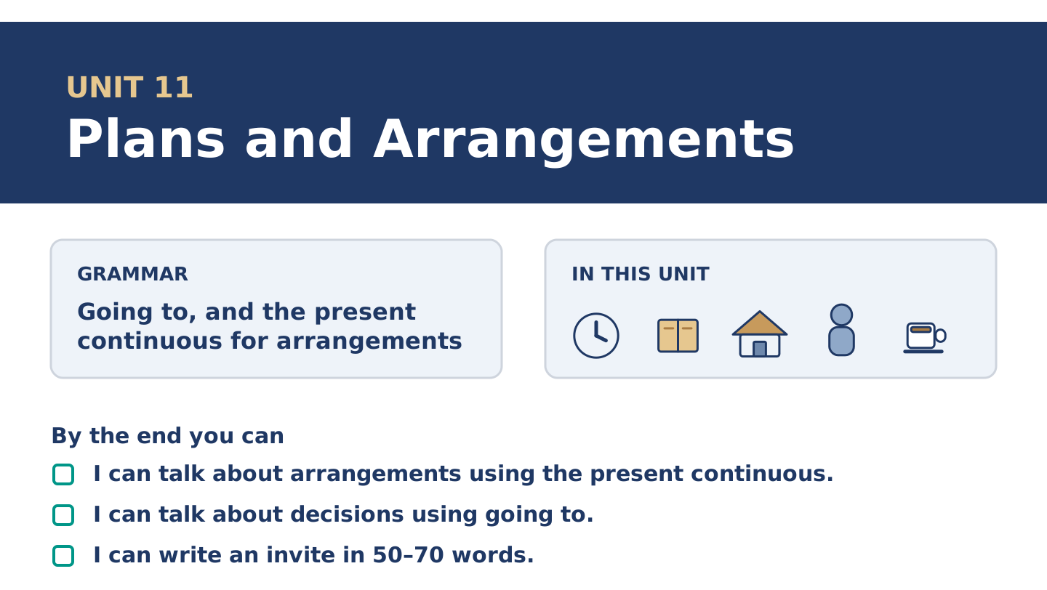
Figure 11.1 · Unit 11 at a glance: the grammar, the topic and what you will be able to do.
Warm Up
[CORE] Core track · in-class starter
Warm-up: Words for Plans
Match the words with their meanings. One meaning is not needed. Write the letter.
Column A
1. | Diary | ____
2. | Booking | ____
3. | Meeting | ____
4. | Host | ____
5. | Invite | ____
Column B
a) | to ask somebody to come
b) | the person whose home or evening it is
c) | a book where you write what you are doing and when
d) | a seat or a room you asked for before you came
e) | when people come together to talk about something
f) | the money you pay to belong to something
Warm-up: Talking About Next Week
Complete the sentences using the words in the word bank.
Word bank: holiday | remind | prepare | hotel
- Amina is taking her first ______________________ in four years.
- Could you ______________________ me on Thursday? I forget everything.
- Yuki is going to ______________________ the food on Friday evening.
- Dani found a ______________________ by the station for eleven pounds a night. It has no lift.
Warm-up: Six People, Six Saturdays
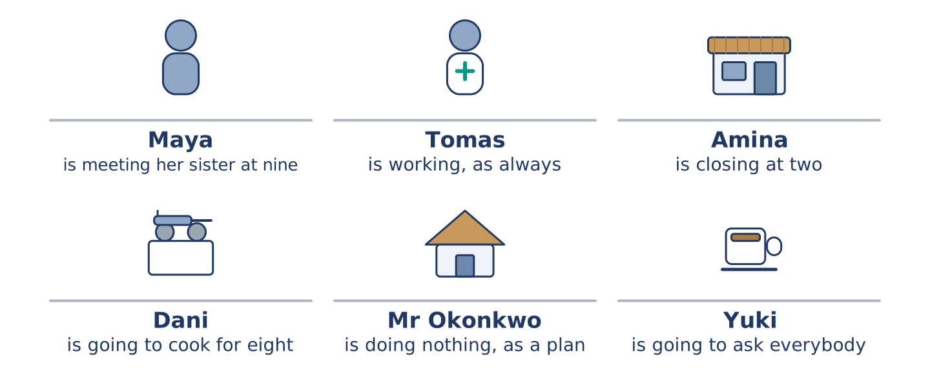
Figure 11.2 · What each of them is doing on Saturday, and what they are going to do.
Read the text and choose the correct answer.
Everybody at number 14 has a Saturday. Maya is meeting her sister at the station at nine. Tomas is working, because he is always working on a Saturday. Amina is closing the shop at two and going nowhere near a party. Dani is going to cook for eight people and told nobody yet. Mr Okonkwo is not doing anything, and he says that carefully, as a plan. Yuki is going to ask them all to come at seven, and she is going to ask today.
1. What is Maya doing at nine?
○ A) Working
○ B) Cooking for eight
○ C) Meeting her sister
○ D) Closing the shop
2. What is Mr Okonkwo doing on Saturday?
○ A) Nothing, and he means it
○ B) Going to the station
○ C) Working
○ D) Cooking
Part 1 · Vocabulary and Terminology
[CORE] Core track · pre-class input
Part 1: Words for Arrangements
Match the words with their meanings. One meaning is not needed. (0. is done for you.)
- Party → an evening when people come to one place to eat, talk and stay late.
Column A
1. | Diary | ____
2. | Booking | ____
3. | Meeting | ____
4. | Host | ____
5. | Remind | ____
6. | Prepare | ____
7. | Holiday | ____
Column B
a) | days away from work
b) | a seat or room asked for in advance
c) | to make somebody think of it again
d) | when people come together to talk about something
e) | a book where you write what you are doing
f) | to get everything ready first
g) | the person whose home or evening it is
h) | a thin flat covering, with another one over it
Gloss: diary = a book where you write what you are doing · booking = a seat or room asked for in advance · host = the person whose home or evening it is · arrange = to fix a time with somebody else
Part 1: Pronunciation
🔊 Audio Track 11.1
Listen to going to. Say each one aloud, then say it to a partner.
I’m going to ask them — in speech this is one quick sound: /ˈɡənə/
He’s going to cook — the same again: he’s gonna cook
We’re going to the station — here it is slow and clear, because to is a place
Are you going to come? — quick again, because come is a verb
The rule is simple. When going to carries a verb, English runs it together. When it carries a place, it stays apart. Say all three words every time and you are understood, and you always sound like a book.
Part 1: Four Plans, Four Kinds
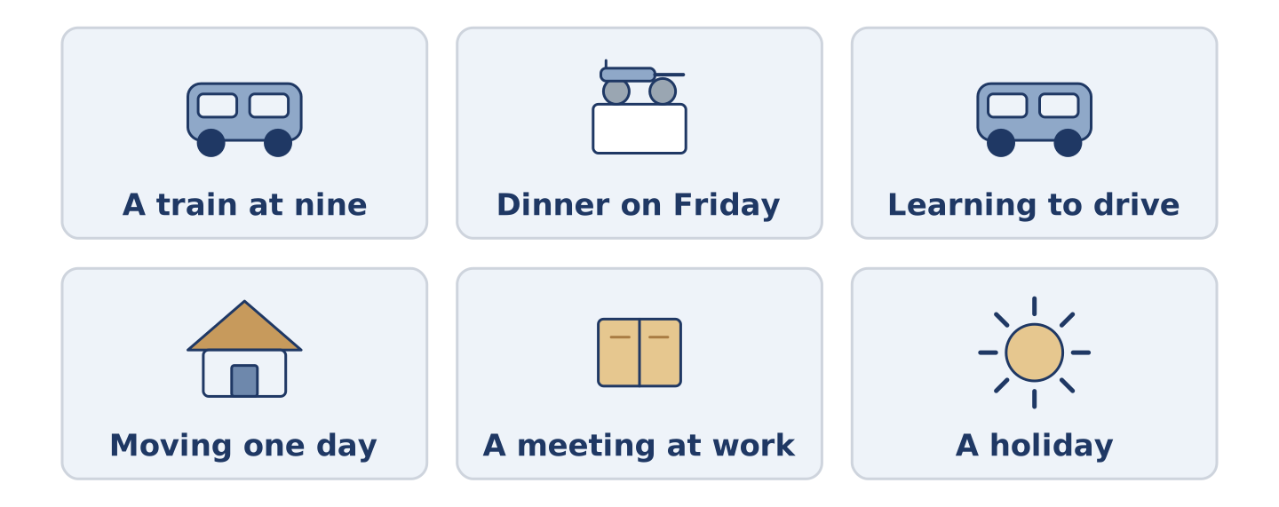
Figure 11.3 · Four kinds of plan, from the fixed to the half-decided.
Complete the table. Write how sure it is and how you say it. (0. is done.)
The plan | How sure is it? | How you say it
A train at nine, already paid | fixed, with a ticket | (example)
Dinner with a friend on Friday
Learning to drive this year
Moving to another city one day
- A train at nine, already paid — fixed, with a ticket — I am catching the nine o’clock.
Think about your own week. There is more than one right answer; be ready to say why.
Part 1: Sure, Half Sure, Not Sure
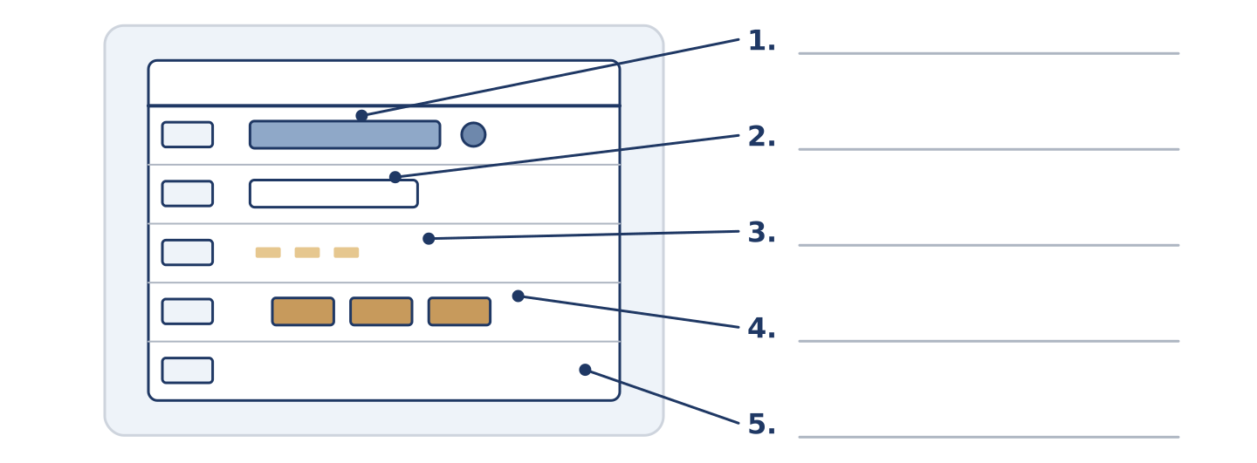
Figure 11.4 · How sure a plan is — write the correct word on each line.
Match the ways of talking about plans with how sure they are. One is not needed. Write the letter.
Column A
1. | I am meeting her at nine. | ____
2. | I am going to ask them. | ____
3. | I hope to go in the spring. | ____
4. | I might go. | ____
5. | I would like to, one day. | ____
Column B
a) | a wish, with no date
b) | decided, but nothing is booked
c) | arranged, with a time and a person
d) | a hope, with a rough time
e) | open, and it may not happen
f) | finished, and it went well
Part 1: Plans — Multiple Choice
Read and choose the correct answer.
1. A seat or a room you asked for before you came is a…
○ A) meeting
○ B) booking
○ C) diary
○ D) holiday
2. The person whose home or evening it is, is the…
○ A) guest
○ B) member
○ C) host
○ D) driver
3. To make somebody think of something again is to…
○ A) prepare
○ B) invite
○ C) book
○ D) remind
Part 1: Vocabulary Fill-in
Complete the sentences with the correct word.
Word bank: invite | diary | meeting | party
- Write it in your ______________________ or you forget by Wednesday.
- Yuki wants to ______________________ the whole building, and she is nervous.
- There is a ______________________ at the school about the new crossing.
- Dani calls it dinner. Everybody else calls it a ______________________ .
Part 1: Write About Your Week (short)
Write two or three sentences about your week. Use three words from this unit.
Model — read this first:
I am at the hospital on Tuesday, which is in my diary twice because I once forgot it. On Thursday I am meeting a friend who is never on time. At the weekend I am doing nothing at all. (39 words)
Part 2 · Grammar — Going To and the Present Continuous
[CORE] Core track · pre-class input
Part 2: Notice
Read these lines. Underline the plans. Which are arranged with somebody, and which are only decided?
Maya is meeting her sister at nine. Dani is going to cook for eight people. Yuki is asking them all today. Amina is going to close early, probably. Tomas is working on Saturday. I am going to learn to drive this year.
Three of these carry a time or another person. Three are only a decision, and nothing more.
Part 2: Grammar Focus Box
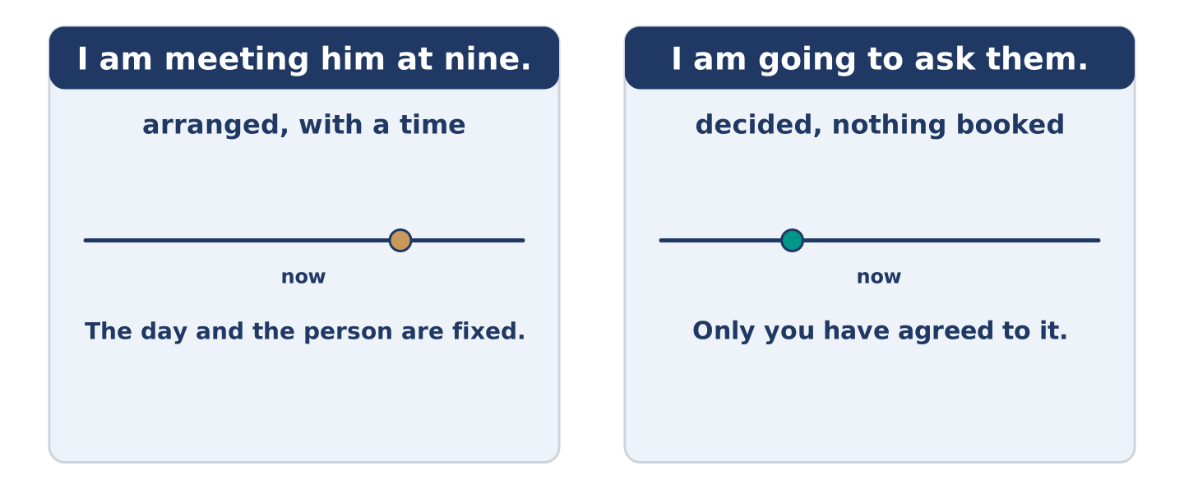
Figure 11.5 · Arranged, and only decided: two futures, two jobs.
 | Form | Use | Example
present continuous | am/is/are + -ing | an arrangement, with a time | I am meeting him at nine.
going to | am/is/are going to + verb | a decision, not yet arranged | I am going to cook for eight.
going to (evidence) | the same form | what you can already see | Look at that sky — it is going to rain.
negative | am/is/are not | both forms, the same way | I am not working on Saturday.
Remember: an arrangement needs another person or a time: I am meeting him at nine, not I am meeting one day.
Watch out! ✗ I going to cook. → ✓ I am going to cook. (going to always needs am, is or are). ✗ I will meet her at nine, it is arranged. → ✓ I am meeting her at nine. (English uses the continuous for arrangements).
Part 2: Controlled Practice
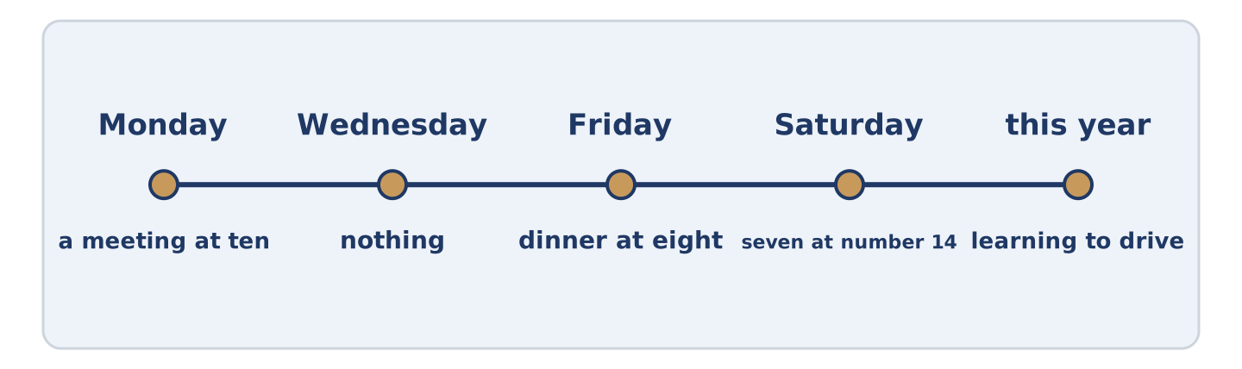
Figure 11.6 · One week, from Monday to Saturday.
Complete with the present continuous or going to. (0. is done.)
- Maya is meeting her sister at nine on Saturday. (arranged)
- Dani ______________________ cook for eight people. (decided)
- Tomas ______________________ at the hospital all weekend. (arranged)
- Yuki ______________________ ask everybody today. (decided)
- Amina ______________________ the shop at two. (arranged)
Part 2: Arranged or Decided?
Write arranged or decided. (0. is done.)
- I am meeting him at the station at nine. — arranged
- I am going to learn to drive this year. ____________
- We are having dinner at eight on Friday. ____________
- He is going to ask for more money. ____________
- He is working on Saturday. ____________
Part 2: Correct the Sentence
Each sentence has one grammar mistake. Write the correct sentence.
- I going to cook for eight people.
- She is going to meeting her sister at nine.
- We are have dinner at eight on Friday.
- He is going to works on Saturday.
Part 2: Freer Practice
Write two sentences about your week: one arrangement with a time, and one decision with no date.
Part 2: Grammar Review
Choose the correct sentence.
1. Which sentence is an arrangement?
○ A) I am going to see him sometime.
○ B) I am seeing him at nine on Friday.
○ C) I will see him, probably.
○ D) I see him at nine on Friday.
2. Which sentence is correct?
○ A) I going to ask them today.
○ B) I am going to asking them today.
○ C) I am going ask them today.
○ D) I am going to ask them today.
→ Harvest: you will see both futures again in the Part 5 reading. Watch for the times.
Part 3 · Listening
[CORE] Core track · pre-class input · scripts printed inline
Part 3: Arranging an Evening
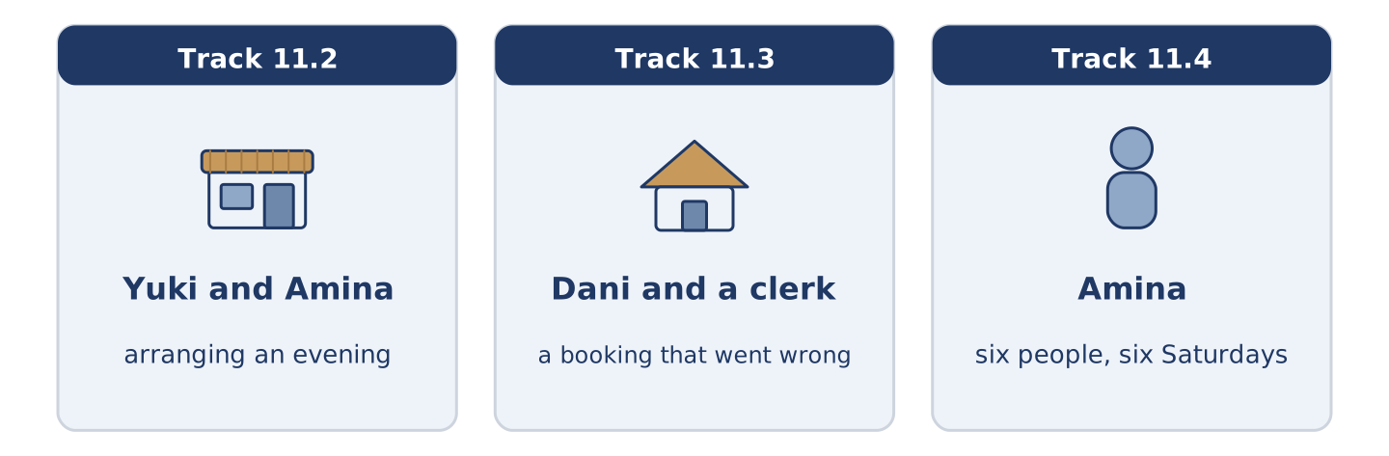
Figure 11.7 · The three listenings: who is speaking, and what about.
🔊 Audio Track 11.2
Before you listen: how far ahead do people in your country arrange an evening?
Yuki: Amina, are you doing anything on Saturday evening? Amina: I’m closing at two and then I’m doing nothing, which is the plan. Yuki: I’m going to ask everybody to come at seven. Amina: Everybody? Yuki: All five of you. Amina: Yuki, nobody in this building ever goes into anybody’s flat. Yuki: I know. That’s why I’m asking. Amina: Then I’m coming, and I’m bringing something, and don’t argue.
While you listen: write True, False, or Not Given. (0. is done.)
- Yuki is arranging something for Saturday evening. — True
- Amina is working on Saturday evening. ____
- Amina says she is bringing something. ____
- Yuki cooked for six people last year. ____
Useful phrases: Are you doing anything…? · I’m going to ask… · That’s why I’m asking · don’t argue
Part 3: A Booking That Went Wrong
🔊 Audio Track 11.3
Before you listen: what do you say when a booking is not there?
Dani: I’ve a booking at this hotel for two nights, the name is Rossi. Clerk: I’m sorry, I’m not finding it. Dani: I made it on the telephone on Monday. Clerk: Who did you speak to? Dani: A man. I didn’t ask. Clerk: Did you get a number? Dani: No. Clerk: Then I’m going to put you in a room anyway, because the hotel has one, and next time take the number. Dani: I’m going to write that on my hand.
Answer the questions. (0. is done.)
- How many nights is the booking for? — Two.
- When did Dani make the booking?
- What did Dani not ask for?
- What does the clerk tell him to do next time?
Part 3: Six People, Six Saturdays
🔊 Audio Track 11.4
Before you listen: who in your street always knows what everybody is doing?
Amina: I know everybody’s Saturday, and I never ask. Maya is meeting her sister off the nine o’clock, and she’s already nervous about it. Tomas is working, because Tomas is always working. Dani is going to cook, and he is not saying how many people yet. Mr Okonkwo is doing nothing, and he plans it like a job. And Yuki is going to ask us all to come at seven, and I’m going to say yes before she finishes the sentence.
While you listen: match each person with their Saturday. One is not needed. (0. is done.)
- Amina → she knows and never asks.
Useful phrases: ___ is meeting her sister · ___ is working · ___ is going to cook
Column A
1. | Maya | ____
2. | Tomas | ____
3. | Mr Okonkwo | ____
4. | Yuki | ____
Column B
a) | is going to ask everybody to come at seven
b) | is working, as always
c) | is meeting her sister off the nine o’clock
d) | is doing nothing, and plans it like a job
e) | is going away for the weekend
Part 4 · Speaking
[CORE] Core track · in-class output
Part 4: Your Week
Work with a partner. Ask and answer these questions.
- What are you doing this weekend?
- What are you going to do this year that you have not started?
- Who arranges things in your family, and how far ahead?
Useful language: I’m meeting… · I’m going to… · on Friday at… · nothing at all
Part 4: Find the Difference (pairwork)
Student A and Student B each have a week in a diary. Ask questions and find three differences.
Useful questions: What are you doing on Monday? · Are you free on Thursday? · Who are you meeting? · What time?
Student A — your week: Monday meeting at ten, Wednesday free, Friday dinner at eight, Saturday nothing.
Student B — your week: Monday meeting at ten, Wednesday hospital, Friday free, Saturday nothing.
Part 4: Arranging Something Together
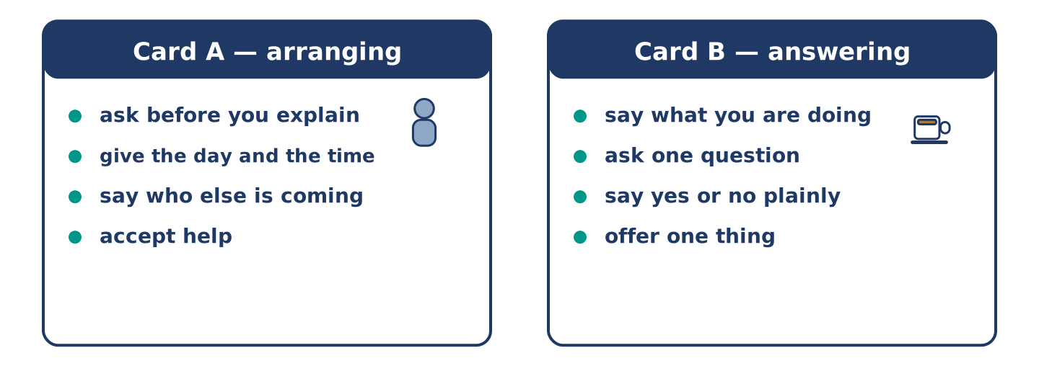
Figure 11.8 · Card A and Card B: what each of you has to say.
Work in pairs. Read the model, then use the cards.
Model exchange:
A: Are you doing anything on Saturday evening? — B: Nothing at all. Why? — A: I’m going to ask everybody to come at seven. — B: Everybody? — A: All of them. — B: Then I’m coming, and I’m bringing something. — A: There is no need. — B: I know. Seven.
Useful language: Are you doing anything…? · Nothing at all · I’m going to… · I’m bringing…
Card A — arranging: ask before you explain · give the day and the time · say who else is coming to the party · accept help.
Card B — answering: say what you are doing · ask one question · say yes or no plainly · offer to bring one thing.
Your turn: run the dialogue, then swap roles.
Stretch [PLUS]: you cannot come, and the real reason is awkward — say no without inventing anything.
Part 4: Mini-Presentation
Prepare a short talk (about one minute). Describe one week you have arranged: three things in it, and one thing you decided but did not book.
Part 5 · Reading
[CORE] Core track · pre-class input
Part 5: How Far Ahead Do People Plan?
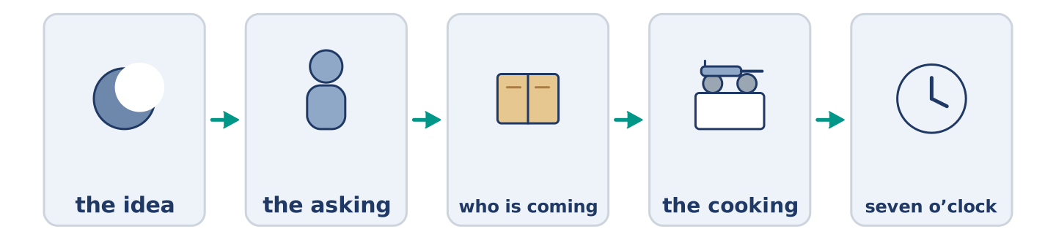
Figure 11.9 · One invite, from the idea to the evening itself.
Before you read: is a plan made a month ahead a kinder plan or a colder one?
Gloss: spontaneous = done without planning · notice = how much warning somebody gets · calendar = where people keep their dates · compliment = something kind said about you
Ask somebody in one country to dinner next Tuesday and they say yes. Ask somebody in another country the same thing and they look in a calendar and offer you a date five weeks away. Neither of them is being rude. In some places people fix an evening the same afternoon, and a plan a month old feels cold by the time it arrives. In others, short notice means you were not somebody’s first thought, and a date far ahead is a compliment. The trouble starts when the two kinds of person live in the same street. One is hurt by the diary; the other is hurt by the doorbell. Both of them meant well, and neither of them said so.
Answer the multiple-choice questions. (0. is done.)
- What do the two people do when they are asked to dinner? — One says yes; the other looks in a calendar.
1. What does a date five weeks away mean in some countries?
○ A) That you are not wanted
○ B) That the person is busy and rude
○ C) That you are a compliment and were planned for
○ D) That the evening is cancelled
2. In other places, how is an evening usually arranged?
○ A) The same afternoon
○ B) A month ahead
○ C) By letter
○ D) Never
3. What does the text say starts the trouble?
○ A) The food
○ B) The money
○ C) The weather
○ D) The two kinds of person in one street
Part 5: Vocabulary in Context
Match each word from the text with its meaning. One meaning is not needed. Write the letter.
Column A
1. | spontaneous | ____
2. | notice | ____
3. | compliment | ____
4. | calendar | ____
Column B
a) | how much warning somebody gets
b) | something kind that is said about you
c) | done without planning
d) | where people keep their dates
e) | the money you pay to belong
Part 5: Three Ways of Keeping a Week
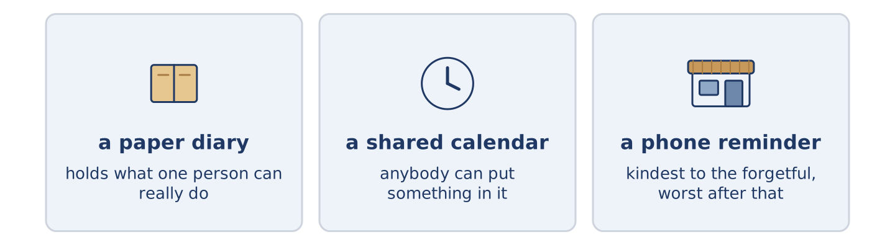
Figure 11.10 · Three ways people keep track of what they are doing.
Before you read: where do you keep what you are doing next week?
Gloss: paper diary = a book you write in by hand · shared = used by more than one person · reminder = a note that comes back to you later
People keep a week in very different ways, and the way shapes the week. A paper diary holds about as much as a person can really do, because the page runs out. A shared calendar at work holds far more, and anybody can put something in it. That is why a Thursday fills up with other people’s ideas. A phone reminder is the kindest of the three to a forgetful person. It is the worst for anybody who then stops remembering at all. None of them is the right one. The question is only which kind of forgetting you can afford.
Answer the questions. (0. is done.)
- Do people keep a week in the same way? — No, they keep it very differently.
- Why does a paper diary hold about as much as a person can do?
- Why does a Thursday fill up in a shared calendar?
- Who is a phone reminder worst for?
Part 6 · Writing
[CORE] Core track · in-class / homework
Part 6: An Invitation (50–70 words)
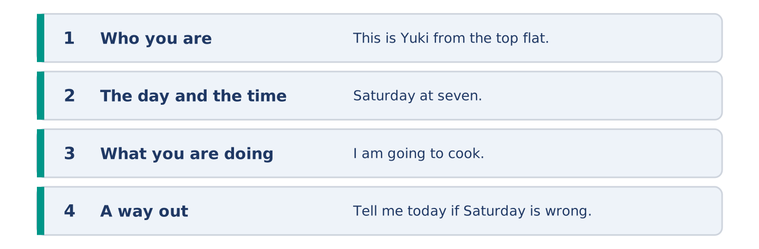
Figure 11.11 · The shape of the message you are about to write.
Write a message inviting your neighbours to something at your home.
Model — read this first:
This is Yuki from the top flat. I am asking everybody at number 14 to come to mine on Saturday at seven. I am going to cook, and there is no need to bring anything, although I know some of you are going to. Come for an hour or come for the evening. Tell me today if Saturday is wrong, and I am happy to move it. (67 words)
Plan (fill in, then write): This is ___. I am asking ___ to ___ on ___ at ___. I am going to ___. ___ if ___.
Word bank: I am asking | at seven | there is no need | come for | tell me if
Check before you finish: ☐ who you are? ☐ the day and the time? ☐ what you are doing? ☐ 50–70 words?
Part 6: Plan Ahead or Decide Late? (50–70 words)
Is it better to arrange things far ahead or to decide on the day? Give your opinion and two or three reasons.
Model — read this first:
Far ahead, and I say that as somebody who hates diaries. A plan made on the day only works when everybody is free, and people stop asking the never-free. Four weeks is long enough for anybody to say no honestly. The cost is that you lose the evening nobody planned, which was always the best one. (56 words)
Word bank: I think… because… | ahead | however | in my opinion | it depends on
Check before you finish: ☐ a clear opinion? ☐ two or three reasons? ☐ 50–70 words?
Part 6: Changing an Arrangement (50–70 words)
You cannot come to something you agreed to. Write the message you send.
Model — read this first:
I am sorry about Saturday. I said yes three weeks ago and I am now working that evening, which I did not know then. I am not going to pretend I am ill, because you would hear it. Can we do the Saturday after? I am free all day and I am going to keep it free. (57 words)
Plan (fill in, then write): I am sorry about ___. I ___, and ___. Can we ___? I am ___.
Check before you finish: ☐ the apology first? ☐ the real reason? ☐ a new day offered? ☐ 50–70 words?
Part 6: Reflection — Something I Keep Not Doing (40–60 words)
Write about something you are always going to do and never start.
Model — read this first:
I am going to learn to swim. I said this every January for nine years and I say it with the same face every time. I know where the pool is and I know what it costs. What I do not have is a Tuesday evening I am willing to give up. (52 words)
Check before you finish: ☐ what you are going to do? ☐ how long you have said it? ☐ what stops you? ☐ 40–60 words?
Part 7 · Real-World File — Making and Changing Arrangements
[PLUS] Plus track (optional) · stronger learners
7A: Phrase Bank
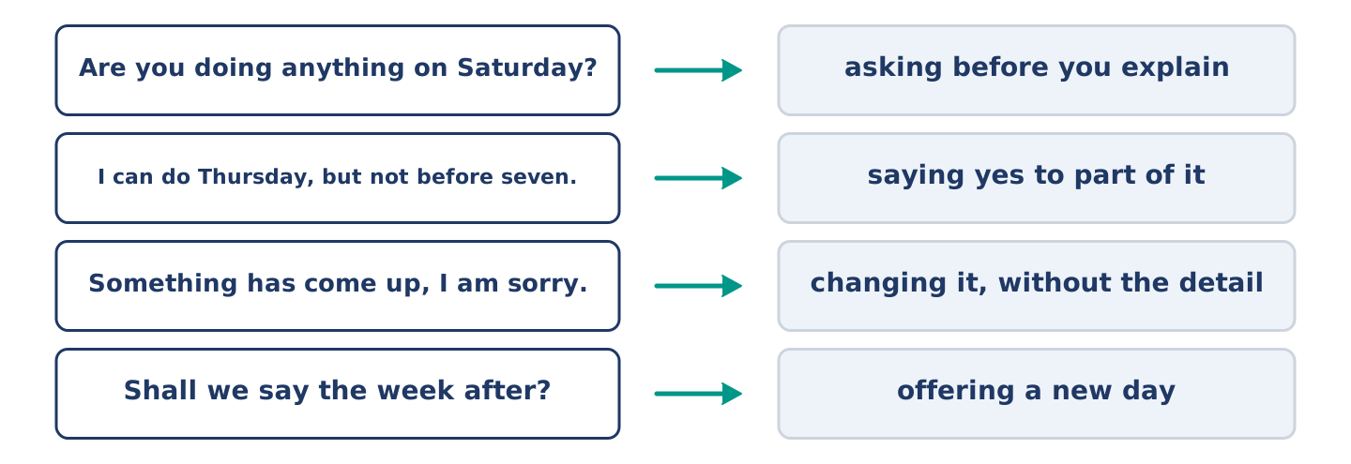
Figure 11.12 · What you say when you arrange or change something, and what each line does.
Match what a person says with its purpose. One purpose is not needed. Write the letter.
Column A
1. | “Are you doing anything on Saturday?” | ____
2. | “I can do Thursday, but not before seven.” | ____
3. | “Something has come up, I am sorry.” | ____
4. | “Shall we say the week after?” | ____
Column B
a) | offering a new day
b) | asking before you explain
c) | asking how much it costs
d) | changing it, without the detail
e) | saying yes to part of it
7B: A Booking Nobody Can Find
🔊 Audio Track 11.5
Before you read: who keeps the number when you book something by telephone?
Dani: The name is Rossi, two nights. Clerk: And you booked when? Dani: Monday, on the telephone. Clerk: I have a Rossi for next month. Dani: That is not me. Or it is me, and the man wrote it wrong. Clerk: Did he read it back to you? Dani: I do not remember. Clerk: That is the part that matters. I am going to give you a room tonight, and I am going to put a note on the other one.
Answer the questions. (0. is done.)
- How many nights did Dani book? — Two.
- What does the clerk find in the system?
- What does the clerk say is the part that matters?
- What is the clerk going to do about the other booking?
7C: Controlled Practice — Making a Booking Well
Put the steps in order. Number them 1–5. (0. is done.)
- Say what you want and for when. — 1
____ Write the number down where you can find it.
____ Give your name and spell it.
____ Ask for a booking number.
____ Ask them to read it all back to you.
7D: Role-Play — Changing an Arrangement
In pairs. One has to change something; one has to answer. Use the model and cards.
Model exchange: A: I am sorry, I cannot do Saturday. — B: What has happened? — A: I am working, and I only found out today. — B: That is a shame. — A: Shall we say the week after? — B: The week after is good. — A: I am going to keep it free.
Card A — changing: apologise first · give the real reason · offer a new day · promise one thing.
Card B — answering: ask once · do not make them explain twice · take the new day or offer another · end it warmly.
Stretch [PLUS]: it is the third time you have changed it — say so yourself before they do.
7E: Writing — Arranging Something with Four People (50–80 words)
Write one message that arranges something with four people at once.
Model — read this first:
Saturday the fourteenth, seven o’clock, at mine. I am cooking, so I need to know numbers by Thursday, and after Thursday I am going to take it that you are coming. Tomas, I know you are on nights, so come late or come next time. There is no dress code and there is no present. Answer this one message and not me alone. (63 words)
Check before you finish: ☐ the day, the date and the time? ☐ what people have to do? ☐ one thing about one person? ☐ 50–80 words?
Part 8 · Global Story — The Huts That Nobody Books
[PLUS] Plus track · pre-read / discuss
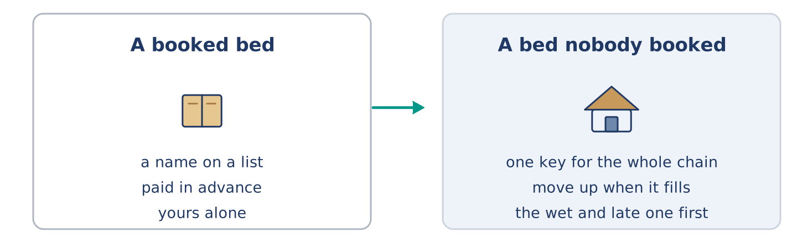
Figure 11.13 · A booked bed, and a bed nobody booked.
Before you read: can a thing work better with no booking at all?
Gloss: shelter = a small building that keeps the weather off · key = the thing that opens a lock · trust = believing that people do what they should
In the mountains of Norway there is a chain of small shelters, a day’s walk apart. For most of them there is no booking at all. You buy one key, once, and it opens every door in the chain. You walk in, you take a bed, you write your name in the book, and you pay later. If the shelter is full when you arrive, nobody turns you away. The people already there move up, and the last one in sleeps on the floor. The rule everybody knows is the one about weather. If somebody arrives wet and late, the bed goes to them. It works because the plan is the walk and not the bed. Somebody taking the last bed one week carries a stove for a stranger the next.
Answer the questions. (0. is done.)
- How far apart are the shelters? — About a day’s walk.
- What does one key open?
- What happens if a shelter is full?
- What is the rule everybody knows?
Part 8: Vocabulary in Context
Match each word with its meaning. One meaning is not needed. Write the letter.
Column A
1. | shelter | ____
2. | chain | ____
3. | trust | ____
4. | stranger | ____
Column B
a) | a line of things joined one after another
b) | somebody you do not know
c) | a small building that keeps the weather off
d) | believing that people do what they should
e) | where people keep their dates
Part 8: Discussion
Talk with a partner. Use the frames.
Discussion frames: “This is similar to where I live because…” · “This is different from where I live because…” · “I think the most important thing is… because…”
Part 9 · Close to Home — The Saturday Nobody Had Arranged
[PLUS] Plus track · pre-read / decide
Before you read: is it harder to ask people in or to go to somebody else’s door?
Yuki asked all five of them on the Tuesday, and by Wednesday evening she had three yeses, one maybe and nothing at all from Tomas. Amina said yes before the sentence was finished. Dani said yes and then asked what he could cook, which was not the offer anybody wanted. Maya said yes and then quietly moved her sister to the Sunday. Mr Okonkwo said he would see, which from him is a yes with the door left open. Tomas said nothing for two days, because Tomas was on nights and did not read his phone. On Saturday he came at half past nine, straight off a shift, still in the wrong shoes, and stayed until one.
Answer the questions. (0. is done.)
- When did Yuki ask everybody? — On the Tuesday.
- What did Dani ask after he said yes?
- What did Maya quietly move?
- Why did Tomas say nothing for two days?
Part 9: Decision Task
You want to ask six neighbours to something and two have never spoken to you. Should you (a) ask everybody at once, (b) ask the ones you know first, or (c) put a note through every door? Decide and explain. Use the frame.
Answer frame: “I think I should ___ because ___. Also, ___. This is better than ___ because ___.”
Model — read this first:
I think I should ask everybody at once, because asking the easy ones first turns the others into an afterthought, and they can tell. Also, one message means nobody wonders who else was on the list. This is better than a note through the door, because a note is easy to put down and never answer. (56 words)
Phrase bank: I think I should… · because… · Also,… · This is better than… · In my opinion…
Part 10 · Review and Can-Do
[CORE + PLUS] · homework / self-study
Part 10: Spiral Review
Complete the review. (0. is done.)
- A book where you write what you are doing and when is a diary.
Word bank: booking | meeting | host | remind | holiday | am meeting | am going to | junction
- A seat or a room you asked for before you came is a ______________________ .
- When people come together to talk about something, it is a ______________________ .
- The person whose home or evening it is, is the ______________________ .
- To make somebody think of something again is to ______________________ .
- Days away from work, usually away from home, are a ______________________ .
- I ______________________ him at nine on Friday. (arranged)
- I ______________________ learn to drive this year. (decided)
- (from Unit 9) Where two or more roads meet is a ______________________ .
Part 10: Can-Do
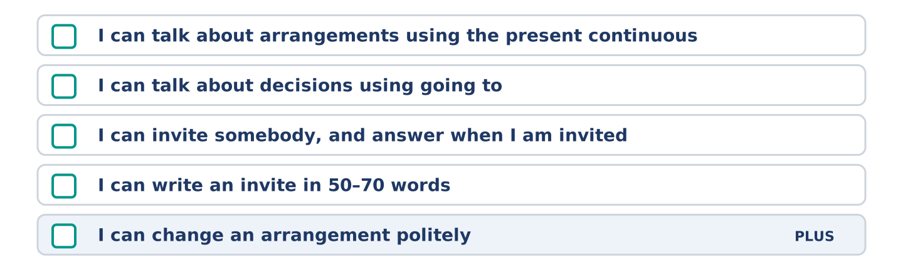
Figure 11.14 · What you can do at the end of this unit.
Can-Do checklist
☐ I can talk about arrangements using the present continuous.
☐ I can talk about decisions using going to.
☐ I can invite somebody, and answer when I am invited.
☐ I can write an invite in 50–70 words.
☐ I can change an arrangement politely (Plus).
Part 10: Glossary
Unit 11 glossary (10 words)
diary · booking · meeting · invite · host · party · holiday · remind · prepare · hotel
Unit 12: Weather and What Might Happen
English for Daily Life · Level: A2 · Tracks: [CORE] Warm-Up + Parts 1–6 · [PLUS] Parts 7–10
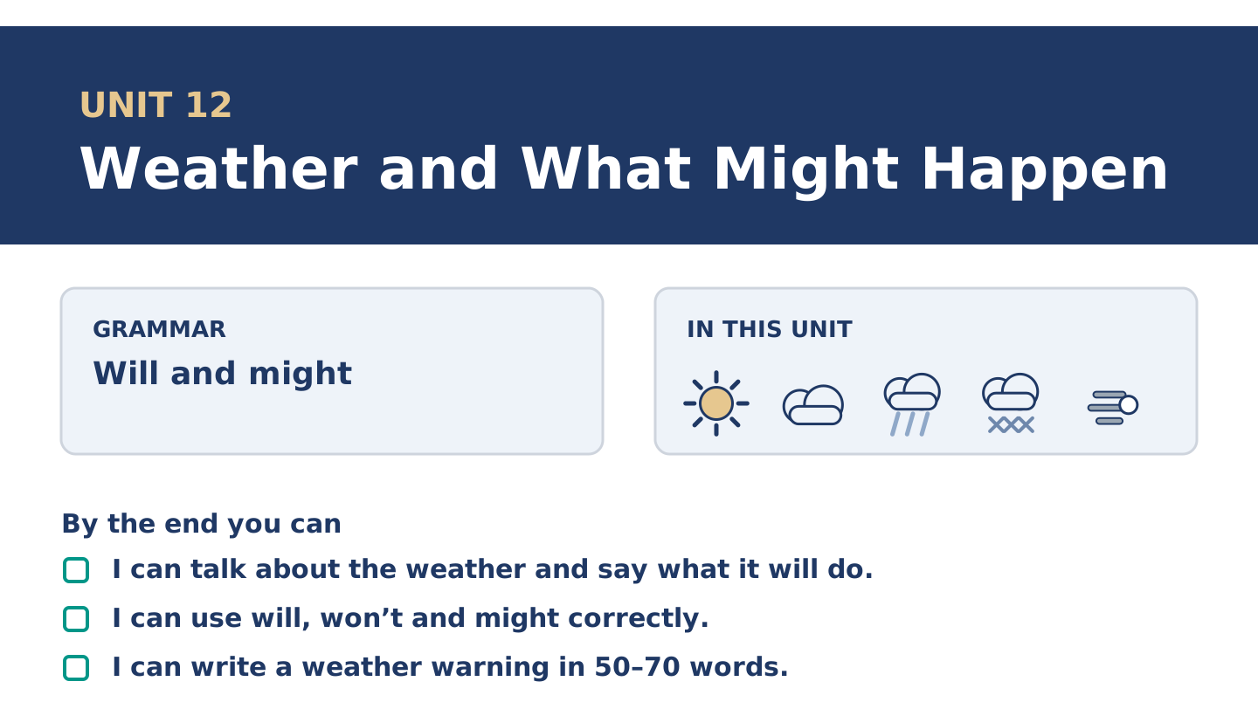
Figure 12.1 · Unit 12 at a glance: the grammar, the topic and what you will be able to do.
Warm Up
[CORE] Core track · in-class starter
Warm-up: Weather Words
Match the words with their meanings. One meaning is not needed. Write the letter.
Column A
1. | Storm | ____
2. | Shower | ____
3. | Fog | ____
4. | Flood | ____
5. | Ice | ____
Column B
a) | thick cloud at ground level, so you see almost nothing
b) | short heavy rain that stops again
c) | water over roads and into houses
d) | strong wind and heavy rain together
e) | water that has gone hard with cold
f) | days away from work, usually away from home
Warm-up: Talking About the Weather
Complete the sentences using the words in the word bank.
Word bank: temperature | sunny | wind | freeze
- The ______________________ is going up all week, which nobody expected.
- Put the bike inside tonight, because the ______________________ is getting stronger.
- It will be ______________________ on Saturday, and Amina says she will believe it then.
- If it goes below zero the water in that pipe will ______________________ .
Warm-up: Six People, Six Forecasts
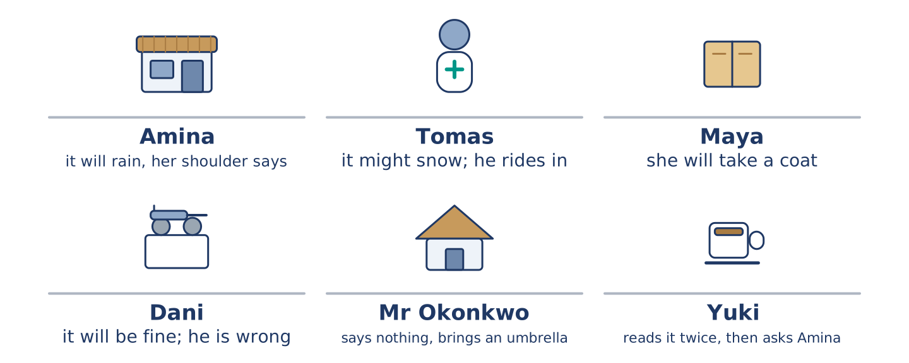
Figure 12.2 · What each of them thinks the weather will do.
Read the text and choose the correct answer.
Everybody at number 14 has a weather rule. Amina says it will rain because her shoulder says so, and her shoulder is right more often than the radio. Tomas says it might snow and he will ride in anyway. Maya says she will take a coat and she always takes a coat. Dani says it will be fine, and Dani is wrong about this every single week. Mr Okonkwo says nothing and brings an umbrella. Yuki reads the forecast twice and then asks Amina.
1. Whose shoulder is right more often than the radio?
○ A) Amina’s
○ B) Maya’s
○ C) Yuki’s
○ D) Dani’s
2. What does Mr Okonkwo do?
○ A) He reads the forecast twice
○ B) He says nothing and brings an umbrella
○ C) He rides in anyway
○ D) He says it will be fine
Part 1 · Vocabulary and Terminology
[CORE] Core track · pre-class input
Part 1: Words for Weather
Match the words with their meanings. One meaning is not needed. (0. is done for you.)
- Degree → one step on the scale that says how hot or cold it is.
Column A
1. | Storm | ____
2. | Shower | ____
3. | Temperature | ____
4. | Fog | ____
5. | Freeze | ____
6. | Flood | ____
7. | Wind | ____
Column B
a) | thick cloud at ground level
b) | air that is moving, sometimes hard
c) | short heavy rain that stops again
d) | to go hard with cold
e) | how hot or cold something is
f) | strong wind and heavy rain together
g) | water over roads and into houses
h) | a seat or room asked for in advance
Gloss: fog = thick cloud at ground level · flood = water over roads and into houses · freeze = to go hard with cold
Part 1: Pronunciation
🔊 Audio Track 12.1
Listen to will and won’t. Say each pair aloud.
It will rain — in speech will drops to one sound: it’ll rain
It won’t rain — won’t never drops, and the sound is long: /wəʊnt/
I’ll bring one — I will becomes I’ll, almost one letter
I won’t need it — long again, and clear
This is the same trap as can and can’t in Unit 8. The yes-form almost disappears and the no-form stands up and shouts. Say will strongly in the middle of a sentence and an English ear listens for a not that never comes.
Part 1: Four Kinds of Weather
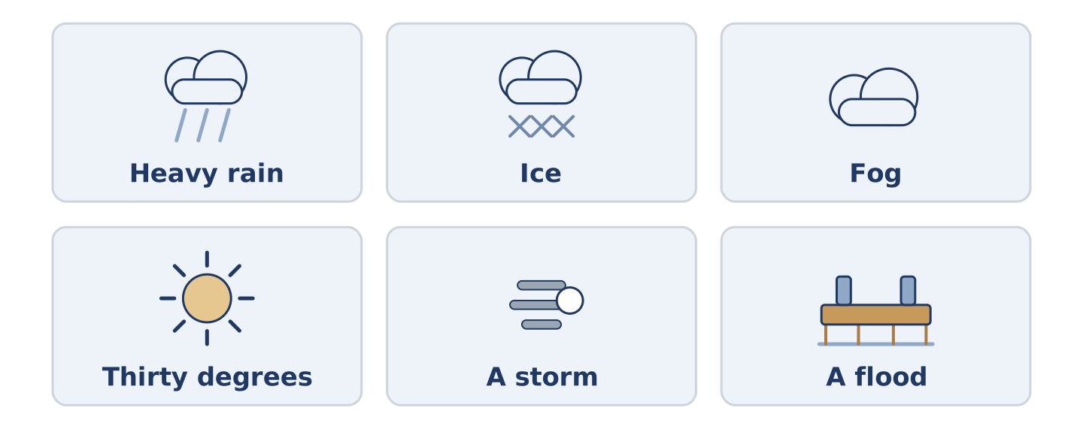
Figure 12.3 · Four kinds of weather, and what people do about each.
Complete the table. Write what you take and what you cancel. (0. is done.)
The weather | What you take | What you cancel
Heavy rain all day | a coat and dry shoes | (example)
Ice on the roads
Fog in the morning
Thirty degrees
- Heavy rain all day — a coat and dry shoes — nothing; you go anyway.
Think about where you live. There is more than one right answer; be ready to say why.
Part 1: How Sure Is It?
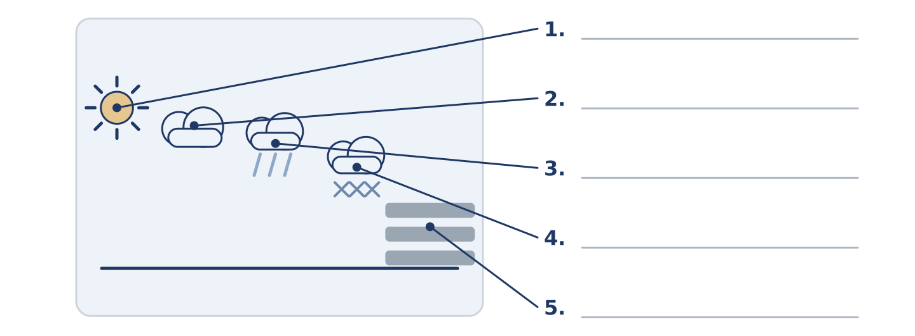
Figure 12.4 · How sure a forecast is — write the correct word on each line.
Match the ways of talking about the future with how sure they are. One is not needed. Write the letter.
Column A
1. | It will rain. | ____
2. | It might rain. | ____
3. | It will probably rain. | ____
4. | It won’t rain. | ____
5. | It might not rain. | ____
Column B
a) | sure it is not going to happen
b) | possible, and possible the other way too
c) | sure it is going to happen
d) | likely, but not certain
e) | possible that it does not happen
f) | it happened and it was heavy
Part 1: Weather — Multiple Choice
Read and choose the correct answer.
1. Thick cloud at ground level is…
○ A) fog
○ B) a shower
○ C) a storm
○ D) ice
2. Water over roads and into houses is a…
○ A) shower
○ B) wind
○ C) flood
○ D) degree
3. Short heavy rain that stops again is a…
○ A) fog
○ B) shower
○ C) storm
○ D) flood
Part 1: Vocabulary Fill-in
Complete the sentences with the correct word.
Word bank: ice | storm | degree | sunny
- There is ______________________ on the steps, so hold the rail.
- It is one ______________________ above zero and the sky is white.
- The ______________________ took three tiles off the roof at number 8.
- Two ______________________ days in March, and the whole street is outside.
Part 1: Write About Your Weather (short)
Write two or three sentences about the weather where you live. Use three words from this unit.
Model — read this first:
It rains here in short showers and then the sun comes out and nobody believes it. We get fog twice a winter and the buses stop. It never freezes hard enough for ice on the roads, so the one year it did, nobody could drive at all. (47 words)
Part 2 · Grammar — Will and Might
[CORE] Core track · pre-class input
Part 2: Notice
Read these lines. Underline will, won’t and might. Which are sure, and which are only possible?
It will rain this afternoon. It might snow on Thursday. It won’t be warm again until April. I will take a coat. I might take the bus. With ice on the hill, the buses won’t run.
Three of these are sure. Two are only possible. One is a decision made while speaking.
Part 2: Grammar Focus Box
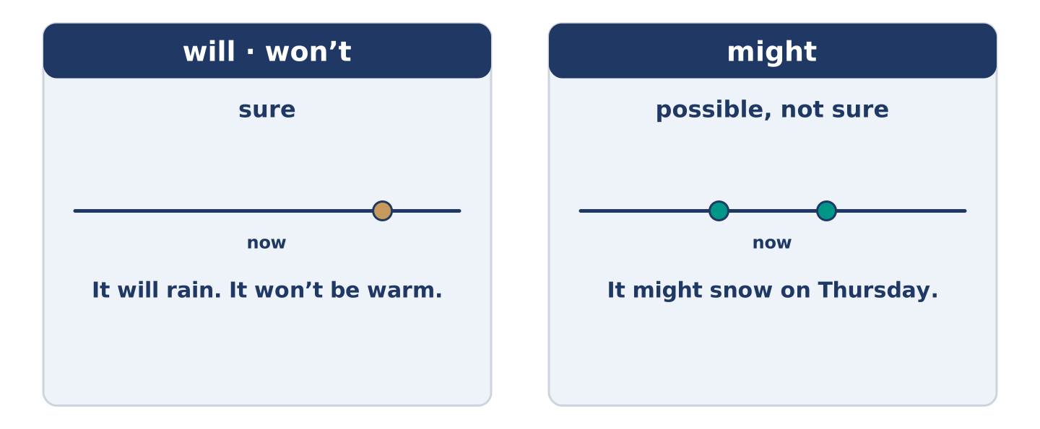
Figure 12.5 · Sure and possible: two words, two jobs.
 | Form | Use | Example
will | will + plain verb | sure about the future | It will rain this afternoon.
won’t | will not + plain verb | sure it does not happen | It won’t be warm until April.
might | might + plain verb | possible, not sure | It might snow on Thursday.
will (deciding) | the same form | a decision made as you speak | Fine — I will take a coat.
Remember: will and might never take to: it might rain, not it might to rain.
Watch out! ✗ It will to rain. → ✓ It will rain. (no to after will). ✗ Maybe it will perhaps rain. → ✓ It might rain. (one word for possible is enough).
Part 2: Controlled Practice
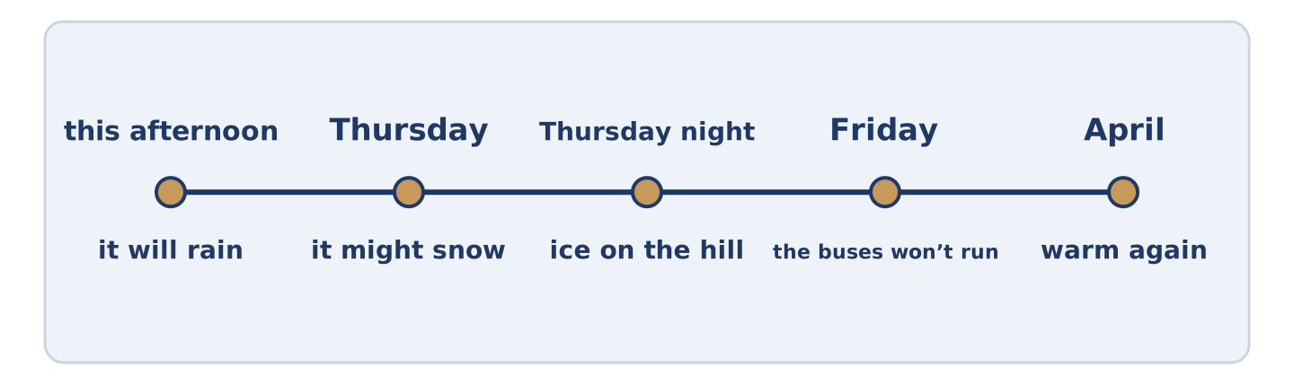
Figure 12.6 · One week of forecasts, from sure to possible.
Complete with will, won’t or might. (0. is done.)
- The forecast says it will rain this afternoon.
- It ______________________ snow on Thursday, but nobody is sure.
- It ______________________ be warm again until April.
- I think I ______________________ take a coat.
- If there is ice on the hill, the buses ______________________ run.
Part 2: Sure or Possible?
Write sure or possible. (0. is done.)
- It will rain this afternoon. — sure
- It might snow on Thursday. ____________
- It won’t be warm until April. ____________
- I might take the bus. ____________
- I will bring an umbrella. ____________
Part 2: Correct the Sentence
Each sentence has one grammar mistake. Write the correct sentence.
- It will to rain this afternoon.
- It might snows on Thursday.
- Maybe it will perhaps rain later.
- The buses not will run in ice.
Part 2: Freer Practice
Write two sentences about tomorrow: one you are sure about, and one that is only possible.
Part 2: Grammar Review
Choose the correct sentence.
1. Which sentence says it is only possible?
○ A) It will snow on Thursday.
○ B) It won’t snow on Thursday.
○ C) It is snowing on Thursday.
○ D) It might snow on Thursday.
2. Which sentence about the future is right?
○ A) It might rain later.
○ B) It will to rain later.
○ C) It might to rain later.
○ D) It will rains later.
→ Harvest: you will see will and might again in the Part 5 reading. Watch for how sure each one is.
Part 3 · Listening
[CORE] Core track · pre-class input · scripts printed inline
Part 3: The Shoulder and the Radio
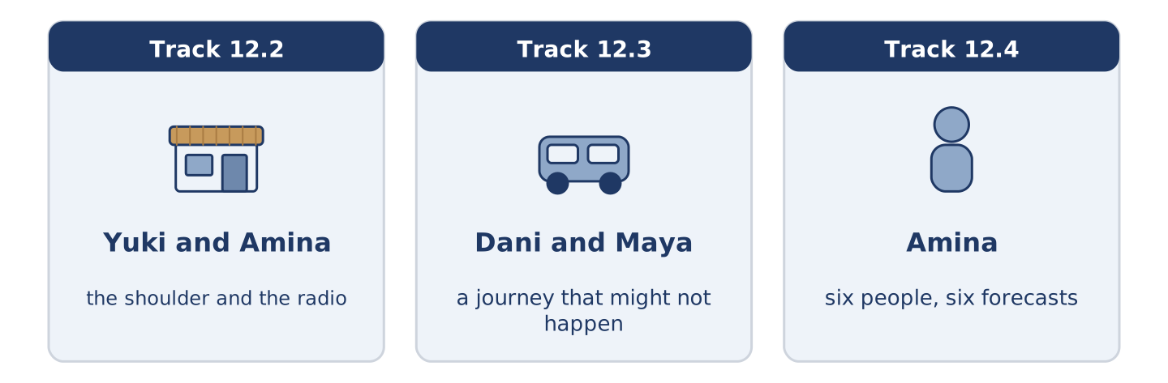
Figure 12.7 · The three listenings: who is speaking, and what about.
🔊 Audio Track 12.2
Before you listen: who do you believe about the weather?
Yuki: The forecast says sun all weekend. Amina: It’ll rain on Saturday. Yuki: It says sun. Amina: My shoulder says rain, and my shoulder was here long before that radio. Yuki: So do I take the washing in? Amina: Take it in. Say I’m wrong — then you’ve dry washing in a dry flat, and nobody ever died of that. Yuki: And Sunday? Amina: Sunday might be lovely. I’m not promising.
While you listen: write True, False, or Not Given. (0. is done.)
- The forecast says sun all weekend. — True
- Amina thinks it will rain on Saturday. ____
- Amina is sure about Sunday. ____
- Amina was right about last weekend. ____
Useful phrases: The forecast says… · It’ll rain on… · So do I…? · I’m not promising.
Part 3: A Journey That Might Not Happen
🔊 Audio Track 12.3
Before you listen: what do you do when the weather might stop a journey?
Dani: I’m going to my brother’s on Friday. Maya: There’s ice coming Thursday night. Dani: The train will run. Maya: The train might run. The buses to the station won’t run in that. Dani: Then I’ll walk to the station. Maya: It’s forty minutes and it’s all downhill, and downhill is the part that breaks people. Dani: I’ll go Thursday afternoon instead. Maya: There. That took one minute.
Answer the questions. (0. is done.)
- When is Dani going to his brother’s? — On Friday.
- What does Maya say is coming on Thursday night?
- What does Maya say about the buses to the station?
- What does Dani decide in the end?
Part 3: Six People, Six Forecasts
🔊 Audio Track 12.4
Before you listen: is there somebody in your street who is always wrong about the weather?
Amina: I hear all six forecasts before nine every morning. Tomas says it might snow and goes out on the bike all the same. Maya takes a coat whatever anybody says, and she is never cold and never right. Dani says it will be fine, and I stopped telling him years ago. Mr Okonkwo says nothing at all and carries an umbrella, which is the only honest answer. And Yuki reads it twice, then comes down and asks me.
While you listen: match each person with their forecast. One is not needed. (0. is done.)
- Amina → she hears all six before nine.
Useful phrases: ___ goes out regardless · ___ takes a coat · ___ carries an umbrella
Column A
1. | Tomas | ____
2. | Maya | ____
3. | Mr Okonkwo | ____
4. | Yuki | ____
Column B
a) | says nothing and carries an umbrella
b) | reads it twice and then asks Amina
c) | says it might snow and rides in anyway
d) | takes a coat whatever anybody says
e) | checks the river before it rains
Part 4 · Speaking
[CORE] Core track · in-class output
Part 4: What the Weather Does to You
Work with a partner. Ask and answer these questions.
- What will the weather do tomorrow where you are?
- What weather stops everything where you live?
- What do you always carry, and have you ever needed it?
Useful language: It will… · It might… · It won’t… · probably
Part 4: Find the Difference (pairwork)
Student A and Student B each have a forecast for the same week. Ask questions and find three differences.
Useful questions: What will it do on Monday? · Will it rain on Wednesday? · How many degrees on Friday? · Might it snow?
Student A — your forecast: Monday rain, Wednesday sun, Friday nine degrees, Saturday fog.
Student B — your forecast: Monday rain, Wednesday showers, Friday two degrees, Saturday fog.
Part 4: Deciding What to Do About the Weather
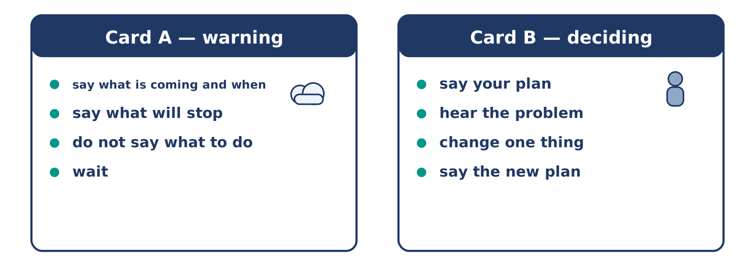
Figure 12.8 · Card A and Card B: what each of you has to say.
Work in pairs. Read the model, then use the cards.
Model exchange:
A: There is ice coming on Thursday night. — B: The train will run. — A: The train might run. The buses won’t. — B: Then I will walk. — A: It is forty minutes and it is all downhill. — B: Then I will go on Thursday afternoon. — A: That took one minute.
Useful language: There is … coming · It might… · It won’t… · Then I will…
Card A — warning: say what is coming and when · say what will stop · do not tell them what to do · wait.
Card B — deciding: say your plan · hear the problem · change one thing · say the new plan out loud.
Your turn: run the dialogue, then swap roles.
Stretch [PLUS]: the other person will not change the plan and the weather is genuinely dangerous — say so once more, and then stop.
Part 4: Mini-Presentation
Prepare a short talk (about one minute). Describe the weather where you grew up: what it will do in each season, and what people do about it.
Part 5 · Reading
[CORE] Core track · pre-class input
Part 5: Why Nobody Believes the Forecast
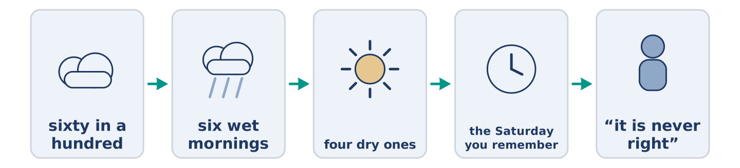
Figure 12.9 · One forecast, from the measurement to the morning.
Before you read: do you believe the forecast where you live?
Gloss: forecast = what somebody says the weather will do · percentage = how many out of a hundred · wrong = not right
A forecast that says sixty in a hundred for rain is right far more often than people think. People still call it no use at all. The reason is simple and it is about us. Sixty in a hundred means that on six mornings out of ten like this one, it rains. Today may be one of the four dry ones, and the forecast was still not wrong. It never promised anything. But a person does not remember six wet mornings. A person remembers the one Saturday they called off, and the sun that came out at eleven. Forecasters know this, and the good ones say probably and might as often as the language allows. The audience then says they never give a straight answer, which is the first complaint again.
Answer the multiple-choice questions. (0. is done.)
- What does the text say about a sixty-in-a-hundred forecast? — It is right far more often than people think.
1. What does sixty in a hundred for rain mean?
○ A) It will rain for sixty minutes
○ B) On six mornings out of ten like this one, it rains
○ C) Sixty parts of the country get rain
○ D) The forecaster is sixty in a hundred sure of everything
2. What does a person remember?
○ A) The six wet mornings
○ B) Every forecast of the year
○ C) The one Saturday they called off
○ D) The temperature
3. What do the good forecasters say?
○ A) Nothing at all
○ B) It will be fine
○ C) The exact hour
○ D) Probably and might
Part 5: Vocabulary in Context
Match each word from the text with its meaning. One meaning is not needed. Write the letter.
Column A
1. | forecast | ____
2. | probably | ____
3. | promised | ____
4. | straight | ____
Column B
a) | said that something was sure
b) | what somebody says the weather will do
c) | plain, with nothing held back
d) | likely, but not certain
e) | water that has gone hard with cold
Part 5: Three Places and Their Weather
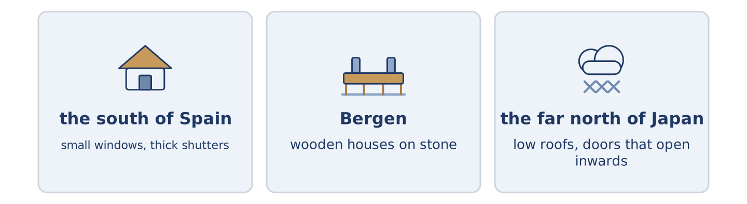
Figure 12.10 · Three places, and the one thing the weather does to each.
Before you read: does the weather where you live change what people build?
Gloss: shutter = a cover you close over a window · roof = the top of a building · season = one of the parts of the year
Weather builds houses, and not only in the sunny half of the world. In the south of Spain the windows are small and the shutters are thick, because for four months the sun is what you keep out. In Bergen it rains about two hundred and thirty days a year. The old wooden houses stand on stone, because wood that sits in water does not last. In the far north of Japan the roofs run almost to the ground and the doors open inwards. A door that opens into the street will meet two metres of snow one morning. None of these are for show. Every one of them is somebody losing an argument with the sky and writing it down in wood.
Answer the questions. (0. is done.)
- What does the text say weather does? — It builds houses.
- Why are the windows small in the south of Spain?
- Why do the old houses in Bergen stand on stone?
- Why do the doors open inwards in the far north of Japan?
Part 6 · Writing
[CORE] Core track · in-class / homework
Part 6: A Weather Warning (50–70 words)
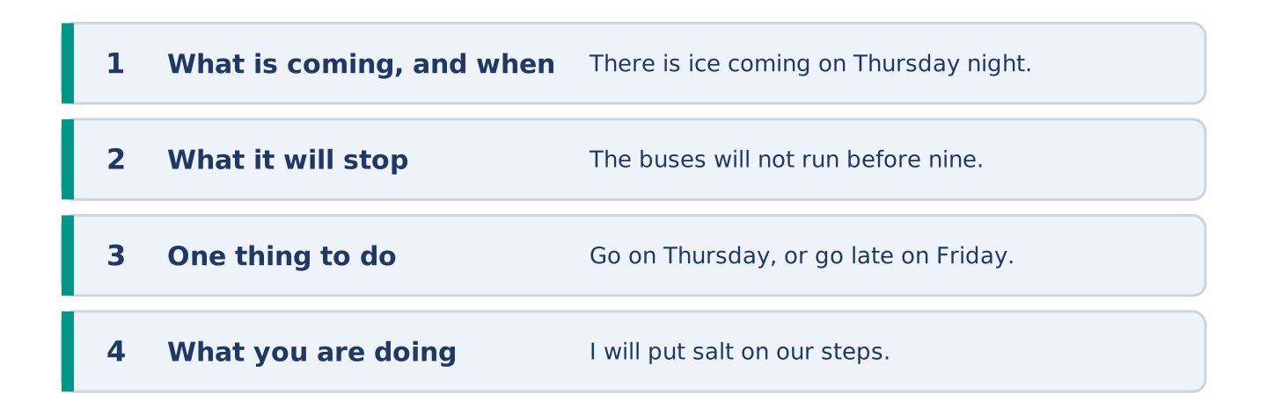
Figure 12.11 · The shape of the warning you are about to write.
Bad weather is coming. Write a short message warning your neighbours.
Model — read this first:
There is ice coming on Thursday night and Friday morning will be bad. The hill will be the worst part, and the buses probably will not run before nine. Going anywhere early? Go on Thursday, or go late on Friday. I will put salt on our steps and on number 8’s. Nobody needs to thank me. (56 words)
Plan (fill in, then write): There is ___ coming on ___. ___ will be the worst part. If you ___, ___. I will ___.
Word bank: there is … coming | it will | it won’t | probably | if you are
Check before you finish: ☐ what is coming and when? ☐ what it will stop? ☐ one piece of advice? ☐ 50–70 words?
Part 6: Does the Weather Change People? (50–70 words)
Does the weather where you live change what people are like? Give your opinion and two or three reasons.
Model — read this first:
It does, and not in the way people say. Cold does not make anybody serious. What it does is take the street away for five months, so nobody runs into anybody, and every meeting has to be fixed first. In a hot country the street is the living room. Here the living room is the living room, and you need a reason to be in it. (66 words)
Word bank: I think… because… | however | in my opinion | it depends on | probably
Check before you finish: ☐ a clear opinion? ☐ two or three reasons? ☐ 50–70 words?
Part 6: A Day the Weather Changed Everything (50–70 words)
Write about a day when the weather changed your plans. Say what happened and what you did.
Model — read this first:
We had the whole thing planned for the Saturday, outside, forty people. On the Friday the forecast turned and said storm, and we moved everything into a hall that smelled of soap. It rained for twenty minutes at two and then stopped for good. Everybody said it was lovely. I am still cross about it. (55 words)
Plan (fill in, then write): We planned ___. Then ___. So we ___. In the end ___.
Check before you finish: ☐ the plan? ☐ what the weather did? ☐ what you did? ☐ 50–70 words?
Part 6: Reflection — The Weather I Would Choose (40–60 words)
Write about the weather you would choose to live in, and why.
Model — read this first:
I would choose a cold, dry winter over a soft wet one, and I know that sounds strange. Soft and wet is four months of the same grey Tuesday. Cold and dry is hard, and it is also bright, and the year moves through it instead of sitting still in it. (51 words)
Check before you finish: ☐ what you would choose? ☐ why? ☐ what you would give up? ☐ 40–60 words?
Part 7 · Real-World File — Warnings and Forecasts
[PLUS] Plus track (optional) · stronger learners
7A: Phrase Bank
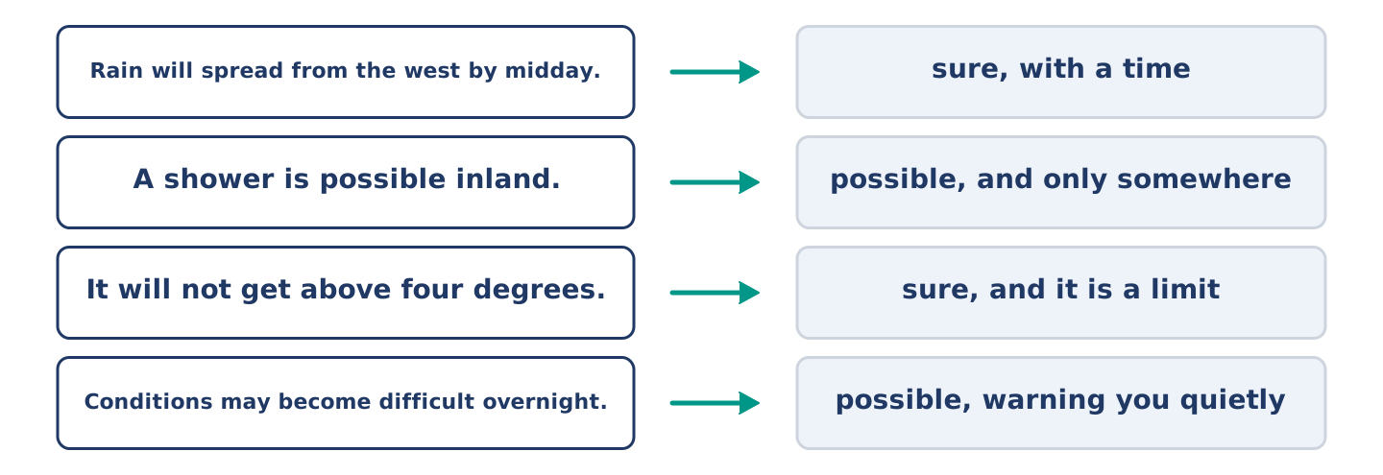
Figure 12.12 · What a forecast says, and how sure each line is.
Match what a forecast says with how sure it is. One is not needed. Write the letter.
Column A
1. | “Rain will spread from the west by midday.” | ____
2. | “A shower is possible inland.” | ____
3. | “It will not get above four degrees.” | ____
4. | “Conditions may become difficult overnight.” | ____
Column B
a) | possible, and they are warning you quietly
b) | sure, and it is a limit
c) | how much it will cost
d) | sure, with a time
e) | possible, and only somewhere
7B: A Warning Nobody Took
🔊 Audio Track 12.5
Before you read: when did you last ignore a warning?
Maya: They said the river might come up on Tuesday. Tomas: They say that every winter. Maya: They were right in the winter you were in Norway. Tomas: Was it bad? Maya: It came into the shop and Amina lost two days. Tomas: Nobody mentioned that to me. Maya: Nobody here tells anybody anything until it is a story. Tomas: So what will you do? Maya: I will move my books off the floor tonight, and I will feel stupid on Wednesday.
Answer the questions. (0. is done.)
- What did they say might happen on Tuesday? — The river might come up.
- What happened the winter Tomas was in Norway?
- What does Maya say about how word travels in the street?
- What is Maya going to do tonight?
7C: Controlled Practice — Giving a Warning Well
Put the steps in order. Number them 1–5. (0. is done.)
- Say what is coming and when. — 1
____ Say what you are doing yourself.
____ Say how sure you are.
____ Give one thing they can do.
____ Say what it will stop.
7D: Role-Play — Warning Somebody Who Is Not Worried
In pairs. One warns; one is not worried. Use the model and cards.
Model exchange: A: They said the river might come up on Tuesday. — B: They say that every winter. — A: They were right two winters ago. — B: Was it bad? — A: It came into the shop. — B: Nobody told me. — A: I am moving my books off the floor tonight.
Card A — warning: say it once, plainly · say how sure you are · give one fact, not five · say what you are doing yourself.
Card B — not worried: say why you are not · ask one real question · change your mind or do not · say what you will actually do.
Stretch [PLUS]: you warned them, they did nothing, and it happened — speak to them the next day without saying you told them so.
7E: Writing — A Warning for a Whole Street (50–80 words)
Write a notice for your street about weather that is coming.
Model — read this first:
The river might come up on Tuesday night. It did the same twice before, and both times it was the Tuesday nobody believed. Move anything that matters off a ground floor this evening. It takes ten minutes, and you feel silly for about a day. The shop will stay open. I will put a note on the door if anything changes. (61 words)
Check before you finish: ☐ what might happen and when? ☐ how sure you are? ☐ one thing to do? ☐ 50–80 words?
Part 8 · Global Story — The Day the Rain Is Due
[PLUS] Plus track · pre-read / discuss
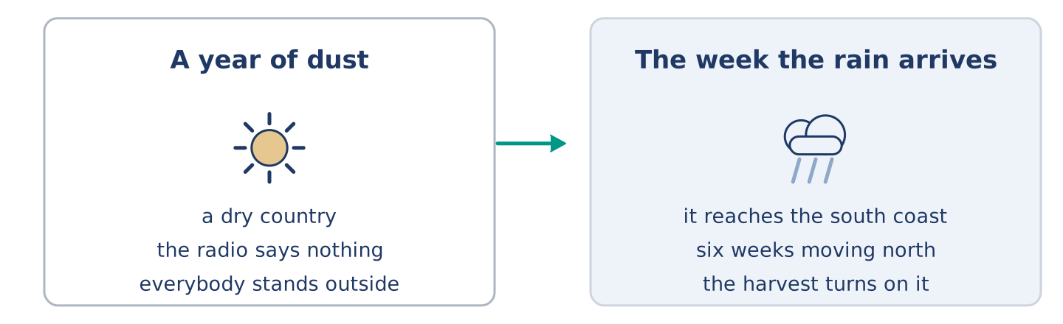
Figure 12.13 · A year of dust, and the week the rain arrives.
Before you read: can a whole country wait for one day of weather?
Gloss: monsoon = the season of heavy rain that comes once a year · harvest = the crops people cut and bring in · dam = a wall that holds water back
In India the rain has a date. The monsoon arrives on the south coast around the first of June and moves north over six weeks. The day it reaches each place goes round the whole country. People stand outside for it. Parents send the children out into it. The radio carries the day it reaches each city, the way it carries a result. The whole year of work turns on whether it is early, late or thin. A late monsoon means a small harvest, and a small harvest means a hard winter in villages a thousand miles from any newspaper. Nothing in Europe compares. The nearest thing is a bad winter, and a bad winter only costs you a week.
Answer the questions. (0. is done.)
- When does the monsoon arrive on the south coast? — Around the first of June.
- How long does it take to move north across the country?
- What happens when it reaches each place?
- What does a late monsoon mean?
Part 8: Vocabulary in Context
Match each word with its meaning. One meaning is not needed. Write the letter.
Column A
1. | monsoon | ____
2. | harvest | ____
3. | arrival | ____
4. | dam | ____
Column B
a) | the moment something gets here
b) | a wall that holds water back
c) | the season of heavy rain that comes once a year
d) | the crops people cut and bring in
e) | a cover you close over a window
Part 8: Discussion
Talk with a partner. Use the frames.
Discussion frames: “This is similar to where I live because…” · “This is different from where I live because…” · “I think the most important thing is… because…”
Part 9 · Close to Home — The Tuesday the River Came Up
[PLUS] Plus track · pre-read / decide
Before you read: who warns a street, and who listens?
The river came up on a Tuesday two winters ago, and almost nobody at number 14 believed it would. Amina lost two days of trade and a freezer. Maya moved her books up and felt silly all Monday evening, and clever by Wednesday. Dani slept through the whole thing on the first floor. Mr Okonkwo lives on the fourth floor and lost nothing at all. He went down at six in the morning and stood at the shop door with Amina for an hour, saying nothing. There was nothing to say, and leaving was worse. Tomas was in Norway. Yuki had not moved in yet. When they tell her about it now, each of them tells it differently, and all five are true.
Answer the questions. (0. is done.)
- When did the river come up? — On a Tuesday two winters ago.
- What did Amina lose?
- How did Maya feel on Monday evening, and on Wednesday?
- What did Mr Okonkwo do at six in the morning?
Part 9: Decision Task
A warning says bad weather might come, and it might not. Should you (a) do nothing until you are sure, (b) do the small cheap thing now, or (c) warn everybody else as well? Decide and explain. Use the frame.
Answer frame: “I think I should ___ because ___. Also, ___. This is better than ___ because ___.”
Model — read this first:
I think I should do the small cheap thing now, because ten minutes of work buys me the whole week without thinking about it. Also, the cost of being wrong is that I feel silly, which is nothing. This is better than waiting until I am sure, because by the time anybody is sure it is already in the shop. (60 words)
Phrase bank: I think I should… · because… · Also,… · This is better than… · In my opinion…
Part 10 · Review and Can-Do
[CORE + PLUS] · homework / self-study
Part 10: Spiral Review
Complete the review. (0. is done.)
- Thick cloud at ground level is fog.
Word bank: storm | shower | flood | temperature | will | might | diary | junction
- Strong wind and heavy rain together is a ______________________ .
- Short heavy rain that stops again is a ______________________ .
- Water over roads and into houses is a ______________________ .
- How hot or cold something is, is the ______________________ .
- The forecast says it ______________________ rain this afternoon. (sure)
- It ______________________ snow on Thursday. (possible)
- (from Unit 11) A book where you write what you are doing is a ______________________ .
- (from Unit 9) Where two or more roads meet is a ______________________ .
Part 10: Can-Do
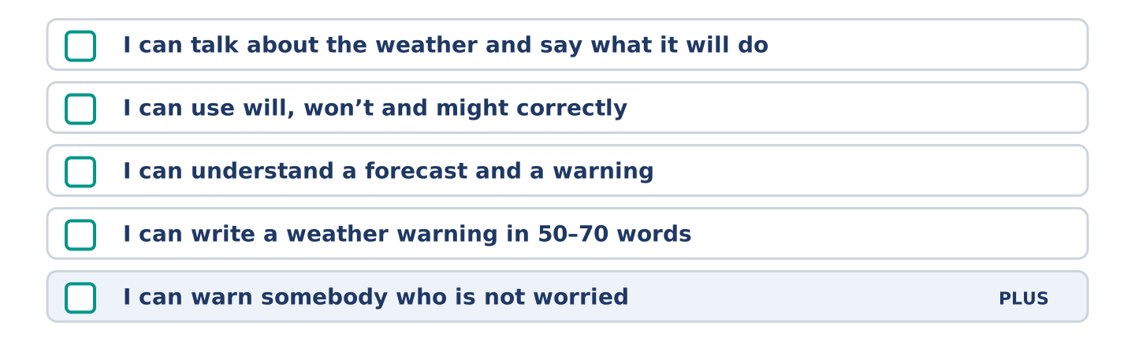
Figure 12.14 · What you can do at the end of this unit.
Can-Do checklist
☐ I can talk about the weather and say what it will do.
☐ I can use will, won’t and might correctly.
☐ I can understand a forecast and a warning.
☐ I can write a weather warning in 50–70 words.
☐ I can warn somebody who is not worried (Plus).
Part 10: Glossary
Unit 12 glossary (10 words)
storm · shower · temperature · degree · ice · fog · wind · sunny · freeze · flood
Unit 13: Rules and Places
English for Daily Life · Level: A2 · Tracks: [CORE] Warm-Up + Parts 1–6 · [PLUS] Parts 7–10
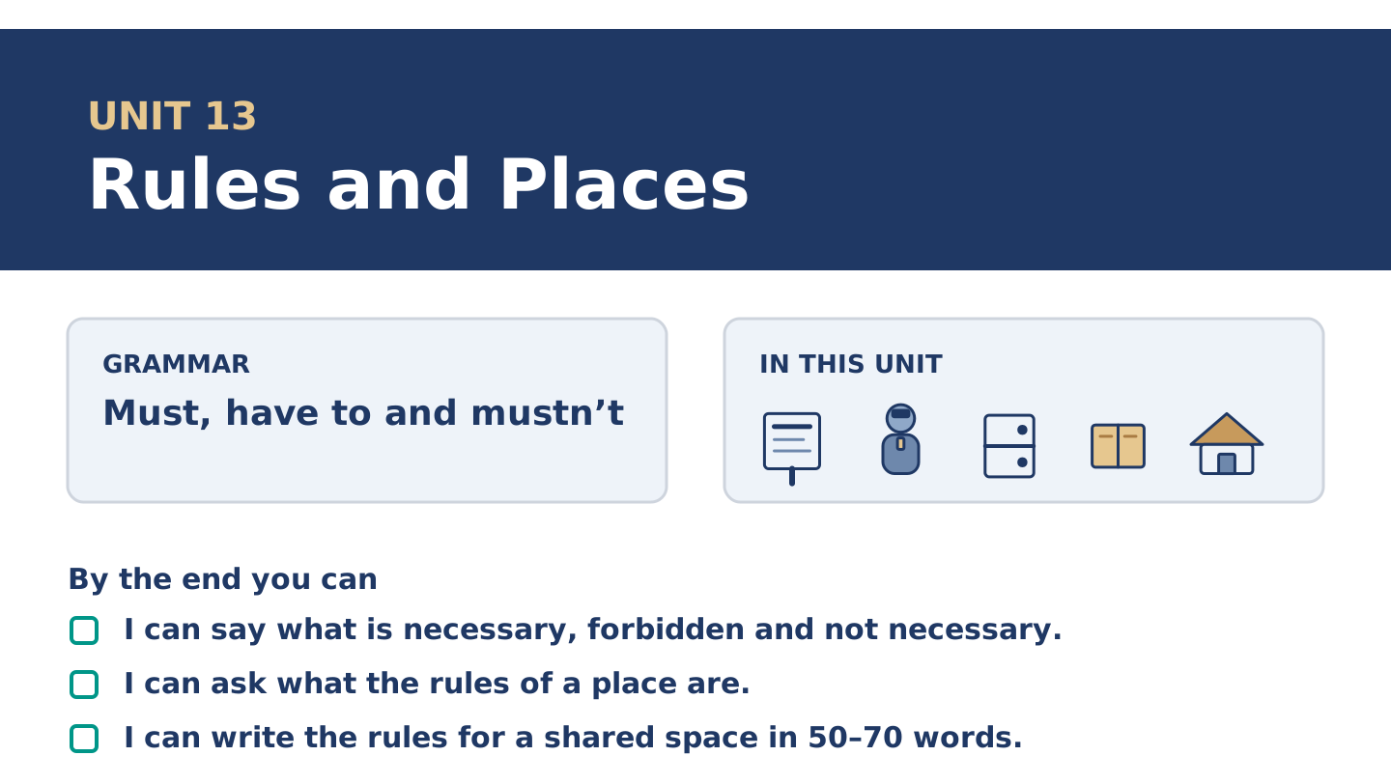
Figure 13.1 · Unit 13 at a glance: the grammar, the topic and what you will be able to do.
Warm Up
[CORE] Core track · in-class starter
Warm-up: Words for Rules
Match the words with their meanings. One meaning is not needed. Write the letter.
Column A
1. | Law | ____
2. | Allowed | ____
3. | Private | ____
4. | Guard | ____
5. | Fee | ____
Column B
a) | not for everybody; only for some people
b) | somebody whose job is to watch a place
c) | a rule that the whole country has to keep
d) | the money you pay to go in or to belong
e) | all right to do; nobody stops you
f) | a book where you write what you are doing
Warm-up: Talking About Rules
Complete the sentences using the words in the word bank.
Word bank: silence | smoking | uniform | member
- There is no ______________________ anywhere in the building, and there never was.
- You have to be a ______________________ to use the room upstairs.
- The sign asks for ______________________ , and the room is never silent.
- The guard at the gallery wears a ______________________ and says almost nothing.
Warm-up: Six People, Six Rules
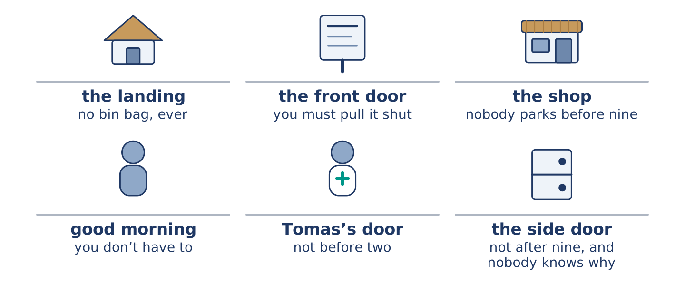
Figure 13.2 · The rules at number 14 that nobody ever wrote down.
Read the text and choose the correct answer.
Number 14 has rules and none of them are written anywhere. You must not put a bin bag on the landing, ever, and everybody knows it. You have to hold the front door for the person behind you, because the lock is slow. You do not have to say good morning, although Amina does. Nobody parks in front of the shop between seven and nine, and nobody ever has to be asked. Mr Okonkwo made that rule twenty years ago, and he never needed a sign for it.
1. What must you not do at number 14?
○ A) Say good morning
○ B) Hold the front door
○ C) Park after nine
○ D) Put a bin bag on the landing
2. What do you not have to do?
○ A) Hold the door
○ B) Say good morning
○ C) Keep the landing clear
○ D) Pay a fee
Part 1 · Vocabulary and Terminology
[CORE] Core track · pre-class input
Part 1: Words for Rules and Places
Match the words with their meanings. One meaning is not needed. (0. is done for you.)
- Notice → a small sign that says what the rule is, in a public or a private place.
Column A
1. | Law | ____
2. | Licence | ____
3. | Member | ____
4. | Uniform | ____
5. | Guard | ____
6. | Fee | ____
7. | Silence | ____
Column B
a) | clothes that say what your job is
b) | a rule the whole country has to keep
c) | somebody who belongs to a club or a library
d) | no sound at all
e) | a paper that says you are allowed to do something
f) | somebody whose job is to watch a place
g) | the money you pay to go in or to belong
h) | a cover you close over a window
Gloss: licence = a paper that says you are allowed to do something · fee = the money you pay to go in or to belong · uniform = clothes that say what your job is · bin = the big box the rubbish goes in
Part 1: Pronunciation
🔊 Audio Track 13.1
Listen to must and mustn’t. Say each pair aloud.
You must wait — must is short and its t is soft
You mustn’t wait — the t in the middle disappears: /ˈmʌsn̩t/
You have to wait — have to is one quick sound: /ˈhæftə/
You don’t have to wait — the same, with don’t: /dəʊnt ˈhæftə/
Two of these four are opposites and sound almost the same. Mustn’t and don’t have to cost learners most, and not because of the sound. It is that nobody tells them the two are not the same.
Part 1: Four Places, Four Rules
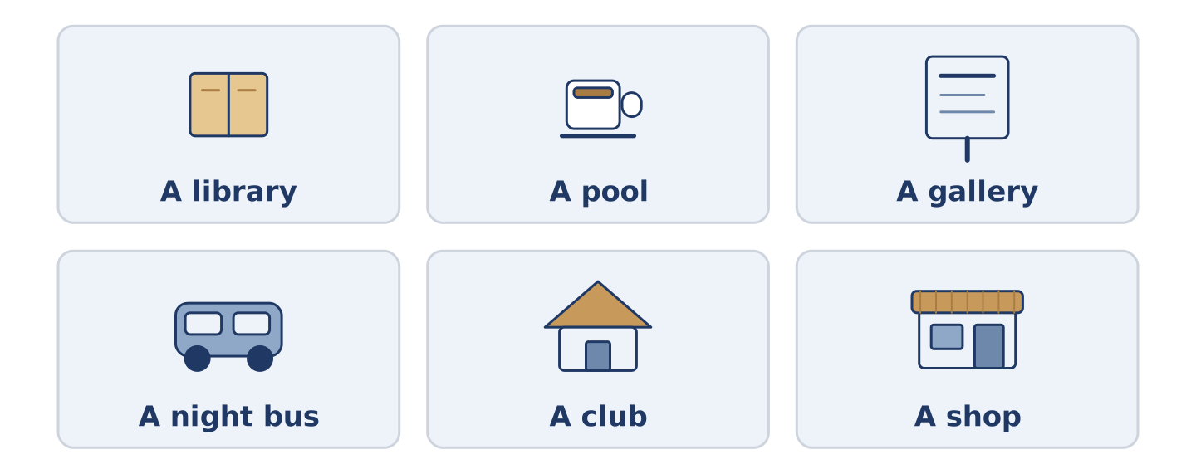
Figure 13.3 · Four places, and the one rule each of them is known for.
Complete the table. Write the rule and who keeps it. (0. is done.)
The place | The rule | Who keeps it
A library | quiet enough | (example)
A swimming pool
A gallery
A night bus
- A library — quiet enough — everybody; the room does it to you.
Think about a place you know. There is more than one right answer; say why.
Part 1: Must, Mustn’t or Do Not Have To?
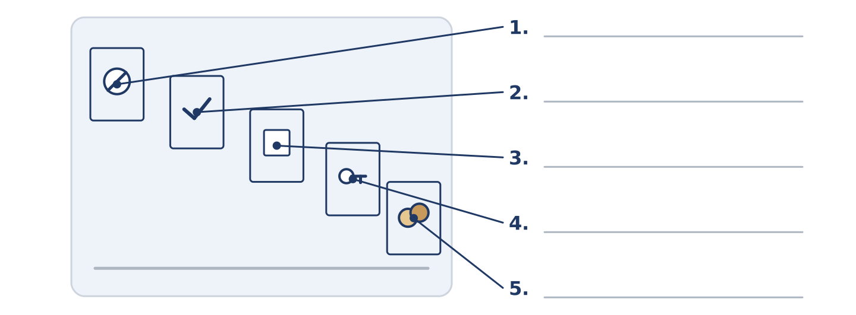
Figure 13.4 · Three kinds of rule — write the correct word on each line.
Match the rules with what they mean. One is not needed. Write the letter.
Column A
1. | You must show your card. | ____
2. | You mustn’t touch the paintings. | ____
3. | You don’t have to pay a fee. | ____
4. | You have to be a member. | ____
5. | You don’t have to be quiet. | ____
Column B
a) | it is forbidden; do not do it
b) | it is necessary; the place requires it
c) | you may make a noise if you want to
d) | it is free; nobody is asking for money
e) | you cannot come in unless you belong
f) | somebody did it and had to leave
Part 1: Rules — Multiple Choice
Read and choose the correct answer.
1. A paper that says you are allowed to do something is a…
○ A) notice
○ B) uniform
○ C) licence
○ D) fee
2. Somebody whose job is to watch a place is a…
○ A) member
○ B) law
○ C) licence
○ D) guard
3. The money you pay to go in or to belong is a…
○ A) uniform
○ B) fee
○ C) silence
○ D) law
Part 1: Vocabulary Fill-in
Complete the sentences with the correct word.
Word bank: private | allowed | law | smoking
- That door says ______________________ , and behind it are chairs.
- ______________________ in the entrance stopped years ago and nobody misses it.
- Dogs are not ______________________ in the park after six.
- It is the ______________________ now, not a shop rule.
Part 1: Write About a Rule (short)
Write two or three sentences about one rule where you live. Use three words from this unit.
Model — read this first:
In our building you must not leave anything on the stairs, and everybody keeps that one because of the fire door. You do not have to tell anybody when you move out. There is no fee for the rubbish bins and no sign about them, and somehow the rubbish bins are fine. (52 words)
Part 2 · Grammar — Must, Have To and Mustn’t
[CORE] Core track · pre-class input
Part 2: Notice
Read these lines. Underline must, have to, mustn’t and don’t have to. Which say you cannot, and which say you need not?
You must show your card at the desk. You have to be a member to use the room. You mustn’t touch the paintings. You don’t have to pay a fee. You mustn’t smoke anywhere inside. You don’t have to be quiet in the garden.
Two of these say it is necessary. Two say you cannot. Two say you need not.
Part 2: Grammar Focus Box
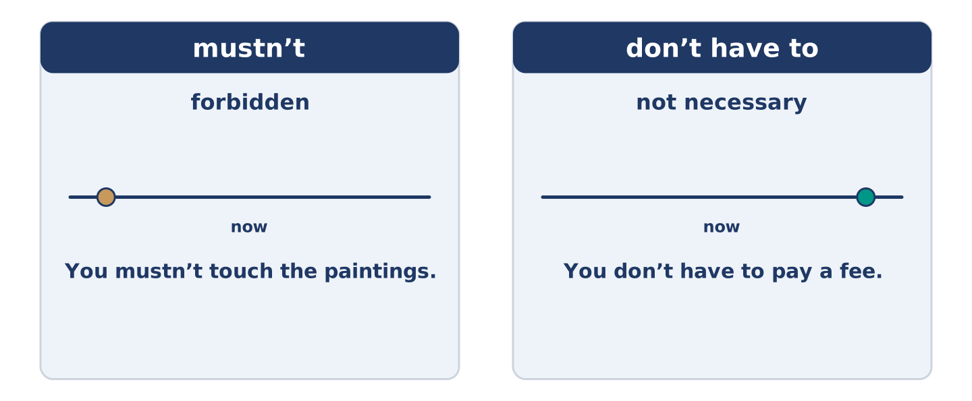
Figure 13.5 · Necessary, forbidden and not necessary: three jobs, four forms.
 | Form | Use | Example
must | must + plain verb | necessary; often the rule itself speaking | You must show your card.
have to | have to + plain verb | necessary; often somebody else’s rule | You have to be a member.
mustn’t | must not + plain verb | forbidden | You mustn’t touch the paintings.
don’t have to | do not have to + verb | not necessary; you may if you like | You don’t have to pay.
Remember: mustn’t and don’t have to are opposites, not the same. One forbids; one frees.
Watch out! ✗ You don’t must touch it. → ✓ You mustn’t touch it. (must makes its own negative). ✗ You mustn’t pay, it is free. → ✓ You don’t have to pay, it is free. (mustn’t pay means paying is forbidden).
Part 2: Controlled Practice
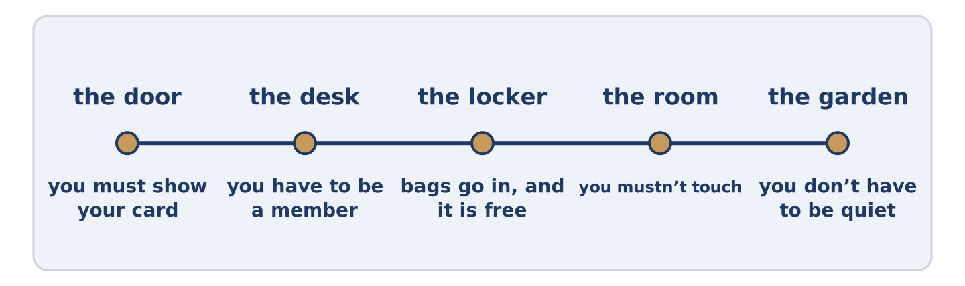
Figure 13.6 · One visit, from the door to the room upstairs.
Complete with must, have to, mustn’t or don’t have to. (0. is done.)
- You must show your card at the desk.
- You ______________________ touch the paintings. (forbidden)
- You ______________________ be a member to use the room. (necessary)
- You ______________________ pay a fee. (not necessary)
- You ______________________ smoke anywhere inside. (forbidden)
Part 2: Necessary, Forbidden or Not Necessary?
Write necessary, forbidden or not necessary. (0. is done.)
- You must show your card. — necessary
- You mustn’t touch the paintings. ____________
- You don’t have to pay a fee. ____________
- You have to be a member. ____________
- You don’t have to be quiet in the garden. ____________
Part 2: Correct the Sentence
Each sentence has one grammar mistake. Write the correct sentence.
- You don’t must touch the paintings.
- You mustn’t pay, the gallery is free.
- You have to showing your card at the desk.
- You must to be a member.
Part 2: Freer Practice
Write two rules for a place you know: one that forbids something, and one that frees you from something.
Part 2: Grammar Review
Choose the correct sentence.
1. Which sentence says it is forbidden?
○ A) You mustn’t touch the paintings.
○ B) You don’t have to touch the paintings.
○ C) You don’t must touch the paintings.
○ D) You have to touch the paintings.
2. Which sentence says it is free?
○ A) You mustn’t pay a fee.
○ B) You must not pay a fee.
○ C) You don’t have to pay a fee.
○ D) You have to pay a fee.
→ Harvest: you will see these four forms again in the Part 5 reading. Watch for which rules people keep.
Part 3 · Listening
[CORE] Core track · pre-class input · scripts printed inline
Part 3: The Guard and the Bag
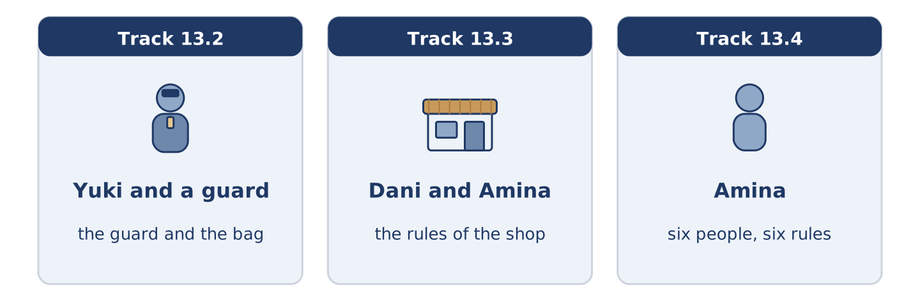
Figure 13.7 · The three listenings: who is speaking, and what about.
🔊 Audio Track 13.2
Before you listen: what do you have to leave at the door of a gallery?
Guard: Bags go in the locker, I’m afraid. Yuki: It’s very small. Guard: It’s the size, not the bag. Anything on your back has to go in. Yuki: Do I have to pay for the locker? Guard: No, it’s free. You don’t have to leave your coat, only the bag. Yuki: And can I take photographs? Guard: You can, but no bright light, and people forget that about four times an hour.
While you listen: write True, False, or Not Given. (0. is done.)
- Yuki has a bag with her. — True
- The locker costs money. ____
- Yuki may take photographs. ____
- The gallery is busy today. ____
Useful phrases: Bags go in… · Do I have to…? · You don’t have to… · you mustn’t…
Part 3: The Rules of the Shop
🔊 Audio Track 13.3
Before you listen: does a small shop need written rules?
Dani: Amina, do you have rules in here? Amina: Four. You mustn’t come in with a lit cigarette, which was a problem once. You have to let somebody with two items go in front of you. You don’t have to buy anything to come in out of the rain. Dani: And the fourth? Amina: You mustn’t tell me what you think of the other customers. Dani: That one is for me. Amina: That one is entirely for you.
Answer the questions. (0. is done.)
- How many rules does Amina have? — Four.
- Who has to go in front of you?
- What do you not have to do to come in out of the rain?
- Which rule does Amina say is for Dani?
Part 3: Six People, Six Rules
🔊 Audio Track 13.4
Before you listen: who in your street keeps every rule, and who keeps none?
Amina: Everybody in this street has one rule they will not break and one they break every week. Maya must have the front door shut behind her and will come back up two floors to check. Tomas mustn’t be late, and he says that is the hospital talking, not him. Dani doesn’t have to do anything, in his own opinion. Mr Okonkwo keeps every rule there is, and then he makes two more of his own. And Yuki asks what the rule is first, which nobody else in this building ever did.
While you listen: match each person with their rule. One is not needed. (0. is done.)
- Amina → she knows all six rules.
Useful phrases: ___ must shut the door · ___ mustn’t be late · ___ asks first
Column A
1. | Maya | ____
2. | Tomas | ____
3. | Mr Okonkwo | ____
4. | Yuki | ____
Column B
a) | mustn’t be late, because of the hospital
b) | asks what the rule is before anything else
c) | must have the front door shut behind her
d) | keeps every rule and makes two more
e) | pays the fee a week late every month
Part 4 · Speaking
[CORE] Core track · in-class output
Part 4: Rules Where You Live
Work with a partner. Ask and answer these questions.
- What must you not do in your building or your street?
- What do people think you have to do, but you do not?
- What is one rule you think is wrong?
Useful language: You must… · You mustn’t… · You have to… · You don’t have to…
Part 4: Find the Difference (pairwork)
Student A and Student B each have the rules of a different pool. Ask questions and find three differences.
Useful questions: Do I have to wear a cap? · Can I take a bag in? · Is there a fee? · Must I shower first?
Student A — your pool: you must shower first, you have to wear a cap, bags are allowed, there is no fee.
Student B — your pool: you must shower first, you don’t have to wear a cap, bags go in a locker, the fee is two pounds.
Part 4: Asking What the Rules Are
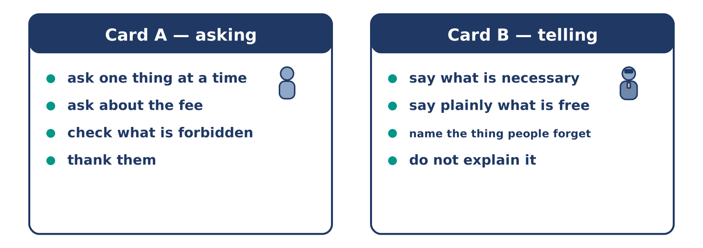
Figure 13.8 · Card A and Card B: what each of you has to say.
Work in pairs. Read the model, then use the cards.
Model exchange:
A: Do I have to leave my bag? — B: Anything on your back, yes. — A: And my coat? — B: You don’t have to leave the coat. — A: Is there a fee for the locker? — B: No, it is free. — A: Can I take photographs? — B: You can, but no bright light.
Useful language: Do I have to…? · You don’t have to… · you mustn’t… · Is there a fee?
Card A — asking: ask about one thing at a time · ask about the fee · check what is forbidden · thank them.
Card B — telling: say what is necessary · say plainly what is free · name the one thing people forget · do not explain the rule.
Your turn: run the dialogue, then swap roles.
Stretch [PLUS]: the rule makes no sense to you and the person telling you did not make it — say so without making it their fault.
Part 4: Mini-Presentation
Prepare a short talk (about one minute). Describe a place you know and its three most important rules.
Part 5 · Reading
[CORE] Core track · pre-class input
Part 5: Why Some Rules Work and Others Do Not
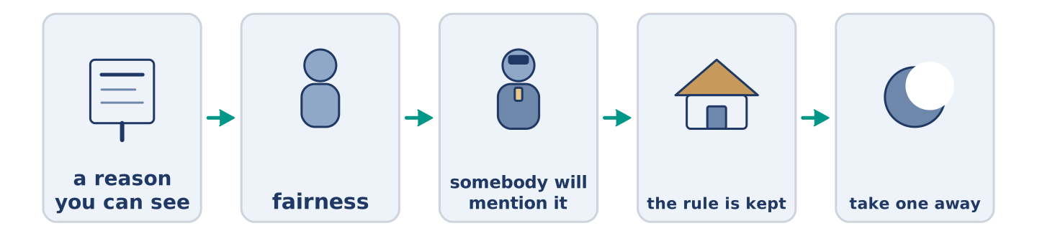
Figure 13.9 · One rule, from the notice to the habit.
Before you read: which rule where you live does everybody ignore?
Gloss: obey = to do what a rule says · enforce = to make people keep a rule · reason = why something is so
A rule that people keep has three things, and a rule that nobody keeps is usually missing one of them. The first is a reason you can see. People put their bags in a locker because they can see why a gallery might ask. Nobody keeps a rule whose reason died years before the notice did. The second is fairness. A rule that one group keeps and another does not is not a rule. It only costs the people with no excuse. The third is somebody who will mention it. Not a guard necessarily, not a fine; somebody willing to say, quietly, that you are standing in the way. Take away any one of the three and the notice stays on the wall and means nothing, which is the state of most notices.
Answer the multiple-choice questions. (0. is done.)
- How many things does a rule that people keep have? — Three.
1. What is the first thing a rule needs?
○ A) A fine
○ B) A reason you can see
○ C) A guard in a uniform
○ D) A notice on the wall
2. What does the text say about an unfair rule?
○ A) It works better than a fair one
○ B) Nobody notices it
○ C) It needs a bigger sign
○ D) It only costs the people with no excuse
3. What is the third thing?
○ A) Somebody willing to mention it
○ B) A law
○ C) A fee
○ D) A locker
Part 5: Vocabulary in Context
Match each word from the text with its meaning. One meaning is not needed. Write the letter.
Column A
1. | obey | ____
2. | fairness | ____
3. | excuse | ____
4. | reason | ____
Column B
a) | treating everybody the same way
b) | to do what a rule says
c) | why something is so
d) | what you say so that a rule does not apply to you
e) | no sound at all
Part 5: Three Places and Their One Rule
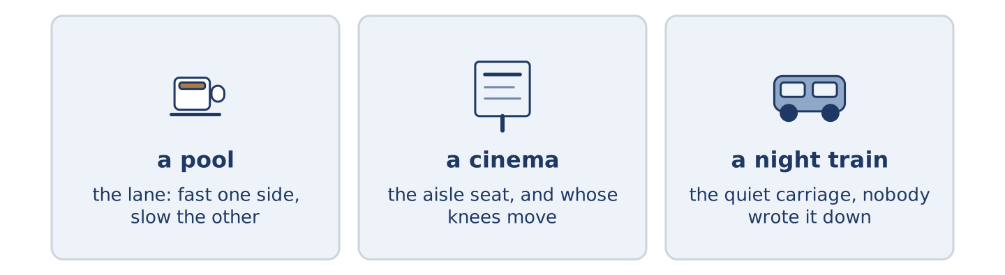
Figure 13.10 · Three places, and the one rule each of them lives by.
Before you read: which place near you has exactly one rule that matters?
Gloss: lane = the part of a pool you swim up and down · aisle = the walkway between seats or shelves · carriage = one part of a train
Some places have one rule and it carries everything. In a swimming pool it is the lane: fast on one side, slow on the other. One swimmer in the wrong lane ruins an hour for twelve people without touching anybody. In a cinema it is the aisle seat. Does the person in it stand up, or turn their knees sideways? That question divides countries and families. On a night train it is the carriage at the end, the quiet one. Nobody wrote that rule down, and everybody keeps it more carefully than the written ones. None of the three needs a guard. All three fall apart the moment one person decides the rule is for other people.
Answer the questions. (0. is done.)
- Do these places have many rules that matter? — No, each has one.
- What is the rule in a swimming pool?
- What is the question in a cinema?
- What happens to all three rules?
Part 6 · Writing
[CORE] Core track · in-class / homework
Part 6: Rules for a Shared Space (50–70 words)
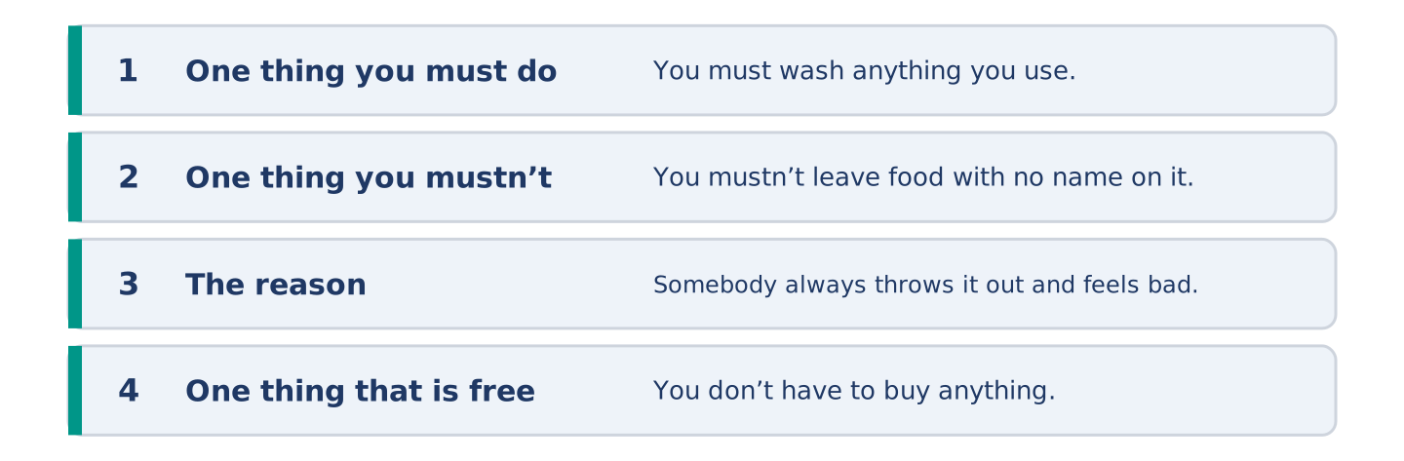
Figure 13.11 · The shape of the rules you are about to write.
Write the rules for a space that several people share. Use must, mustn’t and don’t have to.
Model — read this first:
You must wash anything you use and put it back the same day. You mustn’t leave food in the fridge with no name on it, because somebody always throws it out and then feels bad. You don’t have to buy anything for the kitchen, although nobody stops you. You must shut the window at night. (55 words)
Plan (fill in, then write): You must ___. You mustn’t ___, because ___. You don’t have to ___. ___ must ___.
Word bank: you must | you mustn’t | you don’t have to | because | anything
Check before you finish: ☐ one must? ☐ one mustn’t with a reason? ☐ one don’t have to? ☐ 50–70 words?
Part 6: Is a Rule Better Than a Sign? (50–70 words)
Is it better to write a rule down or to let people learn it? Give your opinion and two or three reasons.
Model — read this first:
Write it down, and I say that as somebody who hates notices. A rule nobody wrote is a rule you learn by breaking it. The newest person in the room always does, three days in and already red in the face. A sign is ugly for everybody and hard on nobody. (51 words)
Word bank: I think… because… | better | however | in my opinion | it depends on
Check before you finish: ☐ a clear opinion? ☐ two or three reasons? ☐ 50–70 words?
Part 6: A Rule You Had to Learn (50–70 words)
Write about a rule you did not know until you broke it. Say what happened.
Model — read this first:
I stood on the left on an escalator for about four seconds in my first week. A whole city went round me making a noise I did not know. Nobody said anything. Nobody had to. I stood on the right ever after, and I still do not know who decided it. (51 words)
Plan (fill in, then write): I ___. Then ___. Nobody ___. Since then I ___.
Check before you finish: ☐ what you did? ☐ what happened? ☐ what you do now? ☐ 50–70 words?
Part 6: Reflection — A Rule I Would Change (40–60 words)
Write about one rule you would change, and what you would put in its place.
Model — read this first:
I would change the rule that a library must have no sound in it at all. Quiet, yes. No sound makes a room where a child cannot ask a question, and a library with no children in it is only a store room. I would put a sign up that says talk, but talk like this, and then write it quietly. (61 words)
Check before you finish: ☐ which rule? ☐ why? ☐ what you would put in its place? ☐ 40–60 words?
Part 7 · Real-World File — Signs, Notices and Asking
[PLUS] Plus track (optional) · stronger learners
7A: Phrase Bank
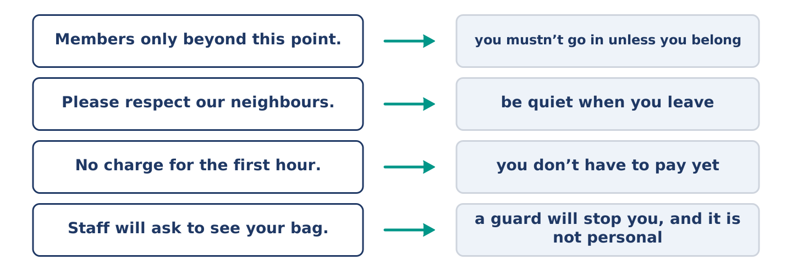
Figure 13.12 · What a sign says, and what it actually means.
Match what the sign says with what it means. One is not needed. Write the letter.
Column A
1. | “Members only beyond this point.” | ____
2. | “Please respect our neighbours.” | ____
3. | “No charge for the first hour.” | ____
4. | “Staff will ask to see your bag.” | ____
Column B
a) | you don’t have to pay yet
b) | be quiet when you leave
c) | a guard will stop you, and it is not personal
d) | how far it is to the station
e) | you mustn’t go in unless you belong
7B: A Rule Nobody Explained
🔊 Audio Track 13.5
Before you read: have you kept a rule for years without knowing why?
Yuki: Why must the bins go out after six? Amina: Because the big van comes at seven and the street is one car wide. Yuki: Nobody mentioned that to me. Amina: Nobody tells anybody. You find out when somebody is cross with you. Yuki: That is a terrible system. Amina: It is. Thirty years here, and I still do not know why we mustn’t use the side door after nine. Yuki: So there is one for you too. Amina: There is one for everybody.
Answer the questions. (0. is done.)
- When must the rubbish bins go out? — After six.
- Why must they go out then?
- How does Amina say people find out the rules?
- What does Amina still not know?
7C: Controlled Practice — Explaining a Rule Well
Put the steps in order. Number them 1–5. (0. is done.)
- Say the rule in one sentence. — 1
____ Say what happens if nobody keeps it.
____ Give the reason behind it.
____ Say who it does not apply to.
____ Ask whether that makes sense.
7D: Role-Play — Asking Why the Rule Exists
In pairs. One asks why a rule exists; one explains it. Use the model and cards.
Model exchange: A: Why must the bins go out after six? — B: The big van comes at seven and the street is one car wide. — A: Nobody mentioned it. — B: Nobody tells anybody here. — A: That is a terrible system. — B: It is, and I have no plan to fix it.
Card A — asking: ask why, not whether · say you were not told · say what you think of it · ask one more.
Card B — explaining: give the reason in one sentence · admit what you do not know · do not defend the system · agree where you agree.
Stretch [PLUS]: the rule has no reason left and you both know it — decide out loud whether to keep it anyway.
7E: Writing — A Notice for a Shared Door (50–80 words)
Write a notice for a door that several people use.
Model — read this first:
You must shut this door, not push it to. The lock is slow and it looks shut when it is not, and that is how we lost two bikes in the spring. You don’t have to lock it during the day; after nine, please turn the key. Carrying something heavy? Knock, and somebody comes down. The bell works. (58 words)
Check before you finish: ☐ the rule in the first sentence? ☐ the reason? ☐ one thing you do not have to do? ☐ 50–80 words?
Part 8 · Global Story — The Rule Everybody Said Would Fail
[PLUS] Plus track · pre-read / discuss
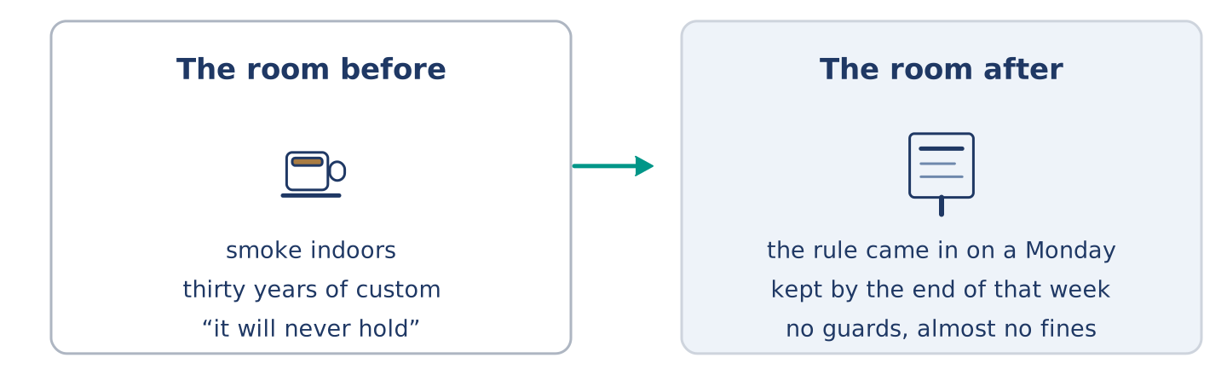
Figure 13.13 · A room before the rule, and the same room after it.
Before you read: can a whole country change a habit in one night?
Gloss: indoors = inside a building · workplace = anywhere people work · custom = what people have always done
Ireland was the first country in the world to stop smoking in every indoor workplace, and almost nobody thought it would hold. The bar was the heart of the thing, and the custom was older than anybody arguing about it. Smoking customers said they would go on smoking. Owners said they would lose everything. The rule came in on a Monday. By the end of that week almost everybody was keeping it, with no guards and almost no fines. What surprised the loudest arguers was how fast the new habit became the normal one. Thirty years of smoke left a room in a weekend. Within a year other countries were copying the law word for word, which nobody had expected on that Monday morning.
Answer the questions. (0. is done.)
- What was Ireland the first country to do? — Stop smoking in every indoor workplace.
- What did the smoking customers say?
- What did the owners say?
- What surprised the loudest arguers?
Part 8: Vocabulary in Context
Match each word with its meaning. One meaning is not needed. Write the letter.
Column A
1. | indoors | ____
2. | custom | ____
3. | habit | ____
4. | owner | ____
Column B
a) | what people have always done
b) | the person the place belongs to
c) | inside a building
d) | something you do without deciding to
e) | the walkway between seats or shelves
Part 8: Discussion
Talk with a partner. Use the frames.
Discussion frames: “This is similar to where I live because…” · “This is different from where I live because…” · “I think the most important thing is… because…”
Part 9 · Close to Home — The Rules Nobody Wrote Down
[PLUS] Plus track · pre-read / decide
Before you read: how does a new person learn the rules of a building?
There is no list of rules at number 14 and there are about eleven of them. The bins go out after six. You must pull the front door shut, not push it to. Nobody parks in front of the shop before nine. You do not knock on Tomas’s door before two in the afternoon, because of his nights. Nobody uses the side door after nine and nobody now alive knows why. Yuki learned nine of the eleven in her first month. She got every one of them wrong first, then heard about it, kindly, from whoever was standing there. The other two she still does not know, and the building decided long ago that she does not need them.
Answer the questions. (0. is done.)
- How many rules are there at number 14? — About eleven.
- Why do you not knock on Tomas’s door before two?
- How did Yuki learn nine of the eleven?
- What has the building decided about the other two?
Part 9: Decision Task
A place you belong to has rules nobody has written down. Should you (a) write them all on a notice, (b) tell each new person yourself, or (c) leave it as it is? Decide and explain. Use the frame.
Answer frame: “I think I should ___ because ___. Also, ___. This is better than ___ because ___.”
Model — read this first:
I think I should tell each new person myself, because a notice makes a building sound like a station and nobody reads one anyway. Also, telling somebody is a way of meeting them. This is better than leaving it as it is, because the way it is now, a new person finds out when somebody tells them off. (58 words)
Phrase bank: I think I should… · because… · Also,… · This is better than… · In my opinion…
Part 10 · Review and Can-Do
[CORE + PLUS] · homework / self-study
Part 10: Spiral Review
Complete the review. (0. is done.)
- A rule the whole country has to keep is a law.
Word bank: licence | guard | fee | member | mustn’t | don’t have to | storm | diary
- A paper that says you are allowed to do something is a ______________________ .
- Somebody whose job is to watch a place is a ______________________ .
- The money you pay to go in or to belong is a ______________________ .
- Somebody who belongs to a club or a library is a ______________________ .
- You ______________________ touch the paintings. (forbidden)
- You ______________________ pay a fee. (not necessary)
- (from Unit 12) Strong wind and heavy rain together is a ______________________ .
- (from Unit 11) A book where you write what you are doing is a ______________________ .
Part 10: Can-Do
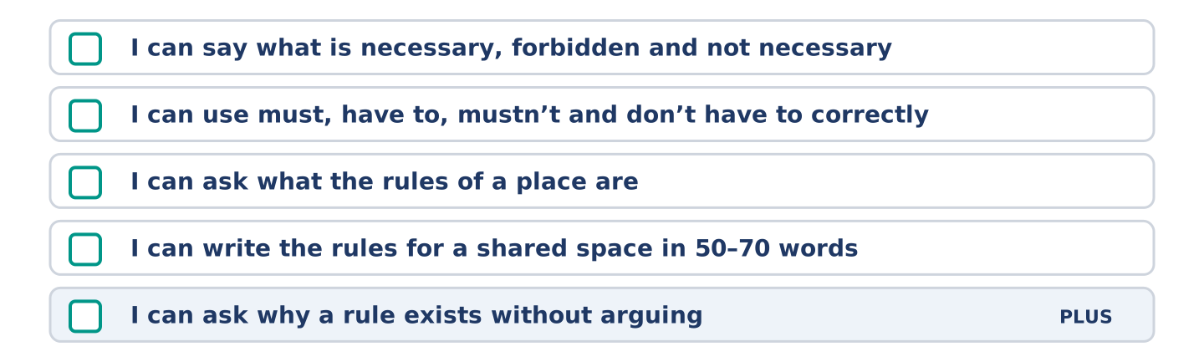
Figure 13.14 · What you can do at the end of this unit.
Can-Do checklist
☐ I can say what is necessary, forbidden and not necessary.
☐ I can use must, have to, mustn’t and don’t have to correctly.
☐ I can ask what the rules of a place are.
☐ I can write the rules for a shared space in 50–70 words.
☐ I can ask why a rule exists without arguing (Plus).
Part 10: Glossary
Unit 13 glossary (10 words)
law · allowed · silence · smoking · member · private · uniform · licence · guard · fee
Unit 14: Health and Feeling Better
English for Daily Life · Level: A2 · Tracks: [CORE] Warm-Up + Parts 1–6 · [PLUS] Parts 7–10
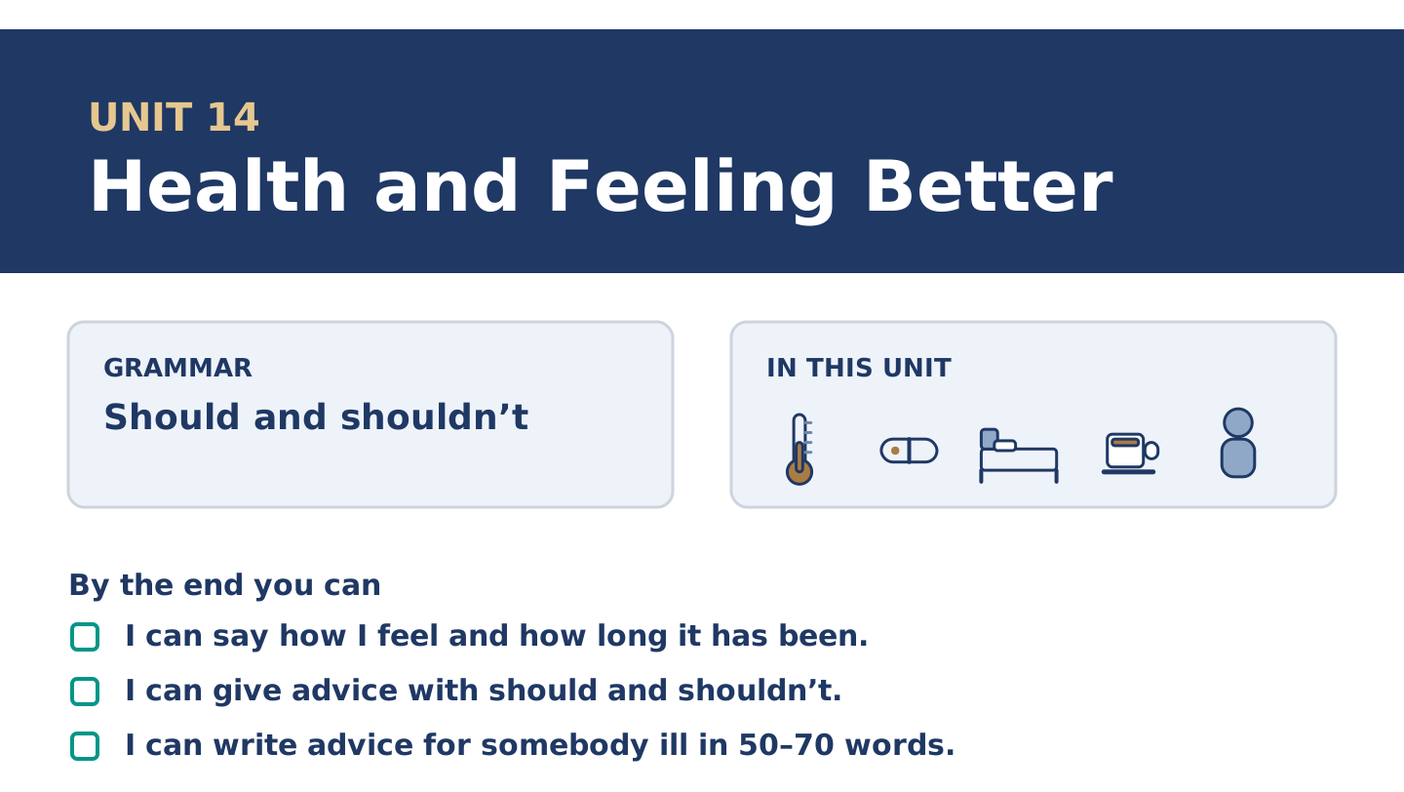
Figure 14.1 · Unit 14 at a glance: the grammar, the topic and what you will be able to do.
Warm Up
[CORE] Core track · in-class starter
Warm-up: Words for Not Feeling Well
Match the words with their meanings. One meaning is not needed. Write the letter.
Column A
1. | Pain | ____
2. | Headache | ____
3. | Fever | ____
4. | Throat | ____
5. | Medicine | ____
Column B
a) | a pain in your head
b) | the part inside your neck that food and air go down
c) | what you take to get better
d) | the feeling when part of you hurts
e) | when your body is much too hot
f) | the money you pay to go in or to belong
Warm-up: Giving Advice
Complete the sentences using the words in the word bank.
Word bank: doctor | sick | pill | healthy
- You should see a ______________________ if it is still there on Monday.
- Tomas says one ______________________ , with food, and never two pills at once.
- Dani says he is never ______________________ , and he was in bed all week being sick.
- Maya is the ______________________ one and she is the one who worries.
Warm-up: Six People, Six Kinds of Advice
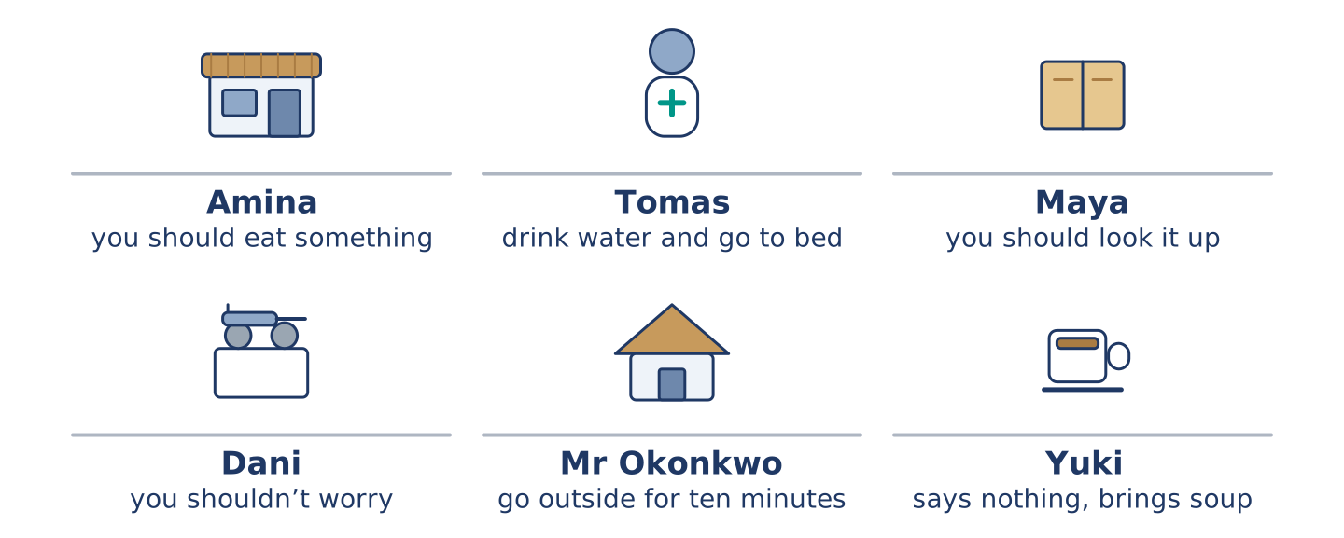
Figure 14.2 · What each of them says you should do.
Read the text and choose the correct answer.
Everybody at number 14 has advice and none of it agrees. Amina says you should eat something, whatever is wrong with you. Tomas says you should drink water and go to bed, and he is a nurse, so people listen. Maya says you should look it up, which is never good advice at two in the morning. Dani says you shouldn’t worry, and says it about everything. Mr Okonkwo says you should go outside for ten minutes. Yuki says nothing and quietly brings soup.
1. Who says you should drink water and go to bed?
○ A) Amina
○ B) Mr Okonkwo
○ C) Tomas
○ D) Maya
2. What does Yuki do?
○ A) She says nothing and brings soup
○ B) She says you shouldn’t worry
○ C) She tells you to look it up
○ D) She tells you to go outside
Part 1 · Vocabulary and Terminology
[CORE] Core track · pre-class input
Part 1: Words for Health
Match the words with their meanings. One meaning is not needed. (0. is done for you.)
- Rest → to stop and do nothing, so that your body can mend itself.
Column A
1. | Pain | ____
2. | Fever | ____
3. | Medicine | ____
4. | Healthy | ____
5. | Dentist | ____
6. | Throat | ____
7. | Sick | ____
Column B
a) | not well; your body is not working properly
b) | the doctor who looks after your teeth
c) | the feeling when part of you hurts
d) | strong and well, and likely to stay so
e) | when your body is much too hot
f) | what you take to get better
g) | the part inside your neck that food and air go down
h) | clothes that say what your job is
Gloss: fever = when your body is much too hot · dentist = the doctor who looks after your teeth · healthy = strong and well, and likely to stay so · chemist = the shop that sells medicine, and the person in it
Part 1: Pronunciation
🔊 Audio Track 14.1
Listen to should and shouldn’t. Say each pair aloud.
You should rest — the l says nothing: /ʃʊd/, never /ʃʊld/
You shouldn’t wait — the l says nothing here either: /ˈʃʊdn̩t/
Should I go? — weak at the front of a question: /ʃəd aɪ ɡəʊ/
Yes, you should — strong at the end: /ʃʊd/
That quiet l surprises nearly everybody, because it is sitting there in the spelling. It is the same letter doing the same nothing in could and would. Three words, one rule, and almost no learner is ever told it.
Part 1: Four Problems, Four Answers
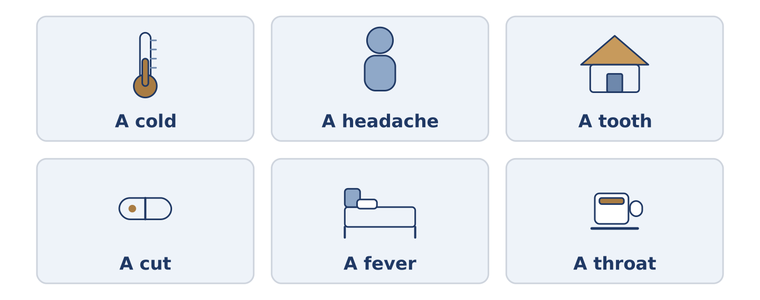
Figure 14.3 · Four everyday problems, and what people usually say about each.
Complete the table. Write what you should do and when to see a doctor. (0. is done.)
The problem | What you should do | When to see a doctor
A cold | rest, drink, wait | (example)
A headache that keeps coming back
A tooth that hurts at night
A cut that is not healing
- A cold — rest, drink, wait — if it is still there after two weeks.
Think about where you live. There is more than one right answer; be ready to say why.
Part 1: Should, Shouldn’t or Had Better Not?
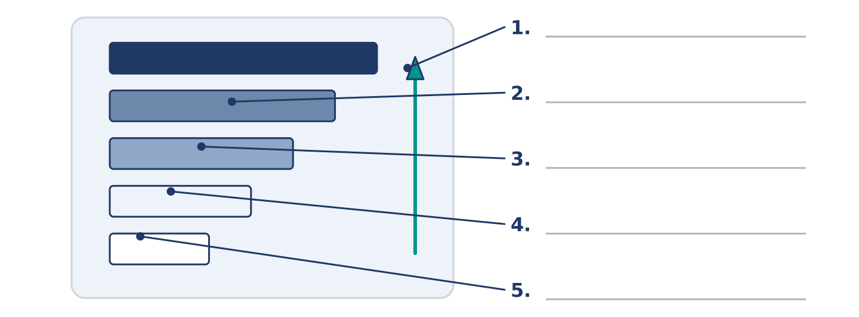
Figure 14.4 · How strong the advice is — write the correct word on each line.
Match the advice with how strong it is. One is not needed. Write the letter.
Column A
1. | You should drink more water. | ____
2. | You shouldn’t go to work. | ____
3. | You could try a warm drink. | ____
4. | You must see somebody today. | ____
5. | You don’t have to stay in bed. | ____
Column B
a) | advice against doing it
b) | one idea among several, and no pressure
c) | not advice at all; it is necessary
d) | ordinary advice for doing it
e) | you may get up if you want to
f) | somebody did it and felt worse
Part 1: Health — Multiple Choice
Read and choose the correct answer.
1. When your body is much too hot, you have a…
○ A) pain
○ B) fever
○ C) headache
○ D) throat
2. The doctor who looks after your teeth is a…
○ A) nurse
○ B) guard
○ C) member
○ D) dentist
3. What you take to get better is…
○ A) a pain
○ B) a fever
○ C) medicine
○ D) a throat
Part 1: Vocabulary Fill-in
Complete the sentences with the correct word.
Word bank: throat | headache | healthy | pain
- My ______________________ hurts and I can hardly swallow.
- She has had a ______________________ since Tuesday and she is still at work.
- There is a sharp ______________________ here when I turn my head.
- He eats well, walks everywhere and is the least ______________________ person I know.
Part 1: Write Some Advice (short)
Write two or three sentences of advice for somebody with a cold. Use three words from this unit.
Model — read this first:
You should drink more than you want to and sleep more than you think you need. You shouldn’t take medicine for a fever under thirty-eight degrees; the fever is doing something. If your throat is still bad after five days, see somebody. (42 words)
Part 2 · Grammar — Should and Shouldn’t
[CORE] Core track · pre-class input
Part 2: Notice
Read these lines. Underline should and shouldn’t. Which give advice, and which ask for it?
You should drink more water. You shouldn’t go to work today. Should I see a doctor? You should see somebody if it gets worse. I shouldn’t have another coffee. What should I take for it?
Four of these give advice. Two ask for it.
Part 2: Grammar Focus Box
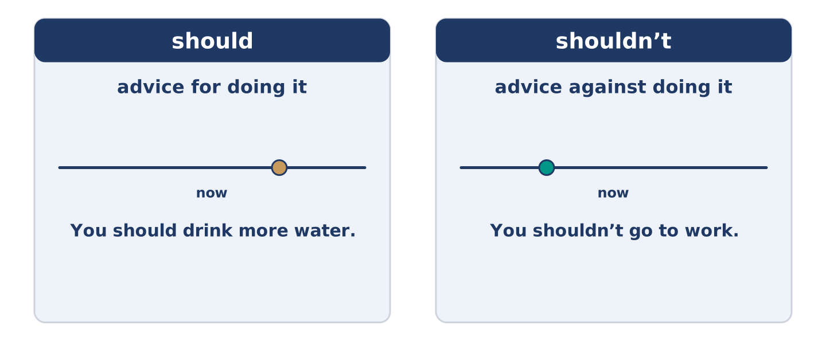
Figure 14.5 · Advice, advice against, and asking for it.
 | Form | Use | Example
should | should + plain verb | advice for doing it | You should drink more water.
shouldn’t | should not + plain verb | advice against doing it | You shouldn’t go to work.
Should I…? | a question | asking for advice | Should I see a doctor?
I should / I shouldn’t | about yourself | advice you give yourself | I shouldn’t have another coffee.
Remember: should never takes to: you should rest, not you should to rest.
Watch out! ✗ You should to rest. → ✓ You should rest. (no to after should). ✗ You don’t should go. → ✓ You shouldn’t go. (should makes its own negative).
Part 2: Controlled Practice
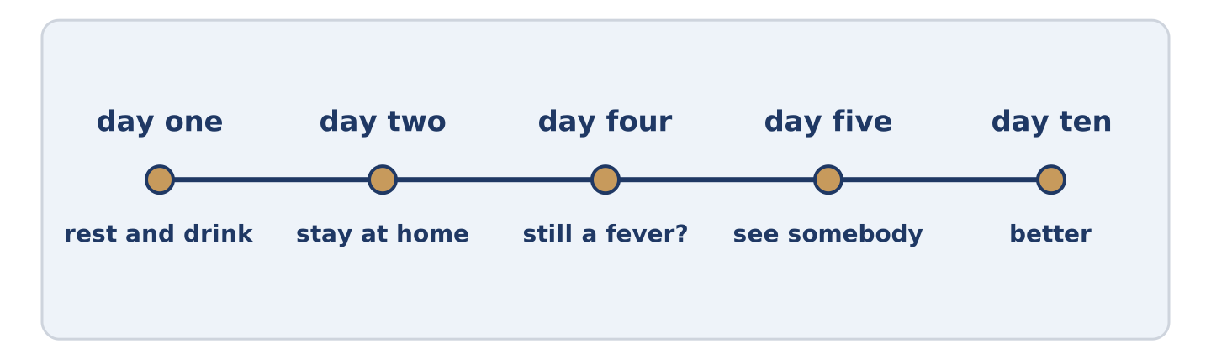
Figure 14.6 · One cold, from the first day to the tenth.
Complete with should or shouldn’t. (0. is done.)
- You should drink more water.
- You ______________________ go to work with a fever.
- You ______________________ see somebody if it gets worse.
- You ______________________ take medicine you found in a drawer.
- ______________________ I stay in bed, or get up?
Part 2: Advice, Advice Against, or Asking?
Write advice, against or asking. (0. is done.)
- You should drink more water. — advice
- You shouldn’t go to work today. ____________
- Should I see a doctor? ____________
- You should rest for two days. ____________
- What should I take for it? ____________
Part 2: Correct the Sentence
Each sentence has one grammar mistake. Write the correct sentence.
- You should to rest for two days.
- You don’t should go to work.
- Should I to see a doctor?
- He shoulds drink more water.
Part 2: Freer Practice
Write two pieces of advice for somebody who never sleeps enough: one should and one shouldn’t.
Part 2: Grammar Review
Choose the correct sentence.
1. Which sentence gives advice against something?
○ A) You shouldn’t go to work today.
○ B) You don’t should go to work today.
○ C) You should not to go to work today.
○ D) You mustn’t go to work today.
2. Which sentence asks for advice?
○ A) I should see a doctor.
○ B) You should see a doctor.
○ C) I shouldn’t see a doctor.
○ D) Should I see a doctor?
→ Harvest: you will see should and shouldn’t again in the Part 5 reading. Watch for who is giving the advice.
Part 3 · Listening
[CORE] Core track · pre-class input · scripts printed inline
Part 3: Asking the Nurse Next Door
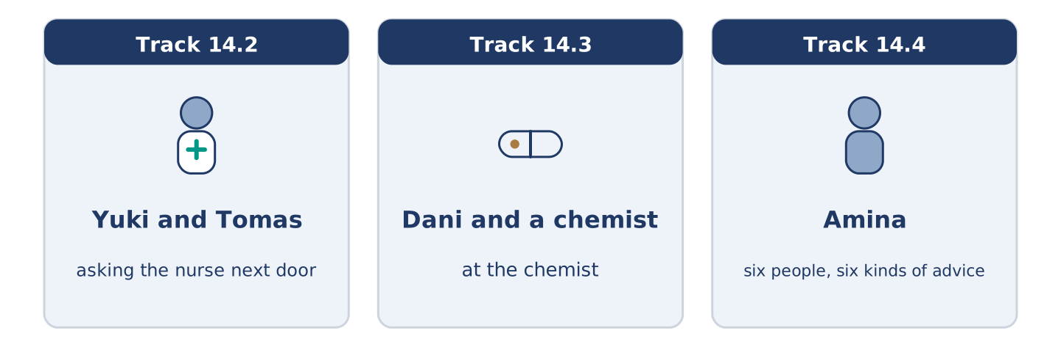
Figure 14.7 · The three listenings: who is speaking, and what about.
🔊 Audio Track 14.2
Before you listen: do you ask a friend before you ask a doctor?
Yuki: Tomas, you’re a nurse. Tomas: I am, and I’m going to say the same thing I always say. Yuki: Which is? Tomas: That I can’t tell you what is wrong with you on a staircase. Yuki: It’s only a headache. Tomas: Then you should drink more water and sleep, and you shouldn’t look it up. Yuki: And if it is still there on Friday? Tomas: Then it is not only a headache, and you should see somebody. Yuki: That is what I wanted.
While you listen: write True, False, or Not Given. (0. is done.)
- Yuki asks Tomas about a headache. — True
- Tomas says he can tell her what is wrong. ____
- Tomas says she should drink more water. ____
- Yuki has had this headache before. ____
Useful phrases: You’re a nurse · It’s only a… · you should… · you shouldn’t…
Part 3: At the Chemist
🔊 Audio Track 14.3
Before you listen: what do you ask for when you do not know the word?
Dani: I need something for a throat. Chemist: Does it hurt, or is it dry? Dani: It hurts. Chemist: And how long? Dani: Four days. Chemist: Four days is fine. Six and you should see a doctor. Dani: What should I take? Chemist: Honestly, warm water and salt. You could buy the pills in the blue box, and they work, and they cost nine. Dani: And the salt is free. Chemist: The salt is in your kitchen.
Answer the questions. (0. is done.)
- What does Dani need something for? — A throat that hurts.
- How long has it been?
- At how many days should he see a doctor?
- What does the chemist say he could use instead?
Part 3: Six People, Six Kinds of Advice
🔊 Audio Track 14.4
Before you listen: whose advice do you actually take?
Amina: I get told how to feel better about four times a week. Tomas says rest and water, which is right and is never what anybody wants to hear. Maya says look it up, and she frightened herself twice doing it. Dani says you shouldn’t worry and never worried about anything in his life. Mr Okonkwo says go outside for ten minutes, which works more often than it has any right to. And Yuki says nothing at all and leaves soup by the door.
While you listen: match each person with their advice. One is not needed. (0. is done.)
- Amina → she gets told four times a week.
Useful phrases: ___ says rest and water · ___ says look it up · ___ leaves soup
Column A
1. | Tomas | ____
2. | Maya | ____
3. | Mr Okonkwo | ____
4. | Yuki | ____
Column B
a) | says go outside for ten minutes
b) | says rest and water
c) | says look it up, and frightens herself
d) | says nothing and leaves soup by the door
e) | says you should take two of everything
Part 4 · Speaking
[CORE] Core track · in-class output
Part 4: Advice You Give and Take
Work with a partner. Ask and answer these questions.
- What should somebody do for a cold where you come from?
- What advice do people give that you think is wrong?
- Who do you ask first when you feel ill, and why?
Useful language: You should… · You shouldn’t… · Should I…? · it depends
Part 4: Find the Difference (pairwork)
Student A and Student B each have advice for the same problem. Ask questions and find three differences.
Useful questions: What should I drink? · Should I stay in bed? · Should I take anything? · When should I see somebody?
Student A — your advice: drink water, stay in bed, take nothing, see somebody after five days.
Student B — your advice: drink warm water with salt, get up and move, take nothing, see somebody after five days.
Part 4: Asking for Advice
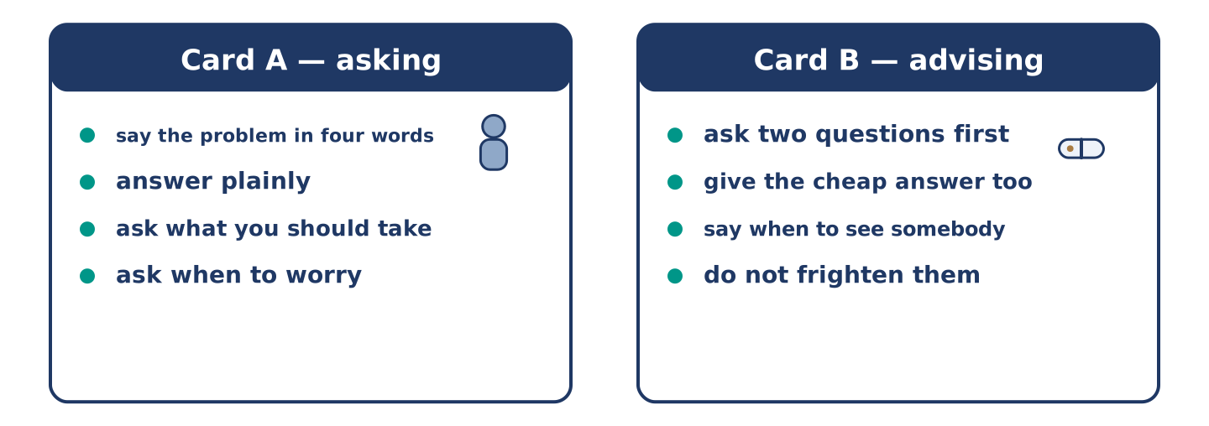
Figure 14.8 · Card A and Card B: what each of you has to say.
Work in pairs. Read the model, then use the cards.
Model exchange:
A: I need something for a throat. — B: Does it hurt, or is it dry? — A: It hurts. — B: And how long? — A: Four days. — B: Four days is fine. Six and you should see a doctor. — A: What should I take? — B: Warm water and salt, honestly.
Useful language: I need something for… · How long? · you should… · you could…
Card A — asking: say the problem in four words · answer the questions plainly · ask what you should take · ask when to worry.
Card B — advising: ask two questions first · give the cheap answer as well · say when they should see somebody · do not frighten them.
Your turn: run the dialogue, then swap roles.
Stretch [PLUS]: the person in front of you should see a doctor today and does not want to — say so without alarming them.
Part 4: Mini-Presentation
Prepare a short talk (about one minute). Describe what people do for a cold where you grew up, and say which part you think works.
Part 5 · Reading
[CORE] Core track · pre-class input
Part 5: Why We Ask the Wrong People
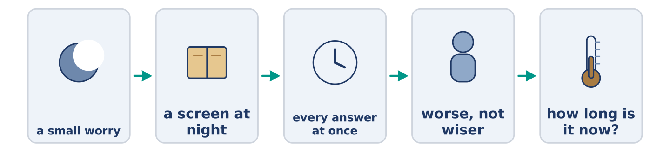
Figure 14.9 · One small worry, from Tuesday to Friday.
Before you read: who do you ask first, and is that the right person?
Gloss: symptom = a sign that something is wrong with your body · harmless = not able to hurt you · reassure = to say something that stops a person worrying
Almost nobody asks a doctor first. They ask a friend, a sister, a shop, and most of all they ask a screen, usually at night and usually alone. The screen is very good at listing everything a symptom could mean. It gives the terrible things the same calm face as the harmless ones. Somebody already a little afraid gets to the end of that list no wiser at all. They only feel worse. What a friend does, and a screen cannot, is reassure badly and ask one good question: how long is it now? That question sorts almost everything. It is the first thing the chemist asks and the second thing the doctor asks, and the list never asks it at all.
Answer the multiple-choice questions. (0. is done.)
- Who do almost all people ask first? — Not a doctor; a friend, a sister, a shop or a screen.
1. What does the text say a screen is good at?
○ A) Asking how long it is now
○ B) Listing everything a symptom could mean
○ C) Telling you to sleep
○ D) Finding you a doctor
2. How does a person feel after reading the list?
○ A) Wiser
○ B) Calm
○ C) Worse
○ D) Better
3. What is the one good question?
○ A) How long is it now?
○ B) Where does it hurt?
○ C) How old are you?
○ D) Did you eat today?
Part 5: Vocabulary in Context
Match each word from the text with its meaning. One meaning is not needed. Write the letter.
Column A
1. | symptom | ____
2. | harmless | ____
3. | reassure | ____
4. | calm | ____
Column B
a) | not able to hurt you
b) | quiet, and not frightened
c) | a sign that something is wrong with your body
d) | to say something that stops a person worrying
e) | the doctor who looks after your teeth
Part 5: Three Things People Get Right Without Knowing Why
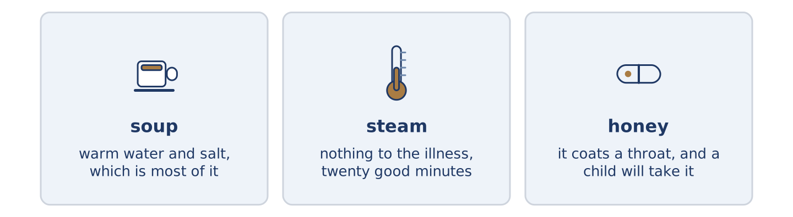
Figure 14.10 · Three old habits, and what each one turns out to do.
Before you read: which old remedy in your family actually works?
Gloss: remedy = an old answer to a small illness · steam = hot water turning into air · honey = the sweet thing bees make · cough = the sharp noise a bad chest makes
Some old remedies survive because they work, and not for the reason anybody gave. Chicken soup was said to feed the blood. What it really does is get warm water and salt into somebody who stopped drinking, and that is most of the problem with a cold. Steam over a bowl was said to drive the illness out. It does nothing to the illness and a great deal to a blocked nose for twenty minutes, which is enough. Honey for a cough is the strangest of the three, because it beats most of what you can buy. The reason seems to be that it coats a throat that hurts. It also tastes good enough that a child will take it. Three remedies, three wrong reasons, three results.
Answer the questions. (0. is done.)
- Do old remedies survive for the reasons people gave? — No, often not.
- What does chicken soup really do?
- What does steam do, and for how long?
- Why does honey work for a cough?
Part 6 · Writing
[CORE] Core track · in-class / homework
Part 6: Advice for Somebody Ill (50–70 words)
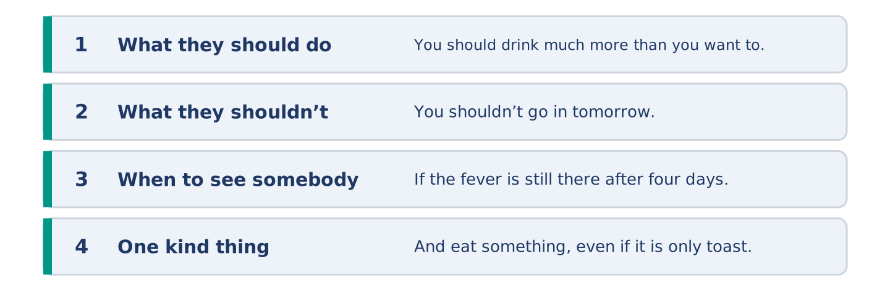
Figure 14.11 · The shape of the advice you are about to write.
A friend has written to say they feel ill. Write back with advice.
Model — read this first:
You should drink much more than you want to, and keep a cup by the bed so you do not have to decide each time. You shouldn’t go in tomorrow, whatever you are telling yourself about Thursday. If the fever is still there after four days, see somebody. And eat something, even if it is only toast and you do not want it. (63 words)
Plan (fill in, then write): You should ___. You shouldn’t ___. If ___, ___. And ___.
Word bank: you should | you shouldn’t | if it is still | see somebody | rest
Check before you finish: ☐ two should sentences? ☐ one shouldn’t? ☐ when to see a doctor? ☐ 50–70 words?
Part 6: Should People Work When They Are Ill? (50–70 words)
Should people go to work when they are ill? Give your opinion and two or three reasons.
Model — read this first:
No, and the argument is not about being kind. One person at a desk with a fever costs an office four more people the following week, which anybody can count. The reason people go in anyway is that nobody above them ever stays at home, so everybody reads the room correctly and comes in coughing. (55 words)
Word bank: I think… because… | however | in my opinion | it depends on | should
Check before you finish: ☐ a clear opinion? ☐ two or three reasons? ☐ 50–70 words?
Part 6: Advice You Were Given (50–70 words)
Write about advice somebody gave you about your health. Say whether you took it.
Model — read this first:
My grandmother said I should put a cut onion in the room when anybody had a cold. I thought it was nonsense and I was right; it does nothing at all. I did it anyway for eleven years. The smell of it meant somebody was looking after me, and that part was not nonsense. (54 words)
Plan (fill in, then write): ___ said I should ___. I thought ___. ___ anyway, because ___.
Check before you finish: ☐ who gave the advice? ☐ what it was? ☐ whether you took it? ☐ 50–70 words?
Part 6: Reflection — Advice I Give and Do Not Take (40–60 words)
Write about advice you give other people and never take yourself.
Model — read this first:
I tell everybody they should go to bed earlier, and I say it with real feeling, and I am always the last one awake. I know exactly what I should do. What I do instead is read one more chapter, which is exactly the decision I was making at nine years old. (52 words)
Check before you finish: ☐ what you tell people? ☐ what you do? ☐ why? ☐ 40–60 words?
Part 7 · Real-World File — At the Chemist and the Surgery
[PLUS] Plus track (optional) · stronger learners
7A: Phrase Bank
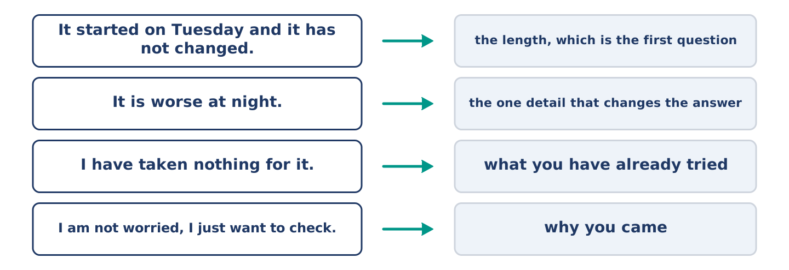
Figure 14.12 · What you say about how you feel, and what each line does.
Match what a person says with its purpose. One purpose is not needed. Write the letter.
Column A
1. | “It started on Tuesday and it has not changed.” | ____
2. | “It is worse at night.” | ____
3. | “I have taken nothing for it.” | ____
4. | “I am not worried, I just want to check.” | ____
Column B
a) | saying what you have already tried
b) | giving the one detail that changes the answer
c) | how much it will cost
d) | giving the length, which is the first question
e) | telling them why you came
7B: The Appointment You Nearly Did Not Make
🔊 Audio Track 14.5
Before you read: how long do you wait before you make an appointment?
Maya: It is probably nothing. Tomas: Probably. Maya: So I should leave it. Tomas: You said probably nothing twice in one minute. Maya: That is not an answer. Tomas: It is the whole answer. Anybody who truly thinks it is nothing does not mention it twice. Maya: You are being annoying. Tomas: I am being a nurse. Make the appointment and be wrong; being wrong takes twenty minutes.
Answer the questions. (0. is done.)
- What does Maya say twice? — That it is probably nothing.
- What does Tomas notice about what she said?
- What does Tomas say about people who think it is nothing?
- What does Tomas tell her to do?
7C: Controlled Practice — Describing How You Feel
Put the steps in order. Number them 1–5. (0. is done.)
- Say what is wrong, in one short sentence. — 1
____ Say what you have already tried.
____ Say how long it has been there.
____ Say why you came today.
____ Say what makes it better or worse.
7D: Role-Play — Asking Whether It Is Worth Asking
In pairs. One thinks it is nothing; one is not sure. Use the model and cards.
Model exchange: A: It is probably nothing. — B: Probably. — A: So I should leave it. — B: You have said probably twice. — A: That is not an answer. — B: It is the whole answer. — A: I will make the appointment.
Card A — unsure: say it is probably nothing · say it twice without noticing · push back once · decide.
Card B — listening: do not say what is wrong · notice what they repeat · give one reason, not four · let them decide.
Stretch [PLUS]: they decide not to go and you think they should — say it once more, and then let it be their decision.
7E: Writing — A Note to a Doctor’s Desk (50–80 words)
Write a short note asking for an appointment, saying what is wrong.
Model — read this first:
I would like an appointment this week if there is one. I get a headache every day, always worse in the afternoon, and nothing shifts it. I am sleeping and drinking normally and I took nothing for it. I am not worried; I would like somebody to say it is nothing. Mornings are easier for me than afternoons. (58 words)
Check before you finish: ☐ what is wrong, in one sentence? ☐ how long? ☐ what you have tried? ☐ 50–80 words?
Part 8 · Global Story — The Country That Asks First
[PLUS] Plus track · pre-read / discuss
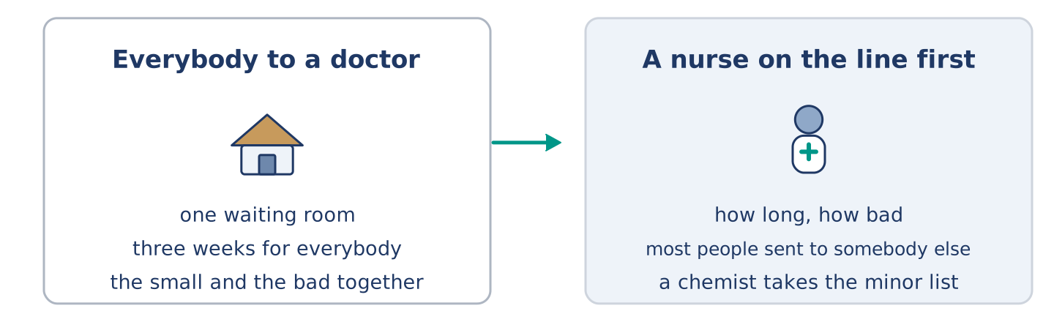
Figure 14.13 · A waiting room, and a telephone line.
Before you read: should the first person you see about your health be a doctor?
Gloss: triage = sorting people by how urgent they are · pharmacist = the person who knows what is in every box · minor = small, and not dangerous
In New Zealand a great deal of the first conversation happens before anybody sees a doctor. A nurse on a telephone line takes the call, asks how long and how bad, and sends most people somewhere other than a waiting room. A pharmacist handles a long list of minor things without an appointment at all. The idea behind it is simple. The hardest part of medicine is not treating people, it is sorting them. Sorting does not need the most expensive person in the building. It upsets people at first. Nobody enjoys hearing that their problem is small, even when it is. A year in, the same people are the ones who argue hardest for it.
Answer the questions. (0. is done.)
- Who takes the first call? — A nurse on a telephone line.
- What does the nurse ask?
- What does a pharmacist handle without an appointment?
- Why does it upset people at first?
Part 8: Vocabulary in Context
Match each word with its meaning. One meaning is not needed. Write the letter.
Column A
1. | triage | ____
2. | pharmacist | ____
3. | minor | ____
4. | urgent | ____
Column B
a) | small, and not dangerous
b) | needing to happen now
c) | sorting people by how urgent they are
d) | the person who knows what is in every box
e) | hot water turning into air
Part 8: Discussion
Talk with a partner. Use the frames.
Discussion frames: “This is similar to where I live because…” · “This is different from where I live because…” · “I think the most important thing is… because…”
Part 9 · Close to Home — The Week Everybody Had It
[PLUS] Plus track · pre-read / decide
Before you read: who looks after a street when everybody in it is ill?
It went through number 14 in nine days and it took them in order, from the top down. Yuki first, then Maya, then Dani, and then Amina, who shut the shop for the only two days she has shut it in eleven years. Tomas did not get it at all, which he said was the hospital and everybody else said was simply unfair. Mr Okonkwo did not get it either, and at seventy-one he was the one carrying bread up four flights to people half his age. On the ninth day Amina opened again and found five people waiting, every one of them buying soup. Nobody said one word about it, which at number 14 is how a thing gets marked and remembered.
Answer the questions. (0. is done.)
- How long did it take to go through number 14? — Nine days.
- Who got it first?
- What did Amina do for two days?
- What was Mr Okonkwo doing at seventy-one?
Part 9: Decision Task
A neighbour is clearly ill and says they are fine. Should you (a) say nothing, (b) ask once and leave it, or (c) bring something round without asking? Decide and explain. Use the frame.
Answer frame: “I think I should ___ because ___. Also, ___. This is better than ___ because ___.”
Model — read this first:
I think I should bring something round without asking, because asking an ill person a question makes them do work. Also, you can walk past soup on a doorstep, and you cannot walk past a conversation. This is better than asking once and leaving it. The fine-on-Tuesday people are usually worse by Thursday and still saying it. (57 words)
Phrase bank: I think I should… · because… · Also,… · This is better than… · In my opinion…
Part 10 · Review and Can-Do
[CORE + PLUS] · homework / self-study
Part 10: Spiral Review
Complete the review. (0. is done.)
- The feeling when part of you hurts is pain.
Word bank: fever | medicine | dentist | healthy | should | shouldn’t | guard | storm
- When your body is much too hot, you have a ______________________ .
- What you take to get better is ______________________ .
- The doctor who looks after your teeth is a ______________________ .
- Strong and well, and likely to stay so, is ______________________ .
- You ______________________ drink more water. (advice)
- You ______________________ go to work with a fever. (advice against)
- (from Unit 13) Somebody whose job is to watch a place is a ______________________ .
- (from Unit 12) Strong wind and heavy rain together is a ______________________ .
Part 10: Can-Do
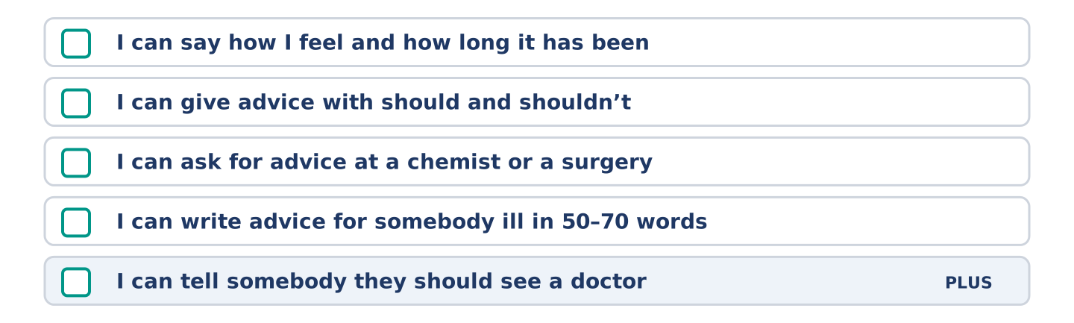
Figure 14.14 · What you can do at the end of this unit.
Can-Do checklist
☐ I can say how I feel and how long it has been.
☐ I can give advice with should and shouldn’t.
☐ I can ask for advice at a chemist or a surgery.
☐ I can write advice for somebody ill in 50–70 words.
☐ I can tell somebody they should see a doctor (Plus).
Part 10: Glossary
Unit 14 glossary (10 words)
pain · headache · medicine · pill · healthy · sick · doctor · fever · throat · dentist
Unit 15: Experiences
English for Daily Life · Level: A2 · Tracks: [CORE] Warm-Up + Parts 1–6 · [PLUS] Parts 7–10
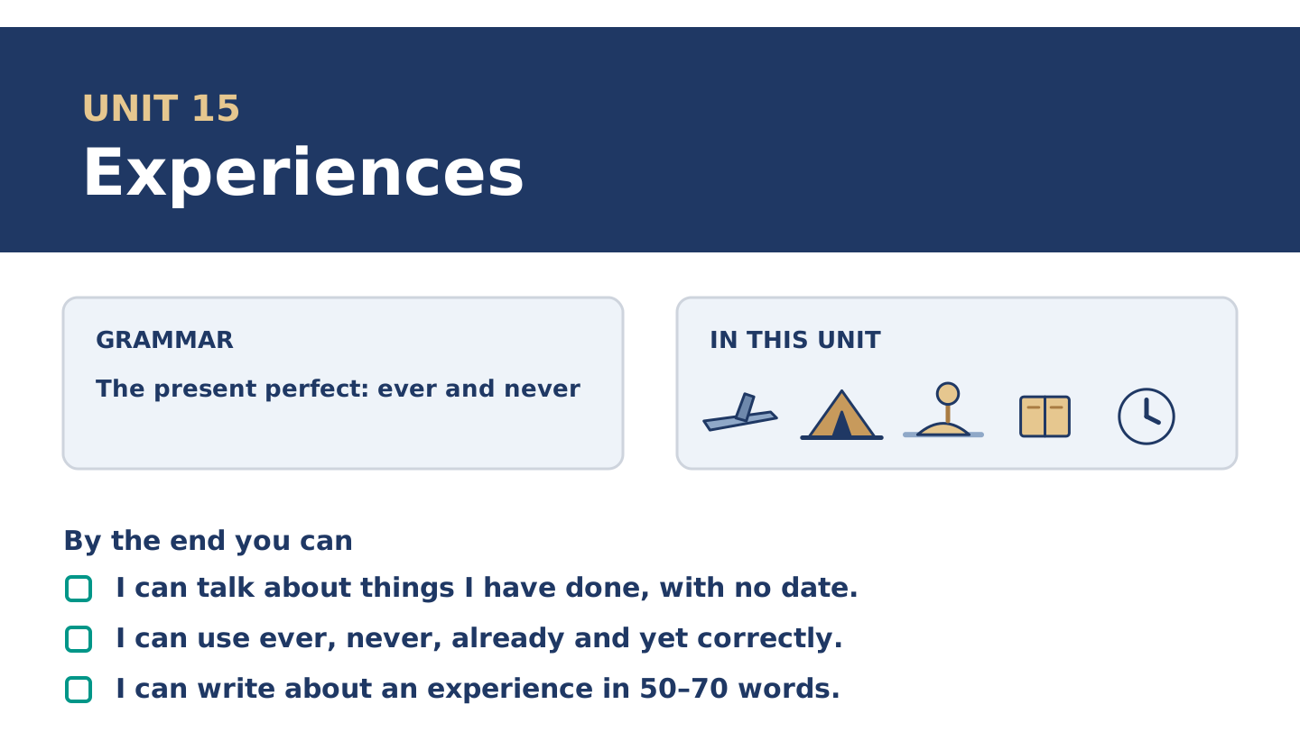
Figure 15.1 · Unit 15 at a glance: the grammar, the topic and what you will be able to do.
Warm Up
[CORE] Core track · in-class starter
Warm-up: Words for Things You Have Done
Match the words with their meanings. One meaning is not needed. Write the letter.
Column A
1. | Abroad | ____
2. | Camping | ____
3. | Festival | ____
4. | Island | ____
5. | Desert | ____
Column B
a) | land with water all round it
b) | sleeping outside, in a tent or a van
c) | in another country
d) | a very dry place where almost nothing grows
e) | days of music or food, usually once a year
f) | the money you pay to go in or to belong
Warm-up: Talking About Experiences
Complete the sentences using the words in the word bank.
Word bank: experience | memory | tour | adventure
- Yuki has never had a bad ______________________ on a night bus, which surprises everybody.
- Dani calls one wrong turn in a city an ______________________ , and he means it.
- Mr Okonkwo has a clear ______________________ of a shop that closed before Maya was born.
- Amina has been on exactly one ______________________ of anything, and it was of a factory.
Warm-up: Six People, Six Experiences
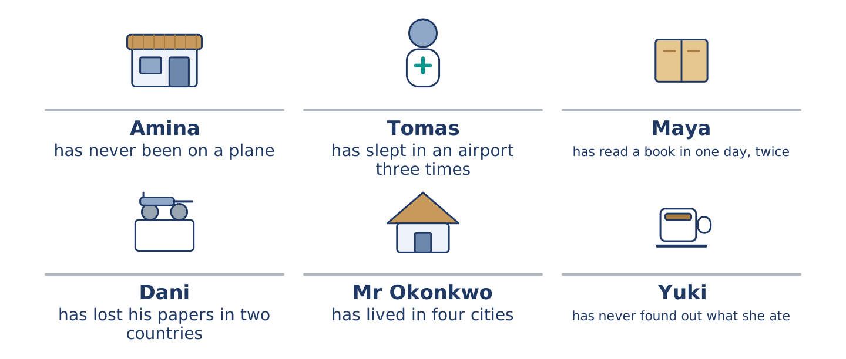
Figure 15.2 · What each of them has done, and what nobody has done at all.
Read the text and choose the correct answer.
Everybody at number 14 has done something the others have not. Amina has never been on a plane and says she has never wanted to. Tomas has slept in an airport three times. Maya has read a book in one day, twice. Dani has lost his papers in two countries. Mr Okonkwo has lived in four cities and will not say which he liked. Yuki has eaten something she still cannot name, in a market, and she has never found out what it was.
1. Who has never been on a plane?
○ A) Amina
○ B) Yuki
○ C) Maya
○ D) Tomas
2. What has Dani done?
○ A) Slept in an airport
○ B) Lived in four cities
○ C) Lost his papers in two countries
○ D) Read a book in one day
Part 1 · Vocabulary and Terminology
[CORE] Core track · pre-class input
Part 1: Words for Experiences
Match the words with their meanings. One meaning is not needed. (0. is done for you.)
- Experience → something that happened to you, and that you still carry.
Column A
1. | Abroad | ____
2. | Adventure | ____
3. | Exhibition | ____
4. | Tour | ____
5. | Memory | ____
6. | Island | ____
7. | Festival | ____
Column B
a) | a walk round a place with somebody explaining it
b) | something you keep in your head from before
c) | in another country
d) | days of music or food, usually once a year
e) | a room of things put out for people to look at
f) | land with water all round it
g) | something that happens to you that you did not plan
h) | a sign that something is wrong with your body
Gloss: exhibition = a room of things put out for people to look at · tour = a walk round a place with somebody explaining it · abroad = in another country
Part 1: Pronunciation
🔊 Audio Track 15.1
Listen to have and has in the present perfect. Say each one aloud.
I have been there — in speech it is one sound: I’ve been there
She has eaten it — the same: she’s eaten it
Have you ever been? — weak at the front: /həv juː/
Yes, I have — strong at the end, and never shortened
The rule is the same one as will in Unit 12 and can in Unit 8 of the first book. In the middle of a sentence the helping word almost disappears. At the end of a short answer it stands up. English does this to every one of them, and a learner who hears it once stops needing to be told.
Part 1: Four Experiences, Four Answers
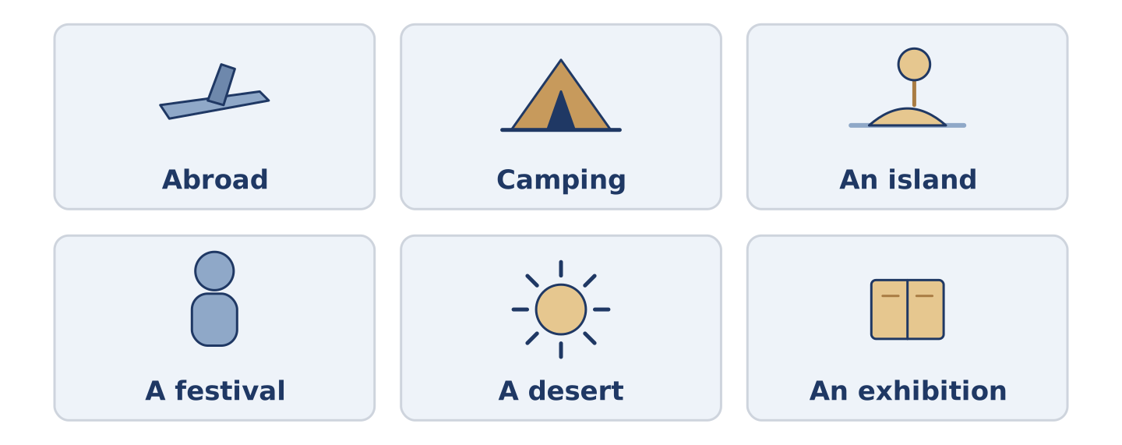
Figure 15.3 · Four things people have done, and how often.
Complete the table. Write how many times and what you remember. (0. is done.)
The experience | How many times? | What you remember
Slept outside | once | (example)
Been abroad
Eaten something you could not name
Been to a festival
- Slept outside — once — that it was far colder than anybody said.
Think about your own life. There is more than one right answer; be ready to say why.
Part 1: Ever, Never, Already or Yet?
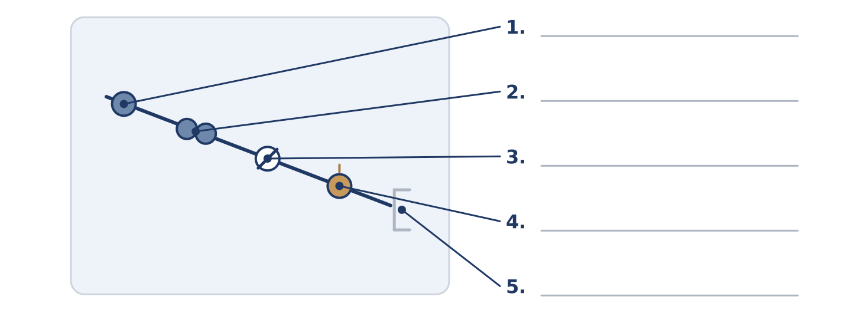
Figure 15.4 · Four small words that change the question — write the correct word on each line.
Match the words with what they do. One is not needed. Write the letter.
Column A
1. | ever | ____
2. | never | ____
3. | already | ____
4. | yet | ____
5. | twice | ____
Column B
a) | not once, in your whole life
b) | sooner than the other person expected
c) | two times, and no more
d) | at any time in your life, in a question
e) | up to now, in a question or a negative
f) | one time, a long while ago
Part 1: Experiences — Multiple Choice
Read and choose the correct answer.
1. In another country is…
○ A) a tour
○ B) a desert
○ C) an island
○ D) abroad
2. A room of things put out for people to look at is an…
○ A) exhibition
○ B) island
○ C) adventure
○ D) experience
3. Land with water all round it is an…
○ A) desert
○ B) island
○ C) abroad
○ D) festival
Part 1: Vocabulary Fill-in
Complete the sentences with the correct word.
Word bank: desert | camping | memory | festival
- They went ______________________ twice and bought a flat the following year.
- My first ______________________ is of a kitchen floor and a dog.
- There is a ______________________ in the square every August and nobody can park.
- He has crossed a ______________________ on a bus and says it was mostly boring.
Part 1: Write About an Experience (short)
Write two or three sentences about something you have done. Use three words from this unit.
Model — read this first:
I have been camping exactly once and I have never done it again. We went to an island in April, which everybody said was too early, and everybody was right. It is my clearest memory of being cold and my only memory of that many stars. (46 words)
Part 2 · Grammar — The Present Perfect
[CORE] Core track · pre-class input
Part 2: Notice
Read these lines. Underline have and has. Which ask about a whole life, and which say it never happened?
I have been to four countries. She has never flown. Have you ever slept outside? He has already eaten. They have not arrived yet. I have lost a travel papers twice.
Two of these are questions or answers about a whole life. Two use a small word that moves the meaning. Two simply state an experience.
Part 2: Grammar Focus Box
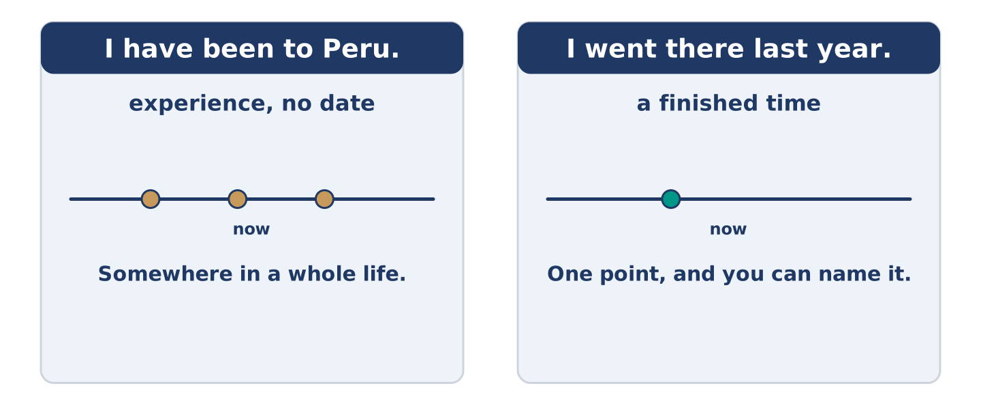
Figure 15.5 · A whole life up to now, and a finished moment.
 | Form | Use | Example
have / has + past participle | I have been, she has gone | experience, with no date | I have been to four countries.
ever | in questions | at any time in your life | Have you ever slept outside?
never | in statements | not once, in your whole life | She has never flown.
already / yet | already in statements, yet in questions and negatives | sooner than expected, or up to now | He has already eaten. They have not arrived yet.
Remember: the present perfect never takes a finished date: I have been to Peru, not I have been to Peru last year.
Watch out! ✗ I have been there last year. → ✓ I went there last year. (a finished date takes the past simple). ✗ Have you ever went? → ✓ Have you ever been? (the third form, not the past).
Part 2: Controlled Practice
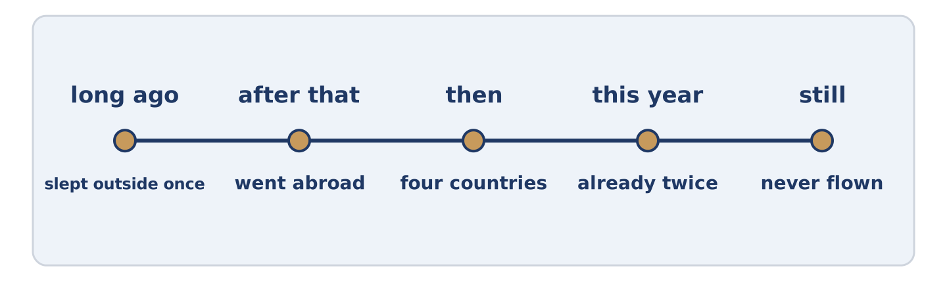
Figure 15.6 · One life, and the things in it with no date.
Complete with the present perfect. (0. is done.)
- I have been to four countries. (be)
- She ______________________ never ______________________ . (fly)
- ______________________ you ever ______________________ outside? (sleep)
- He ______________________ already ______________________ . (eat)
- They ______________________ not arrived yet. (have)
Part 2: Experience or Finished Time?
Write experience or finished time. (0. is done.)
- I have been to four countries. — experience
- I went to Peru last year. ____________
- She has never flown. ____________
- We arrived on Tuesday. ____________
- Have you ever slept outside? ____________
Part 2: Correct the Sentence
Each sentence has one grammar mistake. Write the correct sentence.
- I have been there last year.
- Have you ever went to a festival?
- She has never flied.
- He have already eaten.
Part 2: Freer Practice
Write two sentences about yourself: one thing you have done, and one thing you have never done.
Part 2: Grammar Review
Choose the correct sentence.
1. Which sentence is correct?
○ A) I have been to Peru last year.
○ B) I have went to Peru.
○ C) I have been to Peru.
○ D) I have be to Peru.
2. Which question asks about a whole life?
○ A) Did you sleep outside last night?
○ B) Are you sleeping outside?
○ C) Will you sleep outside?
○ D) Have you ever slept outside?
→ Harvest: you will see the present perfect again in the Part 5 reading. Watch for the sentences with no date in them.
Part 3 · Listening
[CORE] Core track · pre-class input · scripts printed inline
Part 3: Have You Ever?
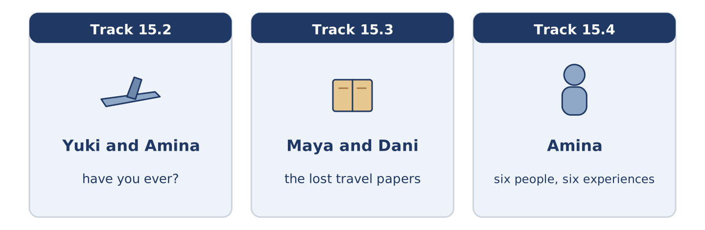
Figure 15.7 · The three listenings: who is speaking, and what about.
🔊 Audio Track 15.2
Before you listen: what is the most ordinary thing you have never done?
Yuki: Have you ever been on a plane? Amina: Never. Yuki: Not once? Amina: Not once, and nobody believes it. Yuki: Have you wanted to? Amina: No, and that’s the part people can’t manage. They can manage the fact. They can’t manage that I don’t mind. Yuki: My mother’s the same about the sea. Amina: Then your mother and I would get on, and neither of us would go anywhere.
While you listen: write True, False, or Not Given. (0. is done.)
- Amina has never been on a plane. — True
- Amina says she has wanted to fly. ____
- Yuki says her mother is the same about the sea. ____
- Amina has been on a boat. ____
Useful phrases: Have you ever…? · Never. · Not once. · My mother is the same.
Part 3: The Passport Story
🔊 Audio Track 15.3
Before you listen: did you ever lose something important while travelling?
Maya: You have lost your papers twice? Dani: In two different countries, which I think is worse. Maya: How? Dani: The first one went in a river. Maya: And the second? Dani: The second one is the bad one. I put it somewhere I would remember. Maya: Where? Dani: That’s the whole story. I’ve never found it and I’ve never stopped looking. Maya: It’s in a book. Dani: It’s in a book. I know it’s in a book.
Answer the questions. (0. is done.)
- How many times has Dani lost his papers? — Two.
- What happened to the first one?
- What did Dani do with the second one?
- What does Maya think happened to it?
Part 3: Six People, Six Experiences
🔊 Audio Track 15.4
Before you listen: who do you know who has done the most, and does it show?
Amina: You find out what people have done sideways, never by asking. Tomas has slept in an airport three times and mentions it like a bus stop. Maya has read a whole book in a day, twice, and both times were in one terrible winter. Dani has lost two of his papers and tells it as a joke. Mr Okonkwo has lived in four cities and will not tell you which one he liked, and everybody has asked him. And Yuki once ate something in a market and has never found out what it was.
While you listen: match each person with their experience. One is not needed. (0. is done.)
- Amina → she finds out by accident.
Useful phrases: ___ has slept in an airport · ___ has lived in four cities · ___ has never found out
Column A
1. | Tomas | ____
2. | Maya | ____
3. | Mr Okonkwo | ____
4. | Yuki | ____
Column B
a) | has lived in four cities and will not say which
b) | has slept in an airport three times
c) | has read a whole book in a day, twice
d) | has never found out what she ate
e) | has crossed a desert on a bus
Part 4 · Speaking
[CORE] Core track · in-class output
Part 4: Things You Have Done
Work with a partner. Ask and answer these questions.
- Have you ever slept somewhere strange?
- What have you never done that most people have?
- What is the best thing you have eaten abroad?
Useful language: Have you ever…? · I have never… · Once, in… · Not yet.
Part 4: Find the Difference (pairwork)
Student A and Student B each have a list of experiences. Ask questions and find three differences.
Useful questions: Have you ever been abroad? · Have you ever slept outside? · How many times? · Have you flown?
Student A — you have: been abroad, slept outside once, never flown, been to two festivals.
Student B — you have: been abroad, slept outside many times, flown, been to two festivals.
Part 4: Finding Something in Common
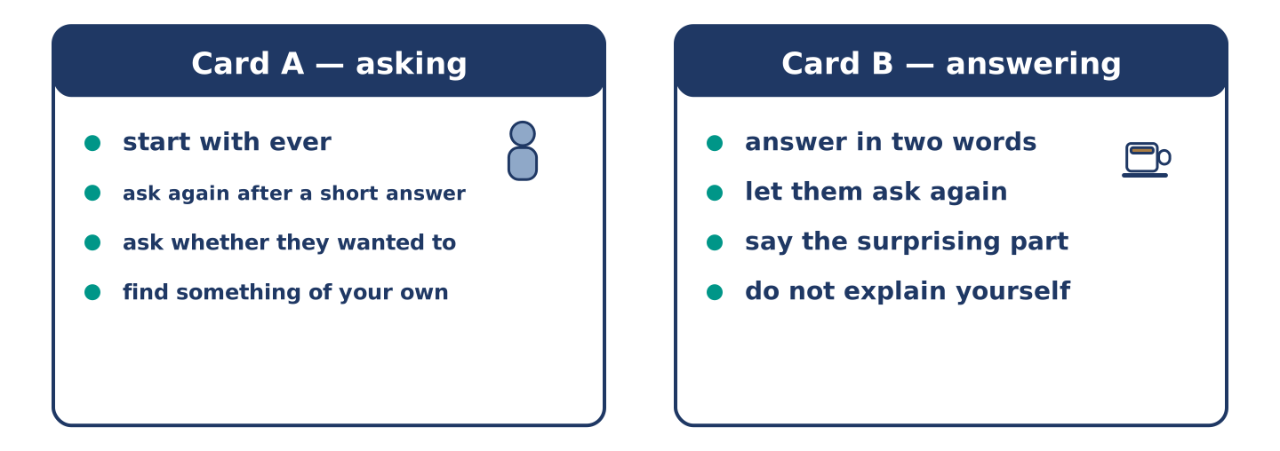
Figure 15.8 · Card A and Card B: what each of you has to say.
Work in pairs. Read the model, then use the cards.
Model exchange:
A: Have you ever been on a plane? — B: Never. — A: Not once? — B: Not once, and nobody believes it. — A: Have you wanted to? — B: No, and that is the part people cannot manage. — A: My mother is the same about the sea.
Useful language: Have you ever…? · Never. · Not once. · So have I.
Card A — asking: start with ever · ask again when the answer is short · ask whether they wanted to · find something of your own.
Card B — answering: answer in two words · let them ask again · say the surprising part · do not explain yourself.
Your turn: run the dialogue, then swap roles.
Stretch [PLUS]: you have done almost nothing on the other person’s list — talk about it without apologising for it once.
Part 4: Mini-Presentation
Prepare a short talk (about one minute). Describe three things you have done and one you have never done.
Part 5 · Reading
[CORE] Core track · pre-class input
Part 5: Why We Remember the Difficult Ones
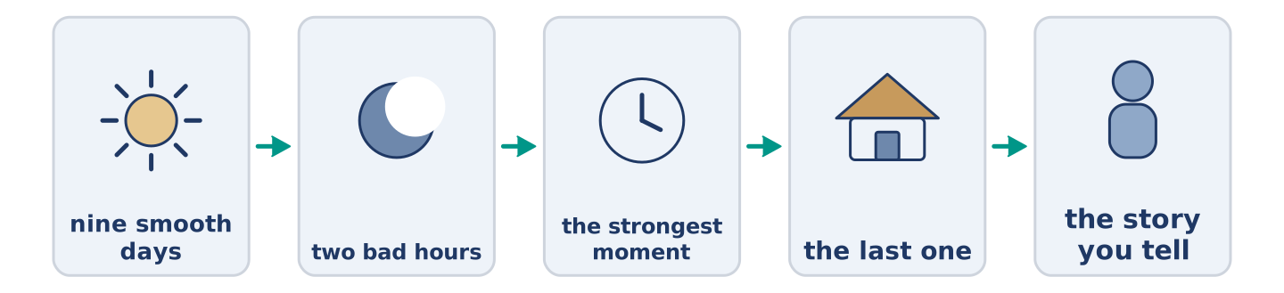
Figure 15.9 · One holiday, and the three days anybody still talks about.
Before you read: which of your holidays do you actually tell people about?
Gloss: smooth = with nothing going wrong · peak = the strongest moment of something · ending = how a thing finishes
Ask somebody about a holiday and they tell you about the boat that broke down. Nobody tells you about the nine smooth days. This is not only a story habit. People remember a long experience by two moments: the strongest one, and the last one. The nine quiet days leave almost nothing behind, and the two bad hours leave a shape. That is why a difficult trip with a good ending stays in the head as a good trip. A smooth week that ends in an argument at an airport does not. It also explains why people go back to the places where something went wrong. They are not going back for the trouble. They are going back for the only days their memory bothered to keep.
Answer the multiple-choice questions. (0. is done.)
- What do people tell you about a holiday? — The boat that broke down.
1. Which two moments do people remember?
○ A) The strongest and the last
○ B) The first and the last
○ C) The cheapest and the longest
○ D) The quiet ones
2. How is a difficult trip with a good ending remembered?
○ A) As a bad trip
○ B) Not at all
○ C) As a good trip
○ D) As an expensive trip
3. Why do people go back to places where something went wrong?
○ A) Because it was cheap
○ B) Because those are the days their memory kept
○ C) Because they want more trouble
○ D) Because the boat is better now
Part 5: Vocabulary in Context
Match each word from the text with its meaning. One meaning is not needed. Write the letter.
Column A
1. | smooth | ____
2. | peak | ____
3. | ending | ____
4. | habit | ____
Column B
a) | how a thing finishes
b) | something you do without deciding to
c) | with nothing going wrong
d) | the strongest moment of something
e) | land with water all round it
Part 5: Three Places People Travel a Long Way to See
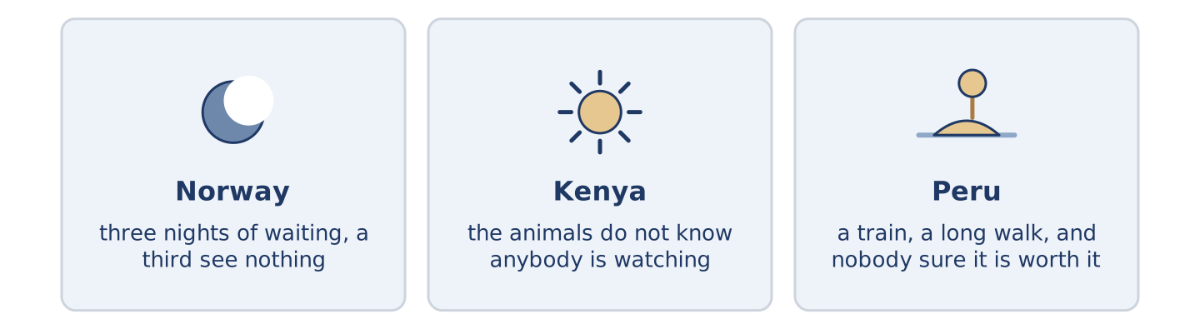
Figure 15.10 · Three places, and what people go there for.
Before you read: is there a place you would cross a continent to see?
Gloss: northern lights = coloured light in a very cold night sky · migration = animals moving a long way together, every year · ruins = what is left of an old building
Some places people travel for days to reach, and the reason is never only the view. In the far north of Norway people wait three nights in the cold for the northern lights. About a third of them see nothing at all and come back anyway. In Kenya the migration crosses the same river every year, and the animals do not know anybody is watching, which is most of the point. In Peru there are ruins at the end of a train ride and a long walk. Almost nobody gets there without hearing, twice, that it is not worth the climb. All three have something in common. You cannot be sure of any of them, and that is why people go.
Answer the questions. (0. is done.)
- Is the reason only the view? — No, it never is.
- How many of the people waiting in Norway see nothing?
- What do the animals in Kenya not know?
- What do all three places have in common?
Part 6 · Writing
[CORE] Core track · in-class / homework
Part 6: The Best Thing You Have Done (50–70 words)
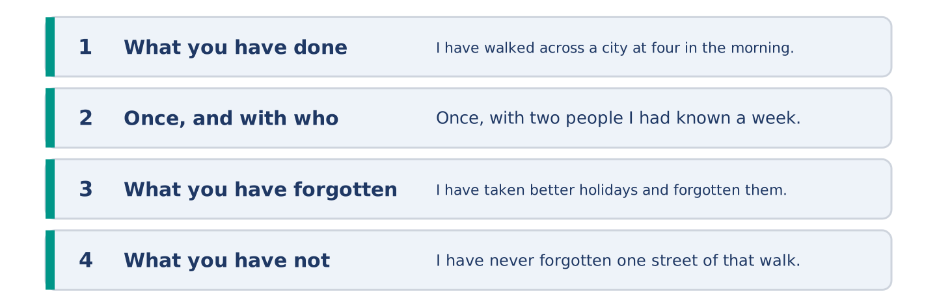
Figure 15.11 · The shape of the piece you are about to write.
Write about the best thing you have ever done. Say when, and what you remember.
Model — read this first:
I have walked across a city at four in the morning, once, with two people I had known for a week. We had missed the last train and there was no money for anything else. I have taken better holidays and I have forgotten all of them. I have never forgotten one street of that walk. (56 words)
Plan (fill in, then write): I have ___. We ___. I have ___ and ___. I have never ___.
Word bank: I have | I have never | once | already | the best thing
Check before you finish: ☐ two present-perfect sentences? ☐ one never? ☐ what you remember? ☐ 50–70 words?
Part 6: Is Travel the Best Way to Learn? (50–70 words)
Is travelling the best way to learn about the world? Give your opinion and two or three reasons.
Model — read this first:
It is not, and the people with the most stamps in their papers say so most loudly. Two weeks somewhere teaches you the airport, the old town and the price of water. What teaches you a country is having to deal with it: a bank, a rent, a hospital. Nobody puts that in a holiday. (55 words)
Word bank: I think… because… | however | in my opinion | it depends on | have travelled
Check before you finish: ☐ a clear opinion? ☐ two or three reasons? ☐ 50–70 words?
Part 6: Something You Have Never Done (50–70 words)
Write about something ordinary that you have never done. Say why not.
Model — read this first:
I have never learned to ride a bicycle. There was no moment when I decided not to; there was simply never an afternoon when somebody held the back of one. By eleven it had become a thing I did not say out loud. By thirty it was a small funny story that I tell badly. (55 words)
Plan (fill in, then write): I have never ___. There was ___. By ___ it had become ___.
Check before you finish: ☐ what you have never done? ☐ why not? ☐ how you feel about it? ☐ 50–70 words?
Part 6: Reflection — A Memory That Will Not Go (40–60 words)
Write about one small memory you have kept for no reason.
Model — read this first:
I have kept, for about thirty years, the sound of one gate. Nothing happened at that gate. I have forgotten the house, the street and most of the people. The gate is still there every time I hear a similar one, which is a strange thing for a head to choose. (51 words)
Check before you finish: ☐ what the memory is? ☐ how long you have had it? ☐ why it is strange? ☐ 40–60 words?
Part 7 · Real-World File — Telling and Asking About Experiences
[PLUS] Plus track (optional) · stronger learners
7A: Phrase Bank
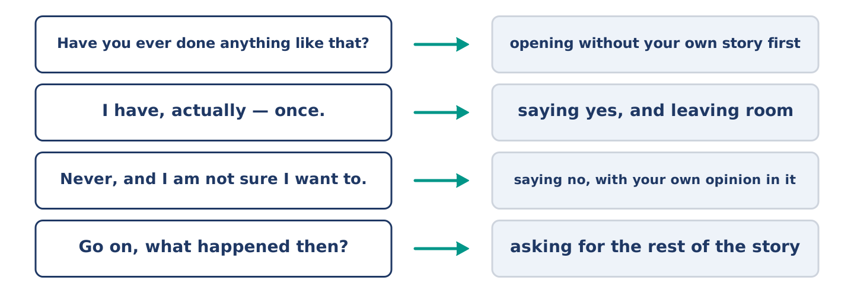
Figure 15.12 · What you say about an experience, and what each line does.
Match what a person says with its purpose. One purpose is not needed. Write the letter.
Column A
1. | “Have you ever done anything like that?” | ____
2. | “I have, actually — once.” | ____
3. | “Never, and I am not sure I want to.” | ____
4. | “Go on, what happened then?” | ____
Column B
a) | saying no, with your own opinion in it
b) | asking for the rest of the story
c) | how much it will cost
d) | opening the subject without telling your own story first
e) | saying yes, and leaving room for them to ask
7B: The Thing Nobody Has Asked About
🔊 Audio Track 15.5
Before you read: is there something about you that nobody has ever asked?
Yuki: You have lived in four cities. Mr Okonkwo: I have. Yuki: Which one did you like? Mr Okonkwo: Everybody asks me that. Yuki: And what do you say? Mr Okonkwo: Nothing, usually. Yuki: Why? Mr Okonkwo: Because the honest answer is the third one, and the third one is where I was unhappy. Then I have to explain that, and we are forty minutes in and nobody is enjoying it.
Answer the questions. (0. is done.)
- How many cities has Mr Okonkwo lived in? — Four.
- What does everybody ask him?
- What does he usually say?
- Why does he not answer?
7C: Controlled Practice — Telling a Story Well
Put the steps in order. Number them 1–5. (0. is done.)
- Say what it was, in one sentence. — 1
____ Say what you would do differently.
____ Say what went wrong.
____ Say when and where it was.
____ Say what you remember most.
7D: Role-Play — Asking About a Life
In pairs. One asks; one does not want to answer fully. Use the model and cards.
Model exchange: A: You have lived in four cities. — B: I have. — A: Which did you like? — B: Everybody asks that. — A: And? — B: And the honest answer takes forty minutes. — A: I have forty minutes.
Card A — asking: ask the obvious question · notice the answer is not one · ask once more · offer the time.
Card B — holding back: answer in three words · say that everybody asks · give the reason, not the answer · decide whether to go on.
Stretch [PLUS]: they ask about the one experience you never discuss — turn the question without lying and without hurting them.
7E: Writing — An Experience, for Somebody Who Was Not There (50–80 words)
Write about one experience for somebody who was not there.
Model — read this first:
I have slept in an airport three times and only one of them was interesting. In the third one, at about two in the morning, somebody started playing a piano. It stood there to look well, and nobody ever played it. About forty of us sat up. Nobody made a sound at the end, because any noise would have made it a show, and it was not one. (68 words)
Check before you finish: ☐ what it was, in one sentence? ☐ when and where? ☐ the one thing you remember? ☐ 50–80 words?
Part 8 · Global Story — The Visitors Who Came Before You
[PLUS] Plus track · pre-read / discuss
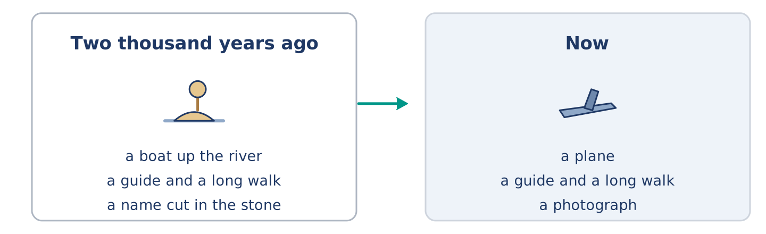
Figure 15.13 · A wall of names, and the people who left them.
Before you read: how old do you think the habit of visiting an old place is?
Gloss: ancient = very, very old · temple = a building people built for a god · visitor = somebody who comes to see a place
In Egypt there are temples with names cut into the stone by visitors, and the names are two thousand years old. Greek and Roman travellers came up the river to look at buildings that were already ancient when they arrived. They paid a guide, they walked round, and then a good many of them wrote their own name on a wall. One of them added that he had seen it and had not thought much of it. The buildings those visitors came to see were older to them than they are to us. Nothing about the trip has changed much either. There is the boat, the guide, the long walk in the heat, and the name on the wall, which we now call a photograph.
Answer the questions. (0. is done.)
- How old are the names cut into the stone? — About two thousand years.
- Who came up the river to look at the buildings?
- What did many of them do on a wall?
- What does the text say we do instead of writing a name?
Part 8: Vocabulary in Context
Match each word with its meaning. One meaning is not needed. Write the letter.
Column A
1. | ancient | ____
2. | temple | ____
3. | visitor | ____
4. | guide | ____
Column B
a) | somebody who shows a place to people and explains it
b) | very, very old
c) | somebody who comes to see a place
d) | a building people built for a god
e) | animals moving a long way together, every year
Part 8: Discussion
Talk with a partner. Use the frames.
Discussion frames: “This is similar to where I live because…” · “This is different from where I live because…” · “I think the most important thing is… because…”
Part 9 · Close to Home — What Nobody at Number 14 Has Done
[PLUS] Plus track · pre-read / decide
Before you read: what has everybody you know done, except you?
Six people have lived at number 14 for years and between them they have done a great deal. There are three things not one of them has done. None of them has ever been to the sea in winter, which Mr Okonkwo says is the only time it is worth going. None of them has eaten in the restaurant at the end of the street. It has been there nine years and all six of them walk past it daily. And none of them has ever been in another one of the six flats, except Yuki’s, on one Saturday in the spring. The restaurant is what bothers Yuki. She has asked twice and both times everybody said yes and nobody picked a day.
Answer the questions. (0. is done.)
- How many things has nobody at number 14 done? — Three.
- When does Mr Okonkwo say the sea is worth going to?
- How long has the restaurant been there?
- What happened both times Yuki asked?
Part 9: Decision Task
Everybody says yes to a plan and nobody picks a day. Should you (a) pick a day yourself, (b) ask once more and then let it go, or (c) go alone? Decide and explain. Use the frame.
Answer frame: “I think I should ___ because ___. Also, ___. This is better than ___ because ___.”
Model — read this first:
I think I should pick a day myself, because a plan with no date is not a plan and everybody knows it. Also, people find it easier to say no to a Thursday than to an idea. This is better than asking once more. Asking again gets another yes, and another yes is what the plan already has too much of. (61 words)
Phrase bank: I think I should… · because… · Also,… · This is better than… · In my opinion…
Part 10 · Review and Can-Do
[CORE + PLUS] · homework / self-study
Part 10: Spiral Review
Complete the review. (0. is done.)
- In another country is abroad.
Word bank: island | exhibition | memory | festival | have been | has never | pain | guard
- Land with water all round it is an ______________________ .
- A room of things put out for people to look at is an ______________________ .
- Something you keep in your head from before is a ______________________ .
- Days of music or food, usually once a year, is a ______________________ .
- I ______________________ to four countries. (experience)
- She ______________________ flown. (not once in her life)
- (from Unit 14) The feeling when part of you hurts is ______________________ .
- (from Unit 13) Somebody whose job is to watch a place is a ______________________ .
Part 10: Can-Do
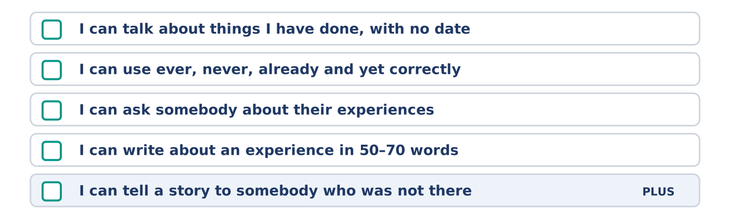
Figure 15.14 · What you can do at the end of this unit.
Can-Do checklist
☐ I can talk about things I have done, with no date.
☐ I can use ever, never, already and yet correctly.
☐ I can ask somebody about their experiences.
☐ I can write about an experience in 50–70 words.
☐ I can tell a story to somebody who was not there (Plus).
Part 10: Glossary
Unit 15 glossary (10 words)
experience · abroad · adventure · camping · festival · exhibition · tour · memory · island · desert
Unit 16: Then and Now
English for Daily Life · Level: A2 · Tracks: [CORE] Warm-Up + Parts 1–6 · [PLUS] Parts 7–10
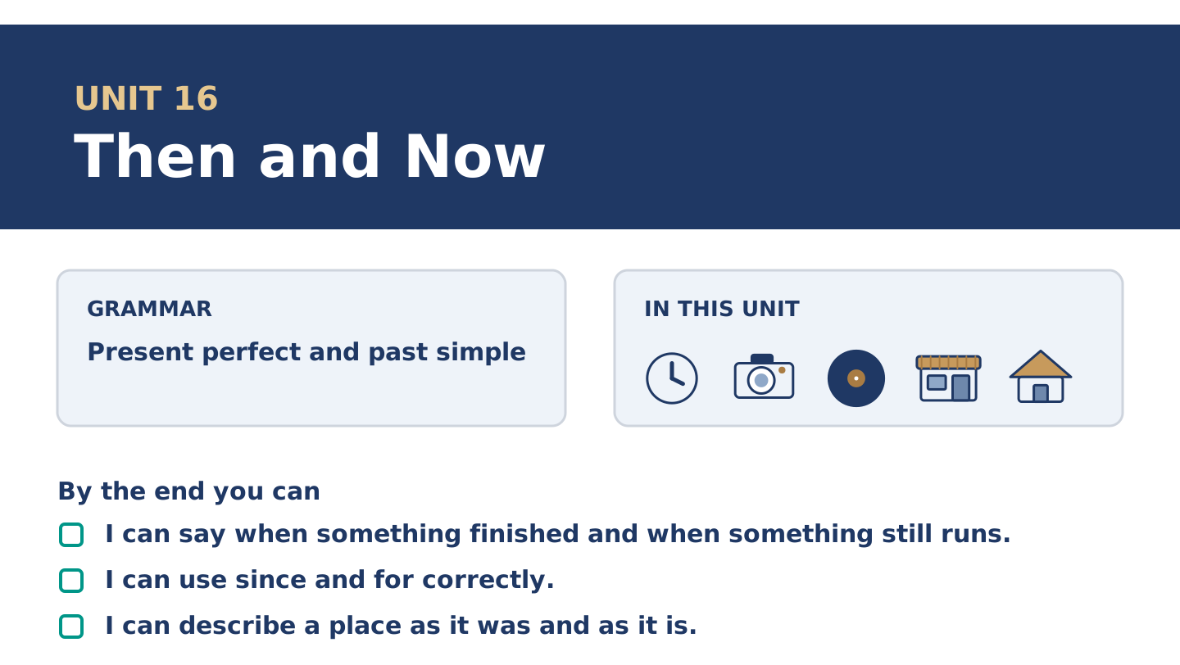
Figure 16.1 · Unit 16 at a glance: the grammar, the topic and what you will be able to do.
Warm Up
[CORE] Core track · in-class starter
Warm-up: Words for Then and Now
Match the words with their meanings. One meaning is not needed. Write the letter.
Column A
1. | Modern | ____
2. | Century | ____
3. | Childhood | ____
4. | Nowadays | ____
5. | Engine | ____
Column B
a) | a hundred years
b) | the part of a machine that makes it move
c) | at the present time, and not before
d) | of the present time, or near it
e) | the years when you were a child
f) | a very dry place where almost nothing grows
Warm-up: Talking About Change
Complete the sentences using the words in the word bank.
Word bank: camera | mobile | computer | record
- Amina has had the same ______________________ since her son bought it for her.
- Mr Okonkwo has never owned a ______________________ and does not feel the loss.
- Maya still has a ______________________ that takes film, and still uses it.
- There is one ______________________ in the shop and nobody plays it.
Warm-up: Six People, Six Changes
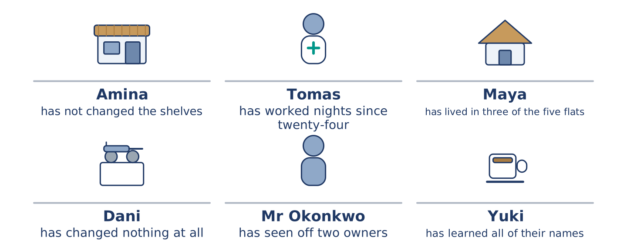
Figure 16.2 · What has changed for each of them, and what has not.
Read the text and choose the correct answer.
Number 14 has changed and the people in it have changed differently. Amina opened the shop eleven years ago and has not changed the shelves since. Tomas started at the hospital at twenty-four and has worked nights ever since. Maya moved in four years ago and has already lived in three of the five flats. Dani came last year and has changed almost nothing, including the light bulb. Mr Okonkwo arrived before any of them and has outlasted two owners. Yuki arrived in March and has learned all of their names.
1. How long has Tomas worked nights?
○ A) Four years
○ B) Since he started at twenty-four
○ C) Eleven years
○ D) Since March
2. What has Maya already done?
○ A) Opened a shop
○ B) Changed the light bulb
○ C) Outlasted two owners
○ D) Lived in three of the five flats
Part 1 · Vocabulary and Terminology
[CORE] Core track · pre-class input
Part 1: Words for Time and Change
Match the words with their meanings. One meaning is not needed. (0. is done for you.)
- Gas → what comes through a pipe and burns, for cooking and for heat.
Column A
1. | Modern | ____
2. | Century | ____
3. | Childhood | ____
4. | Record | ____
5. | Engine | ____
6. | Camera | ____
7. | Nowadays | ____
Column B
a) | a flat black circle that plays music
b) | a hundred years
c) | of the present time, or near it
d) | the thing you take photographs with
e) | the years when you were a child
f) | the part of a machine that makes it move
g) | at the present time, and not before
h) | the doctor who looks after your teeth
Gloss: century = a hundred years · record = a flat black circle that plays music · nowadays = at the present time, and not before · tense = the form of a verb that shows when something happened
Part 1: Pronunciation
🔊 Audio Track 16.1
Listen to the two past forms. Say each pair aloud.
I lived there — one sound at the end: /lɪvd/
I have lived there — the same ending, with have in front
It changed — the -ed is one sound again: /tʃeɪndʒd/
It has changed — and again the ending does not change
Here is the useful part. The word that changes is never the verb; it is the little word in front of it. Learners listen hard at the end of the verb and hear nothing, because there is nothing to hear. You pick the tense two words earlier.
Part 1: Four Things, Then and Now
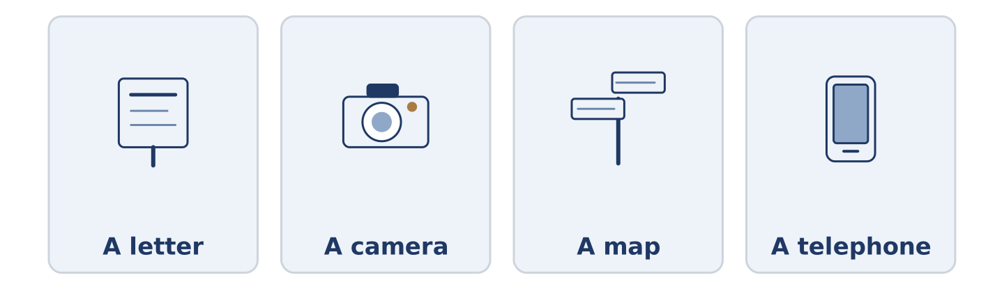
Figure 16.3 · Four things, and what each one became.
Complete the table. Write what it was and what it is now. (0. is done.)
The thing | Then | Now
A letter | days, and a stamp | (example)
A camera
A map
A telephone
- A letter — days, and a stamp — a message that arrives before you put the phone down.
Think about the street you know best. There is more than one right answer.
Part 1: Finished, or Still Going?
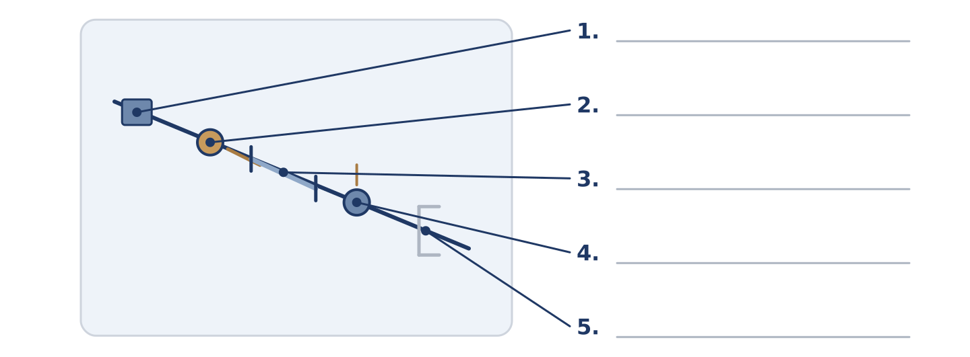
Figure 16.4 · Finished and unfinished time — write the correct word on each line.
Match the time words with what they do. One is not needed. Write the letter.
Column A
1. | in March | ____
2. | since March | ____
3. | for four years | ____
4. | four years ago | ____
5. | this year | ____
Column B
a) | a finished point in the past
b) | a length of time that is still running
c) | a period that has not finished
d) | a starting point, with now at the other end
e) | a finished month
f) | a hundred years
Part 1: Then and Now — Multiple Choice
Read and choose the correct answer.
1. A hundred years is a…
○ A) childhood
○ B) mobile
○ C) century
○ D) engine
2. The part of a machine that makes it move is the…
○ A) engine
○ B) computer
○ C) gas
○ D) camera
3. At the present time, and not before, is…
○ A) modern
○ B) nowadays
○ C) childhood
○ D) already
Part 1: Vocabulary Fill-in
Complete the sentences with the correct word.
Word bank: childhood | modern | gas | engine
- The whole of my ______________________ happened in four streets.
- The building looks ______________________ and is older than the church.
- The ______________________ went off for six hours and the whole street ate bread.
- You can hear the ______________________ from the end of the road, which is how we know he is home.
Part 1: Write About a Change (short)
Write two or three sentences about something that has changed where you live. Use three words from this unit.
Model — read this first:
The market moved in the spring and the square has been quiet ever since. Nowadays there are four tables outside a coffee shop and they are usually empty. I grew up two streets away and I have never got used to it. (42 words)
Part 2 · Grammar — Present Perfect and Past Simple
[CORE] Core track · pre-class input
Part 2: Notice
Read these lines. Underline the verbs. Which have a finished time, and which do not?
Amina opened the shop eleven years ago. She has not changed the shelves since. Tomas started at twenty-four. He has worked nights ever since. The market moved in the spring. It has been quiet ever since.
Three of these name a finished time. Three run from a point in the past up to now.
Part 2: Grammar Focus Box
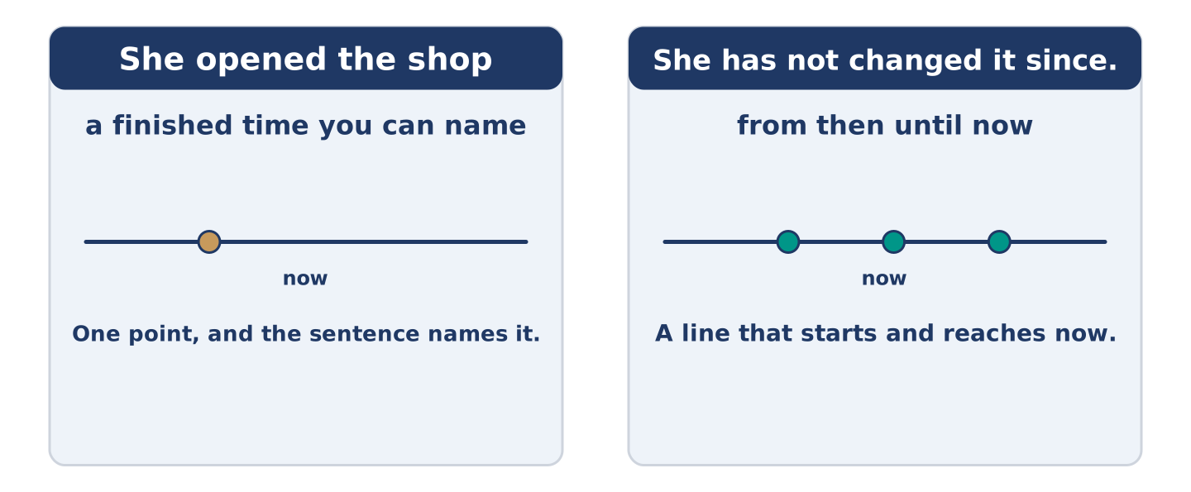
Figure 16.5 · A finished point, and a line that reaches now.
 | Form | Use | Example
past simple | opened, started, moved | a finished time you can name | She opened the shop eleven years ago.
present perfect | has opened, has started | from then until now | She has not changed it since.
since | since + a point | where the line starts | He has worked nights since March.
for | for + a length | how long the line is | He has worked nights for four years.
Remember: since takes a point, for takes a length: since March, for four years.
Watch out! ✗ I have lived here since four years. → ✓ I have lived here for four years. (for takes a length). ✗ She has opened the shop in March. → ✓ She opened the shop in March. (a finished month takes the past simple).
Part 2: Controlled Practice
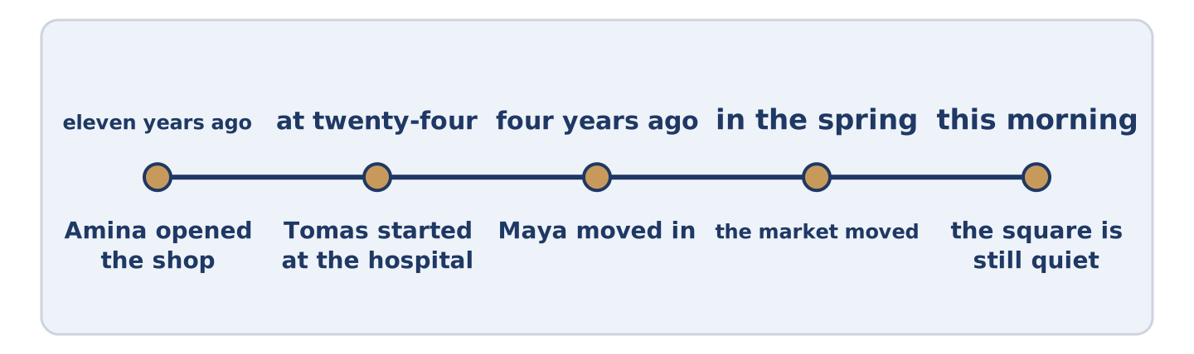
Figure 16.6 · One street, from eleven years ago to this morning.
Complete with the past simple or the present perfect. (0. is done.)
- Amina opened the shop eleven years ago. (open)
- She ______________________ the shelves since. (not change)
- Tomas ______________________ at the hospital at twenty-four. (start)
- He ______________________ nights ever since. (work)
- The market ______________________ in the spring. (move)
Part 2: Finished Time or Up To Now?
Write finished or up to now. (0. is done.)
- She opened the shop eleven years ago. — finished
- She has not changed the shelves since. ____________
- He started at twenty-four. ____________
- He has worked nights for four years. ____________
- The market moved in the spring. ____________
Part 2: Correct the Sentence
Each sentence has one grammar mistake. Write the correct sentence.
- I have lived here since four years.
- She has opened the shop in March.
- He works nights since he was twenty-four.
- The market has moved in the spring.
Part 2: Freer Practice
Write two sentences about your own street: one with a finished time, and one that runs up to now.
Part 2: Grammar Review
Choose the correct sentence.
1. Which sentence uses for correctly?
○ A) I have lived here since four years.
○ B) I live here since four years.
○ C) I have lived here four years ago.
○ D) I have lived here for four years.
2. Which sentence names a finished time?
○ A) She started here in March.
○ B) She has worked here for years.
○ C) She has not changed it since.
○ D) She has worked here since March.
→ Harvest: you will see both tenses again in the Part 5 reading. Watch for the dates.
Part 3 · Listening
[CORE] Core track · pre-class input · scripts printed inline
Part 3: What the Street Used to Be
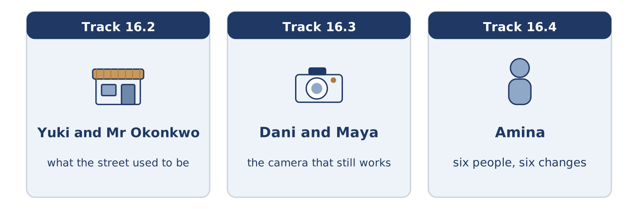
Figure 16.7 · The three listenings: who is speaking, and what about.
🔊 Audio Track 16.2
Before you listen: what was on your street before the thing that is there now?
Yuki: What was here before the coffee shop? Mr Okonkwo: A shoe shop. Before that, a different shoe shop. Yuki: Two shoe shops? That doesn’t sound right. Mr Okonkwo: Alder Street had four at one time, and I have never understood it either. Yuki: And the square? Mr Okonkwo: The market was in the square for ninety years. It moved in the spring, and the square has not been the same since. Yuki: Do you mind? Mr Okonkwo: I have minded for seven months and I have said nothing, which is the local custom.
While you listen: write True, False, or Not Given. (0. is done.)
- There was a shoe shop before the coffee shop. — True
- Alder Street had four shoe shops at one time. ____
- Mr Okonkwo thinks the square is better now. ____
- The market has moved to the car park. ____
Useful phrases: What was here before…? · Before that… · it moved in… · has not been the same since
Part 3: The Camera That Still Works
🔊 Audio Track 16.3
Before you listen: do you keep anything that does the same job worse?
Dani: You still use that? Maya: I have used it since I was fifteen. Dani: It takes film. Maya: It does. There’s still film in the shop on the corner. Dani: You have a mobile. Maya: I have a mobile and I have taken nine thousand photographs on it and I have looked at none of them. Dani: And the camera? Maya: Thirty-six at a time, and I have looked at every one. Dani: That’s an argument. Maya: It took me nine thousand photographs to find it.
Answer the questions. (0. is done.)
- How long has Maya used the camera? — Since she was fifteen.
- How many photographs has she taken on her mobile?
- How many of them has she looked at?
- How many does the camera take at a time?
Part 3: Six People, Six Changes
🔊 Audio Track 16.4
Before you listen: who do you know who has changed least?
Amina: I have watched this street for eleven years and I can tell you who changes. Tomas started at the hospital at twenty-four and has done nights ever since. Maya has been here four years and has lived in three of the five flats. Dani came last year and has changed nothing, including a light bulb that went in June. Mr Okonkwo was here before any of us and has seen off two owners. Yuki arrived in March and has already learned every name.
While you listen: match each person with their change. One is not needed. (0. is done.)
- Amina → she has watched for eleven years.
Useful phrases: ___ has done nights ever since · ___ has lived in three flats · ___ has changed nothing
Column A
1. | Tomas | ____
2. | Maya | ____
3. | Dani | ____
4. | Mr Okonkwo | ____
Column B
a) | has lived in three of the five flats
b) | has changed nothing, including a light bulb
c) | has done nights since he was twenty-four
d) | has seen off two owners
e) | has learned every name in the building
Part 4 · Speaking
[CORE] Core track · in-class output
Part 4: What Has Changed
Work with a partner. Ask and answer these questions.
- What has changed where you live since you arrived?
- What was there before it?
- What has not changed at all, and are you glad?
Useful language: It has changed since… · There used to be… · for ten years · nowadays
Part 4: Find the Difference (pairwork)
Student A and Student B each have a street, then and now. Ask questions and find three differences.
Useful questions: What was there before? · How long has it been there? · Has the market moved? · What has not changed?
Student A — your street: the market moved, the shoe shop closed, the school is the same, there are four coffee shops.
Student B — your street: the market is still there, the shoe shop closed, the school is the same, there is one coffee shop.
Part 4: Describing a Change
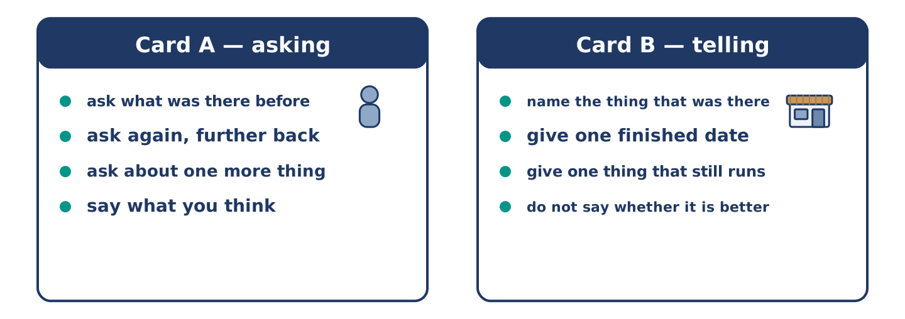
Figure 16.8 · Card A and Card B: what each of you has to say.
Work in pairs. Read the model, then use the cards.
Model exchange:
A: What was here before the coffee shop? — B: A shoe shop. — A: And before that? — B: A different shoe shop. — A: Two? — B: Four, at one time. — A: And the market? — B: It moved in the spring and the square has not been the same since.
Useful language: What was here before…? · And before that? · It moved in… · has not been the same since
Card A — asking: ask what was there before · ask again, further back · ask about one more thing · say what you think.
Card B — telling: name the thing that was there · give one finished date · give one thing that still runs · do not say whether it is better.
Your turn: run the dialogue, then swap roles.
Stretch [PLUS]: the change you are describing was good for you and bad for the person you are talking to — say so honestly.
Part 4: Mini-Presentation
Prepare a short talk (about one minute). Describe your street as it was when you arrived and as it is now.
Part 5 · Reading
[CORE] Core track · pre-class input
Part 5: Why Nothing Feels as Old as the Recent Past
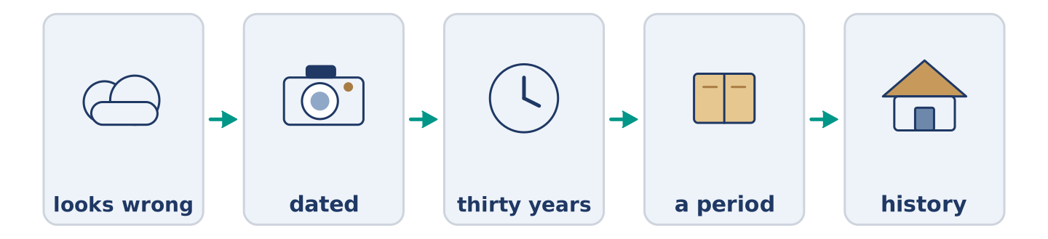
Figure 16.9 · One street, in four pictures.
Before you read: which photograph of your own life looks oldest to you?
Gloss: fashion = what most people wear or like at one time · dated = looking old in a way nobody planned · taste = what a person finds good
A photograph from a hundred years ago looks like history. There is a gas lamp in it, and nobody argues with the lamp. A photograph from twenty years ago looks wrong. The same goes for a ten-year-old computer. This is not about the clothes, or not only. Anything old enough stops arguing with the present and becomes a picture. Anything recent is still close enough to judge against now, and it loses. Anyone who designs things knows this already. A thing looks dated for about thirty years, and then it stops and becomes a period. The same happens to taste, to buildings and to how a street talks about an old shop. Nothing anybody says about a change is honest until the change is older than the person complaining.
Answer the multiple-choice questions. (0. is done.)
- How does a photograph from a hundred years ago look? — Like history.
1. Why does a recent photograph look wrong?
○ A) Because the clothes were worse
○ B) Because the camera was bad
○ C) Because we still judge it against now
○ D) Because nobody kept it
2. How long is a thing dated for?
○ A) Ten years
○ B) About thirty years
○ C) A hundred years
○ D) For ever
3. When does the text say an opinion about a change becomes honest?
○ A) Straight away
○ B) When a newspaper writes about it
○ C) Never
○ D) When the change is older than the person complaining
Part 5: Vocabulary in Context
Match each word from the text with its meaning. One meaning is not needed. Write the letter.
Column A
1. | fashion | ____
2. | dated | ____
3. | taste | ____
4. | period | ____
Column B
a) | a length of time with a character of its own
b) | looking old in a way nobody planned
c) | what a person finds good
d) | what most people wear or like at one time
e) | a hundred years
Part 5: Three Things That Came Back
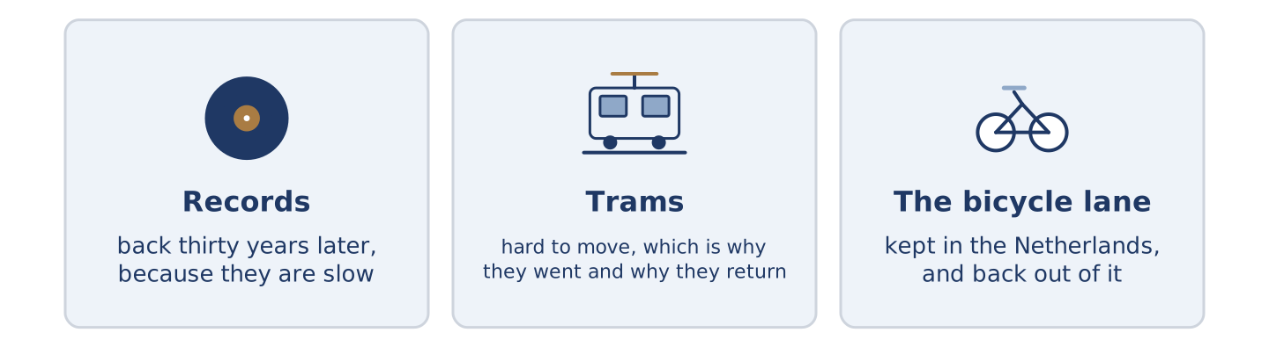
Figure 16.10 · Three things people threw away and then wanted again.
Before you read: has anything you threw away come back into fashion?
Gloss: vinyl = the material old records are made of · tram = a bus on rails in a street · bicycle lane = a part of the road kept for bikes
Some things go away and then return, and the return is never for the first reason. Records went away when the CD arrived. They came back thirty years later, and not because they sound better. They came back because they are slow, and because you have to choose. Trams left the British cities, and several are putting the rails down again. The reason is the old reason turned over: a tram is hard to move. Dutch cities kept the bicycle lane when everybody else tore theirs up. It has travelled back out of the Netherlands to the countries that invented it. Each time, the thing itself did not change. What changed was the problem it answered.
Answer the questions. (0. is done.)
- Is the return always for the first reason? — No, it never is.
- Why did records come back?
- Why are trams being laid again?
- What changed each time?
Part 6 · Writing
[CORE] Core track · in-class / homework
Part 6: A Street, Then and Now (50–70 words)
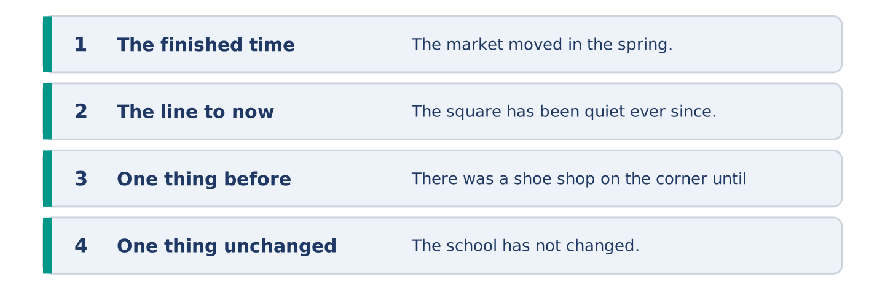
Figure 16.11 · The shape of the piece you are about to write.
Write about a street you know as it was and as it is. Use one finished time and one that runs to now.
Model — read this first:
The market left the square in the spring and the square has been quiet ever since. There was a shoe shop on the corner until ten years ago, and nobody remembers what it was called. The school has not changed. Four coffee shops have opened since I moved here and three have already closed. (54 words)
Plan (fill in, then write): ___ in ___. ___ has ___ ever since. There was ___ until ___. ___ has not changed.
Word bank: has changed | has not changed | since | for | ever since
Check before you finish: ☐ one finished time? ☐ one that runs to now? ☐ one thing unchanged? ☐ 50–70 words?
Part 6: Was Life Better Before? (50–70 words)
Was life better twenty years ago? Give your opinion and two or three reasons.
Model — read this first:
It was not, and most of the ones saying it was are remembering being younger. What has improved is almost everything medical and almost everything about how far a normal person can go. What has got worse is quieter and harder to name: nobody is ever unreachable, and that was a kind of rest. (54 words)
Word bank: I think… because… | has improved | however | in my opinion | it depends on
Check before you finish: ☐ a clear opinion? ☐ two or three reasons? ☐ 50–70 words?
Part 6: Something That Has Not Changed (50–70 words)
Write about one thing that has not changed in your life. Say why you think it has lasted.
Model — read this first:
I have had the same walk for nine years, past the same gate and the same three trees. Everything round it has changed twice. The walk has lasted because nobody has ever had a reason to touch it. That is the only way anything survives — not out of love, but by being in nobody’s way. (56 words)
Plan (fill in, then write): I have had ___ for ___. ___ has changed ___. It has lasted because ___.
Check before you finish: ☐ what has not changed? ☐ how long? ☐ why it has lasted? ☐ 50–70 words?
Part 6: Reflection — A Photograph of Myself (40–60 words)
Write about a photograph of yourself from years ago and what it shows.
Model — read this first:
There is a photograph of me at nineteen in a coat I was proud of. I have looked at it about twice in ten years, and it has gone from fine, to too awful to look at, to interesting. Nothing in the photograph has changed. I have stopped being close enough to it to mind. (55 words)
Check before you finish: ☐ what the photograph shows? ☐ how it has changed for you? ☐ why? ☐ 40–60 words?
Part 7 · Real-World File — Talking About How Things Were
[PLUS] Plus track (optional) · stronger learners
7A: Phrase Bank
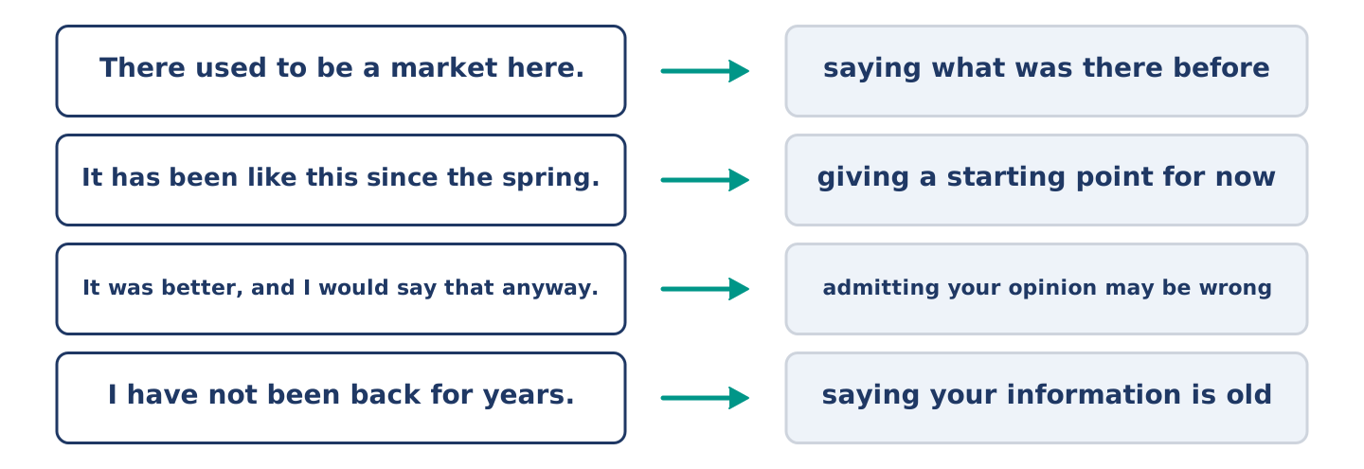
Figure 16.12 · What people say about change, and what each line does.
Match what a person says with its purpose. One purpose is not needed. Write the letter.
Column A
1. | “There used to be a market here.” | ____
2. | “It has been like this since the spring.” | ____
3. | “It was better, and I would say that anyway.” | ____
4. | “I have not been back for years.” | ____
Column B
a) | admitting your opinion may be wrong
b) | giving a starting point for now
c) | how much it will cost
d) | saying what was there before
e) | saying your information is old
7B: The Shop That Everybody Remembers Differently
🔊 Audio Track 16.5
Before you read: do two people ever remember the same shop the same way?
Amina: It was a bread shop. Mr Okonkwo: It was never a bread shop. It sold bread for two years and it was a tool shop for twenty. Amina: I have lived here eleven years and it was a bread shop the whole time. Mr Okonkwo: You came in the last two years of it. Amina: Ah. I didn’t know that. Mr Okonkwo: Everybody remembers the end of a shop, because the end is the part they were there for. Amina: So the bread shop is the end of a tool shop. Mr Okonkwo: The bread shop is the end of a tool shop.
Answer the questions. (0. is done.)
- What does Amina remember the shop as? — A bread shop.
- What does Mr Okonkwo say it was for twenty years?
- How long has Amina lived there?
- What does Mr Okonkwo say everybody remembers?
7C: Controlled Practice — Describing a Change Fairly
Put the steps in order. Number them 1–5. (0. is done.)
- Say what is there now. — 1
____ Say how long you have been watching.
____ Say what was there before.
____ Say what you think, and that you would think it anyway.
____ Say when it changed.
7D: Role-Play — Two People, One Street
In pairs. One has been there longer than the other. Use the model and cards.
Model exchange: A: It was a bread shop. — B: It was never a bread shop. — A: I have lived here eleven years. — B: You came in the last two years of it. — A: Ah. — B: Everybody remembers the end of a shop. — A: Because that is the part they were there for.
Card A — the newer one: say what you remember · say how long you have been here · hear the correction · agree out loud.
Card B — the older one: correct the fact, not the person · give the longer stretch · explain why they remember it that way · do not win.
Stretch [PLUS]: you have been there longest and you are the one who is wrong — notice it in the middle of the conversation.
7E: Writing — A Note for Somebody Who Has Been Away (50–80 words)
Somebody is coming back after ten years away. Write them a note about what has changed.
Model — read this first:
The market has gone; it moved to the car park in the spring and the square is empty now. The shoe shop closed ten years ago and is a coffee shop, and so are two things you remember. The school has not changed and neither has the bus number. Amina is still in the shop and will know you. Nothing you need has moved. (64 words)
Check before you finish: ☐ two things that have changed? ☐ one finished date? ☐ one thing that has not changed? ☐ 50–80 words?
Part 8 · Global Story — The City That Was Rebuilt From Paintings
[PLUS] Plus track · pre-read / discuss
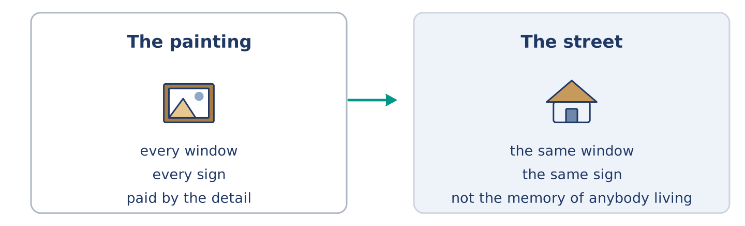
Figure 16.13 · A painting on a wall, and a street built to match it.
Before you read: could you rebuild a street from pictures of it?
Gloss: rebuild = to build again, after something is gone · detail = one small part of something · painting = a picture somebody made with paint
The old centre of Warsaw, in Poland, looks several hundred years old and is not. The war took almost all of it. After the war the country decided to put it back. They used photographs, drawings and a set of paintings of the city from a century and a half earlier. A man from Italy had painted them, and he had put in every window and every sign. He had his own reason for all that care: the city paid him by the detail. The men and women rebuilding the city followed his paintings closely. Where a later owner had changed something, they went back to the painting and not to the memory of anybody living. People have argued about the result ever since, and it is on the world list of places to keep. Both facts are fair.
Answer the questions. (0. is done.)
- How old does the old centre of Warsaw look? — Several hundred years old.
- What three things did they use to put Warsaw back?
- Why had the man from Italy put in every window?
- What did they do where a later owner had changed something?
Part 8: Vocabulary in Context
Match each word with its meaning. One meaning is not needed. Write the letter.
Column A
1. | rebuild | ____
2. | detail | ____
3. | painting | ____
4. | centre | ____
Column B
a) | the middle part of a city
b) | one small part of something
c) | to build again, after something is gone
d) | a picture somebody made with paint
e) | a bus on rails in a street
Part 8: Discussion
Talk with a partner. Use the frames.
Discussion frames: “This is similar to where I live because…” · “This is different from where I live because…” · “I think the most important thing is… because…”
Part 9 · Close to Home — The Shop That Was Four Shops
[PLUS] Plus track · pre-read / decide
Before you read: how long does a place have to be something before it is that thing?
The corner at the end of Alder Street has been four things in thirty years and everybody at number 14 names a different one. Mr Okonkwo says tools, because it was tools for twenty of those years and he bought a hinge there in his first week. Amina says bread shop. It was a bread shop for the two years before she opened her own shop, and she went in every morning. Maya says it has always been the phone shop. Dani has never thought about it at all. Yuki has been here least of all. She asked all five. She now knows more about that corner than anybody except Mr Okonkwo, and he still has the hinge.
Answer the questions. (0. is done.)
- How many things has the corner been in thirty years? — Four.
- Why does Mr Okonkwo say tools?
- Why does Amina say bread shop?
- What did Yuki do?
Part 9: Decision Task
A place you know is about to change and you cannot stop it. Should you (a) write down what it was, (b) say nothing and let it go, or (c) tell everybody who will listen? Decide and explain. Use the frame.
Answer frame: “I think I should ___ because ___. Also, ___. This is better than ___ because ___.”
Model — read this first:
I think I should write down what it was, because memory is the only part of this I can actually keep. Also, in ten years somebody will ask and five people will say five different things. This is better than telling everybody, because somebody about to lose something does not want a speech about it. (55 words)
Phrase bank: I think I should… · because… · Also,… · This is better than… · In my opinion…
Part 10 · Review and Can-Do
[CORE + PLUS] · homework / self-study
Part 10: Spiral Review
Complete the review. (0. is done.)
- A hundred years is a century.
Word bank: modern | childhood | nowadays | engine | opened | has not changed | abroad | pain
- Of the present time, or near it, is ______________________ .
- The years when you were a child are your ______________________ .
- At the present time, and not before, is ______________________ .
- The part of a machine that makes it move is the ______________________ .
- Amina ______________________ the shop eleven years ago. (finished)
- She ______________________ the shelves since. (up to now)
- (from Unit 15) In another country is ______________________ .
- (from Unit 14) The feeling when part of you hurts is ______________________ .
Part 10: Can-Do
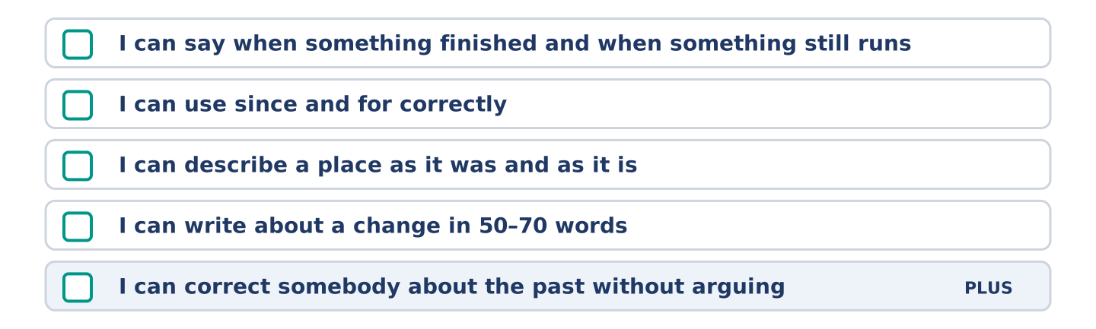
Figure 16.14 · What you can do at the end of this unit.
Can-Do checklist
☐ I can say when something finished and when something still runs.
☐ I can use since and for correctly.
☐ I can describe a place as it was and as it is.
☐ I can write about a change in 50–70 words.
☐ I can correct somebody about the past without arguing (Plus).
Part 10: Glossary
Unit 16 glossary (10 words)
modern · century · childhood · nowadays · camera · record · engine · gas · computer · mobile
Unit 17: How Things Are Made
English for Daily Life · Level: A2 · Tracks: [CORE] Warm-Up + Parts 1–6 · [PLUS] Parts 7–10
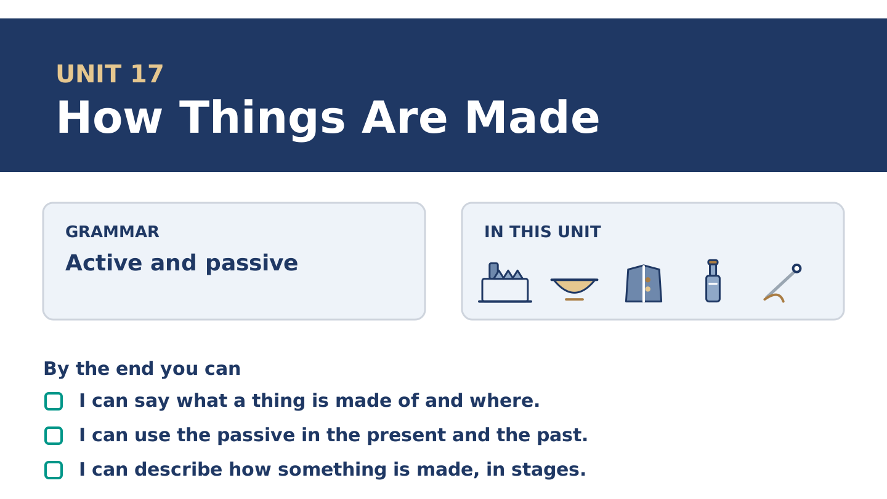
Figure 17.1 · Unit 17 at a glance: the grammar, the topic and what you will be able to do.
Warm Up
[CORE] Core track · in-class starter
Warm-up: Words for Making Things
Match the words with their meanings. One meaning is not needed. Write the letter.
Column A
1. | Factory | ____
2. | Material | ____
3. | Metal | ____
4. | Plastic | ____
5. | Wool | ____
Column B
a) | what a thing is made of
b) | iron, gold or steel
c) | a light material made from oil
d) | a building where things are made in large numbers
e) | the hair of a sheep, turned into cloth
f) | a room where food is kept cold
Warm-up: Talking About Making
Complete the sentences using the words in the word bank.
Word bank: factory | material | metal | wool
- Yuki wants to know what the bowl is made of, and nobody can name the ______________________ .
- Mr Okonkwo’s coat is lined with ______________________ and is warmer than anything newer.
- The buttons are ______________________ , and two of them do not match.
- Everything in Amina’s shop was made in a ______________________ somewhere.
Warm-up: Six People, Six Things
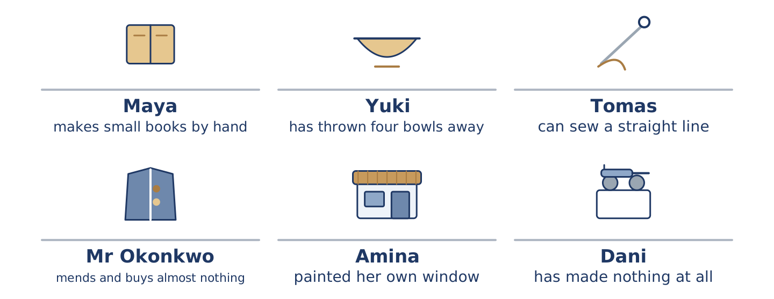
Figure 17.2 · What each of them makes, mends or throws away.
Read the text and choose the correct answer.
Everything at number 14 was made by somebody. Two of them are still making. Maya makes small books by hand, one at a time, and sells about four a year. Yuki is learning to make a bowl and has thrown the first four away. Tomas can sew a straight line, because the work taught him. Mr Okonkwo’s coat has been relined twice and the buttons were changed. Amina painted GREEN SHOP across her own window. Dani has made nothing and has eaten a great deal.
1. What does Maya make?
○ A) Bowls
○ B) Cloth
○ C) Small books by hand
○ D) Buttons
2. Whose coat has been relined twice?
○ A) Mr Okonkwo’s
○ B) Tomas’s
○ C) Yuki’s
○ D) Dani’s
Part 1 · Vocabulary and Terminology
[CORE] Core track · pre-class input
Part 1: Words for Materials
Match the words with their meanings. One meaning is not needed. (0. is done for you.)
- Glass → the hard clear material windows and bottles are made of.
Column A
1. | Factory | ____
2. | Material | ____
3. | Metal | ____
4. | Plastic | ____
5. | Wool | ____
6. | Recycle | ____
7. | Waste | ____
Column B
a) | a light material made from oil
b) | what is thrown away after a thing is used
c) | the hair of a sheep, turned into cloth
d) | iron, gold or steel
e) | a building where things are made in large numbers
f) | to use a material again instead of throwing it away
g) | what a thing is made of
h) | a small shop that sells bread
Gloss: produce = to make something in large numbers · cloth = material for clothes, made from wool or cotton · waste = what is thrown away after a thing is used · mend = to fix a thing instead of buying a new one · passive = the form that puts the thing first and leaves the maker out
Part 1: Pronunciation
🔊 Audio Track 17.1
Listen to the two forms. Say each pair aloud.
Somebody makes it — the verb carries the weight: /meɪks/
It is made — is almost disappears: /ɪts ˈmeɪd/
They changed the buttons — changed is one sound at the end
The buttons were changed — were goes to a schwa: /wə ˈtʃeɪndʒd/
So here is the trap. The little word is the whole grammar and it is the quietest part of the line. Learners hear it made and write it made. Then they produce the bowl made in Japan and wonder why it is wrong. Listen for the small word before the verb, not for the verb.
Part 1: Four Things and What They Are Made Of
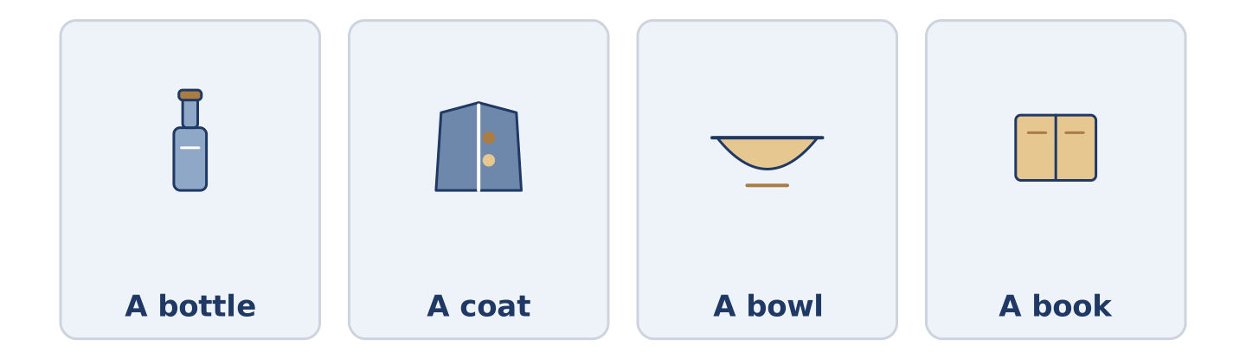
Figure 17.3 · Four things, and the material each one is made of.
Complete the table. Write the material and where it is made. (0. is done.)
The thing | Made of | Made where
A bottle | glass | (example)
A coat
A bowl
A book
- A bottle — glass — in a factory, and then again in another one.
Think about four things in the room you are in now.
Part 1: Who Did It, or Just What Happened?
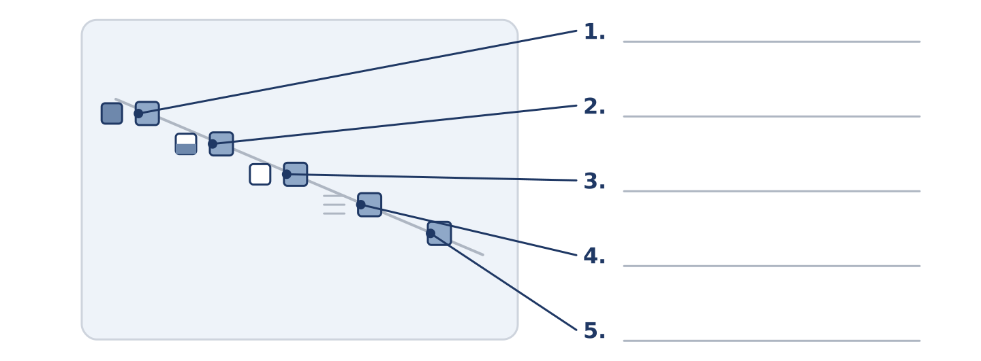
Figure 17.4 · Active and passive — write the correct form on each line.
Match each line with what it does. One purpose is not needed. Write the letter.
Column A
1. | Maya made this book. | ____
2. | This book was made by hand. | ____
3. | Somebody broke the window. | ____
4. | The window was broken. | ____
5. | The bowl is made of clay. | ____
Column B
a) | the maker matters, so the maker goes first
b) | how it was made matters, and the maker does not
c) | we know somebody did it, and we are not saying who
d) | nobody knows who, and nobody is asking
e) | the material is the point
f) | how much the thing cost
Part 1: Materials — Multiple Choice
Read and choose the correct answer.
1. The hair of a sheep is…
○ A) metal
○ B) plastic
○ C) glass
○ D) wool
2. A building where things are made in large numbers is a…
○ A) bowl
○ B) factory
○ C) material
○ D) waste
3. To use a material again instead of throwing it away is to…
○ A) produce
○ B) waste
○ C) recycle
○ D) sew
Part 1: Vocabulary Fill-in
Complete the sentences with the correct word.
Word bank: cloth | produce | glass | recycle
- The coat is lined with a ______________________ nobody makes any more.
- One factory can ______________________ forty thousand bowls in a week.
- Amina keeps the bottles behind the till, because the ______________________ is worth something.
- Everything in this bin can be used again, so please ______________________ it.
Part 1: Write About Something Made (short)
Write two or three sentences about something near you and how it was made. Use three words from this unit.
Model — read this first:
This cup was made in a factory and about a million others were made with it. The handle was put on by a machine. Somewhere there is one with a bad handle, and it was thrown away, and nobody minded. (40 words)
Part 2 · Grammar — Active and Passive
[CORE] Core track · pre-class input
Part 2: Notice
Read these lines. Underline the verbs. Which ones name the maker, and which ones do not?
Maya made this book. This book was made by hand. Somebody changed the buttons. The buttons were changed. One factory produces forty thousand bowls. Forty thousand bowls are produced in one factory.
Three of these put the maker first. Three put the thing first and leave the maker out.
Part 2: Grammar Focus Box
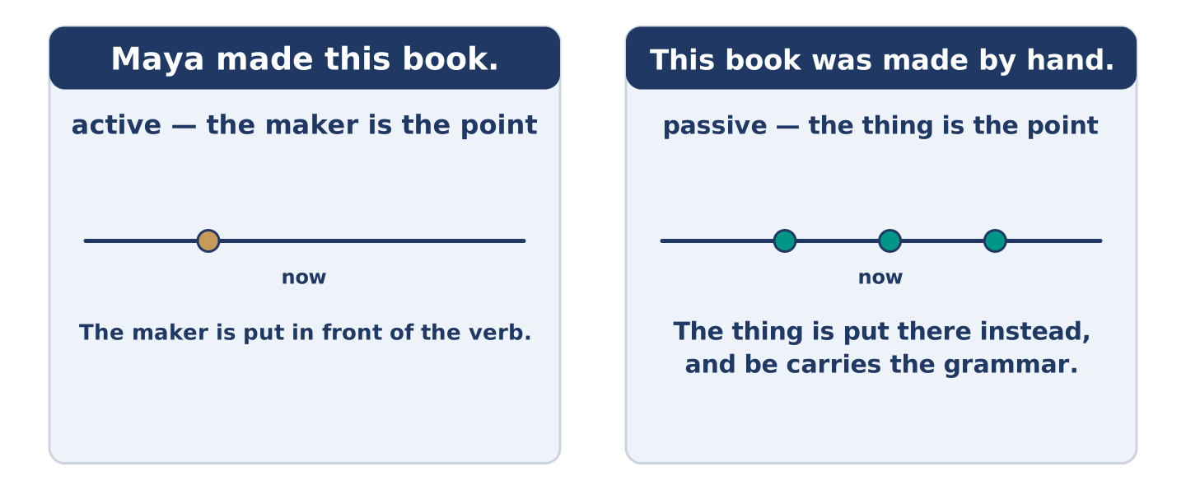
Figure 17.5 · The thing moves to the front, and the maker becomes optional.
 | Form | Use | Example
active | makes, made, produces | the maker is the point | Maya made this book.
passive | is made, was made, are produced | the thing is the point | This book was made by hand.
be + 3rd form | is / was / are / were + made | the form never changes | The buttons were changed.
by + maker | was made by Maya | only when the maker is news | This one was made by Maya.
Remember: the passive is be plus the third form. The third form never changes: made, broken, put, sold.
Watch out! ✗ This book was make by hand. → ✓ This book was made by hand. (the third form, not the first). ✗ The bowl made in a factory. → ✓ The bowl was made in a factory. (be is not optional).
Part 2: Controlled Practice
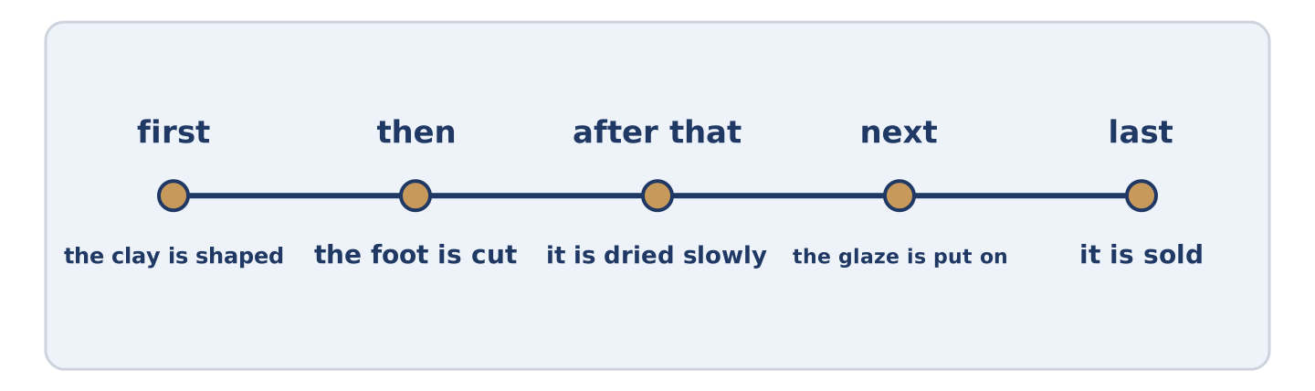
Figure 17.6 · One cup, from the clay to the shelf.
Complete with the active or the passive. (0. is done.)
- Maya made this book by hand. (make)
- The buttons ______________________ twice. (change)
- Forty thousand bowls ______________________ in one week. (produce)
- Somebody ______________________ the window last winter. (break)
- The coat ______________________ with wool. (line)
Part 2: Active or Passive?
Write active or passive. (0. is done.)
- Maya made this book. — active
- This book was made by hand. ____________
- One factory produces forty thousand bowls. ____________
- The buttons were changed twice. ____________
- Somebody broke the window. ____________
Part 2: Correct the Sentence
Each sentence has one grammar mistake. Write the correct sentence.
- This book was make by hand.
- The bowl made in a factory.
- Forty thousand bowls is produced every week.
- The window was broke last winter.
Part 2: Freer Practice
Write two sentences about one thing in your home: one active, one passive.
Part 2: Grammar Review
Choose the correct sentence.
1. Which sentence is a correct passive?
○ A) The buttons were changed last year.
○ B) The buttons was changed last year.
○ C) The buttons changed by somebody last year.
○ D) The buttons were change last year.
2. Which sentence leaves the maker out on purpose?
○ A) Maya made this book by hand.
○ B) This book was made by hand.
○ C) Maya makes four books a year.
○ D) Yuki is learning to make a bowl.
→ Harvest: you will meet the passive again in the Part 5 reading. Count how many makers it names.
Part 3 · Listening
[CORE] Core track · pre-class input · scripts printed inline
Part 3: The Four Bowls That Were Thrown Away
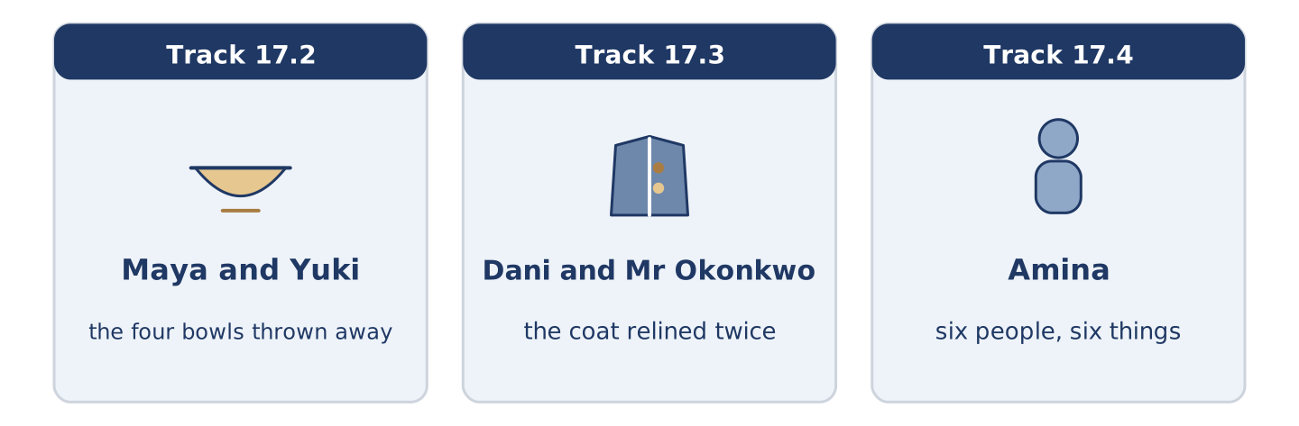
Figure 17.7 · The three listenings: who is speaking, and what about.
🔊 Audio Track 17.2
Before you listen: have you ever thrown away something you made?
Maya: Where are the other bowls? Yuki: They were thrown away. Maya: All four? Yuki: All four. Maya: What was wrong with them? Yuki: Nothing was wrong with the first one. It was thrown away because I could see how it was made. Maya: That isn’t a fault. Yuki: It is in a bowl. Maya: So the new one hides it. Yuki: The new one isn’t finished.
While you listen: write True, False, or Not Given. (0. is done.)
- Four bowls were thrown away. — True
- Yuki could see how the first bowl was made. ____
- The new bowl is finished. ____
- Yuki was taught by somebody at the college. ____
Useful phrases: it was thrown away · nothing was wrong with it · you can see how it was made
Part 3: The Coat That Was Relined Twice
🔊 Audio Track 17.3
Before you listen: how old is the oldest thing you own?
Dani: How old is that coat? Mr Okonkwo: Older than you. Dani: It doesn’t look it. Mr Okonkwo: It has been relined twice and the buttons were changed. Dani: So most of it is new. Mr Okonkwo: None of it is new. It was all made before either of us. Dani: Where was it made? Mr Okonkwo: Here. There was a factory where the station is now.
Answer the questions. (0. is done.)
- How old is the coat? — Older than Dani.
- How many times has the coat been relined?
- What was changed?
- Where was the coat made?
Part 3: Six People, Six Things
🔊 Audio Track 17.4
Before you listen: who do you know who mends things?
Amina: I can tell you who in this building makes and who buys. Maya makes books by hand and gives most of them away. Yuki is learning to make a bowl and has thrown four away. Tomas sews, because the hospital taught him and the hospital is strict about it. Mr Okonkwo mends and has bought almost nothing in forty years. Dani has made one meal for eight people, badly.
While you listen: match each person with what they make. One is not needed. (0. is done.)
- Amina → she knows who makes and who buys.
Useful phrases: ___ makes ___ by hand · ___ is learning to make ___ · ___ mends ___
Column A
1. | Maya | ____
2. | Yuki | ____
3. | Tomas | ____
4. | Mr Okonkwo | ____
Column B
a) | is learning to make a bowl
b) | mends and buys almost nothing
c) | makes small books by hand
d) | sews, because the hospital taught him
e) | cooked one meal for eight people
Part 4 · Speaking
[CORE] Core track · in-class output
Part 4: How It Is Made
Work with a partner. Ask and answer these questions.
- What is the oldest thing you own, and where was it made?
- What in your home was made by hand?
- What do you mend, and what do you throw away?
Useful language: It was made in… · It is made of… · by hand · it was thrown away
Part 4: Find the Difference (pairwork)
Student A and Student B each have a workshop. Ask questions and find three differences.
Useful questions: What is it made of? · Where was it made? · Was it made by hand? · How many are produced?
Student A — your workshop: the bowls are made by hand, the cloth is bought in, four people work there, nothing is thrown away.
Student B — your workshop: the bowls are made by hand, the cloth is made there, twelve people work there, nothing is thrown away.
Part 4: Describing How Something Is Made
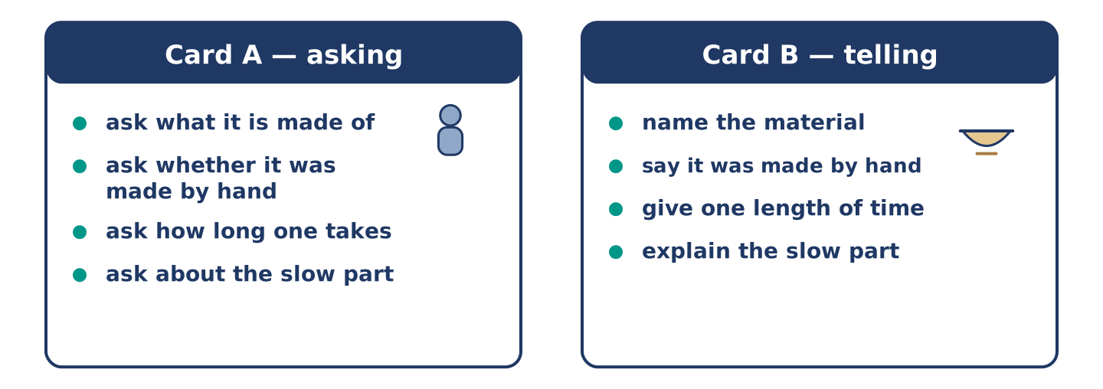
Figure 17.8 · Card A and Card B: what each of you has to say.
Work in pairs. Read the model, then use the cards.
Model exchange:
A: What is it made of? — B: Clay. — A: And it was made by hand? — B: All of it. — A: How long does one take? — B: Three days, and most of that is waiting. — A: Waiting for what? — B: It is dried slowly, or it breaks.
Useful language: What is it made of? · it was made by hand · it is dried slowly · or it breaks
Card A — asking: ask what it is made of · ask whether it was made by hand · ask how long one takes · ask about the slow part.
Card B — telling: name the material · say it was made by hand · give one length of time · explain the slow part.
Your turn: run the dialogue, then swap roles.
Stretch [PLUS]: the thing you are describing was made badly and you made it — say so without apologising twice.
Part 4: Mini-Presentation
Prepare a short talk (about one minute). Describe one thing you own and how it was made.
Part 5 · Reading
[CORE] Core track · pre-class input
Part 5: Why Nobody Knows Who Made Anything
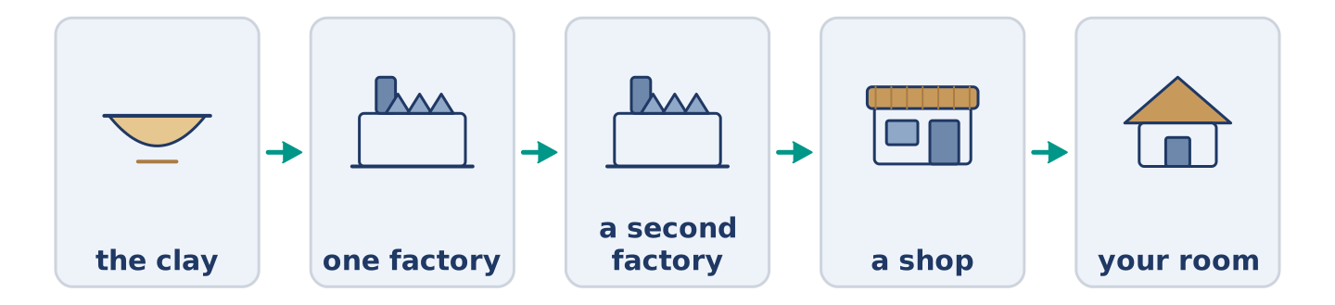
Figure 17.9 · One cup, in five stages.
Before you read: can you name one person who made one thing you own?
Gloss: machine = a thing with moving parts that does work · stage = one step in a long job · hand-made = made by a person and not by a machine
Count the things in your room. Now name the maker of one of them. Most people cannot name one, and this is new. Two hundred years ago almost everything was made within a short walk of where it was used. The maker was somebody you could complain to. Now a cup is made in stages, in two countries, and no single person has held all of it. This is why the passive became so useful. English needed a way to talk about a thing when there is nobody to put in front of the verb. The grammar followed the machines. And it works the other way too: a thing sold as hand-made is sold on the maker, not on the cup.
Answer the multiple-choice questions. (0. is done.)
- Can most people name a person who made something in their room? — No.
1. Why can nobody name the maker of a cup?
○ A) Because the maker is famous
○ B) Because nobody asks
○ C) Because the cup is cheap
○ D) Because it is made in stages, in two countries
2. What does the text say the grammar followed?
○ A) The dictionary
○ B) The school
○ C) The machines
○ D) The newspaper
3. What is a hand-made thing sold on?
○ A) The maker
○ B) The price
○ C) The material
○ D) The weight
Part 5: Vocabulary in Context
Match each word from the text with its meaning. One meaning is not needed. Write the letter.
Column A
1. | machine | ____
2. | stage | ____
3. | hand-made | ____
4. | produce | ____
Column B
a) | to make something in large numbers
b) | one step in a long job
c) | a thing with moving parts that does work
d) | made by a person and not by a machine
e) | the hair of a sheep
Part 5: Three Things That Are Made Twice
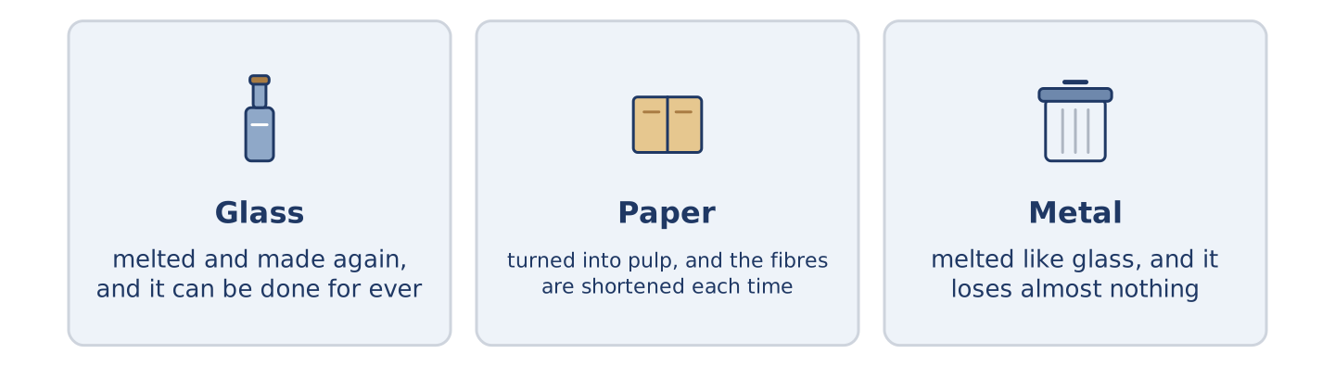
Figure 17.10 · Three materials, and what each one becomes next.
Before you read: what do you throw away that could be used again?
Gloss: melt = to turn a solid into a liquid with heat · pulp = wet paper broken up to be made into paper again · ore = the rock metal is taken out of · aluminium = a light grey metal, used for cans and pans · fibre = one of the tiny threads a material is made of
Three materials are made twice, and each one loses something the second time. Glass is melted and made again, and it can be done for ever, because melting takes nothing out of it. Paper is turned into pulp and made again. The fibres are shortened each time, so after six or seven turns it is only good for boxes. Metal is the strange one. It is melted like glass and loses almost nothing. The saving is enormous: recycled aluminium takes about a twentieth of the power needed to make it from ore. So the material it is most worth recycling is the one people throw away without looking.
Answer the questions. (0. is done.)
- How many of the three materials lose something? — All three, but metal almost nothing.
- Why can glass be made again for ever?
- What happens to paper each time it is made again?
- How much power does recycled aluminium take?
Part 6 · Writing
[CORE] Core track · in-class / homework
Part 6: How Something Is Made (50–70 words)
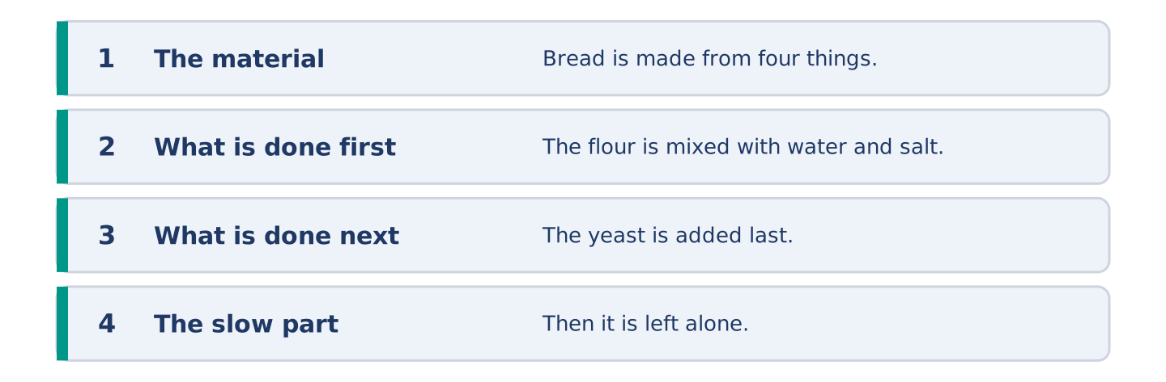
Figure 17.11 · The shape of the piece you are about to write.
Write about how one thing is made. Use the passive at least twice.
Model — read this first:
Bread is made from four things and three of them are free. The flour is mixed with water and salt, and the yeast is added last. Then it is left alone, and nobody ever waits long enough. It is baked for half an hour. Bad bread is almost always bread somebody hurried, and nobody is ever told that. (58 words)
Plan (fill in, then write): ___ is made from ___. The ___ is ___ with ___. Then it is ___. ___ is ___ for ___.
Word bank: is made | is mixed | is added | is left | is baked
Check before you finish: ☐ the passive at least twice? ☐ the stages in order? ☐ one material named? ☐ 50–70 words?
Part 6: Should Things Be Made to Last? (50–70 words)
Should things be made to last? Give your opinion and two or three reasons.
Model — read this first:
They should, and almost nothing is. A washing machine is now built to run for about seven years, and the old ones ran for twenty. The answer people give is that the new ones are cheap. They are, and you buy three. What is really being sold is the feeling of a new one, three times. (56 words)
Word bank: I think… because… | is built to | however | in my opinion | it depends on
Check before you finish: ☐ a clear opinion? ☐ two or three reasons? ☐ 50–70 words?
Part 6: Something You Have Made or Mended (50–70 words)
Write about one thing you have made or mended. Say how it was done.
Model — read this first:
I have mended one chair, badly, and I sit on it every day. The leg was glued and then it was screwed, in that order, which is the wrong order. It holds. It is not straight and it never will be. I like that chair better than the three good ones. (51 words)
Plan (fill in, then write): I have ___ one ___. The ___ was ___ and then it was ___. It ___.
Check before you finish: ☐ what you made or mended? ☐ how it was done? ☐ how you feel about it? ☐ 50–70 words?
Part 6: Reflection — A Thing You Threw Away (40–60 words)
Write about something you threw away and later wanted.
Model — read this first:
A wooden box was thrown out when I moved, because it was heavy and held nothing. I have wanted it about once a year since. Nothing in it mattered. It was the only thing in my flat older than my grandmother, and I threw it away for weighing too much. (50 words)
Check before you finish: ☐ what it was? ☐ why it was thrown away? ☐ why you wanted it? ☐ 40–60 words?
Part 7 · Real-World File — Talking About How Things Are Made
[PLUS] Plus track (optional) · stronger learners
7A: Phrase Bank
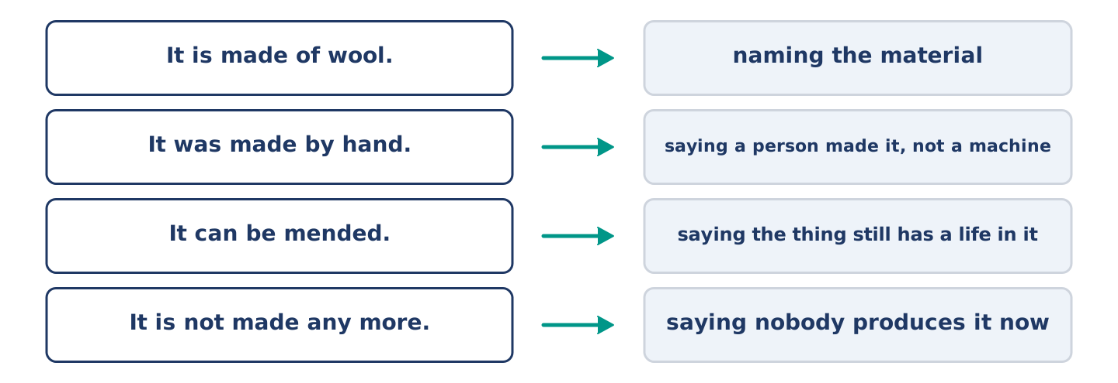
Figure 17.12 · What people say about how a thing was made, and what each line does.
Match what a person says with its purpose. One purpose is not needed. Write the letter.
Column A
1. | “It is made of wool.” | ____
2. | “It was made by hand.” | ____
3. | “It can be mended.” | ____
4. | “It is not made any more.” | ____
Column B
a) | saying the thing still has a life in it
b) | naming the material
c) | how much it will cost
d) | saying nobody produces it now
e) | saying a person made it, not a machine
7B: The Thing That Cannot Be Mended
🔊 Audio Track 17.5
Before you read: has anybody ever told you a thing was not worth mending?
Yuki: Can it be mended? Mr Okonkwo: It can be opened. Yuki: That isn’t the same answer. Mr Okonkwo: No. It is glued shut, so it is opened once and then it is finished. Yuki: Why is it made like that? Mr Okonkwo: Because a thing nobody can open is cheaper to produce. Yuki: And when it breaks? Mr Okonkwo: Another one is produced.
Answer the questions. (0. is done.)
- Can the thing be mended? — No, it can only be opened once.
- What has been done to the thing instead of screwing it?
- Why is it made like that?
- What happens when it breaks?
7C: Controlled Practice — Explaining How a Thing Is Made
Put the steps in order. Number them 1–5. (0. is done.)
- Name the material. — 1
____ Say what is done last.
____ Say where it is made.
____ Say what is done first.
____ Say which stage goes wrong.
7D: Role-Play — One Thing, Two Prices
In pairs. One is selling a hand-made thing. Use the model and cards.
Model exchange: A: Why is this one four times the price? — B: It was made by hand. — A: They look the same. — B: They are not the same inside. — A: Show me. — B: Turn it over. — A: Ah. — B: That part is done by a person, and it takes an hour.
Card A — the buyer: ask about the price · say they look the same · ask to be shown · agree out loud when you are shown.
Card B — the seller: name how it was made · do not say the other one is bad · show one thing · give one length of time.
Stretch [PLUS]: you are selling it and you are not sure it is worth four times the price — be honest and sell it anyway.
7E: Writing — A Note About a Thing Being Mended (50–80 words)
Something of yours is being mended and somebody needs to know. Write them a note.
Model — read this first:
The washing machine has gone to be mended, so everything is in the bath instead. It was taken on Tuesday and it is promised back on Friday. The part is no longer produced and one is being made for it, which is why it costs more than a new machine. I know. I want this one. (56 words)
Check before you finish: ☐ what is being mended? ☐ one date? ☐ why it costs what it costs? ☐ 50–80 words?
Part 8 · Global Story — The City That Drinks Its Own Water Twice
[PLUS] Plus track · pre-read / discuss
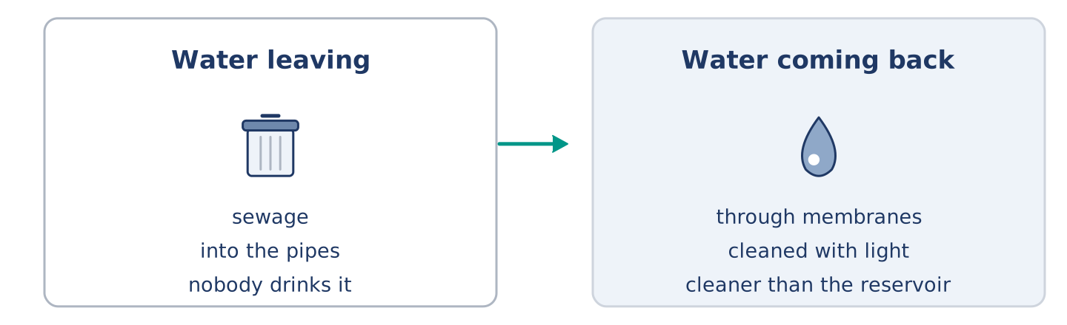
Figure 17.13 · Water leaving a city and the same water coming back.
Before you read: would you drink water that had been used before?
Gloss: sewage = the dirty water that leaves a city through pipes · membrane = a very thin sheet with holes too small to see · reservoir = a lake kept for a city’s water
Singapore has almost no land and no river worth the name, and for years most of its water was bought from Malaysia. So the used water is now taken back. Sewage is carried to a plant, pushed through membranes with holes a bacterium cannot pass, and cleaned again with light. What comes out is cleaner than the water in the reservoir. It is called NEWater, and about two-fifths of the island’s water is now produced this way. Most of it is sold to factories, which need water cleaner than people do. The rest is put into the reservoir first, because a thing is easier to drink after it has been rained on.
Answer the questions. (0. is done.)
- What did Singapore buy from Malaysia? — Most of its water.
- What three things are done to the sewage?
- How much of the island’s water is produced this way?
- Why is some of it put into the reservoir first?
Part 8: Vocabulary in Context
Match each word with its meaning. One meaning is not needed. Write the letter.
Column A
1. | sewage | ____
2. | membrane | ____
3. | reservoir | ____
4. | plant | ____
Column B
a) | a building where one job is done to a material
b) | a very thin sheet with holes too small to see
c) | the dirty water that leaves a city through pipes
d) | a lake kept for a city’s water
e) | the rock metal is taken out of
Part 8: Discussion
Talk with a partner. Use the frames.
Discussion frames: “This is similar to where I live because…” · “This is different from where I live because…” · “I think the most important thing is… because…”
Part 9 · Close to Home — The Bowl That Was Never Finished
[PLUS] Plus track · pre-read / decide
Before you read: when is a thing finished?
The newest bowl has been on Yuki’s table since March and it is not finished. The clay was shaped in one evening. The foot was cut the week after. Then it was left, and it has been left ever since, under a cloth, and the cloth is changed when it dries out. Amina has asked about it twice. Maya has offered to fire it. Mr Okonkwo says a thing left under a cloth for six months has been finished for five of them. He says the cloth is now the only part still being worked on. Yuki says the glaze is the part she cannot get right. She is probably correct. That is not why the bowl is still there.
Answer the questions. (0. is done.)
- How long has the newest bowl been on the table? — Since March.
- What was done to the bowl in the first evening?
- What does Mr Okonkwo say about a thing left under a cloth?
- What does Yuki say the hard part is?
Part 9: Decision Task
Something of yours is half made and has been for months. Should you (a) finish it badly, (b) throw it away, or (c) leave it where it is? Decide and explain. Use the frame.
Answer frame: “I think I should ___ because ___. Also, ___. This is better than ___ because ___.”
Model — read this first:
I think I should finish it badly, because a bad finished thing can be used and a good half-made one cannot. Also, the next one is always better and the next one has been waiting for this one. This is better than throwing it away, because nothing is learned by throwing a thing away. (54 words)
Phrase bank: I think I should… · because… · Also,… · This is better than… · In my opinion…
Part 10 · Review and Can-Do
[CORE + PLUS] · homework / self-study
Part 10: Spiral Review
Complete the review. (0. is done.)
- A building where things are made in large numbers is a factory.
Word bank: material | metal | plastic | recycle | was made | is produced | century | pain
- What a thing is made of is its ______________________ .
- Iron, gold and steel are kinds of ______________________ .
- A light material made from oil is ______________________ .
- To use a material again instead of throwing it away is to ______________________ .
- This book ______________________ by hand. (passive, finished)
- Forty thousand bowls ______________________ every week. (passive, now)
- (from Unit 16) A hundred years is a ______________________ .
- (from Unit 14) The feeling when part of you hurts is ______________________ .
Part 10: Can-Do
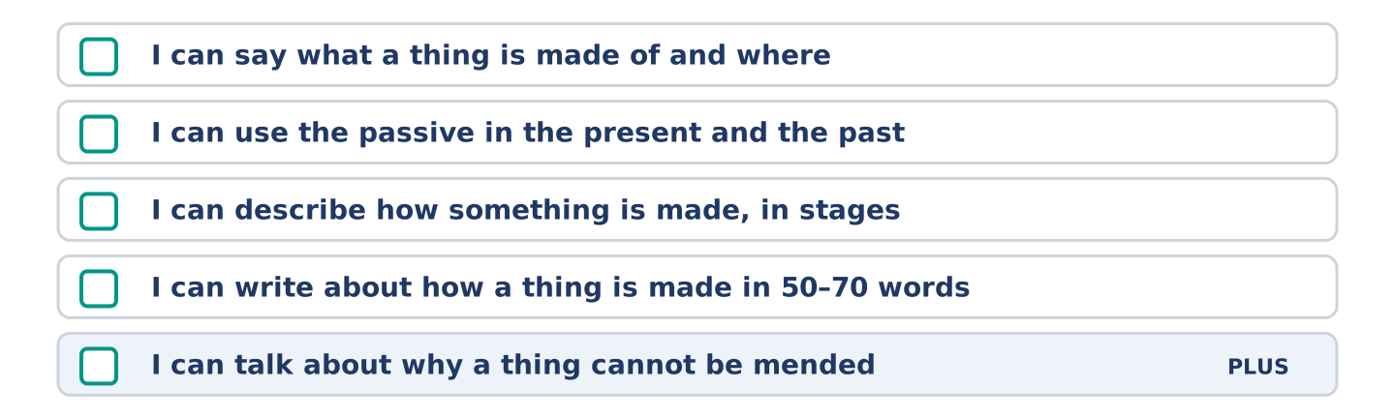
Figure 17.14 · What you can do at the end of this unit.
Can-Do checklist
☐ I can say what a thing is made of and where.
☐ I can use the passive in the present and the past.
☐ I can describe how something is made, in stages.
☐ I can write about how a thing is made in 50–70 words.
☐ I can talk about why a thing cannot be mended (Plus).
Part 10: Glossary
Unit 17 glossary (10 words)
factory · material · metal · plastic · wool · glass · recycle · waste · produce · cloth
Unit 18: If and When
English for Daily Life · Level: A2 · Tracks: [CORE] Warm-Up + Parts 1–6 · [PLUS] Parts 7–10
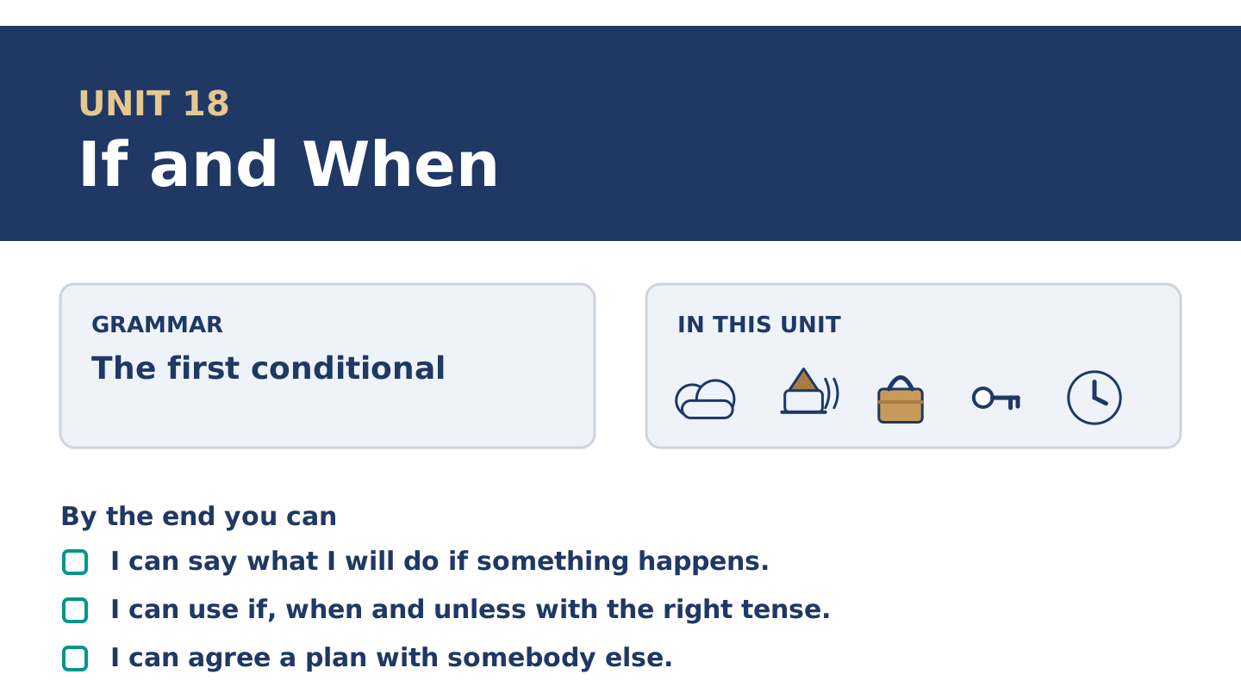
Figure 18.1 · Unit 18 at a glance: the grammar, the topic and what you will be able to do.
Warm Up
[CORE] Core track · in-class starter
Warm-up: Words for What Might Happen
Match the words with their meanings. One meaning is not needed. Write the letter.
Column A
1. | Safe | ____
2. | Danger | ____
3. | Accident | ____
4. | Emergency | ____
5. | Luck | ____
Column B
a) | something bad that happens and nobody planned
b) | the chance that something bad will happen
c) | out of reach of anything that could hurt you
d) | something good or bad that happens for no reason
e) | something bad happening now, so somebody must act
f) | a long line of cars that is not moving
Warm-up: Talking About What Might Happen
Complete the sentences using the words in the word bank.
Word bank: careful | chance | jam | risk
- If you go at seven there is a ______________________ on the bridge.
- Tomas is ______________________ with the pills and counts them twice.
- There is a small ______________________ of rain, so Maya is taking a coat.
- Mr Okonkwo will not take the ______________________ , and he never has.
Warm-up: Six People, Six Plans
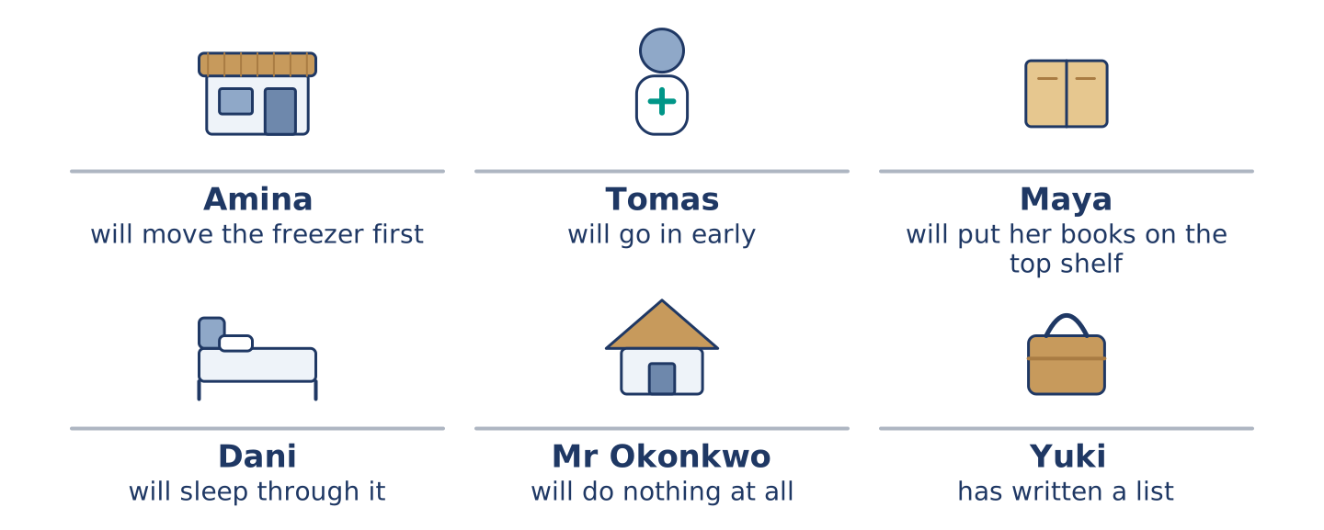
Figure 18.2 · What each of them will do if the weather turns.
Read the text and choose the correct answer.
Nobody at number 14 agrees about what to do if the water comes up again. Amina will move the freezer first, because she lost one in the spring. Tomas will go in early, because the hospital calls him when the roads are bad. Maya will put her books on the top shelf and feel silly if nothing happens. Dani will sleep through it unless somebody wakes him, and Maya says she will. Mr Okonkwo will do nothing at all, and he has been right twice. Yuki has written a list, and she has read it out to nobody.
1. What will Amina move first?
○ A) Her books
○ B) The freezer
○ C) The pills
○ D) Her list
2. What will Dani do?
○ A) Go in early
○ B) Read out a list
○ C) Move the freezer
○ D) Sleep through it
Part 1 · Vocabulary and Terminology
[CORE] Core track · pre-class input
Part 1: Words for Chance and Care
Match the words with their meanings. One meaning is not needed. (0. is done for you.)
- Unless → if not; except if.
Column A
1. | Chance | ____
2. | Risk | ____
3. | Safe | ____
4. | Accident | ____
5. | Emergency | ____
6. | Careful | ____
7. | Jam | ____
Column B
a) | out of reach of anything that could hurt you
b) | a long line of cars that is not moving
c) | how likely something is
d) | taking care, and going slowly to get it right
e) | the chance that something bad will happen
f) | something bad happening now, so somebody must act
g) | something bad that happens and nobody planned
h) | the hair of a sheep, turned into cloth
Gloss: unless = if not; except if · danger = the chance that something bad will happen · luck = something good or bad that happens for no reason
Part 1: Pronunciation
🔊 Audio Track 18.1
Listen to the two halves. Say each one aloud.
If it rains — the voice goes up and waits: /ɪf ɪt ˈreɪnz/
I will stay in — the voice comes down and stops: /aɪl ˈsteɪ ˈɪn/
If it rains, I will stay in — up, wait, down
I will stay in if it rains — one run, no stop
So here is the useful part. The if half is not finished and your voice says so. Learners say both halves flat, and then the listener waits for a sentence that has already ended. When the if half comes second, nothing is written between the halves. Learners taught to write a mark there read the mark out loud.
Part 1: Four Things and What You Will Do
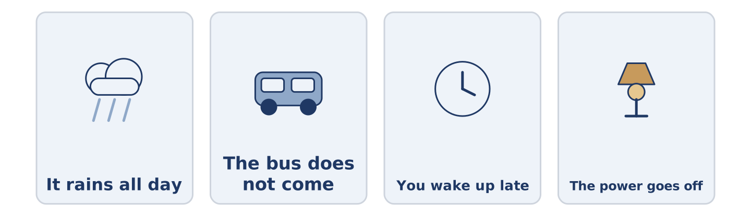
Figure 18.3 · Four things that might happen, and what each person will do.
Complete the table. Write what you will do. (0. is done.)
If this happens | I will…
It rains all day | (example)
The bus does not come
You wake up late
The power goes off
- It rains all day — I will stay in and be glad I have nothing to post.
Think about your own week. More than one answer is right.
Part 1: If, When or Unless?
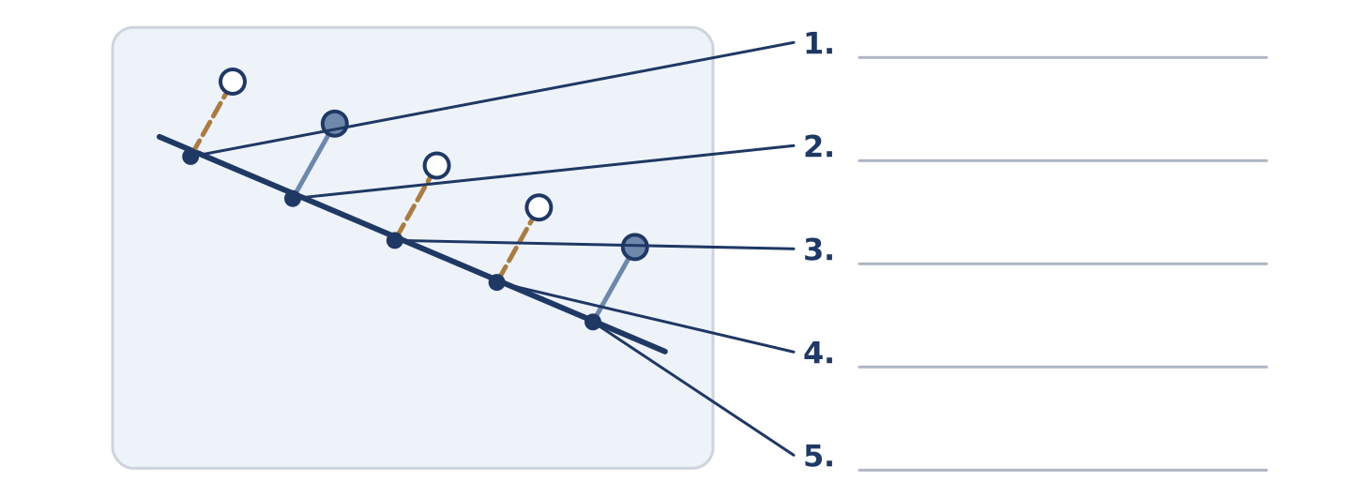
Figure 18.4 · If, when and unless — write the correct word on each line.
Match the words with what they do. One is not needed. Write the letter.
Column A
1. | if | ____
2. | when | ____
3. | unless | ____
4. | as soon as | ____
5. | in case | ____
Column B
a) | it may happen, and it may not
b) | it will happen, and we do not know the hour
c) | the only thing that would stop it
d) | the moment it happens, and not later
e) | before it happens, so that you are ready
f) | a hundred years
Part 1: Chance and Care — Multiple Choice
Read and choose the correct answer.
1. Something bad that happens and nobody planned is an…
○ A) accident
○ B) emergency
○ C) chance
○ D) risk
2. Unless means…
○ A) as soon as
○ B) in case
○ C) if not
○ D) when
3. A long line of cars that is not moving is a…
○ A) risk
○ B) jam
○ C) danger
○ D) chance
Part 1: Vocabulary Fill-in
Complete the sentences with the correct word.
Word bank: safe | danger | luck | emergency
- Put the keys somewhere ______________________ and tell one person where.
- There is no ______________________ at all, and Maya has read about it anyway.
- He has had the same ______________________ twice, which is not a plan.
- In an ______________________ , ring the top bell and keep ringing.
Part 1: Write About a Plan (short)
Write two or three sentences about something that might happen this week. Use three words from this unit.
Model — read this first:
If the bus does not come at eight I will walk, and I will be late, and nobody will mind. There is a small chance of rain. I am taking the long coat in case, which means it will not rain. (41 words)
Part 2 · Grammar — The First Conditional
[CORE] Core track · pre-class input
Part 2: Notice
Read these lines. Underline the two verbs in each. Which half has will in it?
If it rains, I will stay in. When the water comes up, Amina will move the freezer. Unless somebody wakes him, Dani will sleep through it. If the roads are bad, the hospital will ring Tomas.
Will is in the second half of every one, and in none of the first halves.
Part 2: Grammar Focus Box
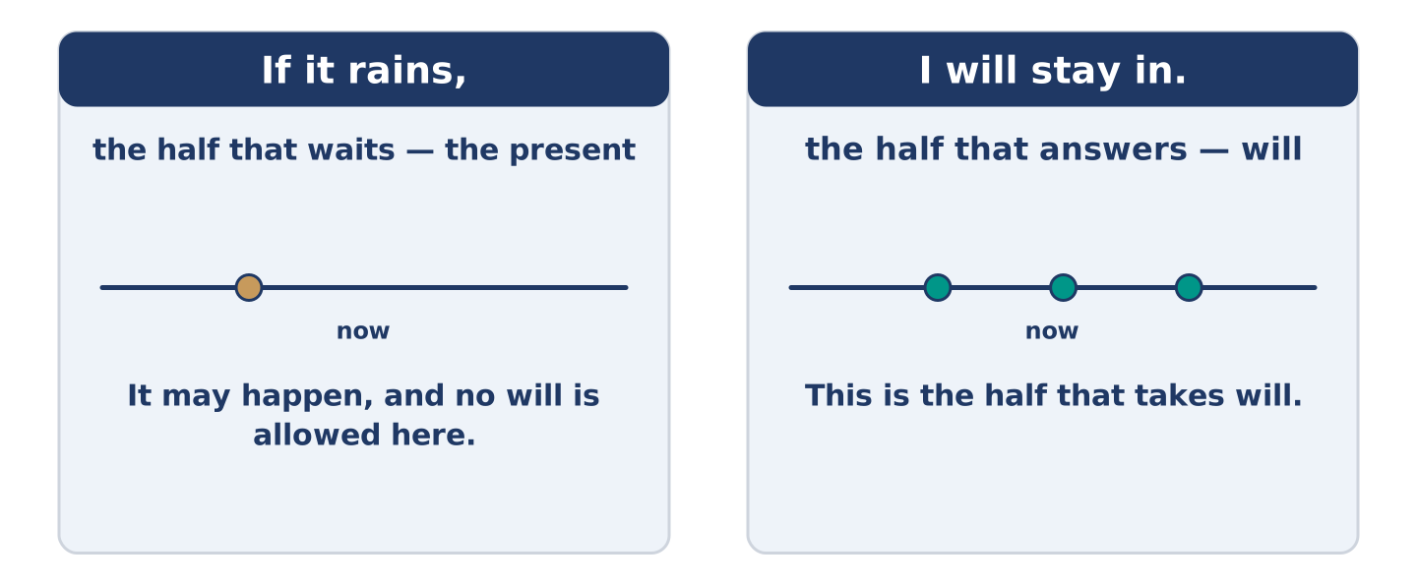
Figure 18.5 · One half waits, the other half answers.
 | Form | Use | Example
if + present | if it rains | it may happen | If it rains, I will stay in.
will + verb | I will stay in | what you will then do | If it rains, I will stay in.
when + present | when it rains | it will happen, time unknown | When it rains, the road floods.
unless + present | unless it rains | the one thing that would stop it | I will walk unless it rains.
Remember: no will after if, when or unless. The present does the work there: if it rains, never if it will rain.
Watch out! ✗ If it will rain, I will stay in. → ✓ If it rains, I will stay in. (no will after if). ✗ Unless it does not rain, I will walk. → ✓ Unless it rains, I will walk. (unless is a negative already).
Part 2: Controlled Practice
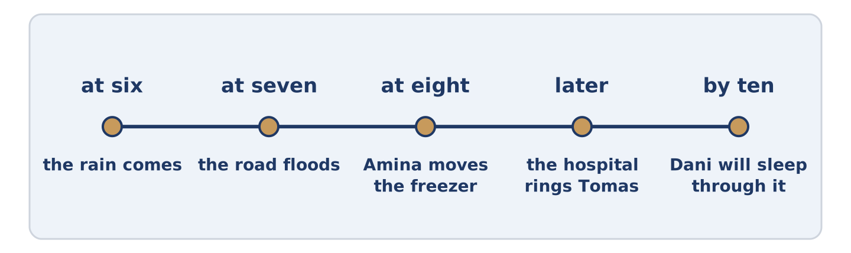
Figure 18.6 · One evening, and what each hour might bring.
Complete with the present simple or will. (0. is done.)
- If it rains, I will stay in. (rain)
- If the water comes up, Amina ______________________ the freezer. (move)
- When the roads are bad, the hospital ______________________ Tomas. (ring)
- Unless somebody ______________________ him, Dani will sleep through it. (wake)
- Maya will put the books back as soon as the rain ______________________ . (stop)
Part 2: Will It or Might It?
Write will happen or might happen. (0. is done.)
- When the rain stops. — will happen
- If the water comes up. ____________
- As soon as he gets home. ____________
- Unless somebody wakes him. ____________
- When Tomas finishes his shift. ____________
Part 2: Correct the Sentence
Each sentence has one grammar mistake. Write the correct sentence.
- If it will rain, I will stay in.
- Unless it does not rain, I will walk.
- When he will get home, he will ring you.
- If the water comes up, Amina moves the freezer.
Part 2: Freer Practice
Write two sentences about tomorrow: one with if, one with unless.
Part 2: Grammar Review
Choose the correct sentence.
1. Which sentence uses if correctly?
○ A) If it will rain, I will stay in.
○ B) If it rains, I stay in tomorrow.
○ C) If it would rain, I will stay in.
○ D) If it rains, I will stay in.
2. Which sentence means if it does not rain?
○ A) Unless it does not rain.
○ B) When it rains.
○ C) Unless it rains.
○ D) As soon as it rains.
→ Harvest: you will meet if and when again in the Part 5 reading. Notice which one is used for things that are certain.
Part 3 · Listening
[CORE] Core track · pre-class input · scripts printed inline
Part 3: What We Will Do If the Water Comes Up
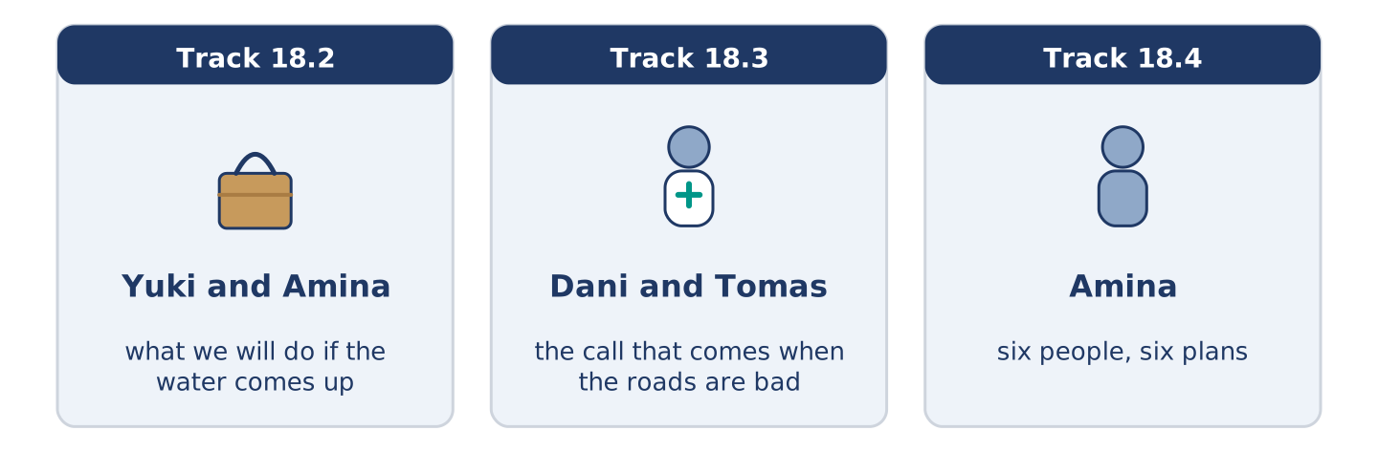
Figure 18.7 · The three listenings: who is speaking, and what about.
🔊 Audio Track 18.2
Before you listen: what would you move first?
Yuki: What happens if it comes up again? Amina: The freezer goes on the crates. Yuki: And if there are no crates? Amina: There’ll be crates. There always are. Yuki: Is there a list anywhere? Amina: There is a list in my head and it has four things on it. Yuki: Could I have it? Amina: If you write it down, nobody will read it. Yuki: I will read it. Amina: Then it is your list.
While you listen: write True, False, or Not Given. (0. is done.)
- Amina will put the freezer on the crates. — True
- Amina’s list has four things on it. ____
- Amina thinks a written list will be read. ____
- The water came up in the spring. ____
Useful phrases: What happens if…? · And if there are no…? · There will be… · Then it is your list
Part 3: The Call That Comes When the Roads Are Bad
🔊 Audio Track 18.3
Before you listen: has work ever rung you at a bad hour?
Dani: Do they ring you, or do you ring them? Tomas: They ring me. Dani: Always? Tomas: It isn’t a choice. When the roads are bad, they ring everybody. Dani: And if you do not answer? Tomas: They ring the next name. Dani: So you could not answer. Tomas: I could. Dani: But you will. Tomas: If the roads are bad, somebody is coming in whatever I do. It may as well be somebody who slept.
Answer the questions. (0. is done.)
- Who rings whom? — The hospital rings Tomas.
- What happens when the roads are bad?
- What happens if Tomas does not answer?
- Why does Tomas answer?
Part 3: Six People, Six Plans
🔊 Audio Track 18.4
Before you listen: who do you know who makes a plan for everything?
Amina: I can tell you what each of them will do. I will move the freezer, because I lost one and I am not losing another. Tomas will go in early, because they will ring him and he will say yes. He is careful that way. Maya will put the books up high and then feel silly. Dani will sleep unless the water reaches the bed. And Mr Okonkwo will sit by his window on the fourth floor and watch the rest of us.
While you listen: match each person with their plan. One is not needed. (0. is done.)
- Amina → she will move the freezer.
Useful phrases: ___ will go in early · ___ will put the books up high · ___ will sleep unless ___
Column A
1. | Tomas | ____
2. | Maya | ____
3. | Dani | ____
4. | Mr Okonkwo | ____
Column B
a) | will put the books up high
b) | will sit by the window and watch
c) | will go in early
d) | will sleep unless the water reaches the bed
e) | will write a list and read it out
Part 4 · Speaking
[CORE] Core track · in-class output
Part 4: What Will You Do If…
Work with a partner. Ask and answer these questions.
- What will you do if it rains all weekend?
- What will you take with you in case?
- What will you do as soon as you get home today?
Useful language: If it…, I will… · unless… · in case… · as soon as…
Part 4: Find the Difference (pairwork)
Student A and Student B each have a plan for one bad evening. Ask questions and find three differences.
Useful questions: What will you do if…? · And if that does not work? · Who will you ring? · What will you take?
Student A — your plan: ring your sister, take the long coat, walk if the bus is late, stay at home if it floods.
Student B — your plan: ring your brother, take the long coat, wait if the bus is late, stay at home if it floods.
Part 4: Agreeing on One Plan
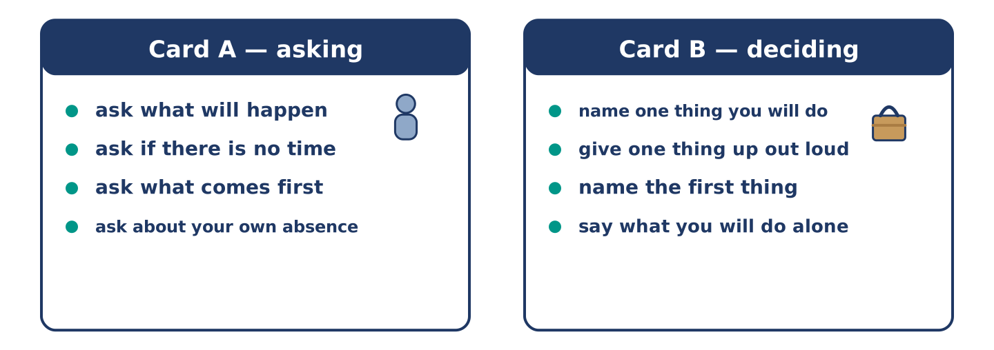
Figure 18.8 · Card A and Card B: what each of you has to say.
Work in pairs. Read the model, then use the cards.
Model exchange:
A: What will we do if it comes up? — B: I will move the freezer. — A: And if there is no time? — B: Then the freezer stays. — A: So what is first? — B: The keys and the papers. They go in a bag now. — A: And if I am out? — B: Then I do it, and you owe me a freezer.
Useful language: What will we do if…? · And if there is no time? · So what is first? · And if I am out?
Card A — asking: ask what will happen · ask about the case where there is no time · ask what comes first · ask about your own absence.
Card B — deciding: name one thing you will do · give one thing up out loud · name the first thing · say what you will do alone.
Your turn: run the dialogue, then swap roles.
Stretch [PLUS]: your partner’s plan is better than yours and you suggested yours first — hand it over in one sentence.
Part 4: Mini-Presentation
Prepare a short talk (about one minute). Say what you will do if one ordinary thing goes wrong this week.
Part 5 · Reading
[CORE] Core track · pre-class input
Part 5: Why Nobody Believes a Warning the First Time
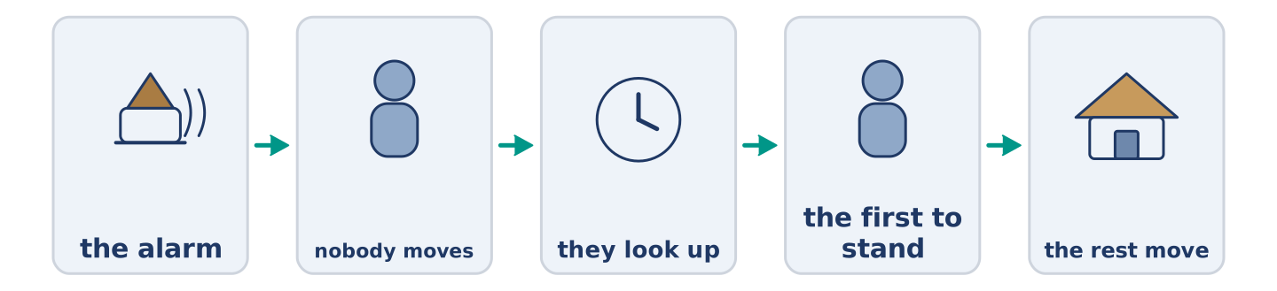
Figure 18.9 · One warning, and what people do in each minute.
Before you read: have you ever ignored a warning and been right?
Gloss: warning = a word or sound that tells you something bad is coming · alarm = a loud sound made on purpose, to warn · drill = a practice for something bad, done when nothing is wrong
If an alarm goes off in a building, almost nobody moves. They look up, then at each other, and the first person to stand decides it for the rest. The same thing has been counted everywhere: people wait to be told twice. The reason is not that people are slow. It is that a first warning costs nothing, and being wrong in front of others is expensive. So a good alarm does two things. It says what is happening, not that something is, and it names what to do. Fire on the third floor. Use the back stairs. Nobody waits for a second opinion about that.
Answer the multiple-choice questions. (0. is done.)
- What does almost nobody do when an alarm goes off? — Move.
1. Who decides it for the rest?
○ A) The first person to stand
○ B) The oldest person there
○ C) The person nearest the door
○ D) Nobody
2. Why do people wait?
○ A) Because they did not hear
○ B) Because the alarm is quiet
○ C) Because they are slow
○ D) Because being wrong in front of others is expensive
3. What does a good alarm name?
○ A) The building
○ B) What to do
○ C) The hour
○ D) The cost
Part 5: Vocabulary in Context
Match each word from the text with its meaning. One meaning is not needed. Write the letter.
Column A
1. | warning | ____
2. | alarm | ____
3. | drill | ____
4. | risk | ____
Column B
a) | a practice for something bad, done when nothing is wrong
b) | the chance that something bad will happen
c) | a word or sound that tells you something bad is coming
d) | a loud sound made on purpose, to warn
e) | a long line of cars that is not moving
Part 5: Three Warnings That Come Too Late to Be Useful
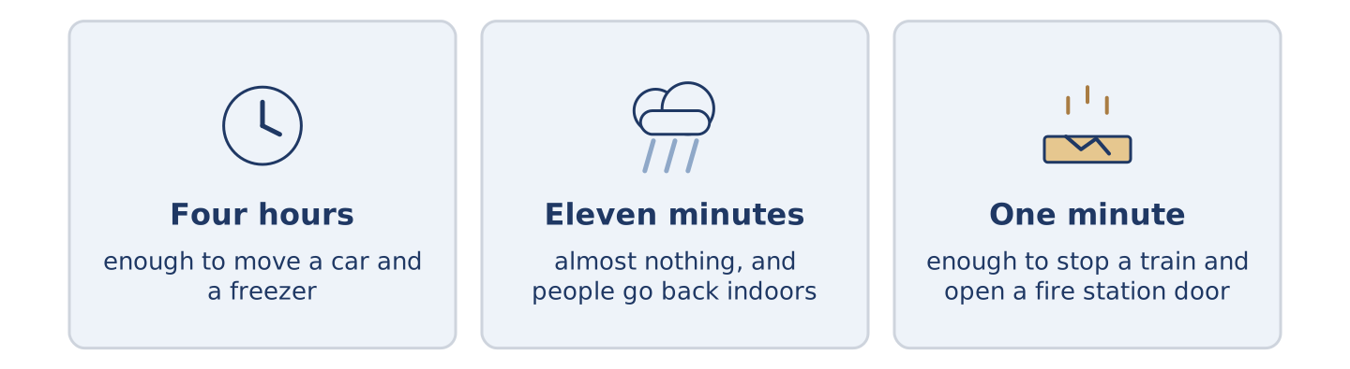
Figure 18.10 · Three warnings, and how long each one gives you.
Before you read: how much warning would be enough?
Gloss: flood = water covering land that is usually dry · sensor = a small machine that notices a change · siren = a very loud sound that carries a long way
A warning is only worth the time it buys. One four hours early empties a street: four hours is enough to move a car and a freezer. One eleven minutes early does almost nothing. In two cities it made things worse: people went back indoors for their papers. An earthquake warning is the strangest. It cannot be early, because nothing happens first. A sensor can feel the first shake and send a siren faster than the ground moves. That buys about a minute. A minute sounds like nothing. It is enough to stop a train and get a surgeon’s hands out of somebody.
Answer the questions. (0. is done.)
- What is a warning worth? — Only the time it buys.
- What does a four-hour flood warning do?
- Why did an eleven-minute warning make things worse?
- Name two things a minute is enough for.
Part 6 · Writing
[CORE] Core track · in-class / homework
Part 6: A Plan for a Bad Day (50–70 words)
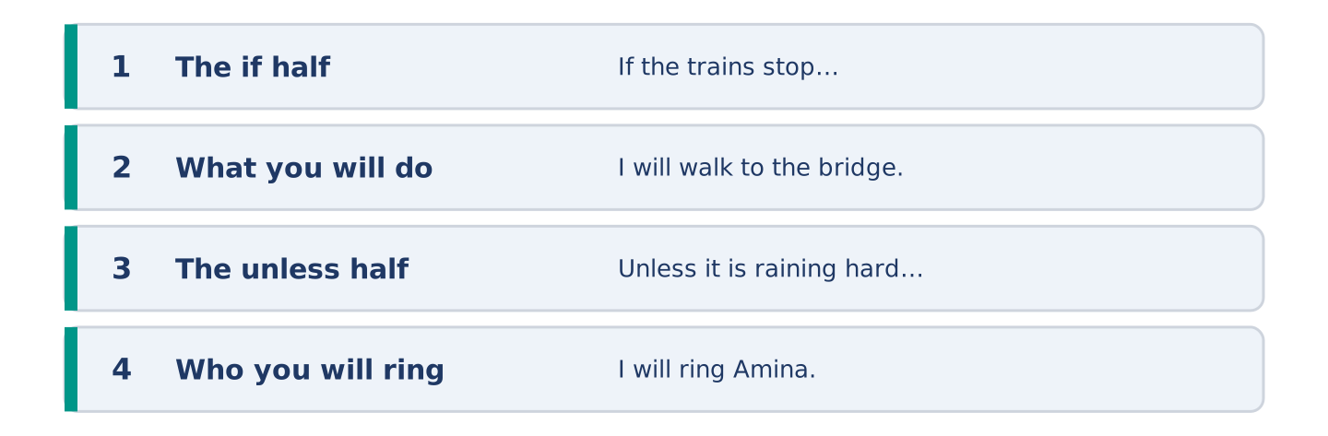
Figure 18.11 · The shape of the piece you are about to write.
Write what you will do if one thing goes wrong tomorrow. Use if and unless.
Model — read this first:
If the trains stop I will walk to the bridge and get the bus there. It takes fifty minutes and I will be late, and being late is allowed. Unless it is raining hard I will not ring anybody. If it is, I will ring Amina. She will say take a taxi, and that is why I will not ring her. (61 words)
Plan (fill in, then write): If ___ , I will ___ . It takes ___ . Unless ___ , I will not ___ . If it is, I will ___ .
Word bank: if | unless | as soon as | in case | I will
Check before you finish: ☐ one if sentence? ☐ one unless sentence? ☐ no will after if? ☐ 50–70 words?
Part 6: Should You Plan for Everything? (50–70 words)
Should you make a plan for every bad thing that might happen? Give your opinion and two or three reasons.
Model — read this first:
You should not, and the ones doing it are no safer for it. A plan for everything is forty plans and you will not remember one of them. Two plans you can say out loud beat forty in a drawer. Keep a bag by the door and know who you will ring. Everything else can be worked out at the time. (58 words)
Word bank: I think… because… | however | in my opinion | it depends on | the main thing is
Check before you finish: ☐ a clear opinion? ☐ two or three reasons? ☐ 50–70 words?
Part 6: A Time You Were Lucky (50–70 words)
Write about a time something went wrong and you were lucky. Say what might have happened.
Model — read this first:
I left a window open in October and came home to a flat full of rain and one dry corner. Everything I own was in the dry corner, for no reason at all. If the wind turns on a day like that, you lose everything you own. I did nothing right. I close that window now before I leave, every time. (56 words)
Plan (fill in, then write): I ___ and ___ . If ___ , ___ . I did ___ . I have ___ since.
Check before you finish: ☐ what went wrong? ☐ why you were lucky? ☐ what you do now? ☐ 50–70 words?
Part 6: Reflection — The Warning You Ignore (40–60 words)
Write about a warning you ignore, and why.
Model — read this first:
The light on my car has been on since March. I know what it means and I know it is not nothing. If it makes a sound one day, I will deal with it in a week. It is a small orange picture, so I have stopped seeing it, and that is how warnings fail. (54 words)
Check before you finish: ☐ which warning? ☐ why you ignore it? ☐ what would change it? ☐ 40–60 words?
Part 7 · Real-World File — Saying What You Will Do
[PLUS] Plus track (optional) · stronger learners
7A: Phrase Bank
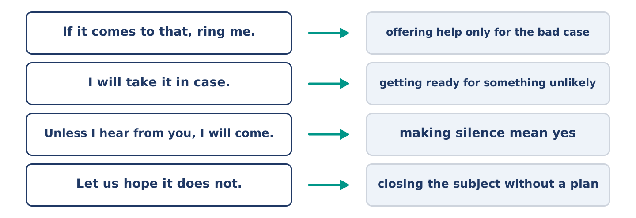
Figure 18.12 · What people say about what might happen, and what each line does.
Match what a person says with its purpose. One purpose is not needed. Write the letter.
Column A
1. | “If it comes to that, ring me.” | ____
2. | “I will take it in case.” | ____
3. | “Unless I hear from you, I will come.” | ____
4. | “Let us hope it does not.” | ____
Column B
a) | getting ready for something unlikely
b) | how much it will cost
c) | offering help only for the bad case
d) | making silence mean yes
e) | closing the subject without a plan
7B: The Plan Nobody Agreed To
🔊 Audio Track 18.5
Before you read: has a plan ever been made for you while you said nothing?
Mr Okonkwo: So who decided the bag by the door? Yuki: Nobody decided. I put it there. Mr Okonkwo: And if there’s no emergency? Yuki: Then there is a bag by the door. Mr Okonkwo: For how long? Yuki: Until there is one. Mr Okonkwo: That could be thirty years. Yuki: Then it’s been a very cheap thirty years. Mr Okonkwo: Put my keys in it.
Answer the questions. (0. is done.)
- Who decided about the bag? — Nobody; Yuki put it there.
- How long will the bag stay by the door?
- What does Mr Okonkwo say that could be?
- What does Mr Okonkwo ask for at the end?
7C: Controlled Practice — Making a Plan With Somebody
Put the steps in order. Number them 1–5. (0. is done.)
- Name the thing that might happen. — 1
____ Say what you will do if there is no time.
____ Say what you will do first.
____ Agree who rings who.
____ Say what you will give up.
7D: Role-Play — One Bag, Two Opinions
In pairs. One has made a plan, the other has not. Use the model and cards.
Model exchange: A: There is a bag by the door. — B: I saw it. — A: Your keys should be in it. — B: If I need my keys I will know where they are. — A: Not at four in the morning. — B: That is fair. — A: So shall I put them in? — B: Put the spare ones in. I am keeping mine.
Card A — the planner: say what you have done · say what they should add · give one hard case · ask for a decision.
Card B — the doubter: agree that you saw it · give your reason once · accept the hard case · agree halfway and say which half.
Stretch [PLUS]: you are the planner and you know you have gone too far — keep one part of the plan and drop the rest out loud.
7E: Writing — A Note About What to Do If (50–80 words)
You are away for a week. Write a note about what to do if something goes wrong.
Model — read this first:
If the heating stops, the small white button is behind the door in the hall and it wants pressing twice. If water comes in under the back door it has done it before and a towel is enough. Ring Amina before you ring me; she is downstairs and I am four hours away. Unless something is on fire, it can wait until Sunday. (60 words)
Check before you finish: ☐ two if sentences? ☐ one unless sentence? ☐ who to ring? ☐ 50–80 words?
Part 8 · Global Story — The City That Gets a Minute
[PLUS] Plus track · pre-read / discuss
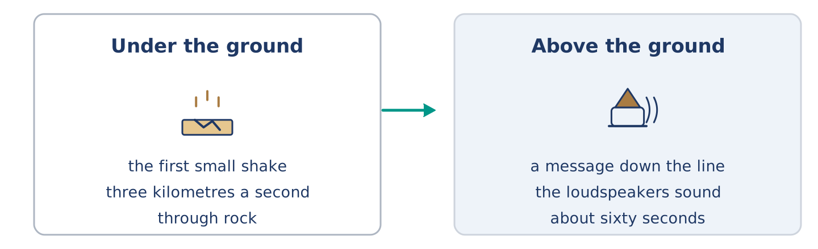
Figure 18.13 · A shake under the ground and a sound above it.
Before you read: what would you do with one minute?
Gloss: earthquake = a shaking of the ground · loudspeaker = a machine that makes a voice loud enough for a street · rehearse = to practise a thing before it is needed
Mexico City sits a long way from the coast where its earthquakes start. That distance is the whole of its luck. Sensors on the coast feel the first small shake. The shake travels through rock at about three kilometres a second; a message down a telephone line travels far faster. So the loudspeakers in the city can sound about sixty seconds before the ground moves. A minute is not enough to leave a building and nobody is told to. It is enough to stop the trains, open the fire station doors and get out of a lift. The city rehearses it every September. If the siren sounds on another day, people do what they did in the drill. That part took thirty years, and it was not the sensors.
Answer the questions. (0. is done.)
- Where do Mexico City’s earthquakes start? — A long way off, near the coast.
- How fast does the shake travel through rock?
- Name two things a minute is enough for.
- What took thirty years?
Part 8: Vocabulary in Context
Match each word with its meaning. One meaning is not needed. Write the letter.
Column A
1. | earthquake | ____
2. | loudspeaker | ____
3. | rehearse | ____
4. | sensor | ____
Column B
a) | a small machine that notices a change
b) | a shaking of the ground
c) | to practise a thing before it is needed
d) | a machine that makes a voice loud enough for a street
e) | water covering land that is usually dry
Part 8: Discussion
Talk with a partner. Use the frames.
Discussion frames: “This is similar to where I live because…” · “This is different from where I live because…” · “I think the most important thing is… because…”
Part 9 · Close to Home — The Bag by the Door
[PLUS] Plus track · pre-read / decide
Before you read: how long would you keep a bag by the door?
There is a bag by the front door of number 14 and nobody voted for it. Yuki put it there in April, after the water came up in the spring and four of them lost something. She did it on a Saturday and she told nobody first. It holds a lamp, a list of six telephone numbers, two sets of spare keys and a bar of chocolate nobody is allowed to eat. Amina has added nothing and is glad it is there. Tomas has looked inside it twice, professionally. Dani has eaten the chocolate once and replaced it. Mr Okonkwo asked how long it would stay and then put his keys in. If nothing ever happens, the bag was a waste of a Saturday afternoon. If something does, it will be the best Saturday anybody spent that year.
Answer the questions. (0. is done.)
- Who put the bag by the door? — Yuki.
- Name three things in the bag.
- What did Dani do?
- What did Mr Okonkwo do after asking his question?
Part 9: Decision Task
Somebody has made a plan for your home and did not ask you. Should you (a) join in, (b) say nothing and leave it, or (c) say it is too much? Decide and explain. Use the frame.
Answer frame: “I think I should ___ because ___. Also, ___. This is better than ___ because ___.”
Model — read this first:
I think I should join in, because the plan costs me one set of keys and I will never miss them. Also, if I say nothing I get the good of it and none of the work, and I would know that. This is better than saying it is too much. Somebody has to be wrong first, and it will not be the one with the bag. (65 words)
Phrase bank: I think I should… · because… · Also,… · This is better than… · In my opinion…
Part 10 · Review and Can-Do
[CORE + PLUS] · homework / self-study
Part 10: Spiral Review
Complete the review. (0. is done.)
- If not, or except if, is unless.
Word bank: chance | risk | safe | emergency | rains | will stay | factory | century
- How likely something is, is the ______________________ .
- The chance that something bad will happen is the ______________________ .
- Out of reach of anything that could hurt you is ______________________ .
- Something bad happening now, so somebody must act, is an ______________________ .
- If it ______________________ , I will stay in. (present)
- If it rains, I ______________________ in. (will)
- (from Unit 17) A building where things are made in large numbers is a ______________________ .
- (from Unit 16) A hundred years is a ______________________ .
Part 10: Can-Do
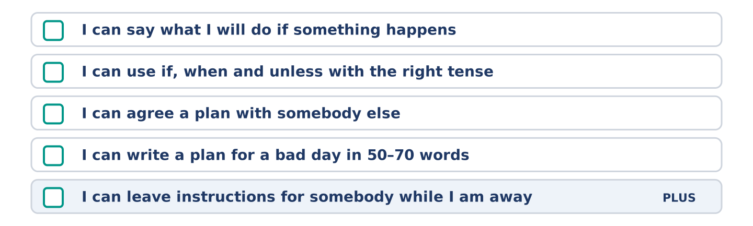
Figure 18.14 · What you can do at the end of this unit.
Can-Do checklist
☐ I can say what I will do if something happens.
☐ I can use if, when and unless with the right tense.
☐ I can agree a plan with somebody else.
☐ I can write a plan for a bad day in 50–70 words.
☐ I can leave instructions for somebody while I am away (Plus).
Part 10: Glossary
Unit 18 glossary (10 words)
unless · chance · risk · safe · accident · emergency · danger · careful · luck · jam
Answer Key
The source this course is modelled on has no answer key at all. This one covers every closed item, and gives marking points and a sample answer for every open task.
Unit 11: Plans and Arrangements — Answer Key
English for Daily Life · Teacher’s section. The source book has no answer key; this is an addition. Open tasks carry a sample answer, not the only correct one.

Warm Up
Warm-up: Words for Plans
- c · 2. d · 3. e · 4. b · 5. a Not needed: f) the money you pay to belong to something
Warm-up: Talking About Next Week
- holiday · 2. remind · 3. prepare · 4. hotel
Warm-up: Six People, Six Saturdays
- C) Meeting her sister · 2. A) Nothing, and he means it

Part 1 · Vocabulary and Terminology
Part 1: Words for Arrangements
- e · 2. b · 3. d · 4. g · 5. c · 6. f · 7. a Not needed: h) a thin flat covering, with another one over it
Item 0 (Party) is a standalone worked example, as in the source: the word is not in Column A and its meaning is not in Column B, so it uses up no letter. Seven items, eight letters, one spare.
Part 1: Pronunciation (Track 11.1)
This is the first drill of the second book and the one that does most for how a learner sounds.
Going to + a verb collapses to /ˈɡənə/ in ordinary speech: I’m gonna ask them. Nobody says the three words separately, and a learner who does is immediately heard as reading. Going to + a place does not collapse: We’re going to the station. Here to is a preposition with a noun after it, and it keeps its own beat.
The test to give the class: if you can put a verb after it, it collapses. If you can put the after it, it does not.
The failure to listen for: learners who have been taught that gonna is bad English. It is not; it is what the form sounds like at speed. They should be able to produce it and recognise it, and write going to every time.
Part 1: Four Plans, Four Kinds
- A train at nine, already paid — fixed, with a ticket — I am catching the nine o’clock (given)
Accept any sensible pair. The expected answers:
The plan | How sure is it? | How you say it
Dinner with a friend on Friday | arranged, with a person | I am having dinner with Sam on Friday.
Learning to drive this year | decided, nothing booked | I am going to learn to drive.
Moving to another city one day | a wish, no date | I would like to move one day.
The point of the table is the ladder, not the vocabulary: a ticket, a person, a decision, a wish. Learners who put going to on the first row and the continuous on the third have the ladder upside down.
Part 1: Sure, Half Sure, Not Sure
- c · 2. b · 3. d · 4. e · 5. a Not needed: f) finished, and it went well
Part 1: Plans — Multiple Choice
- B) booking · 2. C) host · 3. D) remind
Part 1: Vocabulary Fill-in
- diary · 2. invite · 3. meeting · 4. party
Part 1: Write About Your Week (short)
Open. Two or three sentences, using three words from the unit. The unit prints a model; this is a second one.
Sample: On Monday I am meeting the woman who is going to do our kitchen, and it is in my diary in red. On Wednesday there is a meeting at work that nobody wants. On Saturday I am doing nothing, and that is a plan too.

Part 2 · Grammar — Going To and the Present Continuous
Part 2: Notice
Arranged, with a time or a person: Maya is meeting her sister at nine · Yuki is asking them all today · Tomas is working on Saturday Only decided: Dani is going to cook · Amina is going to close early · I am going to learn to drive
The teaching point: both forms are present tense doing a future job, and the difference is not the time but the commitment. An arrangement has somebody else in it. A decision has only you.
Part 2: Controlled Practice
- is meeting (given) · 1. is going to · 2. is working · 3. is going to · 4. is closing
Part 2: Arranged or Decided?
- arranged (given) · 1. decided · 2. arranged · 3. decided · 4. arranged
Part 2: Correct the Sentence
- I am going to cook for eight people. (going to needs am, is or are*)*
- She is going to meet her sister at nine. (plain verb after going to*)*
- We are having dinner at eight on Friday. (the continuous needs -ing*)*
- He is going to work on Saturday. (no -s after going to*)*
Part 2: Freer Practice
Open. One arrangement with a time, one decision with no date.
Sample: I am seeing my brother at the airport at six on Sunday, and I am already dreading the traffic. I am going to start running again, and I have said that twice this year.
Part 2: Grammar Review
- B) I am seeing him at nine on Friday. · 2. D) I am going to ask them today.

Part 3 · Listening
Part 3: Arranging an Evening (Track 11.2)
- True (given)
- False — she is closing at two and then doing nothing.
- True — “I’m bringing something, and don’t argue.”
- Not Given — nothing is said about last year.
Part 3: A Booking That Went Wrong (Track 11.3)
- Two. (given)
- On Monday, on the telephone.
- The name of the person he spoke to, and a number.
- Take the number.
Part 3: Six People, Six Saturdays (Track 11.4)
- Amina → she knows and never asks (given)
- c · 2. b · 3. d · 4. a Not needed: e) is going away for the weekend

Part 4 · Speaking
All four tasks are productive. Accept any answer that meets the brief; correct form, not content.
Part 4: Your Week
Marking points: ☐ at least two present-continuous arrangements with times ☐ one going to decision ☐ a real answer to the third question.
Sample: I am working on Saturday and seeing my mother on Sunday, which is most weekends. I am going to learn to cook three things properly, and I have been going to do that since March. My sister arranges everything in our family, about six weeks ahead, and she is never wrong about who is free.
Part 4: Find the Difference (pairwork)
Marking points: ☐ What are you doing on…? questions ☐ exactly three differences.
Three differences: Wednesday (free / hospital) · Friday (dinner at eight / free) · and the pair should notice that Monday and Saturday are the same. Pairs reporting four have guessed; pairs reporting two have stopped at Wednesday.
Sample exchange: A: What are you doing on Monday? — B: A meeting at ten. — A: Same. Wednesday? — B: Hospital. — A: I’m free. One. Friday? — B: Nothing. — A: Dinner at eight. Two. Saturday? — B: Nothing. — A: Nothing. So three? — B: Two. Monday and Saturday match.
Part 4: Arranging Something Together
Marking points: ☐ A asks before explaining ☐ A gives a day and a time ☐ A says who else is coming ☐ B says what they are doing ☐ B offers one thing.
Card A must produce: a question, a day, a time, acceptance of help. Card B must produce: a plain answer, one question, a yes or no, an offer.
The commonest fault is A explaining the whole evening before asking whether B is free. Stop them and make the first line a question.
Stretch: you cannot come and the reason is awkward. Accept I can’t do Saturday, and I’d rather not go into why — nothing to do with you. Can I come to the next one? The marker is a refusal that neither lies nor over-explains.
Part 4: Mini-Presentation
Marking points: ☐ about one minute ☐ three arrangements with times ☐ one going to decision that is not booked ☐ the two forms used correctly.
Sample (55 words): On Tuesday I am taking my car in at eight, which I arranged a month ago. On Thursday I am meeting an old colleague for lunch. On Saturday my brother is coming and staying two nights. And at some point this year I am going to repaint the back room, which I have said before.

Part 5 · Reading
Part 5: How Far Ahead Do People Plan?
- One says yes; the other looks in a calendar. (given)
- C) That you are a compliment and were planned for
- A) The same afternoon
- D) The two kinds of person in one street
Part 5: Vocabulary in Context
- c · 2. a · 3. b · 4. d Not needed: e) the money you pay to belong
Part 5: Three Ways of Keeping a Week
- No, they keep it very differently. (given)
- Because the page runs out.
- Because anybody can put something in it.
- Somebody who then stops remembering at all.

Part 6 · Writing
Each task already prints a model. These are the marking points and a second sample, so that the printed model is not the only answer a learner has seen.
Part 6: An Invitation (50–70 words)
Marking points: ☐ who you are ☐ the day and the time ☐ what you are doing, in going to or the continuous ☐ a way out for the reader ☐ 50–70 words.
Sample (57 words): This is Dani in flat 3. I am cooking far too much rice on Sunday at six, which happens to me about once a month. Anybody who is in is welcome, and anybody who is not is not in trouble. Bring nothing. If six is too early, come at seven and the rice will still be there.
Part 6: Plan Ahead or Decide Late? (50–70 words)
Marking points: ☐ a clear opinion ☐ two or three reasons ☐ 50–70 words.
Sample (54 words): Decide late, because a diary four weeks deep belongs to the person I was last month. I agree to things in April that I resent by May. A plan made on the morning is made by somebody who knows what the week actually did to them. The cost is that I see fewer people.
Part 6: Changing an Arrangement (50–70 words)
Marking points: ☐ the apology first ☐ the real reason ☐ a new day offered ☐ 50–70 words.
Sample (52 words): I am very sorry about Thursday. My mother is coming in on the early train and I only heard this morning, and I am not going to pretend otherwise. Can we do the same time next week? I am free every evening except Tuesday, and I am going to keep Thursday clear.
Part 6: Reflection — Something I Keep Not Doing (40–60 words)
Marking points: ☐ what you are going to do ☐ how long you have said it ☐ what stops you ☐ 40–60 words.
Sample (46 words): I am going to write to my aunt. I decided this at a funeral four years ago and I meant it completely. Her address is on the shelf in front of me. What stops me is that the first line is now about why I waited.

Part 7 · Real-World File — Making and Changing Arrangements
7A: Phrase Bank
- b · 2. e · 3. d · 4. a Not needed: c) asking how much it costs
7B: A Booking Nobody Can Find (Track 11.5)
- Two. (given)
- A Rossi for next month.
- Whether the man read the booking back to him.
- Give him a room tonight and put a note on the other booking.
7C: Controlled Practice — Making a Booking Well
- Say what you want and for when — 1 (given) Write the number down where you can find it — 5 Give your name and spell it — 2 Ask for a booking number — 4 Ask them to read it all back to you — 3
7D: Role-Play — Changing an Arrangement
Marking points: ☐ A apologises before explaining ☐ A gives the real reason ☐ A offers a new day ☐ B asks once and no more ☐ B ends it warmly.
Sample: A: I’m sorry, I can’t do Friday. — B: What’s happened? — A: My shift changed and I found out this morning. — B: These things happen. — A: Can we say the Friday after? — B: That works. — A: I’m going to keep it free this time.
Stretch: it is the third time you have changed it. Accept This is the third time, and I know it. If I cancel again, stop asking me and I won’t blame you. The marker is naming the pattern yourself before the other person has to.
7E: Writing — Arranging Something with Four People (50–80 words)
Marking points: ☐ the day, the date and the time ☐ what people have to do and by when ☐ one line addressed to one person ☐ 50–80 words.
Sample (65 words): Sunday the ninth, one o’clock, at the long table in the back room. I am booking for however many of us answer by Friday, so answer by Friday. Maya, I know Sundays are hard with the exam, so come for an hour if that is all you have. There is no present and no occasion. Say yes or no to all of us at once.

Part 8 · Global Story — The Huts That Nobody Books
- About a day’s walk. (given)
- Every door in the chain.
- The people already there move up, and the last one in sleeps on the floor.
- If somebody arrives wet and late, the bed goes to them.
Part 8: Vocabulary in Context
- c · 2. a · 3. d · 4. b Not needed: e) where people keep their dates
Part 8: Discussion
Open. Each learner should produce at least one similar frame and one different frame, with a reason.
Sample: This is similar to where I live because the key to the allotment gate is the same key for everybody and nobody has ever lost one. This is different from where I live because nothing here works without booking, and a thing with no booking would be full of people who booked nothing. I think the most important thing is that everybody walks the same route, because then today’s last arrival is next week’s first.

Part 9 · Close to Home — The Saturday Nobody Had Arranged
- On the Tuesday. (given)
- What he could cook.
- Her sister, to the Sunday.
- Because he was on nights and did not read his phone.
Part 9: Decision Task
No option is wrong. The task is the reasoning, and the frame must be used.
Marking points: ☐ a choice stated in the first sentence ☐ a because reason ☐ a second point after Also ☐ a comparison with one rejected option ☐ 50–70 words.
The three options, and the strongest case for each:
- (a) ask everybody at once — nobody is an afterthought and nobody is wondering who else was asked. It also gives the two strangers no private way to say no.
- (b) ask the ones you know first — you find out whether it is happening at all before you risk anything on a doorstep. The two left over can usually tell they were second.
- (c) a note through every door — the kindest to a person who would hate being asked to their face, and the easiest of the three to ignore completely.
Sample (55 words): I think I should put a note through every door, because the two who have never spoken to me can read it alone and decide alone. Also, a note gives a date without putting anybody on the spot. This is better than asking everybody at once, because asking in front of others is a trap.

Part 10 · Review and Can-Do
Part 10: Spiral Review
- diary (given)
- booking · 2. meeting · 3. host · 4. remind
- holiday · 6. am meeting · 7. am going to · 8. junction
Part 10: Can-Do
Self-assessment. No key. If a learner cannot tick line 1 or 2, send them back to Part 2; line 4, back to Part 6.
Part 10: Glossary
diary · booking · meeting · invite · host · party · holiday · remind · prepare · hotel

Counts for this unit.
Closed items 60 — matching 29 · MCQ 10 · gap-fill 13 · True/False/Not Given 3 · short answer 11 — plus 4 ordering steps and 6 table cells. Open tasks 11. Seeded 0. worked examples 14. Figures 14.
Unit 12: Weather and What Might Happen — Answer Key
English for Daily Life · Teacher’s section. The source book has no answer key; this is an addition. Open tasks carry a sample answer, not the only correct one.

Warm Up
Warm-up: Weather Words
- d · 2. b · 3. a · 4. c · 5. e Not needed: f) days away from work, usually away from home
Warm-up: Talking About the Weather
- temperature · 2. wind · 3. sunny · 4. freeze
Warm-up: Six People, Six Forecasts
- A) Amina’s · 2. B) He says nothing and brings an umbrella

Part 1 · Vocabulary and Terminology
Part 1: Words for Weather
- f · 2. c · 3. e · 4. a · 5. d · 6. g · 7. b Not needed: h) a seat or room asked for in advance
Item 0 (Degree) is a standalone worked example, as in the source: the word is not in Column A and its meaning is not in Column B, so it uses up no letter. Seven items, eight letters, one spare.
Part 1: Pronunciation (Track 12.1)
This is the same shape as the can and can’t drill in Unit 8 of volume one, and it is worth saying so to the class: the pattern repeats across English, and a learner who has met it once is halfway there.
Will is weak and usually contracted: it’ll rain, I’ll bring one. In the middle of a sentence it is almost nothing. Won’t never contracts and never weakens. The vowel is long and unmistakable: /wəʊnt/.
The failure to listen for: a learner stressing will. An English ear hears a strong auxiliary and begins waiting for a not. The sentence is then heard as hesitant or as a contradiction, neither of which was meant.
Part 1: Four Kinds of Weather
- Heavy rain all day — a coat and dry shoes — nothing; you go anyway (given)
Accept any sensible pair, and expect disagreement, which is the point. The expected answers:
The weather | What you take | What you cancel
Ice on the roads | flat shoes, more time | the car, and anything with a hill in it
Fog in the morning | lights, and patience | nothing; it lifts by ten
Thirty degrees | water, and a hat | anything at two in the afternoon
A class from one country will agree about the ice row and argue about the thirty-degree row, and a mixed class will do the opposite. Let the argument run; it is the most useful two minutes in the part.
Part 1: How Sure Is It?
- c · 2. b · 3. d · 4. a · 5. e Not needed: f) it happened and it was heavy
Items 2 and 5 are the pair to work on. It might rain and it might not rain describe the same uncertainty from two ends, and learners who think the second is more negative have not yet heard that might carries the doubt, not the verb.
Part 1: Weather — Multiple Choice
- A) fog · 2. C) flood · 3. B) shower
Part 1: Vocabulary Fill-in
- ice · 2. degree · 3. storm · 4. sunny
Part 1: Write About Your Weather (short)
Open. Two or three sentences, using three words from the unit. The unit prints a model; this is a second one.
Sample: We get one storm a year and everybody talks about it until the next one. The temperature sits between eight and fourteen degrees for most of the year, which sounds mild and is not. It has not snowed since I was at school.

Part 2 · Grammar — Will and Might
Part 2: Notice
Sure: It will rain this afternoon · It won’t be warm again until April · the buses won’t run Possible: It might snow on Thursday · I might take the bus A decision made while speaking: I will take a coat
The teaching point is the fourth one, and it is the one coursebooks skip. I will take a coat said in response to a forecast is not a prediction about the future; it is a decision being made aloud at the moment of speaking. Learners who only meet will as a prediction never learn to use it to agree, to offer or to decide.
Part 2: Controlled Practice
- will (given) · 1. might · 2. won’t · 3. will · 4. won’t
Part 2: Sure or Possible?
- sure (given) · 1. possible · 2. sure · 3. possible · 4. sure
Part 2: Correct the Sentence
- It will rain this afternoon. (no to after will*)*
- It might snow on Thursday. (plain verb after might*)*
- It might rain later. (one word for possible is enough)
- The buses won’t run in ice. (not goes inside the contraction)
Part 2: Freer Practice
Open. One sure, one possible.
Sample: The shop will be shut tomorrow, because it is shut every Sunday and always has been. It might be the day I finally clean the windows, although I said that last Sunday too.
Part 2: Grammar Review
- D) It might snow on Thursday. · 2. A) It might rain later.

Part 3 · Listening
Part 3: The Shoulder and the Radio (Track 12.2)
- True (given)
- True — “It’ll rain on Saturday.”
- False — “Sunday might be lovely. I’m not promising.”
- Not Given — nothing is said about last weekend.
Part 3: A Journey That Might Not Happen (Track 12.3)
- On Friday. (given)
- Ice.
- That they won’t run in that.
- To go on Thursday afternoon instead.
Part 3: Six People, Six Forecasts (Track 12.4)
- Amina → she hears all six before nine (given)
- c · 2. d · 3. a · 4. b Not needed: e) checks the river before it rains

Part 4 · Speaking
All four tasks are productive. Accept any answer that meets the brief; correct form, not content.
Part 4: What the Weather Does to You
Marking points: ☐ one will ☐ one might ☐ one won’t ☐ a real answer to the third question.
Sample: It will rain tomorrow, because it rained today and the sky has not changed. Nothing stops everything here except wind, and then the bridge shuts and the whole town is twenty miles apart. I carry an umbrella I have never once opened, and I will keep carrying it.
Part 4: Find the Difference (pairwork)
Marking points: ☐ future questions, not present ☐ exactly three differences.
Three differences: Wednesday (sun / showers) · Friday (nine degrees / two degrees) · and the pair should find that Monday and Saturday match. The Friday row is the one they miss, because both say a number and learners stop comparing once they hear one.
Sample exchange: A: What will it do on Monday? — B: Rain. — A: Same. Wednesday? — B: Showers. — A: Sun. One. Friday? — B: Two degrees. — A: Nine. Two. Saturday? — B: Fog. — A: Fog as well. So three? — B: Two so far, and Friday makes three.
Part 4: Deciding What to Do About the Weather
Marking points: ☐ A says what is coming and when ☐ A says what it will stop ☐ A does not give orders ☐ B states a plan ☐ B changes one thing and says the new plan aloud.
Card A must produce: a fact, a time, a consequence, silence. Card B must produce: a plan, a question, a change, a restatement.
The commonest fault is A telling B what to do. Stop them: the card says say what will stop, not say what to do. The difference is the whole exercise, and it is a difference learners feel in their own language too.
Stretch: they will not change the plan and the weather is genuinely dangerous. Accept I have said it once and I am going to say it once more, and then I will stop: the hill will be ice at six. That is all. The marker is one repetition and a visible end to it.
Part 4: Mini-Presentation
Marking points: ☐ about one minute ☐ all four seasons ☐ at least two will and one might ☐ what people do, not only what the weather does.
Sample (55 words): Where I grew up the summer will be hot and dry and everybody moves indoors at two. Autumn is short and it might rain for a fortnight without stopping. The winter will not go below zero, which surprises people. And in spring the wind comes from the east for three weeks and everybody is unbearable.

Part 5 · Reading
Part 5: Why Nobody Believes the Forecast
- It is right far more often than people think. (given)
- B) On six mornings out of ten like this one, it rains
- C) The one Saturday they called off
- D) Probably and might
Part 5: Vocabulary in Context
- b · 2. d · 3. a · 4. c Not needed: e) water that has gone hard with cold
Part 5: Three Places and Their Weather
- It builds houses. (given)
- Because for four months the sun is what you keep out.
- Because wood that sits in water does not last.
- Because a door that opens into the street will meet two metres of snow one morning.

Part 6 · Writing
Each task already prints a model. These are the marking points and a second sample, so that the printed model is not the only answer a learner has seen.
Part 6: A Weather Warning (50–70 words)
Marking points: ☐ what is coming and when ☐ what it will stop ☐ one piece of advice ☐ what you are doing yourself ☐ 50–70 words.
Sample (56 words): Wind on Sunday night, and it will be worse here than in town because of the gap between the flats. Anything in a yard will move, so put the bins and the chairs inside before dark. The power might go; it did in March. I have candles and a kettle on gas if anybody needs either.
Part 6: Does the Weather Change People? (50–70 words)
Marking points: ☐ a clear opinion ☐ two or three reasons ☐ 50–70 words.
Sample (52 words): No, and I think the idea is lazy. People in cold places are not colder people; they are people with better coats and a plan. What the weather changes is where you meet, not who you are. Give a northern street three warm evenings and it behaves exactly like a southern one.
Part 6: A Day the Weather Changed Everything (50–70 words)
Marking points: ☐ the plan ☐ what the weather did ☐ what you did ☐ 50–70 words.
Sample (57 words): We were going to drive across on the Saturday and the snow came in on the Friday night, four inches of it, in a town that owns one plough. We stayed where we were for three days with a family we had met twice. It is the only part of that whole year anybody still talks about.
Part 6: Reflection — The Weather I Would Choose (40–60 words)
Marking points: ☐ what you would choose ☐ why ☐ what you would give up ☐ 40–60 words.
Sample (49 words): I would take rain, and plenty of it, over heat I cannot get away from. You can dress for rain and you cannot undress for thirty degrees. What I would be giving up is the evening light, and I know people who would not give that up for anything.

Part 7 · Real-World File — Warnings and Forecasts
7A: Phrase Bank
- d · 2. e · 3. b · 4. a Not needed: c) how much it will cost
Item 4 is the one worth teaching. Conditions may become difficult overnight is how an official warning says this could be bad without saying it, and learners who read only the words miss the register entirely.
7B: A Warning Nobody Took (Track 12.5)
- The river might come up. (given)
- It came into the shop and Amina lost two days.
- That nobody tells anybody anything until it is a story.
- Move her books off the floor.
7C: Controlled Practice — Giving a Warning Well
- Say what is coming and when — 1 (given) Say what you are doing yourself — 5 Say how sure you are — 2 Give one thing they can do — 4 Say what it will stop — 3
7D: Role-Play — Warning Somebody Who Is Not Worried
Marking points: ☐ A says it once, plainly ☐ A says how sure ☐ A gives one fact, not five ☐ A says what they are doing themselves ☐ B gives a real reason for not worrying.
Sample: A: They said the wind might take the scaffolding on Sunday. — B: They always say that. — A: It went down two streets away in March. — B: Did it? — A: It did. I am moving the car tonight. — B: I might move mine as well.
Stretch: you warned them, they did nothing, and it happened. Accept Is everything all right? I have a spare pump in the shed if the cellar is wet. The marker is help offered and the sentence I told you never appearing in any form.
7E: Writing — A Warning for a Whole Street (50–80 words)
Marking points: ☐ what might happen and when ☐ how sure you are ☐ one thing to do ☐ what you are doing yourself ☐ 50–80 words.
Sample (67 words): The gas is off on Tuesday between nine and four, and that is certain, not a maybe. No heating and no hot water in any of the flats on this side. If you are at home all day, fill a flask in the morning and you will be fine. Mr Okonkwo is on the fourth floor with no lift; somebody should knock. I am out from eleven.

Part 8 · Global Story — The Day the Rain Is Due
- Around the first of June. (given)
- About six weeks.
- The day it reaches each place goes round the whole country, and people stand outside for it.
- A small harvest, and a hard winter in villages far from any newspaper.
Part 8: Vocabulary in Context
- c · 2. d · 3. a · 4. b Not needed: e) a cover you close over a window
Part 8: Discussion
Open. Each learner should produce at least one similar frame and one different frame, with a reason.
Sample: This is similar to where I live because the whole town watches the first frost and the farmers talk about nothing else for a week. This is different from where I live because nothing we grow decides whether anybody eats. I think the most important thing is that the date is known and the arrival is not, because waiting for a known date is a different kind of waiting.

Part 9 · Close to Home — The Tuesday the River Came Up
- On a Tuesday two winters ago. (given)
- Two days of trade and a freezer.
- Foolish on Monday evening, and clever by Wednesday. (Accept silly for foolish*.)*
- He went down and stood at the shop door with Amina for an hour, saying nothing.
Part 9: Decision Task
No option is wrong. The task is the reasoning, and the frame must be used.
Marking points: ☐ a choice stated in the first sentence ☐ a because reason ☐ a second point after Also ☐ a comparison with one rejected option ☐ 50–70 words.
The three options, and the strongest case for each:
- (a) do nothing until you are sure — the only option that costs nothing when the warning is wrong, which it usually is. It is also the option that is never ready in time when the warning is right.
- (b) do the small cheap thing now — ten minutes against a week of not thinking about it. The hidden cost is that a person who prepares for everything prepares for nothing in particular.
- (c) warn everybody else as well — the one that helps the people who did not hear it. It also spends something you cannot get back: if you are wrong twice, nobody listens the third time.
Sample (56 words): I think I should warn everybody as well, because the people who will be hurt by this are exactly the ones who do not read forecasts. Also, it costs me one message. This is better than quietly moving my own things, because being the only dry flat in a wet building is not something I want.

Part 10 · Review and Can-Do
Part 10: Spiral Review
- fog (given)
- storm · 2. shower · 3. flood · 4. temperature
- will · 6. might · 7. diary · 8. junction
Part 10: Can-Do
Self-assessment. No key. If a learner cannot tick line 2, send them back to Part 2; line 4, back to Part 6.
Part 10: Glossary
storm · shower · temperature · degree · ice · fog · wind · sunny · freeze · flood

Counts for this unit.
Closed items 60 — matching 29 · MCQ 10 · gap-fill 13 · True/False/Not Given 3 · short answer 11 — plus 4 ordering steps and 6 table cells. Open tasks 11. Seeded 0. worked examples 14. Figures 14.
Unit 13: Rules and Places — Answer Key
English for Daily Life · Teacher’s section. The source book has no answer key; this is an addition. Open tasks carry a sample answer, not the only correct one.

Warm Up
Warm-up: Words for Rules
- c · 2. e · 3. a · 4. b · 5. d Not needed: f) a book where you write what you are doing
Warm-up: Talking About Rules
- smoking · 2. member · 3. silence · 4. uniform
Warm-up: Six People, Six Rules
- D) Put a bin bag on the landing · 2. B) Say good morning

Part 1 · Vocabulary and Terminology
Part 1: Words for Rules and Places
- b · 2. e · 3. c · 4. a · 5. f · 6. g · 7. d Not needed: h) a cover you close over a window
Item 0 (Notice) is a standalone worked example, as in the source: the word is not in Column A and its meaning is not in Column B, so it uses up no letter. Seven items, eight letters, one spare.
Part 1: Pronunciation (Track 13.1)
The sound work here is short; the meaning work behind it is the most useful ten minutes in the unit.
Must keeps a soft t before a consonant. Mustn’t loses the middle t entirely: /ˈmʌsn̩t/, not /ˈmʌstnt/. Have to is /ˈhæftə/ in ordinary speech, with an f, not a v. Learners who have only seen it written say /hæv tuː/ and are understood, and sound careful.
The point that matters more than the sound: mustn’t and don’t have to are opposites. One forbids, one frees. Most learners who confuse them were never told; they assumed the negative of must is don’t have to, which is a reasonable guess and wrong. Say it aloud, write both on the board, and come back to it in Part 2.
Part 1: Four Places, Four Rules
- A library — quiet enough — everybody; the room does it to you (given)
Accept any sensible pair. The expected answers:
The place | The rule | Who keeps it
A swimming pool | the lanes: fast one side, slow the other | everybody, until one person does not
A gallery | do not touch, and no bright light | everybody; the guard is for the forgetful
A night bus | do not sit next to somebody if the bus is empty | everybody, and nobody could tell you why
The night-bus row is the one to draw out: it is the clearest example in the unit of a rule with no notice, no guard and no fine that is kept almost perfectly.
Part 1: Must, Mustn’t or Do Not Have To?
- b · 2. a · 3. d · 4. e · 5. c Not needed: f) somebody did it and had to leave
Part 1: Rules — Multiple Choice
- C) licence · 2. D) guard · 3. B) fee
Part 1: Vocabulary Fill-in
- private · 2. Smoking · 3. allowed · 4. law
Part 1: Write About a Rule (short)
Open. Two or three sentences, using three words from the unit. The unit prints a model; this is a second one.
Sample: You must be a member to use the garden at the back, and the fee is four pounds a year, which pays for nothing anybody can name. You don’t have to lock the gate. There is a notice about dogs that nobody has read since it went up.

Part 2 · Grammar — Must, Have To and Mustn’t
Part 2: Notice
Necessary: You must show your card · You have to be a member Forbidden: You mustn’t touch the paintings · You mustn’t smoke anywhere inside Not necessary: You don’t have to pay a fee · You don’t have to be quiet in the garden
The teaching point is the middle column against the right one. Learners read mustn’t and don’t have to as near neighbours because both contain a negative. They are at opposite ends: one closes a door, the other opens it.
The second point, worth a minute: must often sounds like the rule speaking and have to like a person reporting it. You must show your card is the notice. You have to be a member is the person at the desk, who did not make the rule and says so with their voice.
Part 2: Controlled Practice
- must (given) · 1. mustn’t · 2. have to · 3. don’t have to · 4. mustn’t
Part 2: Necessary, Forbidden or Not Necessary?
- necessary (given) · 1. forbidden · 2. not necessary · 3. necessary · 4. not necessary
Part 2: Correct the Sentence
- You mustn’t touch the paintings. (must makes its own negative)
- You don’t have to pay, the gallery is free. (mustn’t pay would forbid paying)
- You have to show your card at the desk. (plain verb after have to*)*
- You must be a member. (no to after must*)*
Part 2: Freer Practice
Open. One forbidding, one freeing.
Sample: You mustn’t take a bicycle through the hall, because the paint is new and the handlebars are exactly the height of it. You don’t have to sign anything to use the room; just put the light out.
Part 2: Grammar Review
- A) You mustn’t touch the paintings. · 2. C) You don’t have to pay a fee.

Part 3 · Listening
Part 3: The Guard and the Bag (Track 13.2)
- True (given)
- False — the guard says it is free.
- True — “You can, but no bright light.”
- Not Given — nothing is said about how busy it is.
Part 3: The Rules of the Shop (Track 13.3)
- Four. (given)
- Somebody with two items.
- Buy anything.
- The fourth: you mustn’t tell her what you think of the other customers.
Part 3: Six People, Six Rules (Track 13.4)
- Amina → she knows all six rules (given)
- c · 2. a · 3. d · 4. b Not needed: e) pays the fee a week late every month

Part 4 · Speaking
All four tasks are productive. Accept any answer that meets the brief; correct form, not content.
Part 4: Rules Where You Live
Marking points: ☐ one mustn’t ☐ one have to ☐ one don’t have to ☐ a reason in the third answer.
Sample: You mustn’t put anything in the hall, not even for an hour, because of the pushchairs. People think you have to be in by eleven and that has never been a rule; the door is just heavy. The rule I think is wrong is that children can’t use the lift alone, because the stairs are worse.
Part 4: Find the Difference (pairwork)
Marking points: ☐ Do I have to…? questions ☐ exactly three differences.
Three differences: the cap (have to / don’t have to) · bags (allowed in / go in a locker) · the fee (none / two pounds). Showering first is the same at both pools. Pairs who report four have guessed; the shower row is the trap.
Sample exchange: A: Do I have to shower first? — B: Yes. — A: Same. A cap? — B: No. — A: We have to. One. Can I take a bag in? — B: It goes in a locker. — A: Ours come in. Two. Is there a fee? — B: Two pounds. — A: Ours is free. Three.
Part 4: Asking What the Rules Are
Marking points: ☐ A asks one thing at a time ☐ A asks about the fee ☐ A checks what is forbidden ☐ B separates necessary from free ☐ B names the thing people forget.
Card A must produce: single questions, the money question, a check, thanks. Card B must produce: the necessary, the free, the forgotten one, no argument.
The commonest fault is B defending the rule. The card says do not explain it, and that is deliberate: somebody on a desk did not write it, and learners need to hear what it sounds like when a person passes on a rule they did not make.
Stretch: the rule makes no sense and the person telling you did not make it. Accept I’ll put it in the locker, of course. It does seem a strange rule, and I know that is not yours to answer for. The marker is compliance plus an opinion that does not land on the person in front of you.
Part 4: Mini-Presentation
Marking points: ☐ about one minute ☐ three rules ☐ at least one mustn’t and one don’t have to ☐ one rule explained, not only stated.
Sample (56 words): At the pool you must shower before you go in, which everybody does. You mustn’t swim in the fast lane unless you really are fast, and that one is broken every Saturday by one man. You don’t have to wear a cap, although people think you do, and so about half the swimmers wear one anyway.

Part 5 · Reading
Part 5: Why Some Rules Work and Others Do Not
- Three. (given)
- B) A reason you can see
- D) It only costs the people with no excuse
- A) Somebody willing to mention it
Part 5: Vocabulary in Context
- b · 2. a · 3. d · 4. c Not needed: e) no sound at all
Part 5: Three Places and Their One Rule
- No, each has one. (given)
- The lane: fast on one side, slow on the other.
- Whether the person in the aisle seat stands up or turns their knees sideways.
- They fall apart the moment one person decides the rule is for other people.

Part 6 · Writing
Each task already prints a model. These are the marking points and a second sample, so that the printed model is not the only answer a learner has seen.
Part 6: Rules for a Shared Space (50–70 words)
Marking points: ☐ one must ☐ one mustn’t with a reason ☐ one don’t have to ☐ 50–70 words.
Sample (54 words): You must take your shoes off at the door, because the floor is old and we have all agreed to care about it. You mustn’t use the big table after ten at night; the room below is a bedroom. You don’t have to ask before you make tea, and you never will have to.
Part 6: Is a Rule Better Than a Sign? (50–70 words)
Marking points: ☐ a clear opinion ☐ two or three reasons ☐ 50–70 words.
Sample (53 words): Do not write it down. A sign turns a shared place into somebody’s property, and the moment one goes up, three more follow. People learn a rule faster from a person than from a wall. The real reason anybody wants a sign is so they never have to say the thing out loud.
Part 6: A Rule You Had to Learn (50–70 words)
Marking points: ☐ what you did ☐ what happened ☐ what you do now ☐ 50–70 words.
Sample (54 words): I took a seat on a train with a small card on the back of it, in a language I could not read. A woman arrived twenty minutes later holding a ticket and looking at me the way you look at furniture in the wrong room. Nobody was unkind. I read the cards now.
Part 6: Reflection — A Rule I Would Change (40–60 words)
Marking points: ☐ which rule ☐ why ☐ what you would put in its place ☐ 40–60 words.
Sample (46 words): I would change the rule that you must not eat on the underground. It exists because of smell and mess, which is fair. I would allow anything cold and dry, and ban anything hot, which is the real problem and is never what the notice says.

Part 7 · Real-World File — Signs, Notices and Asking
7A: Phrase Bank
- e · 2. b · 3. a · 4. c Not needed: d) how far it is to the station
Item 2 is worth a minute. Please respect our neighbours is a notice that names no rule at all and is understood by everybody, which is a thing English does often and learners find strange.
7B: A Rule Nobody Explained (Track 13.5)
- After six. (given)
- Because the big van comes at seven and the street is one car wide.
- You find out when somebody is cross with you.
- Why they mustn’t use the side door after nine.
7C: Controlled Practice — Explaining a Rule Well
- Say the rule in one sentence — 1 (given) Say what happens if nobody keeps it — 3 Give the reason behind it — 2 Say who it does not apply to — 4 Ask whether that makes sense — 5
7D: Role-Play — Asking Why the Rule Exists
Marking points: ☐ A asks why, not whether ☐ A says they were not told ☐ B gives the reason in one sentence ☐ B admits what they do not know ☐ B does not defend the system.
Sample: A: Why must the bikes go in the yard? — B: The hall is the fire way out. — A: Nobody said. — B: Nobody ever does. — A: Then how is anybody meant to know? — B: They are not, and I have never once seen that fixed.
Stretch: the rule has no reason left and you both know it. Accept Nobody can remember why, and we both think it is nothing. Shall we keep it anyway for a year and see if anybody misses it? The marker is the two of them deciding, rather than one of them being right.
7E: Writing — A Notice for a Shared Door (50–80 words)
Marking points: ☐ the rule in the first sentence ☐ the reason ☐ one thing the reader does not have to do ☐ 50–80 words.
Sample (62 words): Please do not prop this door open, even for two minutes. It is the fire door for the whole of this floor and it only works shut. You don’t have to carry everything in one trip; press the green button inside and it holds for thirty seconds. If it is sticking again, tell flat 2 and it gets fixed the same week.

Part 8 · Global Story — The Rule Everybody Said Would Fail
- Stop smoking in every indoor workplace. (given)
- That they would go on smoking.
- That they would lose everything.
- How fast the new habit became the normal one.
Part 8: Vocabulary in Context
- c · 2. a · 3. d · 4. b Not needed: e) the walkway between seats or shelves
Part 8: Discussion
Open. Each learner should produce at least one similar frame and one different frame, with a reason.
Sample: This is similar to where I live because the same law came in two years later and the same people said the same things. This is different from where I live because ours is kept in the cities and ignored completely in small towns, so it is really two laws. I think the most important thing is that it came in everywhere on one day, because a rule with exceptions is an argument and a rule without them is just the weather.

Part 9 · Close to Home — The Rules Nobody Wrote Down
- About eleven. (given)
- Because of his nights.
- By getting every one of them wrong first, then hearing about it kindly from whoever was standing there.
- That she does not need them.
Part 9: Decision Task
No option is wrong. The task is the reasoning, and the frame must be used.
Marking points: ☐ a choice stated in the first sentence ☐ a because reason ☐ a second point after Also ☐ a comparison with one rejected option ☐ 50–70 words.
The three options, and the strongest case for each:
- (a) write them all on a notice — the only one that reaches somebody who moves in while everybody is out. It also makes a home look like a waiting room, and a list of eleven rules reads as a complaint about the last tenant.
- (b) tell each new person yourself — kind, and it is a way of meeting them. It depends entirely on one person remembering, and it fails the week that person is away.
- (c) leave it as it is — what every building in the world actually does, and it works for everybody except the newest person, who is the only one it matters for.
Sample (57 words): I think I should write them on a notice, because the person who needs them most is the one who has nobody to ask yet. Also, a list can be short and friendly. This is better than telling each person myself, because I am not always here and the rules do not stop when I am away.

Part 10 · Review and Can-Do
Part 10: Spiral Review
- law (given)
- licence · 2. guard · 3. fee · 4. member
- mustn’t · 6. don’t have to · 7. storm · 8. diary
Part 10: Can-Do
Self-assessment. No key. If a learner cannot tick line 1 or 2, send them back to Part 2; line 4, back to Part 6.
Part 10: Glossary
law · allowed · silence · smoking · member · private · uniform · licence · guard · fee

Counts for this unit.
Closed items 60 — matching 29 · MCQ 10 · gap-fill 13 · True/False/Not Given 3 · short answer 11 — plus 4 ordering steps and 6 table cells. Open tasks 11. Seeded 0. worked examples 14. Figures 14.
Unit 14: Health and Feeling Better — Answer Key
English for Daily Life · Teacher’s section. The source book has no answer key; this is an addition. Open tasks carry a sample answer, not the only correct one.

Warm Up
Warm-up: Words for Not Feeling Well
- d · 2. a · 3. e · 4. b · 5. c Not needed: f) the money you pay to go in or to belong
Warm-up: Giving Advice
- doctor · 2. pill · 3. sick · 4. healthy
Warm-up: Six People, Six Kinds of Advice
- C) Tomas · 2. A) She says nothing and brings soup

Part 1 · Vocabulary and Terminology
Part 1: Words for Health
- c · 2. e · 3. f · 4. d · 5. b · 6. g · 7. a Not needed: h) clothes that say what your job is
Item 0 (Rest) is a standalone worked example, as in the source: the word is not in Column A and its meaning is not in Column B, so it uses up no letter. Seven items, eight letters, one spare.
Part 1: Pronunciation (Track 14.1)
Short, and almost nobody has been told it.
The l in should says nothing: /ʃʊd/. The same letter does the same nothing in could and would. Three very common words, one rule. Shouldn’t is /ˈʃʊdn̩t/ — no l, and the middle t almost gone as well. At the front of a question should weakens to /ʃəd/; at the end of an answer it goes strong.
The failure to listen for: learners who pronounce the l because it is in the spelling. They are understood every time, and they never sound like somebody who has heard the word said.
Part 1: Four Problems, Four Answers
- A cold — rest, drink, wait — if it is still there after two weeks (given)
Accept any sensible pair, and expect the class to disagree about the last column, which is the point. The expected answers:
The problem | What you should do | When to see a doctor
A headache that keeps coming back | drink more, sleep, write down when it comes | if the pattern does not change in two weeks
A tooth that hurts at night | see somebody; nothing else works | now, and not next month
A cut that is not healing | keep it clean and covered | if the edges go red or it is no better in a week
The tooth row is the one to say out loud: the right answer is that there is no home answer, and a learner who writes take a pill has given the advice most people actually give.
Part 1: Should, Shouldn’t or Had Better Not?
- d · 2. a · 3. b · 4. c · 5. e Not needed: f) somebody did it and felt worse
Item 4 is the one to stop on: you must see somebody today is not advice at all, and the ladder in this exercise runs from could through should to must. Learners who treat all three as politeness levels have missed that the last one has left advice behind.
Part 1: Health — Multiple Choice
- B) fever · 2. D) dentist · 3. C) medicine
Part 1: Vocabulary Fill-in
- throat · 2. headache · 3. pain · 4. healthy
Part 1: Write Some Advice (short)
Open. Two or three sentences, using three words from the unit. The unit prints a model; this is a second one.
Sample: You should stay at home for two days even if you feel able to go in, because the second day is when you give it to everybody else. You shouldn’t take anything for a headache before you have had a glass of water. See a doctor if the pain is in one place and stays there.

Part 2 · Grammar — Should and Shouldn’t
Part 2: Notice
Advice: You should drink more water · You should see somebody if it gets worse · You shouldn’t go to work today · I shouldn’t have another coffee Asking for advice: Should I see a doctor? · What should I take for it?
The teaching point: should is the whole of English advice, and it does not change for politeness. Learners arriving from languages with a conditional for this often reach for would and sound strange. The fourth line is worth naming too: I shouldn’t is advice a person gives themselves, out loud, usually while doing the thing anyway.
Part 2: Controlled Practice
- should (given) · 1. shouldn’t · 2. should · 3. shouldn’t · 4. Should
Part 2: Advice, Advice Against, or Asking?
- advice (given) · 1. against · 2. asking · 3. advice · 4. asking
Part 2: Correct the Sentence
- You should rest for two days. (no to after should*)*
- You shouldn’t go to work. (should makes its own negative)
- Should I see a doctor? (no to in the question either)
- He should drink more water. (should never takes -s*)*
Part 2: Freer Practice
Open. One should, one shouldn’t.
Sample: You should put the telephone in another room an hour before you go to bed. You shouldn’t tell yourself you will catch up at the weekend, because you have been saying that since March.
Part 2: Grammar Review
- A) You shouldn’t go to work today. · 2. D) Should I see a doctor?

Part 3 · Listening
Part 3: Asking the Nurse Next Door (Track 14.2)
- True (given)
- False — he says he cannot tell her what is wrong on a staircase.
- True — “you should drink more water and sleep”.
- Not Given — nothing is said about before.
Part 3: At the Chemist (Track 14.3)
- A throat that hurts. (given)
- Four days.
- Six.
- Warm water and salt.
Part 3: Six People, Six Kinds of Advice (Track 14.4)
- Amina → she gets told four times a week (given)
- b · 2. c · 3. a · 4. d Not needed: e) says you should take two of everything

Part 4 · Speaking
All four tasks are productive. Accept any answer that meets the brief; correct form, not content.
Part 4: Advice You Give and Take
Marking points: ☐ two should ☐ one shouldn’t ☐ a reason in the third answer.
Sample: Where I come from you should drink something hot with lemon and go to bed, and nobody has ever checked whether the lemon does anything. The advice I think is wrong is that you should sweat it out under four blankets. I ask my sister first, because she is a pharmacist and because she tells me when it is nothing.
Part 4: Find the Difference (pairwork)
Marking points: ☐ Should I…? questions ☐ exactly three differences.
Three differences: what to drink (water / warm water with salt) · bed or moving (stay in bed / get up and move) · and the pair must find that taking nothing and five days are the same on both. Pairs who report four have guessed; the trap is that two of the four rows match.
Sample exchange: A: What should I drink? — B: Warm water with salt. — A: Just water. One. Should I stay in bed? — B: Get up and move. — A: Stay in bed. Two. Should I take anything? — B: No. — A: Same. When should I see somebody? — B: Five days. — A: Same. So three.
Part 4: Asking for Advice
Marking points: ☐ A says the problem in four words ☐ A asks what to take ☐ A asks when to worry ☐ B asks two questions before answering ☐ B gives the cheap answer too.
Card A must produce: a short problem, plain answers, two questions. Card B must produce: two questions first, a cheap answer, a threshold, no alarm.
The commonest fault is B answering before asking. Stop them. Everything useful in this exchange is in the two questions, and a learner who gives advice without them is doing what the screen does in the Part 5 reading.
Stretch: they should see a doctor today and do not want to. Accept I would go today rather than Monday, and not because I think it is serious. It is easier to be told it is nothing on a Tuesday than to spend the weekend wondering. The marker is urgency without fear.
Part 4: Mini-Presentation
Marking points: ☐ about one minute ☐ what people do where they grew up ☐ one should and one shouldn’t ☐ an opinion about which part works.
Sample (51 words): At home you should drink chicken soup and stay out of a draught, and the draught part is nonsense. The soup is warm salty water, which is most of what anybody with a cold actually needs. You shouldn’t go out with wet hair, I was told, every winter, for eighteen years.

Part 5 · Reading
Part 5: Why We Ask the Wrong People
- Not a doctor; a friend, a sister, a shop or a screen. (given)
- B) Listing everything a symptom could mean
- C) Worse
- A) How long is it now?
Part 5: Vocabulary in Context
- c · 2. a · 3. d · 4. b Not needed: e) the doctor who looks after your teeth
Part 5: Three Things People Get Right Without Knowing Why
- No, often not. (given)
- It gets warm water and salt into somebody who stopped drinking.
- Nothing to the illness, and a great deal to a blocked nose, for twenty minutes.
- Because it coats a throat that hurts and tastes good enough that a child will take it.

Part 6 · Writing
Each task already prints a model. These are the marking points and a second sample, so that the printed model is not the only answer a learner has seen.
Part 6: Advice for Somebody Ill (50–70 words)
Marking points: ☐ two should ☐ one shouldn’t ☐ when to see a doctor ☐ 50–70 words.
Sample (56 words): You should do nothing at all tomorrow, and I mean nothing, not working quietly from bed. You shouldn’t answer anybody who writes to you about Thursday. Drink more than you want to. If the fever is still there on Sunday, or if it goes and comes back, ring the surgery on Monday morning rather than waiting.
Part 6: Should People Work When They Are Ill? (50–70 words)
Marking points: ☐ a clear opinion ☐ two or three reasons ☐ 50–70 words.
Sample (53 words): Nobody should, and almost everybody does. The real reason is not that people are brave; it is that staying at home costs money in most jobs and costs standing in all of them. Until the person at the top of an office stays at home with a cold, nobody below them ever will.
Part 6: Advice You Were Given (50–70 words)
Marking points: ☐ who gave the advice ☐ what it was ☐ whether you took it ☐ 50–70 words.
Sample (56 words): A teacher told me I should never read in a moving car and I would ruin my eyes. My eyes are fine and the advice was wrong. I did stop reading in cars, for about twenty years, because she said it with such certainty that I did not think to check until I was nearly thirty.
Part 6: Reflection — Advice I Give and Do Not Take (40–60 words)
Marking points: ☐ what you tell people ☐ what you do ☐ why ☐ 40–60 words.
Sample (46 words): I tell everybody they should see somebody about a thing rather than wait. I waited eleven months about a shoulder. The difference is that when it is somebody else, the question is simple, and when it is me, it is a week I do not have.

Part 7 · Real-World File — At the Chemist and the Surgery
7A: Phrase Bank
- d · 2. b · 3. a · 4. e Not needed: c) how much it will cost
Item 1 is the one to teach hardest. English medicine opens with length, every time: it started on Tuesday. A learner who opens with how bad it feels instead will be asked for the length anyway, and has spent their first sentence.
7B: The Appointment You Nearly Did Not Make (Track 14.5)
- That it is probably nothing. (given)
- That she said it twice in one minute.
- That anybody who truly thinks it is nothing does not mention it twice.
- Make the appointment and be wrong; being wrong takes twenty minutes.
7C: Controlled Practice — Describing How You Feel
- Say what is wrong, in one short sentence — 1 (given) Say what you have already tried — 4 Say how long it has been there — 2 Say why you came today — 5 Say what makes it better or worse — 3
7D: Role-Play — Asking Whether It Is Worth Asking
Marking points: ☐ A says it is probably nothing ☐ A repeats it without noticing ☐ A pushes back once ☐ B does not guess what is wrong ☐ B gives one reason, not four ☐ B lets A decide.
Sample: A: It is nothing, really. — B: All right. — A: I mean, it is probably nothing. — B: That is the second time. — A: Is it? — B: It is. — A: Fine. I will ring them in the morning.
Stretch: they decide not to go and you think they should. Accept I think you should, and I have said so, and it is your call. The offer to come with you stays open. The marker is one more sentence and then a real stop.
7E: Writing — A Note to a Doctor’s Desk (50–80 words)
Marking points: ☐ what is wrong in one sentence ☐ how long ☐ what you have tried ☐ 50–80 words.
Sample (66 words): I would like an appointment in the next week or two, nothing urgent. My left knee gives way about once a fortnight, with no pain and no warning, and it started in the spring. I have changed my shoes and it made no difference. I am not in any discomfort; I would just like somebody to look at it before the winter. Any day except Wednesday.

Part 8 · Global Story — The Country That Asks First
- A nurse on a telephone line. (given)
- How long, and how bad.
- A long list of minor things.
- Because nobody enjoys hearing that their problem is small, even when it is.
Part 8: Vocabulary in Context
- c · 2. d · 3. a · 4. b Not needed: e) hot water turning into air
Part 8: Discussion
Open. Each learner should produce at least one similar frame and one different frame, with a reason.
Sample: This is similar to where I live because the pharmacy does half of what a doctor does and nobody books anything. This is different from where I live because here you see a doctor for everything, and so everybody waits three weeks including the people who needed to be seen that afternoon. I think the most important thing is who does the sorting, because sorting badly is how a person with something serious ends up at the back.

Part 9 · Close to Home — The Week Everybody Had It
- Nine days. (given)
- Yuki.
- She shut the shop, for the only two days in eleven years.
- Carrying bread up four flights to people half his age.
Part 9: Decision Task
No option is wrong. The task is the reasoning, and the frame must be used.
Marking points: ☐ a choice stated in the first sentence ☐ a because reason ☐ a second point after Also ☐ a comparison with one rejected option ☐ 50–70 words.
The three options, and the strongest case for each:
- (a) say nothing — the only one that takes them at their word, which is what an adult is owed. It is also what everybody does when they would rather not be involved, and the two are indistinguishable from outside.
- (b) ask once and leave it — honest, brief, and it puts the decision where it belongs. It also asks a person who feels terrible to do the work of answering.
- (c) bring something round without asking — needs no answer and can be ignored. It can also be a way of deciding for somebody that they are worse than they say.
Sample (56 words): I think I should ask once and leave it, because an adult who says they are fine has told me what they want. Also, one question is easy to answer and easy to ignore. This is better than bringing soup round, because turning up at a door makes somebody get out of bed to take it.

Part 10 · Review and Can-Do
Part 10: Spiral Review
- pain (given)
- fever · 2. medicine · 3. dentist · 4. healthy
- should · 6. shouldn’t · 7. guard · 8. storm
Part 10: Can-Do
Self-assessment. No key. If a learner cannot tick line 2, send them back to Part 2; line 4, back to Part 6.
Part 10: Glossary
pain · headache · medicine · pill · healthy · sick · doctor · fever · throat · dentist

Counts for this unit.
Closed items 60 — matching 29 · MCQ 10 · gap-fill 13 · True/False/Not Given 3 · short answer 11 — plus 4 ordering steps and 6 table cells. Open tasks 11. Seeded 0. worked examples 14. Figures 14.
Unit 15: Experiences — Answer Key
English for Daily Life · Teacher’s section. The source book has no answer key; this is an addition. Open tasks carry a sample answer, not the only correct one.

Warm Up
Warm-up: Words for Things You Have Done
- c · 2. b · 3. e · 4. a · 5. d Not needed: f) the money you pay to go in or to belong
Warm-up: Talking About Experiences
- experience · 2. adventure · 3. memory · 4. tour
Warm-up: Six People, Six Experiences
- A) Amina · 2. C) Lost his papers in two countries

Part 1 · Vocabulary and Terminology
Part 1: Words for Experiences
- c · 2. g · 3. e · 4. a · 5. b · 6. f · 7. d Not needed: h) a sign that something is wrong with your body
Item 0 (Experience) is a standalone worked example, as in the source: the word is not in Column A and its meaning is not in Column B, so it uses up no letter. Seven items, eight letters, one spare.
Part 1: Pronunciation (Track 15.1)
The third time this class has met the same rule, and the first time it is worth naming as a rule.
Have and has weaken and contract in the middle of a sentence: I’ve been, she’s eaten. In a question at the front they go to a schwa: /həv juː/. In a short answer at the end they go strong and never contract: Yes, I have. A learner who answers Yes, I’ve has made the one mistake this drill exists to prevent.
Say out loud that this is the same behaviour as can in Unit 8 of volume one and will in Unit 12 of this one. English does it to every auxiliary. A learner who sees the pattern once stops needing it taught again.
Part 1: Four Experiences, Four Answers
- Slept outside — once — that it was far colder than anybody said (given)
Open; there is no expected set, because the column is the learner's own life. Mark the form, not the content: How many times? takes a number or never, and What you remember takes a noun phrase, not a sentence with a date in it.
What to listen for: a learner writing I have slept outside last summer. That is the whole error this unit exists to correct, and it will appear here first.
Part 1: Ever, Never, Already or Yet?
- d · 2. a · 3. b · 4. e · 5. c Not needed: f) one time, a long while ago
Part 1: Experiences — Multiple Choice
- D) abroad · 2. A) exhibition · 3. B) island
Part 1: Vocabulary Fill-in
- camping · 2. memory · 3. festival · 4. desert
Part 1: Write About an Experience (short)
Open. Two or three sentences, using three words from the unit. The unit prints a model; this is a second one.
Sample: I have been abroad eleven times and ten of them were the same country. I have never been on a tour of anything, because I would rather be lost. My clearest memory of any of it is a bus station at five in the morning with nobody in it.

Part 2 · Grammar — The Present Perfect
Part 2: Notice
A whole life: Have you ever slept outside? · She has never flown A small word that moves the meaning: He has already eaten · They have not arrived yet Plain experience: I have been to four countries · I have lost a passport twice
The teaching point, and it is the only one that matters: the present perfect is for experience with no date. The moment a finished time appears — last year, on Tuesday, in March — English switches to the past simple. Learners from languages where the perfect carries the date will produce I have been there last year for months. Correct it every time and explain it once.
Part 2: Controlled Practice
- have been (given) · 1. has / flown · 2. Have / slept · 3. has / eaten · 4. have
Part 2: Experience or Finished Time?
- experience (given) · 1. finished time · 2. experience · 3. finished time · 4. experience
Part 2: Correct the Sentence
- I went there last year. (a finished date takes the past simple)
- Have you ever been to a festival? (the third form, not the past)
- She has never flown. (fly is irregular)
- He has already eaten. (he takes has*)*
Part 2: Freer Practice
Open. One thing done, one never done.
Sample: I have driven on the wrong side of a road for about a kilometre before anybody told me. I have never broken a bone, which people treat as either very lucky or very boring.
Part 2: Grammar Review
- C) I have been to Peru. · 2. D) Have you ever slept outside?

Part 3 · Listening
Part 3: Have You Ever? (Track 15.2)
- True (given)
- False — she says no, and that not minding is the part people cannot manage.
- True — “My mother’s the same about the sea.”
- Not Given — nothing is said about boats.
Part 3: The Passport Story (Track 15.3)
- Two. (given)
- It went in a river.
- He put it somewhere he would remember.
- That it is in a book.
Part 3: Six People, Six Experiences (Track 15.4)
- Amina → she finds out sideways (given)
- b · 2. c · 3. a · 4. d Not needed: e) has crossed a desert on a bus

Part 4 · Speaking
All four tasks are productive. Accept any answer that meets the brief; correct form, not content.
Part 4: Things You Have Done
Marking points: ☐ Have you ever…? at least once ☐ one I have never ☐ no finished dates inside a present perfect.
Sample: I have slept on the floor of an airport and in a car and once in a field, and the field was the best of the three. I have never ridden a horse, which surprises people who know where I grew up. The best thing I have eaten abroad was a soup I could not name and have never found again.
Part 4: Find the Difference (pairwork)
Marking points: ☐ Have you ever…? questions ☐ exactly three differences.
Three differences: sleeping outside (once / many times) · flying (never / has flown) · and the pair must find that been abroad and two festivals match. Note that the first difference is about how many, not whether: a pair that only asks yes-or-no questions will report two and be wrong.
Sample exchange: A: Have you ever been abroad? — B: Yes. — A: Same. Have you slept outside? — B: Many times. — A: Once. One. Have you flown? — B: Yes. — A: Never. Two. Festivals? — B: Two. — A: Two as well. So that is two differences? — B: Three. Mine was many times, yours was once.
Part 4: Finding Something in Common
Marking points: ☐ A opens with ever ☐ A asks again after a short answer ☐ A offers something of their own ☐ B answers in two words ☐ B says the surprising part.
Card A must produce: the ever question, a second ask, a question about wanting, a contribution. Card B must produce: brevity, patience, the surprising detail, no apology.
The commonest fault is A telling their own story immediately after the first answer. The card says find something of your own — at the end, not instead of the second question.
Stretch: you have done almost nothing on their list. Accept I have done none of those, and I have never minded. I have been in the same three streets for eleven years and I know every person in them. The marker is a positive statement and not one word of apology.
Part 4: Mini-Presentation
Marking points: ☐ about one minute ☐ three things done ☐ one never ☐ no finished dates inside the perfect.
Sample (52 words): I have lived in two countries, I have learned to swim as an adult, and I have read the same book four times and understood it differently each time. I have never learned to drive. I keep saying I will, and then another year goes past and the buses are still there.

Part 5 · Reading
Part 5: Why We Remember the Difficult Ones
- The boat that broke down. (given)
- A) The strongest and the last
- C) As a good trip
- B) Because those are the days their memory kept
Part 5: Vocabulary in Context
- c · 2. d · 3. a · 4. b Not needed: e) land with water all round it
Part 5: Three Places People Travel a Long Way to See
- No, it never is. (given)
- About a third of them.
- That anybody is watching.
- You cannot be sure of any of them, and that is why people go.

Part 6 · Writing
Each task already prints a model. These are the marking points and a second sample, so that the printed model is not the only answer a learner has seen.
Part 6: The Best Thing You Have Done (50–70 words)
Marking points: ☐ two present-perfect sentences ☐ one never ☐ what you remember ☐ no finished date inside a perfect ☐ 50–70 words.
Sample (54 words): I have swum in the sea in February, once, on a day somebody dared me. I have done warmer and more sensible things and I remember none of them. What I have kept is the sound forty people make when one of them goes in. I have never been able to describe it properly.
Part 6: Is Travel the Best Way to Learn? (50–70 words)
Marking points: ☐ a clear opinion ☐ two or three reasons ☐ 50–70 words.
Sample (53 words): It is, and the people who say otherwise have usually travelled. Two weeks somewhere teaches you less than a book, that is true. But it teaches you one thing no book does: that the way you grew up is a choice somebody made, and that other people made it differently and are fine.
Part 6: Something You Have Never Done (50–70 words)
Marking points: ☐ what you have never done ☐ why not ☐ how you feel about it ☐ 50–70 words.
Sample (53 words): I have never been to a football match. There is no reason. My family did not go, nobody took me at the age when people get taken, and by the time it was my own decision it had somehow become a thing about me. I would go now. Nobody has ever asked me.
Part 6: Reflection — A Memory That Will Not Go (40–60 words)
Marking points: ☐ what the memory is ☐ how long you have had it ☐ why it is strange ☐ 40–60 words.
Sample (49 words): I have carried, since I was six, the smell of the inside of a particular cupboard. Nothing happened in that cupboard. I have forgotten my first teacher and most of that house. The cupboard is still exactly there, and I have no idea what my head wanted with it.

Part 7 · Real-World File — Telling and Asking About Experiences
7A: Phrase Bank
- d · 2. e · 3. a · 4. b Not needed: c) how much it will cost
Item 2 is the one to teach. I have, actually — once answers the question and hands the conversation back, and a learner who answers only yes has closed it. The actually is doing almost all the work.
7B: The Thing Nobody Has Asked About (Track 15.5)
- Four. (given)
- Which city he liked.
- Nothing, usually.
- Because the honest answer is the third one, which is where he was unhappy, and explaining that takes forty minutes nobody is enjoying.
7C: Controlled Practice — Telling a Story Well
- Say what it was, in one sentence — 1 (given) Say what you would do differently — 5 Say what went wrong — 3 Say when and where it was — 2 Say what you remember most — 4
7D: Role-Play — Asking About a Life
Marking points: ☐ A asks the obvious question ☐ A notices the answer is not one ☐ A asks once more ☐ B answers in three words ☐ B gives the reason rather than the answer.
Sample: A: You have lived abroad. — B: I have. — A: Where? — B: Everybody asks that. — A: And you never say? — B: I say the easy one. — A: Which is not the real one. — B: No. — A: All right. I will not ask again.
Stretch: they ask about the one experience you never discuss. Accept That one I keep for about four people, and it is nothing to do with you. Ask me the one before it. The marker is a refusal that offers something in its place.
7E: Writing — An Experience, for Somebody Who Was Not There (50–80 words)
Marking points: ☐ what it was, in one sentence ☐ when and where ☐ the one thing you remember ☐ 50–80 words.
Sample (66 words): I have been in a power cut in a block of flats, which sounds like nothing. It was a Tuesday in January and it lasted four hours. What I remember is that within about twenty minutes there were nine people on the stairs with candles, including two I had never met in six years, and that it has never happened again since the power came back.

Part 8 · Global Story — The Visitors Who Came Before You
- About two thousand years. (given)
- Greek and Roman travellers.
- Many of them wrote their own name on it.
- We take a photograph.
Part 8: Vocabulary in Context
- b · 2. d · 3. c · 4. a Not needed: e) animals moving a long way together, every year
Part 8: Discussion
Open. Each learner should produce at least one similar frame and one different frame, with a reason.
Sample: This is similar to where I live because there is a bridge with names cut into it going back two hundred years, and people still do it and still get fined. This is different from where I live because nothing here is old enough for the writing to have become part of what people come to see. I think the most important thing is that the complaint about tourists is as old as tourists, because that changes what the complaint is worth.

Part 9 · Close to Home — What Nobody at Number 14 Has Done
- Three. (given)
- In winter.
- Nine years.
- Everybody said yes and nobody picked a day.
Part 9: Decision Task
No option is wrong. The task is the reasoning, and the frame must be used.
Marking points: ☐ a choice stated in the first sentence ☐ a because reason ☐ a second point after Also ☐ a comparison with one rejected option ☐ 50–70 words.
The three options, and the strongest case for each:
- (a) pick a day yourself — the only one that produces a date, and a plan without a date is not one. It also decides for five people, and somebody will be unable to come and will not say so.
- (b) ask once more and let it go — honest, and it stops you being the person who organises everything for ever. It also means the thing does not happen, which is what happened the first two times.
- (c) go alone — the restaurant gets visited, which is more than three years of asking has managed. It is also the opposite of the point, which was the six of them.
Sample (59 words): I think I should go alone, because the thing I actually want is to eat there and I have been waiting for five other people to want it as much. Also, going once makes it easy to say come next Thursday, it is good. This is better than picking a day, because a date nobody chose gets quietly missed.

Part 10 · Review and Can-Do
Part 10: Spiral Review
- abroad (given)
- island · 2. exhibition · 3. memory · 4. festival
- have been · 6. has never · 7. pain · 8. guard
Part 10: Can-Do
Self-assessment. No key. If a learner cannot tick line 1 or 2, send them back to Part 2; line 4, back to Part 6.
Part 10: Glossary
experience · abroad · adventure · camping · festival · exhibition · tour · memory · island · desert

Counts for this unit.
Closed items 60 — matching 29 · MCQ 10 · gap-fill 13 · True/False/Not Given 3 · short answer 11 — plus 4 ordering steps and 6 table cells. Open tasks 11. Seeded 0. worked examples 14. Figures 14.
Unit 16: Then and Now — Answer Key
English for Daily Life · Teacher’s section. The source book has no answer key; this is an addition. Open tasks carry a sample answer, not the only correct one.

Warm Up
Warm-up: Words for Then and Now
- d · 2. a · 3. e · 4. c · 5. b Not needed: f) a very dry place where almost nothing grows
Warm-up: Talking About Change
- mobile · 2. computer · 3. camera · 4. record
Warm-up: Six People, Six Changes
- B) Since he started at twenty-four · 2. D) Lived in three of the five flats
Item 1 is the first thing in the unit the grammar actually decides. Four years is Maya’s number and since March is Yuki’s; both are in the text, and a learner who reads for vocabulary rather than for the sentence will take one of them.

Part 1 · Vocabulary and Terminology
Part 1: Words for Time and Change
- c · 2. b · 3. e · 4. a · 5. f · 6. d · 7. g Not needed: h) the doctor who looks after your teeth
Item 0 (Gas) is a standalone worked example, as in the source: the word is not in Column A and its meaning is not in Column B, so it uses up no letter. Seven items, eight letters, one spare.
Part 1: Pronunciation (Track 16.1)
The point is a negative one, and it is the reason this unit is hard to hear.
-ed is one sound: /d/ after a voiced sound, /t/ after an unvoiced one, /ɪd/ only after /t/ or /d/. The unit has lived /lɪvd/ and changed /tʃeɪndʒd/, both one sound. Nothing is added to the verb when the present perfect arrives. I lived and I have lived end identically.
So the tense is carried entirely by have / has, which is unstressed, early in the sentence, and often contracted. A learner listening at the end of the verb for the difference between the two tenses is listening in the wrong place, and will keep hearing nothing there, because there is nothing there. Say that out loud. It is the single most useful sentence in the unit.
The same was true of can in Unit 8 of volume one and will in Unit 12 of this one: English puts the grammar in the little word and then says the little word quietly.
Part 1: Four Things, Then and Now
- A letter — days, and a stamp — a message that arrives before you put the phone down (given)
Open; there is no expected set, because the right-hand column depends on where the learner lives. Mark the pairing, not the content: each row needs a then that is a thing or a length of time and a now that answers it. A camera row that says film and phone is complete.
What to listen for in the follow-up talk: The map has changed in 2010. A finished year cannot sit inside a present perfect, and this is where it first appears.
Part 1: Finished, or Still Going?
- e · 2. d · 3. b · 4. a · 5. c Not needed: f) a hundred years
Items 2 and 3 are the whole unit in two lines: since names where the line starts, for measures how long it is. A learner who can sort these five can do Part 2.
Part 1: Then and Now — Multiple Choice
- C) century · 2. A) engine · 3. B) nowadays
Part 1: Vocabulary Fill-in
- childhood · 2. modern · 3. gas · 4. engine
Part 1: Write About a Change (short)
Open. Two or three sentences, using three words from the unit. The unit prints a model; this is a second one.
Sample (45 words): The petrol station at the end of the road closed about four years ago and nothing has gone in it since. Nowadays there is a fence and a sign about a modern development. The sign has been there long enough to go pale and curl.

Part 2 · Grammar — Present Perfect and Past Simple
Part 2: Notice
A finished time you can name: Amina opened the shop eleven years ago · Tomas started at twenty-four · The market moved in the spring A line that reaches now: She has not changed the shelves since · He has worked nights ever since · It has been quiet ever since
The teaching point: this is not a choice about how long ago something was. It is a choice about whether the sentence names the time. Eleven years ago names it, so the verb is past simple, however recent it feels. Since does not name it, so the verb is present perfect, however old it is. Learners from languages that use the perfect for any past event will produce I have opened the shop eleven years ago for weeks. Correct it every time and explain it once.
Part 2: Controlled Practice
- opened (given) · 1. has not changed · 2. started · 3. has worked · 4. moved
Part 2: Finished Time or Up To Now?
- finished (given) · 1. up to now · 2. finished · 3. up to now · 4. finished
Part 2: Correct the Sentence
- I have lived here for four years. (for takes a length)
- She opened the shop in March. (a named month takes the past simple)
- He has worked nights since he was twenty-four. (a line reaching now)
- The market moved in the spring. (a named season is a finished time)
Part 2: Freer Practice
Open. One finished time, one that runs to now.
Sample: The baker on the corner shut in 2019. I have walked past the empty window about four thousand times since and I still look in.
Part 2: Grammar Review
- D) I have lived here for four years. · 2. A) She started here in March.

Part 3 · Listening
Part 3: What the Street Used to Be (Track 16.2)
- True (given)
- True — “Alder Street had four at one time.”
- False — “the square has not been the same since”, and “I have minded for seven months”.
- Not Given — the market moved, but nothing is said about where to.
Part 3: The Camera That Still Works (Track 16.3)
- Since she was fifteen. (given)
- Nine thousand.
- None of them.
- Thirty-six.
Part 3: Six People, Six Changes (Track 16.4)
- Amina → she has watched for eleven years (given)
- c · 2. a · 3. b · 4. d Not needed: e) has learned every name in the building
The spare letter is Yuki’s, and she is named in the recording. A learner matching by “who was mentioned” rather than by “who is in Column A” will try to place it.

Part 4 · Speaking
All four tasks are productive. Accept any answer that meets the brief; correct form, not content.
Part 4: What Has Changed
Marking points: ☐ one has changed since… ☐ one there used to be… ☐ one thing that has not changed ☐ no named date inside a present perfect.
Sample: Two things have changed since I arrived. There used to be a post office and it has been a phone shop for about three years. The bus stop has moved twenty metres, which sounds like nothing and has cost me two buses. Nothing about the park has changed at all, and I am glad, because I did not choose any of the rest of it.
Part 4: Find the Difference (pairwork)
Marking points: ☐ What was there before? ☐ How long has it been there? ☐ exactly three differences.
Three differences: the market (moved / still there) · coffee shops (four / one) · and the pair must find that the shoe shop and the school match. A pair that reports four has counted the school, which is the same on both cards; a pair that reports two has missed the number of coffee shops, because they asked is there a coffee shop and both answered yes.
Sample exchange: A: Has the market moved? — B: No, it is still there. — A: Mine moved. One. What about the shoe shop? — B: Closed. — A: Closed as well. The school? — B: The same. — A: The same. How many coffee shops? — B: One. — A: Four. Two. — B: That is only two. — A: The market and the coffee shops. Two.
Part 4: Describing a Change
Marking points: ☐ A asks what was there before ☐ A asks again, further back ☐ B gives one finished date ☐ B gives one thing still running ☐ B does not say whether it is better.
Card A must produce: the before question, a second ask going further back, one more question, an opinion of their own at the end. Card B must produce: the name of the thing, one finished date, one line that reaches now, and no verdict.
The commonest fault is B volunteering and it is much worse now in the second turn. The card forbids it on purpose: a factual account of a change is a separate skill from an opinion about it, and this unit teaches the first one. Card A gets the opinion, and only at the end.
Stretch: the change was good for you and bad for them. Accept The market moving was the best thing that has happened to my morning, and I know it took your Saturday away. I am not going to pretend otherwise. The marker is naming both halves in one turn without taking either back.
Part 4: Mini-Presentation
Marking points: ☐ about one minute ☐ as it was when you arrived ☐ as it is now ☐ one finished time and one that runs to now.
Sample (52 words): When I arrived there were two food shops and a launderette. The launderette closed in my first winter. One of the food shops has been there the whole time and has not changed its window once. There are now three places to buy coffee and nowhere to buy a potato after six.

Part 5 · Reading
Part 5: Why Nothing Feels as Old as the Recent Past
- Like history. (given)
- C) Because we still judge it against now
- B) About thirty years
- D) When the change is older than the person complaining
Part 5: Vocabulary in Context
- d · 2. b · 3. c · 4. a Not needed: e) a hundred years
Part 5: Three Things That Came Back
- No, it never is. (given)
- Because they are slow, and because you have to choose.
- Because a tram is hard to move — which is the reason they were taken out.
- The problem the thing answered, not the thing itself.
Item 2 is the one worth a minute of class time. The same fact — a tram cannot be moved — was the argument for removing trams and is now the argument for laying them. Nothing about the tram changed.

Part 6 · Writing
Each task already prints a model. These are the marking points and a second sample, so that the printed model is not the only answer a learner has seen.
Part 6: A Street, Then and Now (50–70 words)
Marking points: ☐ one finished time ☐ one that runs to now ☐ one thing unchanged ☐ no named date inside a perfect ☐ 50–70 words.
Sample (60 words): The fish shop shut in 2014 and the window has been papered over ever since. There was a bench outside it until somebody took the bench, and nobody has ever found out who. The bus still stops in the same place and still comes every twelve minutes. Four things have opened in the fish shop and all four have closed.
Part 6: Was Life Better Before? (50–70 words)
Marking points: ☐ a clear opinion ☐ two or three reasons ☐ 50–70 words.
Sample (56 words): No, and I would say that even on a bad day. Two things have got better that are hard to argue with: teeth and maps. One thing has got worse and it is the one everybody means: there is no longer any hour of the day when nobody can reach you, and that hour was useful.
Part 6: Something That Has Not Changed (50–70 words)
Marking points: ☐ what has not changed ☐ how long ☐ why it has lasted ☐ 50–70 words.
Sample (57 words): My mother has had the same three cups since before I was born and has broken none of them. Everything else in that kitchen has been replaced twice. The cups have lasted because they are not good enough to be careful with, so nobody has ever put them anywhere safe, and safe is where things get broken.
Part 6: Reflection — A Photograph of Myself (40–60 words)
Marking points: ☐ what the photograph shows ☐ how it has changed for you ☐ why ☐ 40–60 words.
Sample (53 words): There is a photograph of me on my first day at a job I have now left. I have looked at it twice. The first time I saw somebody pretending, and the second time I saw somebody about nineteen. Nothing moved in the photograph. I stopped being the person it was embarrassing for.

Part 7 · Real-World File — Talking About How Things Were
7A: Phrase Bank
- d · 2. b · 3. a · 4. e Not needed: c) how much it will cost
Item 3 is the one to teach. It was better, and I would say that anyway is the sentence the Part 5 reading is about, compressed into eleven words. A learner who can say it has learned something that is not grammar.
7B: The Shop That Everybody Remembers Differently (Track 16.5)
- A bread shop. (given)
- A tool shop.
- Eleven years.
- The end of a shop.
7C: Controlled Practice — Describing a Change Fairly
- Say what is there now — 1 (given) Say how long you have been watching — 4 Say what was there before — 2 Say what you think, and that you would think it anyway — 5 Say when it changed — 3
Step 4 comes before step 5 for a reason worth saying out loud: how long you have been watching is what decides how much your opinion is worth, so it goes in before the opinion and not after it as a defence.
7D: Role-Play — Two People, One Street
Marking points: ☐ A says what they remember ☐ A says how long they have been there ☐ A agrees out loud ☐ B corrects the fact and not the person ☐ B gives the longer stretch ☐ B does not win.
Sample: A: It was a launderette. — B: It was a launderette for about eighteen months. — A: I have been here six years. — B: I have been here twenty-nine. Before the launderette it was a bank for forty years. — A: A bank. — B: Everybody gets the last one. — A: I have been telling people launderette for six years. — B: So had I, about the bank, until somebody showed me a photograph.
Stretch: you have been there longest and you are the one who is wrong. Accept Hold on. I am doing the thing I accuse everybody else of. You are right and I have been wrong about this for years, out loud, to people. The marker is noticing it mid-conversation and not at the end, and not apologising twice.
7E: Writing — A Note for Somebody Who Has Been Away (50–80 words)
Marking points: ☐ two things that have changed ☐ one finished date ☐ one thing that has not changed ☐ 50–80 words.
Sample (74 words): Three things, so you are not surprised. The post office closed in 2021 and the nearest one is now by the station. The big tree on the green came down in a storm last February and they have not planted anything in the gap. Your bus is the same number, the same stop and, as far as I can tell, the same driver. The flat has had four tenants and none of them stayed.

Part 8 · Global Story — The City That Was Rebuilt From Paintings
- Several hundred years old. (given)
- Photographs, drawings and a set of paintings.
- Because the city paid him by the detail.
- They went back to the painting, and not to the memory of anybody living.
Item 2 is the detail that makes the story work and it is easy to read past. The paintings are accurate not because anybody was thinking about a war a century and a half away, but because a man was paid per window. The accuracy was a side effect of a pay arrangement.
Part 8: Vocabulary in Context
- c · 2. b · 3. d · 4. a Not needed: e) a bus on rails in a street
Part 8: Discussion
Open. Each learner should produce at least one similar frame and one different frame, with a reason.
Sample: This is similar to where I live because the old market hall was put back after a fire and most people do not know it is new. This is different from where I live because nobody here had a painting to work from, so they guessed, and the guesses are visible if you look at the windows. I think the most important thing is that a copy everybody agrees to stop calling a copy becomes the real thing after about two generations, which is uncomfortable and is probably true.

Part 9 · Close to Home — The Shop That Was Four Shops
- Four. (given)
- Because it was a tool shop for twenty of the thirty years, and he bought a hinge there in his first week.
- Because it was a bread shop for the two years before she opened her own shop, and she went in every morning.
- She asked all five of the others.
Every one of them is right about the two years they were watching and wrong about the thirty. That is the Part 5 reading again, in a street instead of a photograph, and it is worth saying so.
Part 9: Decision Task
No option is wrong. The task is the reasoning, and the frame must be used.
Marking points: ☐ a choice stated in the first sentence ☐ a because reason ☐ a second point after Also ☐ a comparison with one rejected option ☐ 50–70 words.
The three options, and the strongest case for each:
- (a) write down what it was — the only one that survives you, and the only defence against the thing this unit keeps showing: that in ten years five people will remember five different places. It also takes an afternoon and nobody will read it for twenty years.
- (b) say nothing and let it go — places change and a person who records every change is making a museum of their own street. It is also the choice that guarantees the Mr Okonkwo argument happens, and he is the only one in the building who can settle it.
- (c) tell everybody who will listen — the only option that might actually stop the change, because enough noise occasionally does. It is also the one that costs other people something, and most of them have not asked to mind.
Sample (63 words): I think I should write down what it was, because I have watched it for eleven years and I am the only person who has. Also, I have already been wrong once about what was here before. This is better than telling everybody, because I have been the person who tells everybody, and it changed nothing except how often I was invited out.

Part 10 · Review and Can-Do
Part 10: Spiral Review
- century (given)
- modern · 2. childhood · 3. nowadays · 4. engine
- opened · 6. has not changed · 7. abroad · 8. pain
Part 10: Can-Do
Self-assessment. No key. If a learner cannot tick line 1 or 2, send them back to Part 2; line 3 or 4, back to Part 6; line 5, back to 7D.
Part 10: Glossary
modern · century · childhood · nowadays · camera · record · engine · gas · computer · mobile

Counts for this unit.
Closed items 60 — matching 29 · MCQ 10 · gap-fill 12 · True/False/Not Given 3 · short answer 12 — plus 4 ordering steps and 6 table cells. Open tasks 11. Seeded 0. worked examples 14. Figures 14.
Unit 17: How Things Are Made — Answer Key
English for Daily Life · Teacher’s section. The source book has no answer key; this is an addition. Open tasks carry a sample answer, not the only correct one.

Warm Up
Warm-up: Words for Making Things
- d · 2. a · 3. b · 4. c · 5. e Not needed: f) a room where food is kept cold
Warm-up: Talking About Making
- material · 2. wool · 3. metal · 4. factory
Warm-up: Six People, Six Things
- C) Small books by hand · 2. A) Mr Okonkwo’s
Item 2 is the first passive in the unit and the learner has to read it as one. Whose coat has been relined twice names no reliner, and the text names none either — the question can only be answered by noticing whose coat it is.

Part 1 · Vocabulary and Terminology
Part 1: Words for Materials
- e · 2. g · 3. d · 4. a · 5. c · 6. f · 7. b Not needed: h) a small shop that sells bread
Item 0 (Glass) is a standalone worked example, as in the source: the word is not in Column A and its meaning is not in Column B, so it uses up no letter. Seven items, eight letters, one spare.
Part 1: Pronunciation (Track 17.1)
The passive has a pronunciation problem no other tense has: the grammar is entirely in a word nobody says loudly.
is, are, was and were reduce hard in the middle of a sentence. It is made comes out /ɪts ˈmeɪd/, and the buttons were changed comes out /ðə ˈbʌtnz wə ˈtʃeɪndʒd/, with the auxiliary at a schwa. The participle takes the stress, every time.
So a learner listening for the difference between they changed it and it was changed is listening for the loudest thing in each line, and the loudest thing is the same in both: changed. The difference is the quiet word, and often the difference is only that the quiet word is there at all.
Drill it the other way round. Say the pair and ask which one has an extra small word in it, not which verb is different. A class that can hear the extra word can hear the passive; a class listening at the verb never will.
This is the third auxiliary the course has done it with: can in Unit 8 of volume one, will in Unit 12, have in Unit 15. Say that out loud. English hides every auxiliary, and a learner who learns to listen in the gap stops needing it taught again.
Part 1: Four Things and What They Are Made Of
- A bottle — glass — in a factory, and then again in another one (given)
Open; the right-hand column depends on what the learner owns. Mark the pairing: each row needs a material in the middle column and a place in the last one. A coat — wool — in a factory is complete; A coat — warm — in a shop is two mistakes, a quality for a material and a seller for a maker.
The example is doing a job. And then again in another one is the recycling the unit comes back to in Part 5, planted here where nobody is looking for it.
Part 1: Who Did It, or Just What Happened?
- a · 2. b · 3. c · 4. d · 5. e Not needed: f) how much the thing cost
This is the whole unit in five lines, and it is worth going through item by item. The passive is not a more polite active. Items 3 and 4 differ in what the speaker is willing to say: somebody broke the window says a person did it, the window was broken declines to. Learners who meet the passive as a transformation exercise never notice that choice, and then produce it in the wrong places for years.
Part 1: Materials — Multiple Choice
- D) wool · 2. B) factory · 3. C) recycle
Part 1: Vocabulary Fill-in
- cloth · 2. produce · 3. glass · 4. recycle
Part 1: Write About Something Made (short)
Open. Two or three sentences, using three words from the unit. The unit prints a model; this is a second one.
Marking points: ☐ one material named ☐ at least one passive ☐ three words from the unit.
Sample (47 words): This table is made of three materials and two of them are pretending to be wood. The top was cut somewhere and the legs were made somewhere else, and they were married in a third country. It has been moved four times and it is still square.

Part 2 · Grammar — Active and Passive
Part 2: Notice
The maker goes first: Maya made this book · Somebody changed the buttons · One factory produces forty thousand bowls The thing goes first: This book was made by hand · The buttons were changed · Forty thousand bowls are produced in one factory
The teaching point, and it is not the one most courses give: the passive is not for being vague and it is not for being formal. It is for when the thing is what the sentence is about. English puts the topic in front of the verb, and if the topic is the cup rather than whoever made the cup, the verb has to change shape to let the cup stand there.
That is why the buttons were changed is good English and somebody changed the buttons is a different sentence rather than a better one. Learners taught the passive as a transformation drill will produce it correctly and use it wrongly. Teach the choice, then drill the form.
Part 2: Controlled Practice
- made (given) · 1. were changed · 2. are produced · 3. broke · 4. is lined
Item 3 is the trap and it is deliberate: somebody is in the sentence, so the verb stays active. A learner who has decided the exercise is about producing passives will write was broken and leave somebody stranded in front of it.
Part 2: Active or Passive?
- active (given) · 1. passive · 2. active · 3. passive · 4. active
Part 2: Correct the Sentence
- This book was made by hand. (the third form, not the first)
- The bowl was made in a factory. (be is not optional)
- Forty thousand bowls are produced every week. (a plural subject takes are)
- The window was broken last winter. (broke is the past, broken is the third form)
Part 2: Freer Practice
Open. One active, one passive, about one thing.
Sample: My grandmother made this blanket in about 1970. It was washed roughly for fifty years and it has not lost a stitch.
Part 2: Grammar Review
- A) The buttons were changed last year. · 2. B) This book was made by hand.

Part 3 · Listening
Part 3: The Four Bowls That Were Thrown Away (Track 17.2)
- True (given)
- True — “It was thrown away because I could see how it was made.”
- False — “The new one isn’t finished.”
- Not Given — no college and no teacher is mentioned.
Item 1 is the one learners get wrong, and not because the English is hard. It was thrown away sounds like a fault was found, so they look for the fault and find none, and answer False. The script says the bowl was thrown away for showing how it was made — which is not a fault anywhere except in a bowl. The passive is doing the work: I could see how it was made is a sentence about the bowl, not about Yuki, and that is exactly why it condemns the bowl.
Part 3: The Coat That Was Relined Twice (Track 17.3)
- Older than Dani. (given)
- Twice.
- The buttons.
- Here — in a factory where the station is now.
Part 3: Six People, Six Things (Track 17.4)
- Amina → she knows who makes and who buys (given)
- c · 2. a · 3. d · 4. b Not needed: e) cooked one meal for eight people
The spare letter is Dani’s, and he is named in the recording. A learner matching by “who was mentioned” rather than by “who is in Column A” will try to place it.

Part 4 · Speaking
All four tasks are productive. Accept any answer that meets the brief; correct form, not content.
Part 4: How It Is Made
Marking points: ☐ one it was made in… ☐ one it is made of… ☐ one thing mended and one thrown away ☐ the auxiliary present every time.
Sample: The oldest thing I own is a knife and it was made in Sheffield, which I know because it says so on it. Nothing in my kitchen was made by hand. I mend clothes, badly, and I throw away anything with a motor in it, because those are not made to be opened.
Part 4: Find the Difference (pairwork)
Marking points: ☐ What is it made of? ☐ Where was it made? ☐ exactly three differences.
Three differences: the cloth (bought in / made there) · the people (four / twelve) · and the pair must find that the bowls and the waste match. A pair that reports two has asked do you make the cloth and got a yes from both, because both workshops have cloth; the question has to be where it comes from.
Sample exchange: A: Are the bowls made by hand? — B: Yes. — A: Mine too. Is the cloth made there? — B: It is. — A: Mine is bought in. One. How many people? — B: Twelve. — A: Four. Two. Is anything thrown away? — B: Nothing. — A: Nothing here either. So two? — B: Two, and the cloth was the big one.
Part 4: Describing How Something Is Made
Marking points: ☐ A asks what it is made of ☐ A asks whether it was made by hand ☐ B names the material ☐ B gives one length of time ☐ B explains the slow part.
Card A must produce: the material question, the by-hand question, a question about time, a question about the slow part. Card B must produce: a material, a confirmation, a length of time, and the reason the slow part cannot be hurried.
The commonest fault is B answering the time question with the working time rather than the total. Three days, and most of that is waiting is the answer the card wants, because the waiting is the thing a learner describing any process forgets to mention and the thing every process has.
Stretch: you made it and it was made badly. Accept I made this one and it is not good. The foot is thick and it was not dried slowly enough. The next one will be better and I am not going to say sorry about this one twice. The marker is naming the fault once and moving on.
Part 4: Mini-Presentation
Marking points: ☐ about one minute ☐ one thing described ☐ how it was made ☐ at least two passives.
Sample (50 words): This is a tin box and it was made in about 1950. The sides were cut from one sheet and folded, so there is no join at the bottom. It was painted by hand and the paint has gone from the corners. Nothing inside it has ever been kept dry.

Part 5 · Reading
Part 5: Why Nobody Knows Who Made Anything
- No. (given)
- D) Because it is made in stages, in two countries
- C) The machines
- A) The maker
Item 2 is the sentence the unit is built on and it is worth a minute. The grammar followed the machines is a claim, not a fact, and a strong class should be invited to push back on it: English had the passive long before it had factories. What is true is that the passive became ordinary when the maker became unknown. Say which part is the claim.
Part 5: Vocabulary in Context
- c · 2. b · 3. d · 4. a Not needed: e) the hair of a sheep
Part 5: Three Things That Are Made Twice
- All three, but metal almost nothing. (given)
- Because melting takes nothing out of it.
- The fibres are shortened, so after six or seven turns it is only good for boxes.
- About a twentieth of the power needed to make it from ore.
The last line of the reading is the one to leave them with: the material most worth recycling is the one people throw away without looking. Metal is worth about twenty times what glass is worth to recycle, and it is the one that goes in the wrong bin.

Part 6 · Writing
Each task already prints a model. These are the marking points and a second sample, so that the printed model is not the only answer a learner has seen.
Part 6: How Something Is Made (50–70 words)
Marking points: ☐ the passive at least twice ☐ the stages in order ☐ one material named ☐ 50–70 words.
Sample (55 words): Paper is made from wood and water and almost nothing else. The wood is broken up until it is a grey soup. Then it is poured flat and most of the water is pulled out underneath. What is left is pressed and dried. A sheet of paper is a thing that was once a puddle.
Part 6: Should Things Be Made to Last? (50–70 words)
Marking points: ☐ a clear opinion ☐ two or three reasons ☐ 50–70 words.
Sample (56 words): They should not all be made to last, and that is not the popular answer. A thing nobody will want in six years should be made cheaply and recycled. The argument is only about the things people do keep, and almost everything sold as long-lasting is sold to people who were going to keep it anyway.
Part 6: Something You Have Made or Mended (50–70 words)
Marking points: ☐ what you made or mended ☐ how it was done ☐ how you feel about it ☐ 50–70 words.
Sample (50 words): I have made one shelf and it is up. The wood was cut too short, so a block was put behind it, and the block is the only reason it is level. Nobody has ever noticed. I notice it every single day, and I have stopped meaning to fix it.
Part 6: Reflection — A Thing You Threw Away (40–60 words)
Marking points: ☐ what it was ☐ why it was thrown away ☐ why you wanted it ☐ 40–60 words.
Sample (49 words): A radio was thrown out because it only got two stations. Both of them were the ones I listened to. It was replaced by something with four hundred stations and an application, and I have not turned it on since February. The radio was made in 1974 and worked.

Part 7 · Real-World File — Talking About How Things Are Made
7A: Phrase Bank
- b · 2. e · 3. a · 4. d Not needed: c) how much it will cost
Item 3 is the one to teach, because it is the one with money in it. It can be mended changes what a thing is worth, and the whole of 7B is about who decides whether that sentence is true.
7B: The Thing That Cannot Be Mended (Track 17.5)
- No, it can only be opened once. (given)
- It has been glued shut.
- Because a thing nobody can open is cheaper to produce.
- Another one is produced.
7C: Controlled Practice — Explaining How a Thing Is Made
- Name the material — 1 (given) Say what is done last — 4 Say where it is made — 2 Say what is done first — 3 Say which stage goes wrong — 5
The wrong stage comes last, after the whole process, and not next to the stage it belongs to. That is the order every good explanation uses: describe the thing working, then say where it fails. A learner who puts the fault in the middle loses the listener, who stops following the process to worry about the fault.
7D: Role-Play — One Thing, Two Prices
Marking points: ☐ A asks about the price ☐ A says they look the same ☐ A agrees out loud when shown ☐ B names how it was made ☐ B shows one thing ☐ B gives one length of time ☐ B does not run the other one down.
Sample: A: Why is this one three times the price? — B: The handle was put on by a person. — A: They look identical. — B: From the front. Turn it over. — A: There is a line on the other one. — B: That is where the machine closed it. It takes forty seconds. This one takes twenty minutes. — A: All right. I can see it now.
Stretch: you are not sure it is worth the price. Accept Honestly, for a cup you will use every day, I would buy the cheap one. This one is worth it if you are going to look at it. Most people are not, and I am still going to sell you one. The marker is the doubt said out loud and the sale not abandoned.
7E: Writing — A Note About a Thing Being Mended (50–80 words)
Marking points: ☐ what is being mended ☐ one date ☐ why it costs what it costs ☐ 50–80 words.
Sample (61 words): The oven has been taken away to be mended. It went on Monday and it is promised for Thursday, which probably means Friday. The door spring is no longer produced, so one is being cut by hand, and that is where the money goes. Everything this week is being done in a pan. I am told that is good for us.

Part 8 · Global Story — The City That Drinks Its Own Water Twice
- Most of its water. (given)
- It is carried to a plant, pushed through membranes, and cleaned again with light.
- About two-fifths.
- Because a thing is easier to drink after it has been rained on.
Item 3 is the human sentence in a technical story and it is the one to discuss. The water that goes into the reservoir is cleaner than the water already in it. Putting it there changes nothing about the water and everything about drinking it. That is worth ten minutes with a strong class, and it is also the best argument in the unit for why the passive exists: nobody wants to be told who made their water.
Part 8: Vocabulary in Context
- c · 2. b · 3. d · 4. a Not needed: e) the rock metal is taken out of
Part 8: Discussion
Open. Each learner should produce at least one similar frame and one different frame, with a reason.
Sample: This is similar to where I live because the water comes from a river that three cities upstream have already used, which nobody says out loud. This is different from where I live because here it is not admitted and there it is named and sold. I think the most important thing is that being told makes people object to water they were already drinking, which is an argument for telling them and not against it.

Part 9 · Close to Home — The Bowl That Was Never Finished
- Since March. (given)
- The clay was shaped.
- That it has been finished for five of the six months.
- The glaze.
Every answer in this set is a passive except the last, and the last is the only one Yuki says about herself. That is not an accident and a strong class can be asked why: the bowl is described in the passive because nobody is working on it, and the moment Yuki is the subject she is talking about something she can still do.
Part 9: Decision Task
No option is wrong. The task is the reasoning, and the frame must be used.
Marking points: ☐ a choice stated in the first sentence ☐ a because reason ☐ a second point after Also ☐ a comparison with one rejected option ☐ 50–70 words.
The three options, and the strongest case for each:
- (a) finish it badly — the only one that produces a finished thing, and a finished bad thing teaches you more than a perfect plan. It also puts a bad object in your house for years, where it will annoy you about once a week.
- (b) throw it away — honest, fast, and it ends the small daily failure of walking past it. It also throws away the three days already in it, and the next one will have the same hard part waiting.
- (c) leave it where it is — the hard part may become easy with another six months of practice, and the bowl is not costing anything but shelf space. It is also how the last four ended up as four, and a cloth that gets changed is a thing being tended rather than made.
Sample (59 words): I think I should finish it badly, because the glaze is the part I cannot do and I will not learn it by not doing it. Also, the bowl has stopped being a bowl and become a reminder. This is better than leaving it there, because another six months under a cloth makes it harder to touch, not easier.

Part 10 · Review and Can-Do
Part 10: Spiral Review
- factory (given)
- material · 2. metal · 3. plastic · 4. recycle
- was made · 6. is produced · 7. century · 8. pain
Part 10: Can-Do
Self-assessment. No key. If a learner cannot tick line 2, send them back to Part 2; line 3, back to Part 4; line 4, back to Part 6; line 5, back to 7B.
Part 10: Glossary
factory · material · metal · plastic · wool · glass · recycle · waste · produce · cloth

Counts for this unit.
Closed items 60 — matching 29 · MCQ 10 · gap-fill 12 · True/False/Not Given 3 · short answer 12 — plus 4 ordering steps and 6 table cells. Open tasks 11. Seeded 0. worked examples 14. Figures 14.
Unit 18: If and When — Answer Key
English for Daily Life · Teacher’s section. The source book has no answer key; this is an addition. Open tasks carry a sample answer, not the only correct one.

Warm Up
Warm-up: Words for What Might Happen
- c · 2. b · 3. a · 4. e · 5. d Not needed: f) a long line of cars that is not moving
Warm-up: Talking About What Might Happen
- jam · 2. careful · 3. chance · 4. risk
Warm-up: Six People, Six Plans
- B) The freezer · 2. D) Sleep through it
Item 2 is a quiet grammar question dressed as a comprehension one. The text says Dani will sleep through it unless somebody wakes him, and unless is the one word in the warm-up that reverses a sentence. A learner who reads unless as if answers that he will be woken.

Part 1 · Vocabulary and Terminology
Part 1: Words for Chance and Care
- c · 2. e · 3. a · 4. g · 5. f · 6. d · 7. b Not needed: h) the hair of a sheep, turned into cloth
Item 0 (Unless) is a standalone worked example, as in the source: the word is not in Column A and its meaning is not in Column B, so it uses up no letter. Seven items, eight letters, one spare.
Items 1 and 2 are the pair worth a minute. Chance is how likely a thing is, good or bad; risk is the chance of something bad only. A learner who treats them as the same word will later write there is a risk of sun.
Part 1: Pronunciation (Track 18.1)
The first conditional is two halves and the voice tells you which one you are in.
The if half ends on a rise and hangs there: if it rains ↗. The will half falls and closes: I will stay in ↘. Said in that order there is a clear break between them, and in writing a comma marks it. Said the other way round — I will stay in if it rains — there is no break at all and nothing is written between the halves.
Two faults follow, and they are opposite faults. A learner who says both halves flat leaves the listener waiting for a sentence that has already finished. A learner who has been taught the comma reads it out when it is not there, and produces I will stay in, if it rains, which sounds like an afterthought or a condition being added grudgingly.
Drill it as a shape and not as a rule: hand up on the if half, hand down on the will half, and no hands at all when the order reverses.
Part 1: Four Things and What You Will Do
- It rains all day — I will stay in and be glad I have nothing to post (given)
Open; there is no expected set, because the right-hand column is the learner’s own week. Mark the form, not the plan: the left column is already present tense and the right column must take will. The commonest error appears here first and it is I will stay in if it will rain, with will in both halves.
Part 1: If, When or Unless?
- a · 2. b · 3. c · 4. d · 5. e Not needed: f) a hundred years
This is the whole unit in five lines. If and when are the pair learners confuse, and the difference is certainty and nothing else: when the rain stops says it will stop, if the rain stops says it may not. English will not let you choose freely, and a learner who says when I win about a lottery has said something about themselves.
Part 1: Chance and Care — Multiple Choice
- A) accident · 2. C) if not · 3. B) jam
Part 1: Vocabulary Fill-in
- safe · 2. danger · 3. luck · 4. emergency
Part 1: Write About a Plan (short)
Open. Two or three sentences about something that might happen this week. The unit prints a model; this is a second one.
Marking points: ☐ one if or unless ☐ present tense in that half ☐ three words from the unit.
Sample (46 words): If the lift is broken again I will take the stairs, which is six floors and good for me, and I will hate it. There is a chance it is already mended. Nobody has told me, and nobody will, and I will find out at eight.

Part 2 · Grammar — The First Conditional
Part 2: Notice
Will in the second half: I will stay in · Amina will move the freezer · Dani will sleep through it · the hospital will ring Tomas Present tense in the first half: if it rains · when the water comes up · unless somebody wakes him · if the roads are bad
The teaching point: this is not a rule about if. It is a rule about every word that opens a time or a condition — if, when, unless, as soon as, after, before, until. None of them takes will. English marks the future once per sentence and marks it in the main half.
Say it that way round and the rule stops being a list to memorise. A learner who has learned "no will after if" will still write when he will arrive and as soon as it will stop, because if was not the point.
Part 2: Controlled Practice
- rains (given) · 1. will move · 2. will ring · 3. wakes · 4. stops
Items 3 and 4 are the ones to check. Both have the conditional half second, so the present tense is at the end of the sentence and will is nowhere near it. Learners who have been filling in the second gap all exercise will put will there out of rhythm.
Part 2: Will It or Might It?
- will happen (given) · 1. might happen · 2. will happen · 3. might happen · 4. will happen
Part 2: Correct the Sentence
- If it rains, I will stay in. (no will after if)
- Unless it rains, I will walk. (unless is a negative already)
- When he gets home, he will ring you. (no will after when either)
- If the water comes up, Amina will move the freezer. (the main half needs will)
Item 4 is the mirror of item 1 and it is there on purpose. A learner who has learned to strip will out will strip it out of both halves and be left with a sentence about a habit.
Part 2: Freer Practice
Open. One if, one unless.
Sample: If the shop is shut I will go to the one by the station, which is worse and nearer. Unless it rains I will walk both ways and pretend that was the plan.
Part 2: Grammar Review
- D) If it rains, I will stay in. · 2. C) Unless it rains.

Part 3 · Listening
Part 3: What We Will Do If the Water Comes Up (Track 18.2)
- True (given)
- True — “There is a list in my head and it has four things on it.”
- False — “If you write it down, nobody will read it.”
- Not Given — the water is not dated in this conversation.
Item 2 is the one that teaches the format. Amina states the opposite of the statement rather than simply not stating it, and that is the whole line between False and Not Given. Item 3 is the other side of it: the water did come up in the spring, and the class knows that from the warm-up two pages earlier — but this conversation does not say so, and a True/False/Not Given task is answered from the text in front of you and from nothing else. Learners who answer item 3 True have read it correctly and answered the wrong question.
Part 3: The Call That Comes When the Roads Are Bad (Track 18.3)
- The hospital rings Tomas. (given)
- They ring everybody.
- They ring the next name.
- Because somebody is coming in whatever he does, and it may as well be somebody who slept.
Item 3 is the best sentence in the unit for the grammar. If the roads are bad, somebody is coming in whatever I do has a conditional half and a main half with no will in it at all, because he is not predicting — he is stating what is already arranged. Point it out only to a strong class; it is a complication, and it is also real English.
Part 3: Six People, Six Plans (Track 18.4)
- Amina → she will move the freezer (given)
- c · 2. a · 3. d · 4. b Not needed: e) will write a list and read it out
The spare letter is Yuki’s, and she is in the warm-up text two pages earlier. A learner matching from memory rather than from Column A will place it.

Part 4 · Speaking
All four tasks are productive. Accept any answer that meets the brief; correct form, not content.
Part 4: What Will You Do If…
Marking points: ☐ one if … I will ☐ one in case ☐ one as soon as ☐ no will in the conditional half.
Sample: If it rains all weekend I will finally do the cupboard, which has been waiting since March. I will take an umbrella in case, and I will not use it, because I never do. As soon as I get home today I am going to sit down for ten minutes before anybody asks me anything.
Part 4: Find the Difference (pairwork)
Marking points: ☐ What will you do if…? ☐ And if that does not work? ☐ exactly three differences.
Three differences: who they ring (sister / brother) · the late bus (walk / wait) · and the pair must find that the long coat and staying home if it floods match. A pair that reports four has counted the coat twice, once as a thing taken and once as a thing worn.
Sample exchange: A: Who will you ring? — B: My brother. — A: My sister. One. What will you take? — B: The long coat. — A: Same. If the bus is late? — B: I will wait. — A: I will walk. Two. And if it floods? — B: Stay at home. — A: Stay at home. So two. — B: Two, and the bus was the real one.
Part 4: Agreeing on One Plan
Marking points: ☐ A asks what will happen ☐ A asks about the no-time case ☐ B names one thing they will do ☐ B gives one thing up out loud ☐ B says what they will do alone.
Card A must produce: the opening question, a harder case, a question about order, a question about their own absence. Card B must produce: one action, one thing abandoned, a first priority, and a commitment for when they are alone.
The commonest fault is B refusing to give anything up. The card asks for it on purpose: a plan that keeps everything is not a plan, and the moment that decides whether two people can act together is the moment one of them says then the freezer stays.
Stretch: your partner’s plan is better and you spoke first. Accept Mine was worse. We will do yours, and I am glad one of us thought about it properly. The marker is handing it over in one sentence and not taking it back in the next.
Part 4: Mini-Presentation
Marking points: ☐ about one minute ☐ one ordinary thing that might go wrong ☐ two if sentences ☐ what you will do first.
Sample (51 words): If the nursery rings before ten it is nothing, and if they ring after two I am leaving. The first thing I will do is text my sister, because she is four minutes away and I am forty. If she cannot go, I will go, and work will have to manage.

Part 5 · Reading
Part 5: Why Nobody Believes a Warning the First Time
- Move. (given)
- A) The first person to stand
- D) Because being wrong in front of others is expensive
- B) What to do
Item 2 is the one to discuss. The text says the delay is not slowness, it is cost: a first warning is free and standing up alone in a room of seated people is not. A class that has sat through a fire alarm at work will recognise it, and the honest follow-up question is what their own building’s alarm actually says.
Part 5: Vocabulary in Context
- c · 2. d · 3. a · 4. b Not needed: e) a long line of cars that is not moving
Part 5: Three Warnings That Come Too Late to Be Useful
- Only the time it buys. (given)
- It empties a street, because four hours is enough to move a car and a freezer.
- Because people went back indoors for their papers.
- Stopping a train, and getting a surgeon’s hands out of somebody.
Item 2 is a hard fact and worth stating plainly: a short warning can cost lives that no warning would not have cost, because it sends people back for their things. That is the argument for a warning naming what to do rather than what is coming, which is the Part 5 reading again.

Part 6 · Writing
Each task already prints a model. These are the marking points and a second sample, so that the printed model is not the only answer a learner has seen.
Part 6: A Plan for a Bad Day (50–70 words)
Marking points: ☐ one if sentence ☐ one unless sentence ☐ no will after if ☐ 50–70 words.
Sample (55 words): If the car does not start I will leave it and get the 9.14, which means standing all the way. Unless it is freezing I will not ring the garage, because they will say bring it in and I cannot bring it in if it does not start. I will deal with it on Saturday.
Part 6: Should You Plan for Everything? (50–70 words)
Marking points: ☐ a clear opinion ☐ two or three reasons ☐ 50–70 words.
Sample (56 words): You should, for about four things, and then stop. The four are fire, water, money and who has your keys. Everything past that is a hobby. The danger is not that you will forget the fifth plan; it is that having forty makes you feel ready, and feeling ready is what stops people checking the four.
Part 6: A Time You Were Lucky (50–70 words)
Marking points: ☐ what went wrong ☐ why you were lucky ☐ what you do now ☐ 50–70 words.
Sample (57 words): I put a pan on and went to answer the door and stayed at the door for twenty minutes. The pan was empty, which is the only reason there is still a kitchen. If there had been oil in it, there would not be. I now carry the pan to the door with me, which looks mad.
Part 6: Reflection — The Warning You Ignore (40–60 words)
Marking points: ☐ which warning ☐ why you ignore it ☐ what would change it ☐ 40–60 words.
Sample (50 words): The smoke alarm in the hall goes off when anybody makes toast, so now when it goes off, somebody says toast. If it is ever not toast, somebody will say toast and go on reading. A warning that is wrong four times a week is not a warning any more.

Part 7 · Real-World File — Saying What You Will Do
7A: Phrase Bank
- c · 2. a · 3. d · 4. e Not needed: b) how much it will cost
Item 3 is the one to teach and the one to be careful with. Unless I hear from you, I will come turns the other person’s silence into a yes, which is enormously useful and occasionally unfair. Ask the class when they would mind receiving it.
7B: The Plan Nobody Agreed To (Track 18.5)
- Nobody; Yuki put it there. (given)
- Until there is an emergency.
- Thirty years.
- He asks for his keys to be put in it.
The last line is the whole exchange. Mr Okonkwo spends the conversation questioning the bag and then joins it, and he does it without conceding anything out loud. A strong class can be asked whether he has changed his mind or simply decided it costs him nothing.
7C: Controlled Practice — Making a Plan With Somebody
- Name the thing that might happen — 1 (given) Say what you will do if there is no time — 4 Say what you will do first — 2 Agree who rings who — 3 Say what you will give up — 5
What you will give up goes last, after the ringing is agreed, and that order is the point. You cannot usefully decide what to abandon until you know who is doing what; a plan that starts with sacrifices gets abandoned in the first minute.
7D: Role-Play — One Bag, Two Opinions
Marking points: ☐ A says what they have done ☐ A names what to add ☐ A gives one hard case ☐ A asks for a decision ☐ B gives a reason once ☐ B agrees halfway and says which half.
Sample: A: There is a lamp and a list in the bag now. — B: I saw it. — A: Your keys should be in it. — B: I know where my keys are. — A: Not at four in the morning with the lights off. — B: No. Not then. — A: So shall I? — B: Put the spare set in. I am not giving you the ones I use.
Stretch: you are the planner and you have gone too far. Accept The chocolate was too much and I know it. Keep the lamp and the keys in there and I will take the rest back out. The marker is naming which part survives, not a general apology.
7E: Writing — A Note About What to Do If (50–80 words)
Marking points: ☐ two if sentences ☐ one unless sentence ☐ who to ring ☐ 50–80 words.
Sample (67 words): If the post comes and it looks like a bill, leave it on the table. If the tap in the bathroom starts again, turn the small one under the sink and it stops. The window in the back room does not shut properly and it does not matter. Ring Amina downstairs before you ring me. Unless something is actually wet, it can wait until I am back.

Part 8 · Global Story — The City That Gets a Minute
- A long way off, near the coast. (given)
- About three kilometres a second.
- Stopping the trains, and opening the fire station doors.
- Teaching the city what to do when the siren sounds.
Item 3 is the point of the whole story and it is easy to read past. The sensors were the cheap part. What took thirty years was the September rehearsal, repeated until a siren on an ordinary Tuesday produces the same behaviour. A warning system is a habit with some wiring attached, and this is the Part 5 reading proved on a city.
Part 8: Vocabulary in Context
- b · 2. d · 3. c · 4. a Not needed: e) water covering land that is usually dry
Part 8: Discussion
Open. Each learner should produce at least one similar frame and one different frame, with a reason.
Sample: This is similar to where I live because we have a siren for the dam and it is tested on the first Monday of the month, so everybody knows the sound. This is different from where I live because nobody has ever told us what to do when it goes, so we all know the sound and none of us knows the plan. I think the most important thing is that the sound without the plan is worse than nothing, because it uses up the fright.

Part 9 · Close to Home — The Bag by the Door
- Yuki. (given)
- A lamp, a list of six telephone numbers, two sets of spare keys and a bar of chocolate. (Any three.)
- He ate the chocolate once and replaced it.
- He put his keys in it.
The last two lines of the reading are a first conditional in both directions, and they are worth reading out: if nothing happens, the bag was a wasted Saturday; if something does, it was the best Saturday of the year. The same facts, two outcomes, and no way to know which until afterwards. That is what the grammar is for.
Part 9: Decision Task
No option is wrong. The task is the reasoning, and the frame must be used.
Marking points: ☐ a choice stated in the first sentence ☐ a because reason ☐ a second point after Also ☐ a comparison with one rejected option ☐ 50–70 words.
The three options, and the strongest case for each:
- (a) join in — it costs a spare set of keys and buys a share in something that might matter. It also means the plan becomes partly yours, and you will be asked about the next one.
- (b) say nothing and leave it — the bag harms nobody and the person who made it did not ask for a vote. It is also free riding, and the free rider knows it, which is a small cost paid daily.
- (c) say it is too much — somebody should say it, because a bag becomes a cupboard and a cupboard becomes a hobby. It is also the one option that makes a person who did something kind feel foolish.
Sample (58 words): I think I should join in, because a spare key costs me nothing and I keep losing the ones I use. Also, the water did come up in the spring and four people lost something, so this is not imaginary. This is better than saying nothing, because I would be using a plan I had not paid into.

Part 10 · Review and Can-Do
Part 10: Spiral Review
- unless (given)
- chance · 2. risk · 3. safe · 4. emergency
- rains · 6. will stay · 7. factory · 8. century
Part 10: Can-Do
Self-assessment. No key. If a learner cannot tick line 2, send them back to Part 2; line 3, back to Part 4; line 4, back to Part 6; line 5, back to 7E.
Part 10: Glossary
unless · chance · risk · safe · accident · emergency · danger · careful · luck · jam

Counts for this unit.
Closed items 60 — matching 29 · MCQ 10 · gap-fill 12 · True/False/Not Given 3 · short answer 12 — plus 4 ordering steps and 4 table cells. Open tasks 11. Seeded 0. worked examples 14. Figures 14.
