4.1 Components of equity and the statement of changes in equity
Chapter 4 · section 4.1

Fill every gap. Each word list holds one word more than there are gaps.
Chapter 4, section by section
Each stage leads to the next.
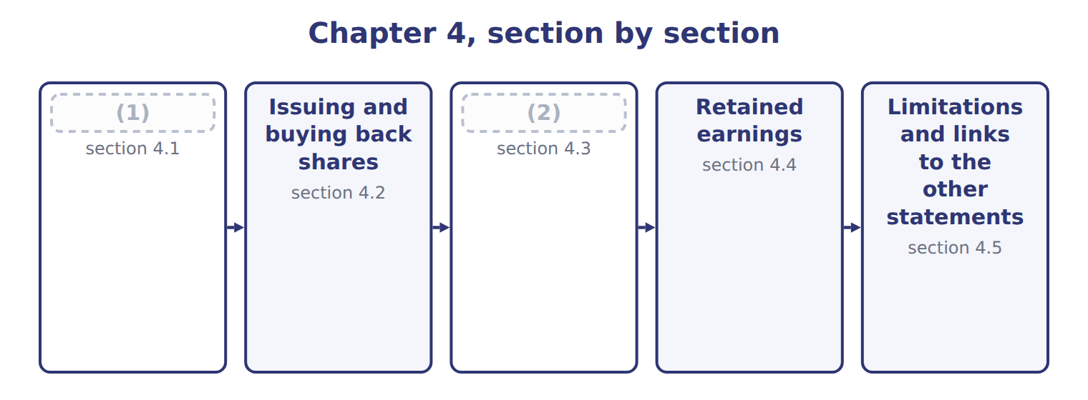
word list
Limitations and links to the other statements · Dividends, stock dividends and stock splits · Components of equity and the statement of chan

Summary 1 gaps 3–10
The (3) of changes in equity explains why each part of equity changed during the period. It (4) two kinds of change. (5) with owners, such as issuing shares and paying dividends, are one kind. (6) income, which the company earns, is the other. Equity has two main parts. (7) capital is what owners have paid: common stock and preferred stock at par or stated value, plus additional paid-in capital. Earned capital is (8) earnings and AOCI. (9) stock is deducted from the total. A (10) interest, if any, is shown separately within equity.
word list
noncontrolling · Transactions · Comprehensive · Contributed · dividends · statement · Treasury · retained · separates

Orontes Foods Inc. — statement of changes in equity, 2025
The parts add up to the total; the bars are to scale.
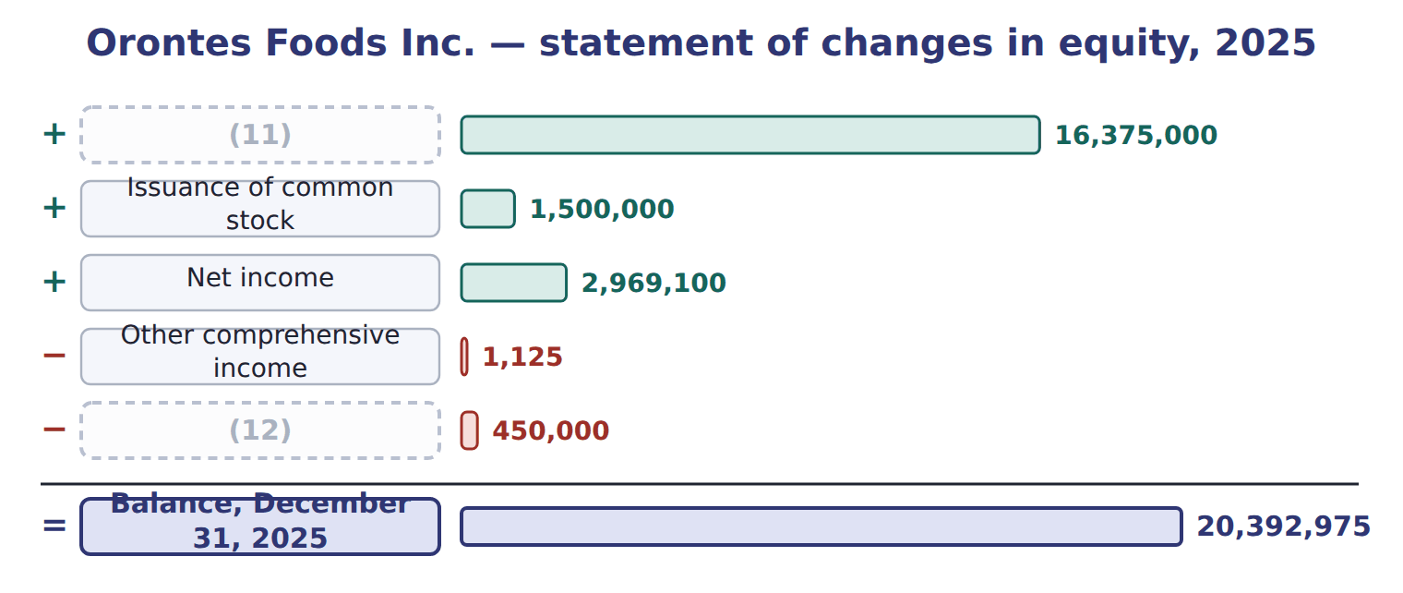
word list
appropriated retained earnings · Cash dividends declared · Balance, January 1, 2025

Summary 2 gaps 13–14
Each column is one equity (13) , and each row is one type of change. The last row equals the equity section of the (14) sheet. Total equity rose by $4,017,975.
word list
separates · balance · account

The English this section uses, and its Arabic
Each term sits against what it means.
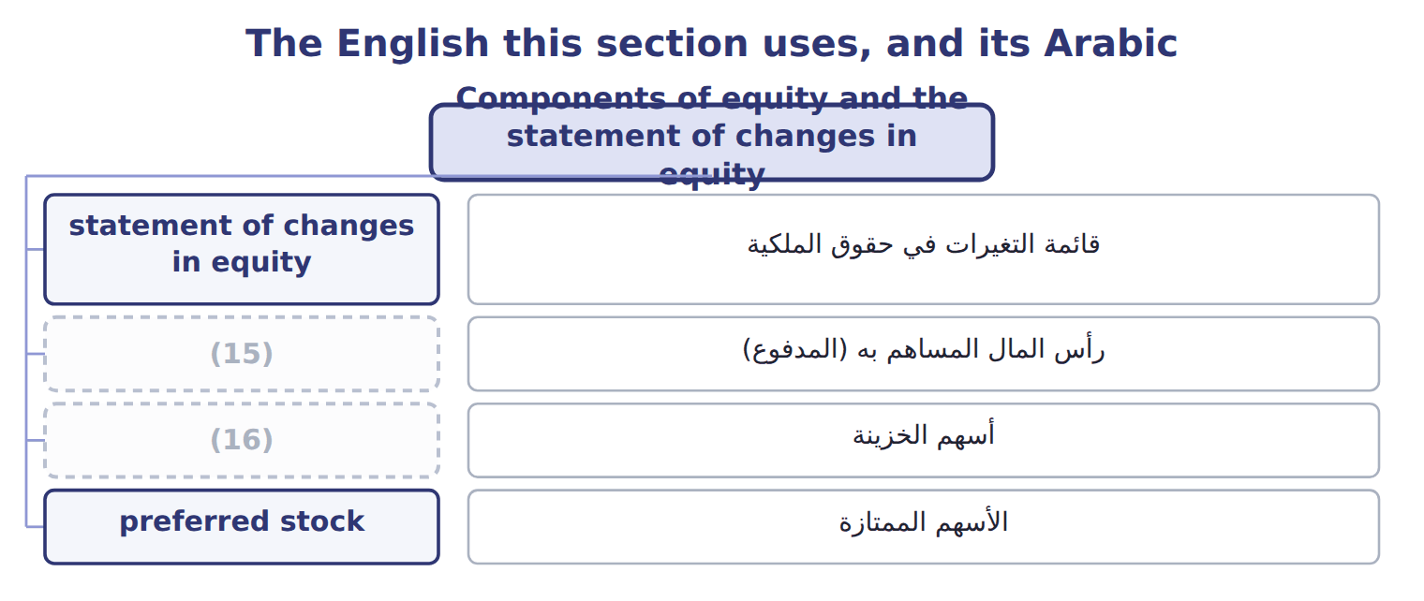
word list
contributed capital · treasury stock · outstanding shares

The English this sheet uses, and its Arabic
English (exam term) | Arabic
contributed capital | رأس المال المساهم به (المدفوع)
preferred stock | الأسهم الممتازة

Answer key · 4.1 Components of equity and the statement of changes in equity

1 Components of equity and the statement of chan | 9 Treasury
2 Dividends, stock dividends and stock splits | 10 noncontrolling
3 statement | 11 Balance, January 1, 2025
4 separates | 12 Cash dividends declared
5 Transactions | 13 account
6 Comprehensive | 14 balance
7 Contributed | 15 contributed capital
8 retained | 16 treasury stock

the summaries in full
Summary 1 The statement of changes in equity explains why each part of equity changed during the period. It separates two kinds of change. Transactions with owners, such as issuing shares and paying dividends, are one kind. Comprehensive income, which the company earns, is the other. Equity has two main parts. Contributed capital is what owners have paid: common stock and preferred stock at par or stated value, plus additional paid-in capital. Earned capital is retained earnings and AOCI. Treasury stock is deducted from the total. A noncontrolling interest, if any, is shown separately within equity.
Summary 2 Each column is one equity account, and each row is one type of change. The last row equals the equity section of the balance sheet. Total equity rose by $4,017,975.

4.2 Issuing and buying back shares
Chapter 4 · section 4.2

Fill every gap. Each word list holds one word more than there are gaps.
Summary 1 gaps 1–12
When a company (1) shares for cash, it (2) common stock with the par value and APIC with the rest. If the shares have no par and no (3) value, the whole (4) goes to common stock. Direct costs of issuing shares, such as (5) fees, reduce APIC; they are not (6) . Shares issued for a (7) asset, such as land, are recorded at the fair value of the shares or of the asset, (8) is more reliable. (9) stock is recorded in the same way, in its own (10) . A company may buy back its own shares and hold them as treasury stock. Under the cost (11) , treasury stock is recorded at the price paid and (12) from equity. Shares held as treasury stock are issued shares but not outstanding shares: they receive no dividends and have no votes. A company never records a gain or loss on its own shares in net income.
word list
Preferred · reduces · amount · stated · account · method · credits · whichever · underwriting · issues · deducted · noncash · expenses

Worked example: treasury stock under the cost method

Summary 2 gaps 13–18
Suppose (13) buys back 50,000 shares at $16 in 2026. Treasury stock is (14) at cost: $800,000. It reissues 20,000 shares at $18. Cash is $360,000 and the cost removed is $320,000, so APIC–treasury stock is (15) with $40,000. It reissues 20,000 more at $13. The (16) below cost is $60,000. APIC–treasury stock absorbs $40,000, and retained earnings absorb the (17) $20,000. No gain or loss (18) in net income.
word list
remaining · credited · shortfall · debited · applies · Orontes · appears

Suppose: Orontes's treasury stock entries in 2026 (cost method)
The bars are drawn to scale.
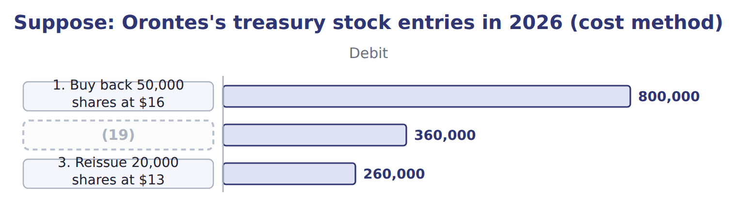
word list
2. Reissue 20,000 shares at $18 · 3. Reissue 20,000 shares at $13

Summary 3 gaps 20–30
If the company (20) its treasury stock (21) , it removes their par value from common stock and the related APIC. Any excess of cost over these (22) reduces retained earnings, or is split (23) APIC and retained earnings. ASU 2025-12 allows companies to charge the whole excess on a (24) to APIC, as long as APIC does not become (25) . It applies to annual periods (26) after December 15, 2026, so it is not (27) before about January 2028. Use the (28) rules on the exam. IFRS also (29) treasury shares from (30) and never shows a gain or loss in profit. It does not prescribe a cost or par-value method, so IFRS companies show the effect in reserves in different ways.
word list
testable · retirement · earnings · between · instead · beginning · current · amounts · equity · deducts · retires · negative

The English this section uses, and its Arabic
Each term sits against what it means.
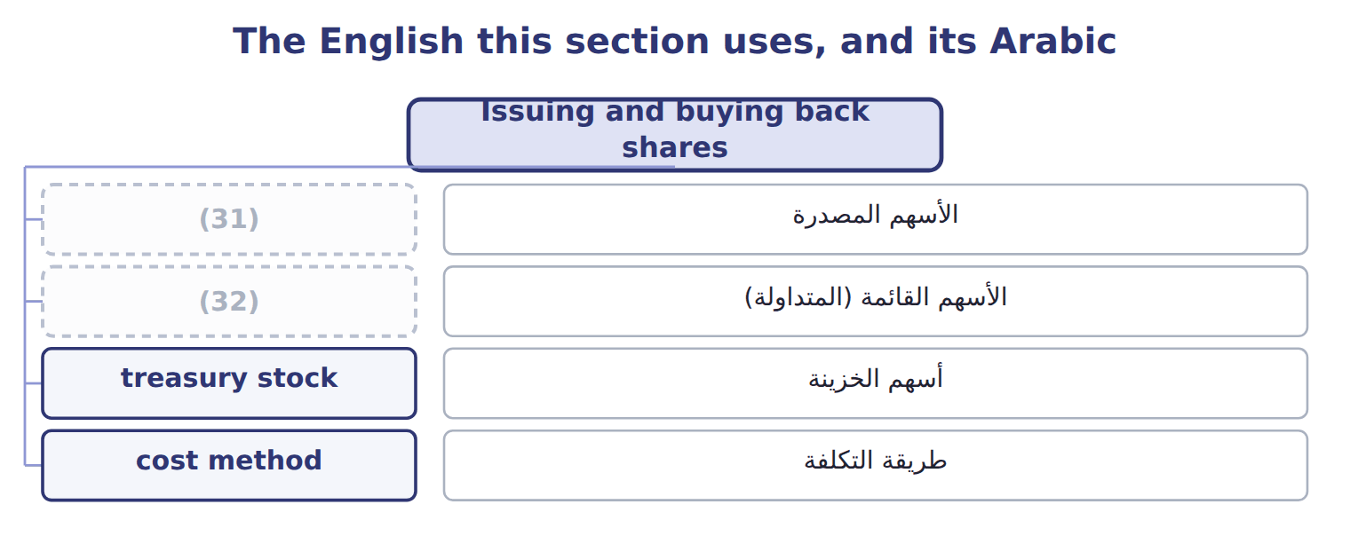
word list
treasury stock · outstanding shares · issued shares

The English this sheet uses, and its Arabic
English (exam term) | Arabic
issued shares | الأسهم المصدرة
outstanding shares | الأسهم القائمة (المتداولة)
treasury stock | أسهم الخزينة
cost method | طريقة التكلفة

Answer key · 4.2 Issuing and buying back shares

1 issues | 17 remaining
2 credits | 18 appears
3 stated | 19 2. Reissue 20,000 shares at $18
4 amount | 20 retires
5 underwriting | 21 instead
6 expenses | 22 amounts
7 noncash | 23 between
8 whichever | 24 retirement
9 Preferred | 25 negative
10 account | 26 beginning
11 method | 27 testable
12 deducted | 28 current
13 Orontes | 29 deducts
14 debited | 30 equity
15 credited | 31 issued shares
16 shortfall | 32 outstanding shares

the summaries in full
Summary 1 When a company issues shares for cash, it credits common stock with the par value and APIC with the rest. If the shares have no par and no stated value, the whole amount goes to common stock. Direct costs of issuing shares, such as underwriting fees, reduce APIC; they are not expenses. Shares issued for a noncash asset, such as land, are recorded at the fair value of the shares or of the asset, whichever is more reliable. Preferred stock is recorded in the same way, in its own account. A company may buy back its own shares and hold them as treasury stock. Under the cost method, treasury stock is recorded at the price paid and deducted from equity. Shares held as treasury stock are issued shares but not outstanding shares: they receive no dividends and have no votes. A company never records a gain or loss on its own shares in net income.
Summary 2 Suppose Orontes buys back 50,000 shares at $16 in 2026. Treasury stock is debited at cost: $800,000. It reissues 20,000 shares at $18. Cash is $360,000 and the cost removed is $320,000, so APIC–treasury stock is credited with $40,000. It reissues 20,000 more at $13. The shortfall below cost is $60,000. APIC–treasury stock absorbs $40,000, and retained earnings absorb the remaining $20,000. No gain or loss appears in net income.
Summary 3 If the company retires its treasury stock instead, it removes their par value from common stock and the related APIC. Any excess of cost over these amounts reduces retained earnings, or is split between APIC and retained earnings. ASU 2025-12 allows companies to charge the whole excess on a retirement to APIC, as long as APIC does not become negative. It applies to annual periods beginning after December 15, 2026, so it is not testable before about January 2028. Use the current rules on the exam. IFRS also deducts treasury shares from equity and never shows a gain or loss in profit. It does not prescribe a cost or par-value method, so IFRS companies show the effect in reserves in different ways.

4.3 Dividends, stock dividends and stock splits
Chapter 4 · section 4.3

Fill every gap. Each word list holds one word more than there are gaps.
Summary 1 gaps 1–10
A cash dividend has three dates. On the (1) date the company debits retained earnings and credits (2) payable, a current liability. On the date of (3) no entry is made; it only (4) who is paid. On the (5) date the liability is paid. Orontes (6) $400,000 in (7) 2025, so that amount is still payable at year-end. A (8) dividend is paid with a (9) asset. The company first (10) the asset to fair value and records any gain or loss, then debits retained earnings at fair value. A scrip dividend creates a note payable. A liquidating dividend returns contributed capital, so it reduces APIC rather than retained earnings.
word list
declaration · decides · property · noncash · payment · record · creates · remeasures · declared · December · dividends

Types of dividends and their effects
Type | Measured at | Retained earnings | Total equity
Cash dividend | (11) | Decreases | Decreases (a liability arises)
Property dividend | Fair value of the asset (gain or loss on remeasurement first) | Decreases | Decreases
Scrip dividend | (12) | Decreases | Decreases (a note payable arises)
Liquidating dividend | Amount beyond retained earnings | No change for that part; APIC decreases | Decreases
Small stock dividend (below about 20–25%) | (13) | Decreases | No change
Large stock dividend (above about 20–25%) | (14) | Decreases | No change
Stock split | No entry; par per share falls | No change | No change

word list
Reissue treasury stock above cost · Amount declared · Face value of the note · Fair value of the shares · Par value of the shares

Summary 2 gaps 15–21
A stock dividend gives (15) more shares (16) of cash. For a small stock dividend, below about 20% to 25% of the (17) shares, the company moves the fair value of the new shares from (18) earnings to common stock and APIC. For a large stock dividend, it moves only the par value. A stock split (19) the number of shares and reduces the par value per share in (20) . Total equity never (21) : only the labels inside equity move.
word list
changes · instead · contributed · retained · increases · proportion · shareholders · outstanding

Suppose: small and large stock dividends and a stock split for Orontes
Every item belongs to exactly one group.
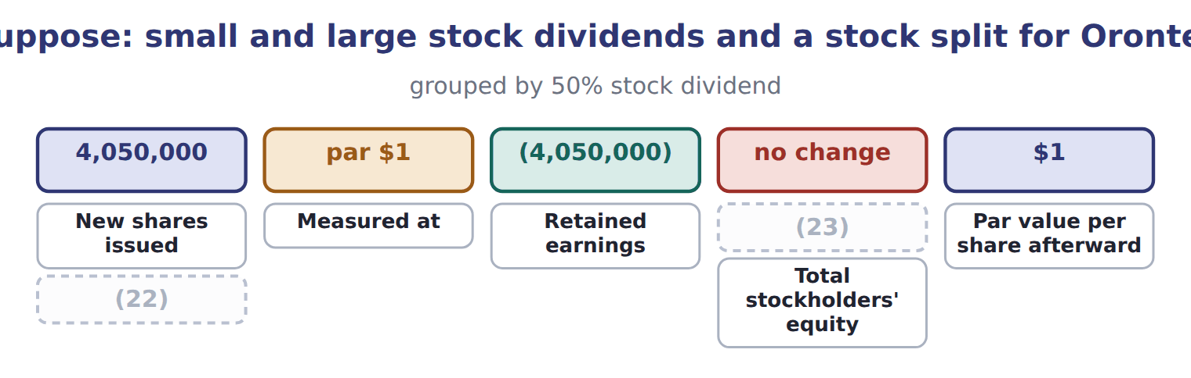
word list
Retained earnings · Additional paid-in capital · Common stock

Effects on retained earnings and total equity

Effects on retained earnings and total equity (complete the blanks)
Every item belongs to exactly one group.
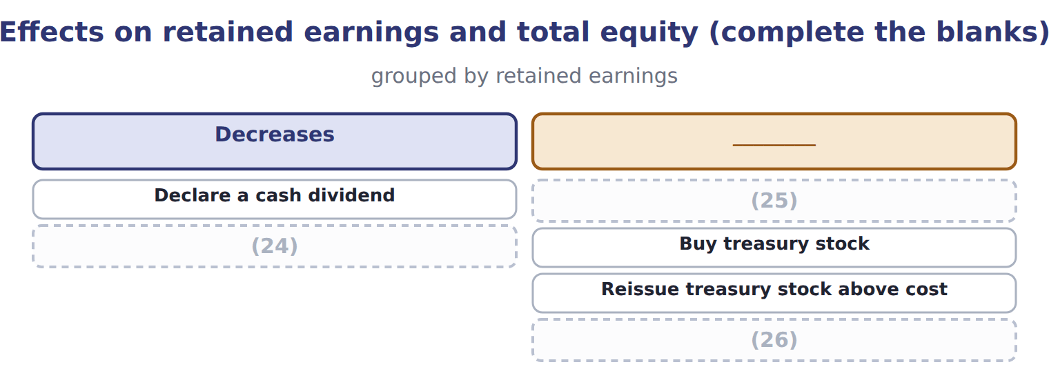
word list
statement of changes in equity · Declare and issue a small stock dividend · Correct a prior-year error that overstated expenses · Carry out a 2-for-1 stock split

Stock dividend traps

Summary 3 gaps 27–29
Small stock dividend at fair value; large stock dividend at par. Do not (27) them. Use (28) shares, not issued shares: treasury stock gets no dividend. A stock dividend (29) is equity, not a liability.
word list
Orontes · reverse · distributable · outstanding

The English this section uses, and its Arabic
Each term sits against what it means.
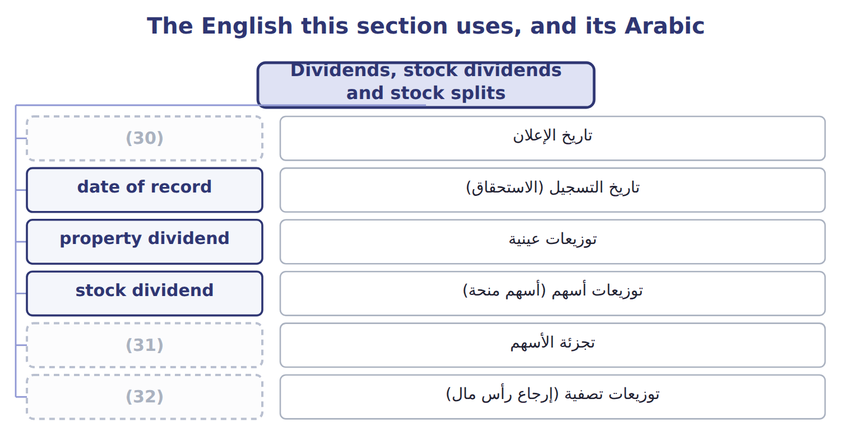
word list
prior-period adjustment · stock split · liquidating dividend · declaration date

The English this sheet uses, and its Arabic
English (exam term) | Arabic
declaration date | تاريخ الإعلان
date of record | تاريخ التسجيل (الاستحقاق)
property dividend | توزيعات عينية
stock dividend | توزيعات أسهم (أسهم منحة)
stock split | تجزئة الأسهم
liquidating dividend | توزيعات تصفية (إرجاع رأس مال)

Answer key · 4.3 Dividends, stock dividends and stock splits

1 declaration | 17 outstanding
2 dividends | 18 retained
3 record | 19 increases
4 decides | 20 proportion
5 payment | 21 changes
6 declared | 22 Common stock
7 December | 23 Additional paid-in capital
8 property | 24 Declare and issue a small stock dividend
9 noncash | 25 Carry out a 2-for-1 stock split
10 remeasures | 26 Correct a prior-year error that overstated expenses
11 Amount declared | 27 reverse
12 Face value of the note | 28 outstanding
13 Fair value of the shares | 29 distributable
14 Par value of the shares | 30 declaration date
15 shareholders | 31 stock split
16 instead | 32 liquidating dividend

the summaries in full
Summary 1 A cash dividend has three dates. On the declaration date the company debits retained earnings and credits dividends payable, a current liability. On the date of record no entry is made; it only decides who is paid. On the payment date the liability is paid. Orontes declared $400,000 in December 2025, so that amount is still payable at year-end. A property dividend is paid with a noncash asset. The company first remeasures the asset to fair value and records any gain or loss, then debits retained earnings at fair value. A scrip dividend creates a note payable. A liquidating dividend returns contributed capital, so it reduces APIC rather than retained earnings.
Summary 2 A stock dividend gives shareholders more shares instead of cash. For a small stock dividend, below about 20% to 25% of the outstanding shares, the company moves the fair value of the new shares from retained earnings to common stock and APIC. For a large stock dividend, it moves only the par value. A stock split increases the number of shares and reduces the par value per share in proportion. Total equity never changes: only the labels inside equity move.
Summary 3 Small stock dividend at fair value; large stock dividend at par. Do not reverse them. Use outstanding shares, not issued shares: treasury stock gets no dividend. A stock dividend distributable is equity, not a liability.

4.4 Retained earnings
Chapter 4 · section 4.4

Fill every gap. Each word list holds one word more than there are gaps.
Summary 1 gaps 1–10
Retained earnings are the (1) a company has kept since it began, less the (2) it has declared. A board may set part of retained earnings aside, for example for a new plant. These (3) retained earnings stay within equity; no costs are ever (4) to them. If a company finds an error in earlier financial (5) , it does not (6) it through this year's net income. It makes a (7) adjustment: it (8) the earlier years and adjusts the opening balance of retained earnings, net of tax. Retained earnings may also be (9) by law or by loan (10) . Restrictions are disclosed in the notes. They do not change the balance.
word list
profits · covenants · statements · dividends · correct · restricted · restates · charged · separate · appropriated · prior-period

Reserves

Summary 2 gaps 11–13
In IFRS and in MENA company law, reserves can mean a legal reserve, a (11) surplus, a translation reserve or share premium. None of these is (12) retained earnings. On a U.S. exam, separate APIC, retained earnings ( (13) or not) and AOCI.
word list
declared · simply · appropriated · revaluation

The English this sheet uses, and its Arabic
English (exam term) | Arabic
appropriated retained earnings | أرباح مبقاة مخصصة
prior-period adjustment | تسوية سنوات سابقة

Answer key · 4.4 Retained earnings

1 profits | 8 restates
2 dividends | 9 restricted
3 appropriated | 10 covenants
4 charged | 11 revaluation
5 statements | 12 simply
6 correct | 13 appropriated
7 prior-period

the summaries in full
Summary 1 Retained earnings are the profits a company has kept since it began, less the dividends it has declared. A board may set part of retained earnings aside, for example for a new plant. These appropriated retained earnings stay within equity; no costs are ever charged to them. If a company finds an error in earlier financial statements, it does not correct it through this year's net income. It makes a prior-period adjustment: it restates the earlier years and adjusts the opening balance of retained earnings, net of tax. Retained earnings may also be restricted by law or by loan covenants. Restrictions are disclosed in the notes. They do not change the balance.
Summary 2 In IFRS and in MENA company law, reserves can mean a legal reserve, a revaluation surplus, a translation reserve or share premium. None of these is simply retained earnings. On a U.S. exam, separate APIC, retained earnings (appropriated or not) and AOCI.

4.5 Limitations and links to the other statements
Chapter 4 · section 4.5

Fill every gap. Each word list holds one word more than there are gaps.
Summary 1 gaps 1–10
Total equity is a book value: assets minus (1) , as measured by the (2) rules. It is not what the company is worth. Most assets are at (3) cost, and internally built brands and (4) are not recorded. (5) stock is shown at the price paid, not at (6) share price. Legal (7) rules also differ from state to state, so equity does not show exactly how much a company may legally (8) . The statement of changes in equity takes net income and OCI from the statement of (9) income, and dividends and share issues from the company's owner (10) . Its closing balances are the equity section of the balance sheet.
word list
Treasury · know-how · recorded · today's · liabilities · distribute · accounting · capital · historical · comprehensive · transactions

Balance / event (USD 000 unless stated) — Amount / details
Balance / event (USD 000 unless stated) | Amount / details
Common stock, $1 par (600,000 shares issued and outstanding) | 600
Additional paid-in capital | 1,900
Retained earnings | 1,280
Total stockholders' equity, January 1, 2026 | 3,780
E1 | (11) : Barada bought 80,000 of its own shares at $6 per share (cost method).
E2 | (12) : Barada reissued 20,000 treasury shares at $8 per share.
E3 | August 20: Barada reissued 10,000 treasury shares at $4 per share.
E4 | October 1: Barada declared and issued a 10% stock dividend. The market price was $7 per share.
E5 | (13) : Barada declared a cash dividend of $0.20 per outstanding share, payable in January 2027.
E6 | Net income for 2026 was 165 (the Chapter 3 case).

word list
June 10 · March 5 · prior-period adjustment · December 15

Item — Answer
Item | Answer
2-for-1 stock split | (14) earnings: no change. Total equity: no change (no entry is made).
Buy treasury stock | Retained earnings: no change. Total equity: decreases by the cost.
Reissue treasury stock above cost | Retained earnings: no change (the excess goes to APIC–treasury stock). Total equity: increases by the cash received.
Correct an error that overstated expenses | Retained earnings: opening balance increases, net of tax. Total equity: increases.

word list
decreases · Retained

Account — Category
Account | Category
APIC–treasury stock | Contributed capital
Retained earnings | Earned capital
Treasury stock | (15)
Dividends payable | (16)
Common stock | (17)

word list
date of record · Contributed capital · Current liability · Deduction from equity

The English this section uses, and its Arabic
Each term sits against what it means.
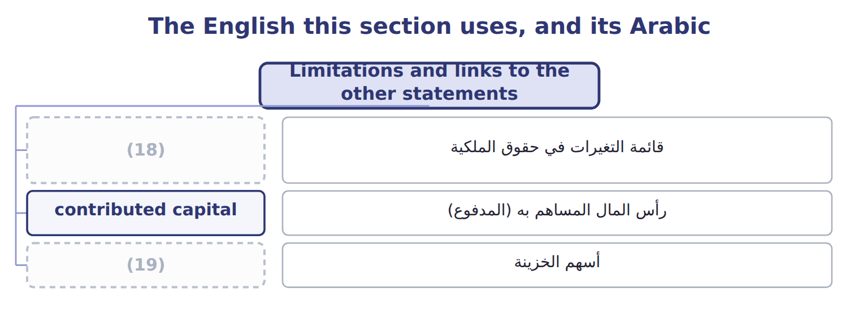
word list
treasury stock · property dividend · statement of changes in equity

Answer key · 4.5 Limitations and links to the other statements

1 liabilities | 11 March 5
2 accounting | 12 June 10
3 historical | 13 December 15
4 know-how | 14 Retained
5 Treasury | 15 Deduction from equity
6 today's | 16 Current liability
7 capital | 17 Contributed capital
8 distribute | 18 statement of changes in equity
9 comprehensive | 19 treasury stock
10 transactions

the summaries in full
Summary 1 Total equity is a book value: assets minus liabilities, as measured by the accounting rules. It is not what the company is worth. Most assets are at historical cost, and internally built brands and know-how are not recorded. Treasury stock is shown at the price paid, not at today's share price. Legal capital rules also differ from state to state, so equity does not show exactly how much a company may legally distribute. The statement of changes in equity takes net income and OCI from the statement of comprehensive income, and dividends and share issues from the company's owner transactions. Its closing balances are the equity section of the balance sheet.

