6.1 Recognizing and measuring receivables
Chapter 6 · section 6.1

Fill every gap. Each word list holds one word more than there are gaps.
Chapter 6, section by section
Each stage leads to the next.
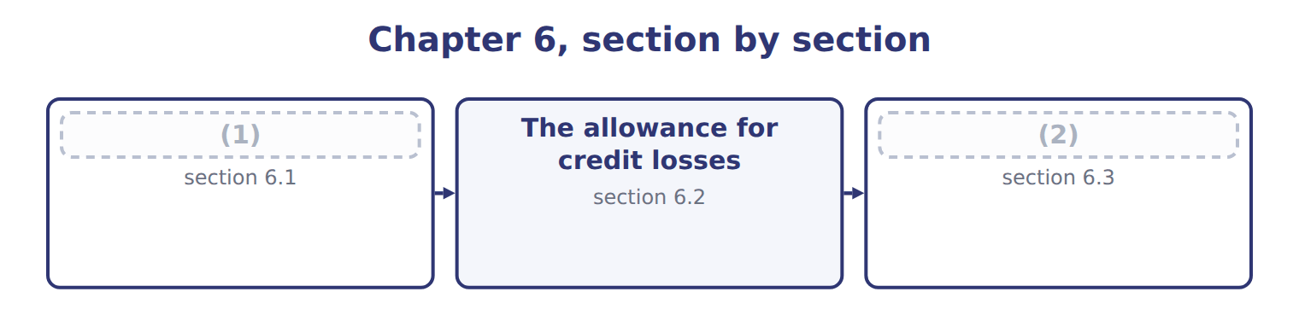
word list
The allowance for credit losses · Recognizing and measuring receivables · Transferring receivables: sale or secured borr

Summary 1 gaps 3–14
A company records an (3) receivable when its right to be paid is (4) : only the passage of time is needed before payment is due. This usually happens when it (5) the goods or services and (6) control. If the company still has to do (7) else before it can bill, for example finish a second (8) , it has a contract asset, not a receivable. The receivable is measured at the (9) price: the amount the company (10) to receive. Expected (11) , rebates and cash discount amounts are variable (12) , so they reduce revenue and the receivable. Some older (13) still use the gross and net (14) . Under the gross method, the company records the full invoice and records a sales discount only when a customer pays early. Under the net method, it records the sale net of the discount, and records sales discounts forfeited when a customer pays late.
word list
transfers · unconditional · transaction · expects · delivers · something · returns · methods · delivery · questions · account · write-off · consideration

Summary 2 gaps 15–19
Trade (15) that are due within one year are not discounted to present value. Notes receivable are (16) . An (17) note is carried at its face amount plus accrued interest. A note with no interest, or with a rate below the market rate, is (18) at its present value. The discount is then (19) to interest revenue over the life of the note.
word list
recorded · amortized · invoice · receivables · interest-bearing · different

Receivable or contract asset?

Summary 3 gaps 20–21
Receivable: only time must pass before (20) . (21) asset: the company must still perform. Expected cash discounts and returns reduce the receivable at the start, not only when they happen.
word list
Contract · transaction · payment

The English this section uses, and its Arabic
Each term sits against what it means.
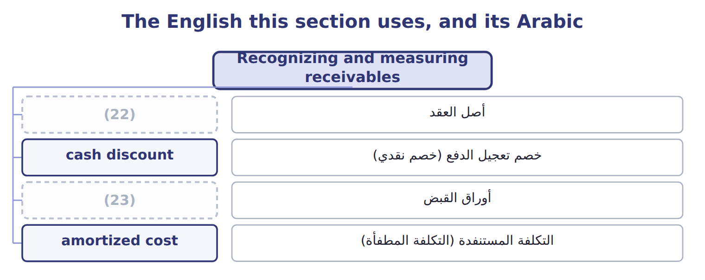
word list
notes receivable · secured borrowing · contract asset

The English this sheet uses, and its Arabic
English (exam term) | Arabic
contract asset | أصل العقد
cash discount | خصم تعجيل الدفع (خصم نقدي)
notes receivable | أوراق القبض
amortized cost | التكلفة المستنفدة (التكلفة المطفأة)

Answer key · 6.1 Recognizing and measuring receivables

1 Recognizing and measuring receivables | 13 questions
2 Transferring receivables: sale or secured borr | 14 methods
3 account | 15 receivables
4 unconditional | 16 different
5 delivers | 17 interest-bearing
6 transfers | 18 recorded
7 something | 19 amortized
8 delivery | 20 payment
9 transaction | 21 Contract
10 expects | 22 contract asset
11 returns | 23 notes receivable
12 consideration

the summaries in full
Summary 1 A company records an account receivable when its right to be paid is unconditional: only the passage of time is needed before payment is due. This usually happens when it delivers the goods or services and transfers control. If the company still has to do something else before it can bill, for example finish a second delivery, it has a contract asset, not a receivable. The receivable is measured at the transaction price: the amount the company expects to receive. Expected returns, rebates and cash discount amounts are variable consideration, so they reduce revenue and the receivable. Some older questions still use the gross and net methods. Under the gross method, the company records the full invoice and records a sales discount only when a customer pays early. Under the net method, it records the sale net of the discount, and records sales discounts forfeited when a customer pays late.
Summary 2 Trade receivables that are due within one year are not discounted to present value. Notes receivable are different. An interest-bearing note is carried at its face amount plus accrued interest. A note with no interest, or with a rate below the market rate, is recorded at its present value. The discount is then amortized to interest revenue over the life of the note.
Summary 3 Receivable: only time must pass before payment. Contract asset: the company must still perform. Expected cash discounts and returns reduce the receivable at the start, not only when they happen.

6.2 The allowance for credit losses
Chapter 6 · section 6.2

Fill every gap. Each word list holds one word more than there are gaps.
Summary 1 gaps 1–12
Under current expected credit losses (CECL), a company (1) its receivables net of an allowance that (2) all the credit losses it expects over their life. It (3) these expected losses from the first day. It does not wait until a loss becomes (4) . The estimate uses past (5) , current conditions and reasonable and (6) forecasts. Trade receivables are measured at (7) cost, and the allowance is a (8) account. The balance sheet shows receivables minus the allowance: the (9) the company expects to (10) . A (11) method is the aging (12) . The company groups its receivables by how long they are past due and applies an expected loss rate to each group. The rates start from history and are adjusted for current conditions and forecasts. The total is the balance the allowance must have at the end of the year.
word list
experience · supportable · covers · records · collect · expected · common · schedule · presents · amortized · amount · probable · contra-asset

The Amman sales office at December 31, 2025

Aging schedule, Orontes Amman sales office, December 31, 2025 (whole USD)
Name each point on the scale from where it sits.
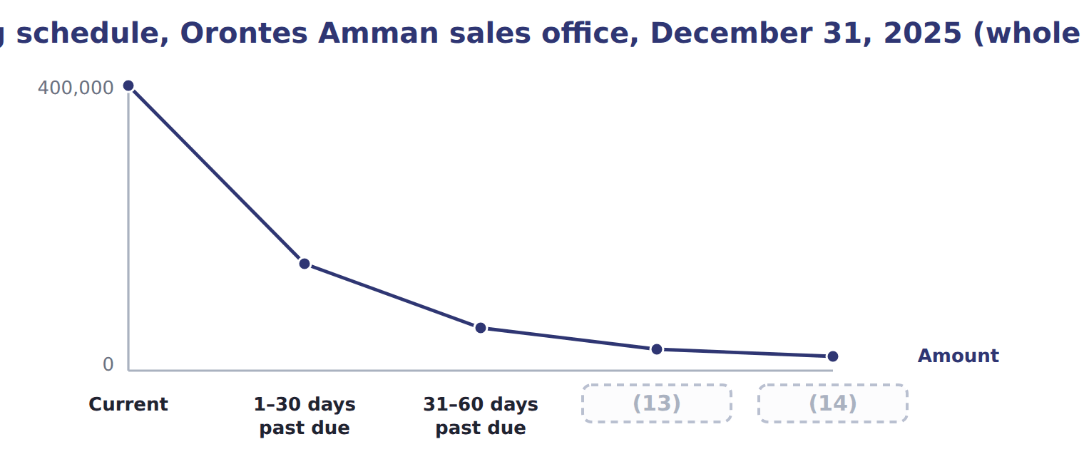
word list
Over 90 days past due · 61–90 days past due · holdback (due from factor)

Summary 2 gaps 15–26
The allowance must end the year at $34,000. During the year, the allowance (15) at $30,000, Orontes wrote off $26,000 of bad receivables and (16) $2,000 that it had written off earlier. The (17) entry is: debit Credit loss expense $28,000, credit Allowance for credit losses $28,000. Net receivables on the balance sheet are $660,000 − $34,000 = $626,000. When a (18) balance is clearly (19) , the company records a write-off: debit the allowance and credit accounts receivable. The write-off (20) neither net income nor net receivables, because the expense was already (21) when the allowance was built. If the customer later pays, the company records a (22) : it first reinstates the receivable (debit accounts receivable, credit allowance) and then records the cash (23) . Older (24) sometimes estimate the expense as a (25) of credit sales. This (26) approach does not measure the expected losses on the ending receivables, so under CECL the aging (balance-sheet) approach is the better choice.
word list
changes · recorded · collection · percentage · customer's · probable · questions · recovery · income-statement · recovered · started · uncollectible · journal

Barada Wholesale's allowance

Summary 3 gaps 27–28
The first row is done. (27) the other rows and the total, then check your total against (28) trial balance.
word list
Barada's · Complete · financial

Barada Wholesale aging, December 31, 2025 (whole USD): complete the blanks
The parts add up to the total; the bars are to scale.
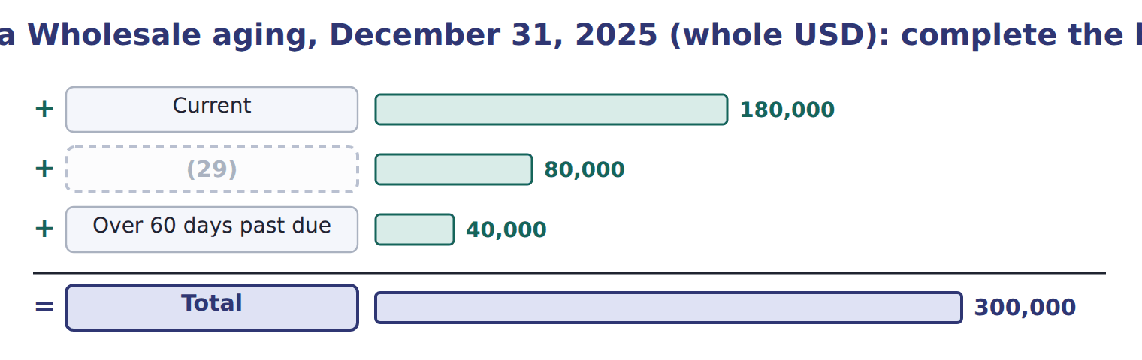
word list
1–60 days past due · allowance for credit losses

Summary 4 gaps 30–40
In 2025 the FASB added a practical expedient: when (30) losses on current receivables, any company may assume that (31) at the balance sheet date will not change. (32) companies may also use cash (33) after year-end. It applies to annual periods (34) after December 15, 2025, so under the (35) rule it is not yet tested on the CMA exam. IFRS 9 also uses expected losses. For trade receivables it uses a (36) approach that always records lifetime losses, often with a (37) matrix, which is very close to CECL. For other (38) assets, IFRS 9 starts with 12-month expected losses and moves to lifetime losses only after credit risk increases (39) . CECL records lifetime losses from day one for all assets at (40) cost.
word list
financial · year-end · conditions · collected · significantly · one-year · forecasting · provision · simplified · beginning · amortized · Private

Allowance or provision?

Summary 5 gaps 41–43
An allowance (41) an asset. A provision under IAS 37 is a (42) . In a U.S. GAAP answer, always write allowance for credit losses, never provision for (43) debts or reserve for bad debts.
word list
records · reduces · doubtful · liability

Balance first, then the expense

Summary 6 gaps 44–46
The aging gives the required ENDING (44) , not the expense. Expense = required balance − unadjusted (45) balance, or required balance + unadjusted debit balance. A (46) does not change net income or net receivables.
word list
approach · credit · write-off · allowance

Allowance method (CECL) versus direct write-off method, Amman sales office 2025 (whole USD)
 | Allowance method (CECL) | Direct write-off method
When is the expense recorded? | (47) | Only when a customer's balance is written off
Expense in 2025 (Amman office) | 28,000 | 26,000
Receivables on the balance sheet | Net: 626,000 | (48)
Acceptable under U.S. GAAP? | Yes (CECL) | (49)

word list
Each period, for expected losses (matching) · Over 60 days past due · Gross: 660,000 (overstated) · No, when bad debts are material; used for U.S. tax

The English this section uses, and its Arabic
Each term sits against what it means.
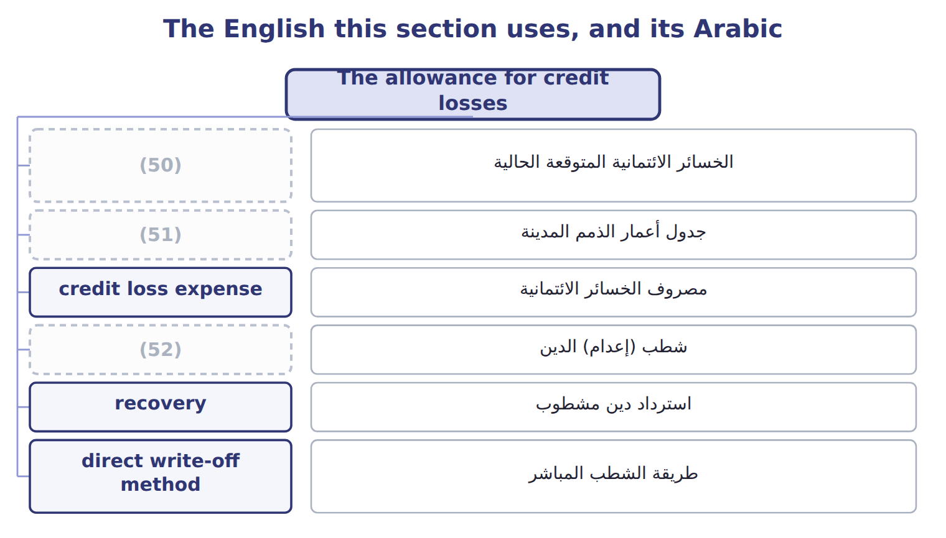
word list
current expected credit losses (CECL) · aging schedule · write-off · factor

The English this sheet uses, and its Arabic
English (exam term) | Arabic
current expected credit losses (CECL) | الخسائر الائتمانية المتوقعة الحالية
aging schedule | جدول أعمار الذمم المدينة
credit loss expense | مصروف الخسائر الائتمانية
write-off | شطب (إعدام) الدين
recovery | استرداد دين مشطوب
direct write-off method | طريقة الشطب المباشر

Answer key · 6.2 The allowance for credit losses

1 presents | 27 Complete
2 covers | 28 Barada's
3 records | 29 1–60 days past due
4 probable | 30 forecasting
5 experience | 31 conditions
6 supportable | 32 Private
7 amortized | 33 collected
8 contra-asset | 34 beginning
9 amount | 35 one-year
10 collect | 36 simplified
11 common | 37 provision
12 schedule | 38 financial
13 61–90 days past due | 39 significantly
14 Over 90 days past due | 40 amortized
15 started | 41 reduces
16 recovered | 42 liability
17 journal | 43 doubtful
18 customer's | 44 allowance
19 uncollectible | 45 credit
20 changes | 46 write-off
21 recorded | 47 Each period, for expected losses (matching)
22 recovery | 48 Gross: 660,000 (overstated)
23 collection | 49 No, when bad debts are material; used for U.S. tax
24 questions | 50 current expected credit losses (CECL)
25 percentage | 51 aging schedule
26 income-statement | 52 write-off

the summaries in full
Summary 1 Under current expected credit losses (CECL), a company presents its receivables net of an allowance that covers all the credit losses it expects over their life. It records these expected losses from the first day. It does not wait until a loss becomes probable. The estimate uses past experience, current conditions and reasonable and supportable forecasts. Trade receivables are measured at amortized cost, and the allowance is a contra-asset account. The balance sheet shows receivables minus the allowance: the amount the company expects to collect. A common method is the aging schedule. The company groups its receivables by how long they are past due and applies an expected loss rate to each group. The rates start from history and are adjusted for current conditions and forecasts. The total is the balance the allowance must have at the end of the year.
Summary 2 The allowance must end the year at $34,000. During the year, the allowance started at $30,000, Orontes wrote off $26,000 of bad receivables and recovered $2,000 that it had written off earlier. The journal entry is: debit Credit loss expense $28,000, credit Allowance for credit losses $28,000. Net receivables on the balance sheet are $660,000 − $34,000 = $626,000. When a customer's balance is clearly uncollectible, the company records a write-off: debit the allowance and credit accounts receivable. The write-off changes neither net income nor net receivables, because the expense was already recorded when the allowance was built. If the customer later pays, the company records a recovery: it first reinstates the receivable (debit accounts receivable, credit allowance) and then records the cash collection. Older questions sometimes estimate the expense as a percentage of credit sales. This income-statement approach does not measure the expected losses on the ending receivables, so under CECL the aging (balance-sheet) approach is the better choice.
Summary 3 The first row is done. Complete the other rows and the total, then check your total against Barada's trial balance.
Summary 4 In 2025 the FASB added a practical expedient: when forecasting losses on current receivables, any company may assume that conditions at the balance sheet date will not change. Private companies may also use cash collected after year-end. It applies to annual periods beginning after December 15, 2025, so under the one-year rule it is not yet tested on the CMA exam. IFRS 9 also uses expected losses. For trade receivables it uses a simplified approach that always records lifetime losses, often with a provision matrix, which is very close to CECL. For other financial assets, IFRS 9 starts with 12-month expected losses and moves to lifetime losses only after credit risk increases significantly. CECL records lifetime losses from day one for all assets at amortized cost.
Summary 5 An allowance reduces an asset. A provision under IAS 37 is a liability. In a U.S. GAAP answer, always write allowance for credit losses, never provision for doubtful debts or reserve for bad debts.
Summary 6 The aging gives the required ENDING allowance, not the expense. Expense = required balance − unadjusted credit balance, or required balance + unadjusted debit balance. A write-off does not change net income or net receivables.

6.3 Transferring receivables: sale or secured borrowing?
Chapter 6 · section 6.3

Fill every gap. Each word list holds one word more than there are gaps.
Summary 1 gaps 1–6
U.S. GAAP (1) a transfer as a sale only if three conditions are all met. Recourse is the (2) right to collect from the seller if (3) do not pay. Recourse does not by (4) make the transfer a (5) . If the three conditions are met, a transfer with recourse is still a sale. The seller then records a recourse (6) at its fair value, which increases the loss on the sale.
word list
receivables · liability · itself · customers · treats · factor's · borrowing

Orontes factors its receivables

The steps, in order
Each stage leads to the next.
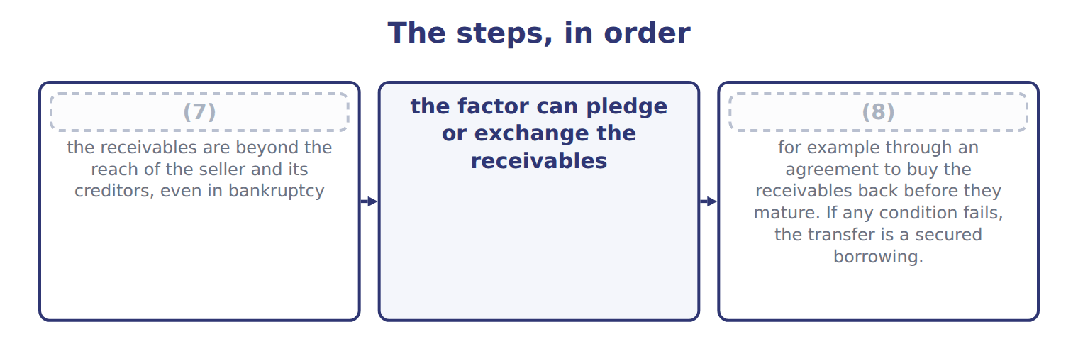
word list
legal isolation · the seller does not keep effective control · credit loss expense

Summary 2 gaps 9–20
Orontes (9) receivables with a carrying amount of $500,000 to Gulf Factor Co. The factor charges a fee of 3% ($15,000) and keeps a holdback (due from factor) of 5% ($25,000) to cover returns and (10) . Orontes (11) $460,000 in cash. Sale (12) recourse: debit Cash $460,000, debit Due from factor $25,000, debit Loss on sale of receivables $15,000; credit Accounts (13) $500,000. Sale with recourse (recourse liability $6,000): the same entry, but the loss is $21,000 and Orontes also (14) Recourse liability $6,000. Secured (15) : debit Cash $460,000, debit (16) expense $15,000; credit Liability to factor $475,000. The receivables stay on the balance sheet, marked as (17) . The balance sheet (18) is the main (19) companies care. A sale (20) the receivables and adds little or no debt, so ratios such as debt to equity look better.
word list
pledged · receivable · records · credits · receives · effect · borrowing · Interest · removes · transfers · reason · discounts · without

Summary 3 gaps 21–27
A (21) borrowing keeps the receivables and adds a (22) . Lenders and (23) read the notes to see which receivables are (24) or transferred. IFRS 9 asks first (25) the seller has transferred (26) all the risks and rewards of the receivables. (27) with substantial recourse usually keeps most of the risk with the seller, so under IFRS it often fails derecognition and is treated as borrowing. Under U.S. GAAP the same transfer may qualify as a sale if the three ASC 860 conditions are met.
word list
analysts · substantially · whether · Lenders · liability · Factoring · pledged · secured

Recourse is not the test

Summary 4 gaps 28–30
Do not assume that every transfer with (28) is a borrowing. Apply the three (29) . The holdback is an asset (due from (30) ), not part of the loss. Pledged receivables stay on the balance sheet.
word list
treated · recourse · conditions · factor

Recourse is not the test
Item | Details (whole USD)
Aging | Current: 250,000 at an expected loss rate of 2%
Aging | (31) : 90,000 at an expected loss rate of 10%
Aging | (32) : 40,000 at an expected loss rate of 40%
Allowance account | Beginning balance 18,000 (credit). (33) during 2025: 24,000. Recoveries: 1,000.
Transfer T1 | Receivables sold to a factor without recourse. The factor may resell them. Orontes has no right or duty to buy them back.
Transfer T2 | Receivables transferred with recourse. They are legally isolated from Orontes, the factor may pledge them, and Orontes cannot buy them back.
Transfer T3 | Receivables transferred to a bank, but Orontes must repurchase them before they mature.
Transfer T4 | Receivables pledged as collateral for a bank loan; Orontes still collects them.
Transfer T2 details | Carrying amount 200,000; factor's fee 2%; holdback 4%; fair value of the recourse obligation 3,000.

word list
T1 · Write-offs · Over 60 days past due · 1–60 days past due

Item — Answer
Item | Answer
1–60 days past due | 80,000 × 8% = 6,400
Over 60 days past due | (34)
Required allowance | (35)

word list
40,000 × 25% = 10,000 · 3,600 + 6,400 + 10,000 = 20,000 · current expected credit losses (CECL)

Transfer — Category
Every item belongs to exactly one group.
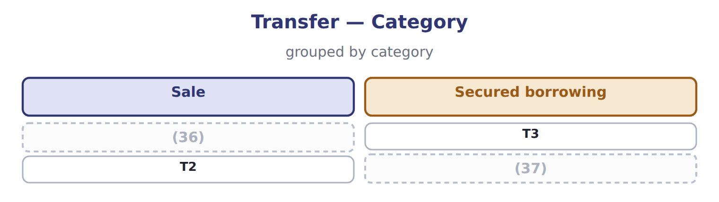
word list
T1 · factor · T4

The English this section uses, and its Arabic
Each term sits against what it means.
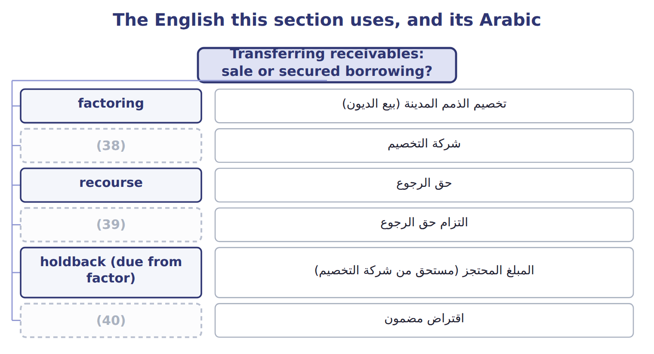
word list
factor · aging schedule · recourse liability · secured borrowing

The English this sheet uses, and its Arabic
English (exam term) | Arabic
factoring | تخصيم الذمم المدينة (بيع الديون)
factor | شركة التخصيم
recourse | حق الرجوع
recourse liability | التزام حق الرجوع
holdback (due from factor) | المبلغ المحتجز (مستحق من شركة التخصيم)
secured borrowing | اقتراض مضمون
pledging | رهن الذمم المدينة
effective control | السيطرة الفعلية
legal isolation | العزل القانوني

Answer key · 6.3 Transferring receivables: sale or secured borrowing?

1 treats | 21 secured
2 factor's | 22 liability
3 customers | 23 analysts
4 itself | 24 pledged
5 borrowing | 25 whether
6 liability | 26 substantially
7 legal isolation | 27 Factoring
8 the seller does not keep effective control | 28 recourse
9 transfers | 29 conditions
10 discounts | 30 factor
11 receives | 31 1–60 days past due
12 without | 32 Over 60 days past due
13 receivable | 33 Write-offs
14 credits | 34 40,000 × 25% = 10,000
15 borrowing | 35 3,600 + 6,400 + 10,000 = 20,000
16 Interest | 36 T1
17 pledged | 37 T4
18 effect | 38 factor
19 reason | 39 recourse liability
20 removes | 40 secured borrowing

the summaries in full
Summary 1 U.S. GAAP treats a transfer as a sale only if three conditions are all met. Recourse is the factor's right to collect from the seller if customers do not pay. Recourse does not by itself make the transfer a borrowing. If the three conditions are met, a transfer with recourse is still a sale. The seller then records a recourse liability at its fair value, which increases the loss on the sale.
Summary 2 Orontes transfers receivables with a carrying amount of $500,000 to Gulf Factor Co. The factor charges a fee of 3% ($15,000) and keeps a holdback (due from factor) of 5% ($25,000) to cover returns and discounts. Orontes receives $460,000 in cash. Sale without recourse: debit Cash $460,000, debit Due from factor $25,000, debit Loss on sale of receivables $15,000; credit Accounts receivable $500,000. Sale with recourse (recourse liability $6,000): the same entry, but the loss is $21,000 and Orontes also credits Recourse liability $6,000. Secured borrowing: debit Cash $460,000, debit Interest expense $15,000; credit Liability to factor $475,000. The receivables stay on the balance sheet, marked as pledged. The balance sheet effect is the main reason companies care. A sale removes the receivables and adds little or no debt, so ratios such as debt to equity look better.
Summary 3 A secured borrowing keeps the receivables and adds a liability. Lenders and analysts read the notes to see which receivables are pledged or transferred. IFRS 9 asks first whether the seller has transferred substantially all the risks and rewards of the receivables. Factoring with substantial recourse usually keeps most of the risk with the seller, so under IFRS it often fails derecognition and is treated as borrowing. Under U.S. GAAP the same transfer may qualify as a sale if the three ASC 860 conditions are met.
Summary 4 Do not assume that every transfer with recourse is a borrowing. Apply the three conditions. The holdback is an asset (due from factor), not part of the loss. Pledged receivables stay on the balance sheet.

