12.1 Why one overhead rate can mislead
Chapter 12 · section 12.1

Fill every gap. Each word list holds one word more than there are gaps.
Chapter 12, section by section
Each stage leads to the next.
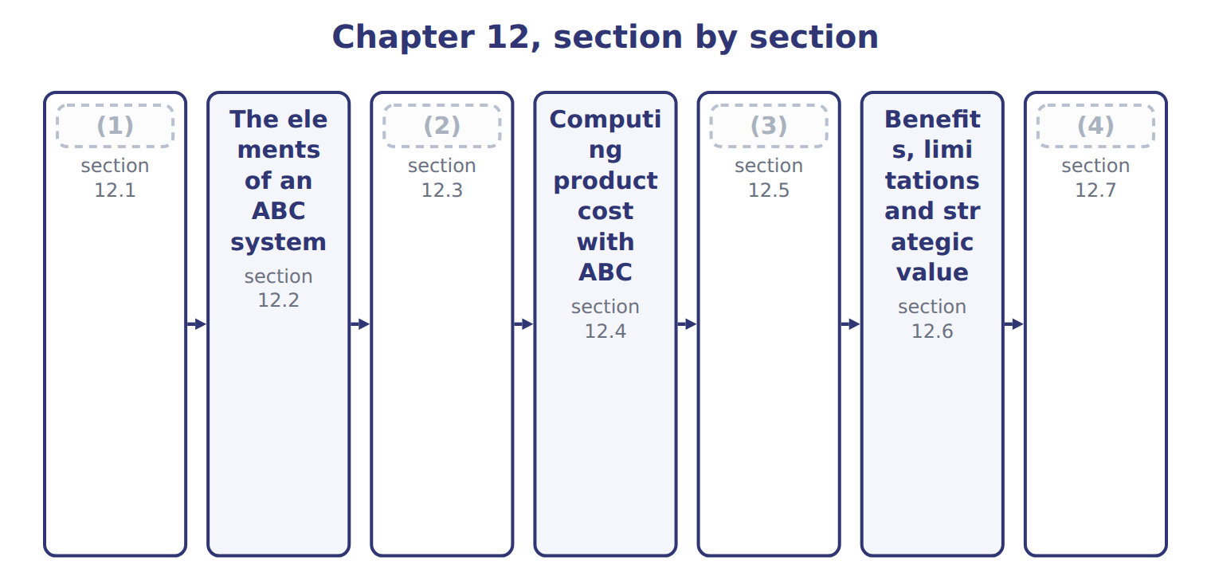
word list
Extended Example 12A: Pulses & Spices in 2027 · ABC as a cost accumulation system · The cost hierarchy · Benefits, limitations and strategic value · Why one overhead rate can mislead

Summary 1 gaps 5–13
A (5) system collects overhead in one pool and (6) it with one volume measure, such as direct labor hours. That works when every product uses overhead in the same way as it uses labor. (7) & Spices has $900,000 of overhead. At $36 a labor hour, (8) receive $720,000 (9) they use most of the labor. Za'atar (10) $180,000, although its many small batches need most of the setups, tests and (11) . The result is cost (12) . (13) , simple products are overcosted, and low-volume, complex products are undercosted. Prices and product decisions based on these costs go wrong.
word list
traditional · spreads · lentils · receipts · receives · because · whether · High-volume · distortion · Pulses

Volume drivers for batch costs

Summary 2 gaps 14–15
A setup costs the same (14) the batch is large or small. If an exam (15) spreads setup costs by units or labor hours, the answer will overcost the large batches.
word list
whether · question · High-volume

Answer key · 12.1 Why one overhead rate can mislead

1 Why one overhead rate can mislead | 9 because
2 The cost hierarchy | 10 receives
3 ABC as a cost accumulation system | 11 receipts
4 Extended Example 12A: Pulses & Spices in 2027 | 12 distortion
5 traditional | 13 High-volume
6 spreads | 14 whether
7 Pulses | 15 question
8 lentils

the summaries in full
Summary 1 A traditional system collects overhead in one pool and spreads it with one volume measure, such as direct labor hours. That works when every product uses overhead in the same way as it uses labor. Pulses & Spices has $900,000 of overhead. At $36 a labor hour, lentils receive $720,000 because they use most of the labor. Za'atar receives $180,000, although its many small batches need most of the setups, tests and receipts. The result is cost distortion. High-volume, simple products are overcosted, and low-volume, complex products are undercosted. Prices and product decisions based on these costs go wrong.
Summary 2 A setup costs the same whether the batch is large or small. If an exam question spreads setup costs by units or labor hours, the answer will overcost the large batches.

12.2 The elements of an ABC system
Chapter 12 · section 12.2

Fill every gap. Each word list holds one word more than there are gaps.
Summary 1 gaps 1–7
An activity is a task that uses (1) , such as a setup or a (2) test. Each activity has an activity cost pool: the total cost of doing it. (3) costing assigns (4) to these pools first and then to products. The first stage uses resource drivers, such as the share of staff time spent on each activity. The (5) stage uses activity drivers, such as the number of setups each (6) needs. Both are cost drivers: they (7) what causes the cost.
word list
quality · resources · Activity-based · product · drivers · second · measure · overhead

Resource drivers: filling the five activity pools
The parts add up to the total; the bars are to scale.
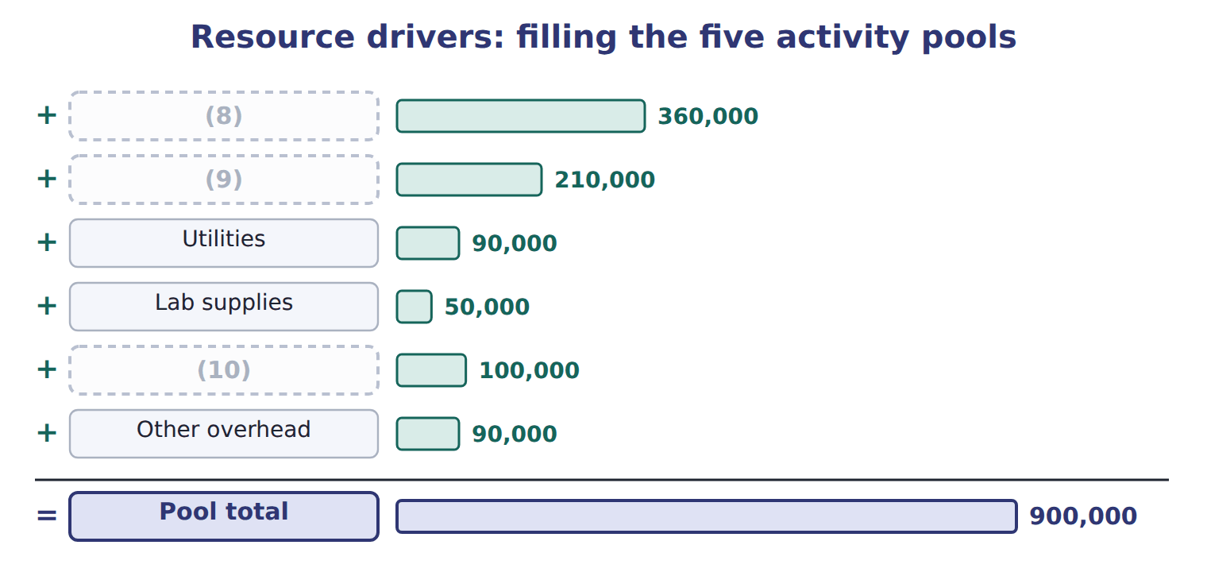
word list
product-sustaining cost · Indirect labor · Equipment depreciation · Warehouse lease

Summary 2 gaps 11–14
A value-added activity is one that customers would pay for, such as (11) . (12) , moving and (13) add cost but not value; ABC makes them visible so managers can reduce them. Here, a value-added activity means an activity customers are (14) to pay for.
word list
re-testing · willing · Receiving · blending · resource

The English this section uses, and its Arabic
Each term sits against what it means.
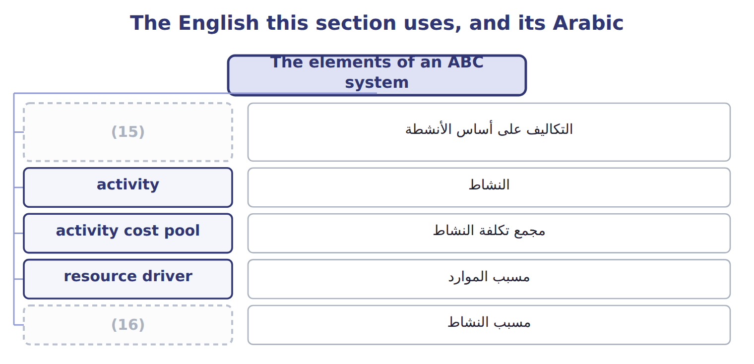
word list
activity driver · batch-level cost · activity-based costing

The English this sheet uses, and its Arabic
English (exam term) | Arabic
activity-based costing | التكاليف على أساس الأنشطة
activity | النشاط
activity cost pool | مجمع تكلفة النشاط
resource driver | مسبب الموارد
activity driver | مسبب النشاط

Answer key · 12.2 The elements of an ABC system

1 resources | 9 Equipment depreciation
2 quality | 10 Warehouse lease
3 Activity-based | 11 blending
4 overhead | 12 Receiving
5 second | 13 re-testing
6 product | 14 willing
7 measure | 15 activity-based costing
8 Indirect labor | 16 activity driver

the summaries in full
Summary 1 An activity is a task that uses resources, such as a setup or a quality test. Each activity has an activity cost pool: the total cost of doing it. Activity-based costing assigns overhead to these pools first and then to products. The first stage uses resource drivers, such as the share of staff time spent on each activity. The second stage uses activity drivers, such as the number of setups each product needs. Both are cost drivers: they measure what causes the cost.
Summary 2 A value-added activity is one that customers would pay for, such as blending. Receiving, moving and re-testing add cost but not value; ABC makes them visible so managers can reduce them. Here, a value-added activity means an activity customers are willing to pay for.

12.3 The cost hierarchy
Chapter 12 · section 12.3

Fill every gap. Each word list holds one word more than there are gaps.
Summary 1 gaps 1–8
ABC groups (1) by what causes them. (2) costs rise with every unit, like (3) hours. (4) costs rise with each batch, like setups, (5) the batch size. (6) costs support one product line, such as its (7) design. Facility-sustaining costs keep the whole site (8) , such as rent. Facility-sustaining costs have no causal driver. Many companies leave them out of product cost for decisions; if they are allocated, as Pulses & Spices does with pallet positions, managers should remember that they will not disappear if one product is dropped.
word list
whatever · packing · Batch-level · running · disappear · recipe · Unit-level · activities · Product-sustaining

The English this section uses, and its Arabic
Each term sits against what it means.
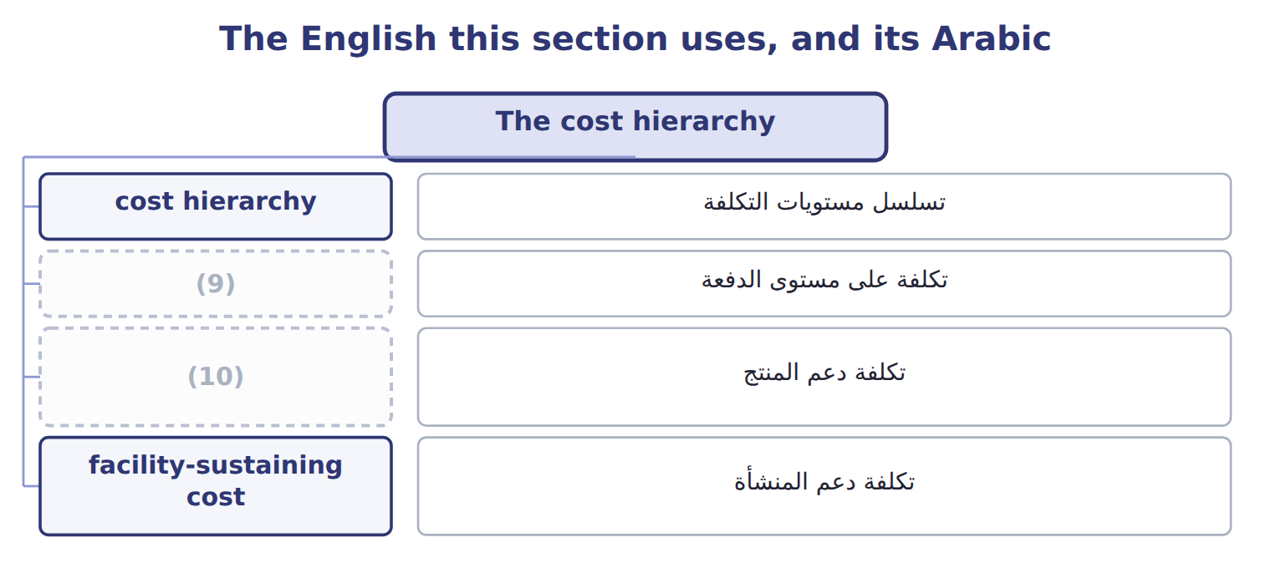
word list
product-sustaining cost · resource driver · batch-level cost

The English this sheet uses, and its Arabic
English (exam term) | Arabic
cost hierarchy | تسلسل مستويات التكلفة
batch-level cost | تكلفة على مستوى الدفعة
product-sustaining cost | تكلفة دعم المنتج
facility-sustaining cost | تكلفة دعم المنشأة

Answer key · 12.3 The cost hierarchy

1 activities | 6 Product-sustaining
2 Unit-level | 7 recipe
3 packing | 8 running
4 Batch-level | 9 batch-level cost
5 whatever | 10 product-sustaining cost

the summaries in full
Summary 1 ABC groups activities by what causes them. Unit-level costs rise with every unit, like packing hours. Batch-level costs rise with each batch, like setups, whatever the batch size. Product-sustaining costs support one product line, such as its recipe design. Facility-sustaining costs keep the whole site running, such as rent. Facility-sustaining costs have no causal driver. Many companies leave them out of product cost for decisions; if they are allocated, as Pulses & Spices does with pallet positions, managers should remember that they will not disappear if one product is dropped.

12.4 Computing product cost with ABC
Chapter 12 · section 12.4

Fill every gap. Each word list holds one word more than there are gaps.
Summary 1 gaps 1–2
For each pool, the (1) rate is the pool cost divided by the total driver quantity. A (2) overhead is the rate times the driver quantity it uses, added over all pools.
word list
activity · Lentils · product's

Worked example: ABC overhead for lentils

Summary 2 gaps 3–4
Blending setups cost $270,000 for 900 setups, a rate of $300. (3) need 100 setups, so they (4) $30,000.
word list
za'atar · receive · Lentils

Worked example: activity rates and ABC overhead for lentils
The parts add up to the total; the bars are to scale.
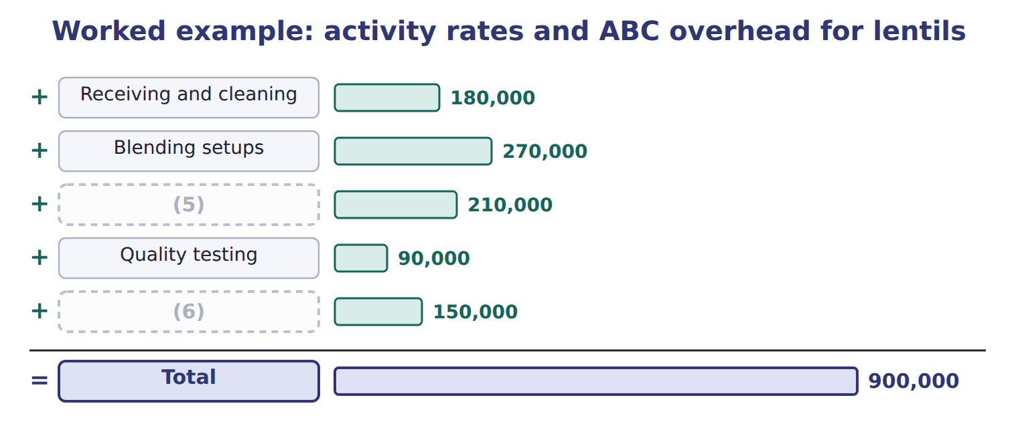
word list
activity · Packaging · Facility

ABC overhead for za'atar

Your turn: ABC overhead for za'atar (complete the blanks)
Za'atar | Use | Rate | Overhead
Receiving and cleaning | 400 receipts | $300 | 120,000
Blending setups | (7) | $300 | 240,000
Packaging | 2,000 packing hours | $30 | ________
Quality testing | (8) | $60 | 72,000
Facility | (9) | $100 | ________
Total |  |  | 542,000

word list
500 pallet positions · 1,200 tests · 800 setups · product-sustaining cost

Summary 3 gaps 10–11
Per pack, (10) for lentils falls from $3.60 to $1.79, and for (11) it rises from $3.60 to $10.84.
word list
za'atar · overhead · quantity

Unit cost and margin per pack: traditional compared with ABC
Per pack | Price | DM + DL | OH trad. | Cost trad. | Margin trad. | OH ABC | Cost ABC | Margin ABC
Lentils | $6.00 | (12) | $3.60 | $6.30 | (13) | $1.79 | $4.49 | $1.51
Za'atar | $11.00 | $3.00 + $1.20 | $3.60 | $7.80 | $3.20 | $10.84 | $15.04 | ($4.04)

word list
Use · ($0.30) · $1.50 + $1.20

Answer key · 12.4 Computing product cost with ABC

1 activity | 8 1,200 tests
2 product's | 9 500 pallet positions
3 Lentils | 10 overhead
4 receive | 11 za'atar
5 Packaging | 12 $1.50 + $1.20
6 Facility | 13 ($0.30)
7 800 setups

the summaries in full
Summary 1 For each pool, the activity rate is the pool cost divided by the total driver quantity. A product's overhead is the rate times the driver quantity it uses, added over all pools.
Summary 2 Blending setups cost $270,000 for 900 setups, a rate of $300. Lentils need 100 setups, so they receive $30,000.
Summary 3 Per pack, overhead for lentils falls from $3.60 to $1.79, and for za'atar it rises from $3.60 to $10.84.

12.5 ABC as a cost accumulation system
Chapter 12 · section 12.5

Fill every gap. Each word list holds one word more than there are gaps.
Summary 1 gaps 1–6
ABC does not need new ledger (1) . (2) and labor go to work in process as before; overhead is applied at the (3) rates instead of one rate. (4) units move to (5) goods and then to cost of goods sold, as in job costing. Because unit costs change, (6) values change too. At the end of 2027 the unsold packs are worth $142,550 with ABC and $133,500 with the old rate.
word list
instead · Completed · finished · accounts · activity · Materials · inventory

Ending finished goods under the two methods
The bars are drawn to scale.
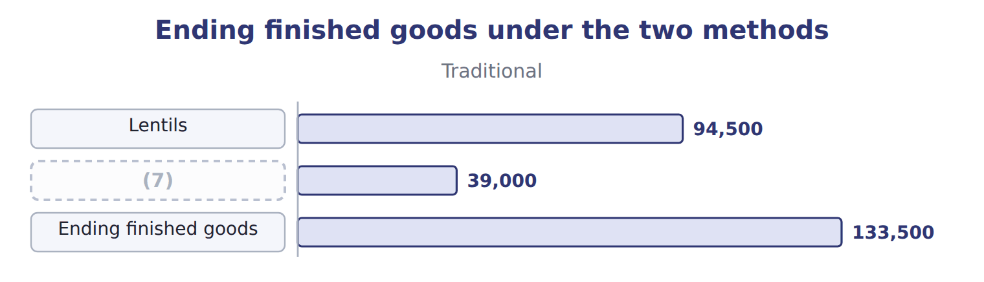
word list
activity · Za'atar

Summary 2 gaps 8–16
Normal spoilage is built into the rates of the activities that cause it, such as (8) testing. Abnormal spoilage is (9) from product cost and (10) as a loss. For example, if a (11) batch fails its test for a normal reason and is thrown away, its cost stays in the (12) and testing pools and reaches the good packs through the rates. A batch (13) by a power cut is abnormal and is (14) off as a loss. ABC suits companies with many (15) that use activities in (16) ways. With one simple product, one rate gives almost the same answer at a lower cost.
word list
removed · quality · expensed · written · testing · different · products · ruined · blending · za'atar

Answer key · 12.5 ABC as a cost accumulation system

1 accounts | 9 removed
2 Materials | 10 expensed
3 activity | 11 za'atar
4 Completed | 12 blending
5 finished | 13 ruined
6 inventory | 14 written
7 Za'atar | 15 products
8 quality | 16 different

the summaries in full
Summary 1 ABC does not need new ledger accounts. Materials and labor go to work in process as before; overhead is applied at the activity rates instead of one rate. Completed units move to finished goods and then to cost of goods sold, as in job costing. Because unit costs change, inventory values change too. At the end of 2027 the unsold packs are worth $142,550 with ABC and $133,500 with the old rate.
Summary 2 Normal spoilage is built into the rates of the activities that cause it, such as quality testing. Abnormal spoilage is removed from product cost and expensed as a loss. For example, if a za'atar batch fails its test for a normal reason and is thrown away, its cost stays in the blending and testing pools and reaches the good packs through the rates. A batch ruined by a power cut is abnormal and is written off as a loss. ABC suits companies with many products that use activities in different ways. With one simple product, one rate gives almost the same answer at a lower cost.

12.6 Benefits, limitations and strategic value
Chapter 12 · section 12.6

Fill every gap. Each word list holds one word more than there are gaps.
Summary 1 gaps 1–5
Activity-based (1) gives more accurate product costs where products differ in complexity. It shows batch-level and (2) costs that a volume rate hides. It also links cost to (3) that managers can change. It needs data on many drivers, (4) to design the pools, and regular updates. Facility costs are still (5) without a true driver.
word list
allocation · accurate · activities · allocated · judgment · product-sustaining

Benefits and limitations of ABC
Benefits | Limitations
More accurate product costs where products use activities differently | (6)
Shows batch-level and product-sustaining costs that volume rates hide | Needs judgment to choose pools and drivers
Better pricing, product-mix and customer decisions | (7) costs are still allocated arbitrarily
Links cost to activities that managers can change | Must still be adjusted for external reporting rules

word list
cost hierarchy · Costly to design and keep up to date · Facility-sustaining

Summary 2 gaps 8–10
The (8) value is in the decisions. With ABC costs, the (9) may raise the za'atar price, make larger za'atar batches to cut setups, or stop pushing lentils away. ABC (10) these choices; it does not make them.
word list
updates · informs · division · strategic

Beyond the exam

Summary 3 gaps 11–13
Time-driven ABC estimates the time each (11) takes instead of surveying staff. Activity-based (12) uses ABC to improve activities. Both are useful in (13) , but they are not in the 2024 Part 1 outcomes.
word list
Facility · practice · activity · management

Answer key · 12.6 Benefits, limitations and strategic value

1 allocation | 8 strategic
2 product-sustaining | 9 division
3 activities | 10 informs
4 judgment | 11 activity
5 allocated | 12 management
6 Costly to design and keep up to date | 13 practice
7 Facility-sustaining

the summaries in full
Summary 1 Activity-based allocation gives more accurate product costs where products differ in complexity. It shows batch-level and product-sustaining costs that a volume rate hides. It also links cost to activities that managers can change. It needs data on many drivers, judgment to design the pools, and regular updates. Facility costs are still allocated without a true driver.
Summary 2 The strategic value is in the decisions. With ABC costs, the division may raise the za'atar price, make larger za'atar batches to cut setups, or stop pushing lentils away. ABC informs these choices; it does not make them.
Summary 3 Time-driven ABC estimates the time each activity takes instead of surveying staff. Activity-based management uses ABC to improve activities. Both are useful in practice, but they are not in the 2024 Part 1 outcomes.

12.7 Extended Example 12A: Pulses & Spices in 2027
Chapter 12 · section 12.7

Fill every gap. Each word list holds one word more than there are gaps.
Summary 1 gaps 1–10
This example (1) a full year of the (2) & Spices line with ABC, from overhead to cost of goods sold. The product costs are (3) ; the entries are for depth. (4) : 200,000 packs of lentils and 50,000 packs of za'atar; 185,000 and 45,000 sold. Direct costs per pack: lentils $1.50 (5) and $1.20 labor; za'atar $3.00 and $1.20. Overhead: $900,000 in five activity pools. Record overhead, direct costs and the (6) at activity rates. Move completed packs to finished goods, record the sales, close the overhead (7) and check every (8) . Overhead (9) : lentils $358,000; za'atar $542,000. Cost completed: lentils $898,000; za'atar $752,000; total $1,650,000. Cost of goods sold: $1,507,450; (10) finished goods $142,550.
word list
Output · balance · ending · applied · application · accounts · Pulses · materials · exam-core · lentils · records

Extended Example: ABC journal, 2027
No. | Account (detail) | Debit | Credit
1 | (11) | 900,000
 | (12) |  | 900,000
2 | WIP - Pulses & Spices | 450,000
 | Raw Materials Inventory |  | 450,000
3 | WIP - Pulses & Spices | 300,000
 | (13) |  | 300,000
4 | (14) | 900,000
 | MOH Applied |  | 900,000
5 | (15) | 1,650,000
 | WIP - Pulses & Spices |  | 1,650,000
6 | (16) | 1,507,450
 | Finished Goods |  | 1,507,450
7 | (17) | 900,000
 | MOH Control |  | 900,000
 | Totals | 6,607,450 | 6,607,450

word list
Cost of Goods Sold · MOH Control · Various accounts · Finished Goods · WIP - Pulses & Spices · Quality tests · Wages Payable · MOH Applied

Everything ties

Summary 2 gaps 18–19
Overhead: $358,000 + $542,000 = $900,000, the same total as the old rate. (18) goods: $1,650,000 in = $1,507,450 sold + $142,550 left. Only the split between the (19) changes.
word list
Compute · products · Finished

Exam view

Summary 3 gaps 20–21
Expect pool costs, driver (20) and each product's use. Compute each rate from the total driver (21) , multiply by each product's use, and compare with the single rate given in the question.
word list
quantities · quantity · Compute

Exam view
The bars are drawn to scale.
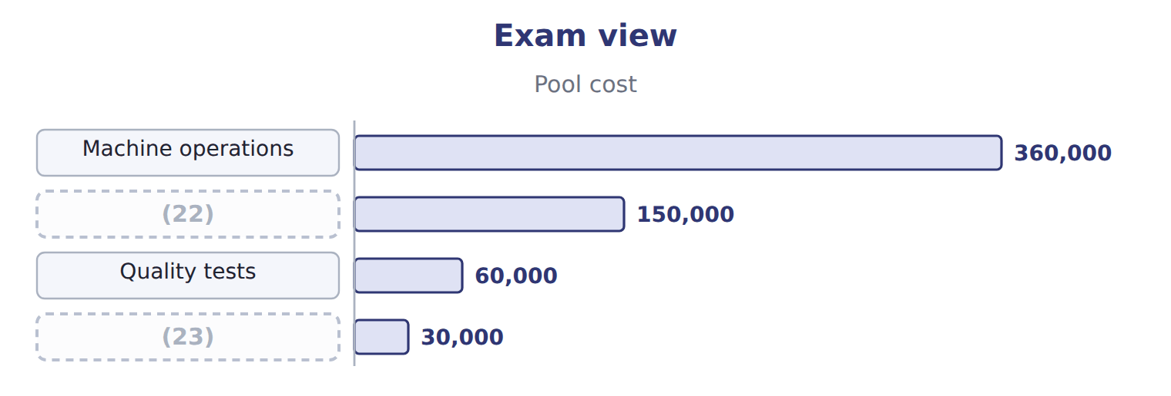
word list
Machine operations · Recipe design (traced) · Setups

Item — Answer
Item | Answer
Packaging (za'atar) | 2,000 packing hours × $30 = $60,000
Facility (za'atar) | (24)

word list
500 pallet positions × $100 = $50,000 · 2,000 packing hours × $30 = $60,000

Overhead item — Category
Overhead item | Category
Machine operations | (25)
Setups | (26)
Quality tests | Batch-level
Recipe design | (27)
Plant manager's salary | Facility-sustaining

word list
Unit-level · Batch-level · setups · Product-sustaining

The English this section uses, and its Arabic
Each term sits against what it means.
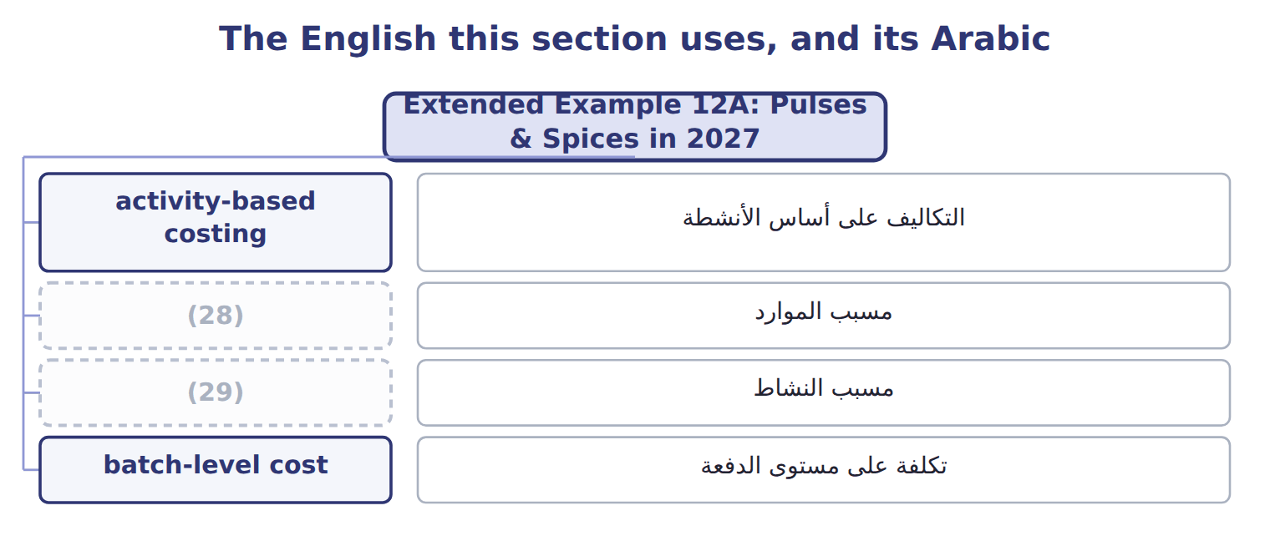
word list
activity driver · value-added activity · resource driver

The English this sheet uses, and its Arabic
English (exam term) | Arabic
activity-based costing | التكاليف على أساس الأنشطة
resource driver | مسبب الموارد
activity driver | مسبب النشاط
batch-level cost | تكلفة على مستوى الدفعة

Answer key · 12.7 Extended Example 12A: Pulses & Spices in 2027

1 records | 16 Cost of Goods Sold
2 Pulses | 17 MOH Applied
3 exam-core | 18 Finished
4 Output | 19 products
5 materials | 20 quantities
6 application | 21 quantity
7 accounts | 22 Setups
8 balance | 23 Recipe design (traced)
9 applied | 24 500 pallet positions × $100 = $50,000
10 ending | 25 Unit-level
11 MOH Control | 26 Batch-level
12 Various accounts | 27 Product-sustaining
13 Wages Payable | 28 resource driver
14 WIP - Pulses & Spices | 29 activity driver
15 Finished Goods

the summaries in full
Summary 1 This example records a full year of the Pulses & Spices line with ABC, from overhead to cost of goods sold. The product costs are exam-core; the entries are for depth. Output: 200,000 packs of lentils and 50,000 packs of za'atar; 185,000 and 45,000 sold. Direct costs per pack: lentils $1.50 materials and $1.20 labor; za'atar $3.00 and $1.20. Overhead: $900,000 in five activity pools. Record overhead, direct costs and the application at activity rates. Move completed packs to finished goods, record the sales, close the overhead accounts and check every balance. Overhead applied: lentils $358,000; za'atar $542,000. Cost completed: lentils $898,000; za'atar $752,000; total $1,650,000. Cost of goods sold: $1,507,450; ending finished goods $142,550.
Summary 2 Overhead: $358,000 + $542,000 = $900,000, the same total as the old rate. Finished goods: $1,650,000 in = $1,507,450 sold + $142,550 left. Only the split between the products changes.
Summary 3 Expect pool costs, driver quantities and each product's use. Compute each rate from the total driver quantity, multiply by each product's use, and compare with the single rate given in the question.

