14.1 Life-cycle costing
Chapter 14 · section 14.1

Fill every gap. Each word list holds one word more than there are gaps.
Chapter 14, section by section
Each stage leads to the next.
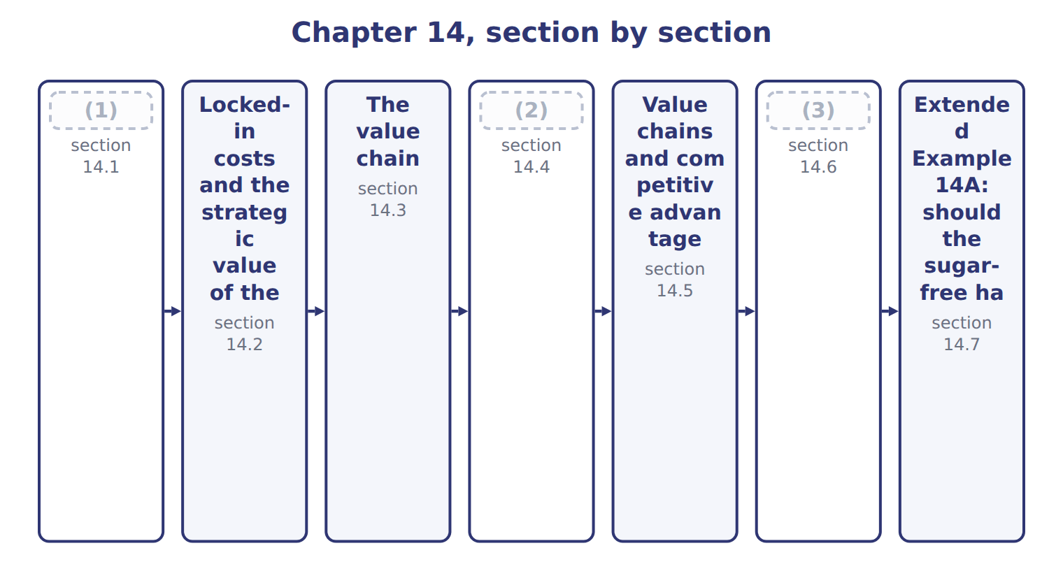
word list
Value-added and non-value-added activities · Life-cycle costing · The steps in value chain analysis · upstream costs

Summary 1 gaps 4–7
Life-cycle costing plans and tracks every cost of a product from research to (4) . It groups costs into three stages: upstream costs before production, (5) costs, and downstream costs after production. Upstream costs include research, design and (6) . Downstream costs include marketing, (7) , customer service and the costs of leaving the market.
word list
manufacturing · withdrawal · testing · division · distribution

Worked example: the halva's life-cycle budget

The division expects to sell 510,000 trays over five years at $7.00.

Worked example: the sugar-free halva's life-cycle budget
The bars are drawn to scale.
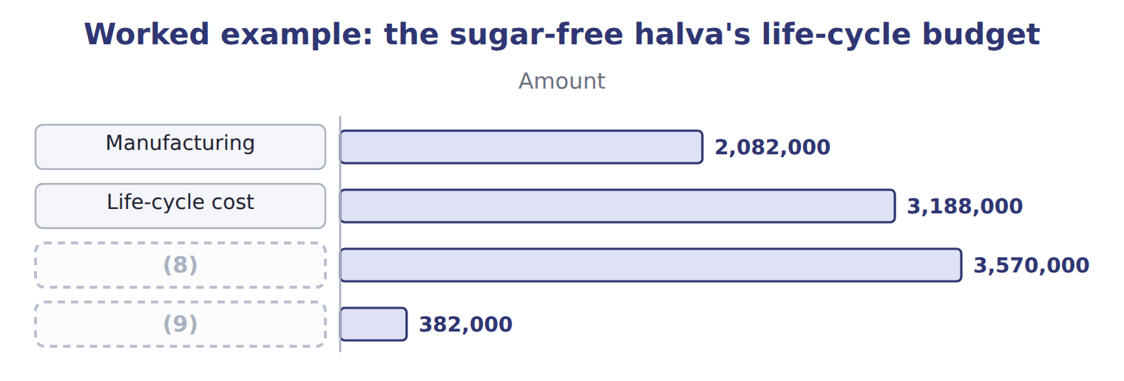
word list
Life-cycle profit · downstream costs · Revenue

The halva's downstream costs

Your turn: the halva's downstream costs (complete the blanks)
Downstream costs, 510,000 trays | Whole USD
Marketing (5 years) | 520,000
Distribution at $0.50 a tray | ________
(10) | ________
(11) | 30,000
Downstream costs | 856,000

word list
Distribution at $0.50 a tray · Exit costs (2032) · Customer service at $0.10 a tray

Summary 2 gaps 12–13
A yearly product report would miss the (12) costs, because they were spent before the product had sales. (13) costing puts them back, so the product is judged on everything it costs.
word list
Life-cycle · upstream · distribution

The English this section uses, and its Arabic
Each term sits against what it means.
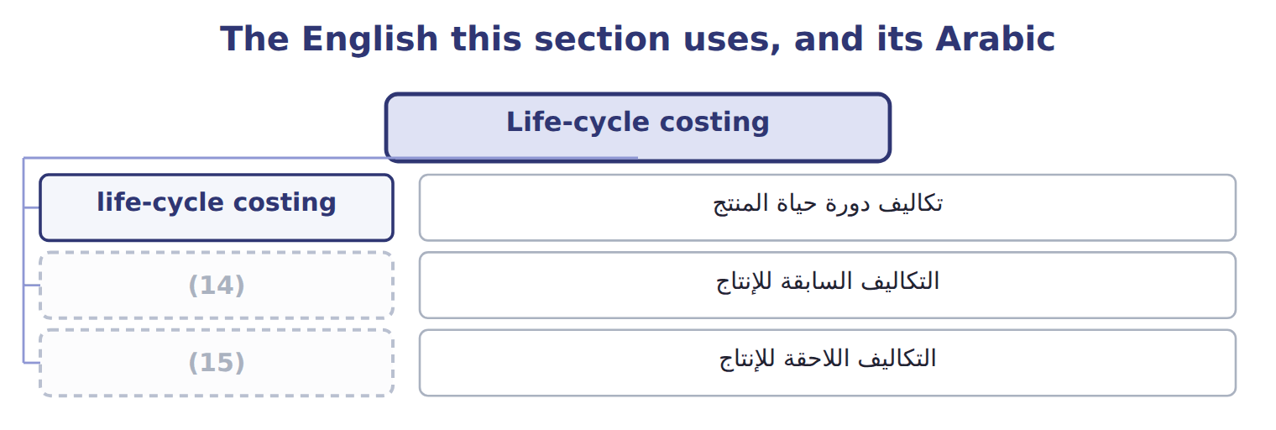
word list
upstream costs · support activities · downstream costs

The English this sheet uses, and its Arabic
English (exam term) | Arabic
life-cycle costing | تكاليف دورة حياة المنتج
upstream costs | التكاليف السابقة للإنتاج
downstream costs | التكاليف اللاحقة للإنتاج

Answer key · 14.1 Life-cycle costing

1 Life-cycle costing | 9 Life-cycle profit
2 The steps in value chain analysis | 10 Customer service at $0.10 a tray
3 Value-added and non-value-added activities | 11 Exit costs (2032)
4 withdrawal | 12 upstream
5 manufacturing | 13 Life-cycle
6 testing | 14 upstream costs
7 distribution | 15 downstream costs
8 Revenue

the summaries in full
Summary 1 Life-cycle costing plans and tracks every cost of a product from research to withdrawal. It groups costs into three stages: upstream costs before production, manufacturing costs, and downstream costs after production. Upstream costs include research, design and testing. Downstream costs include marketing, distribution, customer service and the costs of leaving the market.
Summary 2 A yearly product report would miss the upstream costs, because they were spent before the product had sales. Life-cycle costing puts them back, so the product is judged on everything it costs.

14.2 Locked-in costs and the strategic value of the design stage
Chapter 14 · section 14.2

Fill every gap. Each word list holds one word more than there are gaps.
Summary 1 gaps 1–8
A cost is (1) when the money is spent. It is committed, or (2) in, when a decision makes it (3) later. The (4) , the tray and the choice of (5) fix most future costs long before they are paid. At the end of design, the halva team (6) that 80% of the life-cycle cost is (7) committed, while only 7.8% has been spent. This is the (8) value of life-cycle costing: the cheapest time to reduce cost is the design stage. Once production starts, managers can only control the small share of cost that is still open.
word list
channels · recipe · differentiation · estimates · incurred · unavoidable · locked · already · strategic

Committed is not incurred

Summary 2 gaps 9–10
An exam (9) that most costs are incurred at the design stage is false. Most costs are committed at design and incurred later, during (10) and sales.
word list
statement · production · estimates

The English this section uses, and its Arabic
Each term sits against what it means.
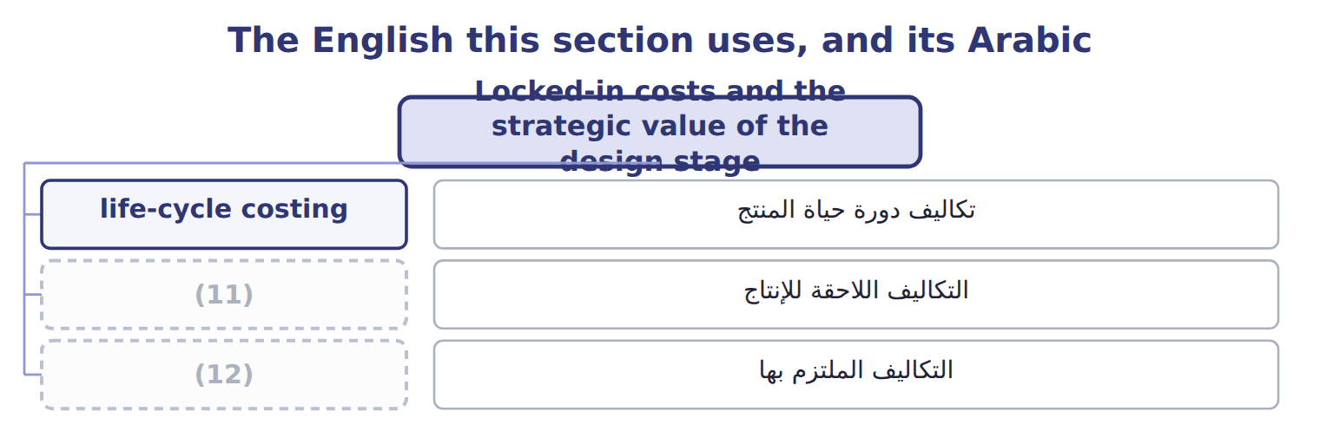
word list
non-value-added activity · locked-in costs · downstream costs

The English this sheet uses, and its Arabic
English (exam term) | Arabic
locked-in costs | التكاليف الملتزم بها

Answer key · 14.2 Locked-in costs and the strategic value of the design stage

1 incurred | 7 already
2 locked | 8 strategic
3 unavoidable | 9 statement
4 recipe | 10 production
5 channels | 11 downstream costs
6 estimates | 12 locked-in costs

the summaries in full
Summary 1 A cost is incurred when the money is spent. It is committed, or locked in, when a decision makes it unavoidable later. The recipe, the tray and the choice of channels fix most future costs long before they are paid. At the end of design, the halva team estimates that 80% of the life-cycle cost is already committed, while only 7.8% has been spent. This is the strategic value of life-cycle costing: the cheapest time to reduce cost is the design stage. Once production starts, managers can only control the small share of cost that is still open.
Summary 2 An exam statement that most costs are incurred at the design stage is false. Most costs are committed at design and incurred later, during production and sales.

14.3 The value chain
Chapter 14 · section 14.3

Fill every gap. Each word list holds one word more than there are gaps.
Summary 1 gaps 1–11
The value chain is the chain of activities a company (1) to design, make, sell, deliver and support its (2) . Value chain (3) studies each activity to find where the company can lower cost or add value for (4) . (5) Porter divided the chain into two (6) . Primary activities make and deliver the product: inbound logistics, (7) , outbound logistics, (8) and sales, and service. Support activities help all of them: firm (9) , human resource management, technology (10) and procurement. The chain does not stop at the (11) walls. The olive growers before Orontes and the distributors after it are part of a wider value system, and many savings come from the links between them. The supply chain links several companies; the value chain is inside one.
word list
marketing · Michael · customers · groups · Orontes · company's · development · analysis · performs · infrastructure · products · operations

The English this section uses, and its Arabic
Each term sits against what it means.
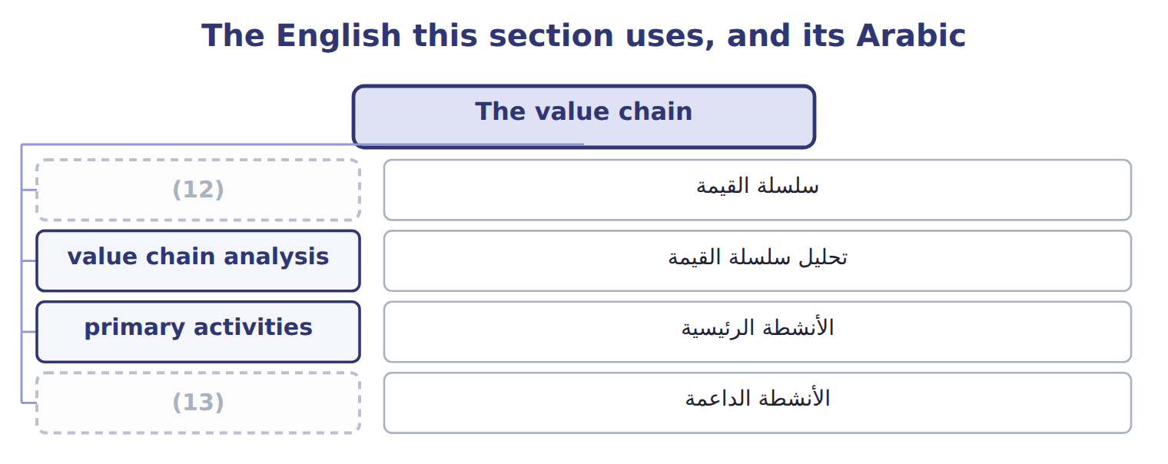
word list
primary activities · support activities · value chain

The English this sheet uses, and its Arabic
English (exam term) | Arabic
value chain | سلسلة القيمة
value chain analysis | تحليل سلسلة القيمة
primary activities | الأنشطة الرئيسية
support activities | الأنشطة الداعمة

Answer key · 14.3 The value chain

1 performs | 8 marketing
2 products | 9 infrastructure
3 analysis | 10 development
4 customers | 11 company's
5 Michael | 12 value chain
6 groups | 13 support activities
7 operations

the summaries in full
Summary 1 The value chain is the chain of activities a company performs to design, make, sell, deliver and support its products. Value chain analysis studies each activity to find where the company can lower cost or add value for customers. Michael Porter divided the chain into two groups. Primary activities make and deliver the product: inbound logistics, operations, outbound logistics, marketing and sales, and service. Support activities help all of them: firm infrastructure, human resource management, technology development and procurement. The chain does not stop at the company's walls. The olive growers before Orontes and the distributors after it are part of a wider value system, and many savings come from the links between them. The supply chain links several companies; the value chain is inside one.

14.4 The steps in value chain analysis
Chapter 14 · section 14.4

Fill every gap. Each word list holds one word more than there are gaps.
Summary 1 gaps 1–2
Value chain analysis has five steps: identify the (1) , assign costs and assets to them, find what drives each cost, study the links inside and outside the company, and look for (2) .
word list
competitor · opportunities · activities

The five steps of value chain analysis in the Oils division
Each stage leads to the next.
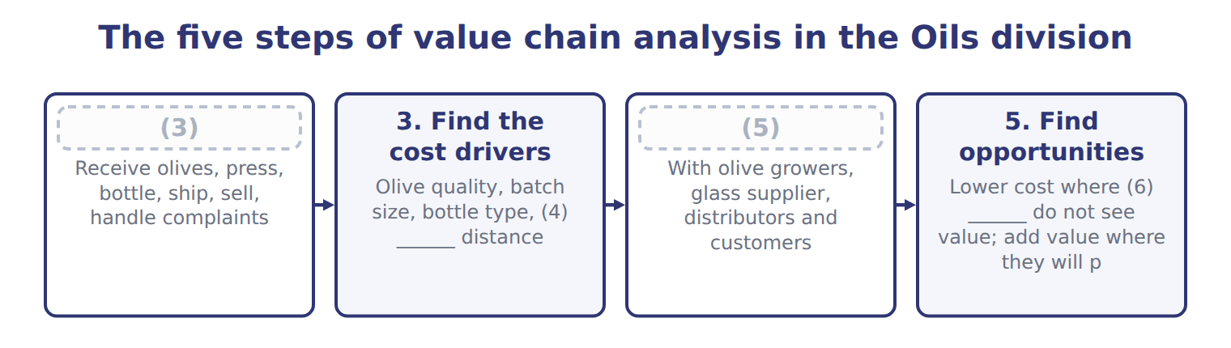
word list
4. Study the links · 1. Identify the activities · life-cycle costing · customers · delivery

Cost per liter of bottled EVOO by activity: Orontes and a bulk competitor
Bottled EVOO, 2027 | Orontes | Bulk competitor
Inbound logistics | $0.45 | $0.30
(7) | $11.30 | $9.10
Outbound logistics | $0.70 | $0.60
(8) | $1.10 | $0.40
(9) | $0.20 | $0.05
(10) | $0.90 | $0.55
Total cost per liter | $14.65 | $11.00
(11) | $16.00 | $11.50
Margin per liter | $1.35 | $0.50

word list
Service · Price per liter · Support activities · Operations · value chain analysis · Marketing and sales

Summary 2 gaps 12–13
Placing the (12) costs beside Orontes's shows where the two companies spend differently. Orontes spends more on (13) and marketing; the competitor spends less almost everywhere.
word list
Orontes · operations · competitor's

The English this section uses, and its Arabic
Each term sits against what it means.
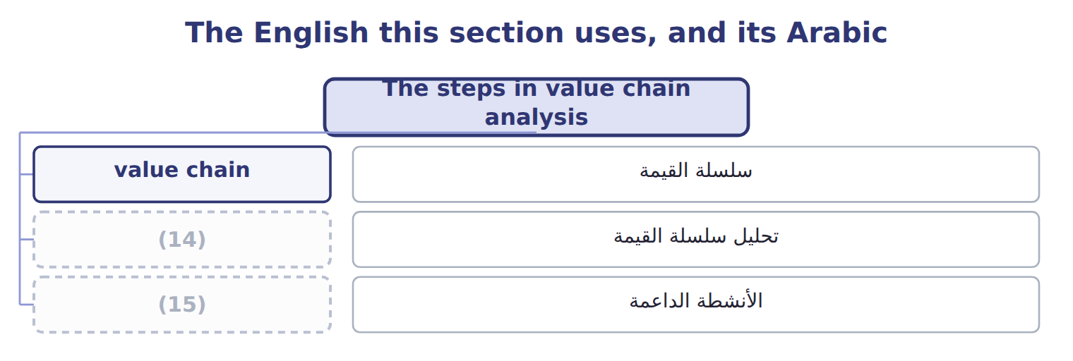
word list
support activities · value chain analysis · cost leadership

Answer key · 14.4 The steps in value chain analysis

1 activities | 9 Service
2 opportunities | 10 Support activities
3 1. Identify the activities | 11 Price per liter
4 delivery | 12 competitor's
5 4. Study the links | 13 operations
6 customers | 14 value chain analysis
7 Operations | 15 support activities
8 Marketing and sales

the summaries in full
Summary 1 Value chain analysis has five steps: identify the activities, assign costs and assets to them, find what drives each cost, study the links inside and outside the company, and look for opportunities.
Summary 2 Placing the competitor's costs beside Orontes's shows where the two companies spend differently. Orontes spends more on operations and marketing; the competitor spends less almost everywhere.

14.5 Value chains and competitive advantage
Chapter 14 · section 14.5

Fill every gap. Each word list holds one word more than there are gaps.
Summary 1 gaps 1–8
A company gains an (1) in one of two ways. Cost leadership means doing the activities more (2) than rivals. Differentiation means doing some activities in a way customers value and will pay more for. The bulk (3) follows cost leadership: its cost per liter is $11.00. Orontes follows differentiation: (4) , traced oil costs more, but customers pay $4.50 more per liter. Value chain (5) shows whether a (6) is working. (7) margin of $1.35 a liter survives only while the premium exceeds the extra cost of its (8) and marketing.
word list
Orontes's · competitor · strategy · marketing · operations · cold-pressed · cheaply · analysis · advantage

Cost leadership and differentiation compared
 | Cost leadership | Differentiation
Aim | (9) | Something customers value and pay more for
Where to spend | (10) | More in the activities customers value
Oils example | Bulk competitor: low operations and marketing costs | Orontes: (11) , traced EVOO; price premium of $4.50 a liter
Risk | (12) | Customers stop paying the premium

word list
cold-pressed · Lowest cost in the industry · A rival with even lower cost · Something customers value and pay more for · As little as possible in every activity

The English this section uses, and its Arabic
Each term sits against what it means.
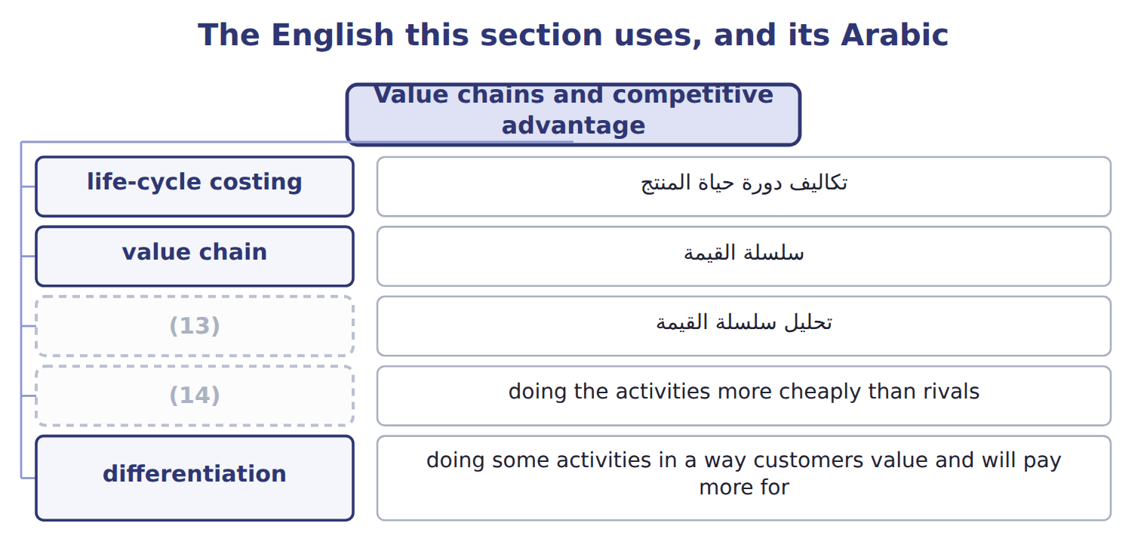
word list
life-cycle costing · value chain analysis · cost leadership

The English this sheet uses, and its Arabic
English (exam term) | Arabic
cost leadership | ريادة التكلفة
differentiation | التمايز

Answer key · 14.5 Value chains and competitive advantage

1 advantage | 8 operations
2 cheaply | 9 Lowest cost in the industry
3 competitor | 10 As little as possible in every activity
4 cold-pressed | 11 cold-pressed
5 analysis | 12 A rival with even lower cost
6 strategy | 13 value chain analysis
7 Orontes's | 14 cost leadership

the summaries in full
Summary 1 A company gains an advantage in one of two ways. Cost leadership means doing the activities more cheaply than rivals. Differentiation means doing some activities in a way customers value and will pay more for. The bulk competitor follows cost leadership: its cost per liter is $11.00. Orontes follows differentiation: cold-pressed, traced oil costs more, but customers pay $4.50 more per liter. Value chain analysis shows whether a strategy is working. Orontes's margin of $1.35 a liter survives only while the premium exceeds the extra cost of its operations and marketing.

14.6 Value-added and non-value-added activities
Chapter 14 · section 14.6

Fill every gap. Each word list holds one word more than there are gaps.
Summary 1 gaps 1–4
A (1) activity is one (2) would pay for, such as filling and labeling bottles. A non-value-added activity adds cost but no value, such as (3) pallets or (4) errors. Some activities, such as final inspection, add no value but are necessary for now.
word list
moving · value-added · customers · without · reworking

Bottling-line activities classified
The parts add up to the total; the bars are to scale.
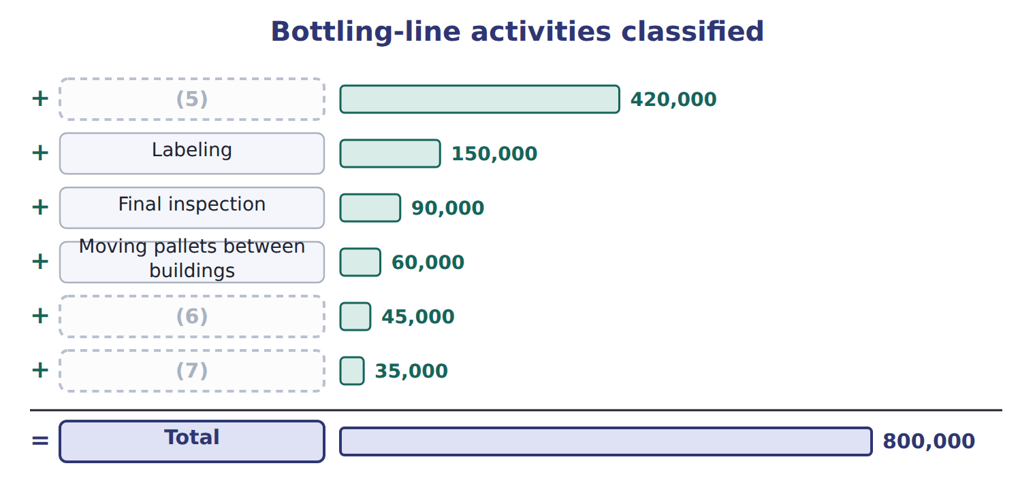
word list
Waiting and storage before filling · Filling and capping · value chain analysis · Reworking mislabeled bottles

Removing non-value-added activities improves performance without making customers worse off.
Removing non-value-added activities
The bars are drawn to scale.
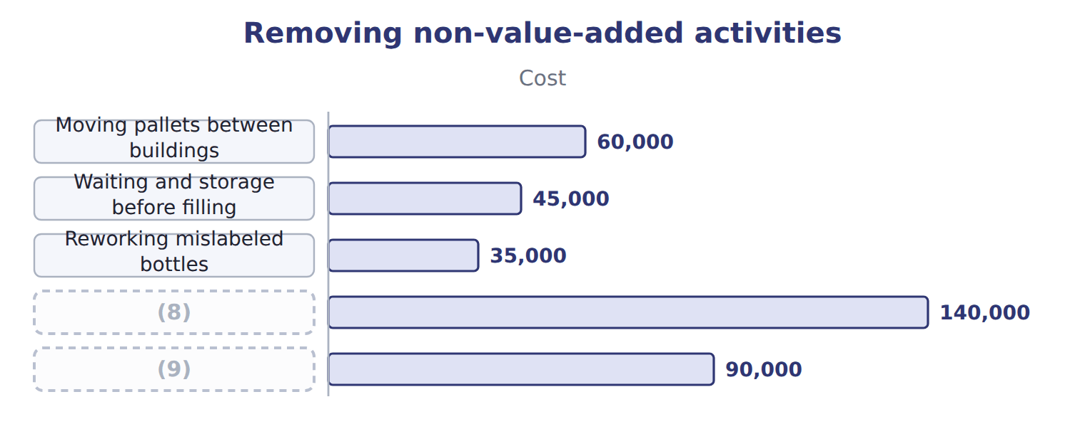
word list
Final inspection (kept: necessary) · Annual cost removed · value chain analysis

The English this sheet uses, and its Arabic
English (exam term) | Arabic
non-value-added activity | نشاط غير مضيف للقيمة

Answer key · 14.6 Value-added and non-value-added activities

1 value-added | 6 Waiting and storage before filling
2 customers | 7 Reworking mislabeled bottles
3 moving | 8 Annual cost removed
4 reworking | 9 Final inspection (kept: necessary)
5 Filling and capping

the summaries in full
Summary 1 A value-added activity is one customers would pay for, such as filling and labeling bottles. A non-value-added activity adds cost but no value, such as moving pallets or reworking errors. Some activities, such as final inspection, add no value but are necessary for now.

14.7 Extended Example 14A: should the sugar-free halva be launched?
Chapter 14 · section 14.7

Fill every gap. Each word list holds one word more than there are gaps.
Summary 1 gaps 1–4
This example sets out the halva's budget year by year and (1) the yearly view with the (2) view. Upstream (2027): research $150,000; design and (3) $60,000; testing and (4) $40,000. Production: $3.20 a tray plus $90,000 a year; distribution $0.50 and service $0.10 a tray; exit costs $30,000 in 2032.
word list
approvals · life-cycle · dropping · packaging · compares

Extended Example: the halva budget year by year
Name each line from how it moves.
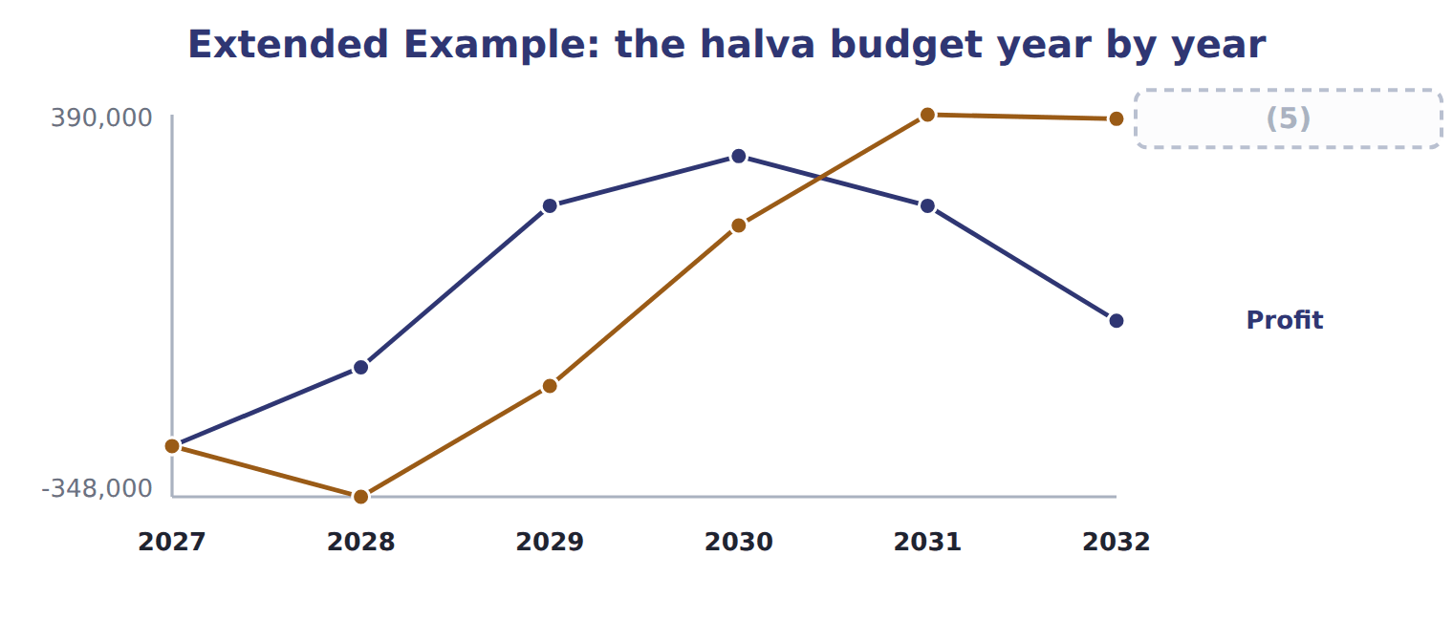
word list
Cumulative · differentiation

Summary 2 gaps 6–8
On a (6) view, the first report after launch would suggest (7) the product. On a (8) view, the halva earns $382,000, so the division launches it and watches whether volumes follow the plan.
word list
dropping · life-cycle · launches · yearly

Everything ties

Summary 3 gaps 9–10
Upstream $250,000 + (9) $2,082,000 + downstream $856,000 = $3,188,000. Revenue $3,570,000 − (10) cost $3,188,000 = $382,000, the last point on the cumulative line.
word list
distribution · life-cycle · manufacturing

Exam view

Summary 4 gaps 11–13
Expect costs by stage and year. Add all three stages for the (11) cost, and do not judge a new (12) on its first year. For value chains, expect to classify activities as primary or support, and as (13) or not.
word list
value-added · product · classify · life-cycle

Exam view
Name each line from how it moves.
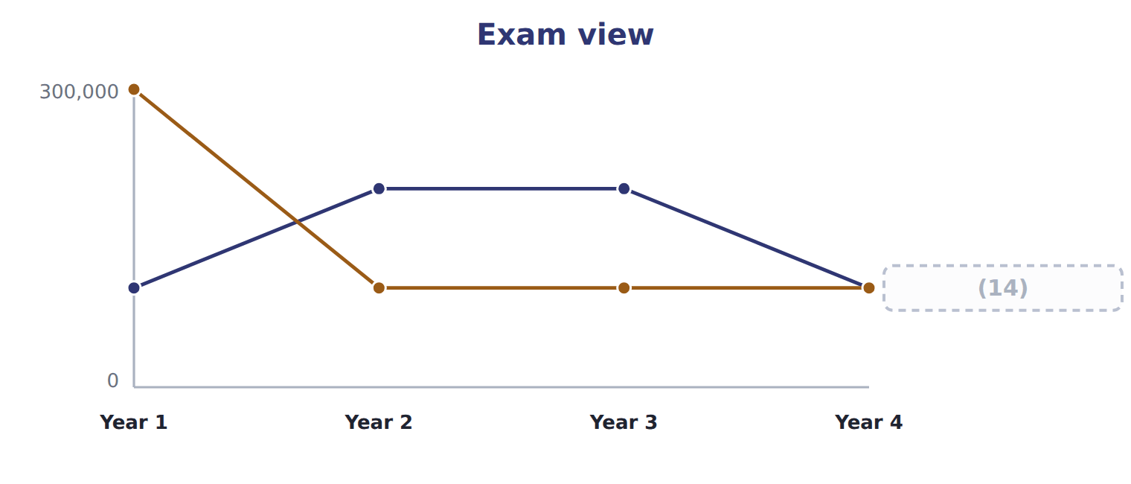
word list
differentiation · Marketing

Item — Answer
Item | Answer
Distribution | 510,000 trays × $0.50 = $255,000
Customer service | (15)

word list
510,000 trays × $0.50 = $255,000 · 510,000 trays × $0.10 = $51,000

Cost — Category
Every item belongs to exactly one group.
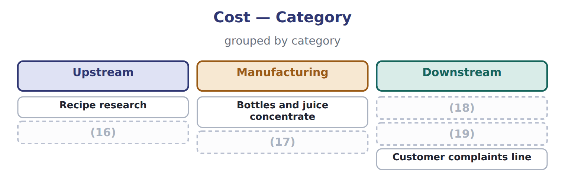
word list
Taste testing before launch · Launch advertising · locked-in costs · Depreciation of the filling line · Delivery to hotels

The English this section uses, and its Arabic
Each term sits against what it means.
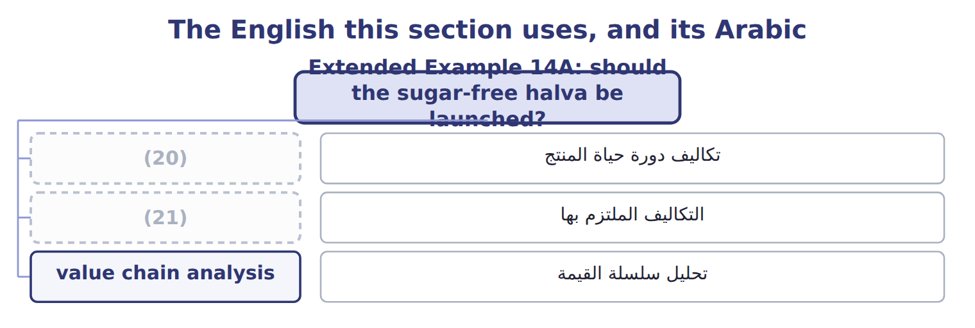
word list
life-cycle costing · upstream costs · locked-in costs

The English this sheet uses, and its Arabic
English (exam term) | Arabic
life-cycle costing | تكاليف دورة حياة المنتج
locked-in costs | التكاليف الملتزم بها
value chain analysis | تحليل سلسلة القيمة

Answer key · 14.7 Extended Example 14A: should the sugar-free halva be launched?

1 compares | 12 product
2 life-cycle | 13 value-added
3 packaging | 14 Marketing
4 approvals | 15 510,000 trays × $0.10 = $51,000
5 Cumulative | 16 Taste testing before launch
6 yearly | 17 Depreciation of the filling line
7 dropping | 18 Launch advertising
8 life-cycle | 19 Delivery to hotels
9 manufacturing | 20 life-cycle costing
10 life-cycle | 21 locked-in costs
11 life-cycle

the summaries in full
Summary 1 This example sets out the halva's budget year by year and compares the yearly view with the life-cycle view. Upstream (2027): research $150,000; design and packaging $60,000; testing and approvals $40,000. Production: $3.20 a tray plus $90,000 a year; distribution $0.50 and service $0.10 a tray; exit costs $30,000 in 2032.
Summary 2 On a yearly view, the first report after launch would suggest dropping the product. On a life-cycle view, the halva earns $382,000, so the division launches it and watches whether volumes follow the plan.
Summary 3 Upstream $250,000 + manufacturing $2,082,000 + downstream $856,000 = $3,188,000. Revenue $3,570,000 − life-cycle cost $3,188,000 = $382,000, the last point on the cumulative line.
Summary 4 Expect costs by stage and year. Add all three stages for the life-cycle cost, and do not judge a new product on its first year. For value chains, expect to classify activities as primary or support, and as value-added or not.

