16.1 Continuous improvement techniques and quality
Chapter 16 · section 16.1

Fill every gap. Each word list holds one word more than there are gaps.
Chapter 16, section by section
Each stage leads to the next.
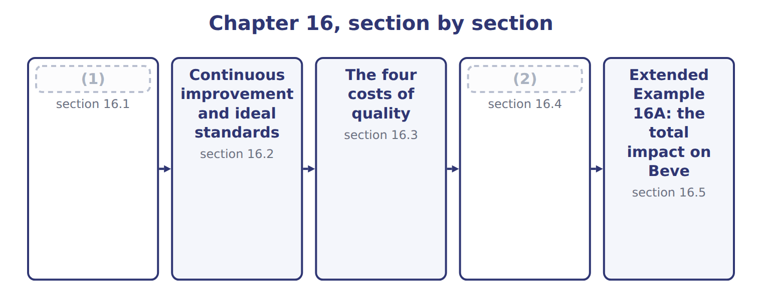
word list
Continuous improvement techniques and quality · The financial impact of quality improvement · Continuous improvement and ideal standards

Summary 1 gaps 3–10
Continuous (3) means improving (4) in many small, regular steps instead of one big change. Each step (5) a little waste or a cause of defects, and quality rises over time. The (6) approach is (7) , in which the people who do the work suggest the improvements. Each change is (8) with the PDCA cycle: plan, do, check, act. Two wider (9) support it. Total quality (10) makes quality everyone's job and lets the customer define it. Six Sigma uses data and statistics to cut defects to very low levels.
word list
removes · best-known · approaches · tested · kaizen · processes · improvement · management · Continuous

Continuous improvement techniques compared
Technique | Idea | Beverages example
Kaizen | Many small (11) , suggested by the people who do the work | Shorter changeovers on the filling line
PDCA cycle | Plan, do, check, act: test a change before adopting it | (12)
Total quality management | (13) | Drivers report damaged cases at delivery
Six Sigma | (14) | Measuring fill-volume variation per bottle

word list
Trying a new cleaning routine on one line first · ideal standard · Data and statistics to cut defects to very low levels · Quality is everyone's job; the customer defines quality · improvements

Worked example: a kaizen event on the filling line

The line team cut each changeover from 60 to 35 minutes.

Worked example: the kaizen changeover saving
Kaizen event on the filling line | Amount
(15) | 400
Minutes per changeover: before → after | 60 → 35
Hours of line time freed a year | 167
(16) | $600
(17) | 100,000

word list
prevention costs · Yearly saving · Changeovers a year · Cost of one hour of line time

The English this section uses, and its Arabic
Each term sits against what it means.
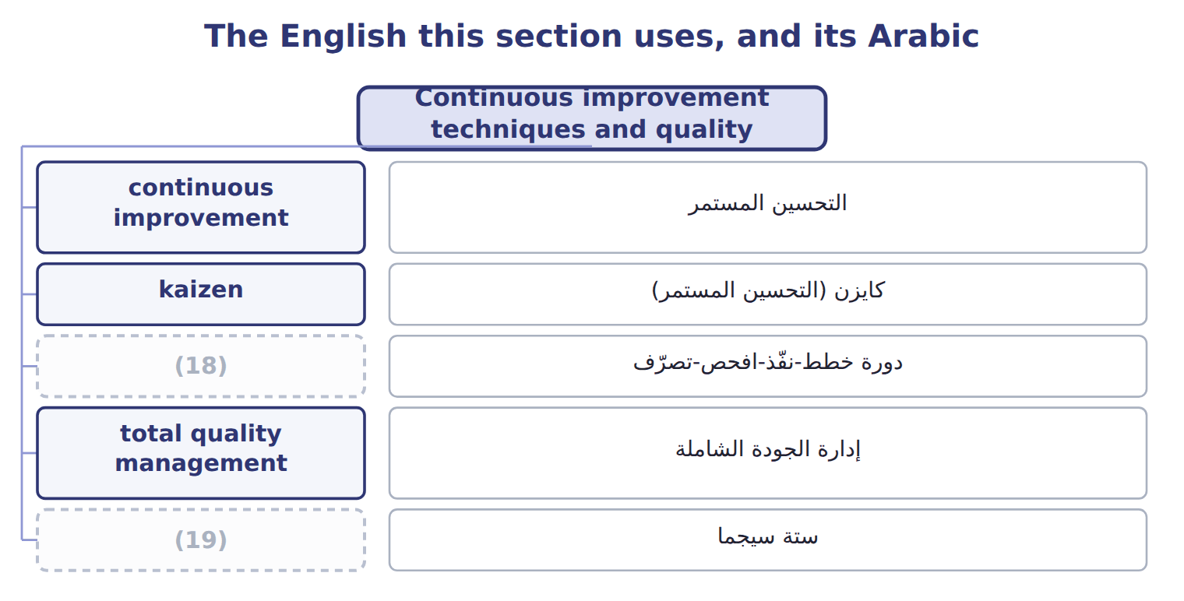
word list
ستة سيجما · PDCA cycle · Six Sigma

The English this sheet uses, and its Arabic
English (exam term) | Arabic
continuous improvement | التحسين المستمر
kaizen | كايزن (التحسين المستمر)
PDCA cycle | دورة خطط-نفّذ-افحص-تصرّف
total quality management | إدارة الجودة الشاملة
Six Sigma | ستة سيجما

Answer key · 16.1 Continuous improvement techniques and quality

1 Continuous improvement techniques and quality | 11 improvements
2 The financial impact of quality improvement | 12 Trying a new cleaning routine on one line first
3 improvement | 13 Quality is everyone's job; the customer defines quality
4 processes | 14 Data and statistics to cut defects to very low levels
5 removes | 15 Changeovers a year
6 best-known | 16 Cost of one hour of line time
7 kaizen | 17 Yearly saving
8 tested | 18 PDCA cycle
9 approaches | 19 Six Sigma
10 management

the summaries in full
Summary 1 Continuous improvement means improving processes in many small, regular steps instead of one big change. Each step removes a little waste or a cause of defects, and quality rises over time. The best-known approach is kaizen, in which the people who do the work suggest the improvements. Each change is tested with the PDCA cycle: plan, do, check, act. Two wider approaches support it. Total quality management makes quality everyone's job and lets the customer define it. Six Sigma uses data and statistics to cut defects to very low levels.

16.2 Continuous improvement and ideal standards
Chapter 16 · section 16.2

Fill every gap. Each word list holds one word more than there are gaps.
Summary 1 gaps 1–6
An ideal standard assumes perfect (1) : no waste, no (2) , no idle time. A (3) attainable standard allows for normal waste and is hard but (4) . The ideal shows the (5) and the size of the waste still in the (6) . Each year the attainable standard moves closer to it. Beverages allows 2.0% normal spoilage this year, aims for 1.2% after its kaizen program, and treats 0.0% as the ideal.
word list
possible · process · breakdowns · kaizen · direction · currently · conditions

Ideal and currently attainable standards
 | Ideal standard | Currently attainable standard
Assumes | Perfect conditions: no waste, no breakdowns | (7)
Use in continuous improvement | (8) | Sets this year's target and judges performance
Effect on people | (9) | Motivates: hard but possible
Beverages spoilage allowance | 0.0% | (10)

word list
Can demotivate if used to judge them · Shows the direction and the size of the remaining waste · Efficient work with normal waste and breaks · 2.0% this year; 1.2% after kaizen · Perfect conditions: no waste, no breakdowns

The English this section uses, and its Arabic
Each term sits against what it means.
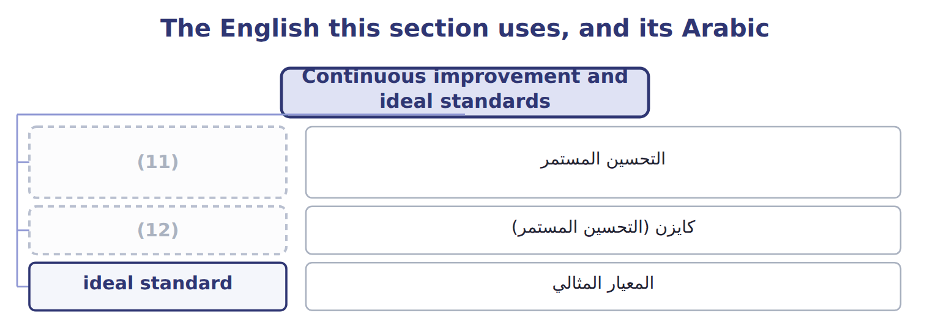
word list
Six Sigma · continuous improvement · kaizen

The English this sheet uses, and its Arabic
English (exam term) | Arabic
ideal standard | المعيار المثالي

Answer key · 16.2 Continuous improvement and ideal standards

1 conditions | 7 Efficient work with normal waste and breaks
2 breakdowns | 8 Shows the direction and the size of the remaining waste
3 currently | 9 Can demotivate if used to judge them
4 possible | 10 2.0% this year; 1.2% after kaizen
5 direction | 11 continuous improvement
6 process | 12 kaizen

the summaries in full
Summary 1 An ideal standard assumes perfect conditions: no waste, no breakdowns, no idle time. A currently attainable standard allows for normal waste and is hard but possible. The ideal shows the direction and the size of the waste still in the process. Each year the attainable standard moves closer to it. Beverages allows 2.0% normal spoilage this year, aims for 1.2% after its kaizen program, and treats 0.0% as the ideal.

16.3 The four costs of quality
Chapter 16 · section 16.3

Fill every gap. Each word list holds one word more than there are gaps.
Summary 1 gaps 1–5
The cost of (1) has four parts. (2) costs stop defects before they happen. Appraisal costs find defects by (3) and testing. Together they are the costs of (4) . (5) failure costs arise from defects found before the product reaches the customer, such as scrap and rework. External failure costs arise from defects the customer finds, such as returns, complaints and lost sales.
word list
Internal · kaizen · conformance · inspection · quality · Prevention

Beverages cost-of-quality report, 2027
Beverages cost-of-quality report, 2027 | Item | Category
(6) | 30,000
Quality training for staff | 40,000
(7) | 50,000
(8) |  | 120,000 (13%)
(9) | 45,000
(10) | 80,000
Lab tests of finished juice | 55,000
Appraisal costs |  | 180,000 (19%)
(11) | 150,000
Re-filtering (rework) | 60,000
(12) | 40,000
Internal failure costs |  | 250,000 (26%)
(13) | 200,000
Handling complaints | 50,000
Lost contribution from lost customers (estimate) | 150,000
External failure costs |  | 400,000 (42%)
Total cost of quality |  | 950,000

word list
Line stops after failures · Prevention costs · Supplier audits · Testing incoming concentrate · Lab tests of finished juice · Preventive maintenance of the fillers · Spoiled batches · In-line checks of fill and seal · Returns and replacements

Hidden external failure costs

Summary 2 gaps 14–16
Lost sales and lost (14) do not appear in the ledger, but they are external failure costs. An exam answer that leaves them out (15) the cost of quality. Both mean the four categories, not the price of a (16) product.
word list
customers · Appraisal · understates · high-quality

The English this section uses, and its Arabic
Each term sits against what it means.
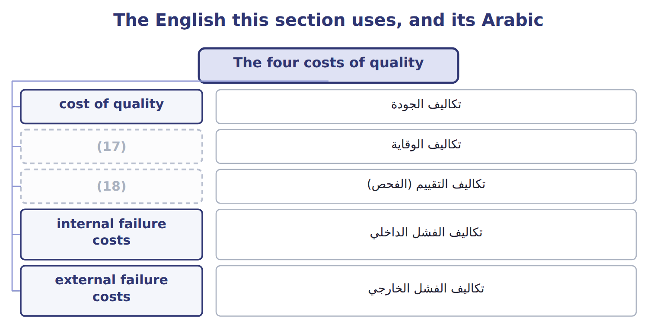
word list
prevention costs · PDCA cycle · appraisal costs

The English this sheet uses, and its Arabic
English (exam term) | Arabic
cost of quality | تكاليف الجودة
prevention costs | تكاليف الوقاية
appraisal costs | تكاليف التقييم (الفحص)
internal failure costs | تكاليف الفشل الداخلي
external failure costs | تكاليف الفشل الخارجي

Answer key · 16.3 The four costs of quality

1 quality | 10 In-line checks of fill and seal
2 Prevention | 11 Spoiled batches
3 inspection | 12 Line stops after failures
4 conformance | 13 Returns and replacements
5 Internal | 14 customers
6 Supplier audits | 15 understates
7 Preventive maintenance of the fillers | 16 high-quality
8 Prevention costs | 17 prevention costs
9 Testing incoming concentrate | 18 appraisal costs

the summaries in full
Summary 1 The cost of quality has four parts. Prevention costs stop defects before they happen. Appraisal costs find defects by inspection and testing. Together they are the costs of conformance. Internal failure costs arise from defects found before the product reaches the customer, such as scrap and rework. External failure costs arise from defects the customer finds, such as returns, complaints and lost sales.
Summary 2 Lost sales and lost customers do not appear in the ledger, but they are external failure costs. An exam answer that leaves them out understates the cost of quality. Both mean the four categories, not the price of a high-quality product.

16.4 The financial impact of quality improvement
Chapter 16 · section 16.4

Fill every gap. Each word list holds one word more than there are gaps.
Summary 1 gaps 1–2
Beverages plans a (1) and process-control program. It adds $110,000 a year of (2) , cuts appraisal by $40,000, and is expected to cut internal failure by 45% and external failure by 60%.
word list
supplier-certification · program · prevention

Worked example: the program's effect

Worked example: the quality program's effect on each category
The parts add up to the total; the bars are to scale.
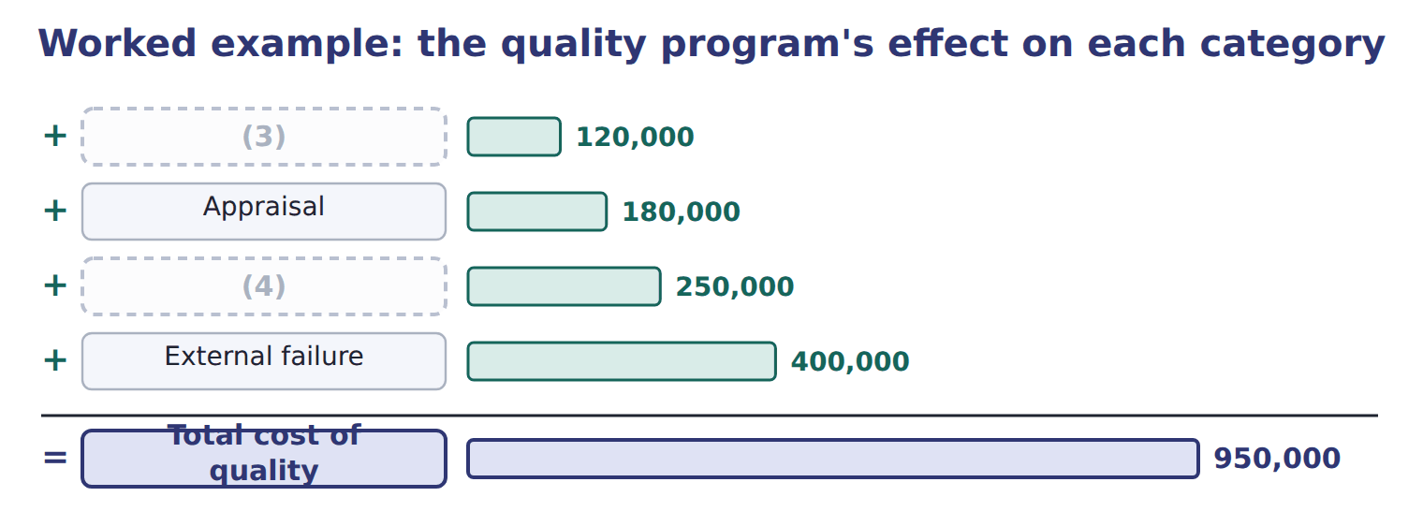
word list
Prevention · Internal failure · Appraisal

The failure costs after the program

Complete the two blank rows.
Your turn: the cost of quality after the program (complete the blanks)
Cost of quality after the program | Whole USD
(5) | 230,000
Appraisal | 140,000
Internal failure (cut by 45%) | ________
(6) | ________
(7) | 667,500

word list
External failure (cut by 60%) · Prevention · Internal failure (cut by 45%) · Total after the program

Answer key · 16.4 The financial impact of quality improvement

1 supplier-certification | 5 Prevention
2 prevention | 6 External failure (cut by 60%)
3 Prevention | 7 Total after the program
4 Internal failure

the summaries in full
Summary 1 Beverages plans a supplier-certification and process-control program. It adds $110,000 a year of prevention, cuts appraisal by $40,000, and is expected to cut internal failure by 45% and external failure by 60%.

16.5 Extended Example 16A: the total impact on Beverages
Chapter 16 · section 16.5

Fill every gap. Each word list holds one word more than there are gaps.
Summary 1 gaps 1–4
This example adds the quality program and the kaizen event (1) , as the division manager (2) them to the board. Cost of quality 2027: (3) $120,000, appraisal $180,000, (4) failure $250,000, external failure $400,000. Improvements: the quality program (Section 16.4) and the changeover kaizen (Section 16.1).
word list
presented · prevention · together · internal · compute

Extended Example: the total yearly financial impact
The bars are drawn to scale.
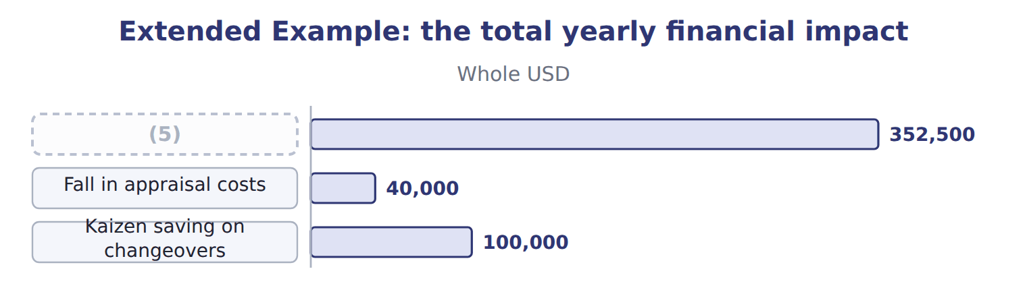
word list
Kaizen saving on changeovers · Fall in failure costs

Everything ties

Summary 2 gaps 6–7
Fall in failure costs $352,500 + fall in (6) $40,000 − extra (7) $110,000 = $282,500.
word list
prevention · quality · appraisal

Exam view

Summary 3 gaps 8–10
Expect a list of quality costs to classify, then a (8) that raises (9) or appraisal and lowers failure costs. Classify first, then compute the new total; the answer is the net change, after the extra (10) .
word list
together · prevention · spending · proposal

Exam view
The bars are drawn to scale.
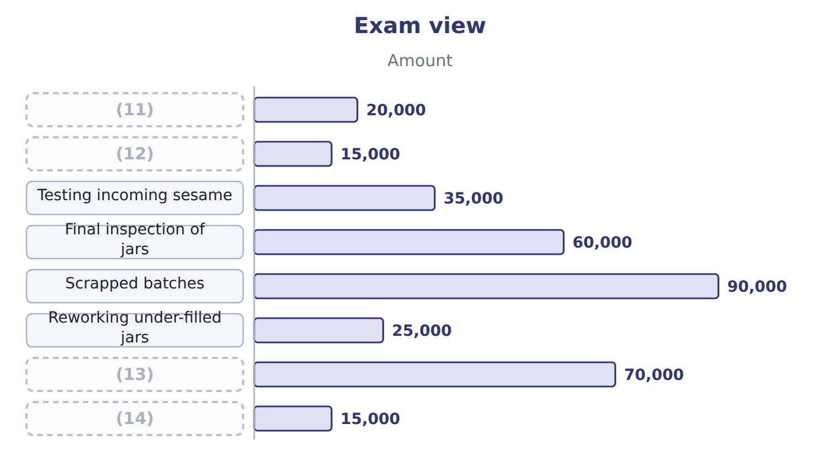
word list
Scrapped batches · Supplier audits · Staff training in hygiene · Handling customer complaints · Returns from Barada

Item — Answer
Item | Answer
Internal failure after the program | (15)
External failure after the program | $400,000 × (100% − 60%) = $160,000

word list
$250,000 × (100% − 45%) = $137,500 · $400,000 × (100% − 60%) = $160,000

Quality cost — Category
Every item belongs to exactly one group.
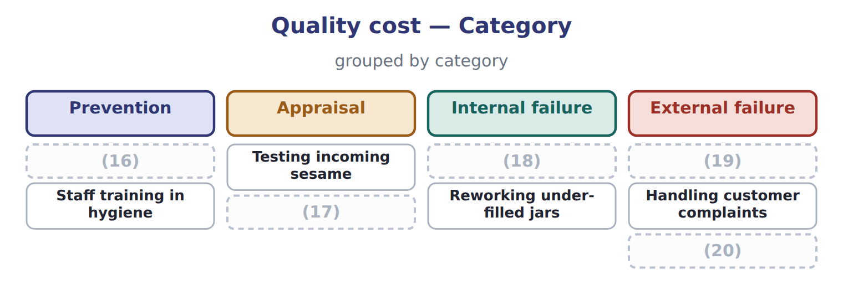
word list
Lost sales after a recall (estimate) · appraisal costs · Final inspection of jars · Returns from Barada · Scrapped batches · Supplier audits

The English this section uses, and its Arabic
Each term sits against what it means.
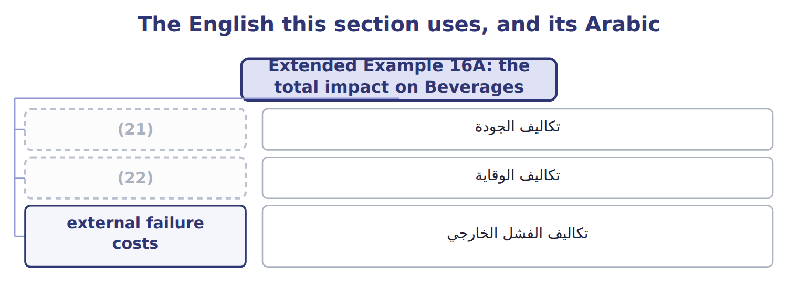
word list
cost of quality · continuous improvement · prevention costs

The English this sheet uses, and its Arabic
English (exam term) | Arabic
cost of quality | تكاليف الجودة
prevention costs | تكاليف الوقاية
external failure costs | تكاليف الفشل الخارجي

Answer key · 16.5 Extended Example 16A: the total impact on Beverages

1 together | 12 Staff training in hygiene
2 presented | 13 Returns from Barada
3 prevention | 14 Handling customer complaints
4 internal | 15 $250,000 × (100% − 45%) = $137,500
5 Fall in failure costs | 16 Supplier audits
6 appraisal | 17 Final inspection of jars
7 prevention | 18 Scrapped batches
8 proposal | 19 Returns from Barada
9 prevention | 20 Lost sales after a recall (estimate)
10 spending | 21 cost of quality
11 Supplier audits | 22 prevention costs

the summaries in full
Summary 1 This example adds the quality program and the kaizen event together, as the division manager presented them to the board. Cost of quality 2027: prevention $120,000, appraisal $180,000, internal failure $250,000, external failure $400,000. Improvements: the quality program (Section 16.4) and the changeover kaizen (Section 16.1).
Summary 2 Fall in failure costs $352,500 + fall in appraisal $40,000 − extra prevention $110,000 = $282,500.
Summary 3 Expect a list of quality costs to classify, then a proposal that raises prevention or appraisal and lowers failure costs. Classify first, then compute the new total; the answer is the net change, after the extra spending.

