17.1 Supply chain management
Chapter 17 · section 17.1

Fill every gap. Each word list holds one word more than there are gaps.
Chapter 17, section by section
Each stage leads to the next.
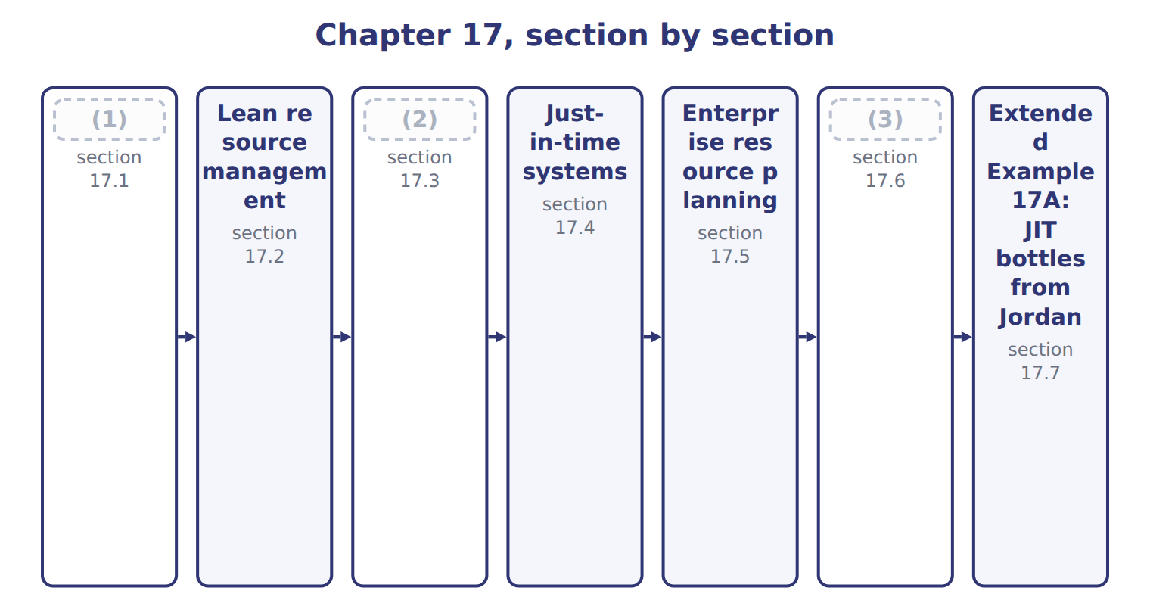
word list
Material requirements planning · Supply chain management · just-in-time (JIT) · Outsourcing

Summary 1 gaps 4–9
A supply chain links every company that helps a product reach the final consumer: suppliers, (4) , distributors, (5) and customers. Supply chain management (6) the flows of goods, (7) and money along the whole chain. Supply chain management is more than (8) . When (9) share sales data, small changes in consumer demand no longer grow into large swings in orders further up the chain, and every partner needs less stock.
word list
purchasing · manufacturers · kanban · retailers · partners · coordinates · information

The English this sheet uses, and its Arabic
English (exam term) | Arabic
supply chain management | إدارة سلسلة الإمداد

Answer key · 17.1 Supply chain management

1 Supply chain management | 6 coordinates
2 Material requirements planning | 7 information
3 Outsourcing | 8 purchasing
4 manufacturers | 9 partners
5 retailers

the summaries in full
Summary 1 A supply chain links every company that helps a product reach the final consumer: suppliers, manufacturers, distributors, retailers and customers. Supply chain management coordinates the flows of goods, information and money along the whole chain. Supply chain management is more than purchasing. When partners share sales data, small changes in consumer demand no longer grow into large swings in orders further up the chain, and every partner needs less stock.

17.2 Lean resource management
Chapter 17 · section 17.2

Fill every gap. Each word list holds one word more than there are gaps.
Summary 1 gaps 1–2
Lean resource (1) delivers value to customers with the least waste of time, materials, space and effort. It (2) by seeing waste.
word list
kanban · starts · management

The eight wastes of lean, with Orontes examples
Waste | Orontes example
Overproduction | Making juice before orders exist
Waiting | (3)
Transport | Moving pallets between two buildings
Over-processing | (4)
Inventory | (5)
Motion | Staff walking to fetch caps
Defects | Under-filled jars, re-filtering
Unused skills | (6)

word list
Filling line idle during long changeovers · Making juice before orders exist · A month of bottles in a rented store · Ignoring line workers' improvement ideas · Checking every invoice twice

Summary 2 gaps 7–8
Lean uses simple techniques to remove waste: tidy work areas, (7) signals that pull materials only when needed, quick changeovers, (8) and maps of each value stream.
word list
kanban · removes · error-proofing

Lean techniques and their operational benefits
Lean technique | What it does | Operational benefit
5S (sort, set, shine, standardize, sustain) | Tidy, organized work areas | (9)
Kanban | (10) | Less inventory
Quick changeover | Shorter setups (Chapter 16) | (11)
Error-proofing | (12) | Fewer defects
Value stream mapping | Map of every step and wait | (13)

word list
Staff walking to fetch caps · Smaller batches, less waiting · Shows where waste is · Devices that stop mistakes · Signals pull materials when needed · Less searching and motion

Summary 3 gaps 14–20
The (14) benefits follow: less (15) and space, shorter lead times, fewer defects and more capacity from the same line. Lean is not simple cost cutting; it removes (16) customers do not value while (17) those they do. At (18) , lean started with a value stream map of the (19) line. It showed that a bottle spent weeks in storage and minutes in (20) . Kanban signals from the filling line to the store, and later to Jordan Glass, cut that waiting time and the space it needed.
word list
activities · Orontes · signals · protecting · Beverages · inventory · production · operational

The English this sheet uses, and its Arabic
English (exam term) | Arabic
lean resource management | الإدارة الرشيقة للموارد
kanban | كانبان

Answer key · 17.2 Lean resource management

1 management | 11 Smaller batches, less waiting
2 starts | 12 Devices that stop mistakes
3 Filling line idle during long changeovers | 13 Shows where waste is
4 Checking every invoice twice | 14 operational
5 A month of bottles in a rented store | 15 inventory
6 Ignoring line workers' improvement ideas | 16 activities
7 kanban | 17 protecting
8 error-proofing | 18 Orontes
9 Less searching and motion | 19 Beverages
10 Signals pull materials when needed | 20 production

the summaries in full
Summary 1 Lean resource management delivers value to customers with the least waste of time, materials, space and effort. It starts by seeing waste.
Summary 2 Lean uses simple techniques to remove waste: tidy work areas, kanban signals that pull materials only when needed, quick changeovers, error-proofing and maps of each value stream.
Summary 3 The operational benefits follow: less inventory and space, shorter lead times, fewer defects and more capacity from the same line. Lean is not simple cost cutting; it removes activities customers do not value while protecting those they do. At Orontes, lean started with a value stream map of the Beverages line. It showed that a bottle spent weeks in storage and minutes in production. Kanban signals from the filling line to the store, and later to Jordan Glass, cut that waiting time and the space it needed.

17.3 Material requirements planning
Chapter 17 · section 17.3

Fill every gap. Each word list holds one word more than there are gaps.
Summary 1 gaps 1–2
Material (1) planning (MRP) calculates which materials are needed, how many, and when to order them. It uses three inputs: the master (2) schedule, the bill of materials, and the stock records.
word list
production · requirements · forecast

Worked example: bottles for week 1

Summary 2 gaps 3–5
Beverages plans 18,000 cases in week 1, or 216,000 bottles. It has 60,000 bottles, must keep 20,000 as (3) stock, and (4) 150,000 from an open order. Net need: 216,000 − 150,000 − 40,000 = 26,000 bottles, (5) one week ahead.
word list
expects · safety · ordered · schedule

Bottles for weeks 3 and 4

Your turn: net bottle requirements (complete the blanks)
Name each point on the scale from where it sits.
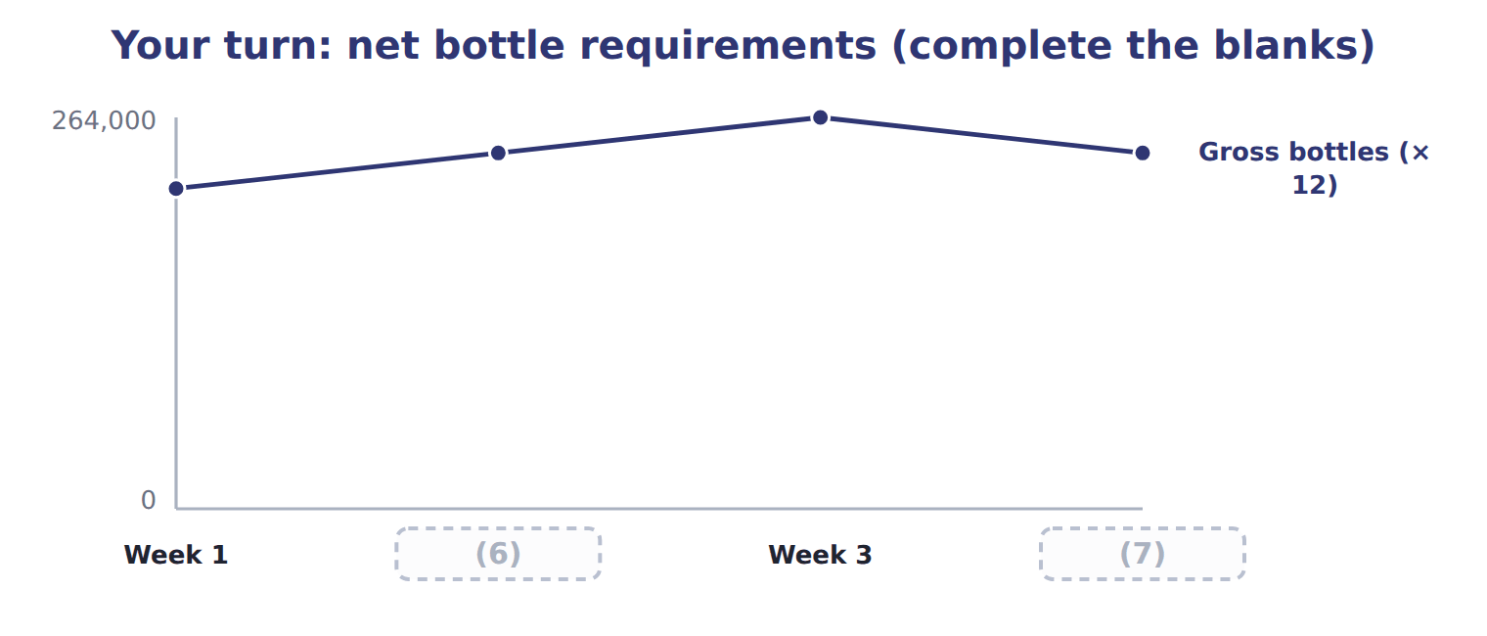
word list
Week 2 · Week 4 · Cases planned

Summary 3 gaps 8–10
MRP is a push system: it plans (8) from a forecast schedule and pushes (9) into production. It works well for (10) production, but a wrong forecast leaves the company with too much or too little stock.
word list
materials · planned · purchases · outsourcing

The English this section uses, and its Arabic
Each term sits against what it means.
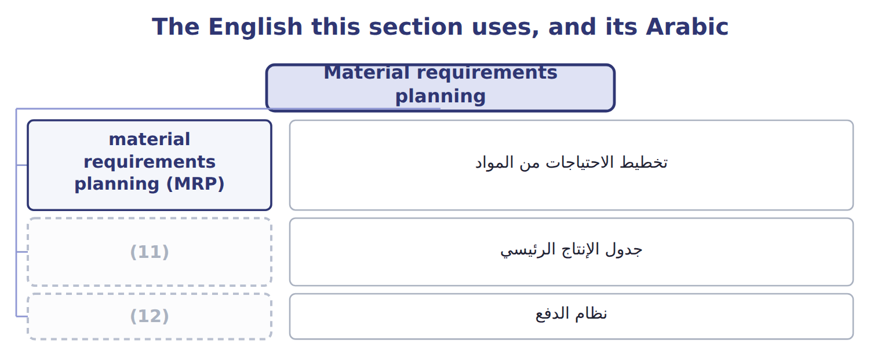
word list
جدول الإنتاج الرئيسي · push system · master production schedule

The English this sheet uses, and its Arabic
English (exam term) | Arabic
material requirements planning (MRP) | تخطيط الاحتياجات من المواد
master production schedule | جدول الإنتاج الرئيسي
push system | نظام الدفع

Answer key · 17.3 Material requirements planning

1 requirements | 7 Week 4
2 production | 8 purchases
3 safety | 9 materials
4 expects | 10 planned
5 ordered | 11 master production schedule
6 Week 2 | 12 push system

the summaries in full
Summary 1 Material requirements planning (MRP) calculates which materials are needed, how many, and when to order them. It uses three inputs: the master production schedule, the bill of materials, and the stock records.
Summary 2 Beverages plans 18,000 cases in week 1, or 216,000 bottles. It has 60,000 bottles, must keep 20,000 as safety stock, and expects 150,000 from an open order. Net need: 216,000 − 150,000 − 40,000 = 26,000 bottles, ordered one week ahead.
Summary 3 MRP is a push system: it plans purchases from a forecast schedule and pushes materials into production. It works well for planned production, but a wrong forecast leaves the company with too much or too little stock.

17.4 Just-in-time systems
Chapter 17 · section 17.4

Fill every gap. Each word list holds one word more than there are gaps.
Summary 1 gaps 1–3
Just-in-time (JIT) is a pull (1) . (2) arrive and products are made only when the next step, or the customer, asks for them. JIT needs reliable (3) , short setups and good quality, because there is almost no stock to hide problems.
word list
system · Materials · because · suppliers

Operational benefits of JIT for the Beverages division
JIT benefit | Beverages example
Lower inventory | (4)
Less space | (5)
Faster response | Production follows actual orders
Higher quality | (6)
Closer suppliers | Daily deliveries need a reliable partner (Jordan Glass)

word list
Bottle stock falls from a month to a day · Problems show quickly, before large stocks are made · Daily deliveries need a reliable partner (Jordan Glass) · The rented bottle store is given up

Backflush costing

Summary 2 gaps 7–10
With JIT, work in process is small, so some companies use (7) costing: they record costs only at a few trigger points, such as (8) or sale. Under U.S. GAAP this is (9) only when the (10) is close to what full costing would give (ASC 330).
word list
outsourcing · backflush · result · completion · acceptable

The English this section uses, and its Arabic
Each term sits against what it means.
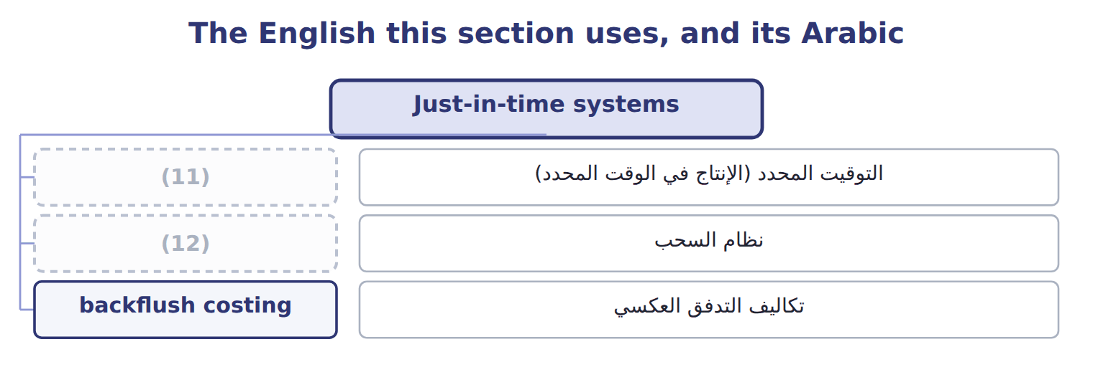
word list
pull system · just-in-time (JIT) · نظام السحب

The English this sheet uses, and its Arabic
English (exam term) | Arabic
just-in-time (JIT) | التوقيت المحدد (الإنتاج في الوقت المحدد)
pull system | نظام السحب
backflush costing | تكاليف التدفق العكسي

Answer key · 17.4 Just-in-time systems

1 system | 7 backflush
2 Materials | 8 completion
3 suppliers | 9 acceptable
4 Bottle stock falls from a month to a day | 10 result
5 The rented bottle store is given up | 11 just-in-time (JIT)
6 Problems show quickly, before large stocks are made | 12 pull system

the summaries in full
Summary 1 Just-in-time (JIT) is a pull system. Materials arrive and products are made only when the next step, or the customer, asks for them. JIT needs reliable suppliers, short setups and good quality, because there is almost no stock to hide problems.
Summary 2 With JIT, work in process is small, so some companies use backflush costing: they record costs only at a few trigger points, such as completion or sale. Under U.S. GAAP this is acceptable only when the result is close to what full costing would give (ASC 330).

17.5 Enterprise resource planning
Chapter 17 · section 17.5

Fill every gap. Each word list holds one word more than there are gaps.
Summary 1 gaps 1–4
Enterprise resource planning (ERP) is an (1) system in which sales, (2) , production, inventory, accounting and human resources all work from one shared database. (3) data is entered once, the copying and (4) removed. Managers see stock, orders and costs as they change, and MRP runs on live data instead of last month's reports.
word list
purchasing · re-typing · production · Because · integrated

Operational benefits of ERP
Operational benefit of ERP | Example
Data entered once | No copying of orders (Chapter 15)
Real-time information | (5)
Integrated planning | MRP uses live sales and stock data
Faster period-end close | (6)
Better control | (7)

word list
Managers see stock, orders and costs as they change · Standard processes and a full record of who did what · Fewer reconciliations between departments · enterprise resource planning (ERP)

The English this sheet uses, and its Arabic
English (exam term) | Arabic
enterprise resource planning (ERP) | تخطيط موارد المؤسسة

Answer key · 17.5 Enterprise resource planning

1 integrated | 5 Managers see stock, orders and costs as they change
2 purchasing | 6 Fewer reconciliations between departments
3 Because | 7 Standard processes and a full record of who did what
4 re-typing

the summaries in full
Summary 1 Enterprise resource planning (ERP) is an integrated system in which sales, purchasing, production, inventory, accounting and human resources all work from one shared database. Because data is entered once, the copying and re-typing removed. Managers see stock, orders and costs as they change, and MRP runs on live data instead of last month's reports.

17.6 Outsourcing
Chapter 17 · section 17.6

Fill every gap. Each word list holds one word more than there are gaps.
Outsourcing means buying from an outside supplier something the company used to do itself.
Benefits and limitations of outsourcing
Benefits | Limitations
Lower cost when the supplier has scale | Loss of control over quality and timing
Focus on core activities | (1)
Access to skills and technology | Confidential know-how may leak
Fixed costs become variable | (2)

word list
Dependence on one supplier · Hidden costs: contracts, monitoring, transport · Printer lease (can be cancelled)

Summary 1 gaps 3–5
The (3) test compares the (4) price with the costs that would really disappear, not with the full cost. Allocated plant overhead and (5) on equipment that cannot be sold stay whether or not the work is outsourced.
word list
supplier's · financial · outsourcing · depreciation

Worked example: printing labels

Summary 2 gaps 6–7
Beverages prints its own labels at a full cost of $265,000, of which $225,000 is (6) . A (7) offers the labels for $200,000, and the freed room can be rented for $12,000.
word list
printer · Beverages · avoidable

Worked example: print labels in-house or buy them?
The bars are drawn to scale.
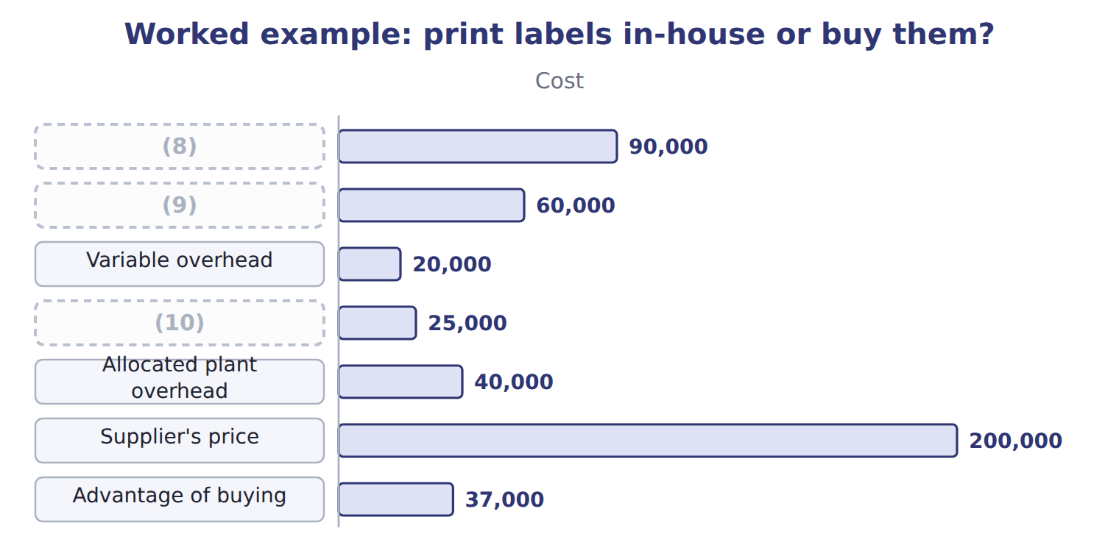
word list
Printing staff · Variable overhead · Label stock and ink · Printer lease (can be cancelled)

Summary 3 gaps 11–14
The (11) are only half of the (12) . (13) are not a core skill, and several (14) can supply them, so the risks are small. For a core activity with one possible supplier, the same saving might not be worth the loss of control.
word list
numbers · Labels · depreciation · decision · printers

Full cost is not avoidable cost

Summary 4 gaps 15–16
If an exam answer compares the (15) price with the full cost, it counts costs that will not disappear. Compare with the (16) cost, and add any income from freed resources.
word list
supplier's · Beverages · avoidable

The English this sheet uses, and its Arabic
English (exam term) | Arabic
outsourcing | الاستعانة بمصادر خارجية

Answer key · 17.6 Outsourcing

1 Dependence on one supplier | 9 Printing staff
2 Hidden costs: contracts, monitoring, transport | 10 Printer lease (can be cancelled)
3 financial | 11 numbers
4 supplier's | 12 decision
5 depreciation | 13 Labels
6 avoidable | 14 printers
7 printer | 15 supplier's
8 Label stock and ink | 16 avoidable

the summaries in full
Summary 1 The financial test compares the supplier's price with the costs that would really disappear, not with the full cost. Allocated plant overhead and depreciation on equipment that cannot be sold stay whether or not the work is outsourced.
Summary 2 Beverages prints its own labels at a full cost of $265,000, of which $225,000 is avoidable. A printer offers the labels for $200,000, and the freed room can be rented for $12,000.
Summary 3 The numbers are only half of the decision. Labels are not a core skill, and several printers can supply them, so the risks are small. For a core activity with one possible supplier, the same saving might not be worth the loss of control.
Summary 4 If an exam answer compares the supplier's price with the full cost, it counts costs that will not disappear. Compare with the avoidable cost, and add any income from freed resources.

17.7 Extended Example 17A: JIT bottles from Jordan Glass
Chapter 17 · section 17.7

Fill every gap. Each word list holds one word more than there are gaps.
Summary 1 gaps 1–5
This example measures the (1) impact of moving bottle (2) from monthly to daily deliveries. Now: monthly deliveries; average bottle inventory $120,000; a (3) store at $30,000 a year. JIT: daily deliveries; average inventory $10,000; an extra (4) charge of $24,000 and extra (5) of $6,000 a year. Carrying cost: 20% of the average inventory a year.
word list
financial · rented · supply · delivery · handling · measures

Extended Example: the financial impact of JIT bottle deliveries
Beverages bottles (whole USD) | Monthly deliveries | JIT daily deliveries
Average bottle inventory | 120,000 | 10,000
Carrying cost (20% of average inventory) | 24,000 | 2,000
(6) | 30,000 | —
Damage and breakage | 8,000 | 1,000
Extra delivery charge | — | 24,000
(7) | — | 6,000
(8) | 62,000 | 33,000
(9) |  | 29,000
(10) |  | 110,000

word list
supply chain management · Yearly saving · Yearly cost · Extra receiving and handling · Rent of the bottle store · Cash released once from lower inventory

Summary 2 gaps 11–13
The saving is real but (11) on Jordan Glass (12) every day. Orontes owns part of Jordan Glass, which makes the link closer, but the division still keeps a small safety stock for (13) .
word list
difference · delivering · depends · breakdowns

Everything ties

Summary 3 gaps 14–15
Carrying cost now: $120,000 × 20% = $24,000; under JIT: $2,000. (14) saving $29,000 = $62,000 − $33,000; cash (15) $110,000 = $120,000 − $10,000.
word list
carrying-cost · Yearly · released

Exam view

Summary 4 gaps 16–18
Expect inventory levels, a (16) rate and the extra costs of the new (17) . Compute each yearly cost, take the (18) , and treat the fall in inventory as a one-time release of cash, not a yearly saving.
word list
system · financial · difference · carrying-cost

Exam view
Oils: bottling EVOO, 2027 | Per liter
Bottles and caps | $1.50
Bottling labor | $0.90
(19) | $0.40
(20) | $0.50
(21) | $0.30
Bottling cost per liter (Chapter 11) | $3.60
Bottler's quote per liter | $3.20
(22) | 150,000

word list
Allocated plant overhead · Variable overhead · Liters bottled per year · Extra receiving and handling · Depreciation of the bottling line (no resale value)

Item — Answer
Item | Answer
Week 3 net bottles | 22,000 cases × 12 = 264,000
Week 4 net bottles | (23)

word list
20,000 cases × 12 = 240,000 · Carrying cost (20% of average inventory)

Bottling cost — Category
Every item belongs to exactly one group.
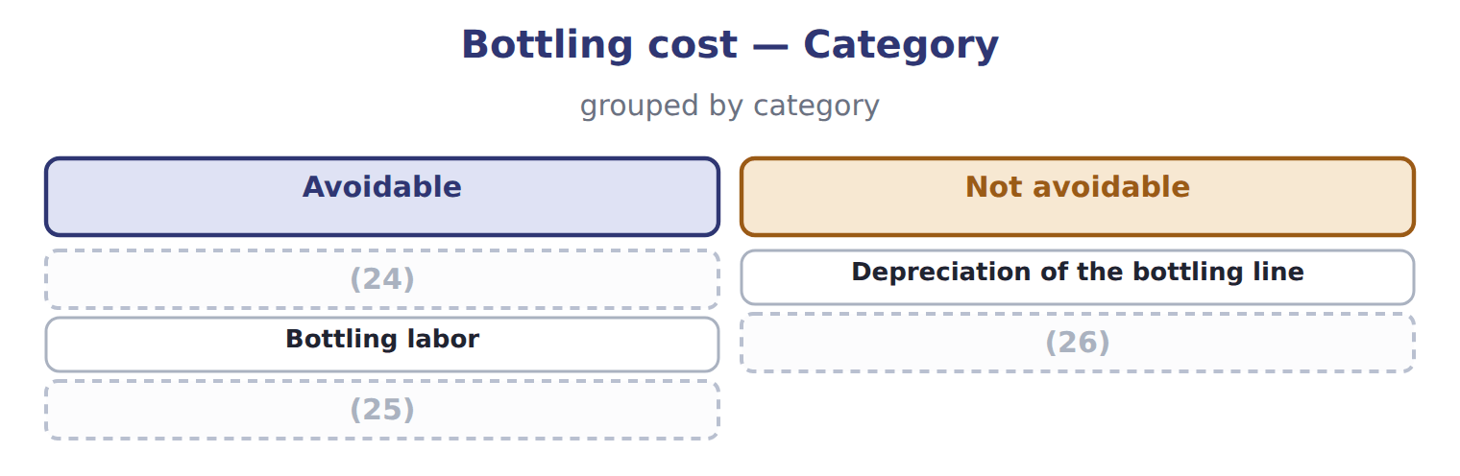
word list
Bottles and caps · Allocated plant overhead · supply chain management · Variable overhead

The English this section uses, and its Arabic
Each term sits against what it means.
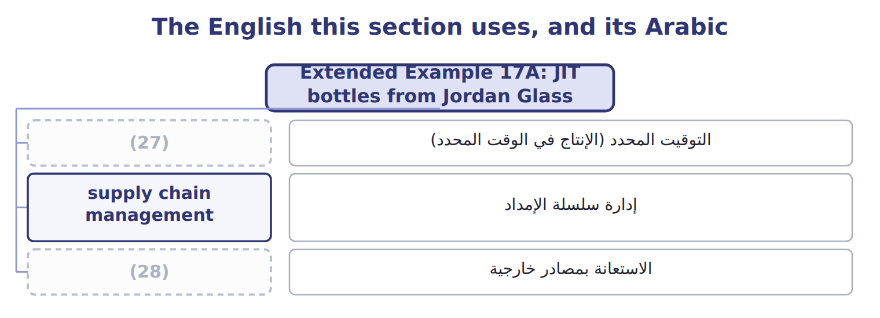
word list
kanban · just-in-time (JIT) · outsourcing

The English this sheet uses, and its Arabic
English (exam term) | Arabic
just-in-time (JIT) | التوقيت المحدد (الإنتاج في الوقت المحدد)
supply chain management | إدارة سلسلة الإمداد
outsourcing | الاستعانة بمصادر خارجية

Answer key · 17.7 Extended Example 17A: JIT bottles from Jordan Glass

1 financial | 15 released
2 supply | 16 carrying-cost
3 rented | 17 system
4 delivery | 18 difference
5 handling | 19 Variable overhead
6 Rent of the bottle store | 20 Depreciation of the bottling line (no resale value)
7 Extra receiving and handling | 21 Allocated plant overhead
8 Yearly cost | 22 Liters bottled per year
9 Yearly saving | 23 20,000 cases × 12 = 240,000
10 Cash released once from lower inventory | 24 Bottles and caps
11 depends | 25 Variable overhead
12 delivering | 26 Allocated plant overhead
13 breakdowns | 27 just-in-time (JIT)
14 Yearly | 28 outsourcing

the summaries in full
Summary 1 This example measures the financial impact of moving bottle supply from monthly to daily deliveries. Now: monthly deliveries; average bottle inventory $120,000; a rented store at $30,000 a year. JIT: daily deliveries; average inventory $10,000; an extra delivery charge of $24,000 and extra handling of $6,000 a year. Carrying cost: 20% of the average inventory a year.
Summary 2 The saving is real but depends on Jordan Glass delivering every day. Orontes owns part of Jordan Glass, which makes the link closer, but the division still keeps a small safety stock for breakdowns.
Summary 3 Carrying cost now: $120,000 × 20% = $24,000; under JIT: $2,000. Yearly saving $29,000 = $62,000 − $33,000; cash released $110,000 = $120,000 − $10,000.
Summary 4 Expect inventory levels, a carrying-cost rate and the extra costs of the new system. Compute each yearly cost, take the difference, and treat the fall in inventory as a one-time release of cash, not a yearly saving.

