5.1 Zero-based budgeting
Chapter 5 · section 5.1

Fill every gap. Each word list holds one word more than there are gaps.
Chapter 5, section by section
Each stage leads to the next.
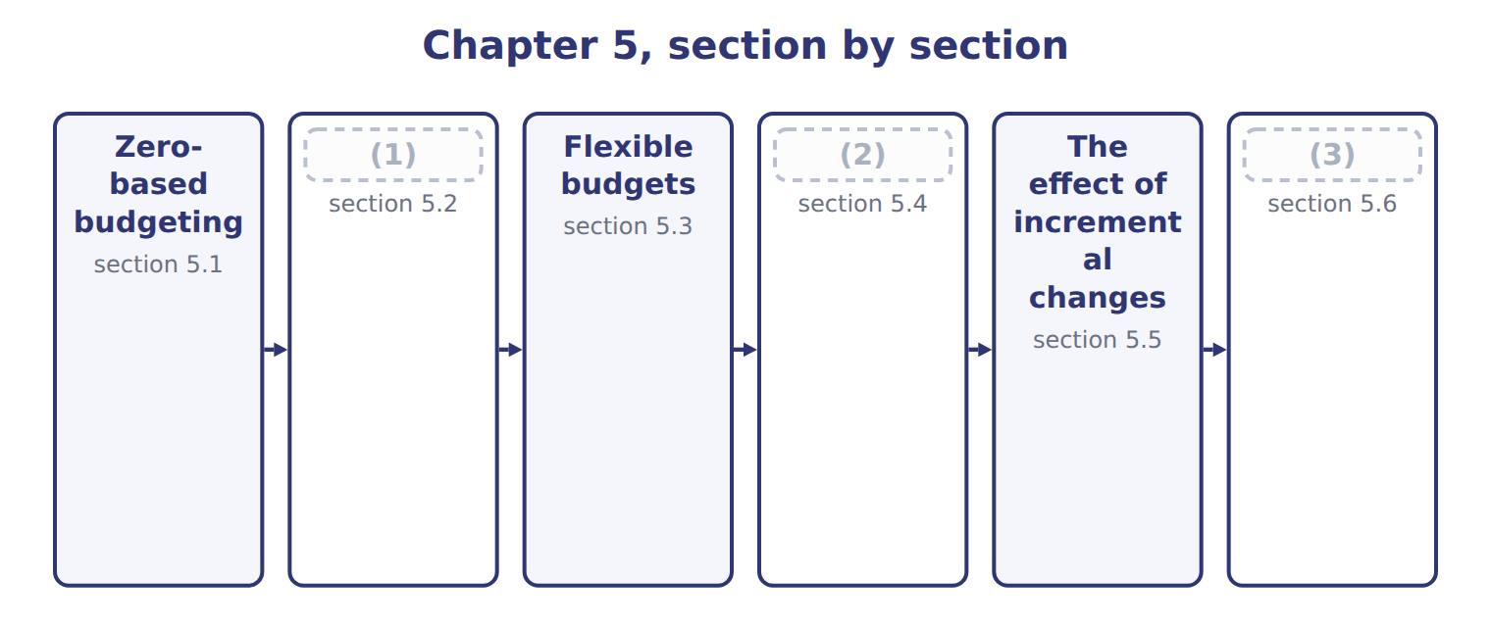
word list
Choosing a budget system · Continuous (rolling) budgets · Extended Example 5A: the 2028 budget review · The effect of incremental changes

Summary 1 gaps 4–10
Incremental budgeting starts from last year's (4) and adds or (5) a change. (6) budgeting starts from zero every year: each activity must be (7) again, as if it were new. It suits (8) costs, such as (9) services, where spending can grow without a clear reason. The budget is built from (10) packages. Each package describes an activity, its cost and its benefit; managers rank the packages, and top management funds them down the ranking until the money runs out.
word list
decision · figures · packages · subtracts · discretionary · Zero-based · head-office · justified

Worked example: the head-office budget for 2028

Summary 2 gaps 11–12
Six packages ask for $1,260,000. The board funds the (11) packages in full, reduces two and rejects the (12) .
word list
essential · sponsorships · services

Worked example: head-office decision packages for 2028
The bars are drawn to scale.
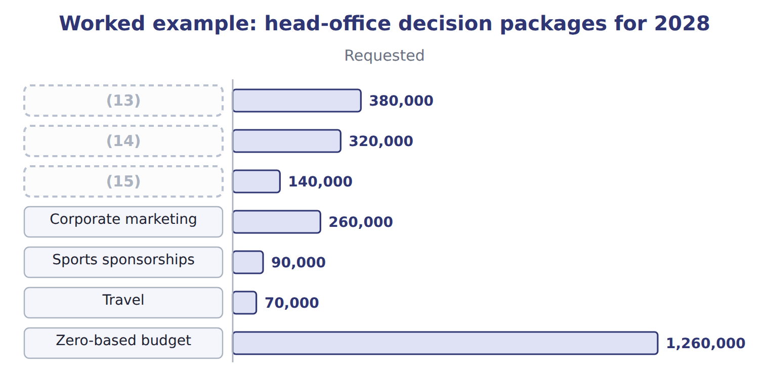
word list
IT support · Finance and reporting · decision package · Legal and compliance

Requested is not approved

Summary 3 gaps 16–17
A zero-based budget uses the (16) amount of each package. An answer that adds the (17) amounts, or starts from last year's total, has not used zero-based budgeting.
word list
Zero-based · requested · approved

The English this section uses, and its Arabic
Each term sits against what it means.
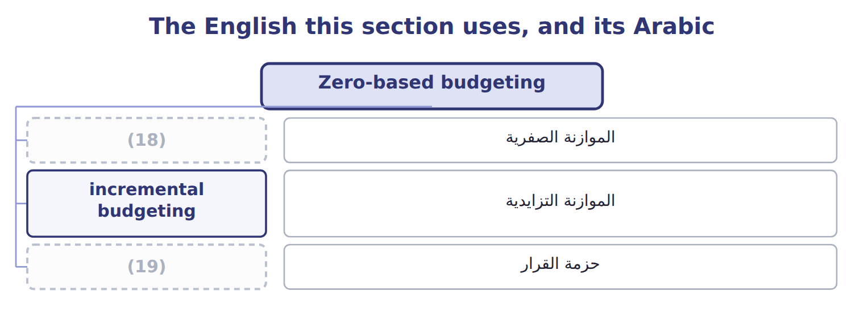
word list
decision package · flexible budget · zero-based budgeting

The English this sheet uses, and its Arabic
English (exam term) | Arabic
zero-based budgeting | الموازنة الصفرية
incremental budgeting | الموازنة التزايدية
decision package | حزمة القرار

Answer key · 5.1 Zero-based budgeting

1 Continuous (rolling) budgets | 11 essential
2 Choosing a budget system | 12 sponsorships
3 Extended Example 5A: the 2028 budget review | 13 Finance and reporting
4 figures | 14 IT support
5 subtracts | 15 Legal and compliance
6 Zero-based | 16 approved
7 justified | 17 requested
8 discretionary | 18 zero-based budgeting
9 head-office | 19 decision package
10 decision

the summaries in full
Summary 1 Incremental budgeting starts from last year's figures and adds or subtracts a change. Zero-based budgeting starts from zero every year: each activity must be justified again, as if it were new. It suits discretionary costs, such as head-office services, where spending can grow without a clear reason. The budget is built from decision packages. Each package describes an activity, its cost and its benefit; managers rank the packages, and top management funds them down the ranking until the money runs out.
Summary 2 Six packages ask for $1,260,000. The board funds the essential packages in full, reduces two and rejects the sponsorships.
Summary 3 A zero-based budget uses the approved amount of each package. An answer that adds the requested amounts, or starts from last year's total, has not used zero-based budgeting.

5.2 Continuous (rolling) budgets
Chapter 5 · section 5.2

Fill every gap. Each word list holds one word more than there are gaps.
Summary 1 gaps 1–6
A (1) (rolling) budget always covers the same length of time ahead, (2) twelve months. When a month or quarter ends, it is (3) and a new one is added at the end. It suits (4) markets, like juice. The (5) budget planned 900,000 cases for 2028. In March, the first quarter is (6) ; the second quarter is raised to 230,000 cases, and the first quarter of the next year is added at 215,000.
word list
December · dropped · finished · usually · continuous · fast-changing · targets

The Beverages rolling budget before and after the March update
Beverages cases | Q1 2028 | Q2 2028 | Q3 2028 | Q4 2028 | Q1 2029 | Four quarters
Budget made in December 2027 | 210,000 | 225,000 | 240,000 | 225,000 | — | 900,000
Rolled forward in March 2028 | (7) | 230,000 | 240,000 | 225,000 | 215,000 | 910,000

word list
zero-based budgeting · (done)

Summary 2 gaps 8–10
A rolling budget keeps planning up to date, but it takes (8) work, and targets that keep moving can confuse (9) evaluation. Many companies keep the annual budget for evaluation and use a rolling (10) for planning.
word list
constant · forecast · finished · performance

The English this sheet uses, and its Arabic
English (exam term) | Arabic
continuous (rolling) budget | الموازنة المستمرة (المتحركة)

Answer key · 5.2 Continuous (rolling) budgets

1 continuous | 6 finished
2 usually | 7 (done)
3 dropped | 8 constant
4 fast-changing | 9 performance
5 December | 10 forecast

the summaries in full
Summary 1 A continuous (rolling) budget always covers the same length of time ahead, usually twelve months. When a month or quarter ends, it is dropped and a new one is added at the end. It suits fast-changing markets, like juice. The December budget planned 900,000 cases for 2028. In March, the first quarter is finished; the second quarter is raised to 230,000 cases, and the first quarter of the next year is added at 215,000.
Summary 2 A rolling budget keeps planning up to date, but it takes constant work, and targets that keep moving can confuse performance evaluation. Many companies keep the annual budget for evaluation and use a rolling forecast for planning.

5.3 Flexible budgets
Chapter 5 · section 5.3

Fill every gap. Each word list holds one word more than there are gaps.
Summary 1 gaps 1–8
A (1) budget is prepared for one planned level of (2) . A (3) budget can be prepared for any level, using the cost formula of each cost: fixed cost plus variable cost per unit. It is used mainly to (4) actual costs with what they (5) have been at the actual volume. The (6) cost formula for a month is $350,000 of fixed costs plus $11.80 of variable cost per case. The variable cost is $10.60 of (7) cost from the Book 2 card and $1.20 of (8) cost.
word list
selling · prepared · should · compare · activity · Beverages · flexible · static · manufacturing

Worked example: three levels of activity

Summary 2 gaps 9–10
At 75,000 cases, sales are $1,500,000, (9) costs $885,000 and fixed costs $350,000, so (10) income is $265,000.
word list
variable · planned · operating

Worked example: the Beverages flexible budget for one month
The bars are drawn to scale.
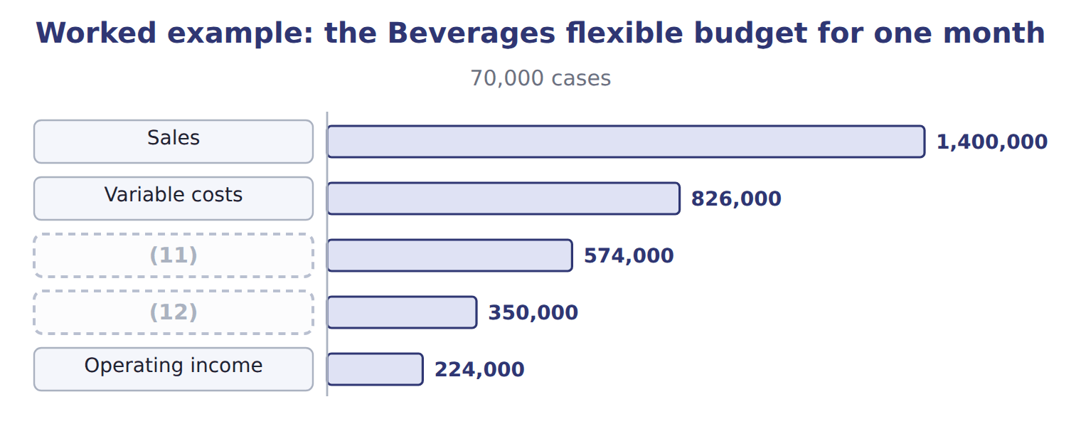
word list
Fixed costs · incremental budgeting · Contribution margin

The flexible budget at the higher volume

Summary 3 gaps 13–14
Complete the blank cells. Each extra case adds $8.20 of (13) income, because fixed costs do not change. The flexible budget (14) shows how much income should rise or fall with volume.
word list
operating · therefore · variable

The English this section uses, and its Arabic
Each term sits against what it means.
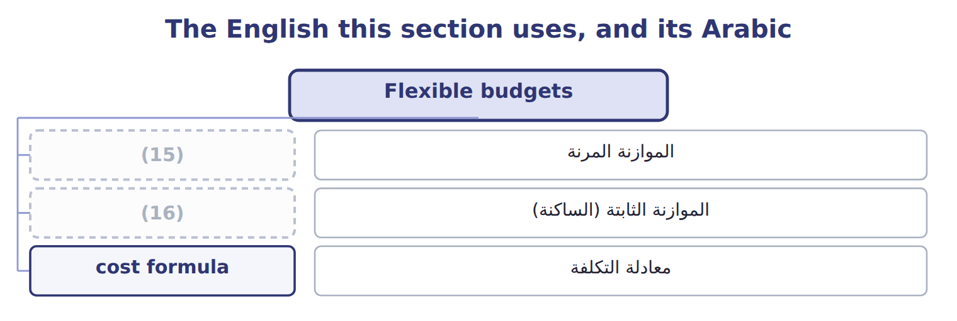
word list
الموازنة المرنة · static budget · flexible budget

The English this sheet uses, and its Arabic
English (exam term) | Arabic
flexible budget | الموازنة المرنة
static budget | الموازنة الثابتة (الساكنة)
cost formula | معادلة التكلفة

Answer key · 5.3 Flexible budgets

1 static | 9 variable
2 activity | 10 operating
3 flexible | 11 Contribution margin
4 compare | 12 Fixed costs
5 should | 13 operating
6 Beverages | 14 therefore
7 manufacturing | 15 flexible budget
8 selling | 16 static budget

the summaries in full
Summary 1 A static budget is prepared for one planned level of activity. A flexible budget can be prepared for any level, using the cost formula of each cost: fixed cost plus variable cost per unit. It is used mainly to compare actual costs with what they should have been at the actual volume. The Beverages cost formula for a month is $350,000 of fixed costs plus $11.80 of variable cost per case. The variable cost is $10.60 of manufacturing cost from the Book 2 card and $1.20 of selling cost.
Summary 2 At 75,000 cases, sales are $1,500,000, variable costs $885,000 and fixed costs $350,000, so operating income is $265,000.
Summary 3 Complete the blank cells. Each extra case adds $8.20 of operating income, because fixed costs do not change. The flexible budget therefore shows how much income should rise or fall with volume.

5.4 Choosing a budget system
Chapter 5 · section 5.4

Fill every gap. Each word list holds one word more than there are gaps.
The right system depends on the situation and the decision.
Recommending a budget system for each situation
Business situation (B.4.e) | Recommended system | Orontes example
Costs keep rising with no clear reason; many discretionary costs | (1) | Head office
Fast-changing market; plans must look a year ahead at all times | (2) | Beverages sales
Volume varies; managers must be judged fairly on costs | (3) | Beverages plant
One large investment over more than a year | Project budget (Chapter 4) | (4)
Overhead used very differently by products | (5) | Pulses & Spices

word list
Filling line · Beverages sales · Zero-based budget · Flexible budget · Continuous (rolling) budget · Activity-based budget (Chapter 4)

Benefits and limitations of zero-based, rolling and flexible budgets
System | Benefits | Limitations
Zero-based | (6) | Takes much time; managers may resist
Continuous (rolling) | Always up to date; always a year ahead | (7)
Flexible | Fair comparison at the actual volume | (8)

word list
Removes waste; questions every cost · Needs reliable cost formulas; mixed costs must be split · Constant work; targets keep moving · One large investment over more than a year

Summary 1 gaps 9–11
Systems are often (9) . Orontes uses a master budget for the year, rolling (10) for sales and flexible budgets for plant costs. It also reviews head office on a (11) basis every few years.
word list
decision · zero-based · combined · forecasts

The English this section uses, and its Arabic
Each term sits against what it means.
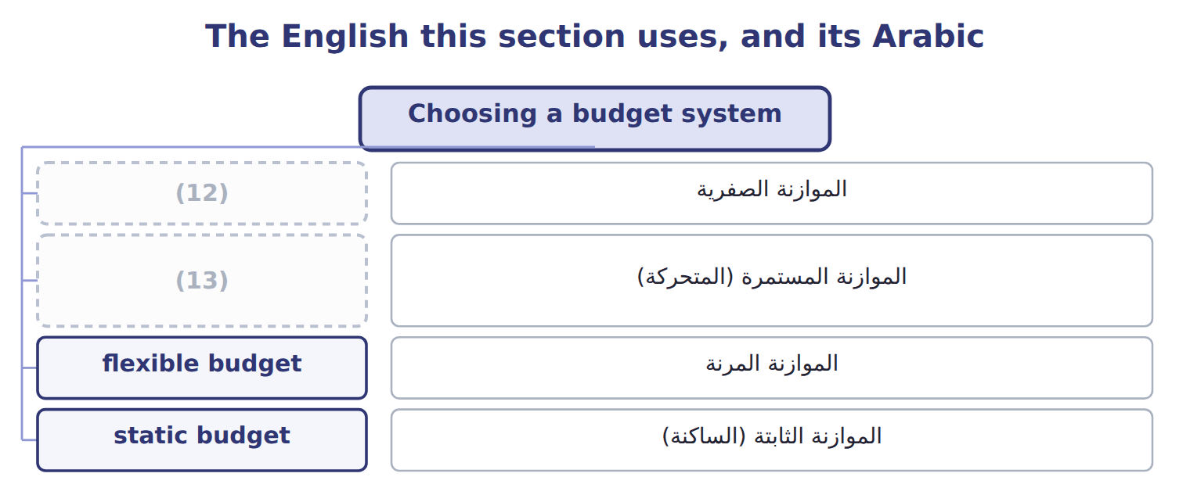
word list
static budget · zero-based budgeting · continuous (rolling) budget

Answer key · 5.4 Choosing a budget system

1 Zero-based budget | 8 Needs reliable cost formulas; mixed costs must be split
2 Continuous (rolling) budget | 9 combined
3 Flexible budget | 10 forecasts
4 Filling line | 11 zero-based
5 Activity-based budget (Chapter 4) | 12 zero-based budgeting
6 Removes waste; questions every cost | 13 continuous (rolling) budget
7 Constant work; targets keep moving

the summaries in full
Summary 1 Systems are often combined. Orontes uses a master budget for the year, rolling forecasts for sales and flexible budgets for plant costs. It also reviews head office on a zero-based basis every few years.

5.5 The effect of incremental changes
Chapter 5 · section 5.5

Fill every gap. Each word list holds one word more than there are gaps.
Summary 1 gaps 1–4
Managers often ask how a change would (1) the budget: a new price, more volume, a (2) cost. The right (3) is the change in (4) margin, and the answer must include every effect of the change, such as lost volume after a price rise.
word list
higher · affect · contribution · measure · include

Worked example: raising the juice price

Sales proposes a 5% price rise to $21.00 and expects to lose 3% of volume.
Worked example: the effect of a juice price rise
Beverages 2028 | Now | Price +5%, volume −3%
Price per case | $20.00 | $21.00
Variable cost per case | $11.80 | $11.80
Contribution margin per case | $8.20 | $9.20
(5) | 900,000 | 873,000
Contribution margin | 7,380,000 | 8,031,600
(6) |  | 651,600

word list
Cases a year · Contribution · Increase

Include the lost volume

Summary 2 gaps 7–8
Multiplying the old volume by the new margin (7) the cases lost after the price rise and (8) the gain. Use the new volume with the new margin.
word list
proposes · ignores · overstates

Answer key · 5.5 The effect of incremental changes

1 affect | 5 Cases a year
2 higher | 6 Increase
3 measure | 7 ignores
4 contribution | 8 overstates

the summaries in full
Summary 1 Managers often ask how a change would affect the budget: a new price, more volume, a higher cost. The right measure is the change in contribution margin, and the answer must include every effect of the change, such as lost volume after a price rise.
Summary 2 Multiplying the old volume by the new margin ignores the cases lost after the price rise and overstates the gain. Use the new volume with the new margin.

5.6 Extended Example 5A: the 2028 budget review
Chapter 5 · section 5.6

Fill every gap. Each word list holds one word more than there are gaps.
Summary 1 gaps 1–4
This example follows the (1) report to the board on the budget systems used for 2028. Head office: costs growing without clear reasons, mostly (2) . Beverages sales: a market that (3) every quarter. Beverages plant: volume that (4) from the plan most months. Pricing: a proposal to raise the juice price.
word list
changes · discretionary · zero-based · differs · controller's

Extended Example: systems and results of the 2028 budget review
Area | System or method | Result
Head office | Zero-based | (5) $1,100,000, saving $148,000 against last year + 4%
Beverages sales | (6) | Next four quarters 910,000 cases after the March update
Beverages costs | (7) | $350,000 a month + $11.80 a case
Pricing proposal | (8) | Price +5%: contribution margin +$651,600 a year

word list
Incremental analysis · Approved · Rolling (quarterly) · Flexible · Price +5%

Summary 2 gaps 9–10
The controller recommends adopting the zero-based (9) budget, the rolling sales forecast and the flexible plant budget. She also recommends (10) the price rise if a market test confirms the volume loss.
word list
proposal · approving · head-office

Everything ties

Summary 3 gaps 11–13
The four (11) of the December (12) total 900,000 cases, the volume agreed. Fixed (13) costs of $150,000 a month equal the Book 2 fixed overhead of $2.00 a case × 75,000 cases.
word list
budget · manufacturing · quarters · Pricing

Exam view

Summary 4 gaps 14–17
Expect to (14) a system for a (15) situation, to prepare a flexible budget at a given volume and to roll a budget forward. You may also have to (16) the effect of a price, volume or cost change on (17) margin or operating income.
word list
recommend · adopting · described · calculate · contribution

Exam view
Tahini & Spreads, 500 g jars | Data
(18) | $3.50
Variable cost per jar | $2.00
(19) | $120,000
Jars in the static budget for the month | 125,000
(20) | 110,000

word list
Jars actually sold in the month · Selling price per jar · Fixed costs per month · 80,000 × $8.20 = $656,000

Item — Answer
Item | Answer
Variable costs | (21)
Contribution margin | (22)
Operating income | $656,000 − $350,000 = $306,000

word list
80,000 × $8.20 = $656,000 · 80,000 × $11.80 = $944,000 · $656,000 − $350,000 = $306,000

Need — Category
Every item belongs to exactly one group.
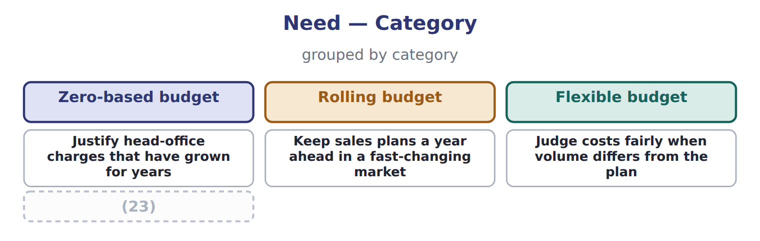
word list
Review whether each support activity is still needed · Justify head-office charges that have grown for years

The English this section uses, and its Arabic
Each term sits against what it means.
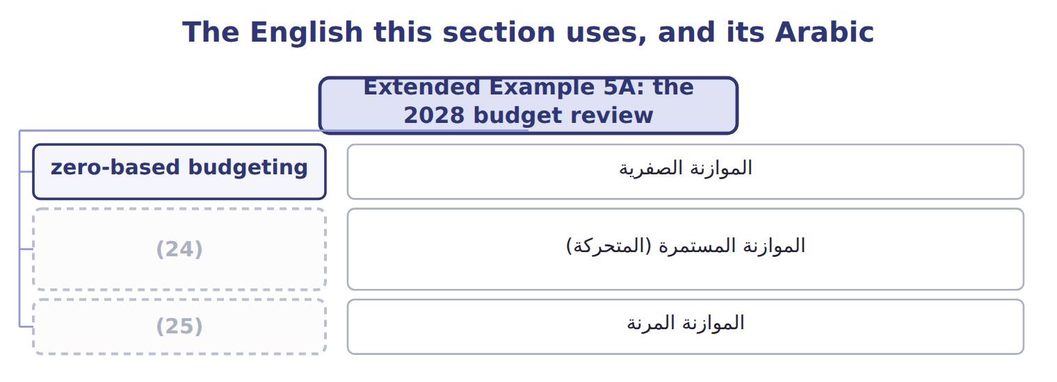
word list
continuous (rolling) budget · flexible budget · zero-based budgeting

The English this sheet uses, and its Arabic
English (exam term) | Arabic
zero-based budgeting | الموازنة الصفرية
continuous (rolling) budget | الموازنة المستمرة (المتحركة)
flexible budget | الموازنة المرنة

Answer key · 5.6 Extended Example 5A: the 2028 budget review

1 controller's | 14 recommend
2 discretionary | 15 described
3 changes | 16 calculate
4 differs | 17 contribution
5 Approved | 18 Selling price per jar
6 Rolling (quarterly) | 19 Fixed costs per month
7 Flexible | 20 Jars actually sold in the month
8 Incremental analysis | 21 80,000 × $11.80 = $944,000
9 head-office | 22 80,000 × $8.20 = $656,000
10 approving | 23 Review whether each support activity is still needed
11 quarters | 24 continuous (rolling) budget
12 budget | 25 flexible budget
13 manufacturing

the summaries in full
Summary 1 This example follows the controller's report to the board on the budget systems used for 2028. Head office: costs growing without clear reasons, mostly discretionary. Beverages sales: a market that changes every quarter. Beverages plant: volume that differs from the plan most months. Pricing: a proposal to raise the juice price.
Summary 2 The controller recommends adopting the zero-based head-office budget, the rolling sales forecast and the flexible plant budget. She also recommends approving the price rise if a market test confirms the volume loss.
Summary 3 The four quarters of the December budget total 900,000 cases, the volume agreed. Fixed manufacturing costs of $150,000 a month equal the Book 2 fixed overhead of $2.00 a case × 75,000 cases.
Summary 4 Expect to recommend a system for a described situation, to prepare a flexible budget at a given volume and to roll a budget forward. You may also have to calculate the effect of a price, volume or cost change on contribution margin or operating income.

