6.1 The sales budget and the profit plan
Chapter 6 · section 6.1

Fill every gap. Each word list holds one word more than there are gaps.
Chapter 6, section by section
Each stage leads to the next.
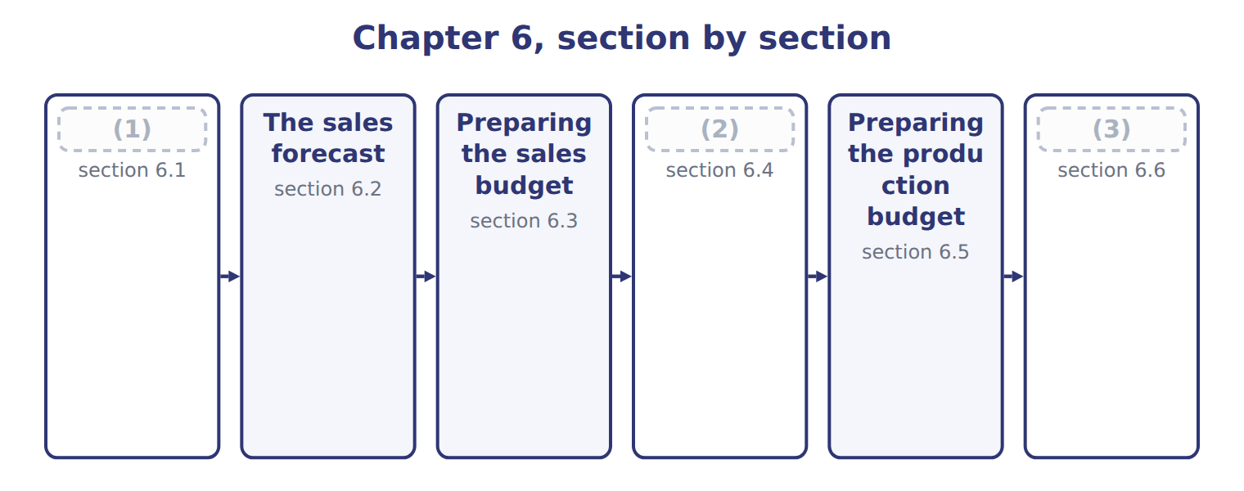
word list
Preparing the production budget · From sales to production · The sales budget and the profit plan · Extended Example 6A: a late order for the summ

Summary 1 gaps 4–9
The master budget is also called the annual profit plan, (4) it ends in (5) profit. The sales budget is its first (6) : the planned units and (7) for each period. (8) every other budget (9) on it. That is why the sales budget deserves the most care. If sales are overstated, the company buys too much material, hires too many people and plans for cash it will never collect.
word list
schedule · revenue · budgeted · depends · because · deserves · Almost

The English this sheet uses, and its Arabic
English (exam term) | Arabic
annual profit plan | خطة الربح السنوية
sales budget | موازنة المبيعات

Answer key · 6.1 The sales budget and the profit plan

1 The sales budget and the profit plan | 6 schedule
2 From sales to production | 7 revenue
3 Extended Example 6A: a late order for the summ | 8 Almost
4 because | 9 depends
5 budgeted

the summaries in full
Summary 1 The master budget is also called the annual profit plan, because it ends in budgeted profit. The sales budget is its first schedule: the planned units and revenue for each period. Almost every other budget depends on it. That is why the sales budget deserves the most care. If sales are overstated, the company buys too much material, hires too many people and plans for cash it will never collect.

6.2 The sales forecast
Chapter 6 · section 6.2

Fill every gap. Each word list holds one word more than there are gaps.
Summary 1 gaps 1–2
The sales (1) is an estimate of what the company could sell. It becomes the sales budget only after (2) decides on prices, promotions and targets.
word list
decisions · forecast · management

Factors in the Beverages sales forecast
Factor in the sales forecast (B.5.b) | Beverages 2028
The market and the industry | Juice market growing 14.0% a year (Chapter 2)
The economy | Low inflation; the dinar pegged to the US dollar (Chapter 3)
Prices and promotions | (3)
Competitors | (4)
Sales team and customers | (5)

word list
Juice market growing 14.0% a year (Chapter 2) · Orders already agreed with Levant and the supermarkets · Price held at $20.00 a case · The market leader holds a much larger share

Summary 2 gaps 6–8
Past (6) show trend and (7) . A good forecast combines several sources: the industry forecast and market share of, the sales team's knowledge of customers, and (8) methods such as the regression of Book 2.
word list
statistical · results · combines · season

Forecast is not budget

Summary 3 gaps 9–10
The (9) says what could happen; the budget says what management plans and commits to. An answer that treats them as the same thing misses (10) decisions on price and promotion.
word list
management's · forecast · industry

The English this section uses, and its Arabic
Each term sits against what it means.
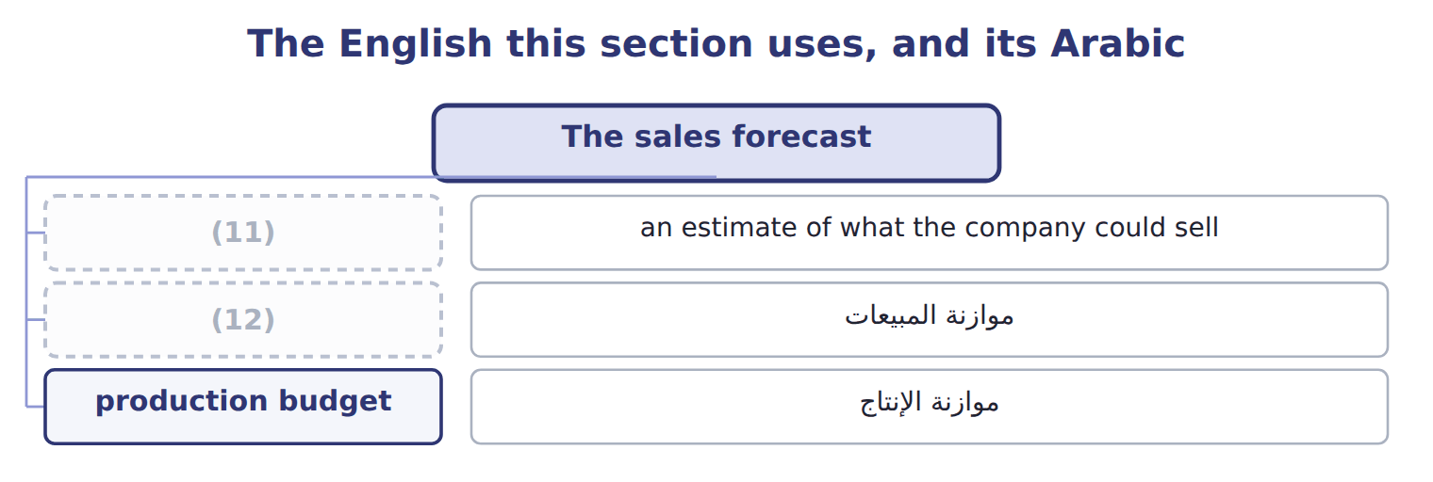
word list
sales forecast · sales budget · production budget

The English this sheet uses, and its Arabic
English (exam term) | Arabic
sales forecast | التنبؤ بالمبيعات

Answer key · 6.2 The sales forecast

1 forecast | 7 season
2 management | 8 statistical
3 Price held at $20.00 a case | 9 forecast
4 The market leader holds a much larger share | 10 management's
5 Orders already agreed with Levant and the supermarkets | 11 sales forecast
6 results | 12 sales budget

the summaries in full
Summary 1 The sales forecast is an estimate of what the company could sell. It becomes the sales budget only after management decides on prices, promotions and targets.
Summary 2 Past results show trend and season. A good forecast combines several sources: the industry forecast and market share of, the sales team's knowledge of customers, and statistical methods such as the regression of Book 2.
Summary 3 The forecast says what could happen; the budget says what management plans and commits to. An answer that treats them as the same thing misses management's decisions on price and promotion.

6.3 Preparing the sales budget
Chapter 6 · section 6.3

Fill every gap. Each word list holds one word more than there are gaps.
Summary 1 gaps 1–2
A sales budget has three (1) for each period: units, price per unit and revenue. Companies with several (2) or channels prepare a line for each and add them up.
word list
products · components · pattern

Worked example: the Beverages sales budget

First quarter: 210,000 cases × $20.00 = $4,200,000.
Worked example: the Beverages sales budget for 2028
Name each point on the scale from where it sits.
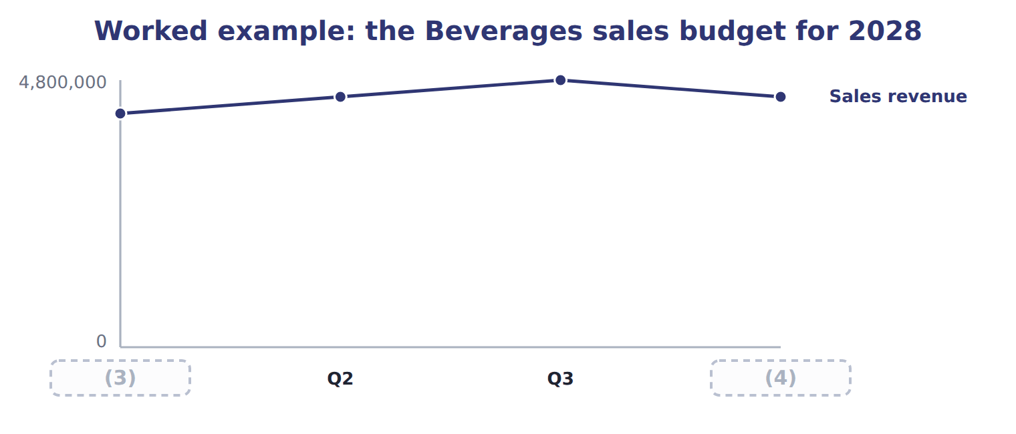
word list
Q4 · Q1 · Cases

Summary 2 gaps 5–6
The (5) split matters as much as the total: (6) , purchasing and cash are all planned by quarter or month, following the pattern of sales.
word list
quarterly · revenue · production

Answer key · 6.3 Preparing the sales budget

1 components | 4 Q4
2 products | 5 quarterly
3 Q1 | 6 production

the summaries in full
Summary 1 A sales budget has three components for each period: units, price per unit and revenue. Companies with several products or channels prepare a line for each and add them up.
Summary 2 The quarterly split matters as much as the total: production, purchasing and cash are all planned by quarter or month, following the pattern of sales.

6.4 From sales to production
Chapter 6 · section 6.4

Fill every gap. Each word list holds one word more than there are gaps.
Summary 1 gaps 1–8
Production does not simply equal sales, (1) the company holds (2) goods. The production budget adds the stock (3) at the end of the period and (4) the stock already on hand at the start. The (5) stock comes from the (6) policy. (7) keeps 20% of next (8) sales in stock, so that it can meet orders while the next batch is filled. Other factors also shape the production budget: plant capacity, storage space, the shelf life of juice and the wish to keep the workforce stable.
word list
inventory · workforce · because · wanted · subtracts · quarter's · Beverages · finished · ending

Factors in the Beverages production budget
Factor in the production budget (B.5.e) | Beverages 2028
Inventory policy | (9)
Capacity | 240,000 cases a quarter (4,800 machine hours)
Storage space | Room for 50,000 cases
Shelf life | (10)
Stable workforce | (11)

word list
Juice must be sold within nine months · Ending stock = 20% of next quarter's sales · Avoid large swings in production between quarters · 240,000 cases a quarter (4,800 machine hours)

The English this sheet uses, and its Arabic
English (exam term) | Arabic
production budget | موازنة الإنتاج
inventory policy | سياسة المخزون

Answer key · 6.4 From sales to production

1 because | 7 Beverages
2 finished | 8 quarter's
3 wanted | 9 Ending stock = 20% of next quarter's sales
4 subtracts | 10 Juice must be sold within nine months
5 ending | 11 Avoid large swings in production between quarters
6 inventory

the summaries in full
Summary 1 Production does not simply equal sales, because the company holds finished goods. The production budget adds the stock wanted at the end of the period and subtracts the stock already on hand at the start. The ending stock comes from the inventory policy. Beverages keeps 20% of next quarter's sales in stock, so that it can meet orders while the next batch is filled. Other factors also shape the production budget: plant capacity, storage space, the shelf life of juice and the wish to keep the workforce stable.

6.5 Preparing the production budget
Chapter 6 · section 6.5

Fill every gap. Each word list holds one word more than there are gaps.
Worked example: the first quarter

Summary 1 gaps 1–2
Sales 210,000 + ending stock 45,000 (20% of 225,000) = 255,000 needed; − (1) stock 42,000 = 213,000 cases to (2) .
word list
produce · beginning · quarter

Worked example: the Beverages production budget for 2028
The bars are drawn to scale.
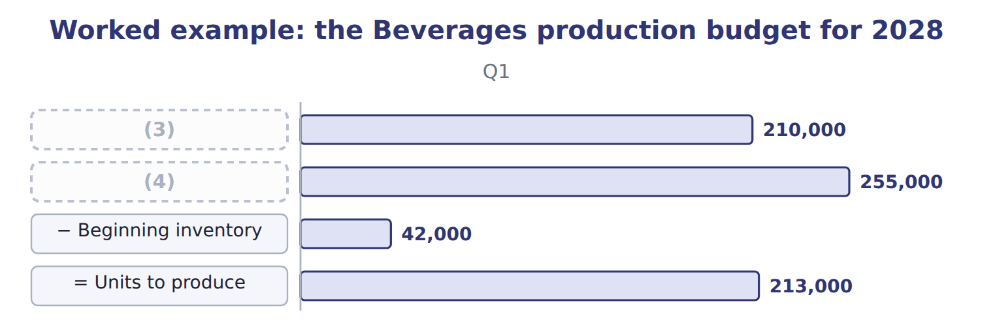
word list
= Units needed · Budgeted sales · sales forecast

The third and fourth quarters

Summary 2 gaps 5–7
Complete the blank cells. The first quarter of 2029 is (5) to sell 215,000 cases. Over the year, (6) of 901,000 cases is 900,000 cases of sales plus the rise in stock from 42,000 to 43,000. The budget must also be (7) .
word list
feasible · expected · beginning · production

Watch the signs

Summary 3 gaps 8–9
Ending inventory is added and beginning inventory is (8) . Reversing the signs, or setting ending stock from this quarter's sales instead of next quarter's, gives the wrong (9) figure.
word list
subtracted · expected · production

Answer key · 6.5 Preparing the production budget

1 beginning | 6 production
2 produce | 7 feasible
3 Budgeted sales | 8 subtracted
4 = Units needed | 9 production
5 expected

the summaries in full
Summary 1 Sales 210,000 + ending stock 45,000 (20% of 225,000) = 255,000 needed; − beginning stock 42,000 = 213,000 cases to produce.
Summary 2 Complete the blank cells. The first quarter of 2029 is expected to sell 215,000 cases. Over the year, production of 901,000 cases is 900,000 cases of sales plus the rise in stock from 42,000 to 43,000. The budget must also be feasible.
Summary 3 Ending inventory is added and beginning inventory is subtracted. Reversing the signs, or setting ending stock from this quarter's sales instead of next quarter's, gives the wrong production figure.

6.6 Extended Example 6A: a late order for the summer
Chapter 6 · section 6.6

Fill every gap. Each word list holds one word more than there are gaps.
Summary 1 gaps 1–4
In (1) , Levant asks for 10,000 extra cases in the third quarter for a hotel chain. This example tests (2) the production (3) can absorb the order. Higher third-quarter sales raise the second quarter's ending stock, and therefore (4) production, as well as third-quarter production.
word list
February · whether · already · budget · second-quarter

Extended Example: the production budget with the late order
The bars are drawn to scale.
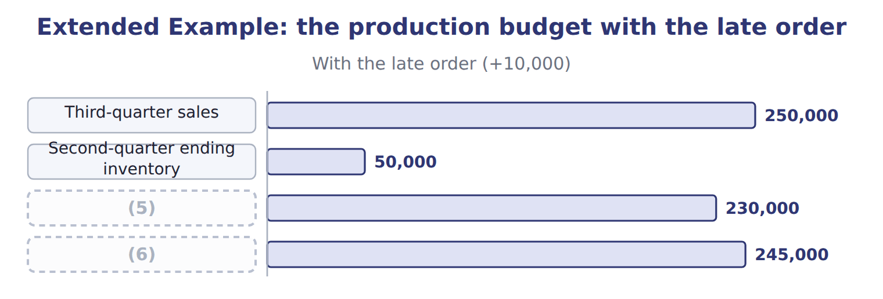
word list
sales forecast · Third-quarter production · Second-quarter production

2. Is it feasible?

Summary 2 gaps 7–8
Third-quarter (7) would be 245,000 cases, 5,000 above capacity. (8) ahead is not possible, because the store would already be full at 50,000 cases.
word list
production · Building · storage

Extended Example: options for the cases above capacity
Options for the 5,000 extra cases | Assessment
Build ahead in the second quarter | Not (9) : the store would already hold 50,000 cases, its limit
Overtime shifts in the third quarter | (10)
Outsource filling of the extra cases | Uses outside capacity (Book 2, Chapter 17); check quality
Accept only part of the order | Loses $41,000 of contribution margin

word list
Adds capacity; costs more per case · possible · Production budget

Summary 3 gaps 11–12
The (11) plans overtime shifts for the third quarter, because the extra cost per case is well below the (12) margin of $8.20 that each case earns.
word list
division · contribution · because

Everything ties

Summary 4 gaps 13–14
Budget: 900,000 cases sold + 43,000 ending − 42,000 (13) = 901,000 produced. Sales (14) $18,000,000 = the sales budget.
word list
beginning · revenue · overtime

Exam view

Summary 5 gaps 15–17
Expect a table of sales by period and an (15) policy. Compute ending and (16) stock for each period, the units to produce, and the sales revenue. Then check (17) and storage if the question gives them.
word list
beginning · capacity · division · inventory

Exam view
Name each point on the scale from where it sits.
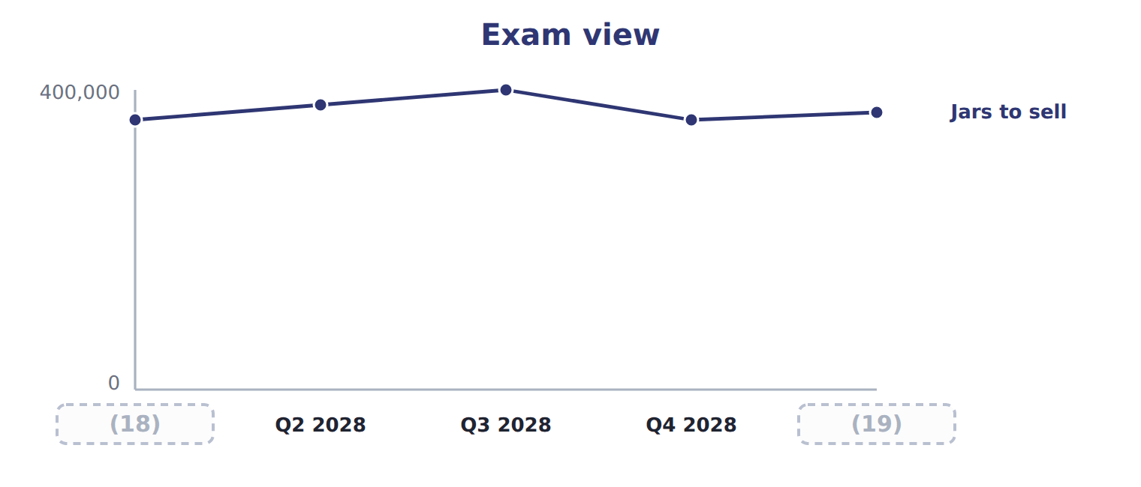
word list
Q2 2028 · Q1 2028 · Q1 2029

Item — Answer
Item | Answer
Q3 | (20)
Q4 | 225,000 + 43,000 (20% of 215,000) = 268,000; − 45,000 = 223,000

word list
Uses outside capacity (Book 2, Chapter 17); check quality · 240,000 + 45,000 = 285,000; − 48,000 = 237,000

Factor — Category
Every item belongs to exactly one group.
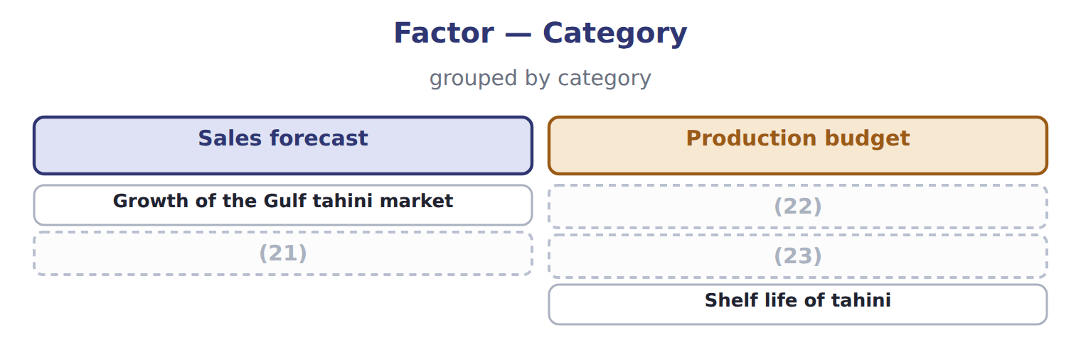
word list
Ending-stock policy of 10% · Capacity of the filling line · Planned price of the jars · Shelf life of tahini

The English this section uses, and its Arabic
Each term sits against what it means.
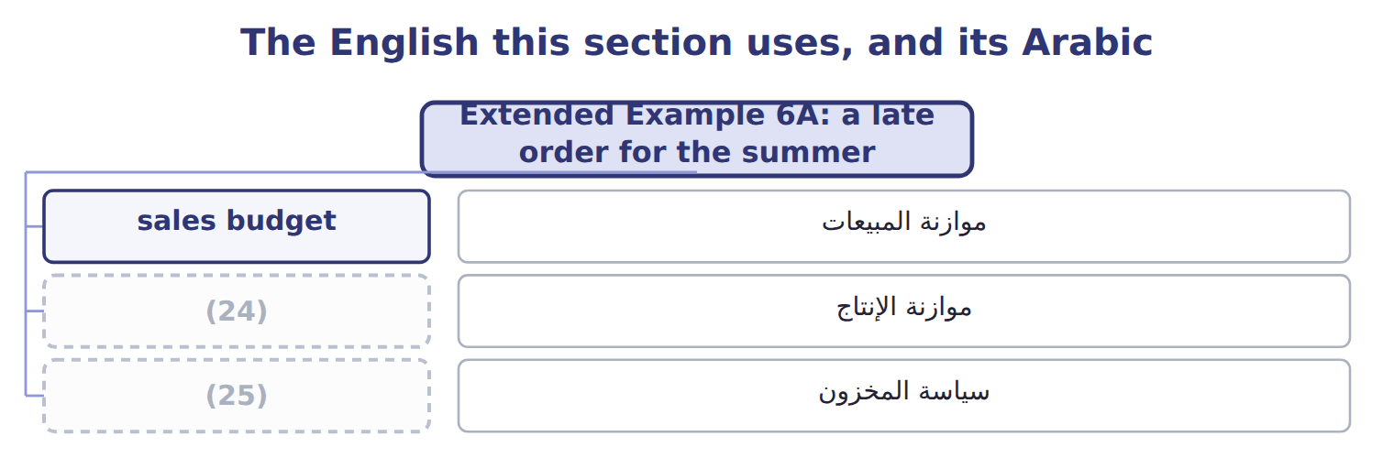
word list
inventory policy · sales budget · production budget

The English this sheet uses, and its Arabic
English (exam term) | Arabic
sales budget | موازنة المبيعات
production budget | موازنة الإنتاج
inventory policy | سياسة المخزون

Answer key · 6.6 Extended Example 6A: a late order for the summer

1 February | 14 revenue
2 whether | 15 inventory
3 budget | 16 beginning
4 second-quarter | 17 capacity
5 Second-quarter production | 18 Q1 2028
6 Third-quarter production | 19 Q1 2029
7 production | 20 240,000 + 45,000 = 285,000; − 48,000 = 237,000
8 Building | 21 Planned price of the jars
9 possible | 22 Ending-stock policy of 10%
10 Adds capacity; costs more per case | 23 Capacity of the filling line
11 division | 24 production budget
12 contribution | 25 inventory policy
13 beginning

the summaries in full
Summary 1 In February, Levant asks for 10,000 extra cases in the third quarter for a hotel chain. This example tests whether the production budget can absorb the order. Higher third-quarter sales raise the second quarter's ending stock, and therefore second-quarter production, as well as third-quarter production.
Summary 2 Third-quarter production would be 245,000 cases, 5,000 above capacity. Building ahead is not possible, because the store would already be full at 50,000 cases.
Summary 3 The division plans overtime shifts for the third quarter, because the extra cost per case is well below the contribution margin of $8.20 that each case earns.
Summary 4 Budget: 900,000 cases sold + 43,000 ending − 42,000 beginning = 901,000 produced. Sales revenue $18,000,000 = the sales budget.
Summary 5 Expect a table of sales by period and an inventory policy. Compute ending and beginning stock for each period, the units to produce, and the sales revenue. Then check capacity and storage if the question gives them.

