13.1 Sales-mix and sales-quantity variances
Chapter 13 · section 13.1

Fill every gap. Each word list holds one word more than there are gaps.
Chapter 13, section by section
Each stage leads to the next.
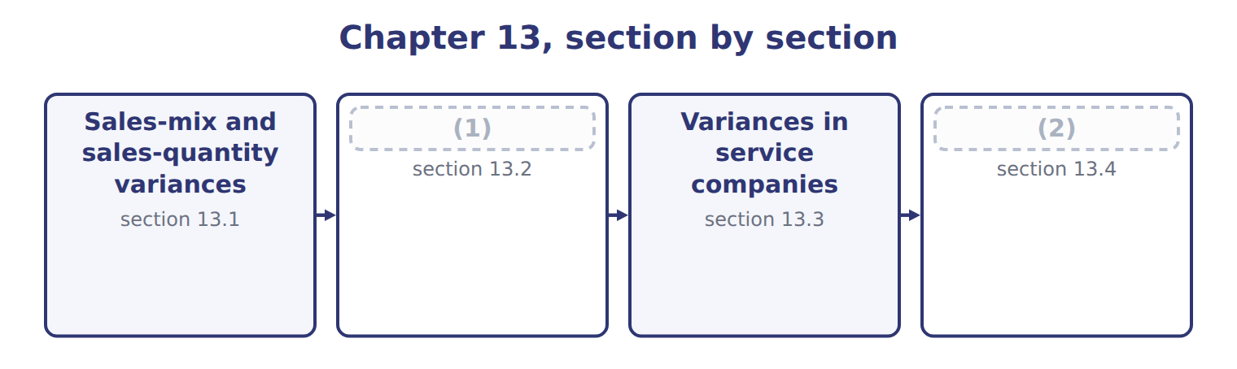
word list
Materials mix and yield variances · Variances in service companies · Extended Example 13A: the month in one report

Summary 1 gaps 3–8
When a (3) sells more than one product, the (4) variance: the total number of units, and the proportions in which they were sold. The (5) variance measures the proportions. It asks what the contribution margin would have been if the (6) total units had been sold in the budgeted mix. The (7) variance measures the total, valued at the budgeted (8) contribution margin. Tahini & Spreads sells three products.
word list
weighted-average · actual · revenue · division · sales-quantity · sales-volume · sales-mix

Budgeted and actual sales mix for the month
The parts add up to the total; the bars are to scale.
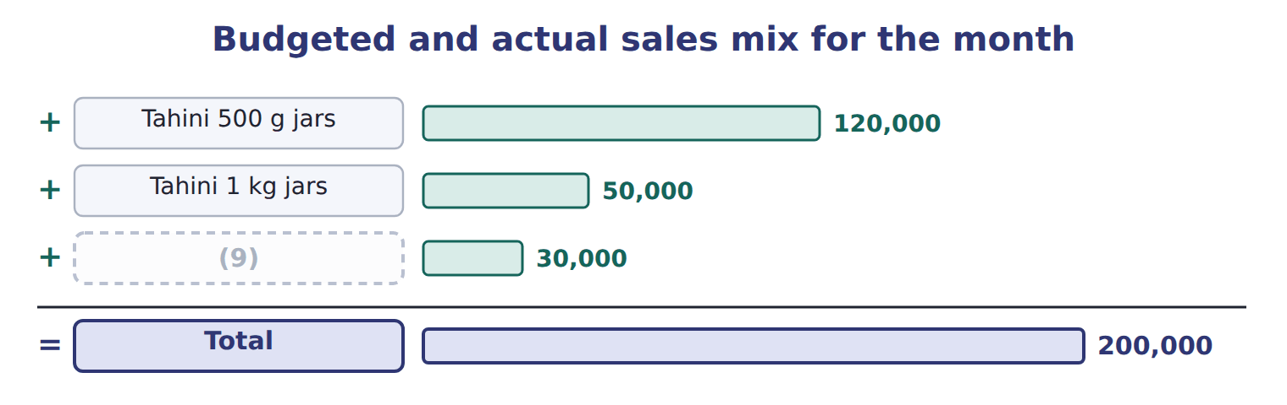
word list
Halva packs · sales-quantity variance

Worked example: the mix and quantity variances

Summary 2 gaps 10–12
In the budgeted mix, the actual 180,000 units would have (10) 108,000 of the small jars, not 117,000. Applying each (11) budgeted margin gives a mix variance of $4,500 unfavorable. The (12) variance is (180,000 − 200,000) × $1.80 = $36,000 unfavorable.
word list
cheapest · included · quantity · product's

Worked example: the sales-mix and sales-quantity variances
The bars are drawn to scale.
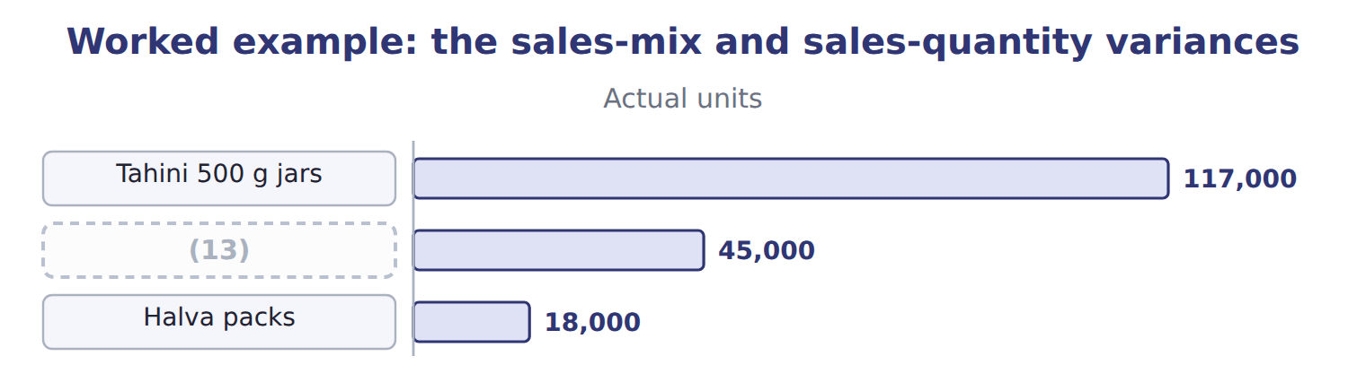
word list
Tahini 1 kg jars · Tahini 500 g jars

The two parts add to the sales-volume variance of $40,500 unfavorable.
The same volume variance, product by product
The bars are drawn to scale.
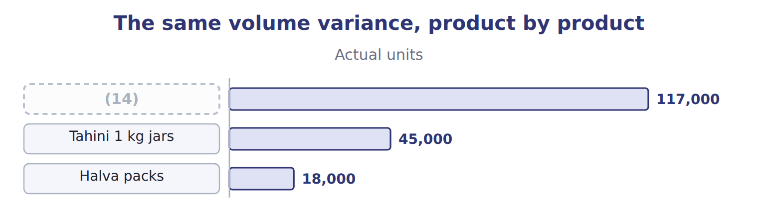
word list
Tahini 1 kg jars · Tahini 500 g jars

Summary 3 gaps 15–17
The mix matters because the products earn (15) margins. Selling a larger share of the cheapest jars costs (16) margin even when the total number of units is unchanged. The effect on (17) follows the same logic, using selling prices.
word list
different · follows · revenue · contribution

Mix uses the actual total

Summary 4 gaps 18–19
The sales-mix variance is always (18) on the actual total units. Using the budgeted total turns it into a different variance and the two parts will not add to the (19) variance.
word list
sales-volume · Applying · calculated

The English this section uses, and its Arabic
Each term sits against what it means.
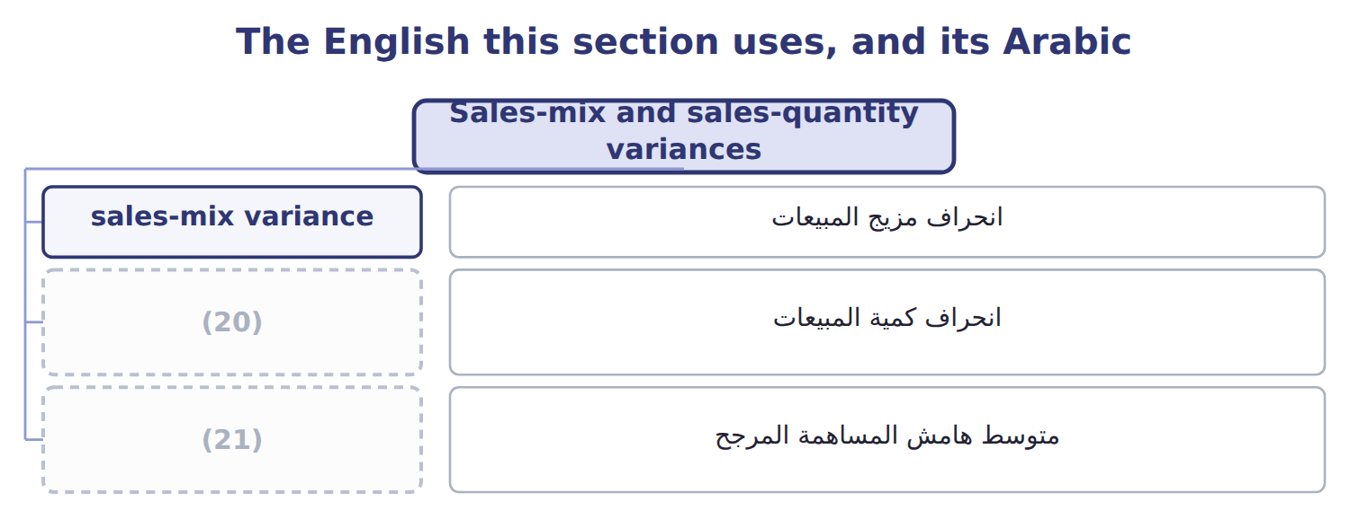
word list
انحراف كمية المبيعات · weighted-average contribution margin · sales-quantity variance

The English this sheet uses, and its Arabic
English (exam term) | Arabic
sales-mix variance | انحراف مزيج المبيعات
sales-quantity variance | انحراف كمية المبيعات
weighted-average contribution margin | متوسط هامش المساهمة المرجح

Answer key · 13.1 Sales-mix and sales-quantity variances

1 Materials mix and yield variances | 12 quantity
2 Extended Example 13A: the month in one report | 13 Tahini 1 kg jars
3 division | 14 Tahini 500 g jars
4 sales-volume | 15 different
5 sales-mix | 16 contribution
6 actual | 17 revenue
7 sales-quantity | 18 calculated
8 weighted-average | 19 sales-volume
9 Halva packs | 20 sales-quantity variance
10 included | 21 weighted-average contribution margin
11 product's

the summaries in full
Summary 1 When a division sells more than one product, the sales-volume variance: the total number of units, and the proportions in which they were sold. The sales-mix variance measures the proportions. It asks what the contribution margin would have been if the actual total units had been sold in the budgeted mix. The sales-quantity variance measures the total, valued at the budgeted weighted-average contribution margin. Tahini & Spreads sells three products.
Summary 2 In the budgeted mix, the actual 180,000 units would have included 108,000 of the small jars, not 117,000. Applying each product's budgeted margin gives a mix variance of $4,500 unfavorable. The quantity variance is (180,000 − 200,000) × $1.80 = $36,000 unfavorable.
Summary 3 The mix matters because the products earn different margins. Selling a larger share of the cheapest jars costs contribution margin even when the total number of units is unchanged. The effect on revenue follows the same logic, using selling prices.
Summary 4 The sales-mix variance is always calculated on the actual total units. Using the budgeted total turns it into a different variance and the two parts will not add to the sales-volume variance.

13.2 Materials mix and yield variances
Chapter 13 · section 13.2

Fill every gap. Each word list holds one word more than there are gaps.
Summary 1 gaps 1–3
The same idea (1) to inputs that can be (2) for each other. Halva is made from sesame paste and sugar in a standard blend; using more paste and less sugar changes the cost even if the total input is (3) .
word list
process · unchanged · substituted · applies

Worked example: the halva blend

Worked example: the halva mix and yield variances
The bars are drawn to scale.
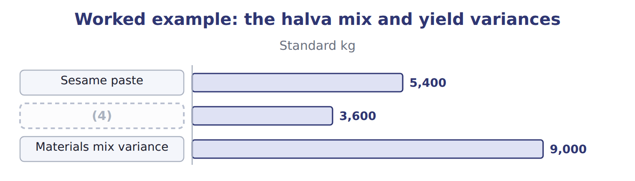
word list
Sesame paste · Sugar

The sugar line

Summary 2 gaps 5–7
Complete the blank cells. Mix and yield (5) make up the usage variance of $800 (6) , which is what. The mix variance (7) to whoever chose the blend; the yield variance to whoever ran the process.
word list
weighted-average · together · unfavorable · belongs

Yield is valued at the average

Summary 3 gaps 8–9
The yield (8) is valued at the (9) standard price of the blend, $1.90 a kilogram here, not at the price of one input.
word list
weighted-average · variance · substituted

The English this sheet uses, and its Arabic
English (exam term) | Arabic
materials mix variance | انحراف مزيج المواد
materials yield variance | انحراف مردود المواد

Answer key · 13.2 Materials mix and yield variances

1 applies | 6 unfavorable
2 substituted | 7 belongs
3 unchanged | 8 variance
4 Sugar | 9 weighted-average
5 together

the summaries in full
Summary 1 The same idea applies to inputs that can be substituted for each other. Halva is made from sesame paste and sugar in a standard blend; using more paste and less sugar changes the cost even if the total input is unchanged.
Summary 2 Complete the blank cells. Mix and yield together make up the usage variance of $800 unfavorable, which is what. The mix variance belongs to whoever chose the blend; the yield variance to whoever ran the process.
Summary 3 The yield variance is valued at the weighted-average standard price of the blend, $1.90 a kilogram here, not at the price of one input.

13.3 Variances in service companies
Chapter 13 · section 13.3

Fill every gap. Each word list holds one word more than there are gaps.
Summary 1 gaps 1–2
A service company has no finished goods, but it still has (1) : hours per delivery, hours per audit, minutes per call. Every variance in, with labor hours in place of (2) .
word list
materials · inventory · standards

Worked example: Levant Distribution

Summary 2 gaps 3–4
Levant made 2,400 (3) , allowing 1,200 hours at $10.00; it worked 1,260 hours at $10.40. The overhead (4) variance compares actual variable overhead with the standard rate applied to the hours worked.
word list
spending · deliveries · minutes

Worked example: variances at Levant Distribution
Levant: 2,400 deliveries | Calculation | Variance
Labor rate | ($10.40 − $10.00) × 1,260 hours | (5)
Labor efficiency | (6) | 600 U
Overhead spending | $7,980 − 1,260 hours × $6.00 | (7)
Overhead efficiency | (8) | 360 U

word list
504 U · Fuel, vehicle running costs, utilities · (1,260 − 1,200) hours × $6.00 · 420 U · (1,260 − 1,200) hours × $10.00

How each variance is read in a service company
Variance | In a service company | How it is calculated
Price or rate | (9) | Same formula: (AR − SR) × actual hours
Efficiency | Hours per delivery or per order | (10)
Spending | (11) | Actual overhead − standard rate × actual hours
Mix | (12) | Same formula as a materials or sales mix
No inventory | Services are consumed as produced | There is no usage variance for stock, but input (13) remain

word list
Share of senior and junior staff, or of service types · Same formula: (AH − SH allowed) × standard rate · variances · materials yield variance · Wage paid to drivers and warehouse staff · Fuel, vehicle running costs, utilities

Summary 3 gaps 14–16
The one (14) is that a service (15) be stored. There is no stock of unsold (16) , so the usage variance never carries into inventory; it affects the period in which the work was done.
word list
service · cannot · deliveries · difference

The English this sheet uses, and its Arabic
English (exam term) | Arabic
overhead spending variance | انحراف إنفاق التكاليف غير المباشرة

Answer key · 13.3 Variances in service companies

1 standards | 9 Wage paid to drivers and warehouse staff
2 materials | 10 Same formula: (AH − SH allowed) × standard rate
3 deliveries | 11 Fuel, vehicle running costs, utilities
4 spending | 12 Share of senior and junior staff, or of service types
5 504 U | 13 variances
6 (1,260 − 1,200) hours × $10.00 | 14 difference
7 420 U | 15 cannot
8 (1,260 − 1,200) hours × $6.00 | 16 deliveries

the summaries in full
Summary 1 A service company has no finished goods, but it still has standards: hours per delivery, hours per audit, minutes per call. Every variance in, with labor hours in place of materials.
Summary 2 Levant made 2,400 deliveries, allowing 1,200 hours at $10.00; it worked 1,260 hours at $10.40. The overhead spending variance compares actual variable overhead with the standard rate applied to the hours worked.
Summary 3 The one difference is that a service cannot be stored. There is no stock of unsold deliveries, so the usage variance never carries into inventory; it affects the period in which the work was done.

13.4 Extended Example 13A: the month in one report
Chapter 13 · section 13.4

Fill every gap. Each word list holds one word more than there are gaps.
This example collects the chapter's variances into the report that goes to the Orontes board.
Extended Example: the month's mix, yield and service variances
Variance | Amount | Who answers, and why
Sales mix | (1) | Sales team: the product mix moved to cheaper jars
Sales quantity | (2) | Sales team and market: fewer units in total
Materials mix (halva) | 420 U | (3) : more paste, less sugar than the recipe
Materials yield (halva) | (4) | Plant: more total input than the standard allows
Levant labor and overhead | 1,884 U | Levant: rate, efficiency and spending together

word list
Variance · 36,000 U · 380 U · Plant · 4,500 U

Summary 1 gaps 5–7
The largest number is the (5) variance: the (6) simply sold fewer units. The mix variance is smaller but more useful, because it shows that the sales team sold the cheaper jars while halva, the richest product, fell (7) .
word list
furthest · budgeted · division · quantity

Everything ties

Mix $4,500 + quantity $36,000 = sales-volume $40,500, all unfavorable. Halva mix $420 + yield $380 = usage $800, all unfavorable.
Exam view

Summary 2 gaps 8–10
Expect budgeted and actual units for several (8) with their budgeted (9) , or a standard blend with actual inputs. Work out the actual total in the budgeted or standard (10) first; that single column gives both variances.
word list
margins · proportions · products · quantity

Exam view
The parts add up to the total; the bars are to scale.
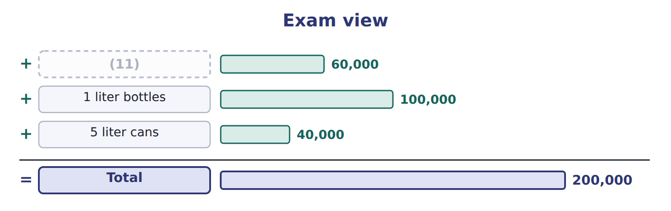
word list
1 liter bottles · 500 ml bottles

Item — Answer
Item | Answer
Sugar mix variance | (3,400 − 3,680) × $1.00 = $(280) (favorable: less sugar than the blend allows)
Total mix variance | (12)

word list
$700 unfavorable − $(280) favorable = $420 unfavorable · Plant: more total input than the standard allows

Variance — Category
Each stage leads to the next.
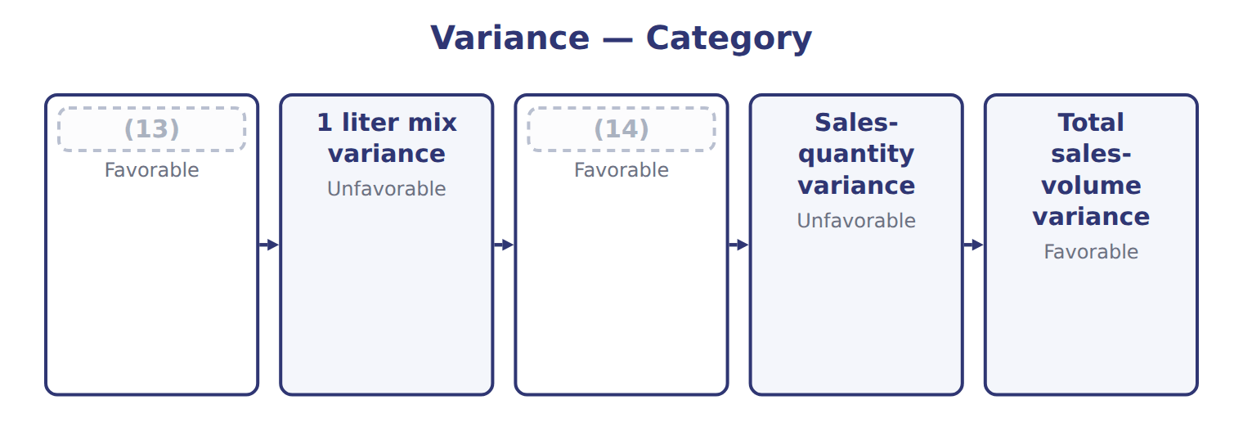
word list
5 liter mix variance · 500 ml mix variance · 1 liter mix variance

The English this section uses, and its Arabic
Each term sits against what it means.
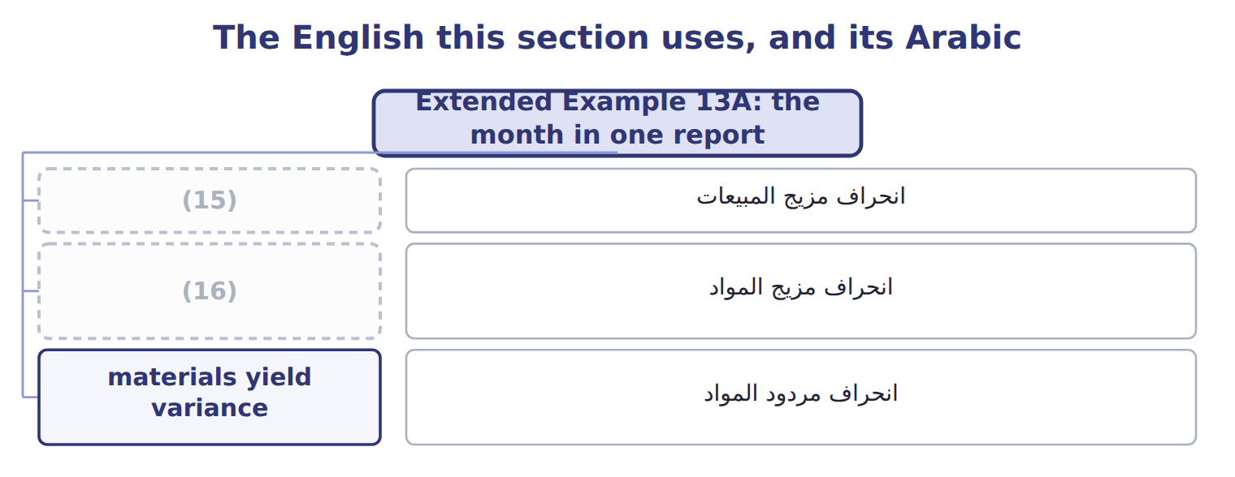
word list
sales-quantity variance · materials mix variance · sales-mix variance

The English this sheet uses, and its Arabic
English (exam term) | Arabic
sales-mix variance | انحراف مزيج المبيعات
materials mix variance | انحراف مزيج المواد
materials yield variance | انحراف مردود المواد

Answer key · 13.4 Extended Example 13A: the month in one report

1 4,500 U | 9 margins
2 36,000 U | 10 proportions
3 Plant | 11 500 ml bottles
4 380 U | 12 $700 unfavorable − $(280) favorable = $420 unfavorable
5 quantity | 13 500 ml mix variance
6 division | 14 5 liter mix variance
7 furthest | 15 sales-mix variance
8 products | 16 materials mix variance

the summaries in full
Summary 1 The largest number is the quantity variance: the division simply sold fewer units. The mix variance is smaller but more useful, because it shows that the sales team sold the cheaper jars while halva, the richest product, fell furthest.
Summary 2 Expect budgeted and actual units for several products with their budgeted margins, or a standard blend with actual inputs. Work out the actual total in the budgeted or standard proportions first; that single column gives both variances.

