18.1 Critical success factors and KPIs
Chapter 18 · section 18.1

Fill every gap. Each word list holds one word more than there are gaps.
Chapter 18, section by section
Each stage leads to the next.
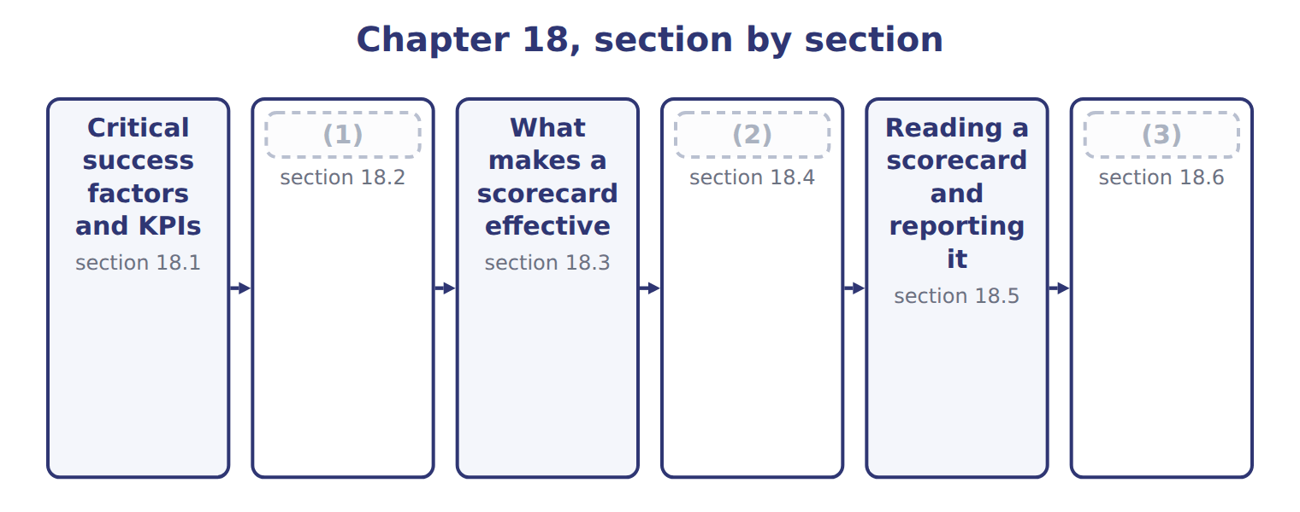
word list
Extended Example 18A: recommending measures fo · Reading a scorecard and reporting it · The strategy map · The balanced scorecard and its four perspectiv

Summary 1 gaps 4–7
A (4) success factor (CSF) is something an (5) must do well if its strategy is to succeed. A key (6) indicator (KPI) is the (7) that shows how well it is being done. The CSF is the thing; the KPI is the number.
word list
performance · matters · measure · organization · critical

Critical success factors and the KPI for each
Critical success factor | KPI that measures it | 2028
Win export customers in the Gulf | Export share of revenue | (8)
Deliver reliably | (9) | target 97%, actual 94%
Run the plant without long stoppages | (10) | target 30 minutes, actual 42
Keep skilled operators | (11) | turnover target 8%, actual 7%
Earn the return the group requires | Return on investment | (12)

word list
Training hours and staff turnover · target 20.4%, actual 19.6% · Changeover time · balanced scorecard · On-time delivery · target 11.8%, actual 12.6%

Summary 2 gaps 13–15
The pair (13) because a measure without a factor (14) it is noise, and a factor without a measure is a wish. Together they tell a manager what to work on and show whether the work is (15) .
word list
without · behind · matters · succeeding

The English this sheet uses, and its Arabic
English (exam term) | Arabic
critical success factor (CSF) | عامل النجاح الحاسم
key performance indicator (KPI) | مؤشر الأداء الرئيسي

Answer key · 18.1 Critical success factors and KPIs

1 The balanced scorecard and its four perspectiv | 9 On-time delivery
2 The strategy map | 10 Changeover time
3 Extended Example 18A: recommending measures fo | 11 Training hours and staff turnover
4 critical | 12 target 11.8%, actual 12.6%
5 organization | 13 matters
6 performance | 14 behind
7 measure | 15 succeeding
8 target 20.4%, actual 19.6%

the summaries in full
Summary 1 A critical success factor (CSF) is something an organization must do well if its strategy is to succeed. A key performance indicator (KPI) is the measure that shows how well it is being done. The CSF is the thing; the KPI is the number.
Summary 2 The pair matters because a measure without a factor behind it is noise, and a factor without a measure is a wish. Together they tell a manager what to work on and show whether the work is succeeding.

18.2 The balanced scorecard and its four perspectives
Chapter 18 · section 18.2

Fill every gap. Each word list holds one word more than there are gaps.
Summary 1 gaps 1–6
A balanced scorecard is a set of measures drawn from four (1) , each with its (2) , measures, targets and the actions planned to reach them. It is balanced because (3) results alone (4) only what has already happened. Each perspective (5) the same four (6) : what the company wants to achieve, the measure that tracks it, the target for the period and the action planned to reach it.
word list
describe · perspectives · objectives · carries · information · financial · components

Worked example: the Orontes scorecard for 2028

Worked example: the Orontes balanced scorecard for 2028
The bars are drawn to scale.
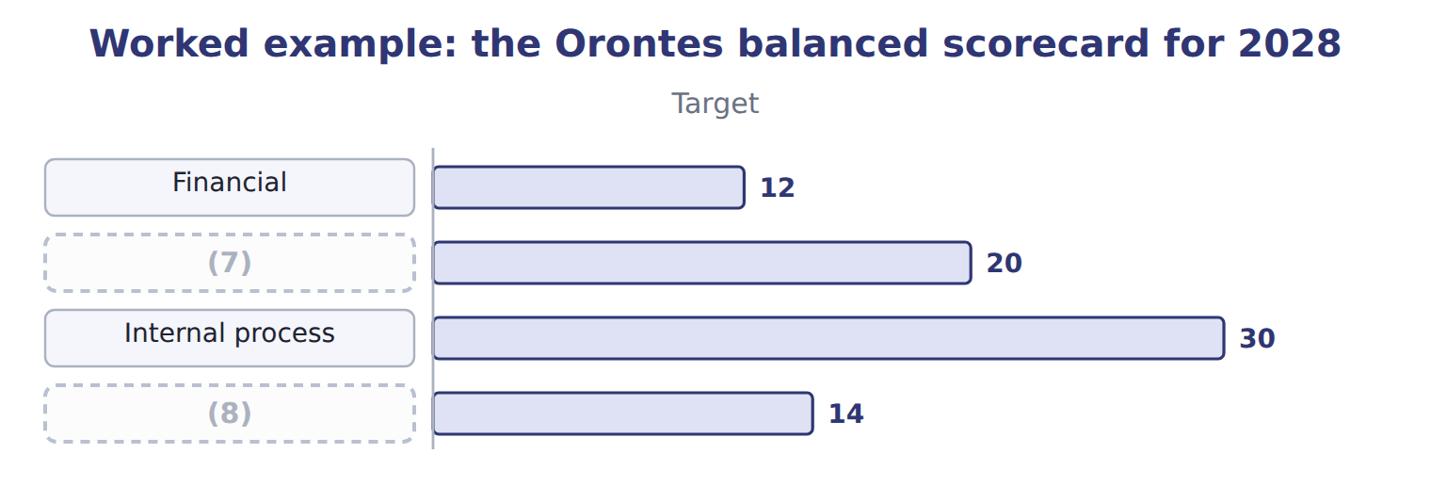
word list
Internal process · Learning and growth · Customer

The last two perspectives

Complete the blank cells.
Balanced means four perspectives, not four financial ratios

Summary 2 gaps 9–13
A scorecard with (9) , margin, return and growth on it is not (10) ; it measures the same thing four ways. Each (11) must bring (12) the others do not. The scorecard is not a report (13) after the year. It is agreed with the plan, reviewed during the year, and used to decide what to do next, which is why.
word list
profit · perspective · actions · produced · balanced · information

The English this section uses, and its Arabic
Each term sits against what it means.
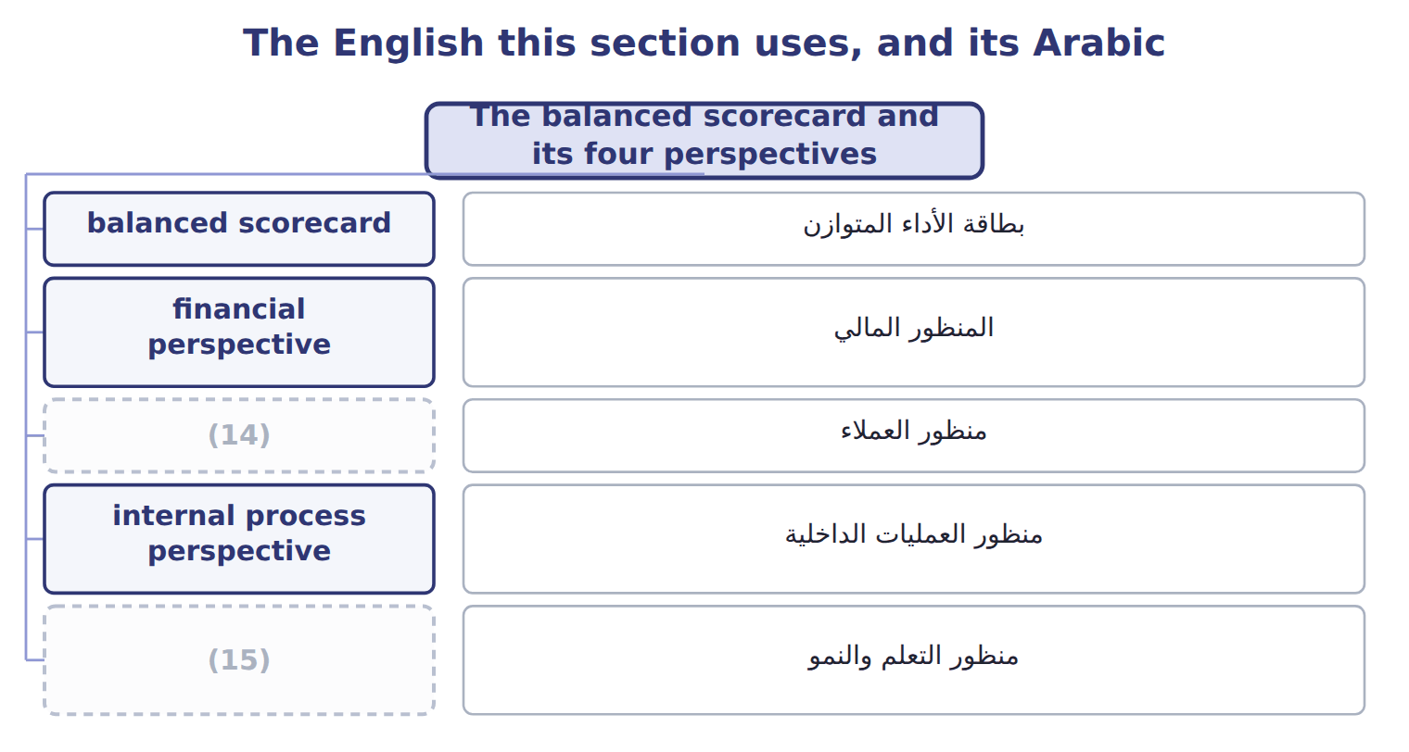
word list
learning and growth perspective · customer perspective · key performance indicator (KPI)

The English this sheet uses, and its Arabic
English (exam term) | Arabic
balanced scorecard | بطاقة الأداء المتوازن
financial perspective | المنظور المالي
customer perspective | منظور العملاء
internal process perspective | منظور العمليات الداخلية
learning and growth perspective | منظور التعلم والنمو

Answer key · 18.2 The balanced scorecard and its four perspectives

1 perspectives | 9 profit
2 objectives | 10 balanced
3 financial | 11 perspective
4 describe | 12 information
5 carries | 13 produced
6 components | 14 customer perspective
7 Customer | 15 learning and growth perspective
8 Learning and growth

the summaries in full
Summary 1 A balanced scorecard is a set of measures drawn from four perspectives, each with its objectives, measures, targets and the actions planned to reach them. It is balanced because financial results alone describe only what has already happened. Each perspective carries the same four components: what the company wants to achieve, the measure that tracks it, the target for the period and the action planned to reach it.
Summary 2 A scorecard with profit, margin, return and growth on it is not balanced; it measures the same thing four ways. Each perspective must bring information the others do not. The scorecard is not a report produced after the year. It is agreed with the plan, reviewed during the year, and used to decide what to do next, which is why.

18.3 What makes a scorecard effective
Chapter 18 · section 18.3

Fill every gap. Each word list holds one word more than there are gaps.
A scorecard fails more often from its design than from its arithmetic.
Characteristics of an effective balanced scorecard
Characteristic (C.3.o) | What it means | At Orontes
Few measures | (1) | Orontes uses 12 in total
Linked to strategy | (2) | Chapter 1 set the objectives
Balanced | Leading as well as lagging indicators | (3)
Owned | Each measure has a manager who can influence it | (4)
Measurable and timely | (5) | Delivery weekly, return quarterly
Reviewed | Measures change as the strategy changes | (6)

word list
Four to six a perspective, not forty · Training and changeover time, not only return · Every measure traces to a critical success factor · Reviewed with the plan each year · Data available often enough to act on · Changeover time belongs to the plant · Leading as well as lagging indicators

Summary 1 gaps 7–11
The commonest fault is too many (7) . A board that reviews forty numbers reviews none of them, and (8) whose bonus depends on a long list will work on (9) is easiest to move. The (10) commonest is a measure (11) owns. Every measure on the Orontes scorecard has a manager who can influence it, which is the controllability principle.
word list
reviews · measures · managers · second · whichever · nobody

Answer key · 18.3 What makes a scorecard effective

1 Four to six a perspective, not forty | 7 measures
2 Every measure traces to a critical success factor | 8 managers
3 Training and changeover time, not only return | 9 whichever
4 Changeover time belongs to the plant | 10 second
5 Data available often enough to act on | 11 nobody
6 Reviewed with the plan each year

the summaries in full
Summary 1 The commonest fault is too many measures. A board that reviews forty numbers reviews none of them, and managers whose bonus depends on a long list will work on whichever is easiest to move. The second commonest is a measure nobody owns. Every measure on the Orontes scorecard has a manager who can influence it, which is the controllability principle.

18.4 The strategy map
Chapter 18 · section 18.4

Fill every gap. Each word list holds one word more than there are gaps.
Summary 1 gaps 1–7
A strategy map draws the (1) links between the objectives in the four (2) . It is read upward: investment in people (3) processes, better processes satisfy customers, and (4) customers produce the financial result. The map (5) why leading (6) matter. Training hours and (7) time move before the financial result does, so they give warning while there is still time to act. A lagging indicator such as return on investment reports a year that is already over.
word list
satisfied · improves · changeover · indicators · perspectives · cause-and-effect · explains · objectives

The English this section uses, and its Arabic
Each term sits against what it means.
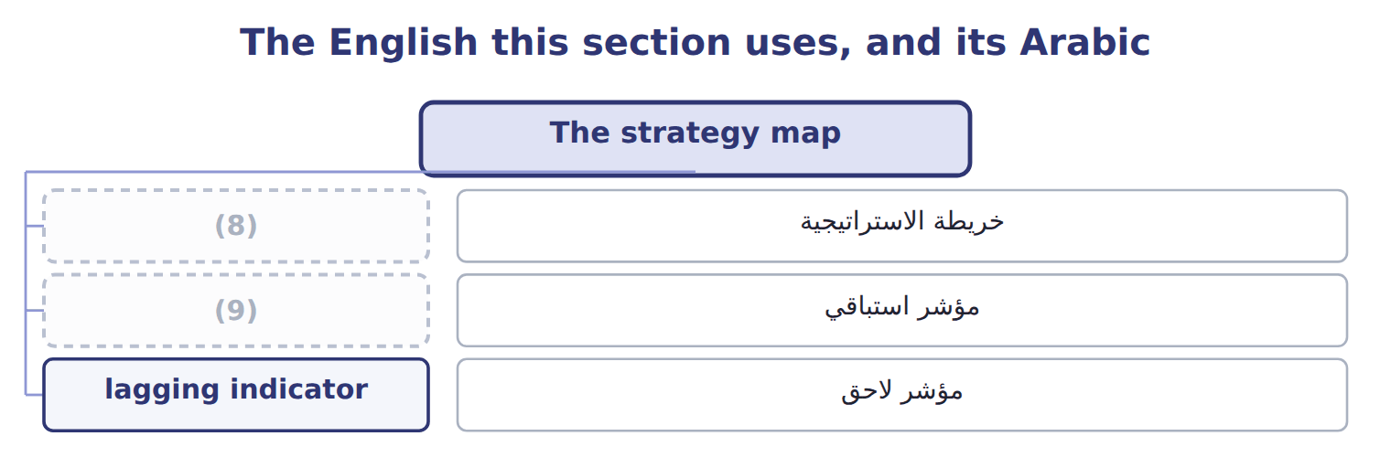
word list
خريطة الاستراتيجية · leading indicator · strategy map

The English this sheet uses, and its Arabic
English (exam term) | Arabic
strategy map | خريطة الاستراتيجية
leading indicator | مؤشر استباقي
lagging indicator | مؤشر لاحق

Answer key · 18.4 The strategy map

1 cause-and-effect | 6 indicators
2 perspectives | 7 changeover
3 improves | 8 strategy map
4 satisfied | 9 leading indicator
5 explains

the summaries in full
Summary 1 A strategy map draws the cause-and-effect links between the objectives in the four perspectives. It is read upward: investment in people improves processes, better processes satisfy customers, and satisfied customers produce the financial result. The map explains why leading indicators matter. Training hours and changeover time move before the financial result does, so they give warning while there is still time to act. A lagging indicator such as return on investment reports a year that is already over.

18.5 Reading a scorecard and reporting it
Chapter 18 · section 18.5

Fill every gap. Each word list holds one word more than there are gaps.
Worked example: what the 2028 scorecard says

Every financial measure was met, and only two of the six customer and internal-process measures.
Worked example: reading the 2028 scorecard
Perspective | Result | What it says
The financial perspective | (1) | The year was good. These are lagging indicators
The customer perspective | 1 of 3 met | Export share and (2) both missed: the strategy of Chapter 1 is behind
Internal process | (3) | Changeover time explains the variances of Chapters 12 and 14
Learning and growth | (4) | Training is on track, but new products are not
Overall | 7 of 12 met | (5)

word list
1 of 3 met · Good results now, weak drivers for next year · delivery · 3 of 3 met · learning and growth perspective · 2 of 3 met

Summary 1 gaps 6–9
The (6) reading is that 2028 was a good year that is not (7) a good 2029. Export share and (8) both missed, and those are the drivers of the (9) set. How often each measure is reported matters as much as the measure itself.
word list
strategy · delivery · building · board's · measure

How often each measure is reported
Every item belongs to exactly one group.
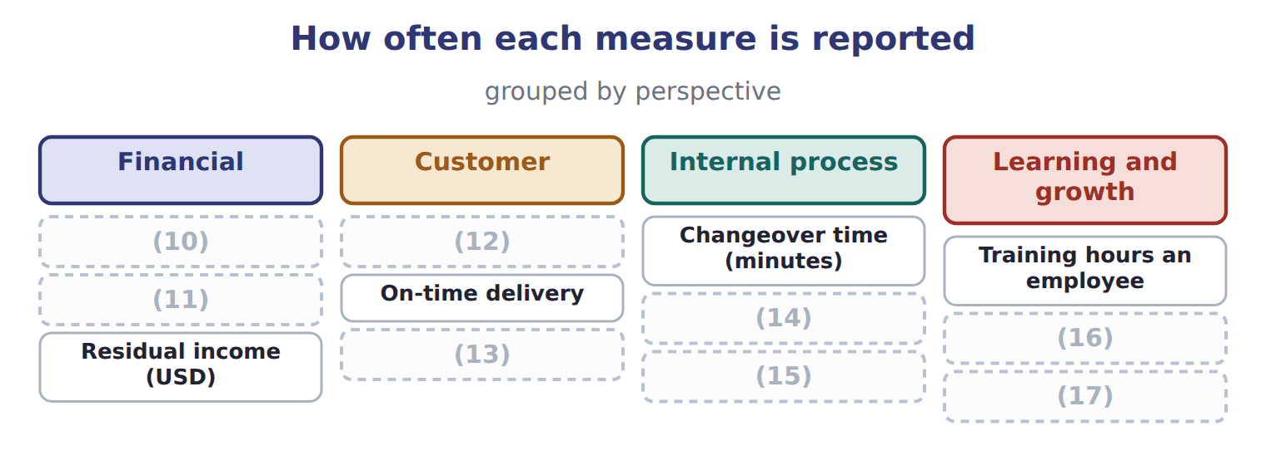
word list
Return on investment · Scrap rate · Residual income (USD) · Revenue growth · Complaints per 1,000 cases · New products share of revenue · Export share of revenue · Staff turnover · Energy a case (kWh)

Match the interval to the decision

Summary 2 gaps 18–19
A measure should be (18) as often as it can change and be acted on. Monthly reporting of a daily problem wastes a month; daily reporting of an annual measure wastes (19) .
word list
financial · attention · reported

Answer key · 18.5 Reading a scorecard and reporting it

1 3 of 3 met | 11 Revenue growth
2 delivery | 12 Export share of revenue
3 1 of 3 met | 13 Complaints per 1,000 cases
4 2 of 3 met | 14 Energy a case (kWh)
5 Good results now, weak drivers for next year | 15 Scrap rate
6 board's | 16 New products share of revenue
7 building | 17 Staff turnover
8 delivery | 18 reported
9 strategy | 19 attention
10 Return on investment

the summaries in full
Summary 1 The board's reading is that 2028 was a good year that is not building a good 2029. Export share and delivery both missed, and those are the drivers of the strategy set. How often each measure is reported matters as much as the measure itself.
Summary 2 A measure should be reported as often as it can change and be acted on. Monthly reporting of a daily problem wastes a month; daily reporting of an annual measure wastes attention.

18.6 Extended Example 18A: recommending measures for next year
Chapter 18 · section 18.6

Fill every gap. Each word list holds one word more than there are gaps.
Summary 1 gaps 1–2
The board asks for a short list of (1) to put right what 2028 missed, for use in 2029. This example (2) it.
word list
builds · targets · measures

Extended Example: recommended measures for next year
Operational goal (C.3.r) | Recommended measure | Reported | Owner
Shorten changeovers | Changeover time in minutes | (3) | Plant manager
Improve delivery | On-time delivery to Levant and the Gulf | Weekly | (4)
Grow exports | Export share of revenue | (5) | Sales director
Launch new products | Share of revenue from products under three years old | Quarterly | (6)

word list
Division managers · Daily · Levant manager · Monthly · strategy map

Summary 2 gaps 7–8
Each follows directly from a measure that was missed, each has an owner who can (7) it, and together they form one chain of the strategy map rather than four (8) targets.
word list
influence · directly · unrelated

Everything ties

Summary 3 gaps 9–10
Residual income on the (9) , $2,260,000, is the sum of the three divisions. Company return on (10) 12.6% beats the 11.8% objective set.
word list
scorecard · results · investment

Exam view

Summary 4 gaps 11–13
Expect a list of measures to sort into (11) , a scorecard to read, or a goal for which you must (12) a measure, an interval and an owner. Say what the (13) of results means, not just how many were met.
word list
investment · pattern · recommend · perspectives

Exam view
Tahini & Spreads, one quarter | Target | Actual
(14) | 840,000 | 812,000
(15) | 95% | 97%
Sesame yield (kg of paste a kg of seed) | 0.62 | 0.59
(16) | 12 | 12
Complaints from supermarkets | 5 | 9

word list
Operators trained on the new line · Gulf chain orders delivered in full · Segment margin · Recommended measure

Item — Answer
Item | Answer
Internal process | (17) : missed; energy 0.47 against 0.48: met; scrap 1.8% against 1.5%: missed
Learning and growth | Training 15.2 against 14.4: met; new products 5.1% against 7.8%: missed; turnover 7% against 8%: met

word list
Changeover time 42 against 30 · Tahini & Spreads, one quarter

Measure — Category
Measure | Category
Segment margin | (18)
Gulf chain orders delivered in full | (19)
Sesame yield a kilogram of seed | Internal process
Operators trained on the new line | (20)
Complaints from supermarkets | Customer

word list
Customer · Financial · Learning and growth · Recommended measure

The English this section uses, and its Arabic
Each term sits against what it means.
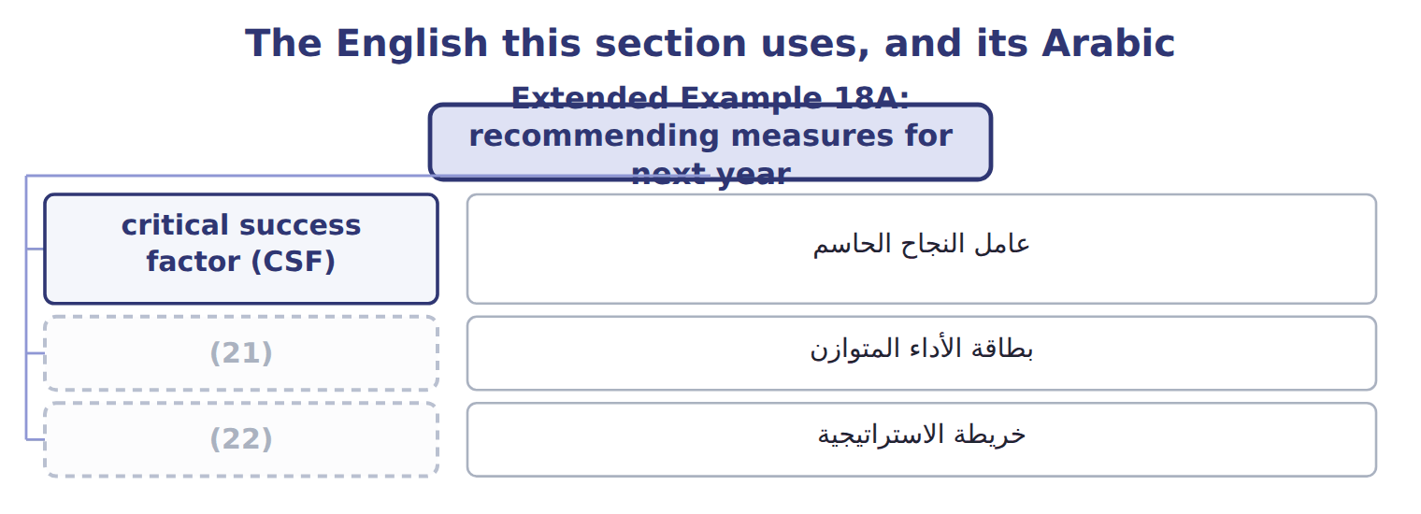
word list
strategy map · خريطة الاستراتيجية · balanced scorecard

The English this sheet uses, and its Arabic
English (exam term) | Arabic
critical success factor (CSF) | عامل النجاح الحاسم
balanced scorecard | بطاقة الأداء المتوازن
strategy map | خريطة الاستراتيجية

Answer key · 18.6 Extended Example 18A: recommending measures for next year

1 measures | 12 recommend
2 builds | 13 pattern
3 Daily | 14 Segment margin
4 Levant manager | 15 Gulf chain orders delivered in full
5 Monthly | 16 Operators trained on the new line
6 Division managers | 17 Changeover time 42 against 30
7 influence | 18 Financial
8 unrelated | 19 Customer
9 scorecard | 20 Learning and growth
10 investment | 21 balanced scorecard
11 perspectives | 22 strategy map

the summaries in full
Summary 1 The board asks for a short list of measures to put right what 2028 missed, for use in 2029. This example builds it.
Summary 2 Each follows directly from a measure that was missed, each has an owner who can influence it, and together they form one chain of the strategy map rather than four unrelated targets.
Summary 3 Residual income on the scorecard, $2,260,000, is the sum of the three divisions. Company return on investment 12.6% beats the 11.8% objective set.
Summary 4 Expect a list of measures to sort into perspectives, a scorecard to read, or a goal for which you must recommend a measure, an interval and an owner. Say what the pattern of results means, not just how many were met.

