8.1 Which test applies?
Chapter 8 · section 8.1

Fill every gap. Each word list holds one word more than there are gaps.
Chapter 8, section by section
Each stage leads to the next.
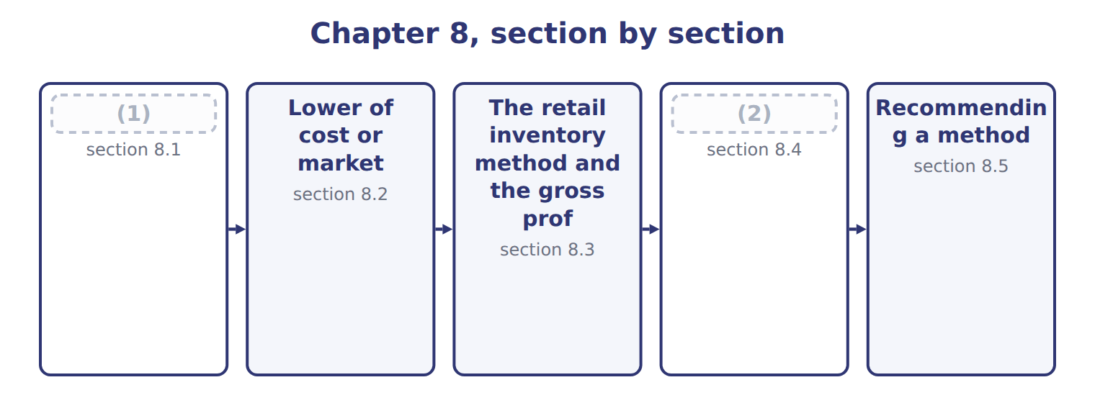
word list
Advantages and disadvantages of the methods · Which test applies? · net realizable value (NRV)

Summary 1 gaps 3–11
At each (3) sheet date, the company checks (4) the cost of its inventory is still (5) . Inventory measured by FIFO, average cost or specific (6) uses the lower of cost and net realizable value (LCNRV). Inventory measured by LIFO or the retail inventory method uses the lower of cost or (7) (LCM) (Section 8.2). Net realizable value (NRV) is the estimated selling price in the (8) course of business, minus the costs to complete, sell and transport the goods. If NRV is below cost, the company (9) a write-down to NRV. The loss goes to income, (10) inside cost of goods sold, or as a (11) line if it is large.
word list
markup · records · ordinary · separate · balance · usually · identification · recoverable · whether · market

LCNRV for Orontes olive oil

Summary 2 gaps 12–14
In, Orontes used FIFO for olive oil. Its (12) inventory was 2,000 cases at $50. In late December, a large (13) cut prices. Orontes now expects to sell each case for $54, with $6 of selling and (14) costs.
word list
competitor · December · delivery · ending

LCNRV for Orontes olive oil at December 31, 2025 (whole USD)
Orontes olive oil, December 31, 2025 | Amount
(15) | 2,000
Cost per case | $50
New estimated selling price per case | $54
Costs to sell and deliver per case | $6
(16) | $48
(17) | $100,000
(18) | $96,000
Write-down (loss in income) | $4,000

word list
Inventory at cost · Olive oil cases on hand (FIFO layer from Chapter 7) · Inventory at LCNRV · lower of cost or market (LCM) · NRV per case

Summary 3 gaps 19–20
The (19) of $4,000 is a loss of 2025. The new (20) , $48 a case, is now the cost basis of these cases.
word list
write-down · amount · inventories

NRV has no profit deduction

Summary 4 gaps 21–25
A (21) recognized in an interim quarter is the only (22) : it may be recovered in a later quarter of the same fiscal year. NRV = (23) price − costs to complete, sell and (24) . Do NOT deduct a normal profit; that only defines the LCM (25) . Check the method first: FIFO or average → LCNRV; LIFO or retail → LCM.
word list
write-down · floor · exception · selling · transport · original

What each framework says
The two columns are not matched row by row.
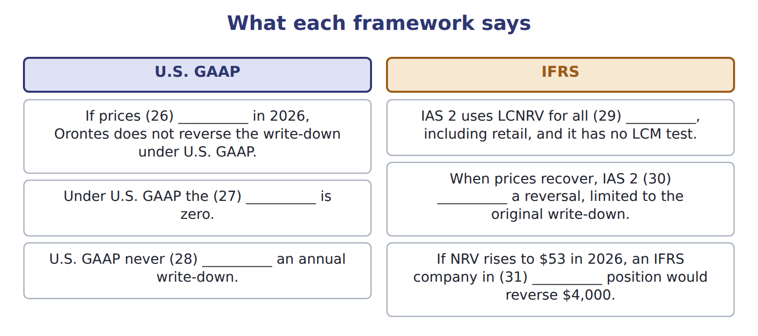
word list
Orontes's · reverses · requires · reversal · markdown · inventories · recover

The English this section uses, and its Arabic
Each term sits against what it means.
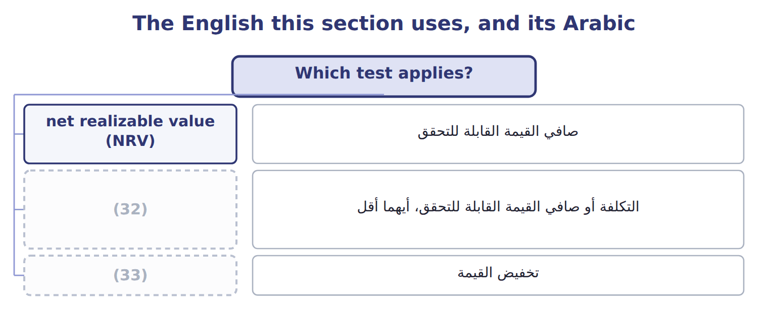
word list
write-down · floor · lower of cost and net realizable value (LCNRV)

The English this sheet uses, and its Arabic
English (exam term) | Arabic
net realizable value (NRV) | صافي القيمة القابلة للتحقق
lower of cost and net realizable value (LCNRV) | التكلفة أو صافي القيمة القابلة للتحقق، أيهما أقل
write-down | تخفيض القيمة

Answer key · 8.1 Which test applies?

1 Which test applies? | 18 Inventory at LCNRV
2 Advantages and disadvantages of the methods | 19 write-down
3 balance | 20 amount
4 whether | 21 write-down
5 recoverable | 22 exception
6 identification | 23 selling
7 market | 24 transport
8 ordinary | 25 floor
9 records | 26 recover
10 usually | 27 reversal
11 separate | 28 reverses
12 ending | 29 inventories
13 competitor | 30 requires
14 delivery | 31 Orontes's
15 Olive oil cases on hand (FIFO layer from Chapter 7) | 32 lower of cost and net realizable value (LCNRV)
16 NRV per case | 33 write-down
17 Inventory at cost

the summaries in full
Summary 1 At each balance sheet date, the company checks whether the cost of its inventory is still recoverable. Inventory measured by FIFO, average cost or specific identification uses the lower of cost and net realizable value (LCNRV). Inventory measured by LIFO or the retail inventory method uses the lower of cost or market (LCM) (Section 8.2). Net realizable value (NRV) is the estimated selling price in the ordinary course of business, minus the costs to complete, sell and transport the goods. If NRV is below cost, the company records a write-down to NRV. The loss goes to income, usually inside cost of goods sold, or as a separate line if it is large.
Summary 2 In, Orontes used FIFO for olive oil. Its ending inventory was 2,000 cases at $50. In late December, a large competitor cut prices. Orontes now expects to sell each case for $54, with $6 of selling and delivery costs.
Summary 3 The write-down of $4,000 is a loss of 2025. The new amount, $48 a case, is now the cost basis of these cases.
Summary 4 A write-down recognized in an interim quarter is the only exception: it may be recovered in a later quarter of the same fiscal year. NRV = selling price − costs to complete, sell and transport. Do NOT deduct a normal profit; that only defines the LCM floor. Check the method first: FIFO or average → LCNRV; LIFO or retail → LCM.

8.2 Lower of cost or market
Chapter 8 · section 8.2

Fill every gap. Each word list holds one word more than there are gaps.
Summary 1 gaps 1–9
Under LCM, market (1) with replacement cost: the current cost to buy or make the item again. But market has two limits. It cannot be (2) than a ceiling equal to NRV, and it cannot be lower than a floor equal to NRV minus a (3) profit margin. The (4) has two steps. First, find market: take the middle value of replacement cost, the ceiling and the floor. (5) , compare market with cost and take the lower. Why the limits? The ceiling stops the company from (6) inventory above what it can (7) . The floor stops an (8) write-down that would (9) an abnormally high profit when the goods are sold later.
word list
carrying · commitment · excessive · create · Second · procedure · recover · starts · normal · higher

LCM, item by item

Summary 2 gaps 10–11
Values are per case in whole (10) . For each line, market is the (11) of the three limits, and LCM is the lower of cost and market.
word list
dollars · directly · middle

LCM, item by item, for four Orontes product lines measured under LIFO (whole USD per case)
The parts add up to the total; the bars are to scale.
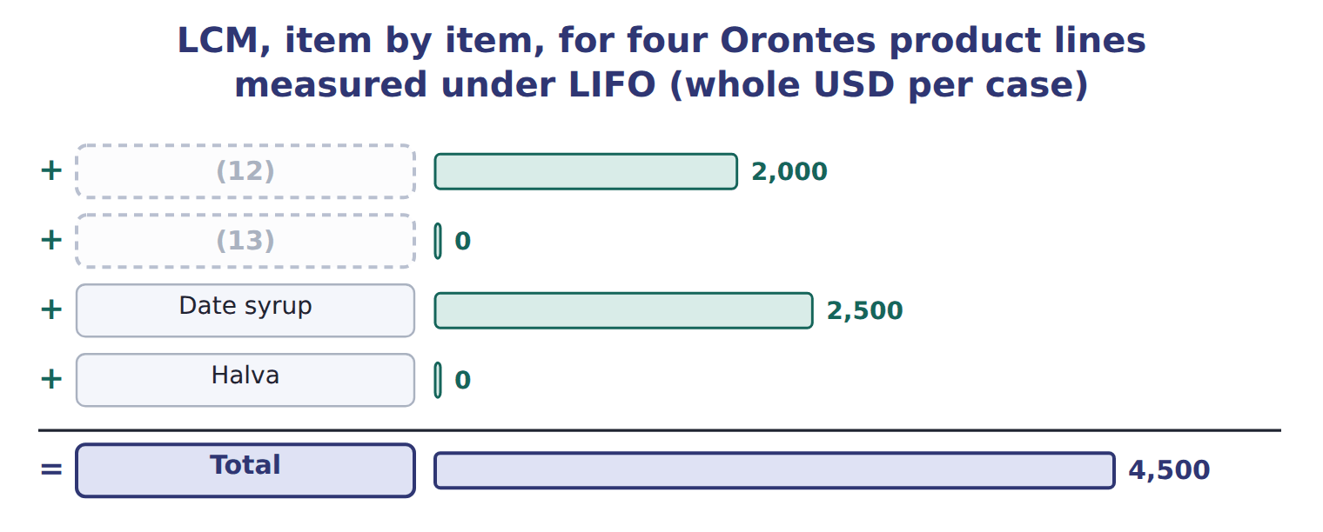
word list
shrinkage · Tahini · Chickpeas

Summary 3 gaps 14–21
The item-by-item basis gives a total write-down of $4,500. A company may also apply LCM by category or to the total inventory, if it does so (14) . On the total basis, total market ($121,500) is (15) with total cost ($122,000), and the write-down is only $500, (16) gains on some items (17) losses on others. The item-by-item basis is the most (18) . One more rule: if a company has a firm, (19) purchase commitment at a price above the current market, it records the (20) loss now, in the current (21) .
word list
expected · compared · offset · period · conservative · because · non-cancellable · question · consistently

Find market first

Summary 4 gaps 22–23
Do not compare replacement cost (22) with cost. First limit it by the ceiling and the floor. When replacement cost is below the floor, market is the floor. When it is above the ceiling, market is the ceiling. Read the basis in the (23) : item by item, by category or total.
word list
consistently · question · directly

The English this section uses, and its Arabic
Each term sits against what it means.
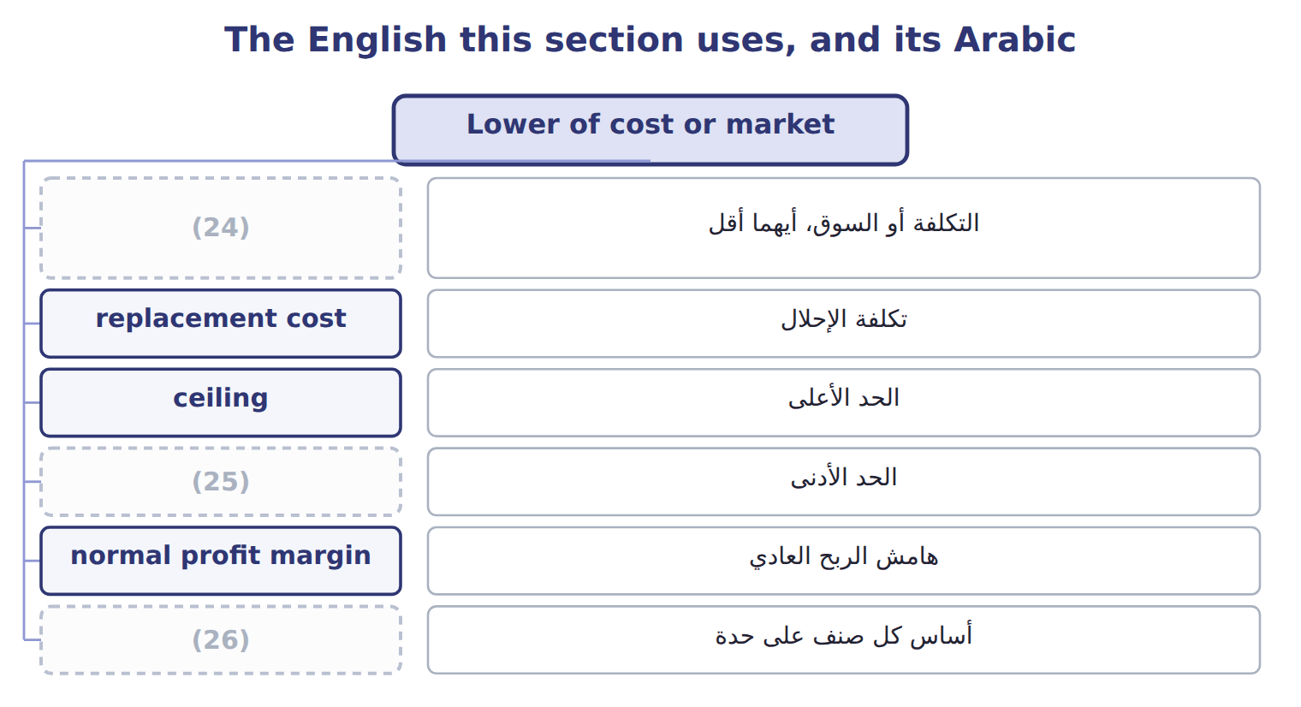
word list
floor · lower of cost or market (LCM) · item-by-item basis · net realizable value (NRV)

The English this sheet uses, and its Arabic
English (exam term) | Arabic
lower of cost or market (LCM) | التكلفة أو السوق، أيهما أقل
replacement cost | تكلفة الإحلال
ceiling | الحد الأعلى
floor | الحد الأدنى
normal profit margin | هامش الربح العادي
item-by-item basis | أساس كل صنف على حدة
purchase commitment | التزام شراء

Answer key · 8.2 Lower of cost or market

1 starts | 14 consistently
2 higher | 15 compared
3 normal | 16 because
4 procedure | 17 offset
5 Second | 18 conservative
6 carrying | 19 non-cancellable
7 recover | 20 expected
8 excessive | 21 period
9 create | 22 directly
10 dollars | 23 question
11 middle | 24 lower of cost or market (LCM)
12 Tahini | 25 floor
13 Chickpeas | 26 item-by-item basis

the summaries in full
Summary 1 Under LCM, market starts with replacement cost: the current cost to buy or make the item again. But market has two limits. It cannot be higher than a ceiling equal to NRV, and it cannot be lower than a floor equal to NRV minus a normal profit margin. The procedure has two steps. First, find market: take the middle value of replacement cost, the ceiling and the floor. Second, compare market with cost and take the lower. Why the limits? The ceiling stops the company from carrying inventory above what it can recover. The floor stops an excessive write-down that would create an abnormally high profit when the goods are sold later.
Summary 2 Values are per case in whole dollars. For each line, market is the middle of the three limits, and LCM is the lower of cost and market.
Summary 3 The item-by-item basis gives a total write-down of $4,500. A company may also apply LCM by category or to the total inventory, if it does so consistently. On the total basis, total market ($121,500) is compared with total cost ($122,000), and the write-down is only $500, because gains on some items offset losses on others. The item-by-item basis is the most conservative. One more rule: if a company has a firm, non-cancellable purchase commitment at a price above the current market, it records the expected loss now, in the current period.
Summary 4 Do not compare replacement cost directly with cost. First limit it by the ceiling and the floor. When replacement cost is below the floor, market is the floor. When it is above the ceiling, market is the ceiling. Read the basis in the question: item by item, by category or total.

8.3 The retail inventory method and the gross profit method
Chapter 8 · section 8.3

Fill every gap. Each word list holds one word more than there are gaps.
Summary 1 gaps 1–9
Retailers sell (1) of items. They know the selling price of every item on the shelf, but (2) the cost of each one is (3) . The retail inventory method estimates ending inventory at cost from retail prices. It uses a (4) ratio: goods available at cost (5) by goods available at retail. Retail prices (6) during the year. A markup raises the selling price above the (7) retail price. A (8) lowers it. The conventional retail method includes net markups in the ratio but leaves out net markdowns. This gives a lower ratio and a lower ending inventory, which (9) LCM. The average-cost retail method includes both.
word list
approximates · thousands · change · cost-to-retail · divided · markdown · expensive · original · tracking · floor

Item — Cost column
Every item belongs to exactly one group.
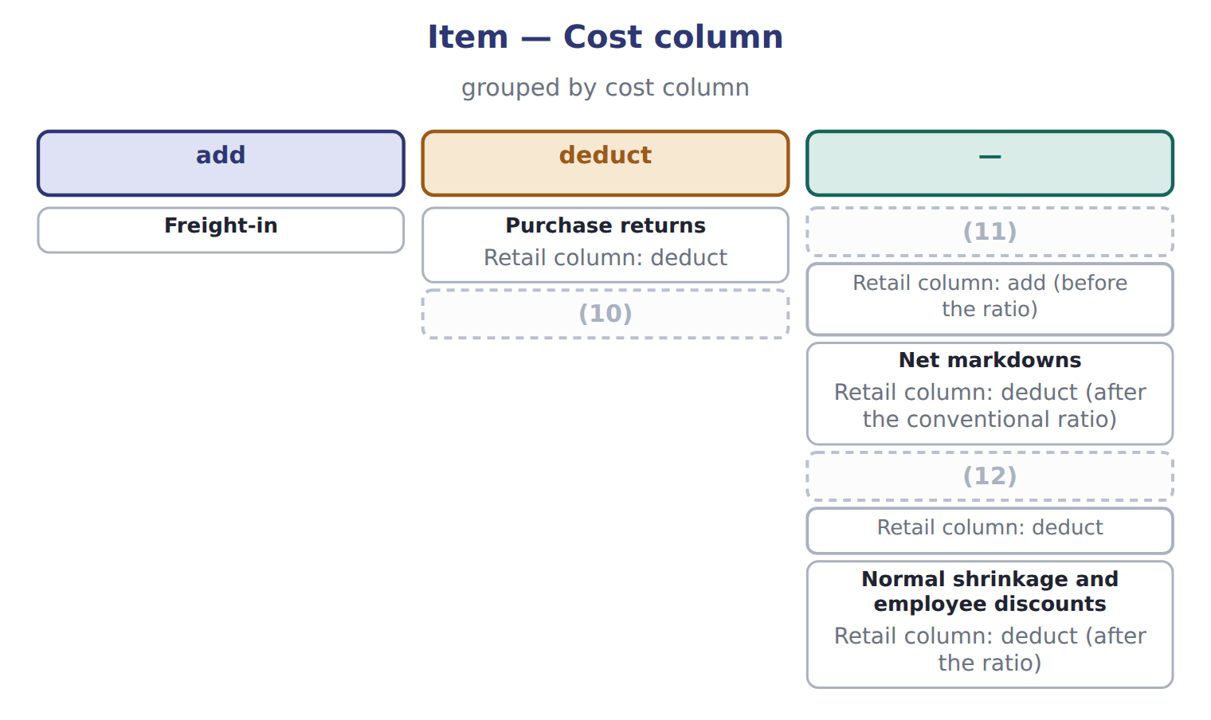
word list
Net sales · Net markups · cost-to-retail ratio · Purchase discounts

Orontes Farm Shops, Amman

Summary 2 gaps 13–16
Orontes runs a group of farm shops in Amman. They (13) under U.S. GAAP with the rest of the company. The conventional ratio is 0.60, so ending (14) at cost is $25,200. The (15) ratio is 0.62, which gives $26,040. Cost of goods sold under the conventional (16) is $186,000 − $25,200 = $160,800.
word list
inventory · method · average-cost · floor · report

The Dubai shop

Summary 3 gaps 17–28
Complete the (17) boxes using the conventional retail method. A LIFO retail method also (18) . It leaves beginning inventory out of the ratio, includes markdowns, and adds a new layer each year at that (19) ratio. The exam tests it less often. The gross profit method estimates ending inventory from the usual gross profit rate. It is used for (20) reports, to check a (21) count, and to (22) inventory lost in a fire or a theft. It is not (23) for annual financial (24) . A fire (25) part of the Orontes (26) in Jebel Ali. Beginning inventory was $80,000, (27) were $300,000 and net sales were $400,000. The usual gross profit rate is 30% of sales. Estimated cost of goods sold is $280,000, so estimated inventory at the date of the fire is $380,000 − $280,000 = $100,000. Goods (28) $12,000 were saved, so the estimated fire loss is $88,000.
word list
purchases · warehouse · year's · thousands · costing · interim · statements · physical · destroyed · estimate · acceptable · exists · dashed

Markup on cost is not a margin on sales

Summary 4 gaps 29–33
If the (29) gives a markup on cost, (30) it: gross profit rate on sales = markup ÷ (1 + markup). For example, a markup of one half on cost is a gross profit rate of one third on sales. Conventional retail: markups IN the ratio, markdowns OUT. (31) goes in the cost (32) only; normal (33) is deducted from retail after the ratio.
word list
question · shrinkage · Orontes · convert · column · Freight-in

The English this section uses, and its Arabic
Each term sits against what it means.
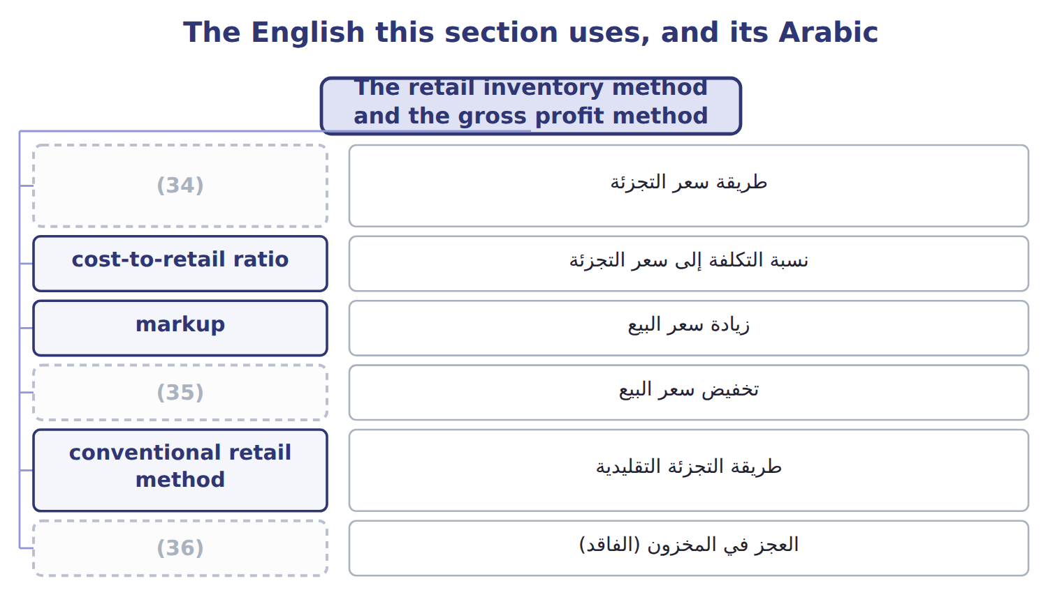
word list
retail inventory method · floor · markdown · shrinkage

The English this sheet uses, and its Arabic
English (exam term) | Arabic
retail inventory method | طريقة سعر التجزئة
cost-to-retail ratio | نسبة التكلفة إلى سعر التجزئة
markup | زيادة سعر البيع
markdown | تخفيض سعر البيع
conventional retail method | طريقة التجزئة التقليدية
shrinkage | العجز في المخزون (الفاقد)
gross profit method | طريقة مجمل الربح

Answer key · 8.3 The retail inventory method and the gross profit method

1 thousands | 19 year's
2 tracking | 20 interim
3 expensive | 21 physical
4 cost-to-retail | 22 estimate
5 divided | 23 acceptable
6 change | 24 statements
7 original | 25 destroyed
8 markdown | 26 warehouse
9 approximates | 27 purchases
10 Purchase discounts | 28 costing
11 Net markups | 29 question
12 Net sales | 30 convert
13 report | 31 Freight-in
14 inventory | 32 column
15 average-cost | 33 shrinkage
16 method | 34 retail inventory method
17 dashed | 35 markdown
18 exists | 36 shrinkage

the summaries in full
Summary 1 Retailers sell thousands of items. They know the selling price of every item on the shelf, but tracking the cost of each one is expensive. The retail inventory method estimates ending inventory at cost from retail prices. It uses a cost-to-retail ratio: goods available at cost divided by goods available at retail. Retail prices change during the year. A markup raises the selling price above the original retail price. A markdown lowers it. The conventional retail method includes net markups in the ratio but leaves out net markdowns. This gives a lower ratio and a lower ending inventory, which approximates LCM. The average-cost retail method includes both.
Summary 2 Orontes runs a group of farm shops in Amman. They report under U.S. GAAP with the rest of the company. The conventional ratio is 0.60, so ending inventory at cost is $25,200. The average-cost ratio is 0.62, which gives $26,040. Cost of goods sold under the conventional method is $186,000 − $25,200 = $160,800.
Summary 3 Complete the dashed boxes using the conventional retail method. A LIFO retail method also exists. It leaves beginning inventory out of the ratio, includes markdowns, and adds a new layer each year at that year's ratio. The exam tests it less often. The gross profit method estimates ending inventory from the usual gross profit rate. It is used for interim reports, to check a physical count, and to estimate inventory lost in a fire or a theft. It is not acceptable for annual financial statements. A fire destroyed part of the Orontes warehouse in Jebel Ali. Beginning inventory was $80,000, purchases were $300,000 and net sales were $400,000. The usual gross profit rate is 30% of sales. Estimated cost of goods sold is $280,000, so estimated inventory at the date of the fire is $380,000 − $280,000 = $100,000. Goods costing $12,000 were saved, so the estimated fire loss is $88,000.
Summary 4 If the question gives a markup on cost, convert it: gross profit rate on sales = markup ÷ (1 + markup). For example, a markup of one half on cost is a gross profit rate of one third on sales. Conventional retail: markups IN the ratio, markdowns OUT. Freight-in goes in the cost column only; normal shrinkage is deducted from retail after the ratio.

8.4 Advantages and disadvantages of the methods
Chapter 8 · section 8.4

Fill every gap. Each word list holds one word more than there are gaps.
Summary 1 gaps 1–2
No method is best in every (1) . Each one is (2) on some goals and weak on others.
word list
situation · weighted · strong

Advantages and disadvantages of the inventory methods
Every item belongs to exactly one group.
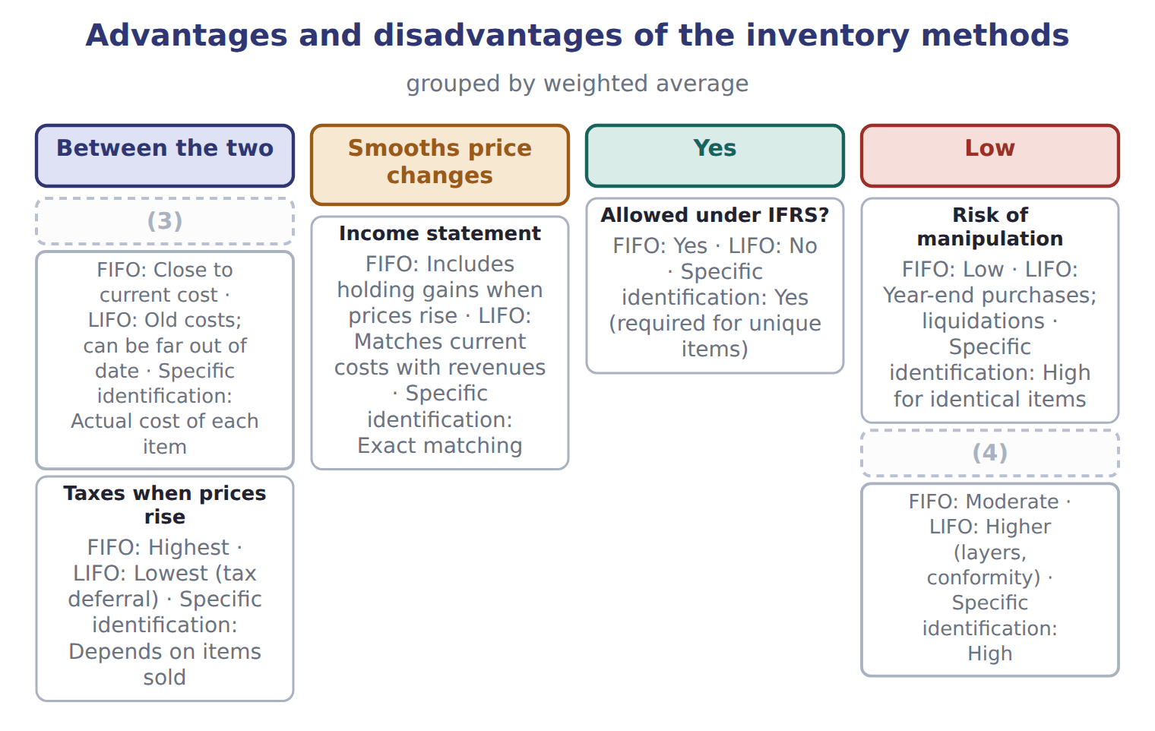
word list
Between the two · Cost of records · Balance sheet (inventory)

Summary 2 gaps 5–13
The weighted average and specific identification have their own (5) . The weighted average is simple, (6) price changes and is hard to (7) , but its results are neither fully current on the balance sheet nor on the income statement. Specific identification gives exact matching for unique items, but for (8) items it is costly and lets (9) choose which costs to report. The main (10) is between the two (11) . LIFO gives a more realistic income statement when (12) change, but an (13) balance sheet. FIFO gives a realistic balance sheet, but its income includes holding gains. The weighted average sits between them.
word list
trade-off · management · statements · strengths · identical · out-of-date · ceiling · manipulate · smooths · prices

Answer key · 8.4 Advantages and disadvantages of the methods

1 situation | 8 identical
2 strong | 9 management
3 Balance sheet (inventory) | 10 trade-off
4 Cost of records | 11 statements
5 strengths | 12 prices
6 smooths | 13 out-of-date
7 manipulate

the summaries in full
Summary 1 No method is best in every situation. Each one is strong on some goals and weak on others.
Summary 2 The weighted average and specific identification have their own strengths. The weighted average is simple, smooths price changes and is hard to manipulate, but its results are neither fully current on the balance sheet nor on the income statement. Specific identification gives exact matching for unique items, but for identical items it is costly and lets management choose which costs to report. The main trade-off is between the two statements. LIFO gives a more realistic income statement when prices change, but an out-of-date balance sheet. FIFO gives a realistic balance sheet, but its income includes holding gains. The weighted average sits between them.

8.5 Recommending a method
Chapter 8 · section 8.5

Fill every gap. Each word list holds one word more than there are gaps.
Summary 1 gaps 1–7
A Level C question may give you a set of facts and ask you to (1) a method. (2) check the facts that can rule a method out. If the company, or its (3) , reports under IFRS, LIFO is not (4) . If items are identical and sold in large volumes, specific (5) is costly and open to (6) . If the company wants the U.S. tax benefit of LIFO, it must also report LIFO profits to investors, and it must avoid (7) old layers.
word list
parent · possible · Always · identification · liquidating · records · recommend · manipulation

A recommendation for Orontes

Summary 2 gaps 8–17
Orontes reports under U.S. GAAP, and olive oil prices are (8) . The finance (9) wants lower taxes but also a balance sheet that lenders trust. Olive oil is a (10) , identical product that Orontes ships (11) . LIFO would lower taxes while prices rise, but (12) would lower (13) profits too, and the balance sheet would show old costs. FIFO (14) the physical flow and gives lenders a (15) inventory amount, but taxes are higher. Recommendation: if the tax saving is the priority, LIFO, with clear (16) of the LIFO reserve; if lender (17) and the balance sheet matter more, FIFO. The answer depends on the stated priority, and a good exam answer names it.
word list
perishable · rising · matches · conformity · specific · disclosure · oldest-first · reported · current · relations · director

Recommendations need reasons

Summary 3 gaps 18–19
In a (18) question, a recommendation earns credit only if it follows from the facts given. Check IFRS, taxes, price trends, the physical flow and the cost of (19) before you choose.
word list
case-based · profits · records

Recommendations need reasons
Item | Method | Units | Unit cost | Replace-ment cost | Selling price | Costs to sell | Normal profit
Pomegranate molasses | LIFO | 800 | 25 | 21 | 32 | 3 | 6
Rose water | (20) | 1,200 | 10 | 11 | 16 | 2 | 3
Za'atar mix | (21) | 2,000 | 12 | 10 | 14 | 3 | 2
Frozen kibbeh | FIFO | 1,000 | 30 | 29 | 36 | 4 | 5
Olive-oil soap | FIFO | 500 | 8 | 7 | 9 | 2.5 | 1

word list
floor · LIFO · FIFO

Item — Answer
Item | Answer
Goods available at retail | 150,000 − 6,000 = 144,000
Ending inventory at retail | (22)
Conventional ratio | (23)
Ending inventory at cost | 24,000 × 0.60 = $14,400

word list
24,000 × 0.60 = $14,400 · 90,000 ÷ 150,000 = 0.60 · 144,000 − 120,000 = 24,000

Product line — Category
Product line | Category
Pomegranate molasses | LCM (market with ceiling and floor)
Rose water | (24)
Za'atar mix | LCNRV
Frozen kibbeh | LCNRV
Olive-oil soap | (25)

word list
LCM (market with ceiling and floor) · purchase commitment · LCNRV

Answer key · 8.5 Recommending a method

1 recommend | 14 matches
2 Always | 15 current
3 parent | 16 disclosure
4 possible | 17 relations
5 identification | 18 case-based
6 manipulation | 19 records
7 liquidating | 20 LIFO
8 rising | 21 FIFO
9 director | 22 144,000 − 120,000 = 24,000
10 perishable | 23 90,000 ÷ 150,000 = 0.60
11 oldest-first | 24 LCM (market with ceiling and floor)
12 conformity | 25 LCNRV
13 reported

the summaries in full
Summary 1 A Level C question may give you a set of facts and ask you to recommend a method. Always check the facts that can rule a method out. If the company, or its parent, reports under IFRS, LIFO is not possible. If items are identical and sold in large volumes, specific identification is costly and open to manipulation. If the company wants the U.S. tax benefit of LIFO, it must also report LIFO profits to investors, and it must avoid liquidating old layers.
Summary 2 Orontes reports under U.S. GAAP, and olive oil prices are rising. The finance director wants lower taxes but also a balance sheet that lenders trust. Olive oil is a perishable, identical product that Orontes ships oldest-first. LIFO would lower taxes while prices rise, but conformity would lower reported profits too, and the balance sheet would show old costs. FIFO matches the physical flow and gives lenders a current inventory amount, but taxes are higher. Recommendation: if the tax saving is the priority, LIFO, with clear disclosure of the LIFO reserve; if lender relations and the balance sheet matter more, FIFO. The answer depends on the stated priority, and a good exam answer names it.
Summary 3 In a case-based question, a recommendation earns credit only if it follows from the facts given. Check IFRS, taxes, price trends, the physical flow and the cost of records before you choose.

