10.1 The cost of property, plant and equipment
Chapter 10 · section 10.1

Fill every gap. Each word list holds one word more than there are gaps.
Chapter 10, section by section
Each stage leads to the next.
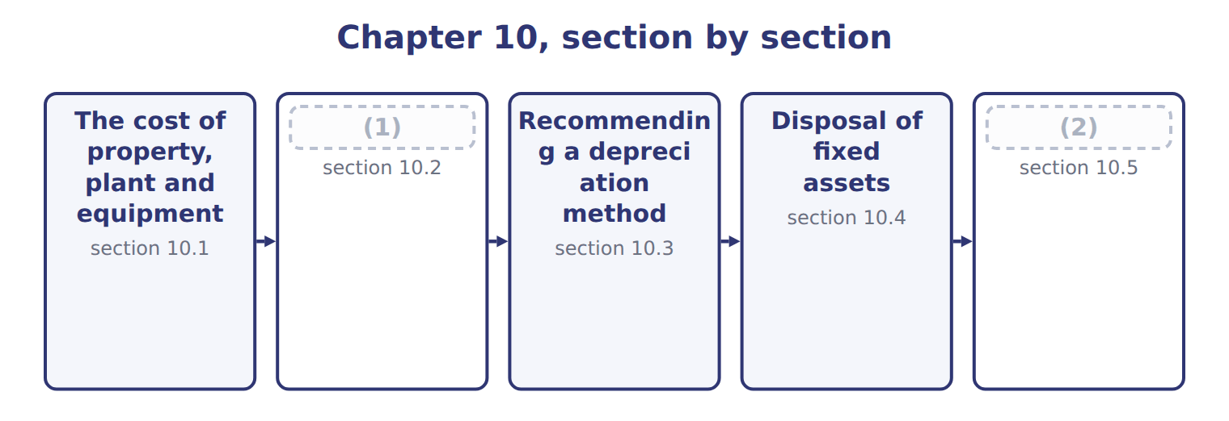
word list
Impairment of long-lived assets, intangibles a · change in accounting estimate · Depreciation methods and their effects

Summary 1 gaps 3–14
Property, plant and (3) (PP&E) is recorded at (4) cost: everything needed to acquire the asset and get it ready for use. This includes the price, freight, (5) , testing and site (6) . When a company buys land with an old building and pulls the building down, the (7) cost is part of the cost of the land. When it buys (8) assets for one price, it divides the price by their (9) fair values. After (10) , a capital expenditure that extends the asset's life or (11) its capacity is added to its cost. A revenue expenditure, such as (12) repairs and (13) , is an expense of the period. When a company builds an asset for its own use, it capitalizes interest during (14) . Capitalized interest is the avoidable interest: weighted-average accumulated expenditures × the interest rate, but never more than the interest actually incurred. For example, if Orontes spends on average $2,000 (USD 000) on a new warehouse during the year and the rate on the related loan is 6%, avoidable interest is 120.
word list
increases · acquire · equipment · demolition · maintenance · purchase · several · relative · construction · installation · historical · ordinary · preparation

Summary 2 gaps 15–19
Actual interest is 150, so Orontes capitalizes 120. (15) stops when the asset is (16) complete. IAS 23 also capitalizes borrowing costs on (17) assets. One (18) : when a company invests borrowed money for a short time before spending it, IAS 23 deducts the investment income from the amount capitalized. U.S. GAAP (19) does not.
word list
substantially · generally · Capitalization · recorded · qualifying · difference

The English this section uses, and its Arabic
Each term sits against what it means.
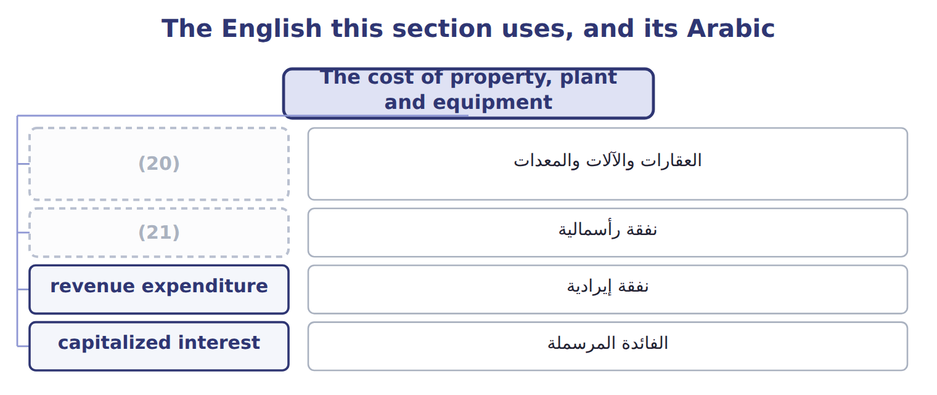
word list
revenue expenditure · capital expenditure · property, plant and equipment (PP&E)

The English this sheet uses, and its Arabic
English (exam term) | Arabic
property, plant and equipment (PP&E) | العقارات والآلات والمعدات
capital expenditure | نفقة رأسمالية
revenue expenditure | نفقة إيرادية
capitalized interest | الفائدة المرسملة

Answer key · 10.1 The cost of property, plant and equipment

1 Depreciation methods and their effects | 12 ordinary
2 Impairment of long-lived assets, intangibles a | 13 maintenance
3 equipment | 14 construction
4 historical | 15 Capitalization
5 installation | 16 substantially
6 preparation | 17 qualifying
7 demolition | 18 difference
8 several | 19 generally
9 relative | 20 property, plant and equipment (PP&E)
10 purchase | 21 capital expenditure
11 increases

the summaries in full
Summary 1 Property, plant and equipment (PP&E) is recorded at historical cost: everything needed to acquire the asset and get it ready for use. This includes the price, freight, installation, testing and site preparation. When a company buys land with an old building and pulls the building down, the demolition cost is part of the cost of the land. When it buys several assets for one price, it divides the price by their relative fair values. After purchase, a capital expenditure that extends the asset's life or increases its capacity is added to its cost. A revenue expenditure, such as ordinary repairs and maintenance, is an expense of the period. When a company builds an asset for its own use, it capitalizes interest during construction. Capitalized interest is the avoidable interest: weighted-average accumulated expenditures × the interest rate, but never more than the interest actually incurred. For example, if Orontes spends on average $2,000 (USD 000) on a new warehouse during the year and the rate on the related loan is 6%, avoidable interest is 120.
Summary 2 Actual interest is 150, so Orontes capitalizes 120. Capitalization stops when the asset is substantially complete. IAS 23 also capitalizes borrowing costs on qualifying assets. One difference: when a company invests borrowed money for a short time before spending it, IAS 23 deducts the investment income from the amount capitalized. U.S. GAAP generally does not.

10.2 Depreciation methods and their effects
Chapter 10 · section 10.2

Fill every gap. Each word list holds one word more than there are gaps.
Summary 1 gaps 1–8
Depreciation (1) the depreciable base, cost minus salvage value, over the useful life in a (2) and rational way. Four methods (3) on the exam. Straight-line method: the same (4) each year, depreciable base ÷ useful life. (5) method: twice the straight-line rate, applied to the (6) book value. Salvage is ignored in the (7) , but the book value may not fall below salvage. Sum-of-the-years'-digits method: depreciable base × remaining life at the start of the year ÷ the sum of the years' digits. (8) method: a rate per unit or hour of use, times actual use.
word list
Units-of-production · calculation · beginning · Double-declining-balance · amount · appear · systematic · separately · spreads

The Amman bottling line

Summary 2 gaps 9–15
In, Orontes (9) a new bottling line for its Amman plant. Orontes (10) a salvage value of $150,000 after 5 years, or after 21,000 machine hours. The depreciable base is $1,050,000. Straight-line: $1,050,000 ÷ 5 = $210,000 a year. Double-declining: rate 40%; year 1 = 40% × $1,200,000 = $480,000. In year 5 only $5,520 is left, so the book value ends at salvage. Sum-of-the-years'-digits: the digits add up to 15; year 1 = $1,050,000 × 5/15 = $350,000. Units of (11) : $1,050,000 ÷ 21,000 hours = $50 an hour; year 1 = 5,000 hours × $50 = $250,000. All four methods (12) the same total, $1,050,000. They only change the (13) . Depreciation is not a cash flow, so the method changes cash only (14) income taxes, and U.S. tax depreciation (MACRS) is (15) separately from the book method.
word list
chosen · charge · bought · through · production · timing · expects · Depreciation

Effects of the depreciation methods on the financial statements
Every item belongs to exactly one group.
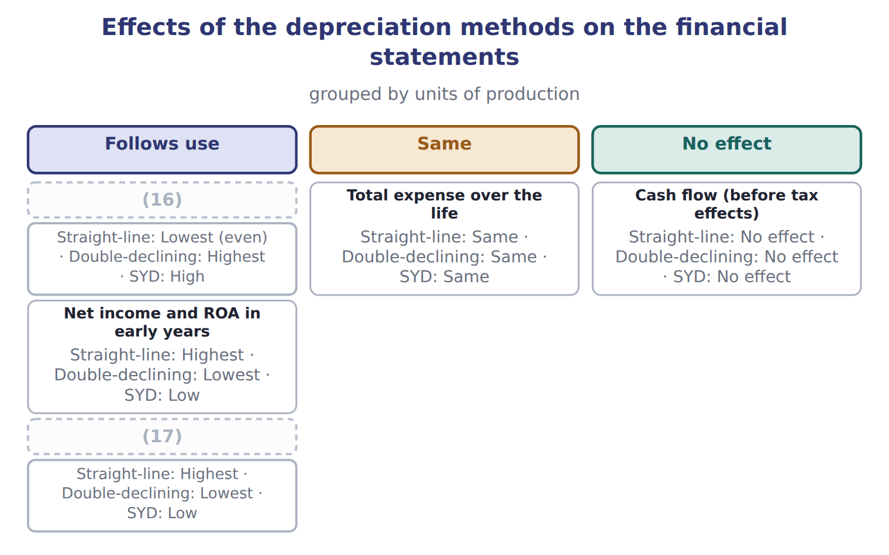
word list
research and development (R&D) · Expense in early years · Carrying amount in early years

Dubai delivery trucks

Summary 3 gaps 18–29
Orontes buys (18) trucks for its Dubai plant for $90,000, with a salvage value of $10,000 after 4 years. (19) the double-declining (20) . A new useful life or salvage value is a change in (21) estimate. It is applied prospectively: the company does not (22) prior years. (23) Orontes used straight-line for the bottling line and, after 2 years, (24) it has 4 more years of life and a salvage value of $90,000. The book value then is $780,000, so each remaining (25) depreciation is ($780,000 − $90,000) ÷ 4 = $172,500. A change in depreciation method is also applied prospectively, as a change in estimate effected by a change in (26) , and the new method must be (27) . An error, such as (28) a machine that should have been (29) , is different: it is corrected by restating the prior years. Some companies use group or composite depreciation for many similar assets. They apply one rate to the whole pool, and when an asset is retired they record no gain or loss.
word list
principle · capitalized · accounting · decides · schedule · restating · year's · Complete · delivery · expensing · restate · preferable · Suppose

Depreciation traps

Summary 4 gaps 30–31
Double-declining: apply the rate to book value; never (30) salvage first, and never go below salvage. SYD: use the remaining life at the start of the year, applied to the depreciable base. Changes in life, salvage or method: (31) .
word list
prospective · depreciated · subtract

Depreciation schedules for the Amman bottling line (whole USD)
Name each line from how it moves.
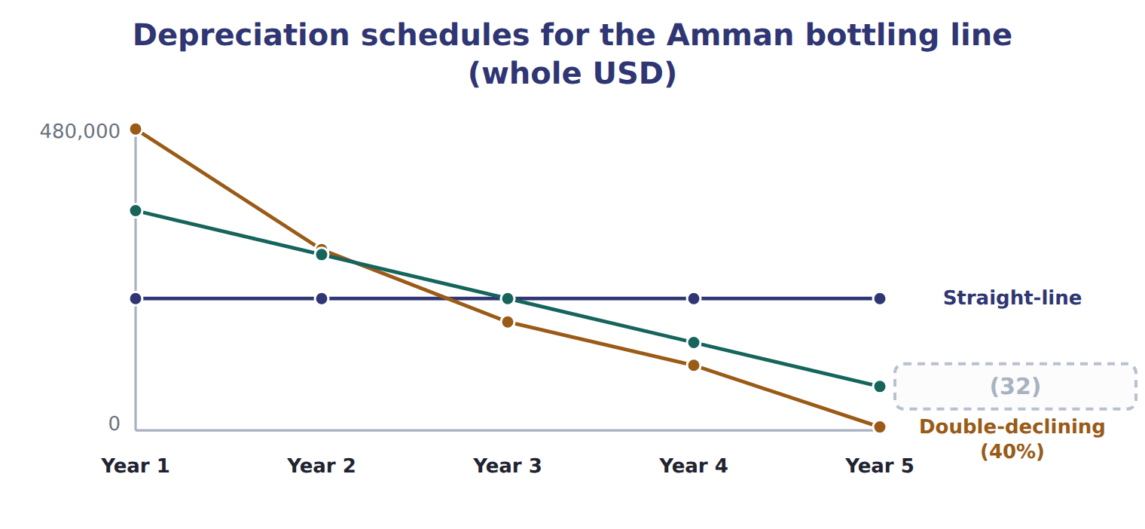
word list
goodwill · Sum-of-the-years'-digits

Double-declining schedule for the Dubai trucks (whole USD): complete the blanks
Every item belongs to exactly one group.
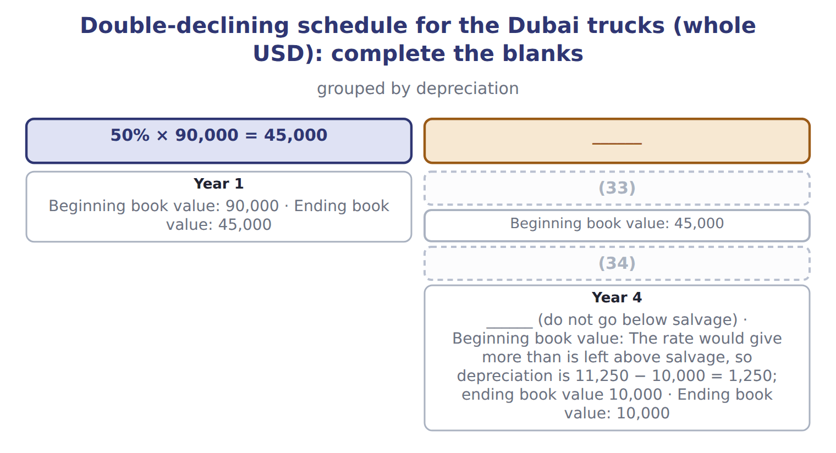
word list
Year 3 · capitalized interest · Year 2

What each framework says
The two columns are not matched row by row.
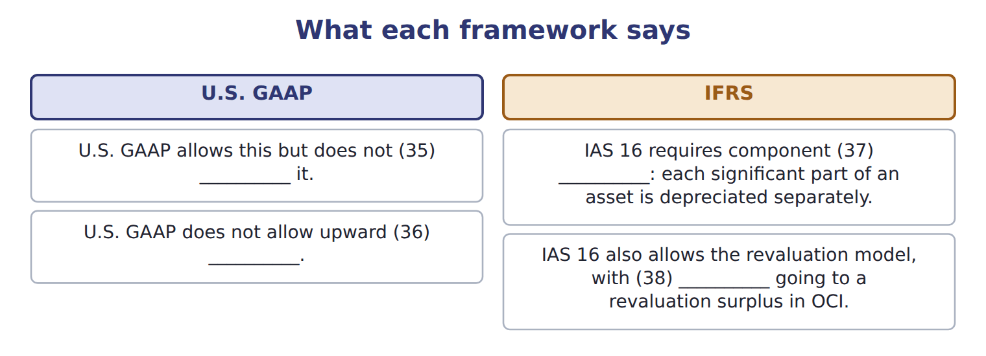
word list
require · increases · goodwill · depreciation · revaluation

The English this section uses, and its Arabic
Each term sits against what it means.
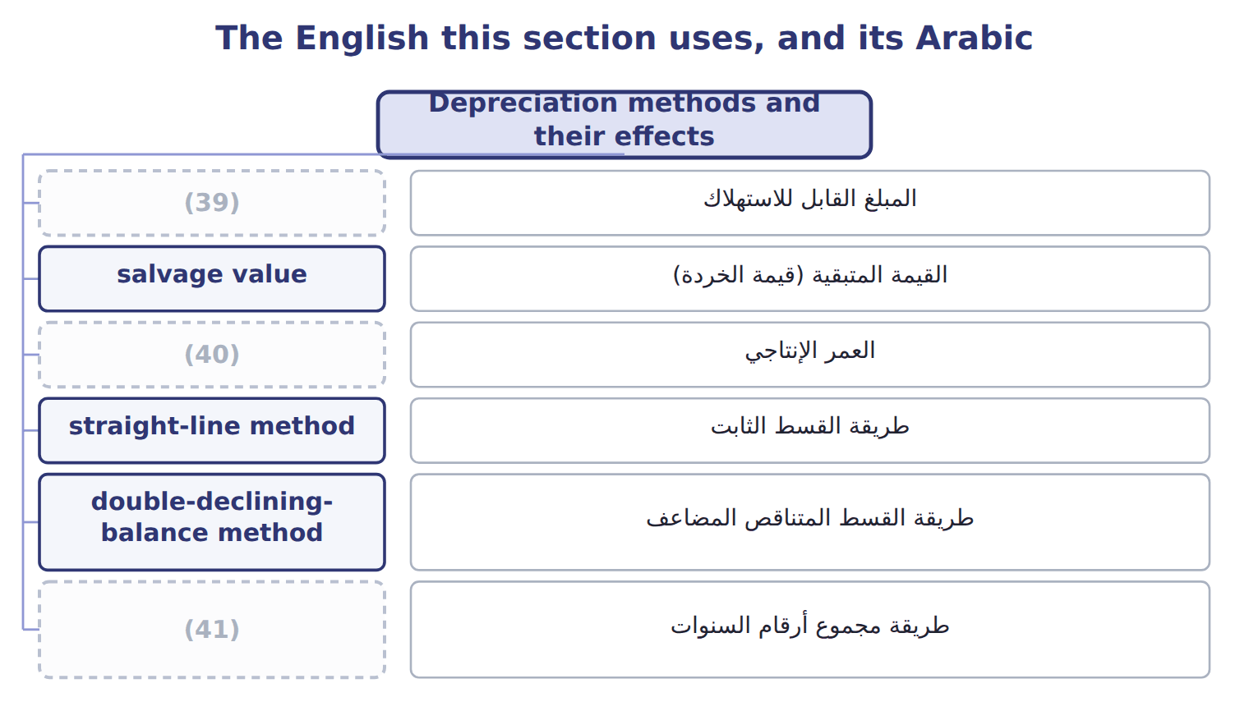
word list
depreciable base · revenue expenditure · sum-of-the-years'-digits method · useful life

The English this sheet uses, and its Arabic
English (exam term) | Arabic
depreciable base | المبلغ القابل للاستهلاك
salvage value | القيمة المتبقية (قيمة الخردة)
useful life | العمر الإنتاجي
straight-line method | طريقة القسط الثابت
double-declining-balance method | طريقة القسط المتناقص المضاعف
sum-of-the-years'-digits method | طريقة مجموع أرقام السنوات
units-of-production method | طريقة وحدات الإنتاج
carrying amount | القيمة الدفترية
change in accounting estimate | التغير في التقدير المحاسبي

Answer key · 10.2 Depreciation methods and their effects

1 spreads | 22 restate
2 systematic | 23 Suppose
3 appear | 24 decides
4 amount | 25 year's
5 Double-declining-balance | 26 principle
6 beginning | 27 preferable
7 calculation | 28 expensing
8 Units-of-production | 29 capitalized
9 bought | 30 subtract
10 expects | 31 prospective
11 production | 32 Sum-of-the-years'-digits
12 charge | 33 Year 2
13 timing | 34 Year 3
14 through | 35 require
15 chosen | 36 revaluation
16 Expense in early years | 37 depreciation
17 Carrying amount in early years | 38 increases
18 delivery | 39 depreciable base
19 Complete | 40 useful life
20 schedule | 41 sum-of-the-years'-digits method
21 accounting

the summaries in full
Summary 1 Depreciation spreads the depreciable base, cost minus salvage value, over the useful life in a systematic and rational way. Four methods appear on the exam. Straight-line method: the same amount each year, depreciable base ÷ useful life. Double-declining-balance method: twice the straight-line rate, applied to the beginning book value. Salvage is ignored in the calculation, but the book value may not fall below salvage. Sum-of-the-years'-digits method: depreciable base × remaining life at the start of the year ÷ the sum of the years' digits. Units-of-production method: a rate per unit or hour of use, times actual use.
Summary 2 In, Orontes bought a new bottling line for its Amman plant. Orontes expects a salvage value of $150,000 after 5 years, or after 21,000 machine hours. The depreciable base is $1,050,000. Straight-line: $1,050,000 ÷ 5 = $210,000 a year. Double-declining: rate 40%; year 1 = 40% × $1,200,000 = $480,000. In year 5 only $5,520 is left, so the book value ends at salvage. Sum-of-the-years'-digits: the digits add up to 15; year 1 = $1,050,000 × 5/15 = $350,000. Units of production: $1,050,000 ÷ 21,000 hours = $50 an hour; year 1 = 5,000 hours × $50 = $250,000. All four methods charge the same total, $1,050,000. They only change the timing. Depreciation is not a cash flow, so the method changes cash only through income taxes, and U.S. tax depreciation (MACRS) is chosen separately from the book method.
Summary 3 Orontes buys delivery trucks for its Dubai plant for $90,000, with a salvage value of $10,000 after 4 years. Complete the double-declining schedule. A new useful life or salvage value is a change in accounting estimate. It is applied prospectively: the company does not restate prior years. Suppose Orontes used straight-line for the bottling line and, after 2 years, decides it has 4 more years of life and a salvage value of $90,000. The book value then is $780,000, so each remaining year's depreciation is ($780,000 − $90,000) ÷ 4 = $172,500. A change in depreciation method is also applied prospectively, as a change in estimate effected by a change in principle, and the new method must be preferable. An error, such as expensing a machine that should have been capitalized, is different: it is corrected by restating the prior years. Some companies use group or composite depreciation for many similar assets. They apply one rate to the whole pool, and when an asset is retired they record no gain or loss.
Summary 4 Double-declining: apply the rate to book value; never subtract salvage first, and never go below salvage. SYD: use the remaining life at the start of the year, applied to the depreciable base. Changes in life, salvage or method: prospective.

10.3 Recommending a depreciation method
Chapter 10 · section 10.3

Fill every gap. Each word list holds one word more than there are gaps.
Summary 1 gaps 1–8
The best method (1) the pattern in which the company uses up the (2) benefits. For the (3) line, machine hours drive the wear, so units of production gives the best matching; straight-line is simpler and is (4) if use is fairly even. Other factors can support the choice: (5) with other companies in the industry, the cost of tracking usage, and (6) view of income (7) . The tax method is a (8) decision, so a company does not need to use the same method for its books.
word list
machine · bottling · matches · smoothing · asset's · separate · acceptable · management's · comparability

Give the reason

What fits each one
Each term sits against what it means.
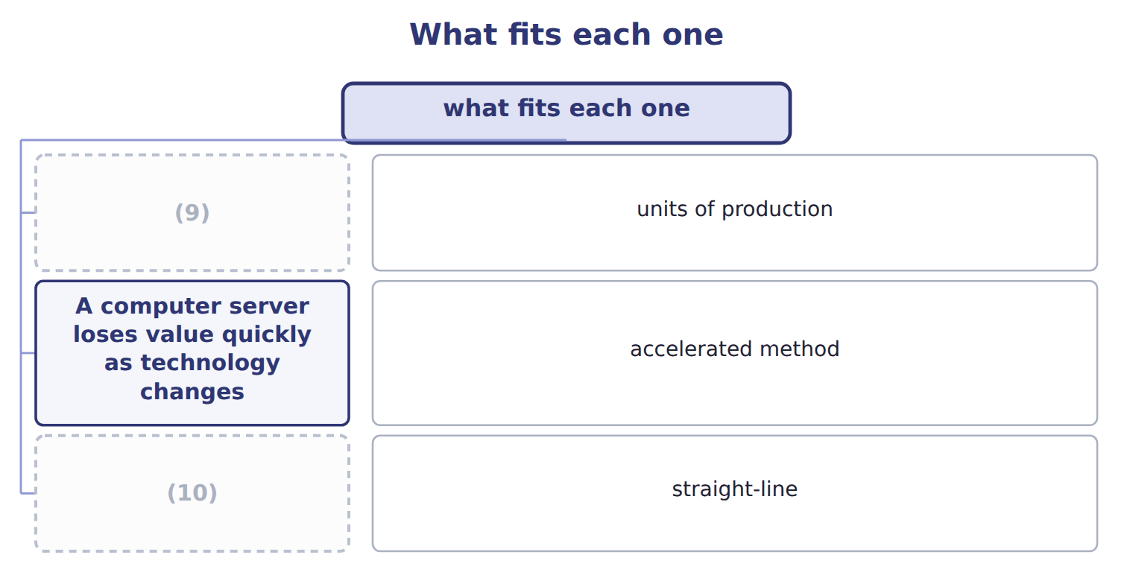
word list
A computer server loses value quickly as technology changes · An office building gives similar service each year · A delivery truck wears out with kilometres driven

Summary 2 gaps 11–12
In a Level C question, a (11) earns credit only with a (12) from the facts: how the asset is used and when its benefits arrive.
word list
reason · recommendation · straight-line

Answer key · 10.3 Recommending a depreciation method

1 matches | 7 smoothing
2 asset's | 8 separate
3 bottling | 9 A delivery truck wears out with kilometres driven
4 acceptable | 10 An office building gives similar service each year
5 comparability | 11 recommendation
6 management's | 12 reason

the summaries in full
Summary 1 The best method matches the pattern in which the company uses up the asset's benefits. For the bottling line, machine hours drive the wear, so units of production gives the best matching; straight-line is simpler and is acceptable if use is fairly even. Other factors can support the choice: comparability with other companies in the industry, the cost of tracking usage, and management's view of income smoothing. The tax method is a separate decision, so a company does not need to use the same method for its books.
Summary 2 In a Level C question, a recommendation earns credit only with a reason from the facts: how the asset is used and when its benefits arrive.

10.4 Disposal of fixed assets
Chapter 10 · section 10.4

Fill every gap. Each word list holds one word more than there are gaps.
Summary 1 gaps 1–4
When a company sells or (1) an asset, it first records depreciation up to the date of (2) . Then it (3) the cost and the accumulated depreciation and (4) the proceeds with the carrying amount. The gain or loss is part of income from continuing operations.
word list
disposal · removes · scraps · compares · insurance

Selling an old oven in Dubai

Which way it goes
The rows are a set, not a sequence.
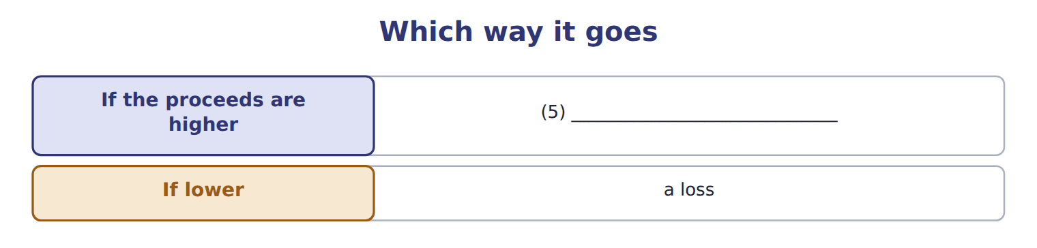
word list
records a gain · held for sale

Summary 2 gaps 6–13
An old (6) oven cost $60,000. At (7) 1, accumulated depreciation was $40,000, and (8) depreciation is $8,000 a year. (9) sells the oven after 3 (10) for $21,000. Two (11) cases appear on the exam. In an (12) conversion, such as a fire or a government (13) , the company records a gain or loss even if it reinvests the insurance money. In an exchange of assets with commercial substance, the new asset is recorded at fair value and the gain or loss is recognized; without commercial substance, the exchange is recorded at book value.
word list
involuntary · straight-line · Orontes · months · January · special · without · pastry · expropriation

Update first

Summary 3 gaps 14–15
Record depreciation up to the sale date before you (14) the gain or loss. Compare proceeds with the carrying amount, not with the (15) cost.
word list
Compare · original · compute

The English this section uses, and its Arabic
Each term sits against what it means.
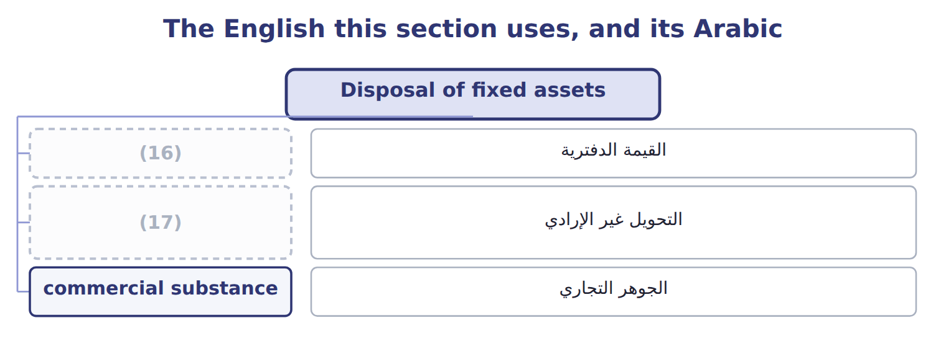
word list
carrying amount · involuntary conversion · depreciable base

The English this sheet uses, and its Arabic
English (exam term) | Arabic
involuntary conversion | التحويل غير الإرادي
commercial substance | الجوهر التجاري

Answer key · 10.4 Disposal of fixed assets

1 scraps | 10 months
2 disposal | 11 special
3 removes | 12 involuntary
4 compares | 13 expropriation
5 records a gain | 14 compute
6 pastry | 15 original
7 January | 16 carrying amount
8 straight-line | 17 involuntary conversion
9 Orontes

the summaries in full
Summary 1 When a company sells or scraps an asset, it first records depreciation up to the date of disposal. Then it removes the cost and the accumulated depreciation and compares the proceeds with the carrying amount. The gain or loss is part of income from continuing operations.
Summary 2 An old pastry oven cost $60,000. At January 1, accumulated depreciation was $40,000, and straight-line depreciation is $8,000 a year. Orontes sells the oven after 3 months for $21,000. Two special cases appear on the exam. In an involuntary conversion, such as a fire or a government expropriation, the company records a gain or loss even if it reinvests the insurance money. In an exchange of assets with commercial substance, the new asset is recorded at fair value and the gain or loss is recognized; without commercial substance, the exchange is recorded at book value.
Summary 3 Record depreciation up to the sale date before you compute the gain or loss. Compare proceeds with the carrying amount, not with the original cost.

10.5 Impairment of long-lived assets, intangibles and goodwill
Chapter 10 · section 10.5

Fill every gap. Each word list holds one word more than there are gaps.
Summary 1 gaps 1–12
An impairment (1) when a company cannot (2) an asset's carrying amount. U.S. GAAP uses different tests for different assets. The company tests an asset group (the (3) level with its own cash flows) only when (4) suggest a problem, such as a sharp fall in market price, physical damage or (5) losses. The test has two steps. In the recoverability test, the company (6) the carrying amount with the sum of the undiscounted future cash flows. If the carrying amount is not higher, there is no impairment, even if fair value is lower. If it is higher, the company measures the loss as carrying amount minus fair value. The (7) amount becomes the new cost basis and is depreciated over the (8) life. The loss is never (9) under U.S. GAAP. An asset is held for sale when management has committed to a plan to sell it, it is (10) for immediate sale, and the sale is expected within one year. It is (11) at the lower of its carrying amount and fair value less cost to sell, and it is no (12) depreciated.
word list
continuing · lowest · recover · occurs · measured · indicators · available · reversed · remaining · longer · reduced · compares · amortization

Summary 2 gaps 13–23
If fair value less cost to sell rises later, the company (13) a gain, but only up to the losses it (14) before. (15) intangibles, such as (16) , are subject to (17) over their (18) lives and follow the PP&E test. An indefinite-lived (19) asset, such as a brand with no expected end, is not amortized. It is tested at least every year in one step: carrying amount against fair value. Goodwill is not amortized by (20) companies. It is tested at least every year at the level of the reporting unit. A company may first make a (21) assessment; if it is not more (22) than not that the unit's fair value is below its carrying amount, no (23) test is needed.
word list
useful · reversals · recognized · amortization · public · patents · Finite-lived · intangible · further · qualitative · records · likely

Summary 3 gaps 24–35
Otherwise it (24) a single step: the loss is the unit's carrying amount minus its fair value, but never more than the goodwill. It also shows the rule for (25) and development (R&D): U.S. GAAP expenses R&D as incurred, except for equipment and (26) that have other future uses. ASU 2025-06 changes when companies start (27) internal-use software ( (28) for annual periods beginning after December 15, 2027). ASU 2025-10 adds guidance on (29) grants for assets. Under the (30) rule, neither is tested yet. IAS 36 uses one step: compare the carrying amount with the (31) amount, which is the higher of fair value less costs of disposal and value in use (a (32) amount). IFRS allows the (33) of impairment losses on assets other than goodwill. IAS 38 (34) development costs to be capitalized when six (35) are met. These are the classic IFRS habits that cost marks on the U.S. GAAP exam.
word list
effective · requires · reversal · one-year · criteria · government · applies · research · recoverable · discounted · facilities · capitalizing · compares

Impairment traps

Summary 4 gaps 36–40
Step 1 uses UNDISCOUNTED cash flows. Step 2 measures the loss against FAIR VALUE. Goodwill: one step, and the loss is (36) at the goodwill (37) . No (38) for assets held and used, indefinite-lived intangibles or goodwill. Held for sale: gains only up to (39) losses. Stop (40) an asset once it is held for sale.
word list
balance · Otherwise · earlier · capped · reversals · depreciating

Impairment in three languages

Impairment in three languages
Item | Asset | Facts | Amounts (USD 000)
P | (41) | Demand for the product fell sharply in 2025. | carrying 500; undiscounted cash flows 450; fair value 380
W | Warehouse, Amman | (42) | carrying 1,000; undiscounted cash flows 1,300; fair value 900
B | Brand 'Orontes Gold' (indefinite life) | Annual test. | (43)
G | Goodwill, Gulf beverages reporting unit | (44) | carrying 2,000; goodwill included 150; fair value 1,700
V | (45) | Management has committed to sell it within one year. | carrying 60; fair value 50; cost to sell 4

word list
Local property prices fell. · Unit carrying amount includes the goodwill. · change in accounting estimate · Pastry line, Dubai · carrying 300; fair value 260 · Delivery van (held for sale)

Asset — Category
Asset | Category
P | Two steps: recoverability, then fair value
W | (46)
B | One step: carrying amount vs fair value
G | (47)
V | Lower of carrying amount and fair value less cost to sell

word list
Brand 'Orontes Gold' (indefinite life) · Two steps: recoverability, then fair value · Single-step goodwill test

The English this section uses, and its Arabic
Each term sits against what it means.
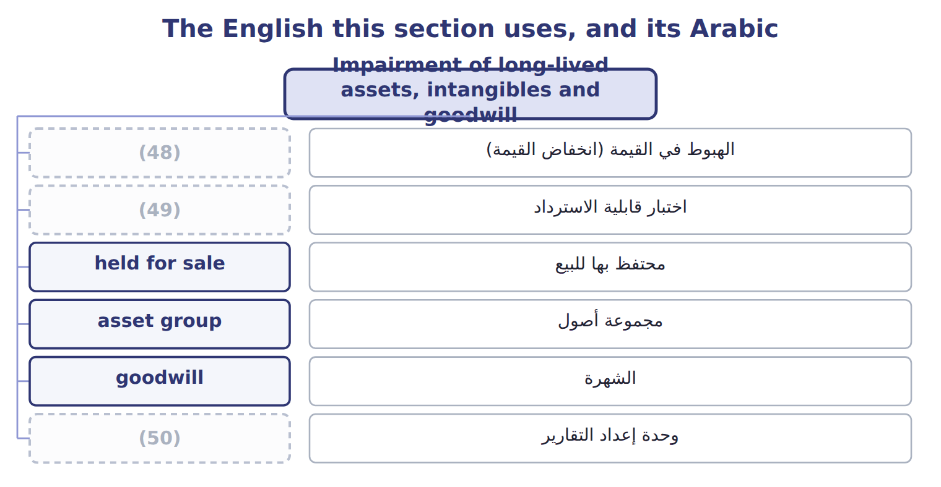
word list
impairment · sum-of-the-years'-digits method · reporting unit · recoverability test

The English this sheet uses, and its Arabic
English (exam term) | Arabic
impairment | الهبوط في القيمة (انخفاض القيمة)
recoverability test | اختبار قابلية الاسترداد
held for sale | محتفظ بها للبيع
asset group | مجموعة أصول
goodwill | الشهرة
reporting unit | وحدة إعداد التقارير
indefinite-lived intangible asset | أصل غير ملموس غير محدد العمر
amortization | الإطفاء
research and development (R&D) | البحث والتطوير

Answer key · 10.5 Impairment of long-lived assets, intangibles and goodwill

1 occurs | 26 facilities
2 recover | 27 capitalizing
3 lowest | 28 effective
4 indicators | 29 government
5 continuing | 30 one-year
6 compares | 31 recoverable
7 reduced | 32 discounted
8 remaining | 33 reversal
9 reversed | 34 requires
10 available | 35 criteria
11 measured | 36 capped
12 longer | 37 balance
13 records | 38 reversals
14 recognized | 39 earlier
15 Finite-lived | 40 depreciating
16 patents | 41 Pastry line, Dubai
17 amortization | 42 Local property prices fell.
18 useful | 43 carrying 300; fair value 260
19 intangible | 44 Unit carrying amount includes the goodwill.
20 public | 45 Delivery van (held for sale)
21 qualitative | 46 Two steps: recoverability, then fair value
22 likely | 47 Single-step goodwill test
23 further | 48 impairment
24 applies | 49 recoverability test
25 research | 50 reporting unit

the summaries in full
Summary 1 An impairment occurs when a company cannot recover an asset's carrying amount. U.S. GAAP uses different tests for different assets. The company tests an asset group (the lowest level with its own cash flows) only when indicators suggest a problem, such as a sharp fall in market price, physical damage or continuing losses. The test has two steps. In the recoverability test, the company compares the carrying amount with the sum of the undiscounted future cash flows. If the carrying amount is not higher, there is no impairment, even if fair value is lower. If it is higher, the company measures the loss as carrying amount minus fair value. The reduced amount becomes the new cost basis and is depreciated over the remaining life. The loss is never reversed under U.S. GAAP. An asset is held for sale when management has committed to a plan to sell it, it is available for immediate sale, and the sale is expected within one year. It is measured at the lower of its carrying amount and fair value less cost to sell, and it is no longer depreciated.
Summary 2 If fair value less cost to sell rises later, the company records a gain, but only up to the losses it recognized before. Finite-lived intangibles, such as patents, are subject to amortization over their useful lives and follow the PP&E test. An indefinite-lived intangible asset, such as a brand with no expected end, is not amortized. It is tested at least every year in one step: carrying amount against fair value. Goodwill is not amortized by public companies. It is tested at least every year at the level of the reporting unit. A company may first make a qualitative assessment; if it is not more likely than not that the unit's fair value is below its carrying amount, no further test is needed.
Summary 3 Otherwise it applies a single step: the loss is the unit's carrying amount minus its fair value, but never more than the goodwill. It also shows the rule for research and development (R&D): U.S. GAAP expenses R&D as incurred, except for equipment and facilities that have other future uses. ASU 2025-06 changes when companies start capitalizing internal-use software (effective for annual periods beginning after December 15, 2027). ASU 2025-10 adds guidance on government grants for assets. Under the one-year rule, neither is tested yet. IAS 36 uses one step: compare the carrying amount with the recoverable amount, which is the higher of fair value less costs of disposal and value in use (a discounted amount). IFRS allows the reversal of impairment losses on assets other than goodwill. IAS 38 requires development costs to be capitalized when six criteria are met. These are the classic IFRS habits that cost marks on the U.S. GAAP exam.
Summary 4 Step 1 uses UNDISCOUNTED cash flows. Step 2 measures the loss against FAIR VALUE. Goodwill: one step, and the loss is capped at the goodwill balance. No reversals for assets held and used, indefinite-lived intangibles or goodwill. Held for sale: gains only up to earlier losses. Stop depreciating an asset once it is held for sale.

