15.1 Gains and losses
Chapter 15 · section 15.1

Fill every gap. Each word list holds one word more than there are gaps.
Chapter 15, section by section
Each stage leads to the next.
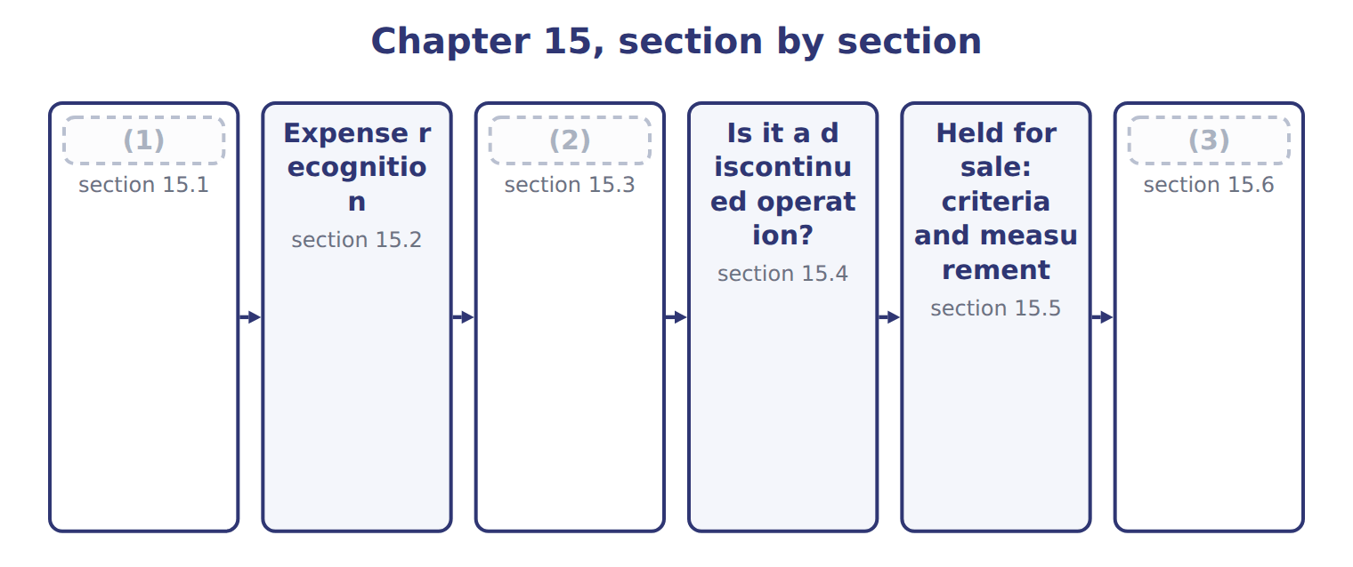
word list
Gains and losses · holding gain or loss · Presentation and IFRS differences · Comprehensive income and reclassification

Summary 1 gaps 4–14
A gain or (4) is an increase or decrease in equity from a (5) or incidental transaction: something other than the company's main activities and other than a transaction with owners. Selling an old machine, (6) a lawsuit and a change in the value of an (7) are examples. Gains and losses are shown net. When Orontes sold its old Dubai oven, it did not report the proceeds as revenue; it (8) a gain of $3,000: the proceeds minus the (9) amount. In a (10) statement, most gains and losses appear in other income and (11) , below operating income. Losses that arise from operating assets, such as (12) , are usually shown within operating expenses. Items that are unusual or (13) get a separate line within (14) operations, before tax.
word list
infrequent · carrying · continuing · multi-step · expense · reported · loss · settling · operating · investment · impairments · peripheral

Where Orontes's 2025 gains and losses appear
Every item belongs to exactly one group.
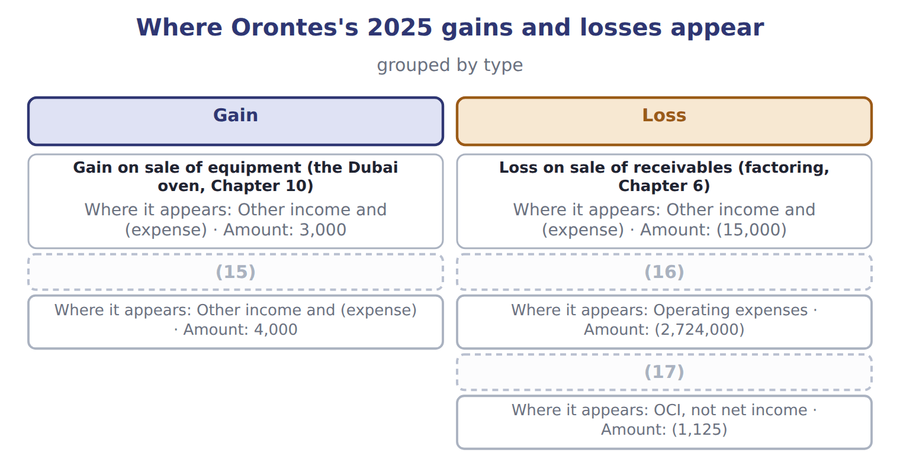
word list
Unrealized gains on securities (Chapter 9) · Unrealized loss on AFS debt securities, net of tax · Impairment losses (Chapter 10) · holding gain or loss

The English this section uses, and its Arabic
Each term sits against what it means.
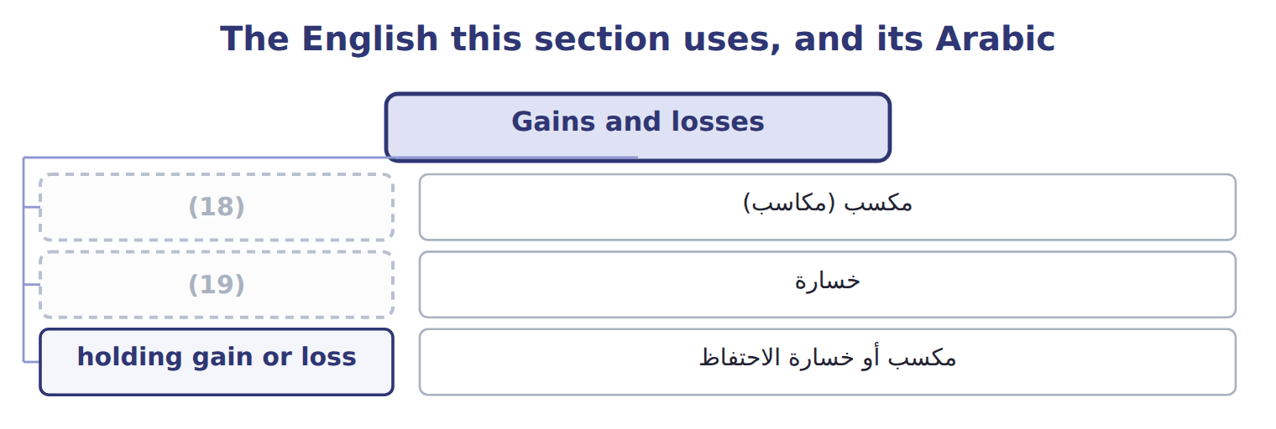
word list
loss · gain · خسارة

The English this sheet uses, and its Arabic
English (exam term) | Arabic
gain | مكسب (مكاسب)
loss | خسارة
holding gain or loss | مكسب أو خسارة الاحتفاظ

Answer key · 15.1 Gains and losses

1 Gains and losses | 11 expense
2 Comprehensive income and reclassification | 12 impairments
3 Presentation and IFRS differences | 13 infrequent
4 loss | 14 continuing
5 peripheral | 15 Unrealized gains on securities (Chapter 9)
6 settling | 16 Impairment losses (Chapter 10)
7 investment | 17 Unrealized loss on AFS debt securities, net of tax
8 reported | 18 gain
9 carrying | 19 loss
10 multi-step

the summaries in full
Summary 1 A gain or loss is an increase or decrease in equity from a peripheral or incidental transaction: something other than the company's main activities and other than a transaction with owners. Selling an old machine, settling a lawsuit and a change in the value of an investment are examples. Gains and losses are shown net. When Orontes sold its old Dubai oven, it did not report the proceeds as revenue; it reported a gain of $3,000: the proceeds minus the carrying amount. In a multi-step statement, most gains and losses appear in other income and expense, below operating income. Losses that arise from operating assets, such as impairments, are usually shown within operating expenses. Items that are unusual or infrequent get a separate line within continuing operations, before tax.

15.2 Expense recognition
Chapter 15 · section 15.2

Fill every gap. Each word list holds one word more than there are gaps.
The set, member by member
The rows are a set, not a sequence.
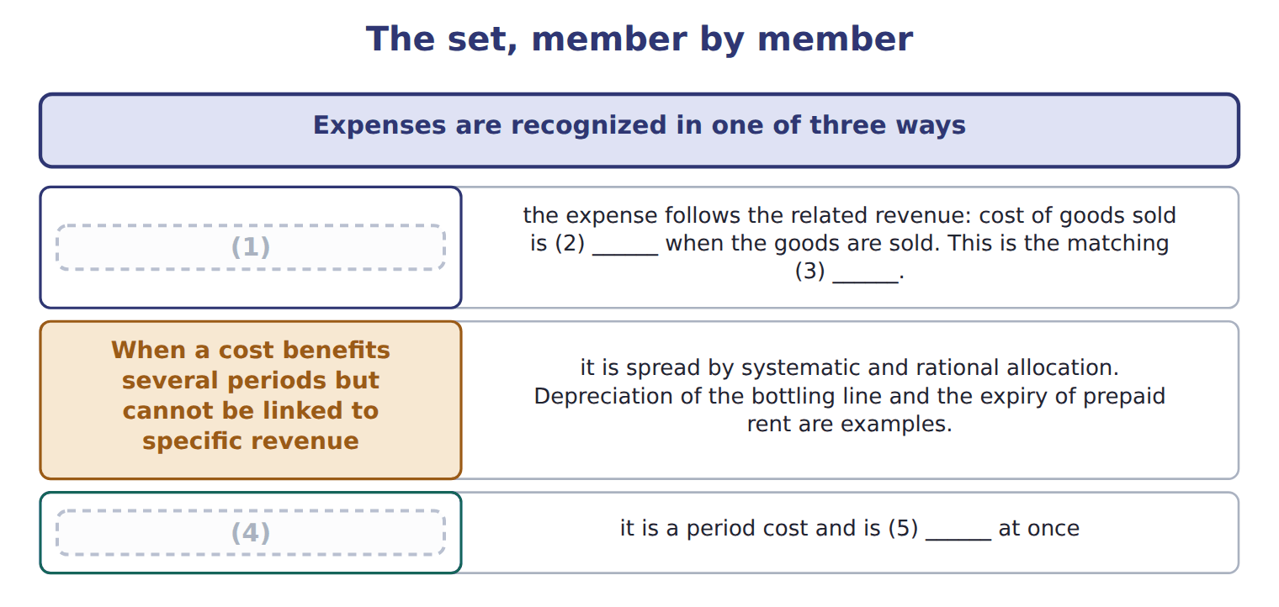
word list
When there is a clear cause and effect · expensed · recognized · fair value less cost to sell · When a cost has no clear link to future revenue · principle

Summary 1 gaps 6–7
Advertising and research and (6) are expensed when (7) , even if they may bring future sales.
word list
development · recognition · incurred

Three expense recognition approaches
Approach | Idea | Orontes examples
Cause and effect (matching) | Expense follows the related revenue | Cost of goods sold; sales (8) (capitalized, Chapter 11)
Systematic and rational allocation | (9) | Depreciation of the bottling line; prepaid rent
Immediate recognition | No clear link to future revenue: a period cost | Advertising; research and development; most general (10)

word list
commissions · No clear link to future revenue · administration · Cost spread over the periods that benefit

Summary 2 gaps 11–13
ASU 2024-03 will require public companies to break down some expense (11) in the notes, for example into (12) purchases, employee pay and depreciation. It does not change recognition, and it is not (13) before about January 2028.
word list
examples · testable · inventory · captions

The English this sheet uses, and its Arabic
English (exam term) | Arabic
period cost | تكلفة الفترة
systematic and rational allocation | التوزيع المنتظم والمنطقي

Answer key · 15.2 Expense recognition

1 When there is a clear cause and effect | 8 commissions
2 recognized | 9 Cost spread over the periods that benefit
3 principle | 10 administration
4 When a cost has no clear link to future revenue | 11 captions
5 expensed | 12 inventory
6 development | 13 testable
7 incurred

the summaries in full
Summary 1 Advertising and research and development are expensed when incurred, even if they may bring future sales.
Summary 2 ASU 2024-03 will require public companies to break down some expense captions in the notes, for example into inventory purchases, employee pay and depreciation. It does not change recognition, and it is not testable before about January 2028.

15.3 Comprehensive income and reclassification
Chapter 15 · section 15.3

Fill every gap. Each word list holds one word more than there are gaps.
Summary 1 gaps 1–9
Comprehensive income is net income plus other comprehensive income. U.S. OCI (1) holding gains and losses on (2) debt securities, foreign currency (3) adjustments, the (4) part of cash-flow hedges, and some (5) gains and losses. (6) gains on equity securities are not OCI; they go to net income. When an OCI item is realized, for example when an AFS bond is sold, the gain moves into net income. At the same time a reclassification adjustment (7) it from OCI. (8) this adjustment, the same gain would be counted twice in comprehensive income: once in OCI when it arose, and again in net income on the sale. Its value rises to $108,000 at the end of 2026, and (9) sells it for $110,000 in 2027. Over the two years, comprehensive income before tax is $10,000: the total gain, counted once.
word list
effective · removes · Orontes · Without · adjustments · available-for-sale · includes · pension · Unrealized · translation

Worked example: the reclassification adjustment

Summary 2 gaps 10–13
After tax at 25%, OCI is $6,000, and AOCI (10) up by the same (11) . OCI for 2027 shows the holding gain of $2,000 and a reclassification of −$10,000: a net OCI (12) of $8,000 before tax, $6,000 after tax. AOCI for this bond (13) to zero.
word list
builds · returns · amount · Unrealized · loss

Suppose: OCI and the reclassification adjustment for an AFS bond
Every item belongs to exactly one group.
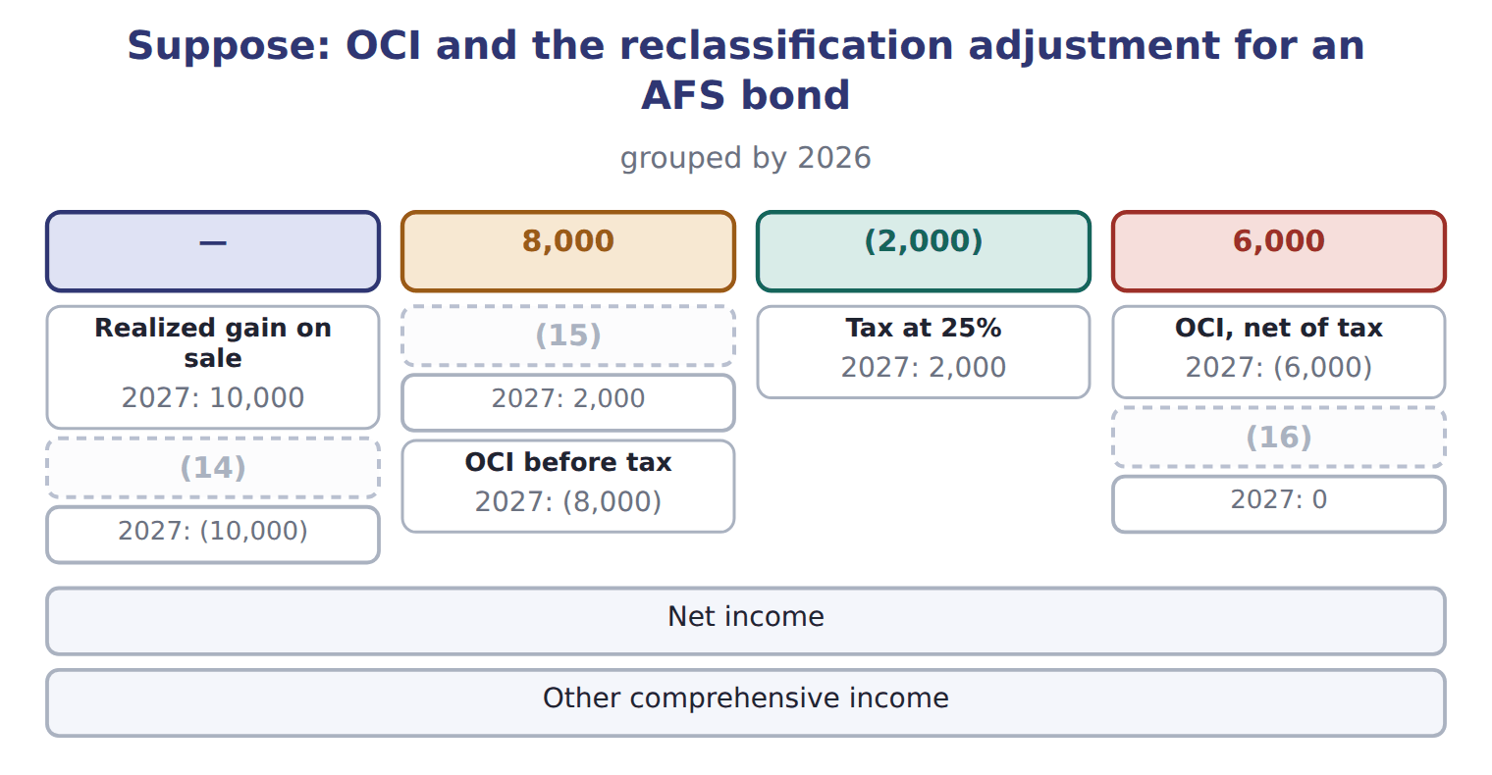
word list
OCI, net of tax · Holding gain during the year · AOCI at year-end (for this bond) · Reclassification adjustment

Comprehensive income traps

Summary 3 gaps 17–19
Forgetting the reclassification (17) a realized gain twice. Comprehensive income adds this year's OCI, not the AOCI (18) . (19) OCI net of tax, or before tax with one tax line: do not mix them.
word list
counts · balance · Report · translation

The English this section uses, and its Arabic
Each term sits against what it means.
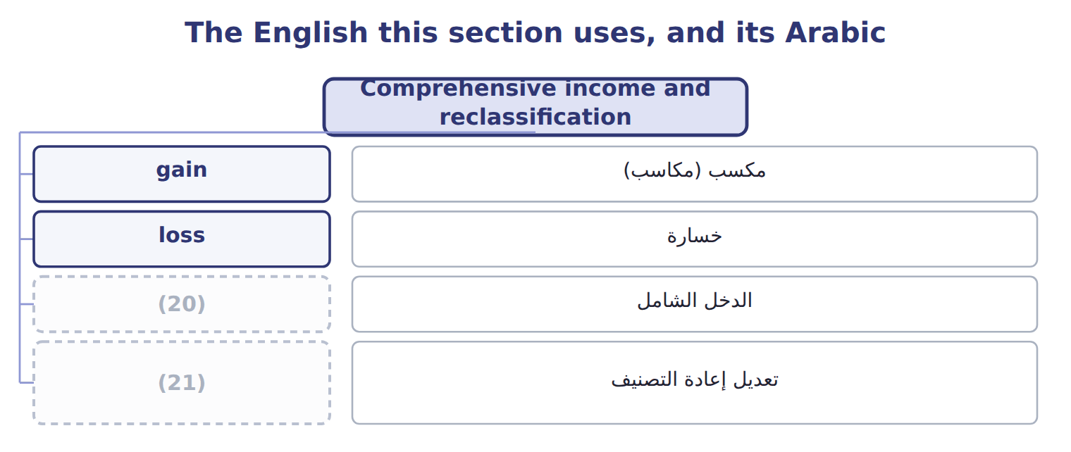
word list
reclassification adjustment · disposal group · comprehensive income

The English this sheet uses, and its Arabic
English (exam term) | Arabic
comprehensive income | الدخل الشامل
reclassification adjustment | تعديل إعادة التصنيف

Answer key · 15.3 Comprehensive income and reclassification

1 includes | 12 loss
2 available-for-sale | 13 returns
3 translation | 14 Reclassification adjustment
4 effective | 15 Holding gain during the year
5 pension | 16 AOCI at year-end (for this bond)
6 Unrealized | 17 counts
7 removes | 18 balance
8 Without | 19 Report
9 Orontes | 20 comprehensive income
10 builds | 21 reclassification adjustment
11 amount

the summaries in full
Summary 1 Comprehensive income is net income plus other comprehensive income. U.S. OCI includes holding gains and losses on available-for-sale debt securities, foreign currency translation adjustments, the effective part of cash-flow hedges, and some pension gains and losses. Unrealized gains on equity securities are not OCI; they go to net income. When an OCI item is realized, for example when an AFS bond is sold, the gain moves into net income. At the same time a reclassification adjustment removes it from OCI. Without this adjustment, the same gain would be counted twice in comprehensive income: once in OCI when it arose, and again in net income on the sale. Its value rises to $108,000 at the end of 2026, and Orontes sells it for $110,000 in 2027. Over the two years, comprehensive income before tax is $10,000: the total gain, counted once.
Summary 2 After tax at 25%, OCI is $6,000, and AOCI builds up by the same amount. OCI for 2027 shows the holding gain of $2,000 and a reclassification of −$10,000: a net OCI loss of $8,000 before tax, $6,000 after tax. AOCI for this bond returns to zero.
Summary 3 Forgetting the reclassification counts a realized gain twice. Comprehensive income adds this year's OCI, not the AOCI balance. Report OCI net of tax, or before tax with one tax line: do not mix them.

15.4 Is it a discontinued operation?
Chapter 15 · section 15.4

Fill every gap. Each word list holds one word more than there are gaps.
Summary 1 gaps 1–6
A disposal is (1) as a discontinued operation only if three (2) are true. There is no official (3) for 'major'; it is a (4) . Selling one machine, one store or one small product is not a strategic shift. The (5) or loss stays in (6) operations, as for the Dubai oven. A business that meets the held-for-sale criteria when it is acquired is also a discontinued operation.
word list
percentage · things · disposal · gain · reported · continuing · judgment

Strategic shift or not?

The first two are done. Decide whether each of the others is a discontinued operation.
Strategic shift or not? (complete the blanks)
Suppose these disposals happen | Discontinued operation?
Orontes sells its whole frozen-foods business, one of its four product lines | (7)
Orontes closes one of its twelve olive-oil shops | No: not a strategic shift
Orontes sells all its operations in Jordan, its only foreign market | ________
Orontes sells an old bottling machine | ________
Orontes sells its 30% stake in Jordan Glass, a major equity-method investment | ________
Orontes stops selling one flavour of juice | ________

word list
fair value less cost to sell · Yes: a major line of business

The steps, in order
Each stage leads to the next.
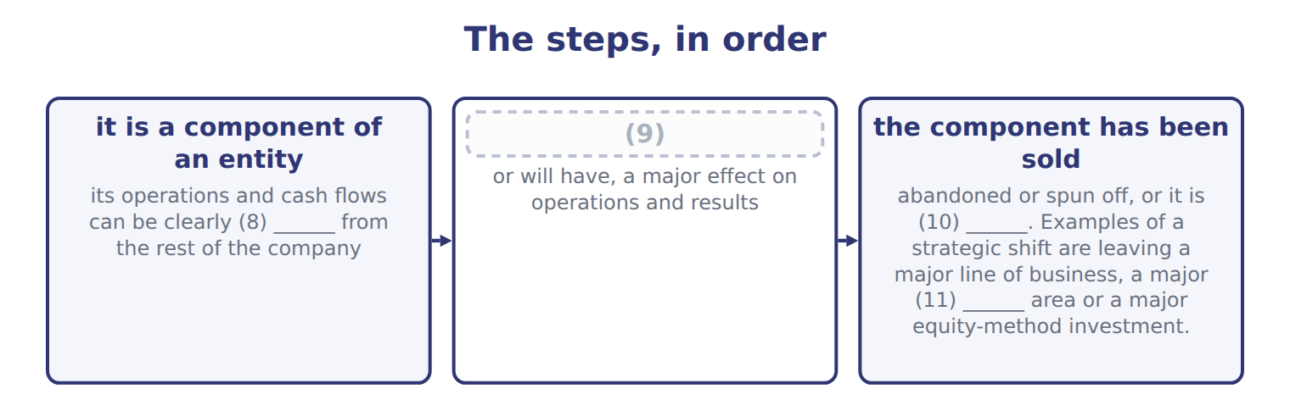
word list
held for sale · geographic · the disposal is a strategic shift that has · it is a component of an entity · separated

The English this section uses, and its Arabic
Each term sits against what it means.
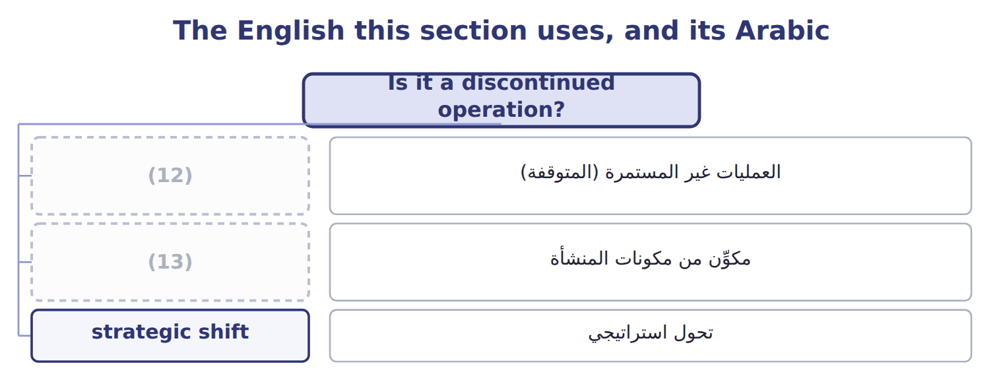
word list
تحول استراتيجي · component of an entity · discontinued operation

The English this sheet uses, and its Arabic
English (exam term) | Arabic
discontinued operation | العمليات غير المستمرة (المتوقفة)
component of an entity | مكوِّن من مكونات المنشأة
strategic shift | تحول استراتيجي

Answer key · 15.4 Is it a discontinued operation?

1 reported | 8 separated
2 things | 9 the disposal is a strategic shift that has
3 percentage | 10 held for sale
4 judgment | 11 geographic
5 gain | 12 discontinued operation
6 continuing | 13 component of an entity
7 Yes: a major line of business

the summaries in full
Summary 1 A disposal is reported as a discontinued operation only if three things are true. There is no official percentage for 'major'; it is a judgment. Selling one machine, one store or one small product is not a strategic shift. The gain or loss stays in continuing operations, as for the Dubai oven. A business that meets the held-for-sale criteria when it is acquired is also a discontinued operation.

15.5 Held for sale: criteria and measurement
Chapter 15 · section 15.5

Fill every gap. Each word list holds one word more than there are gaps.
Summary 1 gaps 1–12
A (1) can be reported as discontinued (2) it is sold, once it is held for sale. All six criteria must be met: (3) with authority commits to a plan; the business is (4) for immediate sale; an active search for a buyer has begun; a sale is probable within one year; the price is (5) ; and the plan is unlikely to change. A held-for-sale disposal group is (6) at the lower of its carrying amount and its fair value less cost to sell. Any write-down is a loss. Depreciation stops, and later (7) in value are (8) only up to the losses already recorded. The board (9) the plan in March, but the business (10) held for sale only on June 30, when all six criteria were met. It (11) the frozen-foods goodwill left after the 2025 impairment. The carrying amount of $3,180,000 is above fair value less cost to sell of $3,000,000, so (12) records a loss of $180,000. This is the disposal loss.
word list
recognized · before · reasonable · component · available · became · approved · increases · includes · already · measured · management · Orontes

Held-for-sale traps

Summary 2 gaps 13–15
Board (13) alone is not (14) : all six criteria must be met. (15) the write-down when the group becomes held for sale, not only when it is sold. Stop depreciation once the group is held for sale.
word list
approval · enough · Recognize · impairment

Suppose: measuring the frozen-foods disposal group on June 30, 2026
Suppose: frozen-foods disposal group, June 30, 2 | Amount
Property, plant and equipment, net | 2,100,000
(16) | 480,000
Receivables | 400,000
Goodwill (left after the 2025 impairment, Chapter 10) | 300,000
(17) | (100,000)
Carrying amount of the disposal group | 3,180,000
Fair value less cost to sell | 3,000,000
(18) | 180,000
(19) | 3,000,000

word list
Held-for-sale group at June 30, 2026 · Remeasurement loss (in discontinued operations) · Less: accounts payable · Inventory · Carrying amount of the disposal group

The English this section uses, and its Arabic
Each term sits against what it means.
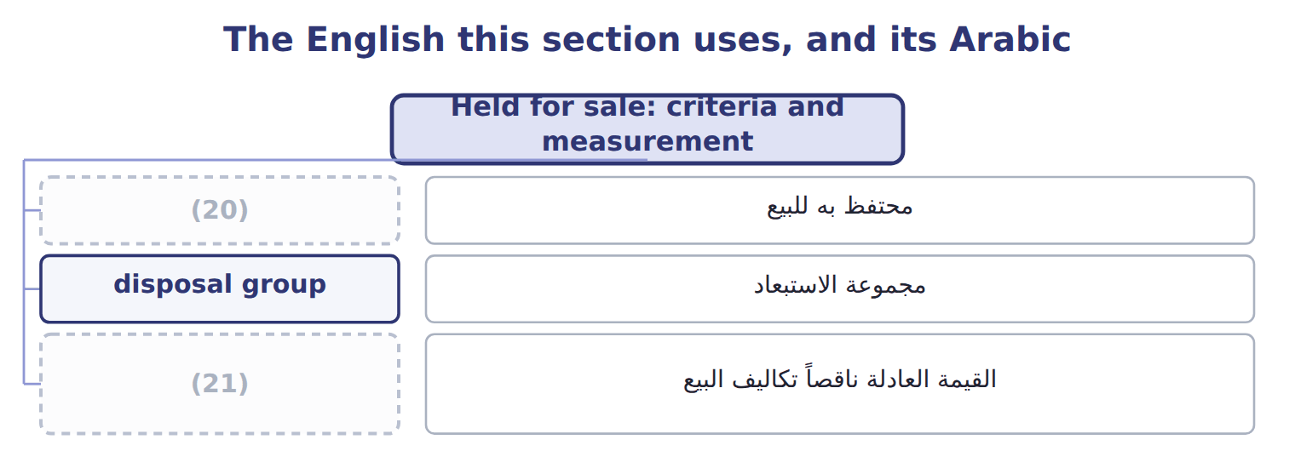
word list
holding gain or loss · fair value less cost to sell · held for sale

The English this sheet uses, and its Arabic
English (exam term) | Arabic
held for sale | محتفظ به للبيع
disposal group | مجموعة الاستبعاد
fair value less cost to sell | القيمة العادلة ناقصاً تكاليف البيع

Answer key · 15.5 Held for sale: criteria and measurement

1 component | 12 Orontes
2 before | 13 approval
3 management | 14 enough
4 available | 15 Recognize
5 reasonable | 16 Inventory
6 measured | 17 Less: accounts payable
7 increases | 18 Remeasurement loss (in discontinued operations)
8 recognized | 19 Held-for-sale group at June 30, 2026
9 approved | 20 held for sale
10 became | 21 fair value less cost to sell
11 includes

the summaries in full
Summary 1 A component can be reported as discontinued before it is sold, once it is held for sale. All six criteria must be met: management with authority commits to a plan; the business is available for immediate sale; an active search for a buyer has begun; a sale is probable within one year; the price is reasonable; and the plan is unlikely to change. A held-for-sale disposal group is measured at the lower of its carrying amount and its fair value less cost to sell. Any write-down is a loss. Depreciation stops, and later increases in value are recognized only up to the losses already recorded. The board approved the plan in March, but the business became held for sale only on June 30, when all six criteria were met. It includes the frozen-foods goodwill left after the 2025 impairment. The carrying amount of $3,180,000 is above fair value less cost to sell of $3,000,000, so Orontes records a loss of $180,000. This is the disposal loss.
Summary 2 Board approval alone is not enough: all six criteria must be met. Recognize the write-down when the group becomes held for sale, not only when it is sold. Stop depreciation once the group is held for sale.

15.6 Presentation and IFRS differences
Chapter 15 · section 15.6

Fill every gap. Each word list holds one word more than there are gaps.
Summary 1 gaps 1–11
The results of a discontinued operation, (1) its operating results and any (2) or disposal gain or loss, are shown net of their own tax below income from continuing operations. (3) companies also show (4) amounts for discontinued operations. The comparative years are (5) so that all periods are shown on the same basis. On the balance sheet, the assets and (6) of a discontinued operation are shown separately for all periods (7) . (8) assets that are not a discontinued operation are also shown separately, but their results stay in continuing operations. Under IFRS 5, a discontinued operation must be a (9) major line of business or (10) area, and earlier balance sheets are not re-presented. Some IFRS OCI items, such as a (11) surplus, never return to profit or loss.
word list
disposal · Held-for-sale · remeasurement · geographical · per-share · Public · including · liabilities · presented · reclassified · separate · revaluation

Discontinued operations and OCI: U.S. GAAP and IFRS
The two sides differ only where the rows say.
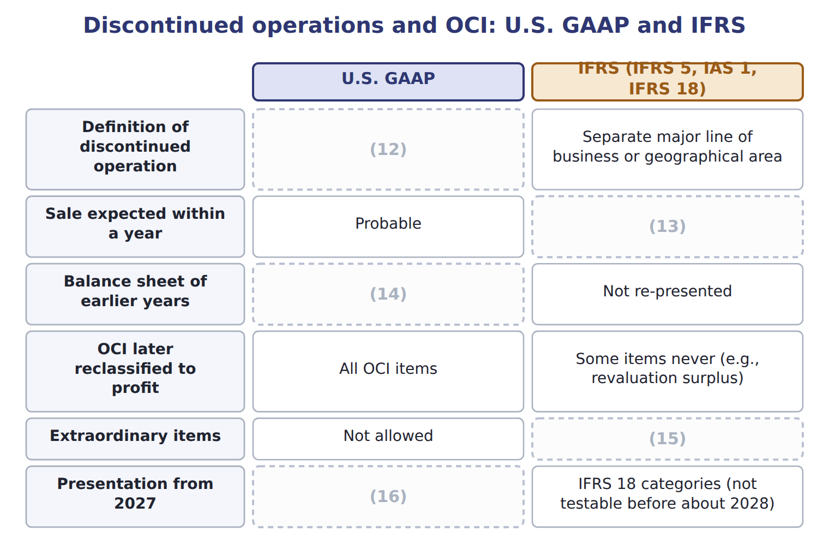
word list
Not allowed · Re-presented: assets and liabilities shown separately · Component + strategic shift with a major effect · Unchanged · period cost · Highly probable

Summary 2 gaps 17–18
U.S. GAAP has no (17) items: unusual or (18) items stay in continuing operations, before tax. Only discontinued operations are shown net of tax below continuing operations.
word list
Held-for-sale · infrequent · extraordinary

Suppose: Orontes, 2027 (USD 000) — Amount / details
Suppose: Orontes, 2027 (USD 000) | Amount / details
Operating income | 5,000
Gain on sale of a warehouse | 200
Loss on settlement of a lawsuit (unusual for Orontes) | 120
Interest expense | 400
Dry-foods division: operating loss before tax | 80
Dry-foods division: gain on sale before tax | 280
Unrealized holding gain on AFS debt securities during 2027 | 40
Realized gain on AFS securities sold in 2027 (included in AOCI before) | 24
M1 | In 2027 Orontes sold its dry-foods division, one of its main product lines. The sale is a strategic shift with a major effect.
M2 | The tax rate is 25% on all items. The (19) AFS gain is already in the other income figures.
M3 | Orontes presents one continuous statement of comprehensive income.

word list
realized · Item

Item — Answer
Item | Answer
All operations in Jordan | (20)
An old bottling machine | No: a single asset; the gain or loss stays in continuing operations.
The stake in Jordan Glass | Yes: a major equity-method investment.
One juice flavour | (21)

word list
No: not a strategic shift. · Suppose: Orontes, 2027 (USD 000) · Yes: a major geographic area.

Item — Category
Every item belongs to exactly one group.
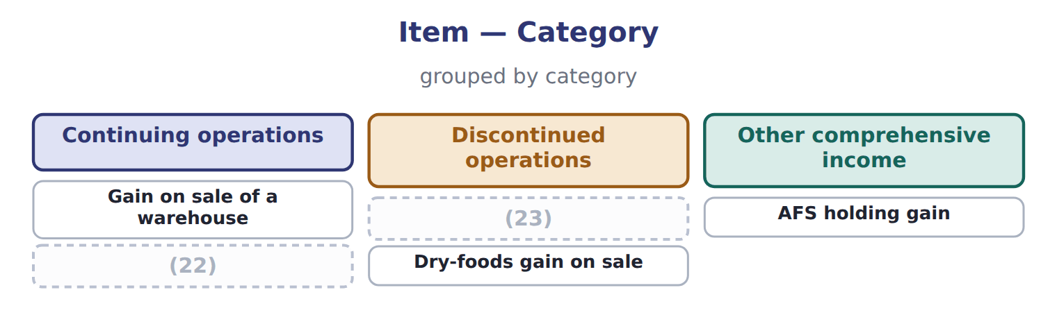
word list
Dry-foods operating loss · held for sale · Lawsuit settlement loss

The English this section uses, and its Arabic
Each term sits against what it means.
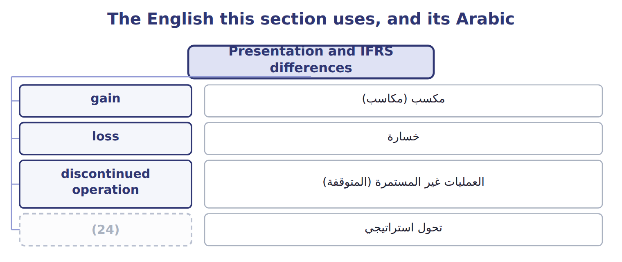
word list
strategic shift · مكسب (مكاسب)

Answer key · 15.6 Presentation and IFRS differences

1 including | 13 Highly probable
2 remeasurement | 14 Re-presented: assets and liabilities shown separately
3 Public | 15 Not allowed
4 per-share | 16 Unchanged
5 reclassified | 17 extraordinary
6 liabilities | 18 infrequent
7 presented | 19 realized
8 Held-for-sale | 20 Yes: a major geographic area.
9 separate | 21 No: not a strategic shift.
10 geographical | 22 Lawsuit settlement loss
11 revaluation | 23 Dry-foods operating loss
12 Component + strategic shift with a major effect | 24 strategic shift

the summaries in full
Summary 1 The results of a discontinued operation, including its operating results and any remeasurement or disposal gain or loss, are shown net of their own tax below income from continuing operations. Public companies also show per-share amounts for discontinued operations. The comparative years are reclassified so that all periods are shown on the same basis. On the balance sheet, the assets and liabilities of a discontinued operation are shown separately for all periods presented. Held-for-sale assets that are not a discontinued operation are also shown separately, but their results stay in continuing operations. Under IFRS 5, a discontinued operation must be a separate major line of business or geographical area, and earlier balance sheets are not re-presented. Some IFRS OCI items, such as a revaluation surplus, never return to profit or loss.
Summary 2 U.S. GAAP has no extraordinary items: unusual or infrequent items stay in continuing operations, before tax. Only discontinued operations are shown net of tax below continuing operations.

