3.1 Why estimate cost functions
Chapter 3 · section 3.1

Fill every gap. Each word list holds one word more than there are gaps.
Chapter 3, section by section
Each stage leads to the next.
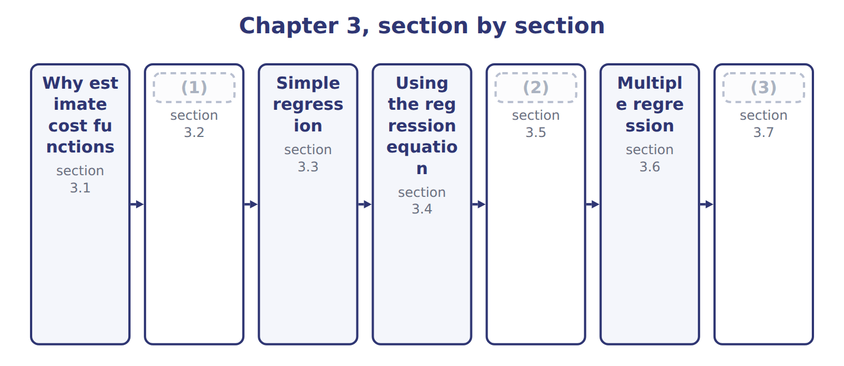
word list
Using regression to estimate fixed costs · Extended Example 3A: the Oils maintenance and · The high-low method · Why estimate cost functions

Summary 1 gaps 4–5
Budgets, prices and (4) budgets all need a cost function: total cost = fixed cost + variable rate × activity. (5) have four main ways to estimate it.
word list
flexible · vertical · Managers

Four ways to estimate a cost function
Method | How it works | Strength | Weakness
Account analysis | (6) | Quick; uses knowledge of the costs | Subjective
High-low | Line through the highest and lowest activity | (7) | Ignores all other data; outliers distort it
Simple regression | Best-fit line through all points | (8) | Needs data and care in use
Engineering (industrial) analysis | Studies inputs needed per unit | (9) | Costly and slow

word list
Works for new products with no history · Judgment on each account · Simple; needs two points · Uses all data; gives R2, t and standard error · Line through the highest and lowest activity

Summary 2 gaps 10–13
The first step in every method is to draw a scatter plot: one point for each month, with activity on the (10) axis and cost on the (11) axis. The plot shows whether a (12) line makes sense and whether any month looks (13) .
word list
scatter · unusual · horizontal · vertical · straight

The English this section uses, and its Arabic
Each term sits against what it means.
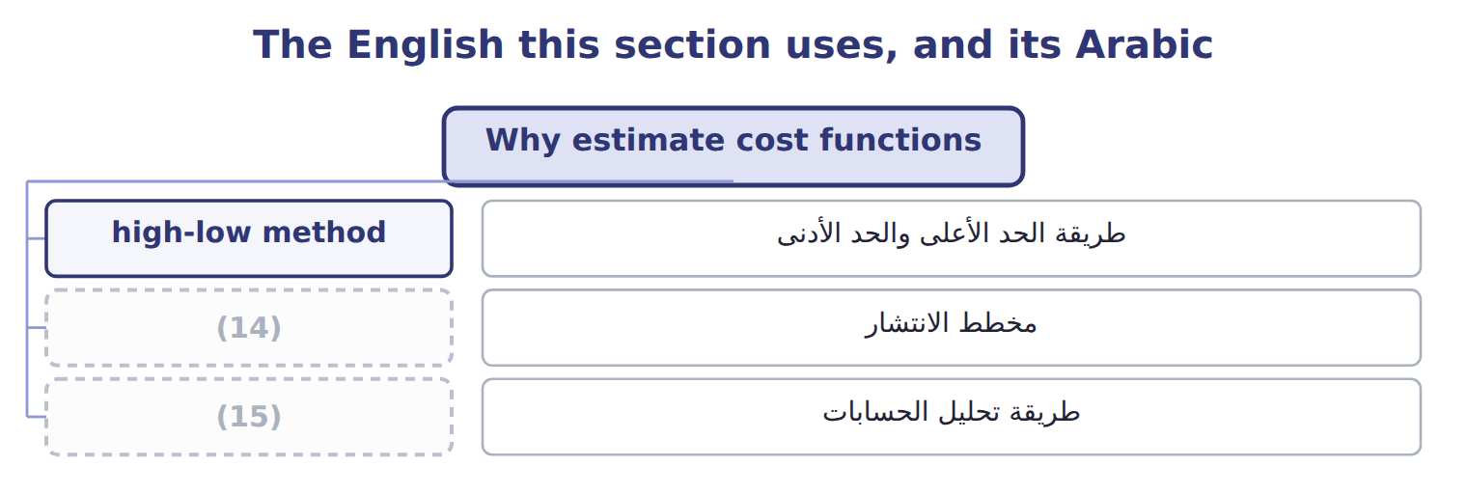
word list
multiple regression · account analysis · scatter plot

The English this sheet uses, and its Arabic
English (exam term) | Arabic
scatter plot | مخطط الانتشار
account analysis | طريقة تحليل الحسابات

Answer key · 3.1 Why estimate cost functions

1 The high-low method | 9 Works for new products with no history
2 Using regression to estimate fixed costs | 10 horizontal
3 Extended Example 3A: the Oils maintenance and | 11 vertical
4 flexible | 12 straight
5 Managers | 13 unusual
6 Judgment on each account | 14 scatter plot
7 Simple; needs two points | 15 account analysis
8 Uses all data; gives R2, t and standard error

the summaries in full
Summary 1 Budgets, prices and flexible budgets all need a cost function: total cost = fixed cost + variable rate × activity. Managers have four main ways to estimate it.
Summary 2 The first step in every method is to draw a scatter plot: one point for each month, with activity on the horizontal axis and cost on the vertical axis. The plot shows whether a straight line makes sense and whether any month looks unusual.

3.2 The high-low method
Chapter 3 · section 3.2

Fill every gap. Each word list holds one word more than there are gaps.
Summary 1 gaps 1–5
The high-low method draws a line (1) two points: the months with the highest and the lowest activity. The variable rate is the change in cost (2) by the change in activity. The fixed cost is what is left at (3) point. (4) the points by activity, not by cost. In the Oils data the highest cost, $69,400, came in a month with 4,200 machine hours, not in the busiest month. The busiest month had 4,300 machine hours and cost $68,600; the (5) had 2,000 hours and cost $43,300. The variable rate is $11 per hour and the fixed cost is $21,300 a month.
word list
either · through · Choose · activity · quietest · divided

Worked example: high-low for Oils maintenance and utilities
Oils M&U, high-low method | Activity | Cost (whole USD)
Highest activity | (6) | 68,600
Lowest activity | 2,000 MH | 43,300
Change | (7) | 25,300
Variable rate = change in cost ÷ change in MH |  | (8)
Fixed cost = 68,600 − $11 × 4,300 |  | 21,300
High-low cost function |  | 21,300 + $11 × MH

word list
2,300 MH · $11 per MH · multiple regression · 4,300 MH

High activity, not high cost

Summary 2 gaps 9–10
Exam (9) often put the highest cost in a month that is not the busiest. (10) find the highest and lowest activity first, then take the costs of those two months.
word list
questions · intercept · Always

The English this sheet uses, and its Arabic
English (exam term) | Arabic
high-low method | طريقة الحد الأعلى والحد الأدنى

Answer key · 3.2 The high-low method

1 through | 6 4,300 MH
2 divided | 7 2,300 MH
3 either | 8 $11 per MH
4 Choose | 9 questions
5 quietest | 10 Always

the summaries in full
Summary 1 The high-low method draws a line through two points: the months with the highest and the lowest activity. The variable rate is the change in cost divided by the change in activity. The fixed cost is what is left at either point. Choose the points by activity, not by cost. In the Oils data the highest cost, $69,400, came in a month with 4,200 machine hours, not in the busiest month. The busiest month had 4,300 machine hours and cost $68,600; the quietest had 2,000 hours and cost $43,300. The variable rate is $11 per hour and the fixed cost is $21,300 a month.
Summary 2 Exam questions often put the highest cost in a month that is not the busiest. Always find the highest and lowest activity first, then take the costs of those two months.

3.3 Simple regression
Chapter 3 · section 3.3

Fill every gap. Each word list holds one word more than there are gaps.
Summary 1 gaps 1–10
Regression (1) fits the line that best explains cost using all the data (2) . In (3) regression there is one (4) variable x, the activity, and one dependent variable y, the cost. The (5) is y = a + b x. The intercept a is the estimated fixed cost for the (6) . The slope b is the variable cost for each extra unit of activity. (7) prints more than a and b. The coefficient of (8) R2 shows how much of the cost variation the activity explains. Each coefficient has a (9) : above about 2 means it is reliably (10) from zero. The standard error of the estimate shows how far actual costs typically lie from the line.
word list
simple · points · intercept · different · independent · equation · analysis · period · t-statistic · Software · determination

Annotated regression output for Oils maintenance and utilities
Regression output | Coefficient / value | Std. error | t-stat | What it means
Intercept | 18,000 | 951 | 18.93 | Estimated fixed cost per month
Machine hours | 12.00 | 0.295 | 40.7 | (11)
R2 | 0.987 |  |  | Share of cost variation explained by machine hours
Standard error of the estimate | 1,000 |  |  | (12)
Observations | 24 |  |  | (13)

word list
Months of data · Share of cost variation explained by machine hours · Typical distance of actual cost from the line · Variable cost per machine hour

The English this section uses, and its Arabic
Each term sits against what it means.
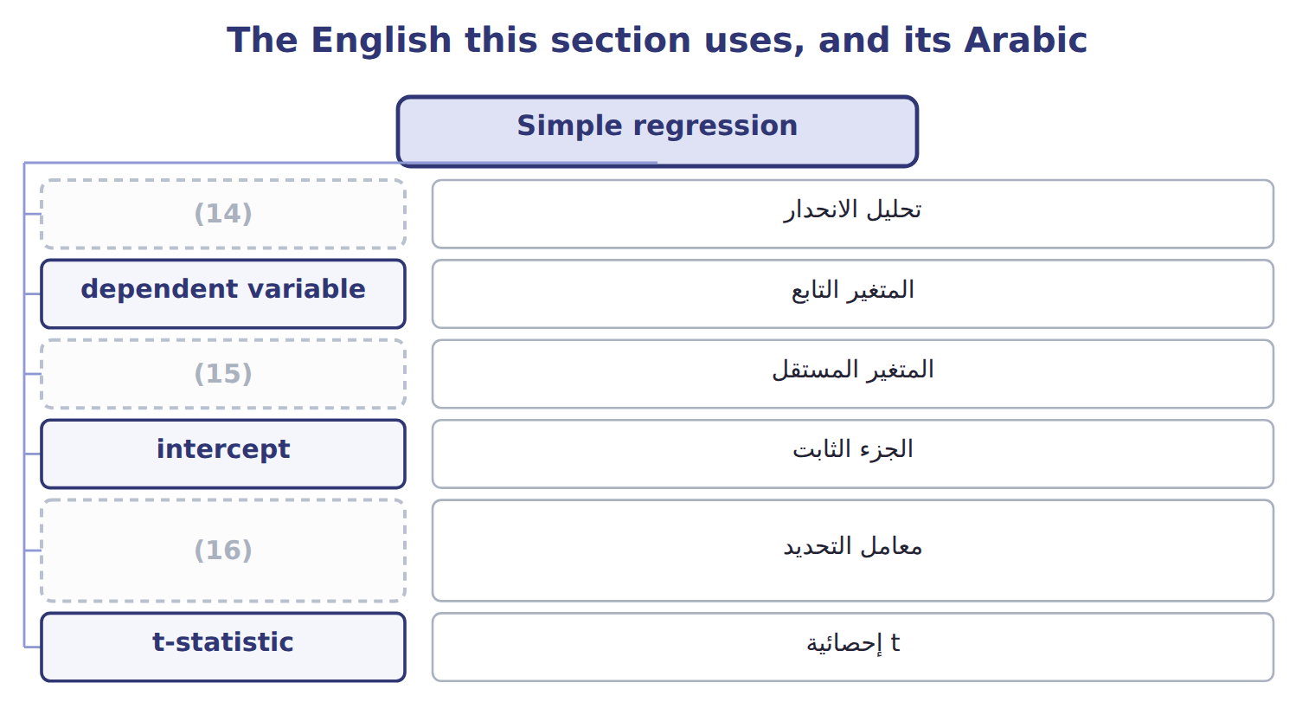
word list
regression analysis · independent variable · coefficient of determination · account analysis

The English this sheet uses, and its Arabic
English (exam term) | Arabic
regression analysis | تحليل الانحدار
dependent variable | المتغير التابع
independent variable | المتغير المستقل
intercept | الجزء الثابت
coefficient of determination | معامل التحديد
t-statistic | إحصائية t
standard error of the estimate | الخطأ المعياري للتقدير

Answer key · 3.3 Simple regression

1 analysis | 9 t-statistic
2 points | 10 different
3 simple | 11 Variable cost per machine hour
4 independent | 12 Typical distance of actual cost from the line
5 equation | 13 Months of data
6 period | 14 regression analysis
7 Software | 15 independent variable
8 determination | 16 coefficient of determination

the summaries in full
Summary 1 Regression analysis fits the line that best explains cost using all the data points. In simple regression there is one independent variable x, the activity, and one dependent variable y, the cost. The equation is y = a + b x. The intercept a is the estimated fixed cost for the period. The slope b is the variable cost for each extra unit of activity. Software prints more than a and b. The coefficient of determination R2 shows how much of the cost variation the activity explains. Each coefficient has a t-statistic: above about 2 means it is reliably different from zero. The standard error of the estimate shows how far actual costs typically lie from the line.

3.4 Using the regression equation
Chapter 3 · section 3.4

Fill every gap. Each word list holds one word more than there are gaps.
Summary 1 gaps 1–5
To forecast, put the planned (1) into x. At 3,200 machine hours, Oils (2) and utilities (3) cost $18,000 + $12 × 3,200 = $56,400. A forecast is only as good as the range of the data. The Oils data run from 2,000 to 4,300 machine hours a month. A forecast inside that range is (4) ; a forecast far (5) it is a guess.
word list
reasonable · outside · Complete · should · activity · maintenance

Forecast with the equation

Summary 2 gaps 6–7
The first two (6) are done. Complete the rest, and think (7) about the last one.
word list
forecasts · carefully · maintenance

Your turn: forecasts with the regression equation (complete the blanks)
Each stage leads to the next.
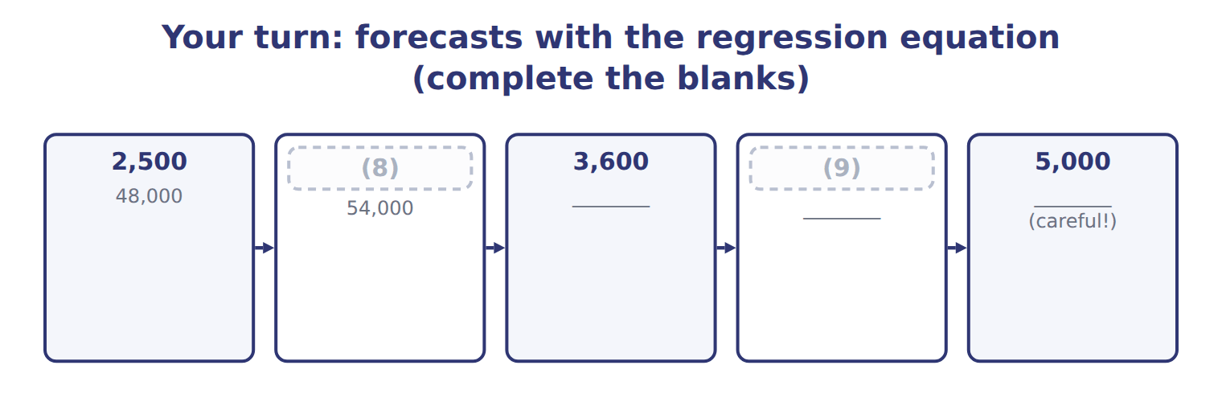
word list
4,000 · 5,000 · 3,000

Answer key · 3.4 Using the regression equation

1 activity | 6 forecasts
2 maintenance | 7 carefully
3 should | 8 3,000
4 reasonable | 9 4,000
5 outside

the summaries in full
Summary 1 To forecast, put the planned activity into x. At 3,200 machine hours, Oils maintenance and utilities should cost $18,000 + $12 × 3,200 = $56,400. A forecast is only as good as the range of the data. The Oils data run from 2,000 to 4,300 machine hours a month. A forecast inside that range is reasonable; a forecast far outside it is a guess.
Summary 2 The first two forecasts are done. Complete the rest, and think carefully about the last one.

3.5 Using regression to estimate fixed costs
Chapter 3 · section 3.5

Fill every gap. Each word list holds one word more than there are gaps.
Summary 1 gaps 1–8
The intercept is (1) estimate of fixed cost: $18,000 a month for Oils (2) and utilities, or $216,000 a year. Use the intercept with care. It is the cost the line (3) at zero activity, and zero lies far (4) the data. It is a sound estimate of fixed cost inside the (5) range, not a (6) of what the plant would cost if it (7) . The t-statistic of the intercept helps. For Oils it is 18.93, well above 2, so the fixed part is (8) greater than zero. A small t-statistic would mean the fixed estimate is weak.
word list
relevant · maintenance · stopped · promise · intercept · regression's · clearly · outside · predicts

Constante

Summary 2 gaps 9–10
The word ' (9) ' suggests a fact, but the (10) is only an estimate from the data.
word list
constant · intercept · promise

Answer key · 3.5 Using regression to estimate fixed costs

1 regression's | 6 promise
2 maintenance | 7 stopped
3 predicts | 8 clearly
4 outside | 9 constant
5 relevant | 10 intercept

the summaries in full
Summary 1 The intercept is regression's estimate of fixed cost: $18,000 a month for Oils maintenance and utilities, or $216,000 a year. Use the intercept with care. It is the cost the line predicts at zero activity, and zero lies far outside the data. It is a sound estimate of fixed cost inside the relevant range, not a promise of what the plant would cost if it stopped. The t-statistic of the intercept helps. For Oils it is 18.93, well above 2, so the fixed part is clearly greater than zero. A small t-statistic would mean the fixed estimate is weak.
Summary 2 The word 'constant' suggests a fact, but the intercept is only an estimate from the data.

3.6 Multiple regression
Chapter 3 · section 3.6

Fill every gap. Each word list holds one word more than there are gaps.
Summary 1 gaps 1–4
Multiple regression uses two or more (1) variables: y = a + b1x1 + b2x2. Each coefficient is the cost per unit of its own variable, with the other variables held constant. Suppose Oils also (2) the number of setups each month. A multiple regression might give $15,000 a month, plus $11.5 per machine hour, plus $150 per setup. Book 4 shows how such (3) are estimated and (4) .
word list
equations · tested · variables · independent · records

Suppose: reading a multiple regression equation
Suppose: Oils M&U, two drivers | Coefficient | Meaning
Intercept | 15,000 | (5)
Machine hours | $11.5 | Variable cost per machine hour, holding setups constant
Number of setups | $150 | Cost per setup, holding machine hours constant
R2 | 0.992 | (6)
Forecast: 3,200 MH and 20 setups | 54,800 | (7)

word list
Share of variation explained by both drivers · Cost per setup, holding machine hours constant · 15,000 + 11.5 × 3,200 + 150 × 20 · Fixed cost per month (with both drivers in the model)

Summary 2 gaps 8–11
Add a (8) driver only when it has a causal link to the cost and (9) the fit. In the example, R2 rises from 0.987 to 0.992, and each coefficient (10) still pass its (11) . Adding drivers that do not cause the cost only makes the equation harder to use.
word list
should · intercept · second · improves · t-test

The English this section uses, and its Arabic
Each term sits against what it means.
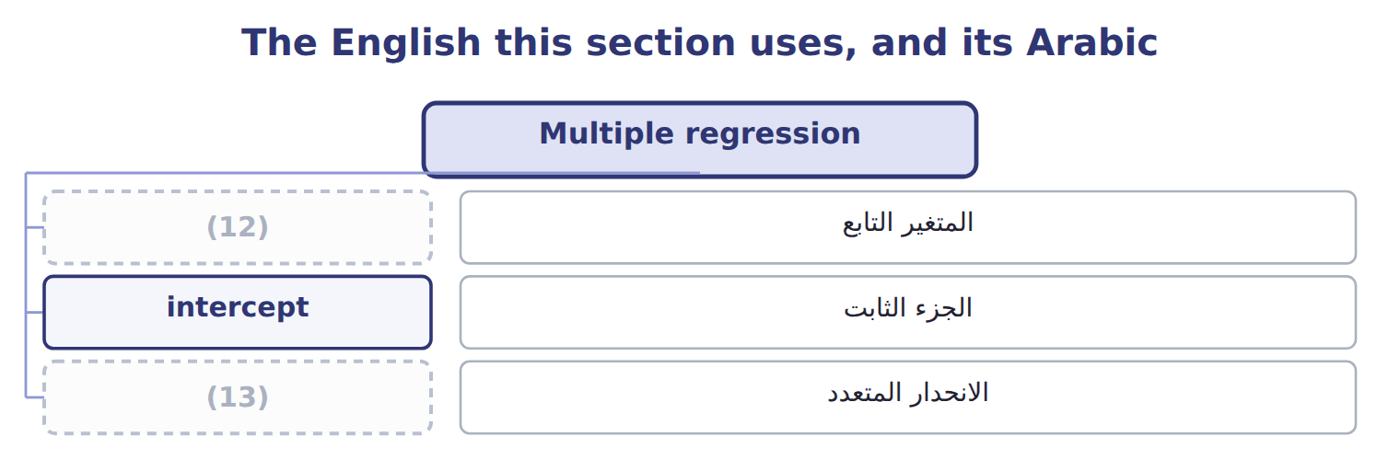
word list
dependent variable · multiple regression · regression analysis

The English this sheet uses, and its Arabic
English (exam term) | Arabic
multiple regression | الانحدار المتعدد

Answer key · 3.6 Multiple regression

1 independent | 8 second
2 records | 9 improves
3 equations | 10 should
4 tested | 11 t-test
5 Fixed cost per month (with both drivers in the model) | 12 dependent variable
6 Share of variation explained by both drivers | 13 multiple regression
7 15,000 + 11.5 × 3,200 + 150 × 20

the summaries in full
Summary 1 Multiple regression uses two or more independent variables: y = a + b1x1 + b2x2. Each coefficient is the cost per unit of its own variable, with the other variables held constant. Suppose Oils also records the number of setups each month. A multiple regression might give $15,000 a month, plus $11.5 per machine hour, plus $150 per setup. Book 4 shows how such equations are estimated and tested.
Summary 2 Add a second driver only when it has a causal link to the cost and improves the fit. In the example, R2 rises from 0.987 to 0.992, and each coefficient should still pass its t-test. Adding drivers that do not cause the cost only makes the equation harder to use.

3.7 Extended Example 3A: the Oils maintenance and utilities cost function
Chapter 3 · section 3.7

Fill every gap. Each word list holds one word more than there are gaps.
Summary 1 gaps 1–8
This example runs both methods on the full 24 months of Oils data and turns the result into the 2027 budget. There are no (1) entries here: the output is a forecast that feeds the budget. Oils has (2) maintenance and (3) costs for January 2025 to (4) 2026, with machine hours from 2,000 to 4,300. For 2027 it plans 3,200 machine hours a month, or 38,400 for the year. Estimate the cost (5) with high-low and with regression. Read the regression output. Forecast the month and the year, (6) the two methods, and pass the result to the budget. (7) does this work, but (8) it once shows what b and a mean.
word list
activity · journal · function · utilities · Software · compare · December · monthly · seeing

Extended Example: regression by hand for the 24 Oils months
Regression by hand: the 24 Oils months | Value
Number of months (n) | 24
(9) | 75,600
(10) | 1,339,200
(11) | 3,150
Mean cost (ȳ) | 55,800
(12) | 11,500,000
Sxy = Σ(x − x̄)(y − ȳ) | 138,000,000
Slope b = Sxy ÷ Sxx | $12
Intercept a = ȳ − b × x̄ = 55,800 − 12 × 3,150 | 18,000
(13) | 22,000,000
(14) | 1,678,000,000
R2 = 1 − SSE ÷ SST | 0.987

word list
Sxx = Σ(x − x̄)2 · Total variation SST = Σ(y − ȳ)2 · Sum of machine hours (Σx) · Unexplained variation SSE = Σ(y − ŷ)2 · R2 = 1 − SSE ÷ SST · Mean machine hours (x̄) · Sum of costs (Σy)

Summary 2 gaps 15–20
The high-low line (15) on two months only; the regression line passes (16) the middle of all 24. The bar at 3,200 hours shows the forecast plus or minus two standard (17) : $54,400 to $58,400. For 2027 regression gives $676,800 and high-low gives $678,000. (18) uses the regression figure, (19) it uses all the data and passes the (20) tests. That is the maintenance line in the.
word list
through · errors · reliability · Orontes · extremes · depends · because

Extended Example: regression and high-low forecasts for 2027
The bars are drawn to scale.
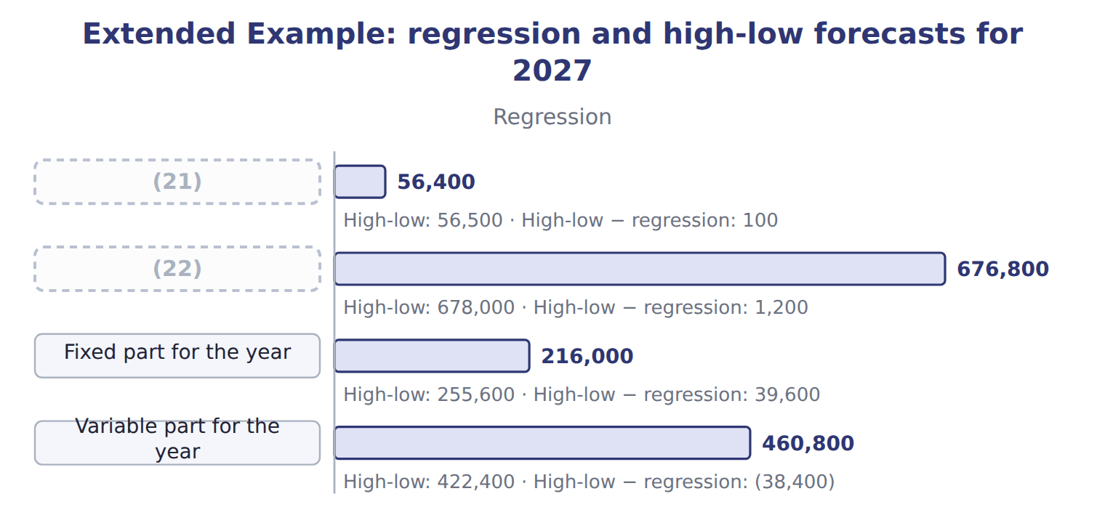
word list
Variable part for the year · Monthly forecast at 3,200 MH · FY2027 forecast at 38,400 MH

Everything ties

Summary 3 gaps 23–24
Slope: Sxy ÷ Sxx = 138,000,000 ÷ 11,500,000 = $12. (23) : 55,800 − 12 × 3,150 = $18,000. Budget: (24) months × $18,000 + $12 × 38,400 = $676,800, the.
word list
printed · twelve · Intercept

Exam view

Summary 4 gaps 25–28
Expect (25) a small data set with a high-low question, or a (26) regression output with a forecast question. For high-low, find the activity (27) first. For regression, take a and b from the coefficient column, put the activity in x, and ignore R2 in the (28) .
word list
either · arithmetic · extremes · printed · standard

Exam view
Barada Wholesale · deliveries in the month | Delivery cost (whole USD)
280 | 16,200
320 | 16,600
380 | 18,900
420 | 19,100
460 | 20,900
480 | 20,800
Regression output
Intercept | 9,000
(29) | 25
R2 | 0.964
(30) | 10.4
Standard error of the estimate | 424

word list
Coefficient on deliveries · t-statistic on deliveries · High-low − regression

Item — Answer
Each stage leads to the next.
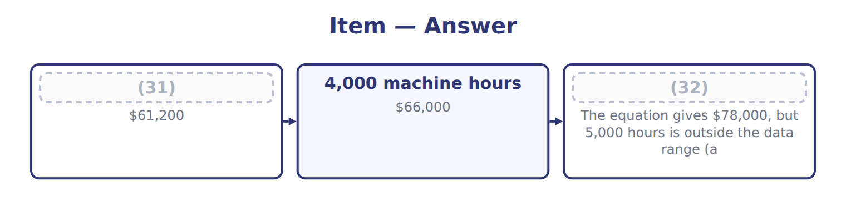
word list
3,600 machine hours · 4,000 machine hours · 5,000 machine hours

Output item — Category
Every item belongs to exactly one group.
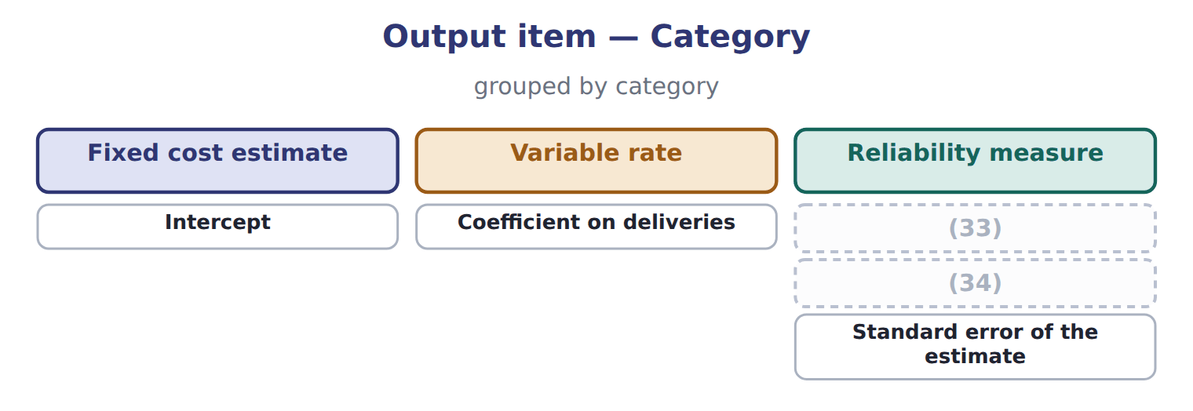
word list
R2 · t-statistic on deliveries · Coefficient on deliveries

The English this section uses, and its Arabic
Each term sits against what it means.
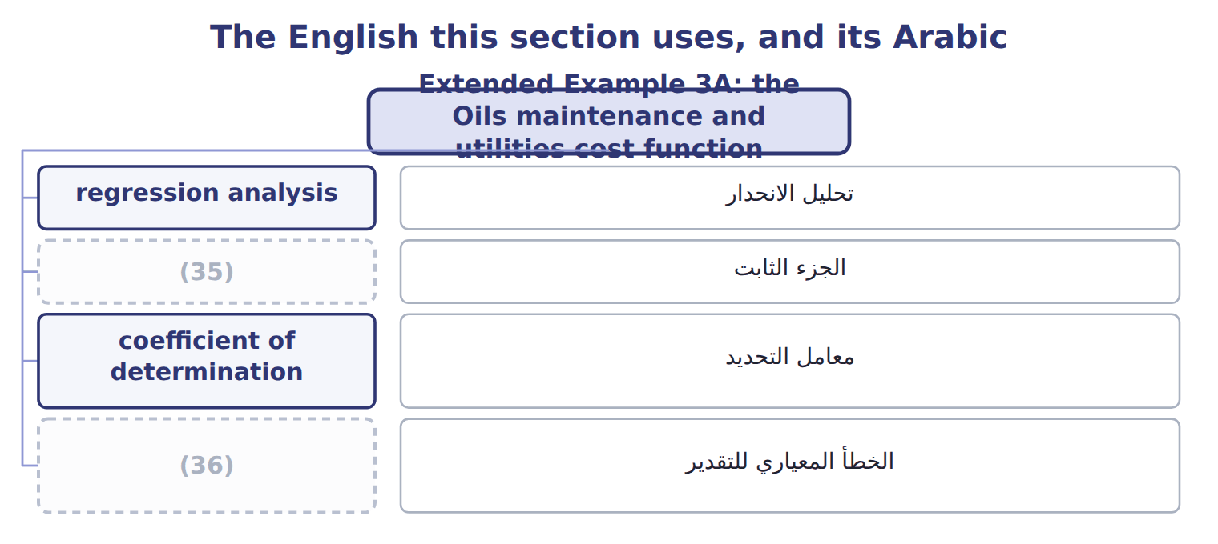
word list
coefficient of determination · standard error of the estimate · intercept

The English this sheet uses, and its Arabic
English (exam term) | Arabic
regression analysis | تحليل الانحدار
intercept | الجزء الثابت
coefficient of determination | معامل التحديد
standard error of the estimate | الخطأ المعياري للتقدير

Answer key · 3.7 Extended Example 3A: the Oils maintenance and utilities cost function

1 journal | 19 because
2 monthly | 20 reliability
3 utilities | 21 Monthly forecast at 3,200 MH
4 December | 22 FY2027 forecast at 38,400 MH
5 function | 23 Intercept
6 compare | 24 twelve
7 Software | 25 either
8 seeing | 26 printed
9 Sum of machine hours (Σx) | 27 extremes
10 Sum of costs (Σy) | 28 arithmetic
11 Mean machine hours (x̄) | 29 Coefficient on deliveries
12 Sxx = Σ(x − x̄)2 | 30 t-statistic on deliveries
13 Unexplained variation SSE = Σ(y − ŷ)2 | 31 3,600 machine hours
14 Total variation SST = Σ(y − ȳ)2 | 32 5,000 machine hours
15 depends | 33 R2
16 through | 34 t-statistic on deliveries
17 errors | 35 intercept
18 Orontes | 36 standard error of the estimate

the summaries in full
Summary 1 This example runs both methods on the full 24 months of Oils data and turns the result into the 2027 budget. There are no journal entries here: the output is a forecast that feeds the budget. Oils has monthly maintenance and utilities costs for January 2025 to December 2026, with machine hours from 2,000 to 4,300. For 2027 it plans 3,200 machine hours a month, or 38,400 for the year. Estimate the cost function with high-low and with regression. Read the regression output. Forecast the month and the year, compare the two methods, and pass the result to the budget. Software does this work, but seeing it once shows what b and a mean.
Summary 2 The high-low line depends on two months only; the regression line passes through the middle of all 24. The bar at 3,200 hours shows the forecast plus or minus two standard errors: $54,400 to $58,400. For 2027 regression gives $676,800 and high-low gives $678,000. Orontes uses the regression figure, because it uses all the data and passes the reliability tests. That is the maintenance line in the.
Summary 3 Slope: Sxy ÷ Sxx = 138,000,000 ÷ 11,500,000 = $12. Intercept: 55,800 − 12 × 3,150 = $18,000. Budget: twelve months × $18,000 + $12 × 38,400 = $676,800, the.
Summary 4 Expect either a small data set with a high-low question, or a printed regression output with a forecast question. For high-low, find the activity extremes first. For regression, take a and b from the coefficient column, put the activity in x, and ignore R2 in the arithmetic.

