8.1 Plantwide, departmental and cost-driver rates
Chapter 8 · section 8.1

Fill every gap. Each word list holds one word more than there are gaps.
Chapter 8, section by section
Each stage leads to the next.
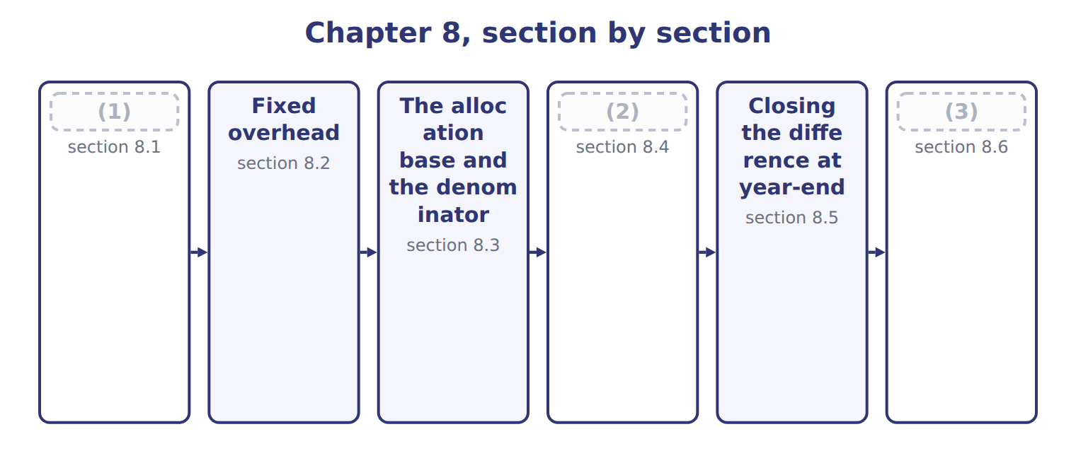
word list
Plantwide, departmental and cost-driver rates · Extended Example 8A: Tahini & Spreads closes 2 · Closing the difference at year-end · Why overhead is over- or under-applied

Summary 1 gaps 4–9
A plantwide overhead rate, also (4) a corporate-wide rate, uses one rate and one base for all overhead. A departmental overhead rate gives each department its own rate and base. Individual cost-driver rates go (5) , with a rate for each activity; that is (6) costing. Tahini & (7) has two departments. Grinding is (8) and packing is labor-heavy. Its plantwide rate of $30 per machine hour ignores that (9) .
word list
difference · similar · Spreads · further · called · machine-heavy · activity-based

Plantwide, departmental and cost-driver rates
Method | How | Benefit | Limitation
Plantwide (corporate-wide) rate | One rate, one base for all overhead | Simple, cheap | (10)
Departmental rates | A rate and base for each department | (11) | More records
Individual cost-driver rates | A rate for each activity (ABC, Chapter 12) | (12) | Costly to design and maintain

word list
Most accurate · Better when departments differ · Distorts cost when departments use different drivers · Packing: labor hours × $16

Worked example: one rate or two?

Summary 2 gaps 13–14
Grinding overhead is $2,200,000 over 80,000 (13) hours: $27.50 per hour. (14) overhead is $800,000 over 50,000 labor hours: $16 per hour.
word list
Packing · machine · ignores

Worked example: plantwide and departmental overhead on two jobs
The bars are drawn to scale.
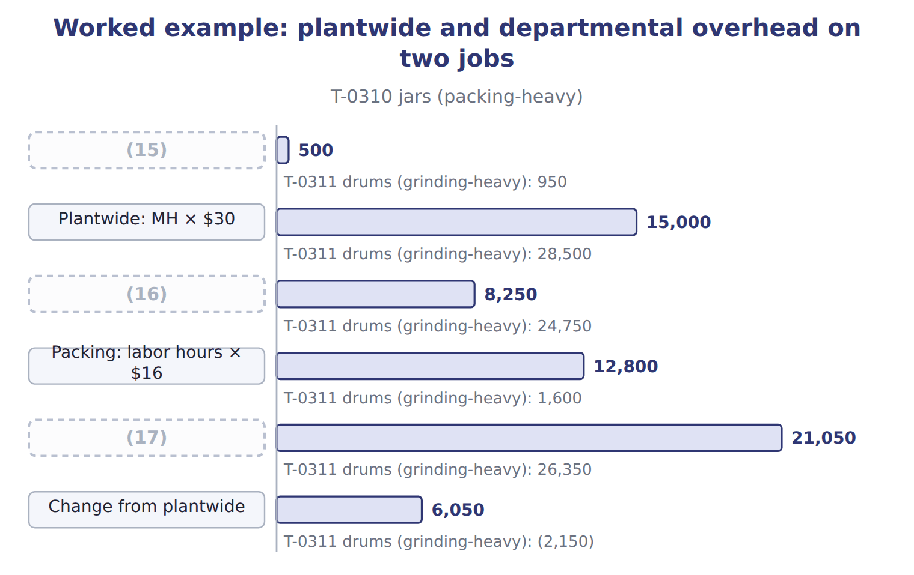
word list
Grinding: MH × $27.50 · Machine hours (grinding + packing) · underapplied overhead · Departmental total

Summary 3 gaps 18–23
The plantwide rate undercosts the (18) jar order by $6,050 and overcosts the (19) drum order. Departmental rates (20) the real drivers, so they give more accurate job costs and better (21) . More rates cost more to run: more bases to (22) and more records to keep. Use a plantwide rate when departments (23) overhead in similar ways; use departmental or driver rates when they do not.
word list
measure · costing · prices · packing-heavy · consume · follow · grinding-heavy

The English this sheet uses, and its Arabic
English (exam term) | Arabic
plantwide overhead rate | معدل التحميل الموحد للمصنع
departmental overhead rate | معدل التحميل على مستوى القسم

Answer key · 8.1 Plantwide, departmental and cost-driver rates

1 Plantwide, departmental and cost-driver rates | 13 machine
2 Why overhead is over- or under-applied | 14 Packing
3 Extended Example 8A: Tahini & Spreads closes 2 | 15 Machine hours (grinding + packing)
4 called | 16 Grinding: MH × $27.50
5 further | 17 Departmental total
6 activity-based | 18 packing-heavy
7 Spreads | 19 grinding-heavy
8 machine-heavy | 20 follow
9 difference | 21 prices
10 Distorts cost when departments use different drivers | 22 measure
11 Better when departments differ | 23 consume
12 Most accurate

the summaries in full
Summary 1 A plantwide overhead rate, also called a corporate-wide rate, uses one rate and one base for all overhead. A departmental overhead rate gives each department its own rate and base. Individual cost-driver rates go further, with a rate for each activity; that is activity-based costing. Tahini & Spreads has two departments. Grinding is machine-heavy and packing is labor-heavy. Its plantwide rate of $30 per machine hour ignores that difference.
Summary 2 Grinding overhead is $2,200,000 over 80,000 machine hours: $27.50 per hour. Packing overhead is $800,000 over 50,000 labor hours: $16 per hour.
Summary 3 The plantwide rate undercosts the packing-heavy jar order by $6,050 and overcosts the grinding-heavy drum order. Departmental rates follow the real drivers, so they give more accurate job costs and better prices. More rates cost more to run: more bases to measure and more records to keep. Use a plantwide rate when departments consume overhead in similar ways; use departmental or driver rates when they do not.

8.2 Fixed overhead
Chapter 8 · section 8.2

Fill every gap. Each word list holds one word more than there are gaps.
Summary 1 gaps 1–3
Fixed overhead is the cost of having (1) : it does not change with (2) in the relevant range. Typical components are (3) , supervision, insurance, property tax, rent or lease costs, and the fixed charges of service departments.
word list
activity · depreciation · supervision · capacity

Tahini & Spreads fixed overhead, 2027
The bars are drawn to scale.
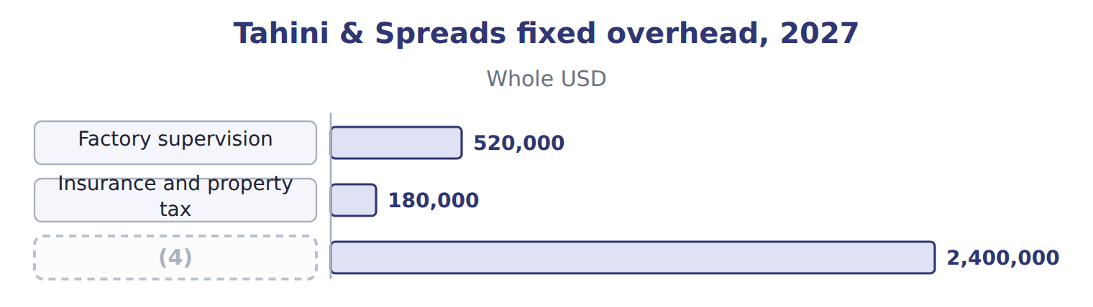
word list
Budgeted fixed overhead · plantwide overhead rate

Summary 2 gaps 5–6
Keep variable items out of the fixed pool. Power for the (5) and cleaning (6) rise with machine hours, so they belong in variable overhead at $6 per machine hour.
word list
supplies · Typical · grinders

The English this sheet uses, and its Arabic
English (exam term) | Arabic
fixed overhead | التكاليف الصناعية غير المباشرة الثابتة

Answer key · 8.2 Fixed overhead

1 capacity | 4 Budgeted fixed overhead
2 activity | 5 grinders
3 depreciation | 6 supplies

the summaries in full
Summary 1 Fixed overhead is the cost of having capacity: it does not change with activity in the relevant range. Typical components are depreciation, supervision, insurance, property tax, rent or lease costs, and the fixed charges of service departments.
Summary 2 Keep variable items out of the fixed pool. Power for the grinders and cleaning supplies rise with machine hours, so they belong in variable overhead at $6 per machine hour.

8.3 The allocation base and the denominator
Chapter 8 · section 8.3

Fill every gap. Each word list holds one word more than there are gaps.
Summary 1 gaps 1–12
The base for fixed overhead (1) measure how (2) use capacity. In an (3) grinding plant that is machine hours. The base must also be (4) for every job. The fixed overhead rate is (5) fixed overhead divided by a (6) level of the base. The choice matters: the same $2,400,000 gives $16 per hour at (7) capacity, $20 at practical capacity, $24 at normal capacity and $25 at (8) capacity. (9) uses normal capacity: 100,000 machine hours, inside a normal range of 90,000 to 110,000 hours a year, which gives $24 per hour and keeps (10) in line with U.S. GAAP. U.S. GAAP and IAS 2 (11) fixed production overhead on normal capacity. Fixed overhead per unit is not increased when production is (12) low; the unallocated amount is expensed in that period.
word list
abnormally · should · master-budget · measurable · budgeted · automated · Orontes · denominator · theoretical · products · allocate · inventory · increased

The English this section uses, and its Arabic
Each term sits against what it means.
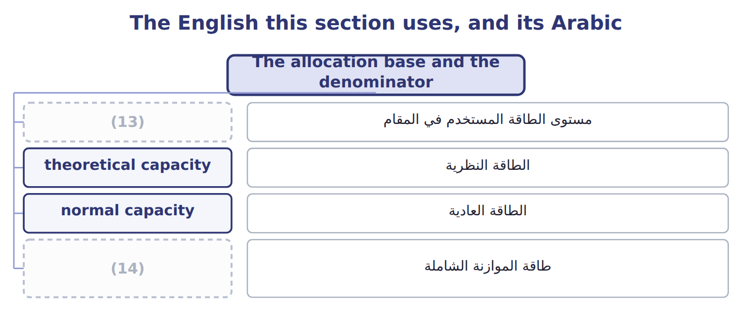
word list
denominator level · theoretical capacity · master-budget capacity

The English this sheet uses, and its Arabic
English (exam term) | Arabic
denominator level | مستوى الطاقة المستخدم في المقام
theoretical capacity | الطاقة النظرية
normal capacity | الطاقة العادية
master-budget capacity | طاقة الموازنة الشاملة

Answer key · 8.3 The allocation base and the denominator

1 should | 8 master-budget
2 products | 9 Orontes
3 automated | 10 inventory
4 measurable | 11 allocate
5 budgeted | 12 abnormally
6 denominator | 13 denominator level
7 theoretical | 14 master-budget capacity

the summaries in full
Summary 1 The base for fixed overhead should measure how products use capacity. In an automated grinding plant that is machine hours. The base must also be measurable for every job. The fixed overhead rate is budgeted fixed overhead divided by a denominator level of the base. The choice matters: the same $2,400,000 gives $16 per hour at theoretical capacity, $20 at practical capacity, $24 at normal capacity and $25 at master-budget capacity. Orontes uses normal capacity: 100,000 machine hours, inside a normal range of 90,000 to 110,000 hours a year, which gives $24 per hour and keeps inventory in line with U.S. GAAP. U.S. GAAP and IAS 2 allocate fixed production overhead on normal capacity. Fixed overhead per unit is not increased when production is abnormally low; the unallocated amount is expensed in that period.

8.4 Why overhead is over- or under-applied
Chapter 8 · section 8.4

Fill every gap. Each word list holds one word more than there are gaps.
Summary 1 gaps 1–9
Actual overhead collects in Manufacturing Overhead (1) ; applied overhead collects in Manufacturing Overhead Applied. When actual is more than applied, the difference is (2) overhead and product costs are too low. When applied is more, the difference is (3) overhead. There are three (4) . Spending can differ from the (5) . Actual (6) can differ from the denominator, so fixed overhead is applied to more or fewer hours than planned. And the base can be used more or less (7) . In 2027 Tahini & Spreads worked 92,000 machine hours, below the (8) denominator of 100,000. So applied fixed overhead fell short even before spending is (9) .
word list
Control · machine · underapplied · budget · normal-capacity · considered · causes · overapplied · efficiently · activity

The English this section uses, and its Arabic
Each term sits against what it means.
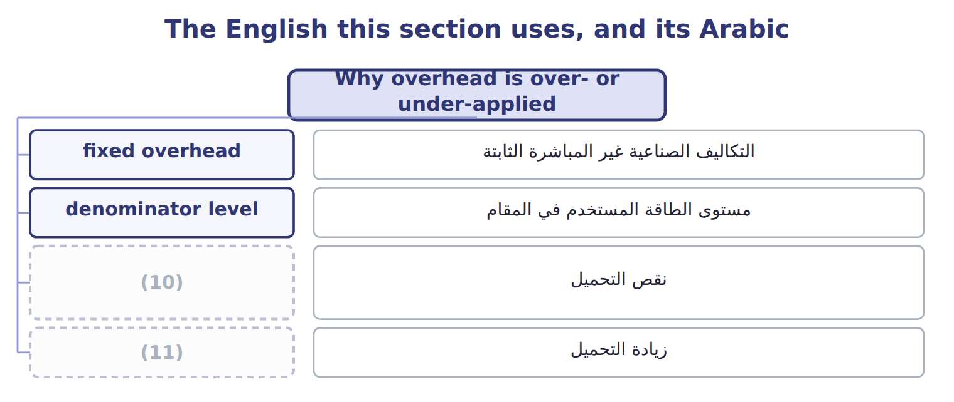
word list
overapplied overhead · underapplied overhead · نقص التحميل

The English this sheet uses, and its Arabic
English (exam term) | Arabic
underapplied overhead | نقص التحميل
overapplied overhead | زيادة التحميل

Answer key · 8.4 Why overhead is over- or under-applied

1 Control | 7 efficiently
2 underapplied | 8 normal-capacity
3 overapplied | 9 considered
4 causes | 10 underapplied overhead
5 budget | 11 overapplied overhead
6 activity

the summaries in full
Summary 1 Actual overhead collects in Manufacturing Overhead Control; applied overhead collects in Manufacturing Overhead Applied. When actual is more than applied, the difference is underapplied overhead and product costs are too low. When applied is more, the difference is overapplied overhead. There are three causes. Spending can differ from the budget. Actual activity can differ from the denominator, so fixed overhead is applied to more or fewer hours than planned. And the base can be used more or less efficiently. In 2027 Tahini & Spreads worked 92,000 machine hours, below the normal-capacity denominator of 100,000. So applied fixed overhead fell short even before spending is considered.

8.5 Closing the difference at year-end
Chapter 8 · section 8.5

Fill every gap. Each word list holds one word more than there are gaps.
Summary 1 gaps 1–7
During the year the difference stays open, because monthly (1) often cancel out. At (2) it must be closed so that both overhead (3) return to zero. If the difference is immaterial, it is closed to cost of goods sold. If it is material, it is spread by (4) over ending work in process, ending (5) goods and cost of goods sold. The (6) come from the overhead applied in each balance this year, not from the total balances. (7) treats a difference above 2% of applied overhead as material.
word list
accounts · proration · year-end · finished · Orontes · monthly · differences · shares

Prorate on applied overhead

Summary 2 gaps 8–9
Use the overhead applied in each balance during the (8) year. Do not use total ending balances, and do not include (9) inventory.
word list
year-end · beginning · current

Share the underapplied overhead

The first share is done.
Your turn: share the underapplied overhead (complete the blanks)
The bars are drawn to scale.
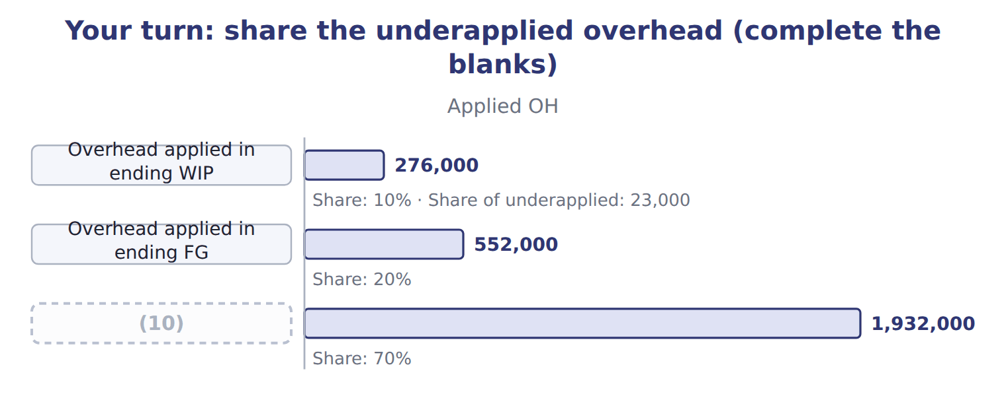
word list
plantwide overhead rate · Overhead applied in COGS

Closing the difference: write-off or proration
 | Write off to COGS | Prorate
When | Difference is immaterial | (11)
Entry | Dr MOH Applied, Dr (or Cr) COGS; Cr MOH Control | (12)
Basis | (13) | Current-period overhead applied in ending WIP, FG and COGS
Effect | Simple; COGS absorbs all | (14)
GAAP note | (15) | Abnormal idle capacity is expensed, never prorated (ASC 330)

word list
Simple; COGS absorbs all · Inventories show nearer-actual cost · Dr MOH Applied, Dr WIP, Dr FG, Dr COGS; Cr MOH Control · Fine if immaterial · All to COGS · Difference is material

The English this sheet uses, and its Arabic
English (exam term) | Arabic
proration | التوزيع النسبي

Answer key · 8.5 Closing the difference at year-end

1 differences | 9 beginning
2 year-end | 10 Overhead applied in COGS
3 accounts | 11 Difference is material
4 proration | 12 Dr MOH Applied, Dr WIP, Dr FG, Dr COGS; Cr MOH Control
5 finished | 13 All to COGS
6 shares | 14 Inventories show nearer-actual cost
7 Orontes | 15 Fine if immaterial
8 current

the summaries in full
Summary 1 During the year the difference stays open, because monthly differences often cancel out. At year-end it must be closed so that both overhead accounts return to zero. If the difference is immaterial, it is closed to cost of goods sold. If it is material, it is spread by proration over ending work in process, ending finished goods and cost of goods sold. The shares come from the overhead applied in each balance this year, not from the total balances. Orontes treats a difference above 2% of applied overhead as material.
Summary 2 Use the overhead applied in each balance during the current year. Do not use total ending balances, and do not include beginning inventory.

8.6 Extended Example 8A: Tahini & Spreads closes 2027
Chapter 8 · section 8.6

Fill every gap. Each word list holds one word more than there are gaps.
Summary 1 gaps 1–12
This example (1) the year's underapplied overhead, (2) it, records the closing entry and compares the (3) with a write-off. The proration and its effect on income are (4) ; the variance split (5) Book 3. Rate: $30 per machine hour, set at normal capacity of 100,000 hours. Actual: 92,000 machine hours; fixed overhead $30,000 above budget; variable overhead $8,000 above the (6) budget. Balances (7) closing: work in (8) $690,000, finished goods $1,380,000, cost of goods sold $6,090,000. Find the underapplied amount and its (9) , test materiality, prorate on applied overhead, (10) the entry and (11) the income effect of the two (12) . Fixed rate: $2,400,000 ÷ 100,000 hours = $24; plus $6 variable = $30 per machine hour. Applied: 92,000 × $30 = $2,760,000. Materiality: 230,000 ÷ 2,760,000 = 8.3%, above the 2% policy, so the difference is prorated.
word list
prorates · result · previews · record · applied · exam-core · process · methods · before · flexible · causes · analyzes · compare

Summary 2 gaps 13–15
Most of it, $192,000, is the (13) effect: fixed overhead was budgeted for normal capacity but applied to only 92,000 hours. (14) adds $30,000 and variable overhead $8,000. Book 3 calls these (15) .
word list
variances · Spending · production-volume · proration

Extended Example: proration of the 2027 underapplied overhead
The bars are drawn to scale.
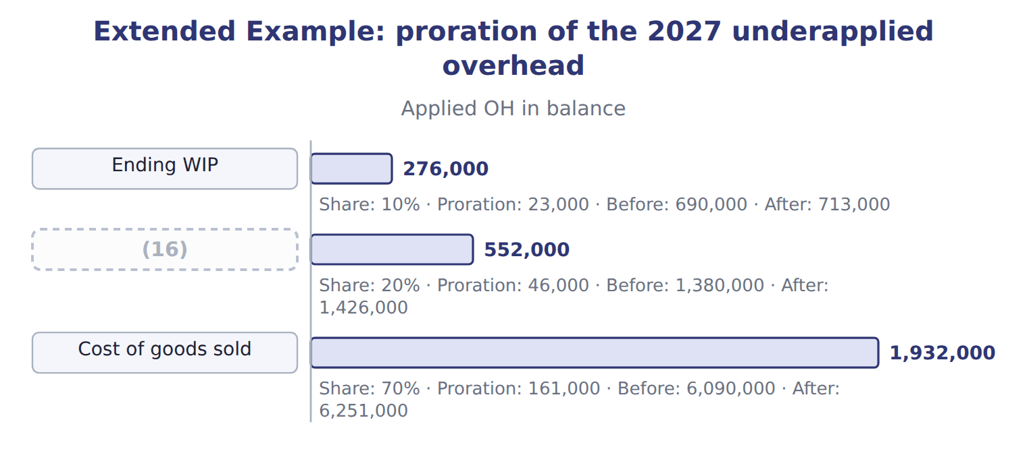
word list
Ending finished goods · departmental overhead rate

Extended Example: year-end closing entry (proration)
No. | Account (detail) | Debit | Credit
1 | (17) | 2,760,000
 | (18) | 23,000
 | Finished Goods Inventory | 46,000
 | Cost of Goods Sold | 161,000
 | (19) |  | 2,990,000
 | Totals | 2,990,000 | 2,990,000

word list
Manufacturing Overhead Control · Work-in-Process Inventory · plantwide overhead rate · Manufacturing Overhead Applied

6. Write-off or proration?

Summary 3 gaps 20–21
Proration leaves $69,000 of the underapplied overhead in inventory, so (20) income is $69,000 higher than with a write-off. The cost reaches the income (21) later, when the inventory is sold.
word list
compared · statement · operating

Extended Example: operating income under the two methods
The bars are drawn to scale.
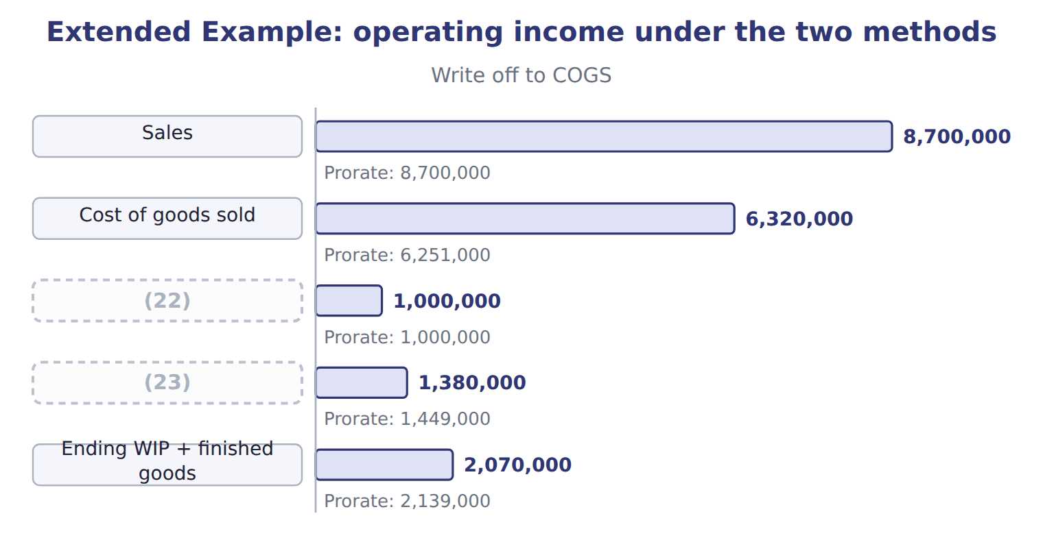
word list
Operating income · master-budget capacity · Selling and administrative

Everything ties

Summary 4 gaps 24–26
Parts of the (24) : $30,000 + $192,000 + $8,000 = $230,000. (25) : $23,000 + $46,000 + $161,000 = $230,000. Income effect: $23,000 + $46,000 = $69,000 kept in (26) . After closing: MOH Control and MOH Applied are both zero.
word list
compare · Proration · inventory · difference

Exam view

Summary 5 gaps 27–29
Expect the applied overhead in ending WIP, finished goods and COGS, and an under- or (27) amount. (28) each share from applied overhead, then say whether income rises or falls (29) with a write-off.
word list
compared · overapplied · methods · Compute

Exam view
Beverages · FY2026 (normal costing, whole USD) | Data
Budgeted fixed overhead | 1,650,000
Normal capacity (Orontes policy) | 16,500 machine hours
Practical capacity | 20,000 machine hours
Variable overhead rate | (30)
Actual machine hours | 16,000
Actual fixed overhead / actual variable overhead | (31)
Machine hours in ending WIP / ending FG / COGS | 800 / 2,400 / 12,800
Unadjusted balances: WIP / FG / COGS | (32)
Materiality policy | (33)

word list
400,000 / 900,000 / 9,000,000 · 1,660,000 / 820,000 · $50 per machine hour · 2% of applied overhead · Applied OH in balance

Item — Answer
Item | Answer
Finished goods share | (34)
COGS share | 70% × 230,000 = 161,000

word list
20% × 230,000 = 46,000 · 70% × 230,000 = 161,000

Beverages cost — Category
Every item belongs to exactly one group.
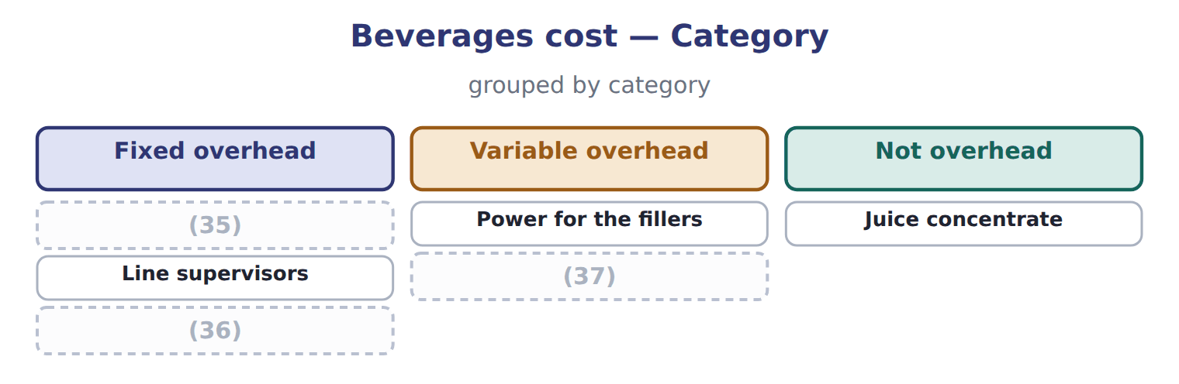
word list
overapplied overhead · Depreciation of the bottling line · Cleaning chemicals · Service department charges

The English this section uses, and its Arabic
Each term sits against what it means.
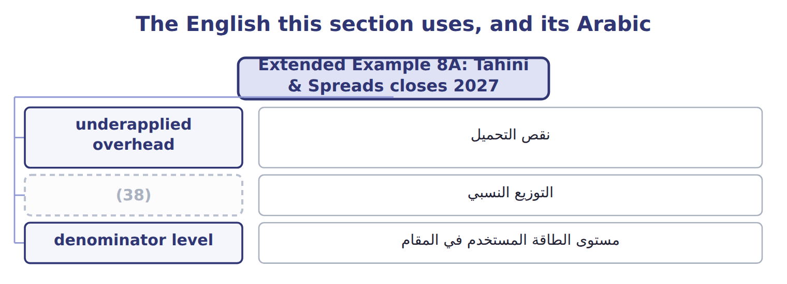
word list
proration · التوزيع النسبي

The English this sheet uses, and its Arabic
English (exam term) | Arabic
underapplied overhead | نقص التحميل
proration | التوزيع النسبي
denominator level | مستوى الطاقة المستخدم في المقام

Answer key · 8.6 Extended Example 8A: Tahini & Spreads closes 2027

1 analyzes | 20 operating
2 prorates | 21 statement
3 result | 22 Selling and administrative
4 exam-core | 23 Operating income
5 previews | 24 difference
6 flexible | 25 Proration
7 before | 26 inventory
8 process | 27 overapplied
9 causes | 28 Compute
10 record | 29 compared
11 compare | 30 $50 per machine hour
12 methods | 31 1,660,000 / 820,000
13 production-volume | 32 400,000 / 900,000 / 9,000,000
14 Spending | 33 2% of applied overhead
15 variances | 34 20% × 230,000 = 46,000
16 Ending finished goods | 35 Depreciation of the bottling line
17 Manufacturing Overhead Applied | 36 Service department charges
18 Work-in-Process Inventory | 37 Cleaning chemicals
19 Manufacturing Overhead Control | 38 proration

the summaries in full
Summary 1 This example analyzes the year's underapplied overhead, prorates it, records the closing entry and compares the result with a write-off. The proration and its effect on income are exam-core; the variance split previews Book 3. Rate: $30 per machine hour, set at normal capacity of 100,000 hours. Actual: 92,000 machine hours; fixed overhead $30,000 above budget; variable overhead $8,000 above the flexible budget. Balances before closing: work in process $690,000, finished goods $1,380,000, cost of goods sold $6,090,000. Find the underapplied amount and its causes, test materiality, prorate on applied overhead, record the entry and compare the income effect of the two methods. Fixed rate: $2,400,000 ÷ 100,000 hours = $24; plus $6 variable = $30 per machine hour. Applied: 92,000 × $30 = $2,760,000. Materiality: 230,000 ÷ 2,760,000 = 8.3%, above the 2% policy, so the difference is prorated.
Summary 2 Most of it, $192,000, is the production-volume effect: fixed overhead was budgeted for normal capacity but applied to only 92,000 hours. Spending adds $30,000 and variable overhead $8,000. Book 3 calls these variances.
Summary 3 Proration leaves $69,000 of the underapplied overhead in inventory, so operating income is $69,000 higher than with a write-off. The cost reaches the income statement later, when the inventory is sold.
Summary 4 Parts of the difference: $30,000 + $192,000 + $8,000 = $230,000. Proration: $23,000 + $46,000 + $161,000 = $230,000. Income effect: $23,000 + $46,000 = $69,000 kept in inventory. After closing: MOH Control and MOH Applied are both zero.
Summary 5 Expect the applied overhead in ending WIP, finished goods and COGS, and an under- or overapplied amount. Compute each share from applied overhead, then say whether income rises or falls compared with a write-off.

