3.1 What budgets are for
Chapter 3 · section 3.1

Fill every gap. Each word list holds one word more than there are gaps.
Chapter 3, section by section
Each stage leads to the next.
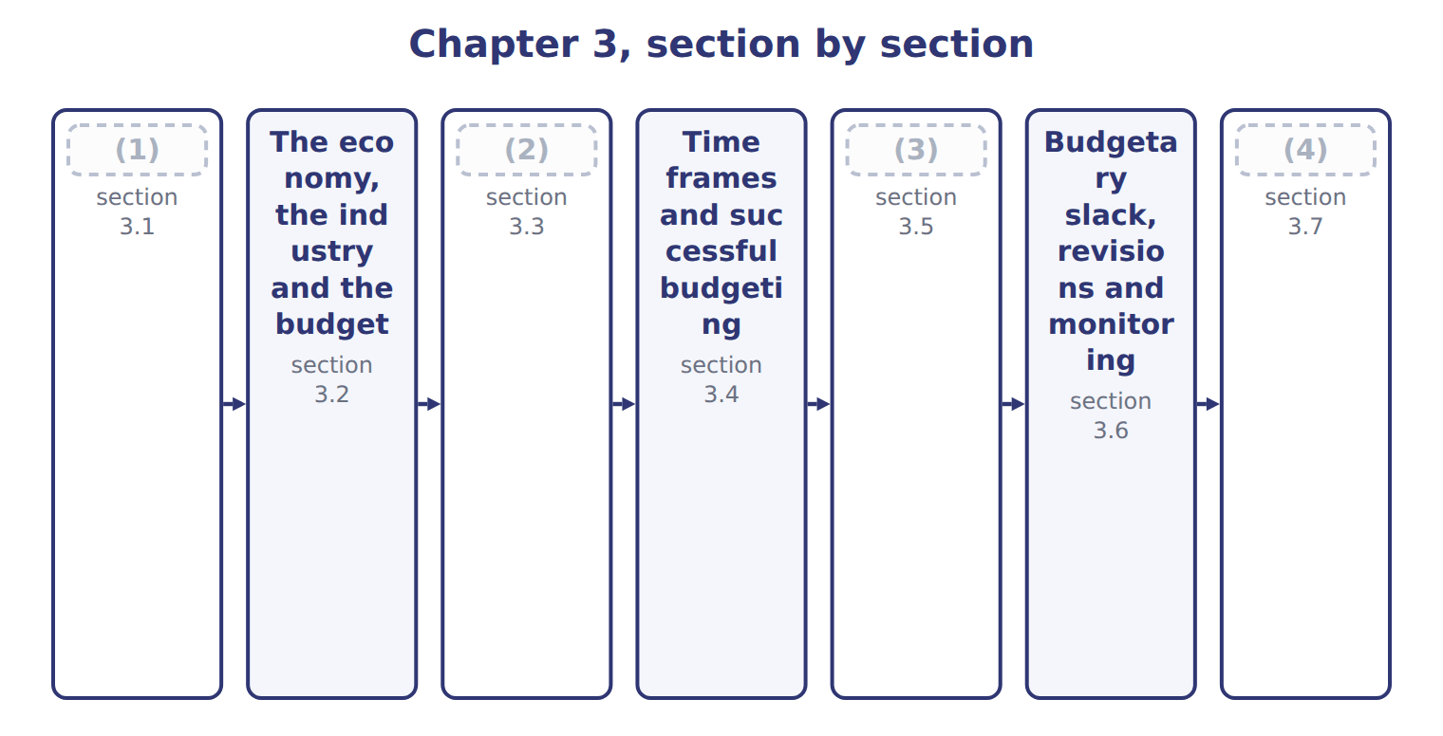
word list
Allocating resources through the budget · People: participation and controllable costs · Budgetary slack, revisions and monitoring · What budgets are for · Extended Example 3A: agreeing the Beverages sa

Summary 1 gaps 5–13
A budget is a (5) plan for a coming period, (6) in money. It turns the strategic plan into (7) objectives: how many cases to sell, what to spend and what (8) to earn. It also tells every unit what the (9) plan to do. The budget cycle runs from the strategic plan to guidelines, (10) , approval, (11) and revision. At the end of the year, the budget (12) the yardstick for (13) results. For planning and control, it sets the targets each month. For coordination, it makes sure that sales, production and purchasing plan for the same volume.
word list
becomes · short-term · quantitative · profit · others · objectives · usually · monitoring · judging · preparation

The roles of the budget at Orontes
Role of the budget | At Orontes
Planning | turns the strategic plan into next year's targets (B.2.a, B.2.c)
Coordination | (14)
Communication | (15)
Resource allocation | (16)
Performance measurement | gives the yardstick for actual results (B.2.d)
Motivation | sets targets managers accept and work towards

word list
sets targets managers accept and work towards · matches sales, production and purchasing plans · tells each unit what is expected and why (B.2.f) · shares scarce funds and people (B.2.h)

Summary 2 gaps 17–19
A budget (17) performance only if the targets were (18) and agreed. When a Beverages manager exceeds a budget that everyone (19) , the result means something; when the budget was imposed without discussion, it means much less.
word list
realistic · quantitative · measures · understood

The English this sheet uses, and its Arabic
English (exam term) | Arabic
budget | الموازنة
budget cycle | دورة الموازنة

Answer key · 3.1 What budgets are for

1 What budgets are for | 11 monitoring
2 Allocating resources through the budget | 12 becomes
3 People: participation and controllable costs | 13 judging
4 Extended Example 3A: agreeing the Beverages sa | 14 matches sales, production and purchasing plans
5 quantitative | 15 tells each unit what is expected and why (B.2.f)
6 usually | 16 shares scarce funds and people (B.2.h)
7 short-term | 17 measures
8 profit | 18 realistic
9 others | 19 understood
10 preparation

the summaries in full
Summary 1 A budget is a quantitative plan for a coming period, usually in money. It turns the strategic plan into short-term objectives: how many cases to sell, what to spend and what profit to earn. It also tells every unit what the others plan to do. The budget cycle runs from the strategic plan to guidelines, preparation, approval, monitoring and revision. At the end of the year, the budget becomes the yardstick for judging results. For planning and control, it sets the targets each month. For coordination, it makes sure that sales, production and purchasing plan for the same volume.
Summary 2 A budget measures performance only if the targets were realistic and agreed. When a Beverages manager exceeds a budget that everyone understood, the result means something; when the budget was imposed without discussion, it means much less.

3.2 The economy, the industry and the budget
Chapter 3 · section 3.2

Fill every gap. Each word list holds one word more than there are gaps.
Summary 1 gaps 1–5
Every budget starts from assumptions about the world outside: (1) growth, inflation, (2) rates and the state of the industry. If the assumptions are wrong, every (3) built on them is wrong too. The (4) sales budget starts from the forecast size of Jordan's juice market, 11,250,000 cases, and (5) share of 8.0%. That gives an evidence-based volume of 900,000 cases.
word list
number · economic · Beverages · outside · Orontes's · exchange

Economic and industry assumptions behind the Beverages sales budget
Assumption | Value | Source and reason
Jordan juice market 2028 | 11,250,000 cases | Industry forecast; market growing 14.0% a year (Chapter 2)
Orontes share | 8.0% | (6)
Evidence-based sales volume | 900,000 cases | (7)
Selling price | $20.00 a case | No increase: the dinar is pegged to the US dollar and inflation is low
Concentrate price | (8) | Supplier contract; watch world fruit prices

word list
Market × share · $0.90 a liter · Supplier contract; watch world fruit prices · From the portfolio review (Chapter 2)

Summary 2 gaps 9–11
The link runs both ways. The industry sets (9) on the plan, and the plan can (10) the industry. If Orontes cuts prices to gain share, rivals may (11) , and the market forecast itself must be revised.
word list
limits · evidence-based · change · respond

Answer key · 3.2 The economy, the industry and the budget

1 economic | 7 Market × share
2 exchange | 8 $0.90 a liter
3 number | 9 limits
4 Beverages | 10 change
5 Orontes's | 11 respond
6 From the portfolio review (Chapter 2)

the summaries in full
Summary 1 Every budget starts from assumptions about the world outside: economic growth, inflation, exchange rates and the state of the industry. If the assumptions are wrong, every number built on them is wrong too. The Beverages sales budget starts from the forecast size of Jordan's juice market, 11,250,000 cases, and Orontes's share of 8.0%. That gives an evidence-based volume of 900,000 cases.
Summary 2 The link runs both ways. The industry sets limits on the plan, and the plan can change the industry. If Orontes cuts prices to gain share, rivals may respond, and the market forecast itself must be revised.

3.3 Allocating resources through the budget
Chapter 3 · section 3.3

Fill every gap. Each word list holds one word more than there are gaps.
Summary 1 gaps 1–2
Resources are (1) scarce. The budget is where the company decides who gets what: money, people, (2) and time. The decision should follow the strategy, not the size of each request.
word list
always · percentage · machines

Worked example: the 2028 capital budget

Summary 2 gaps 3–5
The units asked for $10,000,000 of new (3) ; only $7,000,000 is available. The board uses the (4) review. It funds the star in full, gives part of its request to the question mark, cuts the cash cow's request, and funds the (5) systems.
word list
head-office · investment · machines · portfolio

Worked example: the 2028 capital budget
The parts add up to the total; the bars are to scale.
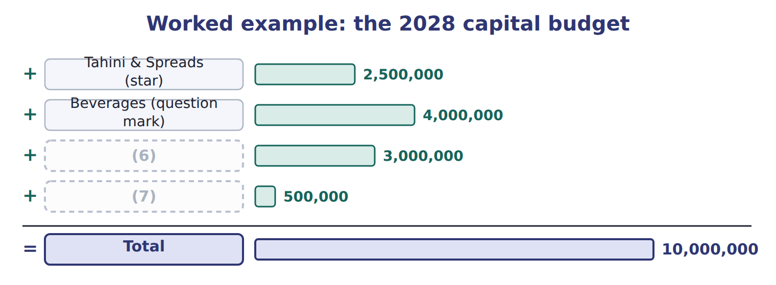
word list
Oils (cash cow) · Head office systems · Beverages (question mark)

Summary 3 gaps 8–12
Cutting every request by the same (8) would have been (9) , but it would have starved the star and overfed the cash cow. (10) allocation puts resources where they (11) the strategy best. Because every unit sees the final allocation, the budget also (12) the strategy to the managers who did not get what they asked for.
word list
support · budget · Efficient · simpler · explains · percentage

Answer key · 3.3 Allocating resources through the budget

1 always | 7 Head office systems
2 machines | 8 percentage
3 investment | 9 simpler
4 portfolio | 10 Efficient
5 head-office | 11 support
6 Oils (cash cow) | 12 explains

the summaries in full
Summary 1 Resources are always scarce. The budget is where the company decides who gets what: money, people, machines and time. The decision should follow the strategy, not the size of each request.
Summary 2 The units asked for $10,000,000 of new investment; only $7,000,000 is available. The board uses the portfolio review. It funds the star in full, gives part of its request to the question mark, cuts the cash cow's request, and funds the head-office systems.
Summary 3 Cutting every request by the same percentage would have been simpler, but it would have starved the star and overfed the cash cow. Efficient allocation puts resources where they support the strategy best. Because every unit sees the final allocation, the budget also explains the strategy to the managers who did not get what they asked for.

3.4 Time frames and successful budgeting
Chapter 3 · section 3.4

Fill every gap. Each word list holds one word more than there are gaps.
Summary 1 gaps 1–3
Each budget has its own time frame. A capital budget (1) the life of the project; the master budget (2) one year, split into (3) or months; the cash budget may be weekly.
word list
executive · follows · quarters · covers

Time frames of the main budgets
Budget | Typical time frame (B.2.i)
Strategic plan | 3–5 years (Chapter 1)
Capital budget | (4)
Master (annual) budget | (5)
Cash budget | (6)
Continuous (rolling) budget | always 12 months ahead (Chapter 5)

word list
Approves revisions under the policy · months or weeks · one year, split by quarter or month · the life of the project, often several years

Summary 2 gaps 7–10
A budget that is too long (7) a guess; one that is too short misses the effect of (8) . The right frame (9) the decision it supports. Successful budgeting is linked to strategy, realistic, (10) , flexible within a clear policy, and followed by timely feedback.
word list
followed · participative · matches · becomes · decisions

Successful budgeting and the role of top management
Successful budget process (B.2.e) | Role of top management (B.2.k)
Linked to strategy | Top management approves goals and guidelines
Realistic, evidence-based targets | (11)
Participation and communication | (12)
Flexibility with a revision policy | (13)
Timely feedback | Uses the budget in performance reviews

word list
Supports the process visibly · Approves revisions under the policy · Uses the budget in performance reviews · Sets the assumptions and resolves conflicts

Summary 3 gaps 14–17
Top management sets the goals and assumptions, resolves conflicts (14) units, approves the final budget and uses it in performance reviews. If top (15) ignore the budget, so will (16) else. At Orontes, the chief (17) opens the budget round with a letter that restates the strategic goals and the key assumptions.
word list
executive · everyone · followed · managers · between

Answer key · 3.4 Time frames and successful budgeting

1 follows | 10 participative
2 covers | 11 Sets the assumptions and resolves conflicts
3 quarters | 12 Supports the process visibly
4 the life of the project, often several years | 13 Approves revisions under the policy
5 one year, split by quarter or month | 14 between
6 months or weeks | 15 managers
7 becomes | 16 everyone
8 decisions | 17 executive
9 matches

the summaries in full
Summary 1 Each budget has its own time frame. A capital budget follows the life of the project; the master budget covers one year, split into quarters or months; the cash budget may be weekly.
Summary 2 A budget that is too long becomes a guess; one that is too short misses the effect of decisions. The right frame matches the decision it supports. Successful budgeting is linked to strategy, realistic, participative, flexible within a clear policy, and followed by timely feedback.
Summary 3 Top management sets the goals and assumptions, resolves conflicts between units, approves the final budget and uses it in performance reviews. If top managers ignore the budget, so will everyone else. At Orontes, the chief executive opens the budget round with a letter that restates the strategic goals and the key assumptions.

3.5 People: participation and controllable costs
Chapter 3 · section 3.5

Fill every gap. Each word list holds one word more than there are gaps.
Summary 1 gaps 1–8
In an (1) budget, top management sets every figure. In (2) budgeting, the managers who must carry out the budget help (3) it. The best (4) usually come from participation with (5) . Managers who know the market and the plant (6) the figures, and top management checks them against the (7) and the strategy. A controllable cost is one a manager can (8) influence in the period. A manager should be judged on controllable costs only; other costs can be reported for information but should not affect the evaluation.
word list
review · participative · evidence · propose · equipment · imposed · significantly · results · prepare

What can the plant manager control?

Complete the two blank rows.
Your turn: what the plant manager controls (complete the blanks)
Every item belongs to exactly one group.
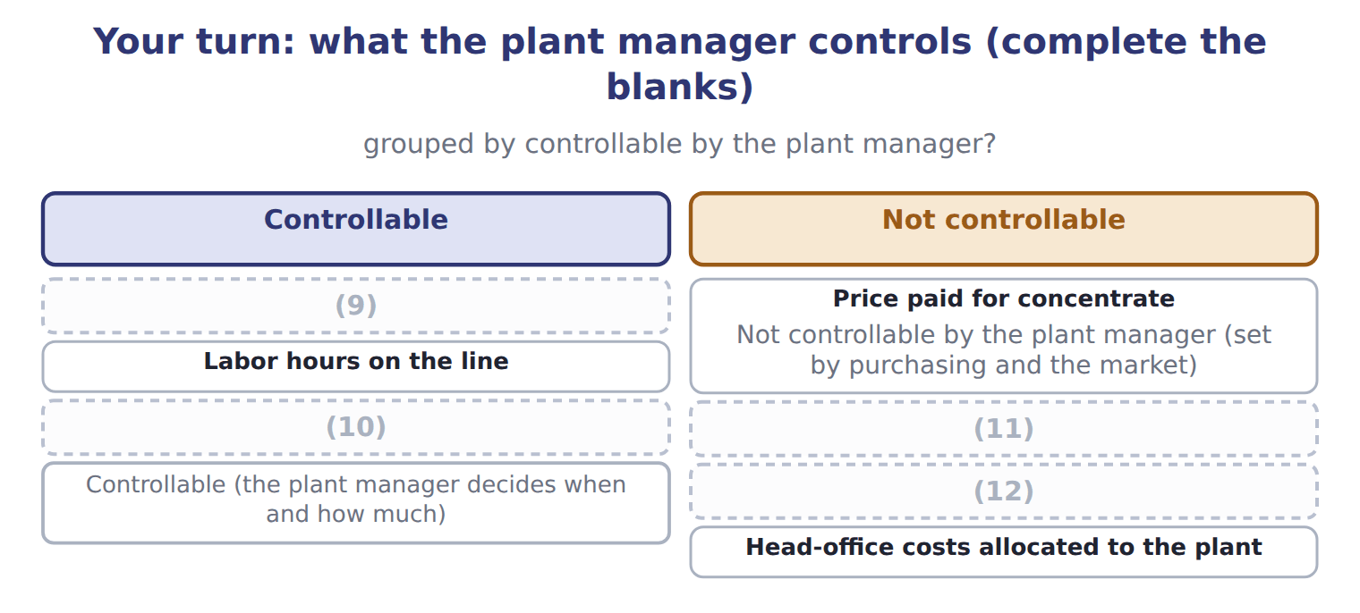
word list
Concentrate used per case · Maintenance spending · Wage rate set by the union contract · Depreciation of the plant · budget revision

Summary 2 gaps 13–16
Controllability also shapes participation: the plant manager should help set targets for usage and hours, while the (13) manager sets the price (14) . Controllability depends on the time frame: in the short run the plant manager cannot change the plant's (15) , but over several years the choice of (16) is partly his.
word list
assumptions · equipment · purchasing · depreciation · information

The English this section uses, and its Arabic
Each term sits against what it means.
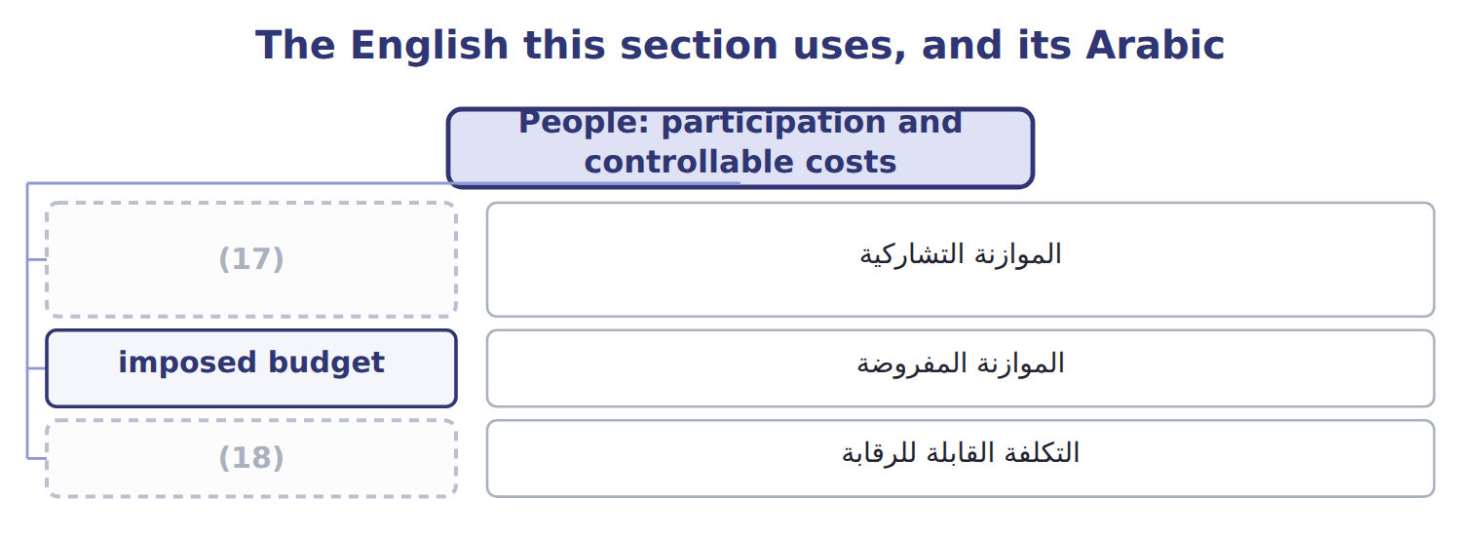
word list
participative budgeting · controllable cost · imposed budget

The English this sheet uses, and its Arabic
English (exam term) | Arabic
participative budgeting | الموازنة التشاركية
imposed budget | الموازنة المفروضة
controllable cost | التكلفة القابلة للرقابة

Answer key · 3.5 People: participation and controllable costs

1 imposed | 10 Maintenance spending
2 participative | 11 Wage rate set by the union contract
3 prepare | 12 Depreciation of the plant
4 results | 13 purchasing
5 review | 14 assumptions
6 propose | 15 depreciation
7 evidence | 16 equipment
8 significantly | 17 participative budgeting
9 Concentrate used per case | 18 controllable cost

the summaries in full
Summary 1 In an imposed budget, top management sets every figure. In participative budgeting, the managers who must carry out the budget help prepare it. The best results usually come from participation with review. Managers who know the market and the plant propose the figures, and top management checks them against the evidence and the strategy. A controllable cost is one a manager can significantly influence in the period. A manager should be judged on controllable costs only; other costs can be reported for information but should not affect the evaluation.
Summary 2 Controllability also shapes participation: the plant manager should help set targets for usage and hours, while the purchasing manager sets the price assumptions. Controllability depends on the time frame: in the short run the plant manager cannot change the plant's depreciation, but over several years the choice of equipment is partly his.

3.6 Budgetary slack, revisions and monitoring
Chapter 3 · section 3.6

Fill every gap. Each word list holds one word more than there are gaps.
Summary 1 gaps 1–8
Budgetary slack is the gap (1) a manager's easy figure and the figure the (2) supports. Sales are (3) too low or costs too high, so the (4) is easy to beat. Slack damages goal (5) : the manager earns a bonus while the company plans for less than it could (6) . Budgets (7) need revising during the year, but only under a clear policy. A good policy (8) for large changes outside managers' control, and keeps the targets for things managers can control. In July, the concentrate price rose 10%.
word list
target · sometimes · between · achieve · revises · congruence · exception · evidence · budgeted

Within the manager's control?

Summary 2 gaps 9–10
Budgets also control (9) during the year. The (10) must use the budget to date, not the annual total.
word list
spending · comparison · congruence

Monitoring marketing spending to the end of June
Beverages marketing, 2028 (USD) | Amount
Annual marketing budget | 600,000
(11) | 300,000
(12) | 340,000
(13) | 40,000 (13.3%)
Left for the second half | 260,000

word list
Annual marketing budget · Budget to the end of June · Overspending to date · Actual to the end of June

Summary 3 gaps 14–15
Management by (14) directs attention to the largest (15) , such as the marketing overspend, so managers spend their time where it matters most.
word list
differences · budgeted · exception

Slack is measured from the evidence

Summary 4 gaps 16–17
Slack is the (16) figure minus the padded figure. (17) it against the manager's own proposal, or as a share of the proposal, gives the wrong answer.
word list
largest · Measuring · evidence-based

The English this section uses, and its Arabic
Each term sits against what it means.
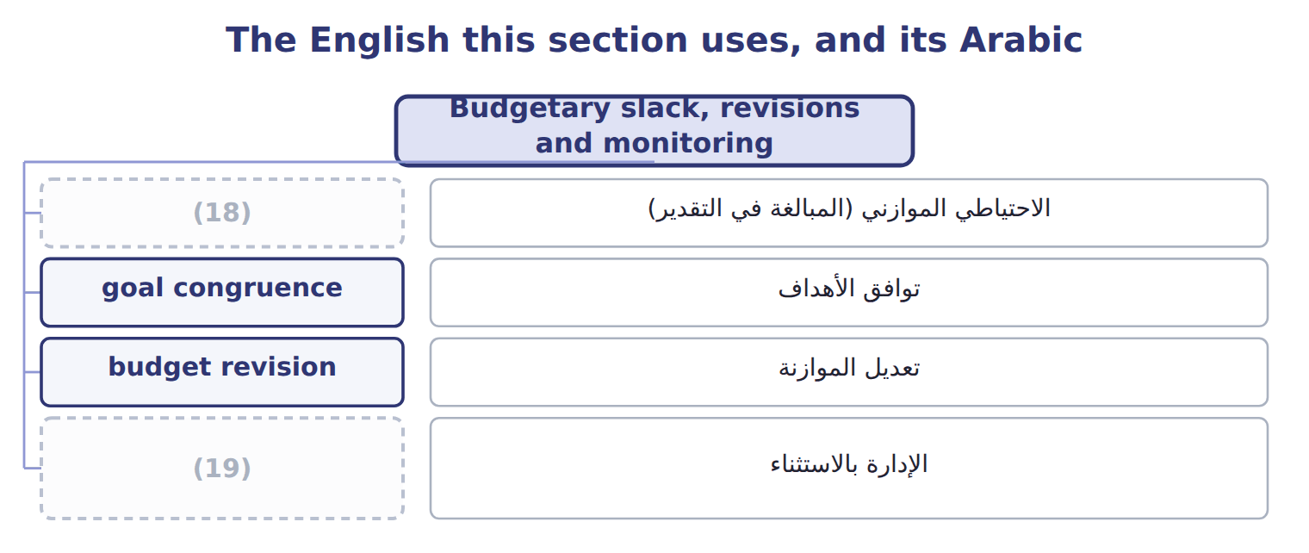
word list
budgetary slack · management by exception · budget revision

The English this sheet uses, and its Arabic
English (exam term) | Arabic
budgetary slack | الاحتياطي الموازني (المبالغة في التقدير)
goal congruence | توافق الأهداف
budget revision | تعديل الموازنة
management by exception | الإدارة بالاستثناء

Answer key · 3.6 Budgetary slack, revisions and monitoring

1 between | 11 Budget to the end of June
2 evidence | 12 Actual to the end of June
3 budgeted | 13 Overspending to date
4 target | 14 exception
5 congruence | 15 differences
6 achieve | 16 evidence-based
7 sometimes | 17 Measuring
8 revises | 18 budgetary slack
9 spending | 19 management by exception
10 comparison

the summaries in full
Summary 1 Budgetary slack is the gap between a manager's easy figure and the figure the evidence supports. Sales are budgeted too low or costs too high, so the target is easy to beat. Slack damages goal congruence: the manager earns a bonus while the company plans for less than it could achieve. Budgets sometimes need revising during the year, but only under a clear policy. A good policy revises for large changes outside managers' control, and keeps the targets for things managers can control. In July, the concentrate price rose 10%.
Summary 2 Budgets also control spending during the year. The comparison must use the budget to date, not the annual total.
Summary 3 Management by exception directs attention to the largest differences, such as the marketing overspend, so managers spend their time where it matters most.
Summary 4 Slack is the evidence-based figure minus the padded figure. Measuring it against the manager's own proposal, or as a share of the proposal, gives the wrong answer.

3.7 Extended Example 3A: agreeing the Beverages sales budget
Chapter 3 · section 3.7

Fill every gap. Each word list holds one word more than there are gaps.
Summary 1 gaps 1–2
This example follows the budget meeting between the (1) sales manager and the controller. Proposal: 820,000 cases, from the sales manager. (2) : market 11,250,000 cases × share 8.0% = 900,000 cases.
word list
explains · Beverages · Evidence

Extended Example: slack in the Beverages sales proposal
The bars are drawn to scale.
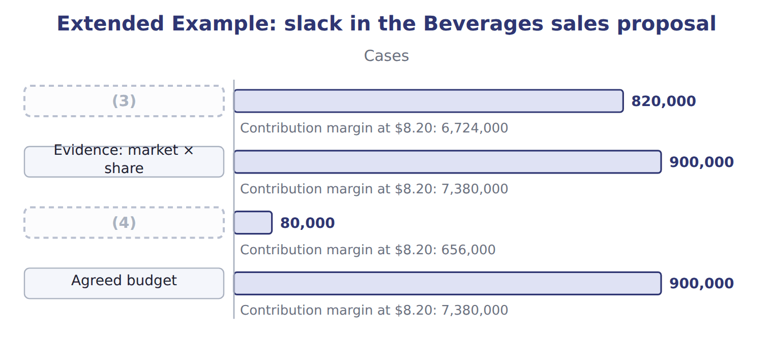
word list
budget cycle · Slack · Sales manager's proposal

Summary 2 gaps 5–8
The sales manager (5) his worry about a new rival. The controller (6) to add a note on this risk, but the budget is set at 900,000 cases. The bonus is also (7) to both the budget and the market share, which (8) the reason to pad.
word list
reduces · agrees · linked · explains · approach

Everything ties

Exam view

Summary 3 gaps 9–11
Expect to classify costs as (9) or not, and to (10) and measure slack. You may also have to choose the best (11) approach, or judge whether a budget should be revised under a stated policy.
word list
controllable · whether · participation · identify

Exam view
Tahini & Spreads, 2028 budget | Data
(12) | 1,400,000
Volume supported by orders and market data (jars) | 1,500,000
(13) | $1.50

word list
Sales manager's proposal (jars) · Contribution margin per jar · Depreciation of the plant

Cost on the plant manager's report — Category
Every item belongs to exactly one group.
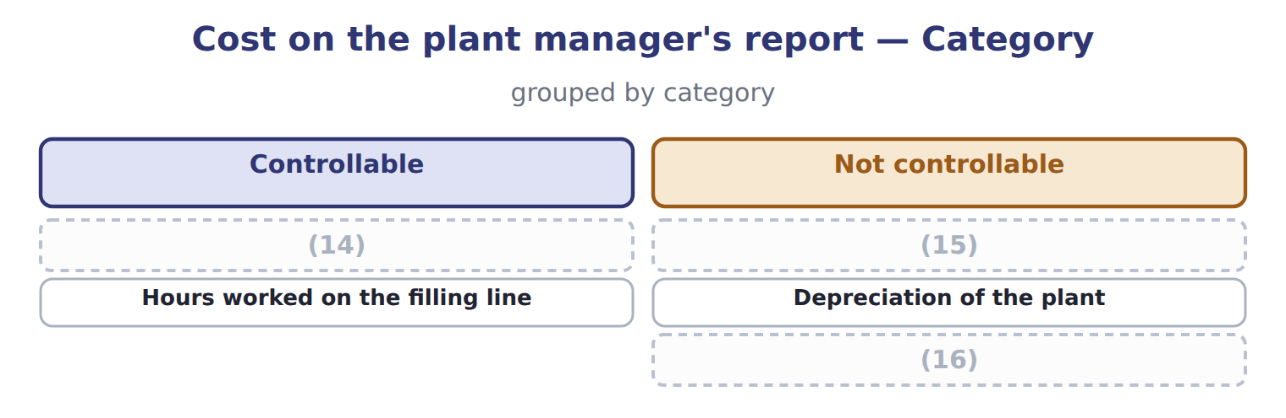
word list
Depreciation of the plant · Head-office costs allocated to the division · Sesame used per jar · Price paid for sesame

The English this section uses, and its Arabic
Each term sits against what it means.
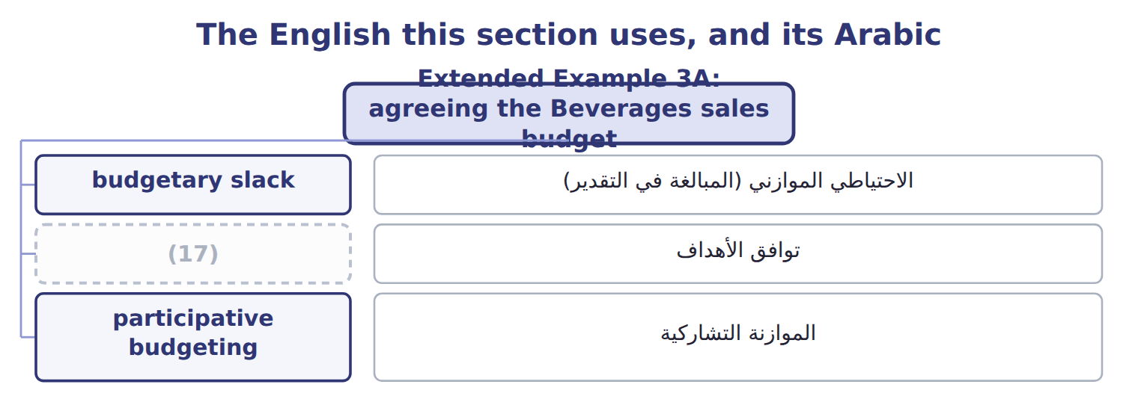
word list
controllable cost · goal congruence

The English this sheet uses, and its Arabic
English (exam term) | Arabic
budgetary slack | الاحتياطي الموازني (المبالغة في التقدير)
goal congruence | توافق الأهداف
participative budgeting | الموازنة التشاركية

Answer key · 3.7 Extended Example 3A: agreeing the Beverages sales budget

1 Beverages | 10 identify
2 Evidence | 11 participation
3 Sales manager's proposal | 12 Sales manager's proposal (jars)
4 Slack | 13 Contribution margin per jar
5 explains | 14 Sesame used per jar
6 agrees | 15 Price paid for sesame
7 linked | 16 Head-office costs allocated to the division
8 reduces | 17 goal congruence
9 controllable

the summaries in full
Summary 1 This example follows the budget meeting between the Beverages sales manager and the controller. Proposal: 820,000 cases, from the sales manager. Evidence: market 11,250,000 cases × share 8.0% = 900,000 cases.
Summary 2 The sales manager explains his worry about a new rival. The controller agrees to add a note on this risk, but the budget is set at 900,000 cases. The bonus is also linked to both the budget and the market share, which reduces the reason to pad.
Summary 3 Expect to classify costs as controllable or not, and to identify and measure slack. You may also have to choose the best participation approach, or judge whether a budget should be revised under a stated policy.

