8.1 The cost of goods sold budget
Chapter 8 · section 8.1

Fill every gap. Each word list holds one word more than there are gaps.
Chapter 8, section by section
Each stage leads to the next.
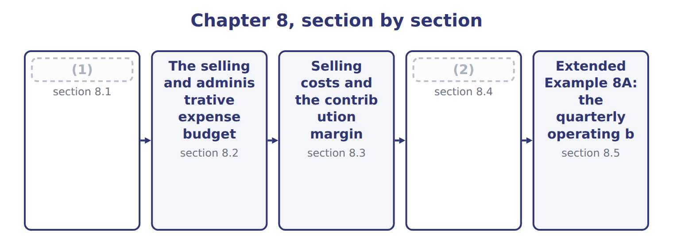
word list
The operating budget · The cost of goods sold budget · The selling and administrative expense budget

Summary 1 gaps 3–4
The cost of goods sold budget has three (3) : beginning finished goods, plus the cost of goods manufactured in the (4) , minus ending finished goods.
word list
production · components · period

Worked example: cost of goods sold for 2028

Summary 2 gaps 5–6
Beginning stock 42,000 cases × $12.60 = $529,200; plus cost of goods (5) $11,350,600; minus (6) stock 43,000 cases × $12.60 = $541,800.
word list
ending · overhead · manufactured

Worked example: the cost of goods sold budget for 2028
Cost of goods sold budget 2028 | Basis | USD
Beginning finished goods | 42,000 cases × $12.60 | 529,200
+ Cost of goods manufactured | (7) | 11,350,600
− Ending finished goods | 43,000 cases × $12.60 | (541,800)
= Cost of goods sold |  | 11,338,000
Check: cases sold × standard | (8)
Less fixed overhead applied above budget | Chapter 7 | (2,000)

word list
900,000 × $12.60 = 11,340,000 · 43,000 cases × $12.60 · Chapter 7

Summary 3 gaps 9–13
The check line (9) the result. At standard, 900,000 cases sold × $12.60 = $11,340,000; the budget is $2,000 lower because fixed overhead applied to (10) is slightly above the fixed overhead (11) . For (12) budgets, cost of goods sold is simply the cases sold at standard, and the small (13) adjustment is made at the end of the year.
word list
fixed-overhead · budgeted · production · explains · quarterly · standard

Cost of goods sold by quarter
Name each line from how it moves.
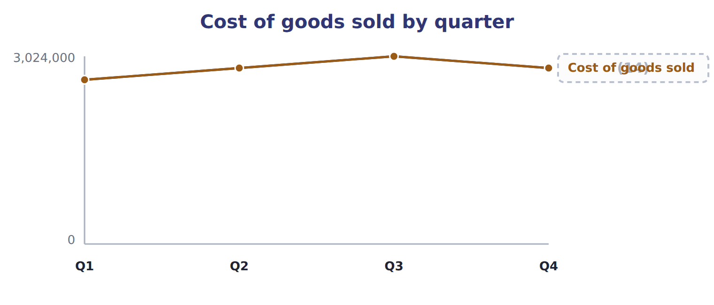
word list
× $12.60 standard · Cases sold

Manufactured is not sold

Summary 4 gaps 15–16
Cost of goods manufactured is the cost of cases finished; cost of goods sold is the cost of cases sold. An (15) that uses one for the other (16) the change in finished goods.
word list
overhead · ignores · answer

The English this sheet uses, and its Arabic
English (exam term) | Arabic
cost of goods sold budget | موازنة تكلفة البضاعة المباعة
cost of goods manufactured | تكلفة الإنتاج التام

Answer key · 8.1 The cost of goods sold budget

1 The cost of goods sold budget | 9 explains
2 The operating budget | 10 production
3 components | 11 budgeted
4 period | 12 quarterly
5 manufactured | 13 fixed-overhead
6 ending | 14 × $12.60 standard
7 Chapter 7 | 15 answer
8 900,000 × $12.60 = 11,340,000 | 16 ignores

the summaries in full
Summary 1 The cost of goods sold budget has three components: beginning finished goods, plus the cost of goods manufactured in the period, minus ending finished goods.
Summary 2 Beginning stock 42,000 cases × $12.60 = $529,200; plus cost of goods manufactured $11,350,600; minus ending stock 43,000 cases × $12.60 = $541,800.
Summary 3 The check line explains the result. At standard, 900,000 cases sold × $12.60 = $11,340,000; the budget is $2,000 lower because fixed overhead applied to production is slightly above the fixed overhead budgeted. For quarterly budgets, cost of goods sold is simply the cases sold at standard, and the small fixed-overhead adjustment is made at the end of the year.
Summary 4 Cost of goods manufactured is the cost of cases finished; cost of goods sold is the cost of cases sold. An answer that uses one for the other ignores the change in finished goods.

8.2 The selling and administrative expense budget
Chapter 8 · section 8.2

Fill every gap. Each word list holds one word more than there are gaps.
Summary 1 gaps 1–5
The selling and (1) expense budget has two kinds of (2) . Variable selling (3) , such as freight to customers and sales (4) , change with cases sold. Fixed costs, such as marketing, salaries, (5) and depreciation of offices and vehicles, are budgeted item by item. The variable rate of $1.20 a case and the fixed total of $2,400,000 are the figures used in the flexible budget.
word list
commissions · expenses · administration · freight · components · administrative

Components of the selling and administrative expense budget
The bars are drawn to scale.
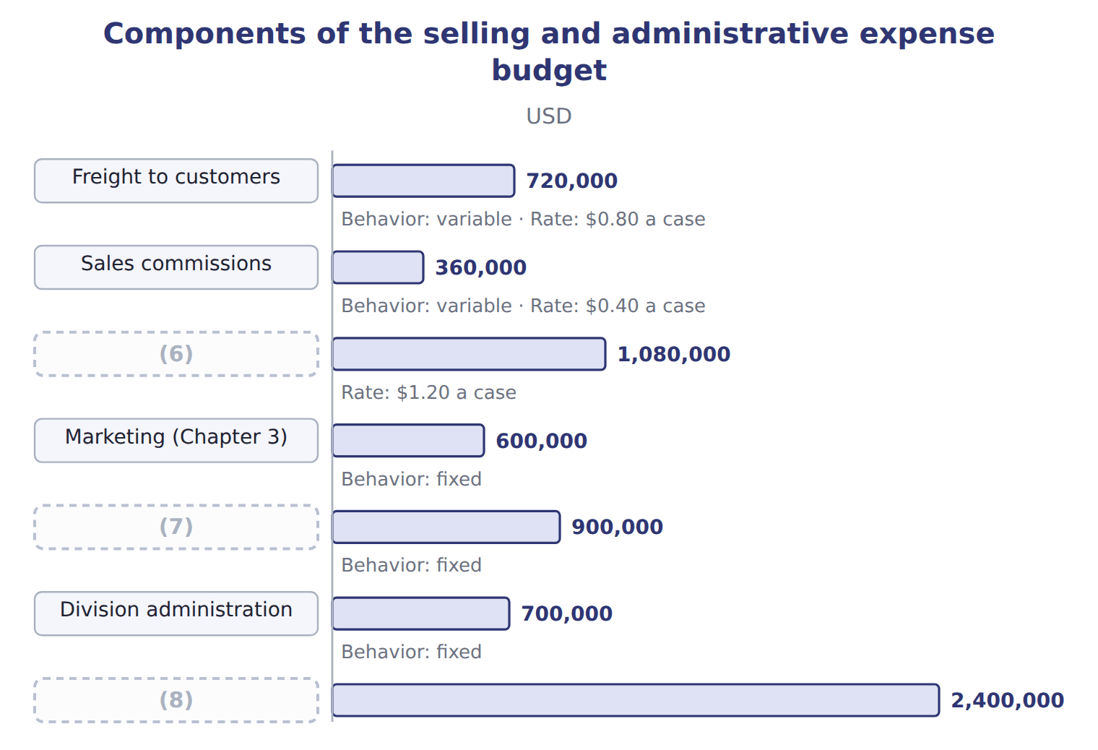
word list
Sales team salaries · Variable selling expenses · Marketing (Chapter 3) · Fixed selling and administrative

Selling and admin in the third and fourth quarters

Complete the blank cells.

Your turn: selling and admin by quarter (complete the blanks)
Name each line from how it moves.
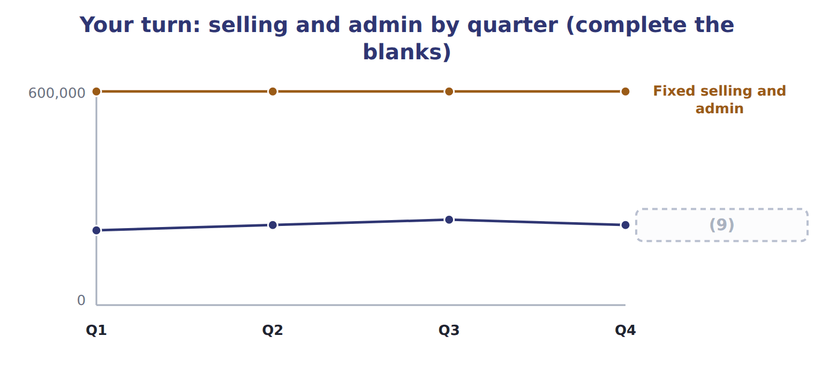
word list
contribution margin · Cases sold

Summary 2 gaps 10–11
Depreciation of offices and vehicles is shown (10) because it uses no cash, together with the depreciation in (11) overhead.
word list
marketing · manufacturing · separately

The English this sheet uses, and its Arabic
English (exam term) | Arabic
selling and administrative expense budget | موازنة المصروفات البيعية والإدارية

Answer key · 8.2 The selling and administrative expense budget

1 administrative | 7 Sales team salaries
2 components | 8 Fixed selling and administrative
3 expenses | 9 Cases sold
4 commissions | 10 separately
5 administration | 11 manufacturing
6 Variable selling expenses

the summaries in full
Summary 1 The selling and administrative expense budget has two kinds of components. Variable selling expenses, such as freight to customers and sales commissions, change with cases sold. Fixed costs, such as marketing, salaries, administration and depreciation of offices and vehicles, are budgeted item by item. The variable rate of $1.20 a case and the fixed total of $2,400,000 are the figures used in the flexible budget.
Summary 2 Depreciation of offices and vehicles is shown separately because it uses no cash, together with the depreciation in manufacturing overhead.

8.3 Selling costs and the contribution margin
Chapter 8 · section 8.3

Fill every gap. Each word list holds one word more than there are gaps.
Summary 1 gaps 1–2
Selling and administrative costs (1) the contribution margin only if they are variable. Freight and commissions are deducted before the contribution margin; marketing, salaries and (2) are deducted after it.
word list
administration · affect · depends

Worked example: a commission plan

Summary 2 gaps 3–4
The sales (3) proposes raising commissions by $0.30 a case and cutting sales salaries by $200,000, (4) 20,000 extra cases. The contribution margin per case falls to $7.90.
word list
expecting · proposes · director

Worked example: the effect of a commission plan
Commission proposal | Now | Commission +$0.30 a case
Contribution margin per case | $8.20 | $7.90
Cases | 900,000 | 920,000
Contribution margin | 7,380,000 | 7,268,000
(5) |  | (112,000)
(6) |  | 200,000
Change in operating income |  | 88,000

word list
Change in contribution margin · Contribution margin per case · Saving in sales salaries

Summary 3 gaps 7–9
The proposal turns a fixed cost into a variable one. That (7) the contribution margin per case and the (8) risk, but it pays more when sales are high. The decision depends on how (9) the division is about the extra volume.
word list
confident · break-even · expecting · lowers

Which costs go above the line?

Summary 4 gaps 10–11
Variable selling costs (10) the contribution margin; fixed selling and administrative costs do not. (11) marketing or salaries before the contribution margin, or leaving out freight and commissions, gives the wrong margin.
word list
reduce · raising · Deducting

Answer key · 8.3 Selling costs and the contribution margin

1 affect | 7 lowers
2 administration | 8 break-even
3 director | 9 confident
4 expecting | 10 reduce
5 Change in contribution margin | 11 Deducting
6 Saving in sales salaries

the summaries in full
Summary 1 Selling and administrative costs affect the contribution margin only if they are variable. Freight and commissions are deducted before the contribution margin; marketing, salaries and administration are deducted after it.
Summary 2 The sales director proposes raising commissions by $0.30 a case and cutting sales salaries by $200,000, expecting 20,000 extra cases. The contribution margin per case falls to $7.90.
Summary 3 The proposal turns a fixed cost into a variable one. That lowers the contribution margin per case and the break-even risk, but it pays more when sales are high. The decision depends on how confident the division is about the extra volume.
Summary 4 Variable selling costs reduce the contribution margin; fixed selling and administrative costs do not. Deducting marketing or salaries before the contribution margin, or leaving out freight and commissions, gives the wrong margin.

8.4 The operating budget
Chapter 8 · section 8.4

Fill every gap. Each word list holds one word more than there are gaps.
Summary 1 gaps 1–3
The operating budget, or budgeted income (1) , brings the (2) together: sales, minus cost of goods sold, minus selling and administrative expenses, gives budgeted operating income. (3) and income taxes are added later.
word list
expenses · statement · schedules · Interest

Worked example: the Beverages operating budget

Summary 2 gaps 4–5
Sales $18,000,000 − cost of goods sold $11,338,000 = gross margin $6,662,000; − selling and (4) $3,480,000 = (5) income $3,182,000.
word list
operating · selling · administrative

Worked example: the Beverages operating budget for 2028
Beverages operating budget 2028 (USD) | Amount
(6) | 18,000,000
− Cost of goods sold | (11,338,000)
= Gross margin | 6,662,000
(7) | (1,080,000)
− Fixed selling and administrative | (2,400,000)
(8) | 3,182,000

word list
administrative · − Variable selling expenses · = Operating income · Sales

In contribution format, the same year gives $3,180,000, the flexible budget.
Reconciling the contribution and functional formats
Reconciling the two formats (USD) | Amount
(9) : 900,000 cases × $8.20 | 7,380,000
(10) | (4,200,000)
(11) | 3,180,000
+ Fixed overhead held in the rise in stock | 2,000
= Operating income, functional format | 3,182,000

word list
− Fixed costs: 12 × $350,000 · cost of goods manufactured · = Operating income, contribution format · Contribution margin

The division plans to keep about one dollar in six of sales as operating income.

The English this sheet uses, and its Arabic
English (exam term) | Arabic
operating budget (budgeted income statement) | الموازنة التشغيلية (قائمة الدخل التقديرية)
contribution margin | هامش المساهمة

Answer key · 8.4 The operating budget

1 statement | 7 − Variable selling expenses
2 schedules | 8 = Operating income
3 Interest | 9 Contribution margin
4 administrative | 10 − Fixed costs: 12 × $350,000
5 operating | 11 = Operating income, contribution format
6 Sales

the summaries in full
Summary 1 The operating budget, or budgeted income statement, brings the schedules together: sales, minus cost of goods sold, minus selling and administrative expenses, gives budgeted operating income. Interest and income taxes are added later.
Summary 2 Sales $18,000,000 − cost of goods sold $11,338,000 = gross margin $6,662,000; − selling and administrative $3,480,000 = operating income $3,182,000.

8.5 Extended Example 8A: the quarterly operating budget for the board
Chapter 8 · section 8.5

Fill every gap. Each word list holds one word more than there are gaps.
Summary 1 gaps 1–2
The board (1) results every quarter, so it wants the operating budget by quarter. This example builds it from the (2) . The year column includes the year-end fixed-overhead adjustment.
word list
quarter's · reviews · schedules

Extended Example: the quarterly operating budget
Beverages 2028 (USD) | Q1 | Q2 | Q3 | Q4 | Year
Sales | 4,200,000 | 4,500,000 | 4,800,000 | 4,500,000 | 18,000,000
(3) | (2,646,000) | (2,835,000) | (3,024,000) | (2,835,000) | (11,338,000)
= Gross margin | 1,554,000 | 1,665,000 | 1,776,000 | 1,665,000 | 6,662,000
− Selling and admin | (852,000) | (870,000) | (888,000) | (870,000) | (3,480,000)
(4) | 702,000 | 795,000 | 888,000 | 795,000 | 3,182,000

word list
− Cost of goods sold · Marketing in the Gulf · = Operating income

Summary 2 gaps 5–6
Operating income (5) the season, peaking at $888,000 in the summer quarter. The board will compare each (6) actual result with this budget, using the flexible budget.
word list
follows · production · quarter's

Everything ties

Quarters: $702,000 + $795,000 + $888,000 + $795,000 = $3,180,000; + $2,000 at year end = $3,182,000.
Exam view

Summary 3 gaps 7–10
Expect stock and (7) figures to build cost of goods sold, a list of selling and administrative costs to (8) , and the parts of an operating budget to combine. Watch which costs are variable, and whether the (9) asks for gross margin, (10) margin or operating income.
word list
classify · contribution · production · question · figures

Exam view
Tahini & Spreads, second quarter 2028 | Data
(11) | 380,000
Jars produced in the second quarter | 382,000
(12) | 38,000
(13) | 40,000
Selling price per jar | $3.50
Variable manufacturing cost per jar | $1.90
Fixed manufacturing overhead per jar (normal volume) | $0.64
(14) | $0.10
(15) | $40,000

word list
Finished jars at the start of the quarter · Jars sold in the second quarter · Fixed selling and admin per month · Variable manufacturing cost per jar · Finished jars at the end of the quarter · Variable selling cost per jar

Item — Answer
Item | Answer
Q3 | (16) 240,000 × $1.20 = $288,000; total $288,000 + $600,000 = $888,000
Q4 | Variable 225,000 × $1.20 = $270,000; total $270,000 + $600,000 = $870,000

word list
Data · Variable

Cost — Category
Cost | Category
Depreciation of the tahini plant | Manufacturing cost
Freight to Gulf buyers per jar | (17)
Sales team salaries | Fixed selling and administrative expense
Sesame paste | Manufacturing cost
Marketing in the Gulf | (18)

word list
Beverages 2028 (USD) · Variable selling expense · Fixed selling and administrative expense

The English this section uses, and its Arabic
Each term sits against what it means.
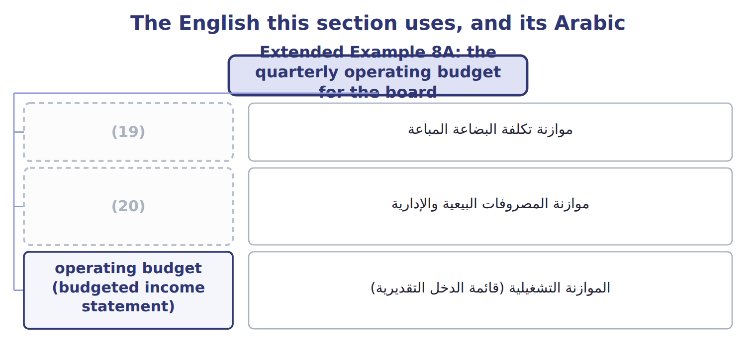
word list
الموازنة التشغيلية (قائمة الدخل التقديرية) · selling and administrative expense budget · cost of goods sold budget

The English this sheet uses, and its Arabic
English (exam term) | Arabic
cost of goods sold budget | موازنة تكلفة البضاعة المباعة
selling and administrative expense budget | موازنة المصروفات البيعية والإدارية
operating budget (budgeted income statement) | الموازنة التشغيلية (قائمة الدخل التقديرية)

Answer key · 8.5 Extended Example 8A: the quarterly operating budget for the board

1 reviews | 11 Jars sold in the second quarter
2 schedules | 12 Finished jars at the start of the quarter
3 − Cost of goods sold | 13 Finished jars at the end of the quarter
4 = Operating income | 14 Variable selling cost per jar
5 follows | 15 Fixed selling and admin per month
6 quarter's | 16 Variable
7 production | 17 Variable selling expense
8 classify | 18 Fixed selling and administrative expense
9 question | 19 cost of goods sold budget
10 contribution | 20 selling and administrative expense budget

the summaries in full
Summary 1 The board reviews results every quarter, so it wants the operating budget by quarter. This example builds it from the schedules. The year column includes the year-end fixed-overhead adjustment.
Summary 2 Operating income follows the season, peaking at $888,000 in the summer quarter. The board will compare each quarter's actual result with this budget, using the flexible budget.
Summary 3 Expect stock and production figures to build cost of goods sold, a list of selling and administrative costs to classify, and the parts of an operating budget to combine. Watch which costs are variable, and whether the question asks for gross margin, contribution margin or operating income.

