9.1 The capital expenditure budget
Chapter 9 · section 9.1

Fill every gap. Each word list holds one word more than there are gaps.
Chapter 9, section by section
Each stage leads to the next.
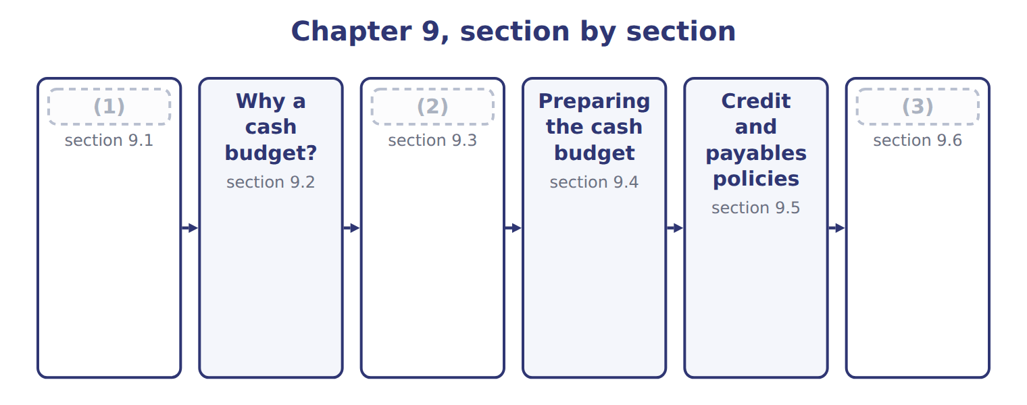
word list
Collections and payments · Extended Example 9A: financing the year and ha · Preparing the cash budget · The capital expenditure budget

Summary 1 gaps 4–7
The capital (4) budget plans spending on (5) assets, such as plant, equipment and systems, by project and by period. Each project is approved (6) , usually with capital (7) methods (a CMA Part 2 topic), and then placed in the quarter when cash will be paid.
word list
depreciation · expenditure · budgeting · separately · long-term

Worked example: the filling line by quarter

Summary 2 gaps 8–9
The project budget: equipment in the first quarter, (8) and half the (9) in the second, the rest in the third.
word list
training · installation · investment

Worked example: the capital expenditure budget for 2028
The bars are drawn to scale.
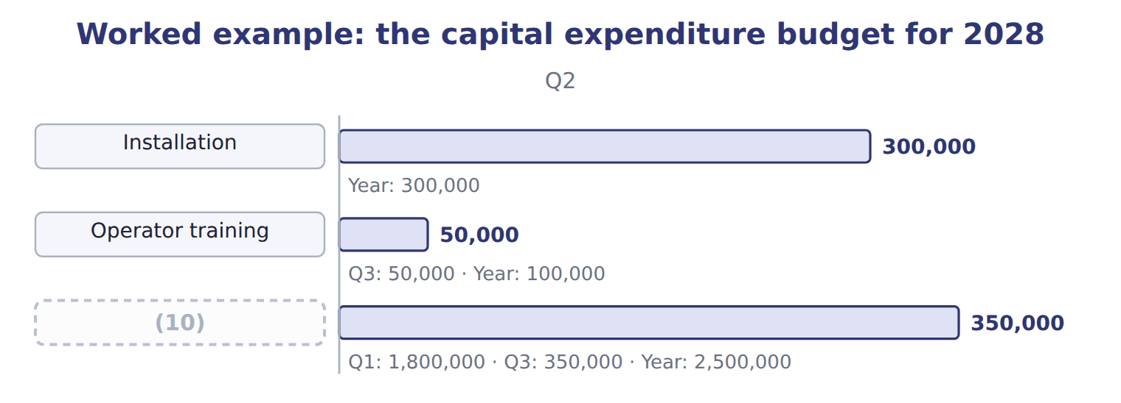
word list
Capital expenditure · credit policy

Summary 3 gaps 11–15
One (11) affects three (12) . The cash budget shows the cash paid; the budgeted income statement shows depreciation over the (13) life; the budgeted (14) sheet shows the asset at cost less depreciation. The capital budget is a (15) budget, not part of the operating budget: the purchase itself is not an expense. Only its depreciation reaches the income statement, a little at a time.
word list
balance · investment · methods · statements · asset's · financial

The English this sheet uses, and its Arabic
English (exam term) | Arabic
capital expenditure budget | موازنة النفقات الرأسمالية

Answer key · 9.1 The capital expenditure budget

1 The capital expenditure budget | 9 training
2 Collections and payments | 10 Capital expenditure
3 Extended Example 9A: financing the year and ha | 11 investment
4 expenditure | 12 statements
5 long-term | 13 asset's
6 separately | 14 balance
7 budgeting | 15 financial
8 installation

the summaries in full
Summary 1 The capital expenditure budget plans spending on long-term assets, such as plant, equipment and systems, by project and by period. Each project is approved separately, usually with capital budgeting methods (a CMA Part 2 topic), and then placed in the quarter when cash will be paid.
Summary 2 The project budget: equipment in the first quarter, installation and half the training in the second, the rest in the third.
Summary 3 One investment affects three statements. The cash budget shows the cash paid; the budgeted income statement shows depreciation over the asset's life; the budgeted balance sheet shows the asset at cost less depreciation. The capital budget is a financial budget, not part of the operating budget: the purchase itself is not an expense. Only its depreciation reaches the income statement, a little at a time.

9.2 Why a cash budget?
Chapter 9 · section 9.2

Fill every gap. Each word list holds one word more than there are gaps.
Summary 1 gaps 1–7
The cash budget plans the cash (1) in and going out each (2) and the cash left at the end. Its purposes are to show (3) early, so that (4) can be arranged in time, and to show surpluses that can be invested or used to repay loans. It is (5) to every other budget. Two (6) change on the way to the cash budget. Timing changes, because customers and suppliers pay later; and non-cash items, such as (7) , drop out.
word list
borrowing · linked · coming · arranged · shortages · depreciation · things · period

The English this sheet uses, and its Arabic
English (exam term) | Arabic
cash budget | الموازنة النقدية

Answer key · 9.2 Why a cash budget?

1 coming | 5 linked
2 period | 6 things
3 shortages | 7 depreciation
4 borrowing

the summaries in full
Summary 1 The cash budget plans the cash coming in and going out each period and the cash left at the end. Its purposes are to show shortages early, so that borrowing can be arranged in time, and to show surpluses that can be invested or used to repay loans. It is linked to every other budget. Two things change on the way to the cash budget. Timing changes, because customers and suppliers pay later; and non-cash items, such as depreciation, drop out.

9.3 Collections and payments
Chapter 9 · section 9.3

Fill every gap. Each word list holds one word more than there are gaps.
Summary 1 gaps 1–3
Cash collections follow the credit (1) , not the sales budget. (2) collects 40% of each quarter's sales in that quarter and 60% in the next, so the first quarter also collects the rest of last year's (3) sales.
word list
policy · fourth-quarter · concentrate · Beverages

Worked example: collections in the first quarter

Summary 2 gaps 4–5
The first quarter (4) $2,460,000 still owed from last year, plus 40% of (5) sales of $4,200,000, for a total of $4,140,000.
word list
collects · supplier · first-quarter

Worked example: the collections schedule for 2028
The bars are drawn to scale.
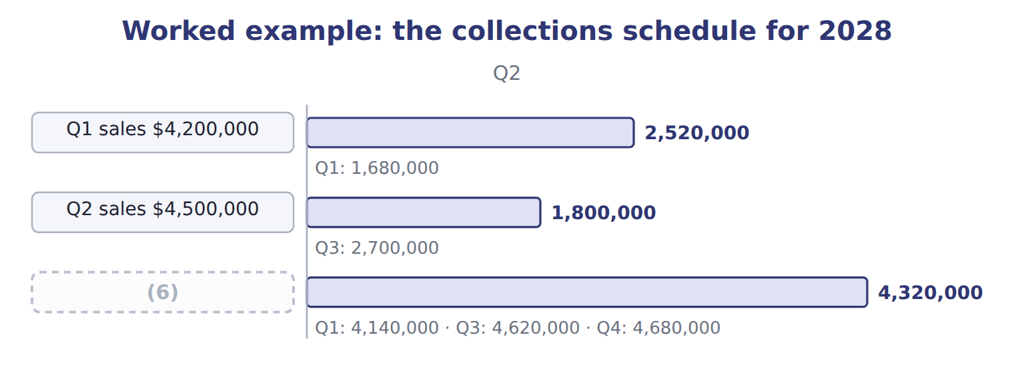
word list
Cash collections · cash disbursements

Summary 3 gaps 7–9
Cash (7) follow the payment terms in the same way. The (8) supplier is paid 50% in the quarter of (9) and the rest in the next; bottles, wages and most expenses are paid as they occur.
word list
disbursements · straight · purchase · concentrate

Concentrate payments by quarter
Name each line from how it moves.
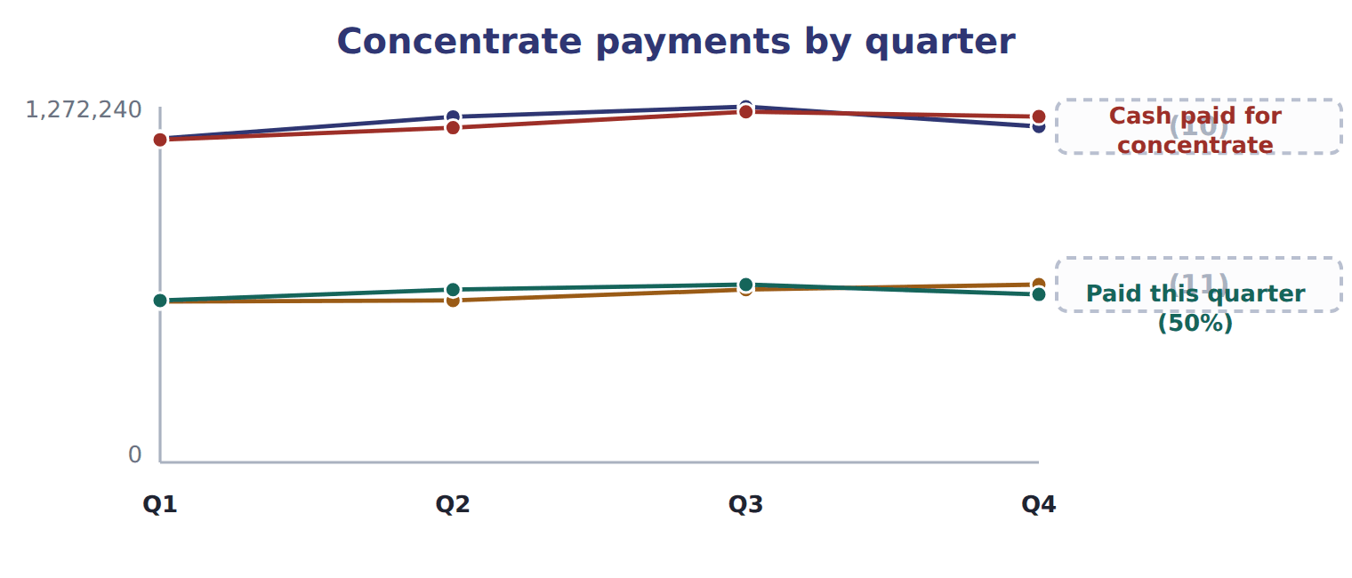
word list
Purchases (Chapter 7) · Paid from last quarter (50%) · Paid this quarter (50%)

Concentrate payments in the third and fourth quarters

Complete the blank cells.
Sales are not collections

Summary 4 gaps 12–13
An answer that puts sales or (12) straight into the cash budget ignores credit and payment terms. Build a collections schedule and a (13) schedule first.
word list
straight · purchases · payments

The English this section uses, and its Arabic
Each term sits against what it means.
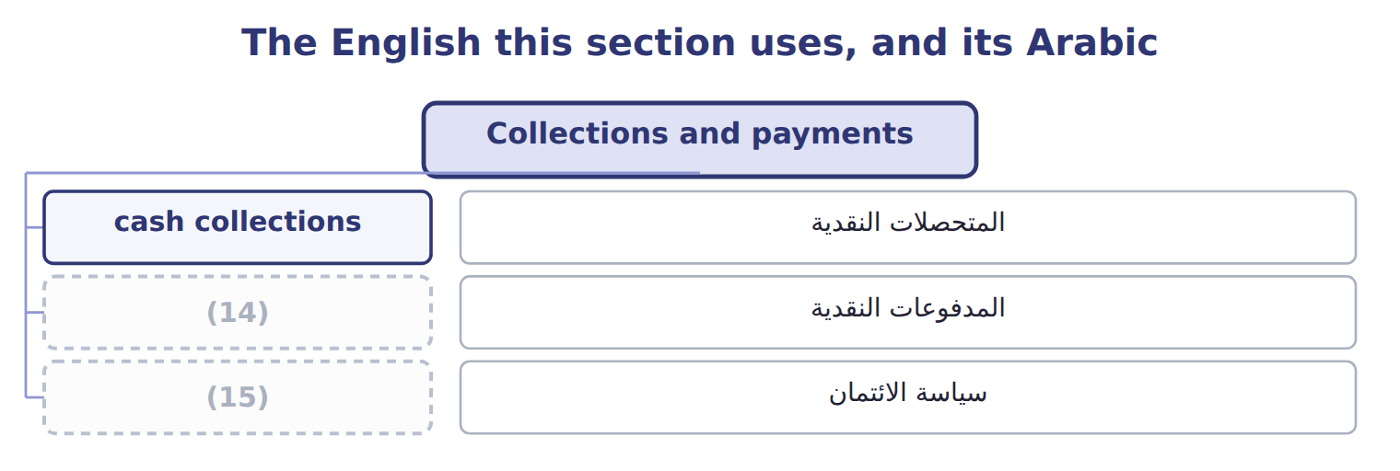
word list
cash disbursements · المتحصلات النقدية · credit policy

The English this sheet uses, and its Arabic
English (exam term) | Arabic
cash collections | المتحصلات النقدية
cash disbursements | المدفوعات النقدية
credit policy | سياسة الائتمان

Answer key · 9.3 Collections and payments

1 policy | 9 purchase
2 Beverages | 10 Purchases (Chapter 7)
3 fourth-quarter | 11 Paid from last quarter (50%)
4 collects | 12 purchases
5 first-quarter | 13 payments
6 Cash collections | 14 cash disbursements
7 disbursements | 15 credit policy
8 concentrate

the summaries in full
Summary 1 Cash collections follow the credit policy, not the sales budget. Beverages collects 40% of each quarter's sales in that quarter and 60% in the next, so the first quarter also collects the rest of last year's fourth-quarter sales.
Summary 2 The first quarter collects $2,460,000 still owed from last year, plus 40% of first-quarter sales of $4,200,000, for a total of $4,140,000.
Summary 3 Cash disbursements follow the payment terms in the same way. The concentrate supplier is paid 50% in the quarter of purchase and the rest in the next; bottles, wages and most expenses are paid as they occur.
Summary 4 An answer that puts sales or purchases straight into the cash budget ignores credit and payment terms. Build a collections schedule and a payments schedule first.

9.4 Preparing the cash budget
Chapter 9 · section 9.4

Fill every gap. Each word list holds one word more than there are gaps.
Summary 1 gaps 1–5
The cash budget has four parts: beginning cash plus collections gives cash available; minus disbursements gives cash before financing; borrowing, interest and (1) give ending cash. (2) keeps a minimum cash (3) of $400,000. (4) costs are left out. Fixed overhead is paid at $300,000 a quarter, not $450,000, because $150,000 of it is depreciation; fixed selling and (5) costs are paid at $550,000.
word list
Non-cash · selling · balance · Management · repayments · administrative

Worked example: the first quarter

Summary 2 gaps 6–7
Cash available $4,640,000 − (6) $5,163,750 = $(523,750) before financing. To stay above the minimum after interest, Beverages (7) $1,000,000 in steps of $100,000; after interest of $20,000, ending cash is $456,250.
word list
quarter · borrows · disbursements

Worked example: the Beverages cash budget for 2028
Beverages cash budget 2028 (USD) | Q1 | Q2 | Q3 | Q4
Beginning cash | 500,000 | 456,250 | 403,470 | 538,920
+ Collections | 4,140,000 | 4,320,000 | 4,620,000 | 4,680,000
= Cash available | 4,640,000 | 4,776,250 | 5,023,470 | 5,218,920
Concentrate | (1,154,150) | (1,197,180) | (1,254,150) | (1,236,870)
Bottles, caps and cartons | (766,800) | (820,800) | (853,200) | (802,800)
Direct labor | (127,800) | (136,800) | (142,200) | (133,800)
(8) | (213,000) | (228,000) | (237,000) | (223,000)
(9) | (300,000) | (300,000) | (300,000) | (300,000)
Variable selling | (252,000) | (270,000) | (288,000) | (270,000)
(10) | (550,000) | (550,000) | (550,000) | (550,000)
Capital expenditure | (1,800,000) | (350,000) | (350,000) | —
(11) | 5,163,750 | 3,852,780 | 3,974,550 | 3,516,470
Cash before financing | (523,750) | 923,470 | 1,048,920 | 1,702,450
+ Borrowing | 1,000,000 | — | — | —
(12) | (20,000) | (20,000) | (10,000) | —
(13) | — | (500,000) | (500,000) | —
(14) | 456,250 | 403,470 | 538,920 | 1,702,450

word list
= Total disbursements · = Ending cash · Fixed selling and admin (cash part) · − Repayment · Variable overhead · Fixed overhead (cash part) · = Cash available · − Interest

By the third quarter, summer collections repay the loan.
The English this sheet uses, and its Arabic
English (exam term) | Arabic
minimum cash balance | الحد الأدنى للرصيد النقدي

Answer key · 9.4 Preparing the cash budget

1 repayments | 8 Variable overhead
2 Management | 9 Fixed overhead (cash part)
3 balance | 10 Fixed selling and admin (cash part)
4 Non-cash | 11 = Total disbursements
5 administrative | 12 − Interest
6 disbursements | 13 − Repayment
7 borrows | 14 = Ending cash

the summaries in full
Summary 1 The cash budget has four parts: beginning cash plus collections gives cash available; minus disbursements gives cash before financing; borrowing, interest and repayments give ending cash. Management keeps a minimum cash balance of $400,000. Non-cash costs are left out. Fixed overhead is paid at $300,000 a quarter, not $450,000, because $150,000 of it is depreciation; fixed selling and administrative costs are paid at $550,000.
Summary 2 Cash available $4,640,000 − disbursements $5,163,750 = $(523,750) before financing. To stay above the minimum after interest, Beverages borrows $1,000,000 in steps of $100,000; after interest of $20,000, ending cash is $456,250.

9.5 Credit and payables policies
Chapter 9 · section 9.5

Fill every gap. Each word list holds one word more than there are gaps.
Summary 1 gaps 1–4
Credit and (1) policies change the (2) of cash, and (3) the borrowing. Collecting faster from customers (4) cash in earlier; paying suppliers faster sends it out earlier. Collecting 50% in the quarter of sale would add $420,000 of cash; paying for concentrate in full at once would take more cash out and raise the loan.
word list
timing · discount · therefore · payables · brings

The effect of credit and payables policies on first-quarter cash
First quarter 2028 (USD) | Budget | Changed policy | Effect on cash
Collections in the first quarter | 4,140,000 | 4,560,000 | (5)
Cash before financing | (523,750) | (103,750) | +420,000
Concentrate paid in the first quarter, if paid 100% at once | 1,154,150 | 1,733,300 | −579,150

word list
+420,000 · cash budget

Summary 2 gaps 6–8
Tighter credit has a cost: customers such as Levant and the (6) may buy less or ask for discounts. Slower payment to suppliers may lose discounts or (7) . The cash budget shows the cash effect; (8) weighs it against these costs.
word list
question · goodwill · supermarkets · management

Policy changes move cash, not profit

Summary 3 gaps 9–11
A change in credit or payment terms (9) when cash arrives or leaves, not the sales or expenses (10) . Unless the question adds a discount or lost sales, (11) income does not change.
word list
themselves · changes · operating · goodwill

Answer key · 9.5 Credit and payables policies

1 payables | 7 goodwill
2 timing | 8 management
3 therefore | 9 changes
4 brings | 10 themselves
5 +420,000 | 11 operating
6 supermarkets

the summaries in full
Summary 1 Credit and payables policies change the timing of cash, and therefore the borrowing. Collecting faster from customers brings cash in earlier; paying suppliers faster sends it out earlier. Collecting 50% in the quarter of sale would add $420,000 of cash; paying for concentrate in full at once would take more cash out and raise the loan.
Summary 2 Tighter credit has a cost: customers such as Levant and the supermarkets may buy less or ask for discounts. Slower payment to suppliers may lose discounts or goodwill. The cash budget shows the cash effect; management weighs it against these costs.
Summary 3 A change in credit or payment terms changes when cash arrives or leaves, not the sales or expenses themselves. Unless the question adds a discount or lost sales, operating income does not change.

9.6 Extended Example 9A: financing the year and handing over to the pro forma statements
Chapter 9 · section 9.6

Fill every gap. Each word list holds one word more than there are gaps.
Summary 1 gaps 1–2
This example (1) the loan through the year and (2) the cash budget as a whole.
word list
follows · checks · minimum

Extended Example: the financing schedule
Name each line from how it moves.
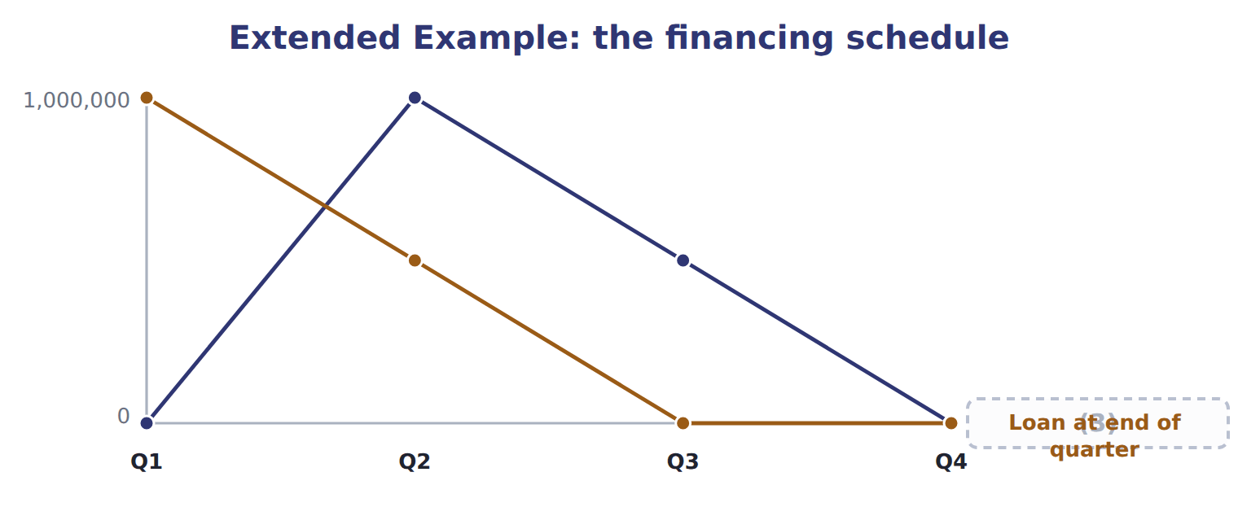
word list
Loan at end of quarter · Loan at start of quarter

Extended Example: the year's cash in one reconciliation
Year 2028 (USD) | Amount
Beginning cash | 500,000
+ Collections | 17,760,000
(4) | (16,507,550)
− Interest | (50,000)
(5) | 1,000,000 − 1,000,000
(6) | 1,702,450

word list
= Ending cash · + Borrowing − repayment · minimum cash balance · − Disbursements

Extended Example: figures passed to the pro forma statements
Item passed to the pro forma statements | Amount | Where it goes
Depreciation left out of cash | $800,000 | Income statement only (Chapters 7–8)
Receivables at year end | $2,700,000 | (7)
Concentrate payable at year end | $600,750 | (8)
Filling line | $2,500,000 | (9)
Cash at year end | $1,702,450 | Balance sheet (Chapter 10)

word list
Collections from the Gulf importer · 60% of fourth-quarter sales · 50% of fourth-quarter purchases · New asset on the balance sheet

Everything ties

Collections $17,760,000 = sales $18,000,000 + opening receivables $2,460,000 − closing receivables $2,700,000.
Exam view

Summary 2 gaps 10–12
Expect sales and purchases with credit terms, a list of (10) including depreciation, a (11) purchase and a minimum cash balance. Build collections and payments, leave out non-cash items, find cash before (12) , and calculate the borrowing, interest and ending cash.
word list
financing · borrowing · capital · expenses

Exam view
Tahini & Spreads, second quarter 2028 | Data
(13) | $1,260,000
Sales: second quarter | $1,330,000
Collected in the quarter of sale | 70%
Sesame purchases: first quarter | $457,500
Sesame purchases: second quarter | $481,000
(14) | 50%
(15) | $0.65
(16) | 382,000
Fixed manufacturing overhead for the quarter | $240,000, including depreciation $60,000
(17) | $38,000
Fixed selling and admin for the quarter | $120,000
New mixer, paid in the second quarter | $150,000
(18) | $300,000
Minimum cash balance | $250,000

word list
Cash at the start of the second quarter · Variable selling for the quarter · Jars produced in the second quarter · New asset on the balance sheet · Jars, labor and variable overhead per jar produced · Sales: first quarter · Sesame paid in the quarter of purchase

Item — Answer
Item | Answer
Q3 | $1,254,150 = 50% of 1,236,060 + 50% of 1,272,240
Q4 | (19)

word list
$1,254,150 = 50% of 1,236,060 + 50% of 1,272,240 · $1,236,870 = 50% of 1,272,240 + 50% of 1,201,500

Item — Category
Every item belongs to exactly one group.
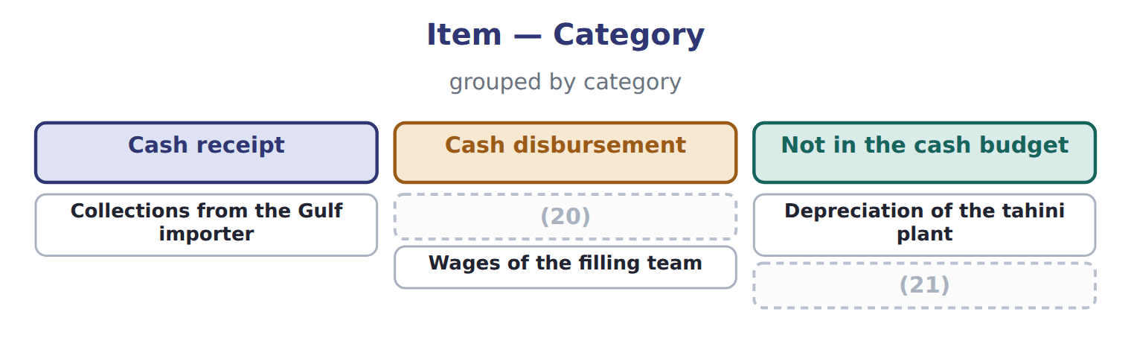
word list
Payment for the new mixer · Sales made but not yet collected · Wages of the filling team

The English this section uses, and its Arabic
Each term sits against what it means.
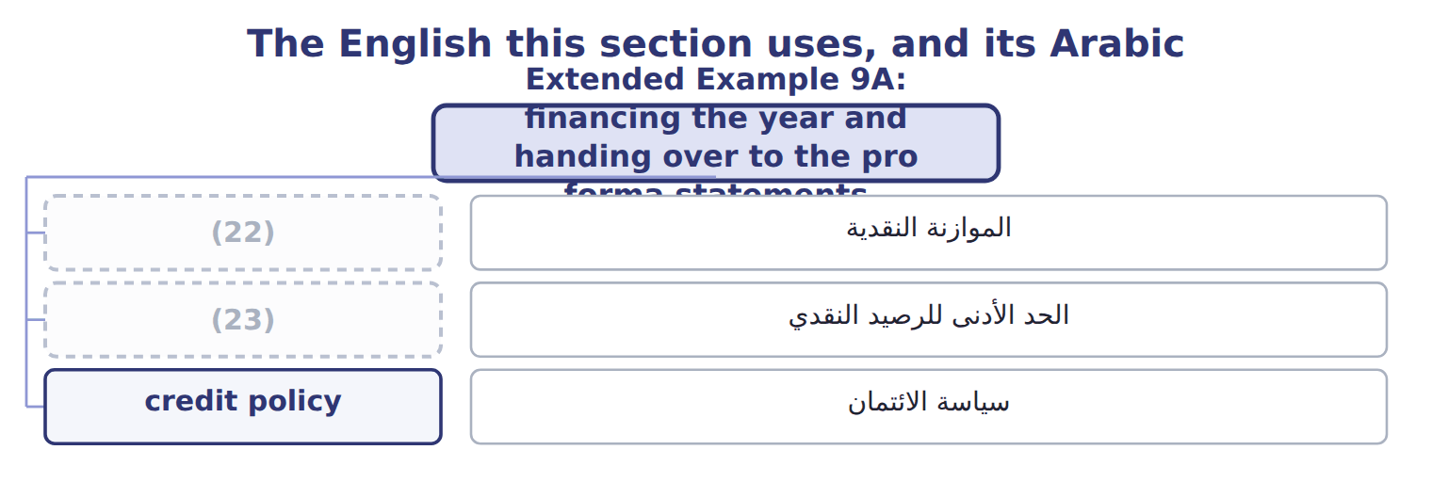
word list
cash budget · الموازنة النقدية · minimum cash balance

The English this sheet uses, and its Arabic
English (exam term) | Arabic
cash budget | الموازنة النقدية
minimum cash balance | الحد الأدنى للرصيد النقدي
credit policy | سياسة الائتمان

Answer key · 9.6 Extended Example 9A: financing the year and handing over to the pro forma statements

1 follows | 13 Sales: first quarter
2 checks | 14 Sesame paid in the quarter of purchase
3 Loan at start of quarter | 15 Jars, labor and variable overhead per jar produced
4 − Disbursements | 16 Jars produced in the second quarter
5 + Borrowing − repayment | 17 Variable selling for the quarter
6 = Ending cash | 18 Cash at the start of the second quarter
7 60% of fourth-quarter sales | 19 $1,236,870 = 50% of 1,272,240 + 50% of 1,201,500
8 50% of fourth-quarter purchases | 20 Payment for the new mixer
9 New asset on the balance sheet | 21 Sales made but not yet collected
10 expenses | 22 cash budget
11 capital | 23 minimum cash balance
12 financing

the summaries in full
Summary 1 This example follows the loan through the year and checks the cash budget as a whole.
Summary 2 Expect sales and purchases with credit terms, a list of expenses including depreciation, a capital purchase and a minimum cash balance. Build collections and payments, leave out non-cash items, find cash before financing, and calculate the borrowing, interest and ending cash.

