10.1 Purpose and relationships
Chapter 10 · section 10.1

Fill every gap. Each word list holds one word more than there are gaps.
Chapter 10, section by section
Each stage leads to the next.
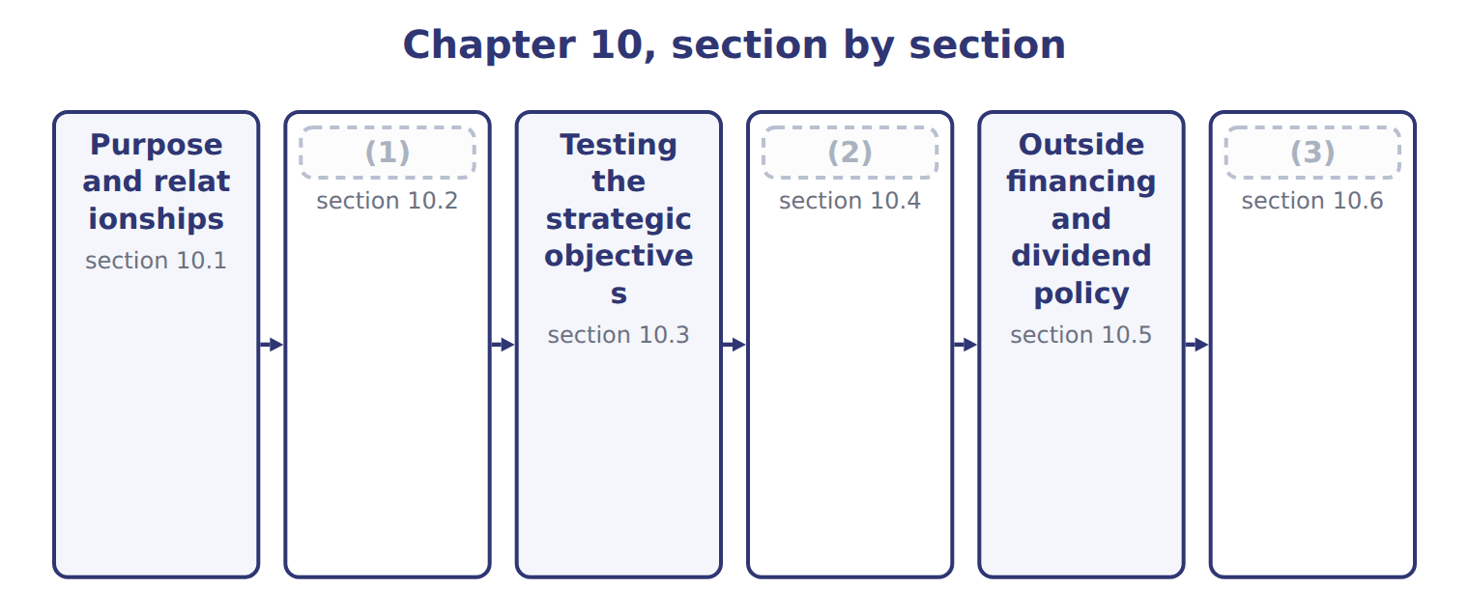
word list
The pro forma balance sheet and statement of c · pro forma statement of cash flows · Extended Example 10A: looking beyond next year · The pro forma income statement and its assumpt

Summary 1 gaps 4–11
Pro forma financial statements show what the financial statements would look like if the plan (4) . The (5) statement shows (6) profit. The pro forma balance sheet shows what the (7) will own and owe, and the pro forma statement of cash flows shows where cash will come from and go. All three come from the same budgets, so they must agree with one (8) . The (9) budgets give profit, the cash budget gives cash, and the (10) budget gives the new asset. The statements are also a last check on the plan. If the balance sheet does not balance, or the cash flow statement does not end at the cash in the cash budget, a schedule (11) is wrong.
word list
planned · capital · income · operating · budgets · somewhere · another · division · happens

The English this section uses, and its Arabic
Each term sits against what it means.
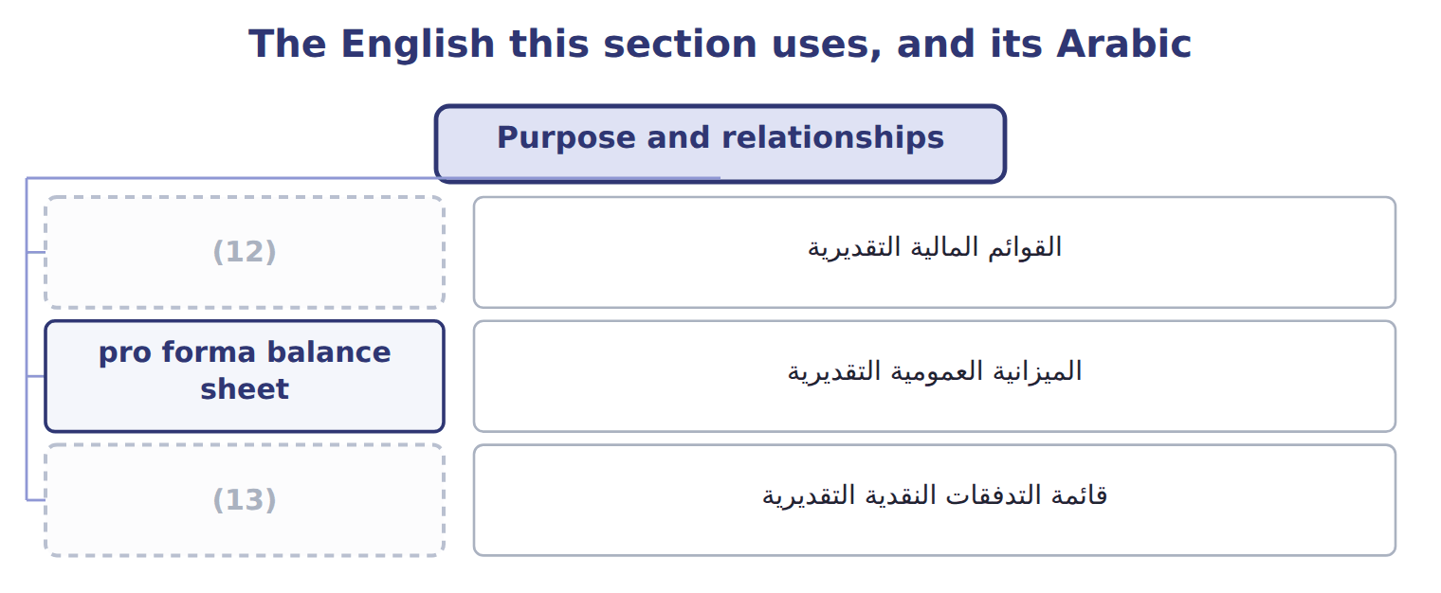
word list
pro forma balance sheet · pro forma statement of cash flows · pro forma financial statements

The English this sheet uses, and its Arabic
English (exam term) | Arabic
pro forma financial statements | القوائم المالية التقديرية
pro forma balance sheet | الميزانية العمومية التقديرية
pro forma statement of cash flows | قائمة التدفقات النقدية التقديرية

Answer key · 10.1 Purpose and relationships

1 The pro forma income statement and its assumpt | 8 another
2 The pro forma balance sheet and statement of c | 9 operating
3 Extended Example 10A: looking beyond next year | 10 capital
4 happens | 11 somewhere
5 income | 12 pro forma financial statements
6 planned | 13 pro forma statement of cash flows
7 division

the summaries in full
Summary 1 Pro forma financial statements show what the financial statements would look like if the plan happens. The income statement shows planned profit. The pro forma balance sheet shows what the division will own and owe, and the pro forma statement of cash flows shows where cash will come from and go. All three come from the same budgets, so they must agree with one another. The operating budgets give profit, the cash budget gives cash, and the capital budget gives the new asset. The statements are also a last check on the plan. If the balance sheet does not balance, or the cash flow statement does not end at the cash in the cash budget, a schedule somewhere is wrong.

10.2 The pro forma income statement and its assumptions
Chapter 10 · section 10.2

Fill every gap. Each word list holds one word more than there are gaps.
The pro forma income statement extends the operating budget.
Worked example: the pro forma income statement for 2028
Pro forma income statement 2028 (USD) | Amount
Sales | 18,000,000
− Cost of goods sold | (11,338,000)
= Gross margin | 6,662,000
− Selling and administrative | (3,480,000)
= Operating income | 3,182,000
(1) | (50,000)
(2) | 3,132,000
(3) | (626,400)
(4) | 2,505,600

word list
− Interest · Total contribution margin · − Income tax at 20% · = Profit before tax · = Net income

Summary 1 gaps 5–7
One plan is not (5) . Sensitivity analysis prepares the statement under other (6) , so that managers know which risks matter. The contribution format: fixed costs stay the same, and only volume or the margin per case (7) .
word list
enough · changes · question · assumptions

Worked example: three more assumptions

Summary 2 gaps 8–9
If volume falls 5%, (8) income falls to $2,811,000. If (9) costs 10% more, the margin falls from $8.20 to $7.66 a case and income to $2,694,000.
word list
operating · changes · concentrate

Operating income under four sets of assumptions
Scenario (USD) | Base plan | Concentrate +10% | Both
Cases sold | 900,000 | 900,000 | 855,000
(10) | $8.20 | $7.66 | $7.66
Total contribution margin | 7,380,000 | 6,894,000 | 6,549,300
(11) | (4,200,000) | (4,200,000) | (4,200,000)
= Operating income | 3,180,000 | 2,694,000 | 2,349,300

word list
pro forma balance sheet · Contribution margin a case · − Fixed costs

Both at once

Complete the last column, where volume falls and concentrate costs more.
Fixed costs stay fixed

Summary 3 gaps 12–14
In a scenario, fixed costs do not change with volume and the (12) cost per unit does not change unless the (13) says so. Changing both at once is the (14) error in sensitivity questions.
word list
statement · question · commonest · variable

The English this sheet uses, and its Arabic
English (exam term) | Arabic
sensitivity analysis | تحليل الحساسية

Answer key · 10.2 The pro forma income statement and its assumptions

1 − Interest | 8 operating
2 = Profit before tax | 9 concentrate
3 − Income tax at 20% | 10 Contribution margin a case
4 = Net income | 11 − Fixed costs
5 enough | 12 variable
6 assumptions | 13 question
7 changes | 14 commonest

the summaries in full
Summary 1 One plan is not enough. Sensitivity analysis prepares the statement under other assumptions, so that managers know which risks matter. The contribution format: fixed costs stay the same, and only volume or the margin per case changes.
Summary 2 If volume falls 5%, operating income falls to $2,811,000. If concentrate costs 10% more, the margin falls from $8.20 to $7.66 a case and income to $2,694,000.
Summary 3 In a scenario, fixed costs do not change with volume and the variable cost per unit does not change unless the question says so. Changing both at once is the commonest error in sensitivity questions.

10.3 Testing the strategic objectives
Chapter 10 · section 10.3

Fill every gap. Each word list holds one word more than there are gaps.
Summary 1 gaps 1–2
A plan is not good merely because it is (1) . It must move the company towards the objectives set in the (2) plan.
word list
profitable · measured · strategic

Testing the plan against the 2028 strategic objectives
Every item belongs to exactly one group.
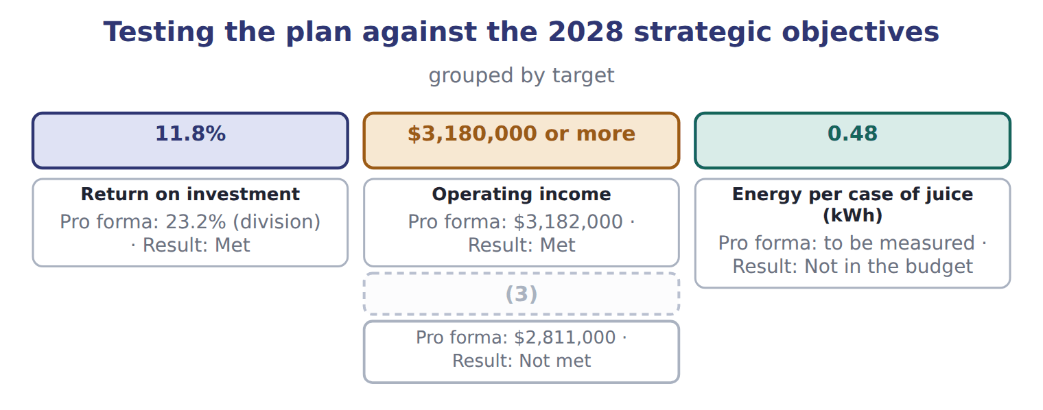
word list
Energy per case of juice (kWh) · Operating income if volume falls 5%

Summary 2 gaps 4–9
The (4) return on investment is 23.2%: net income (5) by average total assets. That is well above the group (6) of 11.8%, as a (7) division with older assets should be. The plan meets the (8) objectives, but not in the (9) where volume falls. Some objectives, such as energy per case, are not measured in money and do not appear in these statements. They are followed through the balanced scorecard.
word list
divided · measured · financial · objective · mature · division's · scenario

Answer key · 10.3 Testing the strategic objectives

1 profitable | 6 objective
2 strategic | 7 mature
3 Operating income if volume falls 5% | 8 financial
4 division's | 9 scenario
5 divided

the summaries in full
Summary 1 A plan is not good merely because it is profitable. It must move the company towards the objectives set in the strategic plan.
Summary 2 The division's return on investment is 23.2%: net income divided by average total assets. That is well above the group objective of 11.8%, as a mature division with older assets should be. The plan meets the financial objectives, but not in the scenario where volume falls. Some objectives, such as energy per case, are not measured in money and do not appear in these statements. They are followed through the balanced scorecard.

10.4 The pro forma balance sheet and statement of cash flows
Chapter 10 · section 10.4

Fill every gap. Each word list holds one word more than there are gaps.
Every line of the pro forma balance sheet comes from a schedule already prepared.
Worked example: the pro forma balance sheet
Pro forma balance sheet (USD) | 1 Jan 2028 | 31 Dec 2028 | Source
Cash | 500,000 | 1,702,450 | Cash budget
Receivables | 2,460,000 | 2,700,000 | Collections schedule
Materials | 115,020 | 117,720 | Materials budget
Finished goods | 529,200 | 541,800 | (1)
Property, plant and equipment | 9,000,000 | 11,500,000 | Capital budget
Accumulated depreciation | (3,400,000) | (4,200,000) | (2)
Total assets | 9,204,220 | 12,361,970
Payables | 575,000 | 600,750 | (3)
Accrued expenses | 240,000 | 240,000 | Unchanged
Income tax payable | — | 626,400 | (4)
Dividends payable | — | 1,002,240 | Dividend policy
Bank loan | — | — | Cash budget
Share capital | 6,000,000 | 6,000,000 | (5)
Retained earnings | 2,389,220 | 3,892,580 | Opening + net income − dividends
Total liabilities and equity | 9,204,220 | 12,361,970

word list
Production budget at standard · Pro forma income statement · Overhead and S&A budgets · Payments schedule · + Depreciation · Unchanged

Summary 1 gaps 6–8
Two new liabilities (6) : the income tax of $626,400 and the dividend of $1,002,240, both (7) for 2028 but paid early in the next year. Total assets of $12,361,970 equal liabilities and equity, as they must. The pro forma statement of cash flows (8) the change in cash.
word list
explains · appear · schedule · declared

Worked example: the pro forma statement of cash flows
Pro forma statement of cash flows 2028 (USD) | Amount
Net income | 2,505,600
+ Depreciation | 800,000
− Increase in receivables | (240,000)
− Increase in inventories | (15,300)
+ Increase in payables | 25,750
(9) | 626,400
(10) | 3,702,450
Purchase of the filling line | (2,500,000)
= Cash used in investing activities | (2,500,000)
Borrowing | 1,000,000
(11) | (1,000,000)
(12) | —
(13) | 1,202,450
(14) | 500,000
Cash at 31 December | 1,702,450

word list
+ Increase in tax payable · Cash at 1 January · Repayment · Net change in cash · = Cash from operating activities · = Cash from financing activities · Total liabilities and equity

Summary 2 gaps 15–16
It ends at $1,702,450, the (15) cash of the cash budget. If the two (16) , there would be an error in one of them.
word list
disagreed · ending · dividend

Depreciation and asset purchases

Summary 3 gaps 17–18
Depreciation is added back in the operating section (17) it reduced profit without using cash. The purchase of the filling line is an investing (18) , not an operating one.
word list
Depreciation · because · outflow

The English this section uses, and its Arabic
Each term sits against what it means.
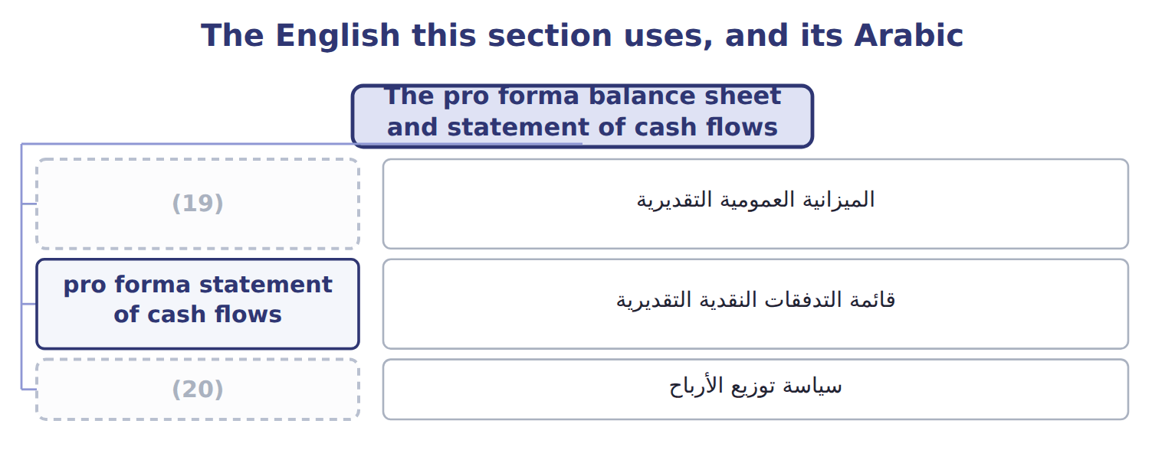
word list
pro forma balance sheet · dividend policy · سياسة توزيع الأرباح

Answer key · 10.4 The pro forma balance sheet and statement of cash flows

1 Production budget at standard | 11 Repayment
2 Overhead and S&A budgets | 12 = Cash from financing activities
3 Payments schedule | 13 Net change in cash
4 Pro forma income statement | 14 Cash at 1 January
5 Unchanged | 15 ending
6 appear | 16 disagreed
7 declared | 17 because
8 explains | 18 outflow
9 + Increase in tax payable | 19 pro forma balance sheet
10 = Cash from operating activities | 20 dividend policy

the summaries in full
Summary 1 Two new liabilities appear: the income tax of $626,400 and the dividend of $1,002,240, both declared for 2028 but paid early in the next year. Total assets of $12,361,970 equal liabilities and equity, as they must. The pro forma statement of cash flows explains the change in cash.
Summary 2 It ends at $1,702,450, the ending cash of the cash budget. If the two disagreed, there would be an error in one of them.
Summary 3 Depreciation is added back in the operating section because it reduced profit without using cash. The purchase of the filling line is an investing outflow, not an operating one.

10.5 Outside financing and dividend policy
Chapter 10 · section 10.5

Fill every gap. Each word list holds one word more than there are gaps.
Required outside financing is what the plan cannot fund from its own cash.
The outside financing the plan requires
Financing need 2028 (USD) | Amount
(1) | 3,702,450
Cash needed for investment | (2,500,000)
Dividends to be paid (next year) | (1,002,240)
(2) | 200,210
Short-term borrowing during the year | 1,000,000
(3) | (1,000,000)
(4) | —

word list
Outside financing needed at the year end · Dividends to be paid (next year) · Cash generated by operations · Cash left over for the year · Repaid during the year

Summary 1 gaps 5–7
The division (5) $1,000,000 during the year but repaid it all, so no outside financing is needed at the year end. The (6) borrowing of, not a funding gap. Dividend policy decides how much of net income leaves the (7) .
word list
decisions · borrowed · business · seasonal

The dividend and retained earnings for 2028
Dividend policy 2028 (USD) | Amount
Net income | 2,505,600
Payout rate | 40%
Dividend | 1,002,240
(8) | 1,503,360
(9) | 2,389,220
Retained earnings at 31 December | 3,892,580

word list
Retained earnings at 1 January · Cash generated by operations · Retained in the division

Summary 2 gaps 10–11
The two (10) are linked. A larger dividend would leave less cash and might force borrowing; a (11) one funds growth but gives owners less now.
word list
smaller · decisions · outside

The English this sheet uses, and its Arabic
English (exam term) | Arabic
required outside financing | التمويل الخارجي المطلوب
dividend policy | سياسة توزيع الأرباح

Answer key · 10.5 Outside financing and dividend policy

1 Cash generated by operations | 7 business
2 Cash left over for the year | 8 Retained in the division
3 Repaid during the year | 9 Retained earnings at 1 January
4 Outside financing needed at the year end | 10 decisions
5 borrowed | 11 smaller
6 seasonal

the summaries in full
Summary 1 The division borrowed $1,000,000 during the year but repaid it all, so no outside financing is needed at the year end. The seasonal borrowing of, not a funding gap. Dividend policy decides how much of net income leaves the business.
Summary 2 The two decisions are linked. A larger dividend would leave less cash and might force borrowing; a smaller one funds growth but gives owners less now.

10.6 Extended Example 10A: looking beyond next year
Chapter 10 · section 10.6

Fill every gap. Each word list holds one word more than there are gaps.
Summary 1 gaps 1–12
The board also asks what cash the division will need up to 2032, the end of the strategic plan. Medium- and long-term forecasts are built (1) from the quarterly cash budget. This example is (2) . A (3) cash budget works from (4) of known orders and invoices. A (5) forecast works from the strategic plan: (6) growth, the investment it needs, and the working capital that grows with sales. Growth: the juice market is (7) , so sales and working capital will keep (8) . Capacity: the plant will reach its limit (9) a few years. Cash: (10) generate $3,702,450 a year at (11) volumes, which funds the current plan but not a second line. The division tells the board that it can fund 2028 from its own cash, but that a second (12) line would need outside financing or a lower dividend. The longer the horizon, the wider the range, so the forecast is given as scenarios rather than one figure.
word list
differently · schedules · operations · filling · recalculate · present · exam-core · medium-term · short-term · planned · within · rising · growing

Everything ties

Summary 2 gaps 13–14
Balance sheet: assets $12,361,970 = (13) $2,469,390 + equity $9,892,580. Cash flows end at $1,702,450, the (14) cash of the.
word list
forecast · ending · liabilities

Exam view

Summary 3 gaps 15–17
Expect to complete a pro forma income statement with interest and tax, and to (15) it under a new (16) . You may also have to find a missing (17) figure, or work out the dividend and the outside financing a plan needs.
word list
assumption · balance-sheet · liabilities · recalculate

Extended Example: factors in a medium- or long-term cash forecast
Factor in a medium- or long-term cash forecast ( | At Orontes
Strategic plan | (18)
Capacity and investment | When the plant reaches its limit and what the next line would cost
Working capital | (19)
Financing and repayment | Loan repayments, interest rates and the dividend policy
Economy and market | Growth, inflation, exchange rates and (20) (Chapters 2–3)
Uncertainty | Scenarios rather than one forecast; the longer the horizon, the wider the range

word list
Receivables, inventory and payables grow with sales · Export and new-product goals to 2032 (Chapter 1) · Category · competitors

Tahini & Spreads, 2028 (USD) — Amount
Tahini & Spreads, 2028 (USD) | Amount
(21) | 1,250,000
(22) | 60,000
Income tax rate | 20%
(23) | 40%
Retained earnings at 1 January 2028 | 1,800,000
(24) | 7,400,000
Total assets at 31 December 2028 | 8,100,000

word list
Interest on the division loan · Total assets at 1 January 2028 · pro forma statement of cash flows · Budgeted operating income · Dividend payout rate

Item — Answer
Item | Answer
Cases and margin | (25)
Contribution margin | $2,349,300 + $4,200,000 fixed costs
Operating income | $2,349,300

word list
pro forma balance sheet · 855,000 cases at $7.66

Item — Category
Item | Category
Income tax expense | Pro forma income statement
Dividends payable | Pro forma balance sheet
Depreciation added back | Pro forma statement of cash flows
Retained earnings | (26)
Purchase of the new mixer | (27)

word list
Pro forma statement of cash flows · Pro forma balance sheet · Total assets at 31 December 2028

The English this section uses, and its Arabic
Each term sits against what it means.
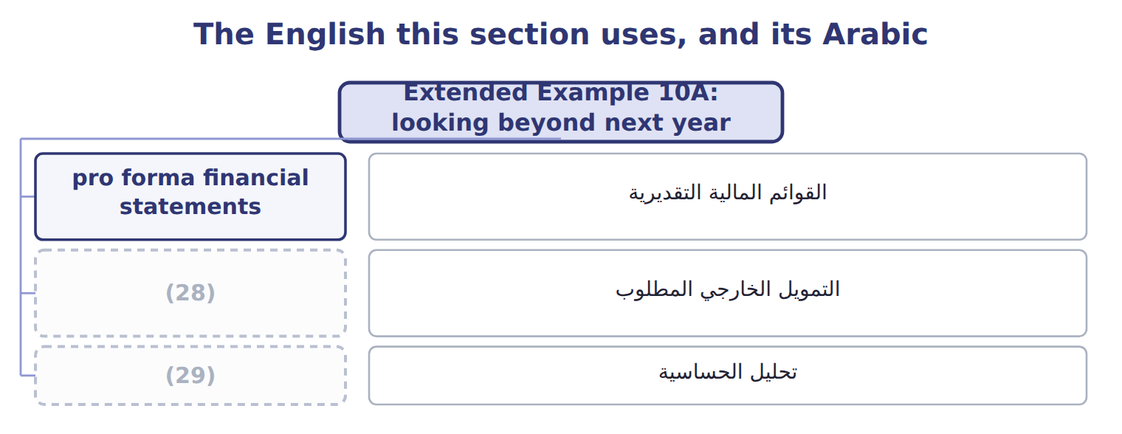
word list
تحليل الحساسية · required outside financing · sensitivity analysis

The English this sheet uses, and its Arabic
English (exam term) | Arabic
pro forma financial statements | القوائم المالية التقديرية
required outside financing | التمويل الخارجي المطلوب
sensitivity analysis | تحليل الحساسية

Answer key · 10.6 Extended Example 10A: looking beyond next year

1 differently | 16 assumption
2 exam-core | 17 balance-sheet
3 short-term | 18 Export and new-product goals to 2032 (Chapter 1)
4 schedules | 19 Receivables, inventory and payables grow with sales
5 medium-term | 20 competitors
6 planned | 21 Budgeted operating income
7 growing | 22 Interest on the division loan
8 rising | 23 Dividend payout rate
9 within | 24 Total assets at 1 January 2028
10 operations | 25 855,000 cases at $7.66
11 present | 26 Pro forma balance sheet
12 filling | 27 Pro forma statement of cash flows
13 liabilities | 28 required outside financing
14 ending | 29 sensitivity analysis
15 recalculate

the summaries in full
Summary 1 The board also asks what cash the division will need up to 2032, the end of the strategic plan. Medium- and long-term forecasts are built differently from the quarterly cash budget. This example is exam-core. A short-term cash budget works from schedules of known orders and invoices. A medium-term forecast works from the strategic plan: planned growth, the investment it needs, and the working capital that grows with sales. Growth: the juice market is growing, so sales and working capital will keep rising. Capacity: the plant will reach its limit within a few years. Cash: operations generate $3,702,450 a year at present volumes, which funds the current plan but not a second line. The division tells the board that it can fund 2028 from its own cash, but that a second filling line would need outside financing or a lower dividend. The longer the horizon, the wider the range, so the forecast is given as scenarios rather than one figure.
Summary 2 Balance sheet: assets $12,361,970 = liabilities $2,469,390 + equity $9,892,580. Cash flows end at $1,702,450, the ending cash of the.
Summary 3 Expect to complete a pro forma income statement with interest and tax, and to recalculate it under a new assumption. You may also have to find a missing balance-sheet figure, or work out the dividend and the outside financing a plan needs.

