12.1 Standard costing and why companies use it
Chapter 12 · section 12.1

Fill every gap. Each word list holds one word more than there are gaps.
Chapter 12, section by section
Each stage leads to the next.
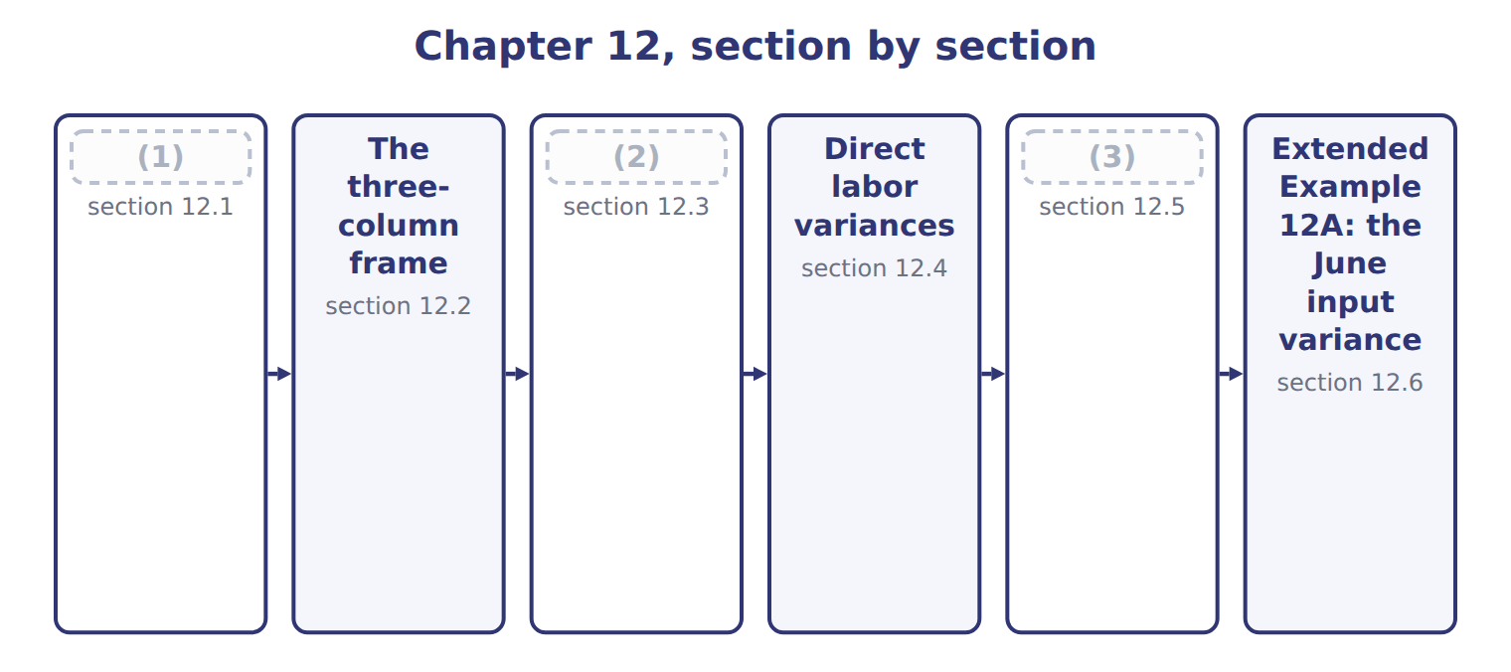
word list
Direct material variances · direct labor efficiency variance · Responsibility and linked variances · Standard costing and why companies use it

Summary 1 gaps 4–7
In a standard costing system, (4) , labor and overhead are recorded at standard cost, and the (5) between standard and actual are recorded as variances. (6) and cost of goods sold (7) carry the same cost for every unit. Together they explain why Orontes keeps standards even though its actual costs are known.
word list
materials · Together · Inventory · therefore · differences

Summary 2 gaps 8–9
The system has costs of its own. Standards must be (8) as prices and methods change, as Book 2, and a standard that is out of date (9) variances that mean nothing.
word list
reviewed · produces · variances

The words this section uses
Each term sits against what it means.
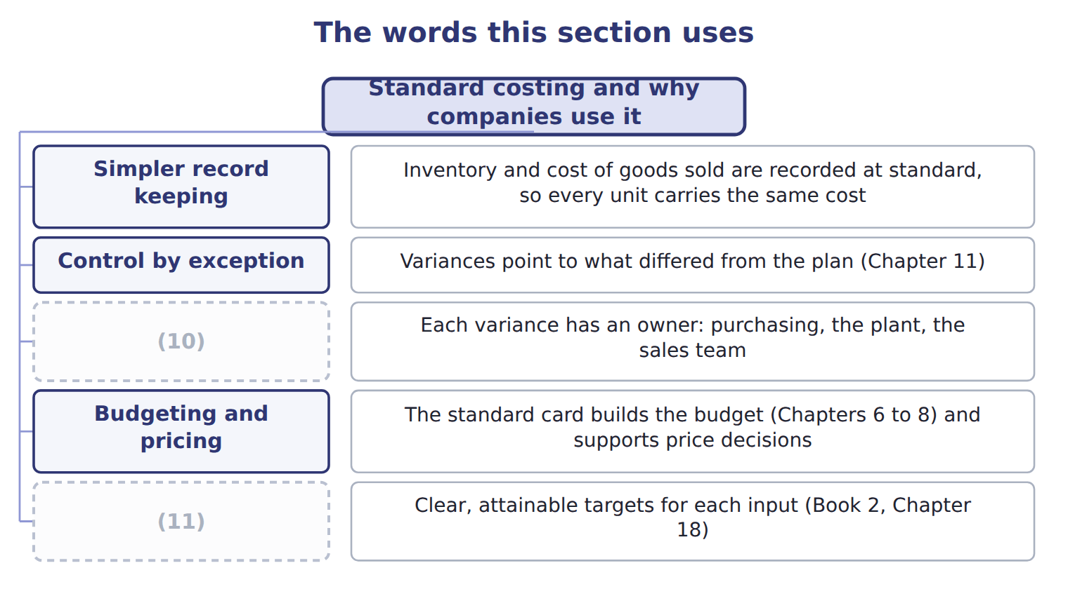
word list
Motivation · Responsibility · standard costing

The English this sheet uses, and its Arabic
English (exam term) | Arabic
standard costing | نظام التكاليف المعيارية

Answer key · 12.1 Standard costing and why companies use it

1 Standard costing and why companies use it | 7 therefore
2 Direct material variances | 8 reviewed
3 Responsibility and linked variances | 9 produces
4 materials | 10 Responsibility
5 differences | 11 Motivation
6 Inventory

the summaries in full
Summary 1 In a standard costing system, materials, labor and overhead are recorded at standard cost, and the differences between standard and actual are recorded as variances. Inventory and cost of goods sold therefore carry the same cost for every unit. Together they explain why Orontes keeps standards even though its actual costs are known.
Summary 2 The system has costs of its own. Standards must be reviewed as prices and methods change, as Book 2, and a standard that is out of date produces variances that mean nothing.

12.2 The three-column frame
Chapter 12 · section 12.2

Fill every gap. Each word list holds one word more than there are gaps.
Summary 1 gaps 1–3
Every input variance uses the same three (1) . The left gap changes only the price, so it is the price or rate variance. The right gap changes only the (2) , so it is the (3) or usage variance.
word list
columns · standard · efficiency · quantity

Formulas for price and efficiency variances
Variance | Formula | Valued at
Material price | (4) | actual quantity bought or used
Material usage | (5) | standard price
Labor rate | (AR − SR) × AH | (6)
Labor efficiency | (AH − SH allowed) × SR | (7)
Total for an input | (8) | both parts together

word list
(AQ − SQ allowed) × SP · (AP − SP) × AQ · standard rate · actual cost − standard cost allowed · actual hours worked · (AH − SH allowed) × SR

Summary 2 gaps 9–11
The standard quantity allowed is the heart of the (9) column: it is the input the standard (10) for the output (11) produced, not for the output planned. In June that is 72,000 cases, not 75,000.
word list
actually · produced · permits · right-hand

The English this sheet uses, and its Arabic
English (exam term) | Arabic
standard quantity allowed | الكمية المعيارية المسموح بها

Answer key · 12.2 The three-column frame

1 columns | 7 standard rate
2 quantity | 8 actual cost − standard cost allowed
3 efficiency | 9 right-hand
4 (AP − SP) × AQ | 10 permits
5 (AQ − SQ allowed) × SP | 11 actually
6 actual hours worked

the summaries in full
Summary 1 Every input variance uses the same three columns. The left gap changes only the price, so it is the price or rate variance. The right gap changes only the quantity, so it is the efficiency or usage variance.
Summary 2 The standard quantity allowed is the heart of the right-hand column: it is the input the standard permits for the output actually produced, not for the output planned. In June that is 72,000 cases, not 75,000.

12.3 Direct material variances
Chapter 12 · section 12.3

Fill every gap. Each word list holds one word more than there are gaps.
The standard allows 6.0 liters a case, so 72,000 cases allow 432,000 liters; the plant used 437,000.
Worked example: concentrate in June

Summary 1 gaps 1–2
Price: ($0.92 − $0.90) × 437,000 (1) = $8,740 unfavorable. Usage: (437,000 − 432,000) × $0.90 = $4,500 unfavorable. (2) $13,240, the figure.
word list
Together · earlier · liters

Worked example: the concentrate variances for June
Concentrate, June 2028 | Amount
Cases produced | 72,000
Standard liters allowed (6.0 a case) | 432,000
Actual liters used | 437,000
Standard price a liter | $0.90
Actual price a liter | $0.92
Price variance | (3)
Usage variance | (4)
Total | 13,240 U

word list
(437,000 − 432,000) × 0.90 = 4,500 U · (0.92 − 0.90) × 437,000 = 8,740 U · $260 of the variance is carried in stock

Summary 2 gaps 5–6
The price variance can be (5) when the material is bought or when it is used. Beverages bought 450,000 liters in June but used 437,000, so the two (6) differ by $260.
word list
reports · conventions · measured

The price variance at purchase and at usage
The bars are drawn to scale.
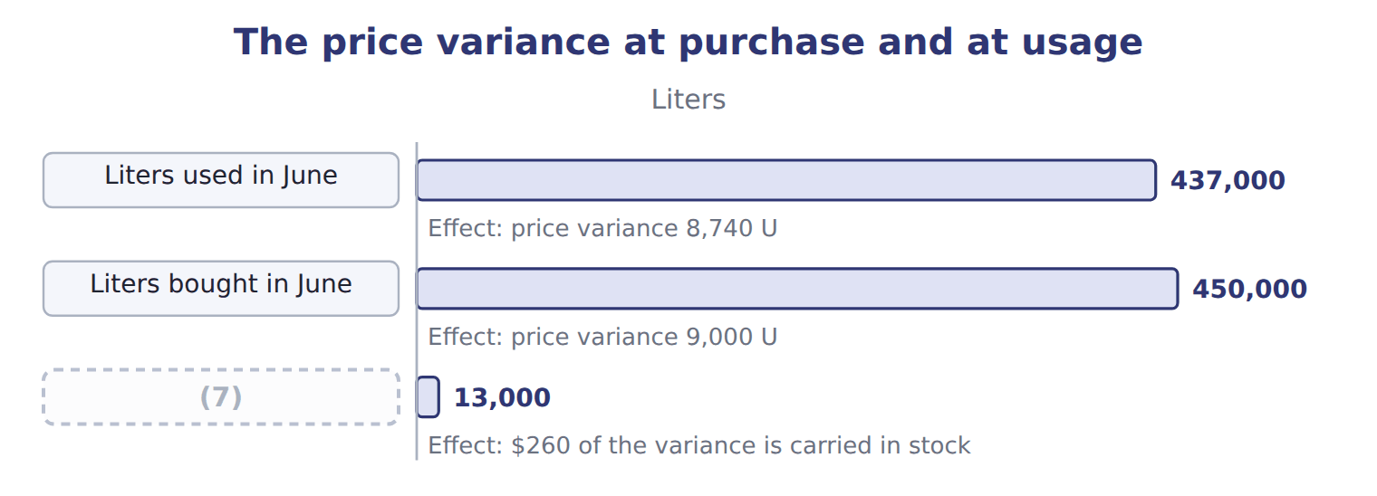
word list
standard costing · Difference

Summary 3 gaps 8–11
Measuring at purchase (8) the variance earlier, which helps (9) act in time, and values the stock at standard. Measuring at usage (10) the variance to the period in which the material was (11) . The exam usually measures at purchase when it gives the quantity bought; otherwise use the quantity used.
word list
matches · purchasing · consumed · usually · reports

Which quantity?

Summary 4 gaps 12–13
The price variance always uses an actual quantity, bought or used; the usage variance always uses the standard price. Using the standard quantity for the price variance, or the actual price for the usage variance, (12) part of the (13) .
word list
double-counts · conventions · difference

The English this sheet uses, and its Arabic
English (exam term) | Arabic
direct material price variance | انحراف سعر المواد المباشرة
direct material usage variance | انحراف استخدام المواد المباشرة

Answer key · 12.3 Direct material variances

1 liters | 8 reports
2 Together | 9 purchasing
3 (0.92 − 0.90) × 437,000 = 8,740 U | 10 matches
4 (437,000 − 432,000) × 0.90 = 4,500 U | 11 consumed
5 measured | 12 double-counts
6 conventions | 13 difference
7 Difference

the summaries in full
Summary 1 Price: ($0.92 − $0.90) × 437,000 liters = $8,740 unfavorable. Usage: (437,000 − 432,000) × $0.90 = $4,500 unfavorable. Together $13,240, the figure.
Summary 2 The price variance can be measured when the material is bought or when it is used. Beverages bought 450,000 liters in June but used 437,000, so the two conventions differ by $260.
Summary 3 Measuring at purchase reports the variance earlier, which helps purchasing act in time, and values the stock at standard. Measuring at usage matches the variance to the period in which the material was consumed. The exam usually measures at purchase when it gives the quantity bought; otherwise use the quantity used.
Summary 4 The price variance always uses an actual quantity, bought or used; the usage variance always uses the standard price. Using the standard quantity for the price variance, or the actual price for the usage variance, double-counts part of the difference.

12.4 Direct labor variances
Chapter 12 · section 12.4

Fill every gap. Each word list holds one word more than there are gaps.
Labor uses the same frame, with hours instead of liters and a wage rate instead of a price.
Worked example: direct labor in June

Rate: ($12.10 − $12.00) × 3,680 hours = $368 unfavorable. Efficiency: (3,680 − 3,600) × $12.00 = $960 unfavorable.
Worked example: the direct labor variances for June
Direct labor, June 2028 | Amount
Cases produced | 72,000
(1) | 3,600
(2) | 3,680
Standard rate an hour | $12.00
(3) | $12.10
Rate variance | (12.10 − 12.00) × 3,680 = 368 U
Efficiency variance | (3,680 − 3,600) × 12.00 = 960 U

word list
Actual hours worked · Standard hours allowed (0.050 a case) · Labor efficiency variance · Actual rate an hour

The labor variances

Complete the blank rows, then do the same for the Tahini division.
Your turn: sesame and labor in the Tahini division
Tahini & Spreads, same month | Standard | Actual
Jars produced | 110,000
Sesame: standard 0.50 kg at $2.50 | 55,000 kg allowed | (4)
Sesame price variance | ________
Sesame usage variance | ________
Labor: standard 0.012 h at $15.00 | (5) | actual 1,350 h at $15.20
Labor rate variance | ________
Labor efficiency variance | ________

word list
actual 56,200 kg at $2.45 · actual 1,350 h at $15.20 · 1,320 h allowed

Summary 1 gaps 6–7
The Tahini figures show a pattern worth noticing: the sesame price variance is (6) while the usage variance is unfavorable. Section 12.5 (7) why the two often move together.
word list
explains · favorable · pattern

The English this sheet uses, and its Arabic
English (exam term) | Arabic
direct labor rate variance | انحراف معدل أجر العمل المباشر
direct labor efficiency variance | انحراف كفاءة العمل المباشر

Answer key · 12.4 Direct labor variances

1 Standard hours allowed (0.050 a case) | 5 1,320 h allowed
2 Actual hours worked | 6 favorable
3 Actual rate an hour | 7 explains
4 actual 56,200 kg at $2.45

the summaries in full
Summary 1 The Tahini figures show a pattern worth noticing: the sesame price variance is favorable while the usage variance is unfavorable. Section 12.5 explains why the two often move together.

12.5 Responsibility and linked variances
Chapter 12 · section 12.5

Fill every gap. Each word list holds one word more than there are gaps.
A variance is useful only if someone can act on it.
Who owns each variance, and why it arises
Every item belongs to exactly one group.
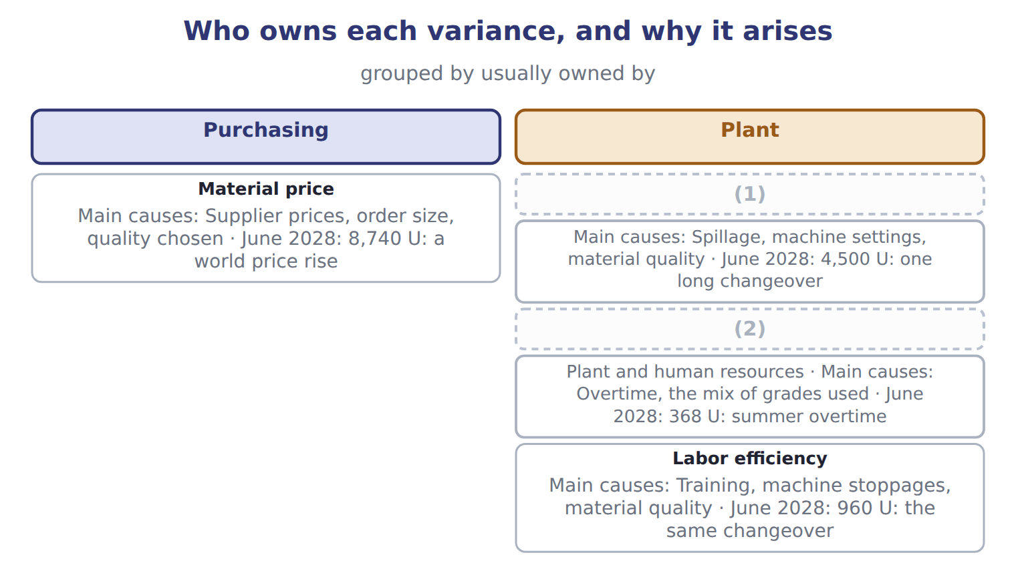
word list
Labor rate · Labor efficiency · Material usage

Summary 1 gaps 3–4
Ownership is a (3) point, not a rule. If (4) buys cheaper, lower-grade concentrate, the price variance is favorable and the usage variance unfavorable, and the plant manager is not to blame.
word list
decision · purchasing · starting

Decisions that move two variances at once
Decision | First effect | Likely second effect
Buying cheaper, lower-grade concentrate | (5) | Usage unfavorable: more spillage and rework
Using less-skilled operators | Rate favorable | (6) : more hours needed
Rushing a delivery by air | (7) | Usage unchanged, but the plant keeps running
Overtime to meet the summer peak | (8) | Efficiency may improve: experienced staff work the extra hours

word list
Price unfavorable · Efficiency unfavorable · Rate unfavorable · Rate favorable · Price favorable

Read the pair, not the single variance

Summary 2 gaps 9–10
A favorable price variance beside an unfavorable usage variance usually points to one decision, not two (9) results. Judging either one alone gives the wrong (10) .
word list
starting · conclusion · separate

Answer key · 12.5 Responsibility and linked variances

1 Material usage | 6 Efficiency unfavorable
2 Labor rate | 7 Price unfavorable
3 starting | 8 Rate unfavorable
4 purchasing | 9 separate
5 Price favorable | 10 conclusion

the summaries in full
Summary 1 Ownership is a starting point, not a rule. If purchasing buys cheaper, lower-grade concentrate, the price variance is favorable and the usage variance unfavorable, and the plant manager is not to blame.
Summary 2 A favorable price variance beside an unfavorable usage variance usually points to one decision, not two separate results. Judging either one alone gives the wrong conclusion.

12.6 Extended Example 12A: the June input variance report
Chapter 12 · section 12.6

Fill every gap. Each word list holds one word more than there are gaps.
Summary 1 gaps 1–2
This example puts the four (1) into the report the division sends to head office. The four (2) come to $14,568 unfavorable.
word list
identified · together · variances

Extended Example: the June input variance report
Every item belongs to exactly one group.
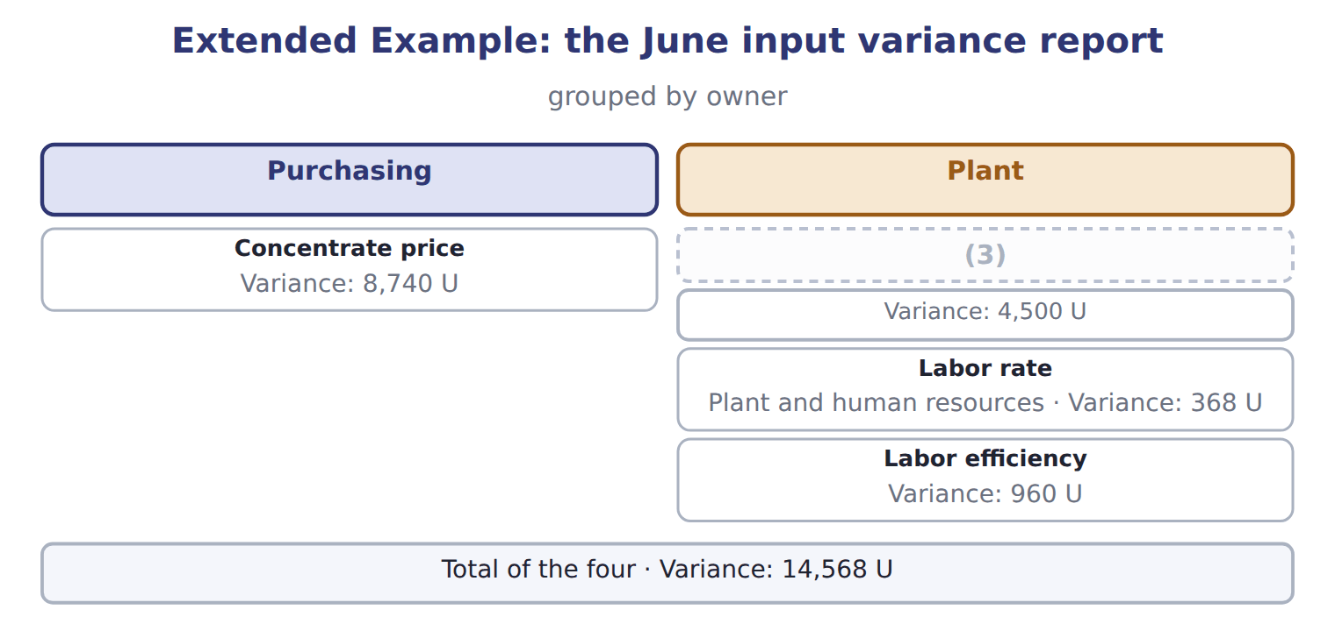
word list
Concentrate usage · Concentrate price

Variance — Category
Every item belongs to exactly one group.
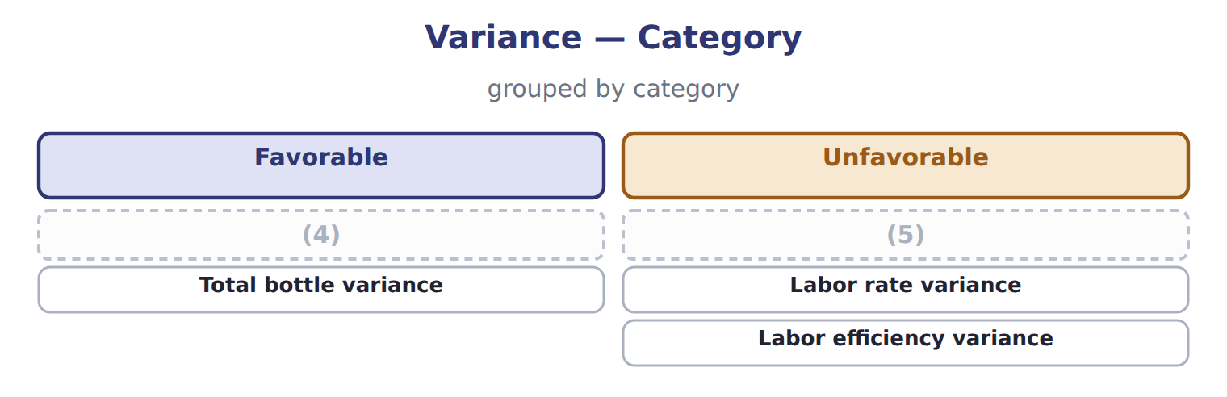
word list
Bottle price variance · Total bottle variance · Bottle usage variance

Summary 2 gaps 6–7
Concentrate (6) the report. Its price variance is outside the (7) control, but the usage variance and the labor efficiency variance share one cause: the long changeover identified.
word list
division's · dominates · quantity

Everything ties

Concentrate $8,740 + $4,500 = $13,240, the concentrate variance. Labor $368 + $960 = $1,328, the labor variance.
Exam view

Summary 3 gaps 8–10
Expect actual quantity, actual price, standard quantity per unit, standard price and the output (8) . (9) the standard quantity (10) first, then the price variance on the actual quantity and the efficiency variance at the standard price.
word list
allowed · Calculate · produced · variances

Exam view
Oils division: EVOO bottling, one month | Data
(11) | 150,000
Standard bottles a liter | 150000 per 150,000 liters
Standard price a bottle | $1.50
(12) | 152,000
Actual price a bottle | $1.47
Bottles bought in the month | 160,000
(13) | 0.075
(14) | $12.00
(15) | 11,500
Actual labor rate | $12.20

word list
Actual labor rate · Standard labor rate · Standard labor hours a liter · Actual hours worked · Liters bottled · Bottles actually used

Item — Answer
Item | Answer
Labor rate variance | ($12.10 − $12.00) × 3,680 = $368 unfavorable
Labor efficiency variance | (3,680 − 3,600) × $12.00 = $960 unfavorable
Tahini sesame price | (16)
Tahini sesame usage | (17)
Tahini labor rate | ($15.20 − $15.00) × 1,350 = $270 unfavorable
Tahini labor efficiency | (18)

word list
($2.45 − $2.50) × 56,200 = $2,810 favorable · (56,200 − 55,000) × $2.50 = $3,000 unfavorable · (3,680 − 3,600) × $12.00 = $960 unfavorable · (1,350 − 1,320) × $15.00 = $450 unfavorable

The English this section uses, and its Arabic
Each term sits against what it means.
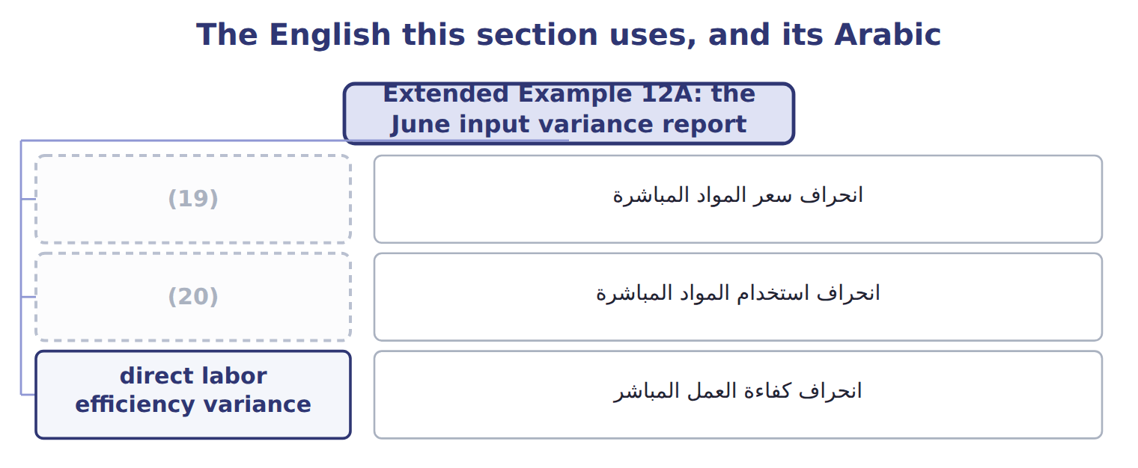
word list
direct material price variance · direct labor efficiency variance · direct material usage variance

The English this sheet uses, and its Arabic
English (exam term) | Arabic
direct material price variance | انحراف سعر المواد المباشرة
direct material usage variance | انحراف استخدام المواد المباشرة
direct labor efficiency variance | انحراف كفاءة العمل المباشر

Answer key · 12.6 Extended Example 12A: the June input variance report

1 variances | 11 Liters bottled
2 together | 12 Bottles actually used
3 Concentrate usage | 13 Standard labor hours a liter
4 Bottle price variance | 14 Standard labor rate
5 Bottle usage variance | 15 Actual hours worked
6 dominates | 16 ($2.45 − $2.50) × 56,200 = $2,810 favorable
7 division's | 17 (56,200 − 55,000) × $2.50 = $3,000 unfavorable
8 produced | 18 (1,350 − 1,320) × $15.00 = $450 unfavorable
9 Calculate | 19 direct material price variance
10 allowed | 20 direct material usage variance

the summaries in full
Summary 1 This example puts the four variances into the report the division sends to head office. The four together come to $14,568 unfavorable.
Summary 2 Concentrate dominates the report. Its price variance is outside the division's control, but the usage variance and the labor efficiency variance share one cause: the long changeover identified.
Summary 3 Expect actual quantity, actual price, standard quantity per unit, standard price and the output produced. Calculate the standard quantity allowed first, then the price variance on the actual quantity and the efficiency variance at the standard price.

