16.1 What a transfer price is for
Chapter 16 · section 16.1

Fill every gap. Each word list holds one word more than there are gaps.
Chapter 16, section by section
Each stage leads to the next.
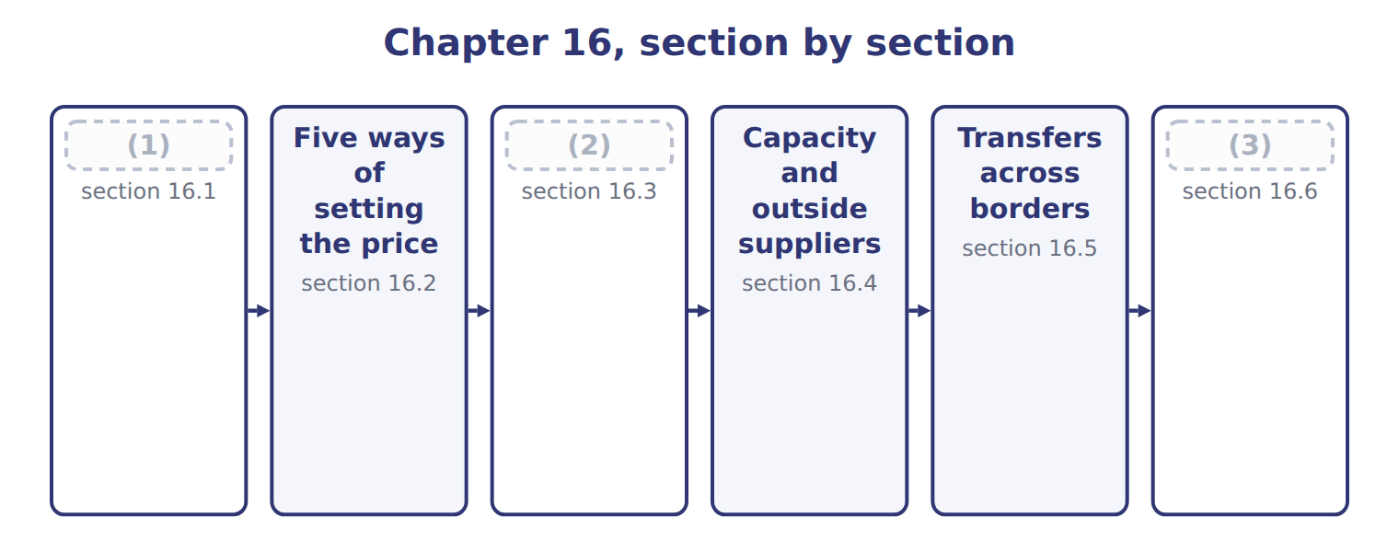
word list
The range: minimum and maximum · Extended Example 16A: raising the Gulf transfe · What a transfer price is for · Five ways of setting the price

Summary 1 gaps 4–8
A transfer price is the price one part of a company (4) another for goods or services supplied (5) . It is revenue to the (6) unit and cost to the buying unit, so the two cancel in the company (7) . (8) it cancels, the transfer price has no direct effect on company profit. Its purpose is to influence decisions and to measure performance fairly.
word list
internally · supplying · Beverages · charges · accounts · Because

Summary 2 gaps 9–11
The (9) can conflict. A price that gives Levant a fair margin may be high enough to push (10) towards an outside carrier. The rest of the chapter works out where the price (11) sit.
word list
Beverages · charges · objectives · should

The words this section uses
Each term sits against what it means, and an instance of it.
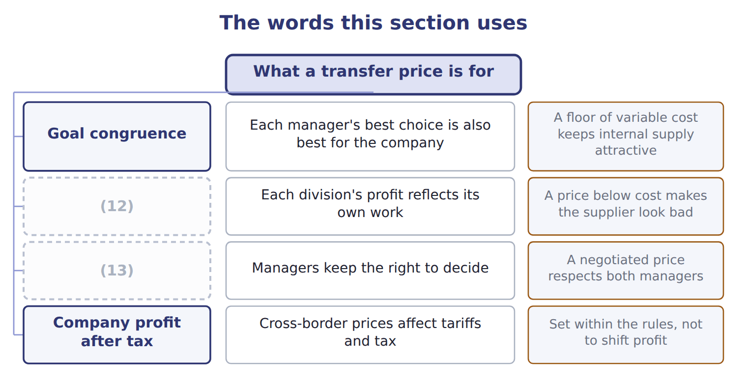
word list
dual-rate transfer pricing · Fair performance evaluation · Divisional autonomy

The English this sheet uses, and its Arabic
English (exam term) | Arabic
transfer price | سعر التحويل

Answer key · 16.1 What a transfer price is for

1 What a transfer price is for | 8 Because
2 The range: minimum and maximum | 9 objectives
3 Extended Example 16A: raising the Gulf transfe | 10 Beverages
4 charges | 11 should
5 internally | 12 Fair performance evaluation
6 supplying | 13 Divisional autonomy
7 accounts

the summaries in full
Summary 1 A transfer price is the price one part of a company charges another for goods or services supplied internally. It is revenue to the supplying unit and cost to the buying unit, so the two cancel in the company accounts. Because it cancels, the transfer price has no direct effect on company profit. Its purpose is to influence decisions and to measure performance fairly.
Summary 2 The objectives can conflict. A price that gives Levant a fair margin may be high enough to push Beverages towards an outside carrier. The rest of the chapter works out where the price should sit.

16.2 Five ways of setting the price
Chapter 16 · section 16.2

Fill every gap. Each word list holds one word more than there are gaps.
Summary 1 gaps 1–3
Companies set transfer (1) in five ways: at the supplier's variable cost, at its full cost, at the market price, at a price the two managers (2) , or at two (3) rates for the two sides.
word list
different · variable · negotiate · prices

Five methods of setting a transfer price
Method (C.2.i) | Price a case | Advantages | Disadvantages
Variable cost | $0.50 | Leads to the right decision for the company | (4)
Full cost | $0.80 | (5) | Fixed cost looks variable to the buyer, so it can refuse good internal business
Market price | $1.10 | Fair to both; good when a competitive market exists | No market price for many internal services; ignores savings on internal trade
Negotiated | $0.90 | (6) | Takes time; the better negotiator wins
Dual rate | (7) | Both divisions see the price that leads to the right decision | The two sides do not add up; the difference must be removed on consolidation

word list
Respects autonomy; managers know their own costs · Simple; covers the supplier's costs · Supplier earns nothing; looks like a poor performer · $1.10 / $0.50 · Takes time; the better negotiator wins

Worked example: the same year at five prices

Summary 2 gaps 8–9
Beverages needs 900,000 cases (8) . At (9) cost Levant earns nothing on the work and Beverages keeps $6,930,000; at market price Levant earns $540,000.
word list
variable · something · delivered

Worked example: the same year at five transfer prices
Transfer price for 900,000 cases | Price | Levant | Beverages | Company
Variable cost | $0.50 | 0 | 6,930,000 | 6,930,000
(10) | $0.80 | 270,000 | 6,660,000 | 6,930,000
Negotiated | $0.90 | 360,000 | 6,570,000 | 6,930,000
(11) | $1.10 | 540,000 | 6,390,000 | 6,930,000
(12) | $1.10 / $0.50 | 540,000 | 6,930,000 | 6,930,000

word list
Variable cost · Market price · Dual rate · Full cost

The negotiated and market prices

Summary 3 gaps 13–15
Complete the blank cells. (13) transfer pricing (14) Levant with the market price and charges Beverages only the variable cost, so each manager faces the figure that leads to the right decision. The $540,000 difference is removed when the divisions are added (15) .
word list
together · Dual-rate · credits · removed

The company column never moves

Summary 4 gaps 16–20
Changing a transfer price moves profit (16) divisions. If an answer shows the company better or worse off (17) of the price alone, something has been (18) . No method is right (19) . A market price suits a product with an outside market, a negotiated price suits one without, and dual rates suit a case where the right decision and fair (20) pull apart.
word list
double-counted · pricing · between · everywhere · because · reporting

The English this section uses, and its Arabic
Each term sits against what it means.
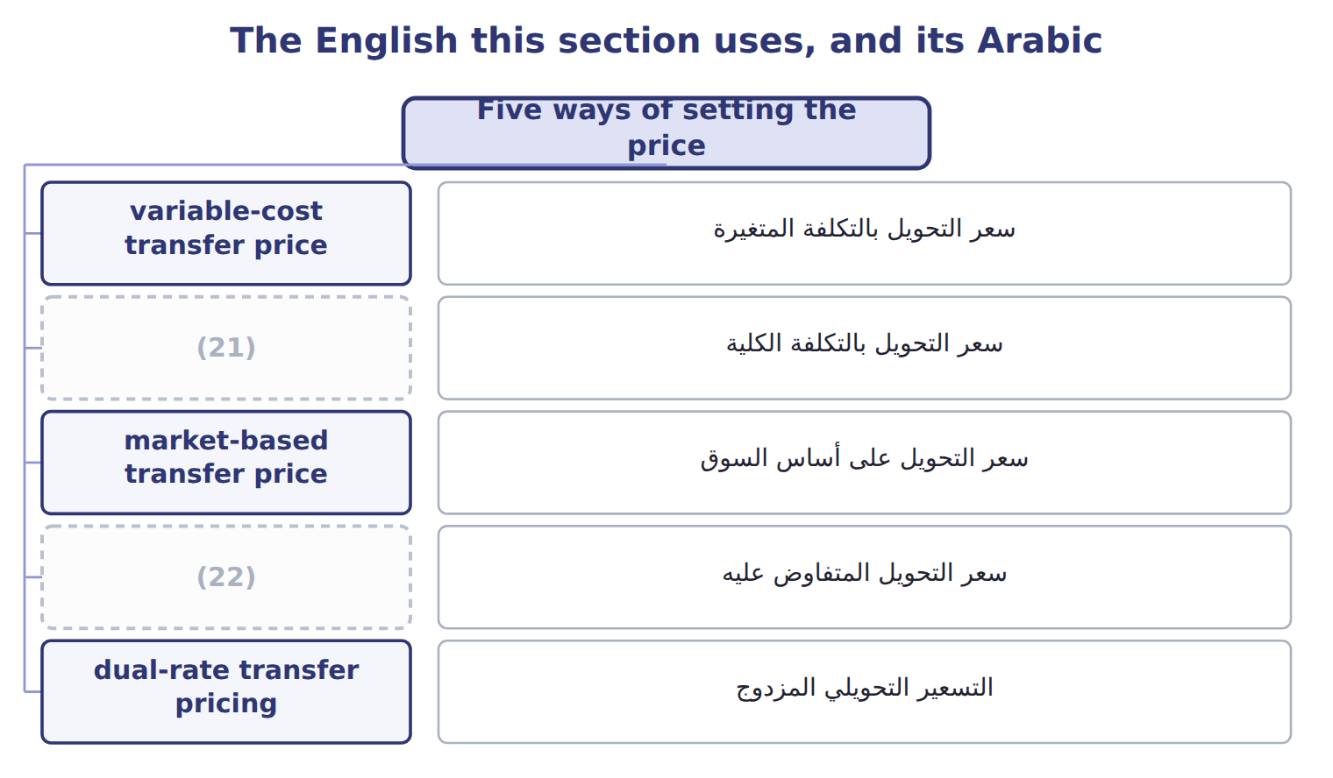
word list
التسعير التحويلي المزدوج · full-cost transfer price · negotiated transfer price

The English this sheet uses, and its Arabic
English (exam term) | Arabic
variable-cost transfer price | سعر التحويل بالتكلفة المتغيرة
full-cost transfer price | سعر التحويل بالتكلفة الكلية
market-based transfer price | سعر التحويل على أساس السوق
negotiated transfer price | سعر التحويل المتفاوض عليه
dual-rate transfer pricing | التسعير التحويلي المزدوج

Answer key · 16.2 Five ways of setting the price

1 prices | 12 Dual rate
2 negotiate | 13 Dual-rate
3 different | 14 credits
4 Supplier earns nothing; looks like a poor performer | 15 together
5 Simple; covers the supplier's costs | 16 between
6 Respects autonomy; managers know their own costs | 17 because
7 $1.10 / $0.50 | 18 double-counted
8 delivered | 19 everywhere
9 variable | 20 reporting
10 Full cost | 21 full-cost transfer price
11 Market price | 22 negotiated transfer price

the summaries in full
Summary 1 Companies set transfer prices in five ways: at the supplier's variable cost, at its full cost, at the market price, at a price the two managers negotiate, or at two different rates for the two sides.
Summary 2 Beverages needs 900,000 cases delivered. At variable cost Levant earns nothing on the work and Beverages keeps $6,930,000; at market price Levant earns $540,000.
Summary 3 Complete the blank cells. Dual-rate transfer pricing credits Levant with the market price and charges Beverages only the variable cost, so each manager faces the figure that leads to the right decision. The $540,000 difference is removed when the divisions are added together.
Summary 4 Changing a transfer price moves profit between divisions. If an answer shows the company better or worse off because of the price alone, something has been double-counted. No method is right everywhere. A market price suits a product with an outside market, a negotiated price suits one without, and dual rates suit a case where the right decision and fair reporting pull apart.

16.3 The range: minimum and maximum
Chapter 16 · section 16.3

Fill every gap. Each word list holds one word more than there are gaps.
Summary 1 gaps 1–4
The minimum transfer price is what the supplier must (1) to be no worse off: variable cost plus the opportunity cost of (2) it gives up. The maximum is what the buyer could pay outside. When the minimum is below the maximum, a range exists and any price inside it leaves both (3) better off. When the minimum is above the maximum, the company should not transfer (4) .
word list
internally · divisions · supplier · receive · anything

The minimum and maximum transfer price
Rule (C.2.j) | Formula | Levant and Beverages
Minimum (the supplier will not go below) | (5) | $0.50 with spare capacity; $1.10 at full capacity
Maximum (the buyer will not go above) | (6) | $1.00 from the outside carrier
If minimum is below maximum | (7) | $0.50 to $1.00 with spare capacity
If minimum is above maximum | no internal transfer should happen | (8)

word list
the price of buying outside · variable cost + opportunity cost · $0.50 with spare capacity; $1.10 at full capacity · a range exists; any price inside it suits both · At full capacity, because $1.10 is above $1.00

The English this sheet uses, and its Arabic
English (exam term) | Arabic
minimum transfer price | الحد الأدنى لسعر التحويل

Answer key · 16.3 The range: minimum and maximum

1 receive | 5 variable cost + opportunity cost
2 anything | 6 the price of buying outside
3 divisions | 7 a range exists; any price inside it suits both
4 internally | 8 At full capacity, because $1.10 is above $1.00

the summaries in full
Summary 1 The minimum transfer price is what the supplier must receive to be no worse off: variable cost plus the opportunity cost of anything it gives up. The maximum is what the buyer could pay outside. When the minimum is below the maximum, a range exists and any price inside it leaves both divisions better off. When the minimum is above the maximum, the company should not transfer internally.

16.4 Capacity and outside suppliers
Chapter 16 · section 16.4

Fill every gap. Each word list holds one word more than there are gaps.
Everything turns on the opportunity cost, and that depends on capacity.
Worked example: the outside carrier's offer

Summary 1 gaps 1–2
An outside (1) offers Beverages $1.00 a case. With spare capacity, the company's real cost of (2) inside is only $0.50, so going outside would cost $450,000 a year. At full capacity the real cost is $1.10, so going outside would save $90,000.
word list
delivering · carrier · transfer

Worked example: should Beverages use the outside carrier?
Situation | Company's cost of supplying inside | Outside offer | Effect of buying outside
Levant has spare capacity | $0.50 | $1.00 | (3) : supply inside
Levant is at full capacity | $1.10 | $1.00 | Company gains $90,000: buy outside

word list
Company loses $450,000 · minimum transfer price

Summary 2 gaps 4–6
This is why a (4) transfer price can (5) . At $0.80 a case, Beverages sees a cost above the outside offer and refuses (6) supply, even though the company is better off supplying inside whenever Levant has spare capacity.
word list
mislead · internal · contribution · full-cost

Ask about capacity first

Summary 3 gaps 7–9
The (7) transfer price cannot be found without knowing whether the (8) has spare capacity. With spare capacity there is no opportunity cost; at capacity the opportunity cost is the lost (9) margin.
word list
minimum · contribution · Everything · supplier

The English this section uses, and its Arabic
Each term sits against what it means.
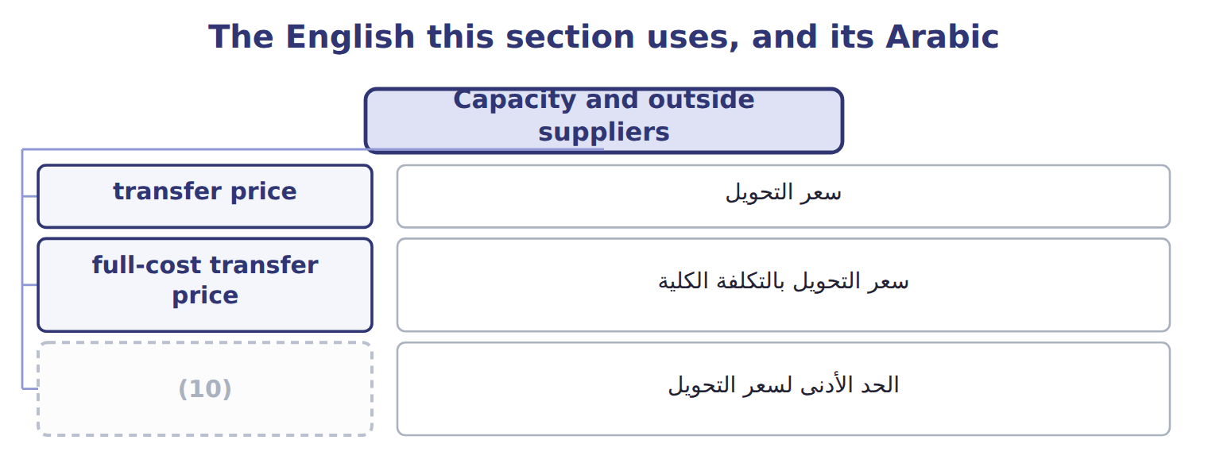
word list
market-based transfer price · minimum transfer price

Answer key · 16.4 Capacity and outside suppliers

1 carrier | 6 internal
2 delivering | 7 minimum
3 Company loses $450,000 | 8 supplier
4 full-cost | 9 contribution
5 mislead | 10 minimum transfer price

the summaries in full
Summary 1 An outside carrier offers Beverages $1.00 a case. With spare capacity, the company's real cost of delivering inside is only $0.50, so going outside would cost $450,000 a year. At full capacity the real cost is $1.10, so going outside would save $90,000.
Summary 2 This is why a full-cost transfer price can mislead. At $0.80 a case, Beverages sees a cost above the outside offer and refuses internal supply, even though the company is better off supplying inside whenever Levant has spare capacity.
Summary 3 The minimum transfer price cannot be found without knowing whether the supplier has spare capacity. With spare capacity there is no opportunity cost; at capacity the opportunity cost is the lost contribution margin.

16.5 Transfers across borders
Chapter 16 · section 16.5

Fill every gap. Each word list holds one word more than there are gaps.
Summary 1 gaps 1–2
Orontes sells to the Gulf through a (1) it part-owns, so some (2) cross a border.
word list
distributor · transfers · part-owns

Issues in a cross-border transfer
Issue (C.2.l) | Effect on the transfer price | At Orontes
Tariffs | A higher transfer price raises the duty paid at the border | (3)
Income taxes | Profit is taxed where it is reported | Jordan 20%, the Gulf buyer 10%
Exchange rates | A price fixed in one (4) moves the profit when rates change | The dinar is pegged to the dollar; Gulf currencies are not
Currency restrictions | Cash may not be (5) , so a high price traps profit abroad | Watch controls on moving funds out
Expropriation risk | Assets or balances in a country may be seized | (6)
Availability of materials and skills | A division may have to buy inside because nothing else is available | (7)

word list
remittable · currency · Keep balances low where the risk is high · 5% on the Gulf shipment · dual-rate transfer pricing · Specialist bottling in Jordan

Summary 2 gaps 8–14
Tax and tariffs pull in opposite (8) . A higher transfer price moves profit to the (9) country and cuts tax if the rate there is lower. It also raises the duty paid at the border, because duty is (10) on the invoice value. Tax (11) also set rules. A transfer price must be (12) as one that unrelated parties would have agreed, and (13) is usually required. A price chosen only to move profit invites (14) and penalties.
word list
charged · buying · adjustment · usually · directions · defensible · documentation · authorities

The English this sheet uses, and its Arabic
English (exam term) | Arabic
expropriation risk | مخاطر المصادرة

Answer key · 16.5 Transfers across borders

1 distributor | 8 directions
2 transfers | 9 buying
3 5% on the Gulf shipment | 10 charged
4 currency | 11 authorities
5 remittable | 12 defensible
6 Keep balances low where the risk is high | 13 documentation
7 Specialist bottling in Jordan | 14 adjustment

the summaries in full
Summary 1 Orontes sells to the Gulf through a distributor it part-owns, so some transfers cross a border.
Summary 2 Tax and tariffs pull in opposite directions. A higher transfer price moves profit to the buying country and cuts tax if the rate there is lower. It also raises the duty paid at the border, because duty is charged on the invoice value. Tax authorities also set rules. A transfer price must be defensible as one that unrelated parties would have agreed, and documentation is usually required. A price chosen only to move profit invites adjustment and penalties.

16.6 Extended Example 16A: raising the Gulf transfer price
Chapter 16 · section 16.6

Fill every gap. Each word list holds one word more than there are gaps.
Summary 1 gaps 1–3
This example works out whether a (1) price rise is worth (2) . The (3) team proposes raising the price on 100,000 units by $0.20, moving $20,000 of profit from Jordan, taxed at 20%, to the Gulf buyer, taxed at 10%.
word list
finance · statement · proposed · making

Extended Example: the tax and tariff effect of a higher Gulf price
Raising the Gulf transfer price (USD) | Amount
Profit (4) by raising the price $0.20 on 100,000 units | 20,000
Tax saved: 20% − 10% | 2,000
(5) | (1,000)
Net effect | 1,000

word list
Net effect · shifted · Extra tariff at 5%

Summary 2 gaps 6–9
The gain is small, and it depends entirely on the price still being (6) to both tax (7) . The (8) advises against (9) the price for tax reasons alone. The net gain is $1,000 against the risk of an adjustment, and the Gulf currency and remittance rules could trap the extra profit abroad.
word list
whether · authorities · changing · defensible · controller

Everything ties

Summary 3 gaps 10–11
Company (10) on internal (11) is $6,930,000 at every transfer price. Tax saved $2,000 − duty $1,000 = $1,000.
word list
reasons · delivery · contribution

Exam view

Summary 4 gaps 12–14
Expect a supplying division's variable and full cost, an outside market price, an outside offer to the buyer, and a statement about capacity. Find the (12) and the maximum, say whether a range (13) , and state what the company (14) do.
word list
minimum · exists · should · adjustment

Exam view
Oils and Tahini & Spreads, one year | Data
(15) | 200,000
(16) | $1.80
(17) | $0.70
Price Oils charges outside customers | $3.00
Price an outside supplier offers Tahini & Spreads | $2.70
Liters Oils can supply without giving up outside sales | 120,000

word list
Liters of pressed oil needed by Tahini & Spreads · Oils fixed cost a liter at normal volume · Oils variable cost a liter · The transfer price changes which division reports the profit

Item — Answer
Item | Answer
Negotiated price | Levant $360,000; (18) $6,570,000; company $6,930,000
Market price | Levant $540,000; Beverages $6,390,000; company $6,930,000

word list
Beverages · Data

Statement — Category
Statement | Category
The transfer price changes which division reports the profit | (19)
Supplying from idle capacity costs the company only the variable cost | True for the company
A higher transfer price raises the supplying division's profit | (20)
Buying outside at a price above the company's incremental cost wastes cash | True for the company
A higher transfer price lowers the buying division's profit | True only for one division

word list
True for the company · True only for one division · Oils variable cost a liter

The English this section uses, and its Arabic
Each term sits against what it means.
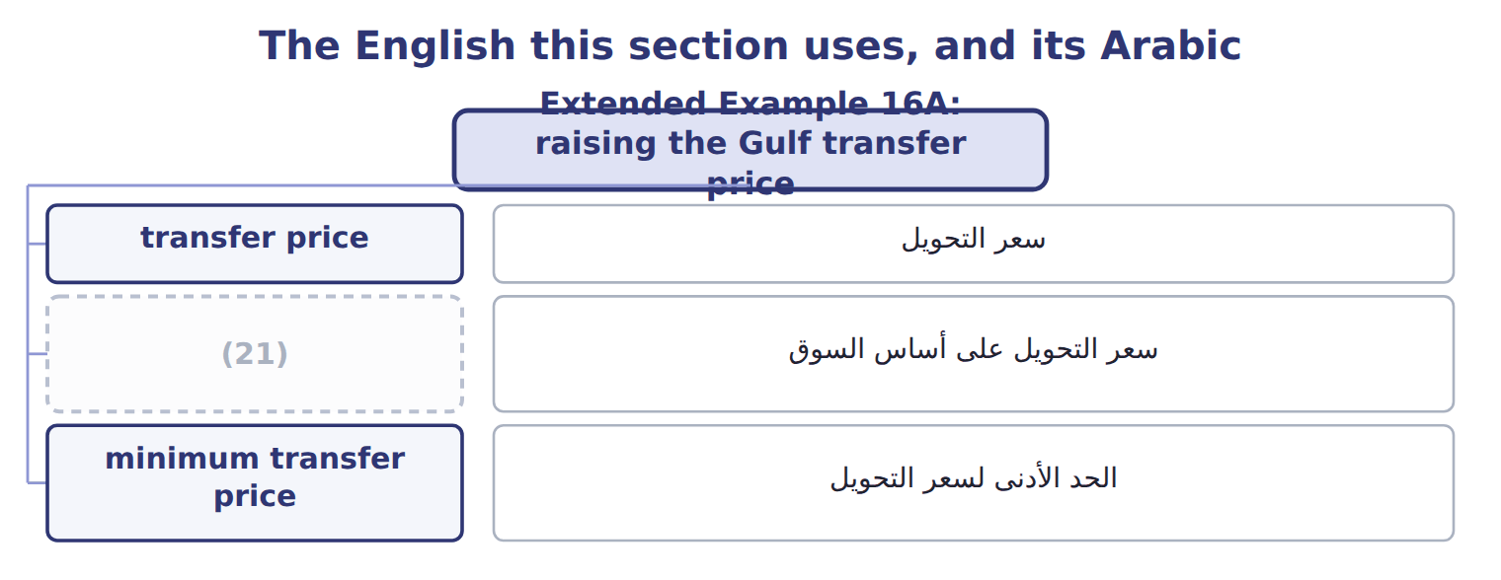
word list
market-based transfer price · variable-cost transfer price

The English this sheet uses, and its Arabic
English (exam term) | Arabic
transfer price | سعر التحويل
market-based transfer price | سعر التحويل على أساس السوق
minimum transfer price | الحد الأدنى لسعر التحويل

Answer key · 16.6 Extended Example 16A: raising the Gulf transfer price

1 proposed | 12 minimum
2 making | 13 exists
3 finance | 14 should
4 shifted | 15 Liters of pressed oil needed by Tahini & Spreads
5 Extra tariff at 5% | 16 Oils variable cost a liter
6 defensible | 17 Oils fixed cost a liter at normal volume
7 authorities | 18 Beverages
8 controller | 19 True for the company
9 changing | 20 True only for one division
10 contribution | 21 market-based transfer price
11 delivery

the summaries in full
Summary 1 This example works out whether a proposed price rise is worth making. The finance team proposes raising the price on 100,000 units by $0.20, moving $20,000 of profit from Jordan, taxed at 20%, to the Gulf buyer, taxed at 10%.
Summary 2 The gain is small, and it depends entirely on the price still being defensible to both tax authorities. The controller advises against changing the price for tax reasons alone. The net gain is $1,000 against the risk of an adjustment, and the Gulf currency and remittance rules could trap the extra profit abroad.
Summary 3 Company contribution on internal delivery is $6,930,000 at every transfer price. Tax saved $2,000 − duty $1,000 = $1,000.
Summary 4 Expect a supplying division's variable and full cost, an outside market price, an outside offer to the buyer, and a statement about capacity. Find the minimum and the maximum, say whether a range exists, and state what the company should do.

