1.1 Internal control risk and how it is managed
Chapter 1 · section 1.1

Fill every gap. Each word list holds one word more than there are gaps.
Chapter 1, section by section
Each stage leads to the next.
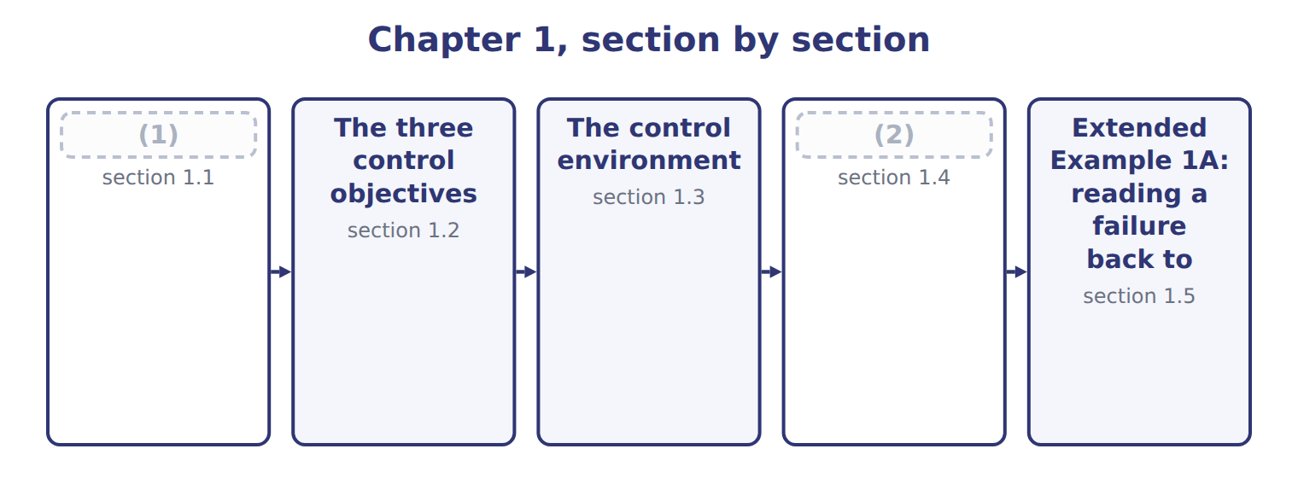
word list
Extended Example 1A: reading a failure back to · Reasonable, not absolute, assurance · Internal control risk and how it is managed

Summary 1 gaps 3–10
Internal control is a process, carried out by the board, management and other staff, designed to give (3) assurance that the (4) objectives will be achieved. It is a process, not a (5) : a written (6) that nobody follows is not a control. Control risk is the risk that internal control will not (7) or detect a material (8) in time. It sits (9) two others. Inherent risk is how exposed something is before any control is (10) , and detection risk is the risk that the auditor's own work misses the problem.
word list
organization's · procedure · beside · designed · considered · misstatement · document · prevent · reasonable

Summary 2 gaps 11–15
The three (11) to give audit risk. Management can reduce inherent risk by changing what the business does, and control risk by (12) better controls, but only the auditor can change detection risk, by testing more or (13) . (14) control risk is a cycle: (15) what could go wrong, design a control, operate it, monitor whether it works, and fix it when it does not.
word list
designing · differently · identify · Managing · multiply · follows

The words this section uses
Each term sits against what it means, and an instance of it.
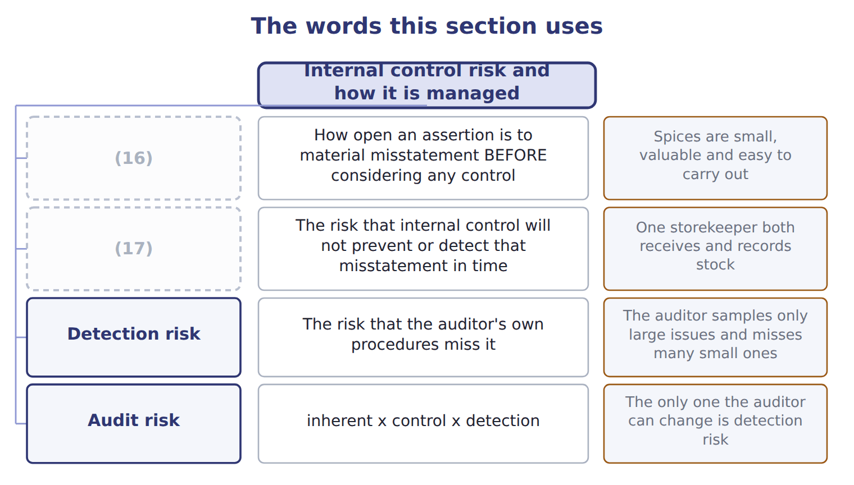
word list
Control risk · Inherent risk · Detection risk

The English this sheet uses, and its Arabic
English (exam term) | Arabic
internal control | الرقابة الداخلية
control risk | مخاطر الرقابة
inherent risk | المخاطر الملازمة

Answer key · 1.1 Internal control risk and how it is managed

1 Internal control risk and how it is managed | 10 considered
2 Reasonable, not absolute, assurance | 11 multiply
3 reasonable | 12 designing
4 organization's | 13 differently
5 document | 14 Managing
6 procedure | 15 identify
7 prevent | 16 Inherent risk
8 misstatement | 17 Control risk
9 beside

the summaries in full
Summary 1 Internal control is a process, carried out by the board, management and other staff, designed to give reasonable assurance that the organization's objectives will be achieved. It is a process, not a document: a written procedure that nobody follows is not a control. Control risk is the risk that internal control will not prevent or detect a material misstatement in time. It sits beside two others. Inherent risk is how exposed something is before any control is considered, and detection risk is the risk that the auditor's own work misses the problem.
Summary 2 The three multiply to give audit risk. Management can reduce inherent risk by changing what the business does, and control risk by designing better controls, but only the auditor can change detection risk, by testing more or differently. Managing control risk is a cycle: identify what could go wrong, design a control, operate it, monitor whether it works, and fix it when it does not.

1.2 The three control objectives
Chapter 1 · section 1.2

Fill every gap. Each word list holds one word more than there are gaps.
Summary 1 gaps 1–2
Internal control serves three (1) of objective. (2) a control does falls into one of them.
word list
categories · Everything · usually

Summary 2 gaps 3–12
The second category is the one most often (3) . It is reporting, not financial reporting: it covers internal (4) as well as external ones, and non-financial (5) as well as financial. The energy and water (6) of Book 3. Many study (7) still say the second objective is (8) of financial reporting (their wording). That was the wording of the 1992 framework. The 2013 framework (9) it to reporting, (10) internal and external, financial and non-financial. A (11) that offers both (12) is testing exactly this. Safeguarding of assets is not a fourth category. It sits inside operations, because losing an asset is an operating failure, though it usually shows up in reporting too.
word list
reliability · misremembered · control · question · wordings · figures · information · widened · meaning · guides · reports

The words this section uses
Each term sits against what it means, and an instance of it.
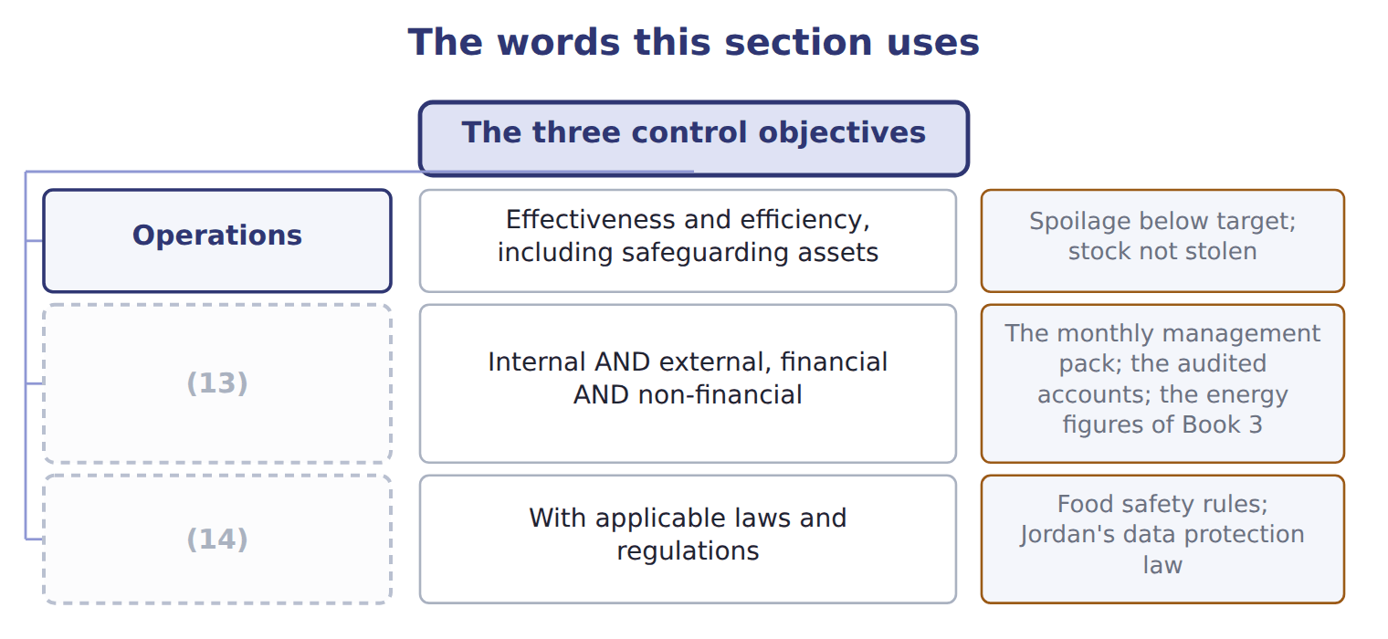
word list
Compliance · Operations · Reporting

The English this sheet uses, and its Arabic
English (exam term) | Arabic
detection risk | مخاطر الاكتشاف

Answer key · 1.2 The three control objectives

1 categories | 8 reliability
2 Everything | 9 widened
3 misremembered | 10 meaning
4 reports | 11 question
5 information | 12 wordings
6 figures | 13 Reporting
7 guides | 14 Compliance

the summaries in full
Summary 1 Internal control serves three categories of objective. Everything a control does falls into one of them.
Summary 2 The second category is the one most often misremembered. It is reporting, not financial reporting: it covers internal reports as well as external ones, and non-financial information as well as financial. The energy and water figures of Book 3. Many study guides still say the second objective is reliability of financial reporting (their wording). That was the wording of the 1992 framework. The 2013 framework widened it to reporting, meaning internal and external, financial and non-financial. A question that offers both wordings is testing exactly this. Safeguarding of assets is not a fourth category. It sits inside operations, because losing an asset is an operating failure, though it usually shows up in reporting too.

1.3 The control environment
Chapter 1 · section 1.3

Fill every gap. Each word list holds one word more than there are gaps.
Summary 1 gaps 1–4
The control (1) is the set of standards, processes and structures that provide the basis for carrying out internal control across the (2) . It is the first of the five (3) and it is first for a reason: it (4) whether the other four work.
word list
decides · environment · components · manager · organization

Summary 2 gaps 5–11
Management (5) and style matter more than any single (6) . If a plant manager is (7) only on output, (8) will be cut, whatever the manual says. This is what is meant by the tone at the top: not a slogan, but what people (9) from watching what management rewards and (10) . (11) matters in the same practical way. Levant Distribution reports to the group rather than to the division it serves, so the manager who negotiates its prices is not the manager who approves its results.
word list
tolerates · Structure · procedure · rewarded · philosophy · inspection · conclude · practical

The words this section uses
Each term sits against what it means, and an instance of it.
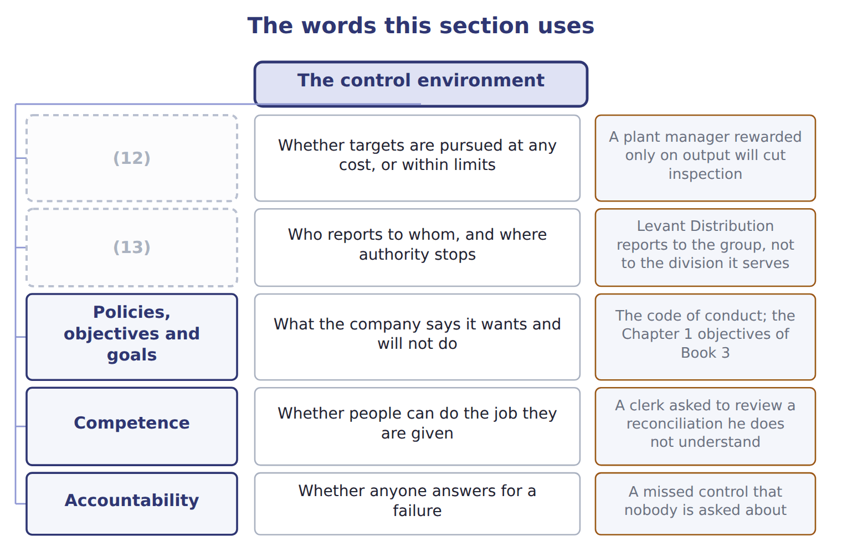
word list
Organizational structure · control risk · Management philosophy and style

The English this sheet uses, and its Arabic
English (exam term) | Arabic
control environment | بيئة الرقابة
tone at the top | النهج الذي تحدده الإدارة العليا

Answer key · 1.3 The control environment

1 environment | 8 inspection
2 organization | 9 conclude
3 components | 10 tolerates
4 decides | 11 Structure
5 philosophy | 12 Management philosophy and style
6 procedure | 13 Organizational structure
7 rewarded

the summaries in full
Summary 1 The control environment is the set of standards, processes and structures that provide the basis for carrying out internal control across the organization. It is the first of the five components and it is first for a reason: it decides whether the other four work.
Summary 2 Management philosophy and style matter more than any single procedure. If a plant manager is rewarded only on output, inspection will be cut, whatever the manual says. This is what is meant by the tone at the top: not a slogan, but what people conclude from watching what management rewards and tolerates. Structure matters in the same practical way. Levant Distribution reports to the group rather than to the division it serves, so the manager who negotiates its prices is not the manager who approves its results.

1.4 Reasonable, not absolute, assurance
Chapter 1 · section 1.4

Fill every gap. Each word list holds one word more than there are gaps.
Summary 1 gaps 1–11
No system of (1) control can give (2) assurance. The standard is reasonable assurance: a high level of (3) , not a guarantee. Two of them deserve (4) because the exam (5) to them. Collusion defeats a (6) of duties designed for one person acting alone: the clerk who raises an invoice and the (7) who approves it can agree together. (8) override is the harder one, because the people who design and enforce the (9) are the people best placed to step around them. The (10) limit is not an excuse but a design (11) . A control that costs more than the loss it prevents makes the company worse off, so the question is always whether the control is worth its cost, not whether it is perfect.
word list
returns · confidence · controls · attention · cost-benefit · principle · supervisor · assurance · internal · Management · absolute · separation

Reasonable means high, not weak

Summary 2 gaps 12–14
Reasonable assurance is a high level of assurance. A question that treats it as 'some (12) ' or 'better than (13) ' has the sense wrong. The word (14) the six limits, not a low standard.
word list
acknowledges · nothing · because · comfort

The English this section uses, and its Arabic
Each term sits against what it means.
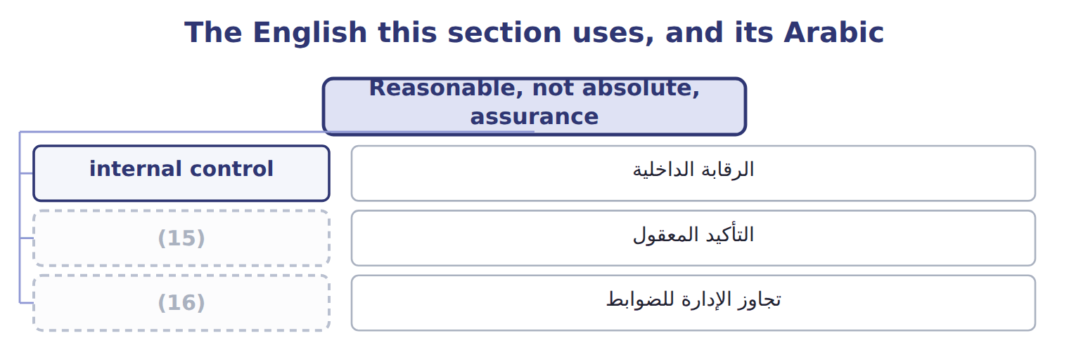
word list
detection risk · reasonable assurance · management override

The English this sheet uses, and its Arabic
English (exam term) | Arabic
reasonable assurance | التأكيد المعقول
management override | تجاوز الإدارة للضوابط

Answer key · 1.4 Reasonable, not absolute, assurance

1 internal | 9 controls
2 absolute | 10 cost-benefit
3 confidence | 11 principle
4 attention | 12 comfort
5 returns | 13 nothing
6 separation | 14 acknowledges
7 supervisor | 15 reasonable assurance
8 Management | 16 management override

the summaries in full
Summary 1 No system of internal control can give absolute assurance. The standard is reasonable assurance: a high level of confidence, not a guarantee. Two of them deserve attention because the exam returns to them. Collusion defeats a separation of duties designed for one person acting alone: the clerk who raises an invoice and the supervisor who approves it can agree together. Management override is the harder one, because the people who design and enforce the controls are the people best placed to step around them. The cost-benefit limit is not an excuse but a design principle. A control that costs more than the loss it prevents makes the company worse off, so the question is always whether the control is worth its cost, not whether it is perfect.
Summary 2 Reasonable assurance is a high level of assurance. A question that treats it as 'some comfort' or 'better than nothing' has the sense wrong. The word acknowledges the six limits, not a low standard.

1.5 Extended Example 1A: reading a failure back to its cause
Chapter 1 · section 1.5

Fill every gap. Each word list holds one word more than there are gaps.
Summary 1 gaps 1–7
This example takes a real failure at (1) and traces it back through the (2) . It is (3) : questions give you the failure and ask which component or which limitation (4) it. A (5) clerk at the Amman plant was able to add a supplier to the approved list and to release payments to it. Over fourteen months, payments went to a supplier that (6) nothing. The loss was found when a new controller reconciled supplier (7) against goods received.
word list
available · purchasing · Orontes · framework · exam-core · explains · records · delivered

2. Which risk was this?

Summary 2 gaps 8–11
Inherent risk was high: payments to new suppliers are easy to disguise and hard to (8) . Control risk was also high, because one (9) held two duties that (10) have been separated. Detection risk was high too, since nobody reconciled suppliers to (11) until the new controller arrived.
word list
receipts · verify · questions · should · person

3. Which component failed?

Summary 3 gaps 12–14
Control activities failed first: the duties were not separated. But monitoring activities failed as well, because fourteen months (12) before anyone (13) . And the control environment was weak underneath both: nobody owned supplier approval, so no one was (14) when it went wrong.
word list
activities · passed · looked · accountable

4. Which objective was missed?

Summary 4 gaps 15–16
Operations, because cash left the company for nothing. Reporting, because (15) and payables were misstated for more than a year. Compliance, because the payments breached the company's own (16) policy.
word list
Control · purchases · procurement

5. Could a control have stopped it?

Summary 5 gaps 17–21
Separating supplier approval from (17) release would have stopped this (18) fraud, and it costs almost nothing. But it would not stop two people agreeing together, which is collusion, and it would not stop a director (19) the clerk, which is (20) override. Reasonable assurance is the honest claim; absolute assurance is not (21) at any price.
word list
particular · available · payment · instructing · management · activities

Everything connects

Summary 6 gaps 22–24
High inherent risk plus high control risk plus high detection risk gave a high audit risk. Control activities failed, monitoring failed, and the control environment (22) both. All three (23) were missed: operations, reporting and compliance. The fix is cheap, but it buys reasonable assurance, not (24) .
word list
certainty · objectives · environment · allowed

Classify four more failures

Complete the blank cells.
Your turn: classify four failures (complete the blanks)
Every item belongs to exactly one group.
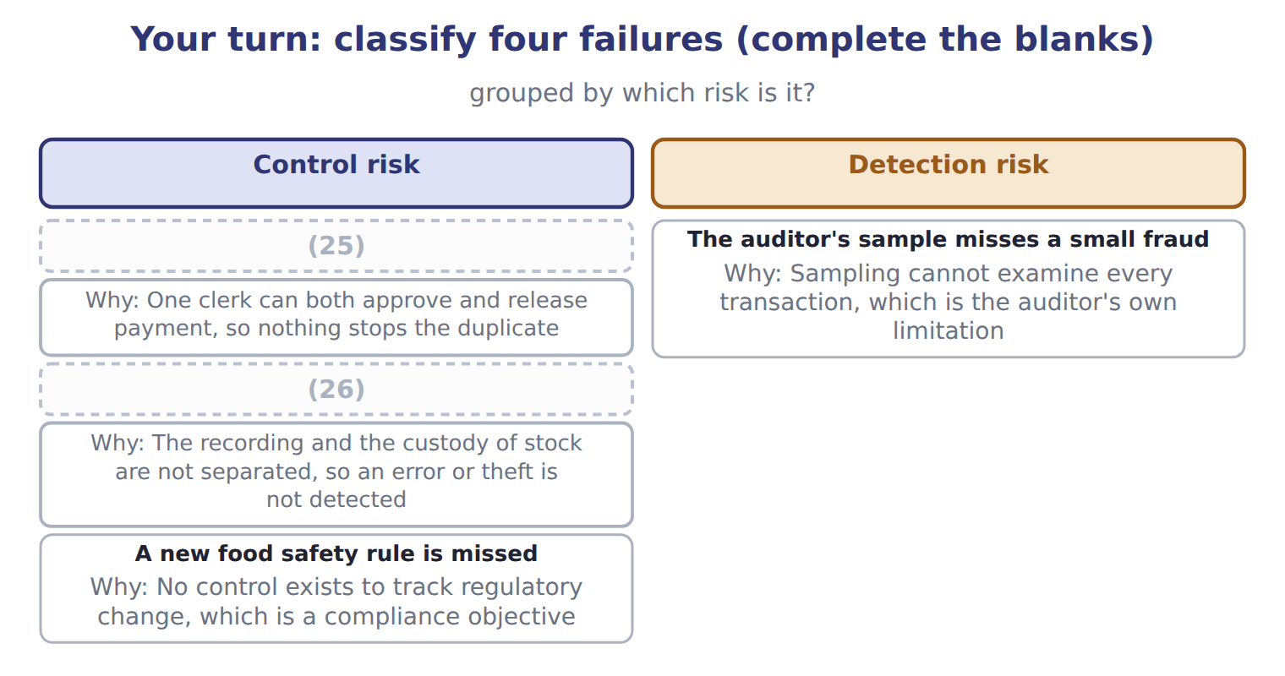
word list
A new food safety rule is missed · Stock records differ from the count · A supplier invoice is paid twice

Exam view

Summary 7 gaps 27–30
A case gives a failure and asks which component, which (27) or which limitation it (28) . Work (29) : what was supposed to stop this, why did it not, and was there (30) that could have? If the answer is that two people agreed together, the answer is collusion, not a missing control.
word list
illustrates · objective · backwards · anything · limitation

Exam view
Fact from the case | Category
Payments to new suppliers are easy to disguise | (31)
One clerk both approved suppliers and released payments | (32)
Nobody reconciled suppliers to goods received for fourteen months | Detection risk
The approved supplier list was never reviewed | Control risk

word list
Inherent risk · Detection risk · Control risk

The English this section uses, and its Arabic
Each term sits against what it means.
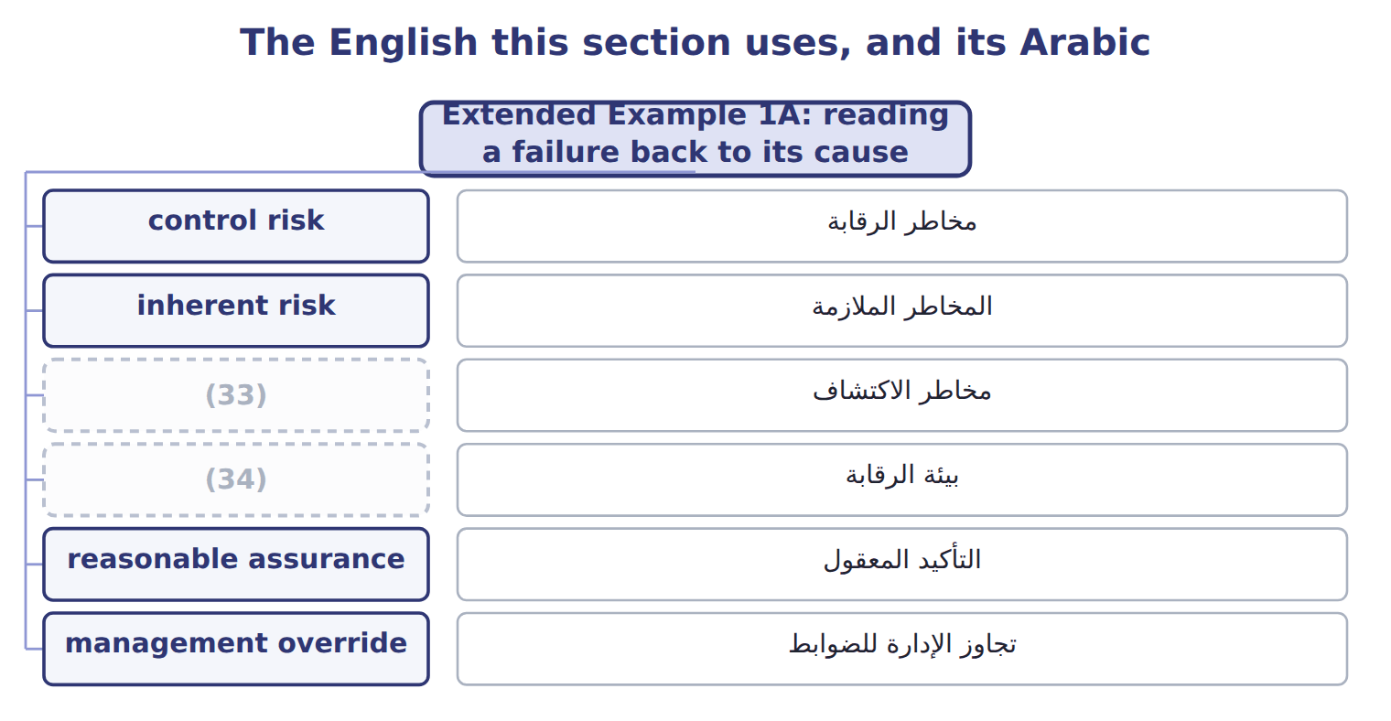
word list
detection risk · control environment · control risk

Answer key · 1.5 Extended Example 1A: reading a failure back to its cause

1 Orontes | 18 particular
2 framework | 19 instructing
3 exam-core | 20 management
4 explains | 21 available
5 purchasing | 22 allowed
6 delivered | 23 objectives
7 records | 24 certainty
8 verify | 25 A supplier invoice is paid twice
9 person | 26 Stock records differ from the count
10 should | 27 objective
11 receipts | 28 illustrates
12 passed | 29 backwards
13 looked | 30 anything
14 accountable | 31 Inherent risk
15 purchases | 32 Control risk
16 procurement | 33 detection risk
17 payment | 34 control environment

the summaries in full
Summary 1 This example takes a real failure at Orontes and traces it back through the framework. It is exam-core: questions give you the failure and ask which component or which limitation explains it. A purchasing clerk at the Amman plant was able to add a supplier to the approved list and to release payments to it. Over fourteen months, payments went to a supplier that delivered nothing. The loss was found when a new controller reconciled supplier records against goods received.
Summary 2 Inherent risk was high: payments to new suppliers are easy to disguise and hard to verify. Control risk was also high, because one person held two duties that should have been separated. Detection risk was high too, since nobody reconciled suppliers to receipts until the new controller arrived.
Summary 3 Control activities failed first: the duties were not separated. But monitoring activities failed as well, because fourteen months passed before anyone looked. And the control environment was weak underneath both: nobody owned supplier approval, so no one was accountable when it went wrong.
Summary 4 Operations, because cash left the company for nothing. Reporting, because purchases and payables were misstated for more than a year. Compliance, because the payments breached the company's own procurement policy.
Summary 5 Separating supplier approval from payment release would have stopped this particular fraud, and it costs almost nothing. But it would not stop two people agreeing together, which is collusion, and it would not stop a director instructing the clerk, which is management override. Reasonable assurance is the honest claim; absolute assurance is not available at any price.
Summary 6 High inherent risk plus high control risk plus high detection risk gave a high audit risk. Control activities failed, monitoring failed, and the control environment allowed both. All three objectives were missed: operations, reporting and compliance. The fix is cheap, but it buys reasonable assurance, not certainty.
Summary 7 A case gives a failure and asks which component, which objective or which limitation it illustrates. Work backwards: what was supposed to stop this, why did it not, and was there anything that could have? If the answer is that two people agreed together, the answer is collusion, not a missing control.

