5.1 The three risks, defined
Chapter 5 · section 5.1

Fill every gap. Each word list holds one word more than there are gaps.
Chapter 5, section by section
Each stage leads to the next.
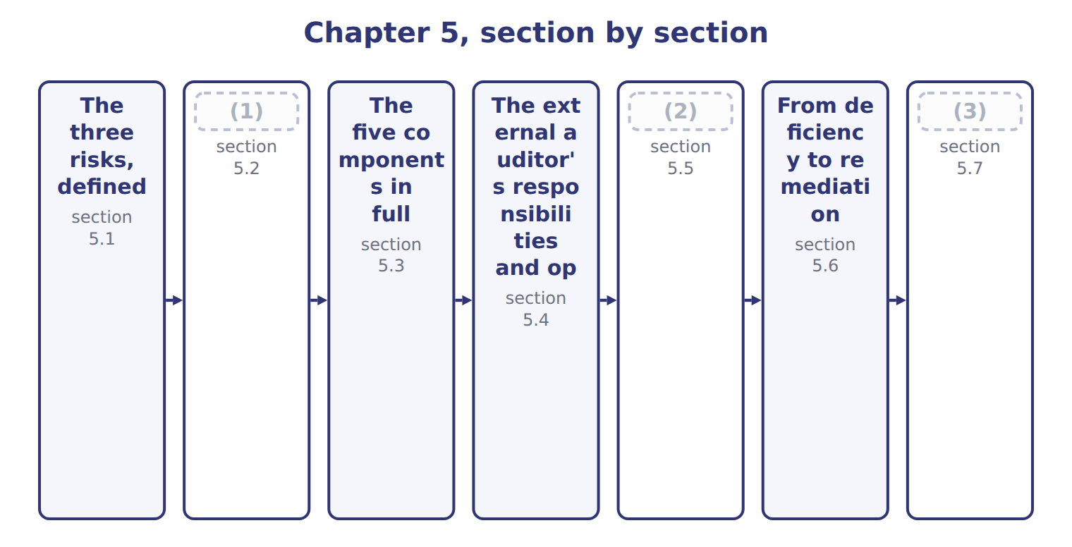
word list
Testing the adequacy of controls · Preventive and detective controls · Extended Example 5A: assessing and mitigating · The external auditor's responsibilities and op

Summary 1 gaps 4–11
Inherent risk is (4) before any control is (5) . Control risk is the risk that the system fails to (6) or detect the (7) in time. Detection risk is the risk that the auditor's own (8) miss it. Together they give audit risk, the risk of an (9) opinion on (10) that are materially misstated. The (11) point is who holds each lever. Management acts on inherent risk by changing the business and on control risk by changing the system. The auditor acts only on detection risk, by testing more, differently, or closer to the year end.
word list
prevent · susceptibility · Inherent · considered · statements · procedures · practical · unmodified · misstatement

The words this section uses
Each term sits against what it means, and an instance of it.
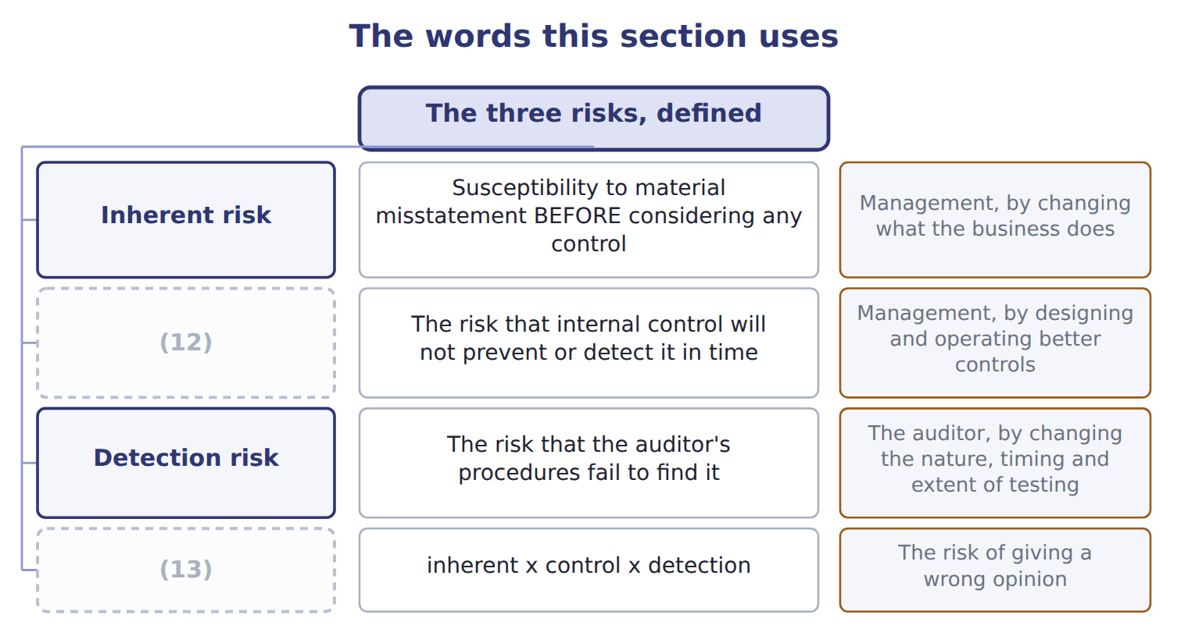
word list
Audit risk · Detection risk · Control risk

The English this sheet uses, and its Arabic
English (exam term) | Arabic
audit risk | مخاطر التدقيق
material misstatement | التحريف الجوهري

Answer key · 5.1 The three risks, defined

1 Preventive and detective controls | 8 procedures
2 Testing the adequacy of controls | 9 unmodified
3 Extended Example 5A: assessing and mitigating | 10 statements
4 susceptibility | 11 practical
5 considered | 12 Control risk
6 prevent | 13 Audit risk
7 misstatement

the summaries in full
Summary 1 Inherent risk is susceptibility before any control is considered. Control risk is the risk that the system fails to prevent or detect the misstatement in time. Detection risk is the risk that the auditor's own procedures miss it. Together they give audit risk, the risk of an unmodified opinion on statements that are materially misstated. The practical point is who holds each lever. Management acts on inherent risk by changing the business and on control risk by changing the system. The auditor acts only on detection risk, by testing more, differently, or closer to the year end.

5.2 Preventive and detective controls
Chapter 5 · section 5.2

Fill every gap. Each word list holds one word more than there are gaps.
Summary 1 gaps 1–4
A preventive control acts before an error or fraud can occur. A detective control finds it (1) . Both are needed, and for (2) reasons. Prevention is cheaper, (3) the loss never happens. Detection is what proves prevention is working: without a (4) nobody knows whether the authorization limits are being respected.
word list
different · Detection · because · afterwards · reconciliation

Classify by when, not by how important

Summary 2 gaps 5–11
A control is preventive or detective (5) to when it acts, not how (6) it is. A stock count is detective even (7) it may be the single most useful control in the (8) . Some (9) do both. A (10) who reviews a payment before it is released is (11) an error, and the same review across a month's payments detects the ones that slipped through. The exam asks when the control acts in the case described, not what it could do in principle.
word list
Detection · valuable · though · according · controls · supervisor · preventing · warehouse

Preventive against detective controls
 | Preventive | Detective
When it acts | Before the error or fraud occurs | (12)
What it does | (13) | Finds it so it can be corrected
Examples | Authorization limits, segregation of duties, input validation, locked stores | Reconciliations, exception reports, stock counts, supervisory review
Cost of failure | The loss never happens | (14)
Why both | (15) | Detection proves prevention is working

word list
Stops it happening · After it has occurred · Before the error or fraud occurs · The loss happens but is recovered or corrected · Prevention is cheaper but cannot catch everything

The English this sheet uses, and its Arabic
English (exam term) | Arabic
preventive control | الرقابة الوقائية
detective control | الرقابة الكاشفة

Answer key · 5.2 Preventive and detective controls

1 afterwards | 9 controls
2 different | 10 supervisor
3 because | 11 preventing
4 reconciliation | 12 After it has occurred
5 according | 13 Stops it happening
6 valuable | 14 The loss happens but is recovered or corrected
7 though | 15 Prevention is cheaper but cannot catch everything
8 warehouse

the summaries in full
Summary 1 A preventive control acts before an error or fraud can occur. A detective control finds it afterwards. Both are needed, and for different reasons. Prevention is cheaper, because the loss never happens. Detection is what proves prevention is working: without a reconciliation nobody knows whether the authorization limits are being respected.
Summary 2 A control is preventive or detective according to when it acts, not how valuable it is. A stock count is detective even though it may be the single most useful control in the warehouse. Some controls do both. A supervisor who reviews a payment before it is released is preventing an error, and the same review across a month's payments detects the ones that slipped through. The exam asks when the control acts in the case described, not what it could do in principle.

5.3 The five components in full
Chapter 5 · section 5.3

Fill every gap. Each word list holds one word more than there are gaps.
Summary 1 gaps 1–11
The framework sets a demanding test for (1) . All five (2) must be present and (3) , and they must be operating together in an integrated manner. A company with excellent control (4) and no monitoring does not have effective internal control; it has four (5) of a system. COSO's 2023 (6) concerns internal control over (7) reporting, not financial reporting. A separate (8) on generative AI (9) in 2026. The 2013 framework (10) has not been (11) . The order of the five is not arbitrary. The control environment comes first because it decides whether the rest function at all, and monitoring comes last because it looks back at everything above it. A question that asks which component a failure belongs to is usually asking where in that order the breakdown began.
word list
integrated · itself · components · revised · supplement · followed · activities · publication · functioning · fifths · effectiveness · sustainability

The English this sheet uses, and its Arabic
English (exam term) | Arabic
present and functioning | قائم ويعمل

Answer key · 5.3 The five components in full

1 effectiveness | 7 sustainability
2 components | 8 publication
3 functioning | 9 followed
4 activities | 10 itself
5 fifths | 11 revised
6 supplement

the summaries in full
Summary 1 The framework sets a demanding test for effectiveness. All five components must be present and functioning, and they must be operating together in an integrated manner. A company with excellent control activities and no monitoring does not have effective internal control; it has four fifths of a system. COSO's 2023 supplement concerns internal control over sustainability reporting, not financial reporting. A separate publication on generative AI followed in 2026. The 2013 framework itself has not been revised. The order of the five is not arbitrary. The control environment comes first because it decides whether the rest function at all, and monitoring comes last because it looks back at everything above it. A question that asks which component a failure belongs to is usually asking where in that order the breakdown began.

5.4 The external auditor's responsibilities and opinions
Chapter 5 · section 5.4

Fill every gap. Each word list holds one word more than there are gaps.
Summary 1 gaps 1–2
The (1) auditor expresses an opinion on whether the financial statements are fairly presented. For an (2) filer the auditor also expresses an opinion on internal control over financial reporting.
word list
accelerated · assurance · external

The opinions available on the statements and on internal control
Opinion | When it is given | On the statements | On internal control
Unqualified (unmodified) | The statements are fairly presented in all material respects | Available | Available: control is effective
Qualified | A material but not pervasive misstatement or scope limitation | Available | (3)
Adverse | A material and pervasive misstatement | Available | (4)
Disclaimer | (5) | Available | Issued for a scope limitation

word list
NOT available on internal control · Issued for a scope limitation · Insufficient evidence, with a pervasive effect · Issued if ANY material weakness exists

Summary 2 gaps 6–17
On internal control the opinion is unqualified or adverse only. There is no qualified opinion: internal control (6) is effective or it is not, and a (7) material weakness makes it adverse. A scope limitation leads to a disclaimer or to (8) . The two opinions are (9) of each other. A company can (10) an adverse opinion on internal control and an unqualified opinion on its financial statements in the same report, (11) the auditor may have done enough extra (12) work to be (13) about the numbers despite the weak controls. The auditor is (14) for obtaining (15) assurance that the statements are free from material misstatement, whether caused by error or fraud. That (16) does not transfer to the auditor what management owes: preparing the statements and maintaining the controls behind them remain (17) work.
word list
responsible · single · withdrawal · receive · substantive · responsibility · reasonable · either · satisfied · because · preparing · management's · independent

The English this section uses, and its Arabic
Each term sits against what it means.
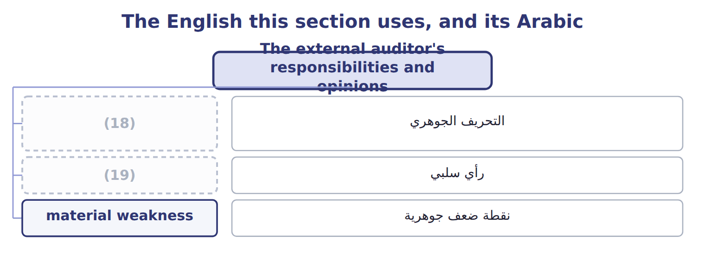
word list
رأي سلبي · material misstatement · adverse opinion

The English this sheet uses, and its Arabic
English (exam term) | Arabic
adverse opinion | رأي سلبي

Answer key · 5.4 The external auditor's responsibilities and opinions

1 external | 11 because
2 accelerated | 12 substantive
3 NOT available on internal control | 13 satisfied
4 Issued if ANY material weakness exists | 14 responsible
5 Insufficient evidence, with a pervasive effect | 15 reasonable
6 either | 16 responsibility
7 single | 17 management's
8 withdrawal | 18 material misstatement
9 independent | 19 adverse opinion
10 receive

the summaries in full
Summary 1 The external auditor expresses an opinion on whether the financial statements are fairly presented. For an accelerated filer the auditor also expresses an opinion on internal control over financial reporting.
Summary 2 On internal control the opinion is unqualified or adverse only. There is no qualified opinion: internal control either is effective or it is not, and a single material weakness makes it adverse. A scope limitation leads to a disclaimer or to withdrawal. The two opinions are independent of each other. A company can receive an adverse opinion on internal control and an unqualified opinion on its financial statements in the same report, because the auditor may have done enough extra substantive work to be satisfied about the numbers despite the weak controls. The auditor is responsible for obtaining reasonable assurance that the statements are free from material misstatement, whether caused by error or fraud. That responsibility does not transfer to the auditor what management owes: preparing the statements and maintaining the controls behind them remain management's work.

5.5 Testing the adequacy of controls
Chapter 5 · section 5.5

Fill every gap. Each word list holds one word more than there are gaps.
Summary 1 gaps 1–9
Four methods are (1) , and the standard ranks them by the strength of the evidence they give. Inquiry asks (2) whether the control is performed. (3) watches it being performed. (4) examines the document the control produced. (5) does the control again and compares the result. Each gives more evidence than the one (6) . Inquiry alone is never (7) . The person asked may be mistaken, may be describing what should happen rather than what does, or may be the person (8) for the failure. A (9) follows a single transaction from start to finish and typically uses all four methods at once.
word list
responsible · someone · available · Observation · sufficient · Re-performance · transaction · Inspection · before · walkthrough

The English this sheet uses, and its Arabic
English (exam term) | Arabic
re-performance | إعادة الأداء

Answer key · 5.5 Testing the adequacy of controls

1 available | 6 before
2 someone | 7 sufficient
3 Observation | 8 responsible
4 Inspection | 9 walkthrough
5 Re-performance

the summaries in full
Summary 1 Four methods are available, and the standard ranks them by the strength of the evidence they give. Inquiry asks someone whether the control is performed. Observation watches it being performed. Inspection examines the document the control produced. Re-performance does the control again and compares the result. Each gives more evidence than the one before. Inquiry alone is never sufficient. The person asked may be mistaken, may be describing what should happen rather than what does, or may be the person responsible for the failure. A walkthrough follows a single transaction from start to finish and typically uses all four methods at once.

5.6 From deficiency to remediation
Chapter 5 · section 5.6

Fill every gap. Each word list holds one word more than there are gaps.
Summary 1 gaps 1–7
Not every (1) is equally (2) . A material weakness is the one that matters most, because its existence prevents (3) from concluding that internal control is (4) . The test combines (5) and magnitude: a reasonable possibility that a material misstatement would not be (6) or detected on a timely basis. There is no numeric (7) . The test is whether there is a reasonable possibility that a material misstatement would go undetected. A weakness can exist where no misstatement has yet occurred at all.
word list
likelihood · management · effective · prevented · serious · threshold · failure · combines

The six steps of remediation
Each stage leads to the next.
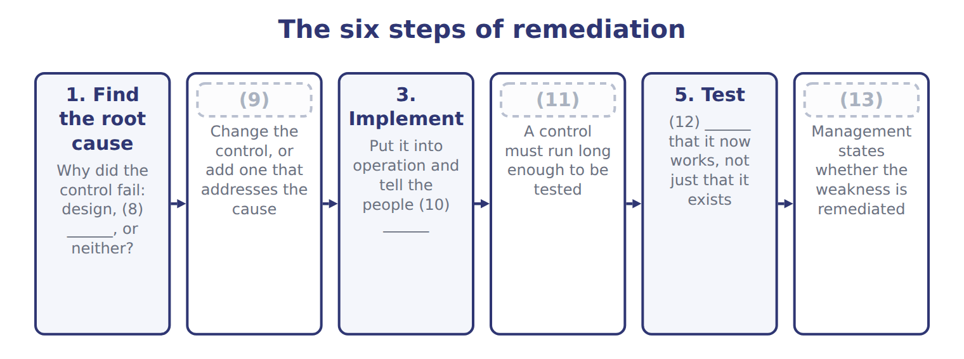
word list
2. Redesign · operation · Evidence · 4. Operate for a period · 6. Conclude and disclose · present and functioning · affected

Summary 2 gaps 14–16
Step four is the one companies try to skip. A control must (14) for long enough to be tested before anyone can say it works, which in (15) means at least a quarter. Announcing a fix is not (16) a weakness.
word list
practice · remediating · operate · misstatement

The words this section uses
Each term sits against what it means, and an instance of it.
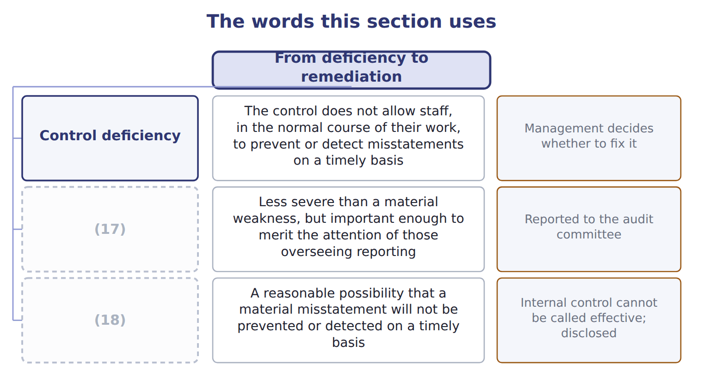
word list
Significant deficiency · Material weakness · Control deficiency

The English this sheet uses, and its Arabic
English (exam term) | Arabic
material weakness | نقطة ضعف جوهرية

Answer key · 5.6 From deficiency to remediation

1 failure | 10 affected
2 serious | 11 4. Operate for a period
3 management | 12 Evidence
4 effective | 13 6. Conclude and disclose
5 likelihood | 14 operate
6 prevented | 15 practice
7 threshold | 16 remediating
8 operation | 17 Significant deficiency
9 2. Redesign | 18 Material weakness

the summaries in full
Summary 1 Not every failure is equally serious. A material weakness is the one that matters most, because its existence prevents management from concluding that internal control is effective. The test combines likelihood and magnitude: a reasonable possibility that a material misstatement would not be prevented or detected on a timely basis. There is no numeric threshold. The test is whether there is a reasonable possibility that a material misstatement would go undetected. A weakness can exist where no misstatement has yet occurred at all.
Summary 2 Step four is the one companies try to skip. A control must operate for long enough to be tested before anyone can say it works, which in practice means at least a quarter. Announcing a fix is not remediating a weakness.

5.7 Extended Example 5A: assessing and mitigating the Orontes control risk
Chapter 5 · section 5.7

Fill every gap. Each word list holds one word more than there are gaps.
Summary 1 gaps 1–6
This example (1) the level of control risk (2) Orontes and (3) what to do about it. E.1.v is a Level C outcome, so the exam will ask for a judgement and a (4) rather than a (5) . Three areas stand out. Purchasing, because of the (6) . The Levant depot, where one person holds custody and the records. And the Gulf export channel, where terms are unusual and oversight is distant.
word list
quarter · assesses · across · failure · recommendation · definition · recommends

Extended Example 5A: control risk assessed area by area
Area | Control risk | Why | Recommended mitigation
Purchasing | Moderate | Duties now segregated and reviewed independently; collusion remains possible | (7)
Levant depot | High | One person holds custody of the stock and (8) the records; nothing has changed | Move the records to another person and reconcile depot records to plant dispatches
Gulf export channel | Moderate | Unusual terms and distant oversight, but amounts pass through the group's systems | Require a second approval on non-standard terms; review the customer master file quarterly

word list
Keep the design and test it each quarter · The revised procedure was circulated to staff · maintains

Summary 2 gaps 9–20
Purchasing now has segregated duties and an independent review, so control risk has (9) from high to moderate, (10) mainly by the possibility of collusion. The depot remains high: nothing has changed there yet. The Gulf channel is moderate, because the risk is real but the amounts pass through the group's own systems. For the depot, move the stock records away from the (11) and have group (12) reconcile depot records to plant dispatches. For the Gulf channel, require a second approval on non-standard terms and review the customer master file quarterly. For purchasing, keep what is in place and test it. The depot weakness is a material weakness if the stock held there is material to the group, because one person can (13) stock and adjust the record without anyone (14) the two. If the depot is small, it is a (15) deficiency: still reported to the audit committee, but not fatal to the (16) . The root cause is not (17) but design: nobody (18) the duties when the depot was set up. Redesign moves the records; (19) means telling both people and updating the procedure; the control then runs for a quarter before anyone tests it; and only after testing can (20) say the weakness is remediated.
word list
separated · finance · remove · dishonesty · limited · comparing · custodian · fallen · implementation · significant · assessment · mitigation · management

Judge four situations

Complete the blank cells.
Your turn: judge four situations (complete the blanks)
Situation | How severe? | Why
A reconciliation that nobody performs | Control deficiency at least | The design is sound but the control does not operate, so it prevents or detects nothing
Approval limits that were never set | Design deficiency | There is no control to operate, so the deficiency is in the design rather than in how it is carried out
One person approves and pays, and the amounts are material | Material weakness | A reasonable possibility that a (21) would not be prevented or detected
A minor posting error found and corrected monthly | Control deficiency | The (22) works, and the amounts are below the threshold for audit committee attention

word list
material weakness · material misstatement · detective control

The pattern behind the assessment

Summary 3 gaps 23–26
Assess control risk area by area, not for the company as a whole. Rate it (23) what the controls (24) do, not what the manual says. Judge severity by (25) and magnitude together, with no percentage rule. (26) is not complete until the new control has run and been tested.
word list
actually · Complete · against · likelihood · Remediation

Exam view

Summary 4 gaps 27–29
A Level C question gives a situation and asks you to assess and (27) . Name the risk, rate it high, moderate or low with a reason, then give a (28) mitigation. A (29) answer such as improve controls earns nothing.
word list
recommend · specific · general · likelihood

Exam view
Step taken or still outstanding | Category
The control was redesigned and the duty named in a job description | (30)
The revised procedure was circulated to staff | Already done
The new control has operated for a sufficient period | Still outstanding
Someone independent has tested that the control works | Still outstanding

word list
Design deficiency · Already done

Answer key · 5.7 Extended Example 5A: assessing and mitigating the Orontes control risk

1 assesses | 16 assessment
2 across | 17 dishonesty
3 recommends | 18 separated
4 recommendation | 19 implementation
5 definition | 20 management
6 failure | 21 material misstatement
7 Keep the design and test it each quarter | 22 detective control
8 maintains | 23 against
9 fallen | 24 actually
10 limited | 25 likelihood
11 custodian | 26 Remediation
12 finance | 27 recommend
13 remove | 28 specific
14 comparing | 29 general
15 significant | 30 Already done

the summaries in full
Summary 1 This example assesses the level of control risk across Orontes and recommends what to do about it. E.1.v is a Level C outcome, so the exam will ask for a judgement and a recommendation rather than a definition. Three areas stand out. Purchasing, because of the failure. The Levant depot, where one person holds custody and the records. And the Gulf export channel, where terms are unusual and oversight is distant.
Summary 2 Purchasing now has segregated duties and an independent review, so control risk has fallen from high to moderate, limited mainly by the possibility of collusion. The depot remains high: nothing has changed there yet. The Gulf channel is moderate, because the risk is real but the amounts pass through the group's own systems. For the depot, move the stock records away from the custodian and have group finance reconcile depot records to plant dispatches. For the Gulf channel, require a second approval on non-standard terms and review the customer master file quarterly. For purchasing, keep what is in place and test it. The depot weakness is a material weakness if the stock held there is material to the group, because one person can remove stock and adjust the record without anyone comparing the two. If the depot is small, it is a significant deficiency: still reported to the audit committee, but not fatal to the assessment. The root cause is not dishonesty but design: nobody separated the duties when the depot was set up. Redesign moves the records; implementation means telling both people and updating the procedure; the control then runs for a quarter before anyone tests it; and only after testing can management say the weakness is remediated.
Summary 3 Assess control risk area by area, not for the company as a whole. Rate it against what the controls actually do, not what the manual says. Judge severity by likelihood and magnitude together, with no percentage rule. Remediation is not complete until the new control has run and been tested.
Summary 4 A Level C question gives a situation and asks you to assess and recommend. Name the risk, rate it high, moderate or low with a reason, then give a specific mitigation. A general answer such as improve controls earns nothing.

