6.1 Segregation inside the systems function
Chapter 6 · section 6.1

Fill every gap. Each word list holds one word more than there are gaps.
Chapter 6, section by section
Each stage leads to the next.
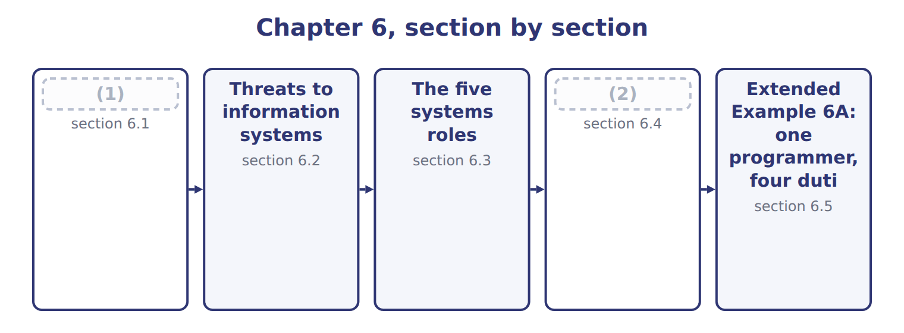
word list
Threats to information systems · Segregation inside the systems function · Physical and logical access

Summary 1 gaps 3–5
A computer (3) power. A clerk who alters one invoice affects one transaction; a (4) who alters one routine affects every transaction it touches, silently, until someone notices. That is why the systems function has its own (5) rules.
word list
segregation · programmer · invoice · concentrates

Summary 2 gaps 6–8
The last row (6) most in a small company. Every separation above becomes theoretical if one (7) holds all the passwords, which is why (8) access is split where possible and logged where it is not.
word list
administrative · matters · segregation · administrator

The words this section uses
Each term sits against what it means, and an instance of it.
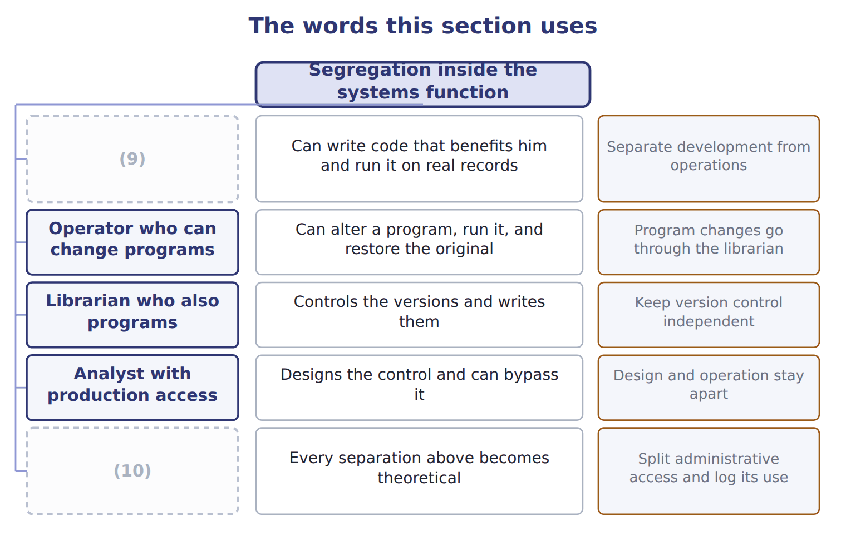
word list
One person holding all system passwords · Program changes go through the librarian · Programmer with access to live data

The English this sheet uses, and its Arabic
English (exam term) | Arabic
systems analyst | محلل النظم
librarian | أمين المكتبة

Answer key · 6.1 Segregation inside the systems function

1 Segregation inside the systems function | 6 matters
2 Physical and logical access | 7 administrator
3 concentrates | 8 administrative
4 programmer | 9 Programmer with access to live data
5 segregation | 10 One person holding all system passwords

the summaries in full
Summary 1 A computer concentrates power. A clerk who alters one invoice affects one transaction; a programmer who alters one routine affects every transaction it touches, silently, until someone notices. That is why the systems function has its own segregation rules.
Summary 2 The last row matters most in a small company. Every separation above becomes theoretical if one administrator holds all the passwords, which is why administrative access is split where possible and logged where it is not.

6.2 Threats to information systems
Chapter 6 · section 6.2

Fill every gap. Each word list holds one word more than there are gaps.
Six threats to information systems
Threat (E.2.b) | What it is | Why it matters | Example
Input manipulation | Entering false or altered data | (1) | A fictitious supplier invoice keyed in
Program alteration | Changing the code itself | (2) | A routine that rounds pennies into one account
Direct file alteration | (3) | Leaves no application audit trail | A balance changed in the database directly
Data theft | Copying data out | Often an insider, often undetected | (4)
Sabotage | (5) | May be a disgruntled employee | Records deleted after a dismissal
Malware and ransomware | Hostile software that spreads or encrypts | (6) | Files encrypted and a payment demanded

word list
A customer list taken on a leaving day · Editing the data file, bypassing the application · Arrives by phishing far more often than by attack · The commonest of all, and needs no technical skill · Destroying data or equipment · Hard to detect without change control · Hostile software that spreads or encrypts

Summary 1 gaps 7–16
Input manipulation is the commonest by a wide (7) , and it is worth (8) why. It needs no technical skill at all: the person simply enters (9) false into a system working exactly as (10) . Direct file alteration (11) attention for the (12) reason. It (13) the application, so the (14) own audit trail shows nothing. Detecting it needs controls at the database level: (15) access, and logging that the database (16) cannot quietly switch off. Malware and ransomware attract the most attention, but the route in is usually mundane. Most arrive through a person opening an attachment or entering a password on a false page, which makes them a training and access problem as much as a technical one.
word list
margin · administrator · noticing · logging · opposite · something · restricted · deserves · bypasses · designed · application's

The English this section uses, and its Arabic
Each term sits against what it means.
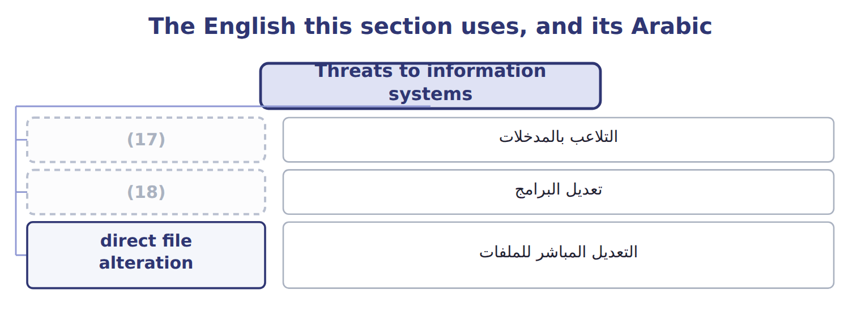
word list
input manipulation · program alteration · التلاعب بالمدخلات

The English this sheet uses, and its Arabic
English (exam term) | Arabic
input manipulation | التلاعب بالمدخلات
program alteration | تعديل البرامج
direct file alteration | التعديل المباشر للملفات

Answer key · 6.2 Threats to information systems

1 The commonest of all, and needs no technical skill | 10 designed
2 Hard to detect without change control | 11 deserves
3 Editing the data file, bypassing the application | 12 opposite
4 A customer list taken on a leaving day | 13 bypasses
5 Destroying data or equipment | 14 application's
6 Arrives by phishing far more often than by attack | 15 restricted
7 margin | 16 administrator
8 noticing | 17 input manipulation
9 something | 18 program alteration

the summaries in full
Summary 1 Input manipulation is the commonest by a wide margin, and it is worth noticing why. It needs no technical skill at all: the person simply enters something false into a system working exactly as designed. Direct file alteration deserves attention for the opposite reason. It bypasses the application, so the application's own audit trail shows nothing. Detecting it needs controls at the database level: restricted access, and logging that the database administrator cannot quietly switch off. Malware and ransomware attract the most attention, but the route in is usually mundane. Most arrive through a person opening an attachment or entering a password on a false page, which makes them a training and access problem as much as a technical one.

6.3 The five systems roles
Chapter 6 · section 6.3

Fill every gap. Each word list holds one word more than there are gaps.
Summary 1 gaps 1–4
Read the (1) column as the whole point of the (2) . The systems analyst designs, the (3) writes, the computer operator runs, the (4) controls the versions, and data control checks what went in and what came out. No one of them can both change the system and use it unobserved.
word list
programmer · librarian · right-hand · arrangement · versions

Answer key · 6.3 The five systems roles

1 right-hand | 3 programmer
2 arrangement | 4 librarian

the summaries in full
Summary 1 Read the right-hand column as the whole point of the arrangement. The systems analyst designs, the programmer writes, the computer operator runs, the librarian controls the versions, and data control checks what went in and what came out. No one of them can both change the system and use it unobserved.

6.4 Physical and logical access
Chapter 6 · section 6.4

Fill every gap. Each word list holds one word more than there are gaps.
Summary 1 gaps 1–10
Access control has two (1) . Physical access controls decide who can reach the (2) . Logical access controls decide who can reach the (3) and the data. Physical controls are the older idea and still (4) . A server room needs a lock, a record of who (5) , and a procedure for (6) old drives. A disk carried out of the (7) defeats every (8) on it. The physical controls also cover (9) that leaves the room. (10) and portable drives carry the same data outside every lock the company owns. Disposal, encryption of portable media and a register of what has been issued therefore belong here rather than with the logical controls.
word list
destroying · equipment · halves · programs · necessary · password · building · machine · entered · forgotten · Laptops

Summary 2 gaps 11–13
Least (11) is the one that decays fastest. Access (12) as people change roles, because granting is easy and revoking is forgotten. The access review (13) to find the clerk who still holds the rights of a job she left two years ago.
word list
exists · accumulates · appears · privilege

A log nobody reads is not a control

Summary 3 gaps 14–16
Logging (14) in almost every list of access controls, and it earns its place only if (15) reviews it. A question describing (16) logging with no review is describing a detective control that detects nothing.
word list
someone · Disposal · extensive · appears

The words this section uses
Each term sits against what it means, and an instance of it.
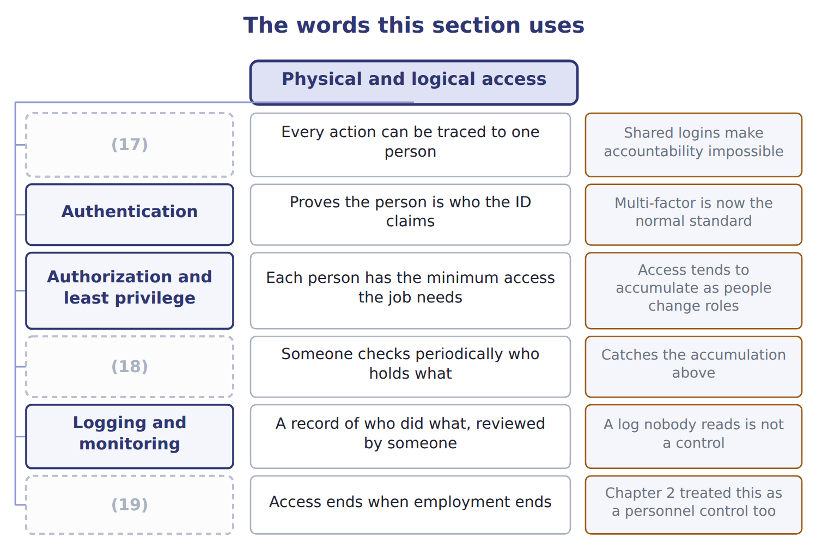
word list
systems analyst · Access reviews · Unique user identification · Removal on exit

The English this sheet uses, and its Arabic
English (exam term) | Arabic
physical access control | الرقابة على الوصول المادي
logical access control | الرقابة على الوصول المنطقي
least privilege | أقل الصلاحيات

Answer key · 6.4 Physical and logical access

1 halves | 11 privilege
2 machine | 12 accumulates
3 programs | 13 exists
4 necessary | 14 appears
5 entered | 15 someone
6 destroying | 16 extensive
7 building | 17 Unique user identification
8 password | 18 Access reviews
9 equipment | 19 Removal on exit
10 Laptops

the summaries in full
Summary 1 Access control has two halves. Physical access controls decide who can reach the machine. Logical access controls decide who can reach the programs and the data. Physical controls are the older idea and still necessary. A server room needs a lock, a record of who entered, and a procedure for destroying old drives. A disk carried out of the building defeats every password on it. The physical controls also cover equipment that leaves the room. Laptops and portable drives carry the same data outside every lock the company owns. Disposal, encryption of portable media and a register of what has been issued therefore belong here rather than with the logical controls.
Summary 2 Least privilege is the one that decays fastest. Access accumulates as people change roles, because granting is easy and revoking is forgotten. The access review exists to find the clerk who still holds the rights of a job she left two years ago.
Summary 3 Logging appears in almost every list of access controls, and it earns its place only if someone reviews it. A question describing extensive logging with no review is describing a detective control that detects nothing.

6.5 Extended Example 6A: one programmer, four duties
Chapter 6 · section 6.5

Fill every gap. Each word list holds one word more than there are gaps.
Summary 1 gaps 1–12
This example takes a single (1) at Orontes and shows how one person's access (2) the four duties. When Orontes (3) its payables system, one developer built it and stayed on to (4) it. He (5) the code, moves his own changes into production, holds the database administrator password, and is the person who investigates when a payment query (6) . He can (7) a supplier record (8) in the database, which is authorization. He can alter the (9) routine, which is recording. (10) a payment run gives him (11) custody. And he investigates the queries that would reveal any of it, which is (12) . One person, four duties. Program alteration, because he changes code with no independent review. Direct file alteration, because he holds the database password and can edit records outside the application. Data theft, because he can extract the supplier and payment history.
word list
directly · arrangement · create · reconciliation · support · installed · arises · writes · collapsed · effective · Releasing · passwords · posting

Summary 2 gaps 13–21
In the second case the (13) audit trail would show nothing. Separate development from production: he may write code, but someone else moves it into live use. Take the database password away and give it to a separate administrator, logged and (14) . Move payment (15) to the cashier. Move query (16) to accounts (17) . Almost nothing in money, and something real in (18) : a change that took him an (19) now needs another person. That is the trade the chapter is about, and the answer at Orontes is clear, because the (20) is one person able to move cash (21) trace.
word list
payable · convenience · alternative · release · reviewed · afternoon · application's · custody · without · investigation

Identify four threats

Complete the blank cells.
Your turn: identify four threats (complete the blanks)
What happened | Which threat? | Why
A clerk keys an invoice for goods never received | Input manipulation | False data entered into a system working exactly as (22)
A developer adds code diverting rounding differences | Program alteration | The code itself was changed, so every transaction it touches is affected until someone notices
A balance is edited straight in the database | Direct file alteration | The application was bypassed, so its audit trail shows nothing
Files are encrypted and a payment demanded | Malware, specifically ransomware | Usually arriving through a person rather than a (23) attack

word list
Authorization · technical · designed

The pattern behind the example

Summary 3 gaps 24–27
Map the person's ACCESS to the four duties, not their job title. Development and production must be separate, whatever the (24) size. (25) passwords are a duty in (26) , and must be held and logged separately. A control that is (27) is not therefore wrong.
word list
inconvenient · Administrative · themselves · company's · authorization

Exam view

Summary 4 gaps 28–30
A case (28) who has which system access and asks for the (29) . (30) access into duties before answering: the ability to edit a database record is authorization and recording at once, whatever the person is called.
word list
describes · production · weakness · Translate

Exam view
The rows are a set, not a sequence.
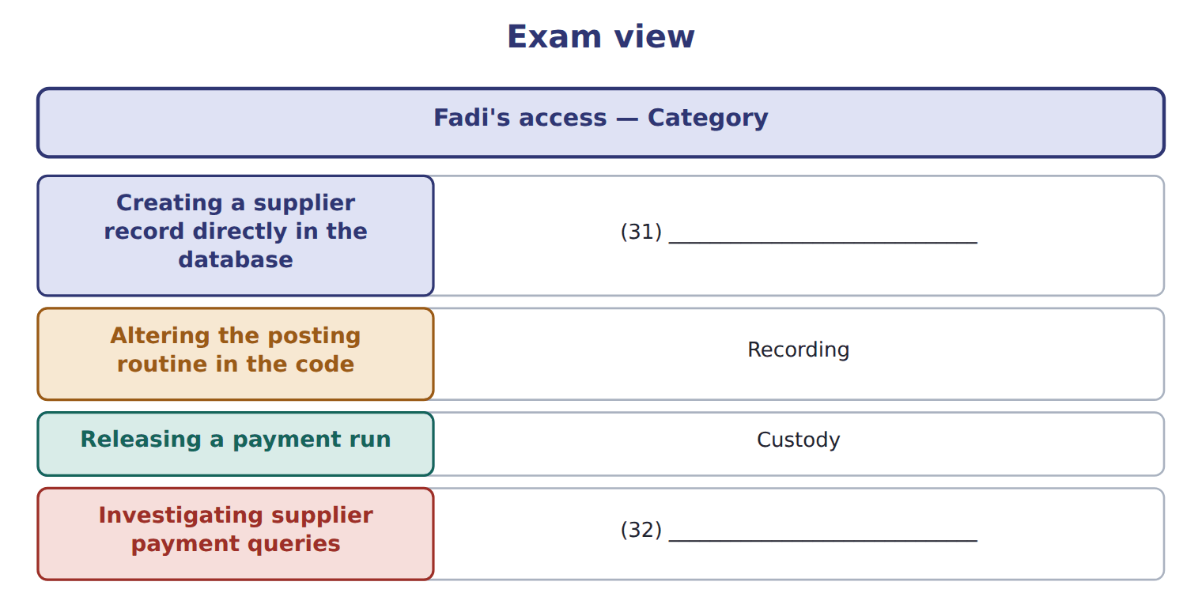
word list
librarian · Reconciliation · Authorization

Answer key · 6.5 Extended Example 6A: one programmer, four duties

1 arrangement | 17 payable
2 collapsed | 18 convenience
3 installed | 19 afternoon
4 support | 20 alternative
5 writes | 21 without
6 arises | 22 designed
7 create | 23 technical
8 directly | 24 company's
9 posting | 25 Administrative
10 Releasing | 26 themselves
11 effective | 27 inconvenient
12 reconciliation | 28 describes
13 application's | 29 weakness
14 reviewed | 30 Translate
15 release | 31 Authorization
16 investigation | 32 Reconciliation

the summaries in full
Summary 1 This example takes a single arrangement at Orontes and shows how one person's access collapsed the four duties. When Orontes installed its payables system, one developer built it and stayed on to support it. He writes the code, moves his own changes into production, holds the database administrator password, and is the person who investigates when a payment query arises. He can create a supplier record directly in the database, which is authorization. He can alter the posting routine, which is recording. Releasing a payment run gives him effective custody. And he investigates the queries that would reveal any of it, which is reconciliation. One person, four duties. Program alteration, because he changes code with no independent review. Direct file alteration, because he holds the database password and can edit records outside the application. Data theft, because he can extract the supplier and payment history.
Summary 2 In the second case the application's audit trail would show nothing. Separate development from production: he may write code, but someone else moves it into live use. Take the database password away and give it to a separate administrator, logged and reviewed. Move payment release to the cashier. Move query investigation to accounts payable. Almost nothing in money, and something real in convenience: a change that took him an afternoon now needs another person. That is the trade the chapter is about, and the answer at Orontes is clear, because the alternative is one person able to move cash without trace.
Summary 3 Map the person's ACCESS to the four duties, not their job title. Development and production must be separate, whatever the company's size. Administrative passwords are a duty in themselves, and must be held and logged separately. A control that is inconvenient is not therefore wrong.
Summary 4 A case describes who has which system access and asks for the weakness. Translate access into duties before answering: the ability to edit a database record is authorization and recording at once, whatever the person is called.

