10.1 What enterprise resource planning is
Chapter 10 · section 10.1

Fill every gap. Each word list holds one word more than there are gaps.
Chapter 10, section by section
Each stage leads to the next.
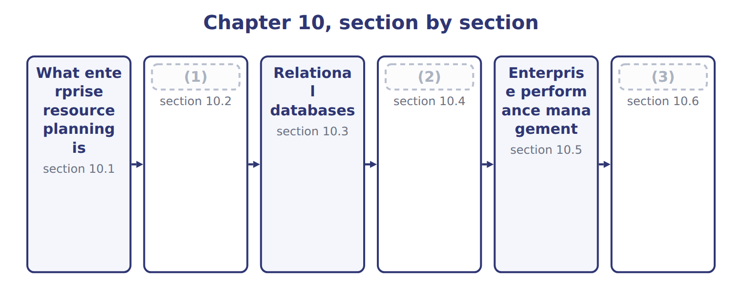
word list
Data warehouses and data marts · What enterprise resource planning is · Extended Example 10A: what Orontes gains, and · How ERP answers the six challenges

Summary 1 gaps 4–7
The (4) feature is the shared database, not the breadth of the modules. Several (5) systems that exchange files are still several systems. One system means one (6) value for each fact, which is where every advantage below comes. Those (7) come at a price, and the exam expects both sides.
word list
changes · advantages · stored · separate · defining

The advantages and disadvantages of ERP
ERP characteristic | Advantage | Disadvantage
Integration | (8) | A long and costly implementation
One version of the data | Everyone works from the same figure | Processes must change to fit the software, or (9) costs rise
Real-time information | A manager sees today, not last month | (10)
Standard processes | The same method across divisions and countries | (11)
Stronger control and audit trail | (12) | A single point of failure if it stops
Scalability | (13) | Dependence on one vendor, and the cost of leaving

word list
Everyone · customisation · Less flexibility for a division that genuinely differs · New sites and companies are added to the same system · One entry serves every module that needs it · Heavy demands on training and change management · One set of access rules and one trail

Summary 2 gaps 14–17
The (14) row is the one that sinks (15) . An ERP (16) a way of working, so a company either (17) its processes to match the software or pays to change the software. Companies that assume a third option exists are the ones whose projects run years late.
word list
embodies · breadth · implementations · changes · second

The English this section uses, and its Arabic
Each term sits against what it means.
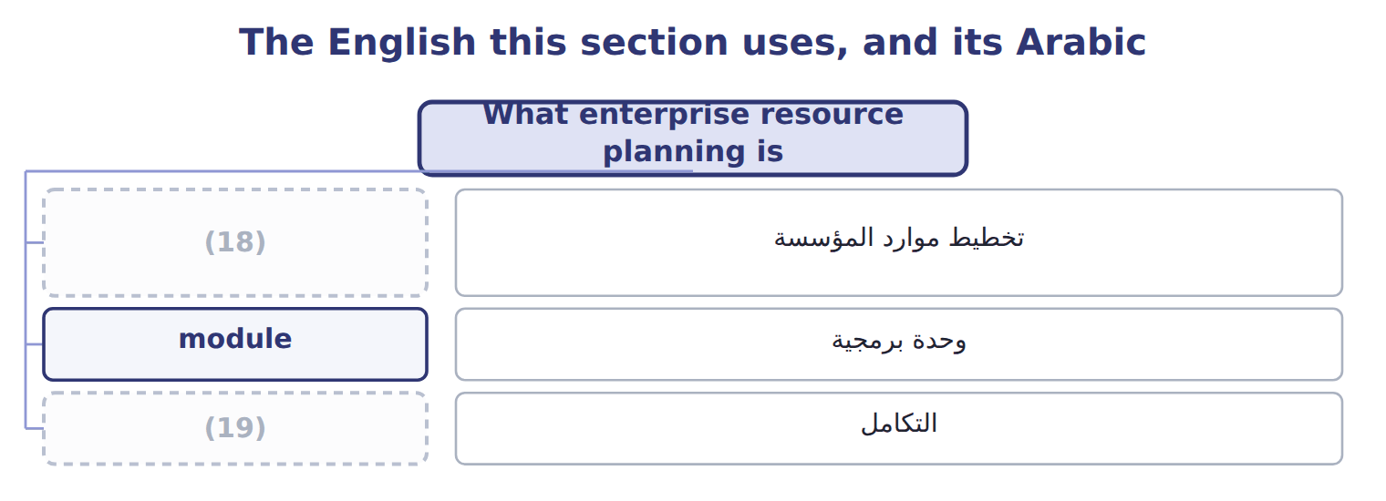
word list
data warehouse · integration · enterprise resource planning (ERP)

The English this sheet uses, and its Arabic
English (exam term) | Arabic
enterprise resource planning (ERP) | تخطيط موارد المؤسسة
module | وحدة برمجية
integration | التكامل

Answer key · 10.1 What enterprise resource planning is

1 How ERP answers the six challenges | 11 Less flexibility for a division that genuinely differs
2 Data warehouses and data marts | 12 One set of access rules and one trail
3 Extended Example 10A: what Orontes gains, and | 13 New sites and companies are added to the same system
4 defining | 14 second
5 separate | 15 implementations
6 stored | 16 embodies
7 advantages | 17 changes
8 One entry serves every module that needs it | 18 enterprise resource planning (ERP)
9 customisation | 19 integration
10 Heavy demands on training and change management

the summaries in full
Summary 1 The defining feature is the shared database, not the breadth of the modules. Several separate systems that exchange files are still several systems. One system means one stored value for each fact, which is where every advantage below comes. Those advantages come at a price, and the exam expects both sides.
Summary 2 The second row is the one that sinks implementations. An ERP embodies a way of working, so a company either changes its processes to match the software or pays to change the software. Companies that assume a third option exists are the ones whose projects run years late.

10.2 How ERP answers the six challenges
Chapter 10 · section 10.2

Fill every gap. Each word list holds one word more than there are gaps.
How ERP answers the six challenges of Chapter 9
Challenge from Chapter 9 | How ERP answers it | At Orontes
Duplicate data entry | The fact is entered once, in the module where it arises | Production output is keyed at the line and is (1) available for costing
Data that disagrees | There is only one stored value, so disagreement is impossible | The 1,500-case difference of Chapter 9 cannot arise
Reconciliation effort | Nothing to reconcile between modules | (2)
Delay | (3) | Margin visible the next morning, not in the third week
No single view | One database holds the customer, product and order together | (4)
Weak transfer control | (5) | The unreconciled upload disappears with the interface

word list
Posting is immediate, not monthly · No transfer exists to fail · immediately · Profit by product is a query, not a project · disagreement · The two days a month are released for analysis

Summary 1 gaps 6–13
One (6) produces all six answers: the fact is stored once. Because production output is a row in the same database the ledger reads, it cannot be keyed twice, cannot (7) with itself, needs no reconciliation, (8) without delay and can be joined to a customer or a product. The sixth (9) is the one (10) overlook. The unreconciled monthly upload; it (11) to exist, because there is nothing to transfer between. Removing a control (12) by removing the thing that needed (13) is the strongest form of the remedy.
word list
disagree · transfer · mechanism · weakness · arrives · ceases · candidates · answer · controlling

Integration is not the same as interfacing

Summary 2 gaps 14–16
Two systems that send each other files are interfaced. One system (14) one copy of the data is (15) . A question describing nightly file (16) between modules is describing interfaced systems, whatever the vendor calls the product.
word list
holding · transfers · describing · integrated

Answer key · 10.2 How ERP answers the six challenges

1 immediately | 9 answer
2 The two days a month are released for analysis | 10 candidates
3 Posting is immediate, not monthly | 11 ceases
4 Profit by product is a query, not a project | 12 weakness
5 No transfer exists to fail | 13 controlling
6 mechanism | 14 holding
7 disagree | 15 integrated
8 arrives | 16 transfers

the summaries in full
Summary 1 One mechanism produces all six answers: the fact is stored once. Because production output is a row in the same database the ledger reads, it cannot be keyed twice, cannot disagree with itself, needs no reconciliation, arrives without delay and can be joined to a customer or a product. The sixth answer is the one candidates overlook. The unreconciled monthly upload; it ceases to exist, because there is nothing to transfer between. Removing a control weakness by removing the thing that needed controlling is the strongest form of the remedy.
Summary 2 Two systems that send each other files are interfaced. One system holding one copy of the data is integrated. A question describing nightly file transfers between modules is describing interfaced systems, whatever the vendor calls the product.

10.3 Relational databases
Chapter 10 · section 10.3

Fill every gap. Each word list holds one word more than there are gaps.
Summary 1 gaps 1–12
A (1) database stores data in tables of rows and columns, with tables linked by shared values rather than by (2) . A primary key uniquely (3) each row: no two (4) may share a supplier number, and none may be left blank. A foreign key is a column in one table (5) the primary key of (6) , which is how the invoice knows which supplier it belongs to. Two control (7) follow directly. The supplier name is stored once, so (8) it corrects every invoice at the same (9) . And an invoice cannot (10) a supplier that does not exist, because the database refuses a foreign key with no (11) primary key. That is (12) integrity, and it is the validity check. A database management system (DBMS) is the software that holds the tables, enforces the keys, decides who may read or change what, and answers queries. The distinction the exam tests is simple: the tables are the data, and the management system is what guards and serves them.
word list
reference · matching · moment · identifies · columns · relational · position · correcting · suppliers · consequences · another · referential · holding

The English this section uses, and its Arabic
Each term sits against what it means.
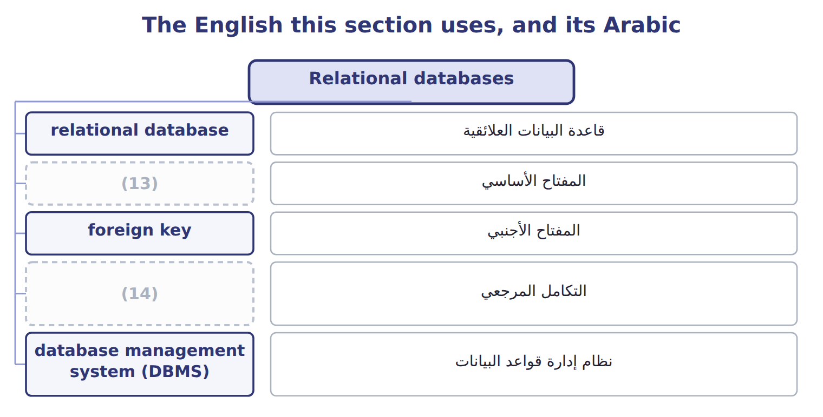
word list
التكامل المرجعي · primary key · referential integrity

The English this sheet uses, and its Arabic
English (exam term) | Arabic
relational database | قاعدة البيانات العلائقية
primary key | المفتاح الأساسي
foreign key | المفتاح الأجنبي
referential integrity | التكامل المرجعي
database management system (DBMS) | نظام إدارة قواعد البيانات

Answer key · 10.3 Relational databases

1 relational | 8 correcting
2 position | 9 moment
3 identifies | 10 reference
4 suppliers | 11 matching
5 holding | 12 referential
6 another | 13 primary key
7 consequences | 14 referential integrity

the summaries in full
Summary 1 A relational database stores data in tables of rows and columns, with tables linked by shared values rather than by position. A primary key uniquely identifies each row: no two suppliers may share a supplier number, and none may be left blank. A foreign key is a column in one table holding the primary key of another, which is how the invoice knows which supplier it belongs to. Two control consequences follow directly. The supplier name is stored once, so correcting it corrects every invoice at the same moment. And an invoice cannot reference a supplier that does not exist, because the database refuses a foreign key with no matching primary key. That is referential integrity, and it is the validity check. A database management system (DBMS) is the software that holds the tables, enforces the keys, decides who may read or change what, and answers queries. The distinction the exam tests is simple: the tables are the data, and the management system is what guards and serves them.

10.4 Data warehouses and data marts
Chapter 10 · section 10.4

Fill every gap. Each word list holds one word more than there are gaps.
Summary 1 gaps 1–11
An operational system is built to process one (1) quickly. Analysis asks the (2) question, reading (3) of rows at once, and (4) that against the live system would slow down the people working in it. That is why analysis happens (5) else. A data warehouse is a (6) store holding history across every subject, loaded from the operational systems, read but never updated by transactions. A data mart is a smaller store (7) one department or subject, usually drawn from the warehouse. The (8) is one of scope, not of (9) . A mart is not a lesser warehouse; it is a (10) worth of structure applied to one subject, so that the sales team can answer its own questions without waiting for, or (11) , anyone else.
word list
quality · running · disturbing · millions · somewhere · relationship · separate · opposite · transaction · serving · process · warehouse's

Data warehouse against data mart
 | Data warehouse | Data mart
Purpose | Supports analysis and decisions across the enterprise | (12)
Scope | (13) | One subject, such as sales or production
Source | (14) | Usually drawn from the warehouse
Time span | (15) | The period that department needs
Changed by users? | No. It is read, not updated by transactions | (16)
Why not just query the live system? | Heavy analysis would slow the system people are working in | Same reason, on a smaller scale

word list
Supports one department or subject · History, kept for years so trends can be seen · All subjects: customers, products, suppliers, plants · Loaded from the operational systems, often overnight · Usually drawn from the warehouse · No, for the same reason

The English this sheet uses, and its Arabic
English (exam term) | Arabic
data warehouse | مستودع البيانات
data mart | سوق البيانات

Answer key · 10.4 Data warehouses and data marts

1 transaction | 9 quality
2 opposite | 10 warehouse's
3 millions | 11 disturbing
4 running | 12 Supports one department or subject
5 somewhere | 13 All subjects: customers, products, suppliers, plants
6 separate | 14 Loaded from the operational systems, often overnight
7 serving | 15 History, kept for years so trends can be seen
8 relationship | 16 No, for the same reason

the summaries in full
Summary 1 An operational system is built to process one transaction quickly. Analysis asks the opposite question, reading millions of rows at once, and running that against the live system would slow down the people working in it. That is why analysis happens somewhere else. A data warehouse is a separate store holding history across every subject, loaded from the operational systems, read but never updated by transactions. A data mart is a smaller store serving one department or subject, usually drawn from the warehouse. The relationship is one of scope, not of quality. A mart is not a lesser warehouse; it is a warehouse's worth of structure applied to one subject, so that the sales team can answer its own questions without waiting for, or disturbing, anyone else.

10.5 Enterprise performance management
Chapter 10 · section 10.5

Fill every gap. Each word list holds one word more than there are gaps.
Summary 1 gaps 1–12
It is not a (1) for ERP, and the (2) is worth stating plainly. An ERP records what happened; (3) performance management decides what should happen, (4) whether it did, and feeds the answer back into the next plan. One is the system of (5) , the other the system of management. Four (6) follow for planning, and they are what a Level C (7) asks about. Planning becomes (8) rather than (9) : the budget is built from cases and prices and rates, so a change in any assumption flows through without rebuilding the model. (10) becomes continuous rather than (11) . Reporting becomes comparison rather than (12) , because plan and actual sit in the same place. And review becomes connected to the next plan, which is the loop Book 3 described in the balanced scorecard: a measure that nobody acts on is only a number.
word list
difference · measures · driver-based · incremental · rebuilding · synonym · description · Forecasting · question · record · annual · things · enterprise

Summary 2 gaps 13–16
The (13) matters less than the (14) . A company can manage performance well with a (15) and badly with an (16) suite, because what the term describes is a set of linked processes rather than a product. The suite makes the processes cheaper to run, not more likely to exist.
word list
discipline · expensive · spreadsheet · software · described

The words this section uses
Each term sits against what it means, and an instance of it.
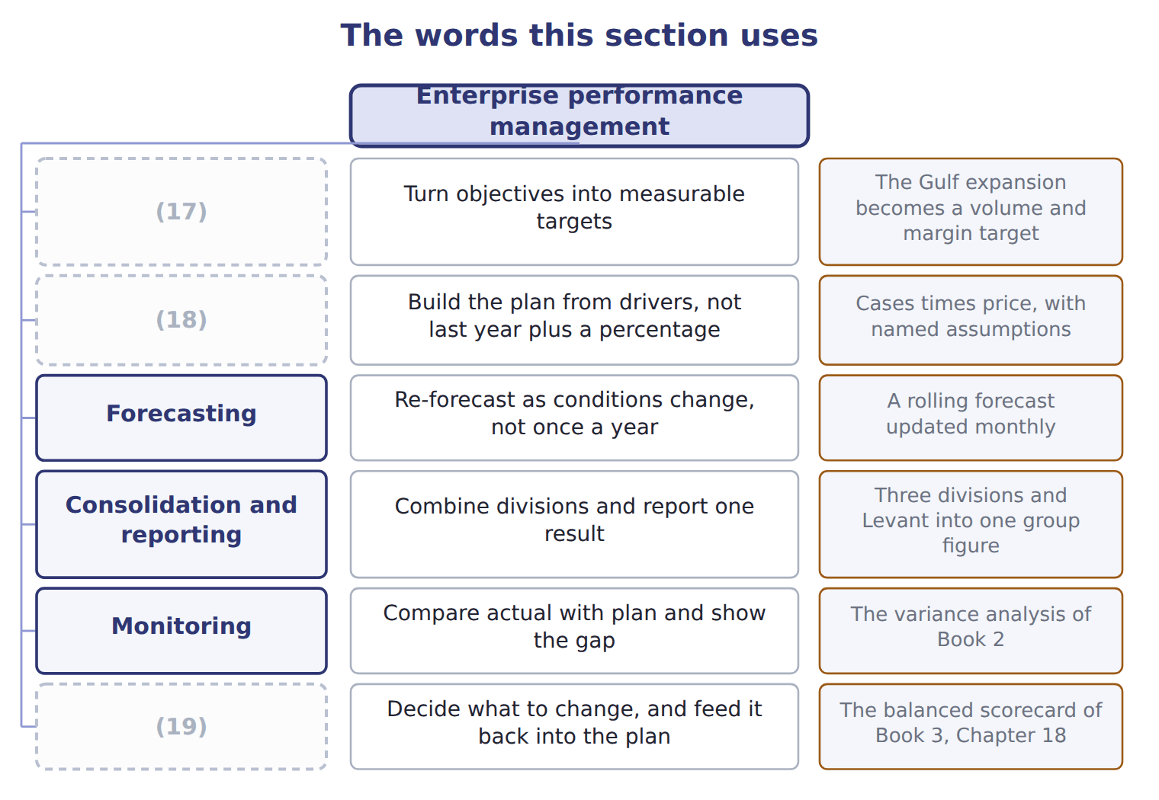
word list
Strategy · relational database · Review and act · Planning and budgeting

The English this sheet uses, and its Arabic
English (exam term) | Arabic
enterprise performance management (EPM) | إدارة أداء المؤسسة

Answer key · 10.5 Enterprise performance management

1 synonym | 11 annual
2 difference | 12 description
3 enterprise | 13 software
4 measures | 14 discipline
5 record | 15 spreadsheet
6 things | 16 expensive
7 question | 17 Strategy
8 driver-based | 18 Planning and budgeting
9 incremental | 19 Review and act
10 Forecasting

the summaries in full
Summary 1 It is not a synonym for ERP, and the difference is worth stating plainly. An ERP records what happened; enterprise performance management decides what should happen, measures whether it did, and feeds the answer back into the next plan. One is the system of record, the other the system of management. Four things follow for planning, and they are what a Level C question asks about. Planning becomes driver-based rather than incremental: the budget is built from cases and prices and rates, so a change in any assumption flows through without rebuilding the model. Forecasting becomes continuous rather than annual. Reporting becomes comparison rather than description, because plan and actual sit in the same place. And review becomes connected to the next plan, which is the loop Book 3 described in the balanced scorecard: a measure that nobody acts on is only a number.
Summary 2 The software matters less than the discipline. A company can manage performance well with a spreadsheet and badly with an expensive suite, because what the term describes is a set of linked processes rather than a product. The suite makes the processes cheaper to run, not more likely to exist.

10.6 Extended Example 10A: what Orontes gains, and what it gives up
Chapter 10 · section 10.6

Fill every gap. Each word list holds one word more than there are gaps.
Summary 1 gaps 1–12
This example judges the Orontes ERP (1) rather than (2) it. F.1.i is a Level C (3) , so the exam will ask what performance management makes possible and whether it is worth (4) . The sales (5) asked what one case of (6) oil cost and how much was labour. Under the present (7) the answer took two days and arrived (8) . On an (9) system it is a query: the batch, its hours, its (10) and its output all sit in one database. Once cost per case is available on (11) , the budget can be built from drivers rather than from last year. Volume times price gives revenue; volume times cost per case gives cost; and a change in the olive price flows through to margin without anyone (12) the model. The variance analysis of Book 2 could already explain a difference after the month closed.
word list
proposal · having · materials · rebuilding · expanding · demand · describing · director · outcome · premium · integrated · unverifiable · arrangement

Summary 2 gaps 13–24
With plan and actual in one place, the same analysis becomes available while the month is still running, which is the difference between (13) a loss and (14) one. Three (15) , and none of them (16) . A long (17) during which (18) goes to the project rather than the business. (19) changed to match the software, (20) some that the plant believes are better than the standard. And dependence on one vendor, with the cost of (21) rising each year. For a company (22) into the Gulf the case is strong, because the questions it will need to answer are exactly the ones (23) systems cannot answer: which products earn most in which market, and what a change in volume does to cost. A company not growing might (24) defer. Implementations fail when a company tries to keep every existing process, customises heavily to do so, and then cannot upgrade. The discipline that makes integration work is accepting a standard process unless there is a real reason not to.
word list
trivial · leaving · things · Processes · preventing · implementation · separate · rationally · including · expanding · available · attention · explaining

Name four things

Complete the blank cells.

Your turn: name four things (complete the blanks)
Description | What is it? | Why
One store of history, covering every subject, loaded overnight | A data warehouse | It serves the whole enterprise and is read rather than updated
A subset for the sales department only | (25) | A mart applies the same structure to one subject, so that department can answer its own questions without disturbing anyone
Uniquely identifies each row of a table | A primary key | (26)
Points from one table back to another | (27) | It must match an existing primary key, which prevents an orphan record

word list
No two rows may share it and none may be blank · Data mart · Three years of order lines refreshed for analysis · A foreign key

The pattern behind the judgement

Summary 3 gaps 28–31
Integration is worth most to a company whose questions span its systems. The gain is not the software but the (28) to plan from drivers and review in time to act. The cost is paid in process change and vendor dependence, not only in (29) fees. Heavy (30) destroys the benefit it was bought to (31) .
word list
ability · customisation · protect · licence · preventing

Exam view

Summary 4 gaps 32–34
A Level C (32) asks whether performance management helps, or what it makes possible. Name the mechanism, not the benefit: (33) planning, continuous forecasting, plan and actual together, and review feeding the next plan. (34) that it improves decisions earns nothing.
word list
question · arrived · Answering · driver-based

Exam view
Every item belongs to exactly one group.
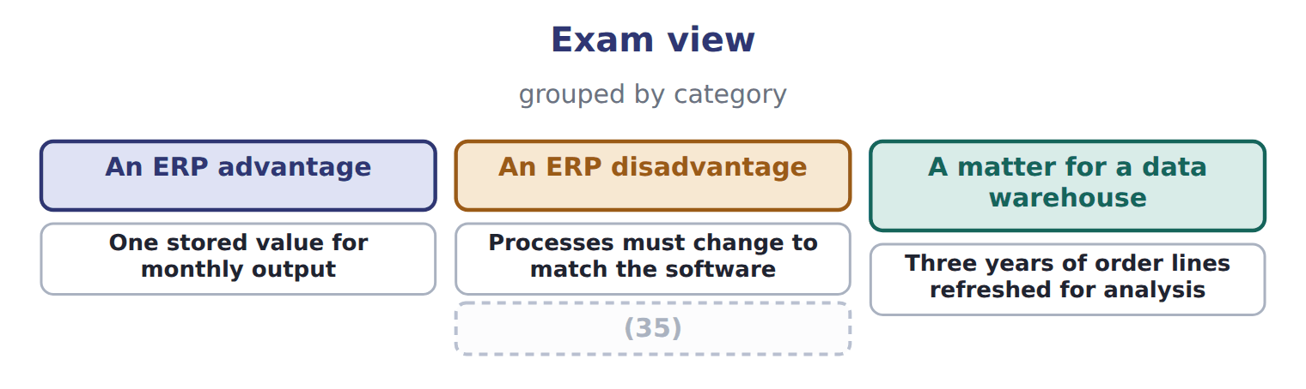
word list
One stored value for monthly output · Reapplying modifications at every upgrade

The English this section uses, and its Arabic
Each term sits against what it means.
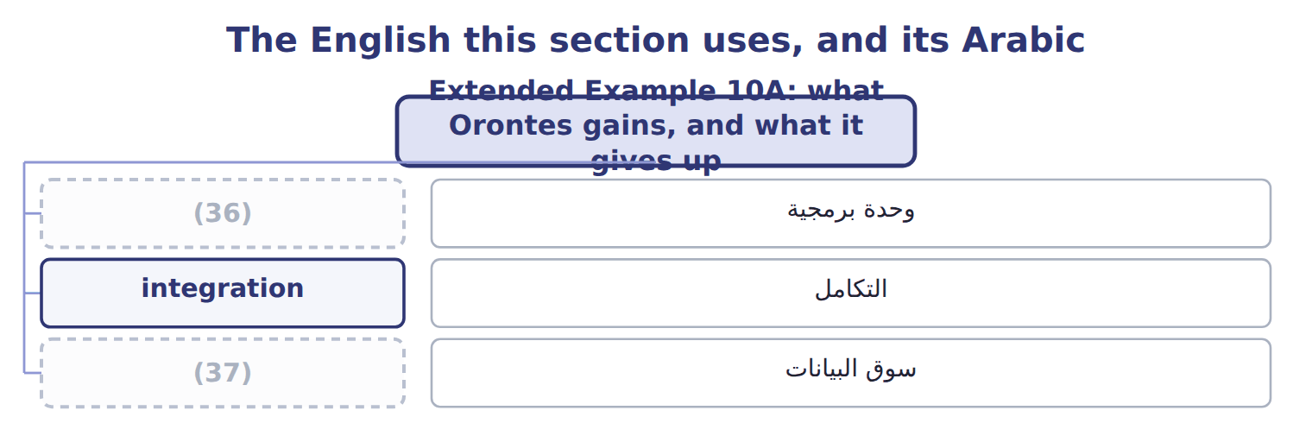
word list
relational database · module · data mart

Answer key · 10.6 Extended Example 10A: what Orontes gains, and what it gives up

1 proposal | 20 including
2 describing | 21 leaving
3 outcome | 22 expanding
4 having | 23 separate
5 director | 24 rationally
6 premium | 25 Data mart
7 arrangement | 26 No two rows may share it and none may be blank
8 unverifiable | 27 A foreign key
9 integrated | 28 ability
10 materials | 29 licence
11 demand | 30 customisation
12 rebuilding | 31 protect
13 explaining | 32 question
14 preventing | 33 driver-based
15 things | 34 Answering
16 trivial | 35 Reapplying modifications at every upgrade
17 implementation | 36 module
18 attention | 37 data mart
19 Processes

the summaries in full
Summary 1 This example judges the Orontes ERP proposal rather than describing it. F.1.i is a Level C outcome, so the exam will ask what performance management makes possible and whether it is worth having. The sales director asked what one case of premium oil cost and how much was labour. Under the present arrangement the answer took two days and arrived unverifiable. On an integrated system it is a query: the batch, its hours, its materials and its output all sit in one database. Once cost per case is available on demand, the budget can be built from drivers rather than from last year. Volume times price gives revenue; volume times cost per case gives cost; and a change in the olive price flows through to margin without anyone rebuilding the model. The variance analysis of Book 2 could already explain a difference after the month closed.
Summary 2 With plan and actual in one place, the same analysis becomes available while the month is still running, which is the difference between explaining a loss and preventing one. Three things, and none of them trivial. A long implementation during which attention goes to the project rather than the business. Processes changed to match the software, including some that the plant believes are better than the standard. And dependence on one vendor, with the cost of leaving rising each year. For a company expanding into the Gulf the case is strong, because the questions it will need to answer are exactly the ones separate systems cannot answer: which products earn most in which market, and what a change in volume does to cost. A company not growing might rationally defer. Implementations fail when a company tries to keep every existing process, customises heavily to do so, and then cannot upgrade. The discipline that makes integration work is accepting a standard process unless there is a real reason not to.
Summary 3 Integration is worth most to a company whose questions span its systems. The gain is not the software but the ability to plan from drivers and review in time to act. The cost is paid in process change and vendor dependence, not only in licence fees. Heavy customisation destroys the benefit it was bought to protect.
Summary 4 A Level C question asks whether performance management helps, or what it makes possible. Name the mechanism, not the benefit: driver-based planning, continuous forecasting, plan and actual together, and review feeding the next plan. Answering that it improves decisions earns nothing.

