13.1 What makes data Big
Chapter 13 · section 13.1

Fill every gap. Each word list holds one word more than there are gaps.
Chapter 13, section by section
Each stage leads to the next.
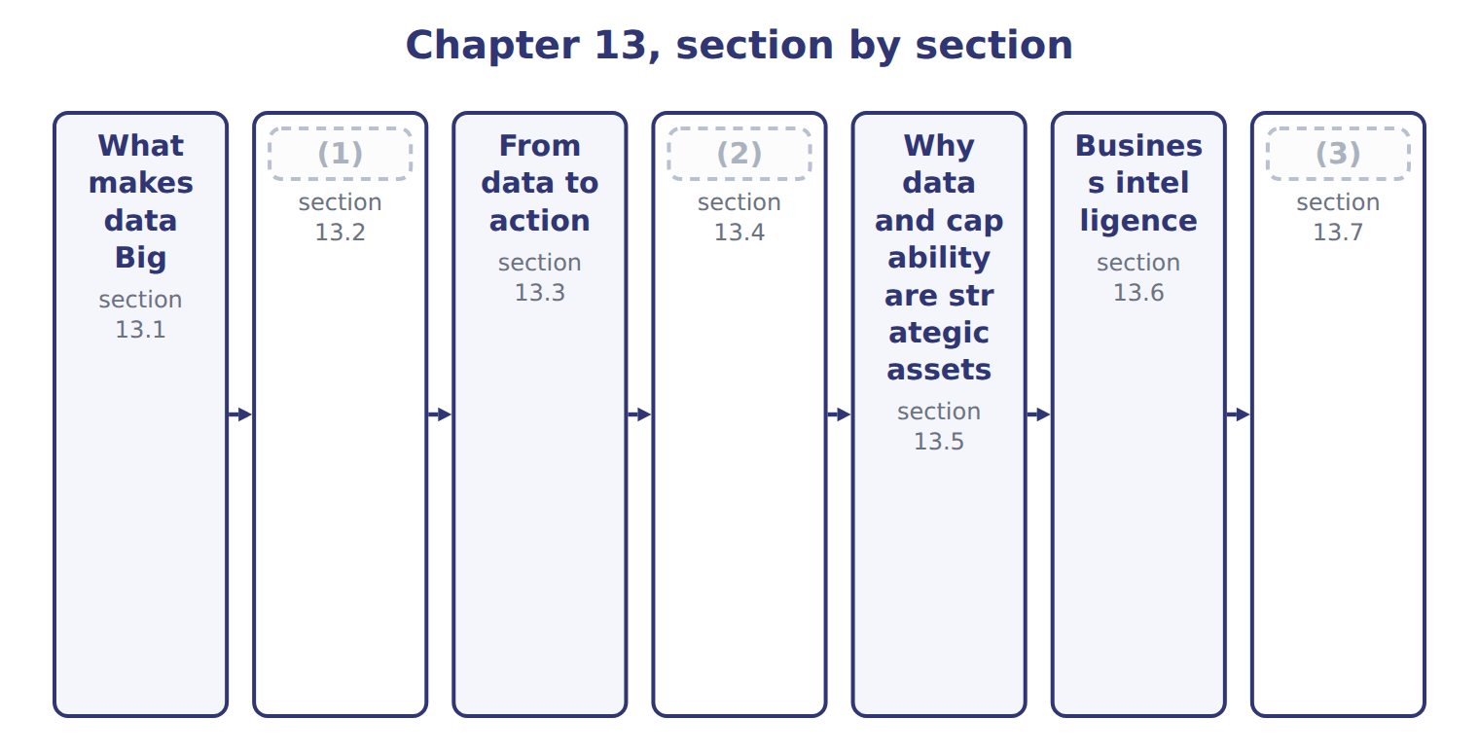
word list
business intelligence (BI) · Structured, semi-structured and unstructured d · Opportunities and challenges · Extended Example 13A: one number becomes a dec

Summary 1 gaps 4–12
Big Data is data whose volume, speed or variety puts it beyond what (4) tools were built to (5) . Many (6) add a fifth V, value, and some add (7) . The (8) outcome names four: volume, (9) , variety and veracity. Answer with four unless a (10) gives you a (11) list to work. Veracity is the one that matters most to an (12) , and the one most often skipped. It asks whether the data can be trusted, and: one distributor recorded under three spellings, fourteen orders with no delivery date. Volume without veracity produces confident answers that are wrong.
word list
different · accountant · guides · question · velocity · traditional · produces · handle · others · official

The English this sheet uses, and its Arabic
English (exam term) | Arabic
Big Data | البيانات الضخمة
veracity | الموثوقية

Answer key · 13.1 What makes data Big

1 Structured, semi-structured and unstructured d | 7 others
2 Opportunities and challenges | 8 official
3 Extended Example 13A: one number becomes a dec | 9 velocity
4 traditional | 10 question
5 handle | 11 different
6 guides | 12 accountant

the summaries in full
Summary 1 Big Data is data whose volume, speed or variety puts it beyond what traditional tools were built to handle. Many guides add a fifth V, value, and some add others. The official outcome names four: volume, velocity, variety and veracity. Answer with four unless a question gives you a different list to work. Veracity is the one that matters most to an accountant, and the one most often skipped. It asks whether the data can be trusted, and: one distributor recorded under three spellings, fourteen orders with no delivery date. Volume without veracity produces confident answers that are wrong.

13.2 Structured, semi-structured and unstructured data
Chapter 13 · section 13.2

Fill every gap. Each word list holds one word more than there are gaps.
Variety is easier to grasp once the three kinds are named.
Structured, semi-structured and unstructured data
Kind of data (F.4.b) | What it means | At Orontes | How it is used
Structured | (1) | The order table of Chapter 10 | Queried directly; the easiest to analyse
Semi-structured | Carries tags or keys but no rigid table | A supplier's electronic invoice file | (2)
Unstructured | (3) | Customer emails, photographs of damaged pallets, call recordings | The largest share, and the hardest to use

word list
Queried directly; the easiest to analyse · No predefined form at all · Readable by machine once the tags are understood · Fits rows and columns with a fixed meaning

Summary 1 gaps 4–11
Structured data is what: rows and columns with a fixed meaning, which a query can read directly. It is the (4) of what a company holds and the (5) majority of what it (6) , for the simple reason that it is the easiest to use. Unstructured data is the (7) and the larger share: emails, photographs, recordings, free text. A (8) of a damaged pallet contains (9) no table holds, and extracting it has until recently needed a person. That is what has (10) , and it is why variety now (11) beside volume.
word list
analyses · overwhelming · information · opposite · minority · changed · appears · contains · photograph

The English this section uses, and its Arabic
Each term sits against what it means.
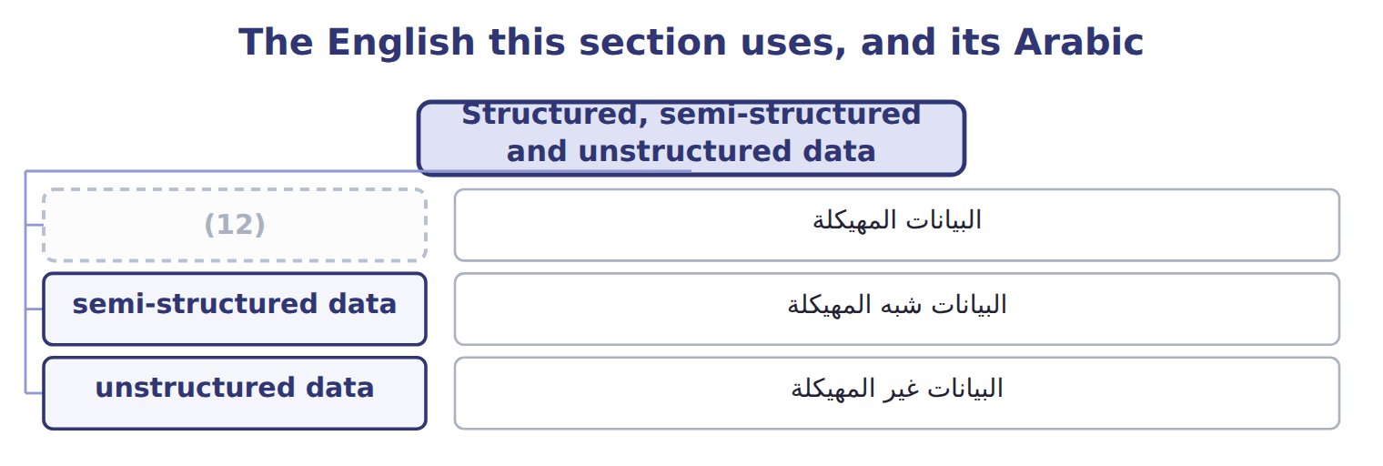
word list
Big Data · structured data

The English this sheet uses, and its Arabic
English (exam term) | Arabic
structured data | البيانات المهيكلة
semi-structured data | البيانات شبه المهيكلة
unstructured data | البيانات غير المهيكلة

Answer key · 13.2 Structured, semi-structured and unstructured data

1 Fits rows and columns with a fixed meaning | 7 opposite
2 Readable by machine once the tags are understood | 8 photograph
3 No predefined form at all | 9 information
4 minority | 10 changed
5 overwhelming | 11 appears
6 analyses | 12 structured data

the summaries in full
Summary 1 Structured data is what: rows and columns with a fixed meaning, which a query can read directly. It is the minority of what a company holds and the overwhelming majority of what it analyses, for the simple reason that it is the easiest to use. Unstructured data is the opposite and the larger share: emails, photographs, recordings, free text. A photograph of a damaged pallet contains information no table holds, and extracting it has until recently needed a person. That is what has changed, and it is why variety now appears beside volume.

13.3 From data to action
Chapter 13 · section 13.3

Fill every gap. Each word list holds one word more than there are gaps.
Summary 1 gaps 1–8
Data by itself (1) nothing. Read it upward and the (2) are clear. (3) needs insight into why a pattern holds; insight needs the knowledge that a pattern (4) ; knowledge needs enough information to see across cases; and information is a fact placed in (5) . Each step is worth more than the one below it, and none can be (6) . The step companies stop at is knowledge. Knowing that the third quarter is always the peak is useful, but it does not say whether to (7) the extra shift to the (8) or to the weather.
word list
skipped · schedule · context · dependencies · exists · calendar · decides · pattern · Action

The English this sheet uses, and its Arabic
English (exam term) | Arabic
insight | البصيرة التحليلية

Answer key · 13.3 From data to action

1 decides | 5 context
2 dependencies | 6 skipped
3 Action | 7 schedule
4 exists | 8 calendar

the summaries in full
Summary 1 Data by itself decides nothing. Read it upward and the dependencies are clear. Action needs insight into why a pattern holds; insight needs the knowledge that a pattern exists; knowledge needs enough information to see across cases; and information is a fact placed in context. Each step is worth more than the one below it, and none can be skipped. The step companies stop at is knowledge. Knowing that the third quarter is always the peak is useful, but it does not say whether to schedule the extra shift to the calendar or to the weather.

13.4 Opportunities and challenges
Chapter 13 · section 13.4

Fill every gap. Each word list holds one word more than there are gaps.
Summary 1 gaps 1–8
The last row deserves (1) because it (2) as data grows. With enough (3) , patterns appear by chance alone: two series that happen to move together, with no (4) between them. More data finds more such patterns, not fewer, and only (5) about what could (6) cause what separates them from real findings. The challenge that defeats most (7) , though, is the (8) one in the fifth row. An insight that reaches nobody with the authority to act changes nothing, and the cost of producing it has been spent.
word list
variables · judgement · attention · projects · worsens · plausibly · ordinary · connection · producing

Opportunities and their matching challenges
 | Opportunity (F.4.a, F.4.d) | Matching challenge
Better decisions | Patterns too large or too fast for a person to see | (9) : an answer from poor data is still poor
Speed | Answers while there is still time to act | (10) : the people who can do this are scarce and expensive
New questions | Questions nobody could previously afford to ask | (11)
Customer understanding | Behaviour across every channel, not just sales | (12) : Chapter 11's obligations still apply
Operational insight | (13) | Acting on it: an insight nobody acts on changes nothing
Competitive position | Capability competitors cannot quickly copy | (14) : more data means more false findings

word list
Skills · Capability competitors cannot quickly copy · Spurious patterns · Privacy and law · Sensor and process data alongside financial data · Cost: storage, tools and time add up before any benefit · Data quality

Answer key · 13.4 Opportunities and challenges

1 attention | 8 ordinary
2 worsens | 9 Data quality
3 variables | 10 Skills
4 connection | 11 Cost: storage, tools and time add up before any benefit
5 judgement | 12 Privacy and law
6 plausibly | 13 Sensor and process data alongside financial data
7 projects | 14 Spurious patterns

the summaries in full
Summary 1 The last row deserves attention because it worsens as data grows. With enough variables, patterns appear by chance alone: two series that happen to move together, with no connection between them. More data finds more such patterns, not fewer, and only judgement about what could plausibly cause what separates them from real findings. The challenge that defeats most projects, though, is the ordinary one in the fifth row. An insight that reaches nobody with the authority to act changes nothing, and the cost of producing it has been spent.

13.5 Why data and capability are strategic assets
Chapter 13 · section 13.5

Fill every gap. Each word list holds one word more than there are gaps.
Summary 1 gaps 1–8
The (1) row carries the (2) . A (3) can buy the same software tomorrow, and could in (4) buy similar data. What cannot be bought quickly is the data science (5) : people who know which (6) is worth asking, which answer is suspect, and how to say so to a board. The last row is the honest (7) . Data (8) the odds of a good decision; it does not make the decision. Book 3's Gulf expansion rested on figures but remained a judgement about risk and ambition, and no quantity of data would have removed.
word list
expansion · principle · qualification · competitor · improves · argument · fourth · question · capability

The words this section uses
Each term sits against what it means, and an instance of it.
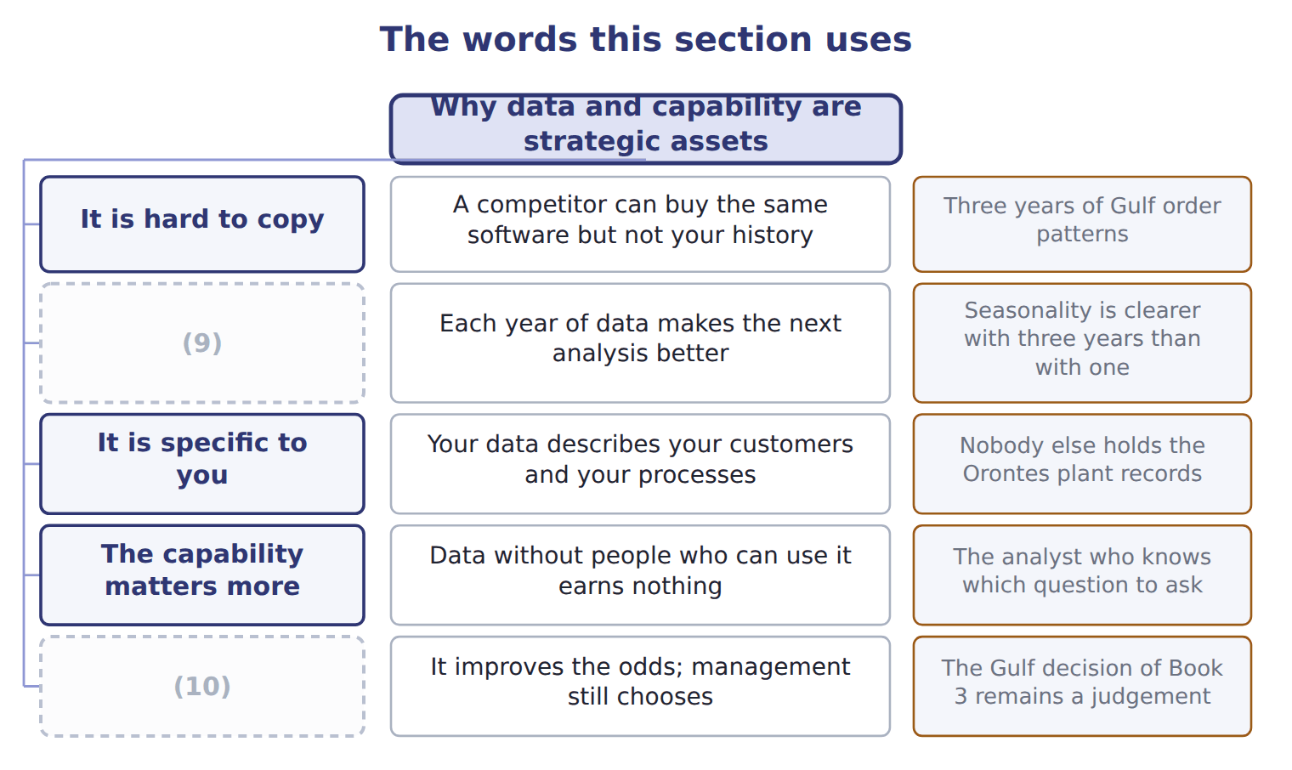
word list
structured data · It enables, not decides · It compounds

The English this sheet uses, and its Arabic
English (exam term) | Arabic
data science capability | القدرة على علم البيانات

Answer key · 13.5 Why data and capability are strategic assets

1 fourth | 6 question
2 argument | 7 qualification
3 competitor | 8 improves
4 principle | 9 It compounds
5 capability | 10 It enables, not decides

the summaries in full
Summary 1 The fourth row carries the argument. A competitor can buy the same software tomorrow, and could in principle buy similar data. What cannot be bought quickly is the data science capability: people who know which question is worth asking, which answer is suspect, and how to say so to a board. The last row is the honest qualification. Data improves the odds of a good decision; it does not make the decision. Book 3's Gulf expansion rested on figures but remained a judgement about risk and ambition, and no quantity of data would have removed.

13.6 Business intelligence
Chapter 13 · section 13.6

Fill every gap. Each word list holds one word more than there are gaps.
Summary 1 gaps 1–4
The third (1) is the one that is (2) missing. Applications and tools can be bought; agreed (3) cannot. If two (4) show different figures for the same measure because nobody settled what it means, the arrangement has failed however good the software is.
word list
analytics · dashboards · usually · element · definitions

Business intelligence is not a dashboard

Summary 2 gaps 5–10
A dashboard is one (5) within business intelligence. The term covers the whole arrangement: the applications, the tools that feed them, and the (6) that make the numbers (7) . A (8) equating the two has (9) it too far. Business intelligence looks (10) and sideways: what happened, where, and compared with. Part IV goes further, into what will happen and what should be done, which is the distinction between the four types of analytics.
word list
trustworthy · backward · veracity · practices · question · narrowed · application

The words this section uses
Each term sits against what it means, and an instance of it.
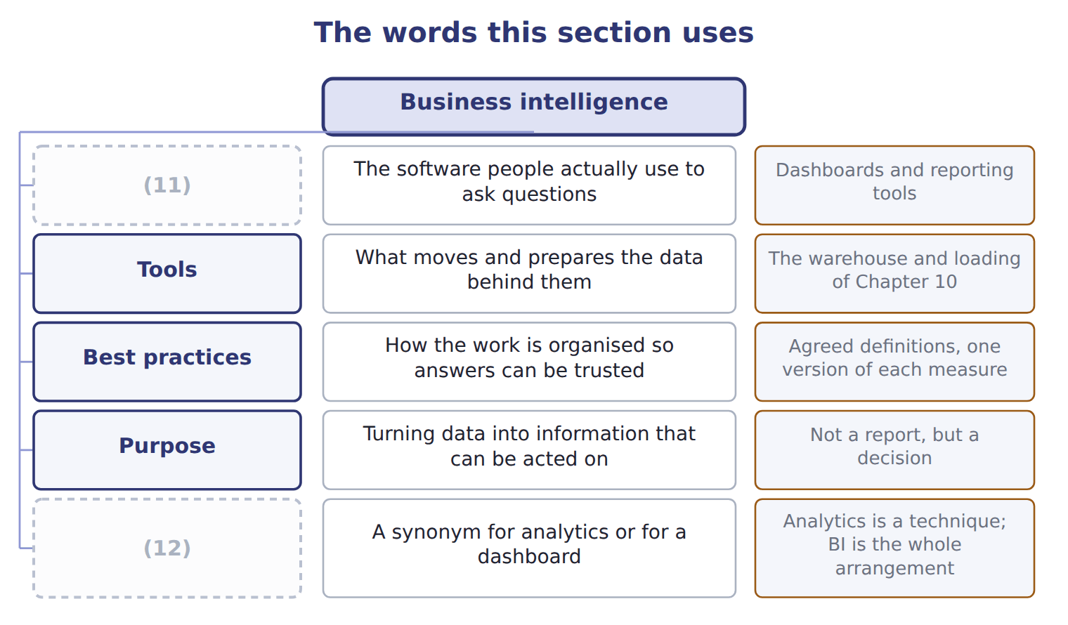
word list
Applications · What it is not · semi-structured data

The English this sheet uses, and its Arabic
English (exam term) | Arabic
business intelligence (BI) | ذكاء الأعمال

Answer key · 13.6 Business intelligence

1 element | 7 trustworthy
2 usually | 8 question
3 definitions | 9 narrowed
4 dashboards | 10 backward
5 application | 11 Applications
6 practices | 12 What it is not

the summaries in full
Summary 1 The third element is the one that is usually missing. Applications and tools can be bought; agreed definitions cannot. If two dashboards show different figures for the same measure because nobody settled what it means, the arrangement has failed however good the software is.
Summary 2 A dashboard is one application within business intelligence. The term covers the whole arrangement: the applications, the tools that feed them, and the practices that make the numbers trustworthy. A question equating the two has narrowed it too far. Business intelligence looks backward and sideways: what happened, where, and compared with. Part IV goes further, into what will happen and what should be done, which is the distinction between the four types of analytics.

13.7 Extended Example 13A: one number becomes a decision
Chapter 13 · section 13.7

Fill every gap. Each word list holds one word more than there are gaps.
Summary 1 gaps 1–12
This example takes a single (1) figure and walks it up the (2) to an action. It is (3) , because the exam gives a statement and asks which step it (4) . The (5) is 240,000. On its own it means (6) at all: it could be cases, dinars, (7) or an account code. Place it in context and it (8) information: 240,000 cases sold in 2028 Q3. Now it can be compared with (9) , which is the whole (10) of context. Set it beside the other (11) and a pattern (12) . The third quarter is the peak in both years, at 240,400 cases in 2027 and 240,000 in 2028. That is knowledge: a regularity across cases rather than a single fact. Knowledge says what happens; insight says why. The third quarter is also the hottest, at 34 degrees against 15 in the first.
word list
something · decision · kilometres · progression · appears · Beverages · purpose · represents · quarters · exam-core · number · becomes · nothing

Summary 2 gaps 13–20
The decision follows from the insight, not from the pattern. If the peak follows the weather rather than the promotion calendar, the extra shift should be (13) to forecast temperature, and promotion (14) in the hottest weeks may be buying demand that would have arrived anyway. (15) up to insight is analysis and can be (16) . The action requires somebody with the (17) to change the shift pattern, and willing to accept an analyst's finding over a (18) assumption. That is the (19) the fourth row describes, and it is not bought with (20) .
word list
capability · authority · spending · software · becomes · Everything · scheduled · delegated · long-standing

Name four characteristics

Complete the blank cells.
Your turn: name four characteristics (complete the blanks)
What is described | Which V? | Why
Millions of order lines held over three years | Volume | (21)
Plant sensors reporting every few seconds | Velocity | Velocity describes how fast data arrives, and sensor data arrives far faster than monthly reporting
Numbers, emails and photographs together | (22) | It describes how many different kinds of data are involved
Three spellings of one distributor | (23) | It describes how far the data can be trusted

word list
data science capability · Veracity · It describes how much data there is · Variety

The pattern behind the progression

Summary 3 gaps 24–26
A fact alone is data; a fact in context is information. A regularity across cases is knowledge; an explanation of it is insight. Only insight (24) an action, because only insight says why. Most (25) stop at knowledge and act on the calendar (26) .
word list
instead · organizations · supports · context

Exam view

Summary 4 gaps 27–28
A (27) gives a statement and asks which step it is. Test it: is it a bare fact, a fact with context, a pattern, an explanation, or a decision? The (28) error is calling a pattern an insight.
word list
insight · question · commonest

Exam view
Statement from the case | Category
240,000 | Data
240,000 cases in the third quarter | Information
The third quarter is the peak every year | (29)
The peak follows temperature rather than the promotion calendar | (30)

word list
Why · Knowledge · Insight

Answer key · 13.7 Extended Example 13A: one number becomes a decision

1 Beverages | 16 delegated
2 progression | 17 authority
3 exam-core | 18 long-standing
4 represents | 19 capability
5 number | 20 software
6 nothing | 21 It describes how much data there is
7 kilometres | 22 Variety
8 becomes | 23 Veracity
9 something | 24 supports
10 purpose | 25 organizations
11 quarters | 26 instead
12 appears | 27 question
13 scheduled | 28 commonest
14 spending | 29 Knowledge
15 Everything | 30 Insight

the summaries in full
Summary 1 This example takes a single Beverages figure and walks it up the progression to an action. It is exam-core, because the exam gives a statement and asks which step it represents. The number is 240,000. On its own it means nothing at all: it could be cases, dinars, kilometres or an account code. Place it in context and it becomes information: 240,000 cases sold in 2028 Q3. Now it can be compared with something, which is the whole purpose of context. Set it beside the other quarters and a pattern appears. The third quarter is the peak in both years, at 240,400 cases in 2027 and 240,000 in 2028. That is knowledge: a regularity across cases rather than a single fact. Knowledge says what happens; insight says why. The third quarter is also the hottest, at 34 degrees against 15 in the first.
Summary 2 The decision follows from the insight, not from the pattern. If the peak follows the weather rather than the promotion calendar, the extra shift should be scheduled to forecast temperature, and promotion spending in the hottest weeks may be buying demand that would have arrived anyway. Everything up to insight is analysis and can be delegated. The action requires somebody with the authority to change the shift pattern, and willing to accept an analyst's finding over a long-standing assumption. That is the capability the fourth row describes, and it is not bought with software.
Summary 3 A fact alone is data; a fact in context is information. A regularity across cases is knowledge; an explanation of it is insight. Only insight supports an action, because only insight says why. Most organizations stop at knowledge and act on the calendar instead.
Summary 4 A question gives a statement and asks which step it is. Test it: is it a bare fact, a fact with context, a pattern, an explanation, or a decision? The commonest error is calling a pattern an insight.

