14.1 What data mining is
Chapter 14 · section 14.1

Fill every gap. Each word list holds one word more than there are gaps.
Chapter 14, section by section
Each stage leads to the next.
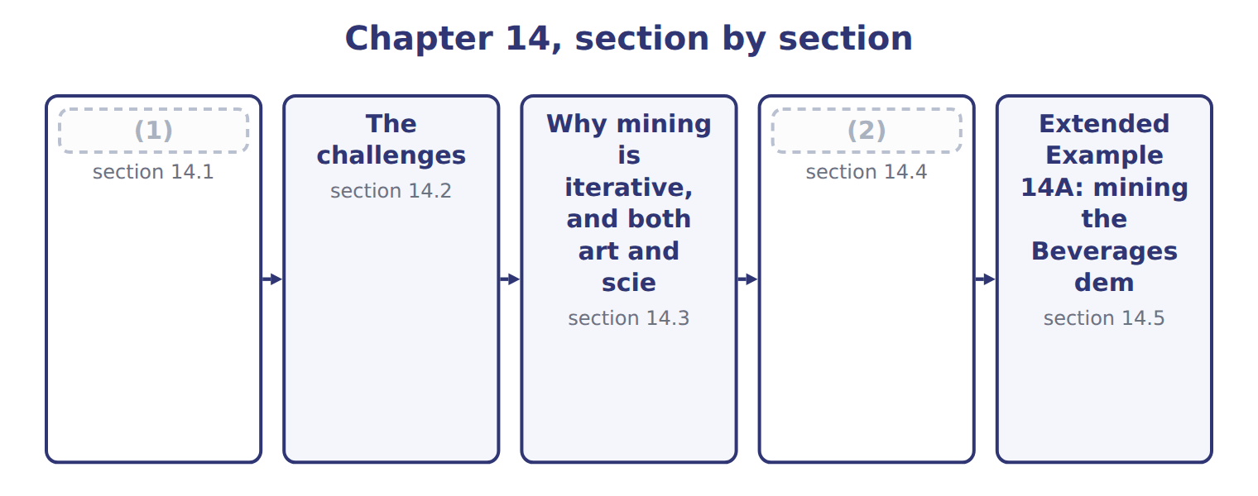
word list
What data mining is · section 14.1 · Structured Query Language

Summary 1 gaps 3–6
Data mining is the search (3) data for patterns, (4) and anomalies that were not known in advance. The last part of that definition (5) it from reporting. A report answers a (6) somebody already had; mining looks for what nobody thought to ask.
word list
relationships · through · distinguishes · technique · question

Summary 2 gaps 7–10
Mining finds (7) , meaning that two things occur together. It cannot by itself (8) that one causes the other. That (9) is not a weakness of the technique but of the data. Causation is established by reasoning about mechanism, or by an (10) , and a dataset of past orders contains neither.
word list
limitation · thought · association · establish · experiment

The words this section uses
Each term sits against what it means, and an instance of it.
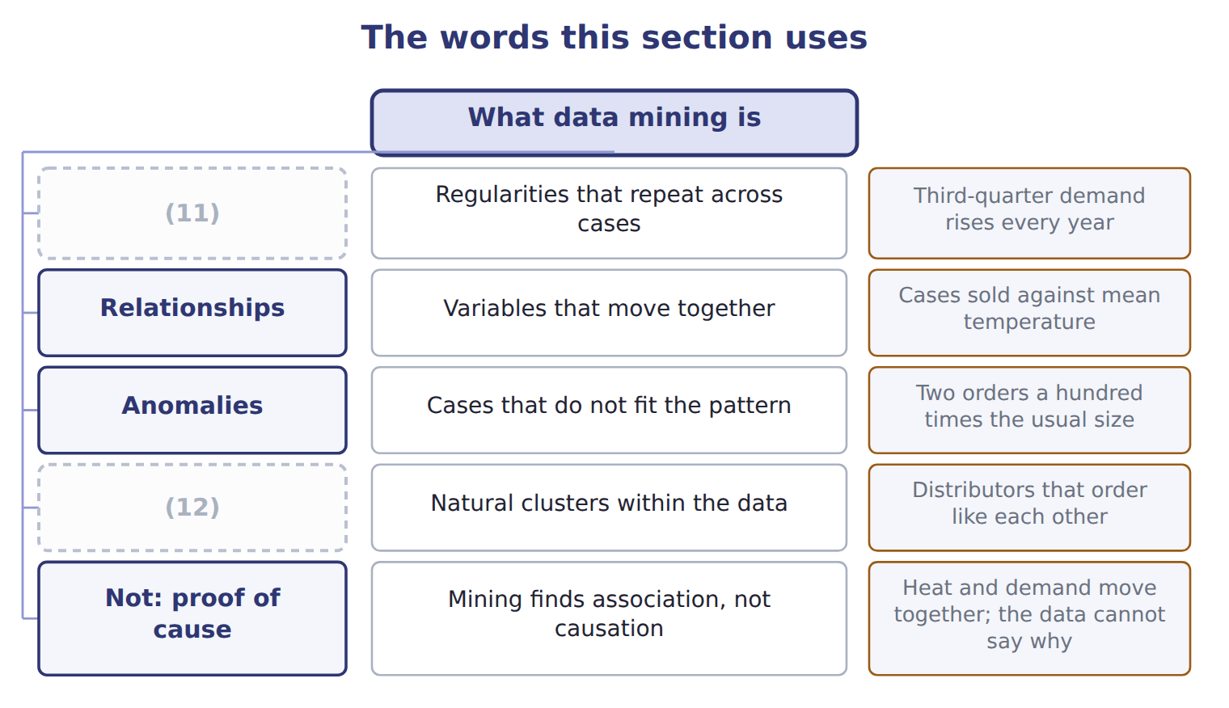
word list
Patterns · Anomalies · Groupings

The English this sheet uses, and its Arabic
English (exam term) | Arabic
data mining | التنقيب في البيانات
association | الارتباط

Answer key · 14.1 What data mining is

1 What data mining is | 7 association
2 Structured Query Language | 8 establish
3 through | 9 limitation
4 relationships | 10 experiment
5 distinguishes | 11 Patterns
6 question | 12 Groupings

the summaries in full
Summary 1 Data mining is the search through data for patterns, relationships and anomalies that were not known in advance. The last part of that definition distinguishes it from reporting. A report answers a question somebody already had; mining looks for what nobody thought to ask.
Summary 2 Mining finds association, meaning that two things occur together. It cannot by itself establish that one causes the other. That limitation is not a weakness of the technique but of the data. Causation is established by reasoning about mechanism, or by an experiment, and a dataset of past orders contains neither.

14.2 The challenges
Chapter 14 · section 14.2

Fill every gap. Each word list holds one word more than there are gaps.
The challenges of data mining
Challenge (F.4.h) | Why it is hard | At Orontes
Data quality | Poor data yields a confident wrong answer | Chapter 11's three spellings and missing dates
Size and cost | (1) | Three years of order lines across three systems
Privacy and law | (2) | Jordan's law, applied since 2025
Spurious findings | (3) | Cases against staff birthdays
Overfitting | A model that fits this data (4) may predict nothing | Chapter 16 returns to this
Knowing when to stop | There is always another cut of the data | (5)

word list
Personal data constrains what may be held and used · Large datasets need storage, tools and time · Two weeks of analysis for a decision due Friday · perfectly · Three years of order lines across three systems · More variables mean more coincidences

Summary 1 gaps 6–11
The first (6) the largest. (7) routinely consumes most of the effort in a mining project. The last is the one (8) warns about. There is always another cut of the data, another (9) to add, another period to extend. An analysis still (10) when the decision is taken has failed as surely as one that was wrong. Knowing when the answer is good (11) is a skill rather than a rule.
word list
Preparation · remains · largest · improving · variable · nobody · enough

Answer key · 14.2 The challenges

1 Large datasets need storage, tools and time | 7 Preparation
2 Personal data constrains what may be held and used | 8 nobody
3 More variables mean more coincidences | 9 variable
4 perfectly | 10 improving
5 Two weeks of analysis for a decision due Friday | 11 enough
6 remains

the summaries in full
Summary 1 The first remains the largest. Preparation routinely consumes most of the effort in a mining project. The last is the one nobody warns about. There is always another cut of the data, another variable to add, another period to extend. An analysis still improving when the decision is taken has failed as surely as one that was wrong. Knowing when the answer is good enough is a skill rather than a rule.

14.3 Why mining is iterative, and both art and science
Chapter 14 · section 14.3

Fill every gap. Each word list holds one word more than there are gaps.
Summary 1 gaps 1–6
It is drawn with return arrows (1) it is never a (2) line. A failed (3) sends the analyst back to the model, to the (4) , or to the question itself. That (5) more than once in any real (6) . A first model that disappoints is the normal case, not a failure of competence. The phrase art and science describes the same cycle from a different angle.
word list
straight · evaluation · disappoints · project · happens · because · preparation

Which parts of the work are art and which are science
Every item belongs to exactly one group.
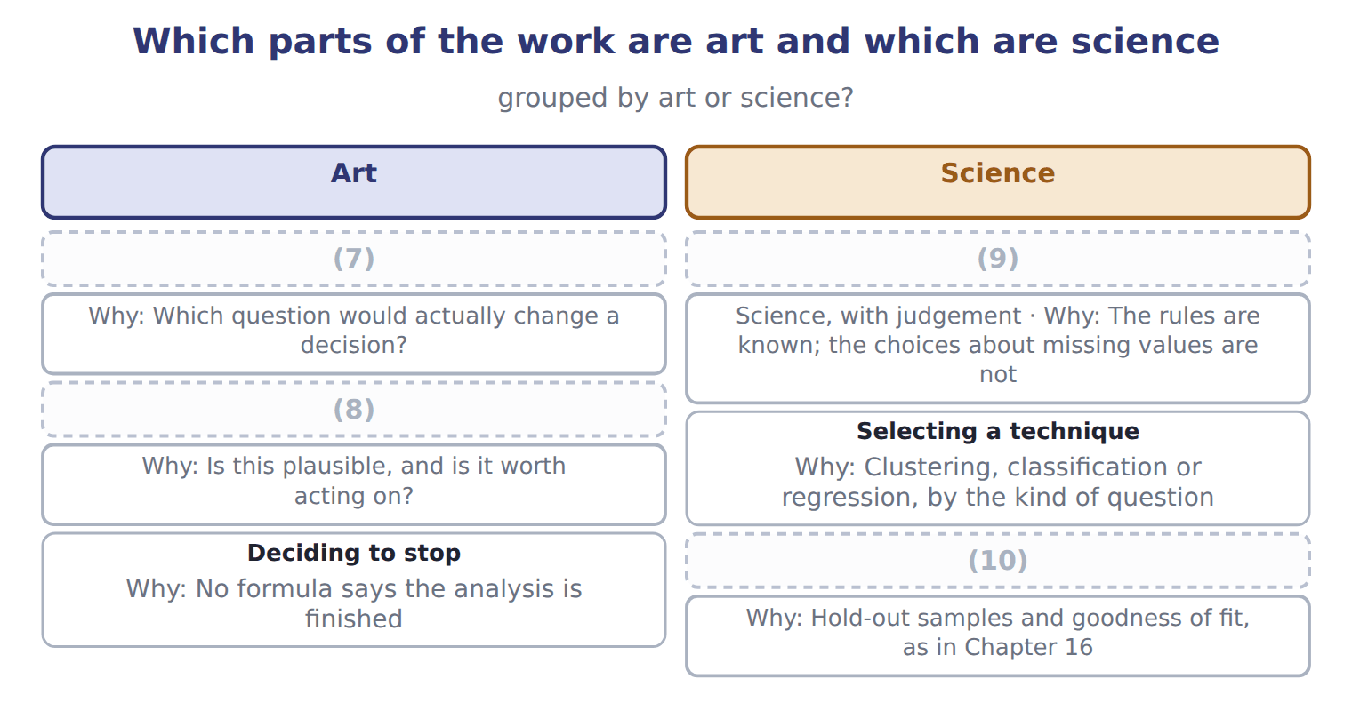
word list
Reading the result · Choosing the question · Preparing the data · Testing the result · Selecting a technique

Summary 2 gaps 11–15
The science is the part that can be (11) down. It covers how to (12) data, which (13) suits which question, and how to test a result. The art is (14) the method (15) settle, and the two that matter most sit at the ends. Choosing a question that would actually change a decision is judgement, and so is deciding that the work is finished.
word list
written · deciding · cannot · prepare · technique · everything

The English this sheet uses, and its Arabic
English (exam term) | Arabic
iterative process | العملية التكرارية

Answer key · 14.3 Why mining is iterative, and both art and science

1 because | 9 Preparing the data
2 straight | 10 Testing the result
3 evaluation | 11 written
4 preparation | 12 prepare
5 happens | 13 technique
6 project | 14 everything
7 Choosing the question | 15 cannot
8 Reading the result

the summaries in full
Summary 1 It is drawn with return arrows because it is never a straight line. A failed evaluation sends the analyst back to the model, to the preparation, or to the question itself. That happens more than once in any real project. A first model that disappoints is the normal case, not a failure of competence. The phrase art and science describes the same cycle from a different angle.
Summary 2 The science is the part that can be written down. It covers how to prepare data, which technique suits which question, and how to test a result. The art is everything the method cannot settle, and the two that matter most sit at the ends. Choosing a question that would actually change a decision is judgement, and so is deciding that the work is finished.

14.4 Structured Query Language
Chapter 14 · section 14.4

Fill every gap. Each word list holds one word more than there are gaps.
Summary 1 gaps 1–10
Structured Query Language (SQL), usually called SQL, is the (1) language for asking a relational (2) for data and for changing what it holds. Read it as six (3) in order. Which (4) do I want, from which table, linked to what, keeping which rows, (5) how, and sorted how. A (6) is the clause that earns the relational design: without the shared key, the orders and the (7) could not be read together at all. A (8) accountant is not expected to write (9) queries. The (10) is to know what SQL is for and to read a simple query. It also includes seeing why an answer depends on which rows were kept and which were not.
word list
customers · database · management · questions · summarised · expectation · production · join · querying · standard · columns

The filter decides the answer

Summary 2 gaps 11–13
Two analysts querying the same table can report (11) totals if one keeps (12) orders and the other does not. When a figure is (13) , the first question is what the query filtered out, not whether the data is wrong.
word list
columns · disputed · different · cancelled

The English this sheet uses, and its Arabic
English (exam term) | Arabic
Structured Query Language (SQL) | لغة الاستعلام الهيكلية
join | الربط

Answer key · 14.4 Structured Query Language

1 standard | 8 management
2 database | 9 production
3 questions | 10 expectation
4 columns | 11 different
5 summarised | 12 cancelled
6 join | 13 disputed
7 customers

the summaries in full
Summary 1 Structured Query Language (SQL), usually called SQL, is the standard language for asking a relational database for data and for changing what it holds. Read it as six questions in order. Which columns do I want, from which table, linked to what, keeping which rows, summarised how, and sorted how. A join is the clause that earns the relational design: without the shared key, the orders and the customers could not be read together at all. A management accountant is not expected to write production queries. The expectation is to know what SQL is for and to read a simple query. It also includes seeing why an answer depends on which rows were kept and which were not.
Summary 2 Two analysts querying the same table can report different totals if one keeps cancelled orders and the other does not. When a figure is disputed, the first question is what the query filtered out, not whether the data is wrong.

14.5 Extended Example 14A: mining the Beverages demand data
Chapter 14 · section 14.5

Fill every gap. Each word list holds one word more than there are gaps.
Summary 1 gaps 1–12
F.4.k asks how an analyst would (1) mine a dataset. This example does it, on the (2) data. The cycle is the (3) this example follows, step by step. The question is whether the extra (4) shift should be (5) to the promotion calendar, as now, or to something else. That is a question worth asking, (6) the answer would change a decision taken every (7) . There are 8 quarters of (8) : cases sold, (9) price, mean temperature and promotion weeks. Eight (10) is few, and the analyst should say so now rather than (11) it later. The (12) is: consolidate the sources, clean what is wrong, transform dates into quarters, and reduce to the columns the question needs. Nothing here is new, and it is where most of the time goes. A first query ranks the quarters by cases.
word list
because · average · observations · production · history · discover · Beverages · consolidate · quarter · structure · scheduled · actually · preparation

Summary 2 gaps 13–24
The peak quarters are the third of each year, at 240,400 cases in 2027 and 240,000 in 2028. The same quarters carry the highest (13) , 33 and 34 (14) . Promotion weeks in those quarters were 6 and 5, which is not the highest in the dataset. The (15) suggests demand follows temperature more (16) than promotion. That is a hypothesis, not a finding, and it is (17) the point at which an analyst is most (18) to stop too early and report it as a result. The hypothesis (19) , but the promotion effect is real as well, which the eyeball analysis had (20) . That last sentence is the (21) . The first look (22) promotion barely (23) ; the model says it matters, just less than temperature. Had the analyst reported after step four, the (24) would have been to cut promotion spending, and it would have been wrong.
word list
recommendation · understated · exactly · mattered · degrees · likely · pattern · closely · suggested · iteration · evaluate · survives · temperatures

Name four SQL clauses

Complete the blank cells.

Your turn: name four SQL clauses (complete the blanks)
What is wanted | Which SQL clause? | Why
Which columns to show | SELECT | (25)
Which rows to keep | WHERE | WHERE filters the rows before anything is (26) , so it determines what the answer covers
How to link a second table | JOIN ... ON | It (27) the two tables on the shared key of Chapter 10
How to summarise by customer | (28) | It collapses many rows into one per group

word list
summarised · matches · GROUP BY · Evaluate · It names the output of the query

The pattern behind the example

Summary 3 gaps 29–32
Start from the decision, not from the data. Look at the data before (29) it, and say how much of it there is. Treat what the first look suggests as a hypothesis, never as a finding. The model (30) to test the hypothesis, and may (31) it rather than (32) it.
word list
confirm · qualify · reported · exists · modelling

Exam view

Summary 4 gaps 33–35
A question (33) an analyst at some point in the work and asks what should happen next. Follow the cycle: (34) , prepare, model, evaluate, deploy. If the (35) has not been done, the answer is not yet a finding.
word list
describes · columns · understand · evaluation

Exam view
The rows are a set, not a sequence.
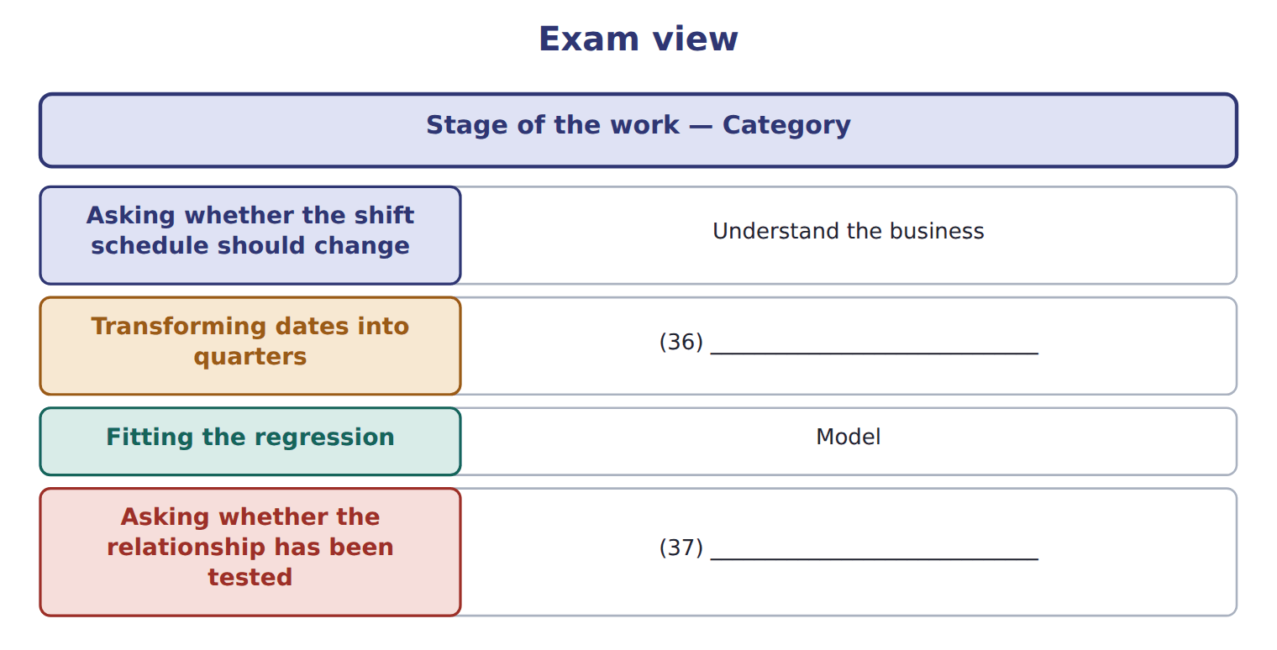
word list
Prepare the data · iterative process · Evaluate

Answer key · 14.5 Extended Example 14A: mining the Beverages demand data

1 actually | 20 understated
2 Beverages | 21 iteration
3 structure | 22 suggested
4 production | 23 mattered
5 scheduled | 24 recommendation
6 because | 25 It names the output of the query
7 quarter | 26 summarised
8 history | 27 matches
9 average | 28 GROUP BY
10 observations | 29 modelling
11 discover | 30 exists
12 preparation | 31 qualify
13 temperatures | 32 confirm
14 degrees | 33 describes
15 pattern | 34 understand
16 closely | 35 evaluation
17 exactly | 36 Prepare the data
18 likely | 37 Evaluate
19 survives

the summaries in full
Summary 1 F.4.k asks how an analyst would actually mine a dataset. This example does it, on the Beverages data. The cycle is the structure this example follows, step by step. The question is whether the extra production shift should be scheduled to the promotion calendar, as now, or to something else. That is a question worth asking, because the answer would change a decision taken every quarter. There are 8 quarters of history: cases sold, average price, mean temperature and promotion weeks. Eight observations is few, and the analyst should say so now rather than discover it later. The preparation is: consolidate the sources, clean what is wrong, transform dates into quarters, and reduce to the columns the question needs. Nothing here is new, and it is where most of the time goes. A first query ranks the quarters by cases.
Summary 2 The peak quarters are the third of each year, at 240,400 cases in 2027 and 240,000 in 2028. The same quarters carry the highest temperatures, 33 and 34 degrees. Promotion weeks in those quarters were 6 and 5, which is not the highest in the dataset. The pattern suggests demand follows temperature more closely than promotion. That is a hypothesis, not a finding, and it is exactly the point at which an analyst is most likely to stop too early and report it as a result. The hypothesis survives, but the promotion effect is real as well, which the eyeball analysis had understated. That last sentence is the iteration. The first look suggested promotion barely mattered; the model says it matters, just less than temperature. Had the analyst reported after step four, the recommendation would have been to cut promotion spending, and it would have been wrong.
Summary 3 Start from the decision, not from the data. Look at the data before modelling it, and say how much of it there is. Treat what the first look suggests as a hypothesis, never as a finding. The model exists to test the hypothesis, and may qualify it rather than confirm it.
Summary 4 A question describes an analyst at some point in the work and asks what should happen next. Follow the cycle: understand, prepare, model, evaluate, deploy. If the evaluation has not been done, the answer is not yet a finding.

