15.1 The four types of analytics
Chapter 15 · section 15.1

Fill every gap. Each word list holds one word more than there are gaps.
Chapter 15, section by section
Each stage leads to the next.
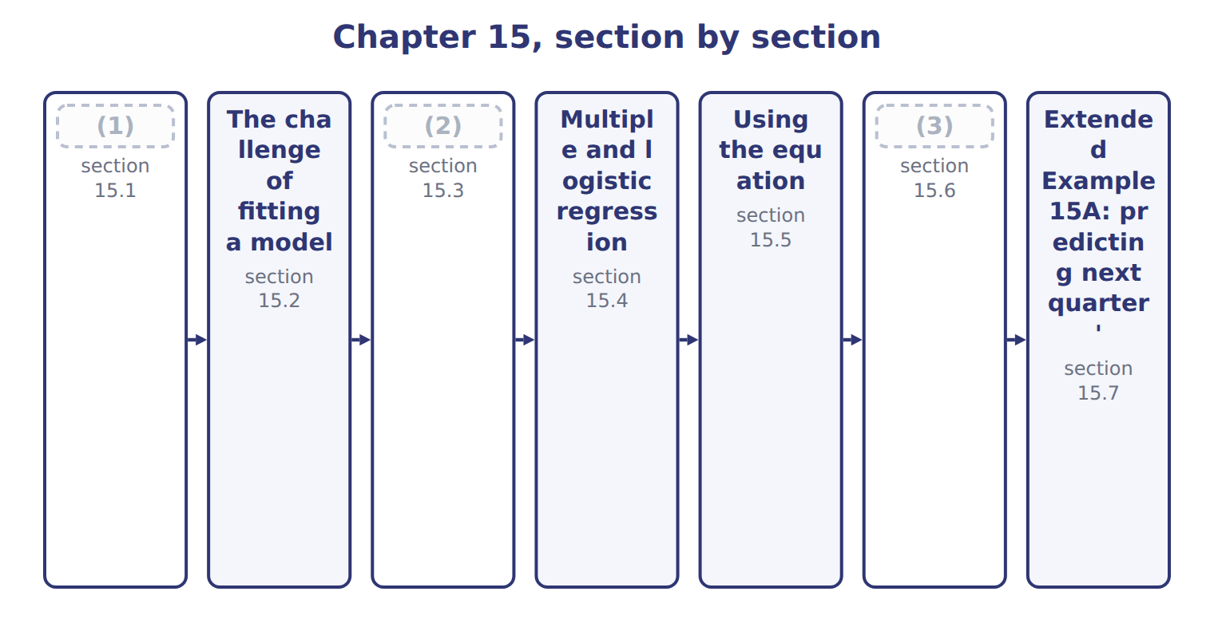
word list
The four types of analytics · The challenge of fitting a model · How well does the model fit? · Clustering and classification

Analytics is usually divided into four types by the question each answers.
The four types of analytics
Type (F.4.m) | Question | What it does | At Orontes
Descriptive | What happened? | (4) | Cases sold by quarter
Diagnostic | Why did it happen? | (5) | The third quarter peak follows temperature
Predictive | What will happen? | Modelling to forecast | (6)
Prescriptive | (7) | Optimising a decision under constraints | How many shifts to schedule, given capacity

word list
Reporting and summarising past data · Drilling into causes and relationships · Optimising a decision under constraints · Next summer's expected demand · What should we do?

Summary 1 gaps 8–9
The order is one of (8) value and difficulty. That is where Book 2's linear (9) would sit if a company joined the two.
word list
clustering · increasing · programming

The English this section uses, and its Arabic
Each term sits against what it means.
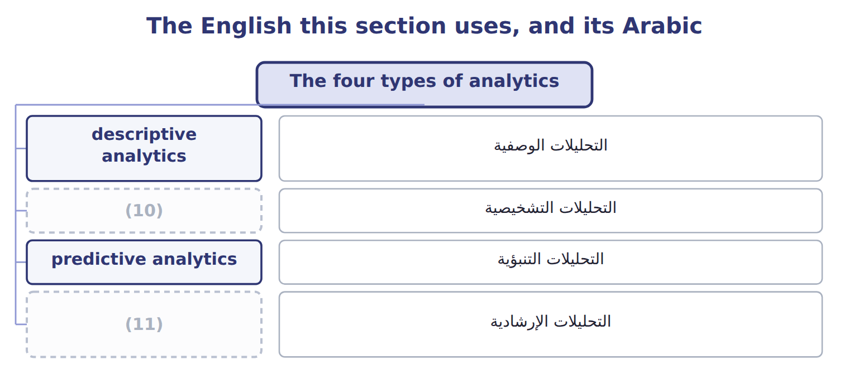
word list
prescriptive analytics · diagnostic analytics · descriptive analytics

The English this sheet uses, and its Arabic
English (exam term) | Arabic
descriptive analytics | التحليلات الوصفية
diagnostic analytics | التحليلات التشخيصية
predictive analytics | التحليلات التنبؤية
prescriptive analytics | التحليلات الإرشادية

Answer key · 15.1 The four types of analytics

1 The four types of analytics | 7 What should we do?
2 Clustering and classification | 8 increasing
3 How well does the model fit? | 9 programming
4 Reporting and summarising past data | 10 diagnostic analytics
5 Drilling into causes and relationships | 11 prescriptive analytics
6 Next summer's expected demand

the summaries in full
Summary 1 The order is one of increasing value and difficulty. That is where Book 2's linear programming would sit if a company joined the two.

15.2 The challenge of fitting a model
Chapter 15 · section 15.2

Fill every gap. Each word list holds one word more than there are gaps.
Summary 1 gaps 1–9
A model is a (1) of reality (2) to be useful. The central (3) is that the data (4) both the pattern you want and noise you do not, and no model can separate them perfectly. A (5) model can be made to pass through every (6) point. It then fits the past perfectly and (7) the future worse than a (8) line would. The reason is that it has (9) the noise as well as the signal, and the noise will not repeat. The defence is to test a model against data it has never seen, and to prefer the simplest model that does the job.
word list
difficulty · contains · straight · clustering · complicated · chosen · simplification · learned · observed · predicts

The English this sheet uses, and its Arabic
English (exam term) | Arabic
underfitting | القصور في المطابقة
overfitting | الإفراط في المطابقة

Answer key · 15.2 The challenge of fitting a model

1 simplification | 6 observed
2 chosen | 7 predicts
3 difficulty | 8 straight
4 contains | 9 learned
5 complicated

the summaries in full
Summary 1 A model is a simplification of reality chosen to be useful. The central difficulty is that the data contains both the pattern you want and noise you do not, and no model can separate them perfectly. A complicated model can be made to pass through every observed point. It then fits the past perfectly and predicts the future worse than a straight line would. The reason is that it has learned the noise as well as the signal, and the noise will not repeat. The defence is to test a model against data it has never seen, and to prefer the simplest model that does the job.

15.3 Clustering and classification
Chapter 15 · section 15.3

Fill every gap. Each word list holds one word more than there are gaps.
Both techniques put cases into groups, and the exam asks which is appropriate.
Clustering against classification
Technique (F.4.n) | What it assumes | What it does | At Orontes
Clustering | (1) : no labels exist | Finds natural groups by similarity | Which distributors behave alike, when nobody has said
Classification | Supervised: labels exist | (2) | Is this order likely to be returned, given past returns
How to choose | (3) | If they are, classify; if not, cluster | Return or not is known; distributor types are not

word list
standard error of the estimate · Assigns a case to a known category · Ask whether the categories are already known · Unsupervised

Summary 1 gaps 4–8
The test is a single (4) : are the categories already known? classification needs (5) history. It (6) from cases whose (7) is known, and then assigns new ones. At Orontes, whether an order was returned is recorded, so (8) returns is classification. Which distributors behave alike has never been recorded by anyone, so finding that out is clustering.
word list
answer · predicting · labelled · learns · question · categories

The English this sheet uses, and its Arabic
English (exam term) | Arabic
clustering | التجميع العنقودي
classification | التصنيف

Answer key · 15.3 Clustering and classification

1 Unsupervised | 5 labelled
2 Assigns a case to a known category | 6 learns
3 Ask whether the categories are already known | 7 answer
4 question | 8 predicting

the summaries in full
Summary 1 The test is a single question: are the categories already known? classification needs labelled history. It learns from cases whose answer is known, and then assigns new ones. At Orontes, whether an order was returned is recorded, so predicting returns is classification. Which distributors behave alike has never been recorded by anyone, so finding that out is clustering.

15.4 Multiple and logistic regression
Chapter 15 · section 15.4

Fill every gap. Each word list holds one word more than there are gaps.
Multiple against logistic regression
Technique (F.4.o) | Predicts | The output is | The question it answers
Multiple regression | A quantity | (1) | How many cases will we sell?
Logistic regression | A yes or no | (2) | Will this customer pay late?
Choosing | (3) | A number or a category | If the answer is a quantity, use multiple regression

word list
Cases, revenue, cost, hours · A yes or no · Look at what is being predicted · Probability between 0 and 1

Summary 1 gaps 4–12
The choice follows (4) from what is being predicted. A quantity, such as cases or cost or hours, calls for multiple regression. A category, such as (5) a customer will pay late, calls for logistic regression, whose output is a probability between zero and one (6) than a number of cases. A multiple regression equation takes the form of an (7) plus a coefficient for each variable (8) by that variable's value. Each coefficient says how much the result (9) when that variable rises by one, holding the others (10) . That last (11) is what makes it more useful than (12) at one variable alone.
word list
changes · clustering · whether · looking · constant · entirely · intercept · rather · multiplied · clause

The English this section uses, and its Arabic
Each term sits against what it means.
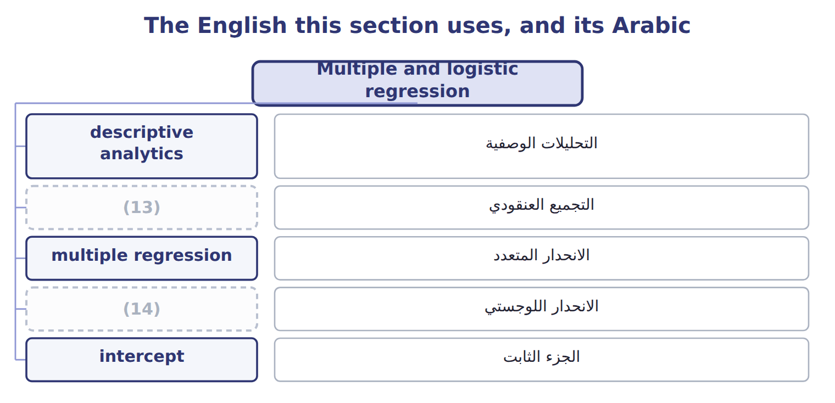
word list
prescriptive analytics · logistic regression · clustering

The English this sheet uses, and its Arabic
English (exam term) | Arabic
multiple regression | الانحدار المتعدد
logistic regression | الانحدار اللوجستي

Answer key · 15.4 Multiple and logistic regression

1 Cases, revenue, cost, hours | 8 multiplied
2 Probability between 0 and 1 | 9 changes
3 Look at what is being predicted | 10 constant
4 entirely | 11 clause
5 whether | 12 looking
6 rather | 13 clustering
7 intercept | 14 logistic regression

the summaries in full
Summary 1 The choice follows entirely from what is being predicted. A quantity, such as cases or cost or hours, calls for multiple regression. A category, such as whether a customer will pay late, calls for logistic regression, whose output is a probability between zero and one rather than a number of cases. A multiple regression equation takes the form of an intercept plus a coefficient for each variable multiplied by that variable's value. Each coefficient says how much the result changes when that variable rises by one, holding the others constant. That last clause is what makes it more useful than looking at one variable alone.

15.5 Using the equation
Chapter 15 · section 15.5

Fill every gap. Each word list holds one word more than there are gaps.
Summary 1 gaps 1–3
Fitting the eight quarters of (1) data to price, mean temperature and promotion weeks gives the (2) below. Only this (3) is examinable in this part of the syllabus, so it is worth being able to do it without hesitation.
word list
calculation · Beverages · overfitting · equation

The fitted equation

Summary 2 gaps 4–11
Price carries a (4) coefficient: raise the price and sell fewer cases. Temperature and promotion carry positive (5) : both raise (6) . Every sign is what a (7) would expect, and that is worth checking in any (8) before trusting it. A coefficient with the wrong sign usually means the (9) are entangled with each other rather than that the world has (10) . The points do not sit exactly on the line because price and promotion also move, and the line holds those at the values used for the (11) .
word list
regression · demand · coefficients · negative · variables · reader · overfitting · prediction · changed

The English this sheet uses, and its Arabic
English (exam term) | Arabic
intercept | الجزء الثابت

Answer key · 15.5 Using the equation

1 Beverages | 7 reader
2 equation | 8 regression
3 calculation | 9 variables
4 negative | 10 changed
5 coefficients | 11 prediction
6 demand

the summaries in full
Summary 1 Fitting the eight quarters of Beverages data to price, mean temperature and promotion weeks gives the equation below. Only this calculation is examinable in this part of the syllabus, so it is worth being able to do it without hesitation.
Summary 2 Price carries a negative coefficient: raise the price and sell fewer cases. Temperature and promotion carry positive coefficients: both raise demand. Every sign is what a reader would expect, and that is worth checking in any regression before trusting it. A coefficient with the wrong sign usually means the variables are entangled with each other rather than that the world has changed. The points do not sit exactly on the line because price and promotion also move, and the line holds those at the values used for the prediction.

15.6 How well does the model fit?
Chapter 15 · section 15.6

Fill every gap. Each word list holds one word more than there are gaps.
Measures of fit
Measure (F.4.q) | Range | What it tells you | Note
Correlation coefficient, R | (1) | Direction and strength of a straight-line relationship | Negative means they move oppositely
Coefficient of determination, R squared | Between 0 and 1 | The share of variation in the result that the model explains | (2)
The link | R squared is R (3) by itself, in simple regression | So R of -0.8 gives R squared of 0.64 | The sign disappears when squared
Adjusted R squared | (4) | Penalises adding variables that do not help | Use it to compare models of different sizes
Standard error of the estimate | In the units of the result | (5) | Smaller is better
What none of them prove | (6) | A high R squared on unrelated series is still a coincidence | Chapter 14's warning applies

word list
multiplied · Not cause · Between -1 and +1 · 0.90 means 90 per cent explained · The typical distance of a point from the line · different · Always at or below R squared

Summary 1 gaps 7–13
The correlation coefficient runs from minus one to plus one and (7) a straight-line relationship: its sign gives the direction, its size the strength. The coefficient of determination is that (8) squared, so it runs from zero to one and gives the share of the variation in the result that the model explains. (9) destroys the sign, which is the point (10) most often miss. A correlation of -0.8 and one of plus 0.8 both give an R squared of 0.64. Both describe an (11) strong relationship, (12) in opposite (13) .
word list
candidates · number · opposite · describes · running · equally · Squaring · directions

A high R squared is not proof

Summary 2 gaps 14–15
R squared (14) how much variation the model accounts for, not whether the relationship is real. (15) about plausible cause comes first, and the statistic second.
word list
plausible · Judgement · measures

The English this section uses, and its Arabic
Each term sits against what it means.
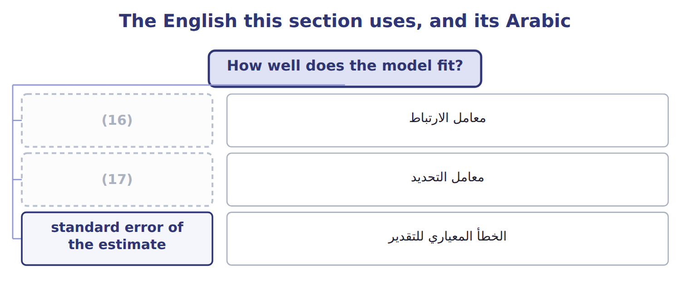
word list
correlation coefficient · معامل الارتباط · coefficient of determination

The English this sheet uses, and its Arabic
English (exam term) | Arabic
correlation coefficient | معامل الارتباط
coefficient of determination | معامل التحديد
standard error of the estimate | الخطأ المعياري للتقدير

Answer key · 15.6 How well does the model fit?

1 Between -1 and +1 | 10 candidates
2 0.90 means 90 per cent explained | 11 equally
3 multiplied | 12 running
4 Always at or below R squared | 13 directions
5 The typical distance of a point from the line | 14 measures
6 Not cause | 15 Judgement
7 describes | 16 correlation coefficient
8 number | 17 coefficient of determination
9 Squaring

the summaries in full
Summary 1 The correlation coefficient runs from minus one to plus one and describes a straight-line relationship: its sign gives the direction, its size the strength. The coefficient of determination is that number squared, so it runs from zero to one and gives the share of the variation in the result that the model explains. Squaring destroys the sign, which is the point candidates most often miss. A correlation of -0.8 and one of plus 0.8 both give an R squared of 0.64. Both describe an equally strong relationship, running in opposite directions.
Summary 2 R squared measures how much variation the model accounts for, not whether the relationship is real. Judgement about plausible cause comes first, and the statistic second.

15.7 Extended Example 15A: predicting next quarter's demand
Chapter 15 · section 15.7

Fill every gap. Each word list holds one word more than there are gaps.
Summary 1 gaps 1–4
This example (1) the one calculation this part of the (2) examines, and then asks how far the answer can be trusted. (3) expects to hold the price at $20.00 next quarter, the (4) mean temperature is 26 degrees, and 4 promotion weeks are planned.
word list
forecast · penalises · Beverages · performs · syllabus

Applying the equation

Summary 2 gaps 5–7
Treating the price coefficient as (5) gives 549,673 cases, which is far too high. The sign is part of the coefficient, and (6) it is the mistake the exam most often tests in this (7) .
word list
positive · dropping · temperature · calculation

4. How good is the fit?

Summary 3 gaps 8–19
The model's R squared is 0.9989, so it (8) for almost all the variation in (9) cases. The adjusted figure is 0.9982, (10) lower because it (11) the three variables used. The standard error is 555 cases, which is the (12) distance of an (13) from the line. An R squared this high on 8 observations should make a reader (14) rather than (15) . With few observations and three variables, a model can fit the past closely without (16) well, which is the (17) of section 15.2. The honest (18) is that the (19) looks strong and needs more quarters to confirm. The temperature coefficient of 1,457 cases a degree, applied to a seasonal swing of some twenty degrees, moves demand far more than the promotion coefficient of 2,706 applied to a few weeks. But promotion is positive and material, so the.
word list
quarterly · overfitting · statement · confident · cautious · observation · typical · slightly · usually · penalises · relationship · predicting · accounts

Name four types of analytics

Complete the blank cells.

Your turn: name four types of analytics (complete the blanks)
The question asked | Which type? | Why
What happened last quarter? | Descriptive | (20)
Why did the third quarter peak? | Diagnostic | (21) drills into the causes and relationships behind what the reporting showed
How many cases next summer? | (22) | It forecasts a future value
How many shifts should we schedule? | (23) | It recommends a course of action given the constraints

word list
Prescriptive · Predictive · Diagnostic analytics · It summarises what has already occurred · Descriptive

Everything ties

Summary 4 gaps 24–25
Each coefficient (24) the sign a reader would (25) . R squared 0.9989, adjusted 0.9982, standard error 555 cases.
word list
trusted · carries · expect

Exam view

Summary 5 gaps 26–28
The calculation is always the same shape: (26) each coefficient by its value, add the (27) , and watch the signs. If the question gives an R squared, it is usually asking what share of variation is (28) , not whether the model is right.
word list
usually · explained · intercept · multiply

Exam view
The rows are a set, not a sequence.
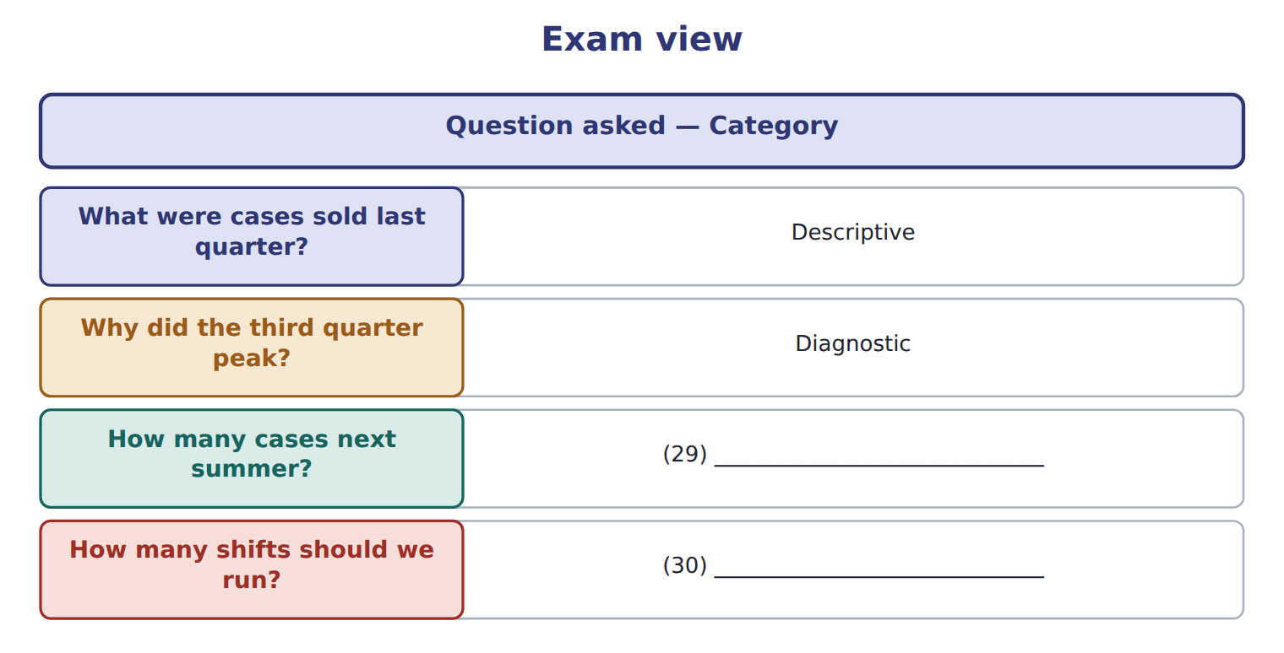
word list
Diagnostic · Prescriptive · Predictive

Answer key · 15.7 Extended Example 15A: predicting next quarter's demand

1 performs | 16 predicting
2 syllabus | 17 overfitting
3 Beverages | 18 statement
4 forecast | 19 relationship
5 positive | 20 It summarises what has already occurred
6 dropping | 21 Diagnostic analytics
7 calculation | 22 Predictive
8 accounts | 23 Prescriptive
9 quarterly | 24 carries
10 slightly | 25 expect
11 penalises | 26 multiply
12 typical | 27 intercept
13 observation | 28 explained
14 cautious | 29 Predictive
15 confident | 30 Prescriptive

the summaries in full
Summary 1 This example performs the one calculation this part of the syllabus examines, and then asks how far the answer can be trusted. Beverages expects to hold the price at $20.00 next quarter, the forecast mean temperature is 26 degrees, and 4 promotion weeks are planned.
Summary 2 Treating the price coefficient as positive gives 549,673 cases, which is far too high. The sign is part of the coefficient, and dropping it is the mistake the exam most often tests in this calculation.
Summary 3 The model's R squared is 0.9989, so it accounts for almost all the variation in quarterly cases. The adjusted figure is 0.9982, slightly lower because it penalises the three variables used. The standard error is 555 cases, which is the typical distance of an observation from the line. An R squared this high on 8 observations should make a reader cautious rather than confident. With few observations and three variables, a model can fit the past closely without predicting well, which is the overfitting of section 15.2. The honest statement is that the relationship looks strong and needs more quarters to confirm. The temperature coefficient of 1,457 cases a degree, applied to a seasonal swing of some twenty degrees, moves demand far more than the promotion coefficient of 2,706 applied to a few weeks. But promotion is positive and material, so the.
Summary 4 Each coefficient carries the sign a reader would expect. R squared 0.9989, adjusted 0.9982, standard error 555 cases.
Summary 5 The calculation is always the same shape: multiply each coefficient by its value, add the intercept, and watch the signs. If the question gives an R squared, it is usually asking what share of variation is explained, not whether the model is right.

