17.1 Expected value
Chapter 17 · section 17.1

Fill every gap. Each word list holds one word more than there are gaps.
Chapter 17, section by section
Each stage leads to the next.
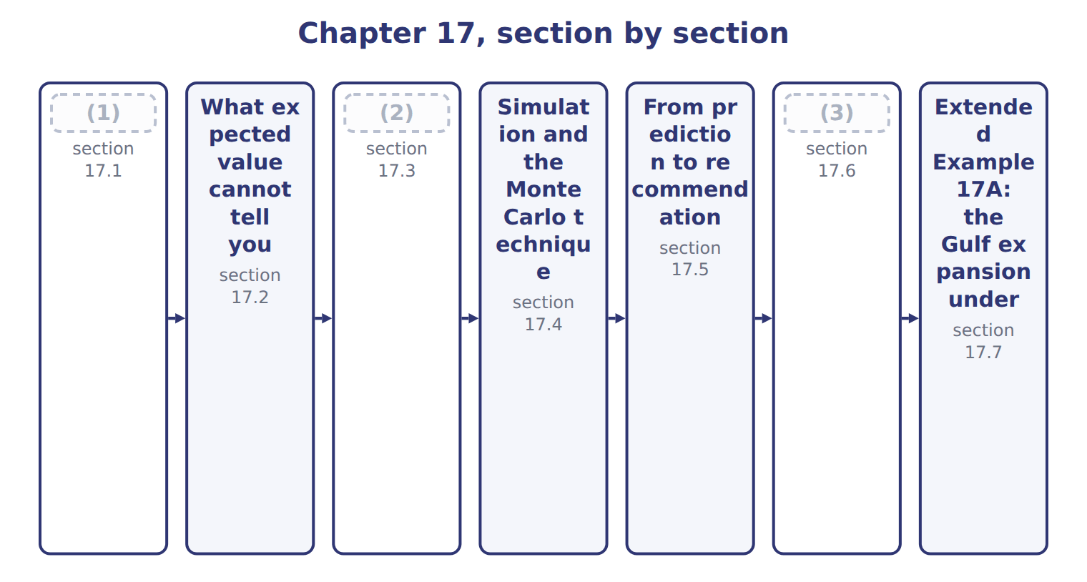
word list
Sensitivity, what-if and goal seeking · Expected value · simulation model · The limitations of data analytics

Summary 1 gaps 4–5
The expected value of an (4) quantity is each possible outcome multiplied by its (5) , and the results added together.
word list
uncertain · percentile · probability

Expected value of the Gulf expansion
The bars are drawn to scale.
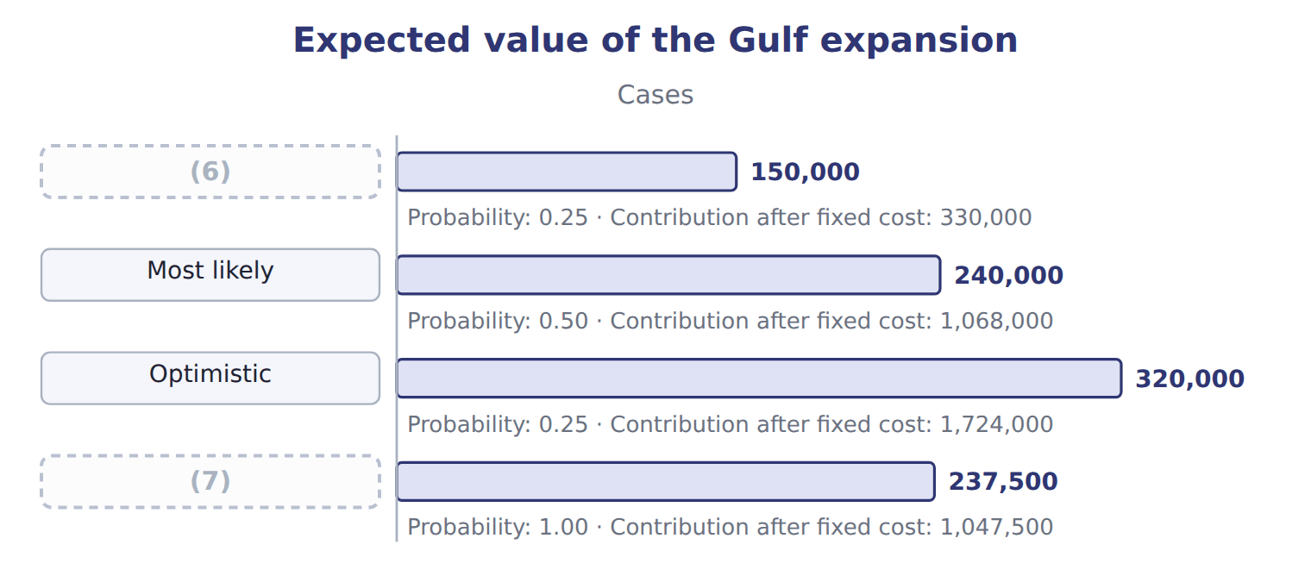
word list
Pessimistic · Expected value · Optimistic

Summary 2 gaps 8–16
The expected (8) of 237,500 cases is not the middle scenario and not the simple (9) of the three, which would be 236,667. The (10) do the work: the most likely case carries half the weight, and the two (11) a quarter each. The same (12) estimates a (13) cash flow. At a (14) of 8.20 a case and fixed costs of 900,000, the expected contribution is 1,047,500. Each (15) own contribution is shown (16) it, and they range from 330,000 to 1,724,000. Where cash flows fall in different years, each year's expected flow is computed this way and then discounted. The two steps must not be combined.
word list
probabilities · volume · scenario's · arithmetic · margin · future · beside · carries · extremes · average

The English this sheet uses, and its Arabic
English (exam term) | Arabic
expected value | القيمة المتوقعة

Answer key · 17.1 Expected value

1 Expected value | 9 average
2 Sensitivity, what-if and goal seeking | 10 probabilities
3 The limitations of data analytics | 11 extremes
4 uncertain | 12 arithmetic
5 probability | 13 future
6 Pessimistic | 14 margin
7 Expected value | 15 scenario's
8 volume | 16 beside

the summaries in full
Summary 1 The expected value of an uncertain quantity is each possible outcome multiplied by its probability, and the results added together.
Summary 2 The expected volume of 237,500 cases is not the middle scenario and not the simple average of the three, which would be 236,667. The probabilities do the work: the most likely case carries half the weight, and the two extremes a quarter each. The same arithmetic estimates a future cash flow. At a margin of 8.20 a case and fixed costs of 900,000, the expected contribution is 1,047,500. Each scenario's own contribution is shown beside it, and they range from 330,000 to 1,724,000. Where cash flows fall in different years, each year's expected flow is computed this way and then discounted. The two steps must not be combined.

17.2 What expected value cannot tell you
Chapter 17 · section 17.2

Fill every gap. Each word list holds one word more than there are gaps.
The benefits and shortcomings of expected value
Expected value (B.3.h) | Benefit | Shortcoming
Uses all the information | Every outcome and its likelihood enter the figure | (1)
Comparable across options | One number per option, so options can be ranked | (2)
Correct over many repetitions | The long-run average of a repeated decision | (3)
Simple to compute and explain | Multiply and add | (4)
 |  | It ignores the decision-maker's attitude to risk

word list
The probabilities are usually estimates, not facts · It hides the spread entirely · Nobody actually receives the expected value · A once-only decision is not a long run · The long-run average of a repeated decision

Summary 1 gaps 5–12
Two of those (5) decide real cases. The first is that nobody receives the expected value: the outcomes here are 330,000, 1,068,000 and 1,724,000, and 1,047,500 is not among them. It is a (6) average, not a (7) of what will happen. The (8) is that it is correct over many repetitions. A company (9) between two (10) every week is in a long run; a company deciding once whether to enter the Gulf is not. For a (11) large decision, the spread of outcomes (12) as much as their average.
word list
single · weighted · shortcomings · forecast · suppliers · between · choosing · matters · second

Answer key · 17.2 What expected value cannot tell you

1 Nobody actually receives the expected value | 7 forecast
2 It hides the spread entirely | 8 second
3 A once-only decision is not a long run | 9 choosing
4 The probabilities are usually estimates, not facts | 10 suppliers
5 shortcomings | 11 single
6 weighted | 12 matters

the summaries in full
Summary 1 Two of those shortcomings decide real cases. The first is that nobody receives the expected value: the outcomes here are 330,000, 1,068,000 and 1,724,000, and 1,047,500 is not among them. It is a weighted average, not a forecast of what will happen. The second is that it is correct over many repetitions. A company choosing between two suppliers every week is in a long run; a company deciding once whether to enter the Gulf is not. For a single large decision, the spread of outcomes matters as much as their average.

17.3 Sensitivity, what-if and goal seeking
Chapter 17 · section 17.3

Fill every gap. Each word list holds one word more than there are gaps.
Three related techniques vary the assumptions deliberately.
Sensitivity, what-if, goal seeking and simulation
Technique | What it does | The question it answers | Varies
Sensitivity analysis | (1) | Which assumption deserves the most work? | One at a time
What-if analysis | (2) | What happens if volume falls by a fifth? | Any number of inputs
Goal seeking | Set the answer you need and solve for the input | (3) | Works backwards
Simulation | Vary every assumption together, thousands of times | What is the whole range of outcomes? | (4)

word list
What happens if volume falls by a fifth? · All at once, with probabilities · Change ONE assumption and see how far the answer moves · Change an input and read the new answer · What volume is needed to break even?

Summary 1 gaps 5–16
Its purpose is not to (5) but to rank: it tells you which assumption deserves the most effort in (6) , and which can be left rough. A ten per cent change in margin or in volume moves (7) by +18.6%, while the same change in fixed cost moves it by +8.6%. Margin and volume (8) deserve the careful estimate, and the fixed cost can be (9) . It sets the answer (10) and solves for the input that would produce it, which is how a (11) volume is found. Both are everyday (12) work rather than (13) techniques, and that is their value. A (14) who can ask the model a question and get an answer in a minute will ask more (15) . The assumptions then get (16) far more often than any formal review would test them.
word list
spreadsheet · estimate · contribution · specialist · manager · questions · required · break-even · tested · approximate · therefore · forecast · estimating

The English this section uses, and its Arabic
Each term sits against what it means.
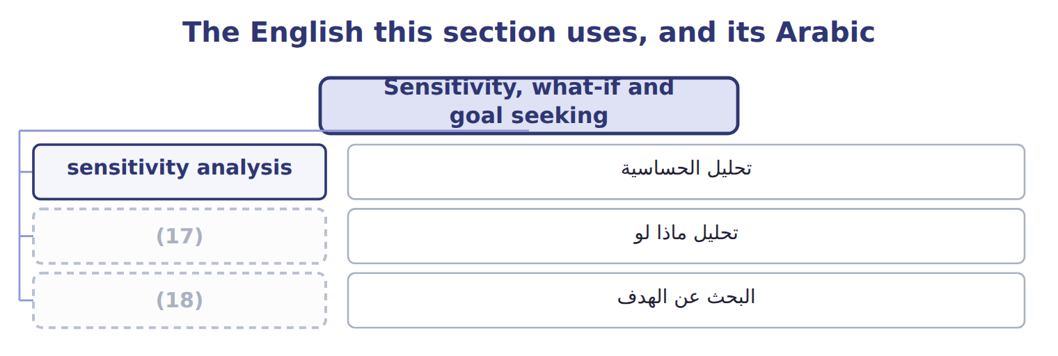
word list
expected value · goal seeking · what-if analysis

The English this sheet uses, and its Arabic
English (exam term) | Arabic
sensitivity analysis | تحليل الحساسية
what-if analysis | تحليل ماذا لو
goal seeking | البحث عن الهدف

Answer key · 17.3 Sensitivity, what-if and goal seeking

1 Change ONE assumption and see how far the answer moves | 10 required
2 Change an input and read the new answer | 11 break-even
3 What volume is needed to break even? | 12 spreadsheet
4 All at once, with probabilities | 13 specialist
5 forecast | 14 manager
6 estimating | 15 questions
7 contribution | 16 tested
8 therefore | 17 what-if analysis
9 approximate | 18 goal seeking

the summaries in full
Summary 1 Its purpose is not to forecast but to rank: it tells you which assumption deserves the most effort in estimating, and which can be left rough. A ten per cent change in margin or in volume moves contribution by +18.6%, while the same change in fixed cost moves it by +8.6%. Margin and volume therefore deserve the careful estimate, and the fixed cost can be approximate. It sets the answer required and solves for the input that would produce it, which is how a break-even volume is found. Both are everyday spreadsheet work rather than specialist techniques, and that is their value. A manager who can ask the model a question and get an answer in a minute will ask more questions. The assumptions then get tested far more often than any formal review would test them.

17.4 Simulation and the Monte Carlo technique
Chapter 17 · section 17.4

Fill every gap. Each word list holds one word more than there are gaps.
Summary 1 gaps 1–12
Sensitivity moves one assumption at a time, which is its (1) : in reality they all move at once, and (2) together. A simulation model varies them all, (3) , each draw taken from a distribution rather than a single value. The Monte Carlo (4) is the standard (5) . Each trial draws a volume, a margin and a fixed cost at random from their ranges, (6) the outcome, and (7) it. Doing that (8) of times builds up the distribution of (9) rather than a single number. The mean of the trials is 1,027,152, close to the single expected value of 1,047,500, which is (10) rather than (11) . The (12) the expected value could not give is the spread: 539,260 to 1,503,517 covers nine trials in ten. That range is what a board needs. It converts a decision from a single number into a question about whether the worst plausible outcome is survivable. That is the question that ought to be asked.
word list
reassuring · surprising · method · records · computes · thousands · sometimes · decision · limitation · repeatedly · information · outcomes · technique

Summary 2 gaps 13–16
Simulation has costs of its own. It needs a distribution for every assumption rather than a single figure, which is more work and more (13) . It is harder to (14) to a board than one number. And its apparent (15) can lend unearned (16) to inputs that were guessed.
word list
authority · outcomes · explain · judgement · sophistication

The English this section uses, and its Arabic
Each term sits against what it means.
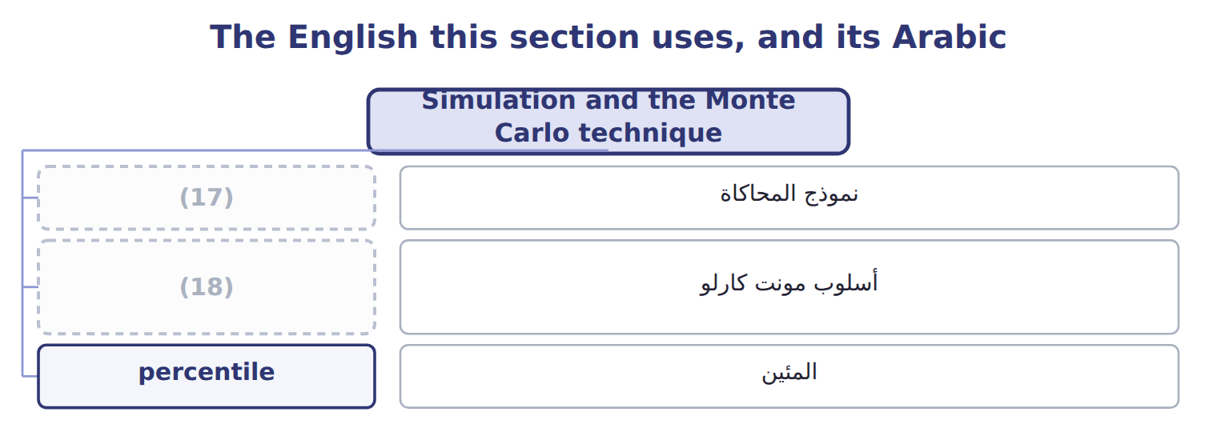
word list
Monte Carlo technique · simulation model · أسلوب مونت كارلو

The English this sheet uses, and its Arabic
English (exam term) | Arabic
simulation model | نموذج المحاكاة
Monte Carlo technique | أسلوب مونت كارلو
percentile | المئين

Answer key · 17.4 Simulation and the Monte Carlo technique

1 limitation | 10 reassuring
2 sometimes | 11 surprising
3 repeatedly | 12 information
4 technique | 13 judgement
5 method | 14 explain
6 computes | 15 sophistication
7 records | 16 authority
8 thousands | 17 simulation model
9 outcomes | 18 Monte Carlo technique

the summaries in full
Summary 1 Sensitivity moves one assumption at a time, which is its limitation: in reality they all move at once, and sometimes together. A simulation model varies them all, repeatedly, each draw taken from a distribution rather than a single value. The Monte Carlo technique is the standard method. Each trial draws a volume, a margin and a fixed cost at random from their ranges, computes the outcome, and records it. Doing that thousands of times builds up the distribution of outcomes rather than a single number. The mean of the trials is 1,027,152, close to the single expected value of 1,047,500, which is reassuring rather than surprising. The information the expected value could not give is the spread: 539,260 to 1,503,517 covers nine trials in ten. That range is what a board needs. It converts a decision from a single number into a question about whether the worst plausible outcome is survivable. That is the question that ought to be asked.
Summary 2 Simulation has costs of its own. It needs a distribution for every assumption rather than a single figure, which is more work and more judgement. It is harder to explain to a board than one number. And its apparent sophistication can lend unearned authority to inputs that were guessed.

17.5 From prediction to recommendation
Chapter 17 · section 17.5

Fill every gap. Each word list holds one word more than there are gaps.
Summary 1 gaps 1–11
The syllabus asks how (1) techniques are used to draw insights and make (2) , and the answer is a sequence rather than a technique. Predict the outcome, test which (3) it depends on, (4) the range, and then state what should be done and under what conditions. A recommendation that names no (5) is weaker than one that does. (6) it with the. Saying demand will be about 226,273 cases is a (7) ; saying the plant should schedule to forecast (8) is a recommendation. The (9) form adds the conditions under which the recommendation would change. Here that is a volume below the fifth (10) , a margin materially below 8.20, or a change in the Gulf market that breaks the (11) the model was fitted to.
word list
simulate · recommendations · condition · prediction · percentile · honest · temperature · assumptions · forecast · Compare · predictive · pattern

Answer key · 17.5 From prediction to recommendation

1 predictive | 7 prediction
2 recommendations | 8 temperature
3 assumptions | 9 honest
4 simulate | 10 percentile
5 condition | 11 pattern
6 Compare

the summaries in full
Summary 1 The syllabus asks how predictive techniques are used to draw insights and make recommendations, and the answer is a sequence rather than a technique. Predict the outcome, test which assumptions it depends on, simulate the range, and then state what should be done and under what conditions. A recommendation that names no condition is weaker than one that does. Compare it with the. Saying demand will be about 226,273 cases is a prediction; saying the plant should schedule to forecast temperature is a recommendation. The honest form adds the conditions under which the recommendation would change. Here that is a volume below the fifth percentile, a margin materially below 8.20, or a change in the Gulf market that breaks the pattern the model was fitted to.

17.6 The limitations of data analytics
Chapter 17 · section 17.6

Fill every gap. Each word list holds one word more than there are gaps.
Summary 1 gaps 1–2
This is the last (1) of Part IV and the one that keeps the rest in (2) .
word list
proportion · outcome · percentile

Summary 2 gaps 3–4
The (3) of 0.25, 0.50 and 0.25 were not measured; somebody estimated them. Every figure computed from them inherits that (4) , however many decimal places the simulation reports.
word list
judgement · simulation · probabilities

Precision is not accuracy

Summary 3 gaps 5–11
A simulation reporting a fifth (5) to the nearest pound looks precise, and is only as (6) as the ranges it was given. A question offering a very exact figure from very rough (7) is testing whether the (8) notices. The last row is the one to carry out of Part IV. (9) informs a decision; it does not make one. The board still votes on the Gulf (10) , and remains (11) for the vote whatever the model said.
word list
candidate · accurate · accountable · assumptions · percentile · expansion · offering · Analytics

The words this section uses
Each term sits against what it means.
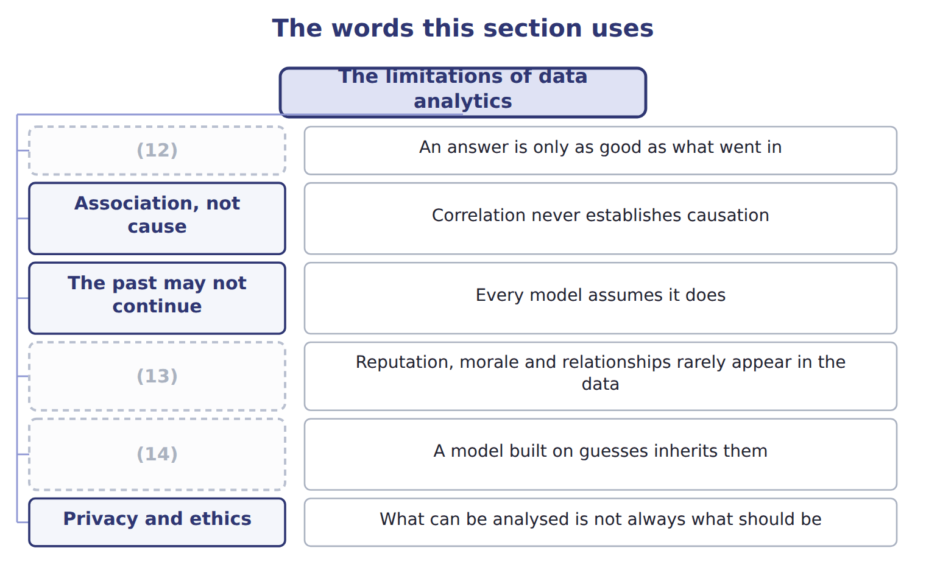
word list
Privacy and ethics · Probabilities are estimates · Data quality · What is not measured

Answer key · 17.6 The limitations of data analytics

1 outcome | 8 candidate
2 proportion | 9 Analytics
3 probabilities | 10 expansion
4 judgement | 11 accountable
5 percentile | 12 Data quality
6 accurate | 13 What is not measured
7 assumptions | 14 Probabilities are estimates

the summaries in full
Summary 1 This is the last outcome of Part IV and the one that keeps the rest in proportion.
Summary 2 The probabilities of 0.25, 0.50 and 0.25 were not measured; somebody estimated them. Every figure computed from them inherits that judgement, however many decimal places the simulation reports.
Summary 3 A simulation reporting a fifth percentile to the nearest pound looks precise, and is only as accurate as the ranges it was given. A question offering a very exact figure from very rough assumptions is testing whether the candidate notices. The last row is the one to carry out of Part IV. Analytics informs a decision; it does not make one. The board still votes on the Gulf expansion, and remains accountable for the vote whatever the model said.

17.7 Extended Example 17A: the Gulf expansion under uncertainty
Chapter 17 · section 17.7

Fill every gap. Each word list holds one word more than there are gaps.
Summary 1 gaps 1–2
This example works the (1) the exam sets and then shows what the single figure (2) .
word list
calculation · conceals · materially

Weighting the three scenarios

Summary 2 gaps 3–14
At 8.20 a case the expected contribution (3) fixed cost is 1,947,500. (4) fixed costs of 900,000 gives 1,047,500, against an (5) of 2,500,000. (6) the three volumes (7) their probabilities gives 236,667 cases rather than 237,500. The (8) is small here because the probabilities are nearly (9) , and it would not be if they were not. Sensitivity analysis says margin and volume (10) , at +18.6% for a ten per cent change, and fixed cost half as much at +8.6%. (11) effort should follow that (12) . No trial in this run (13) a loss, which is itself worth (14) . Proceed, because even the fifth percentile of 539,260 covers the fixed cost comfortably. Review if the margin falls materially below 8.20, because margin is one of the two assumptions the answer depends on most.
word list
investment · before · Deducting · Sensitivity · produced · Averaging · symmetrical · Estimating · difference · reporting · without · ranking · equally

Name four techniques

Complete the blank cells.
Your turn: name four techniques (complete the blanks)
What is done | Which technique? | Why
Change one assumption and see what moves | Sensitivity analysis | It finds which input the answer depends on most
Set the target and solve for the input | Goal seeking | Goal seeking works backwards from a required answer, which is how a break-even volume is found
Vary everything together, many times | Simulation, usually by the Monte Carlo technique | (15)
Each outcome times its probability, summed | Expected value | It gives one number, which is both its (16) and its weakness

word list
Sensitivity analysis · It gives the whole distribution of outcomes · convenience

Everything ties

Summary 3 gaps 17–19
Expected volume 237,500 cases; expected contribution 1,047,500. Simple average 236,667 cases, which is the (17) . Simulation mean 1,027,152, (18) a few per cent of the expected value. Fifth to (19) percentile: 539,260 to 1,503,517.
word list
within · comfortably · ninety-fifth · distractor

Exam view

Summary 4 gaps 20–22
The calculation is (20) outcome times probability, summed. The trap is the (21) average. Where a (22) asks what simulation adds over expected value, the answer is the distribution, not a better single number.
word list
question · always · unweighted · ranking

Exam view
Question from the board | Category
What is the single probability-weighted outcome? | (23)
Which assumption moves the answer most? | Sensitivity analysis
What volume is needed to break even? | Goal seeking
What is the whole range of possible outcomes? | (24)

word list
Expected value · Simulation · Sensitivity analysis

The English this section uses, and its Arabic
Each term sits against what it means.
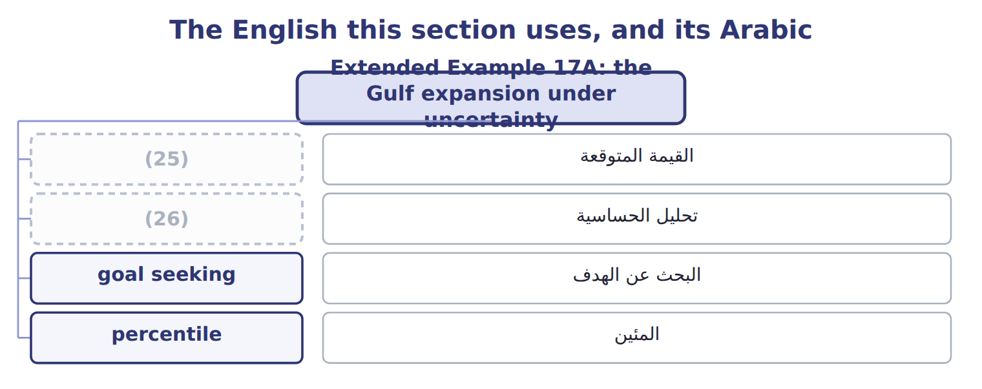
word list
goal seeking · expected value · sensitivity analysis

Answer key · 17.7 Extended Example 17A: the Gulf expansion under uncertainty

1 calculation | 14 reporting
2 conceals | 15 It gives the whole distribution of outcomes
3 before | 16 convenience
4 Deducting | 17 distractor
5 investment | 18 within
6 Averaging | 19 ninety-fifth
7 without | 20 always
8 difference | 21 unweighted
9 symmetrical | 22 question
10 equally | 23 Expected value
11 Estimating | 24 Simulation
12 ranking | 25 expected value
13 produced | 26 sensitivity analysis

the summaries in full
Summary 1 This example works the calculation the exam sets and then shows what the single figure conceals.
Summary 2 At 8.20 a case the expected contribution before fixed cost is 1,947,500. Deducting fixed costs of 900,000 gives 1,047,500, against an investment of 2,500,000. Averaging the three volumes without their probabilities gives 236,667 cases rather than 237,500. The difference is small here because the probabilities are nearly symmetrical, and it would not be if they were not. Sensitivity analysis says margin and volume equally, at +18.6% for a ten per cent change, and fixed cost half as much at +8.6%. Estimating effort should follow that ranking. No trial in this run produced a loss, which is itself worth reporting. Proceed, because even the fifth percentile of 539,260 covers the fixed cost comfortably. Review if the margin falls materially below 8.20, because margin is one of the two assumptions the answer depends on most.
Summary 3 Expected volume 237,500 cases; expected contribution 1,047,500. Simple average 236,667 cases, which is the distractor. Simulation mean 1,027,152, within a few per cent of the expected value. Fifth to ninety-fifth percentile: 539,260 to 1,503,517.
Summary 4 The calculation is always outcome times probability, summed. The trap is the unweighted average. Where a question asks what simulation adds over expected value, the answer is the distribution, not a better single number.

