18.1 Choosing the form
Chapter 18 · section 18.1

Fill every gap. Each word list holds one word more than there are gaps.
Chapter 18, section by section
Each stage leads to the next.
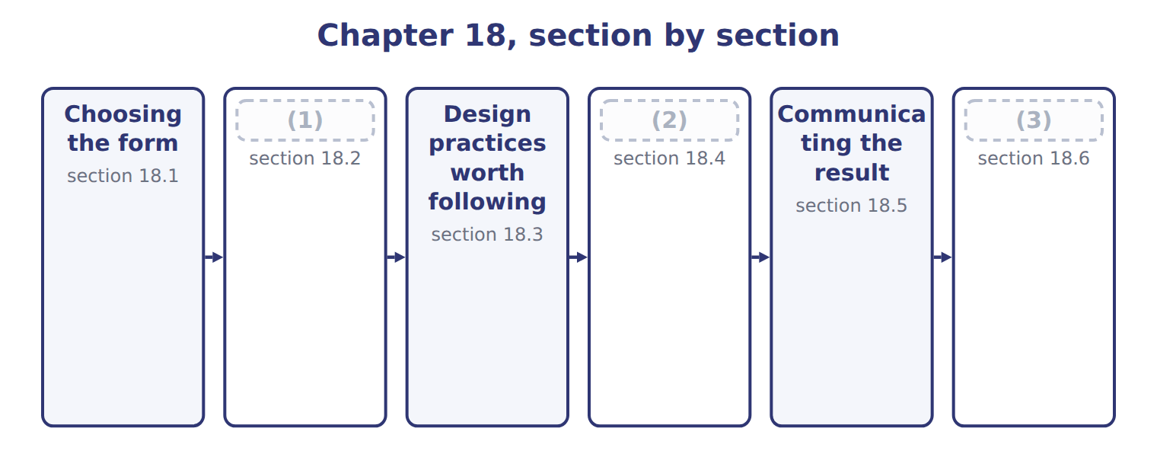
word list
Extended Example 18A: presenting the Gulf deci · Design practices worth following · What a picture can and cannot do · How a true chart misleads

Summary 1 gaps 4–5
The choice of chart (4) from what the reader must see, not from what is (5) in the software.
word list
available · follows · measures

Choosing the form of a visualization
What the reader must see (F.4.cc) | Best form
A comparison across categories | (6)
A trend over time | Line chart
A relationship between two variables | Scatter plot
A distribution of many values | Histogram or box plot
Composition of a whole | (7)
Exact values that will be read off | Table
Several measures watched over time | Dashboard

word list
Stacked bar, or a table · Bar chart · Histogram or box plot

Summary 2 gaps 8–15
Three of those have been used (8) . A scatter plot showed cases against (9) because the question was whether two variables move (10) . A histogram showed the (11) outcomes because the question was about the shape of a distribution. A line chart showed the eight (12) because the question was about (13) over time. The last two rows (14) a note. A dashboard suits several measures watched (15) . And a table is the right answer more often than people expect: where exact values will be read off and compared, a table beats any chart.
word list
deserve · repeatedly · against · movement · already · temperature · simulated · together · quarters

The English this section uses, and its Arabic
Each term sits against what it means.
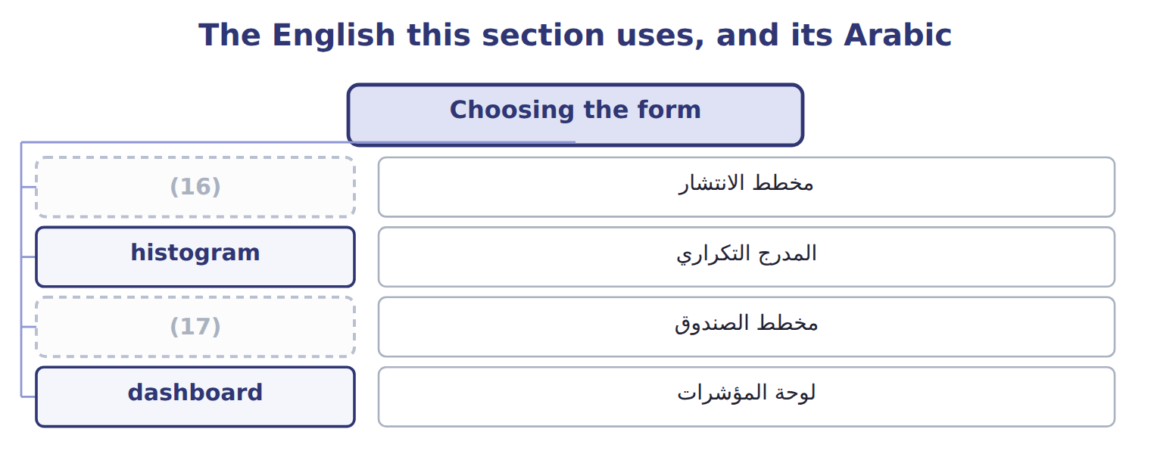
word list
box plot · scatter plot · مخطط الصندوق

The English this sheet uses, and its Arabic
English (exam term) | Arabic
scatter plot | مخطط الانتشار
histogram | المدرج التكراري
box plot | مخطط الصندوق
dashboard | لوحة المؤشرات

Answer key · 18.1 Choosing the form

1 How a true chart misleads | 10 together
2 What a picture can and cannot do | 11 simulated
3 Extended Example 18A: presenting the Gulf deci | 12 quarters
4 follows | 13 movement
5 available | 14 deserve
6 Bar chart | 15 repeatedly
7 Stacked bar, or a table | 16 scatter plot
8 already | 17 box plot
9 temperature

the summaries in full
Summary 1 The choice of chart follows from what the reader must see, not from what is available in the software.
Summary 2 Three of those have been used already. A scatter plot showed cases against temperature because the question was whether two variables move together. A histogram showed the simulated outcomes because the question was about the shape of a distribution. A line chart showed the eight quarters because the question was about movement over time. The last two rows deserve a note. A dashboard suits several measures watched repeatedly. And a table is the right answer more often than people expect: where exact values will be read off and compared, a table beats any chart.

18.2 How a true chart misleads
Chapter 18 · section 18.2

Fill every gap. Each word list holds one word more than there are gaps.
Summary 1 gaps 1–12
Distortion rarely (1) a false number. On the left the axis begins at 205,000, and the (2) bar towers over the first. On the right it begins at zero, and the four (3) are visibly (4) . The third quarter (5) the first by 14 per cent, which the (6) chart conveys and the left-hand chart does not. Every figure in the left-hand chart is (7) . Nothing has been (8) , nothing omitted, and the axis is (9) labelled. It misleads because a bar's length is read as its value, and truncating the axis breaks that (10) while leaving the chart (11) defensible. A label does not undo the distortion, because (12) take the message from the shape before reading the axis. For a bar chart the rule is simple and worth keeping: start at zero. A line chart may begin elsewhere, because a line's message is its slope rather than its length, but the choice should still be stated.
word list
quarters · honestly · relationship · involves · similar · invented · elsewhere · third-quarter · correct · right-hand · readers · exceeds · technically

The English this sheet uses, and its Arabic
English (exam term) | Arabic
truncated axis | المحور المقطوع

Answer key · 18.2 How a true chart misleads

1 involves | 7 correct
2 third-quarter | 8 invented
3 quarters | 9 honestly
4 similar | 10 relationship
5 exceeds | 11 technically
6 right-hand | 12 readers

the summaries in full
Summary 1 Distortion rarely involves a false number. On the left the axis begins at 205,000, and the third-quarter bar towers over the first. On the right it begins at zero, and the four quarters are visibly similar. The third quarter exceeds the first by 14 per cent, which the right-hand chart conveys and the left-hand chart does not. Every figure in the left-hand chart is correct. Nothing has been invented, nothing omitted, and the axis is honestly labelled. It misleads because a bar's length is read as its value, and truncating the axis breaks that relationship while leaving the chart technically defensible. A label does not undo the distortion, because readers take the message from the shape before reading the axis. For a bar chart the rule is simple and worth keeping: start at zero. A line chart may begin elsewhere, because a line's message is its slope rather than its length, but the choice should still be stated.

18.3 Design practices worth following
Chapter 18 · section 18.3

Fill every gap. Each word list holds one word more than there are gaps.
Design practices and the reason for each
Practice (F.4.bb) | Why | Note
Start a bar chart's axis at zero | A bar's length is the message; truncating it lies about the ratio | (1)
Keep the aspect ratio honest | Stretching a chart vertically steepens every trend | Choose it before seeing the result
Label directly where you can | A legend makes the eye travel; a label does not | (2)
Order categories meaningfully | (3) | Unless the reader will look a category up
Remove what does not inform | Gridlines, borders and effects compete with the data | (4)
One message per exhibit | A chart saying three things usually says none | (5)
Show the caveat | Sample size, excluded rows, estimated inputs | (6)

word list
Put the series name at the end of the line · Chapter 17's probabilities were estimates · A line chart may start elsewhere, if labelled · Draw the second chart · Choose it before seeing the result · Every mark should carry meaning · By size, or by time; not by the alphabet

Summary 1 gaps 7–13
The aspect ratio (7) more attention than it usually gets. Stretching a chart vertically steepens every trend in it, and the stretch is (8) to a reader who never sees the (9) . Choosing the (10) before seeing the result removes the (11) . (12) what does not inform is the rule that (13) most charts. Gridlines, borders, shadows and three-dimensional effects compete with the data for the reader's attention, and the data always loses something in the contest.
word list
Removing · improves · invisible · deserves · alternative · temptation · something · proportions

Answer key · 18.3 Design practices worth following

1 A line chart may start elsewhere, if labelled | 8 invisible
2 Put the series name at the end of the line | 9 alternative
3 By size, or by time; not by the alphabet | 10 proportions
4 Every mark should carry meaning | 11 temptation
5 Draw the second chart | 12 Removing
6 Chapter 17's probabilities were estimates | 13 improves
7 deserves

the summaries in full
Summary 1 The aspect ratio deserves more attention than it usually gets. Stretching a chart vertically steepens every trend in it, and the stretch is invisible to a reader who never sees the alternative. Choosing the proportions before seeing the result removes the temptation. Removing what does not inform is the rule that improves most charts. Gridlines, borders, shadows and three-dimensional effects compete with the data for the reader's attention, and the data always loses something in the contest.

18.4 What a picture can and cannot do
Chapter 18 · section 18.4

Fill every gap. Each word list holds one word more than there are gaps.
The benefits of visualization and their matching limitations
Visualization (F.4.dd) | Benefit | Matching limitation
The eye is fast | A pattern visible in a second would take minutes in a table | The same speed makes a distorted chart persuasive
It reaches non-specialists | A board reads a chart it would not read as output | (1)
It reveals the unexpected | Outliers and gaps show themselves | (2)
It compresses volume | (3) | Compression hides the individual case
It aids memory | A reader recalls a shape, not a number | (4)
It supports the argument | The claim and its evidence sit together | (5)

word list
The claim and its evidence sit together · It can imply precision the data lacks · It never establishes cause · A wrong shape is remembered just as well · Thousands of trials in one picture · It can suggest patterns that are coincidence

Summary 1 gaps 6–11
The first pair (6) the argument. The eye reads a pattern in a second that a table would take minutes to yield. That same speed is why a distorted chart (7) before anybody has (8) the axis. Speed is the benefit and the (9) together. The last limitation is the one Part IV has (10) . A chart showing two series moving together is a picture of an (11) .
word list
danger · repeated · carries · association · together · checked · persuades

Answer key · 18.4 What a picture can and cannot do

1 It can imply precision the data lacks | 7 persuades
2 It can suggest patterns that are coincidence | 8 checked
3 Thousands of trials in one picture | 9 danger
4 A wrong shape is remembered just as well | 10 repeated
5 It never establishes cause | 11 association
6 carries

the summaries in full
Summary 1 The first pair carries the argument. The eye reads a pattern in a second that a table would take minutes to yield. That same speed is why a distorted chart persuades before anybody has checked the axis. Speed is the benefit and the danger together. The last limitation is the one Part IV has repeated. A chart showing two series moving together is a picture of an association.

18.5 Communicating the result
Chapter 18 · section 18.5

Fill every gap. Each word list holds one word more than there are gaps.
Summary 1 gaps 1–11
An exhibit has to carry its meaning to someone who did not do the (1) and will not ask (2) . The (3) single change is in the title. A title (4) the axes leaves the reader to work out what (5) , and some will not. A title (6) the finding tells them what to look for, and the chart then has one job: to show that the claim is true. The other three rules (7) from it. One (8) per exhibit, because a chart saying three things (9) says none. The chart (10) the title, by (11) the part that carries the claim. And the caveat is shown rather than hidden, because an audience that discovers an omission later distrusts everything else.
word list
naming · because · analysis · strongest · matters · highlighting · supports · stating · follow · message · questions · usually

The English this sheet uses, and its Arabic
English (exam term) | Arabic
data visualization | العرض المرئي للبيانات

Answer key · 18.5 Communicating the result

1 analysis | 7 follow
2 questions | 8 message
3 strongest | 9 usually
4 naming | 10 supports
5 matters | 11 highlighting
6 stating

the summaries in full
Summary 1 An exhibit has to carry its meaning to someone who did not do the analysis and will not ask questions. The strongest single change is in the title. A title naming the axes leaves the reader to work out what matters, and some will not. A title stating the finding tells them what to look for, and the chart then has one job: to show that the claim is true. The other three rules follow from it. One message per exhibit, because a chart saying three things usually says none. The chart supports the title, by highlighting the part that carries the claim. And the caveat is shown rather than hidden, because an audience that discovers an omission later distrusts everything else.

18.6 Extended Example 18A: presenting the Gulf decision to the board
Chapter 18 · section 18.6

Fill every gap. Each word list holds one word more than there are gaps.
Summary 1 gaps 1–12
F.4.cc is a Level C outcome, so the exam asks you to choose between (1) options and (2) the choice. This example does that for the decision. The board must see three things: that the (3) is expected to (4) 1,047,500, that the realistic range runs from 539,260 to 1,503,517, and that even the low end covers the fixed cost. Three facts, and the decision (5) from them. A table of 1,000 trial (6) shows everything and (7) nothing. A single number is what the finance (8) already tried, and it (9) the question about the worst case. A pie chart has no role here, (10) nothing is a share of a whole. A histogram of the simulated outcomes, as, with the fifth and (11) percentiles marked and the (12) line drawn across it. The shape answers the worst-case question visually, and the marked percentiles answer it numerically.
word list
results · director · fixed-cost · estimated · contribute · communicates · ninety-fifth · follows · because · expansion · defend · provoked · visualization

Summary 2 gaps 13–20
Not 'Distribution of simulated (13) '. (14) closer to: even the (15) tenth of outcomes covers the fixed cost. That is the finding, and the chart (16) to show that it is true. A line under the chart recording that the (17) were estimated by (18) rather than measured. (19) the horizontal axis to begin at the fifth percentile, which would make every outcome look (20) . Or drawing only the mean, which is what started the argument. Both would be defensible in the sense that no number would be false.
word list
comfortable · pessimistic · contribution · management · Something · probabilities · visualization · exists · Truncating

Choose four forms

Complete the blank cells.
Your turn: choose four forms (complete the blanks)
What must be shown | Which form? | Why
A relationship between two variables | A scatter plot | Each point is one (21) placed against both variables
A trend over eight quarters | Line chart | A line chart shows movement over time, and the slope between points carries the message
The distribution of 1,000 simulated outcomes | A histogram | It shows the shape of the distribution and the spread around its centre
Exact figures the reader will read off | A table | Where (22) matters more than shape, a table beats any chart

word list
observation · precision · movement

The pattern behind the choice

Summary 3 gaps 23–26
Start from what the reader must see, not from what the (23) produced. (24) the options that show everything or show too (25) , and say why. Title the exhibit with the finding, not with the axes. Put the (26) on the exhibit, where it will be read.
word list
caveat · argument · Reject · little · analysis

Exam view

Summary 4 gaps 27–30
A Level C question gives a (27) and several chart options. Name what the reader must see, choose the form that shows it, and say what the (28) options would have (29) to convey. Choosing (30) without the reason earns less than the reason deserves.
word list
failed · situation · rejected · Choosing · correctly

Exam view
Every item belongs to exactly one group.
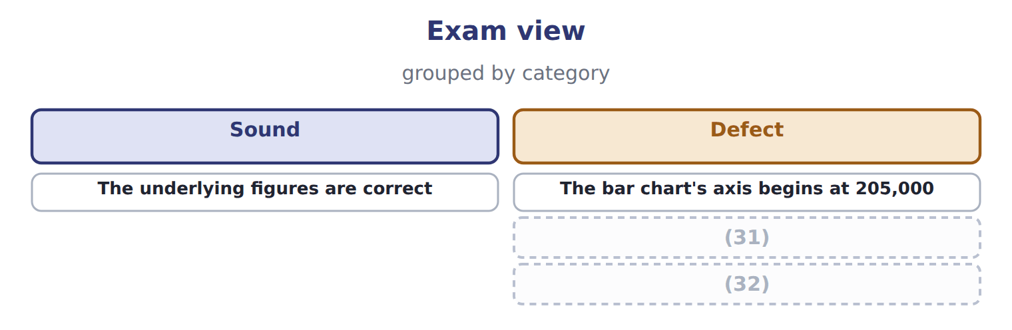
word list
Two charts and two messages on one slide · The bar chart's axis begins at 205,000 · The title names the axes rather than the finding

Answer key · 18.6 Extended Example 18A: presenting the Gulf decision to the board

1 visualization | 17 probabilities
2 defend | 18 management
3 expansion | 19 Truncating
4 contribute | 20 comfortable
5 follows | 21 observation
6 results | 22 precision
7 communicates | 23 analysis
8 director | 24 Reject
9 provoked | 25 little
10 because | 26 caveat
11 ninety-fifth | 27 situation
12 fixed-cost | 28 rejected
13 contribution | 29 failed
14 Something | 30 correctly
15 pessimistic | 31 Two charts and two messages on one slide
16 exists | 32 The title names the axes rather than the finding

the summaries in full
Summary 1 F.4.cc is a Level C outcome, so the exam asks you to choose between visualization options and defend the choice. This example does that for the decision. The board must see three things: that the expansion is expected to contribute 1,047,500, that the realistic range runs from 539,260 to 1,503,517, and that even the low end covers the fixed cost. Three facts, and the decision follows from them. A table of 1,000 trial results shows everything and communicates nothing. A single number is what the finance director already tried, and it provoked the question about the worst case. A pie chart has no role here, because nothing is a share of a whole. A histogram of the simulated outcomes, as, with the fifth and ninety-fifth percentiles marked and the fixed-cost line drawn across it. The shape answers the worst-case question visually, and the marked percentiles answer it numerically.
Summary 2 Not 'Distribution of simulated contribution'. Something closer to: even the pessimistic tenth of outcomes covers the fixed cost. That is the finding, and the chart exists to show that it is true. A line under the chart recording that the probabilities were estimated by management rather than measured. Truncating the horizontal axis to begin at the fifth percentile, which would make every outcome look comfortable. Or drawing only the mean, which is what started the argument. Both would be defensible in the sense that no number would be false.
Summary 3 Start from what the reader must see, not from what the analysis produced. Reject the options that show everything or show too little, and say why. Title the exhibit with the finding, not with the axes. Put the caveat on the exhibit, where it will be read.
Summary 4 A Level C question gives a situation and several chart options. Name what the reader must see, choose the form that shows it, and say what the rejected options would have failed to convey. Choosing correctly without the reason earns less than the reason deserves.

