1.1 Who uses financial statements, and why?
Chapter 1 · section 1.1

Fill every gap. Each word list holds one word more than there are gaps.
Chapter 1, section by section
Each stage leads to the next.
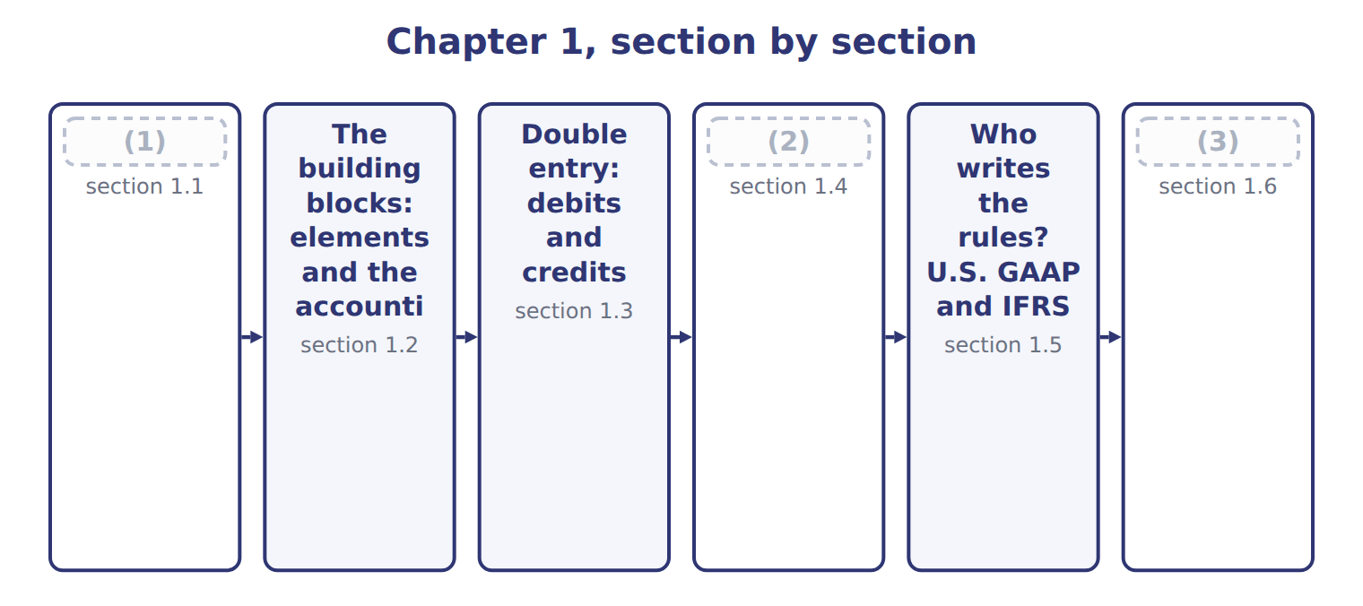
word list
Who uses financial statements, and why? · A first look at the four statements · The building blocks: elements and the accounti · The accrual basis and the matching principle

Summary 1 gaps 4–14
A company collects (4) of facts every day: sales, (5) , salaries and loans. Financial statements (6) these facts in a (7) form for people outside the company. The four main statements are the balance sheet, the income statement, the statement of changes in (8) and the statement of cash flows. Most companies (9) general-purpose financial statements. These are reports for many readers at the same time, not for one special (10) . The U.S. conceptual framework names the most (11) readers. The primary users are existing and (12) investors, lenders and other creditors. They give resources (money, goods or credit) to the company. They (13) cannot ask the company for special reports, so they depend on the (14) statements. Each user makes a different decision, so each user looks for different information.
word list
reader · standard · summarize · purchases · Reporting · usually · important · prepare · equity · potential · thousands · published

Users of financial statements and what they need
User | Decision | Key question | Statements used most
Investors (shareholders) — PRIMARY | (15) | Will the company create future cash flows and returns? | Income statement, cash flows, balance sheet
Lenders (banks, bondholders) — PRIMARY | (16) | Can the company pay interest and repay the principal on time? | Cash flows, balance sheet
Other creditors (suppliers) — PRIMARY | Sell on credit, set credit terms | (17) | Balance sheet (short-term items), cash flows
Employees and unions | (18) | Is the company stable and profitable? | Income statement
Customers | Sign long-term contracts | (19) | Balance sheet, income statement
Governments and regulators | (20) | Does the company follow the rules and pay its taxes? | All statements and notes
Managers (internal) | (21) | Not a primary user: can use internal reports | Internal management reports

word list
Tax, oversight, statistics · Lend, renew or stop a loan · Stay, negotiate pay · Buy, hold or sell shares · Will the company pay its bills when due? · Will the company continue to supply us? · Plan and control operations · Sign long-term contracts

Summary 2 gaps 22–30
Other (22) also read financial statements: employees, customers, governments, tax (23) and the public. Managers read them too. (24) , managers are not primary users of general-purpose statements, (25) they can get any internal information they need. Reporting for managers is management (26) , the subject of most of the CMA exam. What do all these users need? In (27) terms, they ask three questions. What does the company have, and what does it owe? The balance sheet answers this. How did the company (28) in the period? The income statement answers this. Where did cash come from, and where did it go? The statement of cash flows answers this. Users also want to judge (29) : how well the managers used the (30) ' resources.
word list
simple · groups · because · accounting · authorities · perform · owners · fundamental · stewardship · However

What makes information useful?

Summary 3 gaps 31–39
The conceptual framework lists the qualities of useful information. There are two fundamental qualities. Relevance means the information can make a (31) to a decision. It helps users predict the future ( (32) value) or check their past predictions ( (33) value). Relevance includes (34) : an item is material if (35) it out or stating it wrongly could change users' (36) . Faithful representation means the information shows what it (37) to show. It is (38) , neutral and free from error. Four enhancing qualities make information even more useful: comparability, verifiability, timeliness and understandability. Finally, there is a cost (39) : the benefit of reporting information should be greater than its cost.
word list
decisions · inventory · difference · materiality · leaving · claims · predictive · constraint · complete · confirmatory

Who is a primary user?

Summary 4 gaps 40–42
Primary users are (40) , lenders and other (41) . Managers are users, but not primary users of general-purpose statements. Also (42) : relevance and faithful representation are the two fundamental qualities. Comparability, verifiability, timeliness and understandability are only enhancing qualities.
word list
investors · remember · creditors · fundamental

Five accounting verbs

Summary 5 gaps 43–45
These verbs have exact (43) in exam questions. Example: Orontes (44) revenue when it delivers the goods. It (45) the revenue at the invoice price. It presents revenue in the income statement, and it discloses its revenue policy in the notes.
word list
meanings · measures · authorities · recognizes

The words this section uses
Each term sits against what it means.
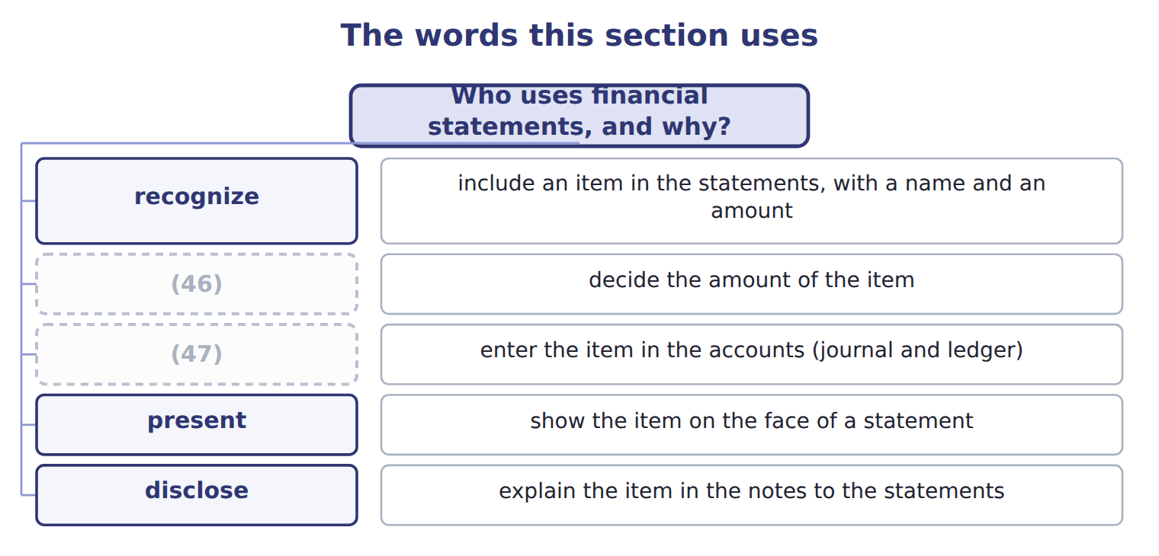
word list
record · measure · materiality

The English this sheet uses, and its Arabic
English (exam term) | Arabic
financial statements | القوائم المالية
general-purpose financial statements | القوائم المالية ذات الغرض العام
primary users | المستخدمون الرئيسيون
relevance | الملاءمة
faithful representation | التمثيل الصادق
materiality | الأهمية النسبية
recognize | يعترف (الاعتراف)
disclose | يُفصح (الإفصاح)

Answer key · 1.1 Who uses financial statements, and why?

1 Who uses financial statements, and why? | 25 because
2 The accrual basis and the matching principle | 26 accounting
3 A first look at the four statements | 27 simple
4 thousands | 28 perform
5 purchases | 29 stewardship
6 summarize | 30 owners
7 standard | 31 difference
8 equity | 32 predictive
9 prepare | 33 confirmatory
10 reader | 34 materiality
11 important | 35 leaving
12 potential | 36 decisions
13 usually | 37 claims
14 published | 38 complete
15 Buy, hold or sell shares | 39 constraint
16 Lend, renew or stop a loan | 40 investors
17 Will the company pay its bills when due? | 41 creditors
18 Stay, negotiate pay | 42 remember
19 Will the company continue to supply us? | 43 meanings
20 Tax, oversight, statistics | 44 recognizes
21 Plan and control operations | 45 measures
22 groups | 46 measure
23 authorities | 47 record
24 However

the summaries in full
Summary 1 A company collects thousands of facts every day: sales, purchases, salaries and loans. Financial statements summarize these facts in a standard form for people outside the company. The four main statements are the balance sheet, the income statement, the statement of changes in equity and the statement of cash flows. Most companies prepare general-purpose financial statements. These are reports for many readers at the same time, not for one special reader. The U.S. conceptual framework names the most important readers. The primary users are existing and potential investors, lenders and other creditors. They give resources (money, goods or credit) to the company. They usually cannot ask the company for special reports, so they depend on the published statements. Each user makes a different decision, so each user looks for different information.
Summary 2 Other groups also read financial statements: employees, customers, governments, tax authorities and the public. Managers read them too. However, managers are not primary users of general-purpose statements, because they can get any internal information they need. Reporting for managers is management accounting, the subject of most of the CMA exam. What do all these users need? In simple terms, they ask three questions. What does the company have, and what does it owe? The balance sheet answers this. How did the company perform in the period? The income statement answers this. Where did cash come from, and where did it go? The statement of cash flows answers this. Users also want to judge stewardship: how well the managers used the owners' resources.
Summary 3 The conceptual framework lists the qualities of useful information. There are two fundamental qualities. Relevance means the information can make a difference to a decision. It helps users predict the future (predictive value) or check their past predictions (confirmatory value). Relevance includes materiality: an item is material if leaving it out or stating it wrongly could change users' decisions. Faithful representation means the information shows what it claims to show. It is complete, neutral and free from error. Four enhancing qualities make information even more useful: comparability, verifiability, timeliness and understandability. Finally, there is a cost constraint: the benefit of reporting information should be greater than its cost.
Summary 4 Primary users are investors, lenders and other creditors. Managers are users, but not primary users of general-purpose statements. Also remember: relevance and faithful representation are the two fundamental qualities. Comparability, verifiability, timeliness and understandability are only enhancing qualities.
Summary 5 These verbs have exact meanings in exam questions. Example: Orontes recognizes revenue when it delivers the goods. It measures the revenue at the invoice price. It presents revenue in the income statement, and it discloses its revenue policy in the notes.

1.2 The building blocks: elements and the accounting equation
Chapter 1 · section 1.2

Fill every gap. Each word list holds one word more than there are gaps.
Summary 1 gaps 1–12
Every amount in the financial (1) belongs to an (2) . The (3) conceptual framework defines ten elements. Three of them describe the balance sheet at one date. An asset is a present right of an entity to an economic benefit. Examples: cash, accounts (4) , inventory and (5) . A (6) is a present obligation of an entity to transfer an economic benefit. Examples: accounts payable, notes payable and wages payable. Equity is the (7) interest in the assets after the liabilities are deducted. It is the owners' claim. The other elements describe (8) during a period. Revenues and expenses come from the company's central, ongoing (9) . When Orontes sells olive oil, it earns revenue. When it pays plant (10) , it has an expense. Gains and losses come from (11) or incidental events. If Orontes sells an old delivery truck for more than its carrying amount, it has a (12) .
word list
receivable · equipment · FASB · gain · dividends · residual · peripheral · statements · workers · element · liability · changes · operations

Summary 2 gaps 13–24
Investments by owners, such as (13) new shares, increase equity. (14) to owners, such as dividends, decrease equity. (15) income is the total (16) in equity from (17) other than owners. The (18) always holds, because (19) (liabilities) or owners (equity) finance every asset. Equity has two main parts. (20) capital is what owners paid: common stock at its par value, plus additional paid-in capital (APIC). Retained earnings (RE) are the past net income that the company kept (21) of paying it out as dividends. Look at the lower part. Revenues and gains increase retained earnings. Expenses and losses decrease it. Dividends also decrease it, but a (22) is not an expense. It is a distribution to owners, so it never (23) in the income statement. The IFRS Conceptual Framework (2018) defines an asset as a present economic resource (24) by the entity as a result of past events.
word list
asset · buying · equation · dividend · Comprehensive · appears · change · controlled · creditors · instead · Contributed · sources · Distributions

Summary 3 gaps 25–27
The idea is the same as in U.S. GAAP; only the wording is (25) . IFRS also uses the word income for both revenue and gains, while U.S. GAAP keeps revenues and gains apart. You may also know these IFRS names: statement of financial (26) (balance sheet), share capital (common stock) and share (27) (additional paid-in capital).
word list
different · premium · Examples · position

Words that look familiar

Summary 4 gaps 28–29
In a CMA question, inventory is always inventory. Revenue is the gross amount from sales. Net income is what (28) after expenses. Do not use income when the question means revenue. In (29) , charges usually means fees.
word list
remains · English · financial

The English this section uses, and its Arabic
Each term sits against what it means.
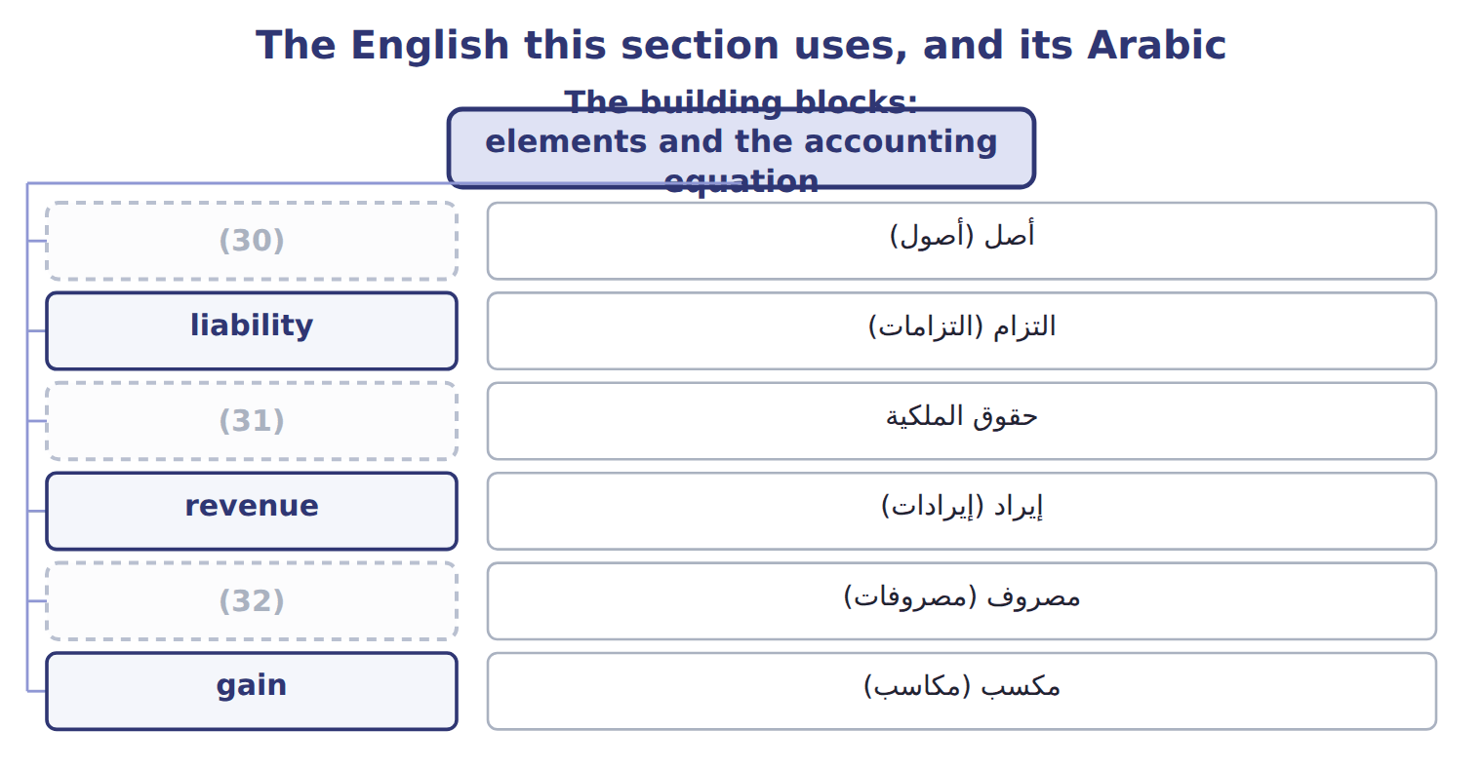
word list
revenue · asset · expense · equity

The English this sheet uses, and its Arabic
English (exam term) | Arabic
asset | أصل (أصول)
liability | التزام (التزامات)
equity | حقوق الملكية
revenue | إيراد (إيرادات)
expense | مصروف (مصروفات)
gain | مكسب (مكاسب)
loss | خسارة
net income | صافي الدخل
retained earnings | الأرباح المحتجزة
common stock | الأسهم العادية
additional paid-in capital | علاوة إصدار الأسهم (رأس المال الإضافي المدفوع)
par value | القيمة الاسمية
dividend | توزيعات الأرباح
accounting equation | المعادلة المحاسبية

Answer key · 1.2 The building blocks: elements and the accounting equation

1 statements | 17 sources
2 element | 18 equation
3 FASB | 19 creditors
4 receivable | 20 Contributed
5 equipment | 21 instead
6 liability | 22 dividend
7 residual | 23 appears
8 changes | 24 controlled
9 operations | 25 different
10 workers | 26 position
11 peripheral | 27 premium
12 gain | 28 remains
13 buying | 29 English
14 Distributions | 30 asset
15 Comprehensive | 31 equity
16 change | 32 expense

the summaries in full
Summary 1 Every amount in the financial statements belongs to an element. The FASB conceptual framework defines ten elements. Three of them describe the balance sheet at one date. An asset is a present right of an entity to an economic benefit. Examples: cash, accounts receivable, inventory and equipment. A liability is a present obligation of an entity to transfer an economic benefit. Examples: accounts payable, notes payable and wages payable. Equity is the residual interest in the assets after the liabilities are deducted. It is the owners' claim. The other elements describe changes during a period. Revenues and expenses come from the company's central, ongoing operations. When Orontes sells olive oil, it earns revenue. When it pays plant workers, it has an expense. Gains and losses come from peripheral or incidental events. If Orontes sells an old delivery truck for more than its carrying amount, it has a gain.
Summary 2 Investments by owners, such as buying new shares, increase equity. Distributions to owners, such as dividends, decrease equity. Comprehensive income is the total change in equity from sources other than owners. The equation always holds, because creditors (liabilities) or owners (equity) finance every asset. Equity has two main parts. Contributed capital is what owners paid: common stock at its par value, plus additional paid-in capital (APIC). Retained earnings (RE) are the past net income that the company kept instead of paying it out as dividends. Look at the lower part. Revenues and gains increase retained earnings. Expenses and losses decrease it. Dividends also decrease it, but a dividend is not an expense. It is a distribution to owners, so it never appears in the income statement. The IFRS Conceptual Framework (2018) defines an asset as a present economic resource controlled by the entity as a result of past events.
Summary 3 The idea is the same as in U.S. GAAP; only the wording is different. IFRS also uses the word income for both revenue and gains, while U.S. GAAP keeps revenues and gains apart. You may also know these IFRS names: statement of financial position (balance sheet), share capital (common stock) and share premium (additional paid-in capital).
Summary 4 In a CMA question, inventory is always inventory. Revenue is the gross amount from sales. Net income is what remains after expenses. Do not use income when the question means revenue. In English, charges usually means fees.

1.3 Double entry: debits and credits
Chapter 1 · section 1.3

Fill every gap. Each word list holds one word more than there are gaps.
Summary 1 gaps 1–12
Accountants (1) every transaction with the (2) system. Each transaction (3) at least two accounts, and total debits always equal total credits. This is why the accounting equation always (4) . Debit (5) means the left side of an account, and credit means the right side. Neither word means good or bad, and neither word always means increase. (6) a debit increases an account depends on the type of account. Each account has a normal balance: the side that increases it. The (7) equation at the bottom is a useful memory aid. Accounts on the left side of the equation (assets, (8) and dividends) increase with a debit. Accounts on the right side (liabilities, equity and (9) ) increase with a credit. A contra account reduces a related account, so it has the (10) normal balance. For example, (11) depreciation reduces equipment. It has a credit balance, but it (12) with the assets. The allowance for credit losses reduces accounts receivable in the same way.
word list
Whether · belongs · simply · expanded · expenses · opposite · revenues · record · double-entry · balances · affects · Amounts · accumulated

Orontes Foods in January

Summary 2 gaps 13–16
Orontes Foods, Inc. makes olive oil and (13) in Amman, Jordan, and (14) pastries in Dubai. Its shares are listed on a U.S. stock (15) , and it reports under U.S. GAAP. Here are its journal entries for six transactions in January 2025. (16) are in USD 000.
word list
exchange · frozen · tahini · inventory · Amounts

Orontes Foods in January
# | Date | Account and explanation | Debit | Credit
1 | (17) | Cash | 1,500
 |  | (18) |  | 100
 |  | Additional paid-in capital |  | 1,400
 |  | Issued 100,000 new shares of $1 par common stock for $15 per share, in cash.
2 | (19) | Cash | 800
 |  | (20) |  | 800
 |  | Borrowed cash from Levant Commerce Bank on a 5-year note at 6% interest.
3 | (21) | Equipment | 1,200
 |  | Cash |  | 1,200
 |  | Bought a new bottling line for the Amman plant and paid cash.
4 | Jan 18 | Accounts receivable | 300
 |  | Sales revenue |  | 300
 |  | (22) | 180
 |  | Inventory |  | 180
 |  | Sold olive oil to GreenBasket Supermarkets on credit. The goods had cost Orontes less than the selling price.
5 | Jan 31 | (23) | 40
 |  | Cash |  | 40
 |  | (24)
6 | Jan 31 | Retained earnings (dividends declared) | 50
 |  | (25) |  | 50
 |  | The board declared a cash dividend, payable on February 15.
 |  | Totals | 4,070 | 4,070

word list
statement of changes in equity · Jan 2 · Paid January wages to plant workers in cash. · Jan 10 · Dividends payable · Common stock · Jan 5 · Wages expense · Cost of goods sold · Notes payable (long-term)

Summary 3 gaps 26–32
Check each entry: the debits equal the credits. Read the grid row by row. Three (26) matter for the exam. Rows 1 and 2 bring in cash of 2,300 in total, but no revenue. Money from (27) and lenders is (28) . Row 4 creates revenue of 300 but no cash. Orontes (29) revenue when it (30) the goods, not when the (31) pays. Row 6 reduces retained earnings by 50 and creates a liability. No cash moves until February, and net income does not (32) . The totals prove the equation. Assets rose by 2,380, liabilities rose by 850 and equity rose by 1,530.
word list
balance · financing · delivers · change · customer · points · owners · records

Three classic mistakes

Summary 4 gaps 33–36
A dividend is not an expense. It reduces retained earnings, not net income. Cash from (33) or from issuing shares is not revenue. (34) equipment for cash is not an expense today. One asset (cash) becomes (35) asset (equipment). The cost becomes an expense later, (36) depreciation.
word list
through · transaction · Buying · another · borrowing

Orontes Foods in February

Summary 5 gaps 37–42
Here are six transactions from February (USD 000). Feb 3: Paid a (37) for olives bought on credit in January. Feb 8: (38) part of the January receivable from GreenBasket Supermarkets. Feb 10: Paid 12 months of (39) rent in advance. Feb 12: A Dubai hotel group paid cash in advance for pastries that Orontes will (40) in March. Feb 15: Paid the dividend declared on January 31. Feb 28: (41) one month of interest on the bank note. Orontes has not paid it yet. Rows 1 to 3 are done for you. (42) rows 4 to 6. Then write the journal entries for rows 4 to 6.
word list
Collected · Recorded · supplier · warehouse · deliver · Complete · transactions

Describing the effect of a transaction

Summary 6 gaps 43–48
X is debited (or (43) ) for an amount: Cash is debited for 1,500. Exam stems often say: The (44) of this transaction is to increase... In (45) , always say depreciation. An allowance (for example, the allowance for credit losses) reduces an asset. A (46) is a liability. Never say (47) for bad debts in a U.S. GAAP answer. That is the (48) view. Do not use banking habits to guess the accounting side.
word list
effect · revenues · bank's · credited · reserve · English · provision

The English this section uses, and its Arabic
Each term sits against what it means.
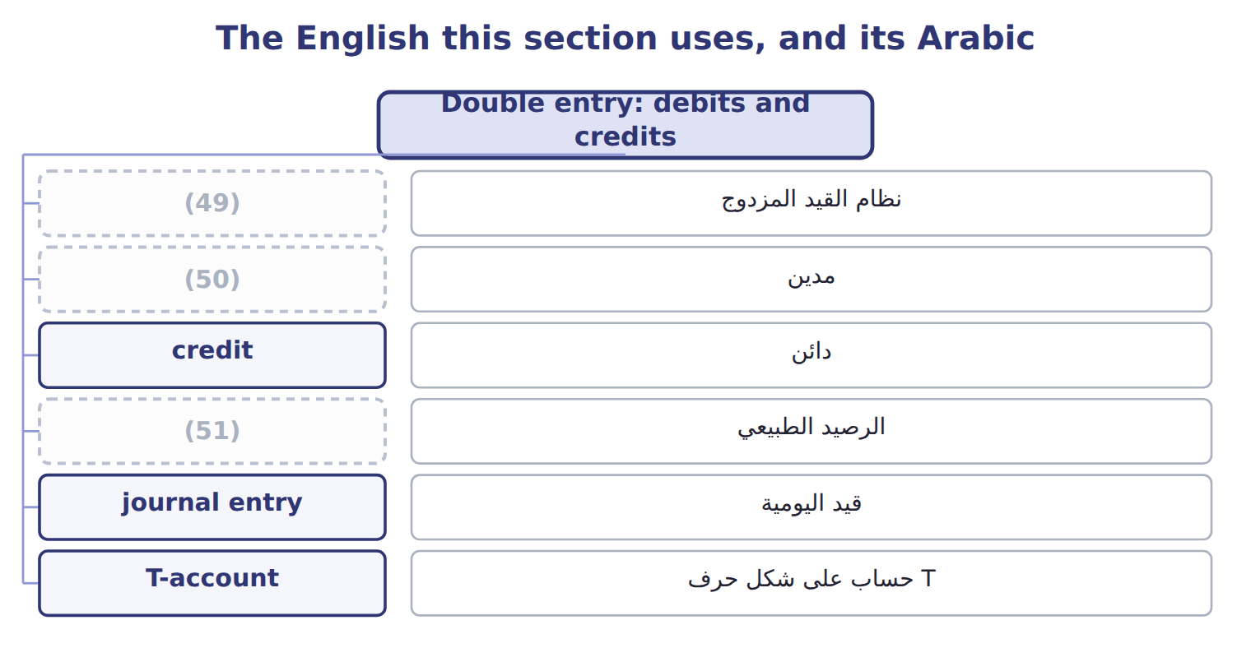
word list
par value · normal balance · double-entry system · debit

The English this sheet uses, and its Arabic
English (exam term) | Arabic
double-entry system | نظام القيد المزدوج
debit | مدين
credit | دائن
normal balance | الرصيد الطبيعي
journal entry | قيد اليومية
T-account | حساب على شكل حرف T
trial balance | ميزان المراجعة
contra account | حساب مقابل (حساب عكسي)
accumulated depreciation | مجمع الإهلاك (مجمع الاستهلاك / الاهتلاك)
allowance for credit losses | مخصص الخسائر الائتمانية
accounts receivable | الذمم المدينة (المدينون)
accounts payable | الذمم الدائنة (الدائنون)
inventory | المخزون
cost of goods sold | تكلفة البضاعة المباعة
notes payable | أوراق الدفع

Answer key · 1.3 Double entry: debits and credits

1 record | 27 owners
2 double-entry | 28 financing
3 affects | 29 records
4 balances | 30 delivers
5 simply | 31 customer
6 Whether | 32 change
7 expanded | 33 borrowing
8 expenses | 34 Buying
9 revenues | 35 another
10 opposite | 36 through
11 accumulated | 37 supplier
12 belongs | 38 Collected
13 tahini | 39 warehouse
14 frozen | 40 deliver
15 exchange | 41 Recorded
16 Amounts | 42 Complete
17 Jan 2 | 43 credited
18 Common stock | 44 effect
19 Jan 5 | 45 English
20 Notes payable (long-term) | 46 provision
21 Jan 10 | 47 reserve
22 Cost of goods sold | 48 bank's
23 Wages expense | 49 double-entry system
24 Paid January wages to plant workers in cash. | 50 debit
25 Dividends payable | 51 normal balance
26 points

the summaries in full
Summary 1 Accountants record every transaction with the double-entry system. Each transaction affects at least two accounts, and total debits always equal total credits. This is why the accounting equation always balances. Debit simply means the left side of an account, and credit means the right side. Neither word means good or bad, and neither word always means increase. Whether a debit increases an account depends on the type of account. Each account has a normal balance: the side that increases it. The expanded equation at the bottom is a useful memory aid. Accounts on the left side of the equation (assets, expenses and dividends) increase with a debit. Accounts on the right side (liabilities, equity and revenues) increase with a credit. A contra account reduces a related account, so it has the opposite normal balance. For example, accumulated depreciation reduces equipment. It has a credit balance, but it belongs with the assets. The allowance for credit losses reduces accounts receivable in the same way.
Summary 2 Orontes Foods, Inc. makes olive oil and tahini in Amman, Jordan, and frozen pastries in Dubai. Its shares are listed on a U.S. stock exchange, and it reports under U.S. GAAP. Here are its journal entries for six transactions in January 2025. Amounts are in USD 000.
Summary 3 Check each entry: the debits equal the credits. Read the grid row by row. Three points matter for the exam. Rows 1 and 2 bring in cash of 2,300 in total, but no revenue. Money from owners and lenders is financing. Row 4 creates revenue of 300 but no cash. Orontes records revenue when it delivers the goods, not when the customer pays. Row 6 reduces retained earnings by 50 and creates a liability. No cash moves until February, and net income does not change. The totals prove the equation. Assets rose by 2,380, liabilities rose by 850 and equity rose by 1,530.
Summary 4 A dividend is not an expense. It reduces retained earnings, not net income. Cash from borrowing or from issuing shares is not revenue. Buying equipment for cash is not an expense today. One asset (cash) becomes another asset (equipment). The cost becomes an expense later, through depreciation.
Summary 5 Here are six transactions from February (USD 000). Feb 3: Paid a supplier for olives bought on credit in January. Feb 8: Collected part of the January receivable from GreenBasket Supermarkets. Feb 10: Paid 12 months of warehouse rent in advance. Feb 12: A Dubai hotel group paid cash in advance for pastries that Orontes will deliver in March. Feb 15: Paid the dividend declared on January 31. Feb 28: Recorded one month of interest on the bank note. Orontes has not paid it yet. Rows 1 to 3 are done for you. Complete rows 4 to 6. Then write the journal entries for rows 4 to 6.
Summary 6 X is debited (or credited) for an amount: Cash is debited for 1,500. Exam stems often say: The effect of this transaction is to increase... In English, always say depreciation. An allowance (for example, the allowance for credit losses) reduces an asset. A provision is a liability. Never say reserve for bad debts in a U.S. GAAP answer. That is the bank's view. Do not use banking habits to guess the accounting side.

1.4 The accrual basis and the matching principle
Chapter 1 · section 1.4

Fill every gap. Each word list holds one word more than there are gaps.
Summary 1 gaps 1–12
When (1) a company record revenues and expenses? U.S. GAAP financial (2) use the accrual basis. Under the accrual basis, a company records revenue when it earns it, that is, when it (3) the goods or services. It records expenses when it (4) them. The (5) of the cash does not (6) the period. The cash basis records items only when cash is received or paid. The cash basis is (7) , but it is not (8) under U.S. GAAP. On (9) 20, 2025, Orontes ships olive oil to GreenBasket (10) and sends an invoice for 90. The goods cost Orontes 54. GreenBasket pays on January 15, 2026. Under the accrual basis, Orontes records the revenue and the cost of goods sold in (11) 2025, the year it delivered the goods. The gross profit of 36 (12) to 2025.
word list
timing · delivers · December · incurs · Supermarkets · fiscal · simple · inventory · should · acceptable · statements · belongs · decide

Summary 2 gaps 13–24
In January, the cash (13) only changes one asset (the (14) ) into another asset (cash). Under the cash basis, the revenue would fall in 2026, which is the wrong period. The matching (15) says: record expenses in the same period as the revenues they help to produce. There are three ways to apply it. Some costs link (16) to a sale. Cost of goods sold is the (17) example: Orontes records it at the same time as the sales revenue. (18) and rational allocation. Some costs help many periods, such as a (19) line. (20) spreads the cost over the years of use. Some costs have no clear link to future revenue, such as most (21) and office salaries. They are expenses in the period in which they are (22) . The accrual basis creates four common types of (23) . You met three of them in the February (24) .
word list
advertising · bottling · transactions · classic · T-account · principle · receivable · Depreciation · incurred · Systematic · directly · receipt · adjustment

Timeline of a December sale collected in January: accrual basis versus cash basis
Every item belongs to exactly one group.
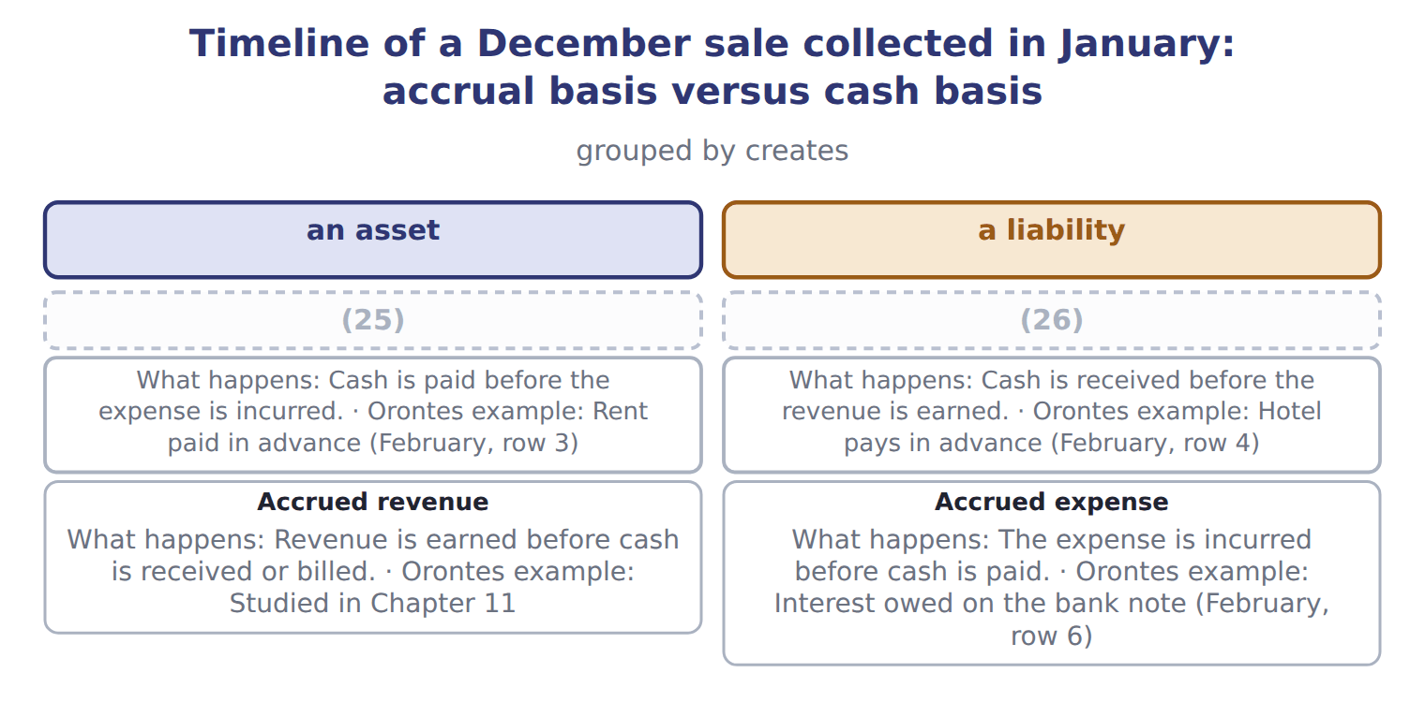
word list
allowance for credit losses · Contract liability, or unearned revenue (deferral) · Prepaid expense (deferral)

Summary 3 gaps 27–29
Two of these names are (27) for the exam. A (28) expense is an asset: the company has paid for a future benefit. A (29) liability (unearned revenue) is a liability: the company must still deliver the goods or services.
word list
liability · prepaid · important · contract

Cash is not the trigger

Summary 4 gaps 30–31
Cash received in advance is a (30) , not revenue. Cash paid in advance is an asset, not an expense. Matching means matching expenses to revenues, not to cash (31) .
word list
GreenBasket · payments · liability

The English this section uses, and its Arabic
Each term sits against what it means.
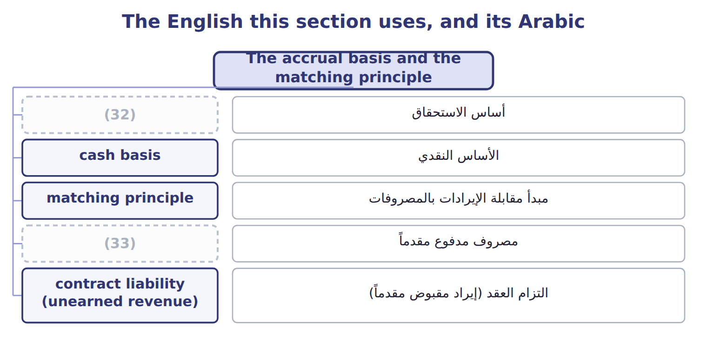
word list
financial statements · accrual basis · prepaid expense

The English this sheet uses, and its Arabic
English (exam term) | Arabic
accrual basis | أساس الاستحقاق
cash basis | الأساس النقدي
matching principle | مبدأ مقابلة الإيرادات بالمصروفات
prepaid expense | مصروف مدفوع مقدماً
contract liability (unearned revenue) | التزام العقد (إيراد مقبوض مقدماً)

Answer key · 1.4 The accrual basis and the matching principle

1 should | 18 Systematic
2 statements | 19 bottling
3 delivers | 20 Depreciation
4 incurs | 21 advertising
5 timing | 22 incurred
6 decide | 23 adjustment
7 simple | 24 transactions
8 acceptable | 25 Prepaid expense (deferral)
9 December | 26 Contract liability, or unearned revenue (deferral)
10 Supermarkets | 27 important
11 fiscal | 28 prepaid
12 belongs | 29 contract
13 receipt | 30 liability
14 receivable | 31 payments
15 principle | 32 accrual basis
16 directly | 33 prepaid expense
17 classic

the summaries in full
Summary 1 When should a company record revenues and expenses? U.S. GAAP financial statements use the accrual basis. Under the accrual basis, a company records revenue when it earns it, that is, when it delivers the goods or services. It records expenses when it incurs them. The timing of the cash does not decide the period. The cash basis records items only when cash is received or paid. The cash basis is simple, but it is not acceptable under U.S. GAAP. On December 20, 2025, Orontes ships olive oil to GreenBasket Supermarkets and sends an invoice for 90. The goods cost Orontes 54. GreenBasket pays on January 15, 2026. Under the accrual basis, Orontes records the revenue and the cost of goods sold in fiscal 2025, the year it delivered the goods. The gross profit of 36 belongs to 2025.
Summary 2 In January, the cash receipt only changes one asset (the receivable) into another asset (cash). Under the cash basis, the revenue would fall in 2026, which is the wrong period. The matching principle says: record expenses in the same period as the revenues they help to produce. There are three ways to apply it. Some costs link directly to a sale. Cost of goods sold is the classic example: Orontes records it at the same time as the sales revenue. Systematic and rational allocation. Some costs help many periods, such as a bottling line. Depreciation spreads the cost over the years of use. Some costs have no clear link to future revenue, such as most advertising and office salaries. They are expenses in the period in which they are incurred. The accrual basis creates four common types of adjustment. You met three of them in the February transactions.
Summary 3 Two of these names are important for the exam. A prepaid expense is an asset: the company has paid for a future benefit. A contract liability (unearned revenue) is a liability: the company must still deliver the goods or services.
Summary 4 Cash received in advance is a liability, not revenue. Cash paid in advance is an asset, not an expense. Matching means matching expenses to revenues, not to cash payments.

1.5 Who writes the rules? U.S. GAAP and IFRS
Chapter 1 · section 1.5

Fill every gap. Each word list holds one word more than there are gaps.
Summary 1 gaps 1–12
In the United States, the accounting rules are (1) U.S. GAAP ( (2) accepted accounting (3) ). The FASB (Financial Accounting Standards Board) writes them. The FASB is a private, independent (4) . It keeps all U.S. GAAP in one place: the Accounting Standards Codification (ASC). The ASC is the single source of authoritative (5) U.S. GAAP. It is (6) by topic numbers. For example, ASC 606 covers (7) and ASC 842 covers leases. When the FASB (8) a rule, it issues an Accounting Standards Update (ASU), which amends the Codification. The SEC ( (9) and Exchange Commission) is a U.S. government agency. It has legal authority over the financial reporting of public companies, and it (10) the FASB as the standard setter. For companies that (11) to the SEC, SEC rules are also part of authoritative GAAP. Do not confuse these bodies with the PCAOB, which (12) the audits of public companies.
word list
called · recognizes · changes · oversees · nongovernmental · report · generally · Securities · principles · organization · authoritative · revenue · organized

Summary 2 gaps 13–24
The PCAOB sets auditing standards, not accounting standards. (13) the United States, many countries use IFRS (International Financial Reporting Standards). The (14) (International Accounting Standards Board) issues them, under the IFRS (15) . Many countries in the (16) East and North Africa, for example Jordan and the United Arab (17) , require IFRS for listed companies. The CMA exam tests U.S. GAAP. (18) , Section A also asks about the main (19) between U.S. GAAP and IFRS. If you (20) accounting under IFRS, this is good news: most (21) are the same. Every chapter has an IFRS (22) box, so. Both systems rest on a (23) framework: the basic ideas behind the standards, such as the users, the elements and the qualities of useful (24) . You studied the U.S. version in Sections 1.1 and 1.2.
word list
expense · differences · Outside · Foundation · IASB · Contrast · However · learned · Emirates · concepts · information · conceptual · Middle

U.S. GAAP (used on the exam) — IFRS
The two sides differ only where the rows say.
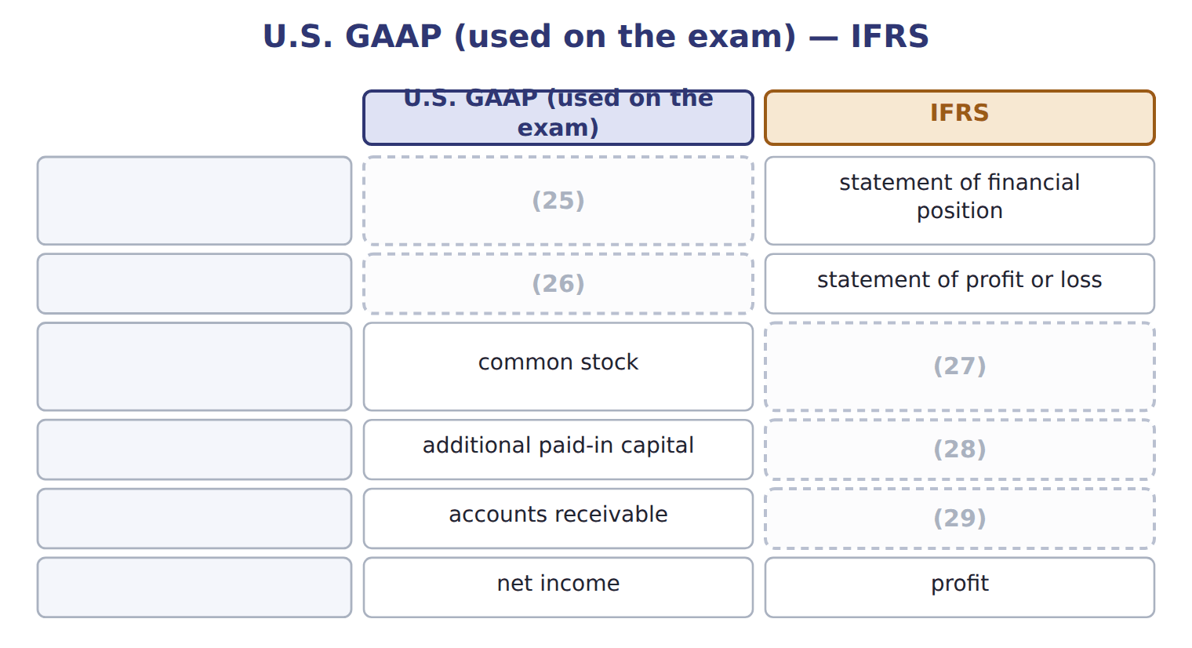
word list
balance sheet · income statement · share capital (ordinary shares) · trade receivables · share premium · primary users

Four bodies, four jobs

Summary 3 gaps 30–31
FASB: (30) U.S. GAAP (the ASC). SEC: U.S. (31) agency with legal authority over public company reporting. PCAOB: sets auditing standards for audits of public companies.
word list
between · writes · government

The English this section uses, and its Arabic
Each term sits against what it means.
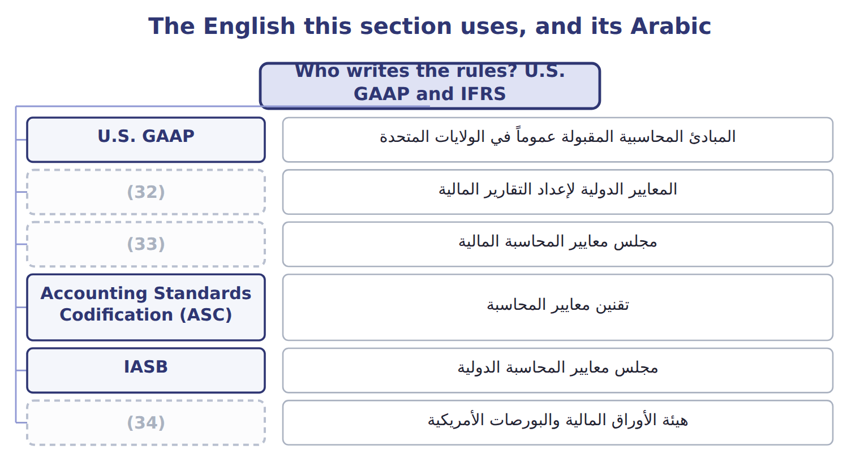
word list
FASB · IFRS · SEC · expense

The English this sheet uses, and its Arabic
English (exam term) | Arabic
U.S. GAAP | المبادئ المحاسبية المقبولة عموماً في الولايات المتحدة
IFRS | المعايير الدولية لإعداد التقارير المالية
FASB | مجلس معايير المحاسبة المالية
Accounting Standards Codification (ASC) | تقنين معايير المحاسبة
IASB | مجلس معايير المحاسبة الدولية
SEC | هيئة الأوراق المالية والبورصات الأمريكية
conceptual framework | الإطار المفاهيمي

Answer key · 1.5 Who writes the rules? U.S. GAAP and IFRS

1 called | 18 However
2 generally | 19 differences
3 principles | 20 learned
4 organization | 21 concepts
5 nongovernmental | 22 Contrast
6 organized | 23 conceptual
7 revenue | 24 information
8 changes | 25 balance sheet
9 Securities | 26 income statement
10 recognizes | 27 share capital (ordinary shares)
11 report | 28 share premium
12 oversees | 29 trade receivables
13 Outside | 30 writes
14 IASB | 31 government
15 Foundation | 32 IFRS
16 Middle | 33 FASB
17 Emirates | 34 SEC

the summaries in full
Summary 1 In the United States, the accounting rules are called U.S. GAAP (generally accepted accounting principles). The FASB (Financial Accounting Standards Board) writes them. The FASB is a private, independent organization. It keeps all U.S. GAAP in one place: the Accounting Standards Codification (ASC). The ASC is the single source of authoritative nongovernmental U.S. GAAP. It is organized by topic numbers. For example, ASC 606 covers revenue and ASC 842 covers leases. When the FASB changes a rule, it issues an Accounting Standards Update (ASU), which amends the Codification. The SEC (Securities and Exchange Commission) is a U.S. government agency. It has legal authority over the financial reporting of public companies, and it recognizes the FASB as the standard setter. For companies that report to the SEC, SEC rules are also part of authoritative GAAP. Do not confuse these bodies with the PCAOB, which oversees the audits of public companies.
Summary 2 The PCAOB sets auditing standards, not accounting standards. Outside the United States, many countries use IFRS (International Financial Reporting Standards). The IASB (International Accounting Standards Board) issues them, under the IFRS Foundation. Many countries in the Middle East and North Africa, for example Jordan and the United Arab Emirates, require IFRS for listed companies. The CMA exam tests U.S. GAAP. However, Section A also asks about the main differences between U.S. GAAP and IFRS. If you learned accounting under IFRS, this is good news: most concepts are the same. Every chapter has an IFRS Contrast box, so. Both systems rest on a conceptual framework: the basic ideas behind the standards, such as the users, the elements and the qualities of useful information. You studied the U.S. version in Sections 1.1 and 1.2.
Summary 3 FASB: writes U.S. GAAP (the ASC). SEC: U.S. government agency with legal authority over public company reporting. PCAOB: sets auditing standards for audits of public companies.

1.6 A first look at the four statements
Chapter 1 · section 1.6

Fill every gap. Each word list holds one word more than there are gaps.
Each statement answers a different question for users. Here is the overview.
Statement — Question it answers
Every item belongs to exactly one group.
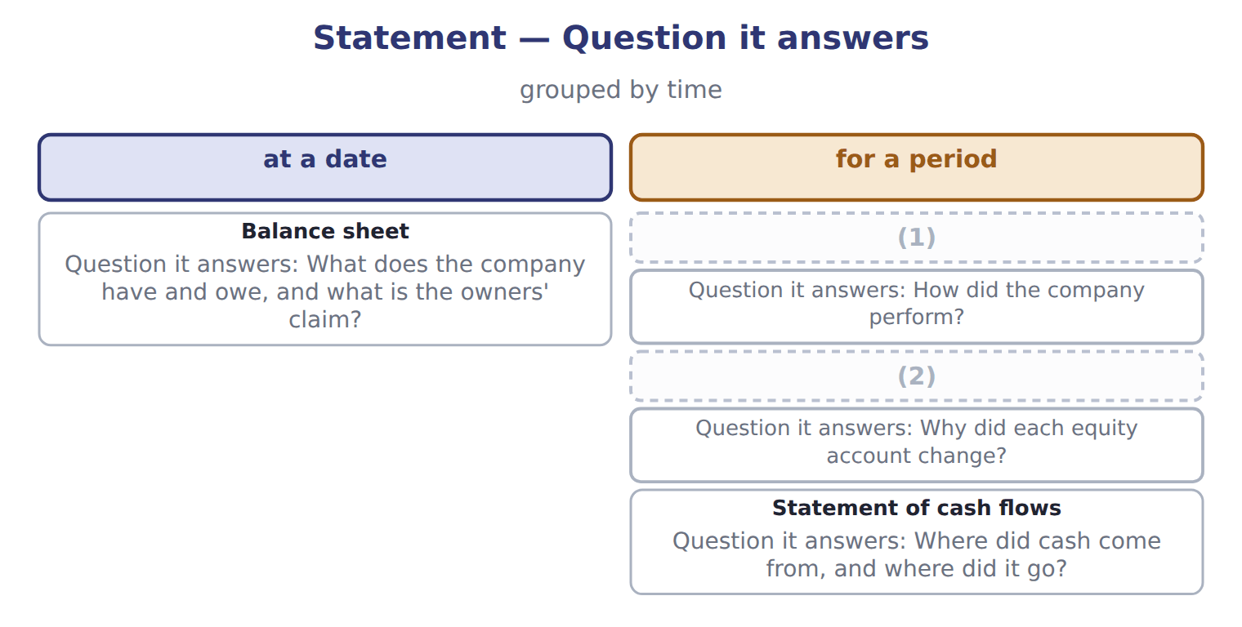
word list
Income statement · Statement of changes in equity · double-entry system

Summary 1 gaps 3–12
The four (3) are linked. Net income flows into retained earnings, and the net change in cash (4) the cash balance on the balance sheet. You can see both links in the January (5) of Orontes. The dividend declared was 50, so retained earnings rose by 30. Cash rose by 1,060: an operating outflow of 40, an (6) outflow of 1,200 and a financing (7) of 2,300. (8) that net income and the change in cash are very different (9) . This is the (10) basis at work. A trial balance lists every account balance and (11) that total debits equal total (12) . You will use it in the section check below and in the practice set.
word list
inflow · transactions · checks · credits · statements · numbers · investing · Notice · explains · dividend · accrual

Barada Wholesale, Inc. — trial balance, December 31, 2025 (USD 000)
Account | Debit | Credit
Cash | 1,050
(13) | 300
Allowance for credit losses |  | 20
(14) | 420
Prepaid rent | 24
Land | 936
Equipment | 4,200
Accumulated depreciation |  | 900
(15) |  | 380
Dividends payable |  | 50
Notes payable (long-term) |  | 1,800
(16) |  | 600
Additional paid-in capital |  | 1,900
(17) |  | 1,000
Dividends declared | 50
Sales revenue |  | 3,100
Cost of goods sold | 1,860
Wages expense | 520
Depreciation expense | 300
Interest expense | 90
Totals | 9,750 | 9,750

word list
Dividends payable · Retained earnings, January 1 · Accounts receivable · Accounts payable · Common stock · Inventory

Reading exam questions

Net income was 80: revenue of 300, minus cost of goods sold of 180, minus wages of 40.
Summary 2 gaps 18–19
MOST likely or BEST (18) : more than one option may be partly true. (19) the best one. NOT or EXCEPT: three options are true. Find the one that is false.
word list
retained · describes · Choose

Reading exam questions
Row | Transaction | Journal entry | Effects
4 | A Dubai hotel group paid cash in advance for pastries that Orontes will deliver in March. | (20) | Assets +60, liabilities +60, equity 0, net income 0; cash flow: operating +60.
5 | (21) | Dr Dividends payable 50; Cr Cash 50 | Assets (50), liabilities (50), equity 0, net income 0; cash flow: financing (50).
6 | Recorded one month of interest on the bank note. Orontes has not paid it yet. | (22) | Assets 0, liabilities +4, equity (4), net income (4); cash flow: none.

word list
Dr Dividends payable 50; Cr Cash 50 · Dr Interest expense 4; Cr Interest payable 4 · Paid the dividend declared on January 31. · Dr Cash 60; Cr Contract liability (unearned revenue) 60

Account — Category
Account | Category
Prepaid rent | Asset
Land | (23)
Dividends payable | Liability
Additional paid-in capital | Equity
Sales revenue | Revenue
Interest expense | Expense
Allowance for credit losses | Contra-asset
Accumulated depreciation | (24)

word list
Asset · Contra-asset · Expense

The English this section uses, and its Arabic
Each term sits against what it means.
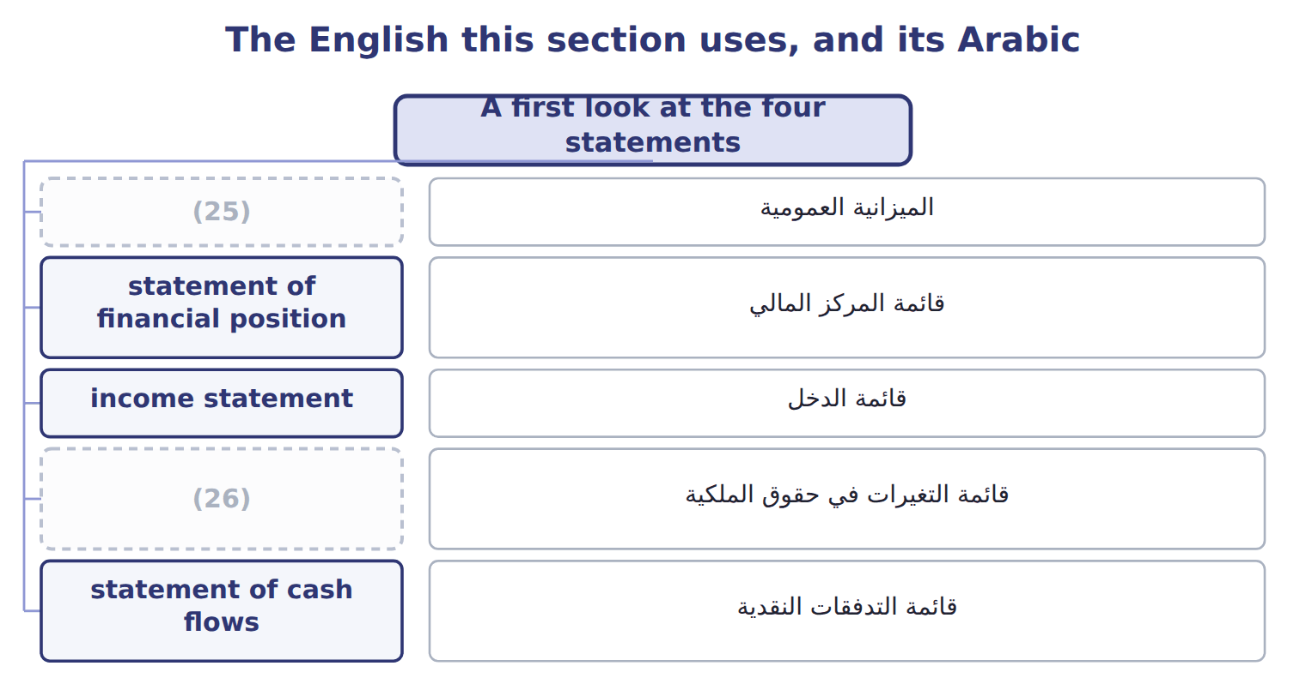
word list
statement of changes in equity · balance sheet · matching principle

The English this sheet uses, and its Arabic
English (exam term) | Arabic
balance sheet | الميزانية العمومية
statement of financial position | قائمة المركز المالي
income statement | قائمة الدخل
statement of changes in equity | قائمة التغيرات في حقوق الملكية
statement of cash flows | قائمة التدفقات النقدية

Answer key · 1.6 A first look at the four statements

1 Income statement | 14 Inventory
2 Statement of changes in equity | 15 Accounts payable
3 statements | 16 Common stock
4 explains | 17 Retained earnings, January 1
5 transactions | 18 describes
6 investing | 19 Choose
7 inflow | 20 Dr Cash 60; Cr Contract liability (unearned revenue) 60
8 Notice | 21 Paid the dividend declared on January 31.
9 numbers | 22 Dr Interest expense 4; Cr Interest payable 4
10 accrual | 23 Asset
11 checks | 24 Contra-asset
12 credits | 25 balance sheet
13 Accounts receivable | 26 statement of changes in equity

the summaries in full
Summary 1 The four statements are linked. Net income flows into retained earnings, and the net change in cash explains the cash balance on the balance sheet. You can see both links in the January transactions of Orontes. The dividend declared was 50, so retained earnings rose by 30. Cash rose by 1,060: an operating outflow of 40, an investing outflow of 1,200 and a financing inflow of 2,300. Notice that net income and the change in cash are very different numbers. This is the accrual basis at work. A trial balance lists every account balance and checks that total debits equal total credits. You will use it in the section check below and in the practice set.
Summary 2 MOST likely or BEST describes: more than one option may be partly true. Choose the best one. NOT or EXCEPT: three options are true. Find the one that is false.

2.1 Purpose and structure of the balance sheet
Chapter 2 · section 2.1

Fill every gap. Each word list holds one word more than there are gaps.
Chapter 2, section by section
Each stage leads to the next.
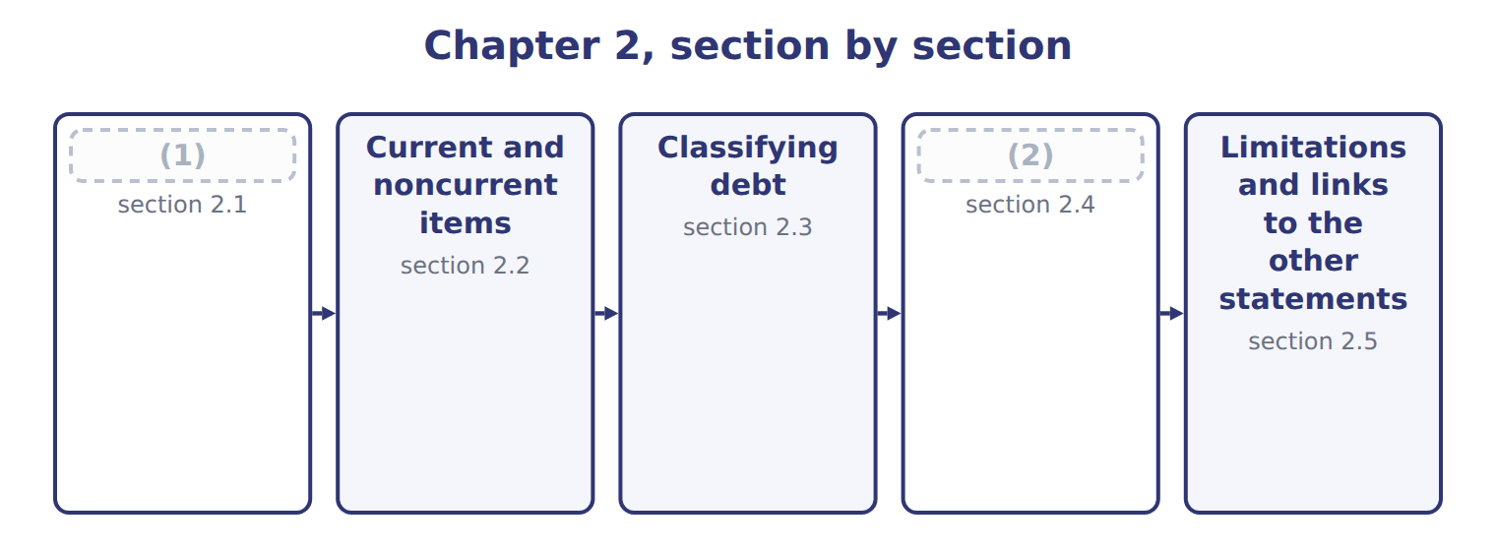
word list
Purpose and structure of the balance sheet · right of setoff · Other presentation matters

Summary 1 gaps 3–14
The balance sheet reports a (3) assets, liabilities and equity at one point in time. It answers three (4) for investors and (5) . Can the company pay its bills in the (6) months? This is liquidity. Can it pay all its debts over time? This is (7) . Can it raise cash or change its plans if something (8) happens? This is financial (9) . U.S. companies that file with the SEC present a (10) balance sheet. It (11) current from noncurrent assets and current from noncurrent liabilities, so users can see the (12) position at once. Some companies, such as banks, list items in order of liquidity (13) , without a current (14) . All the amounts come from the same records as the earlier chapters on receivables, inventory, investments and long-lived assets. For example, the equity-method investments include Jordan Glass Co. from, and goodwill fell after the impairments.
word list
flexibility · lenders · company's · unexpected · coming · questions · current · separates · subtotal · short-term · solvency · classified · instead

Orontes Foods Inc. — classified balance sheets at December 31, 2025 and 2024
Orontes Foods Inc. (whole USD) | Dec 31, 2025 | Dec 31, 2024
ASSETS
Current assets
Cash | 7,302,100 | 2,100,000
Trading securities | 42,000 | 40,000
Accounts (15) , net of allowance (2025: 156,000; 2024: 140,000) | 4,144,000 | 3,760,000
Inventory | 2,450,000 | 2,300,000
(16) | 204,000 | 180,000
Assets held for sale | 46,000 | —
Total current assets | 14,188,100 | 8,380,000
Noncurrent assets
Debt securities (held-to-maturity and (17) ) | 88,500 | 90,000
Equity securities | 27,000 | 25,000
Equity-method investments | 1,807,000 | 500,000
Property, plant and equipment, net of accumulated depreciation (2025: 11,988,000; 2024: 8,000,000) | 14,802,000 | 16,000,000
Brand (indefinite-lived) | 260,000 | 300,000
Goodwill | 300,000 | 950,000
(18) | 200,000 | 200,000
TOTAL ASSETS | 31,672,600 | 26,445,000
LIABILITIES AND STOCKHOLDERS' EQUITY
Current liabilities
(19) | 2,050,000 | 1,900,000
Accrued liabilities | 900,000 | 850,000
(20) | 350,000 | 300,000
Contract liabilities | 180,000 | 120,000
Dividends payable | 400,000 | —
(21) | 400,000 | 400,000
Total current liabilities | 4,280,000 | 3,570,000
Long-term debt, less current portion | 6,000,000 | 5,600,000
Deferred tax liability | 999,625 | 900,000
Total liabilities | 11,279,625 | 10,070,000
Commitments and contingencies (Note 12)
Stockholders' equity
Common stock, $1 par; shares issued and (22) : 2025 8,100,000, 2024 8,000,000 | 8,100,000 | 8,000,000
(23) | 5,400,000 | 4,000,000
(24) | 6,894,100 | 4,375,000
Accumulated other comprehensive income (loss) | (1,125) | —
Total stockholders' equity | 20,392,975 | 16,375,000
TOTAL LIABILITIES AND STOCKHOLDERS' EQUITY | 31,672,600 | 26,445,000

word list
Prepaid expenses · Income taxes payable · Contract liabilities · Other noncurrent assets · Current portion of long-term debt · Additional paid-in capital · Retained earnings · available-for-sale · receivable · Accounts payable · outstanding

Summary 2 gaps 25–30
Read the figure from the top. Current assets come first, from cash down to assets held for sale. Then come the noncurrent assets: investments, property, plant and equipment, and (25) assets. Liabilities (26) the same order, and equity comes last. (27) accounts, such as the allowance for (28) losses and accumulated depreciation, are shown with the asset they (29) . The line Commitments and contingencies has no (30) ; it tells the reader to look at a note.
word list
contingencies · Contra · reduce · credit · intangible · follow · amount

The English this section uses, and its Arabic
Each term sits against what it means.
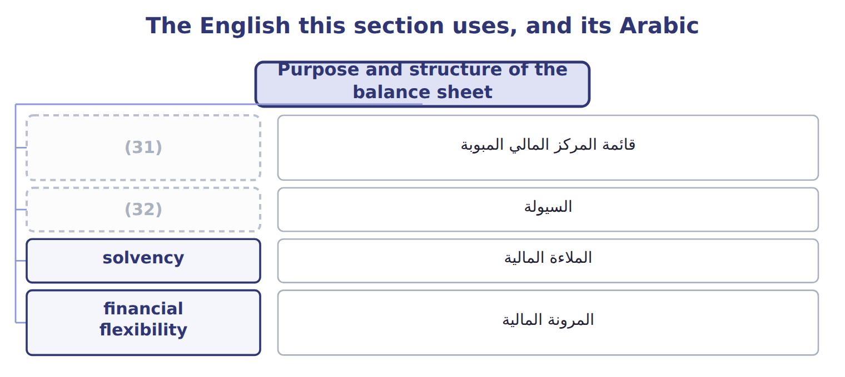
word list
السيولة · liquidity · classified balance sheet

The English this sheet uses, and its Arabic
English (exam term) | Arabic
classified balance sheet | قائمة المركز المالي المبوبة
liquidity | السيولة
solvency | الملاءة المالية
financial flexibility | المرونة المالية

Answer key · 2.1 Purpose and structure of the balance sheet

1 Purpose and structure of the balance sheet | 17 available-for-sale
2 Other presentation matters | 18 Other noncurrent assets
3 company's | 19 Accounts payable
4 questions | 20 Income taxes payable
5 lenders | 21 Current portion of long-term debt
6 coming | 22 outstanding
7 solvency | 23 Additional paid-in capital
8 unexpected | 24 Retained earnings
9 flexibility | 25 intangible
10 classified | 26 follow
11 separates | 27 Contra
12 short-term | 28 credit
13 instead | 29 reduce
14 subtotal | 30 amount
15 receivable | 31 classified balance sheet
16 Prepaid expenses | 32 liquidity

the summaries in full
Summary 1 The balance sheet reports a company's assets, liabilities and equity at one point in time. It answers three questions for investors and lenders. Can the company pay its bills in the coming months? This is liquidity. Can it pay all its debts over time? This is solvency. Can it raise cash or change its plans if something unexpected happens? This is financial flexibility. U.S. companies that file with the SEC present a classified balance sheet. It separates current from noncurrent assets and current from noncurrent liabilities, so users can see the short-term position at once. Some companies, such as banks, list items in order of liquidity instead, without a current subtotal. All the amounts come from the same records as the earlier chapters on receivables, inventory, investments and long-lived assets. For example, the equity-method investments include Jordan Glass Co. from, and goodwill fell after the impairments.
Summary 2 Read the figure from the top. Current assets come first, from cash down to assets held for sale. Then come the noncurrent assets: investments, property, plant and equipment, and intangible assets. Liabilities follow the same order, and equity comes last. Contra accounts, such as the allowance for credit losses and accumulated depreciation, are shown with the asset they reduce. The line Commitments and contingencies has no amount; it tells the reader to look at a note.

2.2 Current and noncurrent items
Chapter 2 · section 2.2

Fill every gap. Each word list holds one word more than there are gaps.
Summary 1 gaps 1–11
Current assets are cash and other assets that the company expects to turn into cash, sell or use up within one year or within its operating cycle, (1) is longer. The operating cycle is the (2) time from buying materials to (3) cash from customers. Current liabilities are (4) the company expects to (5) by using current assets or by (6) other current liabilities. It takes about 32 days to sell its (7) and 34 days to collect from customers: 66 days in total. Because the cycle is (8) than a year, Orontes uses one year to classify its items. Some assets that look current are not. Restricted cash set aside to repay long-term debt or to build a plant is noncurrent. So are long-term investments, (9) that will not be collected within the (10) , the cash surrender value of life insurance, and long-term (11) .
word list
period · shorter · average · divided · collecting · settle · obligations · whichever · receivables · prepayments · creating · inventory

Summary 2 gaps 12–18
On the liability side, current (12) of long-term debt is current, because that part of the (13) is due within a year. Two (14) come directly from these (15) . Working capital is current assets minus current liabilities. The current ratio is current assets (16) by current liabilities. For Orontes at the end of 2025, working capital is $14,188,100 − $4,280,000 = $9,908,100, and the current ratio is 3.31. A year (17) the ratio was 2.35. Part 2 of the CMA exam (18) these ratios in depth.
word list
divided · principal · analyzes · portion · inventory · totals · measures · earlier

Working capital or the ratio?

Summary 3 gaps 19–22
Paying a (19) in cash reduces current assets and current liabilities by the same amount: working capital does not change, but the current ratio (20) . (21) debt from current to noncurrent (22) working capital and the current ratio. Use the operating cycle only when it is longer than one year.
word list
increases · changes · prepayments · Reclassifying · supplier

Worked example: classifying three Orontes items

Summary 4 gaps 23–26
Next year's (23) on long-term debt, $400,000. It is due within one year, so it is a current liability; the rest of the debt stays noncurrent. The (24) van held for sale, $46,000. Orontes expects to sell it within the year, so it is a current asset, (25) PP&E. The (26) investments, $1,807,000. Orontes plans to hold them for the long term, so they are noncurrent assets.
word list
delivery · outside · installment · equity-method · inventory

Current or noncurrent?

The first two are done. Classify the other four and give a reason.
Classify each item: current or noncurrent? (complete the blanks)
Item | Classification | Reason
Cash set aside in a sinking fund to repay bonds in 2029 | (27) | Restricted for a noncurrent purpose
Date vinegar that Orontes ages for 18 months before sale | Current asset | The operating cycle is longer than one year, so the cycle applies
Cash surrender value of an executive life insurance policy | ________ | ________
Bank loan due on demand; the bank has never asked for repayment | ________ | ________
Deferred tax asset from warranty costs expected to reverse next year | ________ | ________
Customer deposits for orders to be delivered next month | ________ | ________

word list
Noncurrent asset · callable debt

The English this section uses, and its Arabic
Each term sits against what it means.
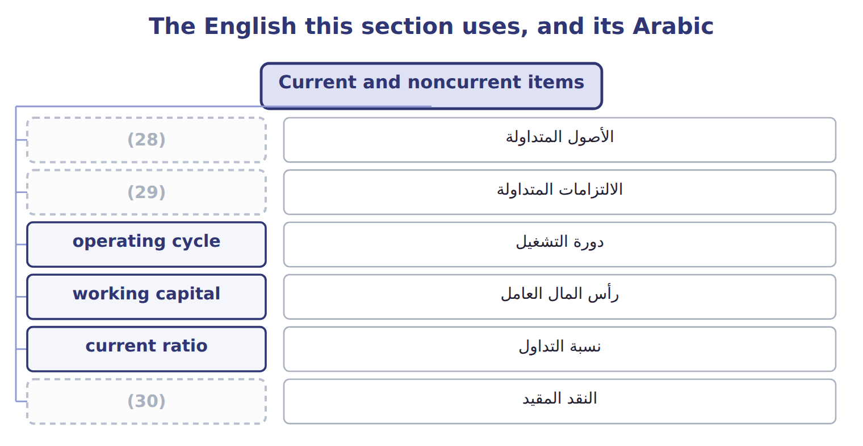
word list
دورة التشغيل · restricted cash · current liabilities · current assets

The English this sheet uses, and its Arabic
English (exam term) | Arabic
current assets | الأصول المتداولة
current liabilities | الالتزامات المتداولة
operating cycle | دورة التشغيل
working capital | رأس المال العامل
current ratio | نسبة التداول
restricted cash | النقد المقيد

Answer key · 2.2 Current and noncurrent items

1 whichever | 16 divided
2 average | 17 earlier
3 collecting | 18 analyzes
4 obligations | 19 supplier
5 settle | 20 changes
6 creating | 21 Reclassifying
7 inventory | 22 increases
8 shorter | 23 installment
9 receivables | 24 delivery
10 period | 25 outside
11 prepayments | 26 equity-method
12 portion | 27 Noncurrent asset
13 principal | 28 current assets
14 measures | 29 current liabilities
15 totals | 30 restricted cash

the summaries in full
Summary 1 Current assets are cash and other assets that the company expects to turn into cash, sell or use up within one year or within its operating cycle, whichever is longer. The operating cycle is the average time from buying materials to collecting cash from customers. Current liabilities are obligations the company expects to settle by using current assets or by creating other current liabilities. It takes about 32 days to sell its inventory and 34 days to collect from customers: 66 days in total. Because the cycle is shorter than a year, Orontes uses one year to classify its items. Some assets that look current are not. Restricted cash set aside to repay long-term debt or to build a plant is noncurrent. So are long-term investments, receivables that will not be collected within the period, the cash surrender value of life insurance, and long-term prepayments.
Summary 2 On the liability side, current portion of long-term debt is current, because that part of the principal is due within a year. Two measures come directly from these totals. Working capital is current assets minus current liabilities. The current ratio is current assets divided by current liabilities. For Orontes at the end of 2025, working capital is $14,188,100 − $4,280,000 = $9,908,100, and the current ratio is 3.31. A year earlier the ratio was 2.35. Part 2 of the CMA exam analyzes these ratios in depth.
Summary 3 Paying a supplier in cash reduces current assets and current liabilities by the same amount: working capital does not change, but the current ratio changes. Reclassifying debt from current to noncurrent increases working capital and the current ratio. Use the operating cycle only when it is longer than one year.
Summary 4 Next year's installment on long-term debt, $400,000. It is due within one year, so it is a current liability; the rest of the debt stays noncurrent. The delivery van held for sale, $46,000. Orontes expects to sell it within the year, so it is a current asset, outside PP&E. The equity-method investments, $1,807,000. Orontes plans to hold them for the long term, so they are noncurrent assets.

2.3 Classifying debt
Chapter 2 · section 2.3

Fill every gap. Each word list holds one word more than there are gaps.
Summary 1 gaps 1–12
Debt is where (1) gets difficult, and where the exam likes to test. Long-term debt that is due in (2) is split: the current (3) of long-term debt is current and the rest is noncurrent. (4) shows $400,000 as current and $6,000,000 as long-term. Loan (5) contain conditions called covenants, for example a maximum (6) ratio. If a company (7) a covenant, the lender may be able to demand (8) at once. Such (9) debt is current, even if the company does not (10) the lender to act. It stays noncurrent only if, before the statements are issued, the lender gives a waiver for more than one year, or a grace (11) exists and the company will probably cure the (12) within it. A subjective acceleration clause, such as a right to demand payment after a 'material adverse change', makes debt current only if acceleration is probable.
word list
portion · breaks · debt-to-equity · waiver · Orontes · classification · period · expect · installments · agreements · callable · repayment · violation

Summary 2 gaps 13–21
Debt that is due on demand is always current. Short-term debt can be shown as noncurrent (13) refinancing, but only if the company intends to (14) it on a long-term basis and shows that it can. It shows this by (15) long-term debt or shares after the (16) sheet date but before the statements are issued, or by signing a (17) financing agreement. IAS 1 asks one (18) : at the reporting date, does the company have a right to defer (19) for at least (20) months? A waiver or refinancing obtained after the reporting date does not count. U.S. GAAP (21) events up to the date the statements are issued.
word list
refinance · through · balance · counts · question · qualifying · issuing · signing · twelve · settlement

Debt classification: U.S. GAAP versus IFRS
Situation at the reporting date | U.S. GAAP (ASC 470-10) | IFRS (IAS 1)
Short-term debt refinanced long-term after year-end, before issuance | (22) | Current (no right to defer at the reporting date)
Covenant broken at year-end; waiver for more than 12 months obtained after year-end | Noncurrent | Current
Covenant broken at year-end; waiver obtained on or before year-end | Noncurrent | Noncurrent
Covenant tested only after year-end (future compliance doubtful) | Noncurrent; disclose | Noncurrent; disclose the risk
Subjective acceleration clause | Current only if acceleration is probable | (23)
Deferred tax assets and liabilities | All noncurrent | (24)

word list
Ignored unless it removes the right to defer · All non-current · Noncurrent (intent and demonstrated ability) · current liabilities

Summary 3 gaps 25–26
The FASB proposed a simpler (25) rule in 2017 and again in 2019, but removed the project from its agenda in April 2021. Do not use the old (26) on the exam.
word list
agreements · debt-classification · proposal

Debt traps

Summary 4 gaps 27–28
Refinanced after (27) but before issuance: noncurrent under U.S. GAAP, current under IFRS. Due on (28) : always current. A waiver obtained before issuance, for more than a year: noncurrent under U.S. GAAP.
word list
reporting · demand · year-end

The English this section uses, and its Arabic
Each term sits against what it means.
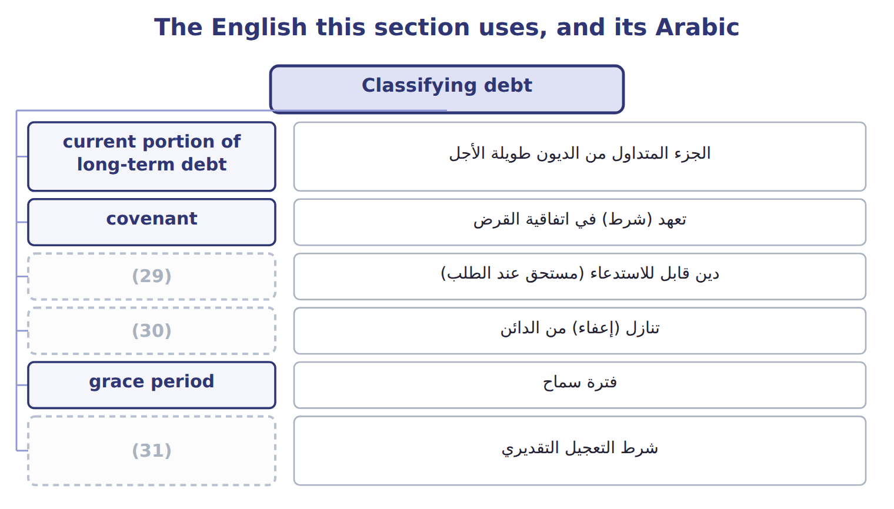
word list
financial flexibility · waiver · callable debt · subjective acceleration clause

The English this sheet uses, and its Arabic
English (exam term) | Arabic
current portion of long-term debt | الجزء المتداول من الديون طويلة الأجل
covenant | تعهد (شرط) في اتفاقية القرض
callable debt | دين قابل للاستدعاء (مستحق عند الطلب)
waiver | تنازل (إعفاء) من الدائن
grace period | فترة سماح
subjective acceleration clause | شرط التعجيل التقديري
refinancing | إعادة التمويل

Answer key · 2.3 Classifying debt

1 classification | 17 qualifying
2 installments | 18 question
3 portion | 19 settlement
4 Orontes | 20 twelve
5 agreements | 21 counts
6 debt-to-equity | 22 Noncurrent (intent and demonstrated ability)
7 breaks | 23 Ignored unless it removes the right to defer
8 repayment | 24 All non-current
9 callable | 25 debt-classification
10 expect | 26 proposal
11 period | 27 year-end
12 violation | 28 demand
13 through | 29 callable debt
14 refinance | 30 waiver
15 issuing | 31 subjective acceleration clause
16 balance

the summaries in full
Summary 1 Debt is where classification gets difficult, and where the exam likes to test. Long-term debt that is due in installments is split: the current portion of long-term debt is current and the rest is noncurrent. Orontes shows $400,000 as current and $6,000,000 as long-term. Loan agreements contain conditions called covenants, for example a maximum debt-to-equity ratio. If a company breaks a covenant, the lender may be able to demand repayment at once. Such callable debt is current, even if the company does not expect the lender to act. It stays noncurrent only if, before the statements are issued, the lender gives a waiver for more than one year, or a grace period exists and the company will probably cure the violation within it. A subjective acceleration clause, such as a right to demand payment after a 'material adverse change', makes debt current only if acceleration is probable.
Summary 2 Debt that is due on demand is always current. Short-term debt can be shown as noncurrent through refinancing, but only if the company intends to refinance it on a long-term basis and shows that it can. It shows this by issuing long-term debt or shares after the balance sheet date but before the statements are issued, or by signing a qualifying financing agreement. IAS 1 asks one question: at the reporting date, does the company have a right to defer settlement for at least twelve months? A waiver or refinancing obtained after the reporting date does not count. U.S. GAAP counts events up to the date the statements are issued.
Summary 3 The FASB proposed a simpler debt-classification rule in 2017 and again in 2019, but removed the project from its agenda in April 2021. Do not use the old proposal on the exam.
Summary 4 Refinanced after year-end but before issuance: noncurrent under U.S. GAAP, current under IFRS. Due on demand: always current. A waiver obtained before issuance, for more than a year: noncurrent under U.S. GAAP.

2.4 Other presentation matters
Chapter 2 · section 2.4

Fill every gap. Each word list holds one word more than there are gaps.
Summary 1 gaps 1–8
A few more rules decide what (1) on the balance sheet and how. All deferred tax assets and liabilities are (2) . (3) shows its deferred tax liability of $999,625 below (4) debt. Assets and liabilities may be offset only when a right of setoff exists: the two parties owe each other (5) amounts, the company has the legal right and the intent to set them off, and the right is (6) . A loss contingency is an existing (7) that may cause a loss, such as a (8) . Gain contingencies are never recorded before they are realized.
word list
Orontes · determinable · situation · enforceable · appears · year-end · noncurrent · lawsuit · long-term

Loss contingencies: recognition and disclosure
Likelihood of the loss | Recognition (if reasonably estimable) | Disclosure
Probable | Accrue a liability and a loss (best estimate; if no best estimate, the minimum of the range) | Accrue and disclose
Reasonably possible | (9) | Disclose the nature and an estimate (or say it cannot be estimated)
Remote | No accrual | (10)
Gain contingency | Never recognized before it is realized | (11)

word list
No accrual · No disclosure (except guarantees) · Disclose carefully, without misleading · current ratio

Each fact, and what it settles
The rows are a set, not a sequence.
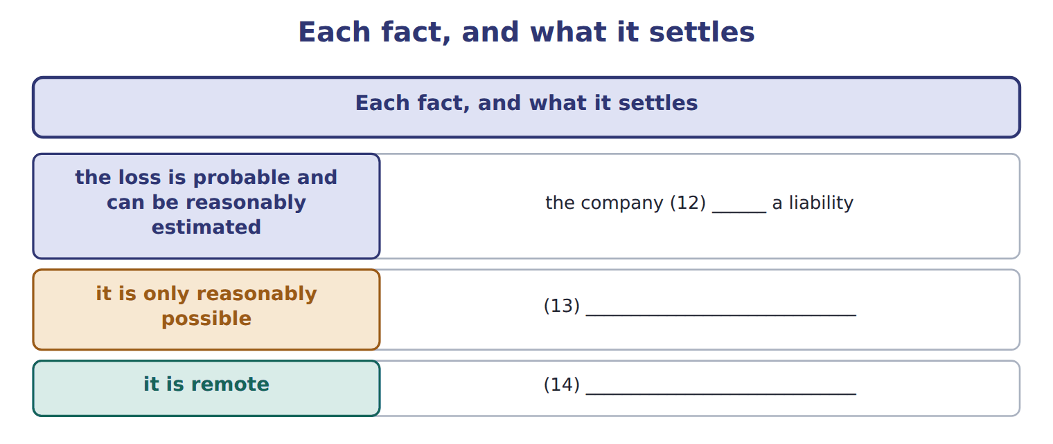
word list
the company discloses it in a note · the company does nothing · it is only reasonably possible · records

Summary 2 gaps 15–24
Subsequent (15) happen after the balance sheet date but before the statements are (16) . If an event gives more (17) about a condition that (18) existed at year-end, the company (19) the statements. If the condition arose after year-end, the company only discloses it. Finally, the notes begin with a summary of (20) accounting policies, such as the inventory method and (21) methods. The notes are part of the statements, not an extra. IFRS records a (22) when a loss is more likely than not, a lower (23) than the U.S. 'probable'. When the estimate is a range, IFRS usually uses the (24) ; U.S. GAAP uses the best estimate or, if none, the minimum.
word list
threshold · contra-assets · depreciation · already · midpoint · events · information · issued · provision · adjusts · significant

Reserve, provision, allowance

Summary 3 gaps 25–26
In U.S. GAAP (25) , use allowance for (26) , accrued liability or loss contingency for liabilities, and never call either a reserve.
word list
contra-assets · answers · appears

The English this section uses, and its Arabic
Each term sits against what it means.
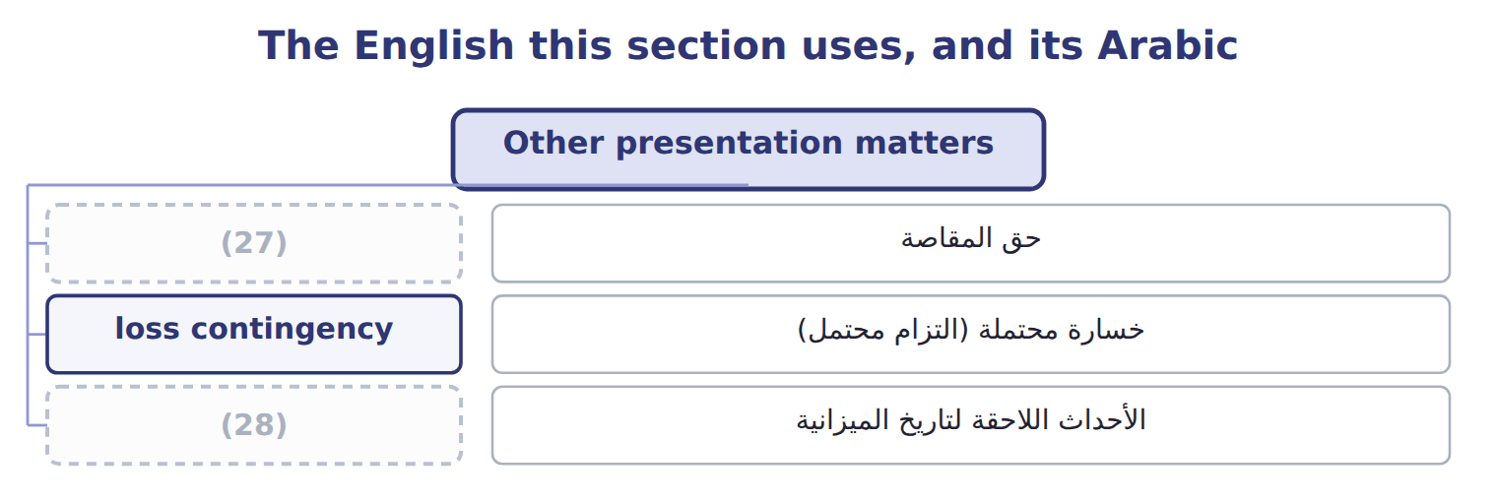
word list
operating cycle · subsequent events · right of setoff

The English this sheet uses, and its Arabic
English (exam term) | Arabic
right of setoff | حق المقاصة
loss contingency | خسارة محتملة (التزام محتمل)
subsequent events | الأحداث اللاحقة لتاريخ الميزانية

Answer key · 2.4 Other presentation matters

1 appears | 15 events
2 noncurrent | 16 issued
3 Orontes | 17 information
4 long-term | 18 already
5 determinable | 19 adjusts
6 enforceable | 20 significant
7 situation | 21 depreciation
8 lawsuit | 22 provision
9 No accrual | 23 threshold
10 No disclosure (except guarantees) | 24 midpoint
11 Disclose carefully, without misleading | 25 answers
12 records | 26 contra-assets
13 the company discloses it in a note | 27 right of setoff
14 the company does nothing | 28 subsequent events

the summaries in full
Summary 1 A few more rules decide what appears on the balance sheet and how. All deferred tax assets and liabilities are noncurrent. Orontes shows its deferred tax liability of $999,625 below long-term debt. Assets and liabilities may be offset only when a right of setoff exists: the two parties owe each other determinable amounts, the company has the legal right and the intent to set them off, and the right is enforceable. A loss contingency is an existing situation that may cause a loss, such as a lawsuit. Gain contingencies are never recorded before they are realized.
Summary 2 Subsequent events happen after the balance sheet date but before the statements are issued. If an event gives more information about a condition that already existed at year-end, the company adjusts the statements. If the condition arose after year-end, the company only discloses it. Finally, the notes begin with a summary of significant accounting policies, such as the inventory method and depreciation methods. The notes are part of the statements, not an extra. IFRS records a provision when a loss is more likely than not, a lower threshold than the U.S. 'probable'. When the estimate is a range, IFRS usually uses the midpoint; U.S. GAAP uses the best estimate or, if none, the minimum.
Summary 3 In U.S. GAAP answers, use allowance for contra-assets, accrued liability or loss contingency for liabilities, and never call either a reserve.

2.5 Limitations and links to the other statements
Chapter 2 · section 2.5

Fill every gap. Each word list holds one word more than there are gaps.
Summary 1 gaps 1–12
The balance sheet is useful, but it is not a (1) of the company. Most assets are at (2) cost, not current value: Orontes's land and (3) are shown at what they cost years ago. Many amounts depend on (4) , such as the allowance for credit losses and useful lives. (5) resources are (6) . (7) developed brands, customer loyalty and a skilled (8) are not recorded, so the balance sheet usually shows much less than the market value of the company. Some (9) are only in the notes. (10) , the balance sheet shows one day. A company can improve its (11) picture, for example by delaying payments to (12) for a few days. Readers therefore compare several dates and read the other statements too. The four statements are connected. Net income from the income statement increases retained earnings in the statement of changes in equity, and the closing retained earnings appear on the balance sheet.
word list
suppliers · historical · Internally · year-end · buildings · Finally · Important · obligations · missing · workforce · improve · estimates · valuation

Summary 2 gaps 13–15
The net change in cash in the statement of cash flows (13) the change in the (14) cash. Other comprehensive income works the same way. Orontes's OCI of $(1,125) does not go into retained earnings. It goes into (15) other comprehensive income, which is $(1,125) on the balance sheet.
word list
balance-sheet · accumulated · retained · explains

Book value is not market value

Summary 3 gaps 16–17
Total (16) ' equity is a book amount. It is not what the company is worth, and it is not the market value of the (17) .
word list
stockholders · shares · compare

Book value is not market value
Account / memo (USD 000) | Balance / details | Side
Cash | 1,050 | debit
Accounts receivable | 300 | debit
Allowance for credit losses | 20 | credit
Inventory | 420 | debit
Prepaid rent | 24 | debit
Land | 936 | (18)
Equipment | 4,200 | debit
Accumulated depreciation | 900 | credit
Accounts payable | 380 | credit
Dividends payable | 50 | credit
Notes payable (long-term) | 1,800 | credit
Common stock | 600 | credit
Additional paid-in capital | 1,900 | credit
Retained earnings, December 31 (after closing) | 1,280 | credit
M1 | Of the notes payable, 300 is an (19) due on June 30, 2026. The rest is due in 2029.
M2 | At December 31, Barada broke a debt-to-equity (20) on the note. On January 20, 2026, before the statements were issued, the bank waived
M3 | A former employee has sued Barada. Its lawyers think a loss of about 60 is reasonably possible, but not probable.
M4 | On February 10, 2026, before the statements were issued, a fire destroyed inventory that cost 70.

word list
installment · credit · debit · covenant

Item — Answer
Item | Answer
Cash surrender value | Noncurrent asset: it is not expected to be turned into cash in the operating cycle.
Loan due on demand | Current liability: debt due on demand is current, whatever the bank's expected behaviour.
Deferred tax asset | (21)
Customer deposits | Current liability (contract liability): it will be settled by delivering goods within a year.

word list
Retained earnings, December 31 (after closing) · Noncurrent asset: all deferred taxes are noncurrent.

Account — Category
Account | Category
Prepaid rent | Current asset
Land | Noncurrent asset
Allowance for credit losses | (22)
Dividends payable | (23)
Additional paid-in capital | (24)

word list
Current liability · Current asset · credit · Equity

Answer key · 2.5 Limitations and links to the other statements

1 valuation | 13 explains
2 historical | 14 balance-sheet
3 buildings | 15 accumulated
4 estimates | 16 stockholders
5 Important | 17 shares
6 missing | 18 debit
7 Internally | 19 installment
8 workforce | 20 covenant
9 obligations | 21 Noncurrent asset: all deferred taxes are noncurrent.
10 Finally | 22 Current asset
11 year-end | 23 Current liability
12 suppliers | 24 Equity

the summaries in full
Summary 1 The balance sheet is useful, but it is not a valuation of the company. Most assets are at historical cost, not current value: Orontes's land and buildings are shown at what they cost years ago. Many amounts depend on estimates, such as the allowance for credit losses and useful lives. Important resources are missing. Internally developed brands, customer loyalty and a skilled workforce are not recorded, so the balance sheet usually shows much less than the market value of the company. Some obligations are only in the notes. Finally, the balance sheet shows one day. A company can improve its year-end picture, for example by delaying payments to suppliers for a few days. Readers therefore compare several dates and read the other statements too. The four statements are connected. Net income from the income statement increases retained earnings in the statement of changes in equity, and the closing retained earnings appear on the balance sheet.
Summary 2 The net change in cash in the statement of cash flows explains the change in the balance-sheet cash. Other comprehensive income works the same way. Orontes's OCI of $(1,125) does not go into retained earnings. It goes into accumulated other comprehensive income, which is $(1,125) on the balance sheet.
Summary 3 Total stockholders' equity is a book amount. It is not what the company is worth, and it is not the market value of the shares.

3.1 Purpose and structure of the income statement
Chapter 3 · section 3.1

Fill every gap. Each word list holds one word more than there are gaps.
Chapter 3, section by section
Each stage leads to the next.
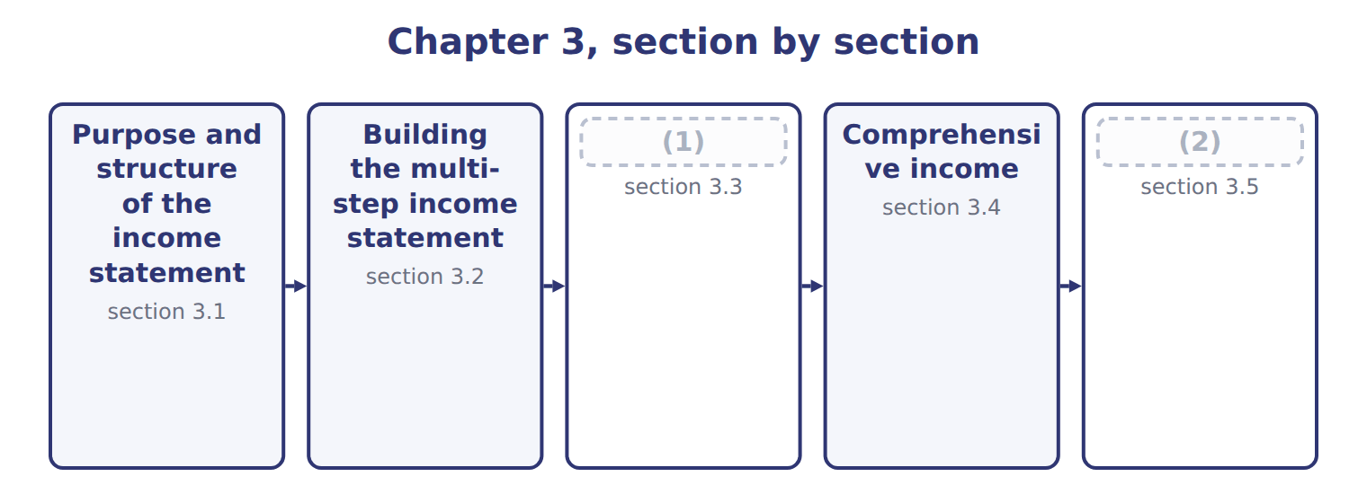
word list
Purpose and structure of the income statement · Unusual items and discontinued operations · Limitations and links to the other statements

Summary 1 gaps 3–14
The income statement reports a (3) revenues, expenses, gains and losses for a period, (4) a year. The (5) is net income, which (6) retained earnings. Where the balance sheet is a (7) , the income statement is a film of the whole year. (8) use it to judge how (9) the company is and to predict its future earnings and cash flows. (10) use it to see (11) the company earns enough to pay interest. (12) use it to compare results with budgets and with (13) . U.S. GAAP does not (14) one layout. A multi-step income statement shows subtotals: gross profit, operating income and income before income taxes. A single-step income statement adds all revenues and gains, deducts all expenses and losses, and reaches net income in one step. SEC registrants such as Orontes follow the SEC's list of captions, which gives a multi-step layout.
word list
Managers · photograph · increases · company's · earnings · Lenders · usually · competitors · require · result · profitable · whether · Investors

Summary 2 gaps 15–20
All the (15) come from the same (16) as the balance sheet. For example, the impairment losses are the ones you (17) in, and the equity-method income comes. The single-step form is (18) to read, but it hides useful (19) . The multi-step form tells a reader that (20) main business earned $4,176,000 before interest and tax, and that other items reduced this by a net $217,200.
word list
records · Orontes's · information · statement · simpler · calculated · amounts

Orontes Foods Inc. — statement of income and comprehensive income, 2025
Orontes Foods Inc., year ended December 31, 2025 | 2025
Net sales | 42,000,000
(21) | (27,300,000)
Gross profit | 14,700,000
Operating expenses
Selling, general and administrative | (7,237,000)
(22) | (63,000)
(23) | (500,000)
Impairment losses | (2,724,000)
Total operating expenses | (10,524,000)
Operating income | 4,176,000
Other income and (expense)
(24) | (390,000)
(25) | 3,800
(26) | 4,000
Equity-method income | 177,000
Gain on sale of equipment | 3,000
Loss on sale of receivables | (15,000)
(27) | (217,200)
Income before income taxes | 3,958,800
Income tax expense | (989,700)
Net income | 2,969,100
Earnings per share, basic and diluted | $0.37
Weighted-average shares outstanding | 8,099,726
(28)
Unrealized loss on available-for-sale debt securities, net of tax of 375 | (1,125)
Comprehensive income | 2,967,975

word list
Credit loss expense · Total other income and (expense) · Other comprehensive income · Interest and dividend income · Interest expense · Cost of goods sold · Research and development · Unrealized gains on securities · Gain on sale of equipment

The English this section uses, and its Arabic
Each term sits against what it means.
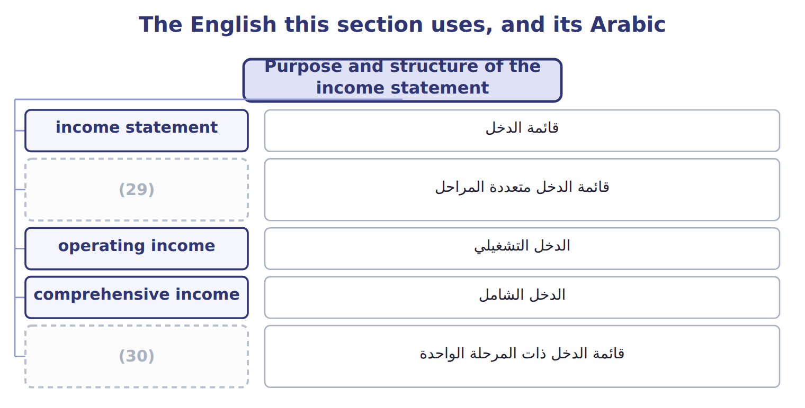
word list
intraperiod tax allocation · single-step income statement · multi-step income statement

The English this sheet uses, and its Arabic
English (exam term) | Arabic
multi-step income statement | قائمة الدخل متعددة المراحل
single-step income statement | قائمة الدخل ذات المرحلة الواحدة

Answer key · 3.1 Purpose and structure of the income statement

1 Unusual items and discontinued operations | 16 records
2 Limitations and links to the other statements | 17 calculated
3 company's | 18 simpler
4 usually | 19 information
5 result | 20 Orontes's
6 increases | 21 Cost of goods sold
7 photograph | 22 Credit loss expense
8 Investors | 23 Research and development
9 profitable | 24 Interest expense
10 Lenders | 25 Interest and dividend income
11 whether | 26 Unrealized gains on securities
12 Managers | 27 Total other income and (expense)
13 competitors | 28 Other comprehensive income
14 require | 29 multi-step income statement
15 amounts | 30 single-step income statement

the summaries in full
Summary 1 The income statement reports a company's revenues, expenses, gains and losses for a period, usually a year. The result is net income, which increases retained earnings. Where the balance sheet is a photograph, the income statement is a film of the whole year. Investors use it to judge how profitable the company is and to predict its future earnings and cash flows. Lenders use it to see whether the company earns enough to pay interest. Managers use it to compare results with budgets and with competitors. U.S. GAAP does not require one layout. A multi-step income statement shows subtotals: gross profit, operating income and income before income taxes. A single-step income statement adds all revenues and gains, deducts all expenses and losses, and reaches net income in one step. SEC registrants such as Orontes follow the SEC's list of captions, which gives a multi-step layout.
Summary 2 All the amounts come from the same records as the balance sheet. For example, the impairment losses are the ones you calculated in, and the equity-method income comes. The single-step form is simpler to read, but it hides useful information. The multi-step form tells a reader that Orontes's main business earned $4,176,000 before interest and tax, and that other items reduced this by a net $217,200.

3.2 Building the multi-step income statement
Chapter 3 · section 3.2

Fill every gap. Each word list holds one word more than there are gaps.
Summary 1 gaps 1–10
Gross profit is net sales minus cost of goods sold. It shows how much the company earns on what it sells before its other costs. Orontes's gross profit is $14,700,000, which is 35% of net sales. Operating income is gross profit minus operating expenses: selling, general and (1) expenses, research and (2) , credit losses and (3) . Interest and income tax are never operating expenses. Orontes's operating income is $4,176,000. Other income and expense (4) operating income. It contains interest, (5) income and gains and losses. A gain or loss comes from a (6) or incidental (7) , and it is shown net. For example, Orontes sold an old oven and (8) a gain of $3,000: the proceeds minus the (9) amount, not the full proceeds. Income tax expense is then (10) from income before income taxes.
word list
investment · development · peripheral · carrying · follows · administrative · reported · transaction · expenses · deducted · impairments

Summary 2 gaps 11–14
Public companies also show earnings per share (EPS) on the face of the (11) . Orontes's basic EPS is $0.37: net income divided by the (12) number of shares outstanding. Part 2 of the CMA exam (13) EPS in depth. The (14) step is the cost of goods sold.
word list
biggest · analyzes · statement · weighted-average · Orontes

Worked example: Orontes's subtotals

Summary 3 gaps 15–17
Gross (15) : $42,000,000 − $27,300,000 = $14,700,000. Operating income: $14,700,000 − $10,524,000 of operating (16) = $4,176,000. Income (17) income taxes: $4,176,000 − net other expense of $217,200 = $3,958,800. Net income: $3,958,800 − income tax of $989,700 = $2,969,100.
word list
profit · investment · expenses · before

Barada's 2025 income statement

Barada's 2025 statements ignore income tax. Fill in the three blanks.
Where the line is drawn

Summary 4 gaps 18–20
Interest expense is below operating income, never (18) it. A gain on selling (19) is other income, not revenue. Gross profit uses cost of goods sold only; wages and depreciation outside (20) are operating expenses.
word list
Orontes's · equipment · production · inside

Barada Wholesale — multi-step income statement, 2025 (complete the blanks)
Barada Wholesale, year ended December 31, 2025 ( | 2025
(21) | 3,100
Cost of goods sold | (1,860)
Gross profit | 1,240
Wages expense | (520)
Depreciation expense | (300)
Operating income | ________
Interest expense | (90)
Net income | ________
(22) | ________

word list
Gross profit as a percentage of sales · Cost of goods sold · Sales revenue

The English this section uses, and its Arabic
Each term sits against what it means.
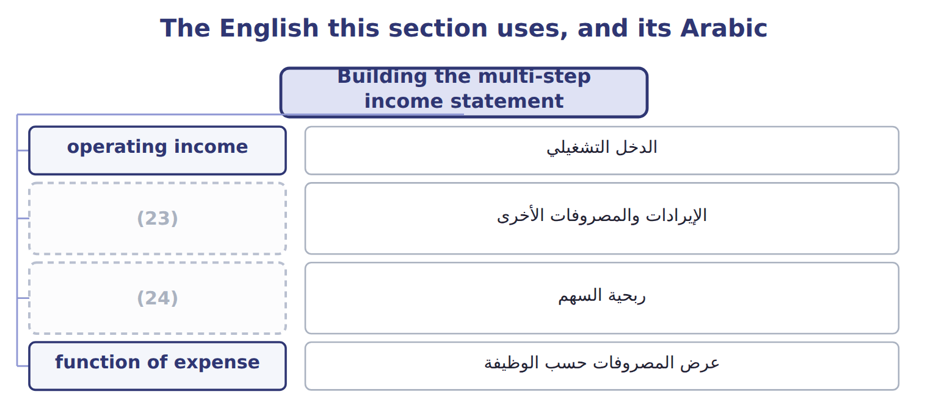
word list
income from continuing operations · other income and expense · earnings per share (EPS)

The English this sheet uses, and its Arabic
English (exam term) | Arabic
operating income | الدخل التشغيلي
other income and expense | الإيرادات والمصروفات الأخرى
earnings per share (EPS) | ربحية السهم
function of expense | عرض المصروفات حسب الوظيفة

Answer key · 3.2 Building the multi-step income statement

1 administrative | 13 analyzes
2 development | 14 biggest
3 impairments | 15 profit
4 follows | 16 expenses
5 investment | 17 before
6 peripheral | 18 inside
7 transaction | 19 equipment
8 reported | 20 production
9 carrying | 21 Sales revenue
10 deducted | 22 Gross profit as a percentage of sales
11 statement | 23 other income and expense
12 weighted-average | 24 earnings per share (EPS)

the summaries in full
Summary 1 Gross profit is net sales minus cost of goods sold. It shows how much the company earns on what it sells before its other costs. Orontes's gross profit is $14,700,000, which is 35% of net sales. Operating income is gross profit minus operating expenses: selling, general and administrative expenses, research and development, credit losses and impairments. Interest and income tax are never operating expenses. Orontes's operating income is $4,176,000. Other income and expense follows operating income. It contains interest, investment income and gains and losses. A gain or loss comes from a peripheral or incidental transaction, and it is shown net. For example, Orontes sold an old oven and reported a gain of $3,000: the proceeds minus the carrying amount, not the full proceeds. Income tax expense is then deducted from income before income taxes.
Summary 2 Public companies also show earnings per share (EPS) on the face of the statement. Orontes's basic EPS is $0.37: net income divided by the weighted-average number of shares outstanding. Part 2 of the CMA exam analyzes EPS in depth. The biggest step is the cost of goods sold.
Summary 3 Gross profit: $42,000,000 − $27,300,000 = $14,700,000. Operating income: $14,700,000 − $10,524,000 of operating expenses = $4,176,000. Income before income taxes: $4,176,000 − net other expense of $217,200 = $3,958,800. Net income: $3,958,800 − income tax of $989,700 = $2,969,100.
Summary 4 Interest expense is below operating income, never inside it. A gain on selling equipment is other income, not revenue. Gross profit uses cost of goods sold only; wages and depreciation outside production are operating expenses.

3.3 Unusual items and discontinued operations
Chapter 3 · section 3.3

Fill every gap. Each word list holds one word more than there are gaps.
Summary 1 gaps 1–12
Some items need special (1) because they may not (2) again. U.S. GAAP no (3) has extraordinary items; the FASB (4) them in 2015. An unusual or infrequent item, such as a large fire loss, is shown as a separate line (5) continuing operations, before tax. It is never shown net of tax. A discontinued operation is a (6) of an entity that the company has sold, has (7) as held for sale, or has abandoned. The disposal must also be a strategic shift with a major (8) on the company. (9) are leaving a major line of business or a major geographic area. (10) one store or (11) one small product does not qualify. The results of a discontinued operation, (12) any gain or loss on disposal, appear below income from continuing operations, net of their own tax. This is called intraperiod tax allocation.
word list
component · stopping · Examples · removed · classified · within · reduces · attention · effect · including · Closing · happen · longer

Summary 2 gaps 13–19
Ask the (13) in order: OCI first, then discontinued operations, then unusual items, and finally main (14) or other income and expense. Suppose that in 2026 Orontes sells its frozen-foods business to focus on (15) and dry foods. This is a strategic shift. The business lost $420,000 before tax (16) the year, and the sale caused a (17) loss of $180,000. Each loss (18) tax, so Orontes (19) a loss from discontinued operations of $450,000, net of tax.
word list
during · activities · reduces · further · reports · questions · component · beverages

Suppose: Orontes sells its frozen-foods business in 2026 — discontinued operations
Suppose: Orontes, 2026 (whole USD) | Before tax | Tax benefit | Net of tax
Loss from operations of the frozen-foods business | (420,000) | 105,000 | (315,000)
(20) | (180,000) | 45,000 | (135,000)
Loss from discontinued operations | (600,000) | 150,000 | (450,000)

word list
Loss on disposal of the business · Loss from operations of the frozen-foods business

Extraordinary nostalgia

Summary 3 gaps 21–26
Older (21) show earthquakes and (22) as extraordinary items, net of tax, below continuing operations. On (23) exam, such an item is unusual or infrequent: a separate (24) line in continuing operations. Only discontinued operations are shown net of tax below continuing operations. IFRS 5 uses a similar idea: a separate major line of business or geographic area. IFRS also (25) extraordinary items, so the two (26) now give very similar results in this area.
word list
pre-tax · discontinued · today's · expropriations · prohibits · frameworks · textbooks

The English this section uses, and its Arabic
Each term sits against what it means.
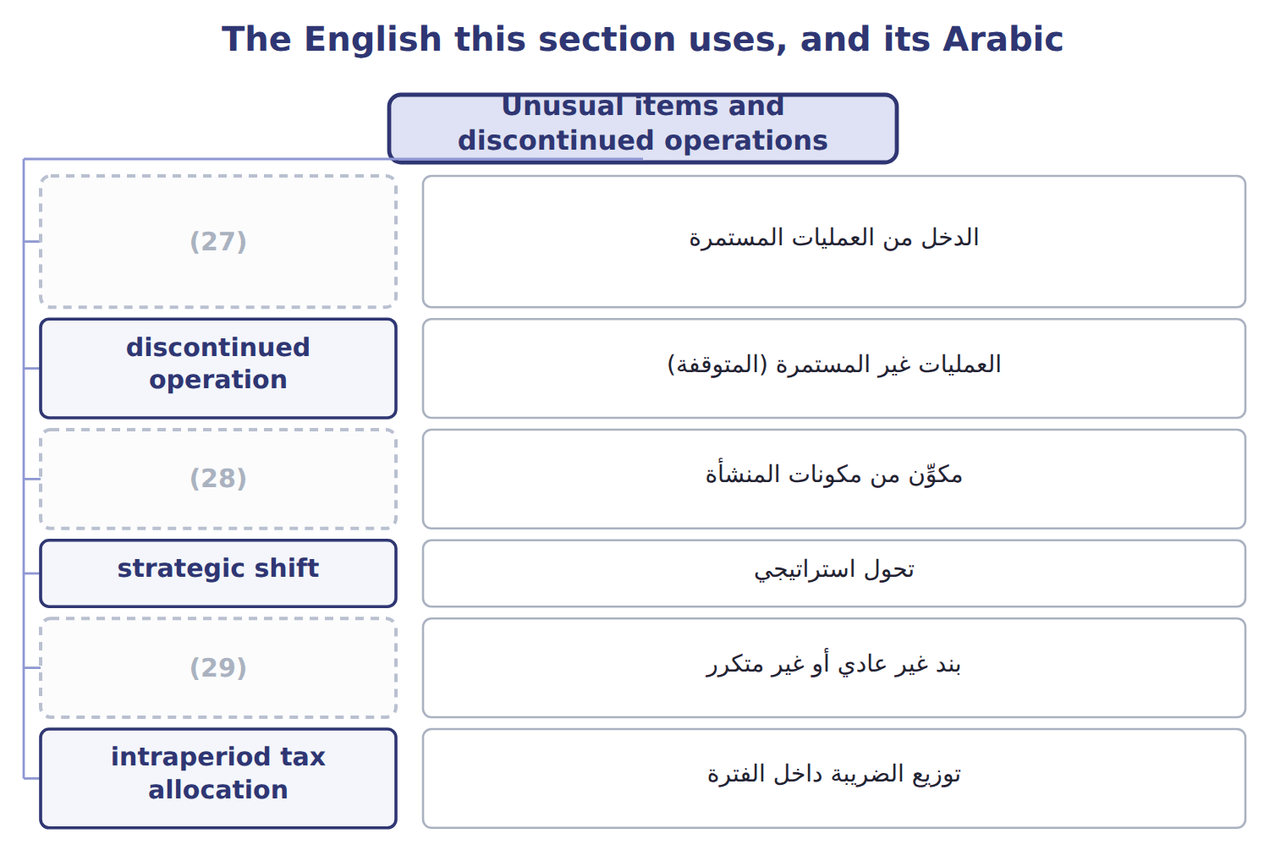
word list
income from continuing operations · component of an entity · unusual or infrequent item · other income and expense

The English this sheet uses, and its Arabic
English (exam term) | Arabic
income from continuing operations | الدخل من العمليات المستمرة
discontinued operation | العمليات غير المستمرة (المتوقفة)
component of an entity | مكوِّن من مكونات المنشأة
strategic shift | تحول استراتيجي
unusual or infrequent item | بند غير عادي أو غير متكرر
intraperiod tax allocation | توزيع الضريبة داخل الفترة

Answer key · 3.3 Unusual items and discontinued operations

1 attention | 16 during
2 happen | 17 further
3 longer | 18 reduces
4 removed | 19 reports
5 within | 20 Loss on disposal of the business
6 component | 21 textbooks
7 classified | 22 expropriations
8 effect | 23 today's
9 Examples | 24 pre-tax
10 Closing | 25 prohibits
11 stopping | 26 frameworks
12 including | 27 income from continuing operations
13 questions | 28 component of an entity
14 activities | 29 unusual or infrequent item
15 beverages

the summaries in full
Summary 1 Some items need special attention because they may not happen again. U.S. GAAP no longer has extraordinary items; the FASB removed them in 2015. An unusual or infrequent item, such as a large fire loss, is shown as a separate line within continuing operations, before tax. It is never shown net of tax. A discontinued operation is a component of an entity that the company has sold, has classified as held for sale, or has abandoned. The disposal must also be a strategic shift with a major effect on the company. Examples are leaving a major line of business or a major geographic area. Closing one store or stopping one small product does not qualify. The results of a discontinued operation, including any gain or loss on disposal, appear below income from continuing operations, net of their own tax. This is called intraperiod tax allocation.
Summary 2 Ask the questions in order: OCI first, then discontinued operations, then unusual items, and finally main activities or other income and expense. Suppose that in 2026 Orontes sells its frozen-foods business to focus on beverages and dry foods. This is a strategic shift. The business lost $420,000 before tax during the year, and the sale caused a further loss of $180,000. Each loss reduces tax, so Orontes reports a loss from discontinued operations of $450,000, net of tax.
Summary 3 Older textbooks show earthquakes and expropriations as extraordinary items, net of tax, below continuing operations. On today's exam, such an item is unusual or infrequent: a separate pre-tax line in continuing operations. Only discontinued operations are shown net of tax below continuing operations. IFRS 5 uses a similar idea: a separate major line of business or geographic area. IFRS also prohibits extraordinary items, so the two frameworks now give very similar results in this area.

3.4 Comprehensive income
Chapter 3 · section 3.4

Fill every gap. Each word list holds one word more than there are gaps.
Summary 1 gaps 1–12
Some changes in value do not go (1) net income. U.S. GAAP sends them to other comprehensive income (OCI) until they are realized. Comprehensive income is net income plus OCI for the (2) . Orontes's (3) debt securities lost $1,500 in fair value in 2025. After tax, the loss in OCI is $1,125, so comprehensive income is $2,969,100 − $1,125 = $2,967,975. Companies show this in one (4) statement, as Orontes does, or in two (5) statements. (6) OCI only in the statement of changes in equity is not (7) . OCI (8) a balance in equity called (9) other comprehensive income (AOCI). When an item is realized, for example when Orontes sells an AFS (10) , the gain or loss moves from AOCI into net income. This (11) adjustment stops the same gain being (12) twice.
word list
balance · allowed · through · counted · Showing · accumulated · security · continuous · builds · consecutive · period · reclassification · available-for-sale

Main OCI items: U.S. GAAP and IFRS
The two sides differ only where the rows say.
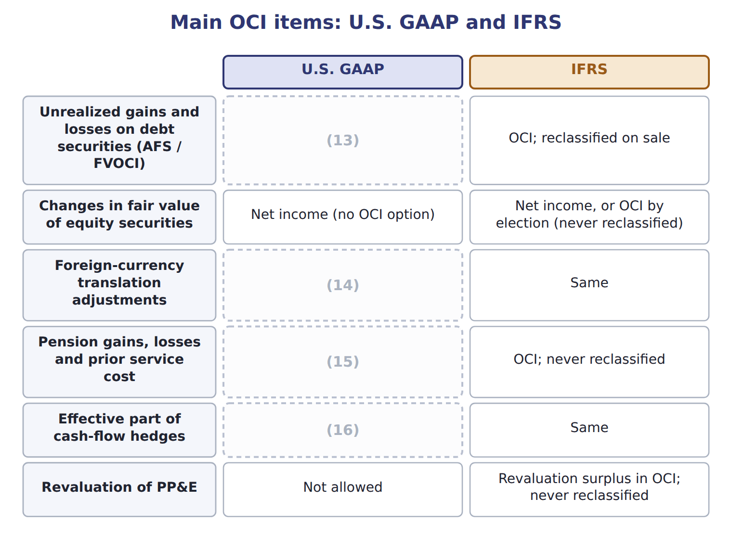
word list
OCI; reclassified when the hedged item affects income · Revaluation surplus in OCI; never reclassified · OCI; reclassified when the foreign operation is sold · OCI; amortized into net income later · OCI; reclassified to net income on sale

Summary 2 gaps 17–19
Under IFRS, a revaluation surplus on PP&E, fair value changes on equity (17) elected to OCI, and pension (18) stay in OCI forever. U.S. GAAP does not allow PP&E revaluation, and it (19) its OCI items to net income later.
word list
Orontes's · reclassifies · investments · remeasurements

Comprehensive income traps

Summary 3 gaps 20–22
Comprehensive income adds this (20) OCI, not the AOCI balance. (21) gains on equity securities go to net income, not OCI. Use OCI after tax, unless the (22) shows the tax on a separate line.
word list
Unrealized · year's · through · question

The English this section uses, and its Arabic
Each term sits against what it means.
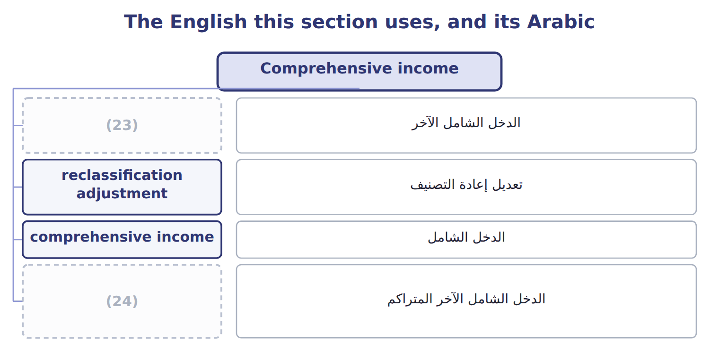
word list
الدخل الشامل الآخر المتراكم · other comprehensive income (OCI) · accumulated other comprehensive income (AOCI)

The English this sheet uses, and its Arabic
English (exam term) | Arabic
other comprehensive income (OCI) | الدخل الشامل الآخر
reclassification adjustment | تعديل إعادة التصنيف
comprehensive income | الدخل الشامل
accumulated other comprehensive income (AOCI) | الدخل الشامل الآخر المتراكم

Answer key · 3.4 Comprehensive income

1 through | 13 OCI; reclassified to net income on sale
2 period | 14 OCI; reclassified when the foreign operation is sold
3 available-for-sale | 15 OCI; amortized into net income later
4 continuous | 16 OCI; reclassified when the hedged item affects income
5 consecutive | 17 investments
6 Showing | 18 remeasurements
7 allowed | 19 reclassifies
8 builds | 20 year's
9 accumulated | 21 Unrealized
10 security | 22 question
11 reclassification | 23 other comprehensive income (OCI)
12 counted | 24 accumulated other comprehensive income (AOCI)

the summaries in full
Summary 1 Some changes in value do not go through net income. U.S. GAAP sends them to other comprehensive income (OCI) until they are realized. Comprehensive income is net income plus OCI for the period. Orontes's available-for-sale debt securities lost $1,500 in fair value in 2025. After tax, the loss in OCI is $1,125, so comprehensive income is $2,969,100 − $1,125 = $2,967,975. Companies show this in one continuous statement, as Orontes does, or in two consecutive statements. Showing OCI only in the statement of changes in equity is not allowed. OCI builds a balance in equity called accumulated other comprehensive income (AOCI). When an item is realized, for example when Orontes sells an AFS security, the gain or loss moves from AOCI into net income. This reclassification adjustment stops the same gain being counted twice.
Summary 2 Under IFRS, a revaluation surplus on PP&E, fair value changes on equity investments elected to OCI, and pension remeasurements stay in OCI forever. U.S. GAAP does not allow PP&E revaluation, and it reclassifies its OCI items to net income later.
Summary 3 Comprehensive income adds this year's OCI, not the AOCI balance. Unrealized gains on equity securities go to net income, not OCI. Use OCI after tax, unless the question shows the tax on a separate line.

3.5 Limitations and links to the other statements
Chapter 3 · section 3.5

Fill every gap. Each word list holds one word more than there are gaps.
Summary 1 gaps 1–12
Net income depends on many (1) : useful lives, credit losses, (2) tests and warranty costs. Different companies also choose different (3) , such as FIFO or LIFO for inventory. Two similar companies can (4) report different profits from the same (5) . The income statement also (6) things out. An (7) in the value of (8) land, or of a brand it built itself, is not reported. Managers can influence results by timing sales or (9) costs, such as research or (10) , near the year-end. Most (11) , net income is not cash. Accrual (12) records revenue when it is earned and expenses when they are incurred. Depreciation and impairments of $4,824,000 reduced income but used no cash in 2025. Net income then moves to the statement of changes in equity, where it increases retained earnings. In the statement of cash flows, the indirect method starts from net income.
word list
activity · increase · results · impairment · discretionary · accounting · leaves · estimates · Orontes's · therefore · importantly · methods · advertising

Summary 2 gaps 13–16
ASU 2024-03 (DISE) (13) public companies to break down some expense captions in the notes, such as employee pay and depreciation. The face of the statement does not (14) . IFRS 18 replaces IAS 1 and adds required (15) , including operating profit. Both apply from 2027 and are not (16) before about January 2028.
word list
change · earnings · requires · subtotals · testable

Item / memo (USD 000) — Amount / details
Item / memo (USD 000) | Amount / details
Net sales | 3,400
Cost of goods sold | 2,040
Wages expense | 560
Depreciation expense | 300
Fire loss (uninsured inventory) | 70
Lawsuit settlement | 50
Interest expense | 80
Gain on sale of equipment | 20
M1 | In August 2026 Barada sold its (17) division to focus only on wholesale food. The division was one of Barada's two lines of busin
M2 | In 2026 the division had an operating loss of 60 before tax. Barada lost 40 before tax on the sale.
M3 | The fire loss is the uninsured inventory destroyed on February 10, 2026. Fires are unusual for Barada.
M4 | The income tax rate is 25% on all items. Barada has no other (18) .

word list
catering-supply · comprehensive income · operating

Item — Answer
Item | Answer
Operating income | (19)
Net income | (20)
Gross profit percentage | 1,240 ÷ 3,100 = 40%

word list
420 − 90 = 330, the same as in Chapter 1 · Loss on sale of the division · 1,240 − 520 − 300 = 420

Item — Category
Item | Category
Fire loss | Operating expenses
Lawsuit settlement | (21)
Interest expense | (22)
Gain on sale of equipment | Other income and expense
Loss on sale of the division | (23)

word list
Operating expenses · Discontinued operations · Other income and expense · intraperiod tax allocation

Answer key · 3.5 Limitations and links to the other statements

1 estimates | 13 requires
2 impairment | 14 change
3 methods | 15 subtotals
4 therefore | 16 testable
5 activity | 17 catering-supply
6 leaves | 18 comprehensive income
7 increase | 19 1,240 − 520 − 300 = 420
8 Orontes's | 20 420 − 90 = 330, the same as in Chapter 1
9 discretionary | 21 Operating expenses
10 advertising | 22 Other income and expense
11 importantly | 23 Discontinued operations
12 accounting

the summaries in full
Summary 1 Net income depends on many estimates: useful lives, credit losses, impairment tests and warranty costs. Different companies also choose different methods, such as FIFO or LIFO for inventory. Two similar companies can therefore report different profits from the same activity. The income statement also leaves things out. An increase in the value of Orontes's land, or of a brand it built itself, is not reported. Managers can influence results by timing sales or discretionary costs, such as research or advertising, near the year-end. Most importantly, net income is not cash. Accrual accounting records revenue when it is earned and expenses when they are incurred. Depreciation and impairments of $4,824,000 reduced income but used no cash in 2025. Net income then moves to the statement of changes in equity, where it increases retained earnings. In the statement of cash flows, the indirect method starts from net income.
Summary 2 ASU 2024-03 (DISE) requires public companies to break down some expense captions in the notes, such as employee pay and depreciation. The face of the statement does not change. IFRS 18 replaces IAS 1 and adds required subtotals, including operating profit. Both apply from 2027 and are not testable before about January 2028.

4.1 Components of equity and the statement of changes in equity
Chapter 4 · section 4.1

Fill every gap. Each word list holds one word more than there are gaps.
Chapter 4, section by section
Each stage leads to the next.
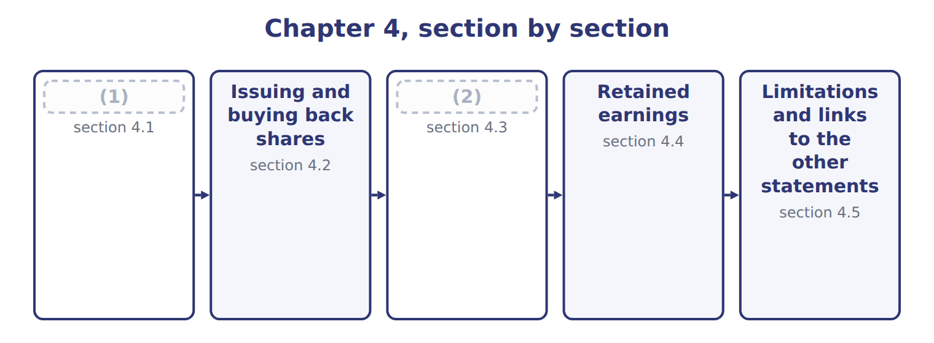
word list
Limitations and links to the other statements · Dividends, stock dividends and stock splits · Components of equity and the statement of chan

Summary 1 gaps 3–13
The (3) of changes in equity (4) why each part of equity changed during the period. It (5) two kinds of change. (6) with owners, such as issuing shares and paying dividends, are one kind. (7) income, which the company earns, is the other. Equity has two main parts. (8) capital is what owners have paid: common stock and preferred stock at par or stated value, plus additional paid-in capital. (9) capital is retained earnings and AOCI. (10) stock is deducted from the total. A (11) interest, if any, is shown separately within equity. On (12) 2 Orontes issued 100,000 shares for $1,500,000: $100,000 to common stock at par and $1,400,000 to APIC. Net income (13) retained earnings, dividends reduced them, and the OCI loss went to AOCI.
word list
statement · separates · Comprehensive · Transactions · noncontrolling · Treasury · Earned · increased · Contributed · explains · January · interest

Orontes Foods Inc. — statement of changes in equity, 2025
Every item belongs to exactly one group.
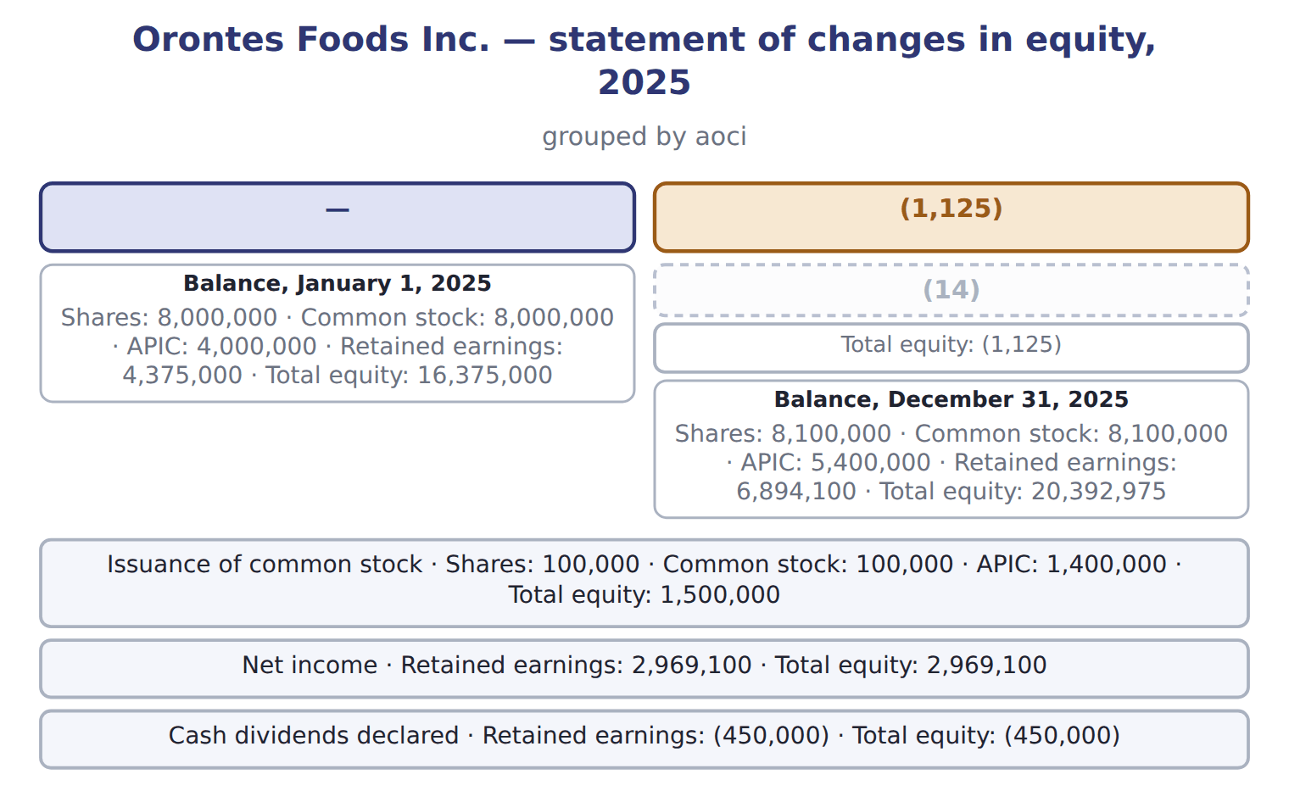
word list
appropriated retained earnings · Other comprehensive income

Summary 2 gaps 15–16
Each column is one equity (15) , and each row is one type of change. The last row equals the equity section of the (16) sheet. Total equity rose by $4,017,975.
word list
Orontes · balance · account

The English this section uses, and its Arabic
Each term sits against what it means.
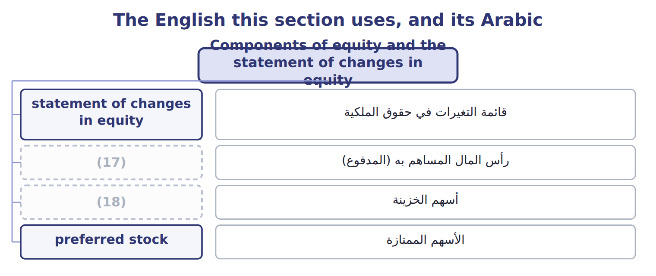
word list
contributed capital · treasury stock · outstanding shares

The English this sheet uses, and its Arabic
English (exam term) | Arabic
contributed capital | رأس المال المساهم به (المدفوع)
preferred stock | الأسهم الممتازة

Answer key · 4.1 Components of equity and the statement of changes in equity

1 Components of equity and the statement of chan | 10 Treasury
2 Dividends, stock dividends and stock splits | 11 noncontrolling
3 statement | 12 January
4 explains | 13 increased
5 separates | 14 Other comprehensive income
6 Transactions | 15 account
7 Comprehensive | 16 balance
8 Contributed | 17 contributed capital
9 Earned | 18 treasury stock

the summaries in full
Summary 1 The statement of changes in equity explains why each part of equity changed during the period. It separates two kinds of change. Transactions with owners, such as issuing shares and paying dividends, are one kind. Comprehensive income, which the company earns, is the other. Equity has two main parts. Contributed capital is what owners have paid: common stock and preferred stock at par or stated value, plus additional paid-in capital. Earned capital is retained earnings and AOCI. Treasury stock is deducted from the total. A noncontrolling interest, if any, is shown separately within equity. On January 2 Orontes issued 100,000 shares for $1,500,000: $100,000 to common stock at par and $1,400,000 to APIC. Net income increased retained earnings, dividends reduced them, and the OCI loss went to AOCI.
Summary 2 Each column is one equity account, and each row is one type of change. The last row equals the equity section of the balance sheet. Total equity rose by $4,017,975.

4.2 Issuing and buying back shares
Chapter 4 · section 4.2

Fill every gap. Each word list holds one word more than there are gaps.
Summary 1 gaps 1–12
When a company (1) shares for cash, it (2) common stock with the par value and APIC with the rest. If the shares have no par and no (3) value, the whole (4) goes to common stock. Direct costs of issuing shares, such as (5) fees, reduce APIC; they are not (6) . Shares issued for a (7) asset, such as land, are recorded at the fair value of the shares or of the asset, (8) is more reliable. (9) stock is recorded in the same way, in its own account. A company may buy back its own shares and hold them as treasury stock. Under the cost method, treasury stock is recorded at the price paid and (10) from equity. Shares held as treasury stock are issued shares but not (11) shares: they receive no (12) and have no votes. A company never records a gain or loss on its own shares in net income.
word list
Preferred · December · amount · stated · deducted · outstanding · credits · whichever · underwriting · issues · dividends · noncash · expenses

Worked example: treasury stock under the cost method

Summary 2 gaps 13–18
Suppose Orontes buys back 50,000 shares at $16 in 2026. Treasury stock is (13) at cost: $800,000. It reissues 20,000 shares at $18. Cash is $360,000 and the cost (14) is $320,000, so APIC–treasury stock is (15) with $40,000. It reissues 20,000 more at $13. The (16) below cost is $60,000. APIC–treasury stock absorbs $40,000, and retained earnings absorb the (17) $20,000. No gain or loss (18) in net income.
word list
remaining · credited · shortfall · removed · receive · debited · appears

Suppose: Orontes's treasury stock entries in 2026 (cost method)
Suppose: Orontes, 2026 (whole USD) | Account | Debit | Credit
1. Buy back 50,000 shares at $16 | Treasury stock | 800,000
 | Cash |  | 800,000
2. Reissue 20,000 shares at $18 | Cash | 360,000
 | Treasury stock |  | 320,000
 | APIC–treasury stock |  | 40,000
3. Reissue 20,000 shares at $13 | Cash | 260,000
 | APIC–treasury stock | 40,000
 | Retained earnings | 20,000
 | Treasury stock |  | 320,000

Summary 3 gaps 19–29
If the company (19) its treasury stock (20) , it removes their par value from common stock and the related APIC. Any excess of cost over these (21) reduces retained earnings, or is split (22) APIC and retained earnings. ASU 2025-12 allows companies to charge the whole excess on a (23) to APIC, as long as APIC does not become (24) . It applies to annual periods (25) after December 15, 2026, so it is not (26) before about January 2028. Use the (27) rules on the exam. IFRS also (28) treasury shares from equity and never shows a gain or loss in (29) . It does not prescribe a cost or par-value method, so IFRS companies show the effect in reserves in different ways.
word list
testable · retirement · earnings · between · instead · beginning · current · amounts · profit · deducts · retires · negative

The English this section uses, and its Arabic
Each term sits against what it means.
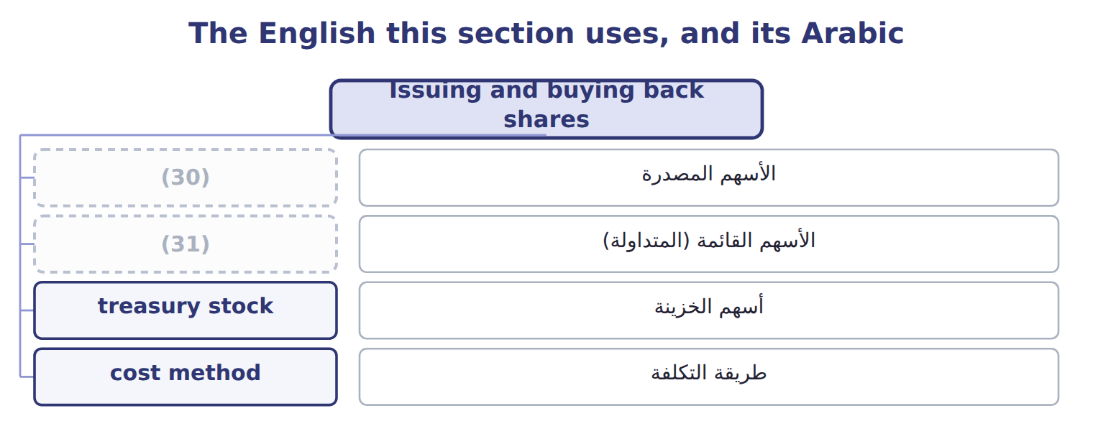
word list
treasury stock · outstanding shares · issued shares

The English this sheet uses, and its Arabic
English (exam term) | Arabic
issued shares | الأسهم المصدرة
outstanding shares | الأسهم القائمة (المتداولة)
treasury stock | أسهم الخزينة
cost method | طريقة التكلفة

Answer key · 4.2 Issuing and buying back shares

1 issues | 17 remaining
2 credits | 18 appears
3 stated | 19 retires
4 amount | 20 instead
5 underwriting | 21 amounts
6 expenses | 22 between
7 noncash | 23 retirement
8 whichever | 24 negative
9 Preferred | 25 beginning
10 deducted | 26 testable
11 outstanding | 27 current
12 dividends | 28 deducts
13 debited | 29 profit
14 removed | 30 issued shares
15 credited | 31 outstanding shares
16 shortfall

the summaries in full
Summary 1 When a company issues shares for cash, it credits common stock with the par value and APIC with the rest. If the shares have no par and no stated value, the whole amount goes to common stock. Direct costs of issuing shares, such as underwriting fees, reduce APIC; they are not expenses. Shares issued for a noncash asset, such as land, are recorded at the fair value of the shares or of the asset, whichever is more reliable. Preferred stock is recorded in the same way, in its own account. A company may buy back its own shares and hold them as treasury stock. Under the cost method, treasury stock is recorded at the price paid and deducted from equity. Shares held as treasury stock are issued shares but not outstanding shares: they receive no dividends and have no votes. A company never records a gain or loss on its own shares in net income.
Summary 2 Suppose Orontes buys back 50,000 shares at $16 in 2026. Treasury stock is debited at cost: $800,000. It reissues 20,000 shares at $18. Cash is $360,000 and the cost removed is $320,000, so APIC–treasury stock is credited with $40,000. It reissues 20,000 more at $13. The shortfall below cost is $60,000. APIC–treasury stock absorbs $40,000, and retained earnings absorb the remaining $20,000. No gain or loss appears in net income.
Summary 3 If the company retires its treasury stock instead, it removes their par value from common stock and the related APIC. Any excess of cost over these amounts reduces retained earnings, or is split between APIC and retained earnings. ASU 2025-12 allows companies to charge the whole excess on a retirement to APIC, as long as APIC does not become negative. It applies to annual periods beginning after December 15, 2026, so it is not testable before about January 2028. Use the current rules on the exam. IFRS also deducts treasury shares from equity and never shows a gain or loss in profit. It does not prescribe a cost or par-value method, so IFRS companies show the effect in reserves in different ways.

4.3 Dividends, stock dividends and stock splits
Chapter 4 · section 4.3

Fill every gap. Each word list holds one word more than there are gaps.
Summary 1 gaps 1–10
A cash dividend has three dates. On the (1) date the company debits retained earnings and credits (2) payable, a current liability. On the date of (3) no entry is made; it only (4) who is paid. On the (5) date the liability is paid. Orontes (6) $400,000 in (7) 2025, so that amount is still payable at year-end. A (8) dividend is paid with a (9) asset. The company first (10) the asset to fair value and records any gain or loss, then debits retained earnings at fair value. A scrip dividend creates a note payable. A liquidating dividend returns contributed capital, so it reduces APIC rather than retained earnings.
word list
declaration · decides · property · noncash · payment · record · returns · remeasures · declared · December · dividends

Types of dividends and their effects
Every item belongs to exactly one group.
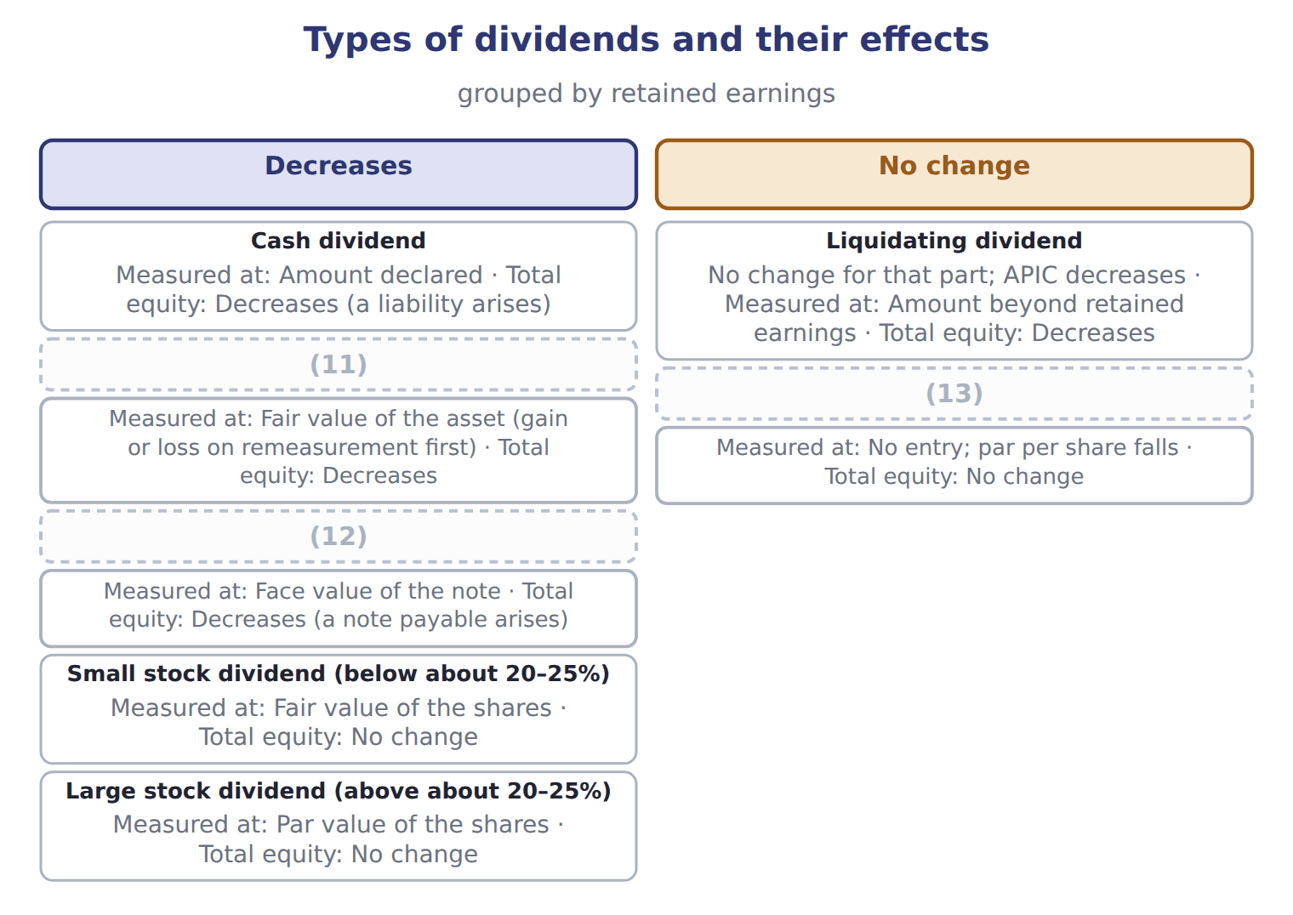
word list
Property dividend · Stock split · Scrip dividend · cost method

Summary 2 gaps 14–20
A stock dividend gives (14) more shares (15) of cash. For a small stock dividend, below about 20% to 25% of the outstanding shares, the company moves the fair value of the new shares from retained earnings to (16) stock and APIC. For a large stock dividend, it moves only the par value. A stock split (17) the number of shares and reduces the par value per share in (18) . Total equity never (19) : only the labels (20) equity move.
word list
inside · instead · payable · increases · proportion · changes · shareholders · common

Suppose: small and large stock dividends and a stock split for Orontes
Every item belongs to exactly one group.
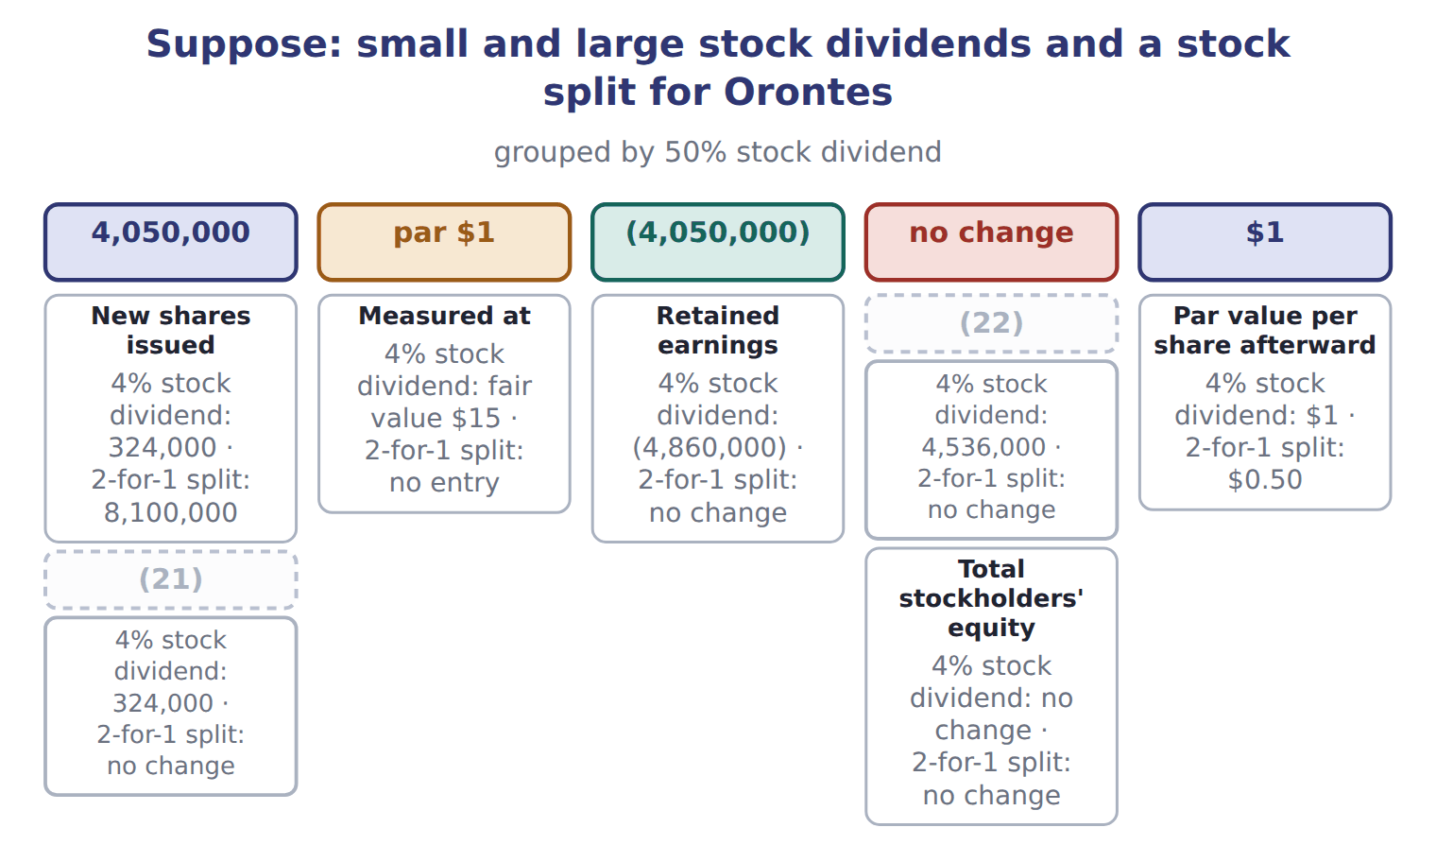
word list
Retained earnings · Additional paid-in capital · Common stock

Effects on retained earnings and total equity

The first two are done. Complete the effects of the other four.

Effects on retained earnings and total equity (complete the blanks)
Every item belongs to exactly one group.
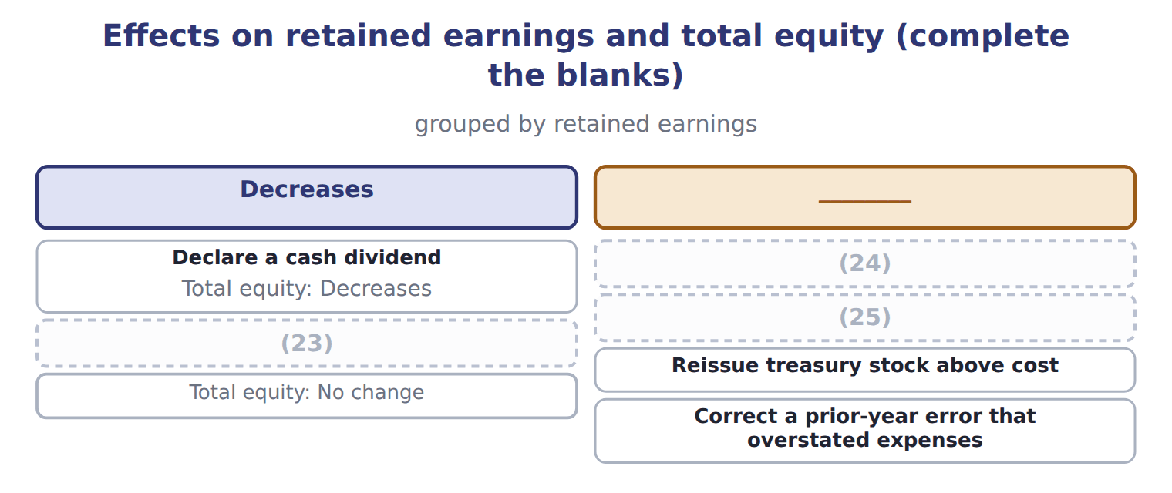
word list
date of record · Declare and issue a small stock dividend · Carry out a 2-for-1 stock split · Buy treasury stock

Stock dividend traps

Summary 3 gaps 26–28
Small stock dividend at fair value; large stock dividend at par. Do not (26) them. Use outstanding shares, not issued shares: (27) stock gets no dividend. A stock dividend (28) is equity, not a liability.
word list
reverse · earnings · distributable · treasury

The English this section uses, and its Arabic
Each term sits against what it means.
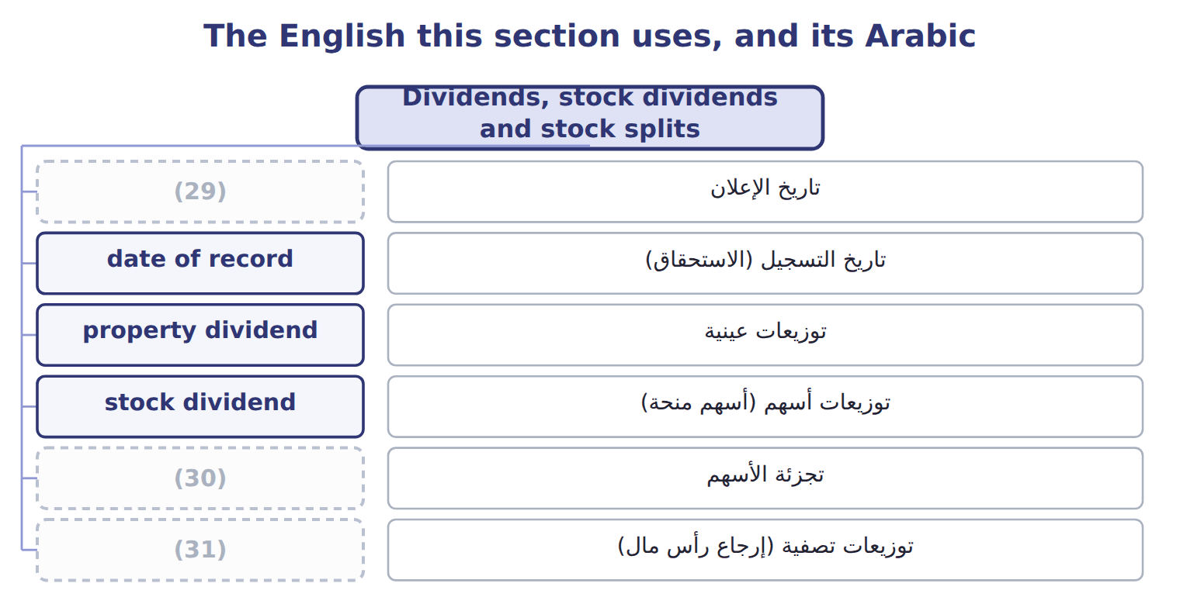
word list
prior-period adjustment · stock split · liquidating dividend · declaration date

The English this sheet uses, and its Arabic
English (exam term) | Arabic
declaration date | تاريخ الإعلان
date of record | تاريخ التسجيل (الاستحقاق)
property dividend | توزيعات عينية
stock dividend | توزيعات أسهم (أسهم منحة)
stock split | تجزئة الأسهم
liquidating dividend | توزيعات تصفية (إرجاع رأس مال)

Answer key · 4.3 Dividends, stock dividends and stock splits

1 declaration | 17 increases
2 dividends | 18 proportion
3 record | 19 changes
4 decides | 20 inside
5 payment | 21 Common stock
6 declared | 22 Additional paid-in capital
7 December | 23 Declare and issue a small stock dividend
8 property | 24 Carry out a 2-for-1 stock split
9 noncash | 25 Buy treasury stock
10 remeasures | 26 reverse
11 Property dividend | 27 treasury
12 Scrip dividend | 28 distributable
13 Stock split | 29 declaration date
14 shareholders | 30 stock split
15 instead | 31 liquidating dividend
16 common

the summaries in full
Summary 1 A cash dividend has three dates. On the declaration date the company debits retained earnings and credits dividends payable, a current liability. On the date of record no entry is made; it only decides who is paid. On the payment date the liability is paid. Orontes declared $400,000 in December 2025, so that amount is still payable at year-end. A property dividend is paid with a noncash asset. The company first remeasures the asset to fair value and records any gain or loss, then debits retained earnings at fair value. A scrip dividend creates a note payable. A liquidating dividend returns contributed capital, so it reduces APIC rather than retained earnings.
Summary 2 A stock dividend gives shareholders more shares instead of cash. For a small stock dividend, below about 20% to 25% of the outstanding shares, the company moves the fair value of the new shares from retained earnings to common stock and APIC. For a large stock dividend, it moves only the par value. A stock split increases the number of shares and reduces the par value per share in proportion. Total equity never changes: only the labels inside equity move.
Summary 3 Small stock dividend at fair value; large stock dividend at par. Do not reverse them. Use outstanding shares, not issued shares: treasury stock gets no dividend. A stock dividend distributable is equity, not a liability.

4.4 Retained earnings
Chapter 4 · section 4.4

Fill every gap. Each word list holds one word more than there are gaps.
Summary 1 gaps 1–10
Retained earnings are the (1) a company has kept since it began, less the (2) it has declared. A board may set part of retained earnings aside, for example for a new plant. These appropriated retained earnings stay (3) equity; no costs are ever (4) to them. If a company finds an error in earlier financial (5) , it does not (6) it through this year's net income. It makes a (7) adjustment: it (8) the earlier years and adjusts the opening balance of retained earnings, net of tax. Retained earnings may also be (9) by law or by loan (10) . Restrictions are disclosed in the notes. They do not change the balance.
word list
profits · covenants · statements · dividends · correct · restricted · restates · charged · separate · within · prior-period

Reserves

Summary 2 gaps 11–13
In IFRS and in MENA company law, reserves can mean a legal reserve, a (11) surplus, a translation reserve or share premium. None of these is (12) retained earnings. On a U.S. exam, (13) APIC, retained earnings (appropriated or not) and AOCI.
word list
through · simply · separate · revaluation

The English this sheet uses, and its Arabic
English (exam term) | Arabic
appropriated retained earnings | أرباح مبقاة مخصصة
prior-period adjustment | تسوية سنوات سابقة

Answer key · 4.4 Retained earnings

1 profits | 8 restates
2 dividends | 9 restricted
3 within | 10 covenants
4 charged | 11 revaluation
5 statements | 12 simply
6 correct | 13 separate
7 prior-period

the summaries in full
Summary 1 Retained earnings are the profits a company has kept since it began, less the dividends it has declared. A board may set part of retained earnings aside, for example for a new plant. These appropriated retained earnings stay within equity; no costs are ever charged to them. If a company finds an error in earlier financial statements, it does not correct it through this year's net income. It makes a prior-period adjustment: it restates the earlier years and adjusts the opening balance of retained earnings, net of tax. Retained earnings may also be restricted by law or by loan covenants. Restrictions are disclosed in the notes. They do not change the balance.
Summary 2 In IFRS and in MENA company law, reserves can mean a legal reserve, a revaluation surplus, a translation reserve or share premium. None of these is simply retained earnings. On a U.S. exam, separate APIC, retained earnings (appropriated or not) and AOCI.

4.5 Limitations and links to the other statements
Chapter 4 · section 4.5

Fill every gap. Each word list holds one word more than there are gaps.
Summary 1 gaps 1–11
Total equity is a book value: assets minus (1) , as measured by the (2) rules. It is not what the company is worth. Most assets are at (3) cost, and internally built brands and (4) are not recorded. Treasury stock is shown at the price paid, not at (5) share price. Legal capital rules also differ from state to state, so equity does not show (6) how much a company may legally (7) . At the January 2025 issue price, (8) shares would be worth about 6.0 times their book value. The statement of changes in equity takes net income and OCI from the statement of (9) income, and dividends and share issues from the company's owner (10) . Its closing (11) are the equity section of the balance sheet.
word list
today's · Orontes's · recorded · exactly · liabilities · accounting · balances · know-how · distribute · historical · comprehensive · transactions

Balance / event (USD 000 unless stated) — Amount / details
Balance / event (USD 000 unless stated) | Amount / details
Common stock, $1 par (600,000 shares issued and outstanding) | 600
Additional paid-in capital | 1,900
Retained earnings | 1,280
Total stockholders' equity, January 1, 2026 | 3,780
E1 | (12) : Barada bought 80,000 of its own shares at $6 per share (cost method).
E2 | (13) : Barada reissued 20,000 treasury shares at $8 per share.
E3 | August 20: Barada reissued 10,000 treasury shares at $4 per share.
E4 | October 1: Barada declared and issued a 10% stock dividend. The market price was $7 per share.
E5 | (14) : Barada declared a cash dividend of $0.20 per outstanding share, payable in January 2027.
E6 | Net income for 2026 was 165 (the Chapter 3 case).

word list
June 10 · March 5 · cost method · December 15

Item — Answer
Item | Answer
2-for-1 stock split | Retained earnings: no change. Total equity: no change (no entry is made).
Buy treasury stock | Retained earnings: no change. Total equity: (15) by the cost.
Reissue treasury stock above cost | Retained earnings: no change (the excess goes to APIC–treasury stock). Total equity: increases by the cash received.
Correct an error that overstated expenses | Retained earnings: opening balance increases, net of tax. Total equity: increases.

word list
E6 · decreases

Account — Category
Account | Category
APIC–treasury stock | Contributed capital
Retained earnings | Earned capital
Treasury stock | (16)
Dividends payable | (17)
Common stock | (18)

word list
issued shares · Contributed capital · Current liability · Deduction from equity

The English this section uses, and its Arabic
Each term sits against what it means.
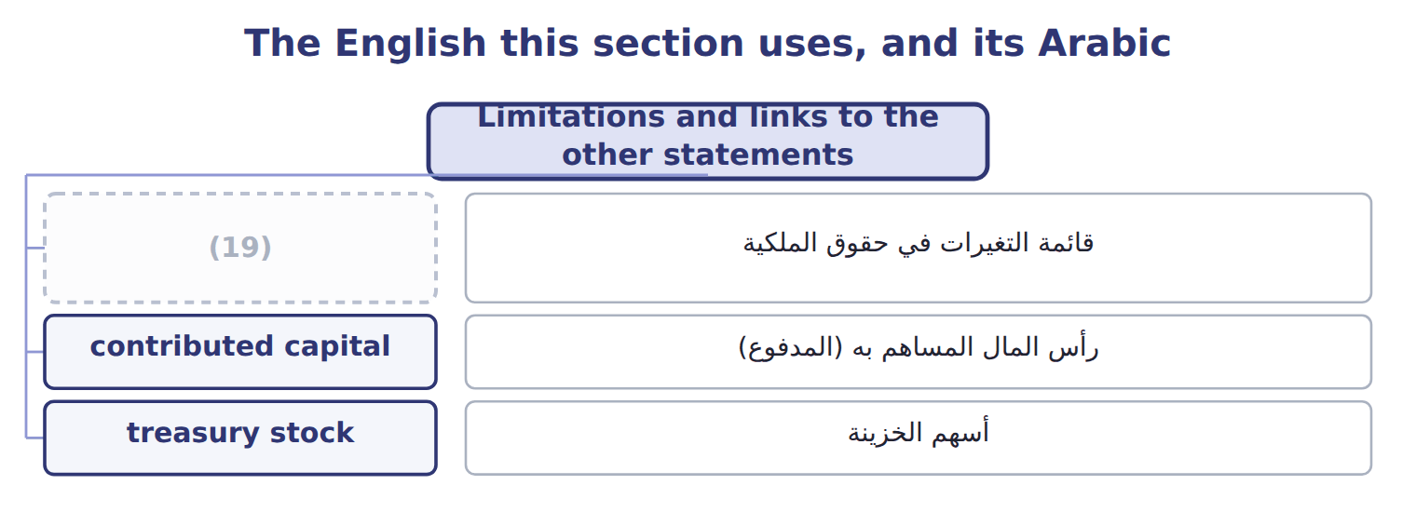
word list
قائمة التغيرات في حقوق الملكية · statement of changes in equity

Answer key · 4.5 Limitations and links to the other statements

1 liabilities | 11 balances
2 accounting | 12 March 5
3 historical | 13 June 10
4 know-how | 14 December 15
5 today's | 15 decreases
6 exactly | 16 Deduction from equity
7 distribute | 17 Current liability
8 Orontes's | 18 Contributed capital
9 comprehensive | 19 statement of changes in equity
10 transactions

the summaries in full
Summary 1 Total equity is a book value: assets minus liabilities, as measured by the accounting rules. It is not what the company is worth. Most assets are at historical cost, and internally built brands and know-how are not recorded. Treasury stock is shown at the price paid, not at today's share price. Legal capital rules also differ from state to state, so equity does not show exactly how much a company may legally distribute. At the January 2025 issue price, Orontes's shares would be worth about 6.0 times their book value. The statement of changes in equity takes net income and OCI from the statement of comprehensive income, and dividends and share issues from the company's owner transactions. Its closing balances are the equity section of the balance sheet.

5.1 Purpose and structure of the statement of cash flows
Chapter 5 · section 5.1

Fill every gap. Each word list holds one word more than there are gaps.
Chapter 5, section by section
Each stage leads to the next.
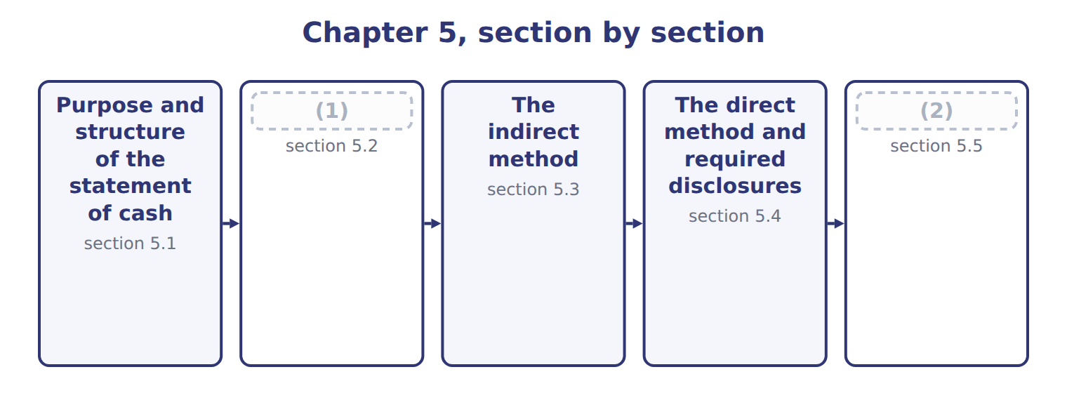
word list
statement of cash flows · Classifying cash flows · Limitations and links between the four stateme

Summary 1 gaps 3–14
The statement of cash flows reports a (3) cash receipts and cash (4) for a period. Users need it (5) profit is not cash. It helps them judge (6) the company can (7) cash, pay its debts and dividends, and fund its growth without new financing. The statement (8) the change in cash, cash equivalents and (9) cash together. Cash equivalents are (10) , highly liquid (11) with an original maturity to the holder of three months or less. (12) money between these (13) is not a cash flow. Cash flows are (14) into operating activities, investing activities and financing activities. Operating activities provided $7,531,100, investing used $4,179,000, and financing provided $1,850,000. Cash rose by $5,202,100, to the $7,302,100 shown on the balance sheet. Strong operating cash is a good sign, but a reader should also ask where the cash went. Orontes spent heavily on equipment and on its investment in Jordan Glass, and it also raised new shares and a bank loan.
word list
produce · restricted · payments · provided · grouped · company's · short-term · because · investments · Moving · explains · categories · whether

Orontes Foods Inc. — statement of cash flows (indirect method), 2025
Orontes Foods Inc., year ended December 31, 2025 | 2025
Cash flows from operating activities
Net income | 2,969,100
Adjustments to reconcile net income to net cash from operating activities:
(15) | 2,100,000
Impairment losses | 2,724,000
Equity-method income | (177,000)
Dividends from equity-method investees | 70,000
(16) | (3,000)
(17) | (4,000)
Deferred income taxes | 100,000
(18) | (384,000)
(19) | (150,000)
Increase in prepaid expenses | (24,000)
(20) | 150,000
(21) | 50,000
Increase in income taxes payable | 50,000
Increase in contract liabilities | 60,000
Net cash provided by operating activities | 7,531,100
Cash flows from investing activities
Purchases of property, plant and equipment | (3,000,000)
Proceeds from sale of equipment | 21,000
Investment in Jordan Glass Co. | (1,200,000)
Net cash used in investing activities | (4,179,000)
Cash flows from financing activities
(22) | 1,500,000
Proceeds from bank note | 800,000
Repayment of long-term debt | (400,000)
Dividends paid | (50,000)
Net cash provided by financing activities | 1,850,000
Net increase in cash | 5,202,100
Cash, January 1, 2025 | 2,100,000
Cash, December 31, 2025 | 7,302,100
(23)
(24) | 390,000
Income taxes paid | 839,700
Noncash investing and financing activities | none

word list
Increase in inventory · Depreciation · Deferred income taxes · Gain on sale of equipment · Increase in accounts receivable, net · Interest paid · Unrealized gains on securities · Increase in accounts payable · Issuance of common stock · Supplemental disclosures · Increase in accrued liabilities

The English this section uses, and its Arabic
Each term sits against what it means.
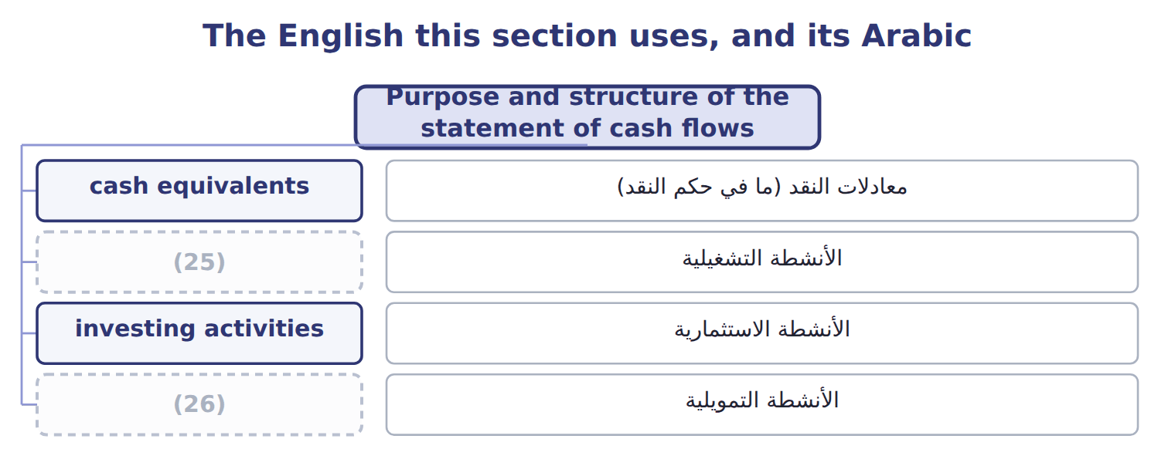
word list
financing activities · الأنشطة التشغيلية · operating activities

The English this sheet uses, and its Arabic
English (exam term) | Arabic
cash equivalents | معادلات النقد (ما في حكم النقد)
operating activities | الأنشطة التشغيلية
investing activities | الأنشطة الاستثمارية
financing activities | الأنشطة التمويلية

Answer key · 5.1 Purpose and structure of the statement of cash flows

1 Classifying cash flows | 14 grouped
2 Limitations and links between the four stateme | 15 Depreciation
3 company's | 16 Gain on sale of equipment
4 payments | 17 Unrealized gains on securities
5 because | 18 Increase in accounts receivable, net
6 whether | 19 Increase in inventory
7 produce | 20 Increase in accounts payable
8 explains | 21 Increase in accrued liabilities
9 restricted | 22 Issuance of common stock
10 short-term | 23 Supplemental disclosures
11 investments | 24 Interest paid
12 Moving | 25 operating activities
13 categories | 26 financing activities

the summaries in full
Summary 1 The statement of cash flows reports a company's cash receipts and cash payments for a period. Users need it because profit is not cash. It helps them judge whether the company can produce cash, pay its debts and dividends, and fund its growth without new financing. The statement explains the change in cash, cash equivalents and restricted cash together. Cash equivalents are short-term, highly liquid investments with an original maturity to the holder of three months or less. Moving money between these categories is not a cash flow. Cash flows are grouped into operating activities, investing activities and financing activities. Operating activities provided $7,531,100, investing used $4,179,000, and financing provided $1,850,000. Cash rose by $5,202,100, to the $7,302,100 shown on the balance sheet. Strong operating cash is a good sign, but a reader should also ask where the cash went. Orontes spent heavily on equipment and on its investment in Jordan Glass, and it also raised new shares and a bank loan.

5.2 Classifying cash flows
Chapter 5 · section 5.2

Fill every gap. Each word list holds one word more than there are gaps.
Summary 1 gaps 1–10
Operating activities are the main revenue activities: cash from (1) and cash paid to (2) and employees. (3) that is not investing or financing is also operating. Investing activities involve (4) assets and other companies' (5) : Orontes paid $3,000,000 for equipment and $1,200,000 for its Jordan Glass shares. Financing activities are with owners and (6) . They include issuing and buying back shares, (7) and repaying (8) , and paying dividends. Orontes received $1,500,000 from its share issue and $800,000 from the bank note, (9) $400,000 of debt and paid $50,000 of dividends. U.S. GAAP fixes four items that (10) often get wrong. Interest paid, interest received, dividends received and income taxes are all operating. Only dividends paid are financing.
word list
repaid · students · borrowing · lenders · securities · suppliers · long-term · disclosed · Anything · customers · principal

Classifying interest, dividends and taxes: U.S. GAAP and IFRS
Every item belongs to exactly one group.
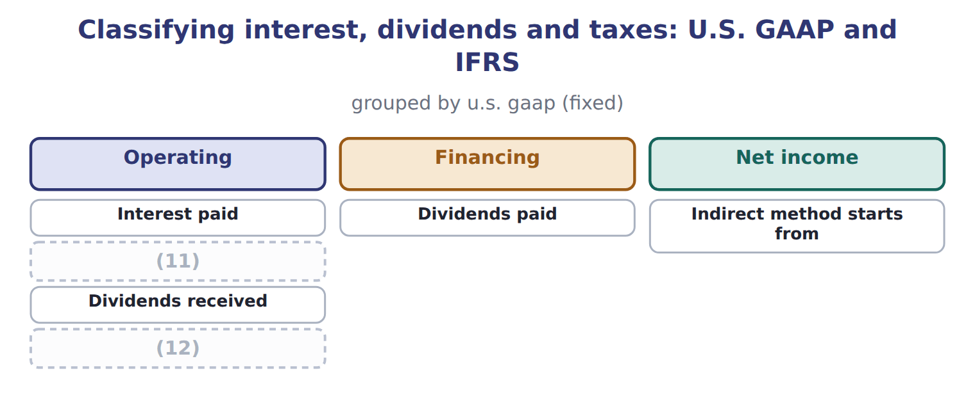
word list
Income taxes paid · Dividends received · Interest received

Summary 2 gaps 13–19
Some investing and financing (13) involve no cash at all, such as buying land by issuing shares or a note. These (14) investing and financing activities are not shown in the body of the (15) . They are disclosed (16) . Orontes had none in 2025. Under IAS 7 today, interest paid can be operating or financing, and interest and dividends received can be operating or investing. The (17) that come with IFRS 18 remove some (18) from 2027, but they are not (19) before about January 2028.
word list
choices · separately · transactions · noncash · testable · amendments · lenders · statement

Which activity?

The first two are done. Classify the other four under U.S. GAAP.

Which activity? (complete the blanks)
Every item belongs to exactly one group.
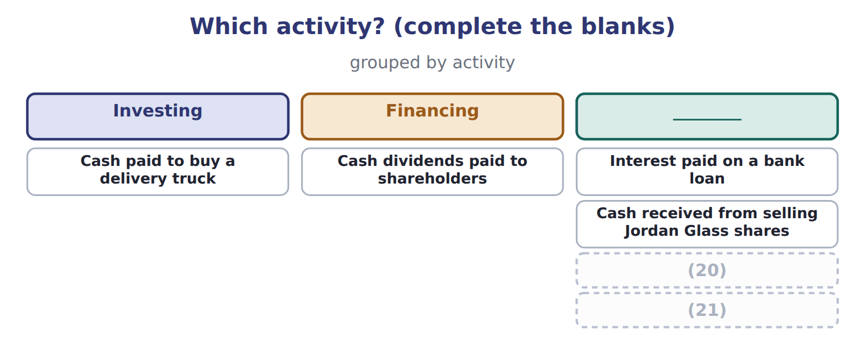
word list
Cash paid to buy back the company's own shares · Land acquired by issuing a long-term note (no cash) · Cash paid to buy a delivery truck

Classification traps

Summary 3 gaps 22–23
Interest paid is operating, not financing, under U.S. GAAP. Dividends paid are financing; dividends received are operating. A note (22) for land is not a cash flow: (23) it.
word list
suppliers · issued · disclose

The English this section uses, and its Arabic
Each term sits against what it means.
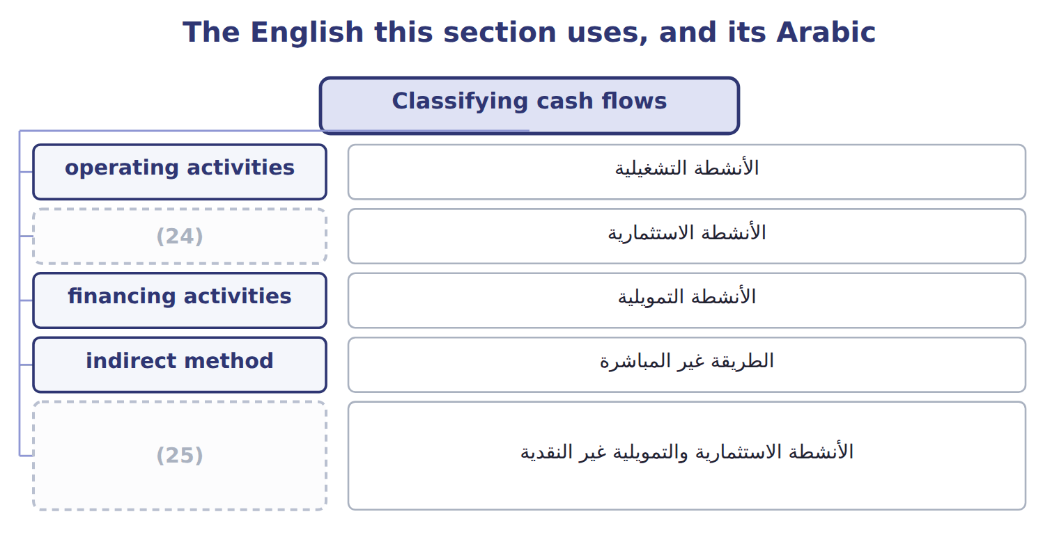
word list
cash equivalents · noncash investing and financing activities · investing activities

The English this sheet uses, and its Arabic
English (exam term) | Arabic
noncash investing and financing activities | الأنشطة الاستثمارية والتمويلية غير النقدية

Answer key · 5.2 Classifying cash flows

1 customers | 14 noncash
2 suppliers | 15 statement
3 Anything | 16 separately
4 long-term | 17 amendments
5 securities | 18 choices
6 lenders | 19 testable
7 borrowing | 20 Land acquired by issuing a long-term note (no cash)
8 principal | 21 Cash paid to buy back the company's own shares
9 repaid | 22 issued
10 students | 23 disclose
11 Interest received | 24 investing activities
12 Income taxes paid | 25 noncash investing and financing activities
13 transactions

the summaries in full
Summary 1 Operating activities are the main revenue activities: cash from customers and cash paid to suppliers and employees. Anything that is not investing or financing is also operating. Investing activities involve long-term assets and other companies' securities: Orontes paid $3,000,000 for equipment and $1,200,000 for its Jordan Glass shares. Financing activities are with owners and lenders. They include issuing and buying back shares, borrowing and repaying principal, and paying dividends. Orontes received $1,500,000 from its share issue and $800,000 from the bank note, repaid $400,000 of debt and paid $50,000 of dividends. U.S. GAAP fixes four items that students often get wrong. Interest paid, interest received, dividends received and income taxes are all operating. Only dividends paid are financing.
Summary 2 Some investing and financing transactions involve no cash at all, such as buying land by issuing shares or a note. These noncash investing and financing activities are not shown in the body of the statement. They are disclosed separately. Orontes had none in 2025. Under IAS 7 today, interest paid can be operating or financing, and interest and dividends received can be operating or investing. The amendments that come with IFRS 18 remove some choices from 2027, but they are not testable before about January 2028.
Summary 3 Interest paid is operating, not financing, under U.S. GAAP. Dividends paid are financing; dividends received are operating. A note issued for land is not a cash flow: disclose it.

5.3 The indirect method
Chapter 5 · section 5.3

Fill every gap. Each word list holds one word more than there are gaps.
Summary 1 gaps 1–2
Most U.S. companies use the (1) method for operating activities. It starts with net income and removes (2) that is not an operating cash flow.
word list
impairments · indirect · everything

Worked example: Orontes's operating cash flow

The steps, in order
Each stage leads to the next.
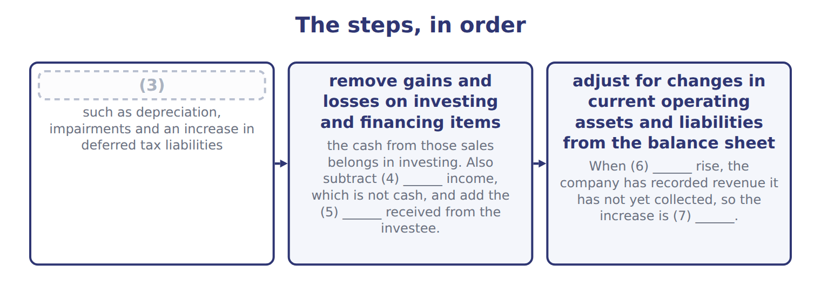
word list
dividends · operating activities · subtracted · equity-method · add back noncash expenses and losses · receivables

Summary 2 gaps 8–11
Start with net income: $2,969,100. Add depreciation, impairments and deferred taxes, which used no cash: $4,924,000. Subtract equity-method income of $177,000, add dividends from (8) of $70,000, and subtract the oven gain of $3,000 and (9) gains of $4,000. (10) changes reduce cash by a net $248,000. The total, $7,531,100, (11) net cash from operating activities.
word list
investees · include · unrealized · Working-capital · equals

Indirect-method traps

Summary 3 gaps 12–14
Start from net income, never from operating income. Dividends payable and notes payable are financing items. Do not (12) their changes in (13) capital. Show the full (14) of a sale in investing, and remove the gain from operating.
word list
working · proceeds · include · investing

The English this section uses, and its Arabic
Each term sits against what it means.
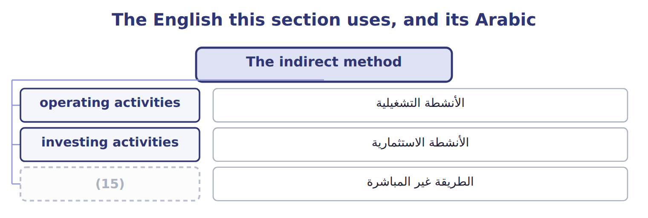
word list
operating activities · indirect method

The English this sheet uses, and its Arabic
English (exam term) | Arabic
indirect method | الطريقة غير المباشرة

Answer key · 5.3 The indirect method

1 indirect | 9 unrealized
2 everything | 10 Working-capital
3 add back noncash expenses and losses | 11 equals
4 equity-method | 12 include
5 dividends | 13 working
6 receivables | 14 proceeds
7 subtracted | 15 indirect method
8 investees

the summaries in full
Summary 1 Most U.S. companies use the indirect method for operating activities. It starts with net income and removes everything that is not an operating cash flow.
Summary 2 Start with net income: $2,969,100. Add depreciation, impairments and deferred taxes, which used no cash: $4,924,000. Subtract equity-method income of $177,000, add dividends from investees of $70,000, and subtract the oven gain of $3,000 and unrealized gains of $4,000. Working-capital changes reduce cash by a net $248,000. The total, $7,531,100, equals net cash from operating activities.
Summary 3 Start from net income, never from operating income. Dividends payable and notes payable are financing items. Do not include their changes in working capital. Show the full proceeds of a sale in investing, and remove the gain from operating.

5.4 The direct method and required disclosures
Chapter 5 · section 5.4

Fill every gap. Each word list holds one word more than there are gaps.
Summary 1 gaps 1–6
The direct method shows the main classes of operating (1) and payments, such as cash from customers and cash paid to (2) . The FASB (3) it, but few companies use it. A company that uses it must still show the (4) of net income to operating cash flow. Cash from customers is sales (5) for the change in (6) and customer deposits. Both methods give the same total, $7,531,100; only the presentation differs.
word list
receivables · reconciliation · encourages · methods · receipts · adjusted · suppliers

Orontes Foods Inc. — operating activities by the direct method, 2025
The parts add up to the total; the bars are to scale.
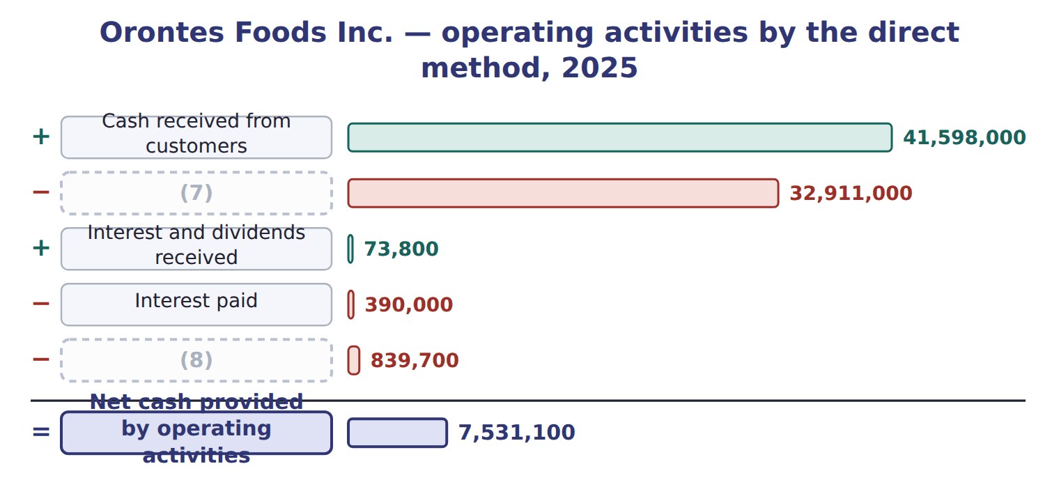
word list
Income taxes paid · Cash paid to suppliers and employees · Cash received from customers

Summary 2 gaps 9–11
A company using the (9) method must disclose interest paid and income taxes paid. (10) paid $390,000 of interest and $839,700 of income taxes. Taxes paid are the current tax expense of $889,700 less the $50,000 (11) in taxes payable.
word list
receipts · indirect · increase · Orontes

The English this section uses, and its Arabic
Each term sits against what it means.
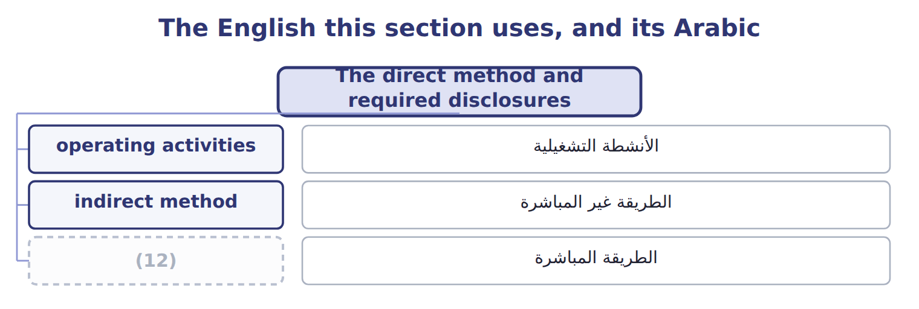
word list
direct method · الطريقة المباشرة

The English this sheet uses, and its Arabic
English (exam term) | Arabic
direct method | الطريقة المباشرة

Answer key · 5.4 The direct method and required disclosures

1 receipts | 7 Cash paid to suppliers and employees
2 suppliers | 8 Income taxes paid
3 encourages | 9 indirect
4 reconciliation | 10 Orontes
5 adjusted | 11 increase
6 receivables | 12 direct method

the summaries in full
Summary 1 The direct method shows the main classes of operating receipts and payments, such as cash from customers and cash paid to suppliers. The FASB encourages it, but few companies use it. A company that uses it must still show the reconciliation of net income to operating cash flow. Cash from customers is sales adjusted for the change in receivables and customer deposits. Both methods give the same total, $7,531,100; only the presentation differs.
Summary 2 A company using the indirect method must disclose interest paid and income taxes paid. Orontes paid $390,000 of interest and $839,700 of income taxes. Taxes paid are the current tax expense of $889,700 less the $50,000 increase in taxes payable.

5.5 Limitations and links between the four statements
Chapter 5 · section 5.5

Fill every gap. Each word list holds one word more than there are gaps.
Summary 1 gaps 1–12
Cash flows are harder to (1) than profits, but not (2) . A company can raise operating cash near year-end by delaying payments to (3) or by selling (4) . The statement also shows only one year, and it is not a (5) of profit. (6) noncash deals, such as buying a (7) with a mortgage, appear only in the notes. Some (8) are also arbitrary: interest paid is operating under U.S. GAAP but may be financing under IFRS, which makes companies harder to (9) . (10) , one year of cash flows can (11) . A company that stops investing will show (12) cash flow for a while, even if its future is weak. Net income starts the statement of cash flows and increases retained earnings. Changes in balance sheet accounts drive the working-capital adjustments. Closing cash equals the cash on the balance sheet.
word list
building · manage · mislead · measure · suppliers · classifications · impossible · strong · Finally · equivalents · receivables · Important · compare

Summary 2 gaps 13–19
The links also help you find (13) that are not given. (14) declared dividends of $450,000, but dividends payable rose by $400,000, so dividends paid were only $50,000. That is the amount in the financing section. In August 2026 the FASB proposed new (15) about the parts of cash equivalents and about some (16) assets. It is only a proposal; the (17) of cash equivalents does not (18) . ASU 2023-09 already requires income taxes paid by (19) ; know this at awareness level.
word list
Orontes · jurisdiction · amounts · digital · change · Closing · definition · disclosures

Tableau de financement

Tableau de financement
Barada Wholesale (USD 000) | Amount, or balance at Dec 31, 2025 | Balance at Dec 31, 2026
Income statement items, 2026
Net income | 165
Depreciation expense | 300
(20) | 20
Loss on sale of the catering-supply division | 40
Balances
Accounts receivable, net | 280 | 310
Inventory | 420 | 390
(21) | 24 | 26
(22) | 380 | 410
(23) | 0 | 30
Cash | 1,050 | ?
(24)
(25) | 70
Proceeds from sale of the division | 150
Purchases of equipment | 200
(26) | 300
Dividend paid (declared in 2025) | 50
(27) | 480
Treasury stock reissued (E2 and E3) | 200
Cash dividend declared December 15, 2026, payable January 2027 | 121

word list
Proceeds from sale of equipment · Proceeds from sale of the division · Income taxes payable · Gain on sale of equipment · Accounts payable · Other 2026 cash information · Prepaid rent · Treasury stock bought (Chapter 4, E1) · Note installment repaid (Chapter 2, M1)

Item — Answer
Item | Answer
Interest paid on a bank loan | (28)
Selling Jordan Glass shares | (29)
Land for a long-term note | Noncash investing and financing activity: disclosed, not in the body.
Buying back own shares | Financing: a transaction with owners.

word list
statement of cash flows · Investing: another company's securities. · Operating (U.S. GAAP gives no choice).

Cash flow — Category
Every item belongs to exactly one group.
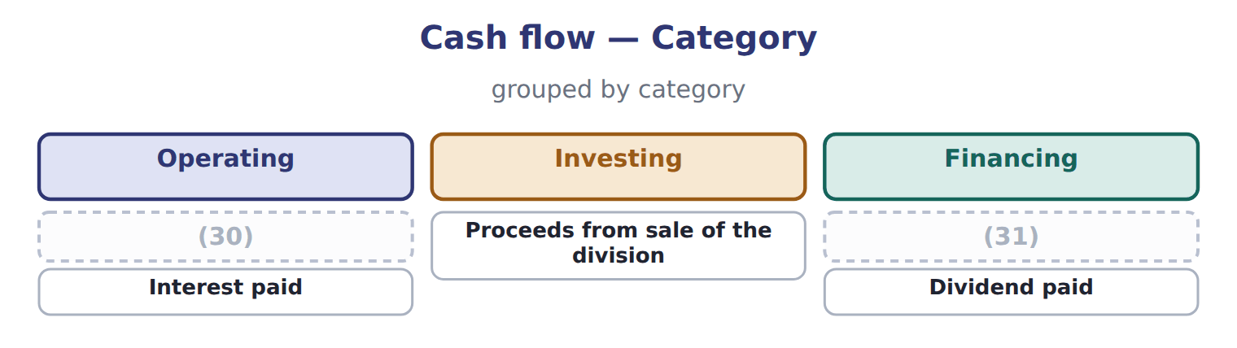
word list
Treasury stock bought · operating activities · Lawsuit settlement paid

The English this section uses, and its Arabic
Each term sits against what it means.
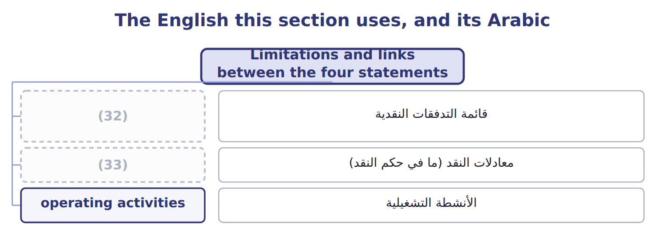
word list
financing activities · statement of cash flows · cash equivalents

Answer key · 5.5 Limitations and links between the four statements

1 manage | 18 change
2 impossible | 19 jurisdiction
3 suppliers | 20 Gain on sale of equipment
4 receivables | 21 Prepaid rent
5 measure | 22 Accounts payable
6 Important | 23 Income taxes payable
7 building | 24 Other 2026 cash information
8 classifications | 25 Proceeds from sale of equipment
9 compare | 26 Note installment repaid (Chapter 2, M1)
10 Finally | 27 Treasury stock bought (Chapter 4, E1)
11 mislead | 28 Operating (U.S. GAAP gives no choice).
12 strong | 29 Investing: another company's securities.
13 amounts | 30 Lawsuit settlement paid
14 Orontes | 31 Treasury stock bought
15 disclosures | 32 statement of cash flows
16 digital | 33 cash equivalents
17 definition

the summaries in full
Summary 1 Cash flows are harder to manage than profits, but not impossible. A company can raise operating cash near year-end by delaying payments to suppliers or by selling receivables. The statement also shows only one year, and it is not a measure of profit. Important noncash deals, such as buying a building with a mortgage, appear only in the notes. Some classifications are also arbitrary: interest paid is operating under U.S. GAAP but may be financing under IFRS, which makes companies harder to compare. Finally, one year of cash flows can mislead. A company that stops investing will show strong cash flow for a while, even if its future is weak. Net income starts the statement of cash flows and increases retained earnings. Changes in balance sheet accounts drive the working-capital adjustments. Closing cash equals the cash on the balance sheet.
Summary 2 The links also help you find amounts that are not given. Orontes declared dividends of $450,000, but dividends payable rose by $400,000, so dividends paid were only $50,000. That is the amount in the financing section. In August 2026 the FASB proposed new disclosures about the parts of cash equivalents and about some digital assets. It is only a proposal; the definition of cash equivalents does not change. ASU 2023-09 already requires income taxes paid by jurisdiction; know this at awareness level.

6.1 Recognizing and measuring receivables
Chapter 6 · section 6.1

Fill every gap. Each word list holds one word more than there are gaps.
Chapter 6, section by section
Each stage leads to the next.
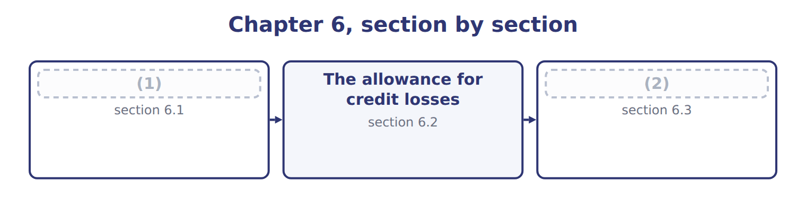
word list
The allowance for credit losses · Recognizing and measuring receivables · Transferring receivables: sale or secured borr

Summary 1 gaps 3–14
A company records an (3) receivable when its right to be paid is (4) : only the passage of time is needed before payment is due. This usually happens when it (5) the goods or services and (6) control. If the company still has to do (7) else before it can bill, for example finish a second (8) , it has a contract asset, not a receivable. The receivable is measured at the (9) price: the amount the company (10) to receive. Expected returns, (11) and cash discount amounts are variable (12) , so they reduce revenue and the receivable. Some older (13) still use the gross and net (14) . Under the gross method, the company records the full invoice and records a sales discount only when a customer pays early. Under the net method, it records the sale net of the discount, and records sales discounts forfeited when a customer pays late.
word list
transfers · unconditional · transaction · expects · delivers · something · rebates · methods · delivery · questions · account · write-off · consideration

Summary 2 gaps 15–19
Trade (15) that are due within one year are not discounted to present value. Notes receivable are (16) . An (17) note is carried at its face amount plus accrued interest. A note with no interest, or with a rate below the market rate, is (18) at its present value. The discount is then (19) to interest revenue over the life of the note.
word list
recorded · amortized · invoice · receivables · interest-bearing · different

Receivable or contract asset?

Summary 3 gaps 20–21
Receivable: only time must pass before payment. Contract asset: the company must still (20) . Expected cash discounts and returns reduce the receivable at the start, not only when they (21) .
word list
happen · transaction · perform

The English this section uses, and its Arabic
Each term sits against what it means.
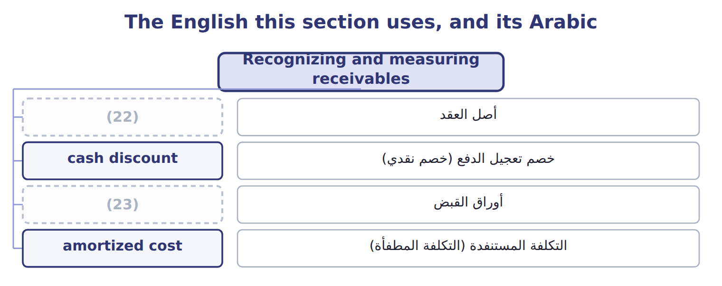
word list
notes receivable · secured borrowing · contract asset

The English this sheet uses, and its Arabic
English (exam term) | Arabic
contract asset | أصل العقد
cash discount | خصم تعجيل الدفع (خصم نقدي)
notes receivable | أوراق القبض
amortized cost | التكلفة المستنفدة (التكلفة المطفأة)

Answer key · 6.1 Recognizing and measuring receivables

1 Recognizing and measuring receivables | 13 questions
2 Transferring receivables: sale or secured borr | 14 methods
3 account | 15 receivables
4 unconditional | 16 different
5 delivers | 17 interest-bearing
6 transfers | 18 recorded
7 something | 19 amortized
8 delivery | 20 perform
9 transaction | 21 happen
10 expects | 22 contract asset
11 rebates | 23 notes receivable
12 consideration

the summaries in full
Summary 1 A company records an account receivable when its right to be paid is unconditional: only the passage of time is needed before payment is due. This usually happens when it delivers the goods or services and transfers control. If the company still has to do something else before it can bill, for example finish a second delivery, it has a contract asset, not a receivable. The receivable is measured at the transaction price: the amount the company expects to receive. Expected returns, rebates and cash discount amounts are variable consideration, so they reduce revenue and the receivable. Some older questions still use the gross and net methods. Under the gross method, the company records the full invoice and records a sales discount only when a customer pays early. Under the net method, it records the sale net of the discount, and records sales discounts forfeited when a customer pays late.
Summary 2 Trade receivables that are due within one year are not discounted to present value. Notes receivable are different. An interest-bearing note is carried at its face amount plus accrued interest. A note with no interest, or with a rate below the market rate, is recorded at its present value. The discount is then amortized to interest revenue over the life of the note.
Summary 3 Receivable: only time must pass before payment. Contract asset: the company must still perform. Expected cash discounts and returns reduce the receivable at the start, not only when they happen.

6.2 The allowance for credit losses
Chapter 6 · section 6.2

Fill every gap. Each word list holds one word more than there are gaps.
Summary 1 gaps 1–12
Under current expected credit losses (CECL), a company (1) its receivables net of an allowance that (2) all the credit losses it expects over their life. It records these expected losses from the first day. It does not wait until a loss becomes (3) . The estimate uses past (4) , current conditions and reasonable and (5) forecasts. Trade receivables are (6) at amortized cost, and the allowance is a (7) account. The balance sheet shows receivables minus the allowance: the amount the company expects to (8) . A (9) method is the aging (10) . The company (11) its receivables by how long they are past due and applies an expected loss rate to each group. The rates start from history and are (12) for current conditions and forecasts. The total is the balance the allowance must have at the end of the year.
word list
supportable · measured · covers · probable · schedule · financial · groups · adjusted · presents · contra-asset · common · experience · collect

The Amman sales office at December 31, 2025

The loss rates already include a forecast of slower payments in some Gulf markets.
Aging schedule, Orontes Amman sales office, December 31, 2025 (whole USD)
Name each point on the scale from where it sits.
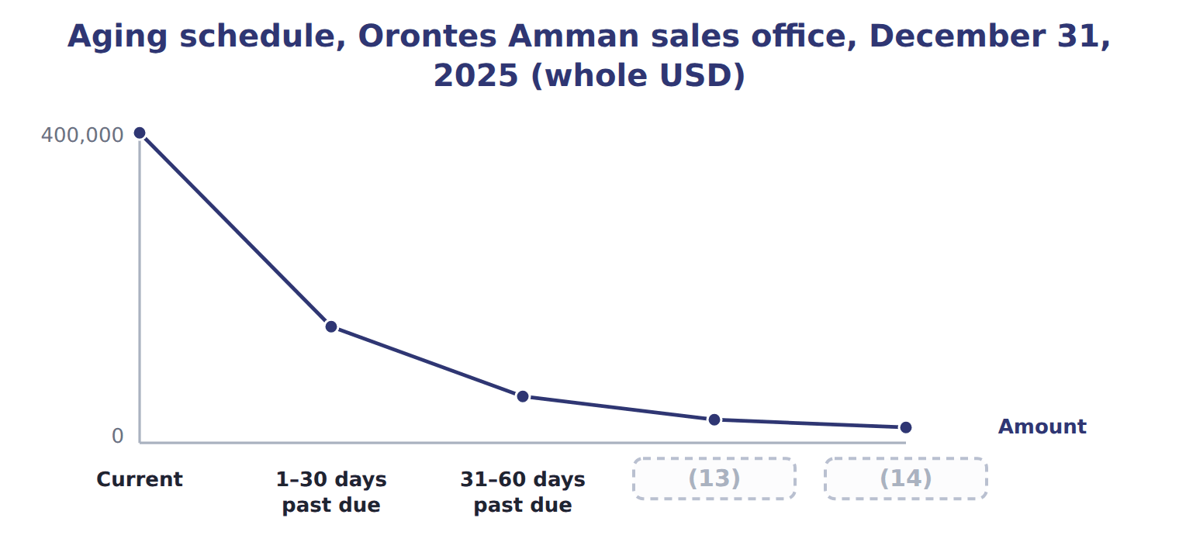
word list
allowance for credit losses · 61–90 days past due · Over 90 days past due

Summary 2 gaps 15–26
The allowance must end the year at $34,000. During the year, the allowance (15) at $30,000, Orontes wrote off $26,000 of bad receivables and (16) $2,000 that it had written off earlier. The (17) entry is: debit Credit loss expense $28,000, credit Allowance for credit losses $28,000. Net receivables on the balance sheet are $660,000 − $34,000 = $626,000. When a customer's balance is clearly (18) , the company records a write-off: debit the allowance and credit accounts receivable. The write-off (19) neither net income nor net receivables, because the expense was already recorded when the allowance was built. If the customer later pays, the company records a (20) : it first reinstates the receivable (debit accounts receivable, credit allowance) and then records the cash (21) . The direct method is used for U.S. tax (22) . It is not GAAP when bad debts are material, because it records losses late and shows receivables at a gross amount. Older (23) sometimes estimate the expense as a (24) of credit sales. This (25) approach does not measure the expected losses on the ending receivables, so under CECL the aging ( (26) ) approach is the better choice.
word list
started · changes · returns · recovery · income-statement · recovered · collection · questions · percentage · journal · write-off · uncollectible · balance-sheet

Barada Wholesale's allowance

Summary 3 gaps 27–28
The first row is done. (27) the other rows and the total, then check your total against (28) trial balance.
word list
Complete · Barada's · unadjusted

Barada Wholesale aging, December 31, 2025 (whole USD): complete the blanks
The parts add up to the total; the bars are to scale.
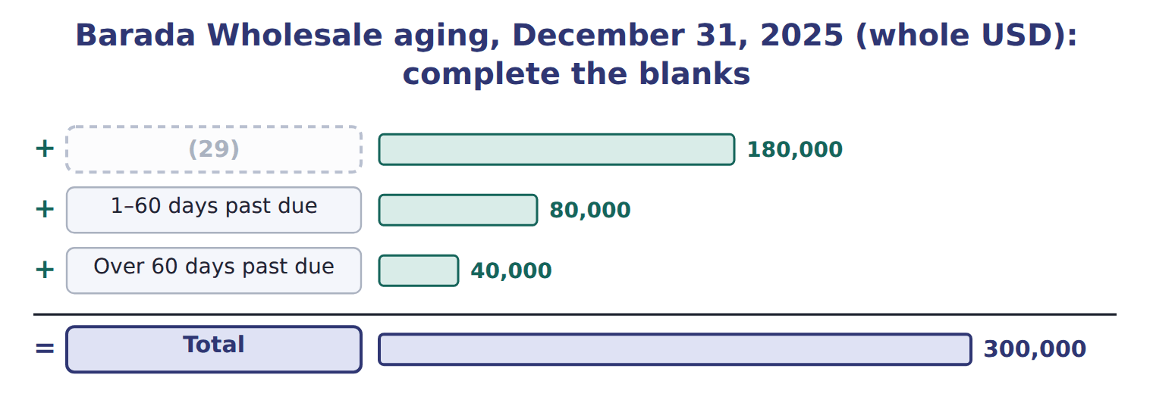
word list
factoring · Current

Summary 4 gaps 30–40
In 2025 the FASB added a (30) expedient: when (31) losses on current receivables, any company may (32) that conditions at the balance sheet date will not change. (33) companies may also use cash (34) after year-end. It applies to annual periods (35) after December 15, 2025, so under the (36) rule it is not yet tested on the CMA exam. IFRS 9 also uses expected losses. For trade receivables it uses a (37) approach that always records lifetime losses, often with a provision (38) , which is very close to CECL. For other (39) assets, IFRS 9 starts with 12-month expected losses and moves to lifetime losses only after credit risk increases (40) . CECL records lifetime losses from day one for all assets at amortized cost.
word list
financial · collected · assume · beginning · simplified · forecasting · December · one-year · matrix · practical · significantly · Private

Allowance or provision?

Summary 5 gaps 41–43
An allowance (41) an asset. A provision under IAS 37 is a (42) . In a U.S. GAAP answer, always write allowance for credit losses, never provision for (43) debts or reserve for bad debts.
word list
increases · liability · doubtful · reduces

Balance first, then the expense

Summary 6 gaps 44–46
The aging gives the required ENDING (44) , not the expense. Expense = required balance − unadjusted (45) balance, or required balance + unadjusted debit balance. A (46) does not change net income or net receivables.
word list
allowance · credit · write-off · approach

Allowance method (CECL) versus direct write-off method, Amman sales office 2025 (whole USD)
 | Allowance method (CECL) | Direct write-off method
When is the expense recorded? | Each period, for expected losses (matching) | (47)
Expense in 2025 (Amman office) | 28,000 | 26,000
Receivables on the balance sheet | Net: 626,000 | (48)
Acceptable under U.S. GAAP? | (49) | No, when bad debts are material; used for U.S. tax

word list
Only when a customer's balance is written off · cash discount · Gross: 660,000 (overstated) · Yes (CECL)

The English this section uses, and its Arabic
Each term sits against what it means.
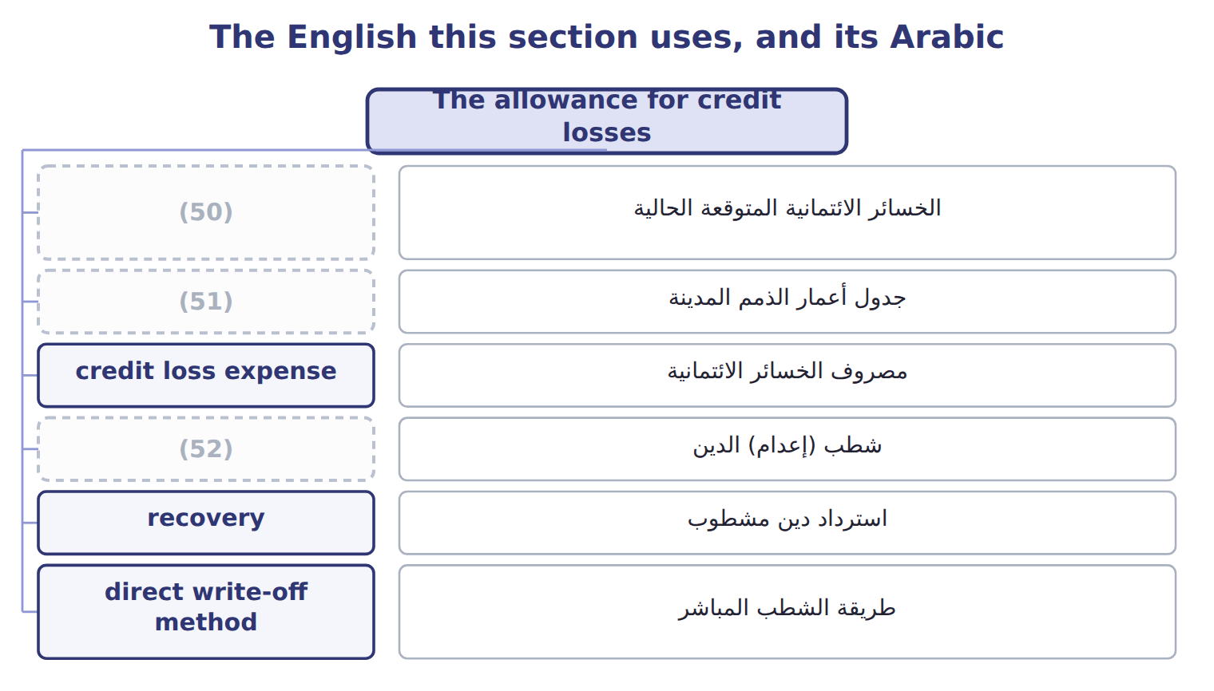
word list
current expected credit losses (CECL) · aging schedule · write-off · factor

The English this sheet uses, and its Arabic
English (exam term) | Arabic
current expected credit losses (CECL) | الخسائر الائتمانية المتوقعة الحالية
aging schedule | جدول أعمار الذمم المدينة
credit loss expense | مصروف الخسائر الائتمانية
write-off | شطب (إعدام) الدين
recovery | استرداد دين مشطوب
direct write-off method | طريقة الشطب المباشر

Answer key · 6.2 The allowance for credit losses

1 presents | 27 Complete
2 covers | 28 Barada's
3 probable | 29 Current
4 experience | 30 practical
5 supportable | 31 forecasting
6 measured | 32 assume
7 contra-asset | 33 Private
8 collect | 34 collected
9 common | 35 beginning
10 schedule | 36 one-year
11 groups | 37 simplified
12 adjusted | 38 matrix
13 61–90 days past due | 39 financial
14 Over 90 days past due | 40 significantly
15 started | 41 reduces
16 recovered | 42 liability
17 journal | 43 doubtful
18 uncollectible | 44 allowance
19 changes | 45 credit
20 recovery | 46 write-off
21 collection | 47 Only when a customer's balance is written off
22 returns | 48 Gross: 660,000 (overstated)
23 questions | 49 Yes (CECL)
24 percentage | 50 current expected credit losses (CECL)
25 income-statement | 51 aging schedule
26 balance-sheet | 52 write-off

the summaries in full
Summary 1 Under current expected credit losses (CECL), a company presents its receivables net of an allowance that covers all the credit losses it expects over their life. It records these expected losses from the first day. It does not wait until a loss becomes probable. The estimate uses past experience, current conditions and reasonable and supportable forecasts. Trade receivables are measured at amortized cost, and the allowance is a contra-asset account. The balance sheet shows receivables minus the allowance: the amount the company expects to collect. A common method is the aging schedule. The company groups its receivables by how long they are past due and applies an expected loss rate to each group. The rates start from history and are adjusted for current conditions and forecasts. The total is the balance the allowance must have at the end of the year.
Summary 2 The allowance must end the year at $34,000. During the year, the allowance started at $30,000, Orontes wrote off $26,000 of bad receivables and recovered $2,000 that it had written off earlier. The journal entry is: debit Credit loss expense $28,000, credit Allowance for credit losses $28,000. Net receivables on the balance sheet are $660,000 − $34,000 = $626,000. When a customer's balance is clearly uncollectible, the company records a write-off: debit the allowance and credit accounts receivable. The write-off changes neither net income nor net receivables, because the expense was already recorded when the allowance was built. If the customer later pays, the company records a recovery: it first reinstates the receivable (debit accounts receivable, credit allowance) and then records the cash collection. The direct method is used for U.S. tax returns. It is not GAAP when bad debts are material, because it records losses late and shows receivables at a gross amount. Older questions sometimes estimate the expense as a percentage of credit sales. This income-statement approach does not measure the expected losses on the ending receivables, so under CECL the aging (balance-sheet) approach is the better choice.
Summary 3 The first row is done. Complete the other rows and the total, then check your total against Barada's trial balance.
Summary 4 In 2025 the FASB added a practical expedient: when forecasting losses on current receivables, any company may assume that conditions at the balance sheet date will not change. Private companies may also use cash collected after year-end. It applies to annual periods beginning after December 15, 2025, so under the one-year rule it is not yet tested on the CMA exam. IFRS 9 also uses expected losses. For trade receivables it uses a simplified approach that always records lifetime losses, often with a provision matrix, which is very close to CECL. For other financial assets, IFRS 9 starts with 12-month expected losses and moves to lifetime losses only after credit risk increases significantly. CECL records lifetime losses from day one for all assets at amortized cost.
Summary 5 An allowance reduces an asset. A provision under IAS 37 is a liability. In a U.S. GAAP answer, always write allowance for credit losses, never provision for doubtful debts or reserve for bad debts.
Summary 6 The aging gives the required ENDING allowance, not the expense. Expense = required balance − unadjusted credit balance, or required balance + unadjusted debit balance. A write-off does not change net income or net receivables.

6.3 Transferring receivables: sale or secured borrowing?
Chapter 6 · section 6.3

Fill every gap. Each word list holds one word more than there are gaps.
Summary 1 gaps 1–7
A company that needs cash before its customers pay can use its receivables in two ways. It can use them as collateral for a loan ( (1) ), or it can transfer them to a (2) company called a factor. U.S. GAAP (3) a transfer as a sale only if three conditions are all met. Recourse is the factor's right to (4) from the seller if customers do not pay. Recourse does not by (5) make the transfer a borrowing. If the three conditions are met, a transfer with recourse is still a sale. The seller then (6) a recourse liability at its fair value, which (7) the loss on the sale.
word list
finance · agreement · records · itself · treats · pledging · increases · collect

Orontes factors its receivables

The steps, in order
Each stage leads to the next.
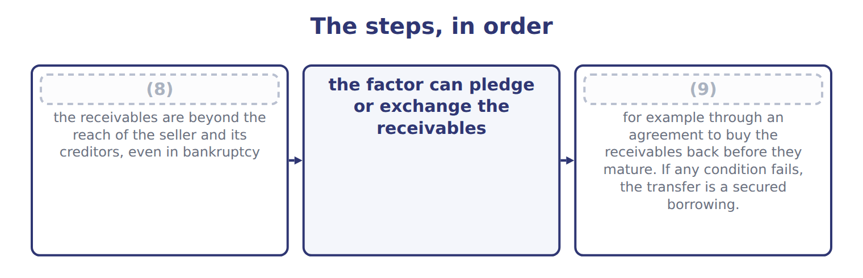
word list
legal isolation · the seller does not keep effective control · credit loss expense

Summary 2 gaps 10–17
Orontes (10) receivables with a carrying amount of $500,000 to Gulf Factor Co. The factor (11) a fee of 3% ($15,000) and keeps a holdback (due from factor) of 5% ($25,000) to cover returns and (12) . Orontes (13) $460,000 in cash. Sale without recourse: debit Cash $460,000, debit Due from factor $25,000, debit Loss on sale of receivables $15,000; credit Accounts (14) $500,000. Sale with recourse (recourse liability $6,000): the same entry, but the loss is $21,000 and Orontes also (15) Recourse liability $6,000. Secured borrowing: debit Cash $460,000, debit (16) expense $15,000; credit Liability to factor $475,000. The receivables stay on the balance sheet, (17) as pledged. Loss on a sale = carrying amount − (cash + due from factor − recourse liability). With recourse: $500,000 − ($460,000 + $25,000 − $6,000) = $21,000.
word list
discounts · marked · receivable · substantially · Interest · transfers · credits · charges · receives

Summary 3 gaps 18–27
The balance sheet (18) is the main (19) companies care. A sale (20) the receivables and adds (21) or no debt, so ratios such as debt to equity look better. A secured borrowing keeps the receivables and adds a liability. Lenders and (22) read the notes to see which receivables are pledged or transferred. IFRS 9 asks first (23) the seller has transferred (24) all the risks and rewards of the receivables. (25) with substantial recourse usually keeps most of the risk with the seller, so under IFRS it often fails (26) and is treated as borrowing. Under U.S. GAAP the same transfer may (27) as a sale if the three ASC 860 conditions are met.
word list
reason · analysts · derecognition · substantially · removes · Recourse · whether · little · qualify · Factoring · effect

Recourse is not the test

Summary 4 gaps 28–30
Do not (28) that every transfer with (29) is a borrowing. Apply the three (30) . The holdback is an asset (due from factor), not part of the loss. Pledged receivables stay on the balance sheet.
word list
customers · assume · recourse · conditions

Recourse is not the test
Item | Details (whole USD)
Aging | Current: 250,000 at an expected loss rate of 2%
Aging | (31) : 90,000 at an expected loss rate of 10%
Aging | (32) : 40,000 at an expected loss rate of 40%
Allowance account | Beginning balance 18,000 (credit). (33) during 2025: 24,000. Recoveries: 1,000.
Transfer T1 | Receivables sold to a factor without recourse. The factor may resell them. Orontes has no right or duty to buy them back.
Transfer T2 | Receivables transferred with recourse. They are legally isolated from Orontes, the factor may pledge them, and Orontes cannot buy them back.
Transfer T3 | Receivables transferred to a bank, but Orontes must repurchase them before they mature.
Transfer T4 | Receivables pledged as collateral for a bank loan; Orontes still collects them.
Transfer T2 details | Carrying amount 200,000; factor's fee 2%; holdback 4%; fair value of the recourse obligation 3,000.

word list
Sale · Write-offs · Over 60 days past due · 1–60 days past due

Item — Answer
Item | Answer
1–60 days past due | 80,000 × 8% = 6,400
Over 60 days past due | (34)
Required allowance | (35)

word list
40,000 × 25% = 10,000 · 3,600 + 6,400 + 10,000 = 20,000 · 80,000 × 8% = 6,400

Transfer — Category
Every item belongs to exactly one group.
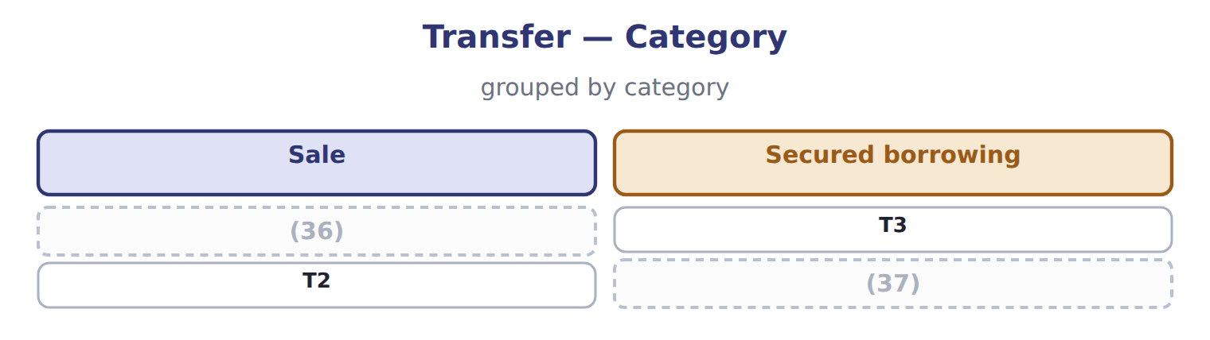
word list
T1 · factor · T4

The English this section uses, and its Arabic
Each term sits against what it means.
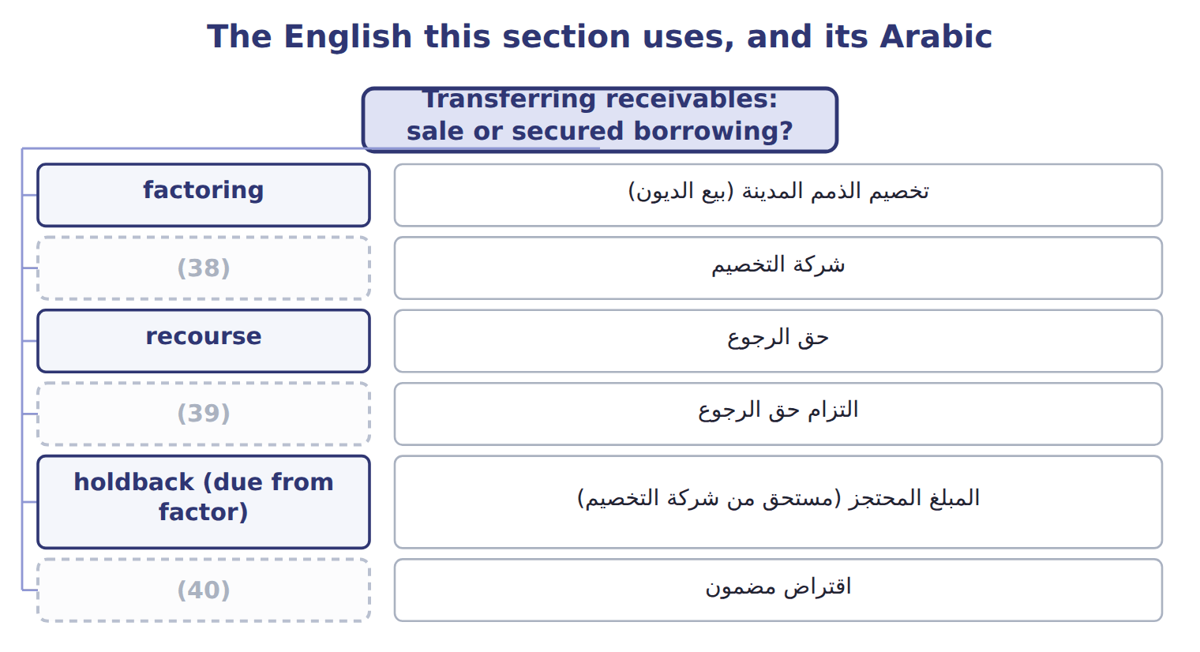
word list
factor · aging schedule · recourse liability · secured borrowing

The English this sheet uses, and its Arabic
English (exam term) | Arabic
factoring | تخصيم الذمم المدينة (بيع الديون)
factor | شركة التخصيم
recourse | حق الرجوع
recourse liability | التزام حق الرجوع
holdback (due from factor) | المبلغ المحتجز (مستحق من شركة التخصيم)
secured borrowing | اقتراض مضمون
pledging | رهن الذمم المدينة
effective control | السيطرة الفعلية
legal isolation | العزل القانوني

Answer key · 6.3 Transferring receivables: sale or secured borrowing?

1 pledging | 21 little
2 finance | 22 analysts
3 treats | 23 whether
4 collect | 24 substantially
5 itself | 25 Factoring
6 records | 26 derecognition
7 increases | 27 qualify
8 legal isolation | 28 assume
9 the seller does not keep effective control | 29 recourse
10 transfers | 30 conditions
11 charges | 31 1–60 days past due
12 discounts | 32 Over 60 days past due
13 receives | 33 Write-offs
14 receivable | 34 40,000 × 25% = 10,000
15 credits | 35 3,600 + 6,400 + 10,000 = 20,000
16 Interest | 36 T1
17 marked | 37 T4
18 effect | 38 factor
19 reason | 39 recourse liability
20 removes | 40 secured borrowing

the summaries in full
Summary 1 A company that needs cash before its customers pay can use its receivables in two ways. It can use them as collateral for a loan (pledging), or it can transfer them to a finance company called a factor. U.S. GAAP treats a transfer as a sale only if three conditions are all met. Recourse is the factor's right to collect from the seller if customers do not pay. Recourse does not by itself make the transfer a borrowing. If the three conditions are met, a transfer with recourse is still a sale. The seller then records a recourse liability at its fair value, which increases the loss on the sale.
Summary 2 Orontes transfers receivables with a carrying amount of $500,000 to Gulf Factor Co. The factor charges a fee of 3% ($15,000) and keeps a holdback (due from factor) of 5% ($25,000) to cover returns and discounts. Orontes receives $460,000 in cash. Sale without recourse: debit Cash $460,000, debit Due from factor $25,000, debit Loss on sale of receivables $15,000; credit Accounts receivable $500,000. Sale with recourse (recourse liability $6,000): the same entry, but the loss is $21,000 and Orontes also credits Recourse liability $6,000. Secured borrowing: debit Cash $460,000, debit Interest expense $15,000; credit Liability to factor $475,000. The receivables stay on the balance sheet, marked as pledged. Loss on a sale = carrying amount − (cash + due from factor − recourse liability). With recourse: $500,000 − ($460,000 + $25,000 − $6,000) = $21,000.
Summary 3 The balance sheet effect is the main reason companies care. A sale removes the receivables and adds little or no debt, so ratios such as debt to equity look better. A secured borrowing keeps the receivables and adds a liability. Lenders and analysts read the notes to see which receivables are pledged or transferred. IFRS 9 asks first whether the seller has transferred substantially all the risks and rewards of the receivables. Factoring with substantial recourse usually keeps most of the risk with the seller, so under IFRS it often fails derecognition and is treated as borrowing. Under U.S. GAAP the same transfer may qualify as a sale if the three ASC 860 conditions are met.
Summary 4 Do not assume that every transfer with recourse is a borrowing. Apply the three conditions. The holdback is an asset (due from factor), not part of the loss. Pledged receivables stay on the balance sheet.

7.1 Which goods belong in inventory?
Chapter 7 · section 7.1

Fill every gap. Each word list holds one word more than there are gaps.
Chapter 7, section by section
Each stage leads to the next.
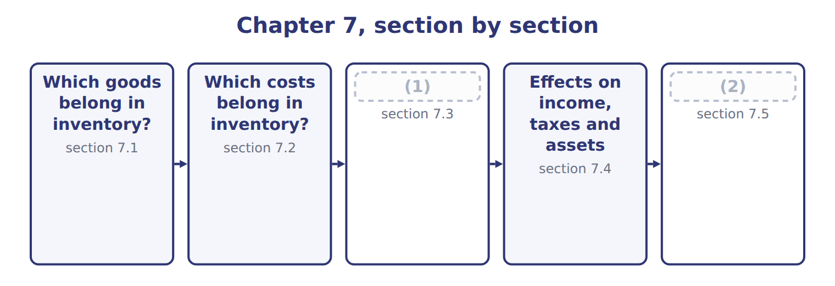
word list
Cost flow assumptions · Inventory errors · FOB destination

Summary 1 gaps 3–14
Inventory means goods held for sale in the (3) course of business, goods in production, and materials that will be used in production. A (4) such as Barada (5) , Inc. has one inventory account. A (6) such as Orontes has three: raw materials, work in process and (7) goods. The basic rule is simple: (8) the goods that the company controls on the balance sheet date, (9) they are. Control (10) follows legal title. Three (11) need care. The shipping term (12) who controls goods that are on a truck or a ship at year-end. Under FOB shipping point, control (13) to the buyer when the goods leave the seller, so the buyer includes them. Under FOB destination, the seller keeps control until the goods (14) , so the seller includes them. In a consignment, the consignor (the owner) gives goods to a consignee, who sells them for a commission.
word list
wherever · finished · include · decides · retailer · Wholesale · ordinary · usually · passes · arrive · manufacturer · special · situations

Summary 2 gaps 15–24
The goods stay in the (15) inventory. The consignee never includes them, even (16) they are in its shop. Goods held for (17) . Goods in the (18) that belong to another company must be taken out of the (19) count. Goods the company owns that are held (20) else must be added. Use it for every year-end item in an exam (21) . Two (22) cases appear in later (23) . When (24) have a right of return, the seller records revenue net of expected returns and a separate asset for the goods it expects to get back. In a bill-and-hold sale, the seller keeps the goods in its inventory unless strict conditions show that the buyer already controls them.
word list
somewhere · question · chapters · warehouse · customers · consigned · others · special · physical · though · consignor's

The FOB flip

Summary 3 gaps 25–27
FOB shipping point: the BUYER includes goods in transit. FOB destination: the SELLER includes them. Many (25) reverse these. The consignee never includes (26) goods, even when they are on its own (27) .
word list
shelves · consigned · candidates · materials

FOB is not the Incoterm you know

Summary 4 gaps 28–30
In (28) trade, FOB (free on board) is an Incoterm about (29) goods onto a ship. In U.S. exam questions, FOB shipping point and FOB destination are simple shipping terms that (30) who controls goods in transit, by truck, rail or sea. Do not bring Incoterm rules into these questions.
word list
consignee · decide · loading · international

The English this section uses, and its Arabic
Each term sits against what it means.
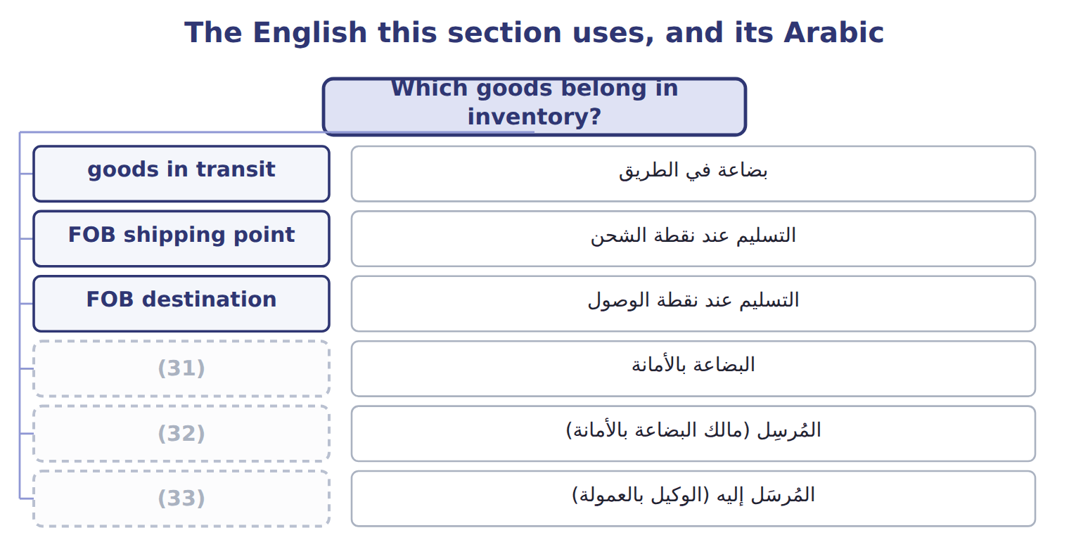
word list
consignment · inventory · consignee · consignor

The English this sheet uses, and its Arabic
English (exam term) | Arabic
goods in transit | بضاعة في الطريق
FOB shipping point | التسليم عند نقطة الشحن
FOB destination | التسليم عند نقطة الوصول
consignment | البضاعة بالأمانة
consignor | المُرسِل (مالك البضاعة بالأمانة)
consignee | المُرسَل إليه (الوكيل بالعمولة)
physical count | الجرد الفعلي

Answer key · 7.1 Which goods belong in inventory?

1 Cost flow assumptions | 18 warehouse
2 Inventory errors | 19 physical
3 ordinary | 20 somewhere
4 retailer | 21 question
5 Wholesale | 22 special
6 manufacturer | 23 chapters
7 finished | 24 customers
8 include | 25 candidates
9 wherever | 26 consigned
10 usually | 27 shelves
11 situations | 28 international
12 decides | 29 loading
13 passes | 30 decide
14 arrive | 31 consignment
15 consignor's | 32 consignor
16 though | 33 consignee
17 others

the summaries in full
Summary 1 Inventory means goods held for sale in the ordinary course of business, goods in production, and materials that will be used in production. A retailer such as Barada Wholesale, Inc. has one inventory account. A manufacturer such as Orontes has three: raw materials, work in process and finished goods. The basic rule is simple: include the goods that the company controls on the balance sheet date, wherever they are. Control usually follows legal title. Three situations need care. The shipping term decides who controls goods that are on a truck or a ship at year-end. Under FOB shipping point, control passes to the buyer when the goods leave the seller, so the buyer includes them. Under FOB destination, the seller keeps control until the goods arrive, so the seller includes them. In a consignment, the consignor (the owner) gives goods to a consignee, who sells them for a commission.
Summary 2 The goods stay in the consignor's inventory. The consignee never includes them, even though they are in its shop. Goods held for others. Goods in the warehouse that belong to another company must be taken out of the physical count. Goods the company owns that are held somewhere else must be added. Use it for every year-end item in an exam question. Two special cases appear in later chapters. When customers have a right of return, the seller records revenue net of expected returns and a separate asset for the goods it expects to get back. In a bill-and-hold sale, the seller keeps the goods in its inventory unless strict conditions show that the buyer already controls them.
Summary 3 FOB shipping point: the BUYER includes goods in transit. FOB destination: the SELLER includes them. Many candidates reverse these. The consignee never includes consigned goods, even when they are on its own shelves.
Summary 4 In international trade, FOB (free on board) is an Incoterm about loading goods onto a ship. In U.S. exam questions, FOB shipping point and FOB destination are simple shipping terms that decide who controls goods in transit, by truck, rail or sea. Do not bring Incoterm rules into these questions.

7.2 Which costs belong in inventory?
Chapter 7 · section 7.2

Fill every gap. Each word list holds one word more than there are gaps.
Summary 1 gaps 1–12
Inventory is (1) at cost. Cost means all the costs (2) to bring the goods to their present condition and location. These are (3) costs: they stay in inventory as an asset, and they (4) cost of goods sold when the goods are sold. Other costs are period costs: they are expenses in the period in which they occur. For goods that are bought, cost includes the purchase price, (5) , import duties, (6) taxes and handling, less trade (7) and any purchase discount taken for early (8) . For goods that are made, cost also includes (9) labor and production overhead. Fixed production overhead needs care. It is allocated to units on the basis of normal (10) : the output the plant (11) on average over several periods. If output is (12) low, the fixed overhead that is not allocated is an expense of the period. It is not added to inventory.
word list
become · needed · discounts · expects · direct · recorded · inventoriable · freight-in · capacity · unusually · expense · non-refundable · payment

Summary 2 gaps 13–16
In the same way, abnormal waste (unusual (13) , idle time or extra (14) ) is an expense, not inventory cost. Period costs include freight-out to customers, sales (15) , advertising, general and administrative costs, and the storage of (16) goods. Interest on inventory that is produced routinely is also a period cost.
word list
spoilage · freight · finished · commissions · routinely

The cost of imported glass bottles

Summary 3 gaps 17–18
Orontes (17) glass bottles for its Amman plant. The (18) is $20,000, and Orontes pays within the discount period, so it takes a 2% discount.
word list
imports · average · invoice

The cost of imported glass bottles
Every item belongs to exactly one group.
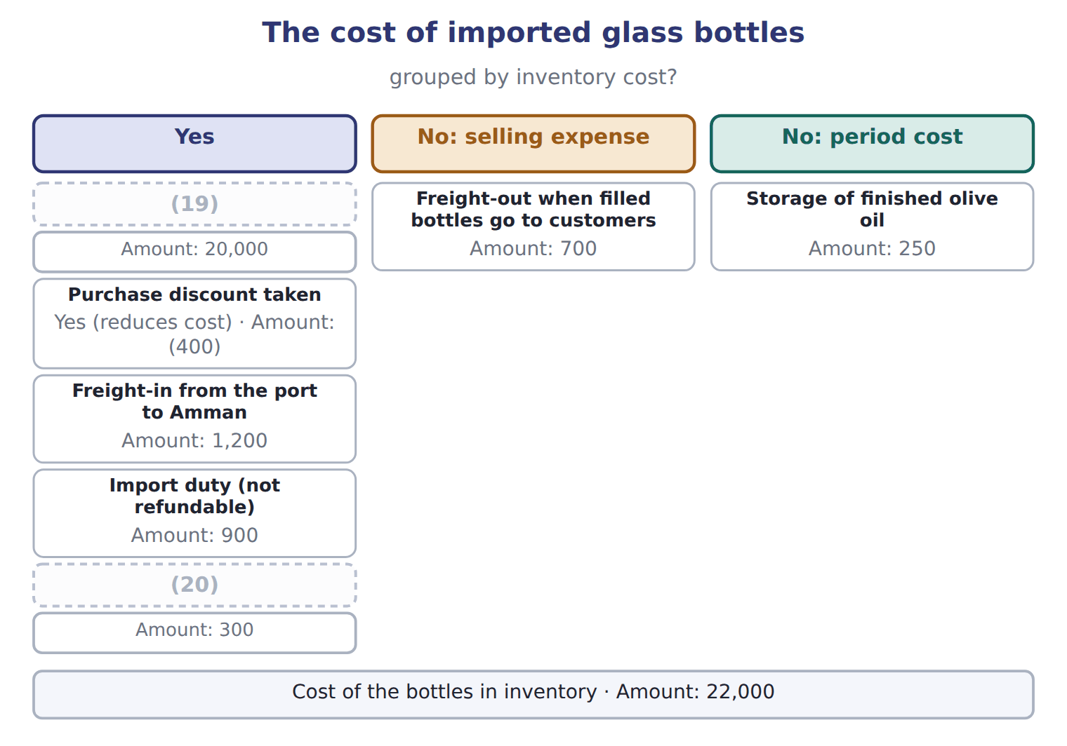
word list
normal capacity · Insurance while the bottles are in transit · Invoice price

Summary 4 gaps 21–25
The two costs at the (21) of the table (22) after the goods are ready for use. They do not bring the bottles to their present condition and location, so they are expenses. IAS 2 uses the same idea of cost and lists the same (23) : abnormal waste, storage, administrative (24) and selling costs. The big IFRS (25) is in the next section: IAS 2 does not allow LIFO.
word list
overheads · exclusions · difference · payment · bottom · happen

The English this section uses, and its Arabic
Each term sits against what it means.
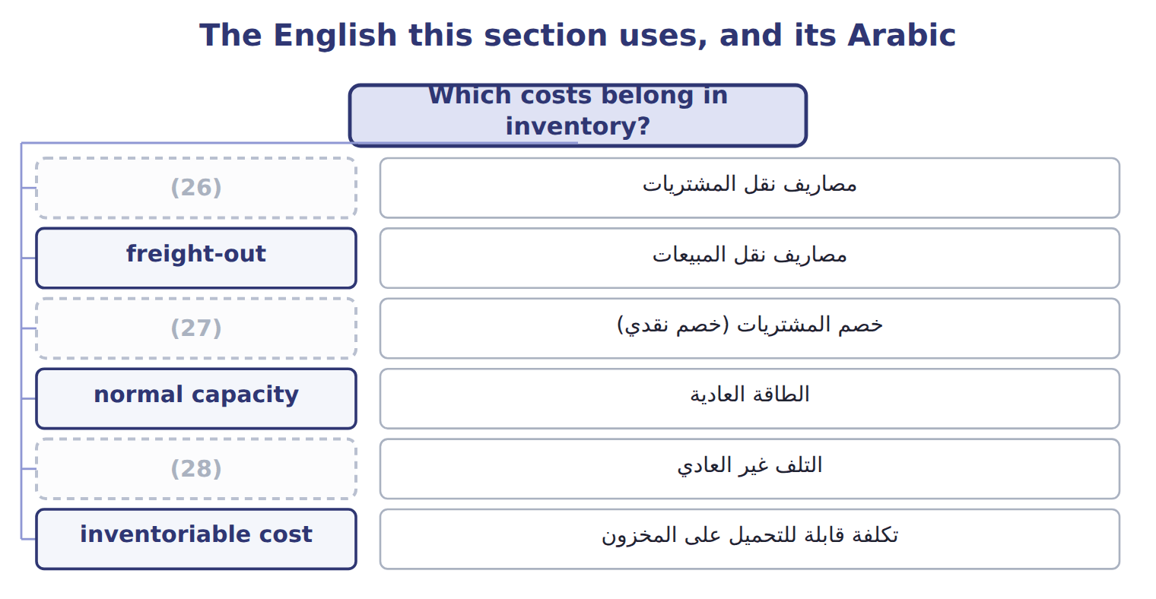
word list
abnormal waste · purchase discount · freight-in · inventory

The English this sheet uses, and its Arabic
English (exam term) | Arabic
freight-in | مصاريف نقل المشتريات
freight-out | مصاريف نقل المبيعات
purchase discount | خصم المشتريات (خصم نقدي)
normal capacity | الطاقة العادية
abnormal waste | التلف غير العادي
inventoriable cost | تكلفة قابلة للتحميل على المخزون
period cost | تكلفة الفترة

Answer key · 7.2 Which costs belong in inventory?

1 recorded | 15 commissions
2 needed | 16 finished
3 inventoriable | 17 imports
4 become | 18 invoice
5 freight-in | 19 Invoice price
6 non-refundable | 20 Insurance while the bottles are in transit
7 discounts | 21 bottom
8 payment | 22 happen
9 direct | 23 exclusions
10 capacity | 24 overheads
11 expects | 25 difference
12 unusually | 26 freight-in
13 spoilage | 27 purchase discount
14 freight | 28 abnormal waste

the summaries in full
Summary 1 Inventory is recorded at cost. Cost means all the costs needed to bring the goods to their present condition and location. These are inventoriable costs: they stay in inventory as an asset, and they become cost of goods sold when the goods are sold. Other costs are period costs: they are expenses in the period in which they occur. For goods that are bought, cost includes the purchase price, freight-in, import duties, non-refundable taxes and handling, less trade discounts and any purchase discount taken for early payment. For goods that are made, cost also includes direct labor and production overhead. Fixed production overhead needs care. It is allocated to units on the basis of normal capacity: the output the plant expects on average over several periods. If output is unusually low, the fixed overhead that is not allocated is an expense of the period. It is not added to inventory.
Summary 2 In the same way, abnormal waste (unusual spoilage, idle time or extra freight) is an expense, not inventory cost. Period costs include freight-out to customers, sales commissions, advertising, general and administrative costs, and the storage of finished goods. Interest on inventory that is produced routinely is also a period cost.
Summary 3 Orontes imports glass bottles for its Amman plant. The invoice is $20,000, and Orontes pays within the discount period, so it takes a 2% discount.
Summary 4 The two costs at the bottom of the table happen after the goods are ready for use. They do not bring the bottles to their present condition and location, so they are expenses. IAS 2 uses the same idea of cost and lists the same exclusions: abnormal waste, storage, administrative overheads and selling costs. The big IFRS difference is in the next section: IAS 2 does not allow LIFO.

7.3 Cost flow assumptions
Chapter 7 · section 7.3

Fill every gap. Each word list holds one word more than there are gaps.
Summary 1 gaps 1–11
Unit costs (1) during the year. When a company sells some units and keeps (2) , it must decide which costs go to cost of goods sold and which stay in ending inventory. This (3) is a cost flow (4) . It does not need to match the (5) flow of the goods. Specific identification (6) the actual cost of each item. It suits unique, (7) items, such as cars or (8) . FIFO ( (9) , first-out) sends the oldest costs to cost of goods sold. Ending inventory holds the newest costs. LIFO ( (10) , first-out) sends the newest costs to cost of goods sold. Ending inventory holds the oldest costs. (11) cost divides the cost of goods available by the units available and uses this one unit cost for both cost of goods sold and ending inventory.
word list
Weighted-average · last-in · change · physical · jewelry · expensive · decision · available · others · first-in · tracks · assumption

Orontes olive oil: three methods, one set of facts

Summary 2 gaps 12–15
Orontes sells (12) olive oil in cases of (13) bottles. (14) rose during 2025. Orontes began the year with 1,000 cases at $40. It (15) 2,000 cases at $44, then 3,000 at $48, then 2,000 at $50. It sold 6,000 cases at $70, so 2,000 cases are left. The company uses a periodic system. Goods available: 8,000 cases costing $372,000.
word list
periodic · twelve · premium · Prices · bought

Orontes olive oil: three methods, one set of facts
The bars are drawn to scale.
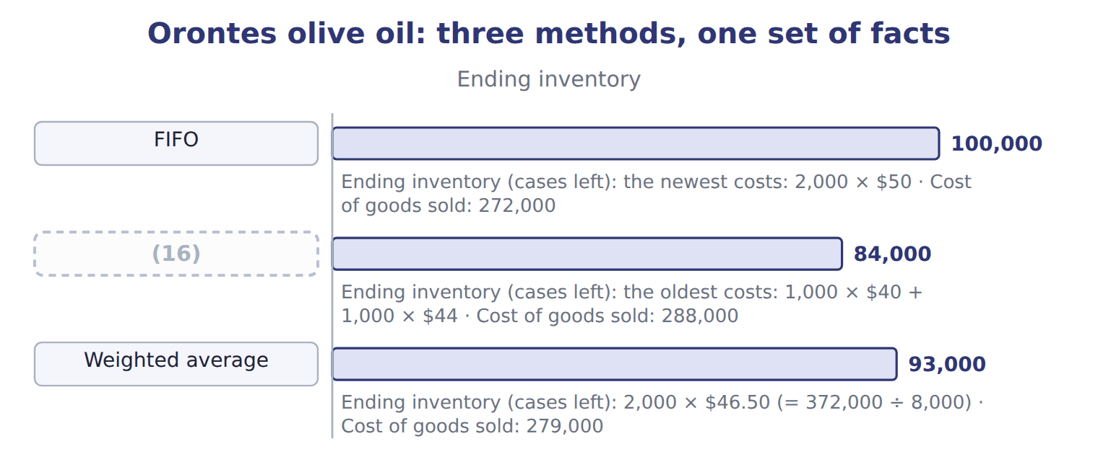
word list
LIFO · freight-in

Summary 3 gaps 17–18
In each row, ending (17) plus cost of goods sold equals the cost of goods available. Only the split is (18) .
word list
Orontes · different · inventory

Olive oil: periodic versus perpetual results (whole USD)
The bars are drawn to scale.
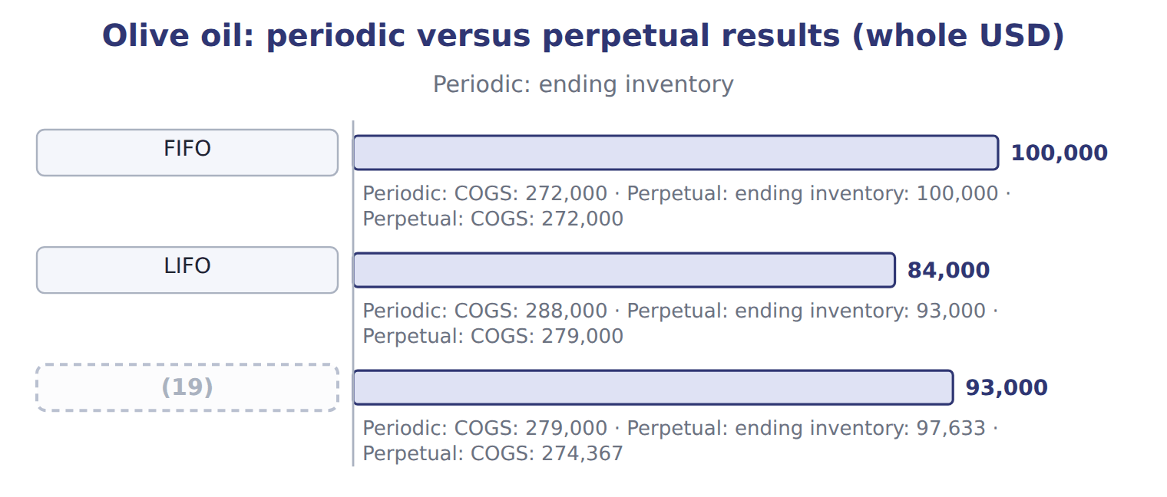
word list
Average (weighted / moving) · goods available for sale

Summary 4 gaps 20–27
In a periodic inventory system, the company (20) the goods at (21) and calculates cost of goods sold for the whole (22) . In a perpetual inventory system, it (23) inventory and cost of goods sold after every purchase and every sale. The average method in a perpetual system is the (24) average: the company calculates a new average after each purchase. FIFO gives the same result in both (25) , because the oldest units are (26) sold first. LIFO and the average method do not: under a perpetual system, each sale can only use the costs that exist on the date of the sale. The sales took place in April, August and (27) .
word list
counts · always · because · updates · November · systems · year-end · moving · period

Periodic LIFO for Dubai pastry trays

Summary 5 gaps 28–33
The Dubai plant had 3,000 (28) pastry trays available in 2025, costing $68,000. It sold 2,200 trays. (29) the dashed boxes below using periodic LIFO. Then check that cost of goods sold plus ending inventory equals the cost of goods available. IAS 2 allows FIFO and the (30) average, and it (31) specific identification for items that are not (32) . It does not allow LIFO. You will compare the two (33) again.
word list
jewelry · frozen · requires · weighted · interchangeable · frameworks · Complete

Talking about time and order

Under LIFO, the company adds a layer when it buys more than it sells. A company can use LIFO even if it ships its oldest bottles first.
The English this section uses, and its Arabic
Each term sits against what it means.
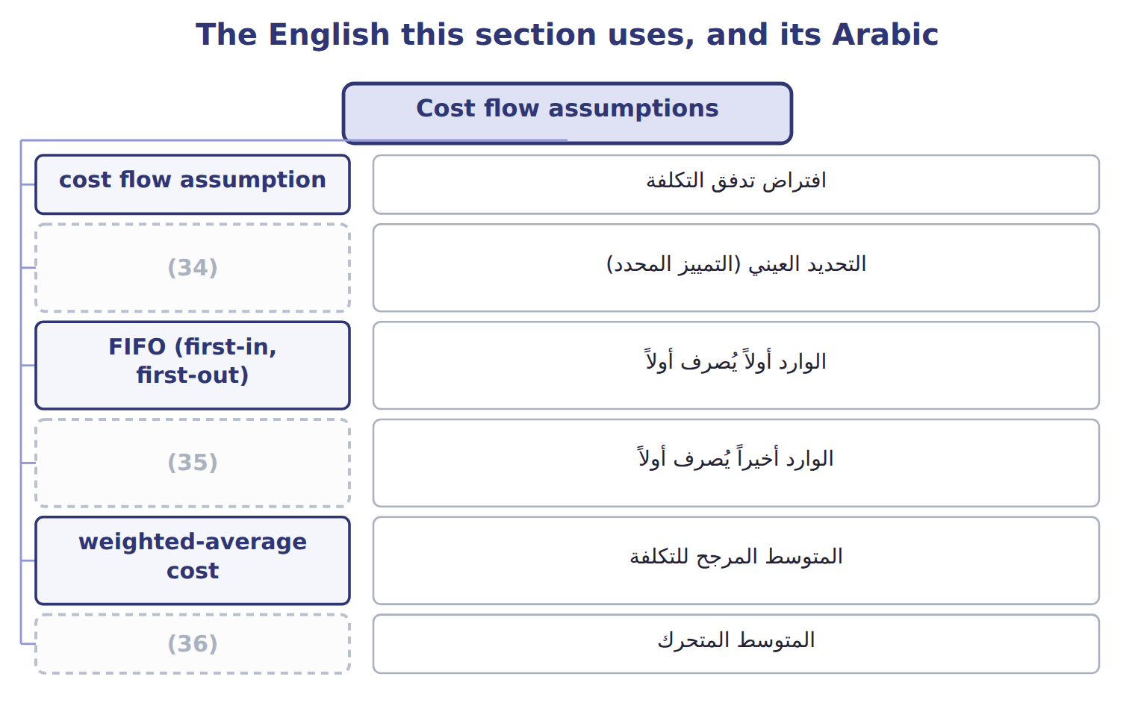
word list
specific identification · moving average · LIFO conformity rule · LIFO (last-in, first-out)

The English this sheet uses, and its Arabic
English (exam term) | Arabic
cost flow assumption | افتراض تدفق التكلفة
specific identification | التحديد العيني (التمييز المحدد)
FIFO (first-in, first-out) | الوارد أولاً يُصرف أولاً
LIFO (last-in, first-out) | الوارد أخيراً يُصرف أولاً
weighted-average cost | المتوسط المرجح للتكلفة
moving average | المتوسط المتحرك
periodic inventory system | نظام الجرد الدوري
perpetual inventory system | نظام الجرد المستمر
goods available for sale | البضاعة المتاحة للبيع

Answer key · 7.3 Cost flow assumptions

1 change | 19 Average (weighted / moving)
2 others | 20 counts
3 decision | 21 year-end
4 assumption | 22 period
5 physical | 23 updates
6 tracks | 24 moving
7 expensive | 25 systems
8 jewelry | 26 always
9 first-in | 27 November
10 last-in | 28 frozen
11 Weighted-average | 29 Complete
12 premium | 30 weighted
13 twelve | 31 requires
14 Prices | 32 interchangeable
15 bought | 33 frameworks
16 LIFO | 34 specific identification
17 inventory | 35 LIFO (last-in, first-out)
18 different | 36 moving average

the summaries in full
Summary 1 Unit costs change during the year. When a company sells some units and keeps others, it must decide which costs go to cost of goods sold and which stay in ending inventory. This decision is a cost flow assumption. It does not need to match the physical flow of the goods. Specific identification tracks the actual cost of each item. It suits unique, expensive items, such as cars or jewelry. FIFO (first-in, first-out) sends the oldest costs to cost of goods sold. Ending inventory holds the newest costs. LIFO (last-in, first-out) sends the newest costs to cost of goods sold. Ending inventory holds the oldest costs. Weighted-average cost divides the cost of goods available by the units available and uses this one unit cost for both cost of goods sold and ending inventory.
Summary 2 Orontes sells premium olive oil in cases of twelve bottles. Prices rose during 2025. Orontes began the year with 1,000 cases at $40. It bought 2,000 cases at $44, then 3,000 at $48, then 2,000 at $50. It sold 6,000 cases at $70, so 2,000 cases are left. The company uses a periodic system. Goods available: 8,000 cases costing $372,000.
Summary 3 In each row, ending inventory plus cost of goods sold equals the cost of goods available. Only the split is different.
Summary 4 In a periodic inventory system, the company counts the goods at year-end and calculates cost of goods sold for the whole period. In a perpetual inventory system, it updates inventory and cost of goods sold after every purchase and every sale. The average method in a perpetual system is the moving average: the company calculates a new average after each purchase. FIFO gives the same result in both systems, because the oldest units are always sold first. LIFO and the average method do not: under a perpetual system, each sale can only use the costs that exist on the date of the sale. The sales took place in April, August and November.
Summary 5 The Dubai plant had 3,000 frozen pastry trays available in 2025, costing $68,000. It sold 2,200 trays. Complete the dashed boxes below using periodic LIFO. Then check that cost of goods sold plus ending inventory equals the cost of goods available. IAS 2 allows FIFO and the weighted average, and it requires specific identification for items that are not interchangeable. It does not allow LIFO. You will compare the two frameworks again.

7.4 Effects on income, taxes and assets
Chapter 7 · section 7.4

Fill every gap. Each word list holds one word more than there are gaps.
Summary 1 gaps 1–12
When prices are rising, the (1) give very different results. FIFO puts the old, (2) costs into cost of goods sold. So FIFO gives the (3) cost of goods sold, the highest gross (4) , the highest income tax and the highest ending inventory. LIFO gives the (5) . The (6) average falls in between. When prices are (7) , all these relationships (8) . Each method has a (9) . LIFO matches current costs with current (10) , so its income is closer to current (11) reality, but its balance sheet shows old costs. FIFO shows ending inventory close to current cost, but its income (12) gains from holding inventory while prices rise. Companies that use LIFO must help readers compare them with FIFO companies. The LIFO reserve is the difference between FIFO (or current cost) inventory and LIFO inventory.
word list
reverse · includes · weighted · lowest · profit · revenues · opposite · strength · methods · falling · sometimes · economic · cheaper

Summary 2 gaps 13–20
For Orontes, the LIFO reserve at the end of 2025 is $100,000 − $84,000 = $16,000. An (13) can convert LIFO results to FIFO with two relationships. FIFO inventory equals LIFO inventory plus the LIFO reserve. FIFO cost of goods sold equals LIFO cost of goods sold minus the increase in the LIFO reserve (14) the year. Orontes (15) the year with no reserve, so the increase is $16,000, and FIFO cost of goods sold is $288,000 − $16,000 = $272,000. At an (16) tax rate of 25%, LIFO saved $4,000 of tax this year. If a LIFO company sells more units than it buys, old (17) layers flow into cost of goods sold. Income rises for one year. This is not a lasting (18) , and the company should (19) it if it is (20) . This is a U.S. tax rule.
word list
business · disclose · improvement · analyst · illustrative · during · low-cost · material · started

Summary 3 gaps 21–23
A company that uses LIFO for its tax (21) must also use LIFO in its financial (22) . This is why U.S. companies that want the tax benefit of LIFO also report lower LIFO profits to (23) .
word list
low-cost · return · statements · investors

Signs and directions

Summary 4 gaps 24–27
To get FIFO cost of goods sold, (24) the increase in the LIFO reserve from LIFO cost of goods sold. In rising prices, LIFO gives LOWER income and LOWER taxes, not (25) . A LIFO (26) raises income once. Do not treat it as a better (27) . Periodic and perpetual LIFO give different answers.
word list
business · SUBTRACT · holding · higher · liquidation

Reserve does not mean reserve

Summary 5 gaps 28–29
The LIFO reserve is not an (28) reserve. It is only the difference between two inventory (29) . It is sometimes called the LIFO allowance or revaluation to LIFO.
word list
results · amounts · equity

The English this section uses, and its Arabic
Each term sits against what it means.
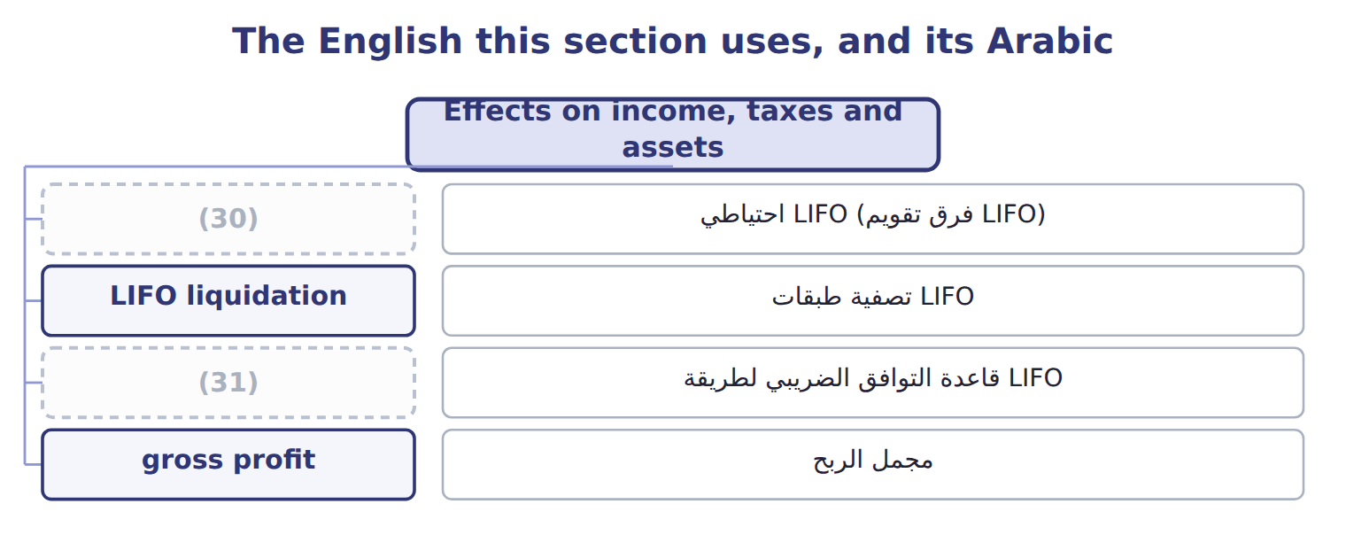
word list
specific identification · LIFO conformity rule · LIFO reserve

The English this sheet uses, and its Arabic
English (exam term) | Arabic
LIFO reserve | احتياطي LIFO (فرق تقويم LIFO)
LIFO liquidation | تصفية طبقات LIFO
LIFO conformity rule | قاعدة التوافق الضريبي لطريقة LIFO
gross profit | مجمل الربح

Answer key · 7.4 Effects on income, taxes and assets

1 methods | 17 low-cost
2 cheaper | 18 improvement
3 lowest | 19 disclose
4 profit | 20 material
5 opposite | 21 return
6 weighted | 22 statements
7 falling | 23 investors
8 reverse | 24 SUBTRACT
9 strength | 25 higher
10 revenues | 26 liquidation
11 economic | 27 business
12 includes | 28 equity
13 analyst | 29 amounts
14 during | 30 LIFO reserve
15 started | 31 LIFO conformity rule
16 illustrative

the summaries in full
Summary 1 When prices are rising, the methods give very different results. FIFO puts the old, cheaper costs into cost of goods sold. So FIFO gives the lowest cost of goods sold, the highest gross profit, the highest income tax and the highest ending inventory. LIFO gives the opposite. The weighted average falls in between. When prices are falling, all these relationships reverse. Each method has a strength. LIFO matches current costs with current revenues, so its income is closer to current economic reality, but its balance sheet shows old costs. FIFO shows ending inventory close to current cost, but its income includes gains from holding inventory while prices rise. Companies that use LIFO must help readers compare them with FIFO companies. The LIFO reserve is the difference between FIFO (or current cost) inventory and LIFO inventory.
Summary 2 For Orontes, the LIFO reserve at the end of 2025 is $100,000 − $84,000 = $16,000. An analyst can convert LIFO results to FIFO with two relationships. FIFO inventory equals LIFO inventory plus the LIFO reserve. FIFO cost of goods sold equals LIFO cost of goods sold minus the increase in the LIFO reserve during the year. Orontes started the year with no reserve, so the increase is $16,000, and FIFO cost of goods sold is $288,000 − $16,000 = $272,000. At an illustrative tax rate of 25%, LIFO saved $4,000 of tax this year. If a LIFO company sells more units than it buys, old low-cost layers flow into cost of goods sold. Income rises for one year. This is not a lasting improvement, and the company should disclose it if it is material. This is a U.S. tax rule.
Summary 3 A company that uses LIFO for its tax return must also use LIFO in its financial statements. This is why U.S. companies that want the tax benefit of LIFO also report lower LIFO profits to investors.
Summary 4 To get FIFO cost of goods sold, SUBTRACT the increase in the LIFO reserve from LIFO cost of goods sold. In rising prices, LIFO gives LOWER income and LOWER taxes, not higher. A LIFO liquidation raises income once. Do not treat it as a better business. Periodic and perpetual LIFO give different answers.
Summary 5 The LIFO reserve is not an equity reserve. It is only the difference between two inventory amounts. It is sometimes called the LIFO allowance or revaluation to LIFO.

7.5 Inventory errors
Chapter 7 · section 7.5

Fill every gap. Each word list holds one word more than there are gaps.
Summary 1 gaps 1–8
Cost of goods sold (1) on the count: beginning inventory plus purchases minus ending inventory. If ending inventory is wrong, cost of goods sold is wrong in the same year. And (2) this year's ending inventory is next year's beginning inventory, the error moves into the next year too. At the end of 2025, Orontes counted some goods twice, so ending inventory was overstated by 40 (USD 000). Cost of goods sold was understated by 40, so pretax income was overstated by 40. In 2026, beginning inventory was too high, so cost of goods sold was overstated and pretax income was understated by 40. Over the two years, the two errors (3) . Retained earnings are overstated at the end of 2025 but correct at the end of 2026. This is a (4) error. (5) the tax effect: at a 25% tax rate, net income was overstated by only 30 in the first year. Errors in purchases work in a (6) way. Row 3 is a (7) exam item: when a purchase is left out of both purchases and the count, cost of goods sold and income are still correct, but inventory and (8) payable are both understated.
word list
already · classic · because · accounts · cancel · Remember · counterbalancing · similar · depends

Effects of four common inventory errors (O = overstated, U = understated)
Every item belongs to exactly one group.
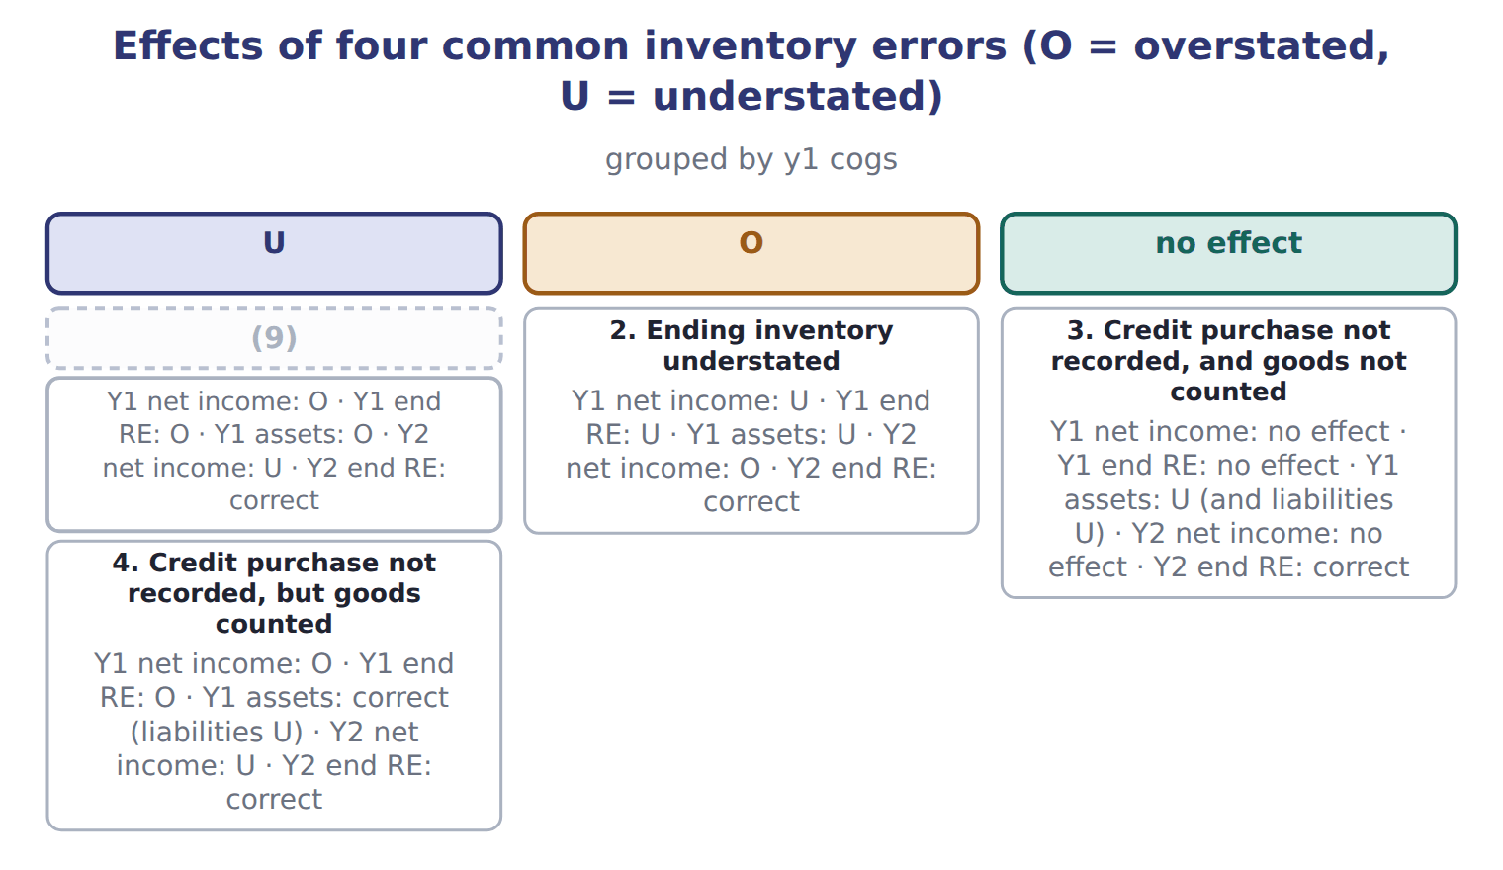
word list
1. Ending inventory overstated · 2. Ending inventory understated

Summary 2 gaps 10–13
If a company finds an error from a prior year, it corrects the error by (10) the prior-year (11) , with an adjustment to beginning retained earnings (ASC 250). If the error has already (12) , retained earnings need no adjustment, but the prior-year income figures shown for (13) are still restated.
word list
comparison · restating · statements · consignment · counterbalanced

Over- and under-

Summary 3 gaps 14–16
The (14) tells you the direction. Net income is overstated by 40 (the size of the error), not overstated to 940. In a (15) , find the direction for the first year, then (16) it for the second year.
word list
question · reverse · prefix · correct

Over- and under-
Date / item | Details | Cartons | USD
Jan 1 | (17) | 4,000 | 120,000
Feb 14 | Purchase at $31 | 10,000 | 310,000
Jun 3 | Purchase at $33 | 12,000 | 396,000
Sep 21 | Purchase at $34 | 8,000 | 272,000
Dec 18 | (18) | 6,000 | 210,000
 | Goods available for sale | 40,000 | 1,308,000
Dec 31 | (19) | 7,500
 | (20)
M1 | Cartons bought on December 29, FOB shipping point, still on the truck on December 31. The purchase is already recorded. | 1,000
M2 | Cartons shipped to a customer on December 30, (21) . They arrive on January 3. | 500
M3 | Cartons in the warehouse that belong to a Beirut producer. Orontes sells them on consignment for the producer. They were included in the cou | 800
M4 | Cartons that Orontes has placed on (22) with a retailer in Doha. They were not counted. | 300

word list
Beginning inventory at $30 · consignment · FIFO (first-in, first-out) · FOB destination · Year-end memo from the warehouse manager · Physical count in the Amman warehouse · Purchase at $35

Item — Answer
Item | Answer
COGS, line 2: 1,200 × $22 | $26,400
Ending inventory, line 1: 300 × $22 | $6,600
Ending inventory, line 2: 500 × $20 | $10,000
Total COGS | $25,000 + $26,400 = $51,400
Total ending inventory | (23)
Check | $51,400 + $16,600 = $68,000, the cost of goods available.

word list
$6,600 + $10,000 = $16,600 · $25,000 + $26,400 = $51,400

Memo item — Category
Each stage leads to the next.
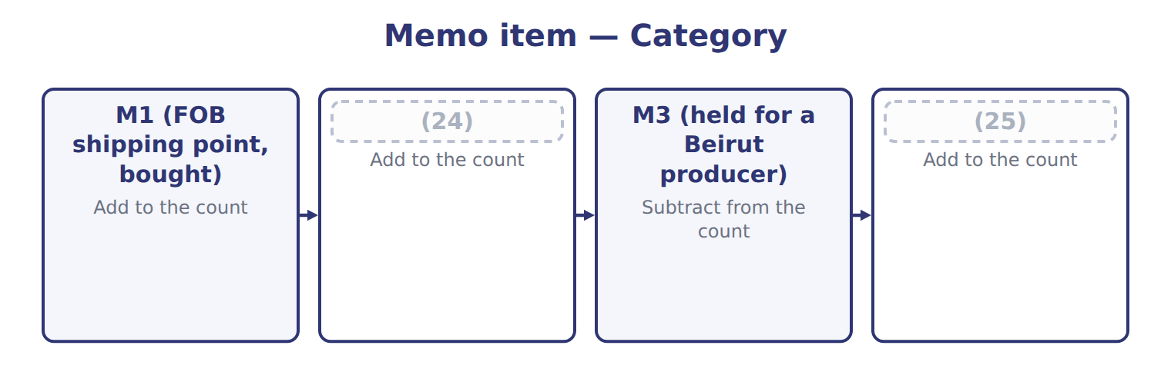
word list
M4 (at a Doha consignee) · M2 (FOB destination, sold) · cost of goods sold

The English this section uses, and its Arabic
Each term sits against what it means.
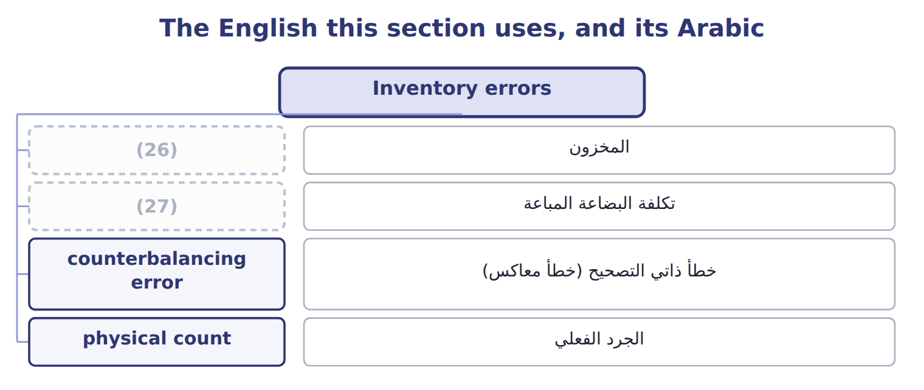
word list
تكلفة البضاعة المباعة · cost of goods sold · inventory

The English this sheet uses, and its Arabic
English (exam term) | Arabic
counterbalancing error | خطأ ذاتي التصحيح (خطأ معاكس)

Answer key · 7.5 Inventory errors

1 depends | 15 question
2 because | 16 reverse
3 cancel | 17 Beginning inventory at $30
4 counterbalancing | 18 Purchase at $35
5 Remember | 19 Physical count in the Amman warehouse
6 similar | 20 Year-end memo from the warehouse manager
7 classic | 21 FOB destination
8 accounts | 22 consignment
9 1. Ending inventory overstated | 23 $6,600 + $10,000 = $16,600
10 restating | 24 M2 (FOB destination, sold)
11 statements | 25 M4 (at a Doha consignee)
12 counterbalanced | 26 inventory
13 comparison | 27 cost of goods sold
14 prefix

the summaries in full
Summary 1 Cost of goods sold depends on the count: beginning inventory plus purchases minus ending inventory. If ending inventory is wrong, cost of goods sold is wrong in the same year. And because this year's ending inventory is next year's beginning inventory, the error moves into the next year too. At the end of 2025, Orontes counted some goods twice, so ending inventory was overstated by 40 (USD 000). Cost of goods sold was understated by 40, so pretax income was overstated by 40. In 2026, beginning inventory was too high, so cost of goods sold was overstated and pretax income was understated by 40. Over the two years, the two errors cancel. Retained earnings are overstated at the end of 2025 but correct at the end of 2026. This is a counterbalancing error. Remember the tax effect: at a 25% tax rate, net income was overstated by only 30 in the first year. Errors in purchases work in a similar way. Row 3 is a classic exam item: when a purchase is left out of both purchases and the count, cost of goods sold and income are still correct, but inventory and accounts payable are both understated.
Summary 2 If a company finds an error from a prior year, it corrects the error by restating the prior-year statements, with an adjustment to beginning retained earnings (ASC 250). If the error has already counterbalanced, retained earnings need no adjustment, but the prior-year income figures shown for comparison are still restated.
Summary 3 The prefix tells you the direction. Net income is overstated by 40 (the size of the error), not overstated to 940. In a question, find the direction for the first year, then reverse it for the second year.

8.1 Which test applies?
Chapter 8 · section 8.1

Fill every gap. Each word list holds one word more than there are gaps.
Chapter 8, section by section
Each stage leads to the next.
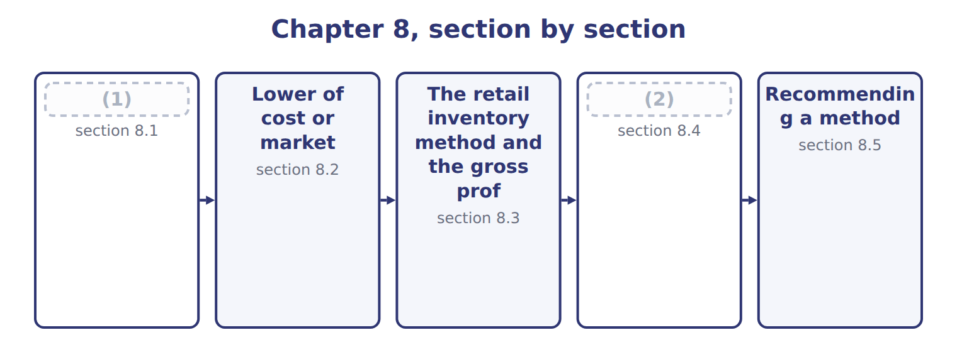
word list
Advantages and disadvantages of the methods · Which test applies? · net realizable value (NRV)

Summary 1 gaps 3–11
At each (3) sheet date, the company checks (4) the cost of its inventory is still (5) . Inventory measured by FIFO, average cost or specific (6) uses the lower of cost and net realizable value (LCNRV). Inventory measured by LIFO or the retail inventory method uses the lower of cost or (7) (LCM) (Section 8.2). Net realizable value (NRV) is the estimated selling price in the (8) course of business, minus the costs to complete, sell and transport the goods. If NRV is below cost, the company (9) a write-down to NRV. The loss goes to income, (10) inside cost of goods sold, or as a (11) line if it is large.
word list
markup · records · ordinary · separate · balance · usually · identification · recoverable · whether · market

LCNRV for Orontes olive oil

Summary 2 gaps 12–14
In, Orontes used FIFO for olive oil. Its (12) inventory was 2,000 cases at $50. In late December, a large (13) cut prices. Orontes now expects to sell each case for $54, with $6 of selling and (14) costs.
word list
competitor · December · delivery · ending

LCNRV for Orontes olive oil at December 31, 2025 (whole USD)
Orontes olive oil, December 31, 2025 | Amount
(15) | 2,000
Cost per case | $50
New estimated selling price per case | $54
Costs to sell and deliver per case | $6
(16) | $48
(17) | $100,000
(18) | $96,000
Write-down (loss in income) | $4,000

word list
Inventory at cost · Olive oil cases on hand (FIFO layer from Chapter 7) · Inventory at LCNRV · lower of cost or market (LCM) · NRV per case

Summary 3 gaps 19–20
The (19) of $4,000 is a loss of 2025. The new (20) , $48 a case, is now the cost basis of these cases.
word list
write-down · amount · inventories

NRV has no profit deduction

Summary 4 gaps 21–25
A (21) recognized in an interim quarter is the only (22) : it may be recovered in a later quarter of the same fiscal year. NRV = (23) price − costs to complete, sell and (24) . Do NOT deduct a normal profit; that only defines the LCM (25) . Check the method first: FIFO or average → LCNRV; LIFO or retail → LCM.
word list
write-down · floor · exception · selling · transport · original

What each framework says
The two columns are not matched row by row.
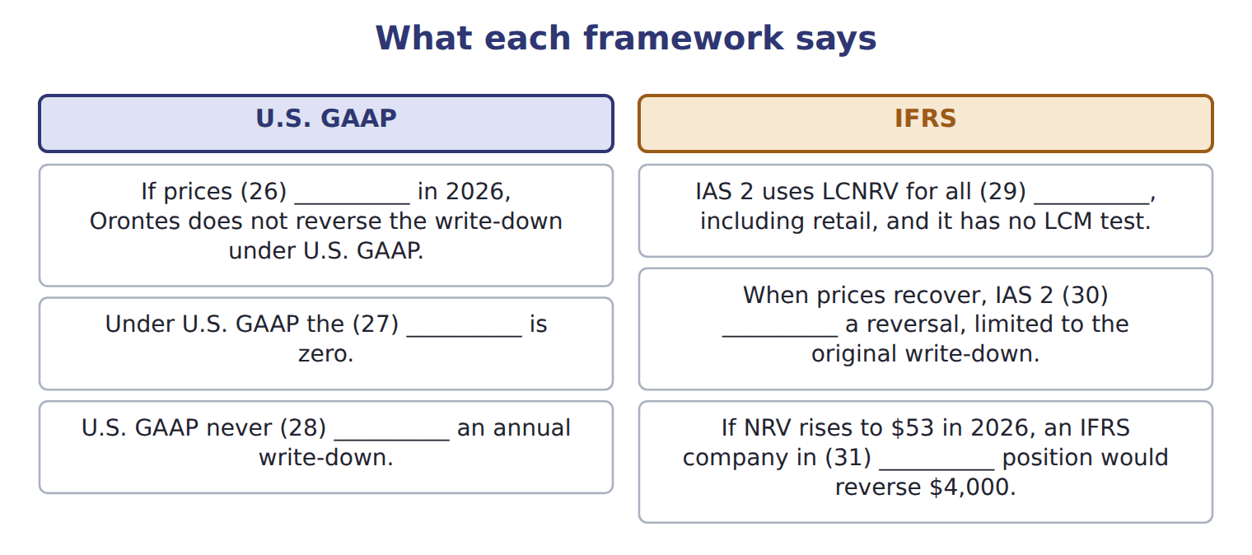
word list
Orontes's · reverses · requires · reversal · markdown · inventories · recover

The English this section uses, and its Arabic
Each term sits against what it means.
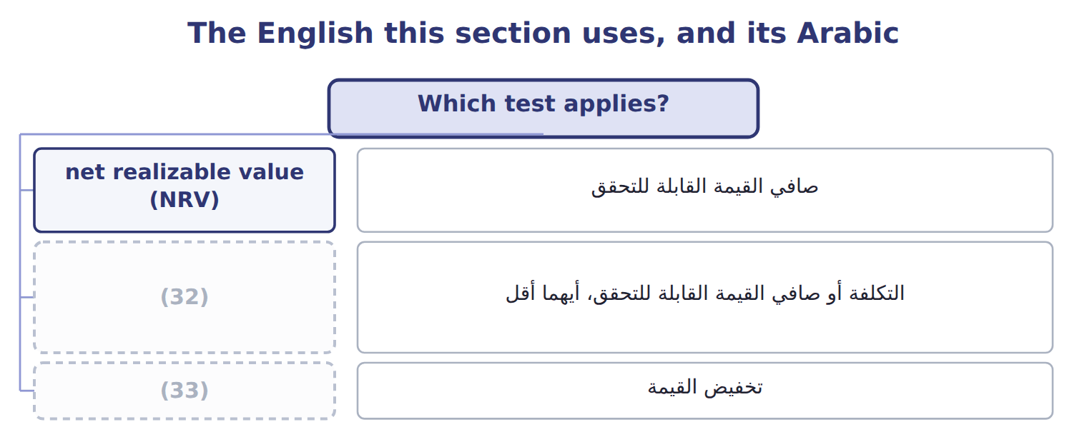
word list
write-down · floor · lower of cost and net realizable value (LCNRV)

The English this sheet uses, and its Arabic
English (exam term) | Arabic
net realizable value (NRV) | صافي القيمة القابلة للتحقق
lower of cost and net realizable value (LCNRV) | التكلفة أو صافي القيمة القابلة للتحقق، أيهما أقل
write-down | تخفيض القيمة

Answer key · 8.1 Which test applies?

1 Which test applies? | 18 Inventory at LCNRV
2 Advantages and disadvantages of the methods | 19 write-down
3 balance | 20 amount
4 whether | 21 write-down
5 recoverable | 22 exception
6 identification | 23 selling
7 market | 24 transport
8 ordinary | 25 floor
9 records | 26 recover
10 usually | 27 reversal
11 separate | 28 reverses
12 ending | 29 inventories
13 competitor | 30 requires
14 delivery | 31 Orontes's
15 Olive oil cases on hand (FIFO layer from Chapter 7) | 32 lower of cost and net realizable value (LCNRV)
16 NRV per case | 33 write-down
17 Inventory at cost

the summaries in full
Summary 1 At each balance sheet date, the company checks whether the cost of its inventory is still recoverable. Inventory measured by FIFO, average cost or specific identification uses the lower of cost and net realizable value (LCNRV). Inventory measured by LIFO or the retail inventory method uses the lower of cost or market (LCM) (Section 8.2). Net realizable value (NRV) is the estimated selling price in the ordinary course of business, minus the costs to complete, sell and transport the goods. If NRV is below cost, the company records a write-down to NRV. The loss goes to income, usually inside cost of goods sold, or as a separate line if it is large.
Summary 2 In, Orontes used FIFO for olive oil. Its ending inventory was 2,000 cases at $50. In late December, a large competitor cut prices. Orontes now expects to sell each case for $54, with $6 of selling and delivery costs.
Summary 3 The write-down of $4,000 is a loss of 2025. The new amount, $48 a case, is now the cost basis of these cases.
Summary 4 A write-down recognized in an interim quarter is the only exception: it may be recovered in a later quarter of the same fiscal year. NRV = selling price − costs to complete, sell and transport. Do NOT deduct a normal profit; that only defines the LCM floor. Check the method first: FIFO or average → LCNRV; LIFO or retail → LCM.

8.2 Lower of cost or market
Chapter 8 · section 8.2

Fill every gap. Each word list holds one word more than there are gaps.
Summary 1 gaps 1–9
Under LCM, market (1) with replacement cost: the current cost to buy or make the item again. But market has two limits. It cannot be (2) than a ceiling equal to NRV, and it cannot be lower than a floor equal to NRV minus a (3) profit margin. The (4) has two steps. First, find market: take the middle value of replacement cost, the ceiling and the floor. (5) , compare market with cost and take the lower. Why the limits? The ceiling stops the company from (6) inventory above what it can (7) . The floor stops an (8) write-down that would (9) an abnormally high profit when the goods are sold later.
word list
carrying · commitment · excessive · create · Second · procedure · recover · starts · normal · higher

LCM, item by item

Summary 2 gaps 10–11
Values are per case in whole (10) . For each line, market is the (11) of the three limits, and LCM is the lower of cost and market.
word list
dollars · directly · middle

LCM, item by item, for four Orontes product lines measured under LIFO (whole USD per case)
The parts add up to the total; the bars are to scale.
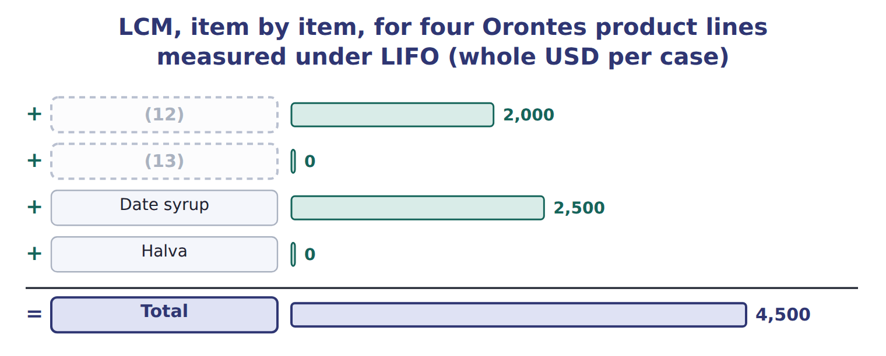
word list
shrinkage · Tahini · Chickpeas

Summary 3 gaps 14–21
The item-by-item basis gives a total write-down of $4,500. A company may also apply LCM by category or to the total inventory, if it does so (14) . On the total basis, total market ($121,500) is (15) with total cost ($122,000), and the write-down is only $500, (16) gains on some items (17) losses on others. The item-by-item basis is the most (18) . One more rule: if a company has a firm, (19) purchase commitment at a price above the current market, it records the (20) loss now, in the current (21) .
word list
expected · compared · offset · period · conservative · because · non-cancellable · question · consistently

Find market first

Summary 4 gaps 22–23
Do not compare replacement cost (22) with cost. First limit it by the ceiling and the floor. When replacement cost is below the floor, market is the floor. When it is above the ceiling, market is the ceiling. Read the basis in the (23) : item by item, by category or total.
word list
consistently · question · directly

The English this section uses, and its Arabic
Each term sits against what it means.
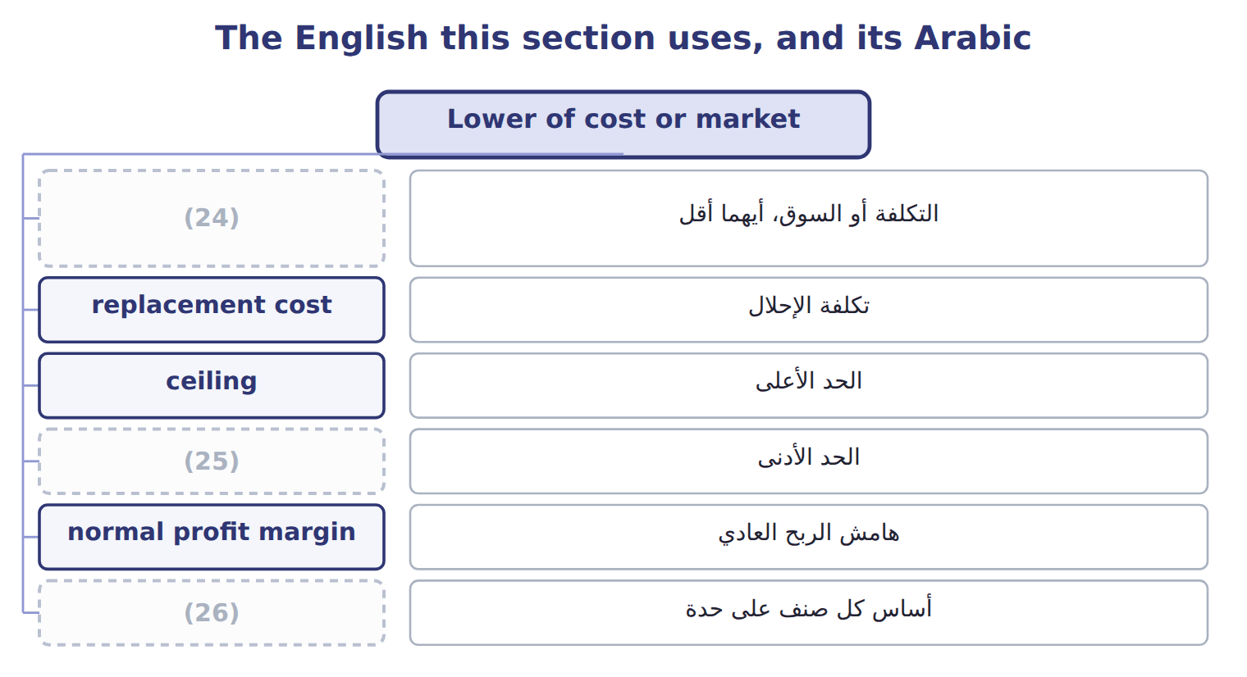
word list
floor · lower of cost or market (LCM) · item-by-item basis · net realizable value (NRV)

The English this sheet uses, and its Arabic
English (exam term) | Arabic
lower of cost or market (LCM) | التكلفة أو السوق، أيهما أقل
replacement cost | تكلفة الإحلال
ceiling | الحد الأعلى
floor | الحد الأدنى
normal profit margin | هامش الربح العادي
item-by-item basis | أساس كل صنف على حدة
purchase commitment | التزام شراء

Answer key · 8.2 Lower of cost or market

1 starts | 14 consistently
2 higher | 15 compared
3 normal | 16 because
4 procedure | 17 offset
5 Second | 18 conservative
6 carrying | 19 non-cancellable
7 recover | 20 expected
8 excessive | 21 period
9 create | 22 directly
10 dollars | 23 question
11 middle | 24 lower of cost or market (LCM)
12 Tahini | 25 floor
13 Chickpeas | 26 item-by-item basis

the summaries in full
Summary 1 Under LCM, market starts with replacement cost: the current cost to buy or make the item again. But market has two limits. It cannot be higher than a ceiling equal to NRV, and it cannot be lower than a floor equal to NRV minus a normal profit margin. The procedure has two steps. First, find market: take the middle value of replacement cost, the ceiling and the floor. Second, compare market with cost and take the lower. Why the limits? The ceiling stops the company from carrying inventory above what it can recover. The floor stops an excessive write-down that would create an abnormally high profit when the goods are sold later.
Summary 2 Values are per case in whole dollars. For each line, market is the middle of the three limits, and LCM is the lower of cost and market.
Summary 3 The item-by-item basis gives a total write-down of $4,500. A company may also apply LCM by category or to the total inventory, if it does so consistently. On the total basis, total market ($121,500) is compared with total cost ($122,000), and the write-down is only $500, because gains on some items offset losses on others. The item-by-item basis is the most conservative. One more rule: if a company has a firm, non-cancellable purchase commitment at a price above the current market, it records the expected loss now, in the current period.
Summary 4 Do not compare replacement cost directly with cost. First limit it by the ceiling and the floor. When replacement cost is below the floor, market is the floor. When it is above the ceiling, market is the ceiling. Read the basis in the question: item by item, by category or total.

8.3 The retail inventory method and the gross profit method
Chapter 8 · section 8.3

Fill every gap. Each word list holds one word more than there are gaps.
Summary 1 gaps 1–9
Retailers sell (1) of items. They know the selling price of every item on the shelf, but (2) the cost of each one is (3) . The retail inventory method estimates ending inventory at cost from retail prices. It uses a (4) ratio: goods available at cost (5) by goods available at retail. Retail prices (6) during the year. A markup raises the selling price above the (7) retail price. A (8) lowers it. The conventional retail method includes net markups in the ratio but leaves out net markdowns. This gives a lower ratio and a lower ending inventory, which (9) LCM. The average-cost retail method includes both.
word list
approximates · thousands · change · cost-to-retail · divided · markdown · expensive · original · tracking · floor

Item — Cost column
Every item belongs to exactly one group.
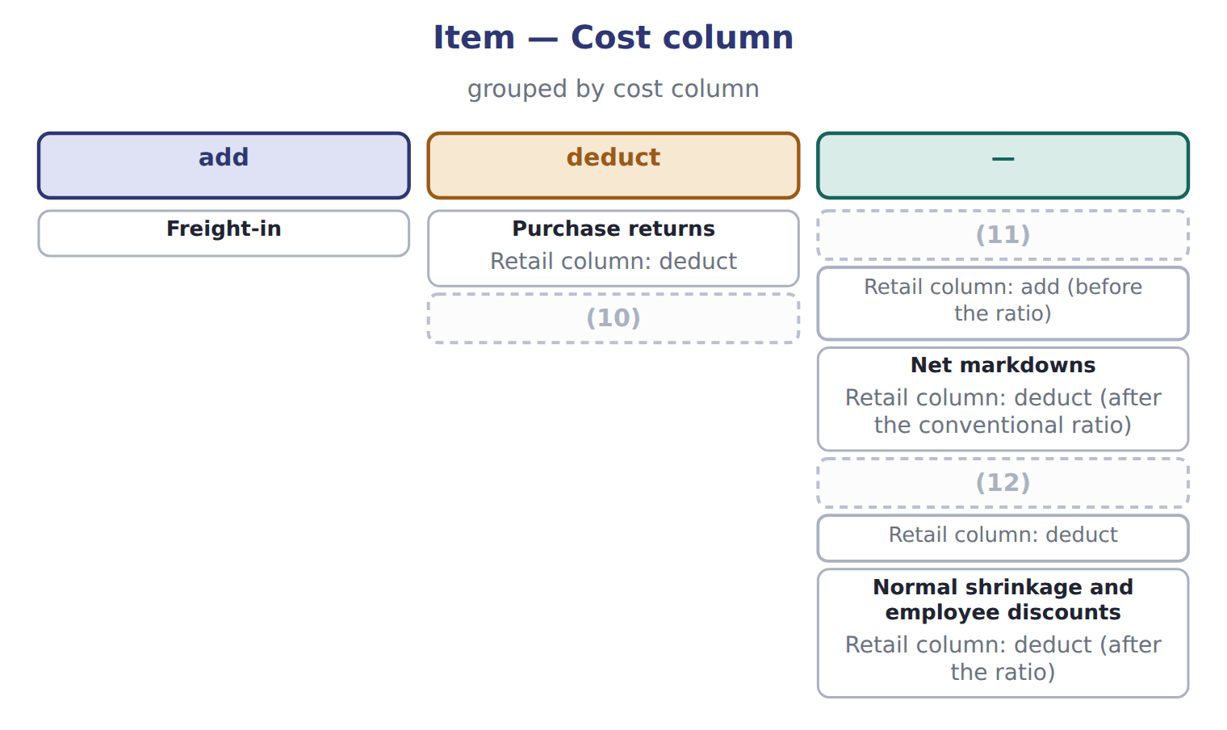
word list
Net sales · Net markups · cost-to-retail ratio · Purchase discounts

Orontes Farm Shops, Amman

Summary 2 gaps 13–16
Orontes runs a group of farm shops in Amman. They (13) under U.S. GAAP with the rest of the company. The conventional ratio is 0.60, so ending (14) at cost is $25,200. The (15) ratio is 0.62, which gives $26,040. Cost of goods sold under the conventional (16) is $186,000 − $25,200 = $160,800.
word list
inventory · method · average-cost · floor · report

The Dubai shop

Summary 3 gaps 17–28
Complete the (17) boxes using the conventional retail method. A LIFO retail method also (18) . It leaves beginning inventory out of the ratio, includes markdowns, and adds a new layer each year at that (19) ratio. The exam tests it less often. The gross profit method estimates ending inventory from the usual gross profit rate. It is used for (20) reports, to check a (21) count, and to (22) inventory lost in a fire or a theft. It is not (23) for annual financial (24) . A fire (25) part of the Orontes (26) in Jebel Ali. Beginning inventory was $80,000, (27) were $300,000 and net sales were $400,000. The usual gross profit rate is 30% of sales. Estimated cost of goods sold is $280,000, so estimated inventory at the date of the fire is $380,000 − $280,000 = $100,000. Goods (28) $12,000 were saved, so the estimated fire loss is $88,000.
word list
purchases · warehouse · year's · thousands · costing · interim · statements · physical · destroyed · estimate · acceptable · exists · dashed

Markup on cost is not a margin on sales

Summary 4 gaps 29–33
If the (29) gives a markup on cost, (30) it: gross profit rate on sales = markup ÷ (1 + markup). For example, a markup of one half on cost is a gross profit rate of one third on sales. Conventional retail: markups IN the ratio, markdowns OUT. (31) goes in the cost (32) only; normal (33) is deducted from retail after the ratio.
word list
question · shrinkage · Orontes · convert · column · Freight-in

The English this section uses, and its Arabic
Each term sits against what it means.
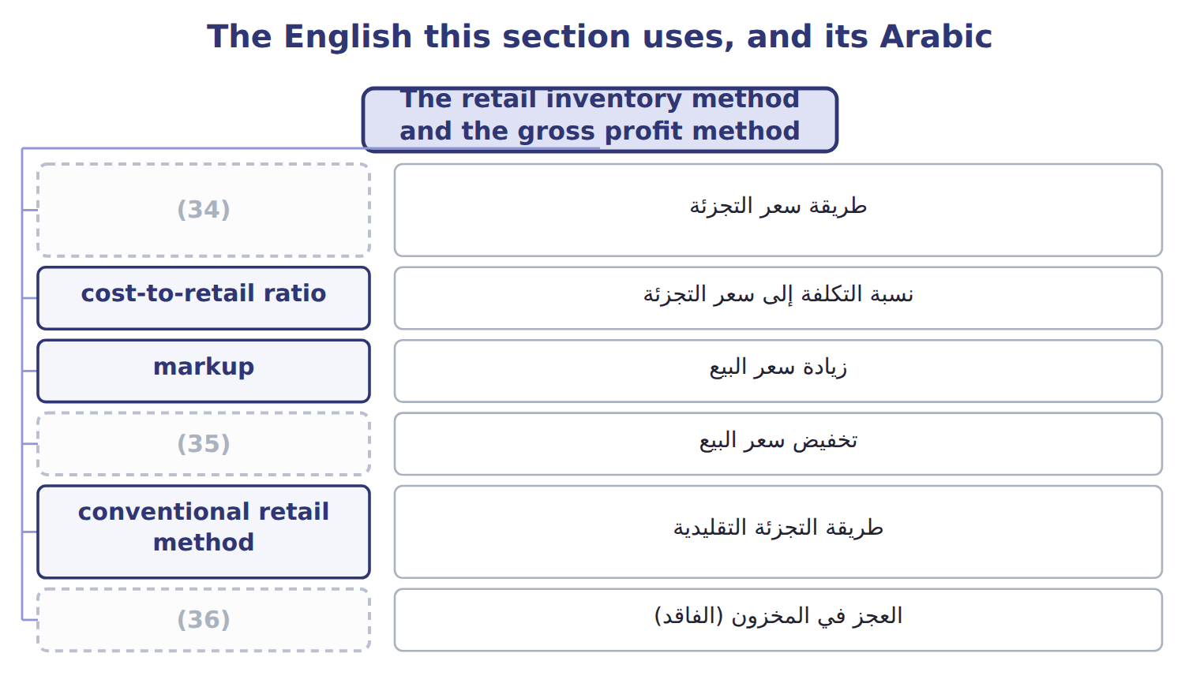
word list
retail inventory method · floor · markdown · shrinkage

The English this sheet uses, and its Arabic
English (exam term) | Arabic
retail inventory method | طريقة سعر التجزئة
cost-to-retail ratio | نسبة التكلفة إلى سعر التجزئة
markup | زيادة سعر البيع
markdown | تخفيض سعر البيع
conventional retail method | طريقة التجزئة التقليدية
shrinkage | العجز في المخزون (الفاقد)
gross profit method | طريقة مجمل الربح

Answer key · 8.3 The retail inventory method and the gross profit method

1 thousands | 19 year's
2 tracking | 20 interim
3 expensive | 21 physical
4 cost-to-retail | 22 estimate
5 divided | 23 acceptable
6 change | 24 statements
7 original | 25 destroyed
8 markdown | 26 warehouse
9 approximates | 27 purchases
10 Purchase discounts | 28 costing
11 Net markups | 29 question
12 Net sales | 30 convert
13 report | 31 Freight-in
14 inventory | 32 column
15 average-cost | 33 shrinkage
16 method | 34 retail inventory method
17 dashed | 35 markdown
18 exists | 36 shrinkage

the summaries in full
Summary 1 Retailers sell thousands of items. They know the selling price of every item on the shelf, but tracking the cost of each one is expensive. The retail inventory method estimates ending inventory at cost from retail prices. It uses a cost-to-retail ratio: goods available at cost divided by goods available at retail. Retail prices change during the year. A markup raises the selling price above the original retail price. A markdown lowers it. The conventional retail method includes net markups in the ratio but leaves out net markdowns. This gives a lower ratio and a lower ending inventory, which approximates LCM. The average-cost retail method includes both.
Summary 2 Orontes runs a group of farm shops in Amman. They report under U.S. GAAP with the rest of the company. The conventional ratio is 0.60, so ending inventory at cost is $25,200. The average-cost ratio is 0.62, which gives $26,040. Cost of goods sold under the conventional method is $186,000 − $25,200 = $160,800.
Summary 3 Complete the dashed boxes using the conventional retail method. A LIFO retail method also exists. It leaves beginning inventory out of the ratio, includes markdowns, and adds a new layer each year at that year's ratio. The exam tests it less often. The gross profit method estimates ending inventory from the usual gross profit rate. It is used for interim reports, to check a physical count, and to estimate inventory lost in a fire or a theft. It is not acceptable for annual financial statements. A fire destroyed part of the Orontes warehouse in Jebel Ali. Beginning inventory was $80,000, purchases were $300,000 and net sales were $400,000. The usual gross profit rate is 30% of sales. Estimated cost of goods sold is $280,000, so estimated inventory at the date of the fire is $380,000 − $280,000 = $100,000. Goods costing $12,000 were saved, so the estimated fire loss is $88,000.
Summary 4 If the question gives a markup on cost, convert it: gross profit rate on sales = markup ÷ (1 + markup). For example, a markup of one half on cost is a gross profit rate of one third on sales. Conventional retail: markups IN the ratio, markdowns OUT. Freight-in goes in the cost column only; normal shrinkage is deducted from retail after the ratio.

8.4 Advantages and disadvantages of the methods
Chapter 8 · section 8.4

Fill every gap. Each word list holds one word more than there are gaps.
Summary 1 gaps 1–2
No method is best in every (1) . Each one is (2) on some goals and weak on others.
word list
situation · weighted · strong

Advantages and disadvantages of the inventory methods
Every item belongs to exactly one group.
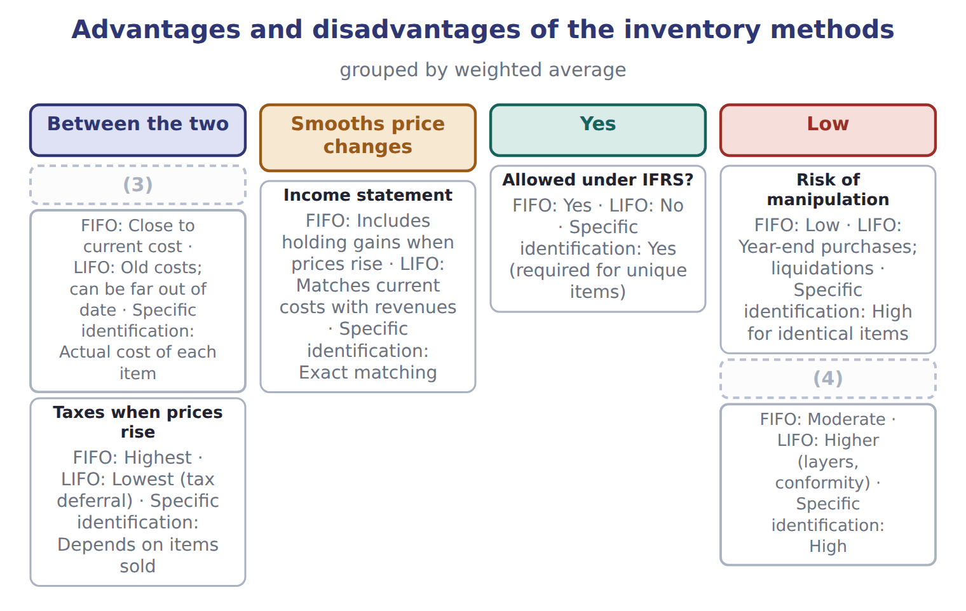
word list
Between the two · Cost of records · Balance sheet (inventory)

Summary 2 gaps 5–13
The weighted average and specific identification have their own (5) . The weighted average is simple, (6) price changes and is hard to (7) , but its results are neither fully current on the balance sheet nor on the income statement. Specific identification gives exact matching for unique items, but for (8) items it is costly and lets (9) choose which costs to report. The main (10) is between the two (11) . LIFO gives a more realistic income statement when (12) change, but an (13) balance sheet. FIFO gives a realistic balance sheet, but its income includes holding gains. The weighted average sits between them.
word list
trade-off · management · statements · strengths · identical · out-of-date · ceiling · manipulate · smooths · prices

Answer key · 8.4 Advantages and disadvantages of the methods

1 situation | 8 identical
2 strong | 9 management
3 Balance sheet (inventory) | 10 trade-off
4 Cost of records | 11 statements
5 strengths | 12 prices
6 smooths | 13 out-of-date
7 manipulate

the summaries in full
Summary 1 No method is best in every situation. Each one is strong on some goals and weak on others.
Summary 2 The weighted average and specific identification have their own strengths. The weighted average is simple, smooths price changes and is hard to manipulate, but its results are neither fully current on the balance sheet nor on the income statement. Specific identification gives exact matching for unique items, but for identical items it is costly and lets management choose which costs to report. The main trade-off is between the two statements. LIFO gives a more realistic income statement when prices change, but an out-of-date balance sheet. FIFO gives a realistic balance sheet, but its income includes holding gains. The weighted average sits between them.

8.5 Recommending a method
Chapter 8 · section 8.5

Fill every gap. Each word list holds one word more than there are gaps.
Summary 1 gaps 1–7
A Level C question may give you a set of facts and ask you to (1) a method. (2) check the facts that can rule a method out. If the company, or its (3) , reports under IFRS, LIFO is not (4) . If items are identical and sold in large volumes, specific (5) is costly and open to (6) . If the company wants the U.S. tax benefit of LIFO, it must also report LIFO profits to investors, and it must avoid (7) old layers.
word list
parent · possible · Always · identification · liquidating · records · recommend · manipulation

A recommendation for Orontes

Summary 2 gaps 8–17
Orontes reports under U.S. GAAP, and olive oil prices are (8) . The finance (9) wants lower taxes but also a balance sheet that lenders trust. Olive oil is a (10) , identical product that Orontes ships (11) . LIFO would lower taxes while prices rise, but (12) would lower (13) profits too, and the balance sheet would show old costs. FIFO (14) the physical flow and gives lenders a (15) inventory amount, but taxes are higher. Recommendation: if the tax saving is the priority, LIFO, with clear (16) of the LIFO reserve; if lender (17) and the balance sheet matter more, FIFO. The answer depends on the stated priority, and a good exam answer names it.
word list
perishable · rising · matches · conformity · specific · disclosure · oldest-first · reported · current · relations · director

Recommendations need reasons

Summary 3 gaps 18–19
In a (18) question, a recommendation earns credit only if it follows from the facts given. Check IFRS, taxes, price trends, the physical flow and the cost of (19) before you choose.
word list
case-based · profits · records

Recommendations need reasons
Item | Method | Units | Unit cost | Replace-ment cost | Selling price | Costs to sell | Normal profit
Pomegranate molasses | LIFO | 800 | 25 | 21 | 32 | 3 | 6
Rose water | (20) | 1,200 | 10 | 11 | 16 | 2 | 3
Za'atar mix | (21) | 2,000 | 12 | 10 | 14 | 3 | 2
Frozen kibbeh | FIFO | 1,000 | 30 | 29 | 36 | 4 | 5
Olive-oil soap | FIFO | 500 | 8 | 7 | 9 | 2.5 | 1

word list
floor · LIFO · FIFO

Item — Answer
Item | Answer
Goods available at retail | 150,000 − 6,000 = 144,000
Ending inventory at retail | (22)
Conventional ratio | (23)
Ending inventory at cost | 24,000 × 0.60 = $14,400

word list
24,000 × 0.60 = $14,400 · 90,000 ÷ 150,000 = 0.60 · 144,000 − 120,000 = 24,000

Product line — Category
Product line | Category
Pomegranate molasses | LCM (market with ceiling and floor)
Rose water | (24)
Za'atar mix | LCNRV
Frozen kibbeh | LCNRV
Olive-oil soap | (25)

word list
LCM (market with ceiling and floor) · purchase commitment · LCNRV

Answer key · 8.5 Recommending a method

1 recommend | 14 matches
2 Always | 15 current
3 parent | 16 disclosure
4 possible | 17 relations
5 identification | 18 case-based
6 manipulation | 19 records
7 liquidating | 20 LIFO
8 rising | 21 FIFO
9 director | 22 144,000 − 120,000 = 24,000
10 perishable | 23 90,000 ÷ 150,000 = 0.60
11 oldest-first | 24 LCM (market with ceiling and floor)
12 conformity | 25 LCNRV
13 reported

the summaries in full
Summary 1 A Level C question may give you a set of facts and ask you to recommend a method. Always check the facts that can rule a method out. If the company, or its parent, reports under IFRS, LIFO is not possible. If items are identical and sold in large volumes, specific identification is costly and open to manipulation. If the company wants the U.S. tax benefit of LIFO, it must also report LIFO profits to investors, and it must avoid liquidating old layers.
Summary 2 Orontes reports under U.S. GAAP, and olive oil prices are rising. The finance director wants lower taxes but also a balance sheet that lenders trust. Olive oil is a perishable, identical product that Orontes ships oldest-first. LIFO would lower taxes while prices rise, but conformity would lower reported profits too, and the balance sheet would show old costs. FIFO matches the physical flow and gives lenders a current inventory amount, but taxes are higher. Recommendation: if the tax saving is the priority, LIFO, with clear disclosure of the LIFO reserve; if lender relations and the balance sheet matter more, FIFO. The answer depends on the stated priority, and a good exam answer names it.
Summary 3 In a case-based question, a recommendation earns credit only if it follows from the facts given. Check IFRS, taxes, price trends, the physical flow and the cost of records before you choose.

9.1 Three categories of debt securities
Chapter 9 · section 9.1

Fill every gap. Each word list holds one word more than there are gaps.
Chapter 9, section by section
Each stage leads to the next.
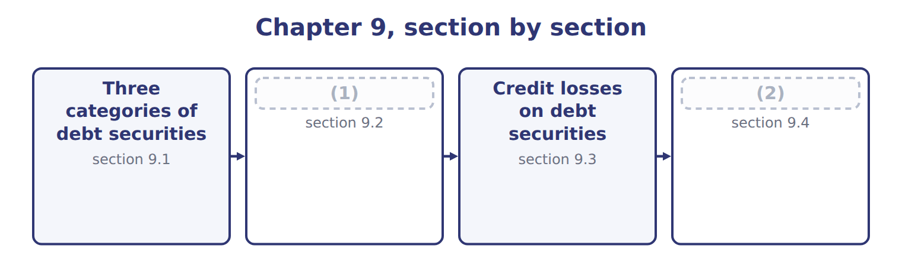
word list
Equity securities and the equity method · other comprehensive income (OCI) · Measuring debt securities

Summary 1 gaps 3–14
A debt security gives its (3) a right to interest and to (4) , like a bond. An equity security gives an (5) interest, like (6) of common stock. Section 9.4 (7) equity securities. When a company buys a debt security, it (8) it into one of three categories, and it reassesses the (9) at each reporting date. The category depends on (10) intent and ability, not on the type of bond. Trading securities are (11) and held mainly to sell in the near term. (12) (HTM) securities are securities the company has the (13) intent and the ability to hold until they mature. (14) (AFS) securities are all other debt securities. HTM is a strict category. If the company would sell the bond when interest rates change or when it needs cash, it does not have the intent to hold it. And if it sells or transfers HTM securities for other reasons, it taints the whole HTM portfolio, which raises doubt about its intent for all its other HTM securities.
word list
classification · ownership · holder · current · covers · Available-for-sale · positive · Held-to-maturity · management's · shares · classifies · bought · repayment

Summary 2 gaps 15–19
The (15) allows a few (16) , such as a sale after the issuer's credit quality falls sharply, or a sale very close to maturity. A company may also elect the fair value (17) for a security when it first (18) it. The election is (19) , and all changes in fair value then go to net income.
word list
option · recognizes · exceptions · standard · security · irrevocable

Intent decides

Summary 3 gaps 20–21
The same bond can be trading, AFS or HTM. Read the facts about intent and ability. A company that might sell when rates change (20) use HTM. Equity securities are never trading, AFS or HTM under (21) U.S. GAAP.
word list
current · cannot · securities

The English this section uses, and its Arabic
Each term sits against what it means.
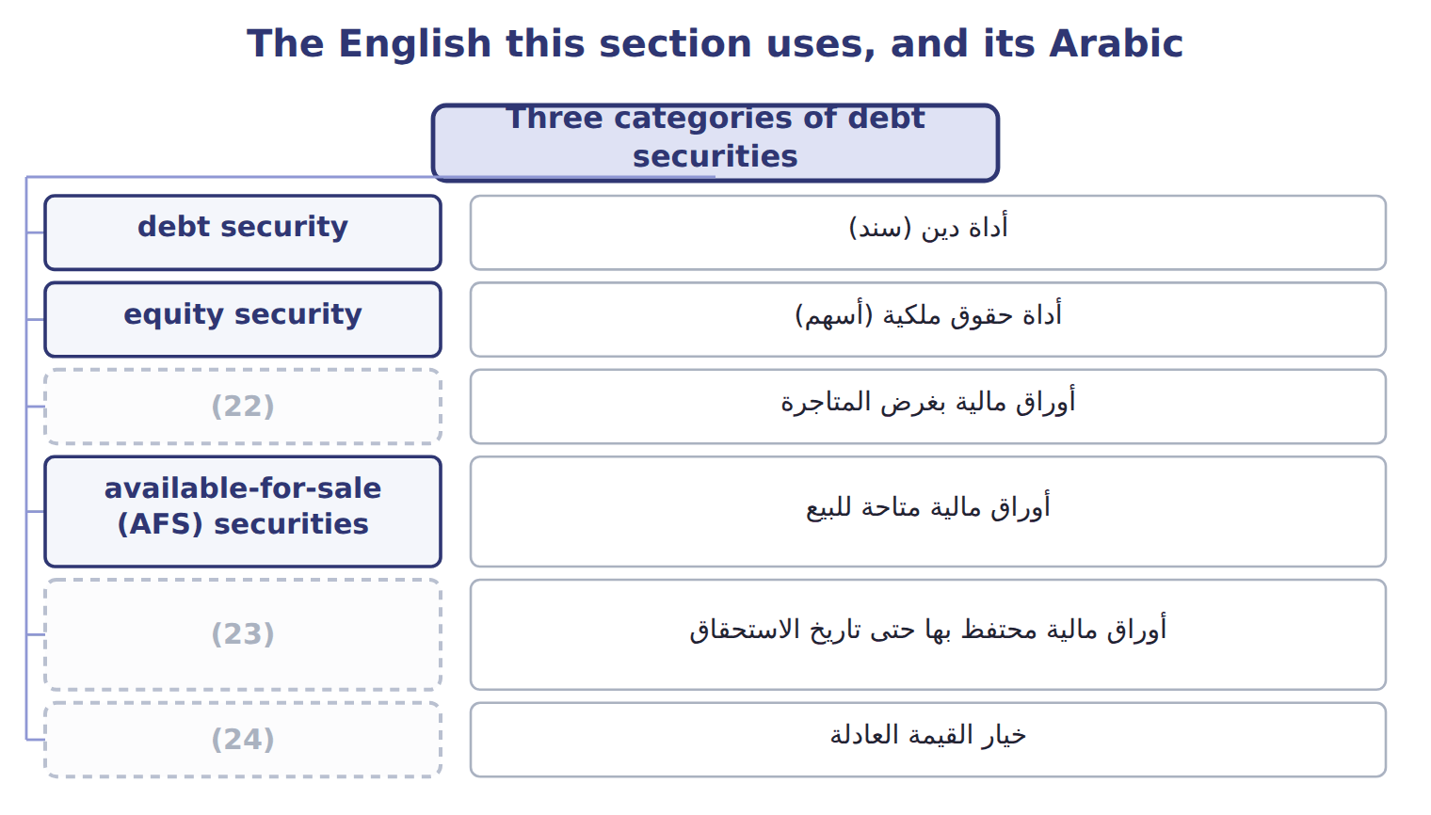
word list
held-to-maturity (HTM) securities · fair value option · أداة دين (سند) · trading securities

The English this sheet uses, and its Arabic
English (exam term) | Arabic
debt security | أداة دين (سند)
equity security | أداة حقوق ملكية (أسهم)
trading securities | أوراق مالية بغرض المتاجرة
available-for-sale (AFS) securities | أوراق مالية متاحة للبيع
held-to-maturity (HTM) securities | أوراق مالية محتفظ بها حتى تاريخ الاستحقاق
fair value option | خيار القيمة العادلة

Answer key · 9.1 Three categories of debt securities

1 Measuring debt securities | 13 positive
2 Equity securities and the equity method | 14 Available-for-sale
3 holder | 15 standard
4 repayment | 16 exceptions
5 ownership | 17 option
6 shares | 18 recognizes
7 covers | 19 irrevocable
8 classifies | 20 cannot
9 classification | 21 current
10 management's | 22 trading securities
11 bought | 23 held-to-maturity (HTM) securities
12 Held-to-maturity | 24 fair value option

the summaries in full
Summary 1 A debt security gives its holder a right to interest and to repayment, like a bond. An equity security gives an ownership interest, like shares of common stock. Section 9.4 covers equity securities. When a company buys a debt security, it classifies it into one of three categories, and it reassesses the classification at each reporting date. The category depends on management's intent and ability, not on the type of bond. Trading securities are bought and held mainly to sell in the near term. Held-to-maturity (HTM) securities are securities the company has the positive intent and the ability to hold until they mature. Available-for-sale (AFS) securities are all other debt securities. HTM is a strict category. If the company would sell the bond when interest rates change or when it needs cash, it does not have the intent to hold it. And if it sells or transfers HTM securities for other reasons, it taints the whole HTM portfolio, which raises doubt about its intent for all its other HTM securities.
Summary 2 The standard allows a few exceptions, such as a sale after the issuer's credit quality falls sharply, or a sale very close to maturity. A company may also elect the fair value option for a security when it first recognizes it. The election is irrevocable, and all changes in fair value then go to net income.
Summary 3 The same bond can be trading, AFS or HTM. Read the facts about intent and ability. A company that might sell when rates change cannot use HTM. Equity securities are never trading, AFS or HTM under current U.S. GAAP.

9.2 Measuring debt securities
Chapter 9 · section 9.2

Fill every gap. Each word list holds one word more than there are gaps.
Summary 1 gaps 1–4
Trading and AFS securities are reported at fair value: the price the company would (1) if it sold the security in an orderly (2) . HTM securities are reported at amortized cost. The main difference between trading and AFS is where the unrealized (3) gain or loss goes. For trading it goes to net income. For AFS it goes to other (4) income (OCI).
word list
comprehensive · transaction · holding · receive · between

How each category of investment is measured
Every item belongs to exactly one group.
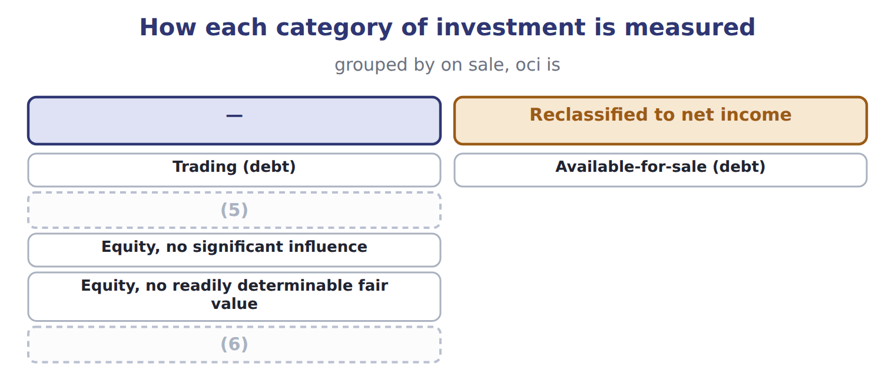
word list
Equity method · Held-to-maturity (debt) · debt security

Summary 2 gaps 7–13
A bond is (7) at a bond premium when its stated interest rate is (8) than the market rate, and at a bond discount when it is lower. Under the (9) method, interest revenue for each year is the carrying amount at the start of the year multiplied by the market rate at (10) . The cash (11) is the face amount multiplied by the stated rate. The difference (12) the premium or discount, so the carrying amount moves (13) face value.
word list
orderly · toward · bought · higher · received · purchase · effective-interest · amortizes

Orontes buys a corporate bond

Summary 3 gaps 14–15
On (14) 1, 2025, Orontes buys a 3-year bond with a face amount of $100,000 and a stated rate of 6%, paid each (15) 31. The market rate is 5%, so Orontes pays $102,723, a premium of $2,723.
word list
sometimes · December · January

Orontes buys a corporate bond
Name each line from how it moves.
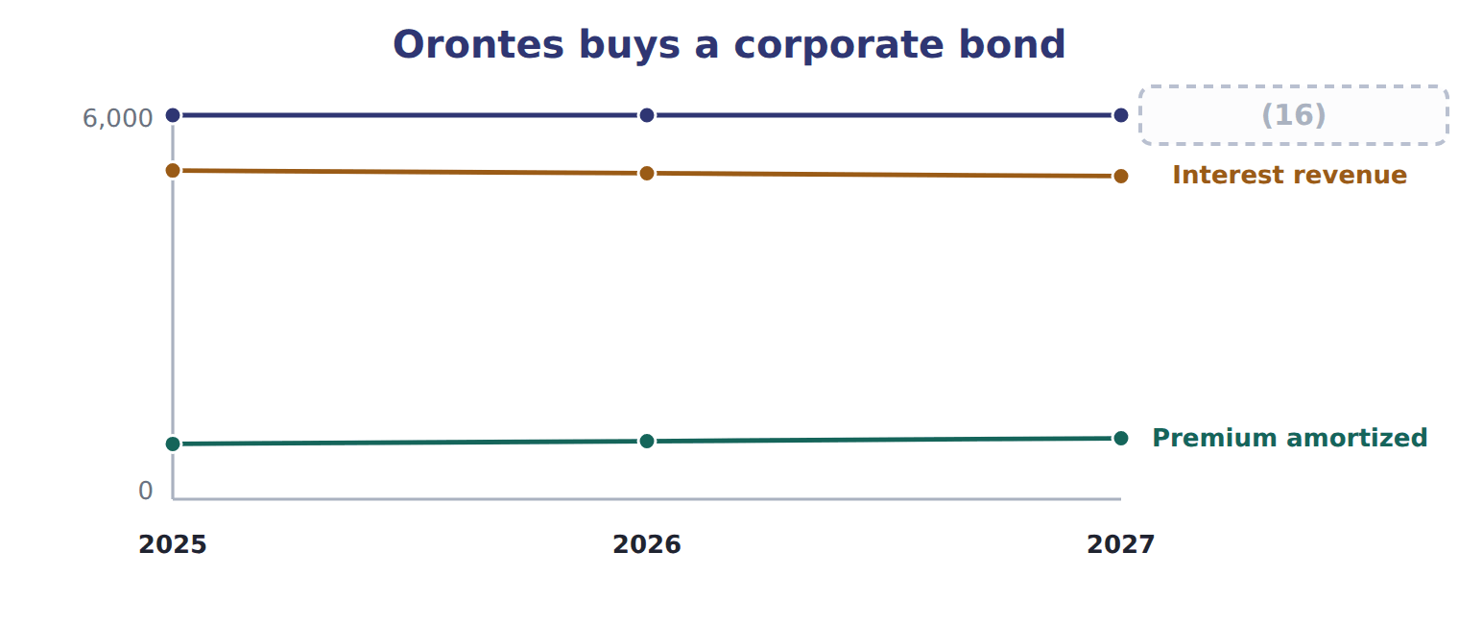
word list
debt security · Cash interest

Summary 4 gaps 17–18
In 2025, (17) revenue is $102,723 × 5% = $5,136. At (18) the bond's fair value is $101,000.
word list
interest · year-end · sometimes

The same bond under three categories, 2025 (whole USD)
Every item belongs to exactly one group.
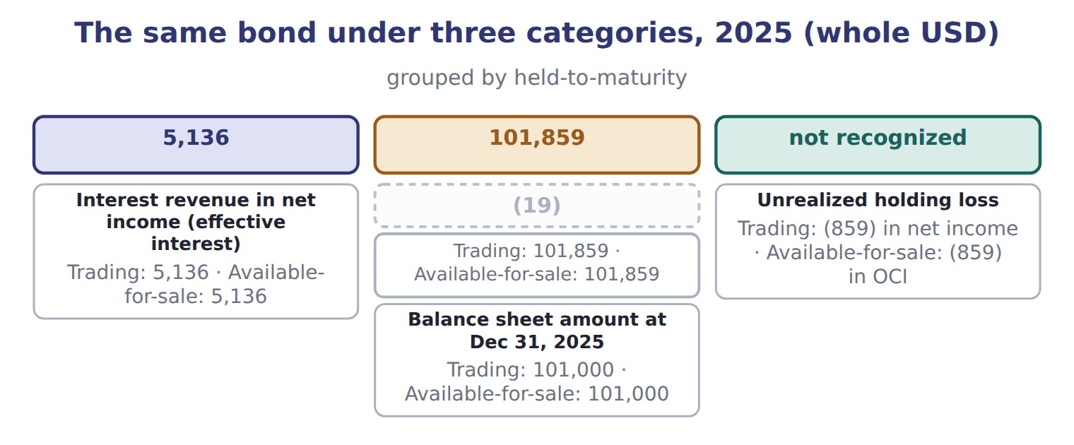
word list
unrealized holding gain or loss · Amortized cost at Dec 31, 2025

Summary 5 gaps 20–30
Interest revenue is the same in all three categories. Only the (20) sheet amount and the place of the unrealized loss (21) . While Orontes holds an AFS bond, its unrealized gains and (22) build up in accumulated OCI, part of (23) . When Orontes sells the bond, the realized gain or loss moves to net income through a (24) adjustment, (25) called recycling. On the sale, the realized gain is the price minus the amortized cost: $101,500 − $100,952 = $548. Accumulated OCI for the bond (26) to zero, so the gain is never (27) twice. Transfers between categories are made at fair value. When a security moves into trading, any unrealized gain or loss not yet in net income goes to net income (28) . When an AFS security moves to HTM, the unrealized amount stays in accumulated OCI and is amortized over the (29) life. Transfers into or out of trading (30) be rare.
word list
balance · remaining · reclassification · differ · sometimes · immediately · discount · should · returns · counted · equity · losses

Where does it go?

Summary 6 gaps 31–33
Trading: fair value (31) in net income. Interest revenue = (32) carrying amount × market rate, not face × stated rate. On sale of AFS debt, (33) the accumulated OCI; do not count the gain twice.
word list
changes · remaining · beginning · recycle

The English this section uses, and its Arabic
Each term sits against what it means.
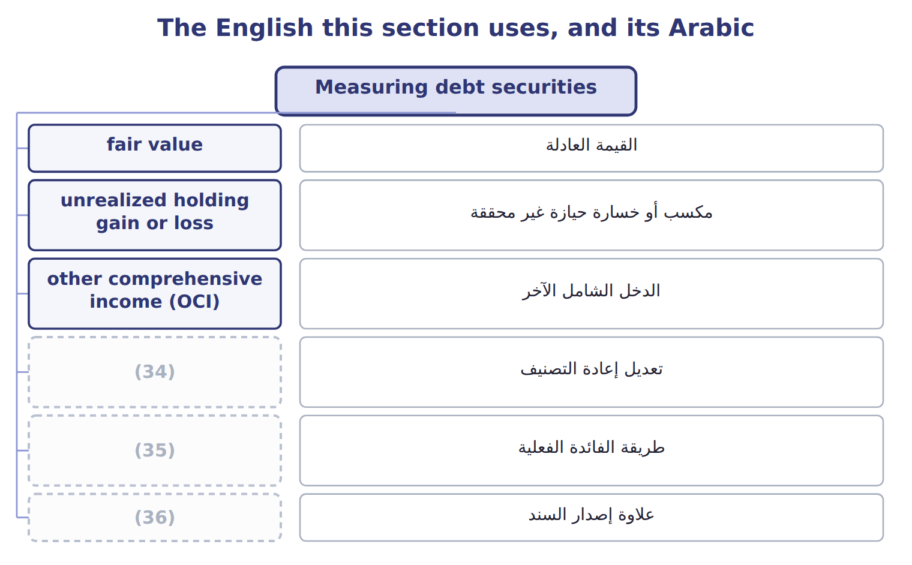
word list
reclassification adjustment · bond discount · effective-interest method · bond premium

The English this sheet uses, and its Arabic
English (exam term) | Arabic
fair value | القيمة العادلة
unrealized holding gain or loss | مكسب أو خسارة حيازة غير محققة
other comprehensive income (OCI) | الدخل الشامل الآخر
reclassification adjustment | تعديل إعادة التصنيف
effective-interest method | طريقة الفائدة الفعلية
bond premium | علاوة إصدار السند
bond discount | خصم إصدار السند

Answer key · 9.2 Measuring debt securities

1 receive | 19 Amortized cost at Dec 31, 2025
2 transaction | 20 balance
3 holding | 21 differ
4 comprehensive | 22 losses
5 Held-to-maturity (debt) | 23 equity
6 Equity method | 24 reclassification
7 bought | 25 sometimes
8 higher | 26 returns
9 effective-interest | 27 counted
10 purchase | 28 immediately
11 received | 29 remaining
12 amortizes | 30 should
13 toward | 31 changes
14 January | 32 beginning
15 December | 33 recycle
16 Cash interest | 34 reclassification adjustment
17 interest | 35 effective-interest method
18 year-end | 36 bond premium

the summaries in full
Summary 1 Trading and AFS securities are reported at fair value: the price the company would receive if it sold the security in an orderly transaction. HTM securities are reported at amortized cost. The main difference between trading and AFS is where the unrealized holding gain or loss goes. For trading it goes to net income. For AFS it goes to other comprehensive income (OCI).
Summary 2 A bond is bought at a bond premium when its stated interest rate is higher than the market rate, and at a bond discount when it is lower. Under the effective-interest method, interest revenue for each year is the carrying amount at the start of the year multiplied by the market rate at purchase. The cash received is the face amount multiplied by the stated rate. The difference amortizes the premium or discount, so the carrying amount moves toward face value.
Summary 3 On January 1, 2025, Orontes buys a 3-year bond with a face amount of $100,000 and a stated rate of 6%, paid each December 31. The market rate is 5%, so Orontes pays $102,723, a premium of $2,723.
Summary 4 In 2025, interest revenue is $102,723 × 5% = $5,136. At year-end the bond's fair value is $101,000.
Summary 5 Interest revenue is the same in all three categories. Only the balance sheet amount and the place of the unrealized loss differ. While Orontes holds an AFS bond, its unrealized gains and losses build up in accumulated OCI, part of equity. When Orontes sells the bond, the realized gain or loss moves to net income through a reclassification adjustment, sometimes called recycling. On the sale, the realized gain is the price minus the amortized cost: $101,500 − $100,952 = $548. Accumulated OCI for the bond returns to zero, so the gain is never counted twice. Transfers between categories are made at fair value. When a security moves into trading, any unrealized gain or loss not yet in net income goes to net income immediately. When an AFS security moves to HTM, the unrealized amount stays in accumulated OCI and is amortized over the remaining life. Transfers into or out of trading should be rare.
Summary 6 Trading: fair value changes in net income. Interest revenue = beginning carrying amount × market rate, not face × stated rate. On sale of AFS debt, recycle the accumulated OCI; do not count the gain twice.

9.3 Credit losses on debt securities
Chapter 9 · section 9.3

Fill every gap. Each word list holds one word more than there are gaps.
Summary 1 gaps 1–7
HTM securities are (1) at amortized cost, so they follow CECL, like the (2) : the company records an allowance for (3) expected credit losses from day one. For very safe bonds, such as U.S. (4) bonds, the expected loss can be zero. AFS securities follow a (5) model. A security is (6) when its fair value is below its amortized cost. The credit part is (7) in an allowance through net income. The rest of the decline goes to OCI.
word list
measured · receivables · recorded · Otherwise · different · impaired · Treasury · lifetime

The fair-value floor

The test, and what follows either way
One route applies, and only one.
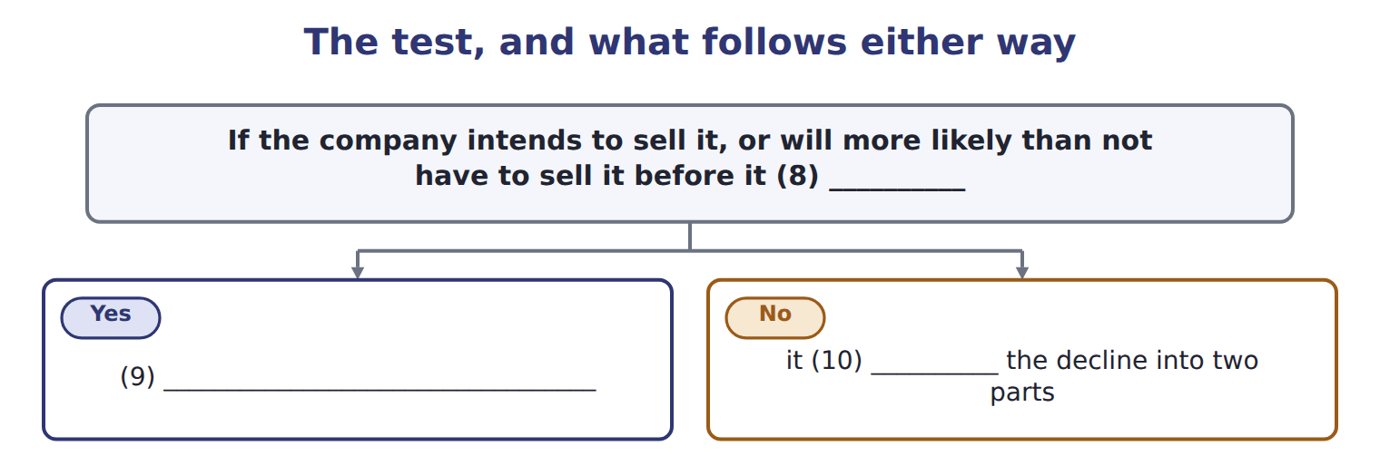
word list
writes the security down to fair value through net income · recovers · reclassification adjustment · separates

Summary 2 gaps 11–15
An AFS bond has an amortized cost of $50,000 and a fair value of $44,000. The allowance can never be (11) than amortized cost minus fair value: $6,000. Case A: the present value of expected cash flows is $47,000. The credit loss is $3,000 (allowance, net income), and the other $3,000 of the decline goes to OCI. Case B: the present value of expected cash flows is $42,000. The credit loss would be $8,000, but the allowance is (12) to $6,000. (13) goes to OCI. If credit quality (14) later, the allowance can be (15) through net income.
word list
larger · Otherwise · limited · reversed · Nothing · improves

The AFS floor

Summary 3 gaps 16–17
AFS allowance ≤ (16) cost − fair value. HTM has no such limit. If the company (17) to sell, there is no allowance: write the bond down to fair value.
word list
intends · amortized · impaired

Answer key · 9.3 Credit losses on debt securities

1 measured | 10 separates
2 receivables | 11 larger
3 lifetime | 12 limited
4 Treasury | 13 Nothing
5 different | 14 improves
6 impaired | 15 reversed
7 recorded | 16 amortized
8 recovers | 17 intends
9 writes the security down to fair value through net income

the summaries in full
Summary 1 HTM securities are measured at amortized cost, so they follow CECL, like the receivables: the company records an allowance for lifetime expected credit losses from day one. For very safe bonds, such as U.S. Treasury bonds, the expected loss can be zero. AFS securities follow a different model. A security is impaired when its fair value is below its amortized cost. The credit part is recorded in an allowance through net income. The rest of the decline goes to OCI.
Summary 2 An AFS bond has an amortized cost of $50,000 and a fair value of $44,000. The allowance can never be larger than amortized cost minus fair value: $6,000. Case A: the present value of expected cash flows is $47,000. The credit loss is $3,000 (allowance, net income), and the other $3,000 of the decline goes to OCI. Case B: the present value of expected cash flows is $42,000. The credit loss would be $8,000, but the allowance is limited to $6,000. Nothing goes to OCI. If credit quality improves later, the allowance can be reversed through net income.
Summary 3 AFS allowance ≤ amortized cost − fair value. HTM has no such limit. If the company intends to sell, there is no allowance: write the bond down to fair value.

9.4 Equity securities and the equity method
Chapter 9 · section 9.4

Fill every gap. Each word list holds one word more than there are gaps.
Summary 1 gaps 1–9
For shares, the key (1) is how much influence the investor has over the investee, the company whose shares it holds. Shares with a readily determinable fair value are measured at fair value, and all changes go to net income. There is no AFS category and no OCI option for shares. Dividends received are income. For example, Orontes bought listed shares for $20,000; at (2) they are worth $23,500, and Orontes received dividends of $400. Net income includes an (3) gain of $3,500 and dividend income of $400. For shares with no readily determinable fair value, such as shares of a (4) company, the investor may use the (5) alternative: cost minus impairment, (6) when an orderly (7) in the same or a (8) share shows a new price. An investor with significant influence can take part in the investee's (9) and operating decisions.
word list
year-end · similar · unrealized · financial · transaction · measurement · adjusted · private · question · operating

Summary 2 gaps 10–16
Influence is (10) when the investor holds 20% to 50% of the voting stock, but the (11) decides: a board seat, (12) in policy decisions or large (13) between the companies can show influence even below 20%. With significant influence, the investor uses the equity method. Under the equity method, the investment starts at cost. It (14) by the investor's share of the investee's net income and (15) by the dividends the investor receives. The dividends are not income, (16) they only return part of the investment.
word list
presumed · decisions · decreases · evidence · because · transactions · increases · participation

Orontes and Jordan Glass Co.

Summary 3 gaps 17–23
On (17) 1, 2025, Orontes buys 30% of Jordan Glass Co., its bottle (18) , for $1,200,000. Jordan (19) net assets have a book value of $3,000,000, so Orontes's share of book value is $900,000. The basis difference of $300,000 has two parts: $30,000 for Orontes's share of (20) worth more than its book value, which is (21) over 10 years ($3,000 a year), and $270,000 of goodwill, which is not amortized. In 2025 Jordan Glass earns $500,000 and pays dividends of $200,000. Orontes (22) equity-method income of $147,000 and an investment of $1,287,000 at the end of 2025. The dividends of $60,000 are cash in and investment out; they do not (23) net income.
word list
supplier · equipment · change · depreciated · Glass's · private · January · reports

Jordan Glass in 2026

Summary 4 gaps 24–35
In 2026 Jordan Glass earns $400,000 and pays dividends of $100,000. The extra depreciation is the same as in 2025. Three more equity-method rules appear in exam (24) . (25) reduce the investment only to zero, (26) the investor has (27) the investee's debts. Profits on sales between the two companies are (28) until the goods are sold to (29) . And when an investor first gains significant influence, it starts the equity method from that date; it does not (30) prior years. An investor may also elect the fair value option for an equity-method investment. Crypto assets that meet the ASU 2023-08 (31) are measured at fair value through net income. This rule became (32) for fiscal years beginning after December 15, 2024, so it is now testable. IFRS 9 (33) debt by the business model and the cash flows (amortized cost, FVOCI or FVPL), not by intent. For shares, IFRS 9 allows an (34) election to put fair value changes in OCI, with no recycling on sale; U.S. GAAP has no such option. Under IAS 28, an equity-method investment that is (35) can later be written back up; under U.S. GAAP the impairment is not reversed.
word list
classifies · guaranteed · readily · questions · eliminated · irrevocable · restate · definition · impaired · effective · unless · outsiders · Losses

Dividends and percentages

Summary 5 gaps 36–38
Equity method: dividends reduce the investment. They are not income. Take only the investor's share of the investee's income. (36) the part of the basis difference (37) to assets; do not (38) the goodwill.
word list
Depreciate · orderly · amortize · assigned

Dividends and percentages
Item | Investment | Facts | Amounts, Dec 31, 2025
A | Corporate bond | Bought to sell in the near term; the (39) team trades it actively. | cost 40,000; fair value 42,000
B | Government bond | Orontes intends and is able to hold it until it matures in 2029. | (40)
C | (41) | No plan to trade it or to hold it to maturity; no credit loss expected. | cost 30,000; fair value 28,500
D | Listed shares (5% of the company) | No significant influence. Dividend received during 2025: 800. | (42)
E | (43) | Orontes has a seat on the board. Carrying amount on Jan 1, 2025: 500,000. Investee net income: 120,000; dividends paid: 40,000.

word list
cost 25,000; fair value 27,000 · Corporate bond · treasury · Shares of Amman Cold Storage Co. (25%) · cost 60,000; fair value 57,000 · A

Item — Answer
Item | Answer
Share of net income | (44)
Extra depreciation | 3,000
Dividends | 30% × 100,000 = 30,000
Ending balance | 1,287,000 + 120,000 − 3,000 − 30,000 = 1,374,000
Equity-method income | (45)

word list
cost 60,000; fair value 57,000 · 30% × 400,000 = 120,000 · 120,000 − 3,000 = 117,000

Investment — Category
Investment | Category
A | Trading
B | (46)
C | (47)
D | Equity: fair value through net income
E | Equity method

word list
Item · Held-to-maturity · Available-for-sale

The English this section uses, and its Arabic
Each term sits against what it means.
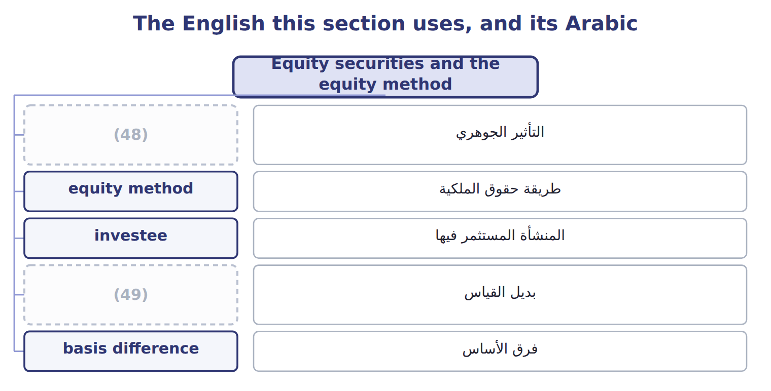
word list
significant influence · measurement alternative · فرق الأساس

The English this sheet uses, and its Arabic
English (exam term) | Arabic
significant influence | التأثير الجوهري
equity method | طريقة حقوق الملكية
investee | المنشأة المستثمر فيها
measurement alternative | بديل القياس
basis difference | فرق الأساس

Answer key · 9.4 Equity securities and the equity method

1 question | 26 unless
2 year-end | 27 guaranteed
3 unrealized | 28 eliminated
4 private | 29 outsiders
5 measurement | 30 restate
6 adjusted | 31 definition
7 transaction | 32 effective
8 similar | 33 classifies
9 financial | 34 irrevocable
10 presumed | 35 impaired
11 evidence | 36 Depreciate
12 participation | 37 assigned
13 transactions | 38 amortize
14 increases | 39 treasury
15 decreases | 40 cost 60,000; fair value 57,000
16 because | 41 Corporate bond
17 January | 42 cost 25,000; fair value 27,000
18 supplier | 43 Shares of Amman Cold Storage Co. (25%)
19 Glass's | 44 30% × 400,000 = 120,000
20 equipment | 45 120,000 − 3,000 = 117,000
21 depreciated | 46 Held-to-maturity
22 reports | 47 Available-for-sale
23 change | 48 significant influence
24 questions | 49 measurement alternative
25 Losses

the summaries in full
Summary 1 For shares, the key question is how much influence the investor has over the investee, the company whose shares it holds. Shares with a readily determinable fair value are measured at fair value, and all changes go to net income. There is no AFS category and no OCI option for shares. Dividends received are income. For example, Orontes bought listed shares for $20,000; at year-end they are worth $23,500, and Orontes received dividends of $400. Net income includes an unrealized gain of $3,500 and dividend income of $400. For shares with no readily determinable fair value, such as shares of a private company, the investor may use the measurement alternative: cost minus impairment, adjusted when an orderly transaction in the same or a similar share shows a new price. An investor with significant influence can take part in the investee's financial and operating decisions.
Summary 2 Influence is presumed when the investor holds 20% to 50% of the voting stock, but the evidence decides: a board seat, participation in policy decisions or large transactions between the companies can show influence even below 20%. With significant influence, the investor uses the equity method. Under the equity method, the investment starts at cost. It increases by the investor's share of the investee's net income and decreases by the dividends the investor receives. The dividends are not income, because they only return part of the investment.
Summary 3 On January 1, 2025, Orontes buys 30% of Jordan Glass Co., its bottle supplier, for $1,200,000. Jordan Glass's net assets have a book value of $3,000,000, so Orontes's share of book value is $900,000. The basis difference of $300,000 has two parts: $30,000 for Orontes's share of equipment worth more than its book value, which is depreciated over 10 years ($3,000 a year), and $270,000 of goodwill, which is not amortized. In 2025 Jordan Glass earns $500,000 and pays dividends of $200,000. Orontes reports equity-method income of $147,000 and an investment of $1,287,000 at the end of 2025. The dividends of $60,000 are cash in and investment out; they do not change net income.
Summary 4 In 2026 Jordan Glass earns $400,000 and pays dividends of $100,000. The extra depreciation is the same as in 2025. Three more equity-method rules appear in exam questions. Losses reduce the investment only to zero, unless the investor has guaranteed the investee's debts. Profits on sales between the two companies are eliminated until the goods are sold to outsiders. And when an investor first gains significant influence, it starts the equity method from that date; it does not restate prior years. An investor may also elect the fair value option for an equity-method investment. Crypto assets that meet the ASU 2023-08 definition are measured at fair value through net income. This rule became effective for fiscal years beginning after December 15, 2024, so it is now testable. IFRS 9 classifies debt by the business model and the cash flows (amortized cost, FVOCI or FVPL), not by intent. For shares, IFRS 9 allows an irrevocable election to put fair value changes in OCI, with no recycling on sale; U.S. GAAP has no such option. Under IAS 28, an equity-method investment that is impaired can later be written back up; under U.S. GAAP the impairment is not reversed.
Summary 5 Equity method: dividends reduce the investment. They are not income. Take only the investor's share of the investee's income. Depreciate the part of the basis difference assigned to assets; do not amortize the goodwill.

10.1 The cost of property, plant and equipment
Chapter 10 · section 10.1

Fill every gap. Each word list holds one word more than there are gaps.
Chapter 10, section by section
Each stage leads to the next.
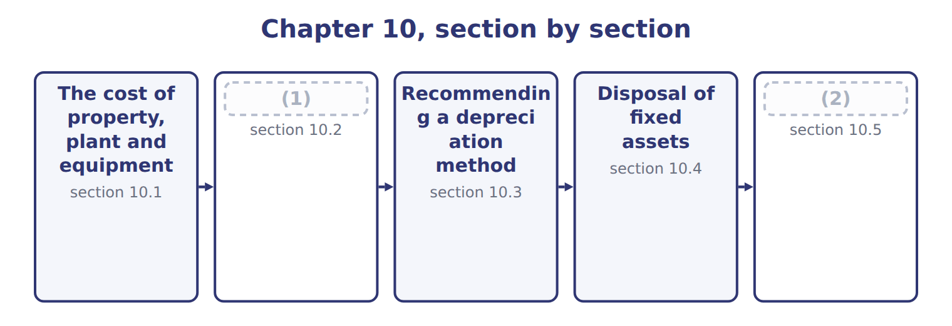
word list
Impairment of long-lived assets, intangibles a · change in accounting estimate · Depreciation methods and their effects

Summary 1 gaps 3–14
Property, plant and (3) (PP&E) is recorded at (4) cost: everything needed to acquire the asset and get it ready for use. This includes the price, freight, (5) , testing and site (6) . When a company buys land with an old building and pulls the building down, the (7) cost is part of the cost of the land. When it buys (8) assets for one price, it divides the price by their (9) fair values. After (10) , a capital expenditure that extends the asset's life or (11) its capacity is added to its cost. A revenue expenditure, such as (12) repairs and (13) , is an expense of the period. When a company builds an asset for its own use, it capitalizes interest during (14) . Capitalized interest is the avoidable interest: weighted-average accumulated expenditures × the interest rate, but never more than the interest actually incurred. For example, if Orontes spends on average $2,000 (USD 000) on a new warehouse during the year and the rate on the related loan is 6%, avoidable interest is 120.
word list
increases · acquire · equipment · demolition · maintenance · purchase · several · relative · construction · installation · historical · ordinary · preparation

Summary 2 gaps 15–19
Actual interest is 150, so Orontes capitalizes 120. (15) stops when the asset is (16) complete. IAS 23 also capitalizes borrowing costs on (17) assets. One (18) : when a company invests borrowed money for a short time before spending it, IAS 23 deducts the investment income from the amount capitalized. U.S. GAAP (19) does not.
word list
substantially · generally · Capitalization · recorded · qualifying · difference

The English this section uses, and its Arabic
Each term sits against what it means.
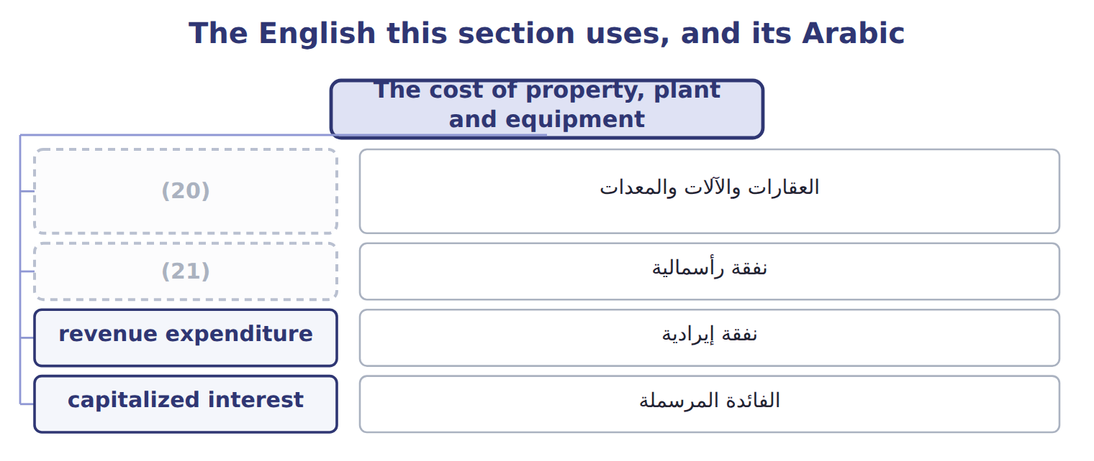
word list
revenue expenditure · capital expenditure · property, plant and equipment (PP&E)

The English this sheet uses, and its Arabic
English (exam term) | Arabic
property, plant and equipment (PP&E) | العقارات والآلات والمعدات
capital expenditure | نفقة رأسمالية
revenue expenditure | نفقة إيرادية
capitalized interest | الفائدة المرسملة

Answer key · 10.1 The cost of property, plant and equipment

1 Depreciation methods and their effects | 12 ordinary
2 Impairment of long-lived assets, intangibles a | 13 maintenance
3 equipment | 14 construction
4 historical | 15 Capitalization
5 installation | 16 substantially
6 preparation | 17 qualifying
7 demolition | 18 difference
8 several | 19 generally
9 relative | 20 property, plant and equipment (PP&E)
10 purchase | 21 capital expenditure
11 increases

the summaries in full
Summary 1 Property, plant and equipment (PP&E) is recorded at historical cost: everything needed to acquire the asset and get it ready for use. This includes the price, freight, installation, testing and site preparation. When a company buys land with an old building and pulls the building down, the demolition cost is part of the cost of the land. When it buys several assets for one price, it divides the price by their relative fair values. After purchase, a capital expenditure that extends the asset's life or increases its capacity is added to its cost. A revenue expenditure, such as ordinary repairs and maintenance, is an expense of the period. When a company builds an asset for its own use, it capitalizes interest during construction. Capitalized interest is the avoidable interest: weighted-average accumulated expenditures × the interest rate, but never more than the interest actually incurred. For example, if Orontes spends on average $2,000 (USD 000) on a new warehouse during the year and the rate on the related loan is 6%, avoidable interest is 120.
Summary 2 Actual interest is 150, so Orontes capitalizes 120. Capitalization stops when the asset is substantially complete. IAS 23 also capitalizes borrowing costs on qualifying assets. One difference: when a company invests borrowed money for a short time before spending it, IAS 23 deducts the investment income from the amount capitalized. U.S. GAAP generally does not.

10.2 Depreciation methods and their effects
Chapter 10 · section 10.2

Fill every gap. Each word list holds one word more than there are gaps.
Summary 1 gaps 1–8
Depreciation (1) the depreciable base, cost minus salvage value, over the useful life in a (2) and rational way. Four methods (3) on the exam. Straight-line method: the same (4) each year, depreciable base ÷ useful life. (5) method: twice the straight-line rate, applied to the (6) book value. Salvage is ignored in the (7) , but the book value may not fall below salvage. Sum-of-the-years'-digits method: depreciable base × remaining life at the start of the year ÷ the sum of the years' digits. (8) method: a rate per unit or hour of use, times actual use.
word list
Units-of-production · calculation · beginning · Double-declining-balance · amount · appear · systematic · separately · spreads

The Amman bottling line

Summary 2 gaps 9–15
In, Orontes (9) a new bottling line for its Amman plant. Orontes (10) a salvage value of $150,000 after 5 years, or after 21,000 machine hours. The depreciable base is $1,050,000. Straight-line: $1,050,000 ÷ 5 = $210,000 a year. Double-declining: rate 40%; year 1 = 40% × $1,200,000 = $480,000. In year 5 only $5,520 is left, so the book value ends at salvage. Sum-of-the-years'-digits: the digits add up to 15; year 1 = $1,050,000 × 5/15 = $350,000. Units of (11) : $1,050,000 ÷ 21,000 hours = $50 an hour; year 1 = 5,000 hours × $50 = $250,000. All four methods (12) the same total, $1,050,000. They only change the (13) . Depreciation is not a cash flow, so the method changes cash only (14) income taxes, and U.S. tax depreciation (MACRS) is (15) separately from the book method.
word list
chosen · charge · bought · through · production · timing · expects · Depreciation

Effects of the depreciation methods on the financial statements
Every item belongs to exactly one group.
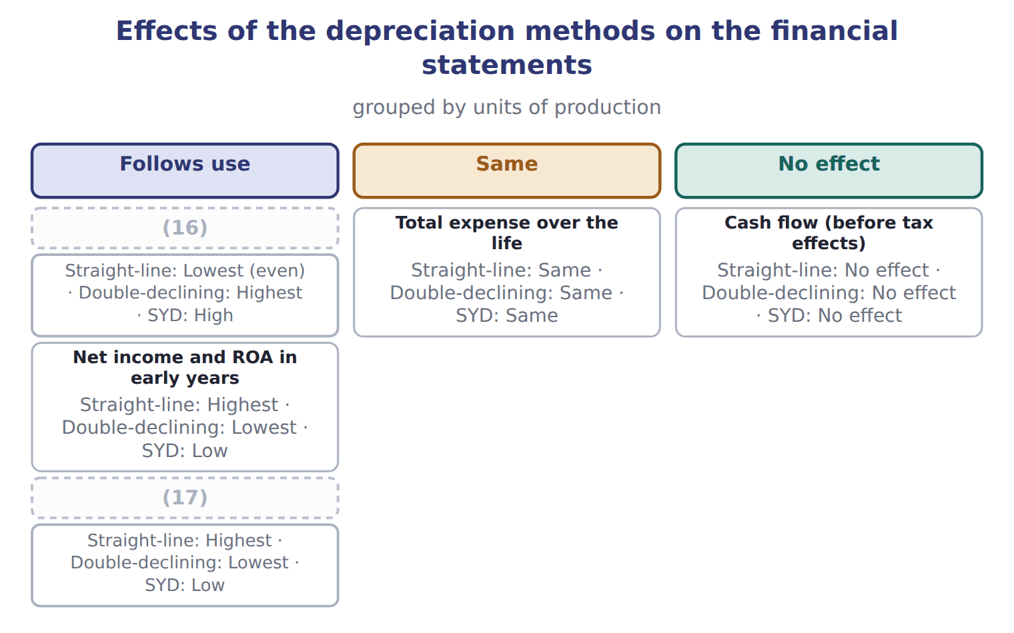
word list
research and development (R&D) · Expense in early years · Carrying amount in early years

Dubai delivery trucks

Summary 3 gaps 18–29
Orontes buys (18) trucks for its Dubai plant for $90,000, with a salvage value of $10,000 after 4 years. (19) the double-declining (20) . A new useful life or salvage value is a change in (21) estimate. It is applied prospectively: the company does not (22) prior years. (23) Orontes used straight-line for the bottling line and, after 2 years, (24) it has 4 more years of life and a salvage value of $90,000. The book value then is $780,000, so each remaining (25) depreciation is ($780,000 − $90,000) ÷ 4 = $172,500. A change in depreciation method is also applied prospectively, as a change in estimate effected by a change in (26) , and the new method must be (27) . An error, such as (28) a machine that should have been (29) , is different: it is corrected by restating the prior years. Some companies use group or composite depreciation for many similar assets. They apply one rate to the whole pool, and when an asset is retired they record no gain or loss.
word list
principle · capitalized · accounting · decides · schedule · restating · year's · Complete · delivery · expensing · restate · preferable · Suppose

Depreciation traps

Summary 4 gaps 30–31
Double-declining: apply the rate to book value; never (30) salvage first, and never go below salvage. SYD: use the remaining life at the start of the year, applied to the depreciable base. Changes in life, salvage or method: (31) .
word list
prospective · depreciated · subtract

Depreciation schedules for the Amman bottling line (whole USD)
Name each line from how it moves.
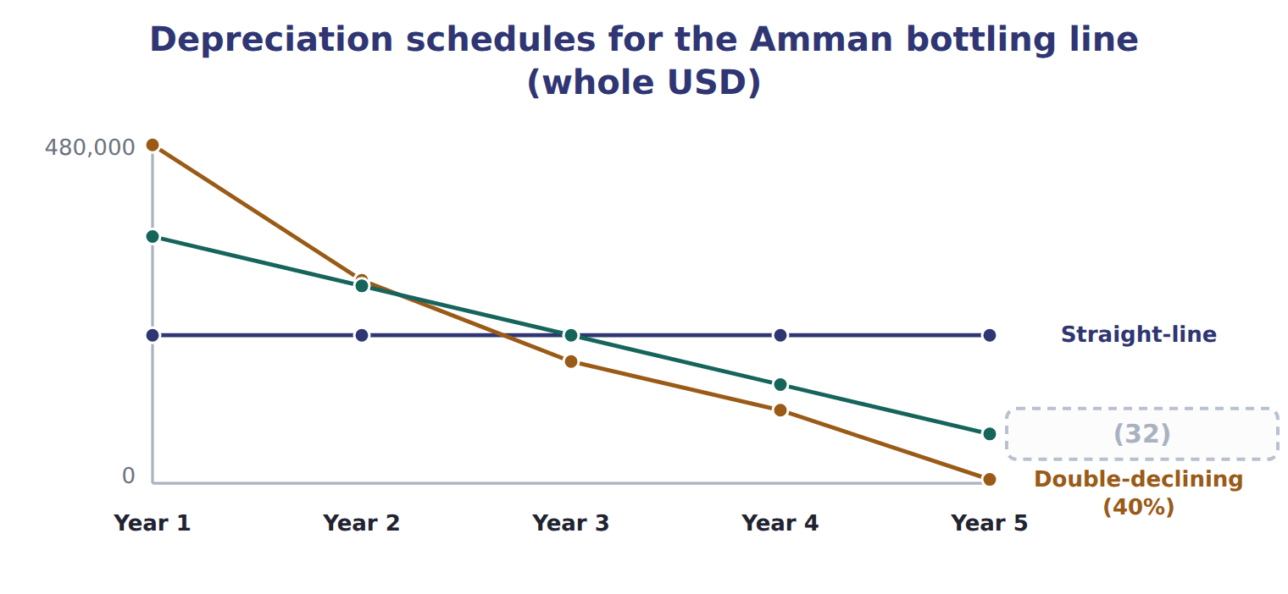
word list
goodwill · Sum-of-the-years'-digits

Double-declining schedule for the Dubai trucks (whole USD): complete the blanks
Every item belongs to exactly one group.
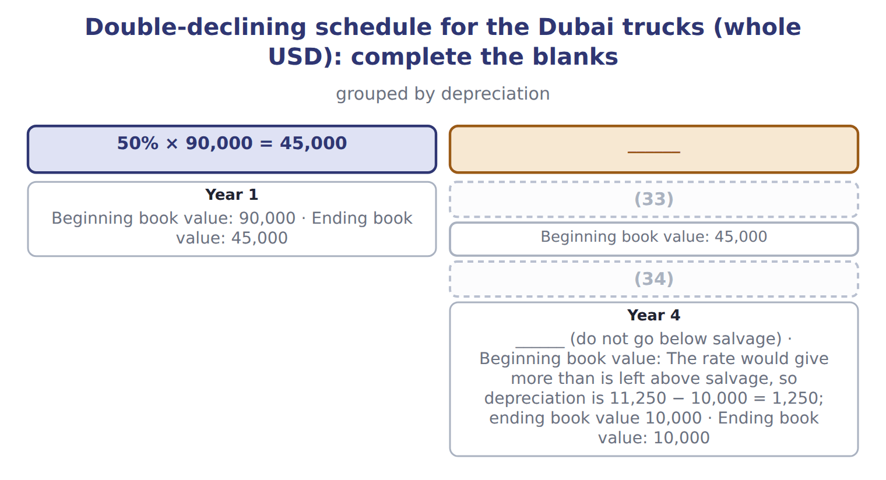
word list
Year 3 · capitalized interest · Year 2

What each framework says
The two columns are not matched row by row.
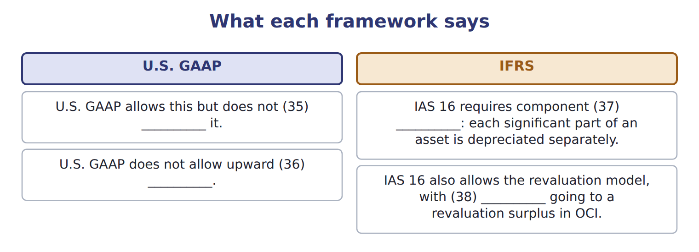
word list
require · increases · goodwill · depreciation · revaluation

The English this section uses, and its Arabic
Each term sits against what it means.
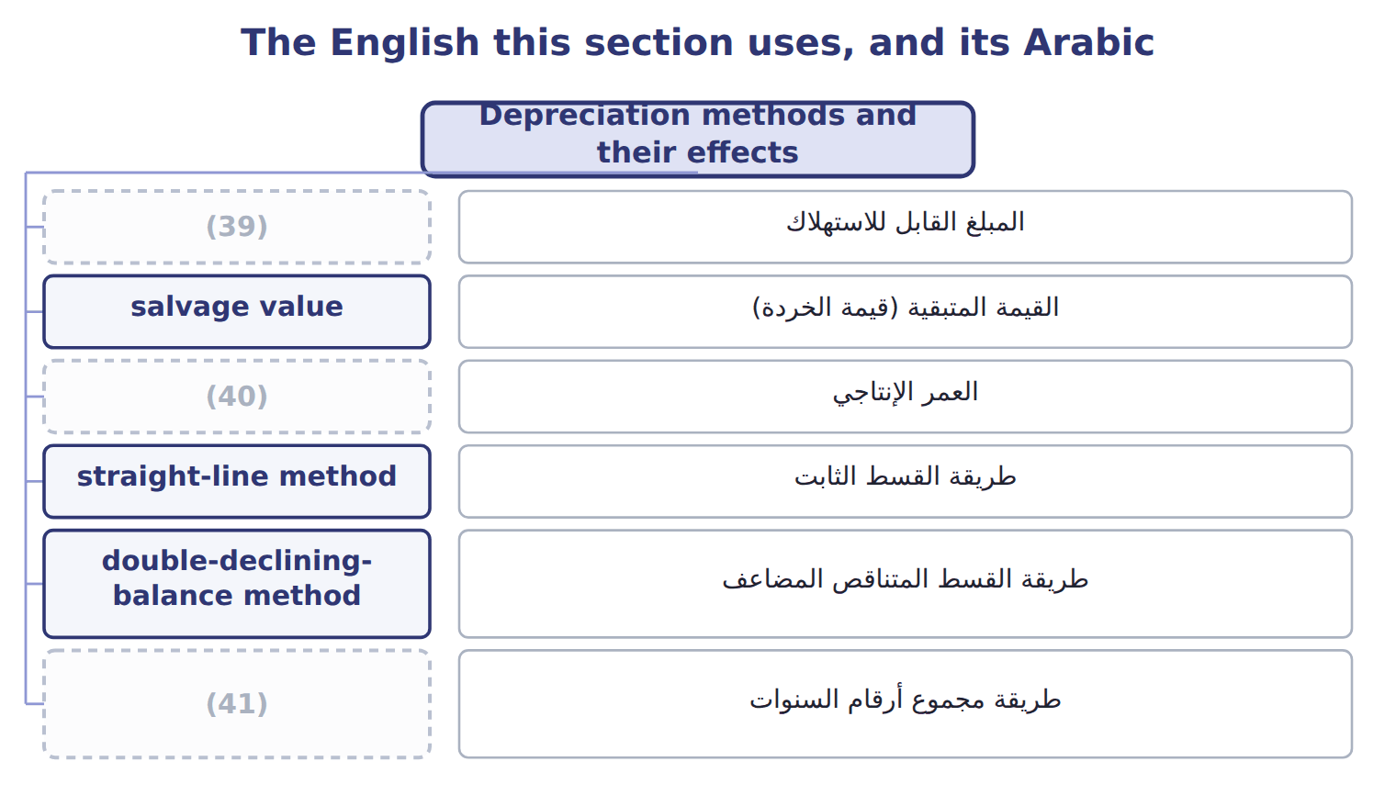
word list
depreciable base · revenue expenditure · sum-of-the-years'-digits method · useful life

The English this sheet uses, and its Arabic
English (exam term) | Arabic
depreciable base | المبلغ القابل للاستهلاك
salvage value | القيمة المتبقية (قيمة الخردة)
useful life | العمر الإنتاجي
straight-line method | طريقة القسط الثابت
double-declining-balance method | طريقة القسط المتناقص المضاعف
sum-of-the-years'-digits method | طريقة مجموع أرقام السنوات
units-of-production method | طريقة وحدات الإنتاج
carrying amount | القيمة الدفترية
change in accounting estimate | التغير في التقدير المحاسبي

Answer key · 10.2 Depreciation methods and their effects

1 spreads | 22 restate
2 systematic | 23 Suppose
3 appear | 24 decides
4 amount | 25 year's
5 Double-declining-balance | 26 principle
6 beginning | 27 preferable
7 calculation | 28 expensing
8 Units-of-production | 29 capitalized
9 bought | 30 subtract
10 expects | 31 prospective
11 production | 32 Sum-of-the-years'-digits
12 charge | 33 Year 2
13 timing | 34 Year 3
14 through | 35 require
15 chosen | 36 revaluation
16 Expense in early years | 37 depreciation
17 Carrying amount in early years | 38 increases
18 delivery | 39 depreciable base
19 Complete | 40 useful life
20 schedule | 41 sum-of-the-years'-digits method
21 accounting

the summaries in full
Summary 1 Depreciation spreads the depreciable base, cost minus salvage value, over the useful life in a systematic and rational way. Four methods appear on the exam. Straight-line method: the same amount each year, depreciable base ÷ useful life. Double-declining-balance method: twice the straight-line rate, applied to the beginning book value. Salvage is ignored in the calculation, but the book value may not fall below salvage. Sum-of-the-years'-digits method: depreciable base × remaining life at the start of the year ÷ the sum of the years' digits. Units-of-production method: a rate per unit or hour of use, times actual use.
Summary 2 In, Orontes bought a new bottling line for its Amman plant. Orontes expects a salvage value of $150,000 after 5 years, or after 21,000 machine hours. The depreciable base is $1,050,000. Straight-line: $1,050,000 ÷ 5 = $210,000 a year. Double-declining: rate 40%; year 1 = 40% × $1,200,000 = $480,000. In year 5 only $5,520 is left, so the book value ends at salvage. Sum-of-the-years'-digits: the digits add up to 15; year 1 = $1,050,000 × 5/15 = $350,000. Units of production: $1,050,000 ÷ 21,000 hours = $50 an hour; year 1 = 5,000 hours × $50 = $250,000. All four methods charge the same total, $1,050,000. They only change the timing. Depreciation is not a cash flow, so the method changes cash only through income taxes, and U.S. tax depreciation (MACRS) is chosen separately from the book method.
Summary 3 Orontes buys delivery trucks for its Dubai plant for $90,000, with a salvage value of $10,000 after 4 years. Complete the double-declining schedule. A new useful life or salvage value is a change in accounting estimate. It is applied prospectively: the company does not restate prior years. Suppose Orontes used straight-line for the bottling line and, after 2 years, decides it has 4 more years of life and a salvage value of $90,000. The book value then is $780,000, so each remaining year's depreciation is ($780,000 − $90,000) ÷ 4 = $172,500. A change in depreciation method is also applied prospectively, as a change in estimate effected by a change in principle, and the new method must be preferable. An error, such as expensing a machine that should have been capitalized, is different: it is corrected by restating the prior years. Some companies use group or composite depreciation for many similar assets. They apply one rate to the whole pool, and when an asset is retired they record no gain or loss.
Summary 4 Double-declining: apply the rate to book value; never subtract salvage first, and never go below salvage. SYD: use the remaining life at the start of the year, applied to the depreciable base. Changes in life, salvage or method: prospective.

10.3 Recommending a depreciation method
Chapter 10 · section 10.3

Fill every gap. Each word list holds one word more than there are gaps.
Summary 1 gaps 1–8
The best method (1) the pattern in which the company uses up the (2) benefits. For the (3) line, machine hours drive the wear, so units of production gives the best matching; straight-line is simpler and is (4) if use is fairly even. Other factors can support the choice: (5) with other companies in the industry, the cost of tracking usage, and (6) view of income (7) . The tax method is a (8) decision, so a company does not need to use the same method for its books.
word list
machine · bottling · matches · smoothing · asset's · separate · acceptable · management's · comparability

Give the reason

What fits each one
Each term sits against what it means.
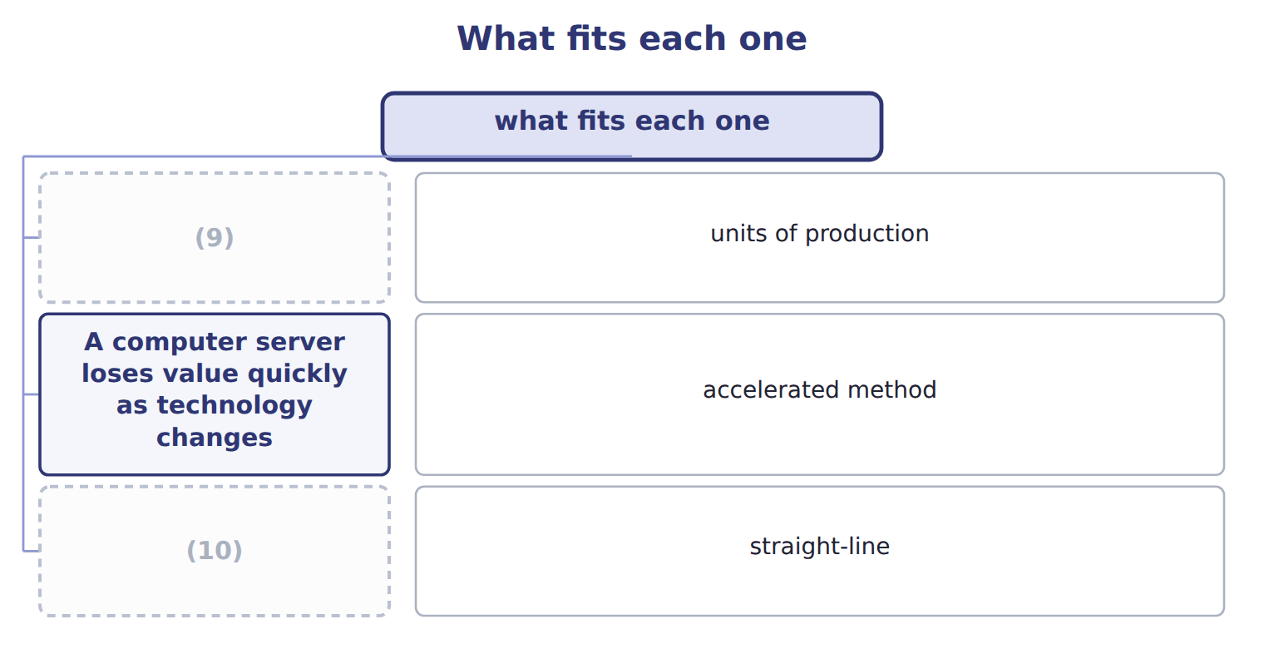
word list
A computer server loses value quickly as technology changes · An office building gives similar service each year · A delivery truck wears out with kilometres driven

Summary 2 gaps 11–12
In a Level C question, a (11) earns credit only with a (12) from the facts: how the asset is used and when its benefits arrive.
word list
reason · recommendation · straight-line

Answer key · 10.3 Recommending a depreciation method

1 matches | 7 smoothing
2 asset's | 8 separate
3 bottling | 9 A delivery truck wears out with kilometres driven
4 acceptable | 10 An office building gives similar service each year
5 comparability | 11 recommendation
6 management's | 12 reason

the summaries in full
Summary 1 The best method matches the pattern in which the company uses up the asset's benefits. For the bottling line, machine hours drive the wear, so units of production gives the best matching; straight-line is simpler and is acceptable if use is fairly even. Other factors can support the choice: comparability with other companies in the industry, the cost of tracking usage, and management's view of income smoothing. The tax method is a separate decision, so a company does not need to use the same method for its books.
Summary 2 In a Level C question, a recommendation earns credit only with a reason from the facts: how the asset is used and when its benefits arrive.

10.4 Disposal of fixed assets
Chapter 10 · section 10.4

Fill every gap. Each word list holds one word more than there are gaps.
Summary 1 gaps 1–4
When a company sells or (1) an asset, it first records depreciation up to the date of (2) . Then it (3) the cost and the accumulated depreciation and (4) the proceeds with the carrying amount. The gain or loss is part of income from continuing operations.
word list
disposal · removes · scraps · compares · insurance

Selling an old oven in Dubai

Which way it goes
The rows are a set, not a sequence.
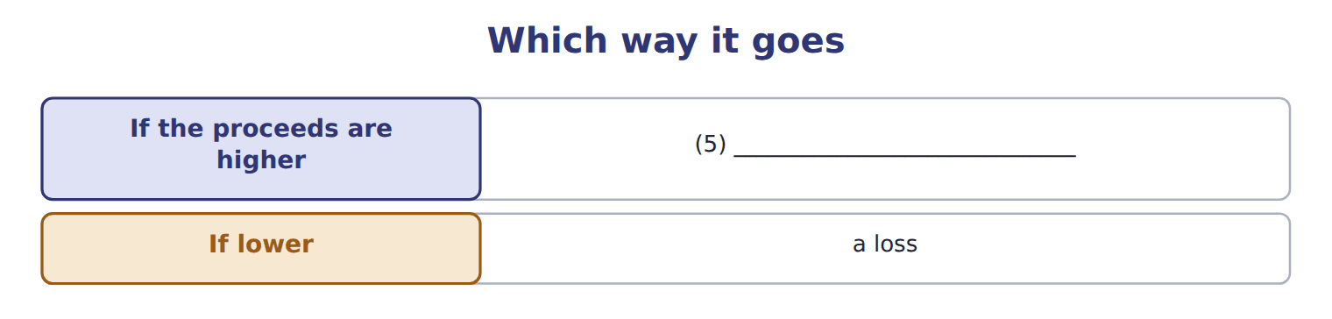
word list
records a gain · held for sale

Summary 2 gaps 6–13
An old (6) oven cost $60,000. At (7) 1, accumulated depreciation was $40,000, and (8) depreciation is $8,000 a year. (9) sells the oven after 3 (10) for $21,000. Two (11) cases appear on the exam. In an (12) conversion, such as a fire or a government (13) , the company records a gain or loss even if it reinvests the insurance money. In an exchange of assets with commercial substance, the new asset is recorded at fair value and the gain or loss is recognized; without commercial substance, the exchange is recorded at book value.
word list
involuntary · straight-line · Orontes · months · January · special · without · pastry · expropriation

Update first

Summary 3 gaps 14–15
Record depreciation up to the sale date before you (14) the gain or loss. Compare proceeds with the carrying amount, not with the (15) cost.
word list
Compare · original · compute

The English this section uses, and its Arabic
Each term sits against what it means.
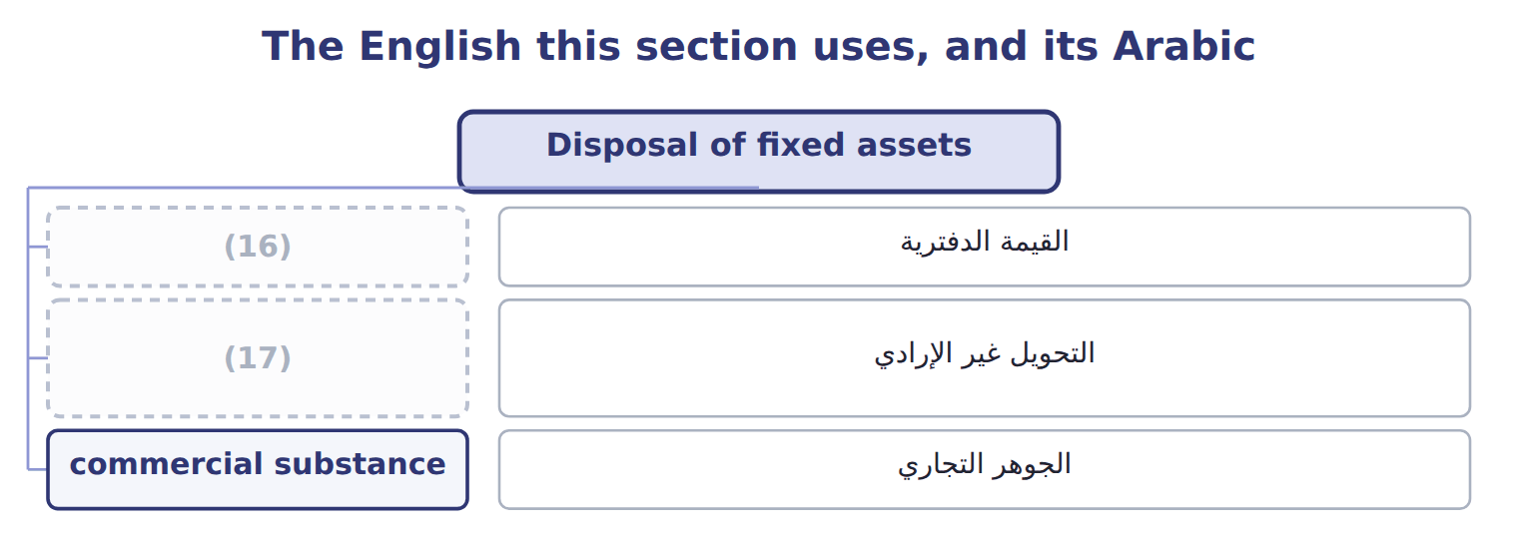
word list
carrying amount · involuntary conversion · depreciable base

The English this sheet uses, and its Arabic
English (exam term) | Arabic
involuntary conversion | التحويل غير الإرادي
commercial substance | الجوهر التجاري

Answer key · 10.4 Disposal of fixed assets

1 scraps | 10 months
2 disposal | 11 special
3 removes | 12 involuntary
4 compares | 13 expropriation
5 records a gain | 14 compute
6 pastry | 15 original
7 January | 16 carrying amount
8 straight-line | 17 involuntary conversion
9 Orontes

the summaries in full
Summary 1 When a company sells or scraps an asset, it first records depreciation up to the date of disposal. Then it removes the cost and the accumulated depreciation and compares the proceeds with the carrying amount. The gain or loss is part of income from continuing operations.
Summary 2 An old pastry oven cost $60,000. At January 1, accumulated depreciation was $40,000, and straight-line depreciation is $8,000 a year. Orontes sells the oven after 3 months for $21,000. Two special cases appear on the exam. In an involuntary conversion, such as a fire or a government expropriation, the company records a gain or loss even if it reinvests the insurance money. In an exchange of assets with commercial substance, the new asset is recorded at fair value and the gain or loss is recognized; without commercial substance, the exchange is recorded at book value.
Summary 3 Record depreciation up to the sale date before you compute the gain or loss. Compare proceeds with the carrying amount, not with the original cost.

10.5 Impairment of long-lived assets, intangibles and goodwill
Chapter 10 · section 10.5

Fill every gap. Each word list holds one word more than there are gaps.
Summary 1 gaps 1–12
An impairment (1) when a company cannot (2) an asset's carrying amount. U.S. GAAP uses different tests for different assets. The company tests an asset group (the (3) level with its own cash flows) only when (4) suggest a problem, such as a sharp fall in market price, physical damage or (5) losses. The test has two steps. In the recoverability test, the company (6) the carrying amount with the sum of the undiscounted future cash flows. If the carrying amount is not higher, there is no impairment, even if fair value is lower. If it is higher, the company measures the loss as carrying amount minus fair value. The (7) amount becomes the new cost basis and is depreciated over the (8) life. The loss is never (9) under U.S. GAAP. An asset is held for sale when management has committed to a plan to sell it, it is (10) for immediate sale, and the sale is expected within one year. It is (11) at the lower of its carrying amount and fair value less cost to sell, and it is no (12) depreciated.
word list
continuing · lowest · recover · occurs · measured · indicators · available · reversed · remaining · longer · reduced · compares · amortization

Summary 2 gaps 13–23
If fair value less cost to sell rises later, the company (13) a gain, but only up to the losses it (14) before. (15) intangibles, such as (16) , are subject to (17) over their (18) lives and follow the PP&E test. An indefinite-lived (19) asset, such as a brand with no expected end, is not amortized. It is tested at least every year in one step: carrying amount against fair value. Goodwill is not amortized by (20) companies. It is tested at least every year at the level of the reporting unit. A company may first make a (21) assessment; if it is not more (22) than not that the unit's fair value is below its carrying amount, no (23) test is needed.
word list
useful · reversals · recognized · amortization · public · patents · Finite-lived · intangible · further · qualitative · records · likely

Summary 3 gaps 24–35
Otherwise it (24) a single step: the loss is the unit's carrying amount minus its fair value, but never more than the goodwill. It also shows the rule for (25) and development (R&D): U.S. GAAP expenses R&D as incurred, except for equipment and (26) that have other future uses. ASU 2025-06 changes when companies start (27) internal-use software ( (28) for annual periods beginning after December 15, 2027). ASU 2025-10 adds guidance on (29) grants for assets. Under the (30) rule, neither is tested yet. IAS 36 uses one step: compare the carrying amount with the (31) amount, which is the higher of fair value less costs of disposal and value in use (a (32) amount). IFRS allows the (33) of impairment losses on assets other than goodwill. IAS 38 (34) development costs to be capitalized when six (35) are met. These are the classic IFRS habits that cost marks on the U.S. GAAP exam.
word list
effective · requires · reversal · one-year · criteria · government · applies · research · recoverable · discounted · facilities · capitalizing · compares

Impairment traps

Summary 4 gaps 36–40
Step 1 uses UNDISCOUNTED cash flows. Step 2 measures the loss against FAIR VALUE. Goodwill: one step, and the loss is (36) at the goodwill (37) . No (38) for assets held and used, indefinite-lived intangibles or goodwill. Held for sale: gains only up to (39) losses. Stop (40) an asset once it is held for sale.
word list
balance · Otherwise · earlier · capped · reversals · depreciating

Impairment in three languages

Impairment in three languages
Item | Asset | Facts | Amounts (USD 000)
P | (41) | Demand for the product fell sharply in 2025. | carrying 500; undiscounted cash flows 450; fair value 380
W | Warehouse, Amman | (42) | carrying 1,000; undiscounted cash flows 1,300; fair value 900
B | Brand 'Orontes Gold' (indefinite life) | Annual test. | (43)
G | Goodwill, Gulf beverages reporting unit | (44) | carrying 2,000; goodwill included 150; fair value 1,700
V | (45) | Management has committed to sell it within one year. | carrying 60; fair value 50; cost to sell 4

word list
Local property prices fell. · Unit carrying amount includes the goodwill. · change in accounting estimate · Pastry line, Dubai · carrying 300; fair value 260 · Delivery van (held for sale)

Asset — Category
Asset | Category
P | Two steps: recoverability, then fair value
W | (46)
B | One step: carrying amount vs fair value
G | (47)
V | Lower of carrying amount and fair value less cost to sell

word list
Brand 'Orontes Gold' (indefinite life) · Two steps: recoverability, then fair value · Single-step goodwill test

The English this section uses, and its Arabic
Each term sits against what it means.
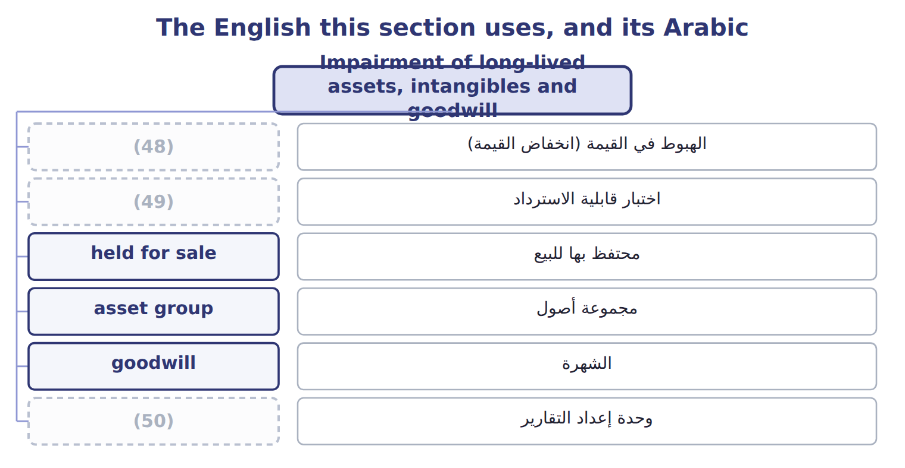
word list
impairment · sum-of-the-years'-digits method · reporting unit · recoverability test

The English this sheet uses, and its Arabic
English (exam term) | Arabic
impairment | الهبوط في القيمة (انخفاض القيمة)
recoverability test | اختبار قابلية الاسترداد
held for sale | محتفظ بها للبيع
asset group | مجموعة أصول
goodwill | الشهرة
reporting unit | وحدة إعداد التقارير
indefinite-lived intangible asset | أصل غير ملموس غير محدد العمر
amortization | الإطفاء
research and development (R&D) | البحث والتطوير

Answer key · 10.5 Impairment of long-lived assets, intangibles and goodwill

1 occurs | 26 facilities
2 recover | 27 capitalizing
3 lowest | 28 effective
4 indicators | 29 government
5 continuing | 30 one-year
6 compares | 31 recoverable
7 reduced | 32 discounted
8 remaining | 33 reversal
9 reversed | 34 requires
10 available | 35 criteria
11 measured | 36 capped
12 longer | 37 balance
13 records | 38 reversals
14 recognized | 39 earlier
15 Finite-lived | 40 depreciating
16 patents | 41 Pastry line, Dubai
17 amortization | 42 Local property prices fell.
18 useful | 43 carrying 300; fair value 260
19 intangible | 44 Unit carrying amount includes the goodwill.
20 public | 45 Delivery van (held for sale)
21 qualitative | 46 Two steps: recoverability, then fair value
22 likely | 47 Single-step goodwill test
23 further | 48 impairment
24 applies | 49 recoverability test
25 research | 50 reporting unit

the summaries in full
Summary 1 An impairment occurs when a company cannot recover an asset's carrying amount. U.S. GAAP uses different tests for different assets. The company tests an asset group (the lowest level with its own cash flows) only when indicators suggest a problem, such as a sharp fall in market price, physical damage or continuing losses. The test has two steps. In the recoverability test, the company compares the carrying amount with the sum of the undiscounted future cash flows. If the carrying amount is not higher, there is no impairment, even if fair value is lower. If it is higher, the company measures the loss as carrying amount minus fair value. The reduced amount becomes the new cost basis and is depreciated over the remaining life. The loss is never reversed under U.S. GAAP. An asset is held for sale when management has committed to a plan to sell it, it is available for immediate sale, and the sale is expected within one year. It is measured at the lower of its carrying amount and fair value less cost to sell, and it is no longer depreciated.
Summary 2 If fair value less cost to sell rises later, the company records a gain, but only up to the losses it recognized before. Finite-lived intangibles, such as patents, are subject to amortization over their useful lives and follow the PP&E test. An indefinite-lived intangible asset, such as a brand with no expected end, is not amortized. It is tested at least every year in one step: carrying amount against fair value. Goodwill is not amortized by public companies. It is tested at least every year at the level of the reporting unit. A company may first make a qualitative assessment; if it is not more likely than not that the unit's fair value is below its carrying amount, no further test is needed.
Summary 3 Otherwise it applies a single step: the loss is the unit's carrying amount minus its fair value, but never more than the goodwill. It also shows the rule for research and development (R&D): U.S. GAAP expenses R&D as incurred, except for equipment and facilities that have other future uses. ASU 2025-06 changes when companies start capitalizing internal-use software (effective for annual periods beginning after December 15, 2027). ASU 2025-10 adds guidance on government grants for assets. Under the one-year rule, neither is tested yet. IAS 36 uses one step: compare the carrying amount with the recoverable amount, which is the higher of fair value less costs of disposal and value in use (a discounted amount). IFRS allows the reversal of impairment losses on assets other than goodwill. IAS 38 requires development costs to be capitalized when six criteria are met. These are the classic IFRS habits that cost marks on the U.S. GAAP exam.
Summary 4 Step 1 uses UNDISCOUNTED cash flows. Step 2 measures the loss against FAIR VALUE. Goodwill: one step, and the loss is capped at the goodwill balance. No reversals for assets held and used, indefinite-lived intangibles or goodwill. Held for sale: gains only up to earlier losses. Stop depreciating an asset once it is held for sale.

11.1 Revenue and the core principle
Chapter 11 · section 11.1

Fill every gap. Each word list holds one word more than there are gaps.
Chapter 11, section by section
Each stage leads to the next.
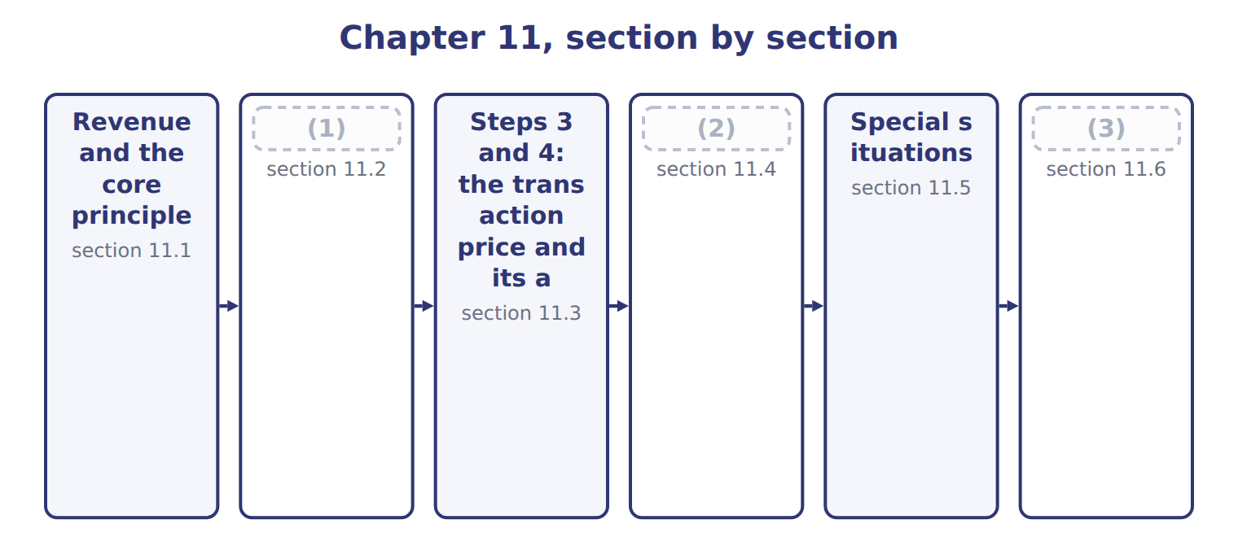
word list
Steps 3 and 4: the transaction price and its a · Step 5: recognizing revenue over time or at a · Steps 1 and 2: the contract and its performanc · Matching, contract costs and IFRS differences

Summary 1 gaps 4–14
Revenue is the inflow from a company's main (4) , such as selling goods or (5) services. Under ASC 606, a company (6) revenue when it (7) control of promised goods or services to a customer. It (8) revenue at the amount it expects to be (9) to in exchange. Control means the customer can (10) the use of the asset and obtain almost all of its (11) . The key question is (12) not when the company is paid, but when the customer gains control. Cash can (13) before, at or after that (14) . ASC 606 applies one model to all contracts with customers: goods, services, construction and software. The model has five steps. Each step answers one question, and each uses the answer to the step before.
word list
agent · transfers · therefore · moment · recognizes · entitled · direct · activities · arrive · measures · providing · benefits

The English this sheet uses, and its Arabic
English (exam term) | Arabic
revenue | إيراد (إيرادات)

Answer key · 11.1 Revenue and the core principle

1 Steps 1 and 2: the contract and its performanc | 8 measures
2 Step 5: recognizing revenue over time or at a | 9 entitled
3 Matching, contract costs and IFRS differences | 10 direct
4 activities | 11 benefits
5 providing | 12 therefore
6 recognizes | 13 arrive
7 transfers | 14 moment

the summaries in full
Summary 1 Revenue is the inflow from a company's main activities, such as selling goods or providing services. Under ASC 606, a company recognizes revenue when it transfers control of promised goods or services to a customer. It measures revenue at the amount it expects to be entitled to in exchange. Control means the customer can direct the use of the asset and obtain almost all of its benefits. The key question is therefore not when the company is paid, but when the customer gains control. Cash can arrive before, at or after that moment. ASC 606 applies one model to all contracts with customers: goods, services, construction and software. The model has five steps. Each step answers one question, and each uses the answer to the step before.

11.2 Steps 1 and 2: the contract and its performance obligations
Chapter 11 · section 11.2

Fill every gap. Each word list holds one word more than there are gaps.
Summary 1 gaps 1–12
Step 1: identify the contract. A contract exists only if the parties have approved it and are committed to it, each party's rights and the payment terms can be (1) , and the contract has (2) substance. Finally, it must be probable that the company will collect (3) all of the (4) . If these (5) are not met, cash received from the customer is a (6) , not revenue. In U.S. GAAP, probable means likely: a (7) level than the IFRS (8) of more likely than not. Step 2: identify the performance obligations. Each promise to (9) a distinct good or service is a (10) obligation. A good or service is distinct if the customer can benefit from it on its own and it is separately (11) in the contract, not highly (12) on other promises. GreenBasket buys olive oil, a beverage dispenser installed in its stores, and two years of dispenser maintenance. Each can be bought separately, so there are three performance obligations.
word list
identified · identifiable · higher · dependent · transfer · substantially · customer · criteria · meaning · consideration · commercial · liability · separate

Suppose: the five steps applied to the Orontes–GreenBasket contract, October 1, 2026
Step | Orontes's analysis | Result (whole USD)
1. Identify the contract | A signed agreement for olive oil, a dispenser and maintenance; payment terms clear; collection probable. | Contract exists
2. Identify the performance obligations | Olive oil, the dispenser and maintenance can each be bought separately and are not highly (13) . | Three obligations
3. Determine the transaction price | Fixed price; no variable amounts, no financing component, no payments to GreenBasket. | 1,080,000
4. Allocate the price | Relative standalone selling prices totalling 1,200,000; each obligation gets 90%. | (14)
5. Recognize revenue | Oil and dispenser: at delivery ( (15) ). Maintenance: over 24 months (over time). | 2026: 515,250

word list
refund liability · 810,000 / 180,000 / 90,000 · interdependent · point in time

Probable is not 50%

Summary 2 gaps 16–18
In U.S. GAAP, probable means likely to occur: in (16) , about 75% or more. IFRS 15 uses probable to mean more likely than not. A (17) that says collection is only a (18) more likely than not fails the U.S. contract test.
word list
question · beverage · little · practice

The English this section uses, and its Arabic
Each term sits against what it means.
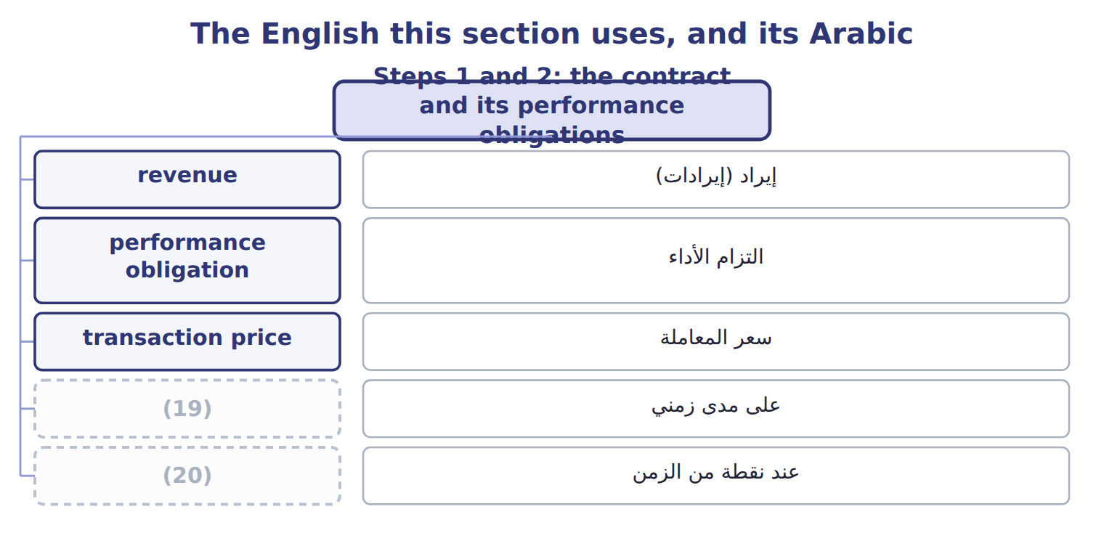
word list
التزام الأداء · over time · point in time

The English this sheet uses, and its Arabic
English (exam term) | Arabic
performance obligation | التزام الأداء

Answer key · 11.2 Steps 1 and 2: the contract and its performance obligations

1 identified | 11 identifiable
2 commercial | 12 dependent
3 substantially | 13 interdependent
4 consideration | 14 810,000 / 180,000 / 90,000
5 criteria | 15 point in time
6 liability | 16 practice
7 higher | 17 question
8 meaning | 18 little
9 transfer | 19 over time
10 separate | 20 point in time

the summaries in full
Summary 1 Step 1: identify the contract. A contract exists only if the parties have approved it and are committed to it, each party's rights and the payment terms can be identified, and the contract has commercial substance. Finally, it must be probable that the company will collect substantially all of the consideration. If these criteria are not met, cash received from the customer is a liability, not revenue. In U.S. GAAP, probable means likely: a higher level than the IFRS meaning of more likely than not. Step 2: identify the performance obligations. Each promise to transfer a distinct good or service is a separate obligation. A good or service is distinct if the customer can benefit from it on its own and it is separately identifiable in the contract, not highly dependent on other promises. GreenBasket buys olive oil, a beverage dispenser installed in its stores, and two years of dispenser maintenance. Each can be bought separately, so there are three performance obligations.
Summary 2 In U.S. GAAP, probable means likely to occur: in practice, about 75% or more. IFRS 15 uses probable to mean more likely than not. A question that says collection is only a little more likely than not fails the U.S. contract test.

11.3 Steps 3 and 4: the transaction price and its allocation
Chapter 11 · section 11.3

Fill every gap. Each word list holds one word more than there are gaps.
Summary 1 gaps 1–12
Step 3: (1) the transaction price, the amount the company (2) to receive. It (3) variable consideration, such as (4) and bonuses. The company estimates it using the expected value, for many possible outcomes, or the most likely amount, for an (5) outcome. Variable amounts are included only to the (6) that a significant reversal of revenue is not probable later. This is the constraint on variable consideration. Three other items (7) the transaction price. A significant (8) component is removed when payment and (9) are far apart; if they are within one year, the company may ignore it. Consideration (10) to a customer, such as a slotting fee paid to a (11) for shelf space, reduces revenue. Sales taxes and VAT (12) may be excluded from revenue by policy. Step 4: allocate the transaction price to the performance obligations in proportion to their standalone selling prices.
word list
marketing · expects · delivery · extent · determine · collected · financing · includes · all-or-nothing · supermarket · rebates · payable · change

Summary 2 gaps 13–16
When an (13) price is not available, the company estimates it, for example from market prices or expected cost plus a margin. The residual approach is allowed only when a price is highly variable or (14) . A (15) is normally shared by all obligations. Each obligation (16) receives 90% of its standalone price.
word list
uncertain · therefore · observable · discount · breakage

Price and allocation traps

Summary 3 gaps 17–20
Revenue for each obligation is its (17) price, not its standalone selling price. A slotting fee paid to a customer reduces revenue; it is not a (18) expense unless Orontes receives a (19) service. Do not use the residual approach when standalone prices can be (20) .
word list
distinct · revenue · allocated · marketing · observed

Variable consideration: most likely amount or expected value
Suppose: sales of 2,400,000 with a 3% volume reb | How it works | Revenue (whole USD)
Most likely amount | The rebate is all or nothing, so use the single most likely outcome: the rebate is earned (70% likely). | 2,328,000
Expected value | (21) : 70% × 72,000 = 50,400 rebate. Best when there are many possible outcomes. | 2,349,600
Constraint | Include variable amounts only if a significant reversal of revenue is not probable later. | (22)

word list
material right · Probability-weighted · Applies to both

The English this section uses, and its Arabic
Each term sits against what it means.
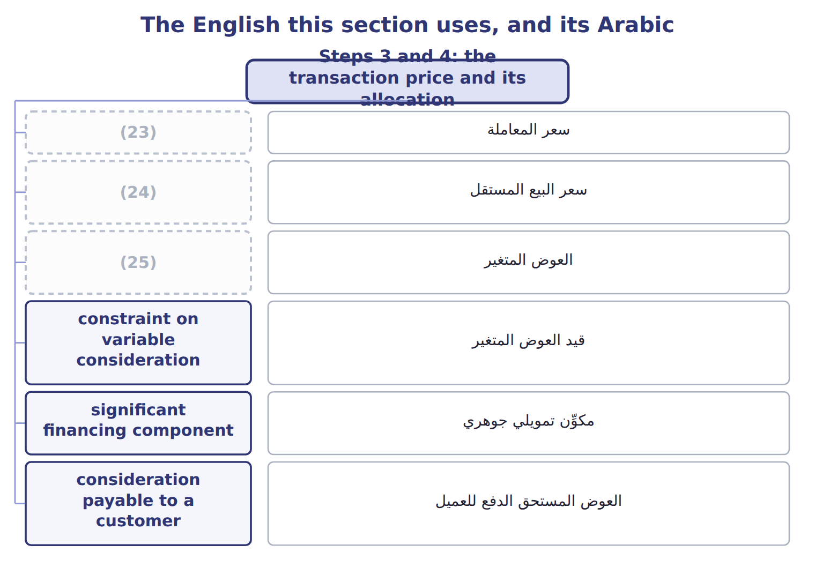
word list
transaction price · variable consideration · standalone selling price · سعر المعاملة

The English this sheet uses, and its Arabic
English (exam term) | Arabic
transaction price | سعر المعاملة
standalone selling price | سعر البيع المستقل
variable consideration | العوض المتغير
constraint on variable consideration | قيد العوض المتغير
significant financing component | مكوِّن تمويلي جوهري
consideration payable to a customer | العوض المستحق الدفع للعميل

Answer key · 11.3 Steps 3 and 4: the transaction price and its allocation

1 determine | 14 uncertain
2 expects | 15 discount
3 includes | 16 therefore
4 rebates | 17 allocated
5 all-or-nothing | 18 marketing
6 extent | 19 distinct
7 change | 20 observed
8 financing | 21 Probability-weighted
9 delivery | 22 Applies to both
10 payable | 23 transaction price
11 supermarket | 24 standalone selling price
12 collected | 25 variable consideration
13 observable

the summaries in full
Summary 1 Step 3: determine the transaction price, the amount the company expects to receive. It includes variable consideration, such as rebates and bonuses. The company estimates it using the expected value, for many possible outcomes, or the most likely amount, for an all-or-nothing outcome. Variable amounts are included only to the extent that a significant reversal of revenue is not probable later. This is the constraint on variable consideration. Three other items change the transaction price. A significant financing component is removed when payment and delivery are far apart; if they are within one year, the company may ignore it. Consideration payable to a customer, such as a slotting fee paid to a supermarket for shelf space, reduces revenue. Sales taxes and VAT collected may be excluded from revenue by policy. Step 4: allocate the transaction price to the performance obligations in proportion to their standalone selling prices.
Summary 2 When an observable price is not available, the company estimates it, for example from market prices or expected cost plus a margin. The residual approach is allowed only when a price is highly variable or uncertain. A discount is normally shared by all obligations. Each obligation therefore receives 90% of its standalone price.
Summary 3 Revenue for each obligation is its allocated price, not its standalone selling price. A slotting fee paid to a customer reduces revenue; it is not a marketing expense unless Orontes receives a distinct service. Do not use the residual approach when standalone prices can be observed.

11.4 Step 5: recognizing revenue over time or at a point in time
Chapter 11 · section 11.4

Fill every gap. Each word list holds one word more than there are gaps.
Summary 1 gaps 1–8
Step 5: (1) revenue when, or as, each obligation is satisfied. An obligation is satisfied over time if the customer (2) the benefit as the company (3) , if the company (4) an asset the customer controls, or if the asset has no other use and the company has a right to payment for work done so far. (5) over time is (6) by an output method, such as units delivered, or an input method, such as costs incurred. If no (7) criterion is met, revenue is recognized at a point in time: when control (8) .
word list
performs · benefit · passes · measured · over-time · Progress · receives · improves · recognize

Worked example: GreenBasket revenue for 2026

Summary 2 gaps 9–13
Olive oil is recognized at each (9) . By December 31, Orontes has delivered 8,000 cases at $40 each of (10) price: $324,000. The dispenser was installed on October 1, when (11) gained control: $180,000. (12) is over time: 3 months of 24 at $3,750 per month, $11,250. Total 2026 revenue is $515,250. The (13) $564,750 will be recognized in later periods.
word list
Maintenance · installed · delivery · allocated · remaining · GreenBasket

Suppose: GreenBasket revenue schedule for 2026
The bars are drawn to scale.
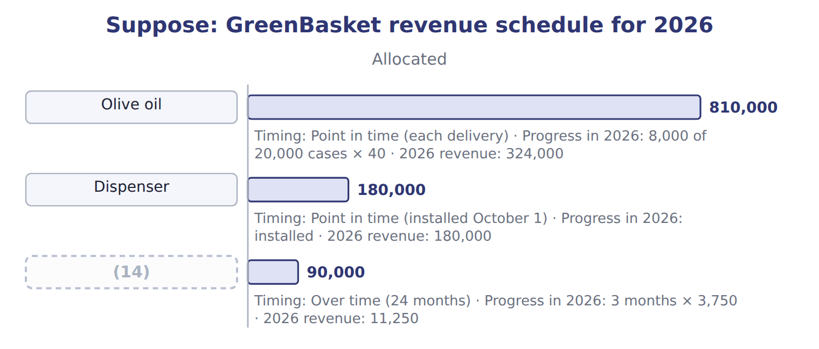
word list
breakage · Maintenance

Summary 3 gaps 15–17
Payments (15) match revenue. A contract asset arises when the company has (16) but its right to payment still depends on something other than time. A contract (17) arises when the customer pays first.
word list
liability · rarely · criterion · performed

The English this section uses, and its Arabic
Each term sits against what it means.
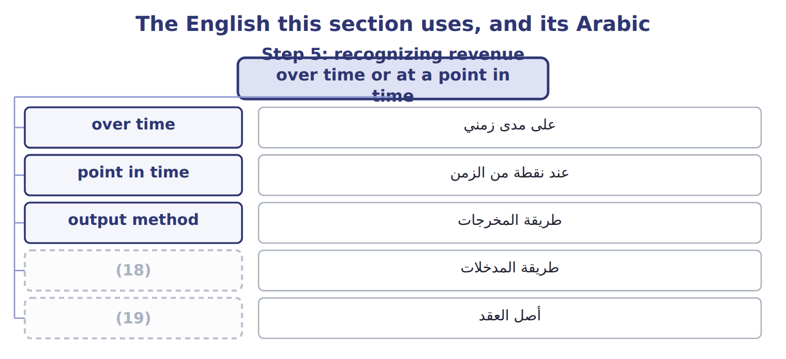
word list
performance obligation · contract asset · input method

The English this sheet uses, and its Arabic
English (exam term) | Arabic
over time | على مدى زمني
point in time | عند نقطة من الزمن
output method | طريقة المخرجات
input method | طريقة المدخلات
contract asset | أصل العقد

Answer key · 11.4 Step 5: recognizing revenue over time or at a point in time

1 recognize | 11 GreenBasket
2 receives | 12 Maintenance
3 performs | 13 remaining
4 improves | 14 Maintenance
5 Progress | 15 rarely
6 measured | 16 performed
7 over-time | 17 liability
8 passes | 18 input method
9 delivery | 19 contract asset
10 allocated

the summaries in full
Summary 1 Step 5: recognize revenue when, or as, each obligation is satisfied. An obligation is satisfied over time if the customer receives the benefit as the company performs, if the company improves an asset the customer controls, or if the asset has no other use and the company has a right to payment for work done so far. Progress over time is measured by an output method, such as units delivered, or an input method, such as costs incurred. If no over-time criterion is met, revenue is recognized at a point in time: when control passes.
Summary 2 Olive oil is recognized at each delivery. By December 31, Orontes has delivered 8,000 cases at $40 each of allocated price: $324,000. The dispenser was installed on October 1, when GreenBasket gained control: $180,000. Maintenance is over time: 3 months of 24 at $3,750 per month, $11,250. Total 2026 revenue is $515,250. The remaining $564,750 will be recognized in later periods.
Summary 3 Payments rarely match revenue. A contract asset arises when the company has performed but its right to payment still depends on something other than time. A contract liability arises when the customer pays first.

11.5 Special situations
Chapter 11 · section 11.5

Fill every gap. Each word list holds one word more than there are gaps.
Summary 1 gaps 1–8
When another party is (1) , the company must decide (2) it is a principal or an agent. A principal (3) the good or service before it is (4) and reports revenue gross. An agent only (5) the sale and reports its fee or commission as revenue. When customers may return goods, the company recognizes revenue only for goods it does not (6) to be returned. It (7) a refund liability for expected (8) and a separate asset for its right to recover the returned goods. The asset and the liability are not netted.
word list
refunds · arranges · controls · whether · transferred · expect · upfront · involved · records

Barada's sale with a right of return

Summary 2 gaps 9–18
Complete the four (9) . (10) is also the test in other cases. Goods sent on consignment are not sold until the (11) sells them. In a (12) arrangement, revenue is (13) only if the goods are identified, ready and cannot be used for other customers, and the customer asked for the arrangement. A (14) to buy the goods back usually means no sale has taken place. Customer options can create a (15) right, such as loyalty points, which is a separate (16) . For gift cards, the company recognizes (17) , the part customers are not expected to use, in (18) to the cards that are used. Nonrefundable upfront fees are usually deferred.
word list
promise · recognized · bill-and-hold · consignee · blanks · breakage · Complete · Control · obligation · proportion · material

Special-situation traps

Summary 3 gaps 19–20
An (19) revenue is its commission, not the full price the customer pays. Present the refund liability and the return asset (20) . Goods on consignment stay in the consignor's inventory.
word list
separately · promise · agent's

Suppose: Barada's sale with a right of return (complete the blanks)
Every item belongs to exactly one group.
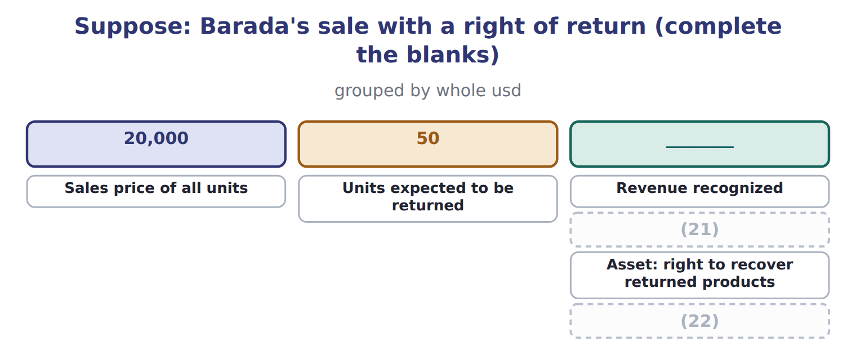
word list
bill-and-hold arrangement · Cost of goods sold · Refund liability

The English this section uses, and its Arabic
Each term sits against what it means.
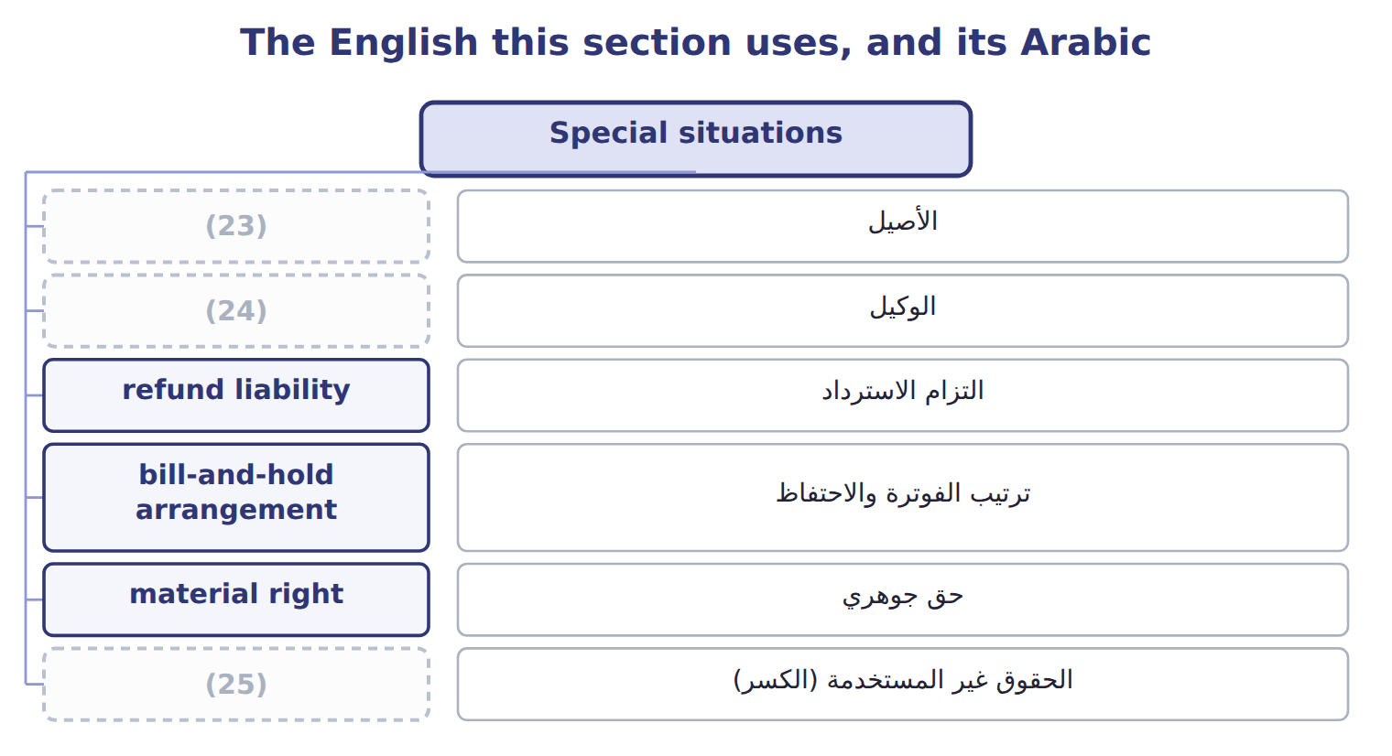
word list
الأصيل · breakage · agent · principal

The English this sheet uses, and its Arabic
English (exam term) | Arabic
principal | الأصيل
agent | الوكيل
refund liability | التزام الاسترداد
bill-and-hold arrangement | ترتيب الفوترة والاحتفاظ
material right | حق جوهري
breakage | الحقوق غير المستخدمة (الكسر)

Answer key · 11.5 Special situations

1 involved | 14 promise
2 whether | 15 material
3 controls | 16 obligation
4 transferred | 17 breakage
5 arranges | 18 proportion
6 expect | 19 agent's
7 records | 20 separately
8 refunds | 21 Refund liability
9 blanks | 22 Cost of goods sold
10 Control | 23 principal
11 consignee | 24 agent
12 bill-and-hold | 25 breakage
13 recognized

the summaries in full
Summary 1 When another party is involved, the company must decide whether it is a principal or an agent. A principal controls the good or service before it is transferred and reports revenue gross. An agent only arranges the sale and reports its fee or commission as revenue. When customers may return goods, the company recognizes revenue only for goods it does not expect to be returned. It records a refund liability for expected refunds and a separate asset for its right to recover the returned goods. The asset and the liability are not netted.
Summary 2 Complete the four blanks. Control is also the test in other cases. Goods sent on consignment are not sold until the consignee sells them. In a bill-and-hold arrangement, revenue is recognized only if the goods are identified, ready and cannot be used for other customers, and the customer asked for the arrangement. A promise to buy the goods back usually means no sale has taken place. Customer options can create a material right, such as loyalty points, which is a separate obligation. For gift cards, the company recognizes breakage, the part customers are not expected to use, in proportion to the cards that are used. Nonrefundable upfront fees are usually deferred.
Summary 3 An agent's revenue is its commission, not the full price the customer pays. Present the refund liability and the return asset separately. Goods on consignment stay in the consignor's inventory.

11.6 Matching, contract costs and IFRS differences
Chapter 11 · section 11.6

Fill every gap. Each word list holds one word more than there are gaps.
Summary 1 gaps 1–12
The matching (1) says that expenses are recognized in the same period as the (2) they help to earn. Cost of goods sold is recognized when the (3) sale is recognized. Costs with no future benefit, such as most (4) , are expensed at once, and long-lived assets are (5) over the periods they serve. Contract costs (6) the same idea. (7) costs of obtaining a contract, such as sales (8) , are capitalized if the company expects to recover them. Orontes pays its (9) a 3% commission, $32,400, on the (10) contract. It (11) this amount and expenses it as it (12) the goods and services. If the amortization period is one year or less, the company may expense such costs immediately. Costs to fulfill a contract are capitalized only if they relate directly to it and create a resource that will be used. Under U.S. GAAP, an impairment of these assets is never reversed. They matter for comparisons, but the five steps are the same.
word list
Incremental · capitalizes · related · salesperson · principle · follow · depreciated · GreenBasket · advertising · transfers · expense · commissions · revenues

ASC 606 and IFRS 15: the main differences
The two sides differ only where the rows say.
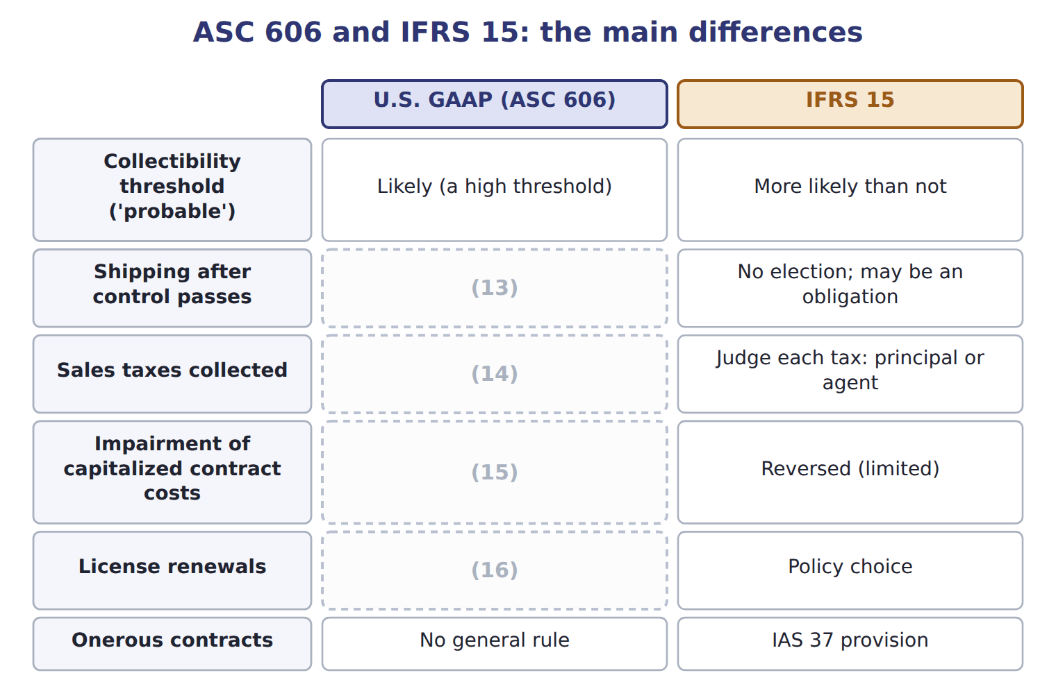
word list
May elect to treat as a fulfillment cost · Revenue when the renewal period begins · Never reversed · May elect to exclude all · Onerous contracts

Summary 2 gaps 17–22
ASU 2025-07 (17) how to account for shares that a customer pays as (18) . It (19) from 2027 and is not testable before about January 2028. ASU 2025-05 adds a (20) expedient for credit losses on current (21) and contract assets; it is not testable before about January 2027. Under ASC 606 the correct term is contract liability, and it can also arise when payment is due, not only when cash is (22) .
word list
receivables · applies · practical · services · consideration · received · explains

Item (USD 000) — Amount / details
Item (USD 000) | Amount / details
Contract date | September 1, 2026
Customer | (23)
Fixed contract price | 600
Fruit juices: 12 equal monthly deliveries from September 2026 (standalone selling price) | 540
Staff training on storing and serving juices, completed in September 2026 (standalone selling price) | 60
M1 | If Qasr's orders pass a volume target, Qasr pays 30 less. Orontes expects the target to be met, and a reversal is not probable.
M2 | Orontes pays Qasr 10 to list Orontes juices on hotel menus. Orontes (24) no distinct service.
M3 | Orontes delivers by its own trucks; control passes when the juices arrive. Orontes treats shipping as a (25) cost.
M4 | By December 31, 2026, Qasr has paid 250. Four monthly deliveries have been made.

word list
receives · Qasr Hotels, a hotel chain in Amman · Performance obligation · fulfillment

Item — Answer
Item | Answer
Revenue recognized | (26)
Refund liability | (27)
Asset: right to recover products | 50 × $12 = 600, shown separately from the refund liability
Cost of goods sold | (1,000 − 50) × $12 = 11,400

word list
May elect to exclude all · (1,000 − 50) × $20 = 19,000 · 50 × $20 = 1,000

Item — Category
Every item belongs to exactly one group.
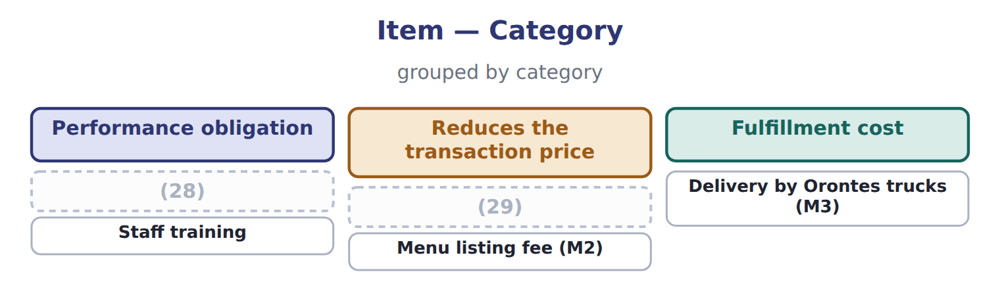
word list
Volume rebate (M1) · standalone selling price · Monthly juice deliveries

The English this section uses, and its Arabic
Each term sits against what it means.
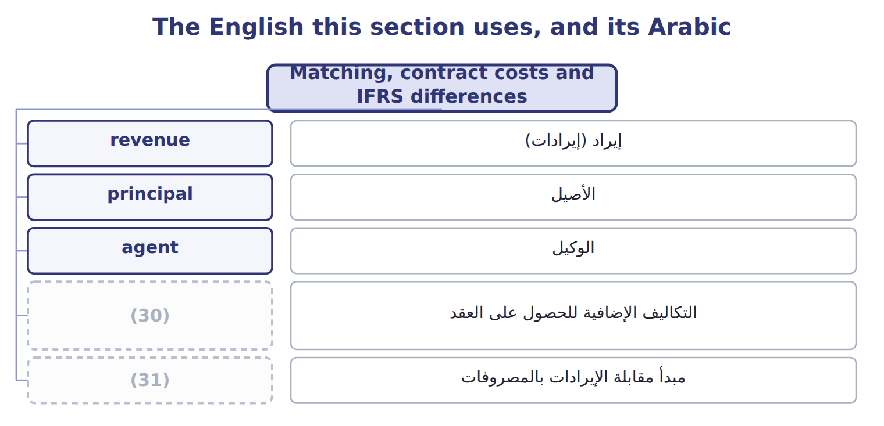
word list
matching principle · incremental costs of obtaining a contract · مبدأ مقابلة الإيرادات بالمصروفات

The English this sheet uses, and its Arabic
English (exam term) | Arabic
incremental costs of obtaining a contract | التكاليف الإضافية للحصول على العقد
matching principle | مبدأ مقابلة الإيرادات بالمصروفات

Answer key · 11.6 Matching, contract costs and IFRS differences

1 principle | 17 explains
2 revenues | 18 consideration
3 related | 19 applies
4 advertising | 20 practical
5 depreciated | 21 receivables
6 follow | 22 received
7 Incremental | 23 Qasr Hotels, a hotel chain in Amman
8 commissions | 24 receives
9 salesperson | 25 fulfillment
10 GreenBasket | 26 (1,000 − 50) × $20 = 19,000
11 capitalizes | 27 50 × $20 = 1,000
12 transfers | 28 Monthly juice deliveries
13 May elect to treat as a fulfillment cost | 29 Volume rebate (M1)
14 May elect to exclude all | 30 incremental costs of obtaining a contract
15 Never reversed | 31 matching principle
16 Revenue when the renewal period begins

the summaries in full
Summary 1 The matching principle says that expenses are recognized in the same period as the revenues they help to earn. Cost of goods sold is recognized when the related sale is recognized. Costs with no future benefit, such as most advertising, are expensed at once, and long-lived assets are depreciated over the periods they serve. Contract costs follow the same idea. Incremental costs of obtaining a contract, such as sales commissions, are capitalized if the company expects to recover them. Orontes pays its salesperson a 3% commission, $32,400, on the GreenBasket contract. It capitalizes this amount and expenses it as it transfers the goods and services. If the amortization period is one year or less, the company may expense such costs immediately. Costs to fulfill a contract are capitalized only if they relate directly to it and create a resource that will be used. Under U.S. GAAP, an impairment of these assets is never reversed. They matter for comparisons, but the five steps are the same.
Summary 2 ASU 2025-07 explains how to account for shares that a customer pays as consideration. It applies from 2027 and is not testable before about January 2028. ASU 2025-05 adds a practical expedient for credit losses on current receivables and contract assets; it is not testable before about January 2027. Under ASC 606 the correct term is contract liability, and it can also arise when payment is due, not only when cash is received.

12.1 What makes a liability current
Chapter 12 · section 12.1

Fill every gap. Each word list holds one word more than there are gaps.
Chapter 12, section by section
Each stage leads to the next.
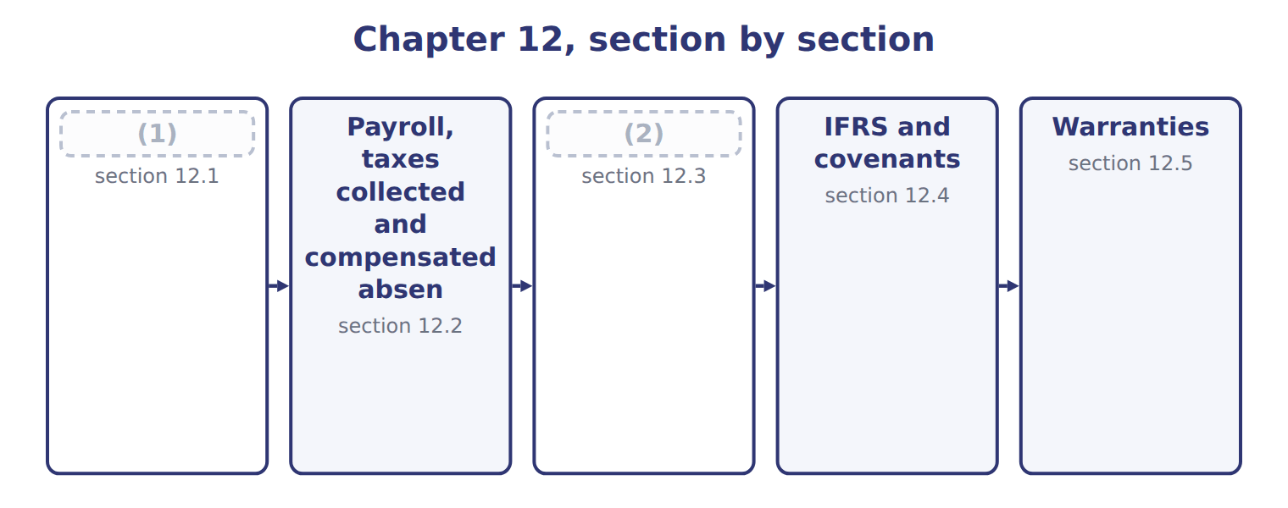
word list
Short-term debt expected to be refinanced · Payroll, taxes collected and compensated absen · What makes a liability current

Summary 1 gaps 3–7
Current liabilities are (3) that a company expects to settle by using current assets or by (4) other current liabilities, normally within one year. They are (5) at the amount to be paid. Because the time is short, they are not (6) to present value. Accounts payable and accruals arise from (7) ; dividends payable and the current portion of long-term debt arise from financing.
word list
obligations · measured · Customer · operations · discounted · creating

Summary 2 gaps 8–10
Customer (8) are contract liabilities: they become revenue when Orontes delivers. Cash dividends become a liability on the (9) date. A stock dividend (10) is not a liability, because no assets will be paid.
word list
declaration · distributable · deposits · discounted

The words this section uses
Each term sits against what it means, and an instance of it.
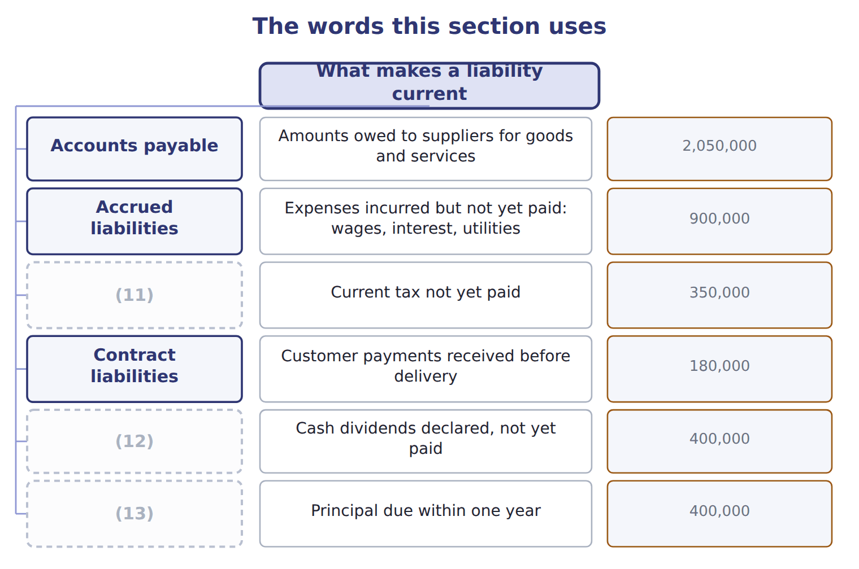
word list
Income taxes payable · Current portion of long-term debt · warranty liability · Dividends payable

Answer key · 12.1 What makes a liability current

1 What makes a liability current | 8 deposits
2 Short-term debt expected to be refinanced | 9 declaration
3 obligations | 10 distributable
4 creating | 11 Income taxes payable
5 measured | 12 Dividends payable
6 discounted | 13 Current portion of long-term debt
7 operations

the summaries in full
Summary 1 Current liabilities are obligations that a company expects to settle by using current assets or by creating other current liabilities, normally within one year. They are measured at the amount to be paid. Because the time is short, they are not discounted to present value. Accounts payable and accruals arise from operations; dividends payable and the current portion of long-term debt arise from financing.
Summary 2 Customer deposits are contract liabilities: they become revenue when Orontes delivers. Cash dividends become a liability on the declaration date. A stock dividend distributable is not a liability, because no assets will be paid.

12.2 Payroll, taxes collected and compensated absences
Chapter 12 · section 12.2

Fill every gap. Each word list holds one word more than there are gaps.
Summary 1 gaps 1–12
Payroll (1) several liabilities. The employer deducts (2) , such as income tax and the employees' share of social security, from gross wages. These (3) belong to the government, so they are liabilities, not (4) . The employer's own payroll taxes, such as its share of social security, are an (5) expense. Suppose Barada's gross wages for a month are $40,000. It withholds $4,000 of income tax and $2,800 of social security, so employees (6) $33,200. Barada's total payroll cost is the gross wages plus its own social security. Sales tax and VAT (7) from customers are also owed to the government. They are (8) as sales tax payable, not as revenue. (9) absences, such as earned (10) , are accrued when employees have already worked for them, the rights vest or (11) , and payment is (12) .
word list
withholding · receive · payable · probable · additional · amounts · collected · creates · accumulate · vacation · recorded · Compensated · expenses

Barada's payroll and sales tax

The first four rows are done. Complete the four blanks.
Suppose: Barada's payroll and sales tax for one month (complete the blanks)
Suppose: Barada, one month in 2027 | Whole USD
(13) | 40,000
(14) | 4,000
Employees' social security withheld (7%) | 2,800
(15) | 33,200
(16) | ________
Total owed to the tax authorities | ________
Cash register total, including 5% sales tax: 21,000. Sales revenue | ________
Sales tax payable | ________

word list
Gross wages for the month · Employer's social security (payroll tax expense, 7%) · Total owed to the tax authorities · Net pay to employees · Income tax withheld from employees

The English this section uses, and its Arabic
Each term sits against what it means.
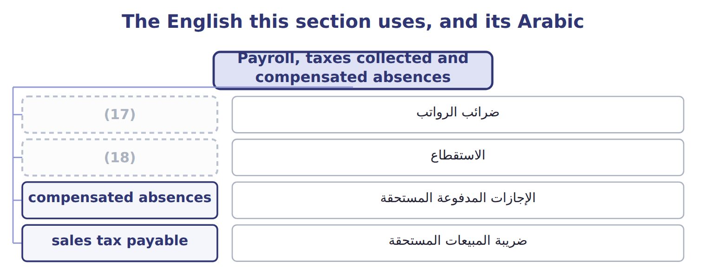
word list
withholding · compensated absences · payroll taxes

The English this sheet uses, and its Arabic
English (exam term) | Arabic
payroll taxes | ضرائب الرواتب
withholding | الاستقطاع
compensated absences | الإجازات المدفوعة المستحقة
sales tax payable | ضريبة المبيعات المستحقة

Answer key · 12.2 Payroll, taxes collected and compensated absences

1 creates | 10 vacation
2 withholding | 11 accumulate
3 amounts | 12 probable
4 expenses | 13 Gross wages for the month
5 additional | 14 Income tax withheld from employees
6 receive | 15 Net pay to employees
7 collected | 16 Employer's social security (payroll tax expense, 7%)
8 recorded | 17 payroll taxes
9 Compensated | 18 withholding

the summaries in full
Summary 1 Payroll creates several liabilities. The employer deducts withholding, such as income tax and the employees' share of social security, from gross wages. These amounts belong to the government, so they are liabilities, not expenses. The employer's own payroll taxes, such as its share of social security, are an additional expense. Suppose Barada's gross wages for a month are $40,000. It withholds $4,000 of income tax and $2,800 of social security, so employees receive $33,200. Barada's total payroll cost is the gross wages plus its own social security. Sales tax and VAT collected from customers are also owed to the government. They are recorded as sales tax payable, not as revenue. Compensated absences, such as earned vacation, are accrued when employees have already worked for them, the rights vest or accumulate, and payment is probable.

12.3 Short-term debt expected to be refinanced
Chapter 12 · section 12.3

Fill every gap. Each word list holds one word more than there are gaps.
Summary 1 gaps 1–10
A short-term (1) is normally current. It may be shown as noncurrent only if the company intends to refinance it on a long-term basis and shows that it can. A qualifying agreement does not expire within one year, cannot be (2) except for an (3) violation, has no violation, and the lender can pay. An agreement that the lender may cancel for a 'material adverse change' does not (4) , because that clause is (5) . The noncurrent amount cannot (6) the amount refinanced or (7) . Debt repaid with current (8) before the new financing is (9) stays current. Refinanced debt moves to noncurrent (10) , never to equity, even when shares are issued.
word list
available · assets · qualify · subjective · liabilities · cancelled · intends · obtained · objective · obligation · exceed

Worked example: Orontes's commercial paper

The set, member by member
The rows are a set, not a sequence.
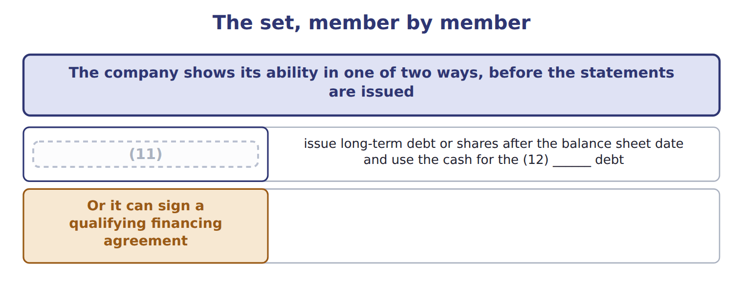
word list
It can actually refinance · short-term · warranty liability

Summary 2 gaps 13–14
Suppose Orontes has commercial paper of $3,000,000 due March 31, 2027, and intends to refinance it. Its 2026 statements are issued on March 1, 2027. Scenario A. Bonds issued on February 10 (13) the paper: the whole $3,000,000 is noncurrent. Scenario C. Shares issued for $2,400,000: that amount is noncurrent and $600,000 stays current. (14) moves to equity. Scenario D. A qualifying agreement for 80% of inventory of at least $3,125,000: $2,500,000 noncurrent, $500,000 current.
word list
Nothing · adverse · replace

Refinancing traps

Summary 3 gaps 15–16
Repaid first, refinanced later: still (15) . Refinanced with shares: noncurrent (16) up to the proceeds, not equity. A 'material adverse change' clause makes the agreement fail.
word list
current · February · liability

Suppose: five refinancing scenarios for Orontes's commercial paper
Suppose: Orontes, commercial paper of 3,000,000 | Noncurrent (U.S. GAAP) | Current (U.S. GAAP)
A. Issues 5-year bonds on February 10 and uses the cash to repay the paper at maturity | 3,000,000 | 0
B. Repays the paper with cash on January 15, then issues bonds on (17) 10 | 0 | 3,000,000
C. Issues shares on February 10 for 2,400,000 to repay the paper | 2,400,000 | 600,000
D. Signs a (18) agreement on February 1 to borrow 80% of inventory; inventory will not fall below 3,125,000 | 2,500,000 | 500,000
E. Same as D, but the lender may cancel if it sees a ' (19) adverse change' | 0 | 3,000,000

word list
qualifying · February · material · withholding

The English this section uses, and its Arabic
Each term sits against what it means.
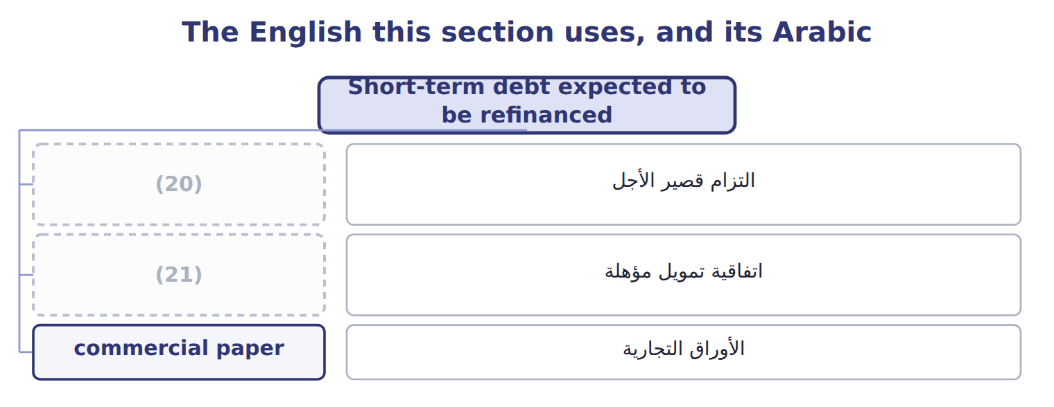
word list
qualifying financing agreement · اتفاقية تمويل مؤهلة · short-term obligation

The English this sheet uses, and its Arabic
English (exam term) | Arabic
short-term obligation | التزام قصير الأجل
qualifying financing agreement | اتفاقية تمويل مؤهلة
commercial paper | الأوراق التجارية

Answer key · 12.3 Short-term debt expected to be refinanced

1 obligation | 12 short-term
2 cancelled | 13 replace
3 objective | 14 Nothing
4 qualify | 15 current
5 subjective | 16 liability
6 exceed | 17 February
7 available | 18 qualifying
8 assets | 19 material
9 obtained | 20 short-term obligation
10 liabilities | 21 qualifying financing agreement
11 It can actually refinance

the summaries in full
Summary 1 A short-term obligation is normally current. It may be shown as noncurrent only if the company intends to refinance it on a long-term basis and shows that it can. A qualifying agreement does not expire within one year, cannot be cancelled except for an objective violation, has no violation, and the lender can pay. An agreement that the lender may cancel for a 'material adverse change' does not qualify, because that clause is subjective. The noncurrent amount cannot exceed the amount refinanced or available. Debt repaid with current assets before the new financing is obtained stays current. Refinanced debt moves to noncurrent liabilities, never to equity, even when shares are issued.
Summary 2 Suppose Orontes has commercial paper of $3,000,000 due March 31, 2027, and intends to refinance it. Its 2026 statements are issued on March 1, 2027. Scenario A. Bonds issued on February 10 replace the paper: the whole $3,000,000 is noncurrent. Scenario C. Shares issued for $2,400,000: that amount is noncurrent and $600,000 stays current. Nothing moves to equity. Scenario D. A qualifying agreement for 80% of inventory of at least $3,125,000: $2,500,000 noncurrent, $500,000 current.
Summary 3 Repaid first, refinanced later: still current. Refinanced with shares: noncurrent liability up to the proceeds, not equity. A 'material adverse change' clause makes the agreement fail.

12.4 IFRS and covenants
Chapter 12 · section 12.4

Fill every gap. Each word list holds one word more than there are gaps.
Summary 1 gaps 1–7
IAS 1 asks only one question: at the reporting date, does the company have a right to defer (1) for at least twelve months? (2) agreed after the reporting date does not change the classification, even if it happens before the statements are issued. In (3) A, C and D above, an IFRS company would show the whole (4) paper as current. Covenants (5) the same logic. Under IFRS, only covenants that must be met on or before the reporting date (6) classification; future covenants are (7) .
word list
settlement · affect · Refinancing · scenarios · commercial · disclosed · follow · January

Classification, covenants and warranty costs: U.S. GAAP and IFRS
The two sides differ only where the rows say.
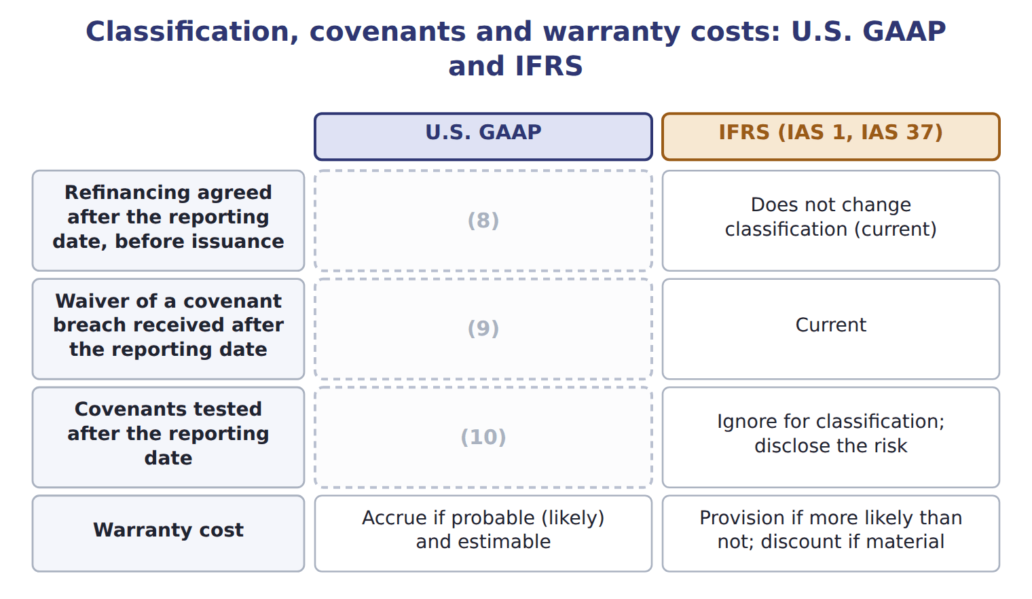
word list
Consider only violations at the balance sheet date · Noncurrent if the waiver lasts more than one year · Can make the debt noncurrent · Accrue if probable (likely) and estimable

Summary 2 gaps 11–13
The IAS 1 (11) on classification and covenants apply from January 1, 2024, and are testable now as IFRS (12) . They confirm that (13) intention to refinance does not matter; only rights at the reporting date do.
word list
contrasts · Covenants · amendments · management's

Answer key · 12.4 IFRS and covenants

1 settlement | 8 Can make the debt noncurrent
2 Refinancing | 9 Noncurrent if the waiver lasts more than one year
3 scenarios | 10 Consider only violations at the balance sheet date
4 commercial | 11 amendments
5 follow | 12 contrasts
6 affect | 13 management's
7 disclosed

the summaries in full
Summary 1 IAS 1 asks only one question: at the reporting date, does the company have a right to defer settlement for at least twelve months? Refinancing agreed after the reporting date does not change the classification, even if it happens before the statements are issued. In scenarios A, C and D above, an IFRS company would show the whole commercial paper as current. Covenants follow the same logic. Under IFRS, only covenants that must be met on or before the reporting date affect classification; future covenants are disclosed.
Summary 2 The IAS 1 amendments on classification and covenants apply from January 1, 2024, and are testable now as IFRS contrasts. They confirm that management's intention to refinance does not matter; only rights at the reporting date do.

12.5 Warranties
Chapter 12 · section 12.5

Fill every gap. Each word list holds one word more than there are gaps.
Summary 1 gaps 1–11
An assurance-type warranty only (1) that a product will work as agreed. It is not a separate performance obligation. The company (2) the repair cost at the time of sale, (3) warranty expense and a warranty liability, and (4) the liability as repairs are made. A service-type warranty gives the customer an extra service, such as extended cover. It is a separate performance obligation: part of the price is recorded as a contract liability and (5) as revenue over the (6) period. A warranty that (7) can buy separately is (8) service-type. Suppose Orontes sells 2,000 beverage (9) in 2026 for $3,000,000, with a one-year (10) warranty. It (11) repairs to cost 2% of sales. It also sells 400 three-year service plans for $120 each.
word list
customers · records · assurance · recognized · always · promises · accrual · dispensers · estimates · coverage · reduces · expects

Suppose: Orontes's warranty entries for 2026
Suppose: Orontes, 2026 (whole USD) | Account | Debit | Credit
Assurance-type: at each sale | Warranty expense | 60,000
 | Warranty liability |  | 60,000
Repairs made in 2026 | (12) | 22,000
 | Cash, parts inventory |  | 22,000
Service-type: plans sold in January | Cash | 48,000
 | (13) |  | 48,000
December 31, 2026 | Contract liability | 16,000
 | (14) |  | 16,000

word list
Contract liability · Service revenue · Customer deposits · Warranty liability

Summary 2 gaps 15–16
The warranty liability is the (15) of $60,000 minus repairs of $22,000: $38,000. The service plans are a contract liability of $32,000, of which the part to be (16) in 2027 is current.
word list
performance · earned · accrual

Warranty traps

Summary 3 gaps 17–19
Standard warranty: accrue the cost at the sale; do not defer revenue. Extended plan sold (17) : defer revenue; do not accrue a cost. (18) warranty costs in the year of the sale, not when (19) are paid.
word list
separately · Expense · Suppose · repairs

Warranty traps
Barada Wholesale, selected liabilities, December | Amount / details
Accounts payable | 450
Bank loan due April 30, 2028 | 400
Note payable due in 2029 (from the Chapter 2 case) | 1,500
Dividends payable | 60
Customer deposits for orders to be delivered in 2028 | 40
Wages payable / income tax withheld / employer payroll taxes | 25 / 5 / 3
M1 | On February 15, 2028, before the statements were issued on March 1, 2028, Barada signed a (20) three-year agreement. The bank will
M2 | In 2027 Barada began selling kitchen (21) with a one-year warranty that the product works as agreed. Sales were 1000; expected repairs
M3 | Barada also sold separately priced three-year service plans for 36, all starting on January 1, 2027.
M4 | Deferred tax balances are not shown here; Chapter 13 covers them.

word list
non-cancelable · equipment · Deferred

Item — Answer
Item | Answer
Employer's social security | (22)
Total owed to the tax authorities | 4,000 + 2,800 + 2,800 = 9,600
Sales revenue | (23)
Sales tax payable | 21,000 − 20,000 = 1,000

word list
7% × 40,000 = 2,800 (payroll tax expense) · Bank loan due April 30, 2028 · 21,000 ÷ 1.05 = 20,000

Item — Category
Item | Category
Bank loan | (24)
Note payable due 2029 | (25)
Warranty liability (M2) | Current liability
Service plans (M3) | Split between current and noncurrent
Customer deposits | (26)

word list
Noncurrent liability · Current liability · Split between current and noncurrent · Employer's social security

The English this section uses, and its Arabic
Each term sits against what it means.
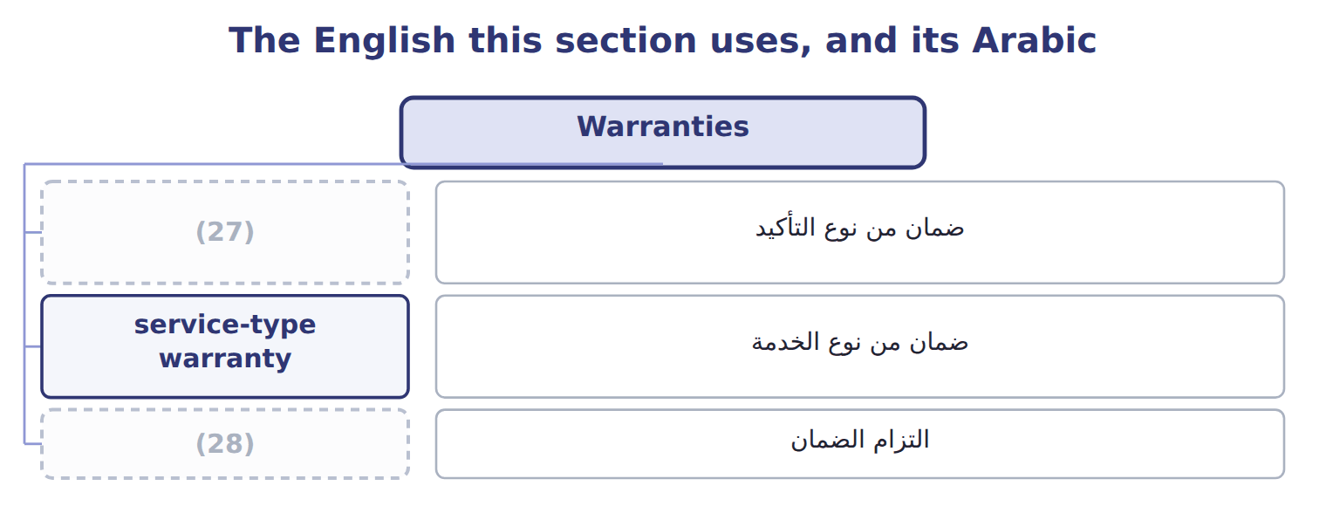
word list
warranty liability · assurance-type warranty · service-type warranty

The English this sheet uses, and its Arabic
English (exam term) | Arabic
assurance-type warranty | ضمان من نوع التأكيد
service-type warranty | ضمان من نوع الخدمة
warranty liability | التزام الضمان

Answer key · 12.5 Warranties

1 promises | 15 accrual
2 estimates | 16 earned
3 records | 17 separately
4 reduces | 18 Expense
5 recognized | 19 repairs
6 coverage | 20 non-cancelable
7 customers | 21 equipment
8 always | 22 7% × 40,000 = 2,800 (payroll tax expense)
9 dispensers | 23 21,000 ÷ 1.05 = 20,000
10 assurance | 24 Split between current and noncurrent
11 expects | 25 Noncurrent liability
12 Warranty liability | 26 Current liability
13 Contract liability | 27 assurance-type warranty
14 Service revenue | 28 warranty liability

the summaries in full
Summary 1 An assurance-type warranty only promises that a product will work as agreed. It is not a separate performance obligation. The company estimates the repair cost at the time of sale, records warranty expense and a warranty liability, and reduces the liability as repairs are made. A service-type warranty gives the customer an extra service, such as extended cover. It is a separate performance obligation: part of the price is recorded as a contract liability and recognized as revenue over the coverage period. A warranty that customers can buy separately is always service-type. Suppose Orontes sells 2,000 beverage dispensers in 2026 for $3,000,000, with a one-year assurance warranty. It expects repairs to cost 2% of sales. It also sells 400 three-year service plans for $120 each.
Summary 2 The warranty liability is the accrual of $60,000 minus repairs of $22,000: $38,000. The service plans are a contract liability of $32,000, of which the part to be earned in 2027 is current.
Summary 3 Standard warranty: accrue the cost at the sale; do not defer revenue. Extended plan sold separately: defer revenue; do not accrue a cost. Expense warranty costs in the year of the sale, not when repairs are paid.

13.1 Why book income and taxable income differ
Chapter 13 · section 13.1

Fill every gap. Each word list holds one word more than there are gaps.
Chapter 13, section by section
Each stage leads to the next.
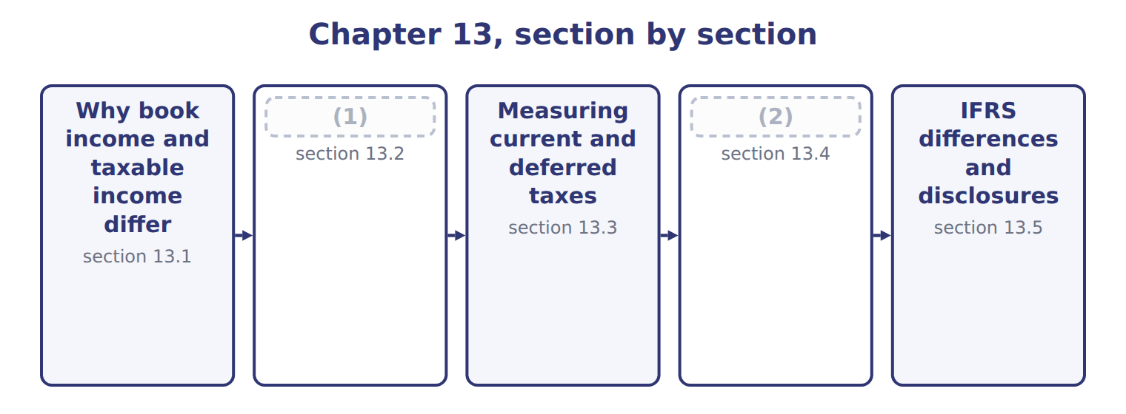
word list
Temporary and permanent differences · IFRS differences and disclosures · Rate changes, valuation allowances, losses and

Summary 1 gaps 3–13
Financial (3) follow U.S. GAAP and are prepared for (4) . Tax (5) follow tax law and are prepared for the (6) . The two sets of rules have (7) goals, so taxable income is (8) not the same as income before income taxes. If a company simply (9) the tax it paid, its tax expense would jump (10) when the rules timed items differently. (11) tax allocation (12) this. The company (13) the tax effects of transactions in the same periods as the transactions themselves, using deferred taxes. Income tax expense of $989,700 has two parts: current tax expense of $889,700, the tax on 2025 taxable income, and deferred tax expense of $100,000. Net taxable temporary differences grew by $400,000, mainly because tax depreciation was faster than book depreciation.
word list
around · recognizes · returns · reported · usually · statements · effects · investors · solves · Interperiod · government · different

Orontes Foods Inc. — income tax figures for 2025
Orontes Foods Inc., 2025 (whole USD) | Amount
Income before income taxes | 3,958,800
(14) | 989,700
Current tax expense (taxes on 2025 taxable income) | 889,700
Deferred tax expense (25% of the 400,000 increase in net taxable temporary differences) | 100,000
(15) | 839,700
Deferred tax liability, January 1, 2025 | 900,000
Deferred tax liability, December 31, 2025 (after the 375 tax effect of the OCI loss) | 999,625

word list
Income tax expense (25% combined federal and state rate) · Current tax expense (taxes on 2025 taxable income) · Income taxes paid in cash (Chapter 5)

The English this section uses, and its Arabic
Each term sits against what it means.
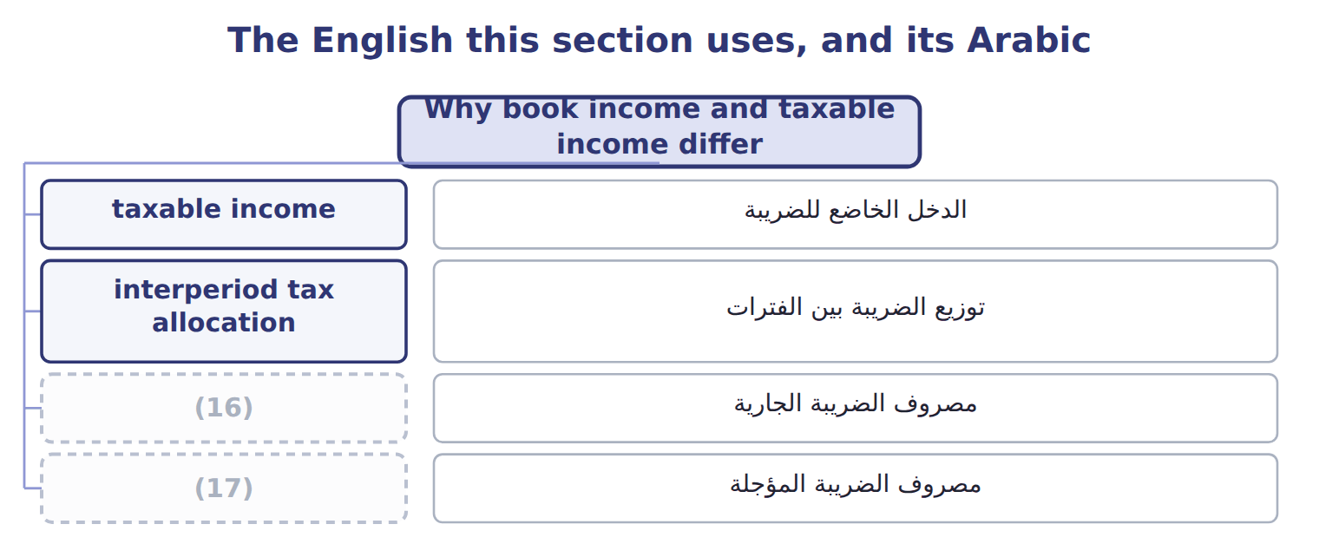
word list
deferred tax asset · deferred tax expense · current tax expense

The English this sheet uses, and its Arabic
English (exam term) | Arabic
taxable income | الدخل الخاضع للضريبة
interperiod tax allocation | توزيع الضريبة بين الفترات
current tax expense | مصروف الضريبة الجارية
deferred tax expense | مصروف الضريبة المؤجلة

Answer key · 13.1 Why book income and taxable income differ

1 Temporary and permanent differences | 10 around
2 Rate changes, valuation allowances, losses and | 11 Interperiod
3 statements | 12 solves
4 investors | 13 recognizes
5 returns | 14 Income tax expense (25% combined federal and state rate)
6 government | 15 Income taxes paid in cash (Chapter 5)
7 different | 16 current tax expense
8 usually | 17 deferred tax expense
9 reported

the summaries in full
Summary 1 Financial statements follow U.S. GAAP and are prepared for investors. Tax returns follow tax law and are prepared for the government. The two sets of rules have different goals, so taxable income is usually not the same as income before income taxes. If a company simply reported the tax it paid, its tax expense would jump around when the rules timed items differently. Interperiod tax allocation solves this. The company recognizes the tax effects of transactions in the same periods as the transactions themselves, using deferred taxes. Income tax expense of $989,700 has two parts: current tax expense of $889,700, the tax on 2025 taxable income, and deferred tax expense of $100,000. Net taxable temporary differences grew by $400,000, mainly because tax depreciation was faster than book depreciation.

13.2 Temporary and permanent differences
Chapter 13 · section 13.2

Fill every gap. Each word list holds one word more than there are gaps.
Summary 1 gaps 1–9
A temporary difference (1) when the tax basis of an asset or liability differs from its (2) amount on the (3) sheet. It reverses in later years. A taxable temporary difference will (4) future taxable income; a deductible temporary difference will (5) it. A permanent difference never reverses. The item is in book income but never in taxable income, or the (6) . Tax-exempt municipal bond interest and fines are common (7) . Permanent (8) create no deferred tax; they only change the (9) tax rate. A taxable temporary difference creates a deferred tax liability: tax that will be paid later. A deductible temporary difference creates a deferred tax asset: tax that will be saved later.
word list
examples · increase · depreciation · reverse · carrying · balance · effective · reduce · differences · arises

Common temporary and permanent differences
Item | Type of difference | Creates
Tax depreciation faster than book (bonus, MACRS) | (10) | Deferred tax liability
Installment sale: revenue now, taxed when cash is collected | Temporary, taxable | Deferred tax liability
Warranty or litigation accrual, deductible when paid | (11) | Deferred tax asset
Rent received in advance, taxed when received | Temporary, deductible | Deferred tax asset
Tax-exempt municipal bond interest | Permanent | None
Fines and penalties | Permanent | None
Life insurance premiums when the company is the beneficiary | Permanent | (12)

word list
Permanent · None · Temporary, deductible · Temporary, taxable

Which way does it go?

Summary 2 gaps 13–15
Tax (13) faster than book: less tax now, more later: deferred tax (14) . Warranty (15) now, deductible when paid: more tax now, less later: deferred tax asset. Fines and municipal interest: permanent, no deferred tax.
word list
taxable · depreciation · liability · accrued

The English this section uses, and its Arabic
Each term sits against what it means.
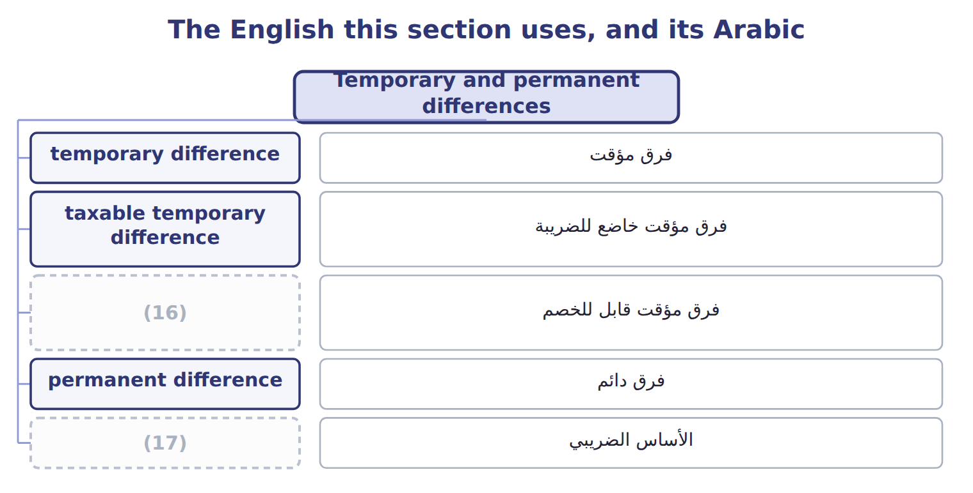
word list
taxable income · tax basis · deductible temporary difference

The English this sheet uses, and its Arabic
English (exam term) | Arabic
temporary difference | فرق مؤقت
taxable temporary difference | فرق مؤقت خاضع للضريبة
deductible temporary difference | فرق مؤقت قابل للخصم
permanent difference | فرق دائم
tax basis | الأساس الضريبي

Answer key · 13.2 Temporary and permanent differences

1 arises | 10 Temporary, taxable
2 carrying | 11 Temporary, deductible
3 balance | 12 None
4 increase | 13 depreciation
5 reduce | 14 liability
6 reverse | 15 accrued
7 examples | 16 deductible temporary difference
8 differences | 17 tax basis
9 effective

the summaries in full
Summary 1 A temporary difference arises when the tax basis of an asset or liability differs from its carrying amount on the balance sheet. It reverses in later years. A taxable temporary difference will increase future taxable income; a deductible temporary difference will reduce it. A permanent difference never reverses. The item is in book income but never in taxable income, or the reverse. Tax-exempt municipal bond interest and fines are common examples. Permanent differences create no deferred tax; they only change the effective tax rate. A taxable temporary difference creates a deferred tax liability: tax that will be paid later. A deductible temporary difference creates a deferred tax asset: tax that will be saved later.
Summary 2 Tax depreciation faster than book: less tax now, more later: deferred tax liability. Warranty accrued now, deductible when paid: more tax now, less later: deferred tax asset. Fines and municipal interest: permanent, no deferred tax.

13.3 Measuring current and deferred taxes
Chapter 13 · section 13.3

Fill every gap. Each word list holds one word more than there are gaps.
Summary 1 gaps 1–4
U.S. GAAP uses the balance sheet (1) . Current tax is taxable income times the tax rate. Deferred tax (2) and assets are the temporary differences times the (3) tax rate that will apply when they reverse. Deferred tax expense is the (4) in the net deferred tax liability during the year.
word list
enacted · change · approach · municipal · liabilities

Worked example: Orontes's 2026 income tax

Summary 2 gaps 5–9
Suppose Orontes earns $2,000,000 before tax in 2026. It (5) the permanent differences: municipal interest of $20,000 and a fine of $10,000. New equipment costs $900,000. Tax law (6) 100% bonus depreciation, but book depreciation is $300,000. The difference of $600,000 (7) taxable income now: a taxable temporary difference. The (8) warranty from,000, but only $22,000 of repairs were paid. The $38,000 not yet deductible (9) taxable income now. Taxable income is $1,428,000, so current tax is $357,000.
word list
reduces · expense · allows · dispenser · removes · increases

Suppose: Orontes's 2026 taxable income and current tax
Suppose: Orontes, 2026 (whole USD) | Amount
Income before income taxes (book) | 2,000,000
(10) | (20,000)
(11) | 10,000
Less: tax depreciation 900,000 above book depreciation 300,000 (temporary) | (600,000)
Add: warranty expense 60,000 not yet deductible; repairs paid 22,000 (temporary) | 38,000
Taxable income | 1,428,000
Current tax expense at 25% | 357,000

word list
Add: fine, not deductible (permanent) · Less: tax-exempt municipal interest (permanent) · Current tax expense at 25%

Summary 3 gaps 12–15
Deferred taxes (12) from the same differences. The equipment creates a deferred tax liability of $150,000, and the warranty a deferred tax asset of $9,500. Deferred tax expense is $140,500, so total income tax expense is $497,500. The effective tax rate is total tax expense (13) by pretax income: 24.875%. It (14) from the statutory 25% only (15) of the permanent differences.
word list
differs · Current · because · divided · follow

Suppose: Orontes's 2026 income tax expense and rate reconciliation
Suppose: Orontes, 2026 (whole USD) | Amount | % of pretax income
Current tax expense | 357,000
Deferred tax liability created: 25% × 600,000 | 150,000
(16) : 25% × 38,000 | (9,500)
Deferred tax expense | 140,500
Total income tax expense | 497,500 | 24.875%
Rate reconciliation (ASU 2023-09 style)
(17) : 25% × 2,000,000 | 500,000 | 25.000%
Nontaxable or nondeductible items: municipal interest | (5,000) | -0.250%
Nontaxable or nondeductible items: fine | 2,500 | 0.125%
(18) | 497,500 | 24.875%

word list
Tax at the statutory rate · Income tax expense and effective tax rate · Deferred tax asset created · Fine for breaking an environmental law

Classify the differences

The first two are done. Classify the other four and say what each creates.
Classify the differences (complete the blanks)
Item | Type | Creates
Tax-exempt municipal bond interest | Permanent | (19)
Tax depreciation faster than book depreciation | (20) | DTL
Warranty expense accrued now, deducted for tax when repairs are paid | ________ | ________
Fine for breaking an environmental law | ________ | ________
Rent received in advance, taxed when received | ________ | ________
Equity-method income, taxed only when dividends are received | ________ | ________

word list
None · Temporary, taxable · Amount

The English this section uses, and its Arabic
Each term sits against what it means.
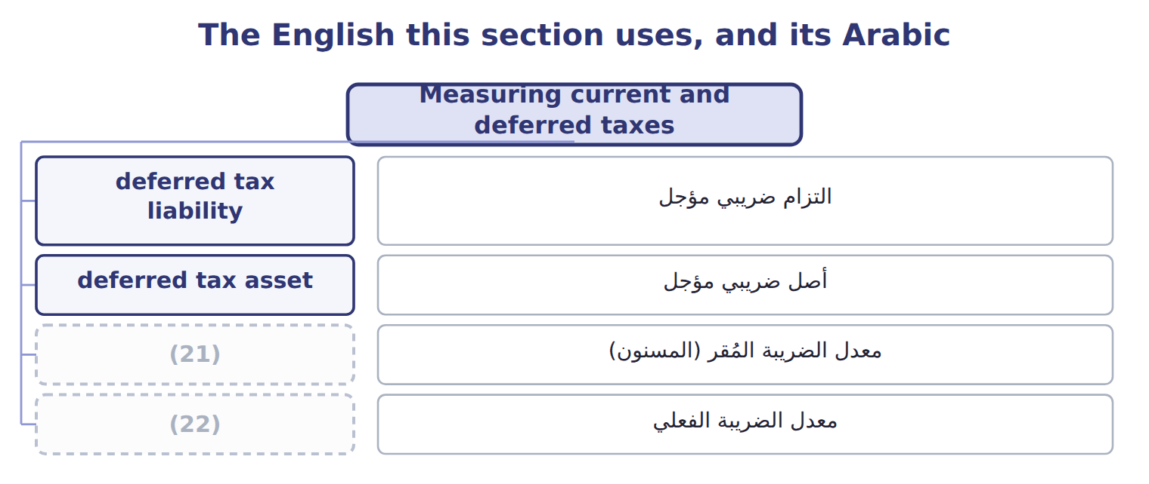
word list
effective tax rate · أصل ضريبي مؤجل · enacted tax rate

The English this sheet uses, and its Arabic
English (exam term) | Arabic
deferred tax liability | التزام ضريبي مؤجل
deferred tax asset | أصل ضريبي مؤجل
enacted tax rate | معدل الضريبة المُقر (المسنون)
effective tax rate | معدل الضريبة الفعلي

Answer key · 13.3 Measuring current and deferred taxes

1 approach | 12 follow
2 liabilities | 13 divided
3 enacted | 14 differs
4 change | 15 because
5 removes | 16 Deferred tax asset created
6 allows | 17 Tax at the statutory rate
7 reduces | 18 Income tax expense and effective tax rate
8 dispenser | 19 None
9 increases | 20 Temporary, taxable
10 Less: tax-exempt municipal interest (permanent) | 21 enacted tax rate
11 Add: fine, not deductible (permanent) | 22 effective tax rate

the summaries in full
Summary 1 U.S. GAAP uses the balance sheet approach. Current tax is taxable income times the tax rate. Deferred tax liabilities and assets are the temporary differences times the enacted tax rate that will apply when they reverse. Deferred tax expense is the change in the net deferred tax liability during the year.
Summary 2 Suppose Orontes earns $2,000,000 before tax in 2026. It removes the permanent differences: municipal interest of $20,000 and a fine of $10,000. New equipment costs $900,000. Tax law allows 100% bonus depreciation, but book depreciation is $300,000. The difference of $600,000 reduces taxable income now: a taxable temporary difference. The dispenser warranty from,000, but only $22,000 of repairs were paid. The $38,000 not yet deductible increases taxable income now. Taxable income is $1,428,000, so current tax is $357,000.
Summary 3 Deferred taxes follow from the same differences. The equipment creates a deferred tax liability of $150,000, and the warranty a deferred tax asset of $9,500. Deferred tax expense is $140,500, so total income tax expense is $497,500. The effective tax rate is total tax expense divided by pretax income: 24.875%. It differs from the statutory 25% only because of the permanent differences.

13.4 Rate changes, valuation allowances, losses and presentation
Chapter 13 · section 13.4

Fill every gap. Each word list holds one word more than there are gaps.
Summary 1 gaps 1–12
When a new tax law (1) the rate, the company (2) its deferred taxes at once. The whole effect goes to income from continuing operations in the period that includes the (3) date, even if the (4) item was in OCI. For example, a U.S. tax law signed on July 4, 2025 changed several (5) rules; companies (6) the effects in the quarter that included that date. (7) a law enacted in 2027 cuts the rate to 21% from 2028. At the end of 2027 the (8) falls from $75,000 to $63,000. The $12,000 (9) is a benefit in 2027. A deferred tax asset is (10) only if the company will have (11) taxable income to use it. If it is more likely than not that some of the asset will not be (12) , the company records a valuation allowance.
word list
useful · deduction · announced · remeasures · recorded · realized · enough · changes · liability · enactment · Suppose · original · decrease

Summary 2 gaps 13–20
A tax loss (13) a net operating loss (14) , which is a deferred tax asset. Under current U.S. (15) law, most losses (16) be carried back. They can be carried forward (17) a time limit, but they can (18) only 80% of taxable income in any year. All deferred tax assets and (19) are noncurrent. Within one tax (20) they are offset and shown as one net amount. Tax is also allocated within the period: Orontes's OCI loss was shown net of its $375 tax effect, and discontinued operations carry their own tax. This is intraperiod tax allocation.
word list
creates · jurisdiction · without · federal · current · liabilities · carryforward · cannot · reduce

Rate and allowance traps

Summary 3 gaps 21–27
Use enacted rates only; an (21) but unsigned rate is (22) . Record the full effect of a rate (23) in continuing operations when the law is enacted. Record the full DTA, then a valuation allowance: do not record only the (24) part. An (25) tax position is (26) only if it is more likely than not to be accepted by the tax authority. The global (27) tax (Pillar Two) is treated as a current cost in the year it arises, with no deferred taxes.
word list
recognized · minimum · ignored · change · uncertain · current · probable · announced

The English this section uses, and its Arabic
Each term sits against what it means.
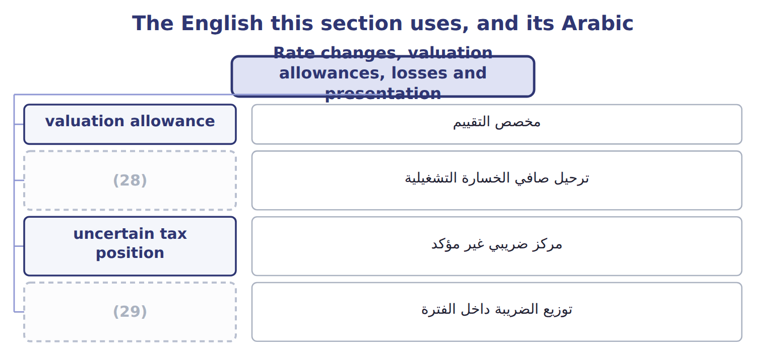
word list
deferred tax asset · intraperiod tax allocation · net operating loss carryforward

The English this sheet uses, and its Arabic
English (exam term) | Arabic
valuation allowance | مخصص التقييم
net operating loss carryforward | ترحيل صافي الخسارة التشغيلية
uncertain tax position | مركز ضريبي غير مؤكد
intraperiod tax allocation | توزيع الضريبة داخل الفترة

Answer key · 13.4 Rate changes, valuation allowances, losses and presentation

1 changes | 16 cannot
2 remeasures | 17 without
3 enactment | 18 reduce
4 original | 19 liabilities
5 deduction | 20 jurisdiction
6 recorded | 21 announced
7 Suppose | 22 ignored
8 liability | 23 change
9 decrease | 24 probable
10 useful | 25 uncertain
11 enough | 26 recognized
12 realized | 27 minimum
13 creates | 28 net operating loss carryforward
14 carryforward | 29 intraperiod tax allocation
15 federal

the summaries in full
Summary 1 When a new tax law changes the rate, the company remeasures its deferred taxes at once. The whole effect goes to income from continuing operations in the period that includes the enactment date, even if the original item was in OCI. For example, a U.S. tax law signed on July 4, 2025 changed several deduction rules; companies recorded the effects in the quarter that included that date. Suppose a law enacted in 2027 cuts the rate to 21% from 2028. At the end of 2027 the liability falls from $75,000 to $63,000. The $12,000 decrease is a benefit in 2027. A deferred tax asset is useful only if the company will have enough taxable income to use it. If it is more likely than not that some of the asset will not be realized, the company records a valuation allowance.
Summary 2 A tax loss creates a net operating loss carryforward, which is a deferred tax asset. Under current U.S. federal law, most losses cannot be carried back. They can be carried forward without a time limit, but they can reduce only 80% of taxable income in any year. All deferred tax assets and liabilities are noncurrent. Within one tax jurisdiction they are offset and shown as one net amount. Tax is also allocated within the period: Orontes's OCI loss was shown net of its $375 tax effect, and discontinued operations carry their own tax. This is intraperiod tax allocation.
Summary 3 Use enacted rates only; an announced but unsigned rate is ignored. Record the full effect of a rate change in continuing operations when the law is enacted. Record the full DTA, then a valuation allowance: do not record only the probable part. An uncertain tax position is recognized only if it is more likely than not to be accepted by the tax authority. The global minimum tax (Pillar Two) is treated as a current cost in the year it arises, with no deferred taxes.

13.5 IFRS differences and disclosures
Chapter 13 · section 13.5

Fill every gap. Each word list holds one word more than there are gaps.
Summary 1 gaps 1–3
The (1) one for the exam is the deferred tax asset: IFRS (2) only the amount it is probable to use, while U.S. GAAP records the full asset and a (3) valuation allowance.
word list
version · biggest · recognizes · separate

Income taxes: U.S. GAAP (ASC 740) and IFRS (IAS 12)
Topic | U.S. GAAP (ASC 740) | IFRS (IAS 12)
Recognizing deferred tax assets | Record the full DTA, then a valuation allowance if realization is not more likely than not | (4) only the amount for which taxable profit is probable
Tax rate | Enacted rates only | (5)
Initial recognition exemption | None in general | (6)
Uncertain tax positions | Two steps: more likely than not, then largest amount over 50% likely | IFRIC 23: most likely amount or expected value
Balance sheet classification | (7) | Non-current
Pillar Two top-up tax | (8) | Mandatory exception; no deferred tax

word list
Noncurrent · valuation allowance · Yes, outside business combinations (narrowed in 2021) · Recognize · Period cost; no deferred tax · Enacted or substantively enacted rates

Summary 2 gaps 9–15
ASU 2023-09 is testable now for public companies. They show a rate (9) in dollars and (10) with eight standard categories, and they list separately any item of at least 5% of pretax income times the statutory rate. They also (11) income taxes paid by federal, state and foreign (12) . For companies that are not public business (13) , ASU 2023-09 applies to annual periods (14) after December 15, 2025. That (15) is not testable before about January 2027.
word list
percentages · business · version · reconciliation · entities · beginning · jurisdictions · disclose

'Provision for income taxes'

U.S. companies often call income tax expense the provision for income taxes. It is an expense, not an IAS 37 provision and not a reserve.

'Provision for income taxes'
Barada Wholesale, 2027 (whole USD) | Amount / details
Income before income taxes, 2027 | 400,000
Tax-exempt municipal bond interest included in income | 12,000
Fine for a late customs filing (not deductible) | 6,000
Tax depreciation above book depreciation in 2027 | 60,000
Warranty liability at December 31, 2027 (Chapter 12 case); repairs are deductible when paid | 18,000
M1 | The enacted combined tax rate is 25% for 2027 and all later years.
M2 | Barada had no temporary differences at January 1, 2027. All deferred taxes are in one tax (16) .
M3 | Barada has been profitable for many years and expects to stay profitable.

word list
jurisdiction · Answer

Item — Answer
Item | Answer
Warranty expense accrued now | Temporary, deductible: DTA
Fine for breaking the law | (17)
Rent received in advance | Temporary, deductible (taxed now, earned later): DTA
Equity-method income | (18)

word list
Temporary, taxable (taxed later): DTL · Permanent: no deferred tax · Mandatory exception; no deferred tax

Item — Category
Item | Category
Municipal bond interest | (19)
Late-filing fine | Permanent difference
Tax depreciation above book | (20)
Warranty liability | (21)
Rent received in advance | Deductible temporary difference (DTA)

word list
Taxable temporary difference (DTL) · Deductible temporary difference (DTA) · tax basis · Permanent difference

Answer key · 13.5 IFRS differences and disclosures

1 biggest | 12 jurisdictions
2 recognizes | 13 entities
3 separate | 14 beginning
4 Recognize | 15 version
5 Enacted or substantively enacted rates | 16 jurisdiction
6 Yes, outside business combinations (narrowed in 2021) | 17 Permanent: no deferred tax
7 Noncurrent | 18 Temporary, taxable (taxed later): DTL
8 Period cost; no deferred tax | 19 Permanent difference
9 reconciliation | 20 Taxable temporary difference (DTL)
10 percentages | 21 Deductible temporary difference (DTA)
11 disclose

the summaries in full
Summary 1 The biggest one for the exam is the deferred tax asset: IFRS recognizes only the amount it is probable to use, while U.S. GAAP records the full asset and a separate valuation allowance.
Summary 2 ASU 2023-09 is testable now for public companies. They show a rate reconciliation in dollars and percentages with eight standard categories, and they list separately any item of at least 5% of pretax income times the statutory rate. They also disclose income taxes paid by federal, state and foreign jurisdictions. For companies that are not public business entities, ASU 2023-09 applies to annual periods beginning after December 15, 2025. That version is not testable before about January 2027.

14.1 What is a lease?
Chapter 14 · section 14.1

Fill every gap. Each word list holds one word more than there are gaps.
Chapter 14, section by section
Each stage leads to the next.
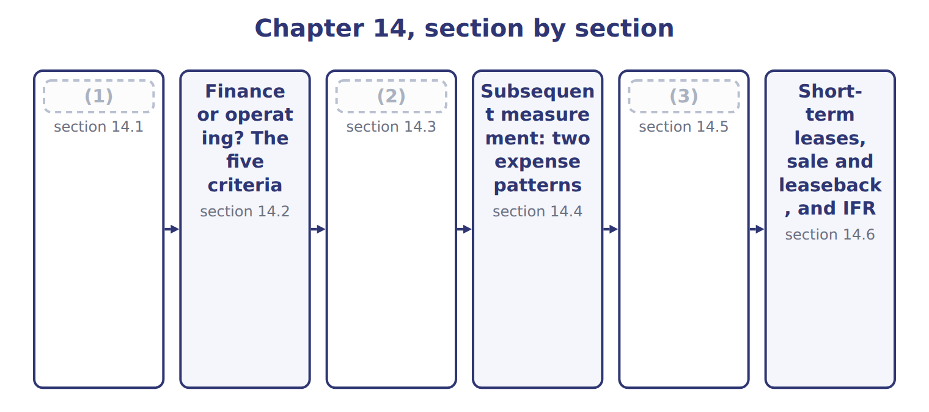
word list
Presentation · What is a lease? · Initial measurement · operating lease

Summary 1 gaps 4–11
A lease is a (4) that gives the right to control the use of an identified asset for a period of time in (5) for payment. The lessee uses the asset; the (6) provides it. The asset must be identified, and the (7) must not have a real right to swap it for (8) . The lessee (9) the asset if it gets almost all of its (10) benefits and decides how it is used. The lease term is the period the lessee cannot cancel, plus any renewal periods it is (11) certain to use.
word list
controls · lessor · exchange · supplier · contract · periods · another · reasonably · economic

The English this section uses, and its Arabic
Each term sits against what it means.
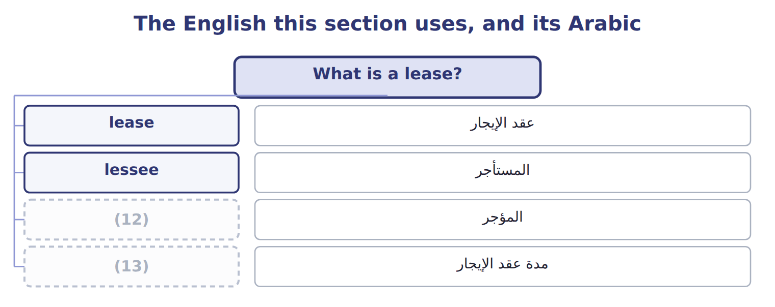
word list
lessor · lessee · lease term

The English this sheet uses, and its Arabic
English (exam term) | Arabic
lease | عقد الإيجار
lessee | المستأجر
lessor | المؤجر
lease term | مدة عقد الإيجار

Answer key · 14.1 What is a lease?

1 What is a lease? | 8 another
2 Initial measurement | 9 controls
3 Presentation | 10 economic
4 contract | 11 reasonably
5 exchange | 12 lessor
6 lessor | 13 lease term
7 supplier

the summaries in full
Summary 1 A lease is a contract that gives the right to control the use of an identified asset for a period of time in exchange for payment. The lessee uses the asset; the lessor provides it. The asset must be identified, and the supplier must not have a real right to swap it for another. The lessee controls the asset if it gets almost all of its economic benefits and decides how it is used. The lease term is the period the lessee cannot cancel, plus any renewal periods it is reasonably certain to use.

14.2 Finance or operating? The five criteria
Chapter 14 · section 14.2

Fill every gap. Each word list holds one word more than there are gaps.
Summary 1 gaps 1–8
A (1) classifies each lease at the start. It is a finance lease if it meets any one of five criteria; (2) it is an operating lease. Many companies use about 75% or more of (3) life as a major part, and about 90% or more of fair value as (4) all. The (5) lease runs 5 years in a building that will last 30 years, and its payments are worth only 28% of the (6) value: an operating lease. The (7) line was built for (8) and the lease covers most of its life: a finance lease.
word list
warehouse · substantially · classifies · building's · lessee · economic · otherwise · olive-press · Orontes

Suppose: classifying Orontes's two leases, January 1, 2026
Every item belongs to exactly one group.
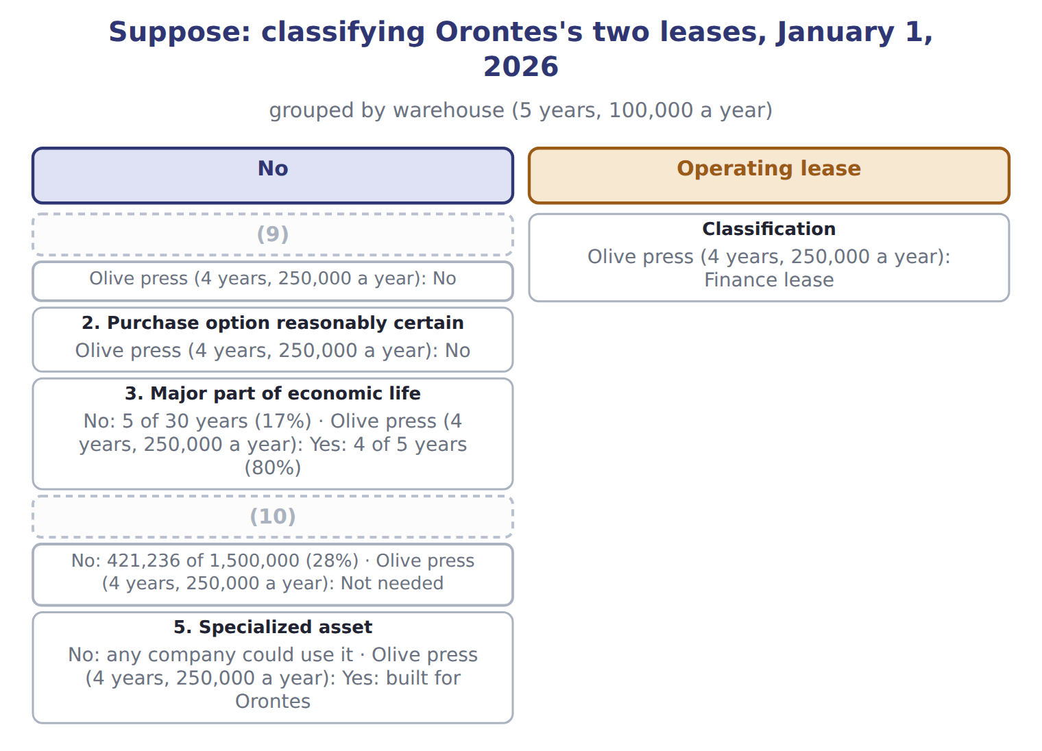
word list
4. PV ≥ substantially all of fair value · 5. Specialized asset · 1. Ownership transfers

Under ASC 842, the class depends only on the five criteria.

The English this section uses, and its Arabic
Each term sits against what it means.
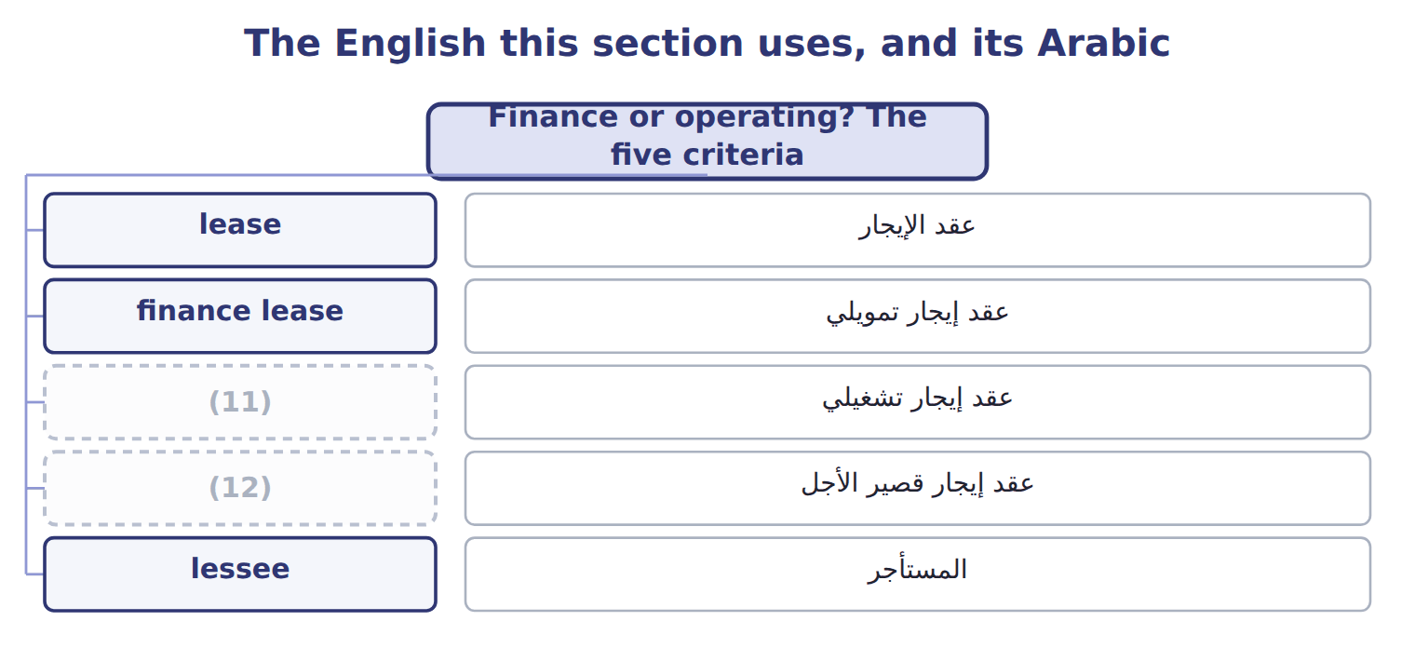
word list
finance lease · short-term lease · operating lease

The English this sheet uses, and its Arabic
English (exam term) | Arabic
finance lease | عقد إيجار تمويلي
operating lease | عقد إيجار تشغيلي

Answer key · 14.2 Finance or operating? The five criteria

1 lessee | 7 olive-press
2 otherwise | 8 Orontes
3 economic | 9 1. Ownership transfers
4 substantially | 10 4. PV ≥ substantially all of fair value
5 warehouse | 11 operating lease
6 building's | 12 short-term lease

the summaries in full
Summary 1 A lessee classifies each lease at the start. It is a finance lease if it meets any one of five criteria; otherwise it is an operating lease. Many companies use about 75% or more of economic life as a major part, and about 90% or more of fair value as substantially all. The warehouse lease runs 5 years in a building that will last 30 years, and its payments are worth only 28% of the building's value: an operating lease. The olive-press line was built for Orontes and the lease covers most of its life: a finance lease.

14.3 Initial measurement
Chapter 14 · section 14.3

Fill every gap. Each word list holds one word more than there are gaps.
Summary 1 gaps 1–11
For both types, the lessee (1) a lease liability and a right-of-use asset at the start. The liability is the present value of the lease payments not yet paid. The discount rate is the rate (2) in the lease if the lessee can find it; (3) it is the lessee's incremental borrowing rate. Lease payments include fixed payments, payments that depend on an index such as CPI, a (4) price the lessee is (5) certain to pay, and amounts it expects to pay under a residual value (6) . The right-of-use asset starts at the liability, plus any (7) payments and initial direct costs, minus incentives (8) . (9) uses 6%, the rate on its bank note. The undiscounted payments are higher, (10) part of each payment is (11) .
word list
received · reasonably · purchase · guarantee · right-of-use · interest · because · otherwise · records · Orontes · implicit · prepaid

Suppose: initial measurement of Orontes's leases
Suppose: January 1, 2026 (whole USD) | Warehouse | Olive press
(12) | 100,000 | 250,000
Number of payments | 5 | 4
(13) | 6% | 6%
Undiscounted payments | 500,000 | 1,000,000
(14) | 421,236 | 866,276
Right-of-use asset (no prepayments, costs or incentives) | 421,236 | 866,276

word list
Discount rate (incremental borrowing rate) · Annual payment (end of each year) · Lease liability = present value of payments · Right-of-use asset (no prepayments, costs or incentives)

The English this section uses, and its Arabic
Each term sits against what it means.
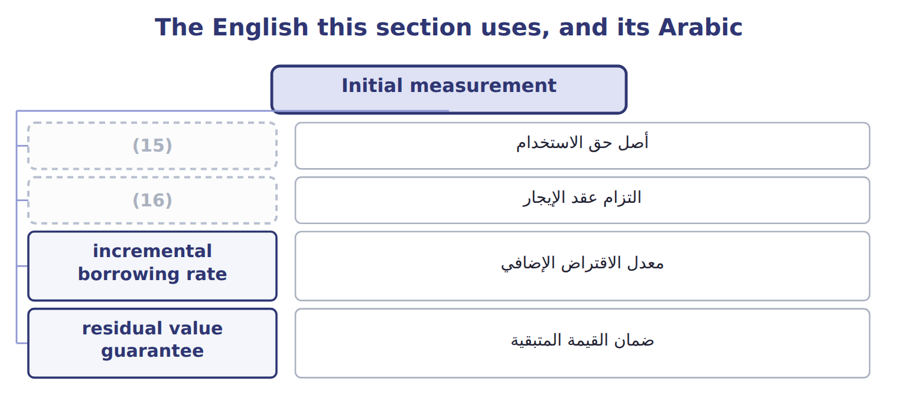
word list
short-term lease · lease liability · right-of-use asset

The English this sheet uses, and its Arabic
English (exam term) | Arabic
right-of-use asset | أصل حق الاستخدام
lease liability | التزام عقد الإيجار
incremental borrowing rate | معدل الاقتراض الإضافي
residual value guarantee | ضمان القيمة المتبقية

Answer key · 14.3 Initial measurement

1 records | 9 Orontes
2 implicit | 10 because
3 otherwise | 11 interest
4 purchase | 12 Annual payment (end of each year)
5 reasonably | 13 Discount rate (incremental borrowing rate)
6 guarantee | 14 Lease liability = present value of payments
7 prepaid | 15 right-of-use asset
8 received | 16 lease liability

the summaries in full
Summary 1 For both types, the lessee records a lease liability and a right-of-use asset at the start. The liability is the present value of the lease payments not yet paid. The discount rate is the rate implicit in the lease if the lessee can find it; otherwise it is the lessee's incremental borrowing rate. Lease payments include fixed payments, payments that depend on an index such as CPI, a purchase price the lessee is reasonably certain to pay, and amounts it expects to pay under a residual value guarantee. The right-of-use asset starts at the liability, plus any prepaid payments and initial direct costs, minus incentives received. Orontes uses 6%, the rate on its bank note. The undiscounted payments are higher, because part of each payment is interest.

14.4 Subsequent measurement: two expense patterns
Chapter 14 · section 14.4

Fill every gap. Each word list holds one word more than there are gaps.
Summary 1 gaps 1–3
For a (1) lease, the lessee records interest on the liability and, separately, amortization of the right-of-use asset, (2) straight-line. Interest is (3) at the start, when the liability is largest, so total expense falls each year.
word list
expense · finance · highest · usually

Worked example: the olive-press finance lease in 2026

Summary 2 gaps 4–6
Interest: 6% × $866,276 = $51,977. Payment of $250,000: the (4) falls to $668,253. (5) : $866,276 ÷ 4 years = $216,569, so the ROU asset is $649,707. Total 2026 (6) is $268,546, which is $18,546 more than the payment.
word list
present · expense · liability · Amortization

Suppose: olive-press finance lease schedule, 2026–2029
Year | Opening liability | Interest | Payment | Closing liability | ROU amortization | Total expense
2026 | 866,276 | 51,977 | 250,000 | 668,253 | 216,569 | 268,546
2027 | 668,253 | 40,095 | 250,000 | 458,348 | 216,569 | 256,664
2028 | 458,348 | 27,501 | 250,000 | 235,849 | 216,569 | 244,070
2029 | 235,849 | 14,151 | 250,000 | 0 | 216,569 | 230,720

Summary 3 gaps 7–9
For an operating lease, the lessee records one lease cost, (7) the same each year. The liability still grows by interest and falls by payments. The amortization of the right-of-use asset is simply the (8) between the lease cost and the interest, so the asset and the liability stay equal when there are no (9) or incentives.
word list
prepayments · difference · normally · amortization

Complete the warehouse schedule

Complete years 2028 to 2030. The lease cost is $100,000 every year.

Suppose: warehouse operating lease schedule (complete the blanks)
Every item belongs to exactly one group.
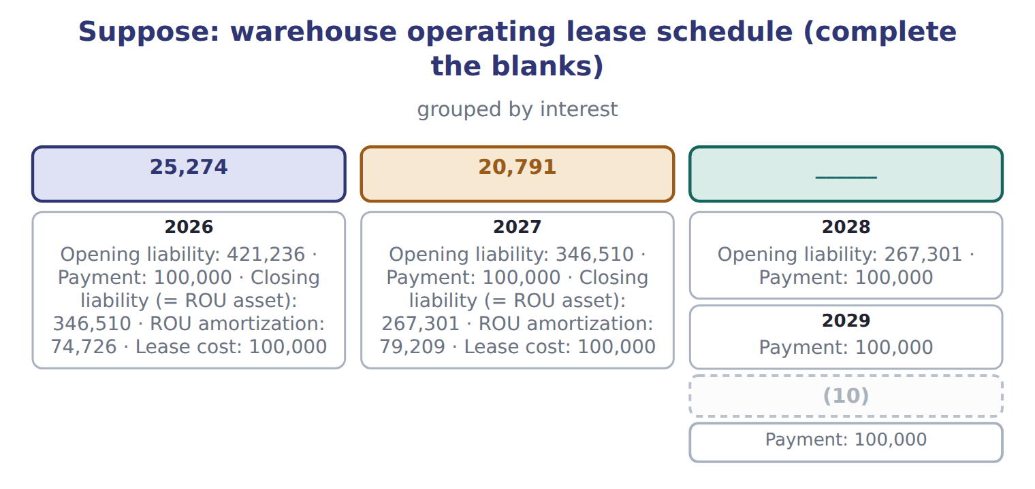
word list
lessee · 2030

Measurement traps

Summary 4 gaps 11–13
The liability is a (11) value, not the total of the payments. Each payment (12) interest first; do not (13) the whole payment from the opening liability. Operating lease: one straight-line cost; do not show interest and amortization separately.
word list
present · deduct · covers · right-of-use

The English this section uses, and its Arabic
Each term sits against what it means.
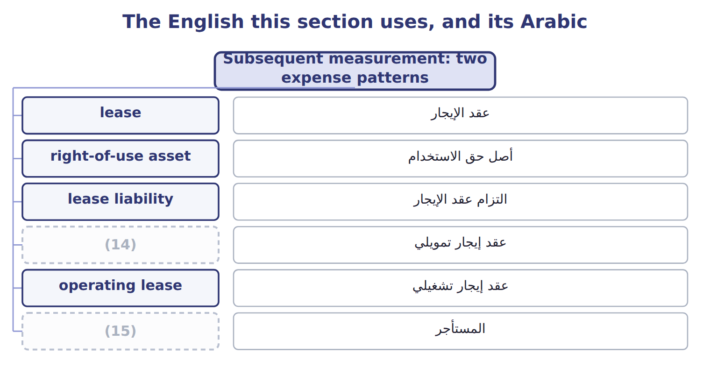
word list
lessor · lessee · finance lease

Answer key · 14.4 Subsequent measurement: two expense patterns

1 finance | 9 prepayments
2 usually | 10 2030
3 highest | 11 present
4 liability | 12 covers
5 Amortization | 13 deduct
6 expense | 14 finance lease
7 normally | 15 lessee
8 difference

the summaries in full
Summary 1 For a finance lease, the lessee records interest on the liability and, separately, amortization of the right-of-use asset, usually straight-line. Interest is highest at the start, when the liability is largest, so total expense falls each year.
Summary 2 Interest: 6% × $866,276 = $51,977. Payment of $250,000: the liability falls to $668,253. Amortization: $866,276 ÷ 4 years = $216,569, so the ROU asset is $649,707. Total 2026 expense is $268,546, which is $18,546 more than the payment.
Summary 3 For an operating lease, the lessee records one lease cost, normally the same each year. The liability still grows by interest and falls by payments. The amortization of the right-of-use asset is simply the difference between the lease cost and the interest, so the asset and the liability stay equal when there are no prepayments or incentives.
Summary 4 The liability is a present value, not the total of the payments. Each payment covers interest first; do not deduct the whole payment from the opening liability. Operating lease: one straight-line cost; do not show interest and amortization separately.

14.5 Presentation
Chapter 14 · section 14.5

Fill every gap. Each word list holds one word more than there are gaps.
Summary 1 gaps 1–8
On the balance sheet, the (1) assets and lease (2) of finance leases are shown separately from those of operating leases, or disclosed with the line items that (3) them. Each liability is split into a current part, the principal due (4) a year, and a noncurrent part. On the income statement, a finance lease shows interest expense and amortization separately; an operating lease shows one lease cost in operating expenses. In the statement of cash flows, finance-lease principal is financing; its interest and all operating-lease payments are operating. New leases are a noncash (5) and financing (6) , disclosed separately. The (7) liability of $668,253 (8) a current part of $209,905, the principal that will be paid in 2027.
word list
olive-press · contain · activity · finance-lease · includes · within · liabilities · investing · right-of-use

Presentation of finance and operating leases, with Orontes at December 31, 2026
Item | Finance lease (olive press) | Operating lease (warehouse)
Balance sheet | ROU asset and lease liability, shown separately from operating leases (or disclosed) | ROU asset and lease liability, shown separately from finance leases (or disclosed)
Income statement | (9) | One lease cost in operating expenses
Cash flow: principal | Financing | Operating
Cash flow: interest | Operating | Operating (part of the single payment)
Orontes at December 31, 2026 | Liability 668,253: current 209,905, noncurrent 458,348; ROU asset 649,707 | (10)

word list
Liability 346,510; ROU asset 346,510 · One lease cost in operating expenses · Interest expense and amortization, shown separately

Cash flow traps

Summary 2 gaps 11–12
Operating-lease (11) are operating cash flows, even (12) a liability is on the balance sheet. Finance-lease interest is operating under U.S. GAAP, not financing.
word list
though · payments · liabilities

The English this section uses, and its Arabic
Each term sits against what it means.
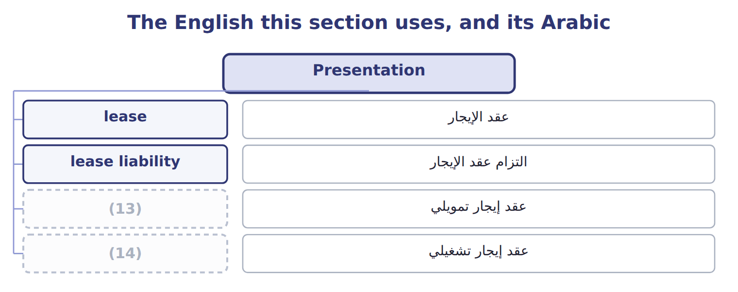
word list
عقد الإيجار · finance lease · operating lease

Answer key · 14.5 Presentation

1 right-of-use | 8 includes
2 liabilities | 9 Interest expense and amortization, shown separately
3 contain | 10 Liability 346,510; ROU asset 346,510
4 within | 11 payments
5 investing | 12 though
6 activity | 13 finance lease
7 olive-press | 14 operating lease

the summaries in full
Summary 1 On the balance sheet, the right-of-use assets and lease liabilities of finance leases are shown separately from those of operating leases, or disclosed with the line items that contain them. Each liability is split into a current part, the principal due within a year, and a noncurrent part. On the income statement, a finance lease shows interest expense and amortization separately; an operating lease shows one lease cost in operating expenses. In the statement of cash flows, finance-lease principal is financing; its interest and all operating-lease payments are operating. New leases are a noncash investing and financing activity, disclosed separately. The olive-press liability of $668,253 includes a current part of $209,905, the principal that will be paid in 2027.
Summary 2 Operating-lease payments are operating cash flows, even though a liability is on the balance sheet. Finance-lease interest is operating under U.S. GAAP, not financing.

14.6 Short-term leases, sale and leaseback, and IFRS 16
Chapter 14 · section 14.6

Fill every gap. Each word list holds one word more than there are gaps.
Summary 1 gaps 1–12
A short-term lease lasts 12 (1) or less and has no purchase option that the lessee is reasonably certain to use. A lessee may (2) , by class of asset, to keep such leases off the (3) sheet and expense the payments (4) . U.S. GAAP has no exemption for low-value assets. In a sale and leaseback, a company sells an asset and leases it back. It is a sale only if control (5) to the buyer under the (6) rules. If the leaseback is a finance lease, or the (7) can buy the asset back, there is no sale: the cash (8) is a loan. IFRS 16 has one lessee model: every lease is (9) for like a finance lease, with (10) and interest. It (11) an exemption for low-value assets and (12) the liability when an index such as CPI changes.
word list
straight-line · seller · passes · allows · balance · months · depreciation · accounted · revenue · choose · remeasures · short-term · received

Leases: U.S. GAAP (ASC 842) and IFRS 16
The two sides differ only where the rows say.
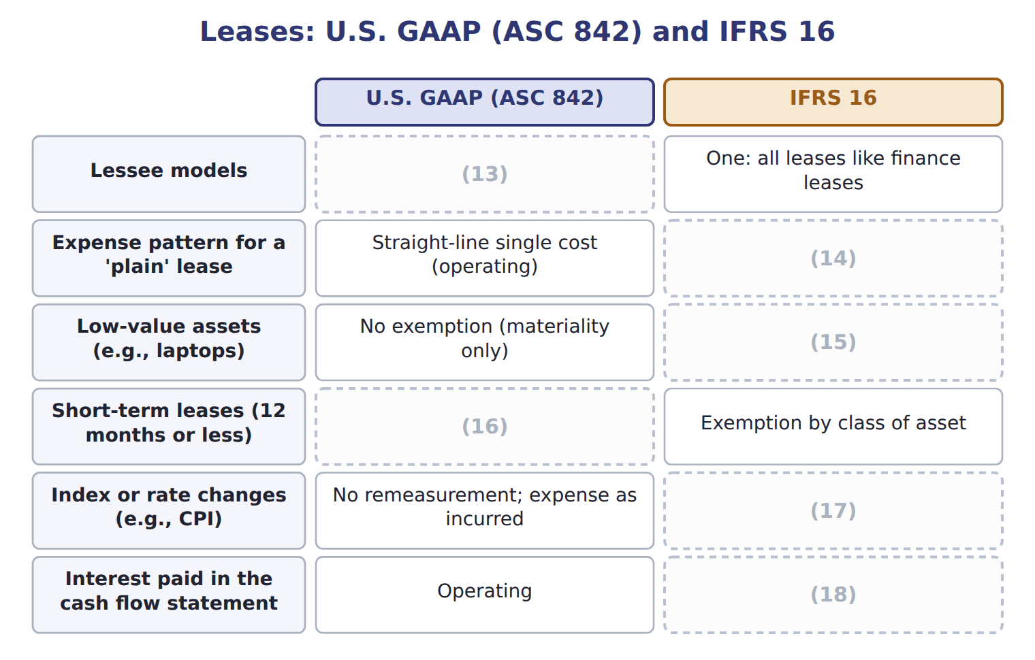
word list
Exemption by class of asset · Two: finance and operating · Remeasure the liability · finance lease · Depreciation plus interest: higher early · Operating or financing (IAS 7 today) · Exemption allowed

Summary 2 gaps 19–20
ASU 2023-01, on leases between companies under common control, is testable now at (19) level. ASU 2025-12 changes a (20) disclosure only; it is not testable before about January 2028.
word list
reasonably · awareness · lessor

Barada Wholesale, leases signed in 2028 (whole U — Details
Barada Wholesale, leases signed in 2028 (whole U | Details
L1 Delivery trucks | 3-year lease from January 1, 2028; 30,000 at the end of each year; economic life 8 years; fair value 150,000; no ownership transfer, no purc
L2 Forklift | 5-year lease with an option to buy the forklift for $1 at the end; Barada is reasonably certain to use it.
L3 Storage room | 10-month lease; no purchase option. Barada applies the short-term exemption.
L4 Laptops | 3-year (21) of office laptops; standard terms; no transfer or option.
M1 | Barada's (22) is 8%. The rate implicit in the leases is not known. Barada is not a public business entity but does not
M2 | (23) value of an annuity of $1 for 3 years at 8%: 2.5771.

word list
incremental borrowing rate · L1 Delivery trucks · Present · lease

Item — Answer
Each stage leads to the next.
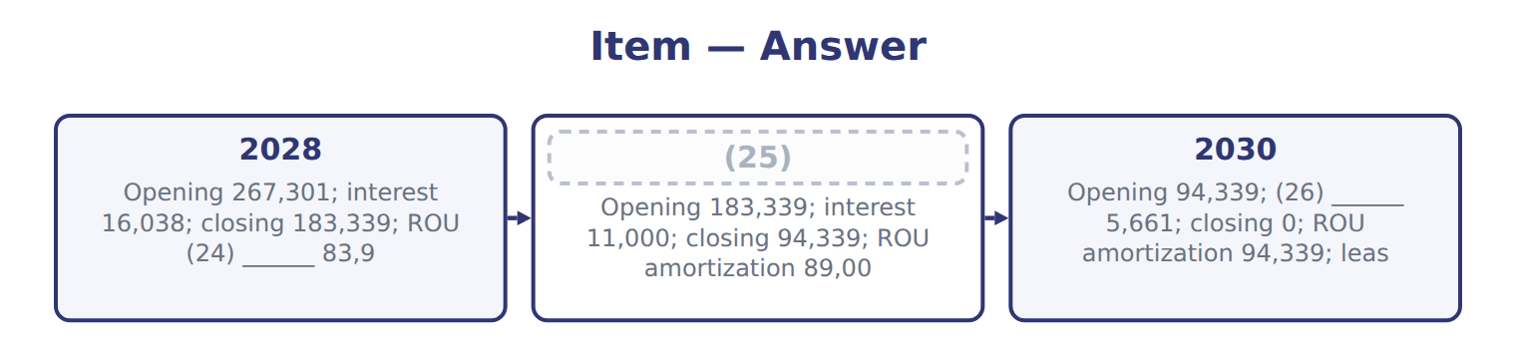
word list
interest · amortization · 2029 · lessee

Lease — Category
Lease | Category
L1 Delivery trucks | Operating lease
L2 Forklift | Finance lease
L3 Storage room | (27)
L4 Laptops | (28)

word list
Short-term lease (exempt) · sale and leaseback · Operating lease

The English this section uses, and its Arabic
Each term sits against what it means.
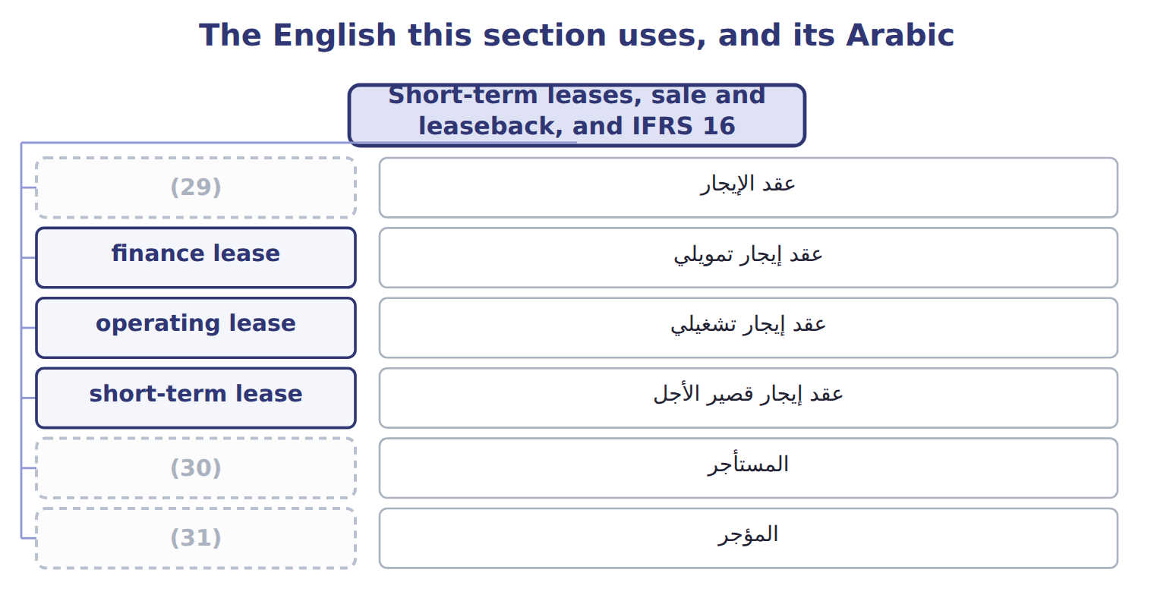
word list
lessor · lessee · lease · المؤجر

The English this sheet uses, and its Arabic
English (exam term) | Arabic
short-term lease | عقد إيجار قصير الأجل
sale and leaseback | البيع وإعادة الاستئجار

Answer key · 14.6 Short-term leases, sale and leaseback, and IFRS 16

1 months | 17 Remeasure the liability
2 choose | 18 Operating or financing (IAS 7 today)
3 balance | 19 awareness
4 straight-line | 20 lessor
5 passes | 21 lease
6 revenue | 22 incremental borrowing rate
7 seller | 23 Present
8 received | 24 amortization
9 accounted | 25 2029
10 depreciation | 26 interest
11 allows | 27 Short-term lease (exempt)
12 remeasures | 28 Operating lease
13 Two: finance and operating | 29 lease
14 Depreciation plus interest: higher early | 30 lessee
15 Exemption allowed | 31 lessor
16 Exemption by class of asset

the summaries in full
Summary 1 A short-term lease lasts 12 months or less and has no purchase option that the lessee is reasonably certain to use. A lessee may choose, by class of asset, to keep such leases off the balance sheet and expense the payments straight-line. U.S. GAAP has no exemption for low-value assets. In a sale and leaseback, a company sells an asset and leases it back. It is a sale only if control passes to the buyer under the revenue rules. If the leaseback is a finance lease, or the seller can buy the asset back, there is no sale: the cash received is a loan. IFRS 16 has one lessee model: every lease is accounted for like a finance lease, with depreciation and interest. It allows an exemption for low-value assets and remeasures the liability when an index such as CPI changes.
Summary 2 ASU 2023-01, on leases between companies under common control, is testable now at awareness level. ASU 2025-12 changes a lessor disclosure only; it is not testable before about January 2028.

15.1 Gains and losses
Chapter 15 · section 15.1

Fill every gap. Each word list holds one word more than there are gaps.
Chapter 15, section by section
Each stage leads to the next.
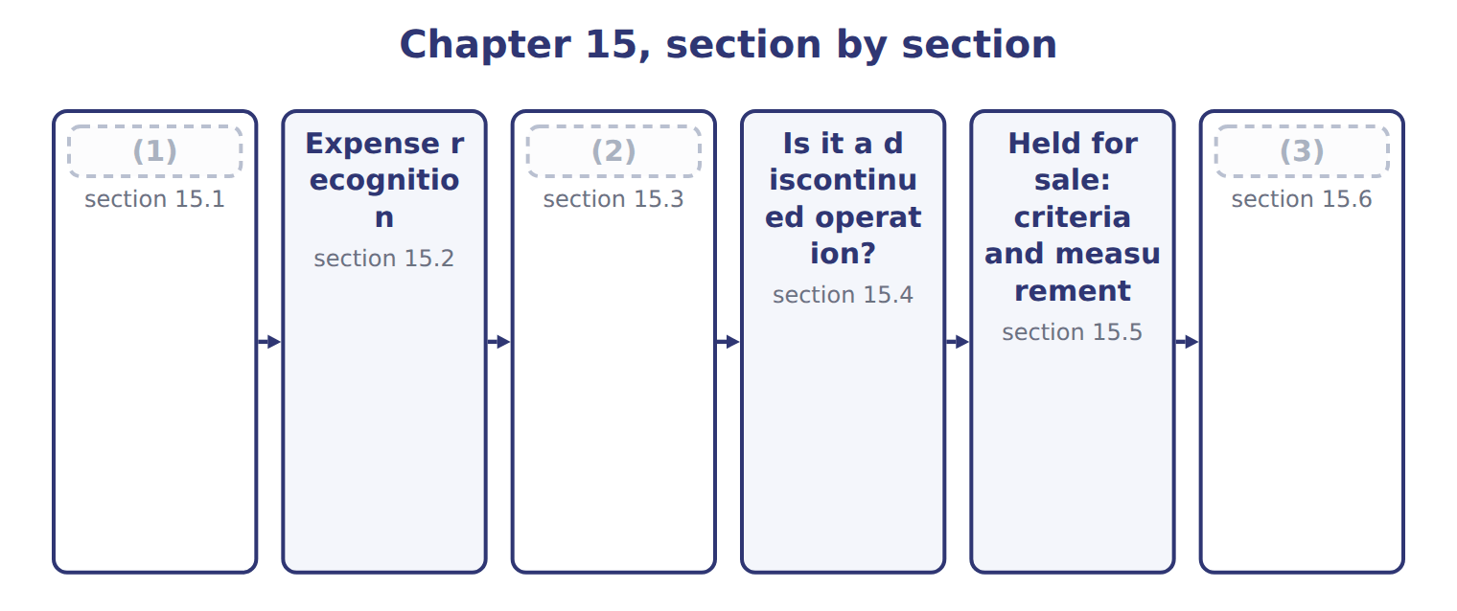
word list
Gains and losses · holding gain or loss · Presentation and IFRS differences · Comprehensive income and reclassification

Summary 1 gaps 4–14
A gain or (4) is an increase or decrease in equity from a (5) or incidental transaction: something other than the company's main activities and other than a transaction with owners. Selling an old machine, (6) a lawsuit and a change in the value of an (7) are examples. Gains and losses are shown net. When Orontes sold its old Dubai oven, it did not report the proceeds as revenue; it (8) a gain of $3,000: the proceeds minus the (9) amount. In a (10) statement, most gains and losses appear in other income and (11) , below operating income. Losses that arise from operating assets, such as (12) , are usually shown within operating expenses. Items that are unusual or (13) get a separate line within (14) operations, before tax.
word list
infrequent · carrying · continuing · multi-step · expense · reported · loss · settling · operating · investment · impairments · peripheral

Where Orontes's 2025 gains and losses appear
Every item belongs to exactly one group.
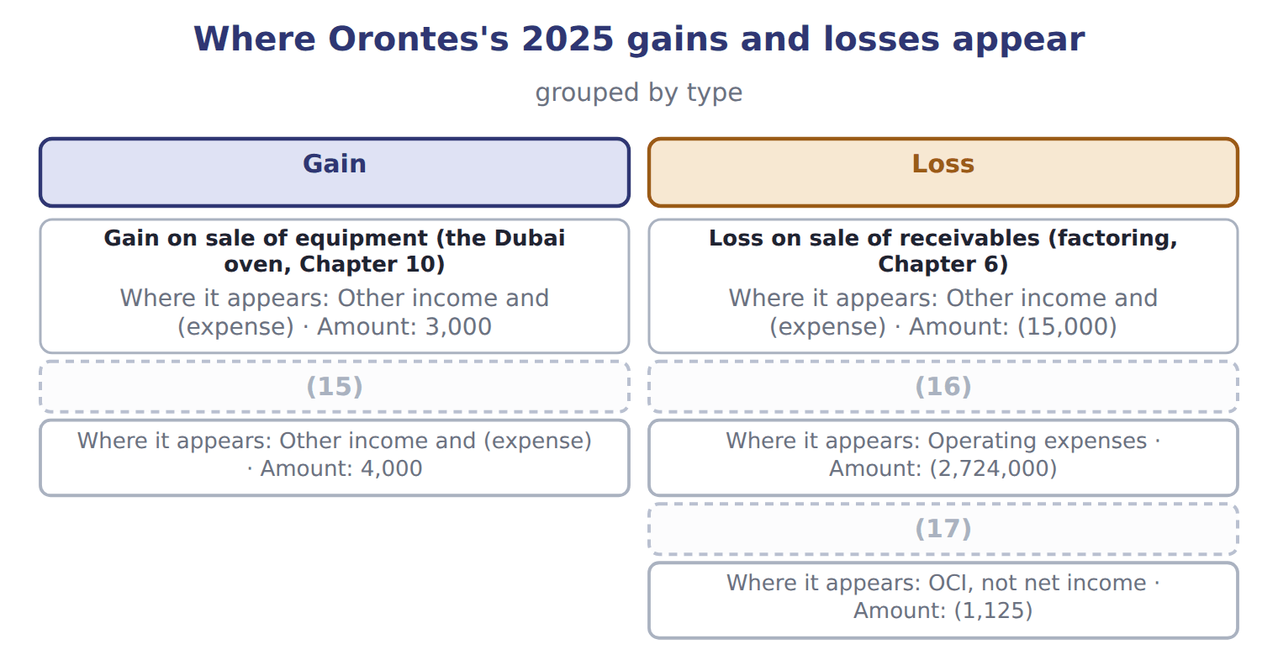
word list
Unrealized gains on securities (Chapter 9) · Unrealized loss on AFS debt securities, net of tax · Impairment losses (Chapter 10) · holding gain or loss

The English this section uses, and its Arabic
Each term sits against what it means.
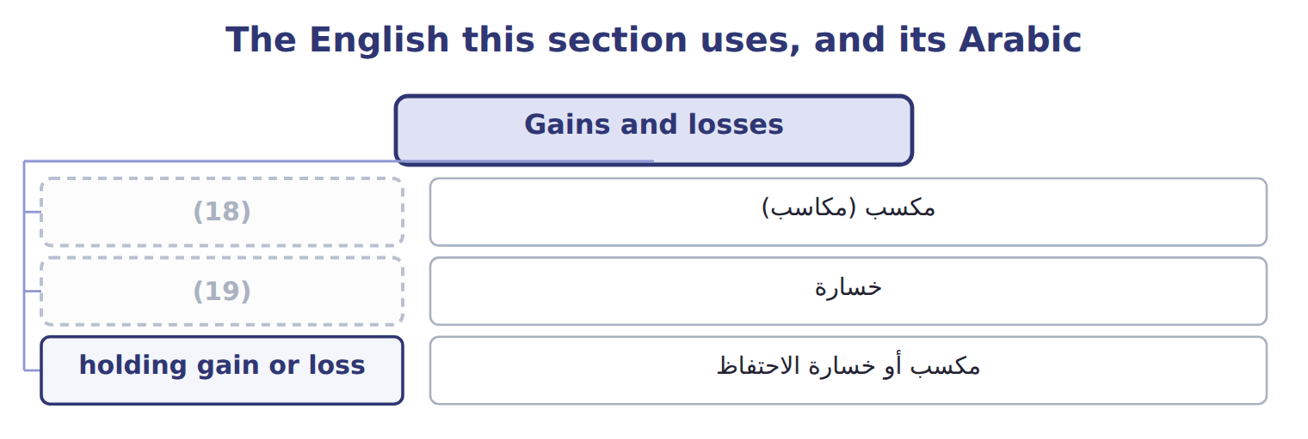
word list
loss · gain · خسارة

The English this sheet uses, and its Arabic
English (exam term) | Arabic
gain | مكسب (مكاسب)
loss | خسارة
holding gain or loss | مكسب أو خسارة الاحتفاظ

Answer key · 15.1 Gains and losses

1 Gains and losses | 11 expense
2 Comprehensive income and reclassification | 12 impairments
3 Presentation and IFRS differences | 13 infrequent
4 loss | 14 continuing
5 peripheral | 15 Unrealized gains on securities (Chapter 9)
6 settling | 16 Impairment losses (Chapter 10)
7 investment | 17 Unrealized loss on AFS debt securities, net of tax
8 reported | 18 gain
9 carrying | 19 loss
10 multi-step

the summaries in full
Summary 1 A gain or loss is an increase or decrease in equity from a peripheral or incidental transaction: something other than the company's main activities and other than a transaction with owners. Selling an old machine, settling a lawsuit and a change in the value of an investment are examples. Gains and losses are shown net. When Orontes sold its old Dubai oven, it did not report the proceeds as revenue; it reported a gain of $3,000: the proceeds minus the carrying amount. In a multi-step statement, most gains and losses appear in other income and expense, below operating income. Losses that arise from operating assets, such as impairments, are usually shown within operating expenses. Items that are unusual or infrequent get a separate line within continuing operations, before tax.

15.2 Expense recognition
Chapter 15 · section 15.2

Fill every gap. Each word list holds one word more than there are gaps.
The set, member by member
The rows are a set, not a sequence.
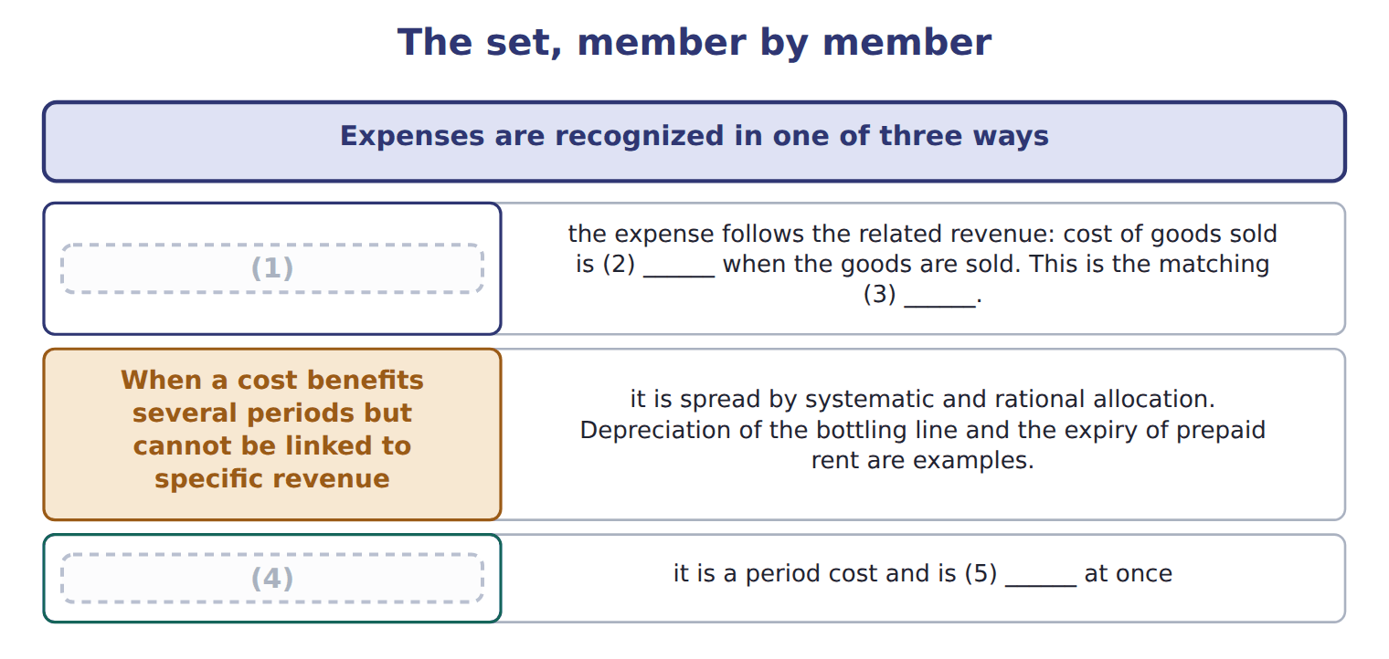
word list
When there is a clear cause and effect · expensed · recognized · fair value less cost to sell · When a cost has no clear link to future revenue · principle

Summary 1 gaps 6–7
Advertising and research and (6) are expensed when (7) , even if they may bring future sales.
word list
development · recognition · incurred

Three expense recognition approaches
Approach | Idea | Orontes examples
Cause and effect (matching) | Expense follows the related revenue | Cost of goods sold; sales (8) (capitalized, Chapter 11)
Systematic and rational allocation | (9) | Depreciation of the bottling line; prepaid rent
Immediate recognition | No clear link to future revenue: a period cost | Advertising; research and development; most general (10)

word list
commissions · No clear link to future revenue · administration · Cost spread over the periods that benefit

Summary 2 gaps 11–13
ASU 2024-03 will require public companies to break down some expense (11) in the notes, for example into (12) purchases, employee pay and depreciation. It does not change recognition, and it is not (13) before about January 2028.
word list
examples · testable · inventory · captions

The English this sheet uses, and its Arabic
English (exam term) | Arabic
period cost | تكلفة الفترة
systematic and rational allocation | التوزيع المنتظم والمنطقي

Answer key · 15.2 Expense recognition

1 When there is a clear cause and effect | 8 commissions
2 recognized | 9 Cost spread over the periods that benefit
3 principle | 10 administration
4 When a cost has no clear link to future revenue | 11 captions
5 expensed | 12 inventory
6 development | 13 testable
7 incurred

the summaries in full
Summary 1 Advertising and research and development are expensed when incurred, even if they may bring future sales.
Summary 2 ASU 2024-03 will require public companies to break down some expense captions in the notes, for example into inventory purchases, employee pay and depreciation. It does not change recognition, and it is not testable before about January 2028.

15.3 Comprehensive income and reclassification
Chapter 15 · section 15.3

Fill every gap. Each word list holds one word more than there are gaps.
Summary 1 gaps 1–9
Comprehensive income is net income plus other comprehensive income. U.S. OCI (1) holding gains and losses on (2) debt securities, foreign currency (3) adjustments, the (4) part of cash-flow hedges, and some (5) gains and losses. (6) gains on equity securities are not OCI; they go to net income. When an OCI item is realized, for example when an AFS bond is sold, the gain moves into net income. At the same time a reclassification adjustment (7) it from OCI. (8) this adjustment, the same gain would be counted twice in comprehensive income: once in OCI when it arose, and again in net income on the sale. Its value rises to $108,000 at the end of 2026, and (9) sells it for $110,000 in 2027. Over the two years, comprehensive income before tax is $10,000: the total gain, counted once.
word list
effective · removes · Orontes · Without · adjustments · available-for-sale · includes · pension · Unrealized · translation

Worked example: the reclassification adjustment

Summary 2 gaps 10–13
After tax at 25%, OCI is $6,000, and AOCI (10) up by the same (11) . OCI for 2027 shows the holding gain of $2,000 and a reclassification of −$10,000: a net OCI (12) of $8,000 before tax, $6,000 after tax. AOCI for this bond (13) to zero.
word list
builds · returns · amount · Unrealized · loss

Suppose: OCI and the reclassification adjustment for an AFS bond
Every item belongs to exactly one group.
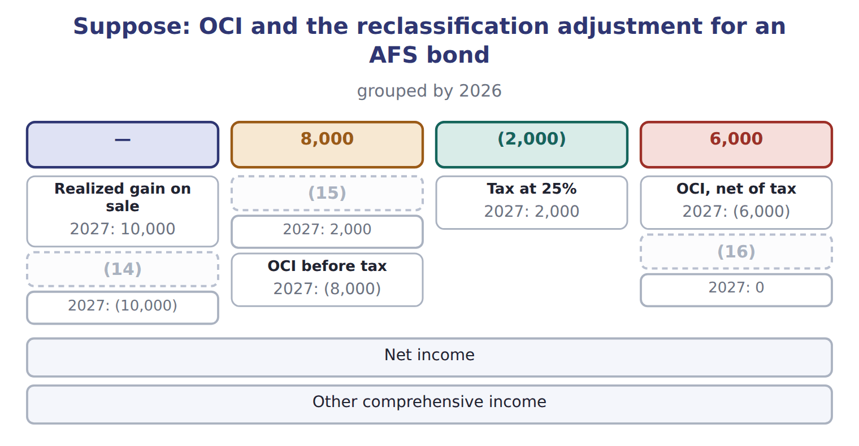
word list
OCI, net of tax · Holding gain during the year · AOCI at year-end (for this bond) · Reclassification adjustment

Comprehensive income traps

Summary 3 gaps 17–19
Forgetting the reclassification (17) a realized gain twice. Comprehensive income adds this year's OCI, not the AOCI (18) . (19) OCI net of tax, or before tax with one tax line: do not mix them.
word list
counts · balance · Report · translation

The English this section uses, and its Arabic
Each term sits against what it means.
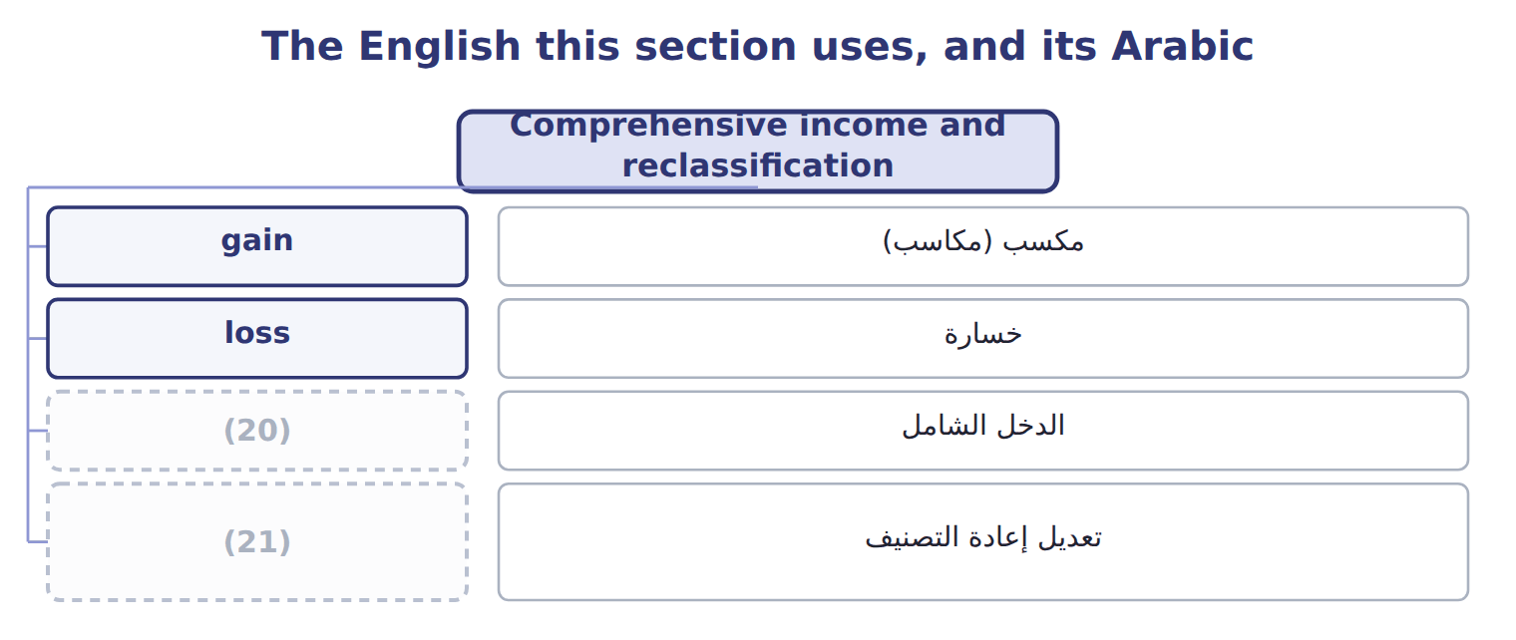
word list
reclassification adjustment · disposal group · comprehensive income

The English this sheet uses, and its Arabic
English (exam term) | Arabic
comprehensive income | الدخل الشامل
reclassification adjustment | تعديل إعادة التصنيف

Answer key · 15.3 Comprehensive income and reclassification

1 includes | 12 loss
2 available-for-sale | 13 returns
3 translation | 14 Reclassification adjustment
4 effective | 15 Holding gain during the year
5 pension | 16 AOCI at year-end (for this bond)
6 Unrealized | 17 counts
7 removes | 18 balance
8 Without | 19 Report
9 Orontes | 20 comprehensive income
10 builds | 21 reclassification adjustment
11 amount

the summaries in full
Summary 1 Comprehensive income is net income plus other comprehensive income. U.S. OCI includes holding gains and losses on available-for-sale debt securities, foreign currency translation adjustments, the effective part of cash-flow hedges, and some pension gains and losses. Unrealized gains on equity securities are not OCI; they go to net income. When an OCI item is realized, for example when an AFS bond is sold, the gain moves into net income. At the same time a reclassification adjustment removes it from OCI. Without this adjustment, the same gain would be counted twice in comprehensive income: once in OCI when it arose, and again in net income on the sale. Its value rises to $108,000 at the end of 2026, and Orontes sells it for $110,000 in 2027. Over the two years, comprehensive income before tax is $10,000: the total gain, counted once.
Summary 2 After tax at 25%, OCI is $6,000, and AOCI builds up by the same amount. OCI for 2027 shows the holding gain of $2,000 and a reclassification of −$10,000: a net OCI loss of $8,000 before tax, $6,000 after tax. AOCI for this bond returns to zero.
Summary 3 Forgetting the reclassification counts a realized gain twice. Comprehensive income adds this year's OCI, not the AOCI balance. Report OCI net of tax, or before tax with one tax line: do not mix them.

15.4 Is it a discontinued operation?
Chapter 15 · section 15.4

Fill every gap. Each word list holds one word more than there are gaps.
Summary 1 gaps 1–6
A disposal is (1) as a discontinued operation only if three (2) are true. There is no official (3) for 'major'; it is a (4) . Selling one machine, one store or one small product is not a strategic shift. The (5) or loss stays in (6) operations, as for the Dubai oven. A business that meets the held-for-sale criteria when it is acquired is also a discontinued operation.
word list
percentage · things · disposal · gain · reported · continuing · judgment

Strategic shift or not?

The first two are done. Decide whether each of the others is a discontinued operation.
Strategic shift or not? (complete the blanks)
Suppose these disposals happen | Discontinued operation?
Orontes sells its whole frozen-foods business, one of its four product lines | (7)
Orontes closes one of its twelve olive-oil shops | No: not a strategic shift
Orontes sells all its operations in Jordan, its only foreign market | ________
Orontes sells an old bottling machine | ________
Orontes sells its 30% stake in Jordan Glass, a major equity-method investment | ________
Orontes stops selling one flavour of juice | ________

word list
fair value less cost to sell · Yes: a major line of business

The steps, in order
Each stage leads to the next.
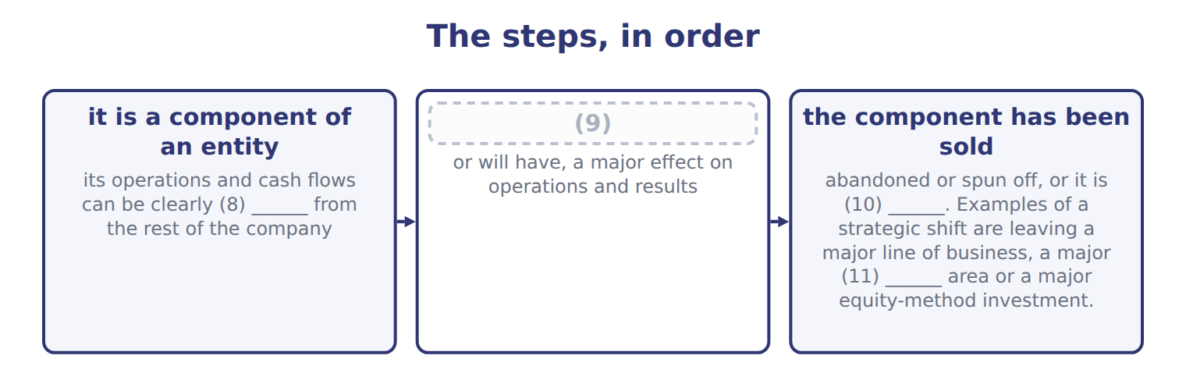
word list
held for sale · geographic · the disposal is a strategic shift that has · it is a component of an entity · separated

The English this section uses, and its Arabic
Each term sits against what it means.
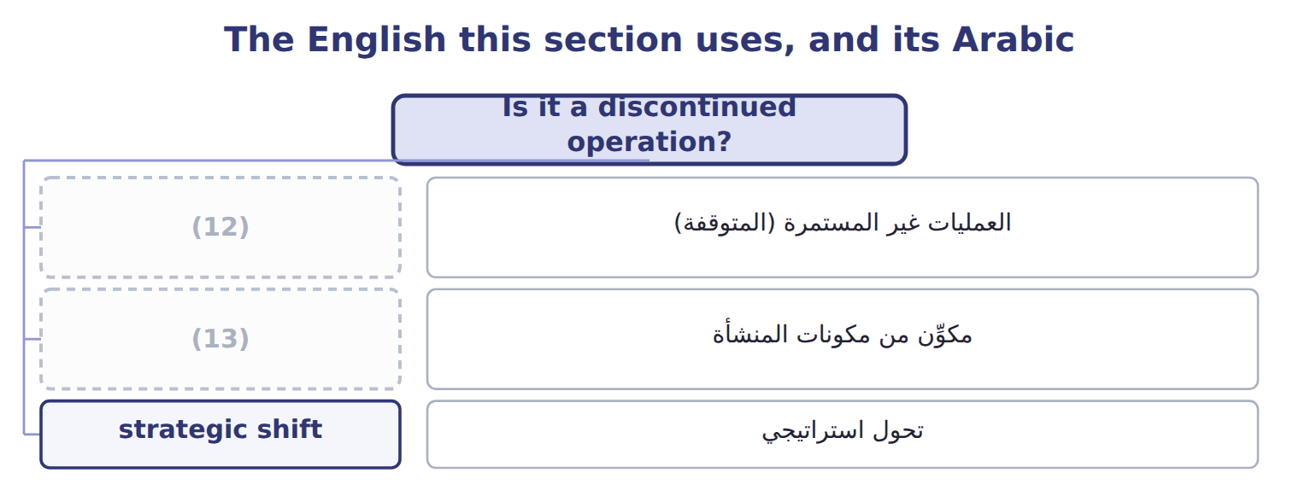
word list
تحول استراتيجي · component of an entity · discontinued operation

The English this sheet uses, and its Arabic
English (exam term) | Arabic
discontinued operation | العمليات غير المستمرة (المتوقفة)
component of an entity | مكوِّن من مكونات المنشأة
strategic shift | تحول استراتيجي

Answer key · 15.4 Is it a discontinued operation?

1 reported | 8 separated
2 things | 9 the disposal is a strategic shift that has
3 percentage | 10 held for sale
4 judgment | 11 geographic
5 gain | 12 discontinued operation
6 continuing | 13 component of an entity
7 Yes: a major line of business

the summaries in full
Summary 1 A disposal is reported as a discontinued operation only if three things are true. There is no official percentage for 'major'; it is a judgment. Selling one machine, one store or one small product is not a strategic shift. The gain or loss stays in continuing operations, as for the Dubai oven. A business that meets the held-for-sale criteria when it is acquired is also a discontinued operation.

15.5 Held for sale: criteria and measurement
Chapter 15 · section 15.5

Fill every gap. Each word list holds one word more than there are gaps.
Summary 1 gaps 1–12
A (1) can be reported as discontinued (2) it is sold, once it is held for sale. All six criteria must be met: (3) with authority commits to a plan; the business is (4) for immediate sale; an active search for a buyer has begun; a sale is probable within one year; the price is (5) ; and the plan is unlikely to change. A held-for-sale disposal group is (6) at the lower of its carrying amount and its fair value less cost to sell. Any write-down is a loss. Depreciation stops, and later (7) in value are (8) only up to the losses already recorded. The board (9) the plan in March, but the business (10) held for sale only on June 30, when all six criteria were met. It (11) the frozen-foods goodwill left after the 2025 impairment. The carrying amount of $3,180,000 is above fair value less cost to sell of $3,000,000, so (12) records a loss of $180,000. This is the disposal loss.
word list
recognized · before · reasonable · component · available · became · approved · increases · includes · already · measured · management · Orontes

Held-for-sale traps

Summary 2 gaps 13–15
Board (13) alone is not (14) : all six criteria must be met. (15) the write-down when the group becomes held for sale, not only when it is sold. Stop depreciation once the group is held for sale.
word list
approval · enough · Recognize · impairment

Suppose: measuring the frozen-foods disposal group on June 30, 2026
Suppose: frozen-foods disposal group, June 30, 2 | Amount
Property, plant and equipment, net | 2,100,000
(16) | 480,000
Receivables | 400,000
Goodwill (left after the 2025 impairment, Chapter 10) | 300,000
(17) | (100,000)
Carrying amount of the disposal group | 3,180,000
Fair value less cost to sell | 3,000,000
(18) | 180,000
(19) | 3,000,000

word list
Held-for-sale group at June 30, 2026 · Remeasurement loss (in discontinued operations) · Less: accounts payable · Inventory · Carrying amount of the disposal group

The English this section uses, and its Arabic
Each term sits against what it means.
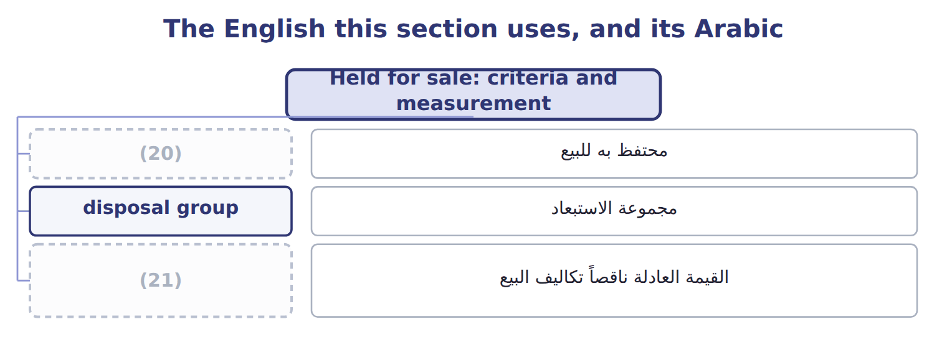
word list
holding gain or loss · fair value less cost to sell · held for sale

The English this sheet uses, and its Arabic
English (exam term) | Arabic
held for sale | محتفظ به للبيع
disposal group | مجموعة الاستبعاد
fair value less cost to sell | القيمة العادلة ناقصاً تكاليف البيع

Answer key · 15.5 Held for sale: criteria and measurement

1 component | 12 Orontes
2 before | 13 approval
3 management | 14 enough
4 available | 15 Recognize
5 reasonable | 16 Inventory
6 measured | 17 Less: accounts payable
7 increases | 18 Remeasurement loss (in discontinued operations)
8 recognized | 19 Held-for-sale group at June 30, 2026
9 approved | 20 held for sale
10 became | 21 fair value less cost to sell
11 includes

the summaries in full
Summary 1 A component can be reported as discontinued before it is sold, once it is held for sale. All six criteria must be met: management with authority commits to a plan; the business is available for immediate sale; an active search for a buyer has begun; a sale is probable within one year; the price is reasonable; and the plan is unlikely to change. A held-for-sale disposal group is measured at the lower of its carrying amount and its fair value less cost to sell. Any write-down is a loss. Depreciation stops, and later increases in value are recognized only up to the losses already recorded. The board approved the plan in March, but the business became held for sale only on June 30, when all six criteria were met. It includes the frozen-foods goodwill left after the 2025 impairment. The carrying amount of $3,180,000 is above fair value less cost to sell of $3,000,000, so Orontes records a loss of $180,000. This is the disposal loss.
Summary 2 Board approval alone is not enough: all six criteria must be met. Recognize the write-down when the group becomes held for sale, not only when it is sold. Stop depreciation once the group is held for sale.

15.6 Presentation and IFRS differences
Chapter 15 · section 15.6

Fill every gap. Each word list holds one word more than there are gaps.
Summary 1 gaps 1–11
The results of a discontinued operation, (1) its operating results and any (2) or disposal gain or loss, are shown net of their own tax below income from continuing operations. (3) companies also show (4) amounts for discontinued operations. The comparative years are (5) so that all periods are shown on the same basis. On the balance sheet, the assets and (6) of a discontinued operation are shown separately for all periods (7) . (8) assets that are not a discontinued operation are also shown separately, but their results stay in continuing operations. Under IFRS 5, a discontinued operation must be a (9) major line of business or (10) area, and earlier balance sheets are not re-presented. Some IFRS OCI items, such as a (11) surplus, never return to profit or loss.
word list
disposal · Held-for-sale · remeasurement · geographical · per-share · Public · including · liabilities · presented · reclassified · separate · revaluation

Discontinued operations and OCI: U.S. GAAP and IFRS
The two sides differ only where the rows say.
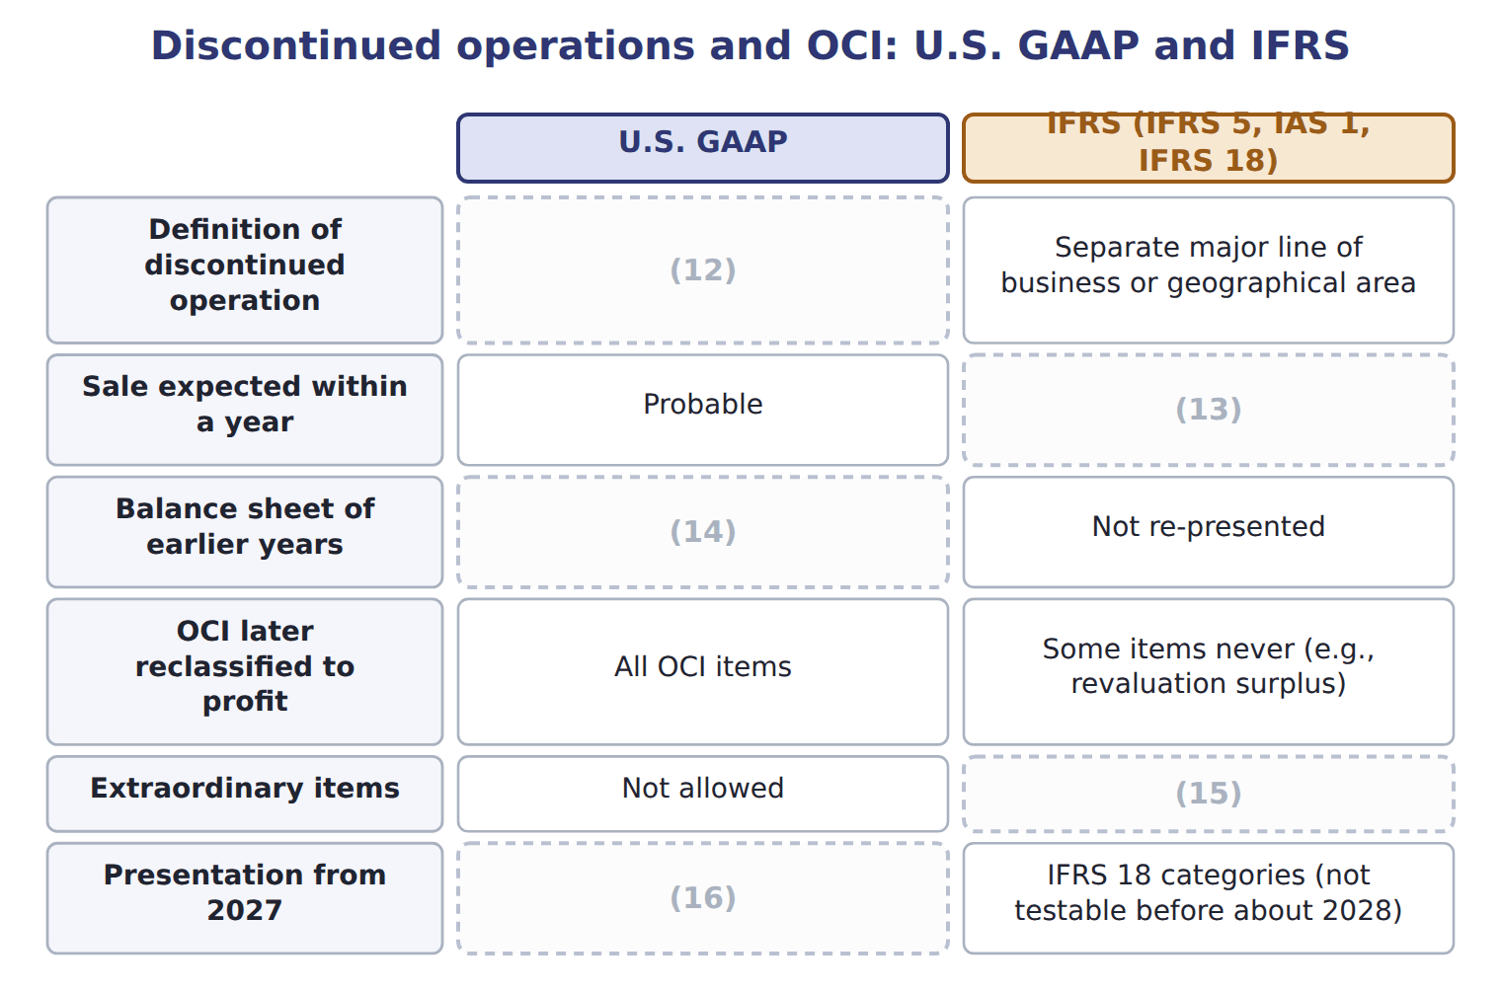
word list
Not allowed · Re-presented: assets and liabilities shown separately · Component + strategic shift with a major effect · Unchanged · period cost · Highly probable

Summary 2 gaps 17–18
U.S. GAAP has no (17) items: unusual or (18) items stay in continuing operations, before tax. Only discontinued operations are shown net of tax below continuing operations.
word list
Held-for-sale · infrequent · extraordinary

Suppose: Orontes, 2027 (USD 000) — Amount / details
Suppose: Orontes, 2027 (USD 000) | Amount / details
Operating income | 5,000
Gain on sale of a warehouse | 200
Loss on settlement of a lawsuit (unusual for Orontes) | 120
Interest expense | 400
Dry-foods division: operating loss before tax | 80
Dry-foods division: gain on sale before tax | 280
Unrealized holding gain on AFS debt securities during 2027 | 40
Realized gain on AFS securities sold in 2027 (included in AOCI before) | 24
M1 | In 2027 Orontes sold its dry-foods division, one of its main product lines. The sale is a strategic shift with a major effect.
M2 | The tax rate is 25% on all items. The (19) AFS gain is already in the other income figures.
M3 | Orontes presents one continuous statement of comprehensive income.

word list
realized · Item

Item — Answer
Item | Answer
All operations in Jordan | (20)
An old bottling machine | No: a single asset; the gain or loss stays in continuing operations.
The stake in Jordan Glass | Yes: a major equity-method investment.
One juice flavour | (21)

word list
No: not a strategic shift. · Suppose: Orontes, 2027 (USD 000) · Yes: a major geographic area.

Item — Category
Every item belongs to exactly one group.
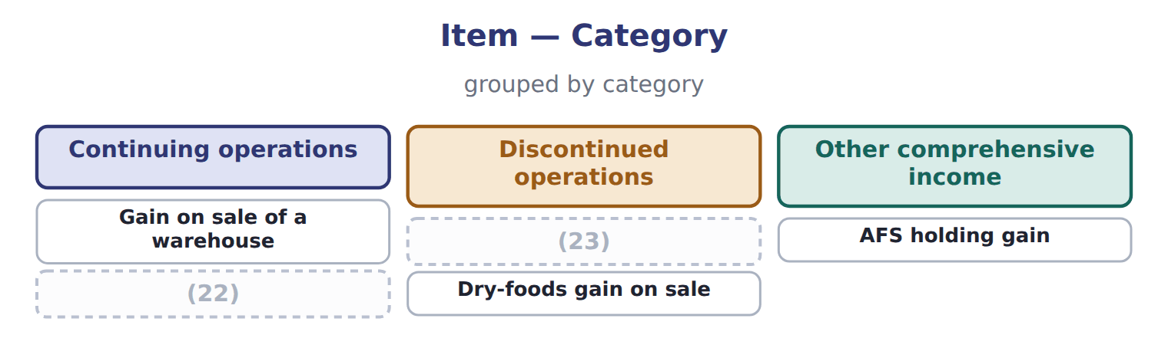
word list
Dry-foods operating loss · held for sale · Lawsuit settlement loss

The English this section uses, and its Arabic
Each term sits against what it means.
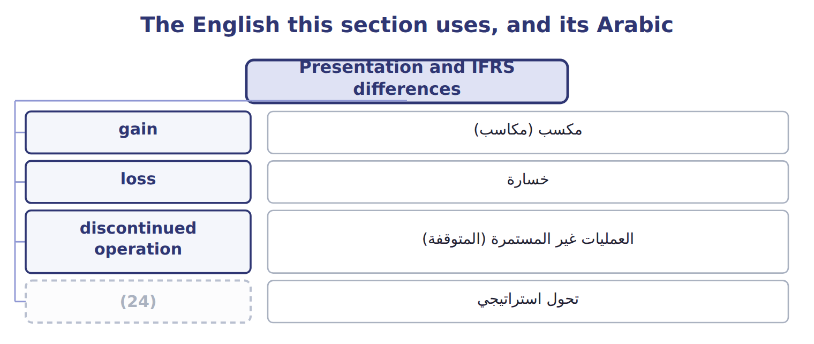
word list
strategic shift · مكسب (مكاسب)

Answer key · 15.6 Presentation and IFRS differences

1 including | 13 Highly probable
2 remeasurement | 14 Re-presented: assets and liabilities shown separately
3 Public | 15 Not allowed
4 per-share | 16 Unchanged
5 reclassified | 17 extraordinary
6 liabilities | 18 infrequent
7 presented | 19 realized
8 Held-for-sale | 20 Yes: a major geographic area.
9 separate | 21 No: not a strategic shift.
10 geographical | 22 Lawsuit settlement loss
11 revaluation | 23 Dry-foods operating loss
12 Component + strategic shift with a major effect | 24 strategic shift

the summaries in full
Summary 1 The results of a discontinued operation, including its operating results and any remeasurement or disposal gain or loss, are shown net of their own tax below income from continuing operations. Public companies also show per-share amounts for discontinued operations. The comparative years are reclassified so that all periods are shown on the same basis. On the balance sheet, the assets and liabilities of a discontinued operation are shown separately for all periods presented. Held-for-sale assets that are not a discontinued operation are also shown separately, but their results stay in continuing operations. Under IFRS 5, a discontinued operation must be a separate major line of business or geographical area, and earlier balance sheets are not re-presented. Some IFRS OCI items, such as a revaluation surplus, never return to profit or loss.
Summary 2 U.S. GAAP has no extraordinary items: unusual or infrequent items stay in continuing operations, before tax. Only discontinued operations are shown net of tax below continuing operations.

16.1 What consolidated statements are
Chapter 16 · section 16.1

Fill every gap. Each word list holds one word more than there are gaps.
Chapter 16, section by section
Each stage leads to the next.
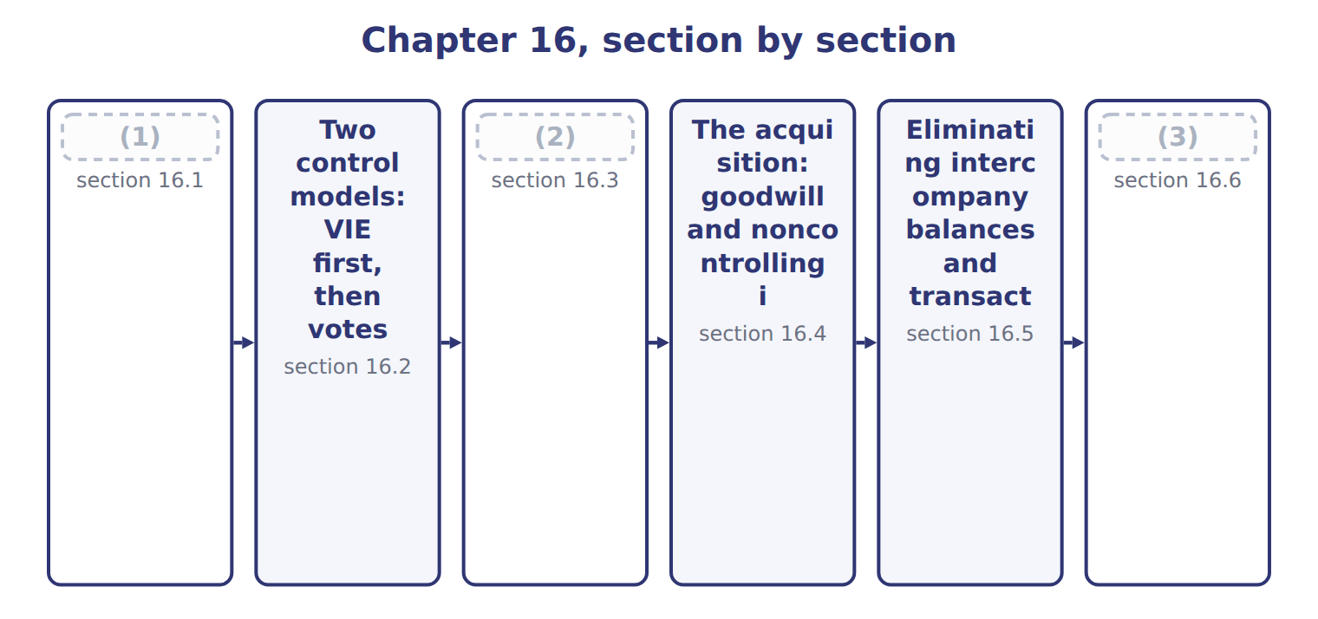
word list
Full consolidation, proportionate consolidatio · IFRS differences and what is changing · What consolidated statements are · Eliminating intercompany balances and transact

Summary 1 gaps 4–15
Consolidated financial statements present a parent and its (4) as a single (5) entity. They are prepared mainly for the parent's (6) and creditors, who need to see all the resources the group controls and all its (7) . A company (8) another entity when it has a (9) financial interest in it. (10) adds all of the subsidiary's assets, (11) , revenues and expenses to the parent's, line by line, even when the parent owns less than all of its shares. The part of a subsidiary's equity that the parent does not own is the noncontrolling interest (NCI). It is shown (12) consolidated equity, (13) from the parent's equity. Net income and (14) income are split (15) the parent and NCI on the face of the statements. The exam uses noncontrolling interest. It is equity, never a liability.
word list
subsidiaries · separately · controlling · Consolidation · between · consolidates · comprehensive · obligations · controls · shareholders · economic · liabilities · within

The English this section uses, and its Arabic
Each term sits against what it means.
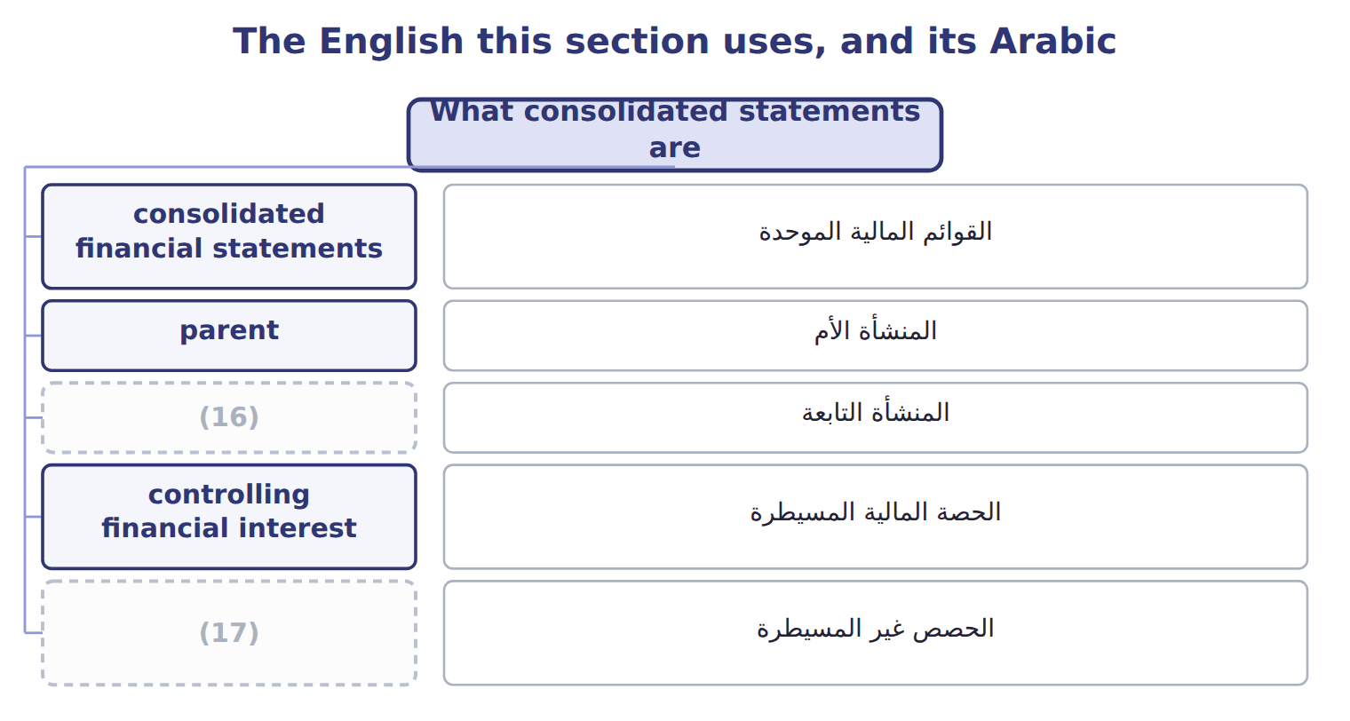
word list
primary beneficiary · subsidiary · noncontrolling interest

The English this sheet uses, and its Arabic
English (exam term) | Arabic
consolidated financial statements | القوائم المالية الموحدة
parent | المنشأة الأم
subsidiary | المنشأة التابعة
controlling financial interest | الحصة المالية المسيطرة
noncontrolling interest | الحصص غير المسيطرة

Answer key · 16.1 What consolidated statements are

1 What consolidated statements are | 10 Consolidation
2 Full consolidation, proportionate consolidatio | 11 liabilities
3 IFRS differences and what is changing | 12 within
4 subsidiaries | 13 separately
5 economic | 14 comprehensive
6 shareholders | 15 between
7 obligations | 16 subsidiary
8 consolidates | 17 noncontrolling interest
9 controlling

the summaries in full
Summary 1 Consolidated financial statements present a parent and its subsidiaries as a single economic entity. They are prepared mainly for the parent's shareholders and creditors, who need to see all the resources the group controls and all its obligations. A company consolidates another entity when it has a controlling financial interest in it. Consolidation adds all of the subsidiary's assets, liabilities, revenues and expenses to the parent's, line by line, even when the parent owns less than all of its shares. The part of a subsidiary's equity that the parent does not own is the noncontrolling interest (NCI). It is shown within consolidated equity, separately from the parent's equity. Net income and comprehensive income are split between the parent and NCI on the face of the statements. The exam uses noncontrolling interest. It is equity, never a liability.

16.2 Two control models: VIE first, then votes
Chapter 16 · section 16.2

Fill every gap. Each word list holds one word more than there are gaps.
Summary 1 gaps 1–12
U.S. GAAP has two ways to (1) control, and they are (2) in order. First, the company asks (3) the other entity is a (4) interest entity (VIE). An entity is a VIE if its equity at risk is too small to finance its activities, or if its equity holders do not have the power to direct it or do not bear its losses and (5) . A VIE is (6) by its primary beneficiary: the party that has both the power to direct the activities that most affect the VIE's (7) and the obligation to absorb losses, or the right to receive benefits, that could be significant. Both (8) are required. If the entity is not a VIE, the (9) interest model (10) . A company that holds more than 50% of the votes (11) controls the entity, unless other owners have substantive (12) rights, such as the right to approve budgets.
word list
whether · consolidated · variable · generally · performance · voting · applied · conditions · participating · primary · applies · returns · identify

Worked example: Orontes's cold-chain entity

Summary 2 gaps 13–16
Suppose a logistics entrepreneur owns all the shares of Orontes Cold-Chain Logistics SPV. The shares cost $100,000. Banks lend $9,900,000, (13) by Orontes. Equity is only 1% of the funding, and Orontes decides routes and customers: the SPV is a VIE. Orontes has the power and bears the losses (14) its guarantee, so it is the primary beneficiary. Orontes consolidates the SPV (15) it owns no shares. The (16) $100,000 is NCI.
word list
guaranteed · entrepreneur's · funding · through · although

Suppose: is the cold-chain SPV a VIE, and who consolidates it?
Suppose: Orontes Cold-Chain Logistics SPV, 2027 | Facts (whole USD) | Conclusion
Is equity at risk enough to finance the activities? | No: (17) equity is 100,000, only 1% of total funding | Suggests a VIE
Do the equity holders direct the key activities? | (18) | VIE
Who absorbs losses? | Orontes guarantees the 9,900,000 of debt | Orontes
Primary beneficiary? | Orontes has both power and exposure to significant losses | Orontes consolidates
NCI in consolidation | The third party's equity of 100,000 | (19)

word list
controlling financial interest · No: Orontes decides routes and customers · third-party · Shown as NCI

Control traps

Summary 3 gaps 20–22
Test the VIE model before (20) votes. The primary beneficiary needs power AND significant (21) , not one of them. Under U.S. GAAP, less than half of the votes is not control, even if the other owners are (22) spread.
word list
holders · economics · widely · counting

The English this sheet uses, and its Arabic
English (exam term) | Arabic
variable interest entity | منشأة ذات حصص متغيرة
primary beneficiary | المستفيد الرئيسي

Answer key · 16.2 Two control models: VIE first, then votes

1 identify | 12 participating
2 applied | 13 guaranteed
3 whether | 14 through
4 variable | 15 although
5 returns | 16 entrepreneur's
6 consolidated | 17 third-party
7 performance | 18 No: Orontes decides routes and customers
8 conditions | 19 Shown as NCI
9 voting | 20 counting
10 applies | 21 economics
11 generally | 22 widely

the summaries in full
Summary 1 U.S. GAAP has two ways to identify control, and they are applied in order. First, the company asks whether the other entity is a variable interest entity (VIE). An entity is a VIE if its equity at risk is too small to finance its activities, or if its equity holders do not have the power to direct it or do not bear its losses and returns. A VIE is consolidated by its primary beneficiary: the party that has both the power to direct the activities that most affect the VIE's performance and the obligation to absorb losses, or the right to receive benefits, that could be significant. Both conditions are required. If the entity is not a VIE, the voting interest model applies. A company that holds more than 50% of the votes generally controls the entity, unless other owners have substantive participating rights, such as the right to approve budgets.
Summary 2 Suppose a logistics entrepreneur owns all the shares of Orontes Cold-Chain Logistics SPV. The shares cost $100,000. Banks lend $9,900,000, guaranteed by Orontes. Equity is only 1% of the funding, and Orontes decides routes and customers: the SPV is a VIE. Orontes has the power and bears the losses through its guarantee, so it is the primary beneficiary. Orontes consolidates the SPV although it owns no shares. The entrepreneur's $100,000 is NCI.
Summary 3 Test the VIE model before counting votes. The primary beneficiary needs power AND significant economics, not one of them. Under U.S. GAAP, less than half of the votes is not control, even if the other owners are widely spread.

16.3 Full consolidation, proportionate consolidation and the equity method
Chapter 16 · section 16.3

Fill every gap. Each word list holds one word more than there are gaps.
Summary 1 gaps 1–8
Full consolidation is used for every (1) the company (2) . The subsidiary's items are added in full, and NCI shows the part the (3) does not own. The equity method, which the LOS call 'equity consolidation', is used when the investor has significant influence, (4) 20% to 50% of the votes, and for most joint ventures. The investment is one line on the (5) sheet, and the investor's share of income is one line on the income (6) , as for Jordan Glass. Proportionate consolidation adds only the investor's share of each asset, liability, revenue and expense. U.S. GAAP (7) does not allow it; it (8) only for some construction and oil and gas interests.
word list
survives · unrealized · statement · controls · generally · balance · parent · entity · usually

Full consolidation, equity method and proportionate consolidation
Method | When used (U.S. GAAP) | What appears | Intercompany profit removed | Orontes
Full consolidation | (9) | 100% of each asset, liability, revenue and expense; NCI shown | 100% of intercompany items | (10)
Equity method | Significant influence (20%–50%); joint ventures | One line: investment and share of income | (11) | (12)
Proportionate consolidation | Rare in U.S. GAAP: some construction and oil and gas interests | (13) | Investor's share | Not used by Orontes

word list
Control (subsidiary or VIE) · Not used by Orontes · Investor's share of each line · Levant (80%) · Only the investor's share: 30% × 40,000 = 12,000 · Jordan Glass (30%)

Summary 2 gaps 14–16
The methods also remove intercompany profit (14) . When Jordan Glass sells bottles to Orontes, the equity method removes only Orontes's 30% share of the (15) profit: $12,000. A (16) subsidiary's intercompany profit is removed in full.
word list
differently · statement · unrealized · controlled

'Equity consolidation' is the equity method

Summary 3 gaps 17–18
The LOS (17) 'equity consolidation' means the equity method: one line, no NCI. It is not full consolidation. Also, joint ventures use the equity method, not (18) consolidation.
word list
proportionate · phrase · differently

The English this section uses, and its Arabic
Each term sits against what it means.
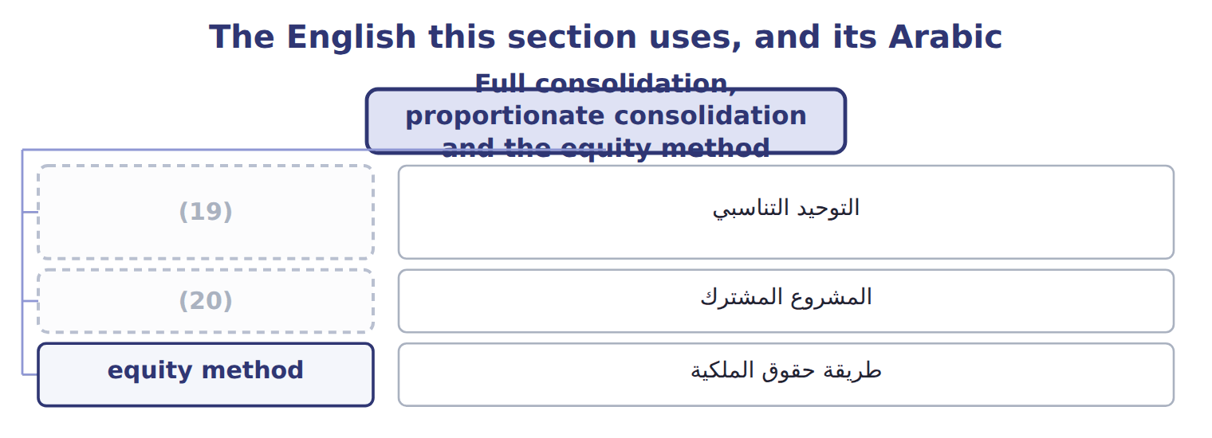
word list
proportionate consolidation · equity method · joint venture

The English this sheet uses, and its Arabic
English (exam term) | Arabic
proportionate consolidation | التوحيد التناسبي
joint venture | المشروع المشترك
equity method | طريقة حقوق الملكية

Answer key · 16.3 Full consolidation, proportionate consolidation and the equity method

1 entity | 11 Only the investor's share: 30% × 40,000 = 12,000
2 controls | 12 Jordan Glass (30%)
3 parent | 13 Investor's share of each line
4 usually | 14 differently
5 balance | 15 unrealized
6 statement | 16 controlled
7 generally | 17 phrase
8 survives | 18 proportionate
9 Control (subsidiary or VIE) | 19 proportionate consolidation
10 Levant (80%) | 20 joint venture

the summaries in full
Summary 1 Full consolidation is used for every entity the company controls. The subsidiary's items are added in full, and NCI shows the part the parent does not own. The equity method, which the LOS call 'equity consolidation', is used when the investor has significant influence, usually 20% to 50% of the votes, and for most joint ventures. The investment is one line on the balance sheet, and the investor's share of income is one line on the income statement, as for Jordan Glass. Proportionate consolidation adds only the investor's share of each asset, liability, revenue and expense. U.S. GAAP generally does not allow it; it survives only for some construction and oil and gas interests.
Summary 2 The methods also remove intercompany profit differently. When Jordan Glass sells bottles to Orontes, the equity method removes only Orontes's 30% share of the unrealized profit: $12,000. A controlled subsidiary's intercompany profit is removed in full.
Summary 3 The LOS phrase 'equity consolidation' means the equity method: one line, no NCI. It is not full consolidation. Also, joint ventures use the equity method, not proportionate consolidation.

16.4 The acquisition: goodwill and noncontrolling interest
Chapter 16 · section 16.4

Fill every gap. Each word list holds one word more than there are gaps.
Summary 1 gaps 1–4
When a company gains control of a (1) , it uses the acquisition (2) . It measures the (3) identifiable assets and (4) at fair value, and it measures NCI at fair value too. Goodwill is the price paid plus the fair value of NCI, minus the fair value of the net assets. Orontes pays $8,000,000 for 80% of Levant, and the other 20% is worth $1,900,000. Levant's net assets are $7,300,000 on its books, but its equipment is worth $1,200,000 more, so the net assets at fair value are $8,500,000.
word list
method · business · liabilities · measures · subsidiary's

Worked example: the acquisition-date elimination

Summary 2 gaps 5–12
Remove Levant's equity of $7,300,000: it is not owned by (5) to the group, except (6) NCI. Add the equipment step-up of $1,200,000 and goodwill of $1,400,000. Remove Orontes's investment of $8,000,000 and (7) NCI of $1,900,000 in equity. Debits and (8) both equal $9,900,000. After the acquisition, if Orontes buys or sells some Levant shares but keeps control, the change is an equity (9) : no gain or loss is (10) . If Orontes loses control, it (11) Levant from the consolidation and (12) any interest it keeps at fair value.
word list
record · outsiders · remeasures · removes · transaction · recognized · acquisition · through · credits

Suppose: elimination entry at the acquisition of Levant
Consolidation worksheet, January 1, 2027 (whole | Debit | Credit
(13) | 7,300,000
(14) | 1,200,000
Goodwill | 1,400,000
(15) |  | 8,000,000
Noncontrolling interest (equity) |  | 1,900,000
Totals | 9,900,000 | 9,900,000

word list
Property, plant and equipment (fair value step-up) · Noncontrolling interest (equity) · Levant's equity (book value) · Investment in Levant (Orontes's books)

The English this section uses, and its Arabic
Each term sits against what it means.
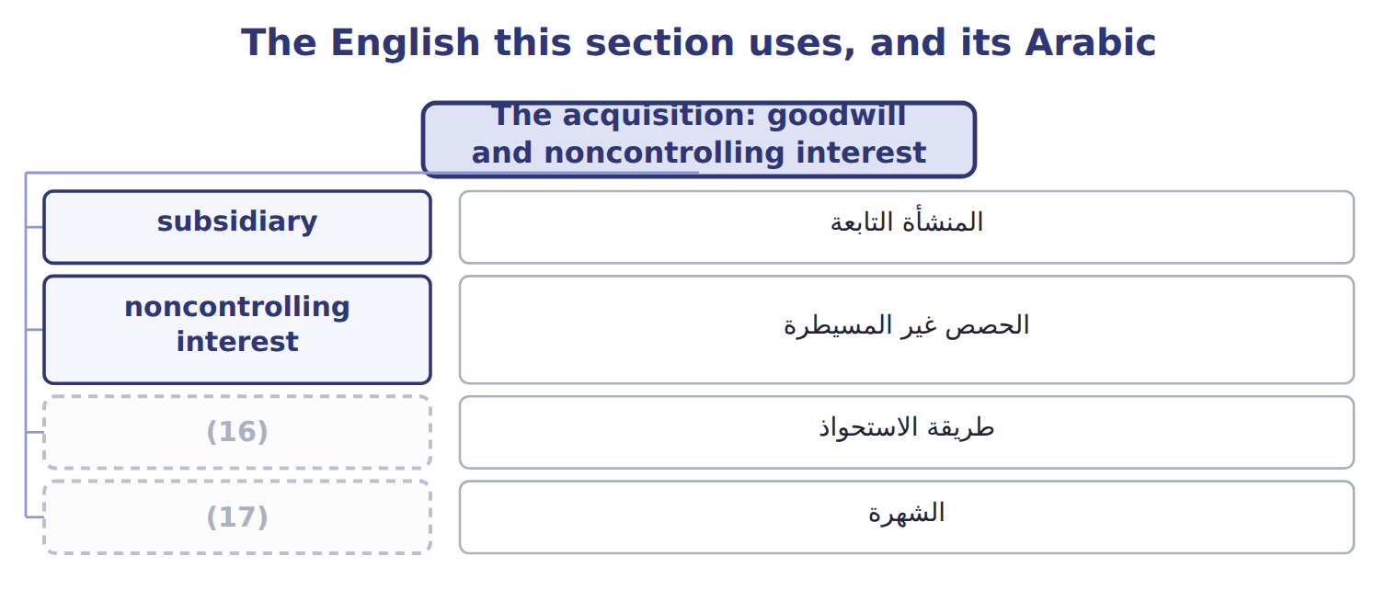
word list
goodwill · طريقة الاستحواذ · acquisition method

The English this sheet uses, and its Arabic
English (exam term) | Arabic
acquisition method | طريقة الاستحواذ
goodwill | الشهرة

Answer key · 16.4 The acquisition: goodwill and noncontrolling interest

1 business | 10 recognized
2 method | 11 removes
3 subsidiary's | 12 remeasures
4 liabilities | 13 Levant's equity (book value)
5 outsiders | 14 Property, plant and equipment (fair value step-up)
6 through | 15 Investment in Levant (Orontes's books)
7 record | 16 acquisition method
8 credits | 17 goodwill
9 transaction

the summaries in full
Summary 1 When a company gains control of a business, it uses the acquisition method. It measures the subsidiary's identifiable assets and liabilities at fair value, and it measures NCI at fair value too. Goodwill is the price paid plus the fair value of NCI, minus the fair value of the net assets. Orontes pays $8,000,000 for 80% of Levant, and the other 20% is worth $1,900,000. Levant's net assets are $7,300,000 on its books, but its equipment is worth $1,200,000 more, so the net assets at fair value are $8,500,000.
Summary 2 Remove Levant's equity of $7,300,000: it is not owned by outsiders to the group, except through NCI. Add the equipment step-up of $1,200,000 and goodwill of $1,400,000. Remove Orontes's investment of $8,000,000 and record NCI of $1,900,000 in equity. Debits and credits both equal $9,900,000. After the acquisition, if Orontes buys or sells some Levant shares but keeps control, the change is an equity transaction: no gain or loss is recognized. If Orontes loses control, it removes Levant from the consolidation and remeasures any interest it keeps at fair value.

16.5 Eliminating intercompany balances and transactions
Chapter 16 · section 16.5

Fill every gap. Each word list holds one word more than there are gaps.
Summary 1 gaps 1–11
A group (1) sell to itself, owe money to itself or earn income from itself. Every intercompany (2) is therefore eliminated in full, whatever the percentage owned: sales and cost of sales, (3) and payables, loans and interest, and dividends. Unrealized profit on goods still held inside the group is also removed from (4) and income until the goods are sold to (5) . In a downstream sale the parent earned the profit, so the whole (6) reduces the parent's share. In an upstream sale the (7) earned it, so NCI bears its share. When one group company sells (8) to another, the gain is eliminated and the asset returns to its (9) cost basis. The (10) extra depreciation on the gain is (11) each year.
word list
outsiders · buyer's · elimination · intercompany · subsidiary · cannot · reversed · inventory · receivables · transaction · equipment · original

Suppose: Orontes's 2027 intercompany eliminations for Levant
Every item belongs to exactly one group.
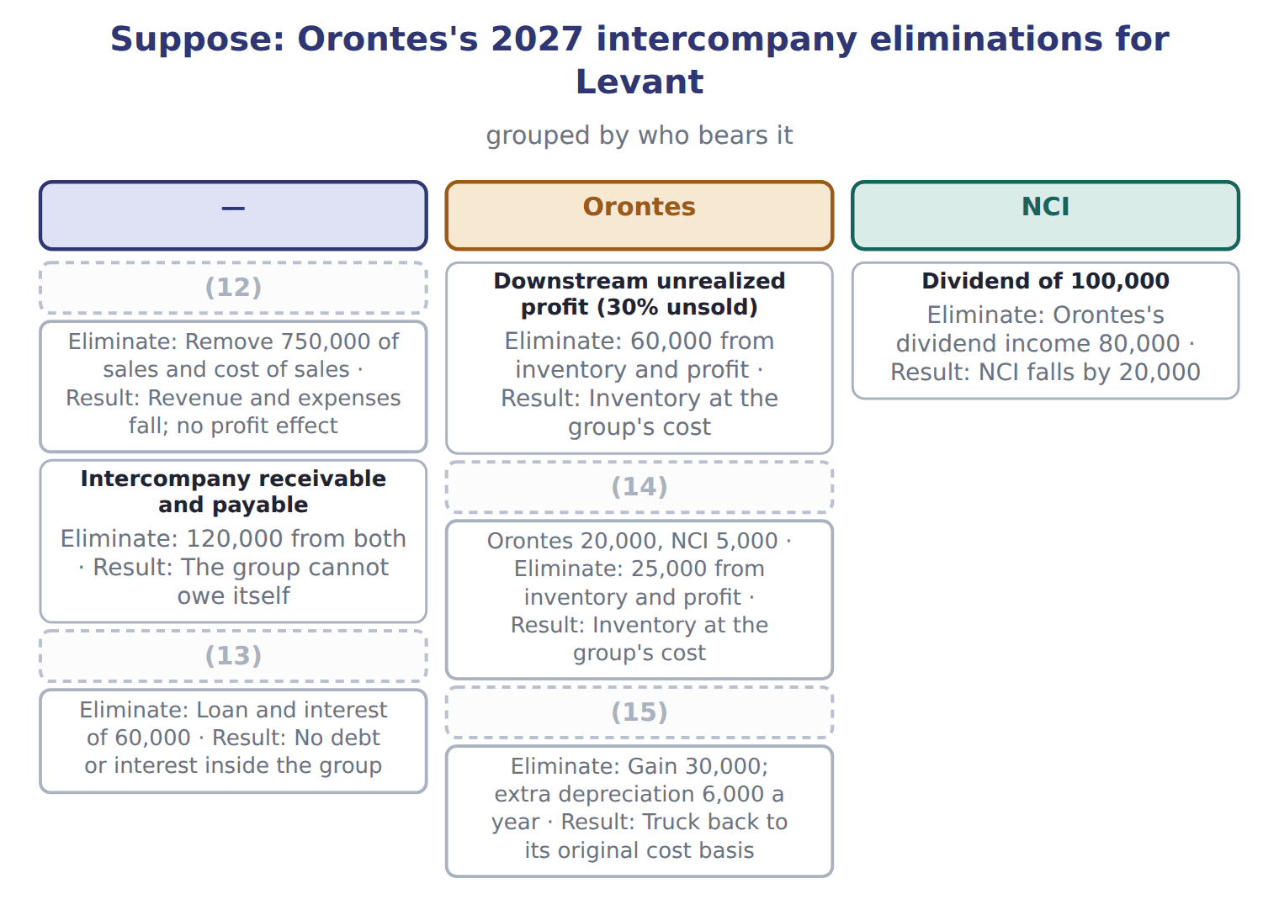
word list
Upstream unrealized profit (40% unsold) · Loan of 1,000,000 at 6% · Truck sold for 90,000 (carrying 60,000) · Intercompany sales and cost of sales · Downstream unrealized profit (30% unsold)

NCI at the end of 2027

Complete the five blanks.

Suppose: NCI roll-forward for Levant, 2027 (complete the blanks)
Suppose: NCI in Levant, 2027 (whole USD) | Amount
(16) | 1,900,000
(17) | 900,000
Less: depreciation on the PP&E step-up (1,200,000 ÷ 10 years) | (120,000)
Less: upstream unrealized profit | ________
(18) | ________
NCI share (20%) | ________
Less: dividends paid to NCI | ________
NCI at December 31, 2027 | ________

word list
NCI at January 1, 2027 (fair value) · Orontes 20,000, NCI 5,000 · Adjusted net income of Levant · Levant's 2027 net income

Elimination traps

Summary 2 gaps 19–21
Eliminate intercompany items in full, not only the parent's share. Downstream profit reduces only the parent's share; upstream profit is (19) with NCI. For an (20) investee, remove only the (21) share of the profit.
word list
investor's · shared · equipment · equity-method

The English this section uses, and its Arabic
Each term sits against what it means.
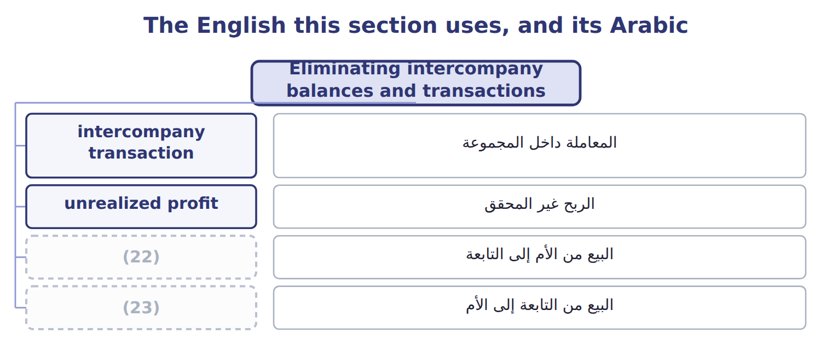
word list
downstream sale · unrealized profit · upstream sale

The English this sheet uses, and its Arabic
English (exam term) | Arabic
intercompany transaction | المعاملة داخل المجموعة
unrealized profit | الربح غير المحقق
downstream sale | البيع من الأم إلى التابعة
upstream sale | البيع من التابعة إلى الأم

Answer key · 16.5 Eliminating intercompany balances and transactions

1 cannot | 13 Loan of 1,000,000 at 6%
2 transaction | 14 Upstream unrealized profit (40% unsold)
3 receivables | 15 Truck sold for 90,000 (carrying 60,000)
4 inventory | 16 NCI at January 1, 2027 (fair value)
5 outsiders | 17 Levant's 2027 net income
6 elimination | 18 Adjusted net income of Levant
7 subsidiary | 19 shared
8 equipment | 20 equity-method
9 original | 21 investor's
10 buyer's | 22 downstream sale
11 reversed | 23 upstream sale
12 Intercompany sales and cost of sales

the summaries in full
Summary 1 A group cannot sell to itself, owe money to itself or earn income from itself. Every intercompany transaction is therefore eliminated in full, whatever the percentage owned: sales and cost of sales, receivables and payables, loans and interest, and dividends. Unrealized profit on goods still held inside the group is also removed from inventory and income until the goods are sold to outsiders. In a downstream sale the parent earned the profit, so the whole elimination reduces the parent's share. In an upstream sale the subsidiary earned it, so NCI bears its share. When one group company sells equipment to another, the gain is eliminated and the asset returns to its original cost basis. The buyer's extra depreciation on the gain is reversed each year.
Summary 2 Eliminate intercompany items in full, not only the parent's share. Downstream profit reduces only the parent's share; upstream profit is shared with NCI. For an equity-method investee, remove only the investor's share of the profit.

16.6 IFRS differences and what is changing
Chapter 16 · section 16.6

Fill every gap. Each word list holds one word more than there are gaps.
Summary 1 gaps 1–8
IFRS 10 uses one control model: an investor (1) an entity if it has power over it, (2) to variable returns, and the (3) to use its power to (4) those returns. There is no (5) VIE model, and an investor can have de facto control with less than half of the votes. IFRS 3 lets a company (6) NCI either at fair value or at its share of net assets, which gives partial goodwill: for Levant, $1,200,000 (7) of $1,400,000. Under IFRS 11, joint ventures use the equity method and joint operations (8) their own share of assets and liabilities.
word list
controls · exposure · measure · separate · instead · together · recognize · affect · ability

Consolidation: U.S. GAAP and IFRS
Topic | U.S. GAAP (ASC 810, 805) | IFRS (IFRS 10, 3, 11)
Control model | (9) | One: power, variable returns and the link between them
Control below 50% of votes | (10) | Possible: de facto control
Measuring NCI | (11) | Fair value or share of net assets (partial goodwill), deal by deal
Joint arrangements | Joint ventures: equity method | Joint ventures: equity method; joint operations: own share of assets and liabilities
Group accounting policies | (12) | Uniform policies required
Investment-entity subsidiaries in a parent's statements | Parent keeps their fair value accounting | (13)

word list
Fair value (full goodwill) · Adjusted net income of Levant · Not through voting alone (unless a VIE) · Two: VIE model first, then voting interest · A non-investment-entity parent consolidates them · No general uniformity rule

Summary 2 gaps 14–18
ASU 2025-03 changes how to (14) the acquirer when the (15) company is a VIE; it is not testable before about January 2028. In January 2026 the FASB began (16) on bringing the VIE and voting models closer (17) . That is a (18) only. ASU 2023-05, on joint venture formations, affects only the joint venture's own statements.
word list
proposal · ventures · together · acquired · identify · research

Suppose: Barada Wholesale and Tadmor Retail, 202 — Amount
Suppose: Barada Wholesale and Tadmor Retail, 202 | Amount
(19) | 600
(20) | 190
Fair value of Tadmor's identifiable net assets | 700
Barada sold goods to Tadmor: sales 200, margin 30%, 25% still held by Tadmor
(21) : sales 160, margin 25%, 50% still held by Barada
Tadmor owes Barada at December 31, 2028 | 40
Tadmor's 2028 net income (before any consolidation adjustment) | 120
(22) | 40
M1 | Tadmor's assets are at fair value on its books, so there is no step-up to depreciate.
(23) | Barada also holds 30% of a supplier (significant influence) and 8% of a listed food company.

word list
Tadmor sold goods to Barada · Dividends paid by Tadmor in 2028 · Fair value of the 25% noncontrolling interest · M2 · Price paid for 75% of Tadmor Retail LLC, January 1, 2028 · equity method

Item — Answer
Item | Answer
Less: upstream unrealized profit | (25,000)
Adjusted net income of Levant | (24)
NCI share | (25)
Less: dividends paid to NCI | (20,000)
NCI at December 31, 2027 | 1,900,000 + 151,000 − 20,000 = 2,031,000

word list
900,000 − 120,000 − 25,000 = 755,000 · 1,900,000 + 151,000 − 20,000 = 2,031,000 · 20% × 755,000 = 151,000

Investment — Category
Investment | Category
Tadmor Retail (75%) | (26)
Supplier (30%, significant influence) | Equity method
Listed food company (8%) | (27)
Cold-storage SPV that Barada directs and guarantees (VIE) | Full consolidation

word list
Full consolidation · joint venture · Fair value through net income

The English this section uses, and its Arabic
Each term sits against what it means.
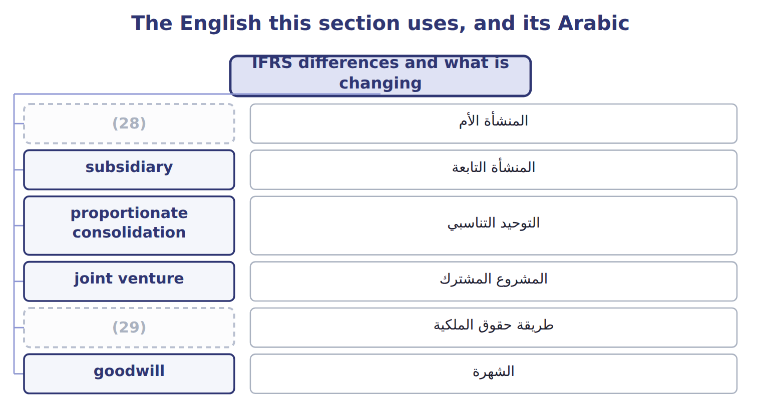
word list
parent · equity method · proportionate consolidation

Answer key · 16.6 IFRS differences and what is changing

1 controls | 16 research
2 exposure | 17 together
3 ability | 18 proposal
4 affect | 19 Price paid for 75% of Tadmor Retail LLC, January 1, 2028
5 separate | 20 Fair value of the 25% noncontrolling interest
6 measure | 21 Tadmor sold goods to Barada
7 instead | 22 Dividends paid by Tadmor in 2028
8 recognize | 23 M2
9 Two: VIE model first, then voting interest | 24 900,000 − 120,000 − 25,000 = 755,000
10 Not through voting alone (unless a VIE) | 25 20% × 755,000 = 151,000
11 Fair value (full goodwill) | 26 Full consolidation
12 No general uniformity rule | 27 Fair value through net income
13 A non-investment-entity parent consolidates them | 28 parent
14 identify | 29 equity method
15 acquired

the summaries in full
Summary 1 IFRS 10 uses one control model: an investor controls an entity if it has power over it, exposure to variable returns, and the ability to use its power to affect those returns. There is no separate VIE model, and an investor can have de facto control with less than half of the votes. IFRS 3 lets a company measure NCI either at fair value or at its share of net assets, which gives partial goodwill: for Levant, $1,200,000 instead of $1,400,000. Under IFRS 11, joint ventures use the equity method and joint operations recognize their own share of assets and liabilities.
Summary 2 ASU 2025-03 changes how to identify the acquirer when the acquired company is a VIE; it is not testable before about January 2028. In January 2026 the FASB began research on bringing the VIE and voting models closer together. That is a proposal only. ASU 2023-05, on joint venture formations, affects only the joint venture's own statements.

17.1 (i) Share-based payments and employee benefits
Chapter 17 · section 17.1

Fill every gap. Each word list holds one word more than there are gaps.
Chapter 17, section by section
Each stage leads to the next.
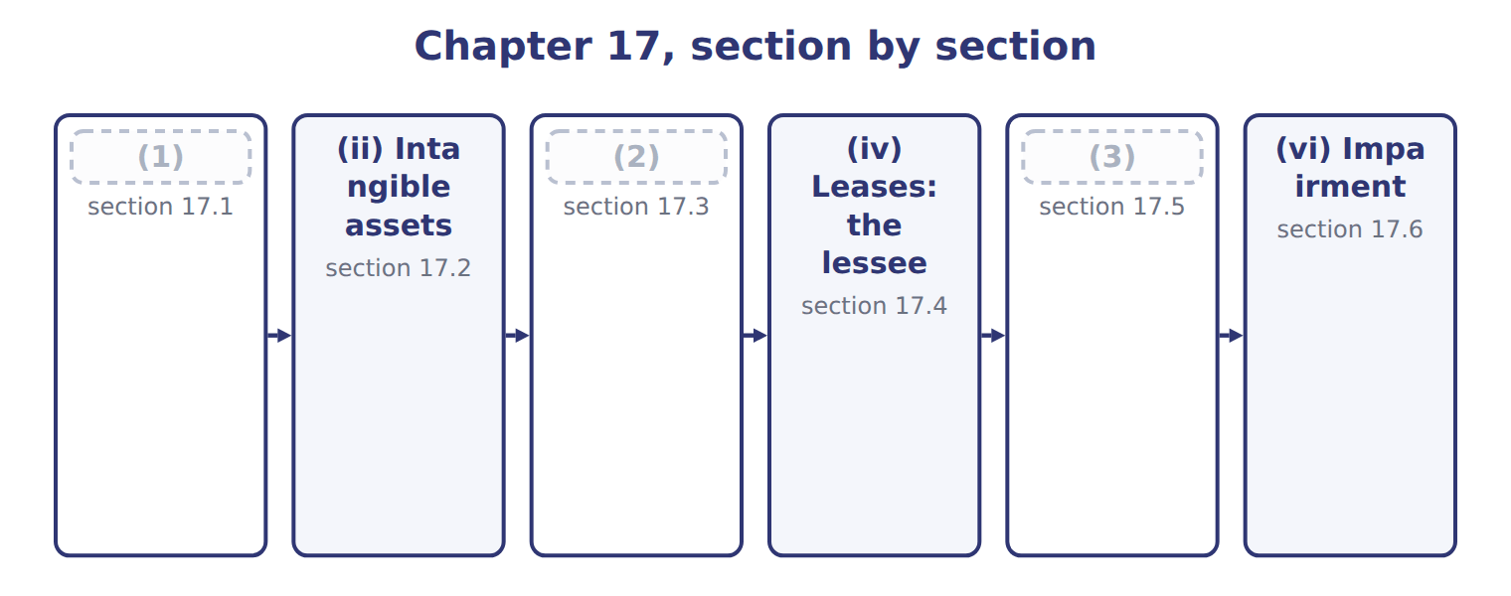
word list
(iii) Inventories · (i) Share-based payments and employee benefits · (vi) Impairment · (v) Long-lived assets

Summary 1 gaps 4–13
For share awards that vest in parts, or graded vesting, U.S. GAAP lets a company (4) the cost straight-line over the whole period or tranche by tranche, when the awards have only service (5) . IFRS 2 requires tranche by tranche, which puts more (6) in the early years. U.S. GAAP also (7) a policy choice to record forfeitures as they occur; IFRS 2 requires an estimate. Employer payroll taxes on share awards are recognized when the tax obligation arises under U.S. GAAP, but accrued over the vesting period under IFRS. For a (8) benefit plan, both (9) put remeasurements in OCI. U.S. GAAP later amortizes them into net income; IAS 19 never (10) them. Orontes (11) its plan and (12) prior service cost of $50,000: U.S. GAAP amortizes $5,000 a year from OCI, while IAS 19 expenses the whole (13) at once.
word list
amount · conditions · creates · expense · reclassifies · recognize · payroll · allows · defined · frameworks · amends

Share-based payments and employee benefits: U.S. GAAP and IFRS
Topic | U.S. GAAP (ASC 718, 715) | IFRS (IFRS 2, IAS 19)
Graded vesting (service condition) | Choice: straight-line over the whole period or tranche by tranche | Tranche by tranche
Forfeitures | (14) | Estimate
Employer payroll taxes on awards | (15) | Accrued over the vesting period
Pension remeasurements (actuarial gains and losses) | OCI, then amortized into net income (corridor) | OCI, never reclassified to profit
Return on plan assets | Expected return | (16)
Prior service cost: Orontes amendment of 50,000 | (17) : 5,000 a year | Expensed at once: 50,000

word list
When the tax obligation arises (exercise or vesting) · Policy choice: estimate or record as they occur · OCI, amortized over 10 years · Net interest at the discount rate · OCI, never reclassified to profit

The English this section uses, and its Arabic
Each term sits against what it means.
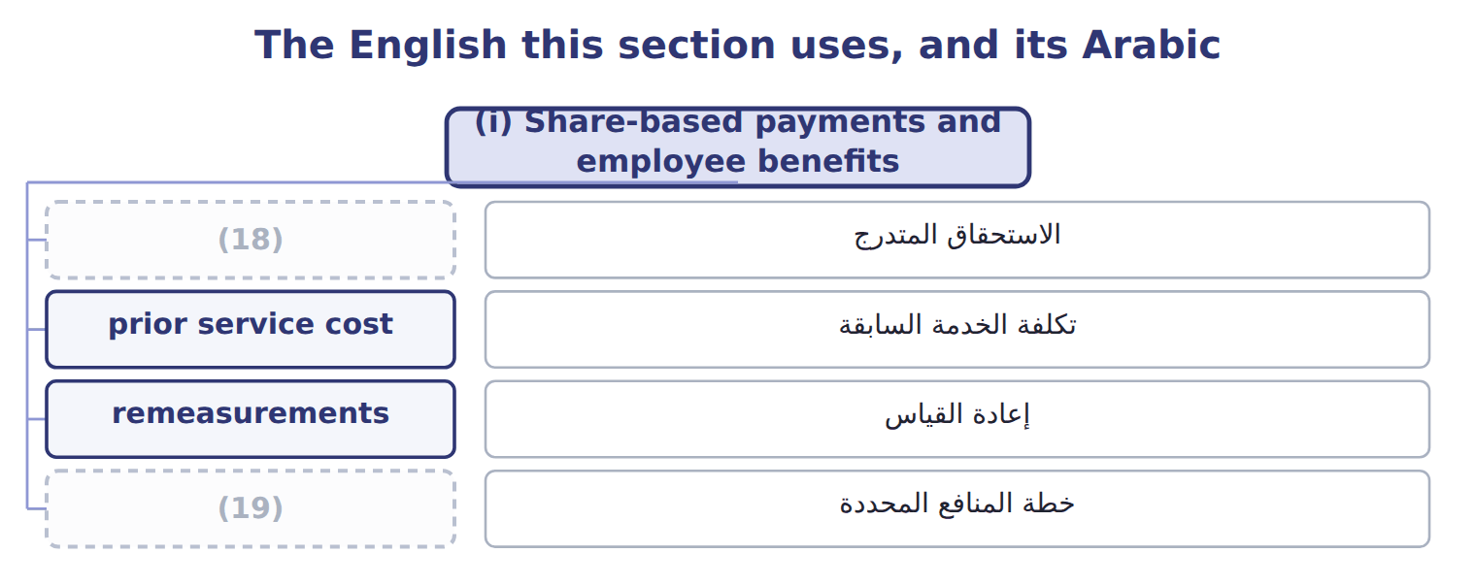
word list
graded vesting · value in use · defined benefit plan

The English this sheet uses, and its Arabic
English (exam term) | Arabic
graded vesting | الاستحقاق المتدرج
prior service cost | تكلفة الخدمة السابقة
remeasurements | إعادة القياس
defined benefit plan | خطة المنافع المحددة

Answer key · 17.1 (i) Share-based payments and employee benefits

1 (i) Share-based payments and employee benefits | 11 amends
2 (iii) Inventories | 12 creates
3 (v) Long-lived assets | 13 amount
4 recognize | 14 Policy choice: estimate or record as they occur
5 conditions | 15 When the tax obligation arises (exercise or vesting)
6 expense | 16 Net interest at the discount rate
7 allows | 17 OCI, amortized over 10 years
8 defined | 18 graded vesting
9 frameworks | 19 defined benefit plan
10 reclassifies

the summaries in full
Summary 1 For share awards that vest in parts, or graded vesting, U.S. GAAP lets a company recognize the cost straight-line over the whole period or tranche by tranche, when the awards have only service conditions. IFRS 2 requires tranche by tranche, which puts more expense in the early years. U.S. GAAP also allows a policy choice to record forfeitures as they occur; IFRS 2 requires an estimate. Employer payroll taxes on share awards are recognized when the tax obligation arises under U.S. GAAP, but accrued over the vesting period under IFRS. For a defined benefit plan, both frameworks put remeasurements in OCI. U.S. GAAP later amortizes them into net income; IAS 19 never reclassifies them. Orontes amends its plan and creates prior service cost of $50,000: U.S. GAAP amortizes $5,000 a year from OCI, while IAS 19 expenses the whole amount at once.

17.2 (ii) Intangible assets
Chapter 17 · section 17.2

Fill every gap. Each word list holds one word more than there are gaps.
Summary 1 gaps 1–10
The (1) intangibles (2) is development costs. U.S. GAAP expenses research and development as (3) , with narrow (4) for software. IAS 38 expenses research but (5) development once six criteria are met, such as technical (6) , intention and ability to complete, and a way to generate future benefits. (7) Orontes spends $300,000 developing a new (8) line, and all six criteria are met. Under U.S. GAAP the whole amount is an (9) ; under IFRS it is an (10) asset, amortized once the product is ready. IAS 38 also allows the revaluation model for intangibles, but only where an active market exists, which is rare. U.S. GAAP never revalues intangibles upward. Both frameworks refuse to recognize internally generated brands.
word list
capitalizes · intangible · incurred · exceptions · sparkling-juice · recognize · expense · largest · Suppose · feasibility · difference

Intangible assets: U.S. GAAP and IFRS
The two sides differ only where the rows say.
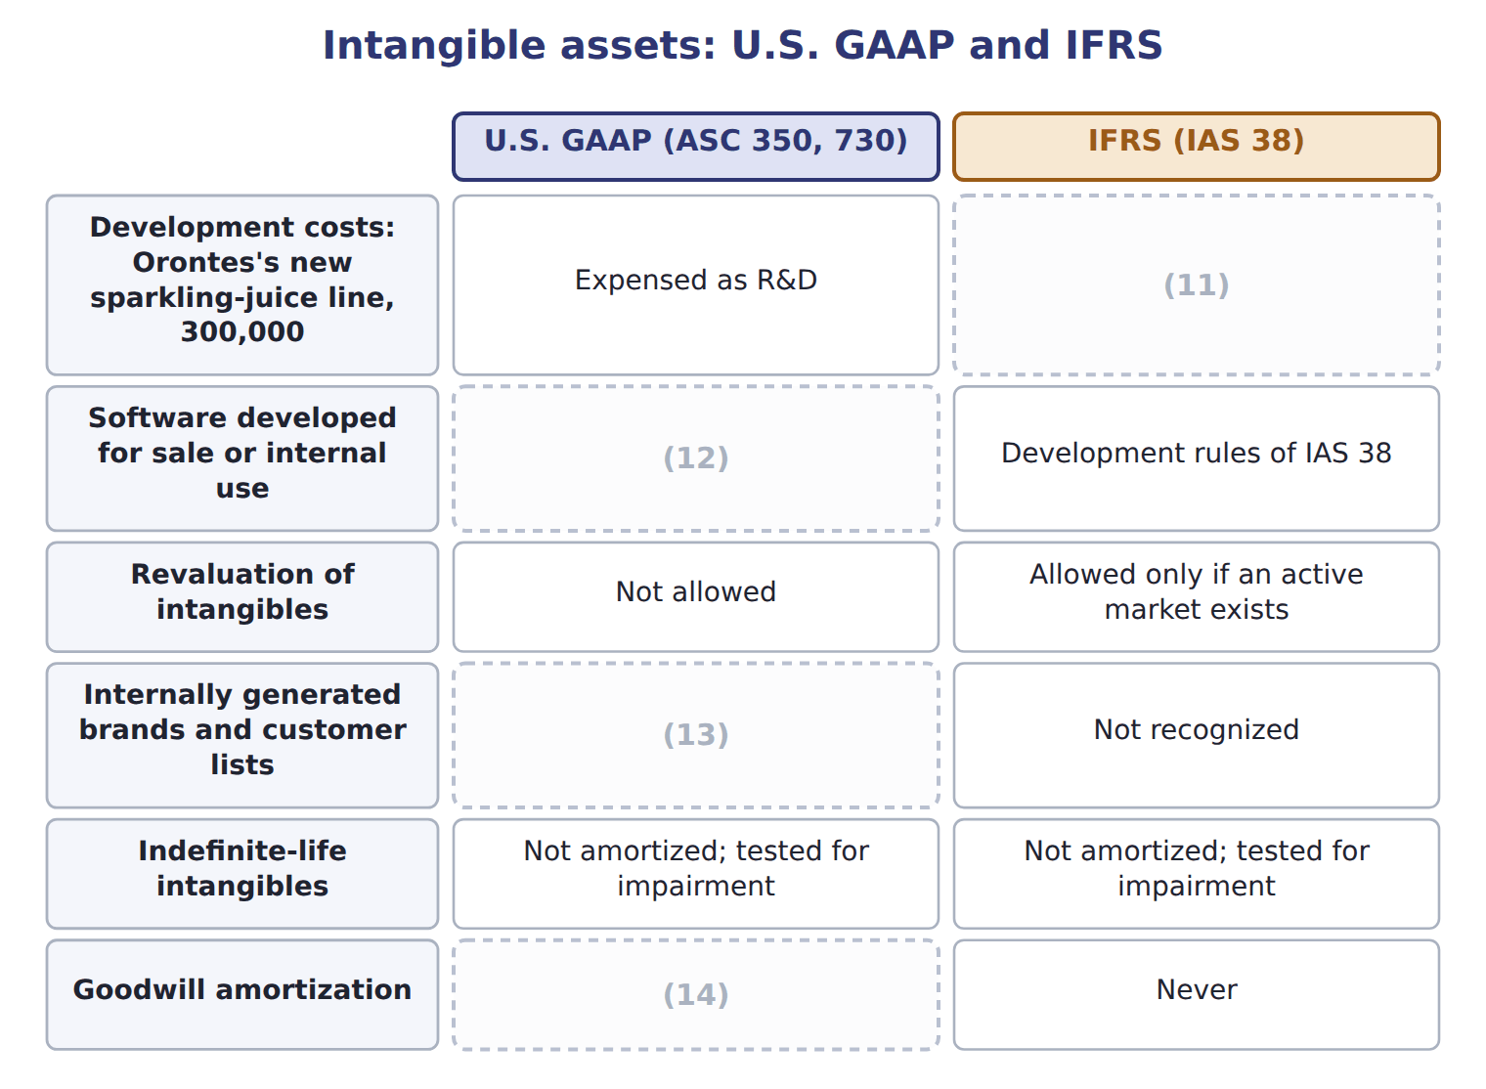
word list
Capitalized: all six IAS 38 criteria are met · Not allowed · Not recognized · Only private companies may elect it · Capitalized only in limited stages (ASC 985-20, 350-40)

Summary 2 gaps 15–17
ASU 2025-06 simplifies when internal-use software costs are capitalized, and ASU 2026-02 creates new rules for (15) credits. Neither is (16) before about January 2029. Private companies may amortize goodwill, but an SEC (17) such as Orontes may not.
word list
environmental · testable · registrant · technical

The English this sheet uses, and its Arabic
English (exam term) | Arabic
development costs | تكاليف التطوير
research and development (R&D) | البحث والتطوير

Answer key · 17.2 (ii) Intangible assets

1 largest | 10 intangible
2 difference | 11 Capitalized: all six IAS 38 criteria are met
3 incurred | 12 Capitalized only in limited stages (ASC 985-20, 350-40)
4 exceptions | 13 Not recognized
5 capitalizes | 14 Only private companies may elect it
6 feasibility | 15 environmental
7 Suppose | 16 testable
8 sparkling-juice | 17 registrant
9 expense

the summaries in full
Summary 1 The largest intangibles difference is development costs. U.S. GAAP expenses research and development as incurred, with narrow exceptions for software. IAS 38 expenses research but capitalizes development once six criteria are met, such as technical feasibility, intention and ability to complete, and a way to generate future benefits. Suppose Orontes spends $300,000 developing a new sparkling-juice line, and all six criteria are met. Under U.S. GAAP the whole amount is an expense; under IFRS it is an intangible asset, amortized once the product is ready. IAS 38 also allows the revaluation model for intangibles, but only where an active market exists, which is rare. U.S. GAAP never revalues intangibles upward. Both frameworks refuse to recognize internally generated brands.
Summary 2 ASU 2025-06 simplifies when internal-use software costs are capitalized, and ASU 2026-02 creates new rules for environmental credits. Neither is testable before about January 2029. Private companies may amortize goodwill, but an SEC registrant such as Orontes may not.

17.3 (iii) Inventories
Chapter 17 · section 17.3

Fill every gap. Each word list holds one word more than there are gaps.
Stocks, provision

Summary 1 gaps 1–2
Both (1) write inventory down when its value falls below cost. The key (2) comes when value recovers.
word list
frameworks · difference · provision

What each framework says
The two columns are not matched row by row.
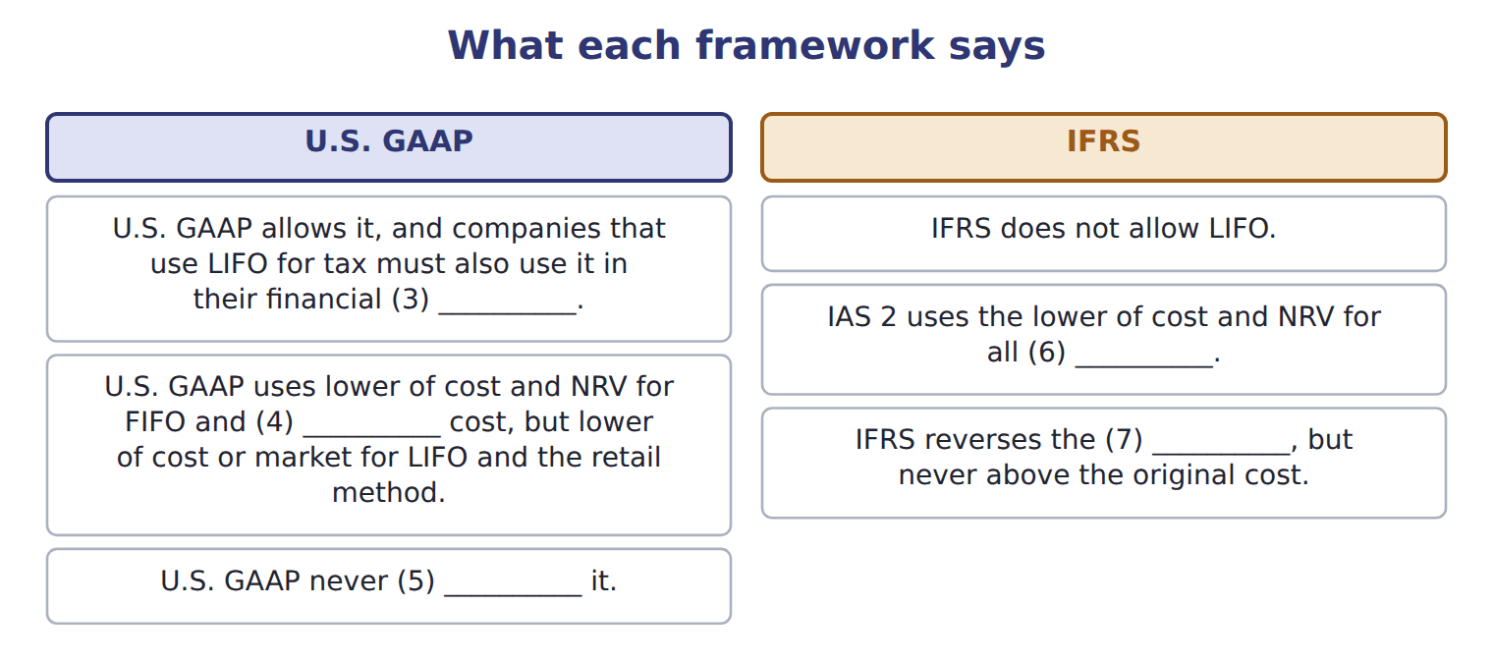
word list
statements · reverses · inventory · remeasurements · average · write-down

Summary 2 gaps 8–9
In U.S. terms, a write-down (8) the inventory itself; do not call it a (9) or a reserve.
word list
provision · reduces · original

The English this sheet uses, and its Arabic
English (exam term) | Arabic
net realizable value (NRV) | صافي القيمة القابلة للتحقق
lower of cost and net realizable value (LCNRV) | التكلفة أو صافي القيمة القابلة للتحقق، أيهما أقل

Answer key · 17.3 (iii) Inventories

1 frameworks | 6 inventory
2 difference | 7 write-down
3 statements | 8 reduces
4 average | 9 provision
5 reverses

the summaries in full
Summary 1 Both frameworks write inventory down when its value falls below cost. The key difference comes when value recovers.
Summary 2 In U.S. terms, a write-down reduces the inventory itself; do not call it a provision or a reserve.

17.4 (iv) Leases: the lessee
Chapter 17 · section 17.4

Fill every gap. Each word list holds one word more than there are gaps.
What each framework says
The two columns are not matched row by row.
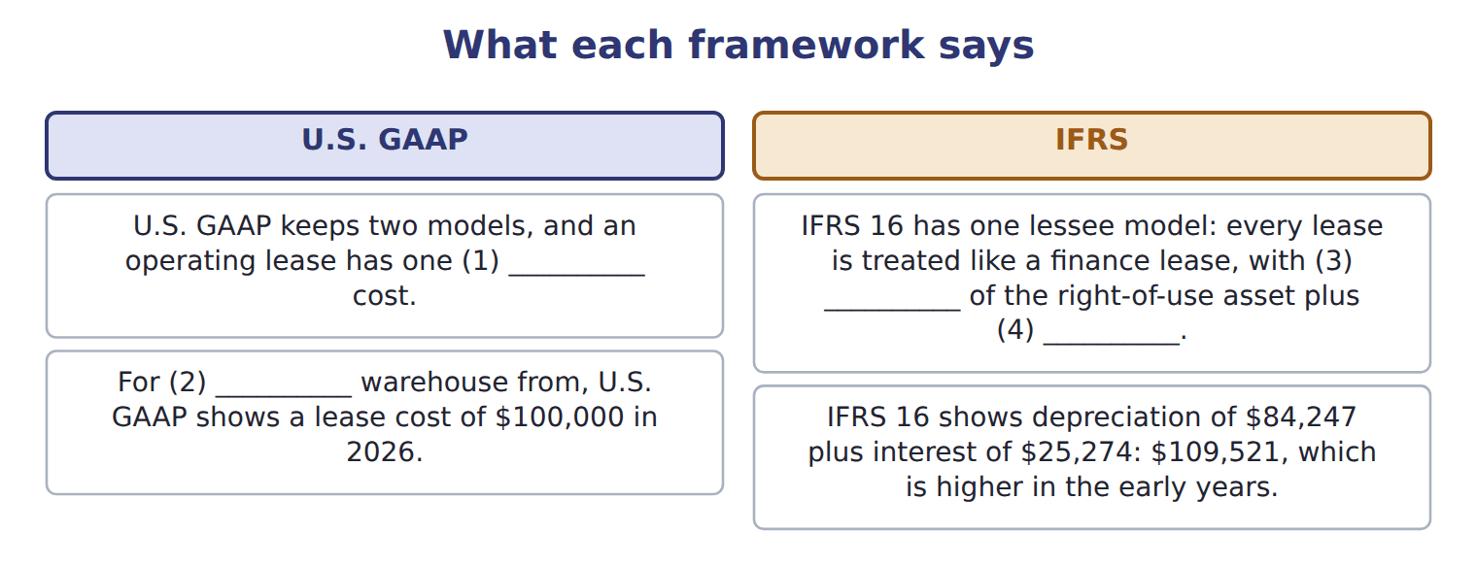
word list
depreciation · interest · Orontes's · remeasurements · straight-line

Summary 1 gaps 5–7
Over the whole lease, total (5) is the same. IFRS 16 also allows an exemption for low-value assets, (6) the liability when an index such as CPI changes, and (7) lease principal as financing.
word list
expense · remeasures · treated · classifies

Lessee accounting: U.S. GAAP and IFRS 16
The two sides differ only where the rows say.
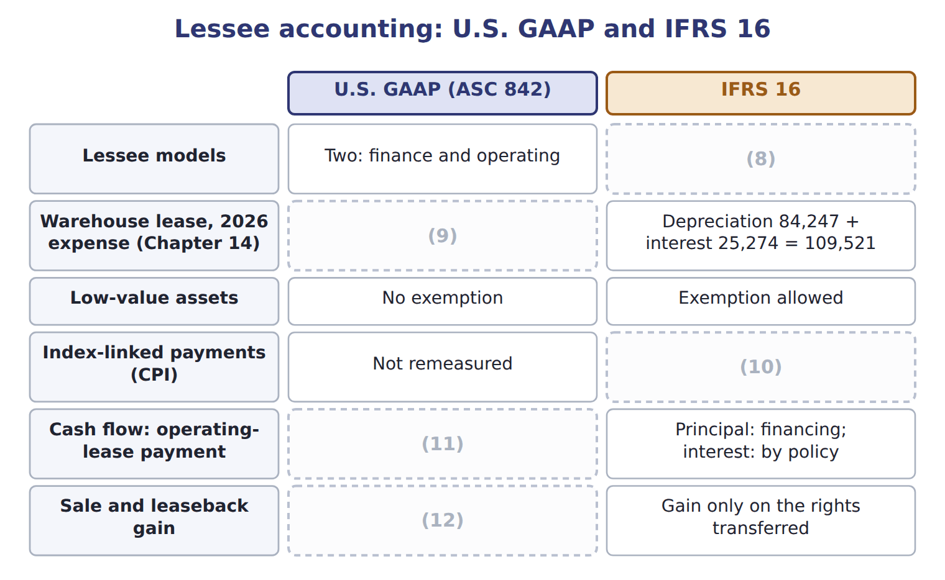
word list
Low-value assets · Full gain if a sale · One: all leases like finance leases · Liability remeasured · Operating · One straight-line lease cost: 100,000

Answer key · 17.4 (iv) Leases: the lessee

1 straight-line | 7 classifies
2 Orontes's | 8 One: all leases like finance leases
3 depreciation | 9 One straight-line lease cost: 100,000
4 interest | 10 Liability remeasured
5 expense | 11 Operating
6 remeasures | 12 Full gain if a sale

the summaries in full
Summary 1 Over the whole lease, total expense is the same. IFRS 16 also allows an exemption for low-value assets, remeasures the liability when an index such as CPI changes, and classifies lease principal as financing.

17.5 (v) Long-lived assets
Chapter 17 · section 17.5

Fill every gap. Each word list holds one word more than there are gaps.
Long-lived assets: U.S. GAAP and IFRS
The two sides differ only where the rows say.
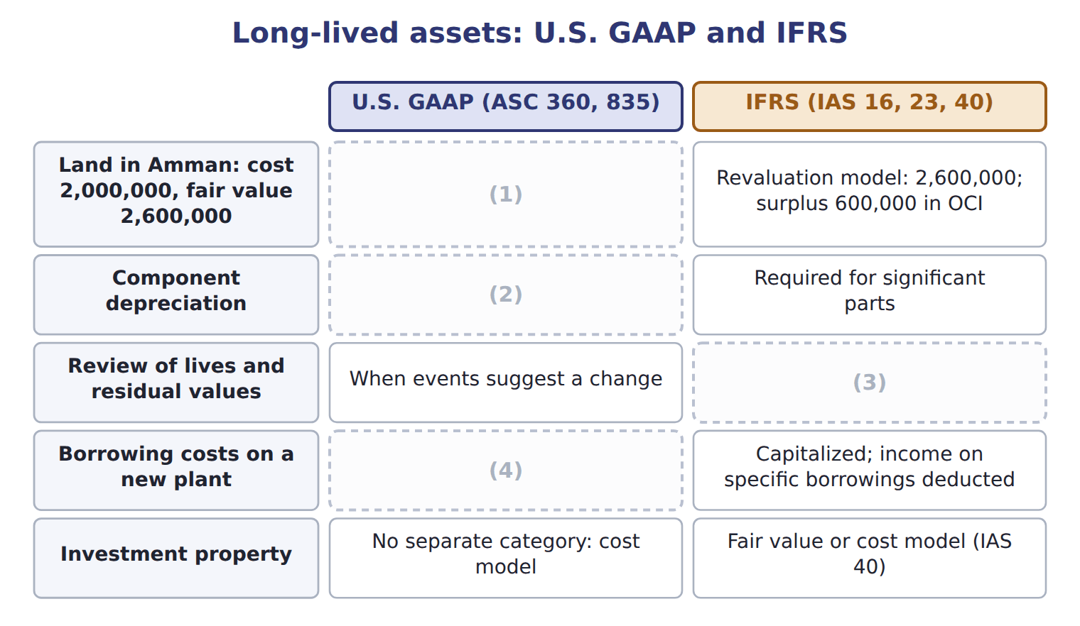
word list
net realizable value (NRV) · Allowed, not required · Capitalized; investment income generally not offset · At least every year · Stays at 2,000,000

Summary 1 gaps 5–9
IAS 16 also allows the revaluation model for a whole class of assets: the assets are (5) at fair value, and (6) go to a revaluation surplus in OCI. Suppose (7) land in Amman cost $2,000,000 and is now worth $2,600,000. IFRS requires component (8) for significant parts with (9) lives; U.S. GAAP allows but does not require it.
word list
carried · significant · increases · Orontes's · different · depreciation

What each framework says
The two columns are not matched row by row.
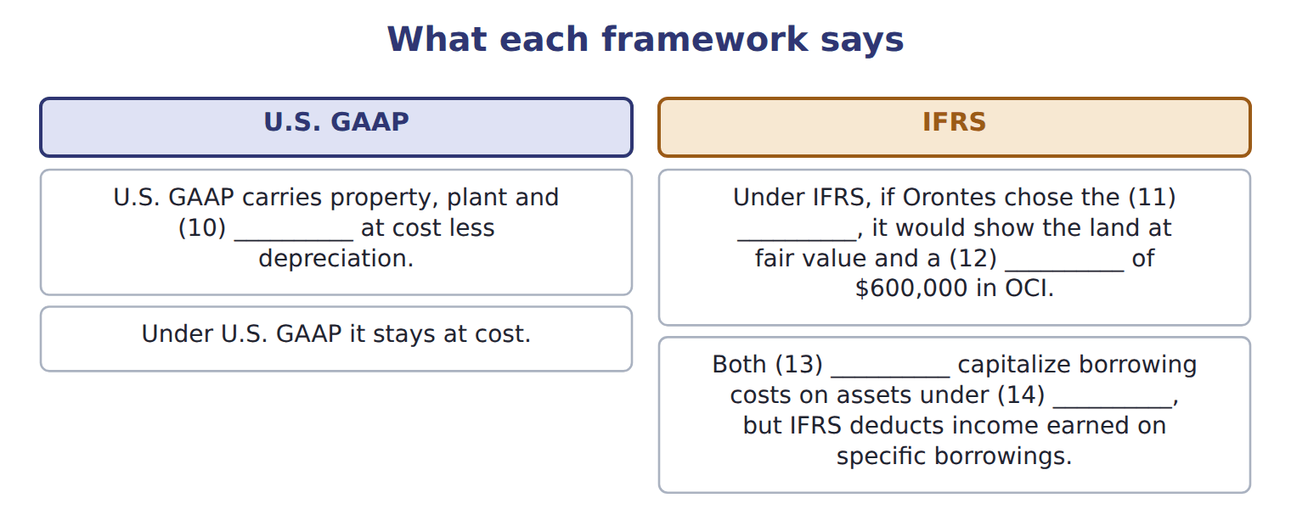
word list
equipment · frameworks · surplus · construction · revaluation model · recoverable amount

The English this section uses, and its Arabic
Each term sits against what it means.
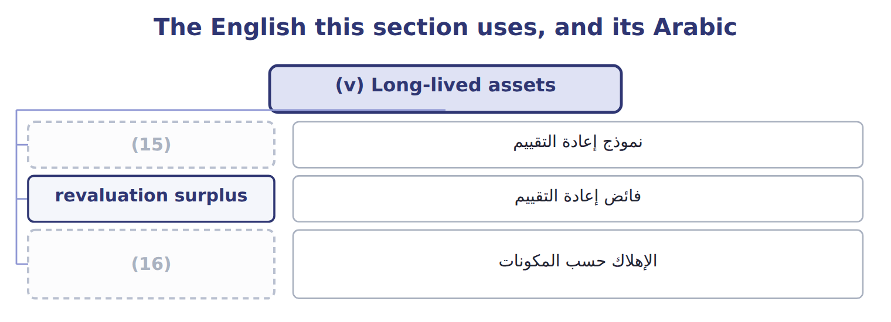
word list
recoverability test · component depreciation · revaluation model

The English this sheet uses, and its Arabic
English (exam term) | Arabic
revaluation model | نموذج إعادة التقييم
revaluation surplus | فائض إعادة التقييم
component depreciation | الإهلاك حسب المكونات

Answer key · 17.5 (v) Long-lived assets

1 Stays at 2,000,000 | 9 different
2 Allowed, not required | 10 equipment
3 At least every year | 11 revaluation model
4 Capitalized; investment income generally not offset | 12 surplus
5 carried | 13 frameworks
6 increases | 14 construction
7 Orontes's | 15 revaluation model
8 depreciation | 16 component depreciation

the summaries in full
Summary 1 IAS 16 also allows the revaluation model for a whole class of assets: the assets are carried at fair value, and increases go to a revaluation surplus in OCI. Suppose Orontes's land in Amman cost $2,000,000 and is now worth $2,600,000. IFRS requires component depreciation for significant parts with different lives; U.S. GAAP allows but does not require it.

17.6 (vi) Impairment
Chapter 17 · section 17.6

Fill every gap. Each word list holds one word more than there are gaps.
Summary 1 gaps 1–9
U.S. GAAP tests a held-and-used asset group in two steps. First, it compares the carrying amount with undiscounted (1) cash flows. Only if the carrying amount is higher does it measure a loss, equal to the carrying amount minus fair value. IAS 36 uses one step. It compares the carrying amount of an asset or (2) unit with its recoverable amount: the higher of fair value less costs of (3) and value in use, a (4) cash-flow measure. (5) there is no undiscounted (6) , IFRS losses often come (7) . The frameworks also (8) after the loss. IFRS reverses an impairment when the recoverable amount rises, but not for goodwill and not above the carrying amount (9) the loss. U.S. GAAP never reverses an impairment of a held-and-used asset or of goodwill.
word list
disposal · without · differ · screen · Because · earlier · cash-generating · measured · future · discounted

Worked example: the beverage plant

Summary 2 gaps 10–11
Undiscounted cash flows of $4,200,000 are above the carrying amount of $4,000,000: the plant is recoverable, so there is no loss. Recoverable amount is the higher of $3,500,000 and $3,700,000: $3,700,000. The carrying amount is higher, so the loss is $300,000. If the U.S. test had (10) , the loss would have been (11) against fair value: $500,000.
word list
measured · compares · failed

Which framework?

Summary 3 gaps 12–13
The first two are done. Decide (12) each of the (13) is true under U.S. GAAP only, IFRS only, or both.
word list
exposure · whether · others

Which framework? (complete the blanks)
Every item belongs to exactly one group.
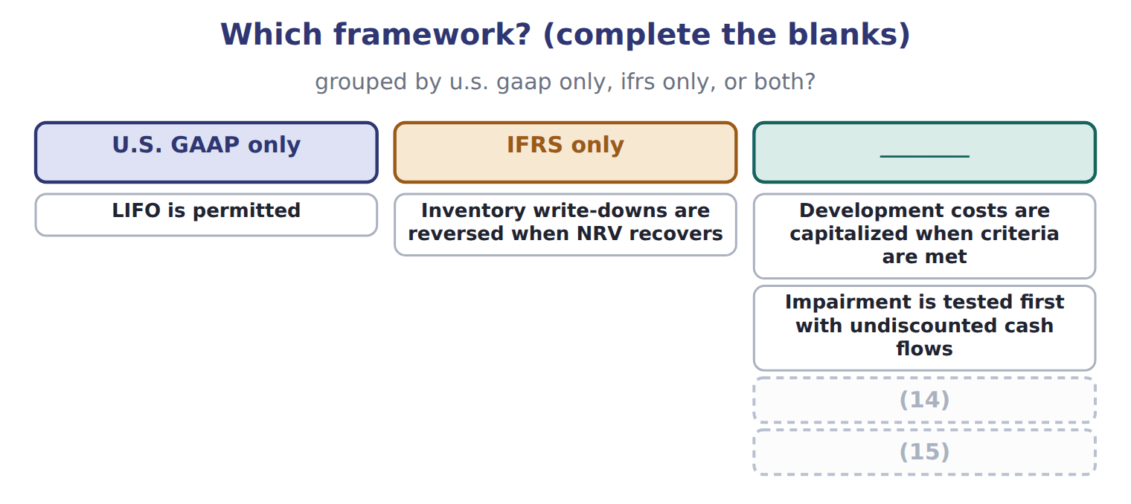
word list
A short-term lease exemption exists · Prior service cost is expensed immediately · fair value less costs of disposal

Summary 4 gaps 16–17
The IASB is still discussing changes to goodwill impairment (16) after its 2024 exposure draft. Goodwill remains (17) under both frameworks for public companies. Do not treat the proposal as a rule.
word list
carrying · disclosures · impairment-only

Suppose: Levant Distribution LLC, 2027 (USD 000) — Amount / details
Suppose: Levant Distribution LLC, 2027 (USD 000) | Amount / details
Levant's 2027 net income under IFRS (local books) | 1,114
L1 | Development costs of a new ordering app capitalized in 2027 under IAS 38: 240. None is amortized yet.
L2 | A 2026 inventory (18) was reversed in 2027 under IAS 2: gain of 30.
L3 | Warehouse land revalued upward by 400; the surplus is in OCI.
L4 | (19) : IAS 36 impairment loss of 50; carrying amount now 450. Undiscounted cash flows are higher than the carrying amount before th
L5 | Truck lease: IFRS 16 expense 78; as a U.S. operating lease, the straight-line cost would be 72.
M1 | Orontes must convert Levant's figures to U.S. GAAP before (20) (Chapter 16). Ignore tax effects.

word list
consolidation · write-down · Truck lease · Delivery fleet

Item — Answer
Every item belongs to exactly one group.
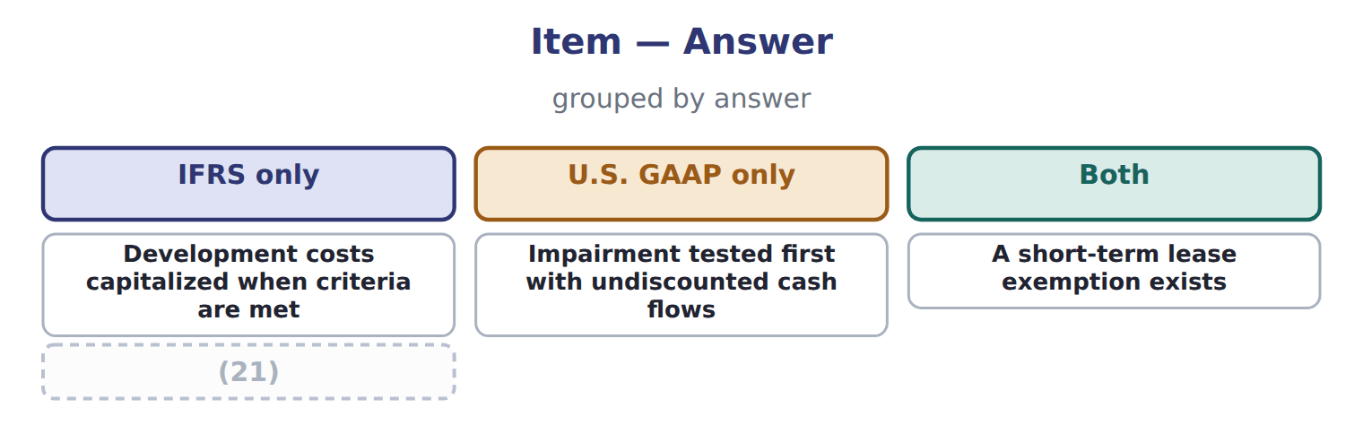
word list
A short-term lease exemption exists · Prior service cost expensed immediately

Item — Category
Every item belongs to exactly one group.
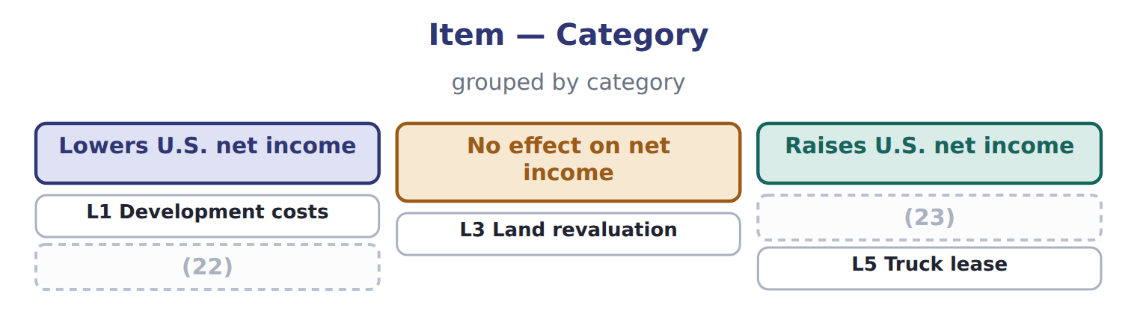
word list
L2 Write-down reversal · value in use · L4 Fleet impairment

The English this section uses, and its Arabic
Each term sits against what it means.
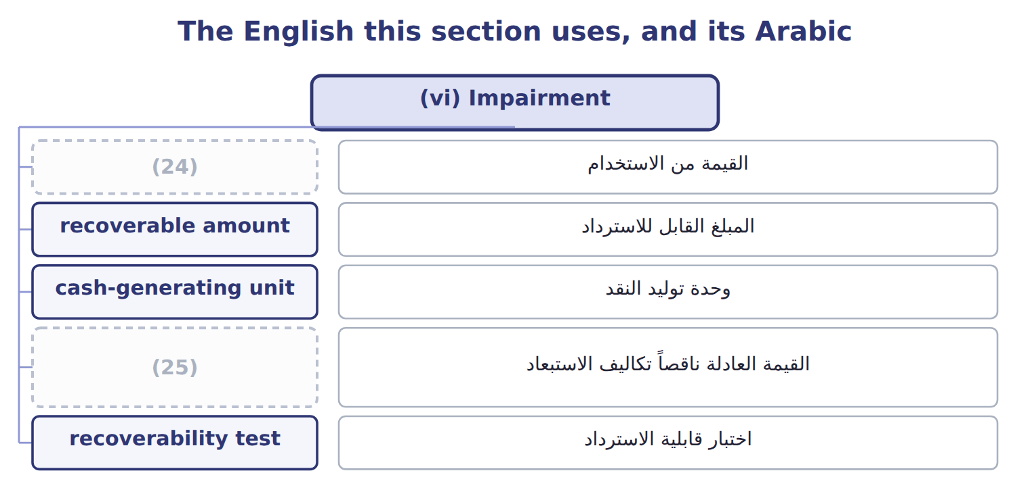
word list
fair value less costs of disposal · research and development (R&D) · value in use

The English this sheet uses, and its Arabic
English (exam term) | Arabic
value in use | القيمة من الاستخدام
recoverable amount | المبلغ القابل للاسترداد
cash-generating unit | وحدة توليد النقد
fair value less costs of disposal | القيمة العادلة ناقصاً تكاليف الاستبعاد
recoverability test | اختبار قابلية الاسترداد

Answer key · 17.6 (vi) Impairment

1 future | 14 A short-term lease exemption exists
2 cash-generating | 15 Prior service cost is expensed immediately
3 disposal | 16 disclosures
4 discounted | 17 impairment-only
5 Because | 18 write-down
6 screen | 19 Delivery fleet
7 earlier | 20 consolidation
8 differ | 21 Prior service cost expensed immediately
9 without | 22 L2 Write-down reversal
10 failed | 23 L4 Fleet impairment
11 measured | 24 value in use
12 whether | 25 fair value less costs of disposal
13 others

the summaries in full
Summary 1 U.S. GAAP tests a held-and-used asset group in two steps. First, it compares the carrying amount with undiscounted future cash flows. Only if the carrying amount is higher does it measure a loss, equal to the carrying amount minus fair value. IAS 36 uses one step. It compares the carrying amount of an asset or cash-generating unit with its recoverable amount: the higher of fair value less costs of disposal and value in use, a discounted cash-flow measure. Because there is no undiscounted screen, IFRS losses often come earlier. The frameworks also differ after the loss. IFRS reverses an impairment when the recoverable amount rises, but not for goodwill and not above the carrying amount without the loss. U.S. GAAP never reverses an impairment of a held-and-used asset or of goodwill.
Summary 2 Undiscounted cash flows of $4,200,000 are above the carrying amount of $4,000,000: the plant is recoverable, so there is no loss. Recoverable amount is the higher of $3,500,000 and $3,700,000: $3,700,000. The carrying amount is higher, so the loss is $300,000. If the U.S. test had failed, the loss would have been measured against fair value: $500,000.
Summary 3 The first two are done. Decide whether each of the others is true under U.S. GAAP only, IFRS only, or both.
Summary 4 The IASB is still discussing changes to goodwill impairment disclosures after its 2024 exposure draft. Goodwill remains impairment-only under both frameworks for public companies. Do not treat the proposal as a rule.

18.1 Integrated thinking, integrated reporting and the integrated report
Chapter 18 · section 18.1

Fill every gap. Each word list holds one word more than there are gaps.
Chapter 18, section by section
Each stage leads to the next.
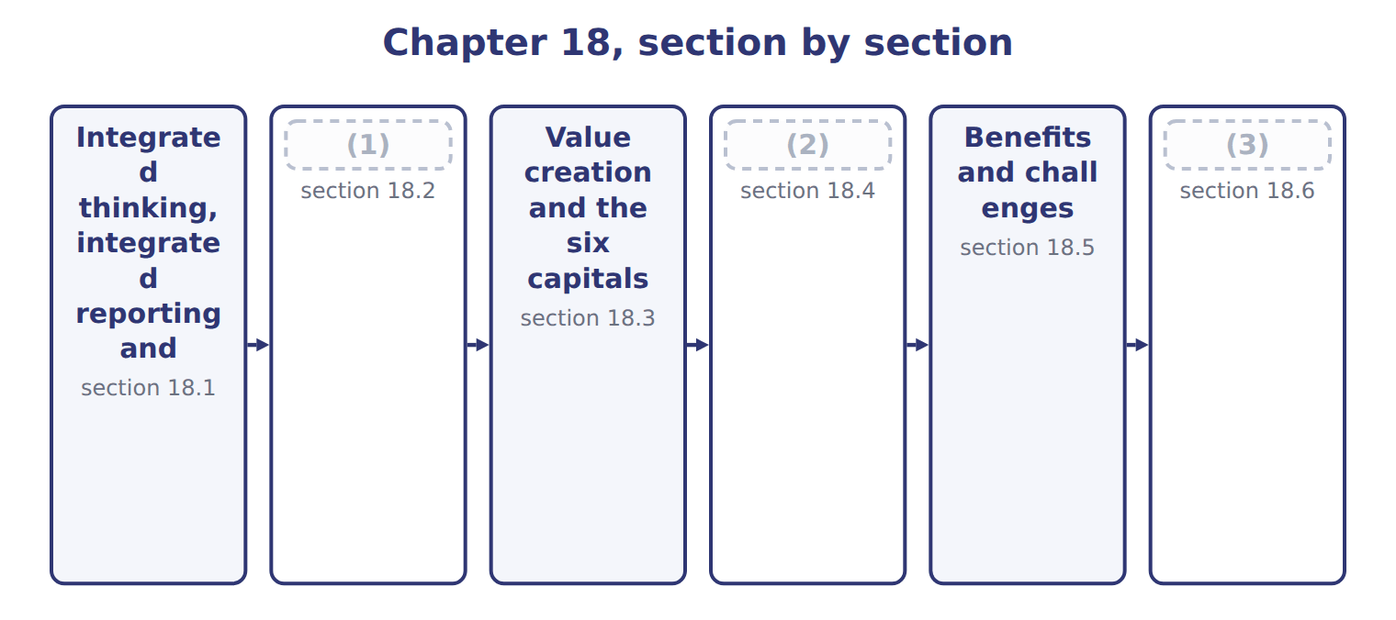
word list
Integrated reporting and sustainability disclo · value creation process · Guiding principles and content elements · The primary purpose

Summary 1 gaps 4–15
Integrated thinking is the way management considers the (4) between the company's units and the resources, or (5) , that it uses and affects. It leads to (6) that consider value creation over the short, (7) and long term. Integrated (8) is the process, founded on integrated thinking, that results in a (9) integrated report. The integrated report is the product: a concise (10) about how the company's strategy, governance, performance and prospects lead to the creation, (11) or erosion of value over time. The three ideas (12) on each other. (13) integrated thinking, a report is just a (14) of separate facts. The rules are in the (15) <IR> Framework, last revised in January 2021. The IFRS Foundation now owns it, and the IASB and the ISSB are jointly responsible for it.
word list
depend · communication · preservation · International · medium · periodic · resources · Without · capitals · reporting · decisions · relationships · collection

The English this section uses, and its Arabic
Each term sits against what it means.
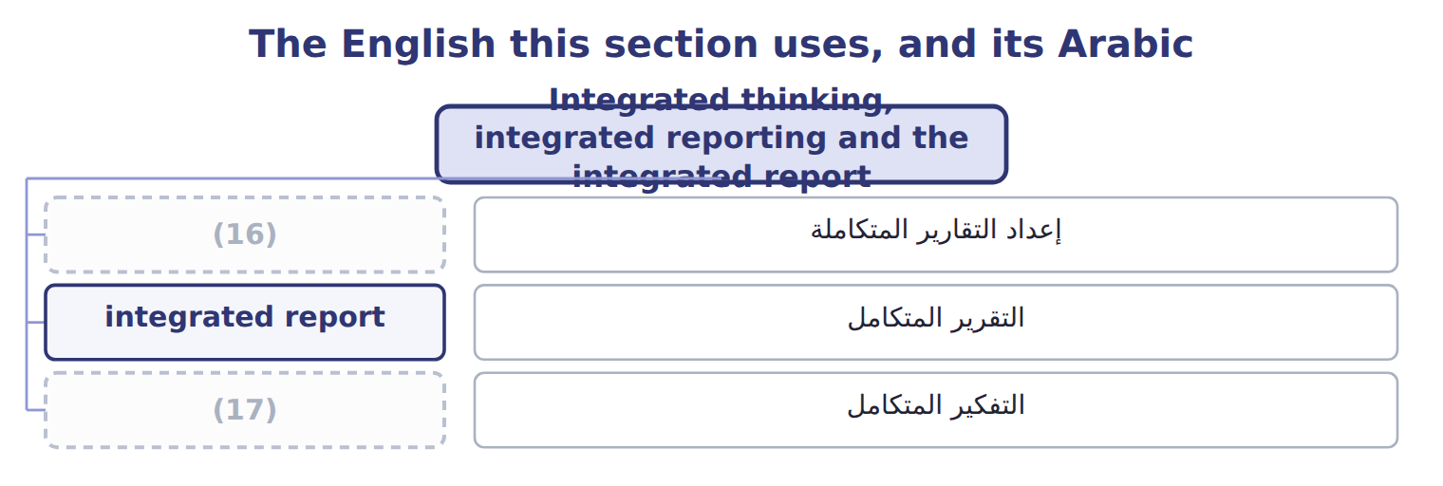
word list
integrated thinking · integrated reporting · التقرير المتكامل

The English this sheet uses, and its Arabic
English (exam term) | Arabic
integrated reporting | إعداد التقارير المتكاملة
integrated report | التقرير المتكامل
integrated thinking | التفكير المتكامل

Answer key · 18.1 Integrated thinking, integrated reporting and the integrated report

1 The primary purpose | 10 communication
2 Guiding principles and content elements | 11 preservation
3 Integrated reporting and sustainability disclo | 12 depend
4 relationships | 13 Without
5 capitals | 14 collection
6 decisions | 15 International
7 medium | 16 integrated reporting
8 reporting | 17 integrated thinking
9 periodic

the summaries in full
Summary 1 Integrated thinking is the way management considers the relationships between the company's units and the resources, or capitals, that it uses and affects. It leads to decisions that consider value creation over the short, medium and long term. Integrated reporting is the process, founded on integrated thinking, that results in a periodic integrated report. The integrated report is the product: a concise communication about how the company's strategy, governance, performance and prospects lead to the creation, preservation or erosion of value over time. The three ideas depend on each other. Without integrated thinking, a report is just a collection of separate facts. The rules are in the International <IR> Framework, last revised in January 2021. The IFRS Foundation now owns it, and the IASB and the ISSB are jointly responsible for it.

18.2 The primary purpose
Chapter 18 · section 18.2

Fill every gap. Each word list holds one word more than there are gaps.
Summary 1 gaps 1–8
The primary purpose of an integrated report is to explain to providers of financial capital, such as (1) and lenders, how the company creates, (2) or erodes value over time. This is the exam (3) to 'Who is the main audience?'. Other stakeholders also benefit: employees, customers, suppliers, (4) , regulators and (5) . They are not the primary audience, but the report is useful to anyone (6) in the company's (7) to create value. In the United States, integrated (8) is voluntary; U.S. GAAP and the SEC do not require it.
word list
reporting · interested · ability · preserves · shareholders · communities · answer · require · policymakers

Integrated reports and other reports
Report | Primary audience | Focus | Required for Orontes?
Financial statements (U.S. GAAP) | (9) | Financial position and performance | Yes: required for an SEC registrant
Management's discussion and analysis (MD&A) | Investors | Explains results, liquidity and risks | (10)
Integrated report (<IR> Framework) | Providers of financial capital, then other stakeholders | How value is created, preserved or eroded, using all six capitals | (11)
Sustainability disclosures (IFRS S1 and S2) | Investors | (12) | Only where a jurisdiction adopts them

word list
No: voluntary · Yes: SEC requirement · integrated reporting · Sustainability and climate risks that affect prospects · Investors and creditors

Audience trap

Summary 2 gaps 13–14
The (13) audience is (14) of financial capital, not 'all stakeholders'. All stakeholders benefit, but the Framework names investors and lenders first.
word list
providers · shareholders · primary

The English this section uses, and its Arabic
Each term sits against what it means.
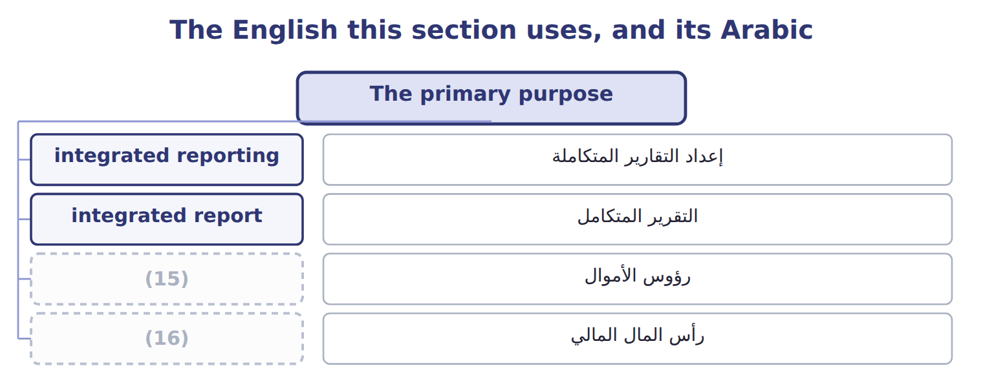
word list
financial capital · capitals · integrated thinking

Answer key · 18.2 The primary purpose

1 shareholders | 9 Investors and creditors
2 preserves | 10 Yes: SEC requirement
3 answer | 11 No: voluntary
4 communities | 12 Sustainability and climate risks that affect prospects
5 policymakers | 13 primary
6 interested | 14 providers
7 ability | 15 capitals
8 reporting | 16 financial capital

the summaries in full
Summary 1 The primary purpose of an integrated report is to explain to providers of financial capital, such as shareholders and lenders, how the company creates, preserves or erodes value over time. This is the exam answer to 'Who is the main audience?'. Other stakeholders also benefit: employees, customers, suppliers, communities, regulators and policymakers. They are not the primary audience, but the report is useful to anyone interested in the company's ability to create value. In the United States, integrated reporting is voluntary; U.S. GAAP and the SEC do not require it.
Summary 2 The primary audience is providers of financial capital, not 'all stakeholders'. All stakeholders benefit, but the Framework names investors and lenders first.

18.3 Value creation and the six capitals
Chapter 18 · section 18.3

Fill every gap. Each word list holds one word more than there are gaps.
Summary 1 gaps 1–3
The (1) describes value in terms of six capitals: (2) of value that (3) , decrease or change as the company works. They are financial capital, manufactured capital, intellectual capital, human capital, social and relationship capital and natural capital.
word list
stocks · resources · Framework · increase

Suppose: Orontes's six capitals, 2027
Capital | Orontes examples (2027) | Possible measure
Financial | (4) | Cash flow from operations
Manufactured | (5) | Plant capacity
Intellectual | Recipes, brand, new sparkling-juice line | (6)
Human | 1,850 employees | (7)
Social and relationship | 2,400 farmers in grower (8) ; supermarket customers | Farmer contracts renewed
Natural | Olive groves, water, energy | (9)

word list
Equity and bank loans (Part I) · Share of sales from new products · Presses, bottling lines, cold stores · Water 900,000 m3; renewable electricity 30% · cooperatives · 20 training hours per employee · Olive groves, water, energy

Summary 2 gaps 10–15
In the value creation process, the business model takes capitals as inputs and turns them, through its activities, into (10) : products, (11) and waste. The (12) are the effects on the capitals, inside and (13) the company. Capitals are (14) , so decisions involve (15) . The six categories are not mandatory; a company may group them differently, but it should consider all the capitals it uses or affects.
word list
trade-offs · by-products · outputs · financial · outside · outcomes · connected

Worked example: the irrigation trade-off

Summary 3 gaps 16–20
Suppose Orontes (16) $2,000,000 on drip (17) for its groves: financial capital falls and manufactured capital rises. Water use falls by 150,000 m3, about 17% of the total: natural capital is (18) . Orontes trains 400 (19) farmers to use the (20) : human and social and relationship capital rise. An integrated report explains the whole trade-off, not only the cost.
word list
cooperative · irrigation · decisions · spends · preserved · system

Which capital?

The first two are done. Name the capital for each of the others.
Which capital? (complete the blanks)
The rows are a set, not a sequence.
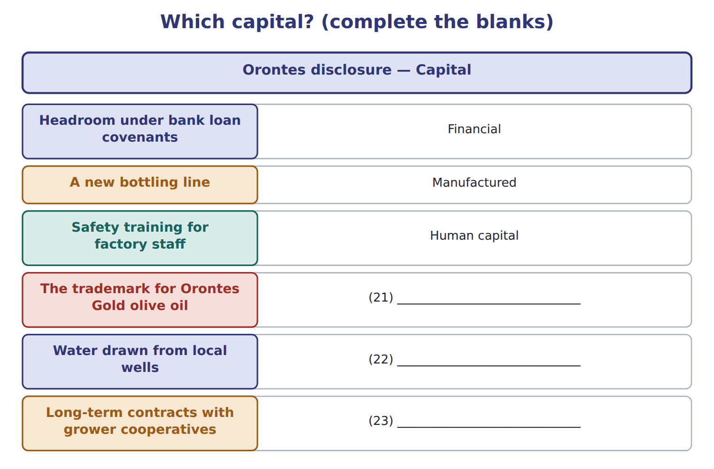
word list
Intellectual capital · Natural capital · guiding principles · Social and relationship capital

Capitals, capitaux

In integrated reporting, capitals are resources and relationships, not share capital. Read the whole phrase.

The English this section uses, and its Arabic
Each term sits against what it means.
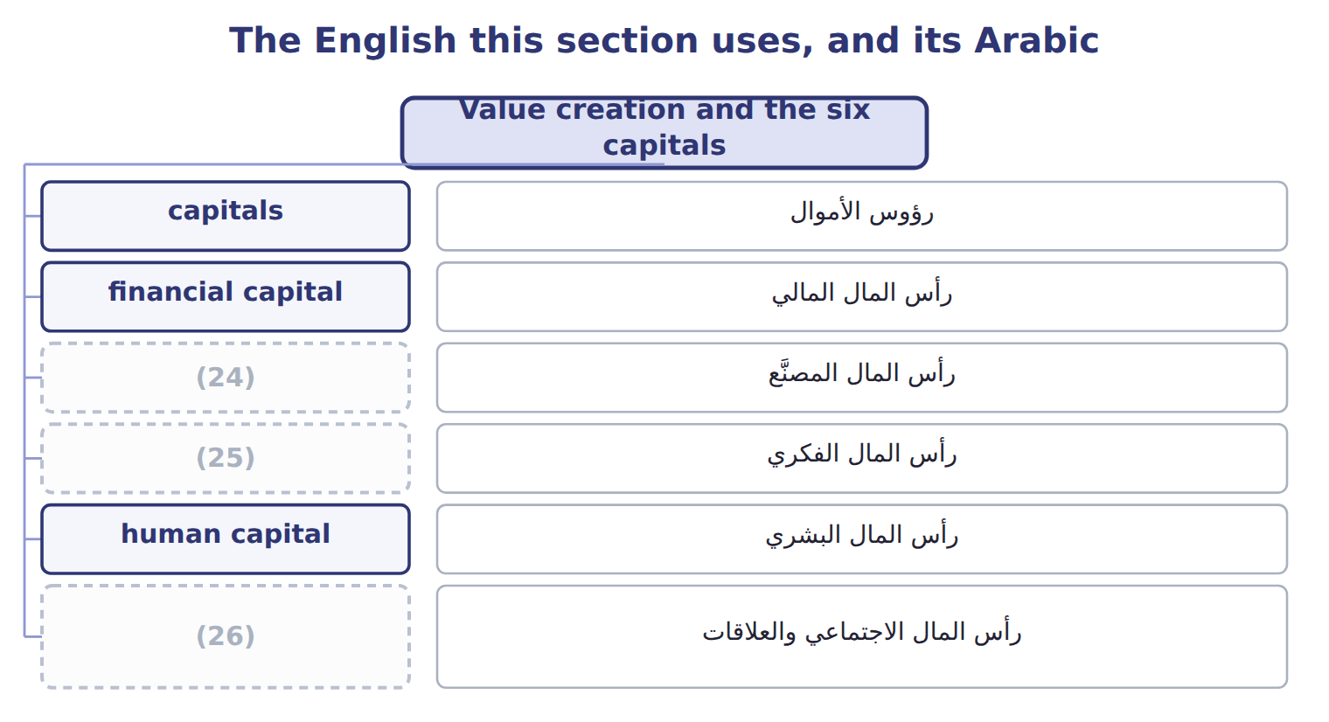
word list
manufactured capital · intellectual capital · social and relationship capital · financial capital

The English this sheet uses, and its Arabic
English (exam term) | Arabic
capitals | رؤوس الأموال
financial capital | رأس المال المالي
manufactured capital | رأس المال المصنَّع
intellectual capital | رأس المال الفكري
human capital | رأس المال البشري
social and relationship capital | رأس المال الاجتماعي والعلاقات
natural capital | رأس المال الطبيعي
value creation process | عملية خلق القيمة
outputs | المخرجات
outcomes | النتائج (الآثار)

Answer key · 18.3 Value creation and the six capitals

1 Framework | 14 connected
2 stocks | 15 trade-offs
3 increase | 16 spends
4 Equity and bank loans (Part I) | 17 irrigation
5 Presses, bottling lines, cold stores | 18 preserved
6 Share of sales from new products | 19 cooperative
7 20 training hours per employee | 20 system
8 cooperatives | 21 Intellectual capital
9 Water 900,000 m3; renewable electricity 30% | 22 Natural capital
10 outputs | 23 Social and relationship capital
11 by-products | 24 manufactured capital
12 outcomes | 25 intellectual capital
13 outside | 26 social and relationship capital

the summaries in full
Summary 1 The Framework describes value in terms of six capitals: stocks of value that increase, decrease or change as the company works. They are financial capital, manufactured capital, intellectual capital, human capital, social and relationship capital and natural capital.
Summary 2 In the value creation process, the business model takes capitals as inputs and turns them, through its activities, into outputs: products, by-products and waste. The outcomes are the effects on the capitals, inside and outside the company. Capitals are connected, so decisions involve trade-offs. The six categories are not mandatory; a company may group them differently, but it should consider all the capitals it uses or affects.
Summary 3 Suppose Orontes spends $2,000,000 on drip irrigation for its groves: financial capital falls and manufactured capital rises. Water use falls by 150,000 m3, about 17% of the total: natural capital is preserved. Orontes trains 400 cooperative farmers to use the system: human and social and relationship capital rise. An integrated report explains the whole trade-off, not only the cost.

18.4 Guiding principles and content elements
Chapter 18 · section 18.4

Fill every gap. Each word list holds one word more than there are gaps.
Summary 1 gaps 1–2
The Framework is (1) : it does not prescribe KPIs or measurement methods. Seven guiding principles shape how the report is prepared, such as connectivity of (2) , materiality and conciseness.
word list
element · principles-based · information

Summary 2 gaps 3–8
Eight content elements set what the report (3) . Each element answers a question: what the company does, how its governance works, how its business model (4) value, which risks and opportunities it faces, where its strategy is going, how it (5) , what lies ahead, and how the report was prepared. The elements are linked, not (6) chapters. For example, (7) water risk (8) under risks and opportunities, drives its strategy, and is measured under performance.
word list
separate · Orontes's · covers · appears · integrated · performed · creates

The eight content elements
Content element (8) | Question it answers | Orontes example
Organizational overview and external environment | (9) | Food producer based in Amman, Jordan, selling across the region
Governance | How does governance support value creation? | (10)
Business model | How does the company turn capitals into value? | (11)
Risks and opportunities | (12) | Water scarcity; demand for healthy drinks
Strategy and resource allocation | (13) | Invest in irrigation and new products
Performance | What did it achieve, and with what effects on the capitals? | (14)
Outlook | What challenges and uncertainties lie ahead? | Olive yields and prices to 2030
Basis of preparation and presentation | (15) | Materiality process; measurement methods

word list
Grow, press, bottle, sell · What could help or harm value creation? · How does governance support value creation? · What does the company do, and where? · Where is it going, and how will it get there? · How were matters chosen and measured? · Renewable electricity 30% · Board committee oversees water risk

Summary 3 gaps 16–18
Those charged with governance, such as the board, should include a (16) that they are (17) for the integrated report. The report can stand alone or be a (18) part of another report, such as the annual report.
word list
statement · elements · distinguishable · responsible

Seven or eight?

Summary 4 gaps 19–20
There are seven (19) principles (how to report) and eight content elements (what to report). Materiality and (20) are principles; governance, business model and outlook are content elements.
word list
guiding · outlook · connectivity

The words this section uses
Each term sits against what it means, and an instance of it.
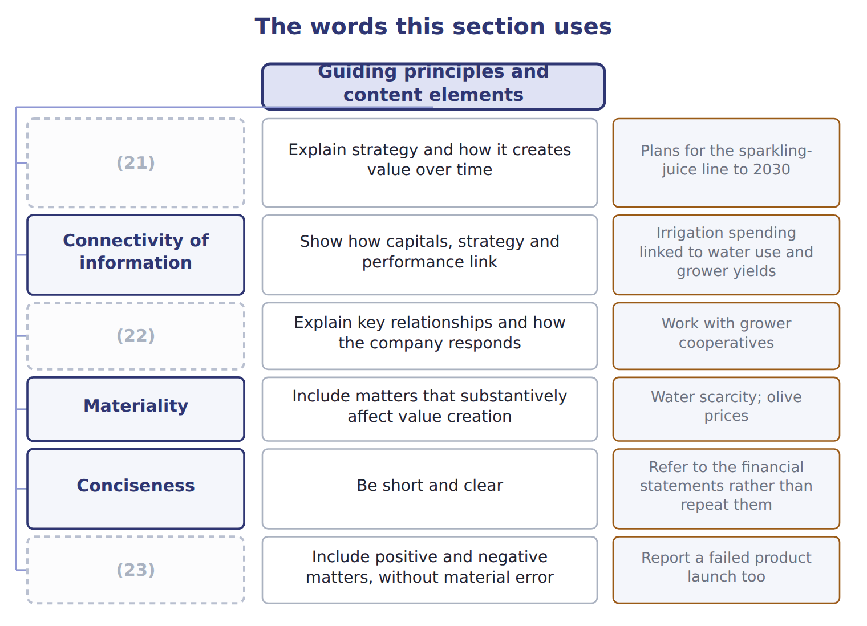
word list
Strategic focus and future orientation · Reliability and completeness · integrated reporting · Stakeholder relationships

The English this sheet uses, and its Arabic
English (exam term) | Arabic
guiding principles | المبادئ التوجيهية
content elements | عناصر المحتوى

Answer key · 18.4 Guiding principles and content elements

1 principles-based | 13 Where is it going, and how will it get there?
2 information | 14 Renewable electricity 30%
3 covers | 15 How were matters chosen and measured?
4 creates | 16 statement
5 performed | 17 responsible
6 separate | 18 distinguishable
7 Orontes's | 19 guiding
8 appears | 20 connectivity
9 What does the company do, and where? | 21 Strategic focus and future orientation
10 Board committee oversees water risk | 22 Stakeholder relationships
11 Grow, press, bottle, sell | 23 Reliability and completeness
12 What could help or harm value creation?

the summaries in full
Summary 1 The Framework is principles-based: it does not prescribe KPIs or measurement methods. Seven guiding principles shape how the report is prepared, such as connectivity of information, materiality and conciseness.
Summary 2 Eight content elements set what the report covers. Each element answers a question: what the company does, how its governance works, how its business model creates value, which risks and opportunities it faces, where its strategy is going, how it performed, what lies ahead, and how the report was prepared. The elements are linked, not separate chapters. For example, Orontes's water risk appears under risks and opportunities, drives its strategy, and is measured under performance.
Summary 3 Those charged with governance, such as the board, should include a statement that they are responsible for the integrated report. The report can stand alone or be a distinguishable part of another report, such as the annual report.
Summary 4 There are seven guiding principles (how to report) and eight content elements (what to report). Materiality and connectivity are principles; governance, business model and outlook are content elements.

18.5 Benefits and challenges
Chapter 18 · section 18.5

Fill every gap. Each word list holds one word more than there are gaps.
Benefits against Challenges
The two columns are not matched row by row.
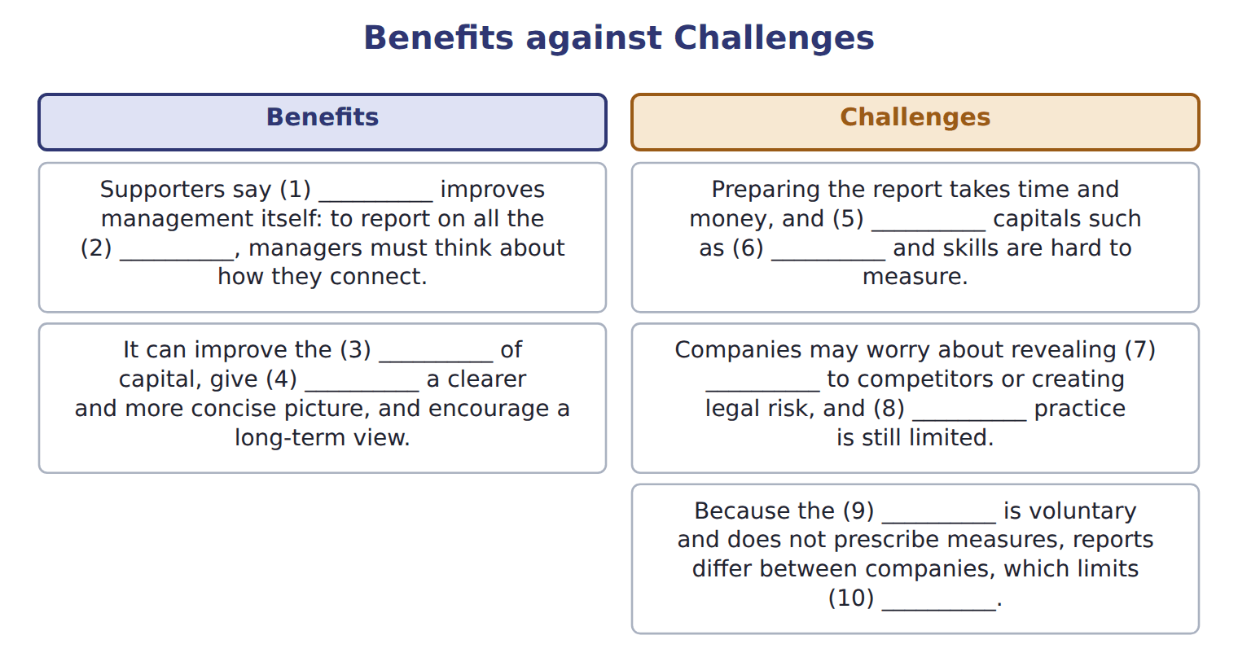
word list
allocation · assurance · information · capitals · non-financial · Framework · integrated reporting · comparability · relationships · investors · guiding principles

Answer key · 18.5 Benefits and challenges

1 integrated reporting | 6 relationships
2 capitals | 7 information
3 allocation | 8 assurance
4 investors | 9 Framework
5 non-financial | 10 comparability

the summaries in full

18.6 Integrated reporting and sustainability disclosures
Chapter 18 · section 18.6

Fill every gap. Each word list holds one word more than there are gaps.
Summary 1 gaps 1–12
IFRS S1 and IFRS S2, issued by the ISSB, require disclosure of (1) and climate risks that affect a (2) prospects. They apply only where a (3) adopts them. S1 asks for connected (4) , an idea taken from integrated (5) , but S1 and S2 disclosures are not an integrated report. In 2024 the ISSB decided not to start a separate (6) project, and the boards continue to support the <IR> (7) . The IASB's revised (8) Statement on (9) commentary, issued in June 2025, also draws on integrated-reporting concepts. It is (10) , and it is not in the LOS. The SEC's 2024 climate disclosure rule never took (11) ; it is stayed, and the SEC (12) to rescind it in 2026. Some MENA markets now require ISSB-based disclosures, for example Qatar from 2026 and the largest Amman Stock Exchange companies from 2026. These are background facts, not exam content.
word list
integration · Practice · proposed · separate · information · Framework · effect · reporting · voluntary · jurisdiction · company's · management · sustainability

Item — Barada Wholesale: draft first integrated report,
Item | Barada Wholesale: draft first integrated report,
D1 | Barada trained all delivery drivers in safe driving.
D2 | Barada used 600 MWh of electricity in 2028; 150 MWh came from its own solar panels.
D3 | Barada signed five-year partnerships with 60 small farmers.
D4 | Staff turnover in the warehouse fell from 25% to 15%.
D5 | (13)
D6 | Rising fuel prices could cut (14) delivery margins in 2029 and 2030.
M1 | The draft says: 'This report is written mainly for our employees and the local community.'
M2 | The draft links each (15) goal to the KPI and the capital it affects.

word list
manufactured capital · Packaging waste sent to landfill fell by one third. · Barada's · strategic

Disclosure — Category
Disclosure | Category
D1 Driver training | Human capital
D2 Electricity and solar | (16)
D3 Farmer partnerships | (17)
D4 Warehouse staff turnover | (18)
D5 Packaging waste | Natural capital

word list
Social and relationship capital · Natural capital · manufactured capital · Human capital

The English this section uses, and its Arabic
Each term sits against what it means.
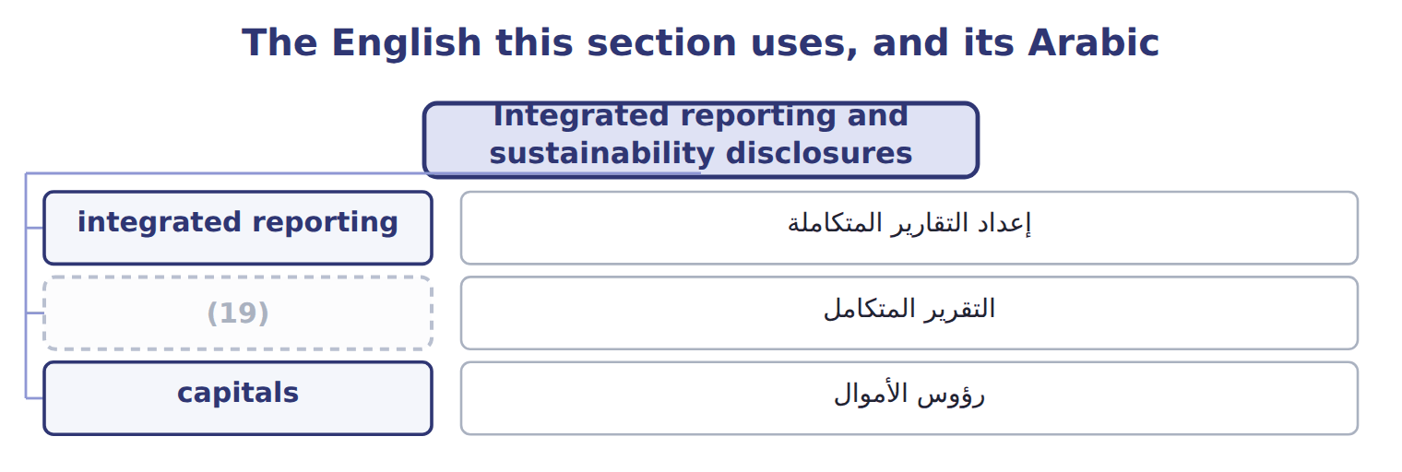
word list
رؤوس الأموال · integrated report

Answer key · 18.6 Integrated reporting and sustainability disclosures

1 sustainability | 11 effect
2 company's | 12 proposed
3 jurisdiction | 13 Packaging waste sent to landfill fell by one third.
4 information | 14 Barada's
5 reporting | 15 strategic
6 integration | 16 Natural capital
7 Framework | 17 Social and relationship capital
8 Practice | 18 Human capital
9 management | 19 integrated report
10 voluntary

the summaries in full
Summary 1 IFRS S1 and IFRS S2, issued by the ISSB, require disclosure of sustainability and climate risks that affect a company's prospects. They apply only where a jurisdiction adopts them. S1 asks for connected information, an idea taken from integrated reporting, but S1 and S2 disclosures are not an integrated report. In 2024 the ISSB decided not to start a separate integration project, and the boards continue to support the <IR> Framework. The IASB's revised Practice Statement on management commentary, issued in June 2025, also draws on integrated-reporting concepts. It is voluntary, and it is not in the LOS. The SEC's 2024 climate disclosure rule never took effect; it is stayed, and the SEC proposed to rescind it in 2026. Some MENA markets now require ISSB-based disclosures, for example Qatar from 2026 and the largest Amman Stock Exchange companies from 2026. These are background facts, not exam content.

