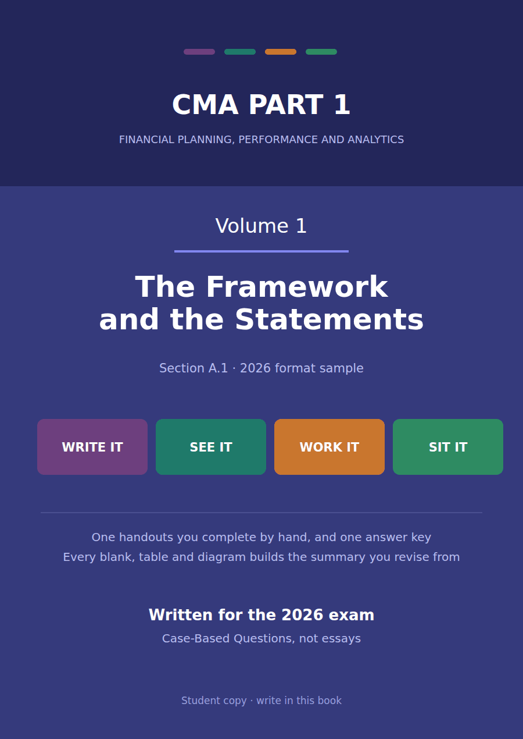

CMA Part 1 · Volume 1
The Framework and the Statements
One handout, rebuilt. The case is given in English and in full Arabic, every calculation table carries a worked row, and the blanks ask for meanings rather than for figures.
These handouts are not notes to read. You write them. The words you supply are the summary, so a finished handout is a page you can revise from, in your own handwriting.
Work in pen. Do not look at the key until the whole handout is done — the key is written to explain the mistake, and you only get that benefit if you have made it first.
The one handouts
# | Handout | What it gives you
1 | Who Reads These Statements, and What They Need | Four statements exist because four different questions are asked of a company. Name the question and the statement chooses itself.

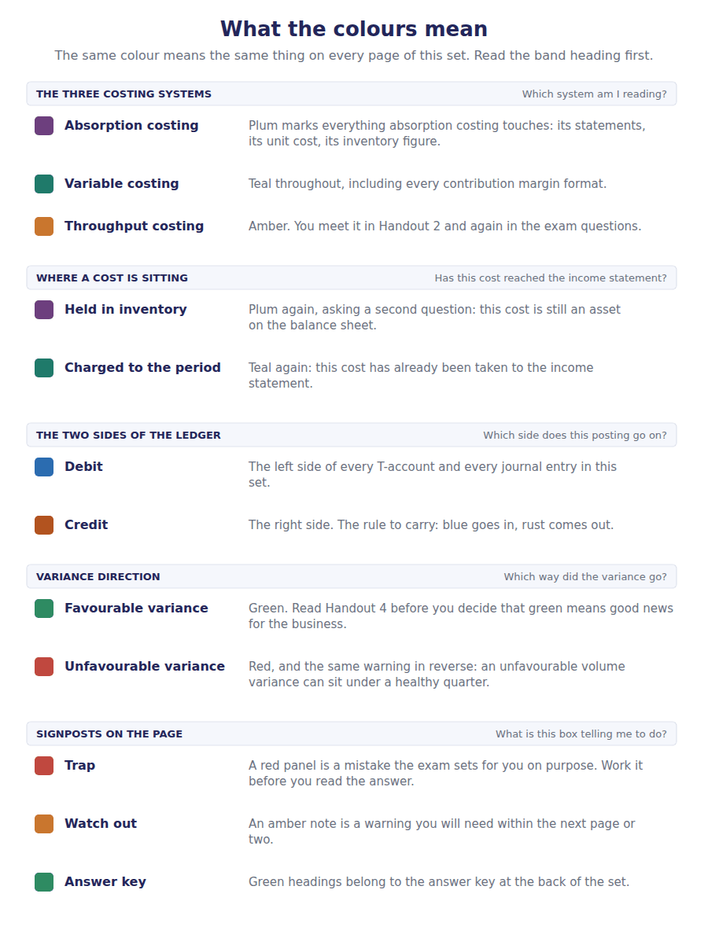
How to read the markers
Marker | Meaning
R1 | Teaching English. Short sentences. This is where a new idea arrives.
R2 | Textbook English. Longer sentences and passive verbs, as a textbook writes them.
R3 | Exam English. Exactly how the CMA exam phrases it, traps included.
Numbered rule | A space you fill in. The number matches the answer key.
Red table | A trap. Read it twice.

Handout 1 · Who Reads These Statements, and What They Need
Four statements exist because four different questions are asked of a company. Name the question and the statement chooses itself.
Volume 1 · The Framework and the Statements · R1 moving to R2
LANGUAGE FOCUS
Register you are working in | R1 while the readers are being named, R2 once the statements are being chosen.
Say it exactly like this | prepare general purpose financial statements · meet the needs of a primary user · assess the prospects for future cash flows · report financial position at a date · report financial performance over a period · hold management to account for the resources entrusted to it
Words that are not the same | financial position / financial performance · a date / a period · primary user / other user · balance sheet / income statement
Remember | General purpose does not mean general interest. It means one report serving users who cannot demand one of their own. The statements do not report what a company is worth. They report what it owns and owes, measured under rules.

The company you will work in for six volumes
Northwind Components, Inc. imports electronic components and sells them to equipment makers. It has one warehouse near the port, two sales offices and a small assembly line.
Its shares are held by about forty investors, none of whom works in the business. Its bank has lent it money repayable over several years, and its suppliers sell to it on credit.
None of those people can walk into the accounts department and ask for a report in the shape they would like. They get one set of statements, prepared the same way for all of them.
The year just ended is 20X4 and the year before it is 20X3. Both are presented, because a reader given one year alone cannot see whether anything is getting better or worse.
In this handout you calculate nothing. You work out who is asking, and which statement answers them.
الحالة بالعربية
شركة نورثويند للمكونات تستورد المكونات الإلكترونية وتبيعها لمصنّعي المعدات. لديها مستودع واحد قرب الميناء، ومكتبان للمبيعات، وخط تجميع صغير.
يملك أسهمها نحو أربعين مستثمراً، لا يعمل أي منهم داخل الشركة. وقد أقرضها المصرف مبلغاً يُسدَّد على عدة سنوات، ويبيع لها مورّدوها بالأجل.
لا يستطيع أي من هؤلاء أن يدخل قسم المحاسبة ويطلب تقريراً بالشكل الذي يناسبه. جميعهم يحصلون على مجموعة واحدة من القوائم، تُعدّ بالطريقة نفسها للجميع.
السنة المنتهية هي 20X4 والسنة التي سبقتها هي 20X3. وتُعرض السنتان معاً، لأن القارئ الذي يرى سنة واحدة فقط لا يستطيع أن يعرف ما إذا كان شيء ما يتحسن أم يسوء.
في هذه الورقة لن تُجري أي حساب. ستحدد مَن هو السائل، وأي قائمة تجيب عليه.

Part 1 · Who is asking? and who is not
Exercise 1A Read and complete. Write one word in each space.
WORD BANK
design · flows · general · primary · profits · public · secondary
Not every word is used.

R1 A company could in principle write a different report for every reader. Its bank could ask for one shape, its shareholders for another. Most readers, however, have no power to demand anything, so one report is prepared for all of them. The framework calls it general purpose financial reporting, and the word that does the work there is ¹ .
The framework names the readers it is written for. They are existing and potential investors, lenders and other creditors, and the framework calls them the ² users.
Employees, customers and regulators all read the statements too, and the report is not addressed to them. The test is whether the reader can require the company to produce a report of their own ³ .
What those readers want is the same thing in three forms: some basis for judging the amount, the timing and the certainty of the company’s future cash ⁴ .
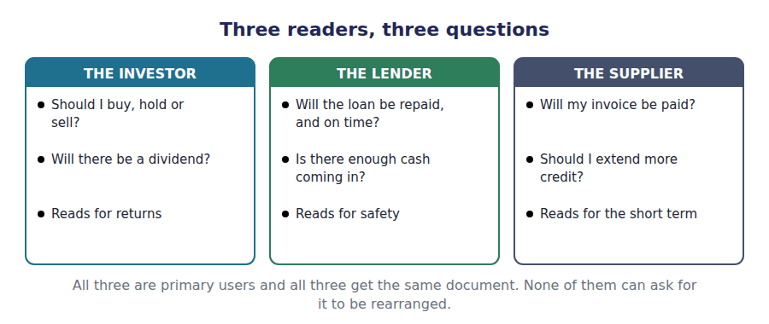
Exercise 1B Match each reader to the decision they are trying to make. Write one letter in each space.
First move: Ask what each reader stands to lose, and the decision follows.
 | Item | Answer |  | Option
1 | An investor holding shares |  | A | Whether to buy more shares, hold, or sell
2 | A bank with a five-year loan outstanding |  | B | Whether the interest and principal will be paid when due
3 | A supplier selling on 30-day credit |  | C | Whether to keep extending credit, and on what terms
4 | The management of the company |  | D | How to run the business, using information no outsider has
5 | A government tax authority |  | E | Not a primary user: it can demand its own return
Four of the five read what they are given. The fifth writes its own rules and asks for its own forms, which is exactly why it is not a primary user.

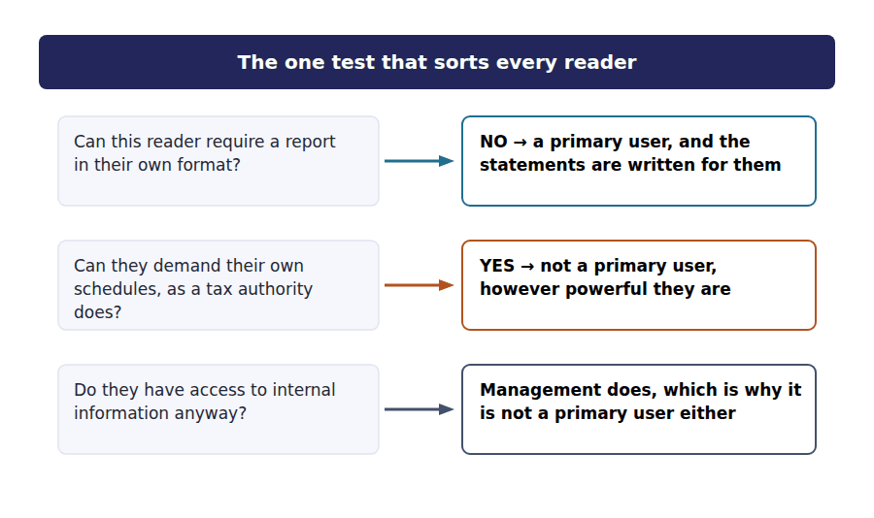
Part 2 · Four statements, four questions and the figure each one holds
Exercise 1C Read and complete. Write one word in each space.
WORD BANK
date · moment · period · sheet · stake · statement · year
Not every word is used.

R1 Each statement answers one question. The income statement asks what was earned and what was spent, and it covers a span of time called a ⁵ .
The balance sheet asks what the company owns and owes, and it can only be answered at one moment. It is drawn up at a single ⁶ .
The statement of cash flows asks where the cash came from and where it went, which is again a question about a span. The statement of changes in equity asks what happened to the owners’ ⁷ .
Two of the four are therefore period statements and two describe something else. The one that describes a single moment is the balance ⁸ .
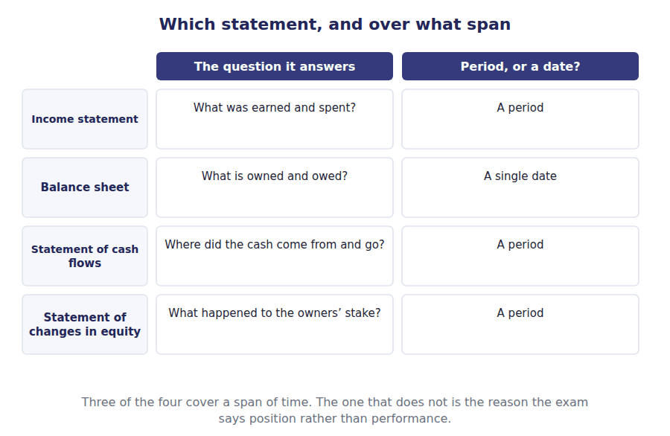
Exercise 1D Name the statement that answers each question, then find Northwind’s figure for it. The first row is done for you.
First move: Work along the row: the question decides the statement, and the statement decides where to look.
The question a reader asks | Which statement answers it | Northwind’s figure for 20X4
How much did the company sell this year? | Income statement | $4,800,000
What profit was left after every expense?
What does the company own and owe at the year end?
How much cash did the trading operations generate?
How much was paid out to the shareholders?
How much cash was actually in the bank at the year end?
Row 1 is worked. Five rows to go, and every figure is in the statements at the back of this volume.

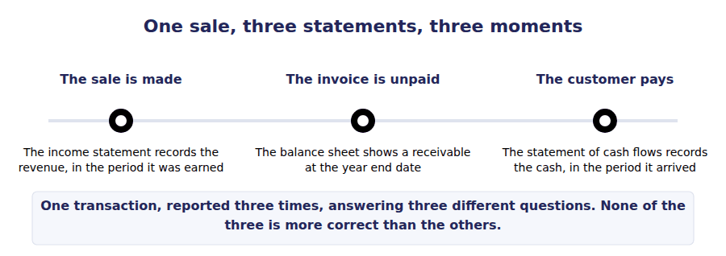
Part 3 · A span of time, or one moment? the distinction the exam leans on
Exercise 1E Decide whether each figure describes a span of time or a single moment, and say how you can tell. The first row is done for you.
Northwind’s figure | A span of time, or one moment? | How you can tell
Sales of $4,800,000 | A span: the year to 31 December 20X4 | It accumulated day by day over twelve months
Total assets of $4,990,000
Net income of $510,000
Cash of $420,000
The third column is the one that matters. A figure that accumulates is a period figure; a figure that could be counted in an afternoon is a date figure.

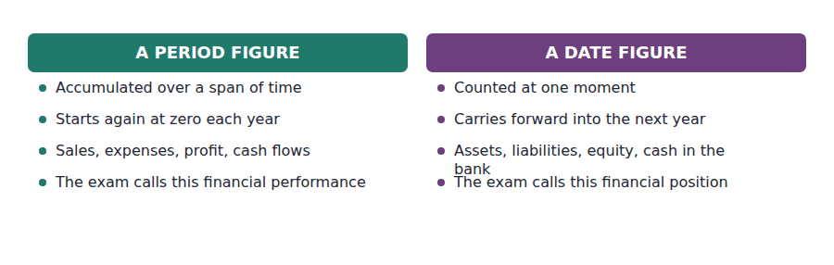
Part 4 · Why not one statement each? the limits of a general purpose report
Exercise 1F Read and complete. Write one word in each space.
WORD BANK
common · comparability · estimate · particular · relevance · stewardship · trend
Not every word is used.

R2 A report written for the bank would emphasise cash and security. One written for an investor would emphasise growth. A single report cannot do both perfectly, so it is designed to meet the needs most readers have in ⁹ rather than to satisfy any one of them fully.
That is a real cost and the framework accepts it openly. What a general purpose report buys in exchange is that every reader is looking at the same document, so one company can be set beside another. The framework calls that quality ¹⁰ .
It is also why two years are always presented. A single year tells a reader a level and nothing about direction, and direction is what a ¹¹ shows.
And it is why the statements do a second job beyond helping anyone decide anything. They let the providers of capital judge how well management has used what was entrusted to it, which the framework calls ¹² .
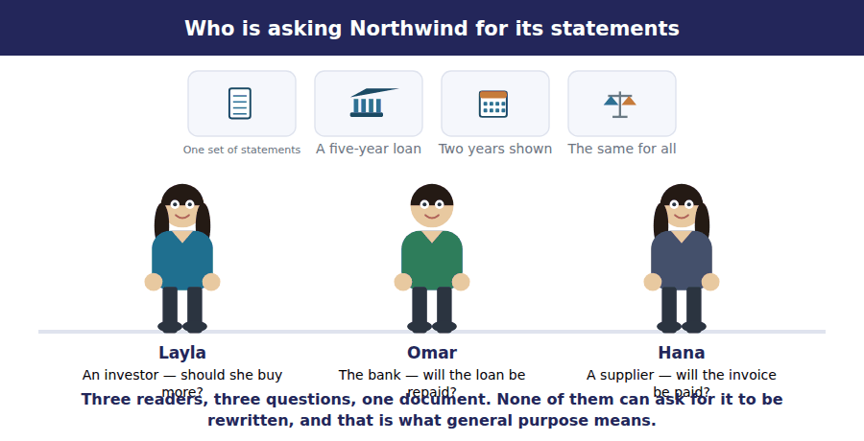
Watch out! The statements are prepared under rules and they use estimates. They do not report what a company is worth, and they never claim to. A question that asks for the value of a company is not asking about the balance sheet.
Part 5 · Exam pitch the questions as the CMA sets them
1. [Level A] The primary users of general purpose financial reports are:
(A) Employees, customers and regulators
(B) Existing and potential investors, lenders and other creditors
(C) Management and the board of directors
(D) Any party with an interest in the company
2. [Level A] A reader wants to know whether Northwind generated enough cash from trading to repay a loan. The statement that answers this is the:
(A) Income statement
(B) Statement of cash flows
(C) Balance sheet
(D) Statement of changes in equity
3. [Level A] The phrase financial position refers to:
(A) Performance over the reporting period
(B) What a company owns and owes at a single date
(C) The cash generated during the year
(D) The market value of the company
4. [Level B] Northwind reports net income of $510,000 and holds $420,000 of cash. The difference arises because:
(A) One of the two figures is wrong
(B) Profit is measured on the accrual basis and cash is not
(C) The cash was paid out as dividends
(D) The two figures measure the same thing at different dates
5. [Level B] The stewardship objective of financial reporting concerns:
(A) Forecasting future profits
(B) How efficiently management has used the resources entrusted to it
(C) Compliance with tax law
(D) The valuation of the company’s shares
6. [Level C] Two companies in the same industry use different but acceptable accounting methods. This primarily affects:
(A) Relevance
(B) Comparability
(C) Faithful representation
(D) Timeliness
7. [Level C] Why can a general purpose report not be tailored to one user?
(A) Because the standards forbid additional disclosure
(B) Because it serves users who cannot demand their own report, so it meets needs they have in common
(C) Because preparing more than one report is illegal
(D) Because all users want exactly the same information
ADAPTIVE TIP When a question names a reader, ask one thing first: can this reader demand a report in their own format? If yes, they are not a primary user and the question is usually testing that alone.

Answer Key
Volume 1 · Handouts 1 to 1
Every answer carries the reason for it and the mistake it defeats.

Handout 1 · Who Reads These Statements, and What They Need answers
Completed text and exercises
# | Answer | Why | The trap it defeats
1 | general | One report, for readers who cannot ask for their own.
2 | primary | The framework’s own word for the named readers.
3 | design | Power to demand a format is the whole test. | Students sort readers by how important they seem. The question is whether they can command a report.
4 | flows | Amount, timing and certainty — of what?
Match 1 | 1-A 2-B 3-C 4-D 5-E | Four of the five read what they are given. The fifth writes its own rules and asks for its own forms, which is exactly why it is not a primary user.
5 | period | A span of time, not a moment.
6 | date | One moment, and the statement is dated.
7 | stake | What the owners have in the company.
8 | sheet | Only one of the four is drawn at a date. | Students treat all four as annual reports. Only three cover a span; the balance sheet is a photograph.
9 | common | What most readers need, rather than what one needs.
10 | comparability | One document, so companies can be set side by side.
11 | trend | Two years, because one shows no direction.
12 | stewardship | The second purpose, and the exam tests it on its own. | Students name only decision usefulness. The framework gives two purposes and asks about the second.

Exam-pitch questions
# | Answer | Why | The trap it defeats
1 | (B) Existing and potential investors, lenders and other creditors | The framework names a short list, and it is defined by who cannot demand a report of their own. (C) has access to everything already, which is exactly why management is excluded. | Level A
2 | (B) Statement of cash flows | Cash generated by trading is the operating section of the cash flow statement. (A) reports profit, which is measured on the accrual basis and is not the same question. | Level A
3 | (B) What a company owns and owes at a single date | Position is a date word and performance is a period word. (D) is the one the statements explicitly do not report. | Level A
4 | (B) Profit is measured on the accrual basis and cash is not | Profit counts revenue when earned and cash when it moves, so the two answer different questions. (C) describes one cause among many and would not account for the whole gap. | Level B
5 | (B) How efficiently management has used the resources entrusted to it | A purpose in its own right, alongside decision usefulness. Students who name only the first purpose lose this mark every time it is asked. | Level B
6 | (B) Comparability | Both sets of figures may be entirely faithful and still not be comparable, which is why a change of method must be disclosed. (C) is about whether a figure represents what it purports to. | Level C
7 | (B) Because it serves users who cannot demand their own report, so it meets needs they have in common | Common needs, by design, and the framework concedes that no single user is served perfectly. (D) is the assumption the whole concept exists to deny. | Level C

Exercise 1D · the statement and the figure
Exercise 1E · a span of time, or one moment
R2 Note what the two tables did between them. The first asked you to choose a statement and then find a figure; the second asked you to say what kind of figure it was. Neither asked you to compute anything, because this handout is about where information lives rather than how it is measured.

Glossary
Every term in Volume 1, with the Arabic equivalent and the places it misleads
The third column is for recognition only. In the exam room you work in English.

Term | What it means in CMA English | بالعربية | Careful
comparability | The quality that lets a user set one company, or one year, beside another. | القابلية للمقارنة | It is why two years are always presented, and why a change of method has to be disclosed.
financial performance | What a company earned and spent over a span of time: the subject of the income statement. | الأداء المالي | Performance is a period word. If a question says position it is asking about a date.
financial position | What a company owns and owes at one moment: the subject of the balance sheet. | المركز المالي | The exam says financial position far more often than it says balance sheet, and means the same thing.
general purpose financial reporting | One set of statements prepared for users who cannot require a company to produce a report in their own format. | التقرير المالي ذو الغرض العام | General purpose means one report for many readers, not a report about general matters.
primary user | An existing or potential investor, lender or other creditor: the readers the statements are written for. | المستخدم الرئيسي | A short list, and employees, customers and regulators are not on it. They may read the statements; the statements are not written for them.
stewardship | How well management has used the resources entrusted to it by the providers of capital. | الإشراف على الموارد | The second job the statements do. The exam tests it as a purpose in its own right, not as part of decision usefulness.

