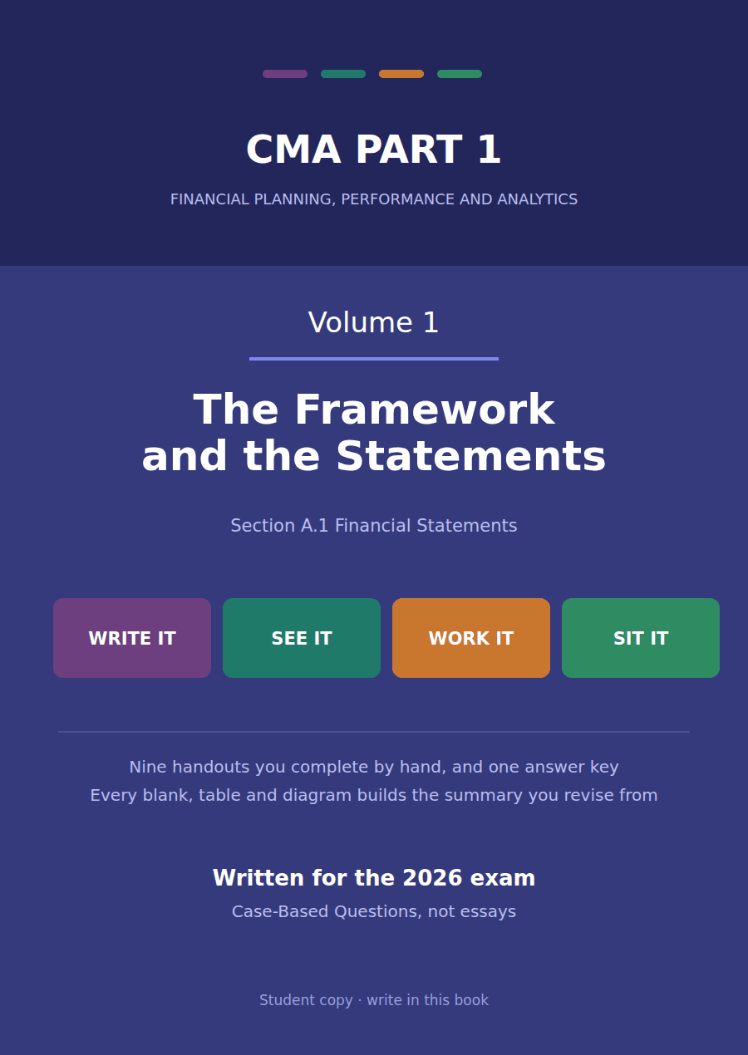

CMA Part 1 · Volume 1
The Framework and the Statements
Nine handouts, one answer key. The four statements, how a transaction moves through all of them, and what each one cannot tell you.
These handouts are not notes to read. You write them. The words you supply are the summary, so a finished handout is a page you can revise from, in your own handwriting.
Work in pen. Do not look at the key until the whole handout is done — the key is written to explain the mistake, and you only get that benefit if you have made it first.
The nine handouts
# | Handout | What it gives you
1 | Who Reads These Statements, and What They Need | Four statements exist because four different questions are asked of a company. Name the question and the statement chooses itself.
2 | The Balance Sheet: What It Holds and How It Is Ordered | Assets, liabilities and equity at one date. The ordering is not decoration: it is the answer to how soon each line turns into cash.
3 | The Income Statement: From Revenue Down to Net Income | One statement, four subtotals. Each subtotal answers a different question, and the exam asks which one you are being shown.
4 | The Statement of Changes in Equity | Four columns and five rows. Every movement in the owners’ claim during the year has to appear in one of the cells.
5 | The Statement of Cash Flows: Operating, Investing, Financing | Three buckets, and every movement of cash falls into exactly one. Getting the bucket right is most of the marks in this topic.
6 | One Transaction, Four Statements | The four statements are not four reports. They are four views of one set of records, and a transaction shows up in each of them differently or not at all.
7 | Building the Balance Sheet and the Income Statement | One list of balances goes in. Two statements come out. The only skill is knowing which line goes where, and in what order.
8 | Building the Statement of Cash Flows (Indirect Method) | Start at net income, remove everything that was not cash, and you arrive at cash. Every adjustment has a reason you can state.
9 | What Each Statement Cannot Tell You | Eight handouts built these statements. This one is about reading them honestly, which means knowing where each of them stops.

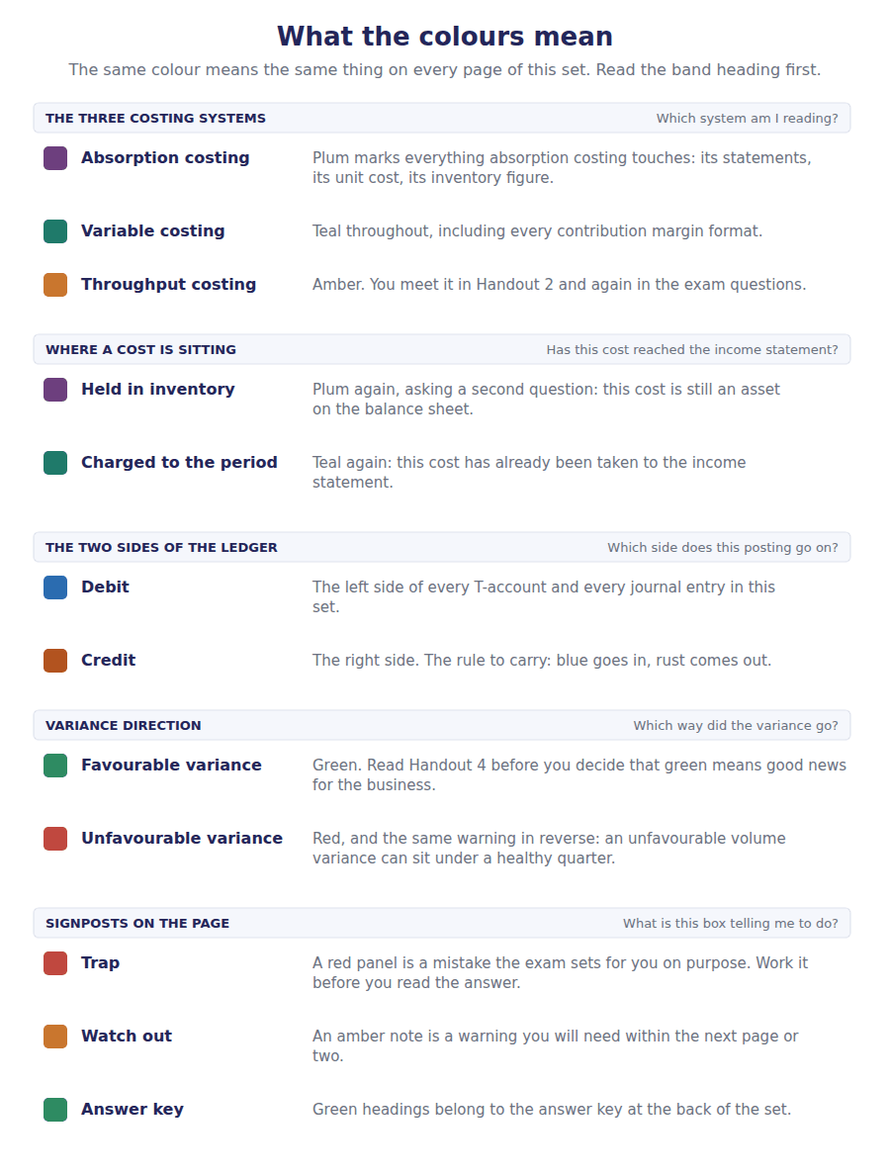
How to read the markers
Marker | Meaning
R1 | Teaching English. Short sentences. This is where a new idea arrives.
R2 | Textbook English. Longer sentences and passive verbs, as a textbook writes them.
R3 | Exam English. Exactly how the CMA exam phrases it, traps included.
Numbered rule | A space you fill in. The number matches the answer key.
Red table | A trap. Read it twice.

Handout 1 · Who Reads These Statements, and What They Need
Four statements exist because four different questions are asked of a company. Name the question and the statement chooses itself.
Volume 1 · The Framework and the Statements · R1 throughout, ending at R2
LANGUAGE FOCUS
Register you are working in | R1 Teaching English. Short sentences, one idea each. This handout introduces the vocabulary the whole volume runs on.
Say it exactly like this | prepare financial statements · present fairly · issue the statements · a user of the statements · assess the prospects for future cash flows · general purpose financial reporting
Words that are not the same | user / preparer · report / statement · financial position / financial performance · profit / cash
Remember | A statement does not say what a company is worth. It says what was recorded, under the rules that were applied. A user is not a customer. Here a user is anyone who reads the statements to make a decision.

What you will be able to do when this handout is finished
- Name the primary users of general purpose financial statements, and say what decision each of them is trying to make.
- State the purpose of each of the four statements in one sentence.
- Choose the statement that answers a given question, and say why the other three do not.
- Explain why general purpose statements cannot be written for one user.
- Use the words financial position and financial performance the way the exam uses them.

The company you will work in for six volumes
Northwind Components, Inc. imports and distributes electronic components to equipment makers. One warehouse near the port, two sales offices, and a small assembly bay.
You will meet this company in every volume of Section A. In this volume you build its four statements. In Volume 3 you write the allowance that sits inside its receivables line, and in Volume 4 you choose the cost flow assumption behind its inventory line.
The year just ended is 20X4. The year before it is 20X3. Both are presented, because a reader given one year alone cannot see a trend.
In this handout you calculate nothing. You learn who is asking, and which statement answers them.

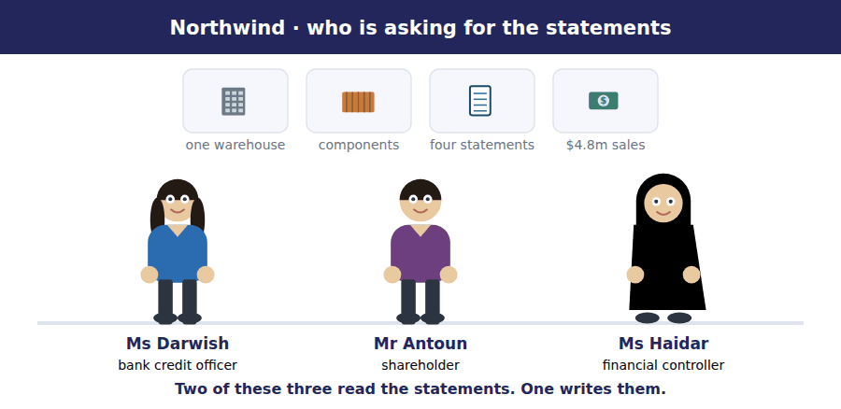
Part 1 · Who is asking? users and their needs
Exercise 1A Read and complete. Write one word in each space.
OBJECTIVE | Name the primary users and say what each of them needs to decide.
YOU WILL NEED | Nothing — this is the first exercise in the volume.
HOW TO START | • Read the whole passage once before writing anything.  • Blank 1 is the word that explains why the statements cannot be tailored.  • Blanks 4 and 5 are two different people with two different questions. One wants to be repaid; the other wants a share of what is left.

WORD BANK
customer · general · inflows · investor · lender · management · owner · primary · regulator · specific
Not every word is used.

R1 Financial statements are written for people outside the company. They are called ¹ purpose statements because the people who read them cannot ask for a report built to their own specification.
Those readers are the ² users: existing and potential investors, lenders, and other creditors. They share one broad need. Each of them is trying to judge the company’s prospects for future net cash ³ .
The questions underneath that need are not the same. A ⁴ wants to know whether the company can pay interest when it falls due and repay the principal at the end. An ⁵ wants to know what is left after everyone else has been paid, because that is what a share is a claim on.
Management reads the statements too, but management is not a primary user. Management can ask the accounting system for any report it likes, so the general purpose statements are not written for ⁶ .
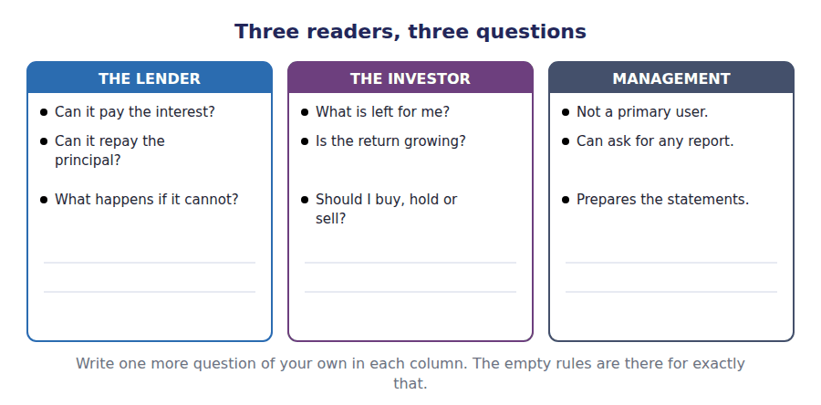
R1 The reports do a second job as well. They let a user judge how well management has used the resources entrusted to it, which is called stewardship. A user assessing stewardship reads the same statements backwards: not what will happen next, but what was done with what was given.
Exercise 1B Match the reader on the left to the decision on the right. Write the letter in the space.
OBJECTIVE | Apply one test to decide whether a reader is a primary user.
YOU WILL NEED | Exercise 1A
HOW TO START | • Three of these readers are primary users and two are not.  • Read the decision first, then ask who would have to make it.  • The supplier is the one most students place wrongly. A supplier who sells on credit is a creditor.

 | Item | Answer |  | Option
1 | A commercial bank considering a three-year loan |  | A | Will this company still pay me interest in year three?
2 | A family that owns 4% of the shares |  | B | Is the residual return on my holding growing or shrinking?
3 | A supplier deciding whether to sell on 60-day terms |  | C | Can this customer pay the invoice before I ship more goods?
4 | The financial controller preparing next year’s budget |  | D | Not a primary user — has full access to internal records.
5 | A tax authority checking a filed return |  | E | Not a primary user — can demand reports in its own format.
Primary users are investors, lenders and other creditors. Any reader who can demand a report built to their own specification is outside the group.

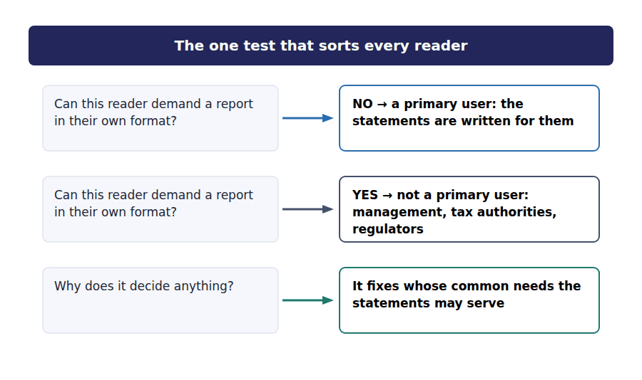
Part 2 · Four statements, four questions what each one is for
Exercise 1C Read and complete. One word in each space.
OBJECTIVE | State the purpose of each statement, and the period or date it covers.
YOU WILL NEED | Exercise 1A, for the idea of a reader with a question.
HOW TO START | • Three of the four statements cover a period. One covers a single date.  • Blank 3 is the word for a single moment in time.  • If you are unsure of a blank, say the sentence aloud with each candidate word in it and listen for the one that fits.

WORD BANK
balance · date · equity · flows · income · moment · period · position · profit
Not every word is used.

R1 The ⁷ statement answers one question: how did the company perform over the year? It runs from the top line down to net income at the bottom, and it covers a ⁸ of time.
The balance sheet answers a different question: what does the company control, and what does it owe? It is not about a period at all. It is a photograph taken at one ⁹ , which is why it is also called the statement of financial position.
The statement of changes in ¹⁰ explains how the owners’ claim moved from the start of the year to the end of it. Profit pushes it up, dividends pull it down, and new shares push it up again.
The statement of cash ¹¹ answers the question none of the other three answers: where did the money actually come from, and where did it go? A company can report a profit and still run out of cash, and this is the statement that shows it.
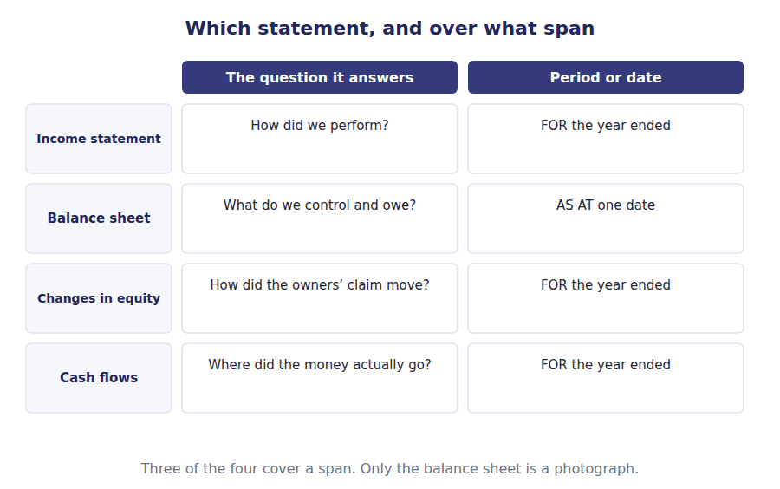
R2 Two phrases are worth fixing now, because the exam uses them instead of the statement names. Financial position is what the company controls and owes at one date. Financial performance is the result of its activities over a period. A question that asks about financial position is asking about the balance sheet, whatever else it mentions.
Exercise 1D Sort each question into the column of the statement that answers it.
OBJECTIVE | Choose the statement that answers a question, and reject the other three.
YOU WILL NEED | Exercise 1C
HOW TO START | • Ask what the question is really about: a span of time, or a single moment.  • If the question contains the word "paid" rather than "charged", look at the cash flow statement.  • The last question belongs in a column you may not expect. Read it twice.

The question a user asks | INCOME STATEMENT | BALANCE SHEET | CASH FLOWS
1. How much did we charge customers this year?
2. How much do customers still owe us?
3. How much did customers actually pay us?
4. What did we spend on new equipment?
5. What is the equipment carried at now?
6. How much depreciation did we charge?

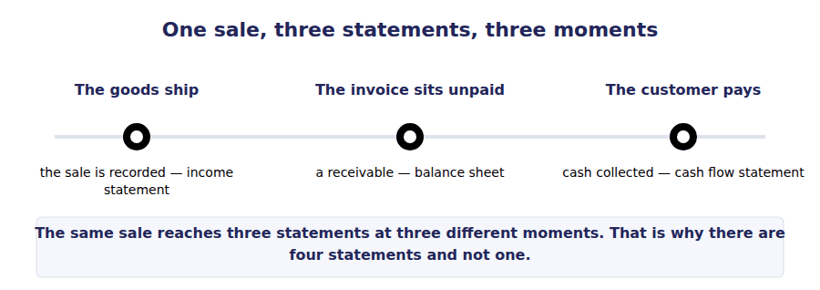
Part 3 · Why not one statement? the limits of a general purpose report
Exercise 1E Read and complete.
OBJECTIVE | Explain why general purpose statements cannot be tailored to one reader.
YOU WILL NEED | Exercises 1A and 1C
HOW TO START | • This passage is written at R2, the register of a textbook. The sentences are longer than in Part 1.  • Blank 1 is a verb meaning "to meet a need exactly".  • The last blank is the name of the quality that lets a reader set this company against another one.

WORD BANK
agreement · average · common · comparability · estimate · satisfy · trend
Not every word is used.

R2 A single set of statements is issued to every reader, and those readers want different things. The lender is concerned with downside and with timing; the investor is concerned with growth in the residual return.
No one report can ¹² both completely. The framework accepts this openly: general purpose financial reports are directed at the needs that the primary users have in ¹³ , rather than at any single user’s own specification.
What the reports can do is make themselves usable. Figures are presented for two years side by side, so that a reader sees a ¹⁴ rather than a single point. Methods are applied the same way from one year to the next, and the methods used are stated openly, which is what gives the statements their ¹⁵ .
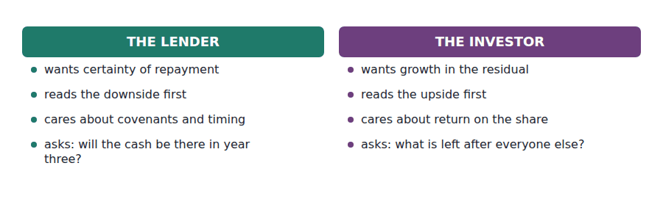
Watch out! Statements are prepared under rules, using estimates. They do not report what a company is worth, and they never claim to. Handout 9 of this volume is about exactly what they cannot tell you.
Part 4 · Exam pitch the questions as the CMA sets them
1. [Level A] According to the conceptual framework for general purpose financial reporting, which of the following is NOT a primary user of a company’s financial statements?
(A) A potential lender evaluating a credit facility
(B) An existing shareholder deciding whether to sell
(C) The company’s chief financial officer preparing a capital budget
(D) A supplier deciding whether to extend 60-day credit terms
2. [Level B] A user wants to know whether a company generated enough cash from its trading activities to replace its equipment without borrowing. Which statement answers this most directly?
(A) The income statement, because it reports the profit from trading
(B) The statement of cash flows, because it separates cash from trading from cash spent on assets
(C) The balance sheet, because it reports what the equipment stands at
(D) The statement of changes in equity, because it reports the owners’ claim
3. [Level B] Which statement about general purpose financial statements is correct?
(A) They are designed to show the current market value of the reporting entity
(B) They are tailored to the information needs of the entity’s largest shareholder
(C) They are directed to the common information needs of primary users and cannot meet every need
(D) They are prepared principally for management’s use in operating the business
4. [Level B] Northwind reports net income of $510,000 for 20X4, but its cash balance rose by only $135,000. A user asks which statement explains the difference. The answer is:
(A) The balance sheet, because it reports both figures
(B) The statement of changes in equity, because it explains the equity movement
(C) The statement of cash flows, because it reconciles income to cash
(D) The income statement, because it reports the net income figure
5. [Level A] Which of the following best describes the stewardship objective of general purpose financial reporting?
(A) Reporting the current market value of the entity to its owners
(B) Enabling users to assess how efficiently management has used the resources entrusted to it
(C) Providing management with the reports it needs to run the business
(D) Ensuring that the entity complies with the relevant tax legislation
6. [Level A] A question refers to an entity’s financial position at the end of the reporting period. The statement being referred to is:
(A) The income statement
(B) The statement of cash flows
(C) The balance sheet
(D) The statement of changes in equity
7. [Level C] Two companies in the same industry apply different but acceptable accounting methods. A user wants to compare them. Which feature of general purpose financial reporting makes that comparison possible?
(A) The requirement that both companies report the same net income
(B) The requirement that the methods applied be stated openly
(C) The requirement that both companies use identical methods
(D) The requirement that both be audited by the same firm
ADAPTIVE TIP When a question names a reader, ask one thing first: can this reader demand a report in their own format? If yes, they are not a primary user. That single test answers most of Section A’s user questions.

Handout 2 · The Balance Sheet: What It Holds and How It Is Ordered
Assets, liabilities and equity at one date. The ordering is not decoration: it is the answer to how soon each line turns into cash.
Volume 1 · The Framework and the Statements · R1 moving to R2
LANGUAGE FOCUS
Register you are working in | R1 for the classification rules, R2 for the measurement note. The sentences lengthen as the handout goes on.
Say it exactly like this | classify an item as current · present an item at cost · carry an asset at · the carrying amount of an asset · settle a liability · realise an asset
Words that are not the same | current / non-current · cost / carrying amount · liability / equity · gross / net
Remember | Carrying amount is not market value. It is what the books say, after the rules have been applied. Current does not mean important. It means it will be realised or settled within the operating cycle or a year, whichever is longer.

What you will be able to do when this handout is finished
- State the accounting equation and show that Northwind’s balance sheet satisfies it.
- Classify an asset or a liability as current or non-current, and name the test you applied.
- Say what a contra account does, and read a net figure back to its gross figure.
- Name the four components of shareholders’ equity and what each one records.

The photograph, taken at one moment
Northwind’s balance sheet at 31 December 20X4 is reproduced twice in this handout: once complete, so you can read it, and once with the figures removed, so you can build it.
Nothing on this statement accumulates. Every figure is the balance at the instant the clock struck midnight on 31 December.
The order of the lines carries information. Assets run from the most liquid to the least; liabilities run from the soonest due to the latest. A reader who knows that can see the company’s position before reading a single number.

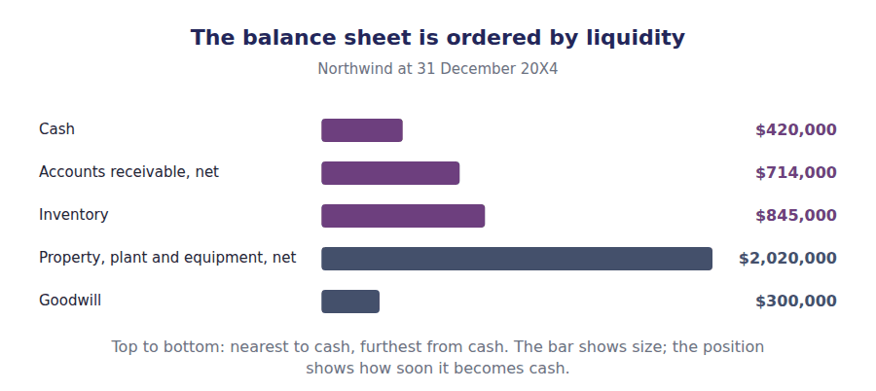
Part 1 · The equation underneath why it always balances
Exercise 2A Read and complete. One word in each space.
OBJECTIVE | State the accounting equation and explain why the two sides must agree.
YOU WILL NEED | Handout 1, for what the balance sheet is for.
HOW TO START | • Blank 2 is the word for the owners’ claim on what is left.  • Blank 4 is the reason the equation is not a coincidence: it is true by the way the records are kept.  • Say the equation aloud before you fill anything in.

WORD BANK
agreement · asset · balance · equity · owners · profit · residual
Not every word is used.

R1 Everything the company controls has to have come from somewhere. It came either from people the company owes, or from its ¹ . That is the whole of the accounting equation.
Written out: assets equal liabilities plus ² . Liabilities are the claims of outsiders. Equity is the claim of the owners, and it is a ³ claim, because the owners get what is left after everyone else has been paid.
The two sides agree every time, and not by luck. Every transaction is recorded twice, once as a debit and once as a credit, so the equation can never be knocked out of ⁴ . If your balance sheet does not balance, you have made a recording error, not a business discovery.
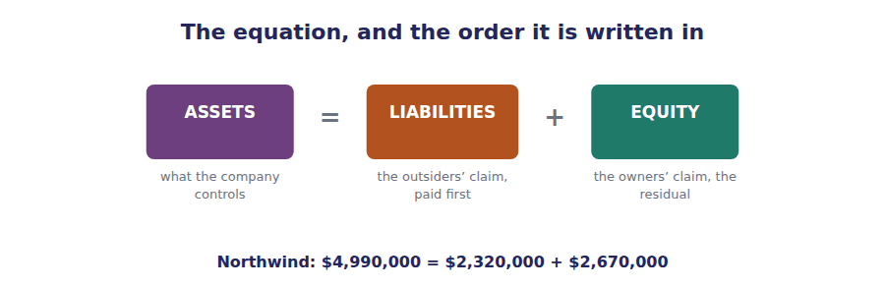
Part 2 · Current or non-current? the classification test
Exercise 2B Read and complete.
OBJECTIVE | Apply the current test, including the half of it most students forget.
YOU WILL NEED | Exercise 2A
HOW TO START | • The test has two limbs joined by the word "or". Both matter.  • Blank 3 is a comparative: when the two limbs disagree, which one wins?  • The last blank is the matching word for a liability rather than an asset.

WORD BANK
cycle · incurred · longer · month · settled · shorter · year
Not every word is used.

R2 An asset is classified as current when it is expected to be realised within one ⁵ of the balance sheet date, or within the entity’s normal operating ⁶ if that cycle is longer.
The second limb matters for a shipbuilder or a distiller, whose cycle runs for several years. Where the two limbs give different answers, the ⁷ of the two periods is used, so inventory that will take eighteen months to sell is still a current asset for such a company.
The parallel test applies to the other side of the balance sheet. A liability is current when it is due to be ⁸ within the same period, which is why the instalment of a loan falling due next year is lifted out of long-term debt and presented separately.
Northwind item at 31 December 20X4 | CURRENT | NON-CURRENT
1. Inventory held for sale in the next four months
2. The $150,000 instalment of long-term debt due next year
3. Goodwill arising on an acquisition three years ago
4. Prepaid insurance covering the next eight months
5. The deferred tax liability, expected to reverse over nine years
6. Debt securities the company may sell at any time but need not

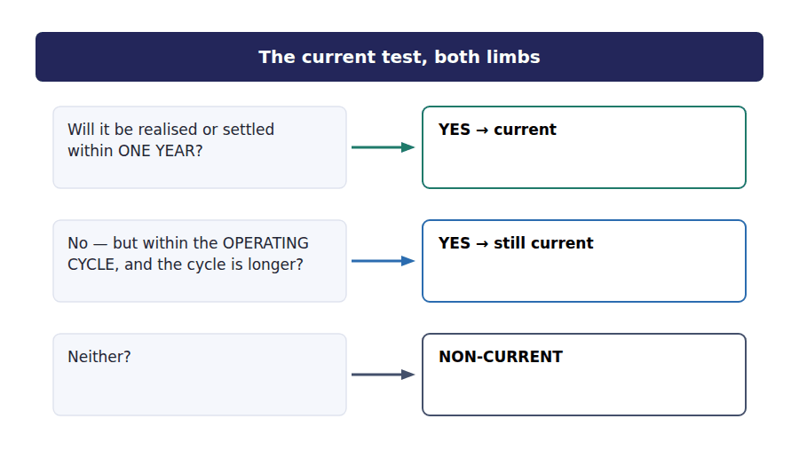
Part 3 · Reading the statement itself gross, contra and net
R2 Three lines on Northwind’s balance sheet are presented net of something. Property, plant and equipment is shown at cost and then reduced by accumulated depreciation. Accounts receivable is shown after the allowance for credit losses. Each deduction sits in a contra account.
R2 A contra account is not a liability. It does not represent money owed to anyone. It is a reduction of the asset it attaches to, presented separately so that the reader can see both the original cost and the amount written off. The figure left after the deduction is the carrying amount.
Exercise 2C Complete the table. Write the missing figure or the missing name.
OBJECTIVE | Read a net figure back to its gross figure, and name the contra account.
YOU WILL NEED | Exercise 2A, and the paragraphs above.
HOW TO START | • Each row is the same arithmetic: gross less contra equals carrying amount.  • Two rows give you the carrying amount and ask for the contra account.  • Write the figures with the comma separators, as the statement does.

Line | Gross | Contra account | Carrying amount
Property, plant and equipment | $3,200,000 | Accumulated depreciation | ______________
Accounts receivable | $760,000 | ______________ | $714,000
Property, plant and equipment | ______________ | $1,180,000 | $2,020,000
Accounts receivable | ______________ | Allowance for credit losses $46,000 | ______________

1 | 2 | 3 | 4

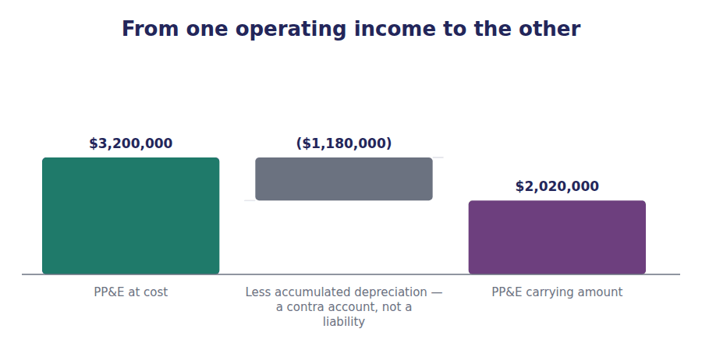
Part 4 · Build it the statement with the figures removed
Exercise 2D Write the figures into the blank statement. The complete statement is in the answer key — do not look until you have finished.
OBJECTIVE | Build Northwind’s balance sheet and prove that it balances.
YOU WILL NEED | Exercises 2A, 2B and 2C
HOW TO START | • Work from the detail lines upward. Every subtotal is the sum of the lines indented under it.  • The two lines in capitals must agree with each other. If they do not, check the subtotals before you check the detail.  • Accumulated depreciation is written as a deduction, in brackets.

Northwind Components, Inc. · Balance Sheet at 31 December 20X4
ASSETS
Current assets
Cash and cash equivalents
Accounts receivable, net of allowance of $46,000
Inventory
Prepaid expenses
Total current assets
Non-current assets
Investments in debt securities
Property, plant and equipment, at cost
Less accumulated depreciation
Property, plant and equipment, net
Intangible assets, net
Goodwill
TOTAL ASSETS
LIABILITIES AND SHAREHOLDERS’ EQUITY
Current liabilities
Accounts payable
Accrued liabilities
Income taxes payable
Current portion of long-term debt
Total current liabilities
Non-current liabilities
Long-term debt
Deferred tax liability
Total liabilities
Shareholders’ equity
Common stock, $1 par
Additional paid-in capital
Retained earnings
Accumulated other comprehensive income
Total shareholders’ equity
TOTAL LIABILITIES AND EQUITY

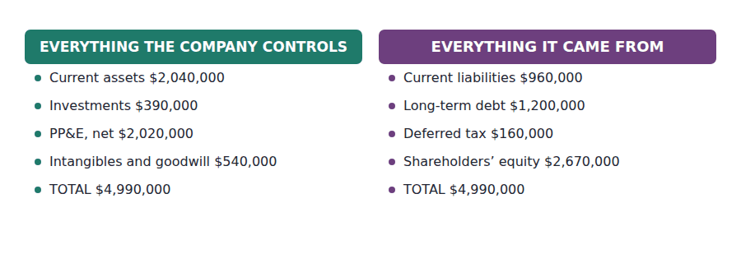
Part 5 · The equity section four lines, four stories
Exercise 2E Match the equity line to what it records.
OBJECTIVE | Name the four components of equity and say what each one records.
YOU WILL NEED | Exercise 2D
HOW TO START | • Two of these four record what shareholders paid in. Two record what the company has accumulated since.  • The split between the first two has no economic meaning. Ask what legal figure causes it.  • The last one is the only equity line that never passed through net income.

 | Item | Answer |  | Option
1 | Common stock, $1 par $300,000 |  | A | The par value of the shares issued — an arbitrary legal figure
2 | Additional paid-in capital $1,020,000 |  | B | What shareholders paid above par value
3 | Retained earnings $1,274,000 |  | C | Profits earned since incorporation and not yet paid out as dividends
4 | Accumulated other comprehensive income $76,000 |  | D | Gains and losses that bypassed net income and went straight to equity
The first two together are contributed capital: $1,320,000 paid in by shareholders. The last two are what the company accumulated.

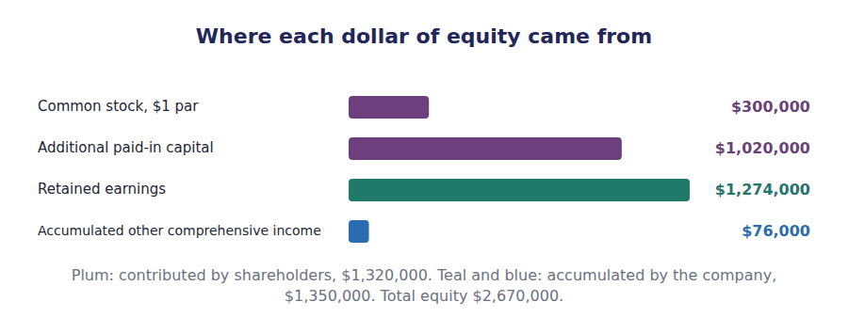
R2 The fourth equity line is worth a sentence here, because its name says where it came from. A few gains and losses are kept out of net income by the rules and taken straight to equity instead. Net income plus those items is comprehensive income, and the running total of the items that bypassed net income accumulates in this line.
Watch out! Par value is a legal relic. A company can issue $1 par shares for $7, and the $6 difference goes to additional paid-in capital. Nothing about the company changes because of where the line falls — but the exam will ask you to put it on the right side of it.
Part 6 · Exam pitch the questions as the CMA sets them
1. [Level C] A distillery’s normal operating cycle is four years. Whisky maturing in its warehouse will be sold in three years. How should the maturing whisky be classified?
(A) Non-current, because it will not be realised within one year
(B) Current, because it will be realised within the normal operating cycle, which is longer than one year
(C) Partly current and partly non-current, apportioned by year
(D) Non-current, because inventory held for more than one year is always non-current
2. [Level A] Accumulated depreciation is best described as:
(A) A liability, because it represents an obligation to replace the asset
(B) An expense of the current period
(C) A contra asset account deducted from property, plant and equipment
(D) A reserve of cash set aside to replace the asset
3. [Level A] Northwind reports property, plant and equipment at cost of $3,200,000 and accumulated depreciation of $1,180,000. The carrying amount reported on the balance sheet is:
(A) $3,200,000
(B) $2,020,000
(C) $1,180,000
(D) $4,380,000
4. [Level A] Which of the following would NOT appear within shareholders’ equity on a balance sheet?
(A) Additional paid-in capital
(B) Retained earnings
(C) Accumulated other comprehensive income
(D) Deferred tax liability
5. [Level B] A company issues 20,000 shares with a par value of $1 each for $7 per share. The effect on the balance sheet is:
(A) Common stock increases $140,000
(B) Common stock increases $20,000 and additional paid-in capital increases $120,000
(C) Additional paid-in capital increases $140,000
(D) Common stock increases $20,000 and retained earnings increases $120,000
6. [Level C] The balance sheet is described as showing financial position at a point in time. Which of the following is a direct consequence?
(A) It must be prepared only at the financial year end
(B) No figure on it represents an amount accumulated over the reporting period
(C) It cannot include estimates
(D) It must be presented for a single year only
7. [Level A] Northwind’s total assets are $4,990,000 and its total liabilities are $2,320,000. Shareholders’ equity is:
(A) $2,670,000
(B) $7,310,000
(C) $1,274,000
(D) $1,320,000
ADAPTIVE TIP Before you classify anything as current, read the stem again for the length of the operating cycle. If the examiner has told you the cycle, they have told you for a reason.

Handout 3 · The Income Statement: From Revenue Down to Net Income
One statement, four subtotals. Each subtotal answers a different question, and the exam asks which one you are being shown.
Volume 1 · The Framework and the Statements · R1 for the structure, R2 for the subtotals
LANGUAGE FOCUS
Register you are working in | R1 while the lines are introduced, R2 once the subtotals start carrying meaning. Read each subtotal name aloud.
Say it exactly like this | recognise revenue · incur an expense · report a gain on disposal · arrive at operating income · bypass net income · present net of tax
Words that are not the same | revenue / gain · expense / loss · gross margin / operating income · net income / comprehensive income
Remember | Revenue is not the same as a gain. Revenue comes from what the company is in business to do; a gain comes from everything else. Operating income is not profit before tax. Interest sits between them, and the exam uses that gap.

What you will be able to do when this handout is finished
- Name the four subtotals of a multi-step income statement and say what each one tells a reader.
- Distinguish revenue from a gain, and an expense from a loss.
- Build Northwind’s income statement from its component lines.
- Explain what other comprehensive income is and why it bypasses net income.
- Say why operating income is the subtotal an analyst looks at first.

The film, not the photograph
Handout 2 took a photograph of Northwind at one date. This handout covers the whole of 20X4: everything that happened between the two photographs.
Northwind’s income statement is presented in the multi-step form, which means it reports subtotals along the way rather than jumping from total income to net income in one move.
There are four of those subtotals. Each one answers a different question, and a reader who knows which subtotal they are looking at knows what has already been deducted and what has not.

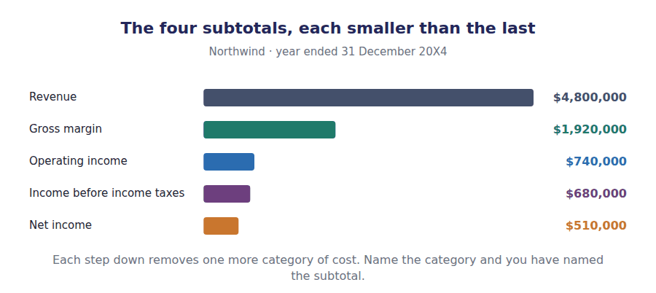
Part 1 · Revenue or gain? the ordinary activities test
Exercise 3A Read and complete. Write one word in each space.
OBJECTIVE | Separate revenue from a gain, and an expense from a loss.
YOU WILL NEED | Handout 1, for what the income statement is for.
HOW TO START | • The test is in the first sentence. Apply it, do not guess from the size of the amount.  • Blank 3 is what Northwind is actually in business to do.  • Blanks 4 and 5 are a matched pair: one is the word used when the amount is positive, the other when it is negative.

WORD BANK
components · expense · gain · loss · ordinary · profit · turnover
Not every word is used.

R1 Not every increase in wealth is revenue. The test is whether it arose from the activities the company is in business to carry on, which the standards call its ¹ activities.
Northwind sold $4,800,000 of components during the year. That is revenue, because selling ² is what the company does.
In the same year it sold a used delivery van for $30,000 more than the van stood at in the books. That $30,000 is not revenue. Northwind is not in the business of selling vans, so the amount is reported as a ³ .
The same test runs the other way. A cost incurred in carrying on ordinary activities is an expense. A decrease arising outside them is a ⁴ . The exam tests this by putting a large gain high up the statement where revenue belongs, and seeing whether you move it.
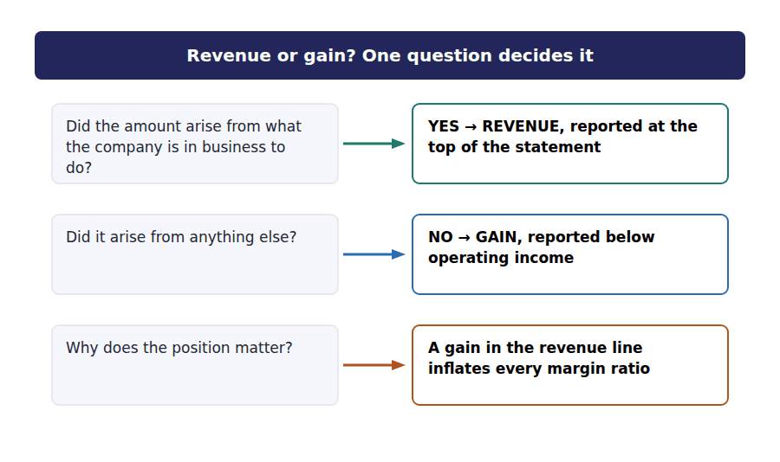
Part 2 · The four subtotals what each one has removed
Exercise 3B Read and complete.
OBJECTIVE | Say what has been deducted by the time each subtotal is reached.
YOU WILL NEED | Exercise 3A
HOW TO START | • Work down the statement as you read. Each paragraph is one step lower than the one before it.  • Blank 2 names the cost that gross margin has already removed.  • Blank 4 is the item that sits between operating income and pre-tax income, and it is about how the company is financed, not how it trades.

WORD BANK
dividend · income · interest · margin · operating · revenue · selling
Not every word is used.

R2 The first subtotal is gross ⁵ : revenue less the cost of goods sold. Nothing else has been deducted. It measures the spread on the product itself, which is why a distributor watches it closely.
The second is operating income. Gross margin less the ⁶ expenses of running the company — selling, administrative, depreciation and amortisation. At this point everything the business does has been charged, but nothing about how it is financed or taxed.
The third is income before income taxes. Operating income is adjusted for items outside the trade, and the largest of these for Northwind is ⁷ expense, which depends on how much the company has borrowed rather than on how well it trades.
The fourth is net ⁸ , after income tax expense. This is the figure that will be carried into the statement of changes in equity and added to retained earnings.
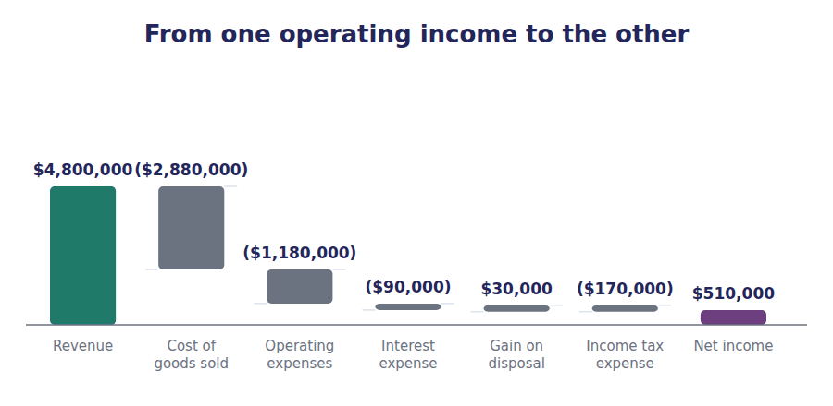
Exercise 3C Sort each question into the column of the subtotal that answers it.
OBJECTIVE | Decide which subtotal answers a given question about the business.
YOU WILL NEED | Exercise 3B
HOW TO START | • Ask what the question is about: the product, the business, or the shareholder.  • A question about borrowing is never answered by operating income.  • One question is about the product spread alone.

What a reader wants to know | GROSS MARGIN | OPERATING INCOME | NET INCOME
1. Is the mark-up on the components we sell holding up?
2. Is the business profitable before we think about the bank?
3. What is available to shareholders this year?
4. Did our selling and administrative costs grow faster than sales?
5. How much did the tax charge reduce the result?
6. Are we buying components at a worse price than last year?

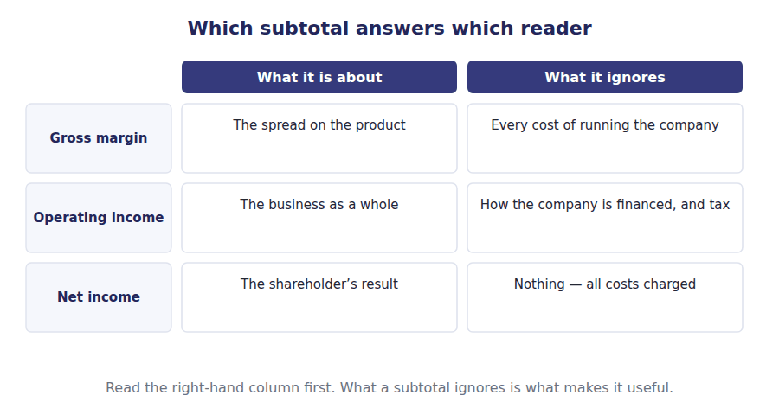
Part 3 · Build it the statement with the figures removed
Exercise 3D Write the figures into the blank statement. Do not look at the key until you have reached the bottom.
OBJECTIVE | Build Northwind’s income statement and arrive at net income.
YOU WILL NEED | Exercises 3A, 3B and 3C
HOW TO START | • Deductions are written in brackets, as the statement does elsewhere.  • Each subtotal is the line above it adjusted by the lines indented under it. Work down, not up.  • Income tax expense is 25%% of income before income taxes. If your pre-tax figure is right, the tax figure follows from it.

Northwind Components, Inc. · Income Statement for the year ended 31 December 20X4
Revenue
Cost of goods sold
Gross margin
Operating expenses
Selling expenses
Administrative expenses
Depreciation and amortisation
Total operating expenses
Operating income
Non-operating items
Interest expense
Gain on disposal of equipment
Income before income taxes
Income tax expense
Net income

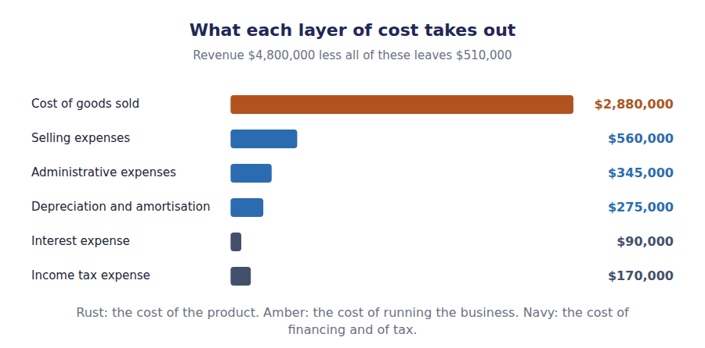
Part 4 · The income that is not net income other comprehensive income
R2 Net income is not the whole of a year’s result. A short, closed list of gains and losses is kept out of net income by the rules and taken straight to equity instead. The list is not a matter of judgement: an item is either on it or it is not.
R2 Northwind has one such item. It holds debt securities classified as available for sale, and those securities rose in value by $32,000 during the year. Because the company has not sold them, the gain is unrealised, and the rules route it through other comprehensive income rather than through net income.
Exercise 3E Read and complete.
OBJECTIVE | Explain what other comprehensive income is and why it bypasses net income.
YOU WILL NEED | Exercise 3D, and the two paragraphs above.
HOW TO START | • Blank 1 is the word for a gain on something the company still owns.  • Blank 3 is the balance sheet line the amounts pile up in, which you met in Handout 2.  • The last blank is the phrase that explains why the reported figure is smaller than the gain itself.

WORD BANK
accumulated · comprehensive · gross · net · operating · realised · unrealised
Not every word is used.

R2 The gain on Northwind’s debt securities has not been turned into cash. The company still holds the securities, so the gain is ⁹ , and reporting it in net income would put a figure in the result that no transaction has yet confirmed.
The rules therefore take it to other ¹⁰ income instead. It is still part of the year’s result, and it is still presented in the statement, but it sits below net income rather than inside it.
From there the amount accumulates on the balance sheet, in the line called ¹¹ other comprehensive income, which rose from $52,000 to $76,000 during the year.
One detail of presentation catches people. Items of other comprehensive income are presented ¹² of tax, so the $32,000 gain appears as $24,000 after the related tax of $8,000 has been deducted.
Northwind Components, Inc. · Statement of Comprehensive Income for the year ended 31 December 20X4
Net income |  | $510,000
Other comprehensive income, net of tax
Unrealised gain on available-for-sale debt securities | $32,000
Less the related income tax | ($8,000)
Other comprehensive income for the year | $24,000
Comprehensive income |  | $534,000

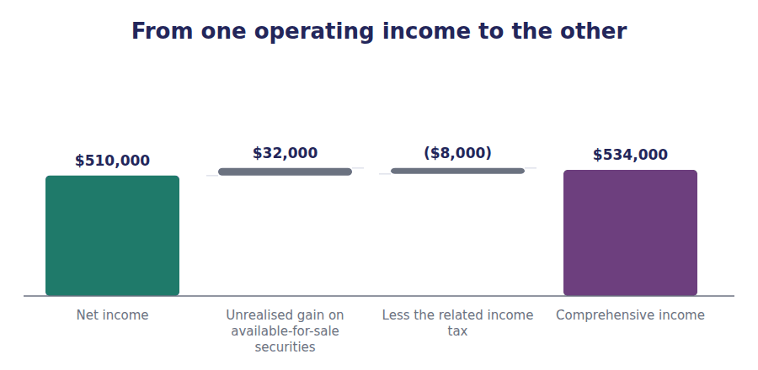
Watch out! Comprehensive income is the wider figure and net income is the narrower one. Only net income reaches retained earnings. Other comprehensive income goes to its own equity line, and Handout 4 shows both arriving.
Part 5 · Exam pitch the questions as the CMA sets them
1. [Level B] Northwind sells a used delivery van for $30,000 more than its carrying amount. How should this be reported?
(A) As revenue, because cash was received from a sale
(B) As a gain, reported below operating income
(C) As a reduction of cost of goods sold
(D) As other comprehensive income, because the van was a long-lived asset
2. [Level C] Which subtotal is unaffected by a company’s decision to finance itself with debt rather than equity?
(A) Net income
(B) Income before income taxes
(C) Operating income
(D) Comprehensive income
3. [Level A] Northwind reports revenue of $4,800,000 and cost of goods sold of $2,880,000. Gross margin is:
(A) $1,920,000
(B) $740,000
(C) $680,000
(D) $510,000
4. [Level B] An unrealised gain on debt securities classified as available for sale is reported:
(A) In net income, because it is a gain
(B) In other comprehensive income, net of tax
(C) As a direct addition to retained earnings
(D) Only in the notes, until the securities are sold
5. [Level A] A company presents all income items, then all expense items, and reports only one profit figure. This presentation is:
(A) A multi-step income statement
(B) A single-step income statement
(C) A statement of comprehensive income
(D) Not permitted
6. [Level A] Northwind’s net income is $510,000 and its other comprehensive income for the year is $24,000. Comprehensive income is:
(A) $510,000
(B) $24,000
(C) $534,000
(D) $486,000
7. [Level C] An analyst notices that a distributor’s gross margin percentage has fallen while its operating income percentage has risen. The most likely explanation is that:
(A) Interest expense fell during the year
(B) Buying prices rose, but selling and administrative costs were cut by more
(C) The company recorded a large gain on disposal
(D) The income tax rate fell
ADAPTIVE TIP When a question gives you a subtotal, write down what has already been deducted to reach it before you do anything else. Half the income statement questions in Section A are testing whether you know which costs are above the line you have been handed.

Handout 4 · The Statement of Changes in Equity
Four columns and five rows. Every movement in the owners’ claim during the year has to appear in one of the cells.
Volume 1 · The Framework and the Statements · R1 for the structure, R2 for the owner transactions
LANGUAGE FOCUS
Register you are working in | R1 while the grid is introduced, R2 once transactions with owners are separated from results of trading.
Say it exactly like this | declare a dividend · issue shares at a premium · carry the balance forward · roll an account forward · a transaction with owners · charge an item to equity
Words that are not the same | declared / paid · issue / distribution · opening balance / closing balance · expense / distribution
Remember | A dividend is not an expense. It never appears on the income statement. Issuing shares is not income. Money from owners is never revenue, whatever its size.

What you will be able to do when this handout is finished
- Name the four columns of Northwind’s equity statement and say which account each one rolls forward.
- Separate a transaction with owners from a result of trading, and place each in the right row.
- Build the statement and show that it closes on the equity figure in the balance sheet.
- Explain why a dividend reduces equity without ever reaching the income statement.

The bridge between two balance sheets
At the end of 20X3 Northwind’s equity stood at $2,166,000. At the end of 20X4 it stood at $2,670,000.
The difference is $504,000. This statement explains all of it, and it has to: there is no other statement in which a movement in the owners’ claim may hide.
The statement is a grid. Each column is one of the four equity accounts you met on the balance sheet, and each row is one thing that happened during the year. Read down a column and you see that account roll forward; read across a row and you see one event land in every account it touches.

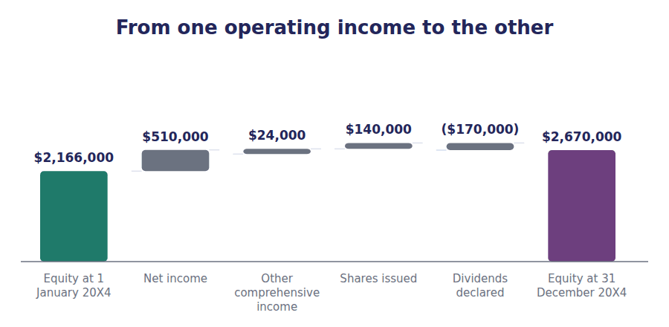
Part 1 · What can move equity? only four things
Exercise 4A Read and complete. Write one word in each space.
OBJECTIVE | List the four things that can move equity and say which column each one lands in.
YOU WILL NEED | Handout 2, for the four equity accounts. · Handout 3, for net income and other comprehensive income.
HOW TO START | • Two of the four are results of trading. Two are dealings with the shareholders themselves.  • Blank 3 is the account that receives net income.  • Blank 5 is a word meaning formally approved by the board.

WORD BANK
accumulated · contributed · declared · earned · issued · paid-in · retained
Not every word is used.

R1 Equity can move for only four reasons, and each has its own row in this statement.
The company can earn a profit. Net income of $510,000 goes into ¹ earnings, which is the account that collects profits the company has kept.
The company can record a gain the rules keep out of net income. Northwind’s other comprehensive income of $24,000 goes into the ² other comprehensive income column, and nowhere near retained earnings.
The shareholders can put more money in. Northwind issued 20,000 shares at $7, so $20,000 went to common stock at par and the remaining $120,000 went to additional ³ capital.
And the company can give money back. The board ⁴ dividends of $170,000, which reduces retained earnings. It is a distribution of profit, not a cost of earning it.
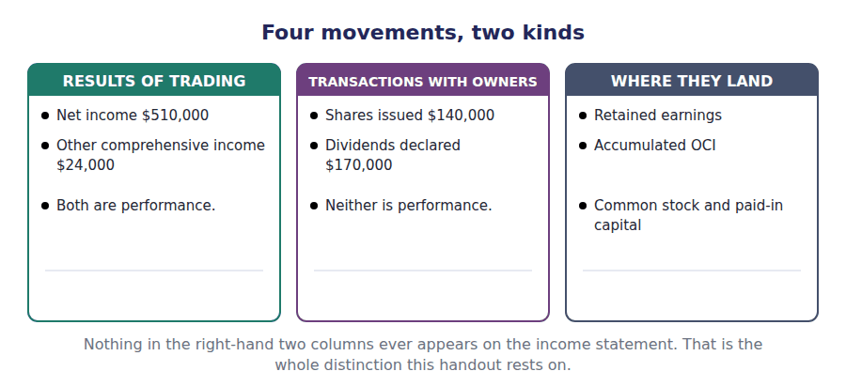
Part 2 · Trading or dealing with owners? the distinction that decides everything
Exercise 4B Sort each event into the column it belongs in.
OBJECTIVE | Separate results of trading from transactions with owners.
YOU WILL NEED | Exercise 4A
HOW TO START | • Ask one question: did this happen because the company traded, or because the shareholders acted as shareholders?  • Two of these never reach the income statement at all.  • The last one is the trap. Read it carefully: who is the money going to?

Event during 20X4 | RESULT OF TRADING | TRANSACTION WITH OWNERS
1. Components sold to customers for $4,800,000
2. Dividends of $170,000 declared by the board
3. 20,000 shares issued for $140,000
4. Securities held rose in value by $32,000 before tax
5. Interest of $90,000 paid to the bank
6. Income tax of $170,000 charged for the year

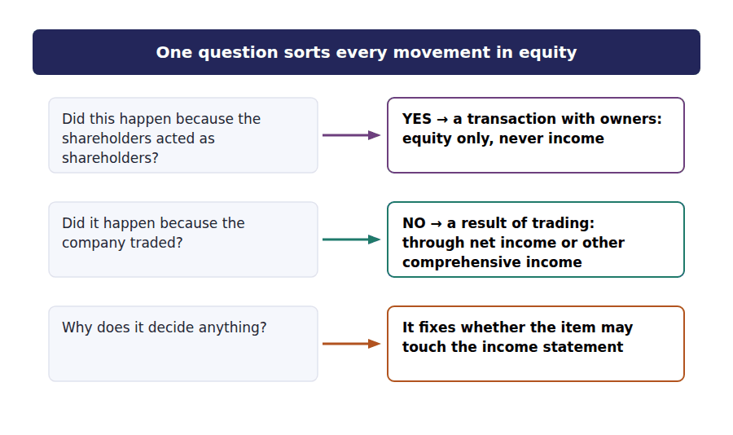
Part 3 · Build it the grid with the figures removed
Exercise 4C Write the figures into the blank grid. Use a dash where an event does not touch a column.
OBJECTIVE | Build the statement of changes in equity and close it on the balance sheet figure.
YOU WILL NEED | Exercises 4A and 4B
HOW TO START | • Fill the opening row from Handout 2’s comparative figures, then work down one event at a time.  • Every row must add across to the total column. Every column must add down to the closing balance.  • The bottom right cell must equal total shareholders’ equity on the balance sheet. If it does not, you have a movement in the wrong column.

 | Common stock | Paid-in capital | Retained earnings | Accumulated OCI | Total
Balance at 1 January 20X4
Net income for the year | — | — |  | —
Other comprehensive income, net of tax | — | — | —
Shares issued: 20,000 shares at $7 |  |  | — | —
Dividends declared | — | — |  | —
Balance at 31 December 20X4

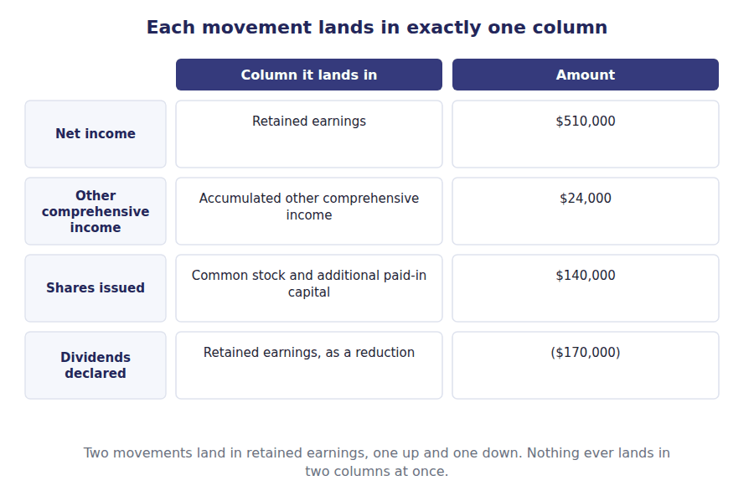
Part 4 · Why a dividend is not an expense the question the exam asks most
R2 A dividend reduces equity, and an expense reduces equity. Students reason from that to the conclusion that a dividend must be an expense somewhere. It is not, and the reason is worth stating carefully.
R2 An expense is a cost of earning revenue. It is incurred in carrying on the business, and it is deducted in arriving at the profit the owners are entitled to. A dividend is paid out of that profit once it has been arrived at. It is the owners taking their return, not a cost of producing it.
Exercise 4D Read and complete.
OBJECTIVE | Explain why a dividend never appears on the income statement.
YOU WILL NEED | Exercise 4C, and the two paragraphs above.
HOW TO START | • Blank 1 is the word for what an expense is incurred to produce.  • Blank 3 names the moment at which a dividend becomes a liability.  • The last blank is what a declared but unpaid dividend becomes on the balance sheet.

WORD BANK
asset · declares · expense · liability · paid · retained · revenue
Not every word is used.

R2 An expense is a cost of earning ⁵ , deducted in arriving at the profit that belongs to the shareholders. A dividend is a share of that profit, handed over after it has been arrived at.
Treating a dividend as an expense would deduct the owners’ return in calculating the owners’ return, which is circular. So the dividend reduces ⁶ earnings directly and never touches the income statement.
The recording moment is the date the board ⁷ the dividend, not the date it is paid. At that moment the company has a legal obligation it cannot avoid.
If the year end falls between declaration and payment, the amount sits on the balance sheet as a ⁸ , and the cash leaves in the following period.
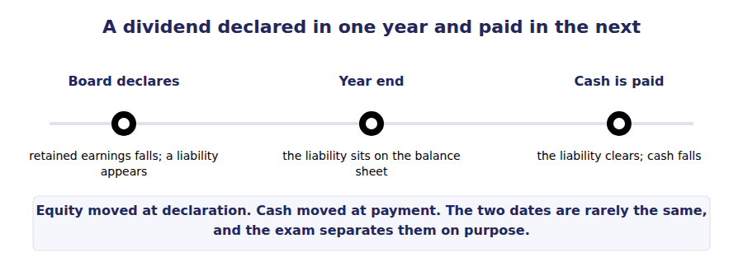
Watch out! The closing total of this statement and the equity section of the balance sheet are the same figure, $2,670,000. If a question gives you one and asks for the other, you already have it.
Part 5 · Exam pitch the questions as the CMA sets them
1. [Level B] A company declares a dividend of $90,000 in December and pays it in February. In the December financial statements the dividend is:
(A) An expense of $90,000 in the income statement
(B) A reduction of retained earnings and a current liability of $90,000
(C) Not recorded until it is paid in February
(D) A reduction of additional paid-in capital of $90,000
2. [Level B] Northwind’s equity rose from $2,166,000 to $2,670,000 during 20X4. Which combination explains the movement?
(A) Net income only
(B) Net income plus other comprehensive income
(C) Net income, other comprehensive income and shares issued, less dividends declared
(D) Net income less dividends declared
3. [Level A] A company issues shares with a total par value of $20,000 for proceeds of $140,000. In the statement of changes in equity this appears as:
(A) $140,000 in the common stock column
(B) $20,000 in common stock and $120,000 in additional paid-in capital
(C) $140,000 in retained earnings
(D) $20,000 in common stock and $120,000 in other comprehensive income
4. [Level A] Other comprehensive income for the year is reported in the statement of changes in equity as an addition to:
(A) Retained earnings
(B) Accumulated other comprehensive income
(C) Additional paid-in capital
(D) Common stock
5. [Level B] Which of the following would NOT appear as a row in the statement of changes in equity?
(A) Dividends declared during the year
(B) Interest paid to the company’s bank
(C) Net income for the year
(D) Proceeds from issuing shares
6. [Level C] The opening balance of retained earnings in a statement of changes in equity does not agree with the closing balance reported in the prior year. This indicates that:
(A) An arithmetic error has certainly been made
(B) A prior period has been restated, and the notes should explain it
(C) The company changed its dividend policy
(D) Other comprehensive income was recorded during the year
7. [Level B] A company reports net income of $400,000, other comprehensive income of $30,000, and dividends declared of $150,000. The increase in retained earnings for the year is:
(A) $250,000
(B) $280,000
(C) $400,000
(D) $430,000
ADAPTIVE TIP Before you answer any equity question, draw the four columns on your scratch paper and write the opening balances across the top. Most of the errors in this topic are items landing in the wrong column, and the columns make that visible.

Handout 5 · The Statement of Cash Flows: Operating, Investing, Financing
Three buckets, and every movement of cash falls into exactly one. Getting the bucket right is most of the marks in this topic.
Volume 1 · The Framework and the Statements · R1 for the three buckets, R2 for the awkward cases
LANGUAGE FOCUS
Register you are working in | R1 while the three classes are introduced, R2 for the items that sit on a boundary.
Say it exactly like this | generate cash from operations · classify a cash flow · acquire a long-lived asset · raise finance · repay the principal · disclose a non-cash transaction
Words that are not the same | cash / profit · interest paid / dividends paid · principal / interest · proceeds / cost
Remember | The statement reports cash, not profit. A profitable company can show negative operating cash flow for years. Interest paid and dividends paid look alike and are classified differently. That difference is examined.

What you will be able to do when this handout is finished
- Name the three classes of cash flow and say what belongs in each.
- Classify a cash movement, including the cases that sit on a boundary.
- Explain why interest paid is operating while dividends paid are financing.
- Say what happens to a significant transaction that moved no cash at all.
- State what the three sections add up to, and where that figure is confirmed.

The statement that cannot be argued with
Every other statement in this volume rests on judgement somewhere. When revenue is recognised, how much of a receivable will be collected, how fast equipment wears out: all of these are estimates.
Cash is not an estimate. Northwind’s cash rose from $285,000 to $420,000 during 20X4, a movement of $135,000, and no accounting policy can change that figure.
What the statement does is explain the movement. It sorts every cash flow of the year into three classes, and the three classes add back to the movement in the cash balance.
In this handout you classify. In Handout 8 you build the statement itself.

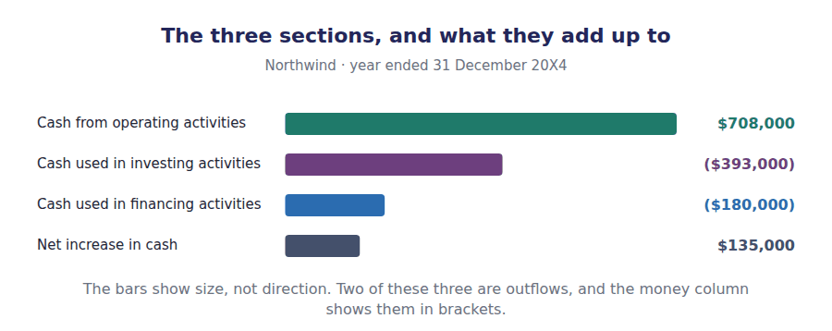
Part 1 · The three buckets what belongs in each
Exercise 5A Read and complete. Write one word in each space.
OBJECTIVE | Name the three classes of cash flow and the test that assigns each one.
YOU WILL NEED | Handout 1, for what the cash flow statement is for.
HOW TO START | • Each paragraph defines one class. The defining word is the blank.  • Blank 3 is about what the money was spent on, not how much.  • Blank 5 names the kind of person on the other side of a financing flow.

WORD BANK
came · capital · customer · from · on · Operating · profit · selling
Not every word is used.

R1 Cash flows are sorted into three classes, and every movement of cash belongs to exactly one of them.
¹ activities are the cash effects of the things that make up net income: collecting from customers, paying suppliers, paying wages, paying tax. This is the default class, and anything that is not clearly one of the other two belongs here.
Investing activities are about what the company spent its money ² . Buying equipment, selling equipment, buying securities: the test is the nature of the asset acquired or sold, never the size of the amount.
Financing activities are about where the money ³ from, and about giving it back. Issuing shares, repaying a loan, paying a dividend. The test here is whether the other party is a provider of ⁴ — an owner or a lender — rather than a customer or a supplier.
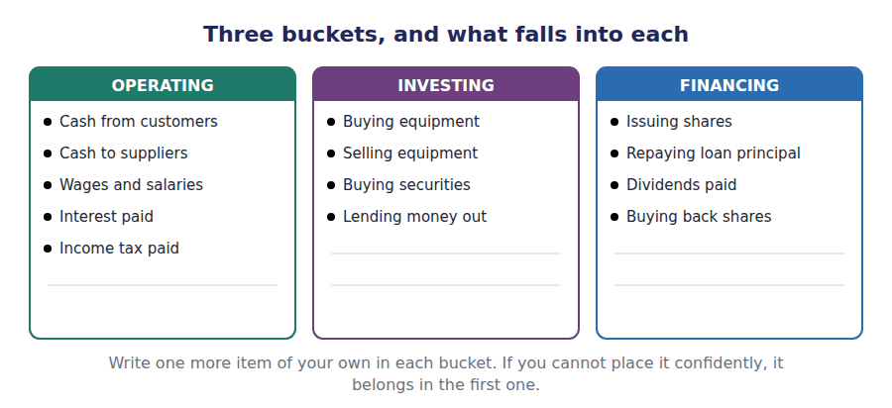
Part 2 · The awkward cases where the exam sets its questions
R2 Three pairs of items look alike and are classified differently. They are where almost every examined error in this topic comes from, so they are worth more attention than the easy cases.
Exercise 5B Read and complete.
OBJECTIVE | Classify the items that sit on a boundary, and say why each falls where it does.
YOU WILL NEED | Exercise 5A
HOW TO START | • The first pair is interest and dividends. Ask which of them is deducted in arriving at net income.  • The second pair splits one loan repayment into two parts. They do not go to the same place.  • Blank 4 is what a transaction that moved no cash is given instead of a line in the statement.

WORD BANK
disclosure · expense · financing · investing · note · operating · principal
Not every word is used.

R2 Interest paid and dividends paid both go to providers of capital, so they look like a matched pair. They are not. Interest expense is deducted in arriving at net income, so under US GAAP the cash paid for it is an ⁵ flow. A dividend is a distribution of profit, never an expense, so the cash paid for it is ⁶ .
A loan repayment has to be split. The interest element is operating, as above, while the repayment of the ⁷ is financing. One cheque leaving the company can therefore appear in two different sections of the statement.
The third case moves no cash at all. If Northwind acquired equipment by signing a note rather than paying for it, nothing would appear in the statement, because no cash moved. Such a transaction is reported in a separate ⁸ , so that a reader can see a significant investing or financing event that the statement itself cannot show.
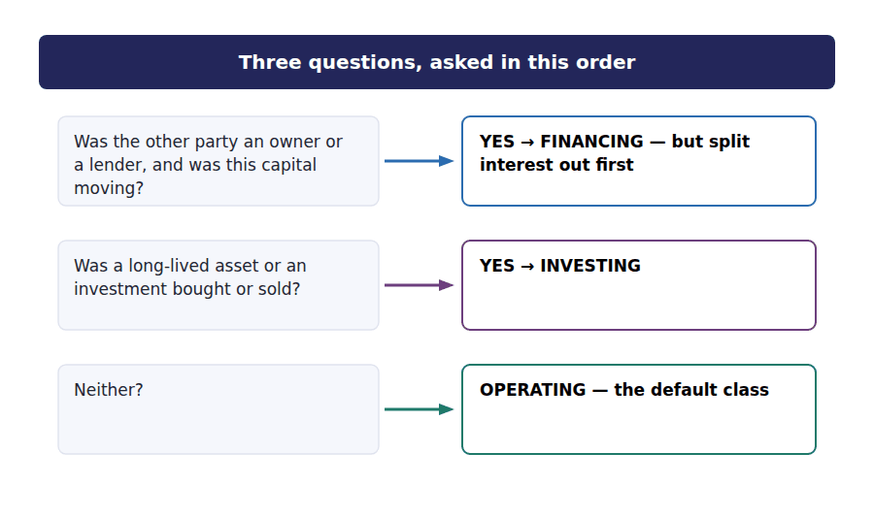
Exercise 5C Sort each item into the section it belongs in.
OBJECTIVE | Classify twelve real movements, including the boundary cases.
YOU WILL NEED | Exercises 5A and 5B
HOW TO START | • Two of these items moved no cash. Decide what happens to them before you place them.  • The loan repayment is deliberately written as one amount. Read it again.  • Work down the list once quickly, then go back to the three you were least sure of.

Cash movement during 20X4 | OPERATING | INVESTING | FINANCING
1. Cash collected from customers
2. Purchase of equipment for $430,000
3. Proceeds of $65,000 from selling old equipment
4. Interest of $90,000 paid to the bank
5. Dividends of $170,000 paid to shareholders
6. Repayment of $150,000 of loan principal
7. $140,000 raised by issuing shares
8. Income tax paid to the government
9. Purchase of $28,000 of debt securities
10. Wages paid to warehouse staff

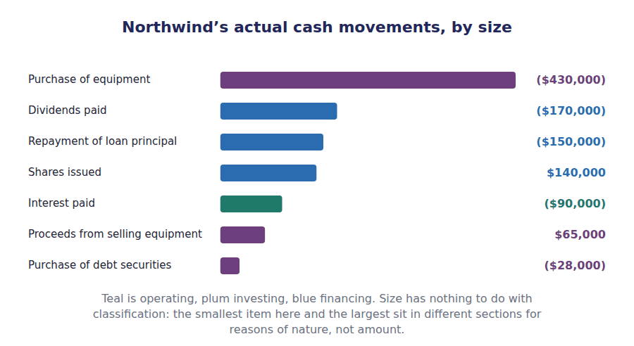
Part 3 · Cash, and what counts as cash cash equivalents and non-cash events
Exercise 5D Read and complete.
OBJECTIVE | Decide what counts as cash, and what happens to an event that moved none.
YOU WILL NEED | Exercise 5C
HOW TO START | • Blank 1 is a length of time. The usual rule is a short one.  • Blank 2 asks what happens when money moves between two things that are both treated as cash.  • The last blank is why a non-cash transaction is disclosed at all rather than simply ignored.

WORD BANK
months · nowhere · position · profit · twice · years
Not every word is used.

R2 The statement explains the movement in cash and cash equivalents taken together. A cash equivalent is a short-term investment that can be turned into a known amount of cash, and the usual test is that it matured within three ⁹ of being acquired.
Because the two are reported as one total, moving money from a current account into a 60-day deposit is not a cash flow at all. It is a movement within the total, and it appears ¹⁰ in the statement.
The opposite case is an event that is significant but moved no cash: acquiring a building in exchange for shares, or settling a debt by issuing equity. These are reported outside the statement, because leaving them out entirely would hide a real change in the company’s ¹¹ from a reader who is relying on this statement to see it.
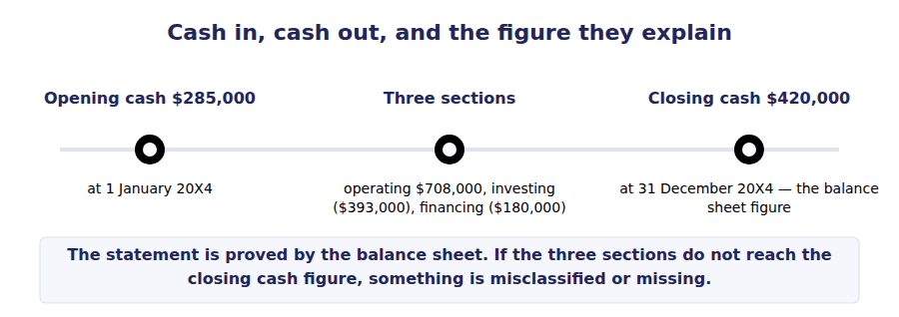
Part 4 · Reading the pattern what the three signs say together
Exercise 5E Match the pattern of signs to the company it describes.
OBJECTIVE | Read a company’s situation from the signs of its three sections.
YOU WILL NEED | Exercise 5C
HOW TO START | • A positive operating figure means the trade generates cash. A negative investing figure means the company is buying assets.  • A young company usually shows the opposite signs to a mature one.  • One of these four is in trouble. Find the one whose trading consumes cash while it also repays debt.

 | Item | Answer |  | Option
1 | Operating positive, investing negative, financing negative |  | A | A mature business funding its own growth and repaying its backers
2 | Operating negative, investing negative, financing positive |  | B | A young business burning cash and raising capital to do it
3 | Operating positive, investing positive, financing negative |  | C | A business selling assets and returning the proceeds to its backers
4 | Operating negative, investing positive, financing negative |  | D | A business in difficulty: trading consumes cash, assets are being sold to repay debt
Northwind is the first pattern: operating $708,000, investing ($393,000), financing ($180,000).

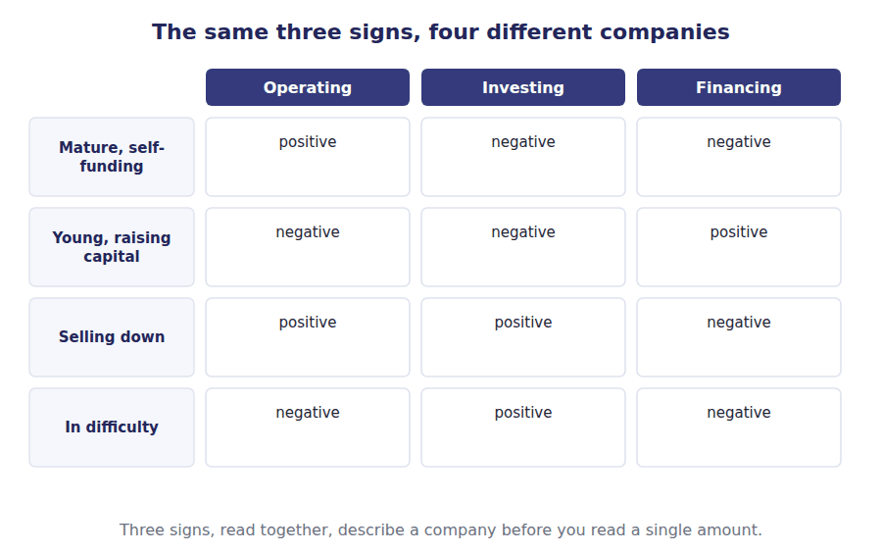
R2 One choice remains, and it affects only the operating section. A company may present operating cash flow by the direct method, listing the actual receipts and payments, or by the indirect method, starting at net income and adjusting it back to cash. Both arrive at the same figure, and the indirect method is used by almost everyone. Handout 8 builds Northwind’s operating section that way.
Watch out! Under US GAAP interest paid is operating. Under IFRS a company may classify it as operating or financing. Volume 12 covers the difference; until then, assume US GAAP unless a question says otherwise.
Part 5 · Exam pitch the questions as the CMA sets them
1. [Level B] Under US GAAP, cash paid for interest on a bank loan is classified in the statement of cash flows as:
(A) A financing activity, because it is paid to a lender
(B) An operating activity, because interest expense enters into the determination of net income
(C) An investing activity
(D) A non-cash transaction requiring disclosure only
2. [Level C] A company repays a loan instalment of $200,000, of which $35,000 is interest. In the statement of cash flows this appears as:
(A) $200,000 financing outflow
(B) $200,000 operating outflow
(C) $165,000 financing outflow and $35,000 operating outflow
(D) $165,000 investing outflow and $35,000 financing outflow
3. [Level B] A company acquires a warehouse by issuing shares to the seller. No cash changes hands. In the statement of cash flows this is:
(A) An investing outflow and a financing inflow of equal amount
(B) Omitted entirely, with no further action
(C) Omitted from the statement but disclosed as a significant non-cash investing and financing transaction
(D) An operating outflow, because no asset was purchased for cash
4. [Level A] Northwind’s three sections are operating $708,000, investing ($393,000) and financing ($180,000). The net increase in cash for the year is:
(A) $135,000
(B) $708,000
(C) $420,000
(D) $1,281,000
5. [Level B] A company transfers $500,000 from its current account into a 60-day treasury deposit. In the statement of cash flows this is:
(A) An investing outflow of $500,000
(B) An operating outflow of $500,000
(C) Not reported, because it is a movement within cash and cash equivalents
(D) A financing outflow of $500,000
6. [Level C] Which company is best described by operating cash flow that is negative, investing cash flow that is negative, and financing cash flow that is positive?
(A) A mature business funding its own growth
(B) A young or fast-growing business raising capital to fund expansion
(C) A business selling off assets to repay debt
(D) A business with no operations at all
7. [Level A] Which of the following is classified as an investing activity?
(A) Cash paid to suppliers for inventory
(B) Cash received from issuing shares
(C) Cash paid to purchase debt securities of another company
(D) Cash paid to employees
ADAPTIVE TIP When a question gives you a payment to a bank, split it in your head before you read the options. Interest and principal almost never belong in the same section, and the options are written to reward you for noticing.

Handout 6 · One Transaction, Four Statements
The four statements are not four reports. They are four views of one set of records, and a transaction shows up in each of them differently or not at all.
Volume 1 · The Framework and the Statements · R2 throughout, with one R3 passage at the end
LANGUAGE FOCUS
Register you are working in | R2 textbook English. The sentences are longer here because the ideas connect two statements at a time.
Say it exactly like this | record a transaction · the statements articulate · affect the elements of a statement · recognise an expense · post an entry · have no effect on cash
Words that are not the same | recognise / receive · earn / collect · incur / pay · effect on profit / effect on cash
Remember | Recognising revenue is not collecting cash. The two happen at different moments and the gap is a receivable. An expense with no cash effect is not a trick. Depreciation is the ordinary case, not the exception.

What you will be able to do when this handout is finished
- Say what it means for the four statements to articulate.
- Trace a transaction through every statement it touches, and say which ones it does not.
- Explain why accrual accounting separates the moment of recognition from the moment of cash.
- Write the entry behind a transaction and read the two sides back into the statements.
- Identify the one figure that links each pair of statements.

Four views, one set of records
Nothing in Northwind’s accounting system is recorded four times. There is one set of records, and the four statements are four views of it.
That is why the statements are tied together. Net income appears at the foot of the income statement, again as a row in the equity statement, and again at the top of the cash flow statement. The closing cash figure appears in the cash flow statement and again on the balance sheet. Closing equity appears in the equity statement and again on the balance sheet.
This handout is the centre of the volume. Once you can trace one transaction through all four views, the two building handouts that follow are mechanical.

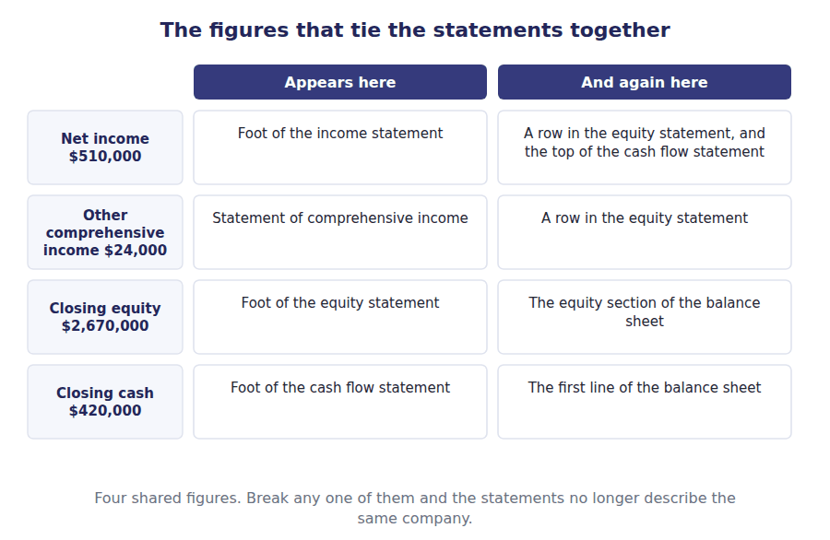
Part 1 · What articulation means and why it is useful
Exercise 6A Read and complete. Write one word in each space.
OBJECTIVE | State what articulation is and name the figures that carry it.
YOU WILL NEED | Handouts 2, 3, 4 and 5, for the four statements separately.
HOW TO START | • Each sentence names one shared figure. The blank is the figure or the statement it travels to.  • Blank 2 is the figure that appears in three statements, more than any other.  • The last blank is what a question is really testing when it gives you three statements and asks for the fourth.

WORD BANK
articulation · balance · cash · income · revenue · separate · shared
Not every word is used.

R2 The four statements are views of one set of records, so figures computed in one of them reappear in another. The accountant’s word for this is ¹ , and it is the reason the statements can be checked against each other.
Net ² does the most travelling. It is the last line of the income statement, a row in the statement of changes in equity, and the first line of the operating section of the cash flow statement.
Two more links close the set. The closing balance of the equity statement is the equity section of the ³ sheet, and the closing figure of the cash flow statement is the cash line at the top of that same balance sheet.
This is what makes a certain kind of exam question possible. If you are given three statements and asked to produce a figure from the fourth, the question is not testing arithmetic. It is testing whether you know which figures are ⁴ .
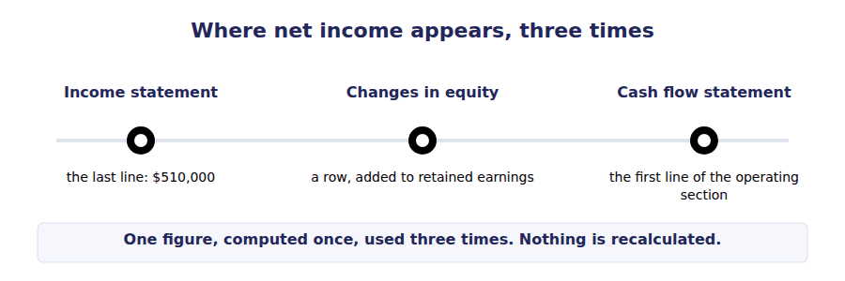
Part 2 · Why recognition and cash are different dates the accrual basis
Exercise 6B Read and complete.
OBJECTIVE | Explain why a transaction can hit the income statement in one year and the cash flow statement in another.
YOU WILL NEED | Exercise 6A
HOW TO START | • Blank 1 is the name of the basis of accounting that separates the two dates.  • Blank 3 is the balance sheet item that exists only because the two dates differ.  • The last blank is the expense that reaches the income statement without ever moving cash.

WORD BANK
accrual · cash · Depreciation · interest · payable · pays · receivable
Not every word is used.

R2 Under the ⁵ basis, a transaction is recorded when it occurs, not when the cash moves. Northwind recognises a sale when the components leave the warehouse and the customer becomes obliged to pay, which may be weeks before any money arrives.
The income statement therefore reports the sale in the year the goods shipped. The cash flow statement reports nothing at all until the customer ⁶ , which may fall in the following year.
The gap between the two dates is not lost. It sits on the balance sheet as a ⁷ , and it is the reason a growing company can be profitable and short of cash at the same time.
The same separation runs the other way. ⁸ of $250,000 was charged against this year’s income although no cash left the company: the cash went out years earlier, when the equipment was bought.
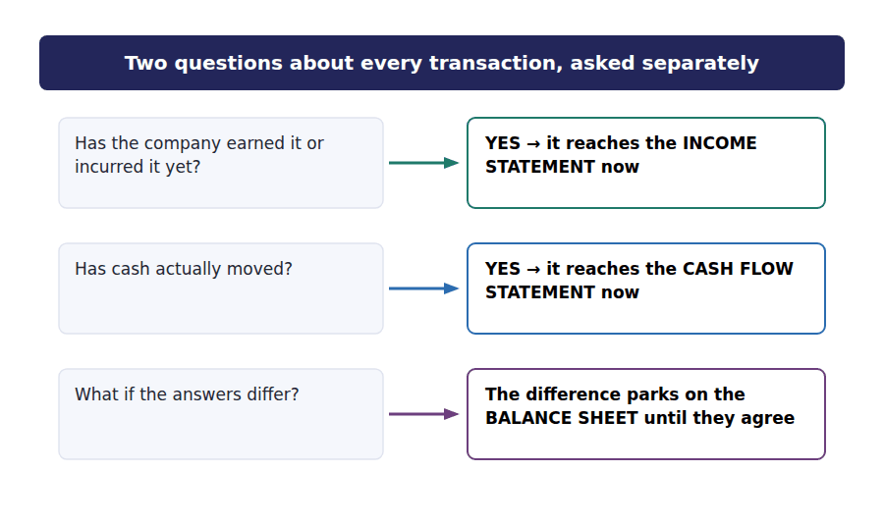
Part 3 · Trace six transactions the grid at the centre of the volume
Exercise 6C Complete the grid. Write an arrow for the direction, or a dash where the transaction does not reach that statement.
OBJECTIVE | Trace each transaction through all four statements, including the ones it does not touch.
YOU WILL NEED | Exercises 6A and 6B
HOW TO START | • Two of these six transactions never reach the income statement at all. Find them first.  • One of them reaches the income statement but never the cash flow statement.  • Work one row at a time, left to right. Do not fill a column down the page.

Transaction | Income statement | Balance sheet | Changes in equity | Cash flows
Sell components on credit, $4,800,000
Collect cash from a customer
Buy equipment for cash, $430,000
Charge depreciation, $250,000
Declare and pay dividends, $170,000
Issue shares, $140,000

1 | 2 | 3 | 4 | 5 | 6

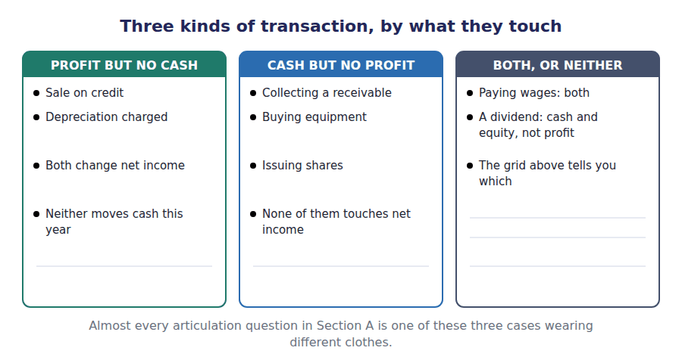
Part 4 · The entry underneath reading two sides back into the statements
R2 Every transaction is recorded with equal amounts on the left and the right, and that record is called a journal entry. Reading the two sides of a journal entry tells you which statements the transaction will reach, before you open a single statement.
R2 The rule is short. An account that belongs on the balance sheet keeps its balance there. An account that belongs on the income statement feeds net income, and net income then travels to the equity statement. If neither side of the entry is cash, the cash flow statement sees nothing.
Exercise 6D Complete the journal entries. Write the account names and the amounts.
OBJECTIVE | Write the entry for four transactions and say which statements each one reaches.
YOU WILL NEED | Exercise 6C
HOW TO START | • Each entry has equal amounts on the two sides. If yours does not, you have missed an account.  • J3 has no cash on either side. Say what that means for the cash flow statement before you move on.  • J4 touches equity directly without passing through the income statement.

J1 Components sold on credit, $4,800,000. Revenue is recognised although no cash has arrived.
Account | Debit | Credit
Accounts Receivable
Sales Revenue
J2 Cash collected from a customer, $1,200,000.
Account | Debit | Credit
Cash
Accounts Receivable
J3 Depreciation charged for the year, $250,000. No cash moves. The cash flow statement sees nothing.
Account | Debit | Credit
Depreciation Expense
Accumulated Depreciation
J4 Dividends declared and paid, $170,000. Equity falls without the income statement being touched.
Account | Debit | Credit
Retained Earnings
Cash

R2 The four accounts below are drawn as T-accounts: one account each, with the left side and the right side kept apart. A T-account is scratch paper rather than a statement, and it is the fastest way to see what a run of entries did to one account.
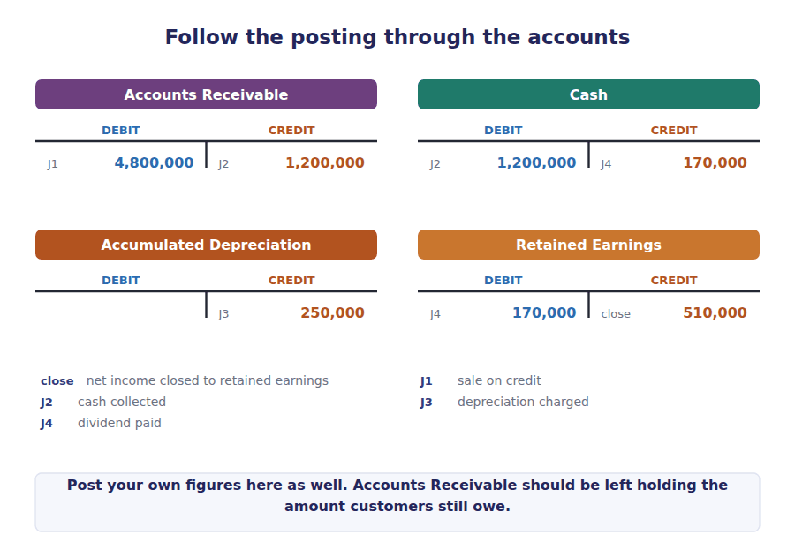
Part 5 · Produce the missing figure the question articulation makes possible
Exercise 6E Read and complete. This passage is written at exam pitch.
OBJECTIVE | Produce a figure from one statement using figures given in the others.
YOU WILL NEED | Exercises 6A to 6D
HOW TO START | • Each sentence gives you two figures and asks for the third. Write the relationship out before you compute.  • Blank 2 is the only figure that can close the retained earnings roll-forward.  • The last blank follows from the cash flow statement and the opening cash balance, not from anything on the income statement.

WORD BANK
$1,920,000 · $170,000 · $2,670,000 · $420,000 · $510,000 · $708,000 · reported
Not every word is used.

R3 Suppose the income statement and the balance sheet are in front of you but the equity statement is missing. Retained earnings opened at $934,000 and closed at $1,274,000, and net income for the year was $510,000. The dividend must therefore have been ⁹ .
Now suppose the cash flow statement is missing instead. Operating activities generated $708,000, investing used ($393,000) and financing used ($180,000), and cash opened at $285,000. Closing cash must be ¹⁰ , and that figure has to agree with the first line of the balance sheet.
Neither question required a single new calculation about the business. Both were answered from figures the other statements had already ¹¹ .
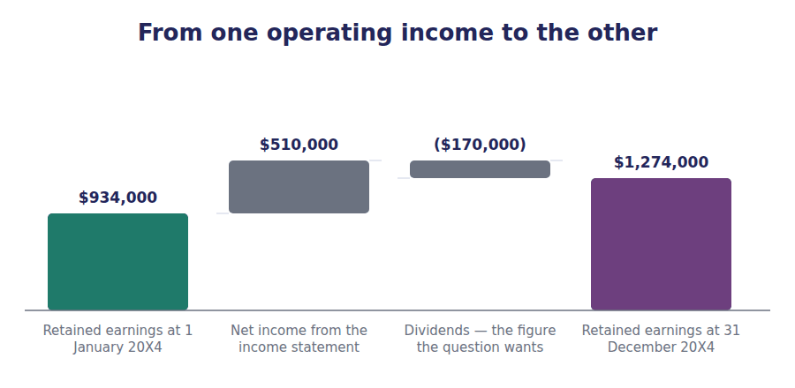
Watch out! If a question gives you three statements, read what it has already told you before you compute anything. Most of these questions are solved by subtraction, and the examiner is checking that you know which figures are shared.
Part 6 · Exam pitch the questions as the CMA sets them
1. [Level B] A company sells goods on credit in December and collects the cash the following March. In the December financial statements, the sale affects:
(A) The income statement and the cash flow statement
(B) The income statement and the balance sheet, but not the cash flow statement
(C) The cash flow statement and the balance sheet only
(D) None of the statements until the cash is collected
2. [Level B] Depreciation expense of $250,000 is charged. Which statement is NOT affected?
(A) The income statement
(B) The balance sheet
(C) The statement of changes in equity
(D) The statement of cash flows, in terms of the net change in cash
3. [Level B] Retained earnings opened at $934,000 and closed at $1,274,000. Net income for the year was $510,000. Dividends declared during the year were:
(A) $170,000
(B) $510,000
(C) $24,000
(D) $340,000
4. [Level A] Which figure appears in three of the four financial statements?
(A) Total assets
(B) Net income
(C) Cash
(D) Revenue
5. [Level A] A company issues shares for cash. The effect on the financial statements is:
(A) Revenue increases and cash increases
(B) Cash increases, equity increases, and net income is unaffected
(C) Cash increases and a liability increases
(D) Cash increases and retained earnings increases
6. [Level B] Operating activities generated $708,000, investing used ($393,000) and financing used ($180,000). Cash at the start of the year was $285,000. Cash reported on the closing balance sheet must be:
(A) $420,000
(B) $135,000
(C) $708,000
(D) $285,000
7. [Level C] A company records a transaction with a debit to an expense account and a credit to a liability account. Which statement is affected in the current period in terms of cash?
(A) The income statement only
(B) The balance sheet only
(C) Neither the cash flow statement’s net change in cash, because no cash moved
(D) All four statements equally
ADAPTIVE TIP Train yourself to ask two separate questions about every transaction: has it been earned or incurred, and has cash moved? Most Section A errors come from answering one of them and assuming the other has the same answer.

Handout 7 · Building the Balance Sheet and the Income Statement
One list of balances goes in. Two statements come out. The only skill is knowing which line goes where, and in what order.
Volume 1 · The Framework and the Statements · R2 throughout, with R3 in the final part
LANGUAGE FOCUS
Register you are working in | R2 textbook English. The vocabulary here is procedural: the words describe what you do, in the order you do it.
Say it exactly like this | extract a trial balance · post an adjusting entry · accrue an expense · close the books · transfer a balance to retained earnings · present a statement
Words that are not the same | trial balance / balance sheet · accrued expense / prepaid expense · permanent account / temporary account · adjust / close
Remember | A trial balance is not a balance sheet. It lists every account, including the income ones, and it is not a statement at all. Balancing is not the same as being correct. A trial balance that balances can still have an amount in the wrong account.

What you will be able to do when this handout is finished
- Say what a trial balance is, and what its balancing does and does not prove.
- Sort every account in a trial balance to the statement it belongs in.
- Build the income statement and the balance sheet from a trial balance, in the right order.
- Explain why the income statement has to be built before the balance sheet.
- Name the two kinds of account and say which ones survive the year end.

One list in, two statements out
Everything Northwind recorded during 20X4 ends up in a single list of account balances, called a trial balance. It is not a statement and it is not presented to anybody. It is the working paper the statements are built from.
The list on the next page has $10,706,000 of debits and the same of credits. That equality is worth something, but far less than students assume, and Part 1 is about exactly how much.
From this one list you will build two statements. The order matters, and it is not the order they are presented in.

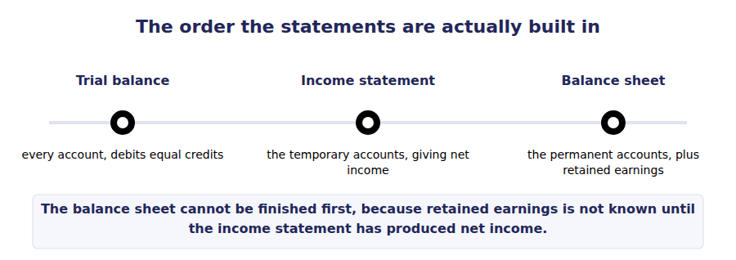
Part 1 · What balancing proves and what it does not
Exercise 7A Read and complete. Write one word in each space.
OBJECTIVE | Say what a trial balance is and what its balancing does not prove.
YOU WILL NEED | Handout 6, for how an entry has two equal sides.
HOW TO START | • Blank 2 is the reason the two columns are always equal, and it is a property of the recording system, not of the figures.  • Blanks 3 and 4 are two kinds of error that leave the columns equal. They are the reason balancing proves so little.  • Say the last sentence aloud. It is the point of the whole exercise.

WORD BANK
account · cash · entirely · incorrectly · paper · statement · twice
Not every word is used.

R2 A trial balance lists every account in the ledger with its balance, debits in one column and credits in the other. It is a working ¹ , not a statement, and no user ever sees it.
The two columns always agree, and they agree for a mechanical reason: every transaction was recorded with equal amounts on both sides, so the totals cannot differ unless an entry was recorded ² on one side only.
What that equality does not prove is accuracy. An amount posted to the wrong ³ leaves the columns equal. So does a transaction omitted ⁴ , because both of its sides are missing together.
A trial balance that balances tells you the arithmetic of the recording held. It tells you nothing whatever about whether the right amounts went into the right accounts.
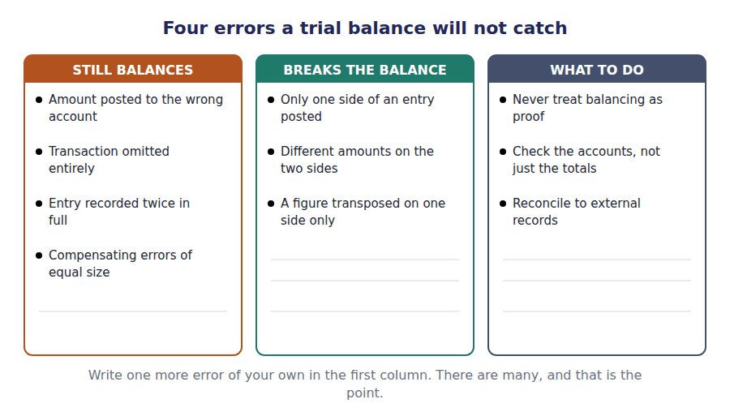
Part 2 · Sorting the list which account goes where
R2 Every account in the list belongs to exactly one of two families. Temporary accounts — revenue, expenses and dividends — measure what happened during the year, and they start the next year at zero. Permanent accounts — assets, liabilities and equity — carry their balances forward.
R2 That division is the same division as the one between the two statements. The temporary accounts become the income statement; the permanent ones become the balance sheet. Dividends are the one account that is temporary without being on the income statement: it is closed to retained earnings directly, which is why it appeared as its own row in the equity statement.
Exercise 7B Sort each account into its column.
OBJECTIVE | Sort the trial balance accounts into the statement each one belongs in.
YOU WILL NEED | Exercise 7A, and the two paragraphs above.
HOW TO START | • Ask whether the account measures something that happened during the year, or something that exists at the year end.  • Two of these accounts are contra accounts. They belong with the asset they reduce, not in a column of their own.  • One account is temporary but does not appear on the income statement. Find it.

Account from the trial balance | INCOME STATEMENT | BALANCE SHEET | NEITHER — equity statement
1. Sales revenue
2. Accumulated depreciation
3. Cost of goods sold
4. Dividends declared
5. Allowance for credit losses
6. Interest expense
7. Deferred tax liability
8. Gain on disposal of equipment
9. Retained earnings, at 1 January

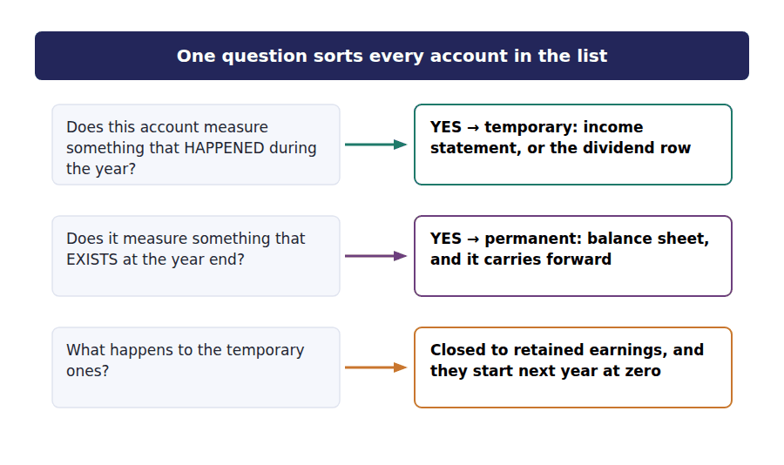
Part 3 · The list itself Northwind at 31 December 20X4
Account (debit balance) | Debit | Account (credit balance) | Credit
Cash | $420,000 | Allowance for credit losses | $46,000
Accounts receivable | $760,000 | Accumulated depreciation | $1,180,000
Inventory | $845,000 | Accounts payable | $530,000
Prepaid expenses | $61,000 | Accrued liabilities | $185,000
Investments in debt securities | $390,000 | Income taxes payable | $95,000
Property, plant and equipment, at cost | $3,200,000 | Current portion of long-term debt | $150,000
Intangible assets | $240,000 | Long-term debt | $1,200,000
Goodwill | $300,000 | Deferred tax liability | $160,000
Cost of goods sold | $2,880,000 | Common stock, $1 par | $300,000
Selling expenses | $560,000 | Additional paid-in capital | $1,020,000
Administrative expenses | $345,000 | Retained earnings, at 1 January | $934,000
Depreciation and amortisation | $275,000 | Accumulated other comprehensive income | $76,000
Interest expense | $90,000 | Sales revenue | $4,800,000
Income tax expense | $170,000 | Gain on disposal of equipment | $30,000
Dividends declared | $170,000
Total debits | $10,706,000 | Total credits | $10,706,000

Exercise 7C Write the figures from the trial balance into the statement. Use only the accounts that belong there.
OBJECTIVE | Build the income statement from the temporary accounts in the list.
YOU WILL NEED | Exercise 7B · Handout 3, for the shape of the statement.
HOW TO START | • Nine accounts in the list are temporary. Find them before you write anything.  • Dividends declared is temporary, and it is not one of the nine. It does not belong on this statement.  • The gain on disposal goes below operating income, not in revenue.

Northwind Components, Inc. · Income Statement for the year ended 31 December 20X4
Revenue
Cost of goods sold
Gross margin
Selling expenses
Administrative expenses
Depreciation and amortisation
Total operating expenses
Operating income
Interest expense
Gain on disposal of equipment
Income before income taxes
Income tax expense
Net income

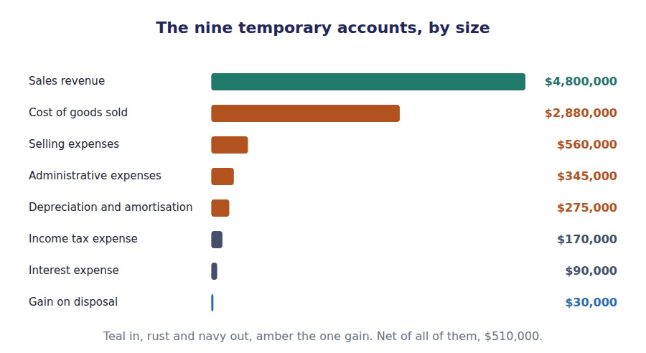
Part 4 · Closing, and the figure that moves why the income statement comes first
Exercise 7D Read and complete.
OBJECTIVE | Explain why retained earnings on the trial balance is not the figure the balance sheet reports.
YOU WILL NEED | Exercise 7C
HOW TO START | • Look at the trial balance again. Retained earnings is listed at its balance on one particular date, and the heading says which.  • Blank 2 is what the closing entry does to the temporary accounts.  • The final figure is the one you computed in Exercise 7C, adjusted for one other temporary account.

WORD BANK
after · before · closed · December · deducted · January · opened
Not every word is used.

R2 The trial balance shows retained earnings as $934,000, and that is the balance at 1 ⁵ , not at the year end. Nothing has yet been done with the year’s results.
At the year end the temporary accounts are ⁶ : their balances are transferred into retained earnings and the accounts are left at zero, ready to measure the next year.
Two things arrive. Net income of $510,000 is added, and dividends declared of $170,000 are ⁷ , which is exactly the roll-forward you built in Handout 4.
Only now is retained earnings known: $1,274,000. This is why the income statement has to be prepared ⁸ the balance sheet, even though it is the balance sheet that gets presented first.
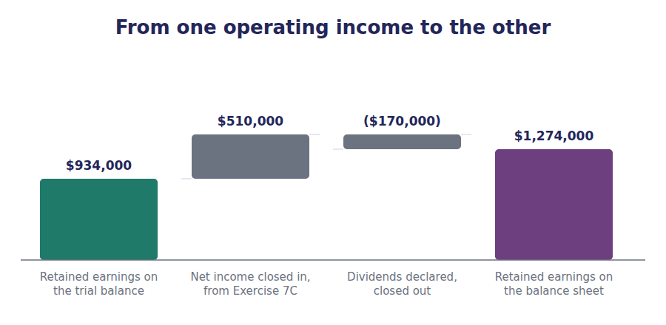
Exercise 7E Write the figures into the statement. The equity section uses the closing figure, not the trial balance figure.
OBJECTIVE | Build the balance sheet, using the retained earnings figure you have just produced.
YOU WILL NEED | Exercises 7C and 7D · Handout 2, for the shape of the statement.
HOW TO START | • Take the permanent accounts straight from the trial balance, except retained earnings.  • The two contra accounts are deductions. Write them in brackets under the asset they reduce.  • If the two totals do not agree, check retained earnings first. It is the only figure on this statement that is not copied from the list.

Northwind Components, Inc. · Balance Sheet at 31 December 20X4
Total current assets
Investments in debt securities
Property, plant and equipment, net
Intangible assets and goodwill
TOTAL ASSETS
Total current liabilities
Long-term debt
Deferred tax liability
Total liabilities
Common stock and paid-in capital
Retained earnings
Accumulated other comprehensive income
Total shareholders’ equity
TOTAL LIABILITIES AND EQUITY

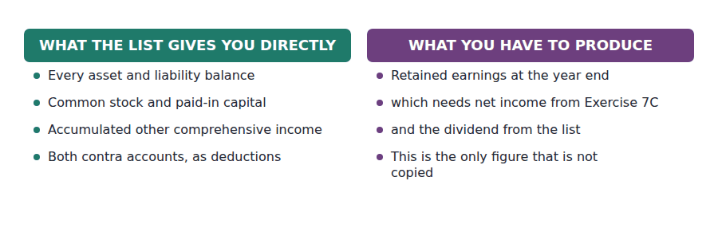
Watch out! The single most common failure in this handout is copying retained earnings from the trial balance. The balance sheet then misses by exactly $340,000, which is net income less dividends. If your balance sheet is out, check that figure before anything else.
Part 5 · Exam pitch the questions as the CMA sets them
1. [Level A] A trial balance balances. This proves that:
(A) No errors have been made in the accounting records
(B) Every transaction has been recorded in the correct account
(C) Total debits recorded equal total credits recorded
(D) The financial statements will present fairly
2. [Level B] Which of the following accounts is closed at the end of the reporting period?
(A) Accumulated depreciation
(B) Dividends declared
(C) Allowance for credit losses
(D) Additional paid-in capital
3. [Level B] A company’s trial balance shows retained earnings of $600,000, net income for the year of $180,000 and dividends declared of $50,000. Retained earnings on the balance sheet will be:
(A) $600,000
(B) $730,000
(C) $780,000
(D) $550,000
4. [Level C] Why must the income statement be prepared before the balance sheet?
(A) Because the income statement is presented first in the annual report
(B) Because retained earnings on the balance sheet cannot be known until net income has been determined
(C) Because the balance sheet depends on the cash flow statement
(D) Because the trial balance does not include revenue accounts
5. [Level B] An accountant posts a $9,000 payment for insurance to the administrative expenses account instead of to prepaid expenses. The trial balance will:
(A) Fail to balance by $9,000
(B) Fail to balance by $18,000
(C) Still balance, although the statements will be wrong
(D) Still balance, and the statements will be unaffected
6. [Level C] Northwind’s trial balance totals $10,706,000 on each side. After the statements are prepared, total assets are $4,990,000. The difference between these two figures is explained by:
(A) An error in the trial balance
(B) The trial balance including income statement accounts and contra accounts, which the balance sheet nets or excludes
(C) The omission of retained earnings from the balance sheet
(D) Deferred tax, which appears in only one of the two
7. [Level B] A cost has been incurred but not yet invoiced at the year end. The adjusting entry required is:
(A) Debit an expense, credit a liability
(B) Debit a liability, credit an expense
(C) Debit an asset, credit an expense
(D) No entry, because no invoice has been received
ADAPTIVE TIP When a question hands you a trial balance, your first move is to mark every account T or P — temporary or permanent. Both statements then write themselves, and you will not copy retained earnings into the wrong place.

Handout 8 · Building the Statement of Cash Flows (Indirect Method)
Start at net income, remove everything that was not cash, and you arrive at cash. Every adjustment has a reason you can state.
Volume 1 · The Framework and the Statements · R2 throughout, with R3 in the final part
LANGUAGE FOCUS
Register you are working in | R2 textbook English. This handout is procedural, and the vocabulary is about direction: add back, deduct, reverse.
Say it exactly like this | add back a non-cash expense · reverse a gain · adjust for the movement in working capital · reconcile net income to cash · arrive at net cash provided · present a subtotal
Words that are not the same | add back / deduct · source of cash / use of cash · increase in an asset / increase in a liability · expense / payment
Remember | Adding back depreciation does not create cash. It removes a deduction that never used cash in the first place. An increase in a current asset is a use of cash, not a source, however healthy it looks.

What you will be able to do when this handout is finished
- State what the indirect method is reconciling, and in which direction.
- Add back a non-cash expense and say why the add-back is not a cash inflow.
- Reverse a gain out of operating activities and say where it reappears.
- Work out the cash effect of a movement in any working capital account.
- Build Northwind’s complete statement and prove it against the balance sheet.

From $510,000 of profit to $708,000 of operating cash
Northwind earned $510,000 and generated $708,000 of cash from its trading. The two figures differ by $198,000, and the operating section of this statement exists to explain every dollar of that difference.
The indirect method starts at net income and works towards cash. It is a reconciliation, not a fresh calculation: nothing in it is a new fact about the business, and every line is a correction to something already reported.
There are three kinds of correction, and once you can name which kind a line is, the sign takes care of itself.

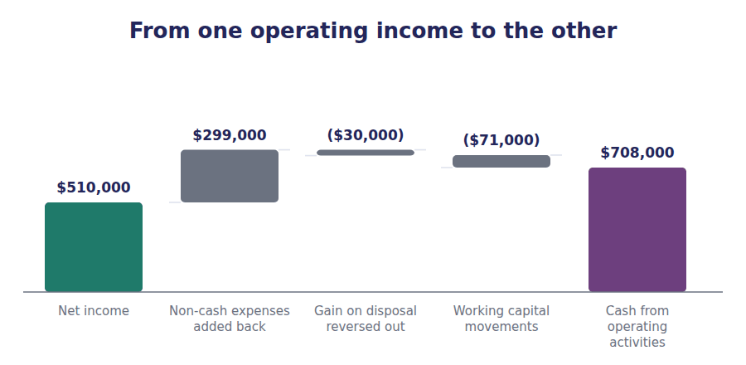
Part 1 · The three corrections what the operating section actually does
Exercise 8A Read and complete. Write one word in each space.
OBJECTIVE | Name the three kinds of correction and say why each one is needed.
YOU WILL NEED | Handout 5, for the three sections. · Handout 6, for why profit and cash differ.
HOW TO START | • Each paragraph is one kind of correction. The blank names it or names its direction.  • Blank 2 is what you do with an expense that used no cash.  • Blank 4 is where the disposal proceeds belong instead. It is a different section of the same statement.

WORD BANK
added · deducted · financing · fixed · ignored · investing · working
Not every word is used.

R2 The operating section starts at net income and corrects it until what is left is cash. There are three kinds of correction and nothing else.
The first deals with expenses that reduced income without using cash. Depreciation and amortisation of $275,000 was charged, but the cash left years ago when the assets were bought, so the amount is ¹ back.
The second deals with items that belong in another section. The $30,000 gain on disposal increased net income, but it was not generated by trading at all. It is ² here, and the whole of the $65,000 proceeds appears instead under ³ activities, where a disposal belongs.
The third deals with timing. Revenue was recognised before some customers paid, and costs were incurred before some suppliers were paid. Those gaps sit in the ⁴ capital accounts, and the movement in each one is an adjustment.
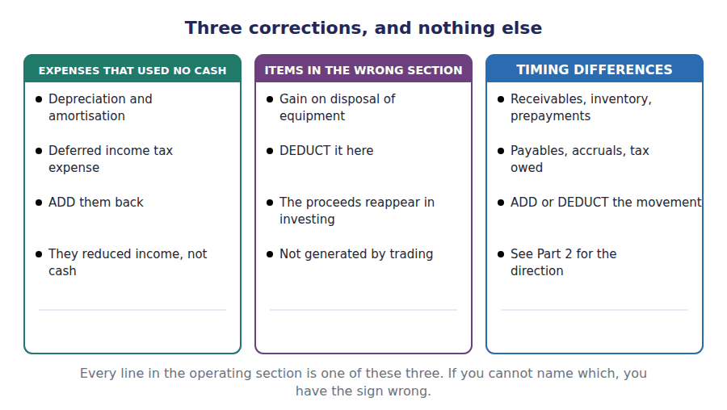
Part 2 · Getting the sign right the working capital rule
R2 The working capital adjustments are where signs go wrong, and the rule behind them is short. Cash is what is left after everything else has moved. If something else goes up, cash went somewhere to pay for it.
R2 So an increase in a current asset is a use of cash: the company is holding more inventory, or has let customers owe it more, and either way the money is tied up rather than in the bank. An increase in a current liability is the reverse: the company is holding on to cash it has not yet paid out.
Exercise 8B Complete the last two columns. Write the change, then whether it added to or took from cash.
OBJECTIVE | Work out the cash effect of each working capital movement.
YOU WILL NEED | Exercise 8A, and the two paragraphs above.
HOW TO START | • Compute the change first, then apply the rule. Do not try to do both in one step.  • The first three rows are assets. The last three are liabilities. The rule reverses between them.  • Write the effect in brackets when it took cash away.

Working capital account | 31 Dec 20X3 | 31 Dec 20X4 | Change | Effect on cash
Accounts receivable, net | $652,000 | $714,000
Inventory | $780,000 | $845,000
Prepaid expenses | $54,000 | $61,000
Accounts payable | $495,000 | $530,000
Accrued liabilities | $170,000 | $185,000
Income taxes payable | $82,000 | $95,000

1 | 2 | 3 | 4 | 5 | 6
7 | 8 | 9 | 10 | 11 | 12

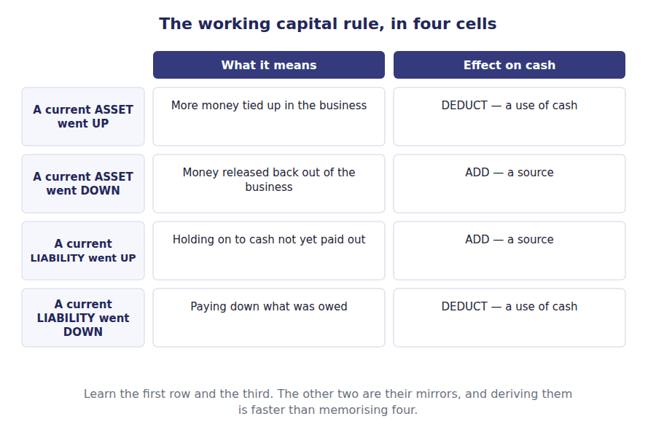
Part 3 · Build it the whole statement
Exercise 8C Write the figures into the blank statement. Work down the page one section at a time.
OBJECTIVE | Build Northwind’s complete statement of cash flows.
YOU WILL NEED | Exercises 8A and 8B · Handout 5, for which section each item belongs in.
HOW TO START | • The operating section is the only one that needs the corrections. The other two are simply the cash amounts.  • The disposal appears twice in your working: as a deduction of the gain in operating, and as the full proceeds in investing.  • The last line must equal the cash figure on the balance sheet. That is the proof the statement is right.

Northwind Components, Inc. · Statement of Cash Flows for the year ended 31 December 20X4
Cash flows from operating activities
Net income
Adjustments for items not involving cash
Depreciation and amortisation
Gain on disposal of equipment
Deferred income tax expense
Changes in working capital
Increase in accounts receivable, net
Increase in inventory
Increase in prepaid expenses
Increase in accounts payable
Increase in accrued liabilities
Increase in income taxes payable
Net cash provided by operating activities
Cash flows from investing activities
Purchase of property, plant and equipment
Proceeds from disposal of equipment
Purchase of debt securities
Net cash used in investing activities
Cash flows from financing activities
Proceeds from issuing common stock
Repayment of long-term debt
Dividends paid
Net cash used in financing activities
Net increase in cash and cash equivalents
Cash and cash equivalents at 1 January 20X4
Cash and cash equivalents at 31 December 20X4

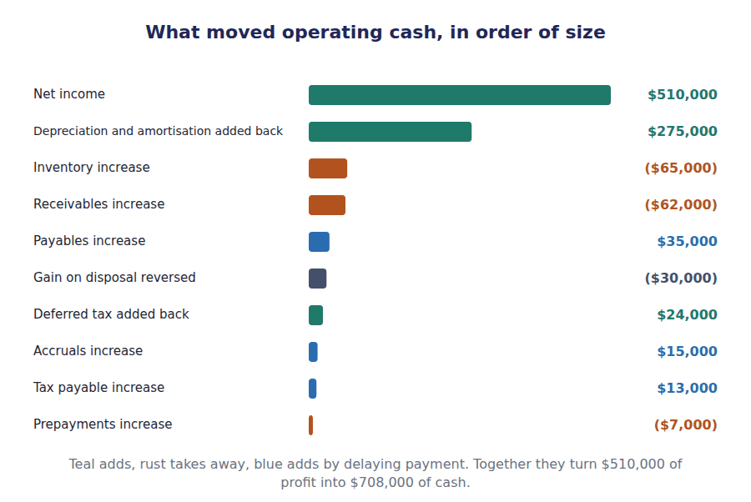
Part 4 · Prove it the check that closes the volume
Exercise 8D Read and complete. This passage is written at exam pitch.
OBJECTIVE | Prove the statement against the balance sheet, and say what a failure would mean.
YOU WILL NEED | Exercise 8C
HOW TO START | • Blank 1 is the figure the three sections must add to.  • Blank 3 is the statement the proof is made against.  • The last blank is what you should check first when the proof fails, and it is a direction, not an account.

WORD BANK
$135,000 · $285,000 · $420,000 · $708,000 · balance · income · sign
Not every word is used.

R3 The three sections total $708,000, ($393,000) and ($180,000). Added together they give a net increase in cash of ⁵ .
Cash at the beginning of the year was $285,000, so cash at the end must be ⁶ , and that figure appears without adjustment as the first line of the ⁷ sheet.
If the two do not agree, the error is almost never in the investing or financing sections, which are simply lists of cash amounts. It is in the operating section, and it is usually a ⁸ : an adjustment added where it should have been deducted, which puts the statement out by twice the amount of the item.
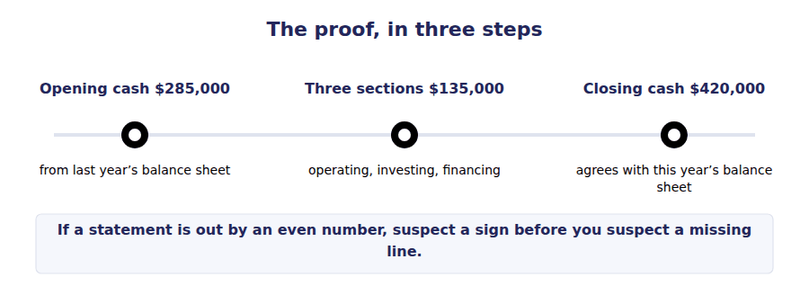
Watch out! The disposal is the item most often handled wrongly. The gain of $30,000 comes out of operating, and the whole $65,000 of proceeds goes into investing. Putting the gain in investing, or the proceeds in operating, breaks the statement in two places at once.
Part 5 · Exam pitch the questions as the CMA sets them
1. [Level B] Under the indirect method, depreciation expense is added back to net income because:
(A) Depreciation generates cash for the replacement of assets
(B) Depreciation reduced net income without using cash in the period
(C) Depreciation is an investing activity
(D) Depreciation is not deductible in computing taxable income
2. [Level B] Accounts receivable rose from $652,000 to $714,000 during the year. The effect on operating cash flow is:
(A) An addition of $62,000
(B) A deduction of $62,000
(C) No effect, because receivables are not cash
(D) A deduction of $62,000 in investing activities
3. [Level C] Equipment with a carrying amount of $35,000 was sold for $65,000. Under the indirect method this is reported as:
(A) $65,000 added in investing activities only
(B) $30,000 deducted in operating activities and $65,000 added in investing activities
(C) $30,000 added in operating activities
(D) $30,000 added in investing activities
4. [Level A] Which of the following movements would INCREASE cash provided by operating activities?
(A) An increase in inventory
(B) A decrease in accounts payable
(C) An increase in accrued liabilities
(D) An increase in prepaid expenses
5. [Level C] A company’s statement of cash flows is out of balance by $46,000, an even amount. The most likely cause is:
(A) A missing item of $46,000
(B) An adjustment of $23,000 included with the wrong sign
(C) An error in the investing section
(D) An error in the opening cash balance
6. [Level B] Northwind’s net income is $510,000 and cash provided by operating activities is $708,000. The difference is explained by:
(A) Dividends paid during the year
(B) Non-cash expenses, the reversal of a gain, and movements in working capital
(C) The purchase of equipment
(D) The issue of shares
7. [Level A] Under the indirect method, the figure at which the operating section begins is:
(A) Revenue
(B) Gross margin
(C) Net income
(D) Cash collected from customers
ADAPTIVE TIP Write the three correction types down the margin before you touch a figure: non-cash, wrong section, timing. Then take each line of the question in turn and label it. The sign follows from the label, and you will stop guessing.

Handout 9 · What Each Statement Cannot Tell You
Eight handouts built these statements. This one is about reading them honestly, which means knowing where each of them stops.
Volume 1 · The Framework and the Statements · R2 throughout, closing at R3
LANGUAGE FOCUS
Register you are working in | R2 textbook English, rising to R3 for the final passage. The vocabulary here is evaluative: it describes limits and doubts.
Say it exactly like this | carry an asset at historical cost · rely on an estimate · omit an item from the statements · disclose in the notes · distort a comparison · window-dress a balance sheet
Words that are not the same | recognised / disclosed · cost / value · omitted / immaterial · measured / estimated
Remember | A figure in the statements is not a fact about value. It is the result of applying a measurement rule. Not everything valuable is an asset. Most of what makes a company worth buying never appears on its balance sheet.

What you will be able to do when this handout is finished
- Name three limitations that apply to the balance sheet and give an example of each.
- Say why net income is more open to judgement than operating cash flow.
- Explain why a company’s most valuable resources may not appear as assets.
- Recognise window dressing from a pattern of year-end movements.
- State what the notes add, and why recognition and disclosure are not the same thing.

Eight handouts of building, one of doubting
You have now built all four of Northwind’s statements and proved them against one another. Total assets are $4,990,000, net income is $510,000, and operating cash flow is $708,000.
None of those figures is a fact about Northwind in the way that its cash balance is a fact. Each is the result of applying a measurement rule, and a different but equally acceptable rule would have given a different number.
This handout is about where each statement stops. It is not a criticism of the statements. A reader who knows the limits reads them better, and the exam tests exactly that reader.

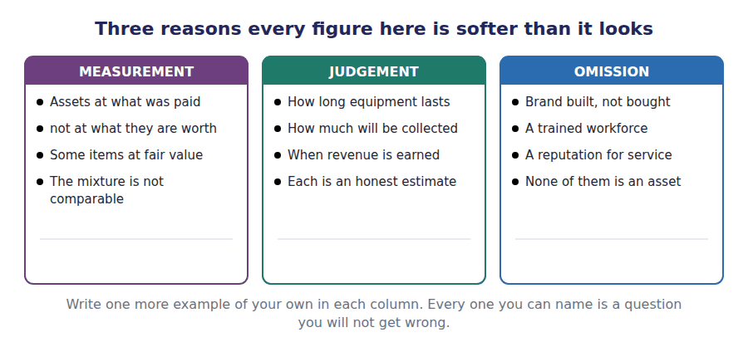
Part 1 · The balance sheet cost, mixture and omission
Exercise 9A Read and complete. Write one word in each space.
OBJECTIVE | Name three limitations of the balance sheet and give an example of each.
YOU WILL NEED | Handout 2, for what the balance sheet reports.
HOW TO START | • Each paragraph is one limitation. The blank names it or names its consequence.  • Blank 1 is the measurement basis most assets use.  • The last blank is the kind of resource that is built rather than bought, and therefore never recognised.

WORD BANK
asset · current · external · historical · internally · liability · mixture
Not every word is used.

R2 Most of what the balance sheet reports is measured at ¹ cost: what was paid, less what has been written off since. Northwind’s warehouse sits at a figure fixed years ago, and no reader can tell from the statement what it would fetch today.
The second limitation follows from the first. A few items — the debt securities, for one — are carried at current value instead, so the total of $4,990,000 is a ² of two measurement bases added together. The total is arithmetically correct and economically meaningless.
The third is what is not there at all. Northwind’s relationships with its suppliers, the knowledge of its warehouse staff and its reputation for next-day delivery are real resources, and none of them is an ³ on this statement.
The rule behind that omission is consistent rather than arbitrary. A brand bought from somebody else has a price and is recognised; a brand built by trading well has no separable cost, so an ⁴ generated intangible is almost never recognised at all.
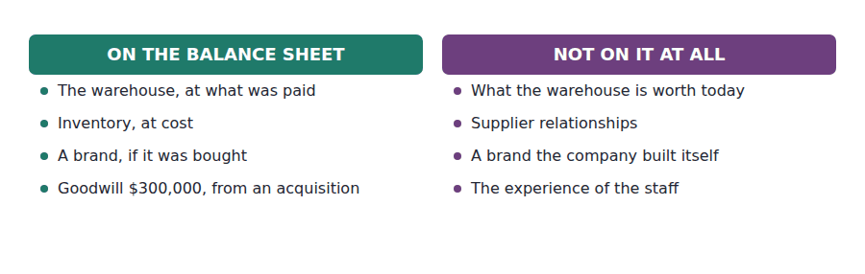
Part 2 · The income statement where judgement enters
R2 Net income is the most quoted figure in the statements and the most dependent on judgement. Three estimates alone move it, and all three are made by the people whose results are being measured.
R2 How long equipment will last decides the depreciation charge. How much of the receivables will be collected decides the charge for credit losses. When a sale has been earned decides which year the revenue falls in. Each judgement is honest and defensible, and each one changes net income.
R2 There is a bias built into those judgements, and it has a name. Conservatism pushes an accountant towards caution when an estimate is genuinely uncertain, so a probable loss tends to be recognised sooner than a probable gain. It makes the statements asymmetric on purpose, and a reader comparing two years should know that the asymmetry is there.
Exercise 9B Complete the table. Write the direction of the effect on net income, and whether operating cash flow moves.
OBJECTIVE | Say how a change in one estimate moves net income, and whether cash moves with it.
YOU WILL NEED | Exercise 9A, and the two paragraphs above.
HOW TO START | • Each row is a change in one estimate only. Hold everything else constant.  • Ask whether any cash actually leaves the company because of the change.  • The last row is different from the first three. Read it carefully.

Change in an estimate | Effect on net income | Effect on operating cash flow
Equipment judged to last 10 years instead of 8 | ______________ | ______________
The allowance for credit losses raised by $50,000 | ______________ | ______________
Revenue on a shipment judged earned in 20X4, not 20X3 | ______________ | ______________
A customer actually pays an invoice in cash | ______________ | ______________

1 | 2 | 3 | 4 | 5 | 6
7 | 8

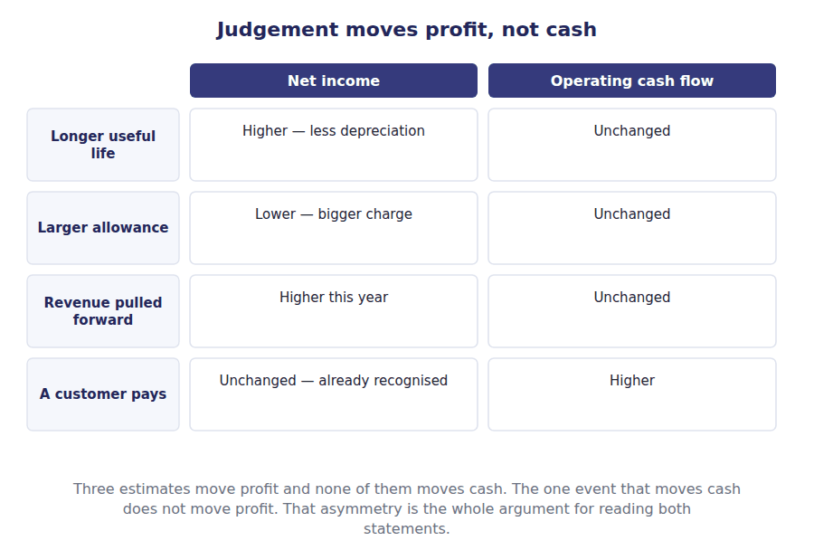
Part 3 · Timing, and the pattern it leaves window dressing
Exercise 9C Read and complete.
OBJECTIVE | Recognise window dressing from a pattern of year-end movements.
YOU WILL NEED | Exercise 9B
HOW TO START | • Blank 2 is the ratio that a year-end repayment is designed to improve.  • Blank 3 is the statement that gives the game away, because it covers the whole year rather than one date.  • The last blank is why most of this behaviour is not fraud.

WORD BANK
balance · flows · fraud · limitation · margin · ratio
Not every word is used.

R2 The balance sheet reports one date, and a company knows in advance which date that is. Paying down a short-term loan on 30 December and redrawing it on 2 January changes nothing about the business, and it changes the statement.
What it improves is the current ⁵ : current assets divided by current liabilities, measured at the one date the reader is shown. Any measure taken at a single moment can be arranged for in advance.
What exposes it is the statement of cash ⁶ , which covers the whole year rather than one instant, and the comparative figures, which let a reader see a pattern repeating every December.
Most of this is not fraud. The transactions are real and they are recorded correctly, which is exactly why it is a ⁷ of the statements rather than a breach of them.
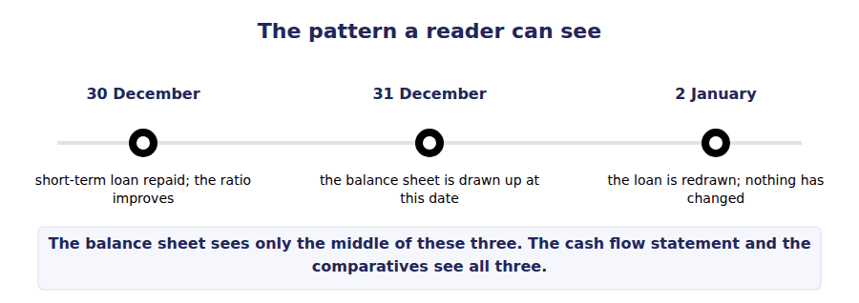
Part 4 · What the notes add recognition is not the same as disclosure
Exercise 9D Match each item to how it is reported.
OBJECTIVE | Say what the notes add and why a disclosed item is not the same as a recognised one.
YOU WILL NEED | Exercise 9C
HOW TO START | • Ask whether the item changes a total on the face of a statement. If it does, it is recognised.  • Two of these change no total at all.  • The last one changes a total only when a condition is met.

 | Item | Answer |  | Option
1 | Depreciation of $250,000 for the year |  | A | Recognised — it changes net income and the carrying amount
2 | The useful lives management has assumed |  | B | Disclosed — the figure is already recognised; this explains it
3 | A lawsuit the company will probably lose, amount estimable |  | C | Recognised — a probable, measurable obligation is a liability
4 | A lawsuit the company might lose, outcome genuinely uncertain |  | D | Disclosed — not probable enough to recognise, too important to omit
5 | A warehouse acquired by issuing shares |  | E | Disclosed — significant, but no cash moved, so no statement line
Recognition changes a total. Disclosure changes a reader’s understanding and leaves every total alone.

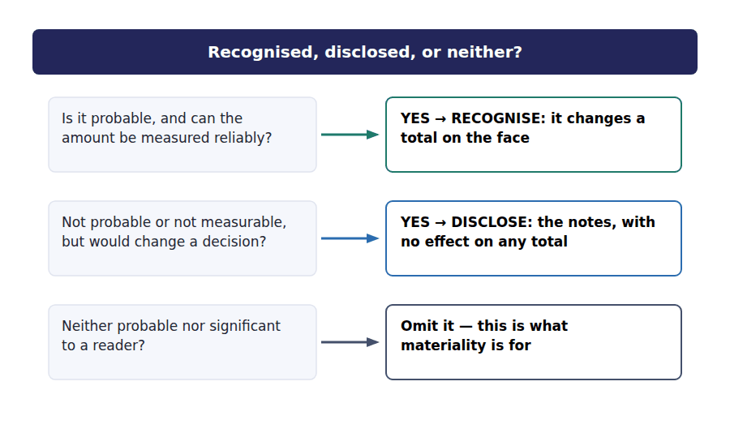
Part 5 · All four, side by side the summary to take into the exam
Statement | What it does well | What it cannot tell you
Balance sheet | Shows what is controlled and owed at a date, and what the claims rank | Historical cost mixed with current value; omits internally generated intangibles; can be arranged for at one date
Income statement | Shows performance over a period, separated into subtotals | Depends on estimates made by management; can be shifted between periods; does not show cash
Changes in equity | Shows every movement in the owners’ claim, with none left out | Says nothing about whether the movements were good for the business
Cash flows | Reports facts, with almost no judgement anywhere in it | Says nothing about profitability; a company can look healthy by not investing

Exercise 9E Read and complete. This passage is written at exam pitch.
OBJECTIVE | Say why cash flow is the hardest statement to manipulate, and what it still cannot show.
YOU WILL NEED | Exercises 9A to 9D, and the table above.
HOW TO START | • Blank 1 is what the cash flow statement contains almost none of, compared with the other three.  • Blank 3 is the thing a company can stop doing to make its cash look better in the short run.  • The final blank is the practice this handout has been building towards all the way through.

WORD BANK
financing · income · investing · judgement · revenue · separately · together
Not every word is used.

R3 Of the four statements the cash flow statement rests on the least ⁸ . A payment either left the bank or it did not, and no assumption about useful lives or collectability can change the figure.
That is why an analyst comparing two companies on the same industry will often start with operating cash flow rather than with net ⁹ , and why a persistent gap between the two is treated as a warning rather than as a curiosity.
It is not beyond arrangement either. A company that stops replacing its equipment reports stronger cash flow immediately, because the ¹⁰ outflow disappears while the trade carries on unchanged — for a while.
No single statement is sufficient, which is the conclusion this volume has been building towards. The four are read ¹¹ , and each one is the control on the others.
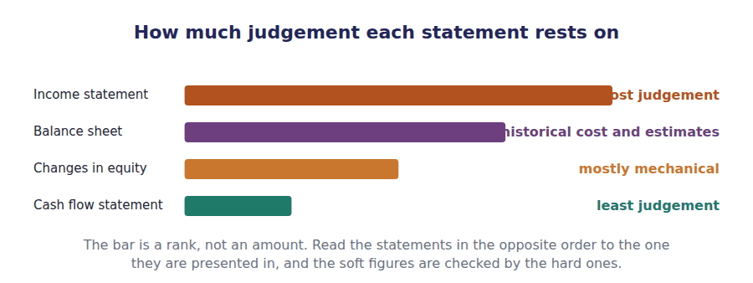
Watch out! Every limitation in this handout is a feature of honest statements prepared correctly. None of them is fraud. The exam asks you to read carefully, not to suspect wrongdoing.
Part 6 · Exam pitch the questions as the CMA sets them
1. [Level B] A company’s balance sheet reports total assets of $4,990,000. A user concludes that the company could be sold for approximately that amount. This conclusion is:
(A) Correct, because assets are measured at fair value
(B) Incorrect, because assets are measured on mixed bases and valuable resources are omitted
(C) Correct, provided the company has no liabilities
(D) Incorrect, because total assets always understate liabilities
2. [Level B] Which of the following is LEAST affected by management judgement?
(A) Net income
(B) The carrying amount of property, plant and equipment
(C) Cash provided by operating activities
(D) The allowance for credit losses
3. [Level C] A company has built a widely recognised brand over twenty years without acquiring it. On its balance sheet the brand is:
(A) Recognised as an intangible asset at its estimated fair value
(B) Recognised as goodwill
(C) Not recognised, because its cost cannot be separated from the cost of operating the business
(D) Recognised only if the company intends to sell it
4. [Level C] A company repays a short-term loan on 30 December and redraws it on 2 January. This is best described as:
(A) Fraudulent financial reporting
(B) An error requiring restatement
(C) Window dressing: real transactions arranged to improve a measure taken at one date
(D) A non-cash transaction requiring disclosure
5. [Level B] An item is disclosed in the notes rather than recognised in the statements. The consequence is that:
(A) It affects no total on the face of any statement
(B) It affects net income but not the balance sheet
(C) It affects the balance sheet but not net income
(D) It is immaterial by definition
6. [Level C] Management extends the assumed useful life of equipment from eight years to ten. In the current year this will:
(A) Increase net income and increase operating cash flow
(B) Increase net income and leave operating cash flow unchanged
(C) Leave net income unchanged and increase operating cash flow
(D) Decrease net income and leave operating cash flow unchanged
7. [Level C] An analyst observes that a company reports rising net income while operating cash flow falls for three consecutive years. The most appropriate response is:
(A) To conclude that fraud has occurred
(B) To ignore the cash flow statement, since net income is the measure of performance
(C) To investigate the working capital movements and the revenue recognition judgements behind the gap
(D) To conclude that the company has stopped investing
ADAPTIVE TIP When a question asks what a statement cannot tell you, work through three words in order: measurement, judgement, omission. Almost every limitation the CMA examines is one of those three, and naming the category usually names the answer.

Answer Key
Volume 1 · Handouts 1 to 9
Every answer carries the reason for it and the mistake it defeats.

Handout 1 · Who Reads These Statements, and What They Need answers
Completed text and exercises
# | Answer | Why | The trap it defeats
1 | general | One set of statements serves many readers, so none of them is served perfectly. | Students describe the statements as written for shareholders alone. Lenders and other creditors rank equally.
2 | primary | The framework names this group and no other.
3 | inflows | Everything in the framework points at future cash, not at past profit for its own sake.
4 | lender | A lender is paid a fixed amount and wants certainty.
5 | investor | An investor holds the residual claim and wants growth.
6 | management | This is the one that catches people in the exam. | Management is an internal user with unlimited access, which is exactly why the statements are not for them.
Match 1 | 1-A 2-B 3-C 4-D 5-E | Primary users are investors, lenders and other creditors. Any reader who can demand a report built to their own specification is outside the group.
7 | income | The top line down to net income, over a span of time.
8 | period | A year, a quarter, a month — but always a span. | Students say the income statement is "as at" a date. It is "for the year ended" a date.
9 | date | One moment. Nothing accumulates on a balance sheet line.
10 | equity | The bridge between last year’s equity and this year’s.
11 | flows | Profit is an opinion about timing. Cash is a fact.
Grid 1 | 1 INCOME STATEMENT 2 BALANCE SHEET 3 CASH FLOWS 4 CASH FLOWS 5 BALANCE SHEET 6 INCOME STATEMENT | The three middle questions are one transaction seen three ways: what was charged, what is still owed, what was collected.
12 | satisfy | A general purpose report is a compromise by design.
13 | common | The framework’s own word. It does not say "the needs of shareholders". | Students assume the statements are built for shareholders, so they misread what the limitations are.
14 | trend | One year alone cannot show direction.
15 | comparability | Stating the method, not using the same method.

Exam-pitch questions
# | Answer | Why | The trap it defeats
1 | (C) The company’s chief financial officer preparing a capital budget | The primary users are existing and potential investors, lenders and other creditors — readers who cannot require the entity to produce reports to their own specification. The CFO can obtain any internal report wanted, so management is not a primary user. (D) is a creditor and therefore is. | Level A
2 | (B) The statement of cash flows, because it separates cash from trading from cash spent on assets | Only the cash flow statement separates cash generated by trading from cash spent on long-lived assets. (A) reports income, not cash. (C) reports a balance at a date, which says nothing about cash generated. (D) reports the owners’ claim, not cash. | Level B
3 | (C) They are directed to the common information needs of primary users and cannot meet every need | This is the framework’s own position, stated plainly. (A) is the most common wrong answer: statements report figures produced by an accounting basis, not entity value. (B) would make the report special purpose. (D) reverses who the reports are for. | Level B
4 | (C) The statement of cash flows, because it reconciles income to cash | Reconciling profit to cash is exactly what the indirect-method operating section does. (A) reports both numbers but explains neither. (B) explains the owners’ claim, not cash. (D) is one end of the comparison, not the bridge between the ends. | Level B
5 | (B) Enabling users to assess how efficiently management has used the resources entrusted to it | Stewardship sits alongside the cash flow objective: the reports let users judge what management did with what it was given. (A) is not an objective of financial reporting at all. (C) describes internal reporting. (D) describes a tax return, which is a special purpose report. | Level A
6 | (C) The balance sheet | Financial position means assets, liabilities and equity at a date, which is the balance sheet, also called the statement of financial position. The other three all cover a period. This is a vocabulary question, and the exam sets it often. | Level A
7 | (B) The requirement that the methods applied be stated openly | Comparability does not require identical methods. It requires that the methods used be stated, so a user can adjust for the difference or at least understand it. (A) and (C) describe uniformity, which the framework does not require. (D) is unrelated to comparability. | Level C

The four statements, in one table
Statement | Answers | Span | Links to
Income statement | Performance | For the year ended | The profit figure carried into the equity statement
Balance sheet | Position | As at | The closing equity in the equity statement
Changes in equity | The owners’ claim | For the year ended | Both of the statements above
Cash flows | Cash movement | For the year ended | The cash line on the balance sheet

Handout 2 · The Balance Sheet: What It Holds and How It Is Ordered answers
Completed text and exercises
# | Answer | Why | The trap it defeats
1 | owners | Two sources only: creditors and owners.
2 | equity | Assets = liabilities + equity. Learn it in this order.
3 | residual | The owners rank last, which is why their return varies. | Students treat equity as a fixed amount the owners put in. It is whatever is left.
4 | balance | Double entry is what enforces it.
5 | year | One year is the first limb, and the only one most students remember.
6 | cycle | Buy inventory, sell it, collect the cash.
7 | longer | Whichever is longer — never whichever is shorter. | The exam writes a long operating cycle into the stem precisely to see whether you apply the second limb.
8 | settled | Realised for an asset, settled for a liability.
Grid 1 | 1 CURRENT 2 CURRENT 3 NON-CURRENT 4 CURRENT 5 NON-CURRENT 6 NON-CURRENT | The last one is the trap. Intention to hold, not ability to sell, decides it — and Northwind holds these as a long-term investment.
Match 1 | 1-A 2-B 3-C 4-D | The first two together are contributed capital: $1,320,000 paid in by shareholders. The last two are what the company accumulated.

Exam-pitch questions
# | Answer | Why | The trap it defeats
1 | (B) Current, because it will be realised within the normal operating cycle, which is longer than one year | The current test is one year OR the operating cycle, whichever is longer. The cycle here is four years, so three-year inventory is current. (A) and (D) apply only the first limb. (C) is not a presentation the standards permit for inventory. | Level C
2 | (C) A contra asset account deducted from property, plant and equipment | It is a contra asset: a deduction presented separately so that both cost and the amount written off are visible. (A) is the classic wrong answer — no one is owed anything. (B) is depreciation expense, a different account. (D) is a persistent myth; no cash is set aside. | Level A
3 | (B) $2,020,000 | Carrying amount is cost less accumulated depreciation: $3,200,000 − $1,180,000 = $2,020,000. (A) is the gross figure, (C) the contra account, (D) adds what should be deducted — the most common slip under time pressure. | Level A
4 | (D) Deferred tax liability | A deferred tax liability is a liability, not a component of equity. The other three are the equity lines Northwind reports, alongside common stock. | Level A
5 | (B) Common stock increases $20,000 and additional paid-in capital increases $120,000 | Par value goes to common stock (20,000 × $1), and the excess goes to additional paid-in capital (20,000 × $6). (A) and (C) ignore the split. (D) is the serious error: money received from owners is never retained earnings, which records profits only. | Level B
6 | (B) No figure on it represents an amount accumulated over the reporting period | Every balance sheet line is a balance at an instant, not a flow over a period. (A) is false — interim balance sheets exist. (C) is false: the allowance and accumulated depreciation are both estimates. (D) is false: comparatives are required precisely so a trend can be seen. The trap in (B) is accumulated depreciation, whose name suggests a flow but which is a balance. | Level C
7 | (A) $2,670,000 | Equity is the residual: $4,990,000 − $2,320,000 = $2,670,000. (B) adds instead of subtracting. (C) is retained earnings alone, one of four equity components. (D) is contributed capital only. | Level A

Exercise 2C · the completed table
Line | Gross | Contra account | Carrying amount
Property, plant and equipment | $3,200,000 | Accumulated depreciation | $2,020,000
Accounts receivable | $760,000 | Allowance for credit losses $46,000 | $714,000
Property, plant and equipment | $3,200,000 | $1,180,000 | $2,020,000
Accounts receivable | $760,000 | Allowance for credit losses $46,000 | $714,000

Exercise 2D · the completed balance sheet
Northwind Components, Inc. · Balance Sheet at 31 December 20X4
ASSETS
Current assets
Cash and cash equivalents | $420,000
Accounts receivable, net of allowance of $46,000 | $714,000
Inventory | $845,000
Prepaid expenses | $61,000
Total current assets | $2,040,000
Non-current assets
Investments in debt securities | $390,000
Property, plant and equipment, at cost | $3,200,000
Less accumulated depreciation | ($1,180,000)
Property, plant and equipment, net | $2,020,000
Intangible assets, net | $240,000
Goodwill | $300,000
TOTAL ASSETS |  | $4,990,000
LIABILITIES AND SHAREHOLDERS’ EQUITY
Current liabilities
Accounts payable | $530,000
Accrued liabilities | $185,000
Income taxes payable | $95,000
Current portion of long-term debt | $150,000
Total current liabilities | $960,000
Non-current liabilities
Long-term debt | $1,200,000
Deferred tax liability | $160,000
Total liabilities | $2,320,000
Shareholders’ equity
Common stock, $1 par | $300,000
Additional paid-in capital | $1,020,000
Retained earnings | $1,274,000
Accumulated other comprehensive income | $76,000
Total shareholders’ equity | $2,670,000
TOTAL LIABILITIES AND EQUITY |  | $4,990,000

Handout 3 · The Income Statement: From Revenue Down to Net Income answers
Completed text and exercises
# | Answer | Why | The trap it defeats
1 | ordinary | The standards’ own phrase. Learn it.
2 | components | The company’s actual business.
3 | gain | Outside ordinary activities, so not revenue. | Students add disposal proceeds to revenue, which inflates both revenue and gross margin and ruins every margin ratio.
4 | loss | The mirror image of a gain.
5 | margin | Revenue less cost of goods sold, and nothing more.
6 | operating | The costs of running the business, not of financing it.
7 | interest | Financing, not trading. That is why it sits below operating income. | Students treat operating income and pre-tax income as the same figure. Interest is the gap, and the exam uses it.
8 | income | The figure that reaches retained earnings.
Grid 1 | 1 GROSS MARGIN 2 OPERATING INCOME 3 NET INCOME 4 OPERATING INCOME 5 NET INCOME 6 GROSS MARGIN | Gross margin is about the product. Operating income is about the business. Net income is about the shareholder.
9 | unrealised | Still held, so no transaction has confirmed it.
10 | comprehensive | The second half of the year’s result.
11 | accumulated | The balance sheet line from Handout 2.
12 | net | Net of tax, which is why the reported figure is smaller. | Students report the pre-tax gain, and the accumulated balance then fails to close.

Exam-pitch questions
# | Answer | Why | The trap it defeats
1 | (B) As a gain, reported below operating income | Selling vans is not Northwind’s ordinary activity, so the amount is a gain, not revenue, and it is reported below operating income. (A) inflates revenue and every margin ratio built on it. (C) has no basis. (D) is wrong: a realised disposal gain goes through net income. | Level B
2 | (C) Operating income | Interest expense is deducted below operating income, so operating income is the same however the company is financed — which is exactly why analysts compare it across companies. The other three are all reached after interest has been charged. | Level C
3 | (A) $1,920,000 | $4,800,000 − $2,880,000 = $1,920,000. (B) has also deducted operating expenses, (C) interest and the disposal gain as well, and (D) income tax on top. Each wrong answer is a real subtotal one step too far down. | Level A
4 | (B) In other comprehensive income, net of tax | Available-for-sale unrealised gains are one of the closed list of items routed to other comprehensive income, presented net of tax. (A) would put an unconfirmed figure in net income. (C) confuses the two equity lines: retained earnings receives net income only. (D) is not permitted — the item is recognised, not merely disclosed. | Level B
5 | (B) A single-step income statement | The single-step form reports no intermediate subtotals. Northwind uses the multi-step form, which reports gross margin and operating income on the way down. (C) is a different statement. (D) is wrong: both forms are acceptable. | Level A
6 | (C) $534,000 | $510,000 + $24,000 = $534,000. (A) omits the other comprehensive income entirely. (B) is that item alone. (D) deducts what should be added — a slip worth guarding against when the item is a gain. | Level A
7 | (B) Buying prices rose, but selling and administrative costs were cut by more | Gross margin falls when the product spread narrows; operating income can still rise if the costs charged below gross margin fall by more. (A) and (D) sit below operating income and cannot move it. (C) is also reported below operating income, so it affects neither percentage. | Level C

Exercise 3D · the completed income statement
Northwind Components, Inc. · Income Statement for the year ended 31 December 20X4
Revenue |  | $4,800,000
Cost of goods sold |  | ($2,880,000)
Gross margin |  | $1,920,000
Operating expenses
Selling expenses | $560,000
Administrative expenses | $345,000
Depreciation and amortisation | $275,000
Total operating expenses | $1,180,000
Operating income |  | $740,000
Non-operating items
Interest expense | ($90,000)
Gain on disposal of equipment | $30,000
Income before income taxes |  | $680,000
Income tax expense | ($170,000)
Net income |  | $510,000

The four subtotals, and what each has removed
Subtotal | Amount | What has been deducted by this point
Gross margin | $1,920,000 | Cost of goods sold only
Operating income | $740,000 | Plus selling, administrative, depreciation and amortisation
Income before income taxes | $680,000 | Plus interest expense, less the gain on disposal
Net income | $510,000 | Plus income tax expense
Comprehensive income | $534,000 | Net income plus other comprehensive income of $24,000

Handout 4 · The Statement of Changes in Equity answers
Completed text and exercises
# | Answer | Why | The trap it defeats
1 | retained | Profits kept in the business.
2 | accumulated | Its own column, never mixed with retained earnings. | Students put other comprehensive income into retained earnings, which breaks both roll-forwards at once.
3 | paid-in | Everything paid above par.
4 | declared | Board approval is the recording event, not payment.
Grid 1 | 1 RESULT OF TRADING 2 TRANSACTION WITH OWNERS 3 TRANSACTION WITH OWNERS 4 RESULT OF TRADING 5 RESULT OF TRADING 6 RESULT OF TRADING | Interest goes to a lender, not an owner, so it is a cost of trading. Tax goes to the government. Only the shareholders are owners.
5 | revenue | A cost of earning it, not a share of it.
6 | retained | Straight to the account that holds kept profits.
7 | declares | Declaration creates the obligation. | Students record the dividend when it is paid, which puts it in the wrong year whenever the dates straddle the year end.
8 | liability | Declared and unpaid is a liability, not equity.

Exam-pitch questions
# | Answer | Why | The trap it defeats
1 | (B) A reduction of retained earnings and a current liability of $90,000 | Declaration creates the obligation, so retained earnings falls and a liability is recognised at once. (A) is the classic error: a dividend is a distribution of profit, never a cost of earning it. (C) ignores the declaration. (D) uses the wrong equity account. | Level B
2 | (C) Net income, other comprehensive income and shares issued, less dividends declared | $510,000 + $24,000 + $140,000 − $170,000 = $504,000, the actual movement. Each wrong answer leaves out at least one row of the statement, and the statement exists precisely so that nothing may be left out. | Level B
3 | (B) $20,000 in common stock and $120,000 in additional paid-in capital | Par goes to common stock, the excess to additional paid-in capital. (A) ignores the split. (C) is the serious error — money from owners is never a profit the company earned. (D) misuses a column reserved for a closed list of gains and losses. | Level A
4 | (B) Accumulated other comprehensive income | Other comprehensive income accumulates in its own column, which is why the balance sheet line carries the word accumulated. Putting it in retained earnings (A) breaks both roll-forwards at once. | Level A
5 | (B) Interest paid to the company’s bank | Interest is a cost of trading paid to a lender, not to an owner, so it is charged in arriving at net income and reaches equity only inside that one figure. The other three are movements in equity in their own right. | Level B
6 | (B) A prior period has been restated, and the notes should explain it | A broken opening balance is the signature of a restatement, which must be disclosed. (A) overstates the case — a restatement is deliberate. (C) would appear as a dividend row, not as a changed opening balance. (D) would land in a different column entirely. | Level C
7 | (A) $250,000 | Retained earnings receives net income and is reduced by dividends: $400,000 − $150,000 = $250,000. (B) wrongly adds the other comprehensive income, which belongs in its own column. (C) omits the dividend. (D) is total comprehensive income before the dividend. | Level B

Exercise 4C · the completed statement of changes in equity
 | Common stock | Paid-in capital | Retained earnings | Accumulated OCI | Total
Balance at 1 January 20X4 | $280,000 | $900,000 | $934,000 | $52,000 | $2,166,000
Net income for the year | — | — | $510,000 | — | $510,000
Other comprehensive income, net of tax | — | — | — | $24,000 | $24,000
Shares issued: 20,000 shares at $7 | $20,000 | $120,000 | — | — | $140,000
Dividends declared | — | — | ($170,000) | — | ($170,000)
Balance at 31 December 20X4 | $300,000 | $1,020,000 | $1,274,000 | $76,000 | $2,670,000

- Read down any column: opening balance, movements, closing balance.
- Read across any row: one event, landing in every account it touches.
- The bottom right cell, $2,670,000, is total shareholders’ equity on the balance sheet at 31 December 20X4.

Handout 5 · The Statement of Cash Flows: Operating, Investing, Financing answers
Completed text and exercises
# | Answer | Why | The trap it defeats
1 | Operating | The default class. Start here and rule it out.
2 | on | The nature of the asset, not the amount.
3 | came | Raising finance, and returning it.
4 | capital | Owner or lender. Suppliers are not providers of capital. | Students classify a payment to a supplier as financing because credit was involved. Trade credit is operating.
5 | operating | Because interest expense is inside net income.
6 | financing | Because a dividend is a distribution, not a cost. | Students pair interest and dividends together and put both in financing. Only the dividend goes there.
7 | principal | Split the cheque: interest operating, principal financing.
8 | disclosure | Disclosed separately, never squeezed into the statement.
Grid 1 | 1 OPERATING 2 INVESTING 3 INVESTING 4 OPERATING 5 FINANCING 6 FINANCING 7 FINANCING 8 OPERATING 9 INVESTING 10 OPERATING | Interest is operating and dividends are financing, although both are paid to providers of capital. That one line is the most examined distinction in the topic.
9 | months | Three months or less from acquisition.
10 | nowhere | A transfer within the total is not a flow. | Students show a transfer to a short deposit as an investing outflow, which double-counts the company’s cash.
11 | position | A reader must still be able to see the event.
Match 1 | 1-A 2-B 3-C 4-D | Northwind is the first pattern: operating $708,000, investing ($393,000), financing ($180,000).

Exam-pitch questions
# | Answer | Why | The trap it defeats
1 | (B) An operating activity, because interest expense enters into the determination of net income | Interest expense is deducted in arriving at net income, so the cash paid for it is operating under US GAAP. (A) is the intuitive answer and the wrong one: the counterparty is a lender, but the charge is inside net income. Compare dividends paid, which are financing because a dividend is never an expense. | Level B
2 | (C) $165,000 financing outflow and $35,000 operating outflow | The instalment splits: principal is financing, interest is operating. One payment appears in two sections. (A) and (B) refuse to split it. (D) places both parts wrongly — repaying borrowings is never investing. | Level C
3 | (C) Omitted from the statement but disclosed as a significant non-cash investing and financing transaction | The statement reports cash, so nothing appears in it; but the event is significant, so it is disclosed separately. (A) invents cash flows that did not occur. (B) would hide a real change in position from the reader. (D) is wrong on both counts. | Level B
4 | (A) $135,000 | The three sections are added: $135,000. (B) is the operating section alone. (C) is the closing balance, not the movement. (D) adds the outflows instead of subtracting them, which is the error to guard against when the brackets are small on the page. | Level A
5 | (C) Not reported, because it is a movement within cash and cash equivalents | A 60-day deposit is a cash equivalent, so the statement’s subject matter has not changed: money moved from one part of the total to another. Reporting it (A, B or D) would double-count the company’s cash position. | Level B
6 | (B) A young or fast-growing business raising capital to fund expansion | Trading consumes cash, assets are being bought, and outside capital is funding both — the signature of a company in an expansion phase. (A) would show positive operating and negative financing. (C) would show positive investing. (D) would show very little anywhere. | Level C
7 | (C) Cash paid to purchase debt securities of another company | Buying securities is acquiring an investment, so it is investing. (A) and (D) are ordinary trading payments and therefore operating. (B) is raising capital from owners, which is financing. | Level A

The classification rules, in one table
Item | Section | Why
Cash from customers | Operating | Inside net income
Interest paid | Operating | Interest expense is inside net income
Income tax paid | Operating | Tax expense is inside net income
Buying or selling equipment | Investing | A long-lived asset moved
Buying or selling securities | Investing | An investment moved
Issuing shares | Financing | Capital raised from owners
Repaying loan principal | Financing | Capital returned to a lender
Dividends paid | Financing | A distribution to owners, not an expense
Transfer to a 60-day deposit | Not reported | A movement within cash and cash equivalents
Asset bought by issuing shares | Disclosed separately | Significant, but no cash moved

Handout 6 · One Transaction, Four Statements answers
Completed text and exercises
# | Answer | Why | The trap it defeats
1 | articulation | The statements are tied by shared figures.
2 | income | Three appearances, more than any other figure.
3 | balance | Both closing figures land on the balance sheet.
4 | shared | That is the whole of this kind of question. | Students recompute from scratch what the question has already given them in another statement.
5 | accrual | Record when it occurs, not when cash moves.
6 | pays | Cash is a separate event with its own date.
7 | receivable | The gap between the two dates, parked on the balance sheet.
8 | Depreciation | An expense that moves no cash this year. | Students look for a cash payment behind every expense. Depreciation is the standing counter-example.
9 | $170,000 | $934,000 + $510,000 − dividends = $1,274,000.
10 | $420,000 | $285,000 plus the three sections.
11 | reported | Articulation does the work, not arithmetic.

Exam-pitch questions
# | Answer | Why | The trap it defeats
1 | (B) The income statement and the balance sheet, but not the cash flow statement | Revenue is recognised when the sale occurs, so the income statement is affected, and the unpaid amount sits on the balance sheet as a receivable. No cash moved, so the cash flow statement reports nothing. (D) describes cash accounting, which these statements do not use. | Level B
2 | (D) The statement of cash flows, in terms of the net change in cash | Depreciation reduces net income, reduces the carrying amount of the asset, and reduces retained earnings through net income. It moves no cash, so the net change in cash is untouched — it appears in the operating section only as an adjustment that cancels its own effect on net income. | Level B
3 | (A) $170,000 | $934,000 + $510,000 − dividends = $1,274,000, so dividends were $170,000. (D) is the movement in the account, which is net income less the dividend, not the dividend itself — the most common slip here. | Level B
4 | (B) Net income | Net income is the last line of the income statement, a row in the equity statement, and the first line of the operating section of the cash flow statement. Cash appears in two, and total assets and revenue in one each. | Level A
5 | (B) Cash increases, equity increases, and net income is unaffected | Money from owners is a transaction with owners, not performance: it reaches the balance sheet and the equity statement, and the cash flow statement as a financing inflow, but never the income statement. (D) uses the wrong equity account — retained earnings receives profits only. | Level A
6 | (A) $420,000 | $285,000 + $135,000 = $420,000. (B) is the movement rather than the balance, which is the error to guard against when a question asks what the balance sheet reports. | Level B
7 | (C) Neither the cash flow statement’s net change in cash, because no cash moved | An expense accrued but unpaid changes net income and creates a liability, so the income statement, the balance sheet and the equity statement all move. Cash does not, so the net change in cash is unaffected. The option is testing whether you read the entry rather than the word expense. | Level C

Exercise 6C · the completed grid
Transaction | Income statement | Balance sheet | Changes in equity | Cash flows
Sell components on credit, $4,800,000 | Revenue ↑ | Receivables ↑ | Through net income | — no cash yet
Collect cash from a customer | — | Cash ↑, receivables ↓ | — | Operating inflow
Buy equipment for cash, $430,000 | — | PP&E ↑, cash ↓ | — | Investing outflow
Charge depreciation, $250,000 | Expense ↑ | PP&E ↓ | Through net income | — no cash moved
Declare and pay dividends, $170,000 | — | Cash ↓ | Retained earnings ↓ | Financing outflow
Issue shares, $140,000 | — | Cash ↑ | Contributed capital ↑ | Financing inflow

Exercise 6D · the completed entries
J1 Components sold on credit.
Account | Debit | Credit
Accounts Receivable | $4,800,000
Sales Revenue |  | $4,800,000
J2 Cash collected from a customer.
Account | Debit | Credit
Cash | $1,200,000
Accounts Receivable |  | $1,200,000
J3 Depreciation charged for the year.
Account | Debit | Credit
Depreciation Expense | $250,000
Accumulated Depreciation |  | $250,000
J4 Dividends declared and paid.
Account | Debit | Credit
Retained Earnings | $170,000
Cash |  | $170,000

Handout 7 · Building the Balance Sheet and the Income Statement answers
Completed text and exercises
# | Answer | Why | The trap it defeats
1 | paper | A working paper. Not a statement, not presented.
2 | incorrectly | Only a one-sided error breaks the equality.
3 | account | Right amount, wrong place: the columns still agree. | Students treat a balanced trial balance as proof the books are correct. It proves only that the recording was arithmetically consistent.
4 | entirely | Both sides missing, so nothing is out of balance.
Grid 1 | 1 INCOME STATEMENT 2 BALANCE SHEET 3 INCOME STATEMENT 4 NEITHER — equity statement 5 BALANCE SHEET 6 INCOME STATEMENT 7 BALANCE SHEET 8 INCOME STATEMENT 9 BALANCE SHEET | Dividends declared is the odd one: temporary, so it is closed at the year end, but it is a distribution and never an expense.
5 | January | Opening, not closing. Read the heading.
6 | closed | Emptied into retained earnings.
7 | deducted | Dividends are temporary too, and they reduce it. | Students carry the trial balance figure for retained earnings straight onto the balance sheet, and the balance sheet then fails to balance by exactly net income less dividends.
8 | before | The order of preparation is not the order of presentation.

Exam-pitch questions
# | Answer | Why | The trap it defeats
1 | (C) Total debits recorded equal total credits recorded | Balancing proves arithmetic consistency and nothing more. An amount in the wrong account, a transaction omitted entirely, or an entry recorded twice all leave the columns equal. (A), (B) and (D) each claim far more than the equality supports. | Level A
2 | (B) Dividends declared | Dividends declared is a temporary account closed to retained earnings, even though it never appears on the income statement. The other three are permanent balance sheet accounts — and the two contra accounts in (A) and (C) are permanent despite the word accumulated. | Level B
3 | (B) $730,000 | $600,000 + $180,000 − $50,000 = $730,000. (A) copies the trial balance figure, which is the opening balance. (C) omits the dividend. (D) deducts the dividend but forgets to add net income. | Level B
4 | (B) Because retained earnings on the balance sheet cannot be known until net income has been determined | The balance sheet needs closing retained earnings, which needs net income. (A) reverses presentation and preparation — they are not the same order. (C) is false. (D) is false: the trial balance includes every account. | Level C
5 | (C) Still balance, although the statements will be wrong | Both sides of the entry were recorded, so the columns still agree; but an expense has been overstated and an asset omitted. (D) is the trap: balancing and correctness are different things, which is the point of Part 1. | Level B
6 | (B) The trial balance including income statement accounts and contra accounts, which the balance sheet nets or excludes | A trial balance lists every account at its gross balance, including all the temporary ones and both contra accounts. The balance sheet reports only permanent accounts, and nets the contras against their assets. The two totals are not comparable and were never meant to be. | Level C
7 | (A) Debit an expense, credit a liability | An accrued expense belongs to the year in which it was incurred, so the expense is recognised and a liability is created. (D) is cash-basis thinking: the invoice is evidence, not the event. (C) describes a prepayment, which is the opposite situation. | Level B

Exercise 7C · the completed income statement
Northwind Components, Inc. · Income Statement for the year ended 31 December 20X4
Revenue |  | $4,800,000
Cost of goods sold |  | ($2,880,000)
Gross margin |  | $1,920,000
Selling expenses | $560,000
Administrative expenses | $345,000
Depreciation and amortisation | $275,000
Total operating expenses | $1,180,000
Operating income |  | $740,000
Interest expense | ($90,000)
Gain on disposal of equipment | $30,000
Income before income taxes |  | $680,000
Income tax expense | ($170,000)
Net income |  | $510,000

Exercise 7E · the completed balance sheet, in summary form
Northwind Components, Inc. · Balance Sheet at 31 December 20X4
Total current assets |  | $2,040,000
Investments in debt securities | $390,000
Property, plant and equipment, net | $2,020,000
Intangible assets and goodwill | $540,000
TOTAL ASSETS |  | $4,990,000
Total current liabilities | $960,000
Long-term debt | $1,200,000
Deferred tax liability | $160,000
Total liabilities | $2,320,000
Common stock and paid-in capital | $1,320,000
Retained earnings | $1,274,000
Accumulated other comprehensive income | $76,000
Total shareholders’ equity | $2,670,000
TOTAL LIABILITIES AND EQUITY |  | $4,990,000

Handout 8 · Building the Statement of Cash Flows (Indirect Method) answers
Completed text and exercises
# | Answer | Why | The trap it defeats
1 | added | It never used cash, so remove the deduction. | Students say depreciation is a source of cash. Nothing arrives; a deduction is simply removed.
2 | deducted | Out of operating, because it is not trading.
3 | investing | The whole proceeds, not just the gain.
4 | working | The timing differences live here.
5 | $135,000 | The three sections added.
6 | $420,000 | $285,000 plus the movement.
7 | balance | The proof is against the balance sheet.
8 | sign | Out by twice the item is the signature of a reversed sign. | Students hunt for a missing item when the statement is out by an even number. A doubled error is a sign error.

Exam-pitch questions
# | Answer | Why | The trap it defeats
1 | (B) Depreciation reduced net income without using cash in the period | The add-back removes a deduction that used no cash. (A) is the persistent myth: nothing arrives because of an add-back. (C) confuses the charge with the original purchase, which was investing. (D) is false and irrelevant. | Level B
2 | (B) A deduction of $62,000 | Customers owe more than before, so more of the year’s sales are still uncollected: an increase in a current asset is a use of cash. (A) reverses the rule. (C) ignores the timing difference the adjustment exists for. (D) puts a trading item in the wrong section. | Level B
3 | (B) $30,000 deducted in operating activities and $65,000 added in investing activities | The gain of $30,000 inflated net income without being a trading cash flow, so it is removed from operating; the full proceeds of $65,000 are the investing inflow. (A) forgets to reverse the gain, leaving it counted twice. (C) and (D) report the gain rather than the proceeds. | Level C
4 | (C) An increase in accrued liabilities | An increase in a current liability means cash has been held on to rather than paid out, so it is a source. The other three are all uses: building inventory, paying down suppliers, and paying costs in advance. | Level A
5 | (B) An adjustment of $23,000 included with the wrong sign | A reversed sign puts the statement out by twice the item, so an even discrepancy points at a $23,000 adjustment added instead of deducted. (A) is possible but less likely with an even figure. (C) and (D) are lists of cash amounts and rarely carry sign errors. | Level C
6 | (B) Non-cash expenses, the reversal of a gain, and movements in working capital | Those are the only three kinds of adjustment the operating section contains. (A) is financing, (C) investing and (D) financing — none of them appears in the operating section at all. | Level B
7 | (C) Net income | The indirect method reconciles net income to operating cash flow, so it begins at net income. (D) is where the direct method begins, and both methods arrive at the same operating cash flow figure. | Level A

Exercise 8B · the completed working capital table
Working capital account | 31 Dec 20X3 | 31 Dec 20X4 | Change | Effect on cash
Accounts receivable, net | $652,000 | $714,000 | $62,000 | ($62,000)
Inventory | $780,000 | $845,000 | $65,000 | ($65,000)
Prepaid expenses | $54,000 | $61,000 | $7,000 | ($7,000)
Accounts payable | $495,000 | $530,000 | $35,000 | $35,000
Accrued liabilities | $170,000 | $185,000 | $15,000 | $15,000
Income taxes payable | $82,000 | $95,000 | $13,000 | $13,000

Exercise 8C · the completed statement of cash flows
Northwind Components, Inc. · Statement of Cash Flows for the year ended 31 December 20X4
Cash flows from operating activities
Net income | $510,000
Adjustments for items not involving cash
Depreciation and amortisation | $275,000
Gain on disposal of equipment | ($30,000)
Deferred income tax expense | $24,000
Changes in working capital
Increase in accounts receivable, net | ($62,000)
Increase in inventory | ($65,000)
Increase in prepaid expenses | ($7,000)
Increase in accounts payable | $35,000
Increase in accrued liabilities | $15,000
Increase in income taxes payable | $13,000
Net cash provided by operating activities |  | $708,000
Cash flows from investing activities
Purchase of property, plant and equipment | ($430,000)
Proceeds from disposal of equipment | $65,000
Purchase of debt securities | ($28,000)
Net cash used in investing activities |  | ($393,000)
Cash flows from financing activities
Proceeds from issuing common stock | $140,000
Repayment of long-term debt | ($150,000)
Dividends paid | ($170,000)
Net cash used in financing activities |  | ($180,000)
Net increase in cash and cash equivalents |  | $135,000
Cash and cash equivalents at 1 January 20X4 |  | $285,000
Cash and cash equivalents at 31 December 20X4 |  | $420,000

- Operating $708,000, investing ($393,000), financing ($180,000).
- Net increase in cash $135,000, added to opening cash of $285,000, gives closing cash of $420,000.
- That figure is the first line of the balance sheet in Handout 2. The four statements now close on one another at every join.

Handout 9 · What Each Statement Cannot Tell You answers
Completed text and exercises
# | Answer | Why | The trap it defeats
1 | historical | What was paid, not what it is worth.
2 | mixture | Two bases added together in one total. | Students read total assets as a value. It is a sum of figures measured on different bases.
3 | asset | Real resources that are not assets.
4 | internally | Built, not bought, so no separable cost.
5 | ratio | A single-date measure, and therefore arrangeable.
6 | flows | A period statement cannot be dressed at one date.
7 | limitation | Real transactions, correctly recorded. | Students look for a rule that has been broken. Usually none has been, and that is the point.
Match 1 | 1-A 2-B 3-C 4-D 5-E | Recognition changes a total. Disclosure changes a reader’s understanding and leaves every total alone.
8 | judgement | Facts, not estimates.
9 | income | A persistent gap between the two is a warning.
10 | investing | Starving the business improves cash in the short run. | Students treat strong operating cash flow as proof of health without checking what was spent on assets.
11 | together | Each is the control on the others.

Exam-pitch questions
# | Answer | Why | The trap it defeats
1 | (B) Incorrect, because assets are measured on mixed bases and valuable resources are omitted | Most assets sit at historical cost, a few at current value, and internally generated intangibles are absent entirely. (A) is false for most of the balance sheet. (C) confuses assets with net assets and still assumes the figures are values. (D) is not a meaningful statement. | Level B
2 | (C) Cash provided by operating activities | Operating cash flow records payments that either happened or did not. (A) absorbs every estimate. (B) depends on useful lives and impairment judgements. (D) is an estimate by definition. | Level B
3 | (C) Not recognised, because its cost cannot be separated from the cost of operating the business | Internally generated intangibles are almost never recognised because no separable cost exists. (B) is the common error: goodwill arises on acquisition, not from trading well. The practical consequence is that the most valuable thing some companies own never appears on their statements. | Level C
4 | (C) Window dressing: real transactions arranged to improve a measure taken at one date | The transactions are real and correctly recorded, which is precisely why it is a limitation of a single-date statement rather than a breach of the rules. (A) and (B) overstate it. (D) is wrong: cash moved both times. | Level C
5 | (A) It affects no total on the face of any statement | Disclosure informs the reader and changes no total, which is why any ratio built on a total is unaffected by it. (D) reverses the logic: items are disclosed precisely because they are material enough to matter. | Level B
6 | (B) Increase net income and leave operating cash flow unchanged | A longer life means a smaller depreciation charge, so net income rises. No cash moves — the equipment was paid for when it was bought — so operating cash flow is unchanged. This asymmetry is the single strongest argument for reading both statements together. | Level C
7 | (C) To investigate the working capital movements and the revenue recognition judgements behind the gap | A persistent gap is a signal to investigate, not a conclusion in itself: it may be growth tying up working capital, or it may be aggressive recognition. (A) leaps far beyond the evidence. (B) discards the hardest figure available. (D) would show in investing, not operating. | Level C

Exercise 9B · the completed table
Change in an estimate | Effect on net income | Effect on operating cash flow
Equipment judged to last 10 years instead of 8 | Higher — the annual depreciation charge falls | Unchanged
The allowance for credit losses raised by $50,000 | Lower — a larger charge for credit losses | Unchanged
Revenue on a shipment judged earned in 20X4, not 20X3 | Higher this year, lower last year | Unchanged
A customer actually pays an invoice in cash | Unchanged — the revenue was recognised when the sale was made | Higher — a receivable has become cash

The four statements and their limits
Statement | What it does well | What it cannot tell you
Balance sheet | What is controlled and owed at a date | Cost mixed with value; internally generated intangibles omitted; arrangeable at one date
Income statement | Performance over a period | Rests on management estimates; shiftable between periods; not cash
Changes in equity | Every movement in the owners’ claim | Does not say whether the movements were good for the business
Cash flows | Facts, with little judgement | Silent on profitability; improved in the short run by not investing

Glossary
Every term in Volume 1, with the Arabic equivalent and the places it misleads
The third column is for recognition only. In the exam room you work in English.

Term | What it means in CMA English | بالعربية | Careful
accrual basis | Recording the effects of transactions when they occur, not when the cash moves. | أساس الاستحقاق | The whole reason the income statement and the cash flow statement differ. Everything in Section A assumes it.
accrued expense | A cost incurred but not yet paid or invoiced. | مصروف مستحق | It creates a liability. The expense belongs to this year even though the cash will leave next year.
accumulated other comprehensive income | The running total of gains and losses that bypassed net income. | الدخل الشامل الآخر المتراكم | A balance sheet line, not an income statement line. Handout 3 explains what lands in it.
add-back | An amount returned to net income because it reduced income without using cash. | إضافة عكسية | An add-back is a correction, not an inflow. Nothing arrives because of it.
additional paid-in capital | What shareholders paid above the par value of the shares issued. | علاوة إصدار | Par value is an arbitrary legal figure. The split between common stock and this account has no economic meaning at all.
adjusting entry | An entry made at the period end so that the accounts reflect what has actually been earned and incurred. | قيد تسوية | Depreciation, the allowance for credit losses and accrued interest are all adjusting entries. None of them involves cash.
articulation | The property that the four statements are tied to one another by shared figures. | الترابط بين القوائم | It is why a question can give you three statements and expect you to produce the fourth.
carrying amount | The figure at which an asset or liability is reported on the balance sheet. | القيمة الدفترية | Also called book value. It is the result of applying the rules, not an estimate of what the item would sell for.
cash equivalent | A short-term, highly liquid investment readily convertible into a known amount of cash. | ما يعادل النقد | Three months or less from acquisition is the usual rule. Moving cash into a cash equivalent is not a cash flow at all.
closing entry | The entry that empties the temporary accounts into retained earnings at the year end. | قيد الإقفال | This is the mechanism behind the link you met in Handout 6: net income arriving in the equity statement.
comparability | The quality that lets a user set one company against another, or one year against the next. | القابلية للمقارنة | Comparability does not mean identical methods. It means the methods used are stated openly.
comprehensive income | Net income plus the gains and losses that bypassed net income. | الدخل الشامل | The wider of the two figures. Handout 3 shows what lands outside net income and why.
conservatism | A bias towards caution when an estimate is uncertain. | التحفظ | It makes statements asymmetric: bad news tends to be recognised earlier than good news.
contra account | An account that is deducted from the account it relates to. | حساب مقابل | Accumulated depreciation and the allowance for credit losses are both contra accounts. Neither is a liability.
contributed capital | The total the shareholders paid in: common stock plus additional paid-in capital. | رأس المال المدفوع | Contributed capital and retained earnings answer different questions: what was put in, and what was earned and kept.
current asset | An asset expected to be realised within one year or the operating cycle, whichever is longer. | أصل متداول | It is about timing, not about size or importance.
declared | Formally approved by the board, which is when a dividend is recorded. | معلن | Declared, not paid. A dividend declared in December and paid in January reduces this year’s equity and next year’s cash.
direct method | Presenting operating cash flow as the actual receipts and payments. | الطريقة المباشرة | Permitted and encouraged, and rarely used. Both methods give the same operating cash flow figure.
disclosure | Information given in the notes rather than as a figure in a statement. | الإفصاح | Disclosed is not the same as recognised. A disclosed item changes no total and no ratio built on a total.
dividend | A distribution of profit to the shareholders. | توزيعات الأرباح | A dividend is never an expense. It is a payment to owners, so it reduces retained earnings and never touches the income statement.
financial performance | The result of the company’s activities over a period. | الأداء المالي | Performance is measured over a span of time, never at a date.
financial position | What the company controls and what it owes at one moment. | المركز المالي | Position is a photograph. Performance is a film. The exam tests that you know which statement is which.
financing activities | Obtaining resources from owners and lenders, and returning them. | الأنشطة التمويلية | The test is whether the counterparty is a provider of capital. That is why repaying a loan is financing and paying a supplier is not.
gain | An increase in economic benefit from something outside the ordinary activities. | المكاسب | Northwind sells equipment and records a gain. It does not record revenue, because selling equipment is not its business.
general purpose financial reporting | Financial reports written for users who cannot demand reports built to their own specification. | التقارير المالية ذات الغرض العام | The phrase is the whole point: one set of statements, many users, none of them served perfectly.
gross margin | Revenue less the cost of the goods sold. | مجمل الربح | Also called gross profit. It measures the spread on the product alone, before any cost of running the company.
historical cost | Measuring an asset at what was paid for it, rather than what it is now worth. | التكلفة التاريخية | The default measurement basis. It is reliable and it is often badly out of date, and both halves of that matter.
indirect method | Presenting operating cash flow by starting at net income and adjusting it. | الطريقة غير المباشرة | Far more common in practice. Handout 8 builds Northwind’s operating section this way.
internally generated intangible | A brand, a reputation or a trained workforce the company built rather than bought. | أصل غير ملموس مولد داخلياً | Almost never recognised, because the cost of building it cannot be separated from the cost of running the business.
investing activities | Acquiring and disposing of long-lived assets and investments. | الأنشطة الاستثمارية | It is about what the cash was spent on, not about how large the amount is.
journal entry | The record of a transaction, with equal amounts on the left and right. | قيد اليومية | Reading an entry tells you which statements the transaction will reach, before you look at any statement.
liquidity | How quickly an item can be turned into cash. | السيولة | The ordering of a balance sheet is an ordering by liquidity, which is why cash is first.
materiality | The threshold above which an omission or error would change a user’s decision. | الأهمية النسبية | It is judged by the effect on the reader, not by the size of the number on its own.
multi-step income statement | An income statement that reports intermediate subtotals. | قائمة دخل متعددة الخطوات | The alternative is the single-step form, which lists all income then all expenses and reports only net income.
net of tax | Presented after deducting the income tax that relates to the item. | بعد خصم الضريبة | Other comprehensive income items are shown net of tax, which is why Northwind’s $32,000 pre-tax gain is reported as $24,000.
non-cash expense | An expense charged against income that involved no payment. | مصروف غير نقدي | Depreciation, amortisation and the charge for credit losses are the common ones. All are added back.
non-cash transaction | A significant investing or financing event that moved no cash. | معاملة غير نقدية | Kept out of the statement itself and disclosed separately, so that the statement still reports only cash.
opening balance | The balance brought forward from the end of the previous period. | الرصيد الافتتاحي | If an opening balance does not match last year’s closing balance, something has been restated and the notes must say so.
operating activities | The cash effects of the transactions that enter into the determination of net income. | الأنشطة التشغيلية | The default class. If a cash flow is not clearly investing or financing, it is operating.
operating cycle | The time from buying inventory to collecting the cash from selling it. | الدورة التشغيلية | The current test is one year OR the operating cycle, whichever is longer. Most students forget the second half.
operating income | Gross margin less the operating expenses of running the business. | الدخل التشغيلي | It stops before interest and before tax, deliberately: it is meant to be readable without knowing how the company is financed.
other comprehensive income | Gains and losses the rules keep out of net income and take to equity. | الدخل الشامل الآخر | Not optional and not a choice. A specific list of items goes here, and an unrealised gain on available-for-sale debt securities is one of them.
par value | A nominal legal amount attached to each share. | القيمة الاسمية | Arbitrary, and usually tiny. Its only effect is to decide how much of what shareholders pay sits in common stock rather than in additional paid-in capital.
permanent account | A balance sheet account, which carries its balance into the next year. | حساب دائم | Also called a real account. The closing balance of one year is the opening balance of the next.
prepaid expense | A cost paid in advance of the period it belongs to. | مصروف مدفوع مقدماً | It creates an asset. The cash has gone, but the benefit has not yet been used up.
primary user | An existing or potential investor, lender, or other creditor. | المستخدم الأساسي | Management is not a primary user. Management can ask for any report it wants, so the statements are not written for it.
recognise | To record an item in the statements, rather than merely disclose it. | الاعتراف | Recognition and cash receipt are separate events, and the exam separates them deliberately.
reconciliation | A presentation that explains the difference between two figures. | تسوية | The operating section is a reconciliation: it starts at net income and ends at cash from operations.
reporting entity | The company, or group of companies, that the statements are about. | المنشأة المُعِدَّة للتقارير | Fix this before anything else. The same transaction looks different if the entity is the parent alone or the whole group.
retained earnings | Profits earned since the company began, less everything paid out as dividends. | الأرباح المحتجزة | Not a pile of cash. It is a claim, and the cash it represents has long since been spent on inventory, equipment and everything else.
revenue | Income arising from the activities the company is in business to carry on. | الإيرادات | The ordinary activities test is what separates revenue from a gain. A component distributor earns revenue by selling components.
roll-forward | Opening balance, plus the movements, equals closing balance. | حركة الحساب | Every column of this statement is a roll-forward, and so is almost every schedule in Section A.
source of cash | A movement that leaves the company holding more cash. | مصدر نقدي | Selling inventory and collecting a receivable are sources. So, awkwardly, is taking longer to pay a supplier.
statement of changes in equity | The statement that explains every movement in the owners’ claim during the period. | قائمة التغيرات في حقوق الملكية | The bridge between last year’s balance sheet and this year’s. Handout 4 builds it.
statement of financial position | The balance sheet: assets, liabilities and equity at a date. | قائمة المركز المالي | Balance sheet and statement of financial position are the same statement. IFRS prefers the second name, and the exam uses both.
stewardship | How well management has used the resources entrusted to it. | الإشراف على الموارد | A second reason the statements exist, alongside helping users judge the prospects for future cash flows.
T-account | A working layout showing one account with its left and right sides. | حساب على شكل حرف T | Not a statement. It is scratch paper, and it is the fastest way to see what a transaction did to one account.
temporary account | An income statement account, which starts each year at zero. | حساب مؤقت | Revenue, expenses and dividends are temporary. They are closed to retained earnings and begin the next year empty.
transaction with owners | A movement in equity caused by the shareholders acting as shareholders. | معاملة مع الملاك | Issuing shares and paying dividends are both in this group. Neither is performance, so neither touches the income statement.
trial balance | A list of every account and its balance, debits in one column and credits in the other. | ميزان المراجعة | A working paper, not a statement. It is where the preparation of the statements begins.
use of cash | A movement that leaves the company holding less cash. | استخدام للنقد | Building inventory and letting receivables grow are both uses, however well the business is trading.
window dressing | Arranging transactions near the year end to make the statements look better at that date. | تجميل القوائم المالية | Mostly legal, and mostly visible: the balance sheet improves at one date while the cash flow statement shows nothing has changed.
working capital | The current assets and current liabilities used in day-to-day trading. | رأس المال العامل | For this statement, only the operating ones. Cash itself and short-term debt are not part of the adjustment.

