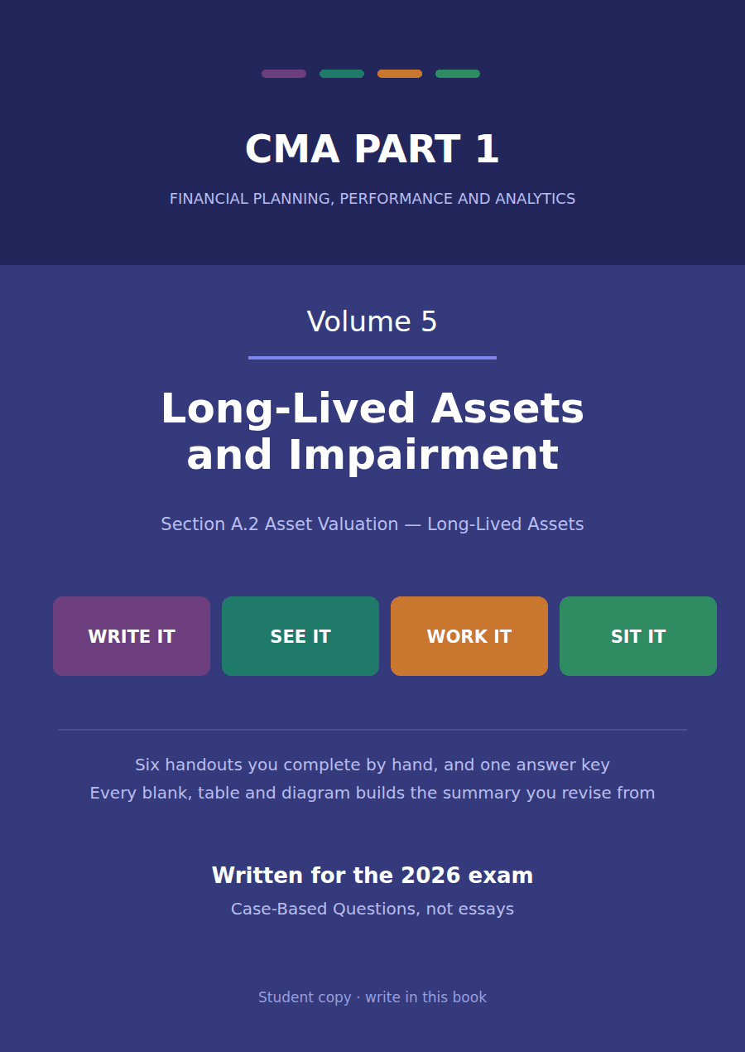

CMA Part 1 · Volume 5
Long-Lived Assets and Impairment
Six handouts, one answer key. Depreciation methods and what each does to the statements, impairment, intangibles and goodwill, and disposal.
These handouts are not notes to read. You write them. The words you supply are the summary, so a finished handout is a page you can revise from, in your own handwriting.
Work in pen. Do not look at the key until the whole handout is done — the key is written to explain the mistake, and you only get that benefit if you have made it first.
The six handouts
# | Handout | What it gives you
1 | The Depreciation Methods, Side by Side | One machine, one life, one amount to write off. Four patterns for writing it off, and they all arrive at the same place.
2 | What Each Method Does to the Statements | The method that reports the lowest profit in year 1 reports the highest in year 5. Over five years it makes no difference at all, except to tax.
3 | Recommending a Depreciation Method | The method should follow the pattern in which the asset delivers its benefit. Say what that pattern is and the method names itself.
4 | Impairment of Long-Lived Assets | Two tests, in order, and the second is never reached unless the first is failed. Most wrong answers skip straight to the second.
5 | Intangibles, Goodwill and the Impairment Test | An asset with no physical form, and one that cannot be sold at all. Whether it has a life decides everything that follows.
6 | Disposal: the Gain or Loss, and Where It Shows | An asset leaves. Three accounts close, one figure is left over, and where that figure is reported matters more than its size.

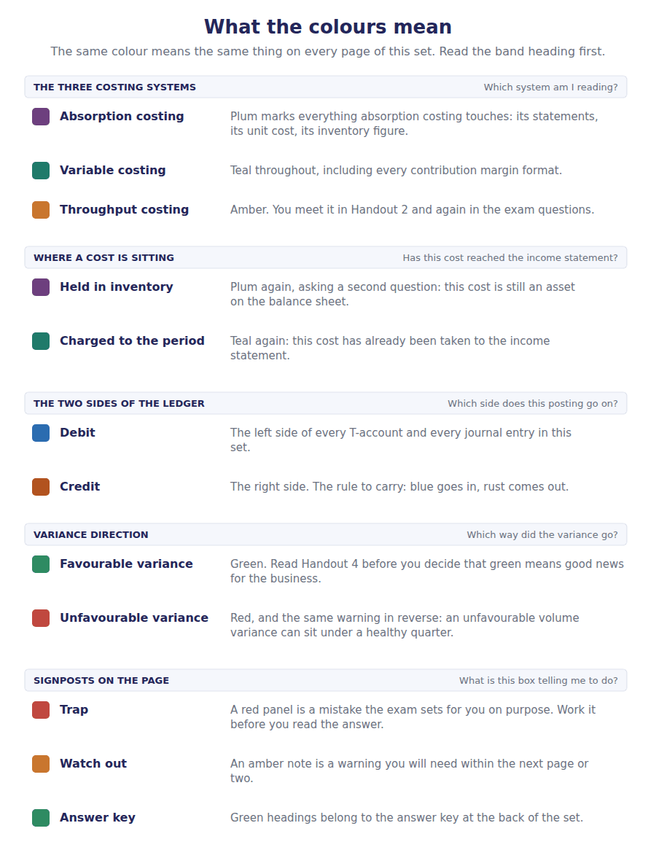
How to read the markers
Marker | Meaning
R1 | Teaching English. Short sentences. This is where a new idea arrives.
R2 | Textbook English. Longer sentences and passive verbs, as a textbook writes them.
R3 | Exam English. Exactly how the CMA exam phrases it, traps included.
Numbered rule | A space you fill in. The number matches the answer key.
Red table | A trap. Read it twice.

Handout 1 · The Depreciation Methods, Side by Side
One machine, one life, one amount to write off. Four patterns for writing it off, and they all arrive at the same place.
Volume 5 · Long-Lived Assets and Impairment · R1 moving to R2
LANGUAGE FOCUS
Register you are working in | R1 while the three inputs are introduced, R2 once the methods are computed.
Say it exactly like this | depreciate an asset over its useful life · estimate the residual value · apply a declining balance rate · allocate the depreciable amount · write an asset down to its residual value · charge depreciation for the period
Words that are not the same | cost / depreciable amount · useful life / physical life · residual value / carrying amount · accelerated / straight line
Remember | Depreciation is not a measure of how much the asset has lost in value. It is an allocation of cost over the years that benefit. Depreciation is not a source of cash. No money moves when the charge is made.

What you will be able to do when this handout is finished
- Name the three estimates every depreciation calculation needs.
- Compute depreciation under the straight line method.
- Compute it under double declining balance, including the cap at the residual value.
- Compute it under sum of the years’ digits and units of production.
- State what is identical under all four methods.

One machine, four schedules
Northwind bought a packing machine in January for $500,000. It expects to use it for 5 years and then sell it for about $50,000.
Over those five years the company will write off $450,000 — the cost less what it expects to get back. That figure is fixed before any method is chosen.
What the method decides is how much of the $450,000 falls in each of the five years. This handout computes four answers, and Handout 2 asks what each of them does to the statements.

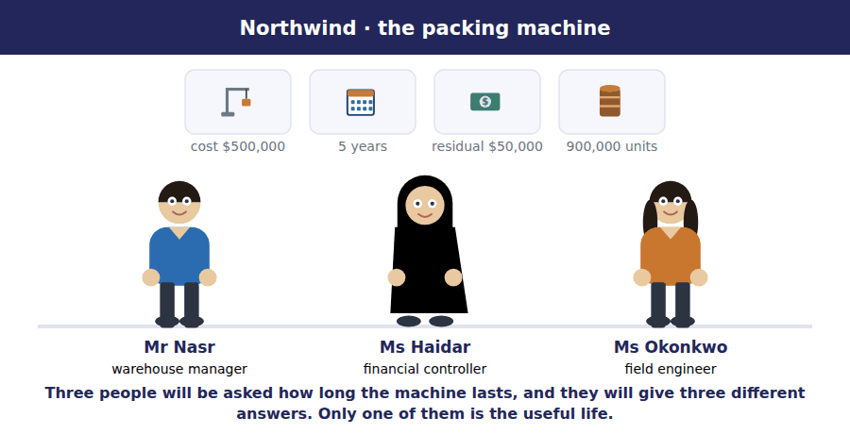
Part 1 · Three estimates everything a calculation needs
Exercise 1A Read and complete. Write one word in each space.
OBJECTIVE | Name the three estimates and say which one is never written off.
YOU WILL NEED | Nothing — this is the first exercise in the volume.
HOW TO START | • Only one of the three inputs is a fact. The other two are estimates made by management.  • Blank 3 is the one amount that is never depreciated.  • The last blank is the figure every method writes off in total.

WORD BANK
carrying · cost · depreciable · life · market · profit · residual
Not every word is used.

R1 Every depreciation calculation needs three things. The ¹ of the asset is the first, and it is the only one of the three that is a fact rather than an estimate.
The second is the useful ² : how long this company expects to use the asset. It is not how long the machine would physically last. A company that replaces its machines every four years depreciates over four years.
The third is the ³ value, which is what the company expects to recover at the end. This amount is never written off, because the company expects to get it back.
Cost less residual value gives the ⁴ amount, and for the packing machine that is $500,000 less $50,000, which is $450,000. Every method in this handout writes off exactly that figure.
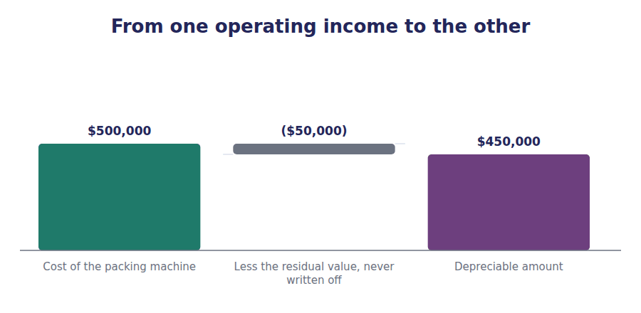
Part 2 · Straight line the same amount every year
Exercise 1B Complete the schedule. One division, then four additions.
OBJECTIVE | Compute the straight line charge and the carrying amount each year.
YOU WILL NEED | Exercise 1A
HOW TO START | • Divide the depreciable amount by the useful life. The answer is the same for all five years.  • The accumulated column is a running total.  • The last carrying amount must equal the residual value. If it does not, you divided the cost instead of the depreciable amount.

Year | Charge | Accumulated depreciation | Carrying amount
1 | ______________ | ______________ | ______________
2 | ______________ | ______________ | ______________
3 | ______________ | ______________ | ______________
4 | ______________ | ______________ | ______________
5 | ______________ | ______________ | ______________

1 | 2 | 3 | 4 | 5 | 6
7 | 8 | 9 | 10 | 11 | 12
13 | 14 | 15

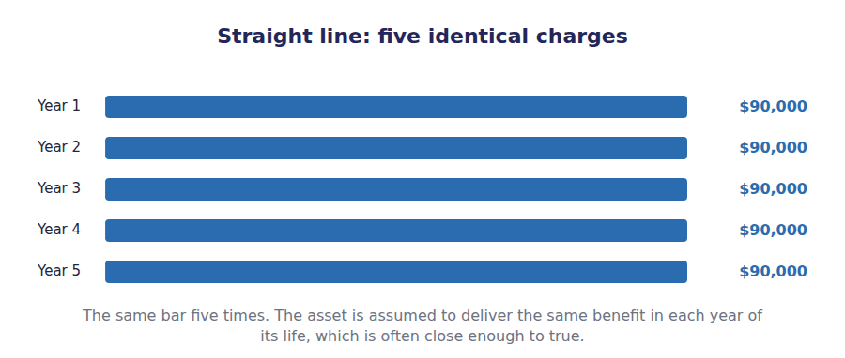
Part 3 · The two accelerated methods more early, less late
R2 Two methods charge more in the early years than in the later ones. Both are called accelerated, and both write off the same total as the straight line method does. They differ in how they get there, and in one awkward detail.
R2 Double declining balance applies a fixed rate to a falling carrying amount, and it ignores the residual value in the calculation. Sum of the years’ digits applies a falling fraction to a fixed depreciable amount, and so it allows for the residual value from the start.
Exercise 1C Read and complete.
OBJECTIVE | Compute double declining balance, including the year the cap bites.
YOU WILL NEED | Exercise 1B, and the two paragraphs above.
HOW TO START | • The rate is twice the straight line rate. Work out the straight line rate as a percentage first.  • The rate is applied to the carrying amount, not to the depreciable amount. The residual value plays no part until the end.  • In the final year the charge is whatever is needed to reach the residual value, and it is smaller than the formula would give.

WORD BANK
$14,800 · 20% · 40% · amount · cost · residual · useful
Not every word is used.

R2 The straight line rate for a 5-year life is 20% a year. Double declining balance uses twice that, so the rate is ⁵ .
That rate is applied to the carrying ⁶ , which falls every year. In year 1 the charge is 40% of $500,000, which is $200,000. In year 2 it is 40% of the reduced carrying amount of $300,000, which is $120,000.
Notice what the formula never mentions: the ⁷ value. Unlike every other method, double declining balance ignores it in the calculation and deals with it only at the end.
That is why the final year is different. By the start of year 5 the carrying amount is $64,800, and only $14,800 remains before the residual value is reached. The charge is therefore ⁸ rather than the $25,920 the formula would give, because no method may take an asset below its residual value.
Year | Straight line | Double declining | Carrying amount at the year end
1 | $90,000 | ______________ | ______________
2 | $90,000 | ______________ | ______________
3 | $90,000 | ______________ | ______________
4 | $90,000 | ______________ | ______________
5 | $90,000 | ______________ | ______________

1 | 2 | 3 | 4 | 5 | 6
7 | 8 | 9 | 10

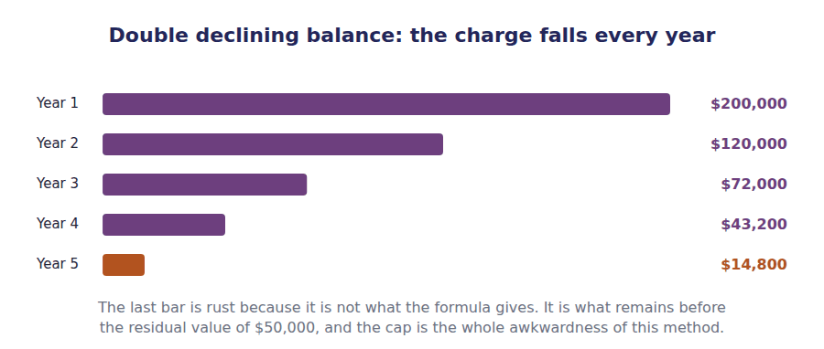
Exercise 1D Read and complete.
OBJECTIVE | Compute sum of the years’ digits and units of production.
YOU WILL NEED | Exercise 1C
HOW TO START | • The denominator for sum of the years’ digits is the digits of the life added together. For five years that is 1+2+3+4+5.  • The numerator counts down: 5 in year 1, 4 in year 2, and so on.  • Units of production needs a rate per unit, and the rate uses the depreciable amount over the total expected output.

WORD BANK
$0.50 · $0.56 · $150,000 · 10 · 15 · busy · idle
Not every word is used.

R2 Sum of the years’ digits adds the digits of the life together: 1 plus 2 plus 3 plus 4 plus 5, which is ⁹ . That is the denominator for every year.
The numerator counts down from the life. Year 1 takes five fifteenths of the depreciable amount, which is 5/15 of $450,000, or ¹⁰ . Year 2 takes 4/15, and so on down to 1/15 in the final year.
Units of production ignores time entirely. The rate is the depreciable amount divided by the expected total output: $450,000 over 900,000 units, which is ¹¹ a unit.
The charge for a year is then that rate times the units actually produced. In year 1 the machine made 240,000 units, so the charge is $120,000. In a year when the machine stands ¹² the charge is nothing at all, which no time-based method can say.
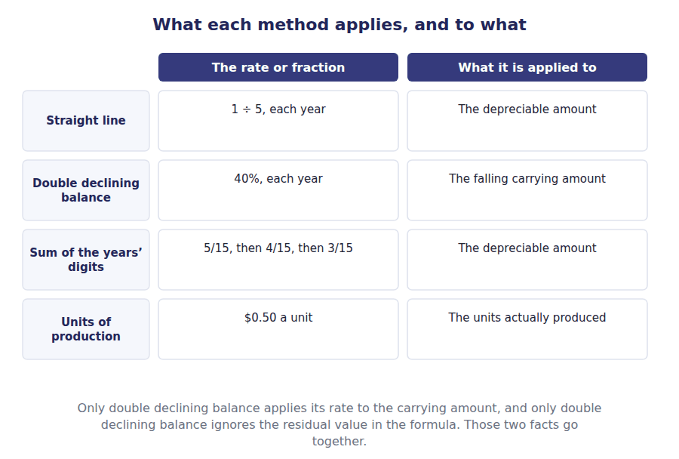
Part 4 · All four together and what is identical among them
Exercise 1E Complete the table, then read the passage underneath.
OBJECTIVE | Set all four schedules side by side and state what they share.
YOU WILL NEED | Exercises 1B, 1C and 1D
HOW TO START | • Copy your four sets of answers into the columns.  • Add each column before you go on. All four totals must be the same figure.  • If one column does not total $450,000, check the final year of that method.

Year | Straight line | Double declining | Sum of the years | Units of production
1
2
3
4
5
Total

1 | 2 | 3 | 4 | 5 | 6
7 | 8 | 9 | 10 | 11 | 12
13 | 14 | 15 | 16 | 17 | 18
19 | 20 | 21 | 22 | 23 | 24

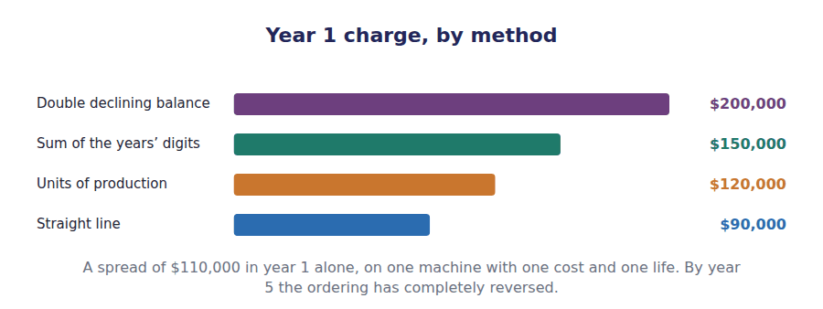
Watch out! Every column of the table totals $450,000, because every method writes off the depreciable amount and no method may go below the residual value of $50,000. The method decides the pattern and never the total.
Part 5 · Exam pitch the questions as the CMA sets them
1. [Level A] An asset costs $500,000, has a residual value of $50,000 and a useful life of 5 years. Annual straight line depreciation is:
(A) $100,000
(B) $90,000
(C) $450,000
(D) $200,000
2. [Level B] Under double declining balance, the rate is applied to:
(A) The depreciable amount
(B) The carrying amount at the start of the year
(C) The residual value
(D) The original cost, every year
3. [Level C] Under double declining balance, the residual value:
(A) Is deducted before the rate is applied
(B) Is ignored in the formula but acts as a floor the carrying amount may not fall below
(C) Is added to the final year’s charge
(D) Plays no part at all
4. [Level B] An asset with a 5-year life uses sum of the years’ digits. The fraction applied in year 2 is:
(A) 5/15
(B) 4/15
(C) 2/15
(D) 1/5
5. [Level B] A machine depreciated by the units of production method stands idle for a whole year. The depreciation charge for that year is:
(A) The same as the previous year
(B) Nil, because no units were produced
(C) The straight line amount
(D) Half the normal charge
6. [Level B] Which of the following is TRUE of all four depreciation methods applied to the same asset?
(A) They charge the same amount in each year
(B) They write off the same total over the useful life
(C) They produce the same carrying amount at the end of year 1
(D) They all ignore the residual value
7. [Level C] A company replaces its delivery vans every four years although they would physically last eight. The vans should be depreciated over:
(A) Eight years, the physical life
(B) Four years, the period the company expects to use them
(C) Either, at the company’s choice
(D) Eight years, with an adjustment when they are sold
ADAPTIVE TIP Write the three estimates at the top of your page before computing anything: cost, life, residual. Then ask one question — does this method apply its rate to the depreciable amount or to the carrying amount? That single question separates double declining balance from the other three.

Handout 2 · What Each Method Does to the Statements
The method that reports the lowest profit in year 1 reports the highest in year 5. Over five years it makes no difference at all, except to tax.
Volume 5 · Long-Lived Assets and Impairment · R2 throughout
LANGUAGE FOCUS
Register you are working in | R2 textbook English throughout. The comparison in Part 4 is the one an exam asks for.
Say it exactly like this | charge depreciation against profit · reduce the carrying amount · defer tax into a later year · report a lower profit in the early years · reverse in the later years · leave cash unaffected
Words that are not the same | charge / payment · early years / later years · reported profit / cash generated · book depreciation / tax depreciation
Remember | Depreciation does not move cash. The cash left when the asset was bought, and the annual charge moves nothing. An accelerated method does not reduce total profit. It moves profit between years, and nothing else.

What you will be able to do when this handout is finished
- Say what depreciation does to each of the four statements.
- Compare reported profit under two methods in the same year.
- Trace the carrying amount under two methods across the whole life.
- Explain why the choice of method does not affect cash.
- Say what remains different after the asset is fully depreciated.

The same machine, two income statements
Handout 1 produced four depreciation schedules for the packing machine. This handout takes two of them — the slowest and the fastest — and asks what each does to the figures a reader sees.
Assume the machine generates $400,000 a year before depreciation, and that tax is charged at 25% on the result.
In year 1 the straight line method charges $90,000 and double declining balance charges $200,000. That is a difference of $110,000 on one machine, and it flows straight through to reported profit.

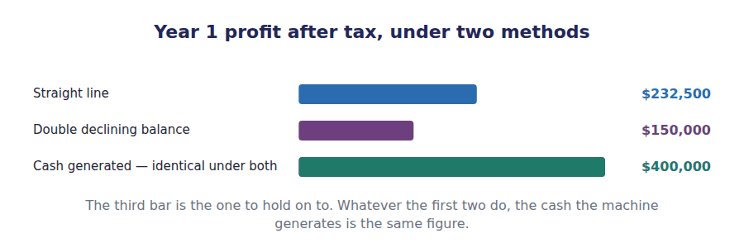
Part 1 · What a depreciation charge actually does four statements, three of them affected
Exercise 2A Read and complete. Write one word in each space.
OBJECTIVE | Say what the charge does to each statement, and which one it leaves alone.
YOU WILL NEED | Handout 1, for the four schedules.
HOW TO START | • Three statements move and one does not. Decide which before you start.  • Blank 2 is the contra account the charge accumulates in.  • The last blank is why the cash flow statement adds the charge back.

WORD BANK
accumulated · bought · carrying · cash · inventory · profit · sold
Not every word is used.

R2 The charge is an expense, so it reduces the year’s ¹ , and through profit it reduces retained earnings in the equity statement.
On the balance sheet it does not reduce the asset account directly. It accumulates in a contra account called ² depreciation, so that a reader can still see both the original cost and the amount written off so far.
The difference between those two is the ³ amount, and it is the figure that enters total assets.
The cash flow statement is the one that does not really move. No cash leaves the company when the charge is made — the cash left when the machine was ⁴ — so the indirect method adds the charge back, and it cancels its own effect on net income exactly.
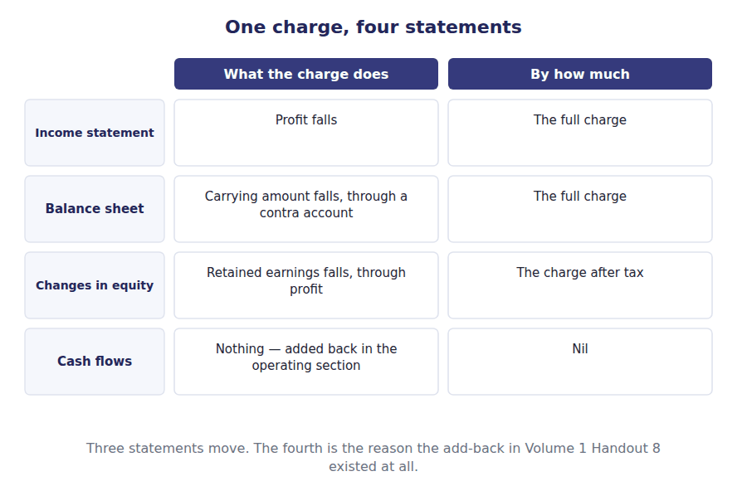
Part 2 · Year one, two ways the comparison a reader actually sees
Exercise 2B Complete the table. The first row and the last are given, and they are the same in both columns.
OBJECTIVE | Prepare year 1 under both methods and compare every line.
YOU WILL NEED | Exercise 2A
HOW TO START | • Only one input differs between the two columns: the depreciation charge. Everything else follows from it.  • The tax line is 25% of profit before tax, computed separately in each column.  • The last row is deliberately identical. Make sure you can say why before you move on.

Year 1 | Straight line | Double declining balance
Result before depreciation | $400,000 | $400,000
Depreciation charged
Profit before tax
Tax at 25%
Profit after tax
Carrying amount at the year end
Cash generated

1 | 2 | 3 | 4 | 5 | 6
7 | 8 | 9 | 10 | 11 | 12

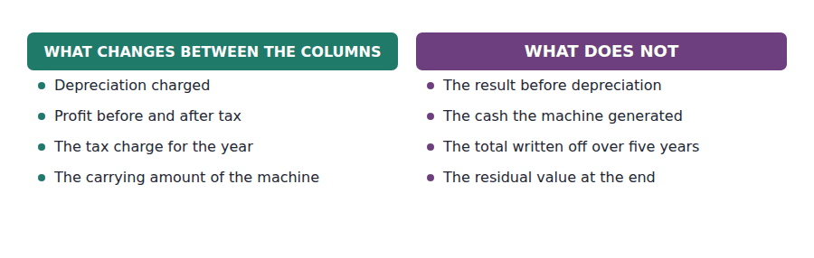
Part 3 · Across the whole life where the comparison reverses
R2 A single year is a misleading place to compare two methods, because the comparison reverses. The method charging more now must charge less later: both write off the same $450,000.
R2 Setting the carrying amounts side by side across all five years shows exactly where the crossover happens, and how far apart the two balance sheets get before they converge again.
Exercise 2C Complete the table. The last column is the gap between the two.
OBJECTIVE | Trace the carrying amount under both methods across the whole life.
YOU WILL NEED | Exercise 2B · Handout 1, for both schedules.
HOW TO START | • Each carrying amount is cost less the accumulated depreciation to date.  • The gap widens for the first few years and then narrows.  • The gap in the final row must be nil. If it is not, one of your schedules does not end at the residual value.

End of year | Straight line | Double declining balance | Difference
1
2
3
4
5

1 | 2 | 3 | 4 | 5 | 6
7 | 8 | 9 | 10 | 11 | 12
13 | 14 | 15

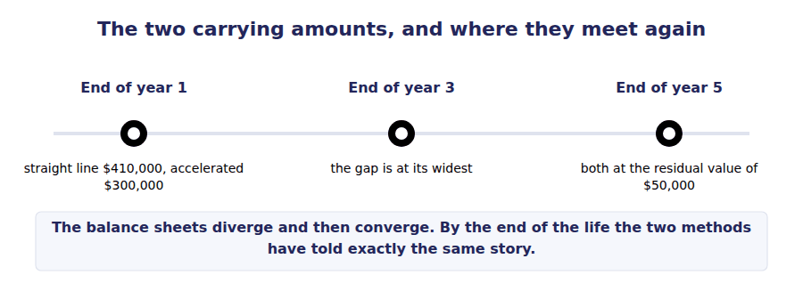
Exercise 2D Read and complete.
OBJECTIVE | Say why the choice of method leaves cash unaffected.
YOU WILL NEED | Exercise 2C
HOW TO START | • Blank 1 is the year in which the cash actually moved.  • Blank 3 is the one real effect the choice of method has on cash, and it is indirect.  • The last blank is the schedule that determines that effect, and it is not the one in the accounts.

WORD BANK
back · bought · forward · revenue · sold · tax
Not every word is used. A word may be used more than once.

R2 The machine cost $500,000 and the company paid for it in the year it was ⁵ . That was an investing outflow, and it happened once.
Every charge after that is an allocation of an amount already spent. Nothing leaves the bank when the charge is made, which is why the operating section of the cash flow statement adds it ⁶ .
There is one real cash effect and it runs through ⁷ . A larger depreciation deduction means a smaller taxable profit and a smaller payment to the tax authority this year.
But that effect follows the ⁸ depreciation schedule, not the one in the financial statements. A company may charge straight line in its accounts and claim an accelerated schedule for tax, and most of them do, so the method chosen for reporting usually has no cash effect at all.
R2 The two schedules even have their own names. Book depreciation is the figure reported in the financial statements; tax depreciation is the deduction the tax rules allow. They are computed separately and they rarely agree.
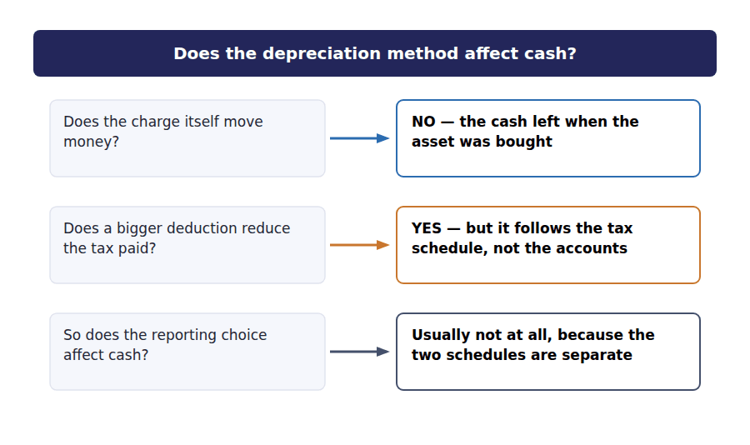
Part 4 · After five years what is left of the difference
Exercise 2E Read and complete. This passage is written at exam pitch.
OBJECTIVE | State what remains different once the asset is fully depreciated.
YOU WILL NEED | Exercises 2A to 2D
HOW TO START | • Blank 1 is the cumulative difference in reported profit over the five years.  • Blank 3 is the only thing that genuinely differs, and it is not an amount.  • The last blank is the comparison a reader cannot make without knowing which method was used.

WORD BANK
$450,000 · cash · comparison · converge · nil · timing · total
Not every word is used.

R2 Over the five years both methods charge $450,000. The cumulative difference in reported profit is therefore ⁹ , and the carrying amount at the end is $50,000 under both.
In the early years the accelerated method reports the lower profit and the lower carrying amount. In the later years it reports the higher profit, because the charge has already been taken. The two statements cross over and then ¹⁰ .
What genuinely differs is the ¹¹ — which year each dollar of expense falls in — and nothing else. The total expense, the total profit and the final carrying amount are identical.
The practical consequence is for a reader rather than for the company. Two otherwise identical companies using different methods report different profits and different assets for years at a time, which is why the method used must be disclosed and why a ¹² made without that disclosure is worthless.
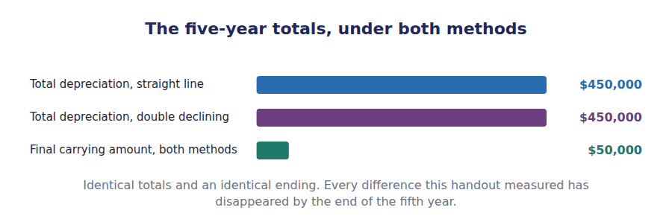
Watch out! If a question asks which method gives the higher profit, check which year it is asking about. An accelerated method gives the lower profit early and the higher profit late, and an answer without a year attached to it is not an answer.
Part 5 · Exam pitch the questions as the CMA sets them
1. [Level B] In the first year of an asset’s life, an accelerated depreciation method compared with straight line produces:
(A) Higher profit and a higher carrying amount
(B) Lower profit and a lower carrying amount
(C) Lower profit and a higher carrying amount
(D) The same profit and the same carrying amount
2. [Level B] A company changes from straight line to an accelerated method. The effect on cash generated from operations is:
(A) An increase, because depreciation is a source of cash
(B) A decrease, because the charge is larger
(C) None, because depreciation involves no cash movement
(D) An increase equal to the additional charge
3. [Level A] The machine costs $500,000 with a residual value of $50,000. At the end of its 5-year life, the carrying amount under the units of production method is:
(A) $0
(B) $50,000
(C) $500,000
(D) $450,000
4. [Level A] Over the entire useful life of an asset, total depreciation under an accelerated method compared with straight line is:
(A) Higher
(B) Lower
(C) The same
(D) Dependent on the residual value
5. [Level C] A company uses straight line depreciation in its financial statements and an accelerated schedule for tax. This:
(A) Is not permitted
(B) Is permitted, and commonly produces a deferred tax liability
(C) Requires the financial statements to be restated
(D) Means the company has made an error
6. [Level A] Accumulated depreciation is best described as:
(A) A fund set aside to replace the asset
(B) A contra asset account holding the total charged since acquisition
(C) An expense of the current period
(D) A liability to be settled when the asset is replaced
7. [Level C] Two identical companies report different profits because one uses straight line and the other an accelerated method. An analyst comparing them should:
(A) Treat the difference as a real difference in performance
(B) Read the disclosed depreciation policies and adjust before comparing
(C) Use the company with the higher profit as the benchmark
(D) Ignore depreciation entirely
ADAPTIVE TIP Any comparison question in this topic needs two things written down before you answer: which year, and which direction prices or charges are moving. Half the wrong options are correct statements about a different year.

Handout 3 · Recommending a Depreciation Method
The method should follow the pattern in which the asset delivers its benefit. Say what that pattern is and the method names itself.
Volume 5 · Long-Lived Assets and Impairment · R2 throughout, closing at R3
LANGUAGE FOCUS
Register you are working in | R2 textbook English, rising to R3 for the final case. The vocabulary here is evaluative rather than computational.
Say it exactly like this | reflect the pattern of consumption · recommend a method for an asset · revise an estimate prospectively · apply a change in principle retrospectively · justify the method chosen · disclose the useful lives applied
Words that are not the same | change in estimate / change in principle · prospective / retrospective · pattern of benefit / pattern of cash · recommend / require
Remember | The method is not chosen to produce a desired profit. It is chosen to reflect how the asset delivers its benefit. Revising a useful life is not an error and is not a change of method. It is a change in estimate, handled differently from both.

What you will be able to do when this handout is finished
- State the principle that should govern the choice of method.
- Recommend a method for five assets and give the deciding fact.
- Say what the recommendation trades away.
- Distinguish a change in estimate from a change in accounting principle.
- Compute depreciation after a useful life has been revised.

The question Handouts 1 and 2 did not ask
You can now compute four depreciation schedules and say what each does to the statements. What you have not been asked is which one a company should use.
That question is Level C in the learning outcomes and it is where the Case-Based Questions live. It has a governing principle, and the principle is short.
An asset should be depreciated in a pattern that reflects how its benefit is actually consumed. Say how the benefit arrives, and the method is usually obvious.

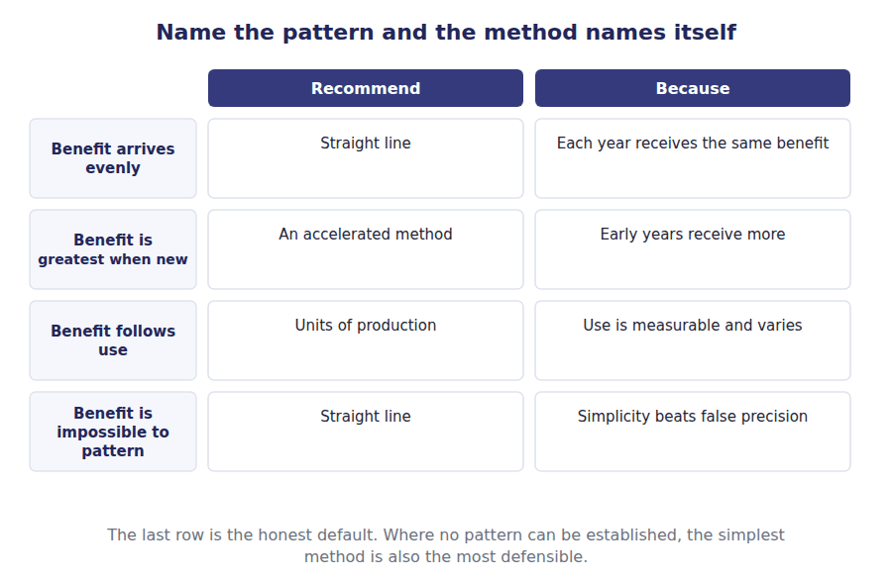
Part 1 · The governing principle and what it is not
Exercise 3A Read and complete. Write one word in each space.
OBJECTIVE | State the principle behind the choice, and rule out the wrong reasons.
YOU WILL NEED | Handout 2, for what each method does to the statements.
HOW TO START | • Blank 1 is the pattern the method is supposed to follow.  • Blank 3 is the wrong reason, and it is the one companies are most tempted by.  • The last blank is the default where no pattern can be established.

WORD BANK
consumed · differently · precise · produced · profit · simple · tax
Not every word is used.

R2 An asset is depreciated in the pattern in which its benefit is ¹ . If a machine delivers the same service every year, the charge should be the same every year; if it delivers most of its service when new, the charge should be larger at the start.
The method is therefore a statement about the asset rather than about the company. A delivery van and an office building are depreciated differently because they wear out ² , and for no other reason.
What the method is not chosen for is the ³ it reports. A company that selects straight line because it flatters this year’s margin has chosen for a reason the standards do not recognise, and an examiner will not accept it either.
Where no pattern can honestly be established, the straight line method is used. That is not a failure. A simple method applied openly is more useful to a reader than a ⁴ one built on an estimate nobody can defend.
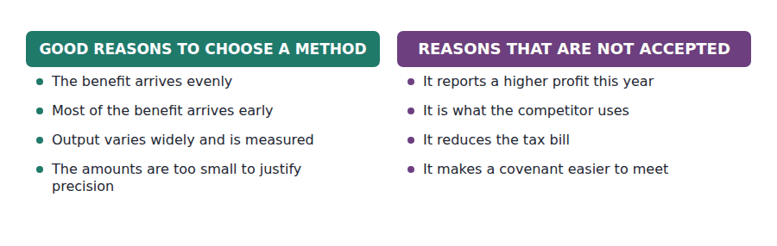
Part 2 · Five assets the recommendation and the deciding fact
Exercise 3B Complete the table. One method and one reason in each row.
OBJECTIVE | Recommend a method for five assets and name the fact that decides each.
YOU WILL NEED | Exercise 3A
HOW TO START | • Ask how the benefit arrives before you think about any method.  • Two of these five point to the same answer for completely different reasons.  • The repairs row is the one most students miss. Think about total annual cost rather than depreciation alone.

The asset | Recommend | The fact that decides it
An office building, used evenly for forty years
A delivery van that will be worked hardest when new
A press whose output varies from 50,000 to 300,000 units a year
A machine that will need rising repairs as it ages
A fleet of identical small tools, individually immaterial

1 | 2 | 3 | 4 | 5 | 6
7 | 8 | 9 | 10

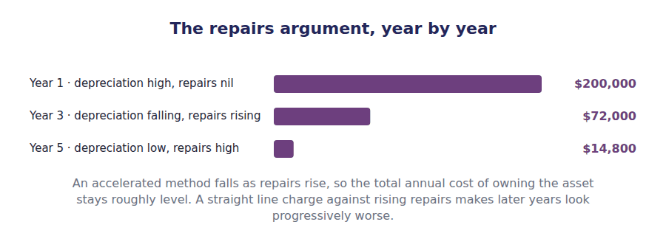
Part 3 · Changing your mind estimate or principle?
R2 Estimates made at the start of an asset’s life turn out to be wrong. A machine lasts longer than expected, or the residual value proves optimistic. The company revises the estimate, and the treatment is not what students expect.
R2 A revised estimate is applied from now onwards. The carrying amount at the date of the revision is spread over the remaining life on the new basis, and the earlier years are left exactly as reported. Nothing is restated and no catch-up adjustment is made.
R2 That treatment has a name worth knowing, because the exam uses it in the options rather than describing it. Applying a revision from now onwards and leaving the earlier years alone is prospective application, and it is what separates a change in estimate from everything else in this part.
Exercise 3C Complete the table. Write the treatment and whether prior years are restated.
OBJECTIVE | Distinguish a change in estimate from a change in accounting principle.
YOU WILL NEED | Exercise 3B, and the two paragraphs above.
HOW TO START | • Two of these are changes in estimate and one is a change in principle. The fourth is neither.  • A change in estimate is never applied backwards.  • A change of method is applied backwards, so that a reader can still compare the years.

Situation | Treated as | Prior years restated?
The useful life is revised from 5 years to 8 | ______________ | ______________
The residual value is revised downwards | ______________ | ______________
The company moves from straight line to an accelerated method | ______________ | ______________
A machine bought three years ago was never recorded at all | ______________ | ______________

1 | 2 | 3 | 4 | 5 | 6
7 | 8

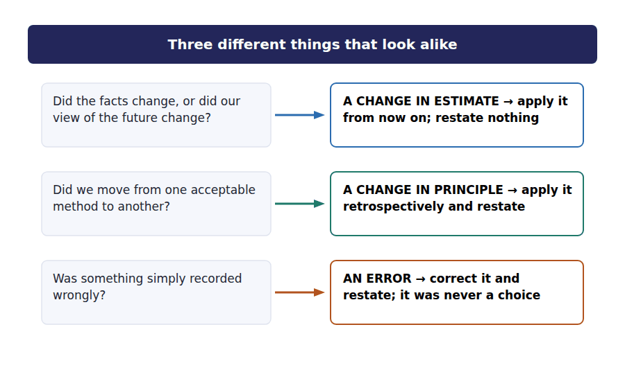
Exercise 3D Read and complete.
OBJECTIVE | Compute depreciation after a useful life has been revised.
YOU WILL NEED | Exercise 3C
HOW TO START | • Find the carrying amount at the date of the revision first. Everything follows from it.  • The remaining depreciable amount is that carrying amount less the residual value.  • Spread it over the remaining life, not over the original life.

WORD BANK
$270,000 · $320,000 · $500,000 · prospectively · remain · retrospectively · three
Not every word is used.

R2 Suppose the packing machine has been depreciated on a straight line basis for two years, so accumulated depreciation is $180,000 and the carrying amount is ⁵ .
At the start of year 3 the company decides the machine will last eight years in total rather than five, with the residual value unchanged at $50,000. Six years of life ⁶ .
The amount still to be written off is the carrying amount less the residual value: $320,000 less $50,000, which is ⁷ .
Spread over the six remaining years, the new annual charge is $45,000. The first two years are left exactly as they were reported, because a change in estimate is applied ⁸ and never backwards.
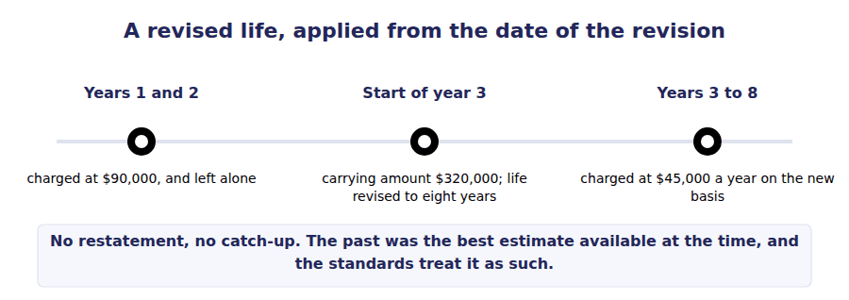
Part 4 · Writing the recommendation what a complete answer contains
Exercise 3E Read and complete. This passage is written at exam pitch.
OBJECTIVE | Write a complete recommendation, including what it trades away.
YOU WILL NEED | Exercises 3A to 3D
HOW TO START | • Blank 1 is the thing the recommendation has to point at in the scenario.  • Blank 3 is the practice of depreciating parts of an asset separately, which the roof example calls for.  • The last blank is what a reader needs in order to compare this company with another.

WORD BANK
component · disclosed · estimate · pattern · profit · revised
Not every word is used.

R3 A recommendation names a method and points at the ⁹ in the scenario that justifies it. Without that second half it earns nothing, because any of the four methods can be named at random.
It then names what the choice costs. Recommending an accelerated method for a van is right, and it is better if you add that the company accepts a lower reported profit in the early years and a carrying amount that falls faster than the van’s resale value.
Some assets need more than one method. A building whose roof lasts fifteen years and whose structure lasts fifty is better depreciated by ¹⁰ , with each part written off over its own life. That approach is required under IFRS and permitted under US GAAP.
Whatever is chosen, the useful lives and the methods applied must be ¹¹ . Two companies depreciating identical assets over different lives report different profits for decades, and a reader cannot adjust for what has not been told.
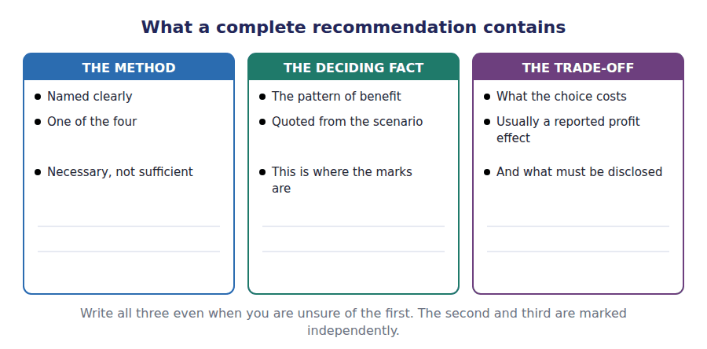
Watch out! A revised useful life is a change in estimate and is applied prospectively. A change of method is applied retrospectively. An exam question that describes one and offers the other’s treatment among the options is testing exactly this.
Part 5 · Exam pitch the questions as the CMA sets them
1. [Level A] The depreciation method selected for an asset should reflect:
(A) The pattern in which the asset’s benefit is consumed
(B) The pattern of cash flows the asset generates
(C) The method used by other companies in the industry
(D) The method that produces the most stable reported profit
2. [Level C] A machine will require increasing repair costs as it ages. An accelerated depreciation method is often recommended because:
(A) It reduces total costs over the life of the asset
(B) The falling depreciation charge offsets the rising repair costs, so the total annual cost of ownership stays level
(C) Repairs are capitalised under an accelerated method
(D) It defers tax
3. [Level B] A company revises the useful life of an asset from 5 years to 8 at the start of year 3. The correct treatment is to:
(A) Restate years 1 and 2 using the new life
(B) Spread the carrying amount less residual value over the 6 remaining years, leaving years 1 and 2 unchanged
(C) Record a catch-up adjustment in year 3 for the excess charged earlier
(D) Treat the revision as the correction of an error
4. [Level B] Which of the following IS a change in accounting principle rather than a change in estimate?
(A) Revising the residual value of a machine
(B) Revising the expected total output of a press
(C) Moving from straight line to sum of the years’ digits
(D) Revising the useful life of a building
5. [Level A] A building has a roof expected to last 15 years and a structure expected to last 50. Depreciating the two separately is called:
(A) Composite depreciation
(B) Group depreciation
(C) Component depreciation
(D) Partial depreciation
6. [Level C] A company depreciates a large number of individually immaterial small tools on a straight line basis over three years. This is defensible because:
(A) Straight line is always the correct method
(B) The cost of applying a more exact method would exceed the benefit of the extra precision
(C) Small tools have no pattern of consumption
(D) The tools are not really assets
7. [Level C] The most complete answer to a question asking which depreciation method a company should adopt names:
(A) The method only
(B) The method, the pattern of benefit that justifies it, and what the choice trades away
(C) All four methods and their computations
(D) The method with the lowest tax effect
ADAPTIVE TIP Before naming any method, write one sentence describing how the asset delivers its benefit. If you cannot write that sentence from the scenario, the answer is almost always straight line, and saying why is worth a mark.

Handout 4 · Impairment of Long-Lived Assets
Two tests, in order, and the second is never reached unless the first is failed. Most wrong answers skip straight to the second.
Volume 5 · Long-Lived Assets and Impairment · R2 throughout, closing at R3
LANGUAGE FOCUS
Register you are working in | R2 textbook English, rising to R3 for the final comparison. The order of the two steps is the whole difficulty, so the sentences are sequenced carefully.
Say it exactly like this | test an asset for impairment · assess the recoverability of a carrying amount · estimate undiscounted future cash flows · write an asset down to fair value · recognise an impairment loss · identify an indicator of impairment
Words that are not the same | recoverability / measurement · undiscounted / discounted · fair value / value in use · held and used / held for sale
Remember | The recoverability test uses undiscounted cash flows. The measurement step uses fair value. Mixing them is the commonest error in the topic. An asset can fail to be worth its carrying amount and still not be impaired, because step 1 ignores the time value of money.

What you will be able to do when this handout is finished
- Name the indicators that trigger an impairment test.
- Apply the recoverability test using undiscounted cash flows.
- Measure the loss using fair value, and only when step 1 has been failed.
- Record the write-down and say what happens to depreciation afterwards.
- State the treatment of a later recovery, and how IFRS differs.

Two production lines, one of them in trouble
Northwind runs two assembly lines. Both stand in the books at $800,000, and both have been hit by a competitor’s new product.
Line A is expected to generate $750,000 of cash over its remaining life. Line B is expected to generate $850,000.
If either line were sold today, it would fetch less than it stands at: line A $620,000 and line B $700,000.
One of these lines is impaired and the other is not, and the reason is not the one most people reach for.

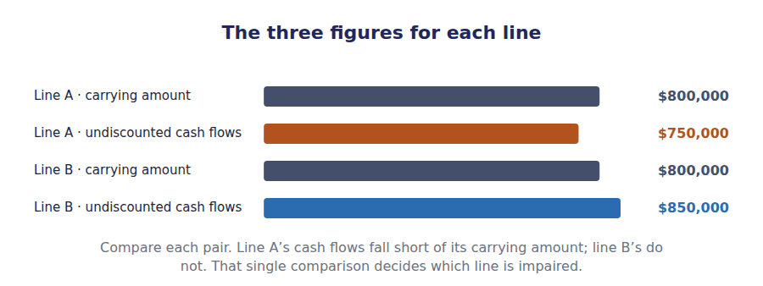
Part 1 · When to test at all indicators, not a calendar
R2 Before any of that is computed, something has to prompt the company to look. An indicator of impairment is the event that does it, and Part 1 lists the ones the standards name.
Exercise 4A Read and complete. Write one word in each space.
OBJECTIVE | Name what triggers an impairment test, and say what does not.
YOU WILL NEED | Handout 2, for how a carrying amount is built.
HOW TO START | • Blank 1 is the word for the kind of event that starts the process.  • Blank 3 is the frequency at which long-lived assets are tested in the absence of such an event.  • The last blank is the group an individual machine is tested within, because it generates no cash flows on its own.

WORD BANK
annually · group · indicator · monthly · schedule · segment · worth
Not every word is used.

R2 A long-lived asset held and used is not tested every year. It is tested when an ¹ suggests that it may not recover what it stands at: a sharp fall in market value, physical damage, an adverse change in the law, a decision to dispose of it early, or current operating losses from using it.
Absent any such sign the asset is simply depreciated. A company does not go looking for impairments, and testing every asset every year would cost more than it is ² .
That is the opposite of the rule for goodwill, which is tested at least ³ whether or not anything has happened. Handout 5 explains why goodwill is treated differently.
One practical point decides how the test is applied. A single machine rarely generates cash flows of its own, so the test is usually applied to the smallest asset ⁴ whose cash flows are largely independent of everything else.
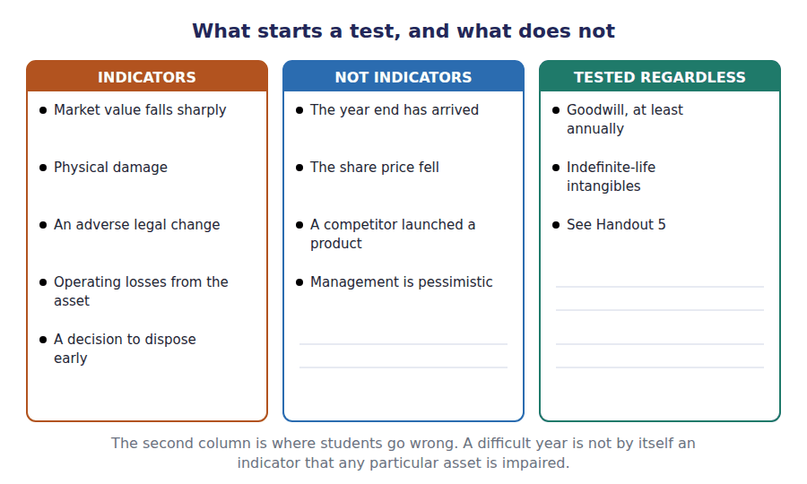
Part 2 · Step one the recoverability test
R2 The first step asks a single question: will the asset generate enough cash, over the rest of its life, to cover what it stands at in the books? The comparison uses undiscounted cash flows, and that word is doing a great deal of work.
R2 Ignoring the time value of money makes the test deliberately generous. An asset passes if the total cash it will produce exceeds its carrying amount, even if that cash arrives so far in the future that nobody would pay the carrying amount for it today.
Exercise 4B Complete the first three rows of the table, then stop and read the note before going further.
OBJECTIVE | Apply the recoverability test to both lines.
YOU WILL NEED | Exercise 4A, and the two paragraphs above.
HOW TO START | • Compare the undiscounted cash flows with the carrying amount. Nothing else is used in this step.  • Fair value is given to you and it plays no part at all in step 1. Resist it.  • One line passes and one fails. Say which before you turn to step 2.

 | Line A | Line B
Carrying amount | $800,000 | $800,000
Undiscounted future cash flows | $750,000 | $850,000
Step 1 · is the carrying amount recoverable?
Fair value | $620,000 | $700,000
Step 2 · impairment loss
New carrying amount

1 | 2 | 3 | 4 | 5 | 6
7 | 8

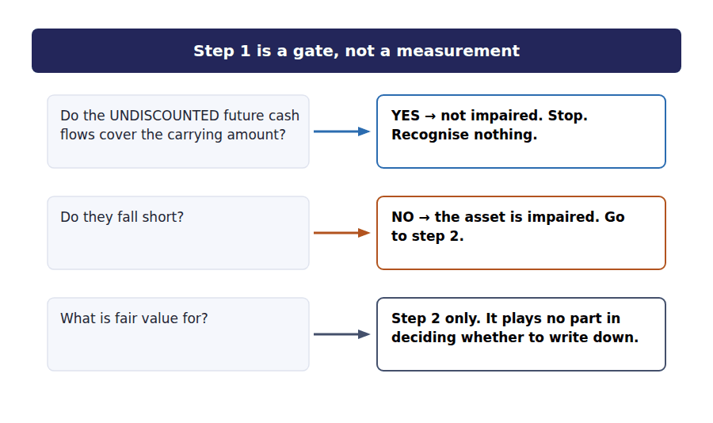
Part 3 · Step two measuring the loss, and only now
Exercise 4C Complete the journal entry, then the two remaining rows of the table in Exercise 4B.
OBJECTIVE | Measure the loss on the impaired line and record it.
YOU WILL NEED | Exercise 4B
HOW TO START | • The loss is the carrying amount less fair value. The undiscounted cash flows play no part in this step.  • Only one of the two lines reaches this step at all.  • Two accounts move, and one of them is an expense.

J1 Line A written down from a carrying amount of $800,000 to its fair value of $620,000. Line B is not written down, although its fair value is also below its carrying amount.
Account | Debit | Credit
Impairment Loss
Accumulated Impairment — Line A

WORD BANK
depreciation · fair · impairment · irrelevant · relevant · undiscounted
Not every word is used.

R2 Line A failed step 1, because its undiscounted cash flows of $750,000 fall short of its carrying amount of $800,000. Only now does fair value matter.
The loss is the carrying amount less ⁵ value: $800,000 less $620,000, which is $180,000. That amount is charged to income immediately, within operating expenses rather than below the operating line.
Line B never reaches step 2 at all. Its fair value of $700,000 is below its carrying amount of $800,000, and that is ⁶ , because the recoverability test was passed and the test is a gate.
After the write-down, line A’s new carrying amount of $620,000 becomes the basis for future ⁷ , spread over the remaining useful life. The annual charge falls, because there is less left to write off.
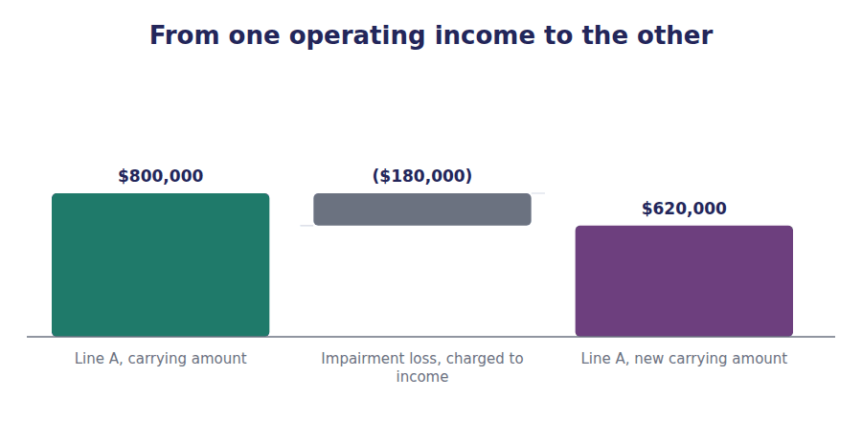
Part 4 · Afterwards depreciation, recovery, and the IFRS difference
Exercise 4D Match each statement to the framework it describes.
OBJECTIVE | Say what happens after the write-down, under US GAAP and under IFRS.
YOU WILL NEED | Exercise 4C
HOW TO START | • One framework never reverses an impairment on an asset held and used. The other does, with a cap.  • Both agree on what happens to depreciation afterwards.  • The cap on a reversal is the carrying amount the asset would have had if no loss had been recognised.

 | Item | Answer |  | Option
1 | The written-down amount becomes the new basis for depreciation |  | A | Both frameworks
2 | An impairment loss on an asset held and used is never reversed |  | B | US GAAP only
3 | An impairment loss may be reversed if the circumstances change |  | C | IFRS only
4 | A reversal is limited to the carrying amount that would have existed had no loss been recognised
5 | The loss is recognised in profit or loss when it arises
The two frameworks agree on recognising the loss and on depreciating afterwards. They disagree only on reversal, and Volume 12 returns to it.

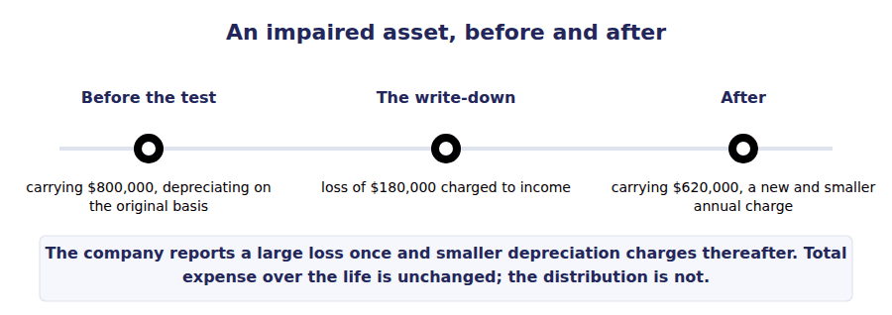
Exercise 4E Read and complete. This passage is written at exam pitch.
OBJECTIVE | State the two tests in order and say why the order matters.
YOU WILL NEED | Exercises 4A to 4D
HOW TO START | • Blank 1 is the measure used in the first test, and the word matters.  • Blank 3 is what makes step 1 deliberately generous.  • The last blank is what a company would have to recognise if the two measures were used the wrong way round.

WORD BANK
depreciated · discounted · fair · impaired · manipulate · market · undiscounted
Not every word is used.

R3 The recoverability test compares the carrying amount with the ⁸ future cash flows. It is a gate: pass it and no loss is recognised, however far the asset’s price has fallen.
Only an asset that fails the gate is measured, and it is measured against ⁹ value, which is a different quantity entirely. The two measures are used in two different steps and are never interchanged.
Ignoring the time value of money in step 1 makes it generous on purpose. An asset whose cash arrives over fifteen years passes the test even though nobody would pay its carrying amount for it today, and the standard setters accepted that in exchange for a test that is hard to ¹⁰ .
Reverse the two measures and the consequences are large. Using discounted cash flows in step 1 would impair assets that recover their cost, and using undiscounted flows in step 2 would understate the loss. Line B is the case in point: it is worth less than it stands at and it is not ¹¹ .
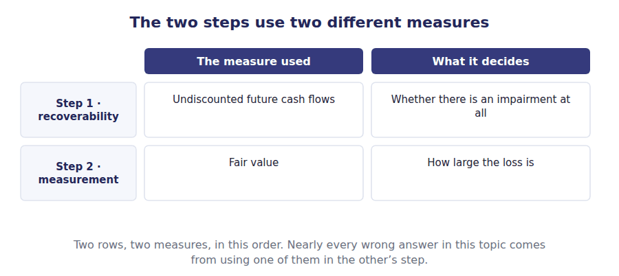
Watch out! Line B is worth $700,000 and stands at $800,000, and it is not impaired. If that feels wrong, read Part 2 again: step 1 is a gate, and line B passed it.
Part 5 · Exam pitch the questions as the CMA sets them
1. [Level C] An asset held and used has a carrying amount of $800,000, undiscounted future cash flows of $850,000 and a fair value of $700,000. The impairment loss is:
(A) $100,000
(B) $0
(C) ($50,000)
(D) $700,000
2. [Level B] An asset has a carrying amount of $800,000, undiscounted future cash flows of $750,000 and a fair value of $620,000. The impairment loss is:
(A) $50,000
(B) $180,000
(C) $0
(D) $130,000
3. [Level A] The recoverability test for a long-lived asset held and used compares the carrying amount with:
(A) Fair value
(B) The discounted future cash flows
(C) The undiscounted future cash flows
(D) Replacement cost
4. [Level A] Which of the following is NOT an indicator that a long-lived asset may be impaired?
(A) A significant decrease in the asset’s market price
(B) Physical damage to the asset
(C) The arrival of the financial year end
(D) Current operating losses associated with using the asset
5. [Level B] After an impairment loss is recognised on an asset held and used, future depreciation is based on:
(A) The original cost
(B) The new reduced carrying amount
(C) The undiscounted cash flows
(D) Fair value at each reporting date
6. [Level B] Under US GAAP, an impairment loss on a long-lived asset held and used:
(A) May be reversed if circumstances improve
(B) May never be reversed
(C) Is reversed automatically when fair value recovers
(D) Is reversed only when the asset is sold
7. [Level C] A single machine generates no identifiable cash flows on its own. The impairment test should be applied to:
(A) The machine alone, using an allocated share of revenue
(B) The smallest group of assets with largely independent cash flows
(C) The whole company
(D) The reporting segment the machine belongs to
ADAPTIVE TIP Write the two steps down the margin before you touch a figure: undiscounted for the gate, fair value for the loss. Then check which numbers the question has given you — it will often give all three precisely to see whether you use them in the right order.

Handout 5 · Intangibles, Goodwill and the Impairment Test
An asset with no physical form, and one that cannot be sold at all. Whether it has a life decides everything that follows.
Volume 5 · Long-Lived Assets and Impairment · R2 throughout, closing at R3
LANGUAGE FOCUS
Register you are working in | R2 textbook English, rising to R3 for the final passage on why goodwill is treated as it is.
Say it exactly like this | amortise an intangible over its useful life · assign goodwill to a reporting unit · test an indefinite-life intangible annually · recognise goodwill on an acquisition · allocate the purchase price · cap a loss at the goodwill carried
Words that are not the same | finite life / indefinite life · amortisation / depreciation · purchased / internally generated · goodwill / other intangibles
Remember | Indefinite does not mean infinite. It means no foreseeable limit, and it is reassessed every year. Goodwill is not a valuation of a reputation. It is the residual from an acquisition, and nothing else.

What you will be able to do when this handout is finished
- Classify an intangible by whether its useful life is finite or indefinite.
- Say which intangibles are amortised and which are tested annually instead.
- Explain what goodwill is and where it comes from.
- Compute a goodwill impairment loss, including the cap.
- Say why an internally generated brand never appears on the balance sheet.

The $540,000 on the balance sheet that nobody can touch
Northwind reports intangible assets of $240,000 and goodwill of $300,000. Neither can be seen in the warehouse, and one of them could not be sold even if a buyer were found.
The intangibles are a customer list bought three years ago when Northwind acquired a competitor, together with some purchased software. Both have lives that can be estimated, so both are being written off.
The goodwill arose on that same acquisition. It has no life that can be estimated, it is never written off, and it is tested every single year whether anything has happened or not.
This handout explains why those two sentences are so different.

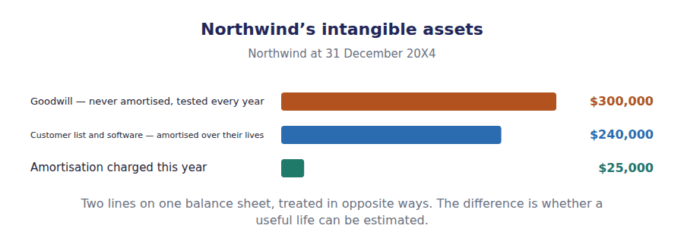
Part 1 · Finite or indefinite? the question that decides everything
Exercise 5A Complete the table. Three columns follow from the first.
OBJECTIVE | Classify five intangibles and say what follows from each classification.
YOU WILL NEED | Handout 4, for when a long-lived asset is tested.
HOW TO START | • Decide the life first. Everything in the other three columns follows from it mechanically.  • Indefinite does not mean the asset lasts forever. It means no foreseeable limit can be put on it.  • The last row is not an asset at all, and saying why is the point of Part 4.

Intangible | Finite or indefinite life? | Amortised? | Tested for impairment
A purchased customer list, 10-year life
A patent with 12 years left to run
A brand expected to be renewed indefinitely
Goodwill from an acquisition
A brand the company built itself

1 | 2 | 3 | 4 | 5 | 6
7 | 8 | 9 | 10 | 11 | 12
13 | 14

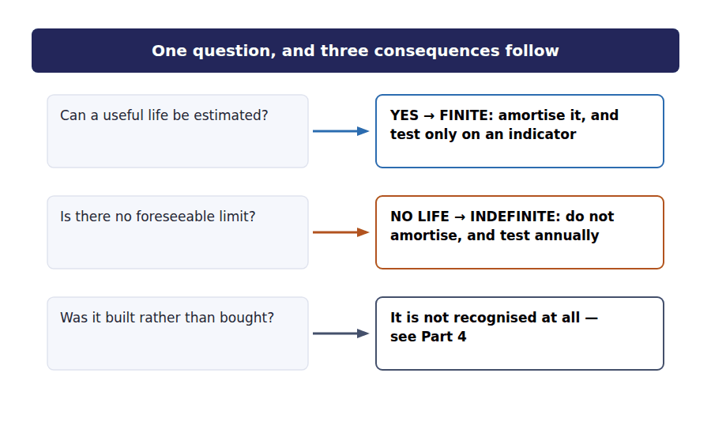
Part 2 · Finite-life intangibles amortisation, and nothing new
Exercise 5B Read and complete. Write one word in each space.
OBJECTIVE | Amortise a finite-life intangible and say how it differs from depreciation.
YOU WILL NEED | Exercise 5A
HOW TO START | • The customer list cost $250,000 and has a 10-year life. One division gives the annual charge.  • Blank 3 is the residual value normally assumed for an intangible, and it is almost always the same figure.  • The last blank is what makes the treatment identical to a machine’s in every respect but the name.

WORD BANK
$25,000 · amortisation · annually · cost · depreciation · indicator · nil
Not every word is used.

R2 Northwind’s customer list cost $250,000 and is being written off over 10 years, so the annual charge is ¹ . The write-off of an intangible is called ² rather than depreciation, and that is the only real difference.
The residual value of an intangible is almost always assumed to be ³ , because there is rarely a market in a half-used customer list or a patent with two years left on it. The whole cost is therefore written off over the life.
The method is almost always straight line, for the honest reason given in Handout 3: where no pattern of consumption can be established, the simplest method is the most defensible.
A finite-life intangible is tested for impairment on exactly the same basis as a machine — when an ⁴ appears, using the two steps from Handout 4, and not otherwise.
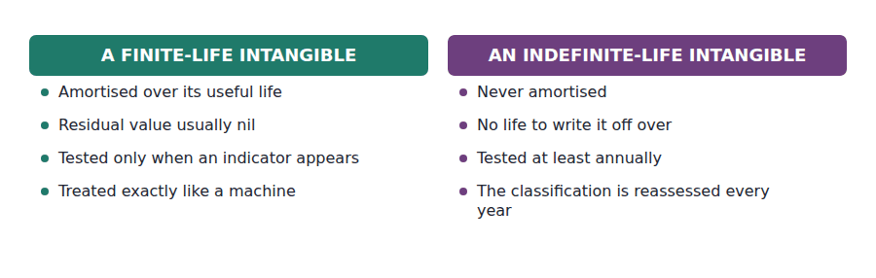
Part 3 · Goodwill what it is, and the test it gets
R2 Goodwill is the hardest asset on any balance sheet to think about clearly, and most of the difficulty comes from the name. It is not a measurement of a company’s reputation, and it has nothing to do with being well regarded.
R2 It is a residual. When one company buys another, it pays a price; the identifiable assets and liabilities acquired are measured at fair value; and whatever the price exceeds those net assets by is recorded as goodwill. It is what is left over after everything identifiable has been accounted for.
Exercise 5C Read and complete.
OBJECTIVE | Say what goodwill is, where it comes from, and why it is tested differently.
YOU WILL NEED | Exercise 5B, and the two paragraphs above.
HOW TO START | • Blank 1 is the word that describes goodwill’s place in an acquisition calculation.  • Blank 3 is the only event that can ever create goodwill.  • The last blank is the unit goodwill is tested inside, because it generates no cash flows on its own.

WORD BANK
acquisition · amortised · merger · premium · residual · segment · unit
Not every word is used.

R2 Goodwill is a ⁵ . It is the excess of what was paid for a business over the fair value of the identifiable assets and liabilities acquired, and it is computed by subtraction rather than measured directly.
It follows that goodwill can arise only on an ⁶ . A company that builds an outstanding reputation over thirty years recognises no goodwill at all, because no transaction has ever established a price for it.
Goodwill has no useful life that can be estimated, so it is never ⁷ . Instead it is tested for impairment at least annually, whether or not anything has happened — which is the opposite of the rule for every other long-lived asset.
And it cannot be tested on its own, because it produces no cash flows by itself. On acquisition it is assigned to a reporting ⁸ , and the test compares the carrying amount of that whole unit with the unit’s fair value.
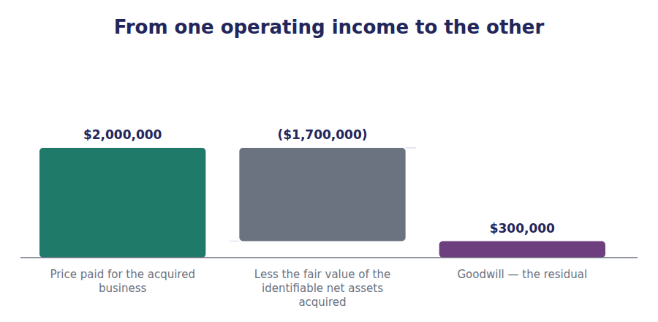
Exercise 5D Complete the schedule. Two subtractions and one comparison.
OBJECTIVE | Compute a goodwill impairment loss, including the cap.
YOU WILL NEED | Exercise 5C
HOW TO START | • Compare the carrying amount of the whole reporting unit with its fair value. The shortfall is the starting point.  • The loss cannot exceed the goodwill carried within the unit, and here that cap does not bite. Check whether it would.  • The write-down is applied to goodwill and never to the other assets of the unit.

Goodwill impairment test | Amount
Carrying amount of the reporting unit, including goodwill | $2,400,000
Fair value of the reporting unit | $2,150,000
Shortfall
Goodwill carried within the unit | $300,000
Impairment loss, limited to the goodwill carried
Goodwill after the write-down

1 | 2 | 3

WORD BANK
$2,150,000 · $250,000 · amortised · cost · goodwill · nil · reversed
Not every word is used.

R2 The reporting unit stands at $2,400,000 including goodwill, and its fair value is $2,150,000. The shortfall is ⁹ .
That shortfall is the impairment loss, with one limit: it may not exceed the ¹⁰ carried within the unit. Northwind’s unit carries $300,000 of goodwill and the shortfall is $250,000, so the whole shortfall is recognised and the cap does not bite.
Had the shortfall been $400,000 instead, the loss would have been limited to the $300,000 of goodwill, because goodwill is the only asset the write-down may touch and it cannot be written below ¹¹ .
After the write-down the unit carries $50,000 of goodwill. And under US GAAP that loss is never ¹² , however completely the unit recovers.
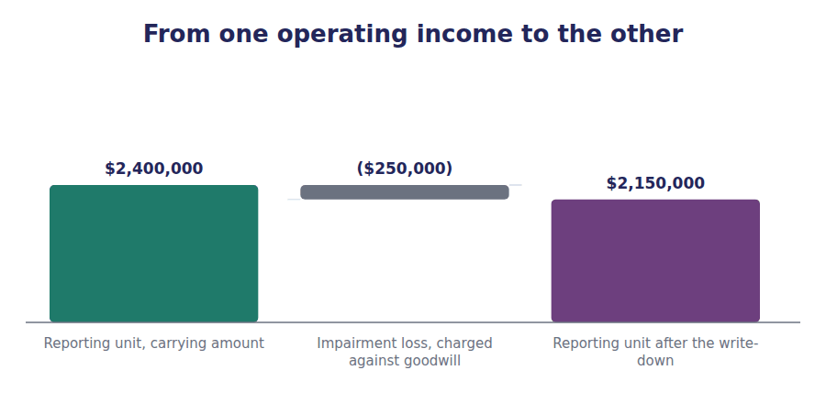
Part 4 · The brand that is not there internally generated intangibles
Exercise 5E Read and complete. This passage is written at exam pitch.
OBJECTIVE | Say why a brand a company built itself never appears as an asset.
YOU WILL NEED | Exercises 5A to 5D
HOW TO START | • Blank 1 is the problem with measuring something that was built rather than bought.  • Blank 3 is the odd consequence: two companies with identical brands report different balance sheets.  • The last blank is what a reader has to do about it.

WORD BANK
bought · cost · expense · hold · investment · price · sold
Not every word is used.

R3 A brand that was bought has a price, because somebody paid it. A brand that was built has no price, and the cost of building it cannot be separated from the ¹³ of running the business that built it.
Advertising, service quality, reliability over twenty years: all of these created the brand, and all of them were also simply the costs of trading. There is no defensible way to say how much of them was ¹⁴ in a brand, so the standards do not ask companies to guess.
The consequence is uncomfortable and worth stating plainly. Two companies with identical brands report different balance sheets if one of them ¹⁵ its brand and the other built it, and the one that built it — at no identifiable cost — reports the smaller total assets.
Nothing in the statements corrects for that. A reader comparing an acquisitive company with an organic one has to hold the difference in mind, because the statements will not ¹⁶ it for them.
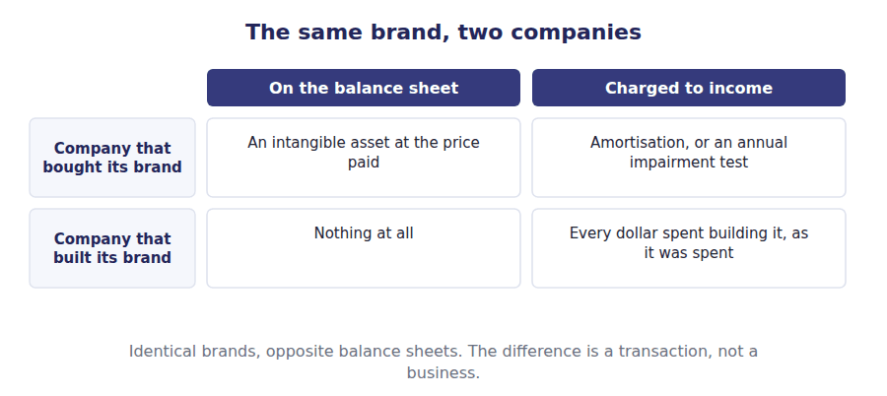
Watch out! Goodwill is tested at least annually and is never amortised. Every other long-lived asset is amortised or depreciated and is tested only on an indicator. Getting those two the wrong way round costs marks in both directions.
Part 5 · Exam pitch the questions as the CMA sets them
1. [Level A] Goodwill arising on an acquisition should be:
(A) Amortised over a maximum of 40 years
(B) Amortised over its estimated useful life
(C) Not amortised, and tested for impairment at least annually
(D) Written off immediately against equity
2. [Level B] A reporting unit has a carrying amount of $2,400,000 including goodwill of $300,000, and a fair value of $2,150,000. The goodwill impairment loss is:
(A) $300,000
(B) $250,000
(C) $0
(D) $2,100,000
3. [Level C] A reporting unit carries goodwill of $200,000. The shortfall between its carrying amount and its fair value is $350,000. The goodwill impairment loss is:
(A) $350,000
(B) $200,000
(C) $150,000
(D) Nil
4. [Level B] A company has built a widely recognised brand over twenty years without acquiring it. On the balance sheet the brand is:
(A) Recognised at estimated fair value
(B) Recognised as goodwill
(C) Not recognised, because its cost cannot be separated from the cost of operating the business
(D) Recognised at the cost of the advertising that created it
5. [Level A] An intangible asset with an indefinite useful life should be:
(A) Amortised over 20 years
(B) Amortised over 40 years
(C) Not amortised, and tested for impairment at least annually
(D) Written off immediately
6. [Level B] A purchased patent with 12 years remaining is tested for impairment:
(A) At least annually, like goodwill
(B) Only when an indicator of impairment appears
(C) Never, because it is being amortised
(D) Every three years
7. [Level B] Under US GAAP, a goodwill impairment loss:
(A) May be reversed if the reporting unit recovers
(B) May never be reversed
(C) Is reversed automatically on the next annual test
(D) Is reversed only if the unit is sold
ADAPTIVE TIP Ask one question about every intangible before anything else: can a useful life be estimated? Amortisation, the testing frequency and half the wrong answers all follow from that single classification.

Handout 6 · Disposal: the Gain or Loss, and Where It Shows
An asset leaves. Three accounts close, one figure is left over, and where that figure is reported matters more than its size.
Volume 5 · Long-Lived Assets and Impairment · R2 throughout, closing at R3
LANGUAGE FOCUS
Register you are working in | R2 textbook English, rising to R3 for the final passage, which ties the disposal back to the cash flow statement.
Say it exactly like this | derecognise an asset on disposal · remove the accumulated depreciation · record a gain on disposal · charge depreciation up to the date of disposal · report proceeds as an investing inflow · reverse a gain out of operating activities
Words that are not the same | proceeds / gain · carrying amount / cost · gain / revenue · disposal / impairment
Remember | A gain on disposal is not revenue. Selling equipment is not what the company is in business to do. The proceeds and the gain are two different figures, and the cash flow statement uses one of each in different sections.

What you will be able to do when this handout is finished
- Charge depreciation to the date of disposal before computing anything else.
- Compute the gain or loss on a disposal.
- Record the entry, closing all three accounts.
- Say where the gain or loss is reported on the income statement.
- Say how the disposal appears in the statement of cash flows.

The $30,000 nobody expected
In 20X4 Northwind sold a piece of equipment. It had cost $180,000 and accumulated depreciation of $145,000 had been charged on it, so it stood in the books at $35,000.
A buyer paid $65,000 for it.
That transaction produced the $30,000 gain you met on the income statement in Volume 1, reversed out of operating activities in the cash flow statement, and replaced in investing activities by the $65,000 of proceeds. This handout is where all of that came from.

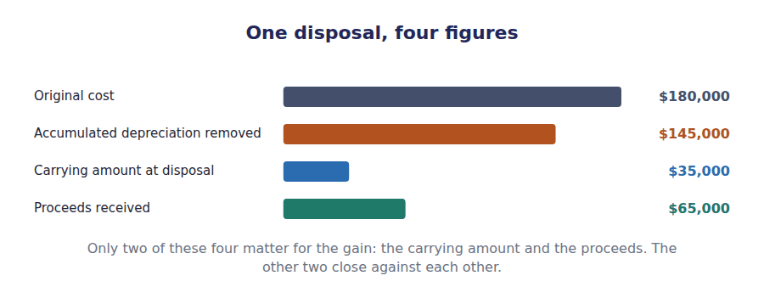
Part 1 · The step before the computation depreciation to the date of disposal
Exercise 6A Read and complete. Write one word in each space.
OBJECTIVE | Say what must happen before the gain or loss is computed at all.
YOU WILL NEED | Handout 1, for how a carrying amount is built.
HOW TO START | • Something has to be brought up to date before anything else happens.  • Blank 2 is the date to which it is brought up.  • The last blank is the figure the proceeds are then compared with.

WORD BANK
amount · date · depreciation · impairment · overstated · understated · year
Not every word is used.

R2 An asset sold in August has been used for eight months of the year, and that use has to be charged. The first step in any disposal is to record ¹ from the start of the year to the date of disposal.
Only then is the carrying amount correct. Skipping this step is the commonest error in the topic, and it moves the gain by the amount of the missing charge — the gain is overstated and the depreciation expense is ² by the same figure.
With that done, the carrying amount is the cost less the accumulated depreciation to the ³ of disposal, and that is the figure the proceeds are compared with.
For the Northwind equipment the arithmetic is given: cost $180,000, accumulated depreciation $145,000, so the carrying ⁴ is $35,000.
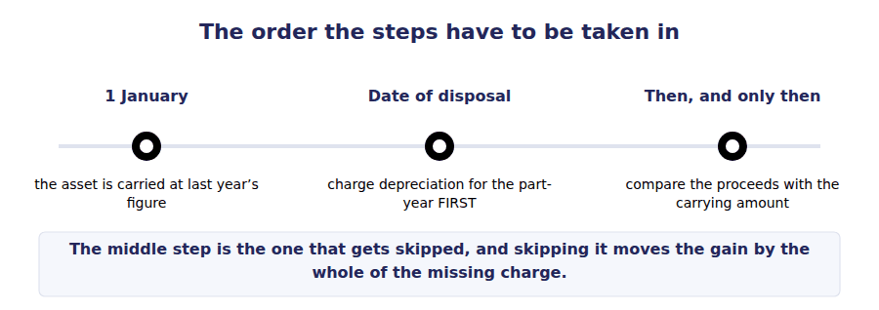
Part 2 · The computation proceeds against carrying amount
Exercise 6B Complete the table. The carrying amount is the same in every row.
OBJECTIVE | Compute the result under four different sets of proceeds.
YOU WILL NEED | Exercise 6A
HOW TO START | • One subtraction per row. The carrying amount of $35,000 does not change.  • The third row is a scrapping: the asset was removed and nothing was received for it.  • The fourth row is the case where nothing appears in income at all. Say why before you write it.

Proceeds received | Carrying amount | Result | Reported as
$65,000 | $35,000
$20,000 | $35,000
$0 | $35,000
$35,000 | $35,000

1 | 2 | 3 | 4 | 5 | 6
7 | 8

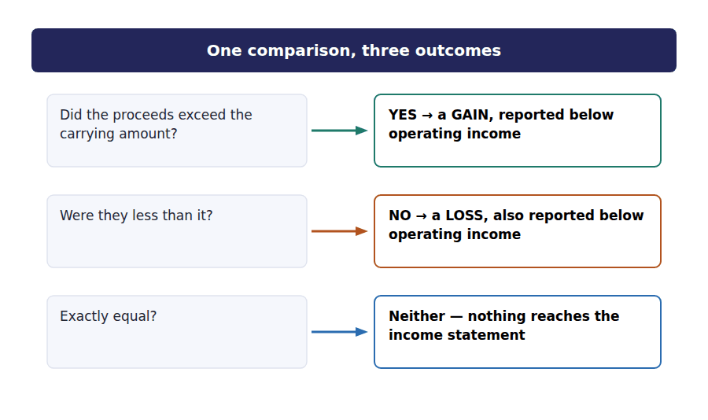
Part 3 · The entry three accounts close and one is left over
R2 The entry looks more complicated than it is. Everything that relates to the asset has to leave the books, which means both the cost and the accumulated depreciation, not just the net figure.
R2 Cash comes in, the asset account is credited at its full original cost, and accumulated depreciation is debited to remove it. Whatever is needed to make the entry balance is the gain or the loss.
Exercise 6C Complete the journal entry. Four lines, and the last one is the balancing figure.
OBJECTIVE | Record the disposal, closing all three accounts.
YOU WILL NEED | Exercise 6B, and the two paragraphs above.
HOW TO START | • Accumulated depreciation is a credit balance, so removing it is a debit.  • The asset account is credited at the full original cost of $180,000, not at the carrying amount.  • The gain is whatever makes the entry balance, and you already know what it is.

J1 Equipment costing $180,000 with accumulated depreciation of $145,000 sold for $65,000. Both the cost and the accumulated depreciation leave the books.
Account | Debit | Credit
Cash
Accumulated Depreciation
Equipment
Gain on Disposal of Equipment

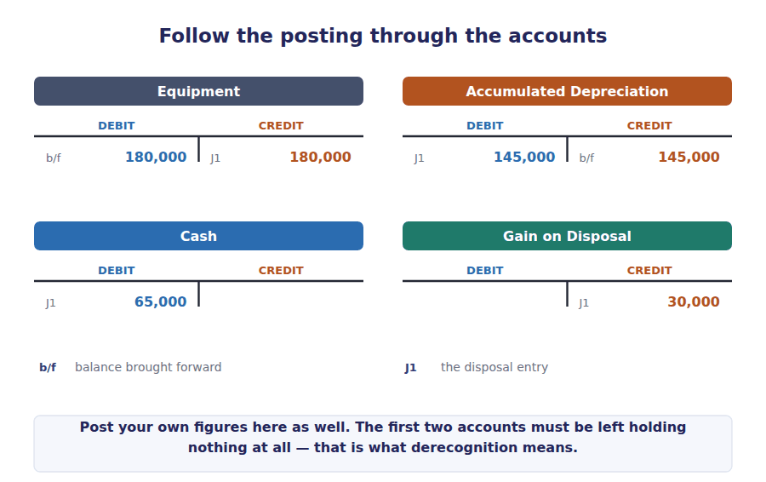
Part 4 · Where it is reported income statement and cash flows
Exercise 6D Read and complete.
OBJECTIVE | Say where the gain appears on the income statement, and why.
YOU WILL NEED | Exercise 6C · Volume 1 Handout 3, for the income statement subtotals.
HOW TO START | • Blank 1 is what the gain is not, and it is the mistake that ruins every margin ratio.  • Blank 3 is the subtotal the gain is reported below.  • The last blank is the test that puts it there.

WORD BANK
expense · gain · gross · income · operating · revenue
Not every word is used. A word may be used more than once.

R2 The $30,000 is not ⁵ . Northwind is in the business of distributing components, and selling a used piece of equipment is not that business.
Reporting it as revenue would inflate the top line and every margin computed from it, which is why the exam offers that option so often. The amount is a ⁶ , and gains are reported separately.
Specifically it is reported below ⁷ income, among the non-operating items, alongside interest expense. A reader looking at operating income therefore sees the result of trading without this amount in it, which is the point.
The test that puts it there is the ordinary activities test from Volume 2: an amount arising outside the activities the company is in business to carry on is a gain and not ⁸ .
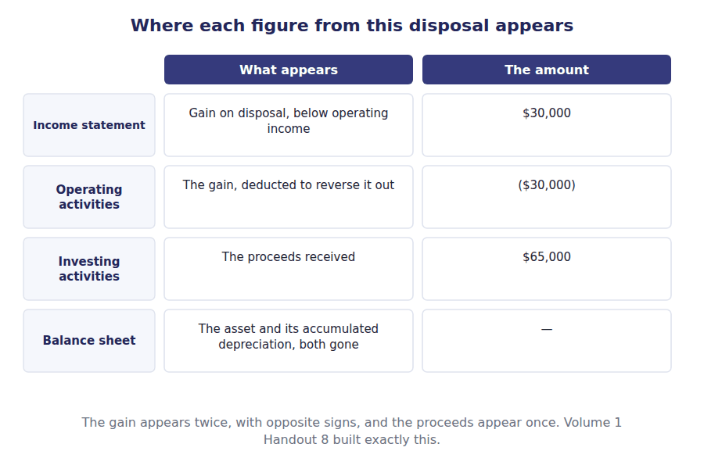
Exercise 6E Read and complete. This passage is written at exam pitch.
OBJECTIVE | Say how the disposal appears in the statement of cash flows.
YOU WILL NEED | Exercise 6D · Volume 1 Handout 8, for the indirect method.
HOW TO START | • Blank 1 is the section the whole proceeds appear in.  • Blank 3 is what has to happen to the gain in the operating section, and why.  • The last blank is the figure that would be double-counted if the reversal were not made.

WORD BANK
$35,000 · added · deducted · gain · investing · operating
Not every word is used.

R3 The cash Northwind actually received was $65,000, and the whole of it is an ⁹ inflow, because the company disposed of a long-lived asset.
But the $30,000 gain has already increased net income, which is the starting point of the operating section. Leaving it there would report part of the same transaction twice: once inside operating cash flow and once in investing.
So the gain is ¹⁰ in the operating section, which removes it from a section it does not belong to, and the full proceeds appear below in investing. One transaction, two entries, and the net effect on cash is exactly the $65,000 that arrived.
Get it wrong in either direction and the statement is out. Reporting only the ¹¹ in investing understates the inflow by the carrying amount, and omitting the reversal overstates operating cash flow by the whole $30,000.
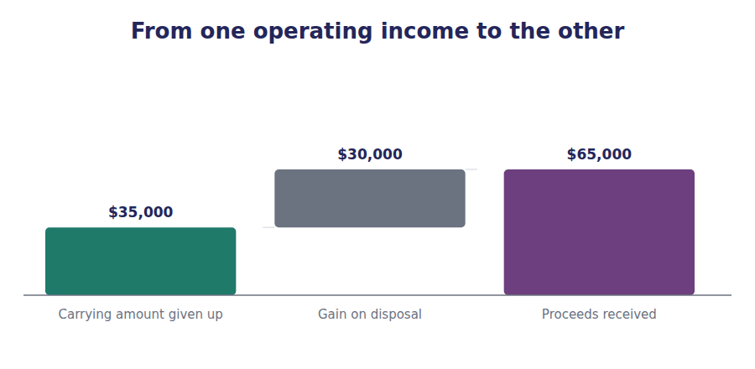
Watch out! A loss on disposal is a message as well as a figure. It says the asset was carried at more than it turned out to be worth, which usually means depreciation was too slow or an impairment was missed.
Part 5 · Exam pitch the questions as the CMA sets them
1. [Level A] Equipment costing $180,000 with accumulated depreciation of $145,000 is sold for $65,000. The result is:
(A) A gain of $65,000
(B) A gain of $30,000
(C) A loss of $115,000
(D) Neither a gain nor a loss
2. [Level B] An asset is sold in August. Before computing the gain or loss, the company must first:
(A) Reverse all prior depreciation on the asset
(B) Record depreciation from the start of the year to the date of disposal
(C) Test the asset for impairment
(D) Restate the prior year
3. [Level B] A gain on the disposal of equipment should be reported:
(A) Within revenue
(B) As a reduction of cost of goods sold
(C) Below operating income, among the non-operating items
(D) In other comprehensive income
4. [Level C] In the statement of cash flows prepared by the indirect method, a $30,000 gain on disposal and $65,000 of proceeds are reported as:
(A) $30,000 added in operating activities
(B) $30,000 deducted in operating activities and $65,000 added in investing activities
(C) $30,000 added in investing activities
(D) $65,000 added in operating activities
5. [Level B] Equipment with a carrying amount of $35,000 is scrapped and nothing is received for it. The company should record:
(A) No entry, since no cash changed hands
(B) A loss of $35,000
(C) A gain of $35,000
(D) An impairment loss of $35,000
6. [Level B] On disposal, the credit to the asset account should be:
(A) The carrying amount at the date of disposal
(B) The original cost of the asset
(C) The proceeds received
(D) The accumulated depreciation
7. [Level C] A company consistently reports losses on the disposal of its equipment. The most likely explanation is that:
(A) Its equipment is being sold too cheaply
(B) Its depreciation charges have been too low, or useful lives too long
(C) It is using an accelerated depreciation method
(D) It has been overstating impairment losses
ADAPTIVE TIP Write four figures down before you answer any disposal question: cost, accumulated depreciation, carrying amount, proceeds. Only the last two produce the gain, and the question will usually give you all four to see whether you know which.

Answer Key
Volume 5 · Handouts 1 to 6
Every answer carries the reason for it and the mistake it defeats.

Handout 1 · The Depreciation Methods, Side by Side answers
Completed text and exercises
# | Answer | Why | The trap it defeats
1 | cost | The only fact among the three.
2 | life | How long this company will use it. | Students use the physical life of the asset. The test is how long the company will use it.
3 | residual | Expected back, so never written off.
4 | depreciable | Cost less residual. Fixed before any method.
5 | 40% | Twice the 20% straight line rate.
6 | amount | A falling base, not a fixed one.
7 | residual | Ignored in the formula, applied as a floor at the end. | Students subtract the residual value before applying the rate, which is right for every method except this one.
8 | $14,800 | Whatever is left before the residual value.
9 | 15 | 1+2+3+4+5.
10 | $150,000 | $450,000 × 5/15.
11 | $0.50 | $450,000 ÷ 900,000 units.
12 | idle | No use, no charge. | Students apply units of production as though a minimum annual charge existed. It does not.

Exam-pitch questions
# | Answer | Why | The trap it defeats
1 | (B) $90,000 | ($500,000 − $50,000) ÷ 5 = $90,000. (A) divides the cost without deducting the residual value, which is the single commonest slip in this calculation. | Level A
2 | (B) The carrying amount at the start of the year | The rate applies to a falling carrying amount, which is what makes the charge decline. (A) is the base for the straight line and sum of the years’ digits methods. (D) would produce a constant charge, which is not what declining balance means. | Level B
3 | (B) Is ignored in the formula but acts as a floor the carrying amount may not fall below | This is the awkward detail that distinguishes the method. (A) is right for every other method and wrong for this one. (D) goes too far — the residual value caps the final charge, which is exactly what happened in year 5 of the schedule. | Level C
4 | (B) 4/15 | The numerator counts down from the life: 5 in year 1, 4 in year 2. The denominator is 1+2+3+4+5 = 15. (C) counts up instead of down, which reverses the whole point of an accelerated method. | Level B
5 | (B) Nil, because no units were produced | An activity method charges by use, so no use means no charge. This is the practical difference between an activity method and every time-based one, and it is why the method suits an asset whose output varies sharply. | Level B
6 | (B) They write off the same total over the useful life | Every method writes off the depreciable amount and stops at the residual value, so the totals agree. (C) is false by a wide margin — the year 1 charges here differ by $110,000. (D) is true of only one of the four. | Level B
7 | (B) Four years, the period the company expects to use them | Useful life means useful to this entity. (A) is the common error and it understates the annual charge by half. (C) treats a measurement requirement as a free choice. | Level C

Exercise 1E · all four schedules
Year | Straight line | Double declining | Sum of the years | Units of production
1 | $90,000 | $200,000 | $150,000 | $120,000
2 | $90,000 | $120,000 | $120,000 | $105,000
3 | $90,000 | $72,000 | $90,000 | $90,000
4 | $90,000 | $43,200 | $60,000 | $75,000
5 | $90,000 | $14,800 | $30,000 | $60,000
Total | $450,000 | $450,000 | $450,000 | $450,000

- Cost $500,000 less residual $50,000 gives a depreciable amount of $450,000.
- Every column totals that same $450,000.
- Double declining balance ignores the residual value in its formula and is capped by it in the final year. The other three allow for it from the start.

Handout 2 · What Each Method Does to the Statements answers
Completed text and exercises
# | Answer | Why | The trap it defeats
1 | profit | An expense, so profit falls.
2 | accumulated | A contra account, so both figures stay visible.
3 | carrying | Cost less accumulated depreciation.
4 | bought | The cash moved years ago. | Students describe depreciation as a source of cash. The add-back removes a deduction; it brings nothing in.
5 | bought | One outflow, in one year.
6 | back | An add-back, not an inflow.
7 | tax | The only route from depreciation to cash. | Students assume the reporting method drives the tax bill. The tax rules have their own schedule.
8 | tax | The only route from depreciation to cash. | Students assume the reporting method drives the tax bill. The tax rules have their own schedule.
9 | nil | Both write off $450,000.
10 | converge | Diverge, cross, converge.
11 | timing | Which year, not how much.
12 | comparison | Disclosure is what makes it possible. | Students compare two companies’ margins without checking the depreciation policies behind them.

Exam-pitch questions
# | Answer | Why | The trap it defeats
1 | (B) Lower profit and a lower carrying amount | A bigger charge reduces both profit and the carrying amount. (C) splits the two, which cannot happen — the same charge drives both. By year 5 the comparison in (A) would be correct. | Level B
2 | (C) None, because depreciation involves no cash movement | No cash moves when the charge is made, and the indirect method adds it back. (A) and (D) describe the persistent myth that depreciation generates cash — the add-back removes a deduction and brings nothing in. | Level B
3 | (B) $50,000 | Every method stops at the residual value, which is never depreciated. (A) is the common error — it would require writing off the whole cost, including an amount the company expects to recover. | Level A
4 | (C) The same | Both write off the depreciable amount, so the totals agree; only the pattern differs. This is the single most useful fact in the topic and the one that disposes of most wrong answers. | Level A
5 | (B) Is permitted, and commonly produces a deferred tax liability | The two schedules are independent, and the timing difference between them is the classic source of a deferred tax liability. (A) confuses this with the LIFO conformity rule, which applies to inventory and has no counterpart here. | Level C
6 | (B) A contra asset account holding the total charged since acquisition | It is a contra asset, presented separately so that both cost and the amount written off remain visible. (A) and (D) both imply money or an obligation, and neither exists. | Level A
7 | (B) Read the disclosed depreciation policies and adjust before comparing | The difference is a policy difference, not a performance one, and the policies are disclosed precisely so that the adjustment can be made. (D) overcorrects: depreciation is a real expense, and discarding it would flatter an asset-heavy company. | Level C

Exercise 2B · year 1 under both methods
Year 1 | Straight line | Double declining balance
Result before depreciation | $400,000 | $400,000
Depreciation charged | ($90,000) | ($200,000)
Profit before tax | $310,000 | $200,000
Tax at 25% | ($77,500) | ($50,000)
Profit after tax | $232,500 | $150,000
Carrying amount at the year end | $410,000 | $300,000
Cash generated | $400,000 | $400,000

Exercise 2C · the carrying amounts across the life
End of year | Straight line | Double declining balance | Difference
1 | $410,000 | $300,000 | ($110,000)
2 | $320,000 | $180,000 | ($140,000)
3 | $230,000 | $108,000 | ($122,000)
4 | $140,000 | $64,800 | ($75,200)
5 | $50,000 | $50,000 | $0

- The accelerated method reports lower profit in the early years and higher profit in the later ones.
- Both reach a carrying amount of $50,000 at the end of year 5.
- Cash is unaffected in both. The only route from depreciation to cash runs through the tax schedule, which is separate from the accounts.

Handout 3 · Recommending a Depreciation Method answers
Completed text and exercises
# | Answer | Why | The trap it defeats
1 | consumed | The pattern of consumption governs.
2 | differently | A statement about the asset, not the company.
3 | profit | Not a permitted reason. | Students justify a method by its effect on reported profit, which is exactly the reasoning the principle excludes.
4 | precise | False precision is worse than openness.
5 | $320,000 | $500,000 less two years at $90,000.
6 | remain | Eight in total, two already used.
7 | $270,000 | Carrying amount less the residual value.
8 | prospectively | From now on; the past is left alone. | Students recompute the first two years on the new life and post a catch-up adjustment. That is the treatment for an error, not for an estimate.
9 | pattern | Point at the fact in the scenario.
10 | component | Different parts, different lives.
11 | disclosed | Lives and methods, both. | Students stop at naming a method. The trade-off and the disclosure are where the remaining marks sit.

Exam-pitch questions
# | Answer | Why | The trap it defeats
1 | (A) The pattern in which the asset’s benefit is consumed | The method follows the pattern of consumption. (B) is close but wrong: cash flows and benefit are not the same thing. (C) and (D) are reasons the standards do not recognise, however common they are in practice. | Level A
2 | (B) The falling depreciation charge offsets the rising repair costs, so the total annual cost of ownership stays level | The argument is about the total annual cost of owning the asset, not about depreciation alone. (A) is false — the total written off is the same under every method. (D) is a real effect and not a permitted reason. | Level C
3 | (B) Spread the carrying amount less residual value over the 6 remaining years, leaving years 1 and 2 unchanged | A change in estimate is applied prospectively. (A) and (C) both reach backwards, which is the treatment for an error, and (D) names it as one — but the earlier figures were the best estimate available at the time, which is not a mistake. | Level B
4 | (C) Moving from straight line to sum of the years’ digits | A move between two acceptable methods is a change in principle, applied retrospectively. The other three are revisions of estimates, applied prospectively, and the difference in treatment is substantial. | Level B
5 | (C) Component depreciation | Component depreciation writes each significant part off over its own life. It is required under IFRS and permitted under US GAAP, which makes it one of the differences Volume 12 returns to. | Level A
6 | (B) The cost of applying a more exact method would exceed the benefit of the extra precision | This is materiality used properly: a simple method applied openly beats a precise one that costs more than it is worth. (A) overstates the case and (C) is not true — the pattern exists and is simply not worth measuring. | Level C
7 | (B) The method, the pattern of benefit that justifies it, and what the choice trades away | The reasoning carries the marks and the trade-off is part of it. (C) is working rather than an answer. (D) chooses on a basis the principle explicitly excludes. | Level C

Exercise 3B · the completed recommendations
The asset | Recommend | The fact that decides it
An office building, used evenly for forty years | Straight line | The benefit is the same in every year
A delivery van that will be worked hardest when new | An accelerated method | Most of the benefit arrives in the early years
A press whose output varies from 50,000 to 300,000 units a year | Units of production | The benefit follows use, and use is measurable
A machine that will need rising repairs as it ages | An accelerated method | Depreciation falls as repairs rise, so total cost stays level
A fleet of identical small tools, individually immaterial | Straight line | The cost of a more exact method exceeds the benefit

Exercise 3C · estimate, principle or error
Situation | Treated as | Prior years restated?
The useful life is revised from 5 years to 8 | A change in estimate | No — prospective only
The residual value is revised downwards | A change in estimate | No — prospective only
The company moves from straight line to an accelerated method | A change in accounting principle | Yes — retrospective
A machine bought three years ago was never recorded at all | An error | Yes — correct and restate

Handout 4 · Impairment of Long-Lived Assets answers
Completed text and exercises
# | Answer | Why | The trap it defeats
1 | indicator | An event, not a date.
2 | worth | Testing everything would cost more than it saves.
3 | annually | Goodwill is the exception, every year.
4 | group | Few machines earn cash alone. | Students test one machine in isolation and find no cash flows at all, which makes the test unanswerable.
5 | fair | Fair value, not the cash flows.
6 | irrelevant | Step 1 was passed, so step 2 is never reached. | Students write line B down to fair value, which recognises a loss the standards specifically do not permit.
7 | depreciation | A new basis, over the remaining life.
Match 1 | 1-A 2-B 3-C 4-C 5-A | The two frameworks agree on recognising the loss and on depreciating afterwards. They disagree only on reversal, and Volume 12 returns to it.
8 | undiscounted | Step 1, and the word is the test.
9 | fair | Step 2, and only step 2.
10 | manipulate | No discount rate to argue about.
11 | impaired | Worth less, and not impaired. | Students treat a fall in fair value as proof of impairment. Line B exists in this handout to disprove exactly that.

Exam-pitch questions
# | Answer | Why | The trap it defeats
1 | (B) $0 | The undiscounted cash flows of $850,000 exceed the carrying amount of $800,000, so the recoverability test is passed and no loss is recognised — even though fair value is lower. (A) skips straight to step 2, which is the single most common error in this topic. | Level C
2 | (B) $180,000 | Step 1 fails, so step 2 measures the loss as carrying amount less fair value: $800,000 − $620,000 = $180,000. (A) uses the step 1 figure to measure the loss, which mixes the two steps. | Level B
3 | (C) The undiscounted future cash flows | Undiscounted, which makes the test deliberately generous and hard to manipulate. (B) is the trap: discounting would impair assets that do recover their cost, and there would be a discount rate to argue over. | Level A
4 | (C) The arrival of the financial year end | Long-lived assets held and used are tested when something has happened, not on a calendar. Goodwill is the exception, and Handout 5 explains why. | Level A
5 | (B) The new reduced carrying amount | The written-down amount becomes the new basis, spread over the remaining useful life, so the annual charge falls. (D) would turn a historical cost model into a fair value one, which impairment accounting is not. | Level B
6 | (B) May never be reversed | US GAAP prohibits reversal for assets held and used; IFRS permits it, capped at the carrying amount that would have existed had no loss been recognised. The pairing of these two options is how the difference is usually examined. | Level B
7 | (B) The smallest group of assets with largely independent cash flows | The asset group is the unit of account precisely because most individual assets produce no cash flows by themselves. (C) and (D) are both too large, and testing at too high a level hides impairments by offsetting them against healthy assets. | Level C

Exercises 4B and 4C · the completed test
 | Line A | Line B
Carrying amount | $800,000 | $800,000
Undiscounted future cash flows | $750,000 | $850,000
Step 1 · is the carrying amount recoverable? | No — $750,000 is less than $800,000 | Yes — $850,000 exceeds $800,000
Fair value | $620,000 | $700,000
Step 2 · impairment loss | $180,000 | None — step 2 is never reached
New carrying amount | $620,000 | $800,000

Exercise 4C · the completed entry
J1 Line A written down to fair value.
Account | Debit | Credit
Impairment Loss | $180,000
Accumulated Impairment — Line A |  | $180,000

- Line A fails the recoverability test and is written down by $180,000.
- Line B passes it and is not written down, although its fair value is $100,000 below its carrying amount.
- Step 1 uses undiscounted cash flows. Step 2 uses fair value. They are never interchanged.

Handout 5 · Intangibles, Goodwill and the Impairment Test answers
Completed text and exercises
# | Answer | Why | The trap it defeats
1 | $25,000 | $250,000 ÷ 10 years.
2 | amortisation | A different word, the same idea.
3 | nil | Rarely a market in a part-used intangible.
4 | indicator | Treated like any other long-lived asset. | Students test every intangible annually. Only the indefinite-life ones and goodwill are tested on a calendar.
5 | residual | Computed by subtraction, not measured.
6 | acquisition | Only a purchase can create it. | Students think a successful company accumulates goodwill. Trading well creates none at all.
7 | amortised | No life, so no amortisation.
8 | unit | Tested inside the unit it was assigned to.
9 | $250,000 | $2,400,000 − $2,150,000.
10 | goodwill | The cap, and the only asset written down.
11 | nil | Goodwill cannot go negative.
12 | reversed | Never reversed, under either framework. | Students apply the IFRS reversal rule to goodwill. Neither framework permits a goodwill reversal.
13 | cost | Inseparable from the cost of trading.
14 | investment | No defensible split exists.
15 | bought | A price exists only where one was paid.
16 | hold | The reader must adjust; the statements will not. | Students read a large goodwill balance as a sign of strength. It is a sign of acquisition, which is a different thing.

Exam-pitch questions
# | Answer | Why | The trap it defeats
1 | (C) Not amortised, and tested for impairment at least annually | Goodwill has no estimable life, so it is tested annually instead of being written off over time. (A) describes a rule abolished many years ago that still appears in older texts, which is why it is offered. | Level A
2 | (B) $250,000 | The shortfall is $2,400,000 − $2,150,000 = $250,000, which is below the $300,000 of goodwill carried, so the whole shortfall is recognised and the cap does not bite. (A) writes goodwill off entirely, which the cap permits but the shortfall does not require. | Level B
3 | (B) $200,000 | The loss is capped at the goodwill carried, because goodwill is the only asset the write-down may touch and it cannot go below nil. The remaining $150,000 shortfall is then considered under the ordinary impairment rules for the unit’s other assets. | Level C
4 | (C) Not recognised, because its cost cannot be separated from the cost of operating the business | No separable cost exists, so no asset is recognised. (B) is the common error: goodwill arises from an acquisition, never from trading well. (D) would require splitting advertising between brand-building and ordinary promotion, which nobody can do defensibly. | Level B
5 | (C) Not amortised, and tested for impairment at least annually | With no estimable life there is nothing to amortise over, so the asset is tested annually instead. Note that the classification is itself reassessed each year: indefinite does not mean permanent. | Level A
6 | (B) Only when an indicator of impairment appears | A finite-life intangible is treated exactly like a machine: amortised, and tested on an indicator. (A) applies the goodwill rule to the wrong asset, which is the mirror image of the error in the previous question. | Level B
7 | (B) May never be reversed | Goodwill impairments are never reversed, under US GAAP or under IFRS. This is the one impairment question where the two frameworks agree, which makes it a useful fixed point among the differences in Volume 12. | Level B

Exercise 5A · the completed classification
Intangible | Finite or indefinite life? | Amortised? | Tested for impairment
A purchased customer list, 10-year life | Finite | Yes | Only when an indicator appears
A patent with 12 years left to run | Finite | Yes | Only when an indicator appears
A brand expected to be renewed indefinitely | Indefinite | No | At least annually
Goodwill from an acquisition | Indefinite | No | At least annually, at the reporting unit
A brand the company built itself | Not recognised | — | — it is not on the balance sheet at all

Exercise 5D · the completed goodwill test
Goodwill impairment test | Amount
Carrying amount of the reporting unit, including goodwill | $2,400,000
Fair value of the reporting unit | $2,150,000
Shortfall | $250,000
Goodwill carried within the unit | $300,000
Impairment loss, limited to the goodwill carried | $250,000
Goodwill after the write-down | $50,000

- Finite life: amortise, and test on an indicator.
- Indefinite life and goodwill: do not amortise, and test at least annually.
- A goodwill loss is capped at the goodwill carried and is never reversed under either framework.

Handout 6 · Disposal: the Gain or Loss, and Where It Shows answers
Completed text and exercises
# | Answer | Why | The trap it defeats
1 | depreciation | Up to the date of sale, not to the year end.
2 | understated | Both figures are wrong, by the same amount. | Students compare proceeds with last year’s carrying amount, which overstates the gain by the missing months of depreciation.
3 | date | The date of disposal.
4 | amount | Cost less accumulated depreciation.
5 | revenue | Not revenue, because not the business.
6 | gain | Reported separately, below the operating line. | Students add disposal proceeds to revenue, which inflates both revenue and gross margin and ruins every ratio built on them.
7 | operating | Below operating income, with the non-operating items.
8 | revenue | Not revenue, because not the business.
9 | investing | The whole proceeds, in investing.
10 | deducted | Reversed out, to avoid counting it twice.
11 | gain | The proceeds, not the gain, go in investing. | Students put the gain in investing instead of the proceeds, which understates the inflow by the carrying amount of the asset.

Exam-pitch questions
# | Answer | Why | The trap it defeats
1 | (B) A gain of $30,000 | Proceeds of $65,000 less a carrying amount of $35,000 gives a gain of $30,000. (A) treats the whole proceeds as the gain. (C) compares the proceeds with the original cost and ignores the depreciation already charged. | Level A
2 | (B) Record depreciation from the start of the year to the date of disposal | The carrying amount must be brought up to the date of sale before it is compared with anything. Skipping this overstates the gain and understates depreciation expense by the same amount — two errors from one omission. | Level B
3 | (C) Below operating income, among the non-operating items | Selling equipment is outside the company’s ordinary activities, so the amount is a gain reported below the operating line. (A) inflates revenue and every margin built on it. (D) is wrong: a realised disposal gain goes through net income. | Level B
4 | (B) $30,000 deducted in operating activities and $65,000 added in investing activities | The gain is reversed out of operating because it is not a trading cash flow, and the full proceeds appear in investing. (C) reports the gain where the proceeds belong, understating the inflow by the carrying amount of $35,000. | Level C
5 | (B) A loss of $35,000 | Proceeds of nil against a carrying amount of $35,000 gives a loss of the whole carrying amount. (A) would leave a scrapped asset on the balance sheet. (D) uses the wrong label: impairment applies to an asset held and used, and this one has gone. | Level B
6 | (B) The original cost of the asset | The asset account holds cost, so it is credited at cost; the accumulated depreciation is removed separately by a debit. Crediting the carrying amount would leave the accumulated depreciation stranded in the books forever. | Level B
7 | (B) Its depreciation charges have been too low, or useful lives too long | A loss means the asset was carried at more than it proved to be worth, which points at depreciation that was too slow. (C) has it backwards: an accelerated method writes assets down faster and tends to produce gains on disposal rather than losses. | Level C

Exercise 6B · the completed table
Proceeds received | Carrying amount | Result | Reported as
$65,000 | $35,000 | Gain of $30,000 | Below operating income
$20,000 | $35,000 | Loss of $15,000 | Below operating income
$0 | $35,000 | Loss of $35,000 | Below operating income
$35,000 | $35,000 | Neither | Nothing appears in income

Exercise 6C · the completed entry
J1 Equipment sold for $65,000.
Account | Debit | Credit
Cash | $65,000
Accumulated Depreciation | $145,000
Equipment |  | $180,000
Gain on Disposal of Equipment |  | $30,000

- Charge depreciation to the date of disposal before anything else.
- The gain is proceeds less carrying amount: $65,000 − $35,000 = $30,000.
- The gain is reported below operating income; the proceeds are an investing inflow; and the gain is reversed out of operating activities so that nothing is counted twice.

Glossary
Every term in Volume 5, with the Arabic equivalent and the places it misleads
The third column is for recognition only. In the exam room you work in English.

Term | What it means in CMA English | بالعربية | Careful
accelerated method | A method that charges more in the early years than in the later ones. | طريقة متسارعة | Double declining balance and sum of the years’ digits are both accelerated. Neither charges more in total.
accumulated depreciation | The running total of all depreciation charged on an asset since it was bought. | مجمع الإهلاك | A contra asset. It is not a fund, and no cash sits behind it.
activity method | A method that charges by use rather than by time. | طريقة النشاط | Units of production is the common one. It produces no charge at all in a year when the machine stands idle.
amortisation | The systematic write-off of a finite-life intangible over its useful life. | الإطفاء | The same idea as depreciation, under a different name, and almost always on a straight line basis.
asset group | The smallest group of assets with identifiable cash flows largely independent of other assets. | مجموعة الأصول | A single machine usually generates no cash flows on its own, so the test is applied to the group it belongs to.
book depreciation | The depreciation reported in the financial statements. | الإهلاك الدفتري | Frequently different from the figure claimed for tax, and that difference is the commonest source of a deferred tax liability.
carrying amount | Cost less accumulated depreciation: what the asset stands at on the balance sheet. | القيمة الدفترية | It falls faster under an accelerated method, and reaches the same residual value at the end under every method.
change in estimate | A revision of a useful life, a residual value or an expected output. | التغير في التقدير | Applied prospectively: the remaining carrying amount is spread over the remaining life. Prior years are never touched.
component depreciation | Depreciating significant parts of an asset separately over their own lives. | إهلاك المكونات | A roof and a structure wear out at different rates. Required under IFRS, permitted under US GAAP.
depreciable amount | Cost less residual value: the amount actually written off. | المبلغ القابل للإهلاك | Every method writes off exactly this figure. They differ only in how they spread it.
depreciation | The systematic allocation of the cost of a long-lived asset over the periods that benefit from it. | الإهلاك | An allocation, not a valuation. The carrying amount after depreciation is not an estimate of what the asset would fetch.
derecognition | Removing an asset from the balance sheet entirely. | إلغاء الاعتراف | The whole point of a disposal entry. Nothing is left behind, not even the accumulated depreciation.
disposal | The sale, scrapping or other removal of a long-lived asset from the balance sheet. | الاستبعاد | Three accounts close together: the cost, the accumulated depreciation and, if the asset was impaired, the accumulated impairment.
fair value | The price that would be received to sell the asset in an orderly transaction between market participants. | القيمة العادلة | Used only in step 2, to measure the loss once step 1 has been failed.
finite-life intangible | An intangible whose useful life can be estimated. | أصل غير ملموس محدد العمر | Amortised over that life, and tested for impairment only when an indicator appears — exactly like a machine.
gain on disposal | The amount by which the proceeds exceed the carrying amount. | مكسب الاستبعاد | Reported below operating income, because selling equipment is not the company’s business.
goodwill | The excess of the price paid for a business over the fair value of its identifiable net assets. | الشهرة | A residual, not a valuation. It arises only on an acquisition and can never be recognised by trading well.
impairment | A reduction in an asset’s carrying amount because it will not recover that amount. | انخفاض القيمة | Tested when something has happened, not routinely every year — except for goodwill, which Handout 5 covers.
indefinite-life intangible | An intangible with no foreseeable limit to the period over which it will generate cash flows. | أصل غير ملموس غير محدد العمر | Not amortised, and tested at least annually. The classification is reassessed every year.
indicator of impairment | An event or change that suggests an asset may not recover its carrying amount. | مؤشر انخفاض القيمة | A fall in market value, physical damage, an adverse legal change, or current operating losses from the asset.
intangible asset | An identifiable non-monetary asset with no physical substance. | أصل غير ملموس | Identifiable is the word that matters: it must be separable or arise from contractual rights. Goodwill is not identifiable, which is why it is accounted for separately.
loss on disposal | The amount by which the carrying amount exceeds the proceeds. | خسارة الاستبعاد | A sign that depreciation was too slow, or that the asset deteriorated faster than expected.
materiality | The threshold below which a more exact treatment is not worth its cost. | الأهمية النسبية | The honest reason small assets are depreciated on a simple basis rather than an accurate one.
pattern of consumption | The way in which the benefit from an asset is used up over its life. | نمط الاستهلاك | The principle behind every recommendation. Name the pattern and the method follows from it.
proceeds | What the company actually received for the asset. | المتحصلات | Not the gain. The two are different figures and the cash flow statement uses each one in a different section.
prospective application | Applying a revision from now onwards, leaving earlier periods alone. | التطبيق المستقبلي | The treatment for every change in estimate. It is what distinguishes one from a change of method.
recoverability test | Comparing the carrying amount with the undiscounted future cash flows the asset will generate. | اختبار إمكانية الاسترداد | Step 1, and it is a gate. Pass it and no loss is recognised, however far fair value has fallen.
reporting unit | An operating segment, or one level below it, at which goodwill is tested. | وحدة التقرير | Goodwill cannot be tested on its own, because it generates no cash flows by itself. It is tested inside the unit it was assigned to.
residual value | What the company expects to recover at the end of the useful life. | القيمة المتبقية | Also called salvage value. It is never depreciated, which is why no method may take the carrying amount below it.
tax depreciation | The deduction the tax rules allow, which follows its own schedule. | الإهلاك الضريبي | A company may use straight line in its accounts and an accelerated schedule for tax, and most do.
undiscounted cash flows | The sum of the expected future cash flows, with no adjustment for the time value of money. | التدفقات النقدية غير المخصومة | Used only in step 1. Using a discounted figure there will give the wrong answer in exactly the cases the exam sets.
useful life | The period over which the asset is expected to be used by this company. | العمر الإنتاجي | Not the physical life of the asset. A company that replaces machines every four years depreciates over four years, however long they would last.

