7.1 Which goods belong in inventory?
Chapter 7 · section 7.1

Fill every gap. Each word list holds one word more than there are gaps.
Chapter 7, section by section
Each stage leads to the next.
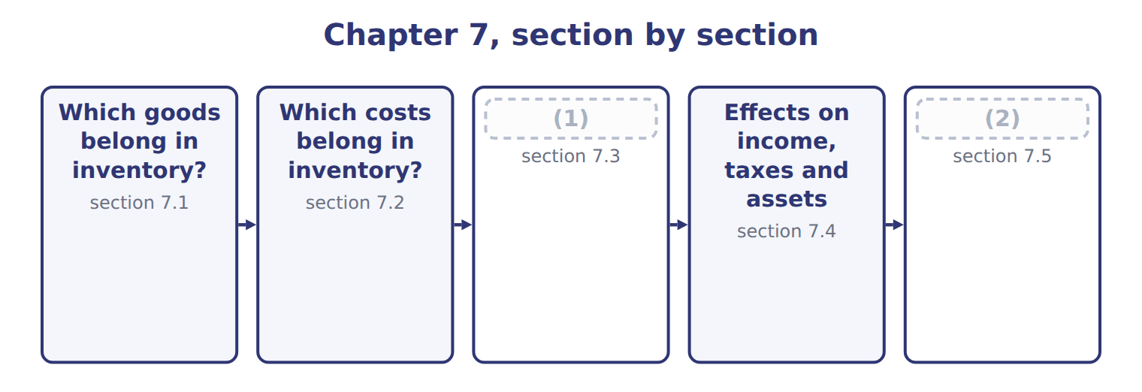
word list
Cost flow assumptions · Inventory errors · FOB destination

Summary 1 gaps 3–14
Inventory means goods held for sale in the (3) course of business, goods in production, and materials that will be used in production. A (4) such as Barada (5) , Inc. has one inventory account. A (6) such as Orontes has three: raw materials, work in process and (7) goods. The basic rule is simple: (8) the goods that the company controls on the balance sheet date, (9) they are. Control (10) follows legal title. Three (11) need care. The shipping term (12) who controls goods that are on a truck or a ship at (13) . Under FOB shipping point, control (14) to the buyer when the goods leave the seller, so the buyer includes them. Under FOB destination, the seller keeps control until the goods arrive, so the seller includes them. In a consignment, the consignor (the owner) gives goods to a consignee, who sells them for a commission.
word list
wherever · finished · include · decides · retailer · Wholesale · ordinary · usually · year-end · passes · manufacturer · follows · situations

Summary 2 gaps 15–23
The goods stay in the (15) inventory. The (16) never includes them, even (17) they are in its shop. Goods held for (18) . Goods in the (19) that belong to another company must be taken out of the (20) count. Goods the company owns that are held (21) else must be added. Two (22) cases appear in later (23) . When customers have a right of return, the seller records revenue net of expected returns and a separate asset for the goods it expects to get back. In a bill-and-hold sale, the seller keeps the goods in its inventory unless strict conditions show that the buyer already controls them.
word list
though · transit · chapters · others · physical · somewhere · special · warehouse · consignee · consignor's

The FOB flip

Summary 3 gaps 24–26
FOB (24) point: the BUYER includes goods in transit. FOB (25) : the SELLER includes them. Many (26) reverse these. The consignee never includes consigned goods, even when they are on its own shelves.
word list
candidates · destination · shipping · follows

FOB is not the Incoterm you know

Summary 4 gaps 27–30
In (27) trade, FOB (free on board) is an Incoterm about (28) goods onto a ship. In U.S. exam questions, FOB shipping point and FOB (29) are simple shipping terms that decide who (30) goods in transit, by truck, rail or sea. Do not bring Incoterm rules into these questions.
word list
controls · consignee · loading · destination · international

The English this section uses, and its Arabic
Each term sits against what it means.
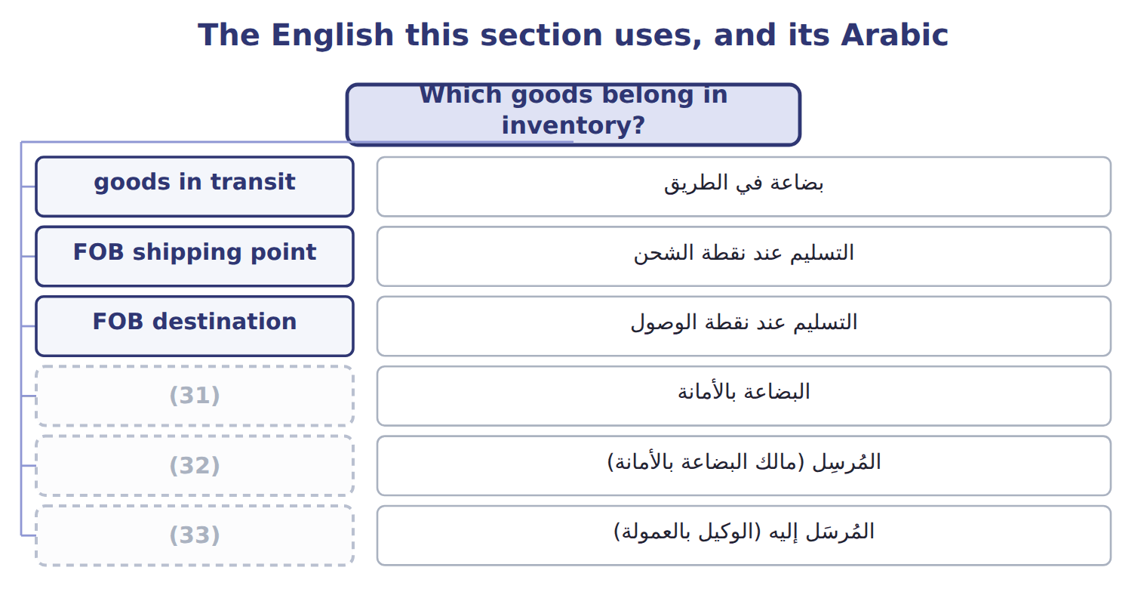
word list
consignment · inventory · consignee · consignor

The English this sheet uses, and its Arabic
English (exam term) | Arabic
goods in transit | بضاعة في الطريق
FOB shipping point | التسليم عند نقطة الشحن
FOB destination | التسليم عند نقطة الوصول
consignment | البضاعة بالأمانة
consignor | المُرسِل (مالك البضاعة بالأمانة)
consignee | المُرسَل إليه (الوكيل بالعمولة)
physical count | الجرد الفعلي

Answer key · 7.1 Which goods belong in inventory?

1 Cost flow assumptions | 18 others
2 Inventory errors | 19 warehouse
3 ordinary | 20 physical
4 retailer | 21 somewhere
5 Wholesale | 22 special
6 manufacturer | 23 chapters
7 finished | 24 shipping
8 include | 25 destination
9 wherever | 26 candidates
10 usually | 27 international
11 situations | 28 loading
12 decides | 29 destination
13 year-end | 30 controls
14 passes | 31 consignment
15 consignor's | 32 consignor
16 consignee | 33 consignee
17 though

the summaries in full
Summary 1 Inventory means goods held for sale in the ordinary course of business, goods in production, and materials that will be used in production. A retailer such as Barada Wholesale, Inc. has one inventory account. A manufacturer such as Orontes has three: raw materials, work in process and finished goods. The basic rule is simple: include the goods that the company controls on the balance sheet date, wherever they are. Control usually follows legal title. Three situations need care. The shipping term decides who controls goods that are on a truck or a ship at year-end. Under FOB shipping point, control passes to the buyer when the goods leave the seller, so the buyer includes them. Under FOB destination, the seller keeps control until the goods arrive, so the seller includes them. In a consignment, the consignor (the owner) gives goods to a consignee, who sells them for a commission.
Summary 2 The goods stay in the consignor's inventory. The consignee never includes them, even though they are in its shop. Goods held for others. Goods in the warehouse that belong to another company must be taken out of the physical count. Goods the company owns that are held somewhere else must be added. Two special cases appear in later chapters. When customers have a right of return, the seller records revenue net of expected returns and a separate asset for the goods it expects to get back. In a bill-and-hold sale, the seller keeps the goods in its inventory unless strict conditions show that the buyer already controls them.
Summary 3 FOB shipping point: the BUYER includes goods in transit. FOB destination: the SELLER includes them. Many candidates reverse these. The consignee never includes consigned goods, even when they are on its own shelves.
Summary 4 In international trade, FOB (free on board) is an Incoterm about loading goods onto a ship. In U.S. exam questions, FOB shipping point and FOB destination are simple shipping terms that decide who controls goods in transit, by truck, rail or sea. Do not bring Incoterm rules into these questions.

7.2 Which costs belong in inventory?
Chapter 7 · section 7.2

Fill every gap. Each word list holds one word more than there are gaps.
Summary 1 gaps 1–12
Inventory is (1) at cost. Cost means all the costs (2) to bring the goods to their present (3) and location. These are (4) costs: they stay in inventory as an asset, and they (5) cost of goods sold when the goods are sold. Other costs are period costs: they are (6) in the period in which they occur. For goods that are bought, cost includes the purchase price, (7) , import duties, (8) taxes and handling, less trade discounts and any purchase discount taken for early payment. For goods that are made, cost also includes (9) labor and production overhead. Fixed production overhead needs care. It is allocated to units on the basis of normal (10) : the output the plant (11) on average over several periods. If output is (12) low, the fixed overhead that is not allocated is an expense of the period. It is not added to inventory.
word list
inventoriable · needed · freight-in · expects · direct · recorded · condition · become · capacity · unusually · freight-out · expenses · non-refundable

Summary 2 gaps 13–16
In the same way, (13) waste (unusual (14) , idle time or extra freight) is an expense, not inventory cost. Period costs include (15) to customers, sales commissions, advertising, general and (16) costs, and the storage of finished goods. Interest on inventory that is produced routinely is also a period cost.
word list
abnormal · spoilage · administrative · freight-out · include

The cost of imported glass bottles

Summary 3 gaps 17–18
Orontes (17) glass bottles for its Amman plant. The (18) is $20,000, and Orontes pays within the discount period, so it takes a 2% discount.
word list
imports · average · invoice

The cost of imported glass bottles
Item | Amount | Inventory cost?
Invoice price | 20,000 | Yes
Purchase discount taken | (400) | Yes ( (19) cost)
Freight-in from the port to Amman | 1,200 | Yes
Import duty (not refundable) | 900 | Yes
Insurance while the bottles are in transit | 300 | Yes
Freight-out when filled bottles go to customers | 700 | No: selling expense
Storage of finished olive oil | 250 | (20)
Cost of the bottles in inventory | 22,000

word list
consignor · No: period cost · reduces

Summary 4 gaps 21–26
The two costs at the (21) of the table (22) after the goods are ready for use. They do not bring the bottles to their present (23) and location, so they are (24) . IAS 2 uses the same idea of cost and lists the same (25) : abnormal waste, storage, (26) overheads and selling costs. The big IFRS difference is in the next section: IAS 2 does not allow LIFO.
word list
expenses · condition · administrative · exclusions · include · bottom · happen

The English this section uses, and its Arabic
Each term sits against what it means.
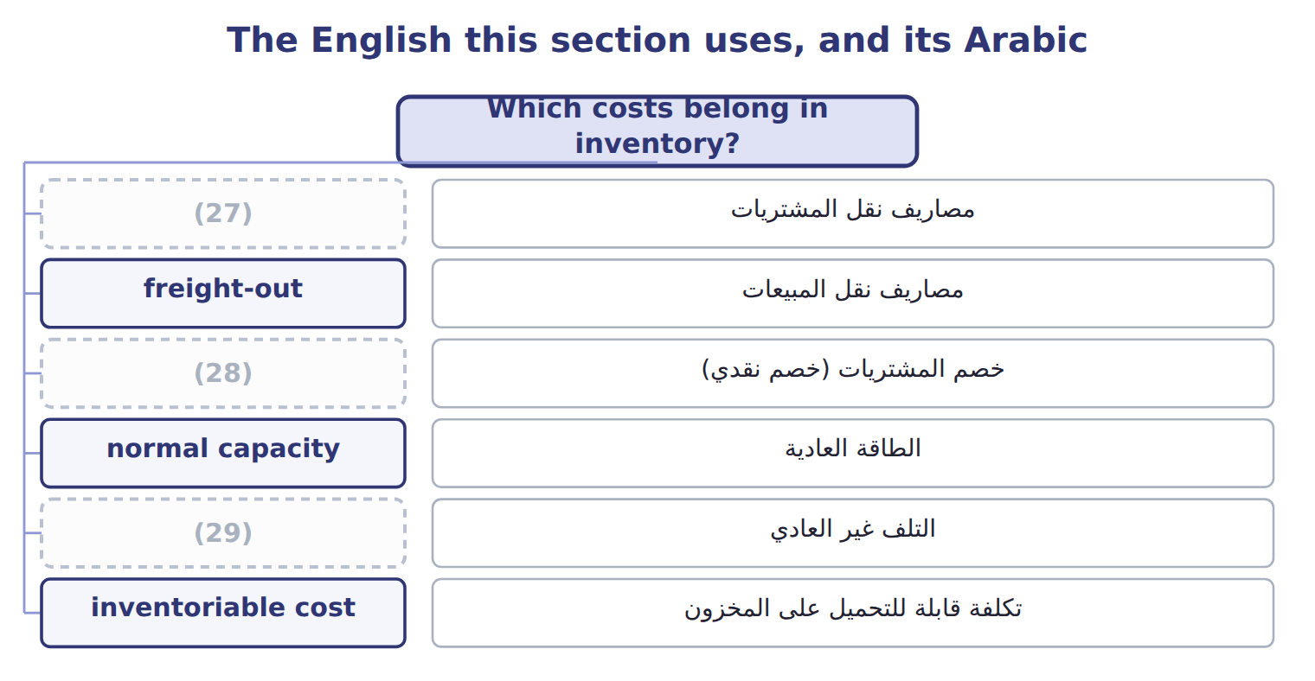
word list
abnormal waste · purchase discount · freight-in · inventory

The English this sheet uses, and its Arabic
English (exam term) | Arabic
freight-in | مصاريف نقل المشتريات
freight-out | مصاريف نقل المبيعات
purchase discount | خصم المشتريات (خصم نقدي)
normal capacity | الطاقة العادية
abnormal waste | التلف غير العادي
inventoriable cost | تكلفة قابلة للتحميل على المخزون
period cost | تكلفة الفترة

Answer key · 7.2 Which costs belong in inventory?

1 recorded | 16 administrative
2 needed | 17 imports
3 condition | 18 invoice
4 inventoriable | 19 reduces
5 become | 20 No: period cost
6 expenses | 21 bottom
7 freight-in | 22 happen
8 non-refundable | 23 condition
9 direct | 24 expenses
10 capacity | 25 exclusions
11 expects | 26 administrative
12 unusually | 27 freight-in
13 abnormal | 28 purchase discount
14 spoilage | 29 abnormal waste
15 freight-out

the summaries in full
Summary 1 Inventory is recorded at cost. Cost means all the costs needed to bring the goods to their present condition and location. These are inventoriable costs: they stay in inventory as an asset, and they become cost of goods sold when the goods are sold. Other costs are period costs: they are expenses in the period in which they occur. For goods that are bought, cost includes the purchase price, freight-in, import duties, non-refundable taxes and handling, less trade discounts and any purchase discount taken for early payment. For goods that are made, cost also includes direct labor and production overhead. Fixed production overhead needs care. It is allocated to units on the basis of normal capacity: the output the plant expects on average over several periods. If output is unusually low, the fixed overhead that is not allocated is an expense of the period. It is not added to inventory.
Summary 2 In the same way, abnormal waste (unusual spoilage, idle time or extra freight) is an expense, not inventory cost. Period costs include freight-out to customers, sales commissions, advertising, general and administrative costs, and the storage of finished goods. Interest on inventory that is produced routinely is also a period cost.
Summary 3 Orontes imports glass bottles for its Amman plant. The invoice is $20,000, and Orontes pays within the discount period, so it takes a 2% discount.
Summary 4 The two costs at the bottom of the table happen after the goods are ready for use. They do not bring the bottles to their present condition and location, so they are expenses. IAS 2 uses the same idea of cost and lists the same exclusions: abnormal waste, storage, administrative overheads and selling costs. The big IFRS difference is in the next section: IAS 2 does not allow LIFO.

7.3 Cost flow assumptions
Chapter 7 · section 7.3

Fill every gap. Each word list holds one word more than there are gaps.
Summary 1 gaps 1–12
Unit costs (1) during the year. When a company sells some units and keeps (2) , it must decide which costs go to cost of goods sold and which stay in ending inventory. This (3) is a cost flow (4) . It does not need to match the (5) flow of the goods. Specific (6) tracks the (7) cost of each item. It suits unique, (8) items, such as cars or (9) . FIFO ( (10) , first-out) sends the oldest costs to cost of goods sold. Ending inventory holds the newest costs. LIFO ( (11) , first-out) sends the newest costs to cost of goods sold. Ending inventory holds the oldest costs. (12) cost divides the cost of goods available by the units available and uses this one unit cost for both cost of goods sold and ending inventory.
word list
actual · expensive · first-in · change · Weighted-average · last-in · decision · physical · November · others · jewelry · identification · assumption

Orontes olive oil: three methods, one set of facts

Summary 2 gaps 13–17
Orontes sells (13) olive oil in cases of twelve bottles. (14) rose during 2025. Orontes began the year with 1,000 cases at $40. It (15) 2,000 cases at $44, then 3,000 at $48, then 2,000 at $50. It sold 6,000 cases at $70, so 2,000 cases are left. The company uses a (16) system. Goods (17) : 8,000 cases costing $372,000.
word list
available · premium · Weighted-average · Prices · bought · periodic

Orontes olive oil: three methods, one set of facts
The bars are drawn to scale.
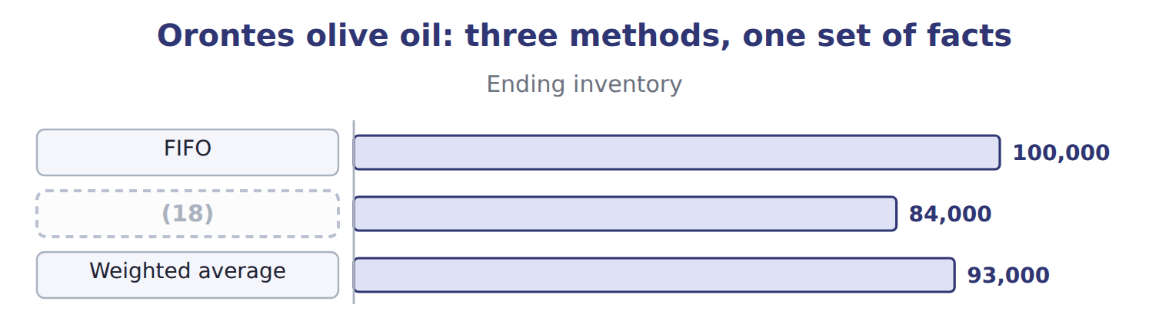
word list
LIFO · freight-in

Summary 3 gaps 19–20
In each row, ending (19) plus cost of goods sold equals the cost of goods available. Only the split is (20) .
word list
Orontes · different · inventory

Olive oil: periodic versus perpetual results (whole USD)
The bars are drawn to scale.
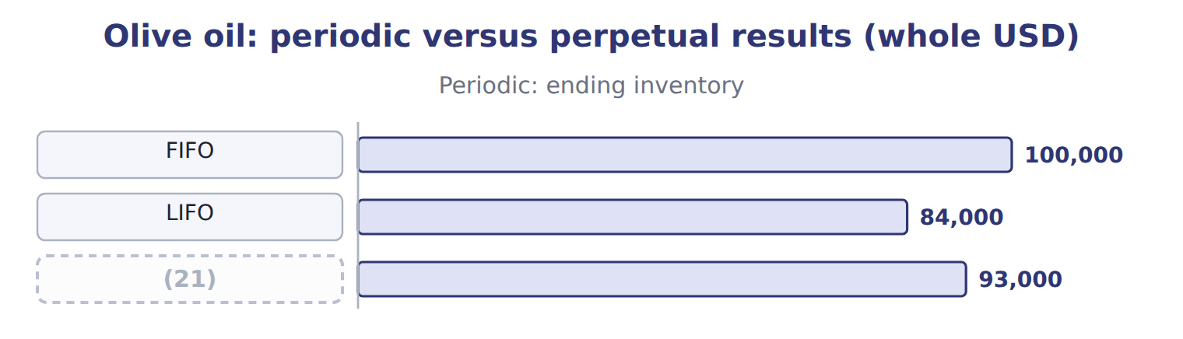
word list
Average (weighted / moving) · goods available for sale

Summary 4 gaps 22–29
In a (22) inventory system, the company (23) the goods at (24) and calculates cost of goods sold for the whole period. In a perpetual inventory system, it (25) inventory and cost of goods sold after every purchase and every sale. The average method in a perpetual system is the (26) average: the company calculates a new average after each purchase. FIFO gives the same result in both (27) , because the (28) units are always sold first. LIFO and the average method do not: under a perpetual system, each sale can only use the costs that exist on the date of the sale. The sales took place in April, August and (29) .
word list
periodic · oldest · perpetual · updates · November · systems · counts · moving · year-end

Periodic LIFO for Dubai pastry trays

Summary 5 gaps 30–35
The Dubai plant had 3,000 (30) pastry trays available in 2025, (31) $68,000. It sold 2,200 trays. (32) the dashed boxes below using periodic LIFO. Then check that cost of goods sold plus ending (33) equals the cost of goods available. IAS 2 allows FIFO and the weighted average, and it requires specific identification for items that are not (34) . It does not allow LIFO. You will compare the two (35) again.
word list
perpetual · frozen · inventory · Complete · interchangeable · frameworks · costing

The English this section uses, and its Arabic
Each term sits against what it means.
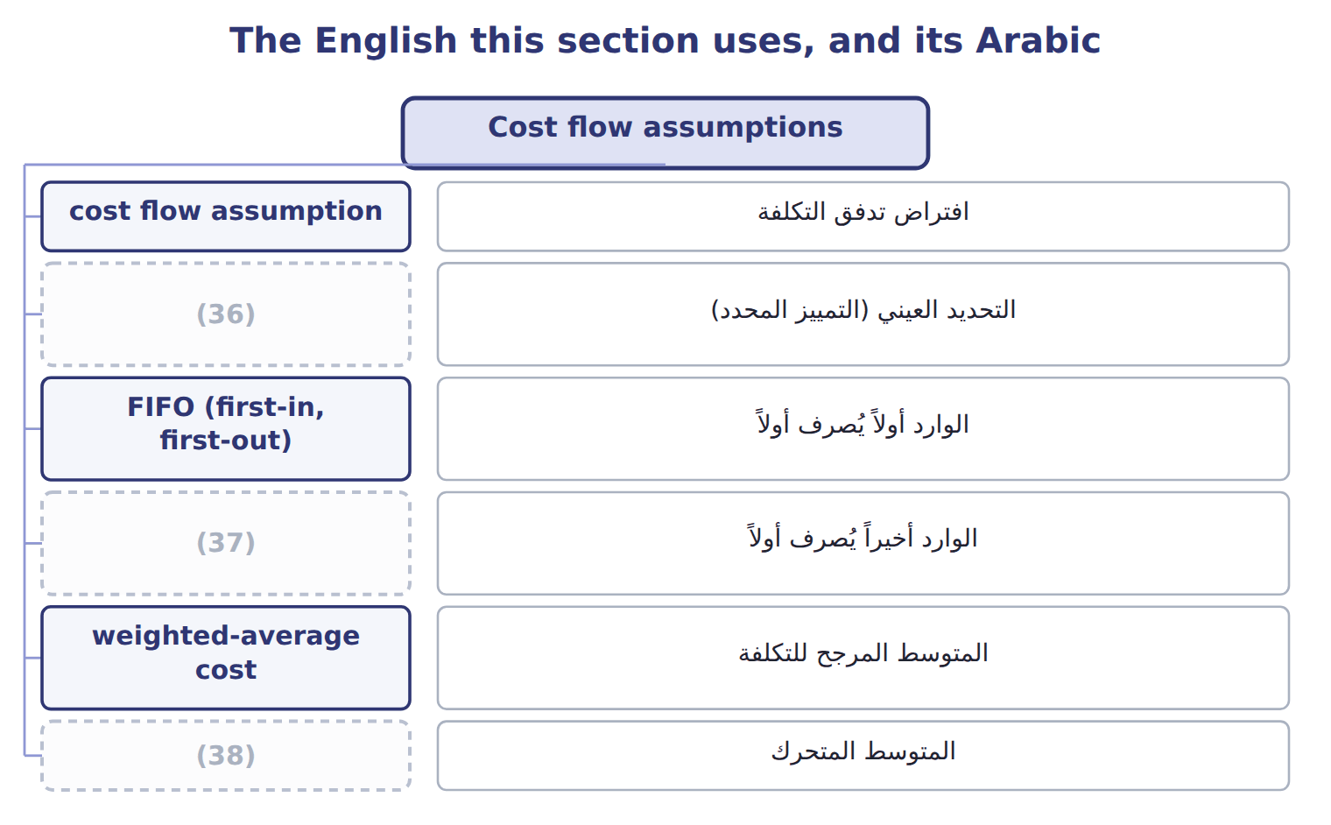
word list
specific identification · moving average · LIFO conformity rule · LIFO (last-in, first-out)

The English this sheet uses, and its Arabic
English (exam term) | Arabic
cost flow assumption | افتراض تدفق التكلفة
specific identification | التحديد العيني (التمييز المحدد)
FIFO (first-in, first-out) | الوارد أولاً يُصرف أولاً
LIFO (last-in, first-out) | الوارد أخيراً يُصرف أولاً
weighted-average cost | المتوسط المرجح للتكلفة
moving average | المتوسط المتحرك
periodic inventory system | نظام الجرد الدوري
perpetual inventory system | نظام الجرد المستمر
goods available for sale | البضاعة المتاحة للبيع

Answer key · 7.3 Cost flow assumptions

1 change | 20 different
2 others | 21 Average (weighted / moving)
3 decision | 22 periodic
4 assumption | 23 counts
5 physical | 24 year-end
6 identification | 25 updates
7 actual | 26 moving
8 expensive | 27 systems
9 jewelry | 28 oldest
10 first-in | 29 November
11 last-in | 30 frozen
12 Weighted-average | 31 costing
13 premium | 32 Complete
14 Prices | 33 inventory
15 bought | 34 interchangeable
16 periodic | 35 frameworks
17 available | 36 specific identification
18 LIFO | 37 LIFO (last-in, first-out)
19 inventory | 38 moving average

the summaries in full
Summary 1 Unit costs change during the year. When a company sells some units and keeps others, it must decide which costs go to cost of goods sold and which stay in ending inventory. This decision is a cost flow assumption. It does not need to match the physical flow of the goods. Specific identification tracks the actual cost of each item. It suits unique, expensive items, such as cars or jewelry. FIFO (first-in, first-out) sends the oldest costs to cost of goods sold. Ending inventory holds the newest costs. LIFO (last-in, first-out) sends the newest costs to cost of goods sold. Ending inventory holds the oldest costs. Weighted-average cost divides the cost of goods available by the units available and uses this one unit cost for both cost of goods sold and ending inventory.
Summary 2 Orontes sells premium olive oil in cases of twelve bottles. Prices rose during 2025. Orontes began the year with 1,000 cases at $40. It bought 2,000 cases at $44, then 3,000 at $48, then 2,000 at $50. It sold 6,000 cases at $70, so 2,000 cases are left. The company uses a periodic system. Goods available: 8,000 cases costing $372,000.
Summary 3 In each row, ending inventory plus cost of goods sold equals the cost of goods available. Only the split is different.
Summary 4 In a periodic inventory system, the company counts the goods at year-end and calculates cost of goods sold for the whole period. In a perpetual inventory system, it updates inventory and cost of goods sold after every purchase and every sale. The average method in a perpetual system is the moving average: the company calculates a new average after each purchase. FIFO gives the same result in both systems, because the oldest units are always sold first. LIFO and the average method do not: under a perpetual system, each sale can only use the costs that exist on the date of the sale. The sales took place in April, August and November.
Summary 5 The Dubai plant had 3,000 frozen pastry trays available in 2025, costing $68,000. It sold 2,200 trays. Complete the dashed boxes below using periodic LIFO. Then check that cost of goods sold plus ending inventory equals the cost of goods available. IAS 2 allows FIFO and the weighted average, and it requires specific identification for items that are not interchangeable. It does not allow LIFO. You will compare the two frameworks again.

7.4 Effects on income, taxes and assets
Chapter 7 · section 7.4

Fill every gap. Each word list holds one word more than there are gaps.
Summary 1 gaps 1–12
When prices are (1) , the methods give very (2) results. FIFO puts the old, (3) costs into cost of goods sold. So FIFO gives the (4) cost of goods sold, the highest gross (5) , the highest income tax and the highest ending inventory. LIFO gives the (6) . The (7) average falls in between. When prices are (8) , all these (9) reverse. Each method has a (10) . LIFO matches current costs with current (11) , so its income is closer to current (12) reality, but its balance sheet shows old costs. FIFO shows ending inventory close to current cost, but its income includes gains from holding inventory while prices rise. Companies that use LIFO must help readers compare them with FIFO companies. The LIFO reserve is the difference between FIFO (or current cost) inventory and LIFO inventory.
word list
falling · economic · opposite · cheaper · lowest · strength · profit · relationships · rising · weighted · holding · revenues · different

Summary 2 gaps 13–23
For Orontes, the LIFO reserve at the end of 2025 is $100,000 − $84,000 = $16,000. An (13) can convert LIFO (14) to FIFO with two (15) . FIFO inventory equals LIFO inventory plus the LIFO reserve. FIFO cost of goods sold equals LIFO cost of goods sold minus the increase in the LIFO reserve (16) the year. Orontes (17) the year with no reserve, so the increase is $16,000, and FIFO cost of goods sold is $288,000 − $16,000 = $272,000. At an (18) tax rate of 25%, LIFO saved $4,000 of tax this year. If a LIFO company sells more units than it buys, old (19) layers flow into cost of goods sold. (20) rises for one year. This is not a lasting (21) , and the company should (22) it if it is (23) . This is a U.S. tax rule.
word list
started · results · low-cost · illustrative · liquidation · analyst · during · material · improvement · Income · relationships · disclose

Summary 3 gaps 24–26
A company that uses LIFO for its tax (24) must also use LIFO in its financial (25) . This is why U.S. companies that want the tax benefit of LIFO also report lower LIFO profits to (26) .
word list
low-cost · return · statements · investors

Signs and directions

Summary 4 gaps 27–30
To get FIFO cost of goods sold, (27) the increase in the LIFO reserve from LIFO cost of goods sold. In (28) prices, LIFO gives LOWER income and LOWER taxes, not higher. A LIFO (29) raises income once. Do not treat it as a better (30) . Periodic and perpetual LIFO give different answers.
word list
business · SUBTRACT · holding · rising · liquidation

Reserve does not mean reserve

Summary 5 gaps 31–32
The LIFO reserve is not an (31) reserve. It is only the difference between two (32) amounts. It is sometimes called the LIFO allowance or revaluation to LIFO.
word list
matches · inventory · equity

The English this section uses, and its Arabic
Each term sits against what it means.
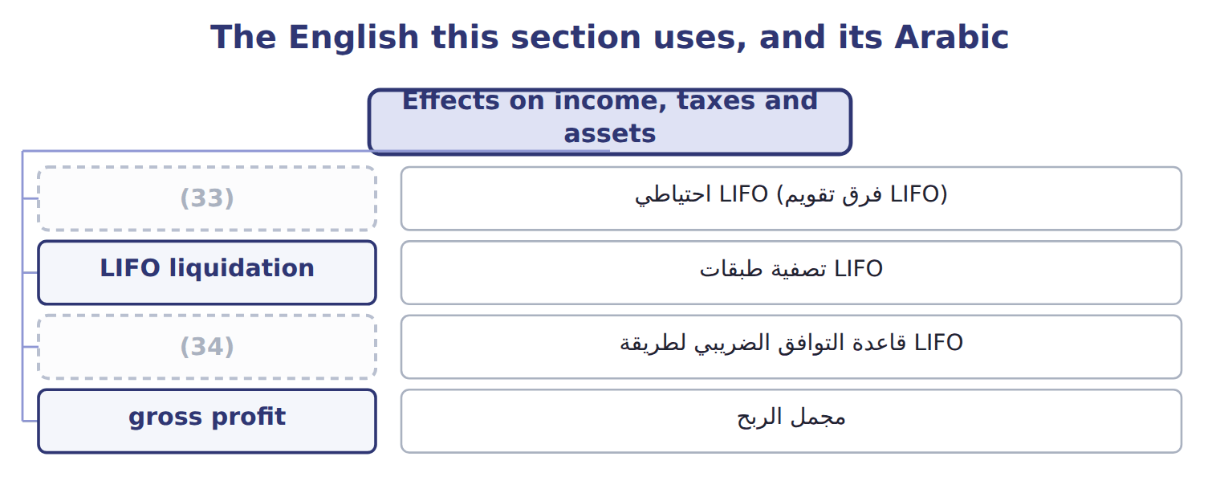
word list
specific identification · LIFO conformity rule · LIFO reserve

The English this sheet uses, and its Arabic
English (exam term) | Arabic
LIFO reserve | احتياطي LIFO (فرق تقويم LIFO)
LIFO liquidation | تصفية طبقات LIFO
LIFO conformity rule | قاعدة التوافق الضريبي لطريقة LIFO
gross profit | مجمل الربح

Answer key · 7.4 Effects on income, taxes and assets

1 rising | 18 illustrative
2 different | 19 low-cost
3 cheaper | 20 Income
4 lowest | 21 improvement
5 profit | 22 disclose
6 opposite | 23 material
7 weighted | 24 return
8 falling | 25 statements
9 relationships | 26 investors
10 strength | 27 SUBTRACT
11 revenues | 28 rising
12 economic | 29 liquidation
13 analyst | 30 business
14 results | 31 equity
15 relationships | 32 inventory
16 during | 33 LIFO reserve
17 started | 34 LIFO conformity rule

the summaries in full
Summary 1 When prices are rising, the methods give very different results. FIFO puts the old, cheaper costs into cost of goods sold. So FIFO gives the lowest cost of goods sold, the highest gross profit, the highest income tax and the highest ending inventory. LIFO gives the opposite. The weighted average falls in between. When prices are falling, all these relationships reverse. Each method has a strength. LIFO matches current costs with current revenues, so its income is closer to current economic reality, but its balance sheet shows old costs. FIFO shows ending inventory close to current cost, but its income includes gains from holding inventory while prices rise. Companies that use LIFO must help readers compare them with FIFO companies. The LIFO reserve is the difference between FIFO (or current cost) inventory and LIFO inventory.
Summary 2 For Orontes, the LIFO reserve at the end of 2025 is $100,000 − $84,000 = $16,000. An analyst can convert LIFO results to FIFO with two relationships. FIFO inventory equals LIFO inventory plus the LIFO reserve. FIFO cost of goods sold equals LIFO cost of goods sold minus the increase in the LIFO reserve during the year. Orontes started the year with no reserve, so the increase is $16,000, and FIFO cost of goods sold is $288,000 − $16,000 = $272,000. At an illustrative tax rate of 25%, LIFO saved $4,000 of tax this year. If a LIFO company sells more units than it buys, old low-cost layers flow into cost of goods sold. Income rises for one year. This is not a lasting improvement, and the company should disclose it if it is material. This is a U.S. tax rule.
Summary 3 A company that uses LIFO for its tax return must also use LIFO in its financial statements. This is why U.S. companies that want the tax benefit of LIFO also report lower LIFO profits to investors.
Summary 4 To get FIFO cost of goods sold, SUBTRACT the increase in the LIFO reserve from LIFO cost of goods sold. In rising prices, LIFO gives LOWER income and LOWER taxes, not higher. A LIFO liquidation raises income once. Do not treat it as a better business. Periodic and perpetual LIFO give different answers.
Summary 5 The LIFO reserve is not an equity reserve. It is only the difference between two inventory amounts. It is sometimes called the LIFO allowance or revaluation to LIFO.

7.5 Inventory errors
Chapter 7 · section 7.5

Fill every gap. Each word list holds one word more than there are gaps.
Summary 1 gaps 1–11
Cost of goods sold (1) on the count: beginning inventory plus purchases minus ending inventory. If ending inventory is wrong, cost of goods sold is wrong in the same year. And (2) this year's ending inventory is next year's beginning inventory, the error moves into the next year too. At the end of 2025, (3) counted some goods twice, so ending inventory was overstated by 40 (USD 000). Cost of goods sold was understated by 40, so pretax income was overstated by 40. In 2026, beginning inventory was too high, so cost of goods sold was overstated and pretax income was understated by 40. Over the two years, the two errors (4) . (5) earnings are overstated at the end of 2025 but correct at the end of 2026. This is a (6) error. (7) the tax effect: at a 25% tax rate, net income was overstated by only 30 in the first year. Errors in purchases work in a (8) way. Row 3 is a (9) exam item: when a (10) is left out of both purchases and the count, cost of goods sold and income are still correct, but inventory and (11) payable are both understated.
word list
purchase · because · inventory · Retained · cancel · Orontes · Remember · accounts · classic · similar · counterbalancing · depends

Effects of four common inventory errors (O = overstated, U = understated)
Every item belongs to exactly one group.
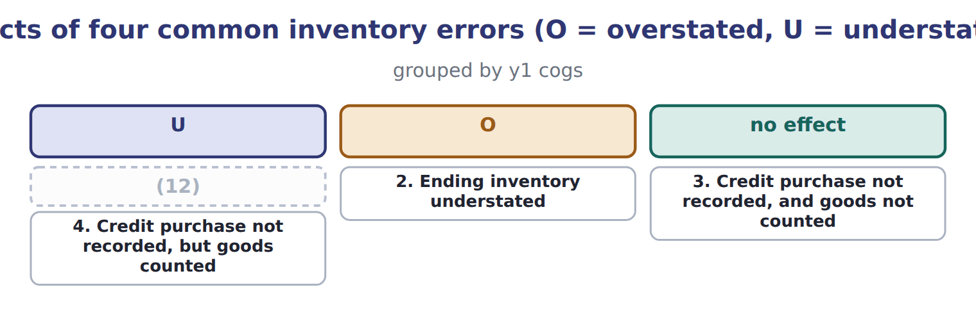
word list
1. Ending inventory overstated · 2. Ending inventory understated

Summary 2 gaps 13–16
If a company finds an error from a prior year, it corrects the error by (13) the prior-year (14) , with an adjustment to beginning retained earnings (ASC 250). If the error has already (15) , retained earnings need no adjustment, but the prior-year income figures shown for (16) are still restated.
word list
comparison · restating · statements · consignment · counterbalanced

Over- and under-

Summary 3 gaps 17–18
Net (17) is overstated by 40 (the size of the error), not overstated to 940. In a question, find the (18) for the first year, then reverse it for the second year.
word list
correct · income · direction

Over- and under-
The bars are drawn to scale.
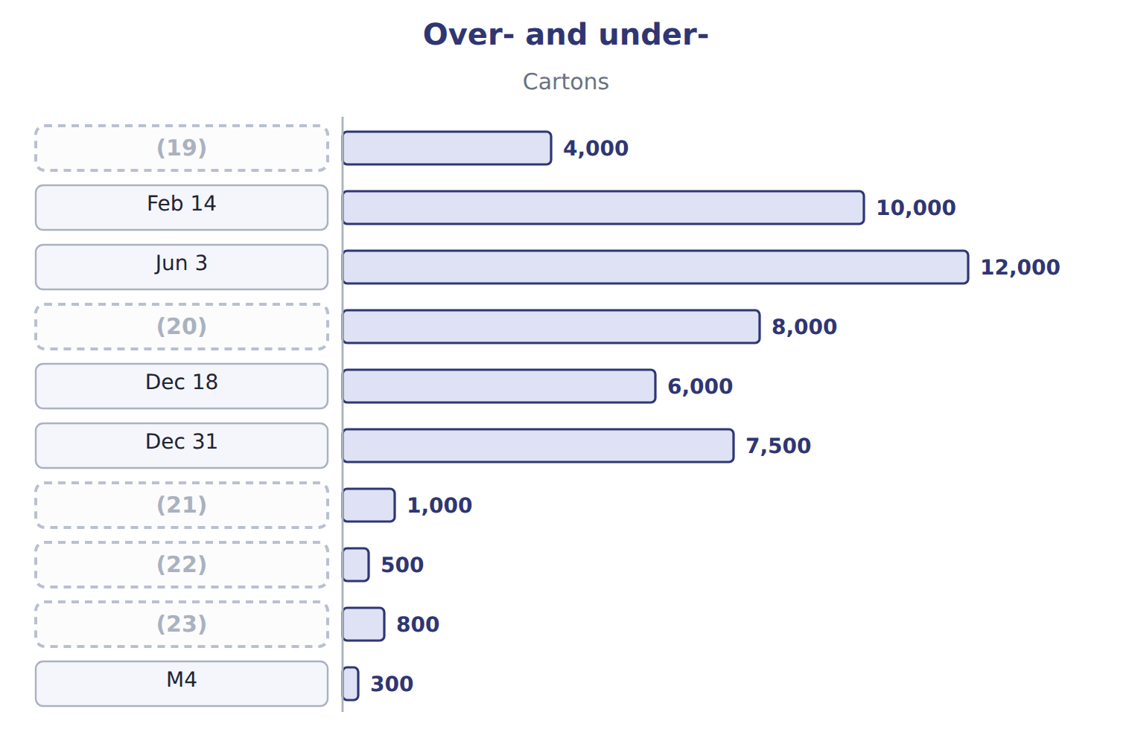
word list
Jan 1 · M3 · counterbalancing error · M2 · M1 · Sep 21

Item — Answer
Item | Answer
COGS, line 2: 1,200 × $22 | $26,400
Ending inventory, line 1: 300 × $22 | $6,600
Ending inventory, line 2: 500 × $20 | $10,000
Total COGS | $25,000 + $26,400 = $51,400
Total ending inventory | (24)
Check | $51,400 + $16,600 = $68,000, the cost of goods (25) .

word list
$6,600 + $10,000 = $16,600 · available · freight-out

Memo item — Category
Each stage leads to the next.
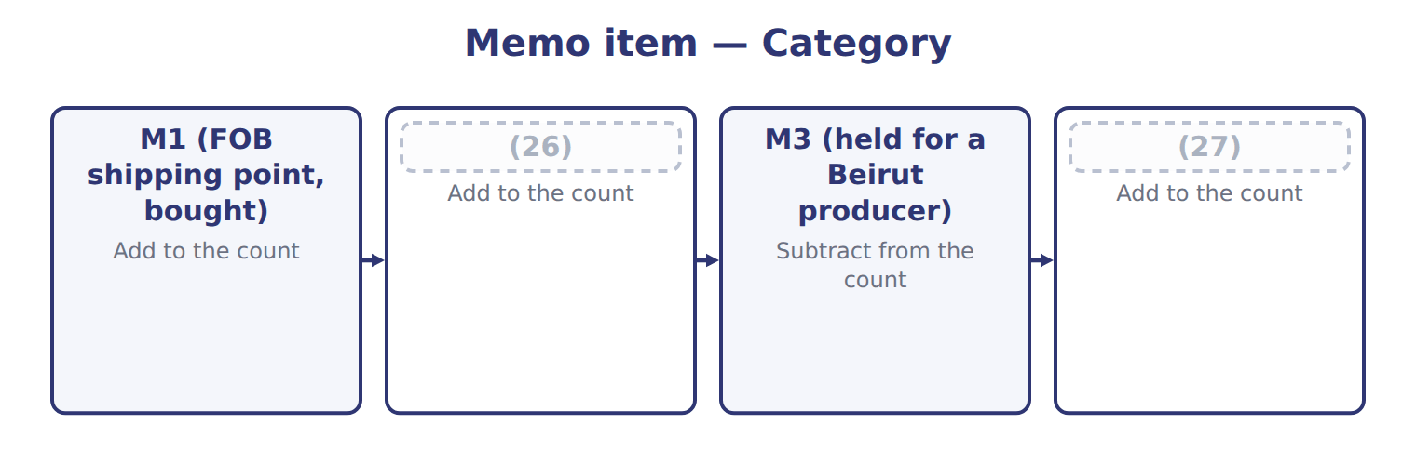
word list
M4 (at a Doha consignee) · M2 (FOB destination, sold) · cost of goods sold

The English this section uses, and its Arabic
Each term sits against what it means.
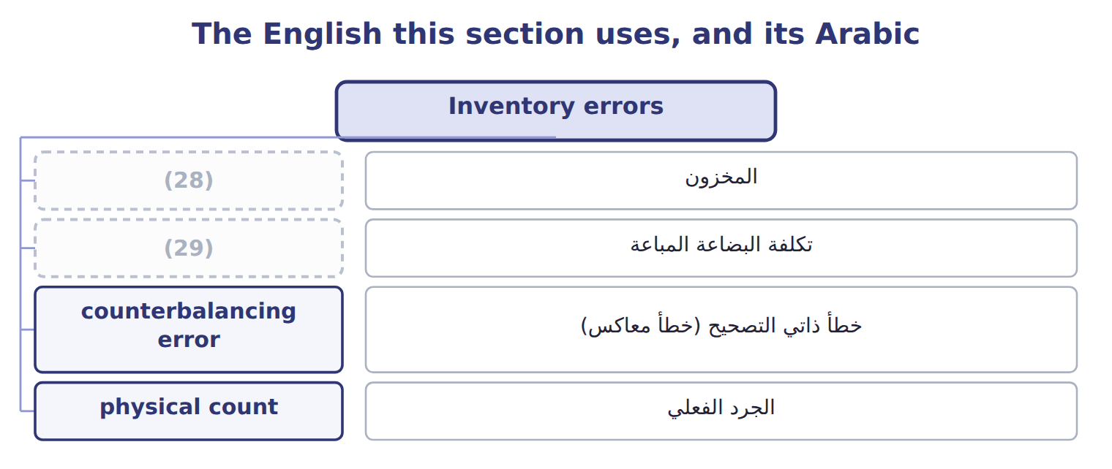
word list
تكلفة البضاعة المباعة · cost of goods sold · inventory

The English this sheet uses, and its Arabic
English (exam term) | Arabic
counterbalancing error | خطأ ذاتي التصحيح (خطأ معاكس)

Answer key · 7.5 Inventory errors

1 depends | 16 comparison
2 because | 17 income
3 Orontes | 18 direction
4 cancel | 19 Jan 1
5 Retained | 20 Sep 21
6 counterbalancing | 21 M1
7 Remember | 22 M2
8 similar | 23 M3
9 classic | 24 $6,600 + $10,000 = $16,600
10 purchase | 25 available
11 accounts | 26 M2 (FOB destination, sold)
12 1. Ending inventory overstated | 27 M4 (at a Doha consignee)
13 restating | 28 inventory
14 statements | 29 cost of goods sold
15 counterbalanced

the summaries in full
Summary 1 Cost of goods sold depends on the count: beginning inventory plus purchases minus ending inventory. If ending inventory is wrong, cost of goods sold is wrong in the same year. And because this year's ending inventory is next year's beginning inventory, the error moves into the next year too. At the end of 2025, Orontes counted some goods twice, so ending inventory was overstated by 40 (USD 000). Cost of goods sold was understated by 40, so pretax income was overstated by 40. In 2026, beginning inventory was too high, so cost of goods sold was overstated and pretax income was understated by 40. Over the two years, the two errors cancel. Retained earnings are overstated at the end of 2025 but correct at the end of 2026. This is a counterbalancing error. Remember the tax effect: at a 25% tax rate, net income was overstated by only 30 in the first year. Errors in purchases work in a similar way. Row 3 is a classic exam item: when a purchase is left out of both purchases and the count, cost of goods sold and income are still correct, but inventory and accounts payable are both understated.
Summary 2 If a company finds an error from a prior year, it corrects the error by restating the prior-year statements, with an adjustment to beginning retained earnings (ASC 250). If the error has already counterbalanced, retained earnings need no adjustment, but the prior-year income figures shown for comparison are still restated.
Summary 3 Net income is overstated by 40 (the size of the error), not overstated to 940. In a question, find the direction for the first year, then reverse it for the second year.

