11.1 Revenue and the core principle
Chapter 11 · section 11.1

Fill every gap. Each word list holds one word more than there are gaps.
Chapter 11, section by section
Each stage leads to the next.
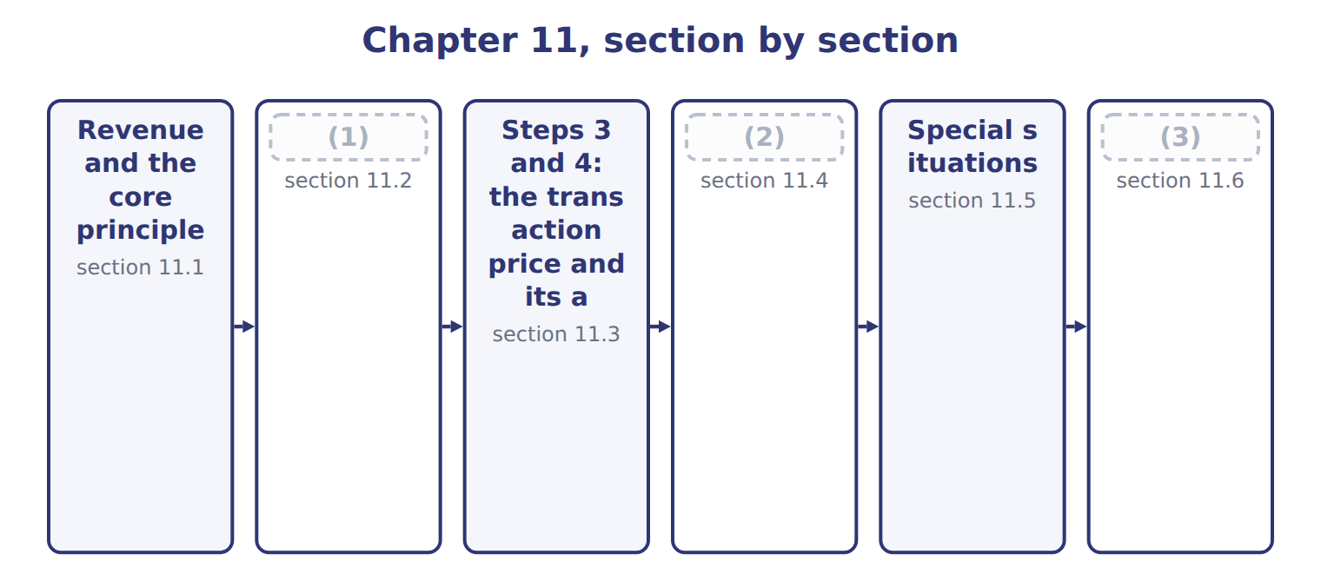
word list
Steps 3 and 4: the transaction price and its a · Step 5: recognizing revenue over time or at a · Steps 1 and 2: the contract and its performanc · Matching, contract costs and IFRS differences

Summary 1 gaps 4–14
Revenue is the inflow from a company's main (4) , such as selling goods or (5) services. Under ASC 606, a company (6) revenue when it (7) control of promised goods or services to a customer. It (8) revenue at the amount it expects to be (9) to in exchange. Control means the customer can (10) the use of the asset and obtain almost all of its (11) . The key question is (12) not when the company is paid, but when the customer gains control. Cash can (13) before, at or after that (14) . ASC 606 applies one model to all contracts with customers: goods, services, construction and software. The model has five steps. Each step answers one question, and each uses the answer to the step before.
word list
agent · transfers · therefore · moment · recognizes · entitled · direct · activities · arrive · measures · providing · benefits

The English this sheet uses, and its Arabic
English (exam term) | Arabic
revenue | إيراد (إيرادات)

Answer key · 11.1 Revenue and the core principle

1 Steps 1 and 2: the contract and its performanc | 8 measures
2 Step 5: recognizing revenue over time or at a | 9 entitled
3 Matching, contract costs and IFRS differences | 10 direct
4 activities | 11 benefits
5 providing | 12 therefore
6 recognizes | 13 arrive
7 transfers | 14 moment

the summaries in full
Summary 1 Revenue is the inflow from a company's main activities, such as selling goods or providing services. Under ASC 606, a company recognizes revenue when it transfers control of promised goods or services to a customer. It measures revenue at the amount it expects to be entitled to in exchange. Control means the customer can direct the use of the asset and obtain almost all of its benefits. The key question is therefore not when the company is paid, but when the customer gains control. Cash can arrive before, at or after that moment. ASC 606 applies one model to all contracts with customers: goods, services, construction and software. The model has five steps. Each step answers one question, and each uses the answer to the step before.

11.2 Steps 1 and 2: the contract and its performance obligations
Chapter 11 · section 11.2

Fill every gap. Each word list holds one word more than there are gaps.
Summary 1 gaps 1–12
Step 1: identify the contract. A contract exists only if the parties have approved it and are committed to it, each party's rights and the payment terms can be (1) , and the contract has (2) substance. Finally, it must be probable that the company will collect (3) all of the (4) . If these (5) are not met, cash received from the customer is a liability, not (6) . In U.S. GAAP, probable means likely: a (7) level than the IFRS (8) of more likely than not. Step 2: identify the (9) obligations. Each promise to (10) a distinct good or service is a separate (11) . A good or service is distinct if the customer can benefit from it on its own and it is separately (12) in the contract, not highly dependent on other promises.
word list
identified · obligation · higher · identifiable · performance · substantially · question · criteria · meaning · consideration · commercial · revenue · transfer

Suppose: the five steps applied to the Orontes–GreenBasket contract, October 1, 2026
Step | Orontes's analysis | Result (whole USD)
1. Identify the contract | A signed agreement for olive oil, a dispenser and (13) ; payment terms clear; collection probable. | Contract exists
2. Identify the performance obligations | Olive oil, the dispenser and maintenance can each be bought separately and are not highly interdependent. | (14)
3. Determine the transaction price | Fixed price; no variable amounts, no financing component, no payments to GreenBasket. | 1,080,000
4. Allocate the price | Relative (15) selling prices totalling 1,200,000; each obligation gets 90%. | 810,000 / 180,000 / 90,000
5. Recognize revenue | Oil and dispenser: at delivery ( (16) ). Maintenance: over 24 months (over time). | 2026: 515,250

word list
refund liability · point in time · Three obligations · maintenance · standalone

Probable is not 50%

Summary 2 gaps 17–19
In U.S. GAAP, probable means likely to occur: in (17) , about 75% or more. IFRS 15 uses probable to mean more likely than not. A question that says (18) is only a little more likely than not fails the U.S. (19) test.
word list
collection · variable · contract · practice

The English this section uses, and its Arabic
Each term sits against what it means.
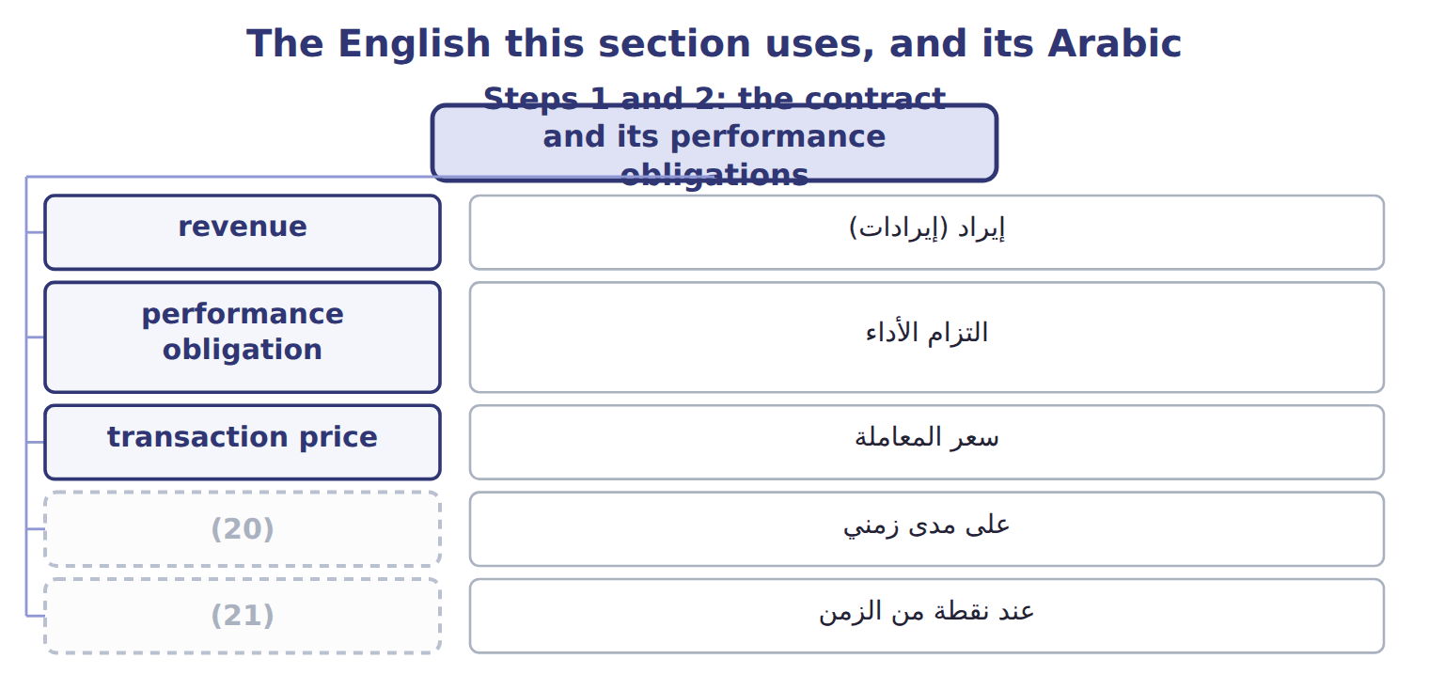
word list
التزام الأداء · over time · point in time

The English this sheet uses, and its Arabic
English (exam term) | Arabic
performance obligation | التزام الأداء

Answer key · 11.2 Steps 1 and 2: the contract and its performance obligations

1 identified | 12 identifiable
2 commercial | 13 maintenance
3 substantially | 14 Three obligations
4 consideration | 15 standalone
5 criteria | 16 point in time
6 revenue | 17 practice
7 higher | 18 collection
8 meaning | 19 contract
9 performance | 20 over time
10 transfer | 21 point in time
11 obligation

the summaries in full
Summary 1 Step 1: identify the contract. A contract exists only if the parties have approved it and are committed to it, each party's rights and the payment terms can be identified, and the contract has commercial substance. Finally, it must be probable that the company will collect substantially all of the consideration. If these criteria are not met, cash received from the customer is a liability, not revenue. In U.S. GAAP, probable means likely: a higher level than the IFRS meaning of more likely than not. Step 2: identify the performance obligations. Each promise to transfer a distinct good or service is a separate obligation. A good or service is distinct if the customer can benefit from it on its own and it is separately identifiable in the contract, not highly dependent on other promises.
Summary 2 In U.S. GAAP, probable means likely to occur: in practice, about 75% or more. IFRS 15 uses probable to mean more likely than not. A question that says collection is only a little more likely than not fails the U.S. contract test.

11.3 Steps 3 and 4: the transaction price and its allocation
Chapter 11 · section 11.3

Fill every gap. Each word list holds one word more than there are gaps.
Summary 1 gaps 1–12
Step 3: (1) the transaction price, the amount the company (2) to receive. It (3) variable consideration, such as (4) and bonuses. The company (5) it using the expected value, for many possible outcomes, or the most likely amount, for an (6) outcome. Variable amounts are included only to the extent that a significant (7) of revenue is not (8) later. This is the (9) on variable consideration. Three other items (10) the transaction price. A significant (11) component is removed when payment and (12) are far apart; if they are within one year, the company may ignore it. Consideration payable to a customer, such as a slotting fee paid to a supermarket for shelf space, reduces revenue. Sales taxes and VAT collected may be excluded from revenue by policy. Step 4: allocate the transaction price to the performance obligations in proportion to their standalone selling prices.
word list
Orontes · expects · constraint · all-or-nothing · determine · delivery · probable · includes · estimates · financing · rebates · change · reversal

Summary 2 gaps 13–16
When an (13) price is not available, the company estimates it, for example from market prices or expected cost plus a margin. The residual approach is allowed only when a price is highly variable or (14) . A discount is normally shared by all (15) . Each obligation therefore receives 90% of its (16) price.
word list
uncertain · standalone · observable · obligations · consideration

Price and allocation traps

Summary 3 gaps 17–20
Revenue for each (17) is its allocated price, not its standalone (18) price. A (19) fee paid to a customer reduces revenue; it is not a (20) expense unless Orontes receives a distinct service. Do not use the residual approach when standalone prices can be observed.
word list
slotting · probable · obligation · selling · marketing

Variable consideration: most likely amount or expected value
Suppose: sales of 2,400,000 with a 3% volume reb | How it works | Revenue (whole USD)
Most likely amount | The rebate is all or nothing, so use the single most likely outcome: the rebate is earned (70% likely). | 2,328,000
Expected value | (21) : 70% × 72,000 = 50,400 rebate. Best when there are many possible outcomes. | 2,349,600
Constraint | Include variable amounts only if a significant reversal of revenue is not probable later. | (22)

word list
revenue · Probability-weighted · Applies to both

The English this section uses, and its Arabic
Each term sits against what it means.
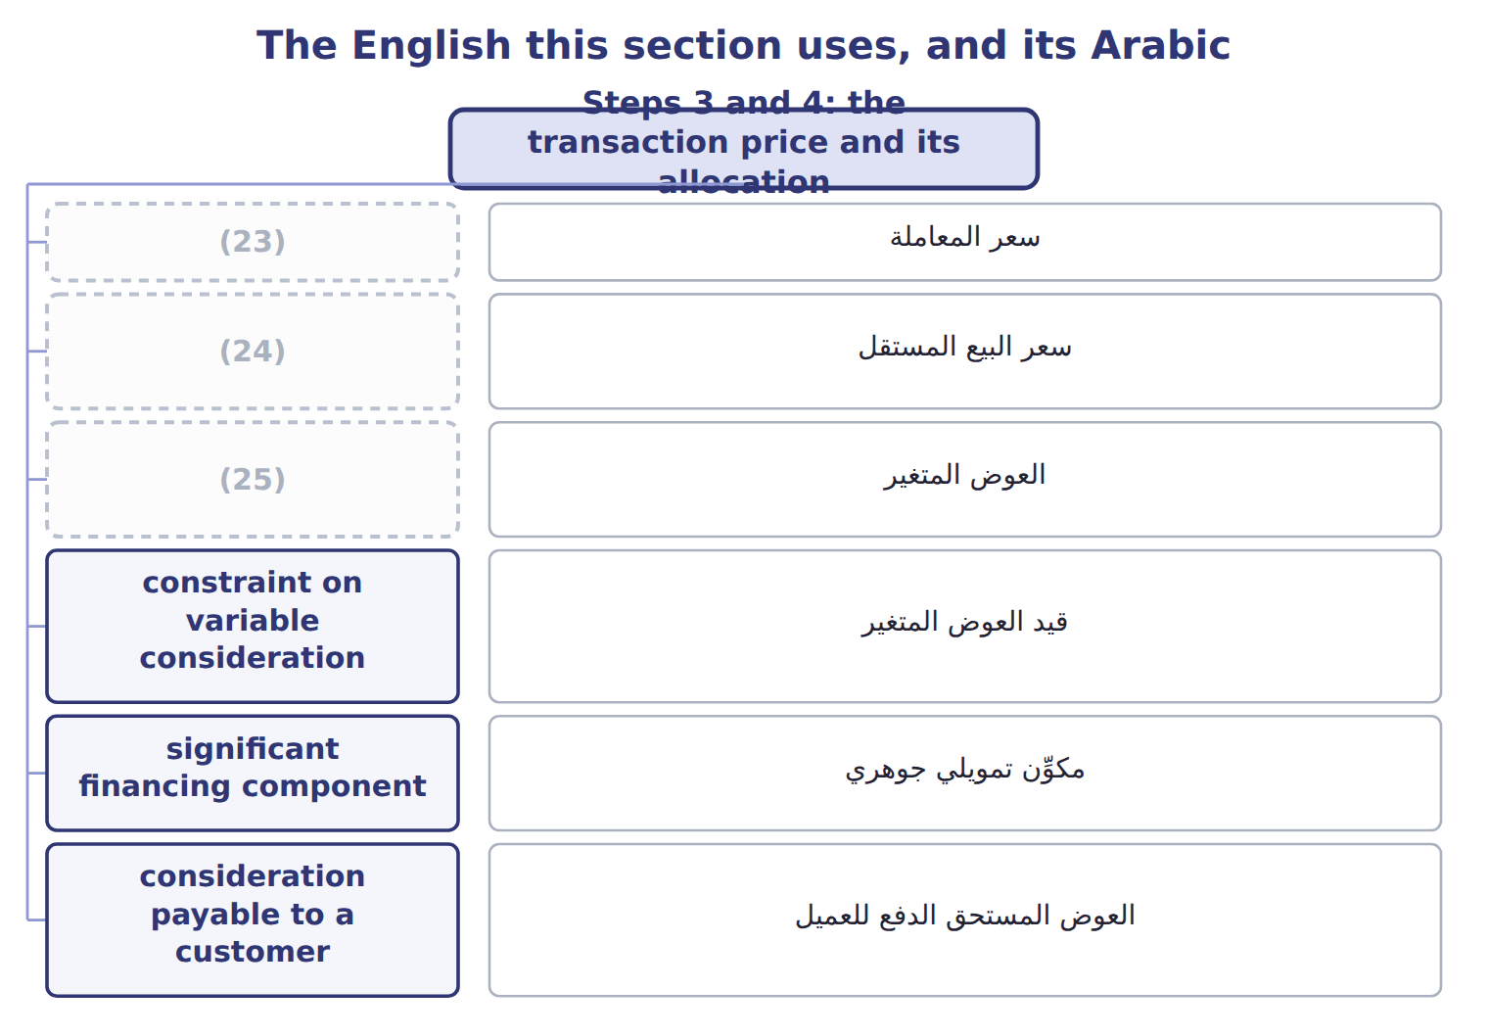
word list
transaction price · variable consideration · standalone selling price · سعر المعاملة

The English this sheet uses, and its Arabic
English (exam term) | Arabic
transaction price | سعر المعاملة
standalone selling price | سعر البيع المستقل
variable consideration | العوض المتغير
constraint on variable consideration | قيد العوض المتغير
significant financing component | مكوِّن تمويلي جوهري
consideration payable to a customer | العوض المستحق الدفع للعميل

Answer key · 11.3 Steps 3 and 4: the transaction price and its allocation

1 determine | 14 uncertain
2 expects | 15 obligations
3 includes | 16 standalone
4 rebates | 17 obligation
5 estimates | 18 selling
6 all-or-nothing | 19 slotting
7 reversal | 20 marketing
8 probable | 21 Probability-weighted
9 constraint | 22 Applies to both
10 change | 23 transaction price
11 financing | 24 standalone selling price
12 delivery | 25 variable consideration
13 observable

the summaries in full
Summary 1 Step 3: determine the transaction price, the amount the company expects to receive. It includes variable consideration, such as rebates and bonuses. The company estimates it using the expected value, for many possible outcomes, or the most likely amount, for an all-or-nothing outcome. Variable amounts are included only to the extent that a significant reversal of revenue is not probable later. This is the constraint on variable consideration. Three other items change the transaction price. A significant financing component is removed when payment and delivery are far apart; if they are within one year, the company may ignore it. Consideration payable to a customer, such as a slotting fee paid to a supermarket for shelf space, reduces revenue. Sales taxes and VAT collected may be excluded from revenue by policy. Step 4: allocate the transaction price to the performance obligations in proportion to their standalone selling prices.
Summary 2 When an observable price is not available, the company estimates it, for example from market prices or expected cost plus a margin. The residual approach is allowed only when a price is highly variable or uncertain. A discount is normally shared by all obligations. Each obligation therefore receives 90% of its standalone price.
Summary 3 Revenue for each obligation is its allocated price, not its standalone selling price. A slotting fee paid to a customer reduces revenue; it is not a marketing expense unless Orontes receives a distinct service. Do not use the residual approach when standalone prices can be observed.

11.4 Step 5: recognizing revenue over time or at a point in time
Chapter 11 · section 11.4

Fill every gap. Each word list holds one word more than there are gaps.
Summary 1 gaps 1–8
Step 5: (1) revenue when, or as, each obligation is satisfied. An obligation is satisfied over time if the customer (2) the benefit as the company (3) , if the company (4) an asset the customer controls, or if the asset has no other use and the company has a right to payment for work done so far. (5) over time is measured by an output method, such as units (6) , or an input method, such as costs incurred. If no (7) criterion is met, revenue is recognized at a point in time: when (8) passes.
word list
performs · benefit · control · delivered · over-time · Progress · receives · improves · recognize

Worked example: GreenBasket revenue for 2026

Summary 2 gaps 9–13
Olive oil is recognized at each (9) . By December 31, Orontes has (10) 8,000 cases at $40 each of allocated price: $324,000. The dispenser was installed on October 1, when (11) gained control: $180,000. (12) is over time: 3 months of 24 at $3,750 per month, $11,250. Total 2026 (13) is $515,250. The remaining $564,750 will be recognized in later periods.
word list
Maintenance · performs · delivery · delivered · revenue · GreenBasket

Suppose: GreenBasket revenue schedule for 2026
The bars are drawn to scale.
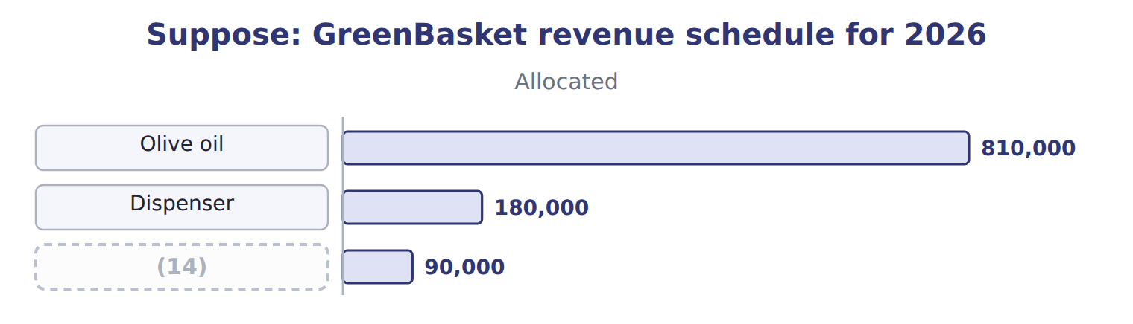
word list
breakage · Maintenance

Summary 3 gaps 15–17
Payments rarely match (15) . A contract asset arises when the company has (16) but its right to payment still depends on something other than time. A contract (17) arises when the customer pays first.
word list
liability · revenue · depends · performed

The English this section uses, and its Arabic
Each term sits against what it means.
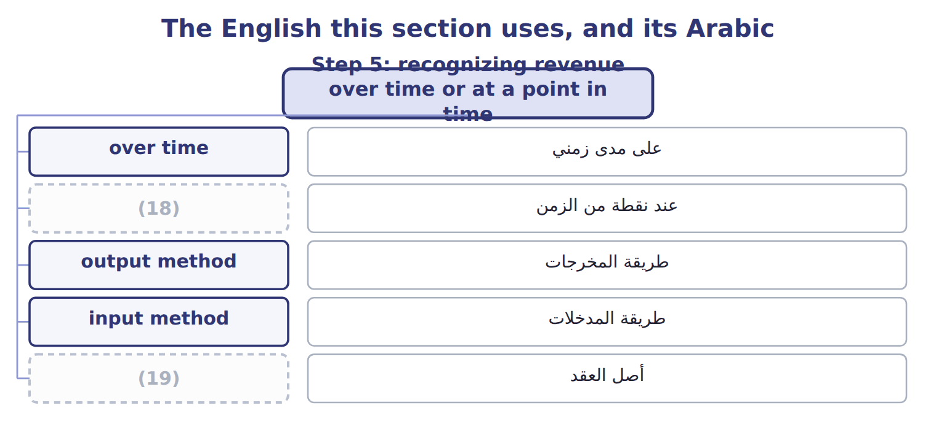
word list
performance obligation · contract asset · point in time

The English this sheet uses, and its Arabic
English (exam term) | Arabic
over time | على مدى زمني
point in time | عند نقطة من الزمن
output method | طريقة المخرجات
input method | طريقة المدخلات
contract asset | أصل العقد

Answer key · 11.4 Step 5: recognizing revenue over time or at a point in time

1 recognize | 11 GreenBasket
2 receives | 12 Maintenance
3 performs | 13 revenue
4 improves | 14 Maintenance
5 Progress | 15 revenue
6 delivered | 16 performed
7 over-time | 17 liability
8 control | 18 point in time
9 delivery | 19 contract asset
10 delivered

the summaries in full
Summary 1 Step 5: recognize revenue when, or as, each obligation is satisfied. An obligation is satisfied over time if the customer receives the benefit as the company performs, if the company improves an asset the customer controls, or if the asset has no other use and the company has a right to payment for work done so far. Progress over time is measured by an output method, such as units delivered, or an input method, such as costs incurred. If no over-time criterion is met, revenue is recognized at a point in time: when control passes.
Summary 2 Olive oil is recognized at each delivery. By December 31, Orontes has delivered 8,000 cases at $40 each of allocated price: $324,000. The dispenser was installed on October 1, when GreenBasket gained control: $180,000. Maintenance is over time: 3 months of 24 at $3,750 per month, $11,250. Total 2026 revenue is $515,250. The remaining $564,750 will be recognized in later periods.
Summary 3 Payments rarely match revenue. A contract asset arises when the company has performed but its right to payment still depends on something other than time. A contract liability arises when the customer pays first.

11.5 Special situations
Chapter 11 · section 11.5

Fill every gap. Each word list holds one word more than there are gaps.
Summary 1 gaps 1–8
When another party is (1) , the company must decide (2) it is a principal or an agent. A principal (3) the good or service before it is (4) and reports revenue gross. An agent only (5) the sale and reports its fee or (6) as revenue. When (7) may return goods, the company (8) revenue only for goods it does not expect to be returned. It records a refund liability for expected refunds and a separate asset for its right to recover the returned goods. The asset and the liability are not netted.
word list
recognizes · arranges · controls · whether · transferred · commission · inventory · involved · customers

Barada's sale with a right of return

Summary 2 gaps 9–17
Control is also the test in other cases. Goods sent on (9) are not sold until the (10) sells them. In a (11) arrangement, (12) is recognized only if the goods are identified, ready and cannot be used for other customers, and the customer asked for the arrangement. A (13) to buy the goods back usually means no sale has taken place. Customer options can create a (14) right, such as loyalty points, which is a separate (15) . For gift cards, the company recognizes (16) , the part customers are not expected to use, in (17) to the cards that are used. Nonrefundable upfront fees are usually deferred.
word list
material · promise · revenue · bill-and-hold · consignment · proportion · separately · consignee · breakage · obligation

Special-situation traps

Summary 3 gaps 18–19
An agent's (18) is its commission, not the full price the customer pays. Present the refund liability and the return asset (19) . Goods on consignment stay in the consignor's inventory.
word list
separately · whether · revenue

Suppose: Barada's sale with a right of return (complete the blanks)
Every item belongs to exactly one group.
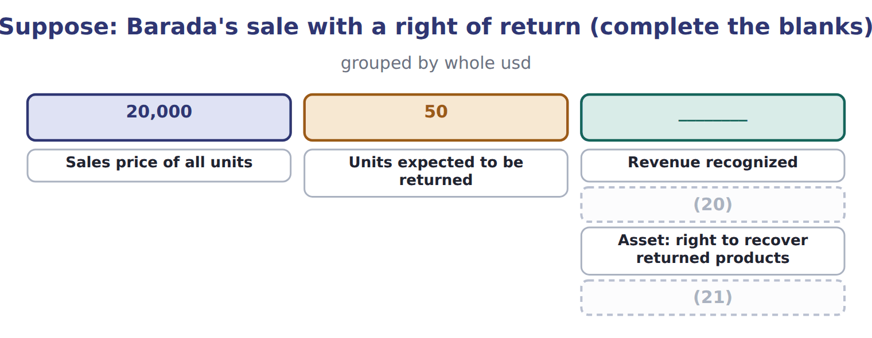
word list
bill-and-hold arrangement · Cost of goods sold · Refund liability

The English this section uses, and its Arabic
Each term sits against what it means.
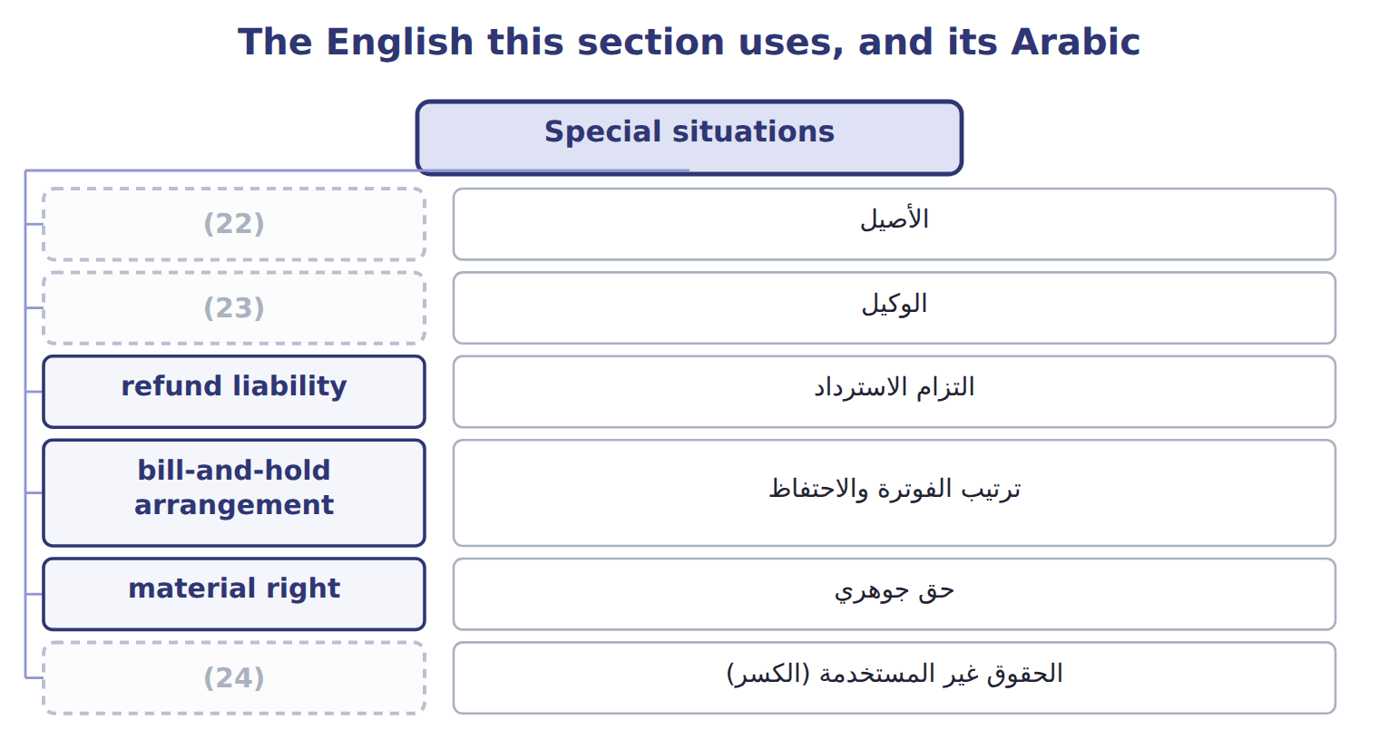
word list
الأصيل · breakage · agent · principal

The English this sheet uses, and its Arabic
English (exam term) | Arabic
principal | الأصيل
agent | الوكيل
refund liability | التزام الاسترداد
bill-and-hold arrangement | ترتيب الفوترة والاحتفاظ
material right | حق جوهري
breakage | الحقوق غير المستخدمة (الكسر)

Answer key · 11.5 Special situations

1 involved | 13 promise
2 whether | 14 material
3 controls | 15 obligation
4 transferred | 16 breakage
5 arranges | 17 proportion
6 commission | 18 revenue
7 customers | 19 separately
8 recognizes | 20 Refund liability
9 consignment | 21 Cost of goods sold
10 consignee | 22 principal
11 bill-and-hold | 23 agent
12 revenue | 24 breakage

the summaries in full
Summary 1 When another party is involved, the company must decide whether it is a principal or an agent. A principal controls the good or service before it is transferred and reports revenue gross. An agent only arranges the sale and reports its fee or commission as revenue. When customers may return goods, the company recognizes revenue only for goods it does not expect to be returned. It records a refund liability for expected refunds and a separate asset for its right to recover the returned goods. The asset and the liability are not netted.
Summary 2 Control is also the test in other cases. Goods sent on consignment are not sold until the consignee sells them. In a bill-and-hold arrangement, revenue is recognized only if the goods are identified, ready and cannot be used for other customers, and the customer asked for the arrangement. A promise to buy the goods back usually means no sale has taken place. Customer options can create a material right, such as loyalty points, which is a separate obligation. For gift cards, the company recognizes breakage, the part customers are not expected to use, in proportion to the cards that are used. Nonrefundable upfront fees are usually deferred.
Summary 3 An agent's revenue is its commission, not the full price the customer pays. Present the refund liability and the return asset separately. Goods on consignment stay in the consignor's inventory.

11.6 Matching, contract costs and IFRS differences
Chapter 11 · section 11.6

Fill every gap. Each word list holds one word more than there are gaps.
Summary 1 gaps 1–12
The matching (1) says that expenses are recognized in the same period as the (2) they help to earn. Cost of goods sold is recognized when the (3) sale is recognized. Costs with no future benefit, such as most (4) , are expensed at once, and long-lived assets are (5) over the periods they serve. Contract costs (6) the same idea. (7) costs of obtaining a contract, such as sales (8) , are capitalized if the company expects to recover them. Orontes pays its (9) a 3% commission, $32,400, on the (10) contract. It (11) this amount and expenses it as it (12) the goods and services. If the amortization period is one year or less, the company may expense such costs immediately. Costs to fulfill a contract are capitalized only if they relate directly to it and create a resource that will be used. Under U.S. GAAP, an impairment of these assets is never reversed.
word list
Incremental · capitalizes · related · salesperson · principle · follow · depreciated · GreenBasket · advertising · transfers · correct · commissions · revenues

ASC 606 and IFRS 15: the main differences
The two sides differ only where the rows say.
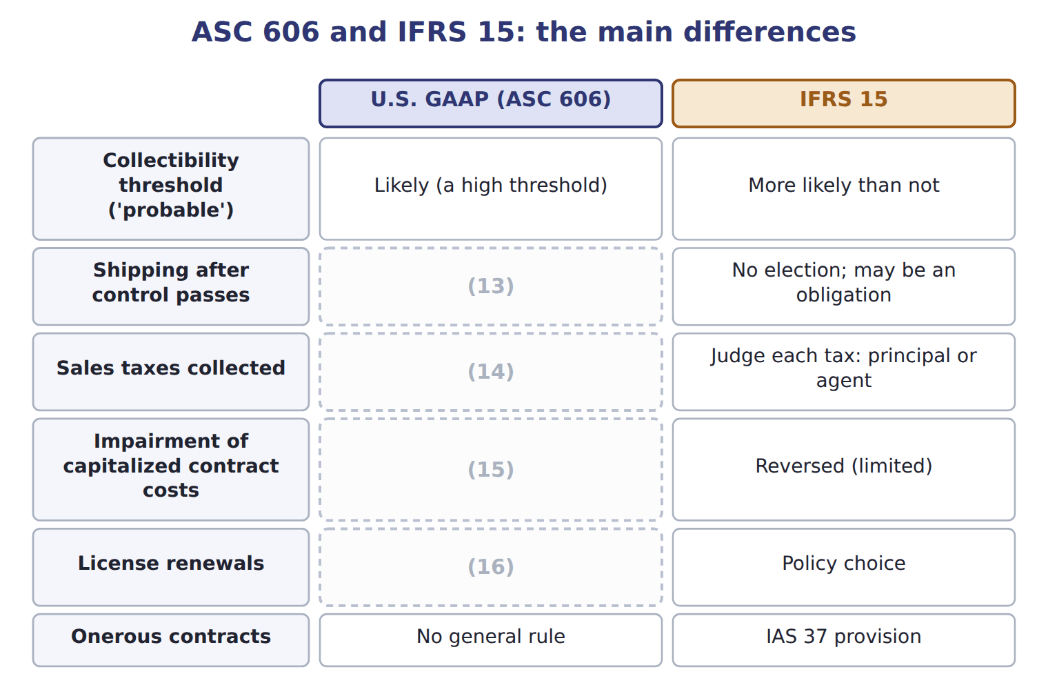
word list
May elect to treat as a fulfillment cost · Revenue when the renewal period begins · Never reversed · May elect to exclude all · Onerous contracts

Summary 2 gaps 17–22
ASU 2025-07 (17) how to account for shares that a customer pays as (18) . It (19) from 2027 and is not testable before about January 2028. ASU 2025-05 adds a (20) expedient for credit losses on current (21) and contract assets; it is not testable before about January 2027. Under ASC 606 the correct term is contract (22) , and it can also arise when payment is due, not only when cash is received.
word list
receivables · applies · practical · expensed · consideration · liability · explains

Item (USD 000) — Amount / details
Item (USD 000) | Amount / details
Contract date | September 1, 2026
Customer | (23)
Fixed contract price | 600
Fruit juices: 12 equal monthly deliveries from September 2026 (standalone selling price) | 540
Staff training on storing and serving juices, completed in September 2026 (standalone selling price) | 60
M1 | If Qasr's orders pass a volume target, Qasr pays 30 less. Orontes expects the target to be met, and a reversal is not probable.
M2 | Orontes pays Qasr 10 to list Orontes juices on hotel menus. Orontes (24) no distinct service.
M3 | Orontes delivers by its own trucks; control passes when the juices arrive. Orontes treats shipping as a (25) cost.
M4 | By December 31, 2026, Qasr has paid 250. Four monthly deliveries have been made.

word list
receives · Qasr Hotels, a hotel chain in Amman · Performance obligation · fulfillment

Item — Answer
Item | Answer
Revenue recognized | (26)
Refund liability | (27)
Asset: right to recover products | 50 × $12 = 600, shown separately from the refund liability
Cost of goods sold | (1,000 − 50) × $12 = 11,400

word list
Revenue when the renewal period begins · (1,000 − 50) × $20 = 19,000 · 50 × $20 = 1,000

Item — Category
Every item belongs to exactly one group.
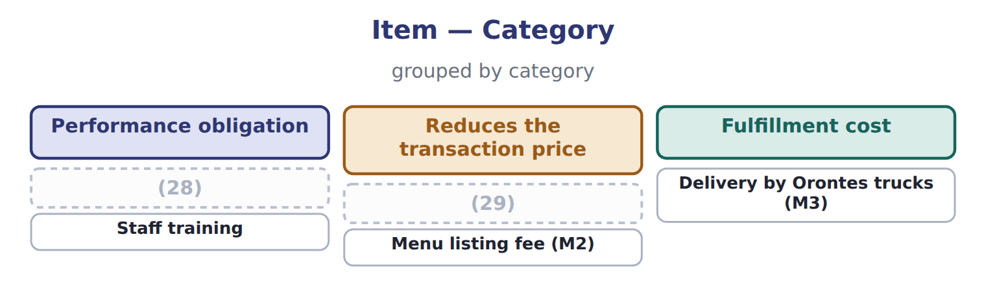
word list
Volume rebate (M1) · standalone selling price · Monthly juice deliveries

The English this section uses, and its Arabic
Each term sits against what it means.
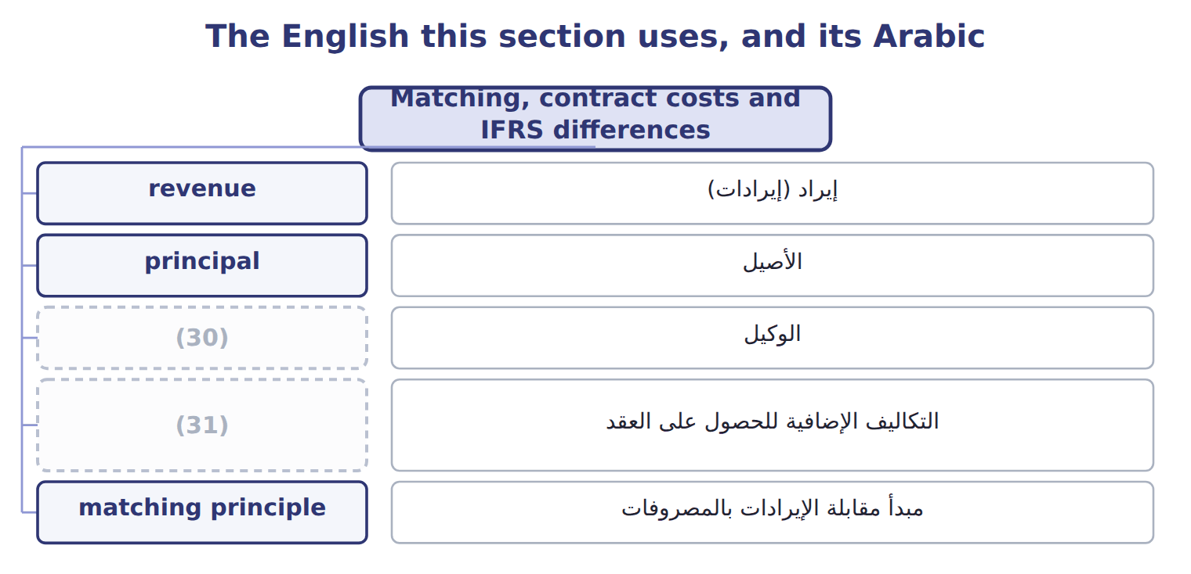
word list
incremental costs of obtaining a contract · agent · مبدأ مقابلة الإيرادات بالمصروفات

The English this sheet uses, and its Arabic
English (exam term) | Arabic
incremental costs of obtaining a contract | التكاليف الإضافية للحصول على العقد
matching principle | مبدأ مقابلة الإيرادات بالمصروفات

Answer key · 11.6 Matching, contract costs and IFRS differences

1 principle | 17 explains
2 revenues | 18 consideration
3 related | 19 applies
4 advertising | 20 practical
5 depreciated | 21 receivables
6 follow | 22 liability
7 Incremental | 23 Qasr Hotels, a hotel chain in Amman
8 commissions | 24 receives
9 salesperson | 25 fulfillment
10 GreenBasket | 26 (1,000 − 50) × $20 = 19,000
11 capitalizes | 27 50 × $20 = 1,000
12 transfers | 28 Monthly juice deliveries
13 May elect to treat as a fulfillment cost | 29 Volume rebate (M1)
14 May elect to exclude all | 30 agent
15 Never reversed | 31 incremental costs of obtaining a contract
16 Revenue when the renewal period begins

the summaries in full
Summary 1 The matching principle says that expenses are recognized in the same period as the revenues they help to earn. Cost of goods sold is recognized when the related sale is recognized. Costs with no future benefit, such as most advertising, are expensed at once, and long-lived assets are depreciated over the periods they serve. Contract costs follow the same idea. Incremental costs of obtaining a contract, such as sales commissions, are capitalized if the company expects to recover them. Orontes pays its salesperson a 3% commission, $32,400, on the GreenBasket contract. It capitalizes this amount and expenses it as it transfers the goods and services. If the amortization period is one year or less, the company may expense such costs immediately. Costs to fulfill a contract are capitalized only if they relate directly to it and create a resource that will be used. Under U.S. GAAP, an impairment of these assets is never reversed.
Summary 2 ASU 2025-07 explains how to account for shares that a customer pays as consideration. It applies from 2027 and is not testable before about January 2028. ASU 2025-05 adds a practical expedient for credit losses on current receivables and contract assets; it is not testable before about January 2027. Under ASC 606 the correct term is contract liability, and it can also arise when payment is due, not only when cash is received.

