18.1 Integrated thinking, integrated reporting and the integrated report
Chapter 18 · section 18.1

Fill every gap. Each word list holds one word more than there are gaps.
Chapter 18, section by section
Each stage leads to the next.
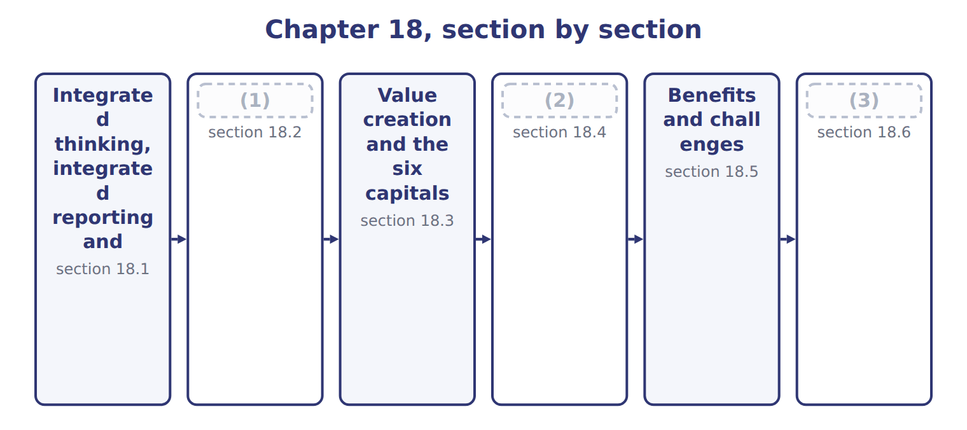
word list
Integrated reporting and sustainability disclo · value creation process · Guiding principles and content elements · The primary purpose

Summary 1 gaps 4–15
Integrated thinking is the way management considers the (4) between the company's units and the resources, or (5) , that it uses and affects. It leads to (6) that consider value creation over the short, (7) and long term. Integrated (8) is the process, founded on integrated thinking, that results in a (9) integrated report. The integrated report is the product: a concise (10) about how the company's strategy, governance, performance and prospects lead to the creation, (11) or erosion of value over time. The three ideas (12) on each other. (13) integrated thinking, a report is just a (14) of separate facts. The rules are in the (15) <IR> Framework, last revised in January 2021. The IFRS Foundation now owns it, and the IASB and the ISSB are jointly responsible for it.
word list
depend · communication · preservation · International · medium · periodic · resources · Without · capitals · reporting · decisions · relationships · collection

The English this section uses, and its Arabic
Each term sits against what it means.
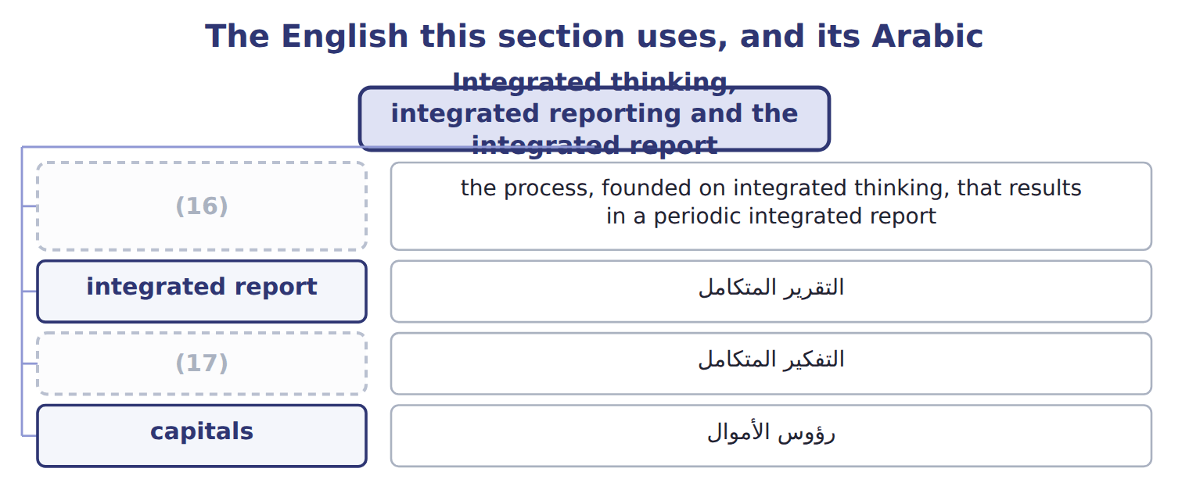
word list
integrated thinking · integrated reporting · intellectual capital

The English this sheet uses, and its Arabic
English (exam term) | Arabic
integrated reporting | إعداد التقارير المتكاملة
integrated report | التقرير المتكامل
integrated thinking | التفكير المتكامل

Answer key · 18.1 Integrated thinking, integrated reporting and the integrated report

1 The primary purpose | 10 communication
2 Guiding principles and content elements | 11 preservation
3 Integrated reporting and sustainability disclo | 12 depend
4 relationships | 13 Without
5 capitals | 14 collection
6 decisions | 15 International
7 medium | 16 integrated reporting
8 reporting | 17 integrated thinking
9 periodic

the summaries in full
Summary 1 Integrated thinking is the way management considers the relationships between the company's units and the resources, or capitals, that it uses and affects. It leads to decisions that consider value creation over the short, medium and long term. Integrated reporting is the process, founded on integrated thinking, that results in a periodic integrated report. The integrated report is the product: a concise communication about how the company's strategy, governance, performance and prospects lead to the creation, preservation or erosion of value over time. The three ideas depend on each other. Without integrated thinking, a report is just a collection of separate facts. The rules are in the International <IR> Framework, last revised in January 2021. The IFRS Foundation now owns it, and the IASB and the ISSB are jointly responsible for it.

18.2 The primary purpose
Chapter 18 · section 18.2

Fill every gap. Each word list holds one word more than there are gaps.
Summary 1 gaps 1–8
The primary purpose of an integrated report is to explain to (1) of financial capital, such as (2) and lenders, how the company creates, preserves or erodes value over time. This is the exam (3) to 'Who is the main audience?'. Other (4) also benefit: employees, customers, suppliers, communities, regulators and (5) . They are not the primary audience, but the report is useful to anyone (6) in the company's (7) to create value. In the United States, integrated (8) is voluntary; U.S. GAAP and the SEC do not require it.
word list
reporting · interested · ability · shareholders · providers · stakeholders · answer · require · policymakers

Integrated reports and other reports
Report | Primary audience | Focus | Required for Orontes?
Financial statements (U.S. GAAP) | Investors and creditors | (9) | Yes: required for an SEC registrant
Management's discussion and analysis (MD&A) | Investors | Explains results, liquidity and risks | (10)
Integrated report (<IR> Framework) | (11) | How value is created, preserved or eroded, using all six capitals | No: voluntary
Sustainability disclosures (IFRS S1 and S2) | Investors | (12) | Only where a jurisdiction adopts them

word list
Providers of financial capital, then other stakeholders · Yes: SEC requirement · Yes: required for an SEC registrant · Sustainability and climate risks that affect prospects · Financial position and performance

Audience trap

Summary 2 gaps 13–14
The primary audience is (13) of financial capital, not 'all stakeholders'. All stakeholders benefit, but the (14) names investors and lenders first.
word list
Framework · shareholders · providers

The English this section uses, and its Arabic
Each term sits against what it means.
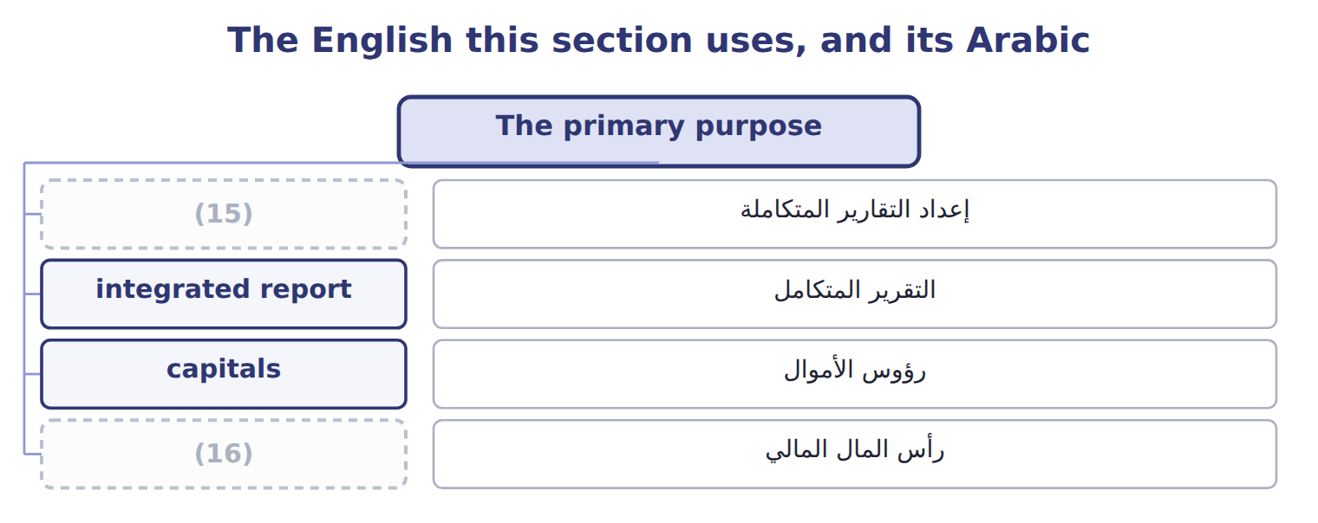
word list
financial capital · integrated reporting · integrated thinking

Answer key · 18.2 The primary purpose

1 providers | 9 Financial position and performance
2 shareholders | 10 Yes: SEC requirement
3 answer | 11 Providers of financial capital, then other stakeholders
4 stakeholders | 12 Sustainability and climate risks that affect prospects
5 policymakers | 13 providers
6 interested | 14 Framework
7 ability | 15 integrated reporting
8 reporting | 16 financial capital

the summaries in full
Summary 1 The primary purpose of an integrated report is to explain to providers of financial capital, such as shareholders and lenders, how the company creates, preserves or erodes value over time. This is the exam answer to 'Who is the main audience?'. Other stakeholders also benefit: employees, customers, suppliers, communities, regulators and policymakers. They are not the primary audience, but the report is useful to anyone interested in the company's ability to create value. In the United States, integrated reporting is voluntary; U.S. GAAP and the SEC do not require it.
Summary 2 The primary audience is providers of financial capital, not 'all stakeholders'. All stakeholders benefit, but the Framework names investors and lenders first.

18.3 Value creation and the six capitals
Chapter 18 · section 18.3

Fill every gap. Each word list holds one word more than there are gaps.
Summary 1 gaps 1–3
The (1) describes value in terms of six (2) : stocks of value that increase, decrease or change as the company works. They are financial capital, (3) capital, intellectual capital, human capital, social and relationship capital and natural capital.
word list
capitals · products · Framework · manufactured

Suppose: Orontes's six capitals, 2027
Capital | Orontes examples (2027) | Possible measure
Financial | (4) | Cash flow from operations
Manufactured | (5) | Plant capacity
Intellectual | Recipes, brand, new sparkling-juice line | (6)
Human | 1,850 employees | (7)
Social and relationship | 2,400 farmers in grower (8) ; supermarket customers | Farmer contracts renewed
Natural | Olive groves, water, energy | (9)

word list
Equity and bank loans (Part I) · Share of sales from new products · Presses, bottling lines, cold stores · Water 900,000 m3; renewable electricity 30% · cooperatives · 20 training hours per employee · manufactured capital

Summary 2 gaps 10–15
In the value creation process, the business model takes capitals as inputs and turns them, through its activities, into (10) : products, (11) and waste. The (12) are the effects on the capitals, inside and (13) the company. Capitals are (14) , so decisions involve (15) . The six categories are not mandatory; a company may group them differently, but it should consider all the capitals it uses or affects.
word list
trade-offs · by-products · outputs · financial · outside · outcomes · connected

Worked example: the irrigation trade-off

Summary 3 gaps 16–20
Suppose Orontes spends $2,000,000 on drip (16) for its groves: financial capital falls and (17) capital rises. Water use falls by 150,000 m3, about 17% of the total: (18) capital is (19) . Orontes trains 400 cooperative farmers to use the system: human and social and (20) capital rise. An integrated report explains the whole trade-off, not only the cost.
word list
preserved · manufactured · explains · irrigation · natural · relationship

Which capital?

Which capital? (complete the blanks)
Every item belongs to exactly one group.
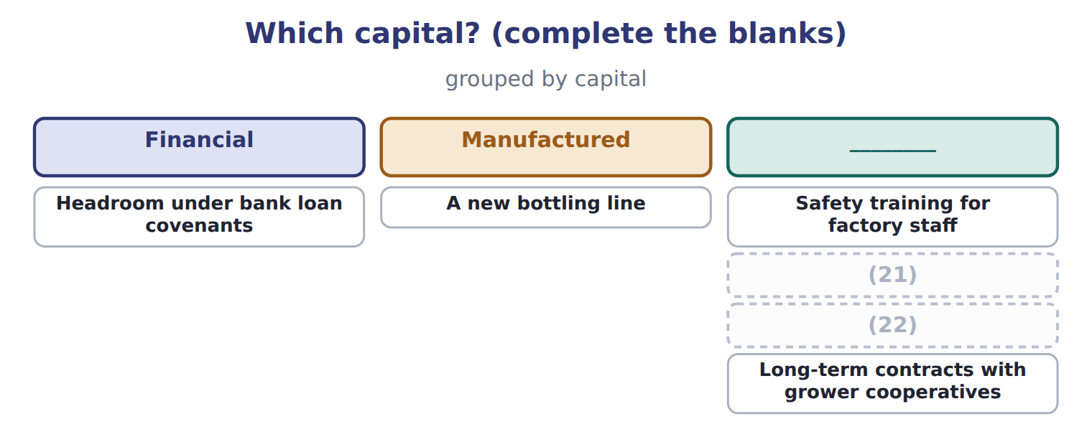
word list
The trademark for Orontes Gold olive oil · Headroom under bank loan covenants · Water drawn from local wells

Capitals, capitaux

In integrated reporting, capitals are resources and relationships, not share capital. Read the whole phrase.
The English this section uses, and its Arabic
Each term sits against what it means.
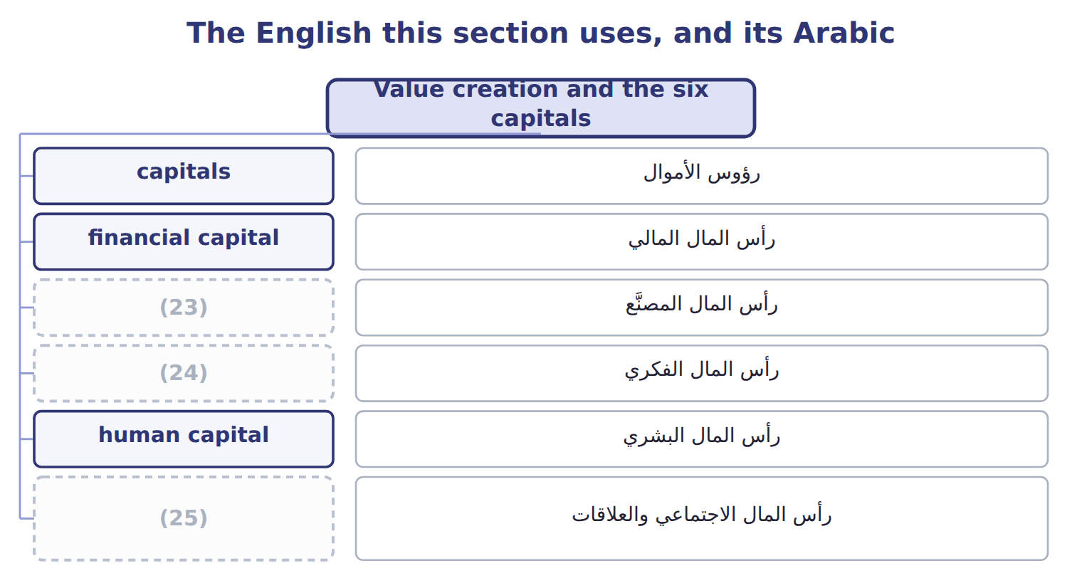
word list
manufactured capital · intellectual capital · social and relationship capital · financial capital

The English this sheet uses, and its Arabic
English (exam term) | Arabic
capitals | رؤوس الأموال
financial capital | رأس المال المالي
manufactured capital | رأس المال المصنَّع
intellectual capital | رأس المال الفكري
human capital | رأس المال البشري
social and relationship capital | رأس المال الاجتماعي والعلاقات
natural capital | رأس المال الطبيعي
value creation process | عملية خلق القيمة
outputs | المخرجات
outcomes | النتائج (الآثار)

Answer key · 18.3 Value creation and the six capitals

1 Framework | 14 connected
2 capitals | 15 trade-offs
3 manufactured | 16 irrigation
4 Equity and bank loans (Part I) | 17 manufactured
5 Presses, bottling lines, cold stores | 18 natural
6 Share of sales from new products | 19 preserved
7 20 training hours per employee | 20 relationship
8 cooperatives | 21 The trademark for Orontes Gold olive oil
9 Water 900,000 m3; renewable electricity 30% | 22 Water drawn from local wells
10 outputs | 23 manufactured capital
11 by-products | 24 intellectual capital
12 outcomes | 25 social and relationship capital
13 outside

the summaries in full
Summary 1 The Framework describes value in terms of six capitals: stocks of value that increase, decrease or change as the company works. They are financial capital, manufactured capital, intellectual capital, human capital, social and relationship capital and natural capital.
Summary 2 In the value creation process, the business model takes capitals as inputs and turns them, through its activities, into outputs: products, by-products and waste. The outcomes are the effects on the capitals, inside and outside the company. Capitals are connected, so decisions involve trade-offs. The six categories are not mandatory; a company may group them differently, but it should consider all the capitals it uses or affects.
Summary 3 Suppose Orontes spends $2,000,000 on drip irrigation for its groves: financial capital falls and manufactured capital rises. Water use falls by 150,000 m3, about 17% of the total: natural capital is preserved. Orontes trains 400 cooperative farmers to use the system: human and social and relationship capital rise. An integrated report explains the whole trade-off, not only the cost.

18.4 Guiding principles and content elements
Chapter 18 · section 18.4

Fill every gap. Each word list holds one word more than there are gaps.
Summary 1 gaps 1–2
The Framework is (1) : it does not prescribe KPIs or measurement methods. Seven guiding principles shape how the report is prepared, such as (2) of information, materiality and conciseness.
word list
element · principles-based · connectivity

The seven guiding principles
Guiding principle (7) | What it means | Orontes example
Strategic focus and future orientation | (3) | Plans for the sparkling-juice line to 2030
Connectivity of information | Show how capitals, strategy and performance link | (4) spending linked to water use and grower yields
Stakeholder relationships | (5) | Work with grower cooperatives
Materiality | Include matters that substantively affect value creation | (6)
Conciseness | Be short and clear | Refer to the financial (7) rather than repeat them
Reliability and completeness | Include positive and negative matters, without material error | (8)
Consistency and comparability | (9) | Same water measure every year

word list
Report a failed product launch too · Water scarcity; olive prices · Explain key relationships and how the company responds · Irrigation · statements · Explain strategy and how it creates value over time · Use the same basis over time and allow comparison · Grow, press, bottle, sell

Summary 2 gaps 10–15
Eight (10) elements set what the report (11) . Each element answers a question: what the company does, how its (12) works, how its business model creates value, which risks and opportunities it faces, where its strategy is going, how it (13) , what lies ahead, and how the report was prepared. The elements are linked, not (14) chapters. For example, Orontes's water risk appears under risks and opportunities, drives its strategy, and is measured under (15) .
word list
content · performance · performed · separate · governance · covers · statement

The eight content elements
Content element (8) | Question it answers | Orontes example
Organizational overview and external environment | (16) | Food producer based in Amman, Jordan, selling across the region
Governance | (17) | Board committee oversees water risk
Business model | How does the company turn capitals into value? | (18)
Risks and opportunities | What could help or harm value creation? | (19)
Strategy and resource allocation | Where is it going, and how will it get there? | (20)
Performance | What did it achieve, and with what effects on the capitals? | (21)
Outlook | What challenges and uncertainties lie ahead? | (22)
Basis of preparation and presentation | How were matters chosen and measured? | Materiality process; measurement methods

word list
Renewable electricity 30% · Olive yields and prices to 2030 · Water scarcity; demand for healthy drinks · What does the company do, and where? · Show how capitals, strategy and performance link · Invest in irrigation and new products · How does governance support value creation? · Grow, press, bottle, sell

Summary 3 gaps 23–25
Those charged with (23) , such as the board, should include a statement that they are (24) for the integrated report. The report can stand alone or be a (25) part of another report, such as the annual report.
word list
governance · distinguishable · responsible · outlook

Seven or eight?

Summary 4 gaps 26–27
There are seven (26) principles (how to report) and eight content elements (what to report). Materiality and (27) are principles; governance, business model and outlook are content elements.
word list
connectivity · guiding · distinguishable

The English this section uses, and its Arabic
Each term sits against what it means.
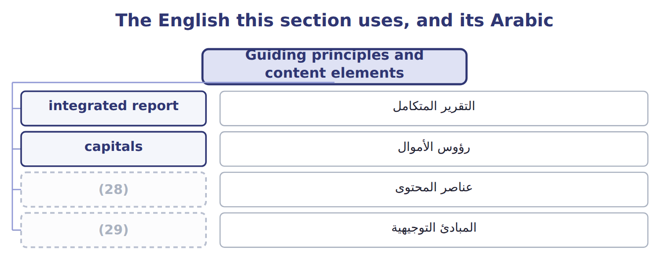
word list
رؤوس الأموال · guiding principles · content elements

The English this sheet uses, and its Arabic
English (exam term) | Arabic
guiding principles | المبادئ التوجيهية
content elements | عناصر المحتوى

Answer key · 18.4 Guiding principles and content elements

1 principles-based | 16 What does the company do, and where?
2 connectivity | 17 How does governance support value creation?
3 Explain strategy and how it creates value over time | 18 Grow, press, bottle, sell
4 Irrigation | 19 Water scarcity; demand for healthy drinks
5 Explain key relationships and how the company responds | 20 Invest in irrigation and new products
6 Water scarcity; olive prices | 21 Renewable electricity 30%
7 statements | 22 Olive yields and prices to 2030
8 Report a failed product launch too | 23 governance
9 Use the same basis over time and allow comparison | 24 responsible
10 content | 25 distinguishable
11 covers | 26 guiding
12 governance | 27 connectivity
13 performed | 28 content elements
14 separate | 29 guiding principles
15 performance

the summaries in full
Summary 1 The Framework is principles-based: it does not prescribe KPIs or measurement methods. Seven guiding principles shape how the report is prepared, such as connectivity of information, materiality and conciseness.
Summary 2 Eight content elements set what the report covers. Each element answers a question: what the company does, how its governance works, how its business model creates value, which risks and opportunities it faces, where its strategy is going, how it performed, what lies ahead, and how the report was prepared. The elements are linked, not separate chapters. For example, Orontes's water risk appears under risks and opportunities, drives its strategy, and is measured under performance.
Summary 3 Those charged with governance, such as the board, should include a statement that they are responsible for the integrated report. The report can stand alone or be a distinguishable part of another report, such as the annual report.
Summary 4 There are seven guiding principles (how to report) and eight content elements (what to report). Materiality and connectivity are principles; governance, business model and outlook are content elements.

18.5 Benefits and challenges
Chapter 18 · section 18.5

Fill every gap. Each word list holds one word more than there are gaps.
Benefits against Challenges
The two columns are not matched row by row.
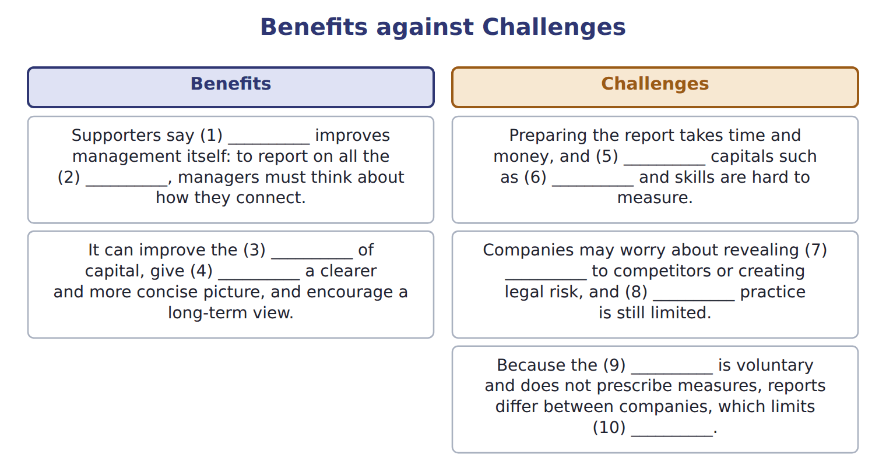
word list
allocation · assurance · information · capitals · non-financial · Framework · integrated reporting · comparability · relationships · investors · guiding principles

Answer key · 18.5 Benefits and challenges

1 integrated reporting | 6 relationships
2 capitals | 7 information
3 allocation | 8 assurance
4 investors | 9 Framework
5 non-financial | 10 comparability

the summaries in full

18.6 Integrated reporting and sustainability disclosures
Chapter 18 · section 18.6

Fill every gap. Each word list holds one word more than there are gaps.
Summary 1 gaps 1–12
IFRS S1 and IFRS S2, issued by the ISSB, require disclosure of (1) and climate risks that affect a (2) prospects. They apply only where a (3) adopts them. S1 asks for connected (4) , an idea taken from integrated (5) , but S1 and S2 disclosures are not an integrated report. In 2024 the ISSB decided not to start a separate (6) project, and the boards continue to support the <IR> (7) . The IASB's revised (8) Statement on (9) commentary, issued in June 2025, also draws on integrated-reporting concepts. It is (10) , and it is not in the LOS. The SEC's 2024 climate disclosure rule never took (11) ; it is stayed, and the SEC (12) to rescind it in 2026. Some MENA markets now require ISSB-based disclosures, for example Qatar from 2026 and the largest Amman Stock Exchange companies from 2026. These are background facts, not exam content.
word list
integration · Practice · proposed · separate · information · Framework · effect · reporting · voluntary · jurisdiction · company's · management · sustainability

Item — Barada Wholesale: draft first integrated report,
Item | Barada Wholesale: draft first integrated report,
D1 | Barada trained all delivery drivers in safe driving.
D2 | Barada used 600 MWh of electricity in 2028; 150 MWh came from its own solar panels.
D3 | Barada signed five-year (13) with 60 small farmers.
D4 | (14)
D5 | (15)
D6 | Rising fuel prices could cut (16) delivery margins in 2029 and 2030.
M1 | The draft says: 'This report is written mainly for our employees and the local community.'
M2 | The draft links each strategic goal to the KPI and the capital it affects.

word list
Barada's · partnerships · Staff turnover in the warehouse fell from 25% to 15%. · Packaging waste sent to landfill fell by one third. · guiding principles

Item — Answer
Item | Answer
Safety training for factory staff | (17)
The trademark for Orontes Gold olive oil | Intellectual capital
Water drawn from local wells | Natural capital
Long-term contracts with grower cooperatives | (18)

word list
Human capital · Social and relationship capital · natural capital

Disclosure — Category
Disclosure | Category
D1 Driver training | Human capital
D2 Electricity and solar | Natural capital
D3 Farmer partnerships | (19)
D4 Warehouse staff turnover | (20)
D5 Packaging waste | (21)

word list
Human capital · manufactured capital · Social and relationship capital · Natural capital

Answer key · 18.6 Integrated reporting and sustainability disclosures

1 sustainability | 12 proposed
2 company's | 13 partnerships
3 jurisdiction | 14 Staff turnover in the warehouse fell from 25% to 15%.
4 information | 15 Packaging waste sent to landfill fell by one third.
5 reporting | 16 Barada's
6 integration | 17 Human capital
7 Framework | 18 Social and relationship capital
8 Practice | 19 Social and relationship capital
9 management | 20 Human capital
10 voluntary | 21 Natural capital
11 effect

the summaries in full
Summary 1 IFRS S1 and IFRS S2, issued by the ISSB, require disclosure of sustainability and climate risks that affect a company's prospects. They apply only where a jurisdiction adopts them. S1 asks for connected information, an idea taken from integrated reporting, but S1 and S2 disclosures are not an integrated report. In 2024 the ISSB decided not to start a separate integration project, and the boards continue to support the <IR> Framework. The IASB's revised Practice Statement on management commentary, issued in June 2025, also draws on integrated-reporting concepts. It is voluntary, and it is not in the LOS. The SEC's 2024 climate disclosure rule never took effect; it is stayed, and the SEC proposed to rescind it in 2026. Some MENA markets now require ISSB-based disclosures, for example Qatar from 2026 and the largest Amman Stock Exchange companies from 2026. These are background facts, not exam content.

