6.1 When job order costing fits
Chapter 6 · section 6.1

Fill every gap. Each word list holds one word more than there are gaps.
Chapter 6, section by section
Each stage leads to the next.
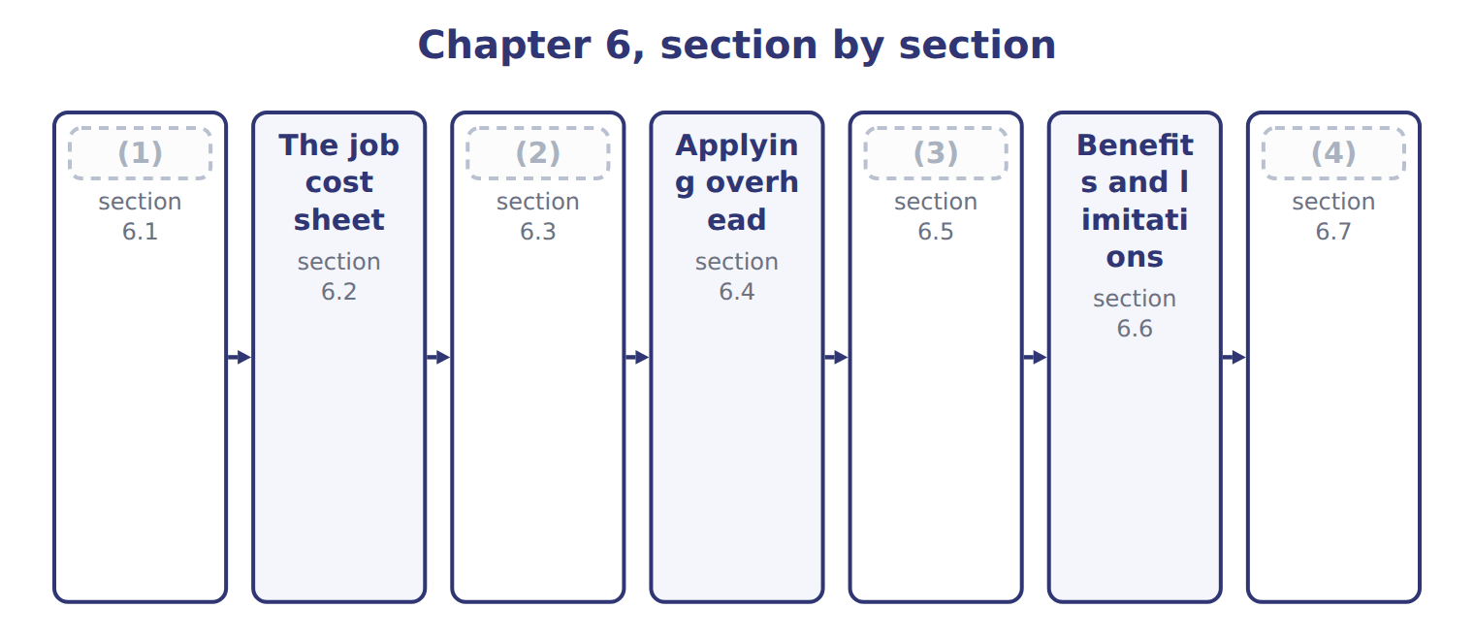
word list
Extended Example 6A: Tahini & Spreads, March 2 · The job cost sheet · Recording materials and labor · When job order costing fits · Inventory values and cost of goods sold

Summary 1 gaps 5–13
Job order costing (5) costs for each (6) job, batch or customer order. It fits when the (7) are different from each other and each order can be (8) from start to finish. (9) tahini fits well. One job may be a Barada order in (10) tubs, and the next a Gulf (11) order in glass jars with a different sesame blend. (12) firms, builders, law firms and (13) also use job costing. Orontes's Oils division does not use it. Olive oil flows through crushing and bottling as identical liters, so costs are collected by department instead. That is process costing, the topic.
word list
separate · plastic · identified · retailer's · Private-label · Printing · products · hospitals · collects · bottling

Answer key · 6.1 When job order costing fits

1 When job order costing fits | 8 identified
2 Recording materials and labor | 9 Private-label
3 Inventory values and cost of goods sold | 10 plastic
4 Extended Example 6A: Tahini & Spreads, March 2 | 11 retailer's
5 collects | 12 Printing
6 separate | 13 hospitals
7 products

the summaries in full
Summary 1 Job order costing collects costs for each separate job, batch or customer order. It fits when the products are different from each other and each order can be identified from start to finish. Private-label tahini fits well. One job may be a Barada order in plastic tubs, and the next a Gulf retailer's order in glass jars with a different sesame blend. Printing firms, builders, law firms and hospitals also use job costing. Orontes's Oils division does not use it. Olive oil flows through crushing and bottling as identical liters, so costs are collected by department instead. That is process costing, the topic.

6.2 The job cost sheet
Chapter 6 · section 6.2

Fill every gap. Each word list holds one word more than there are gaps.
Summary 1 gaps 1–6
A job cost sheet is the (1) of one job. It collects three costs: direct materials from materials (2) , direct labor from labor time tickets, and overhead applied at the (3) rate. The job cost sheets form a (4) ledger. The total of all open sheets must equal the balance of the (5) Inventory control (6) in the general ledger. When a job is finished, its sheet moves to the finished goods file.
word list
account · predetermined · record · balance · Work-in-Process · requisitions · subsidiary

Worked example: the cost of job T-0303

Summary 2 gaps 7–8
In March 2027 job T-0303, a Barada (7) order, used direct (8) of $140,000 and direct labor of $80,000. It used 4,200 machine hours. Overhead is applied at $30 per machine hour, so applied overhead is $126,000.
word list
general · private-label · materials

Worked example: job cost sheet for T-0303
The bars are drawn to scale.
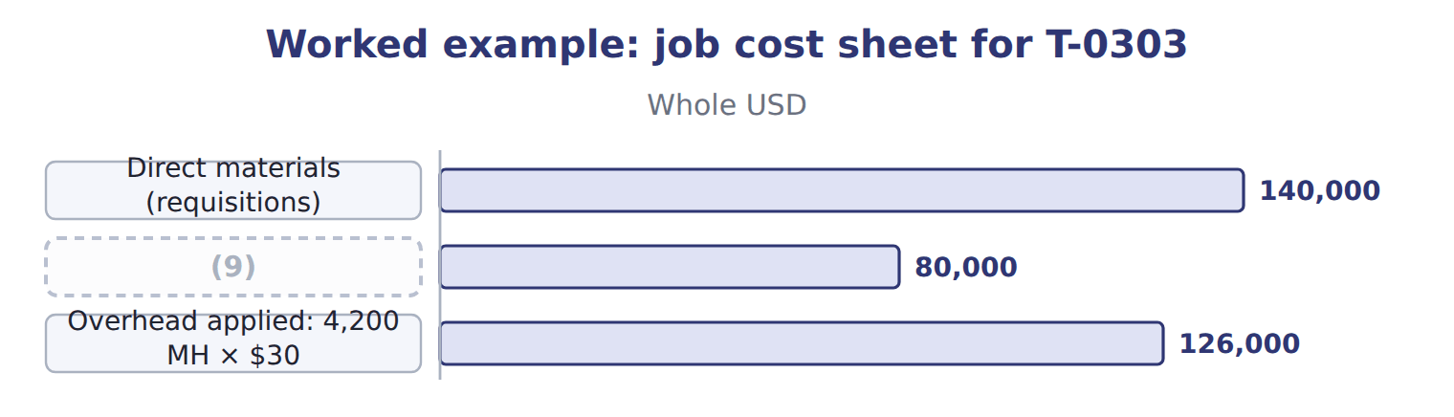
word list
Direct labor (time tickets) · cost of goods manufactured

The English this section uses, and its Arabic
Each term sits against what it means.
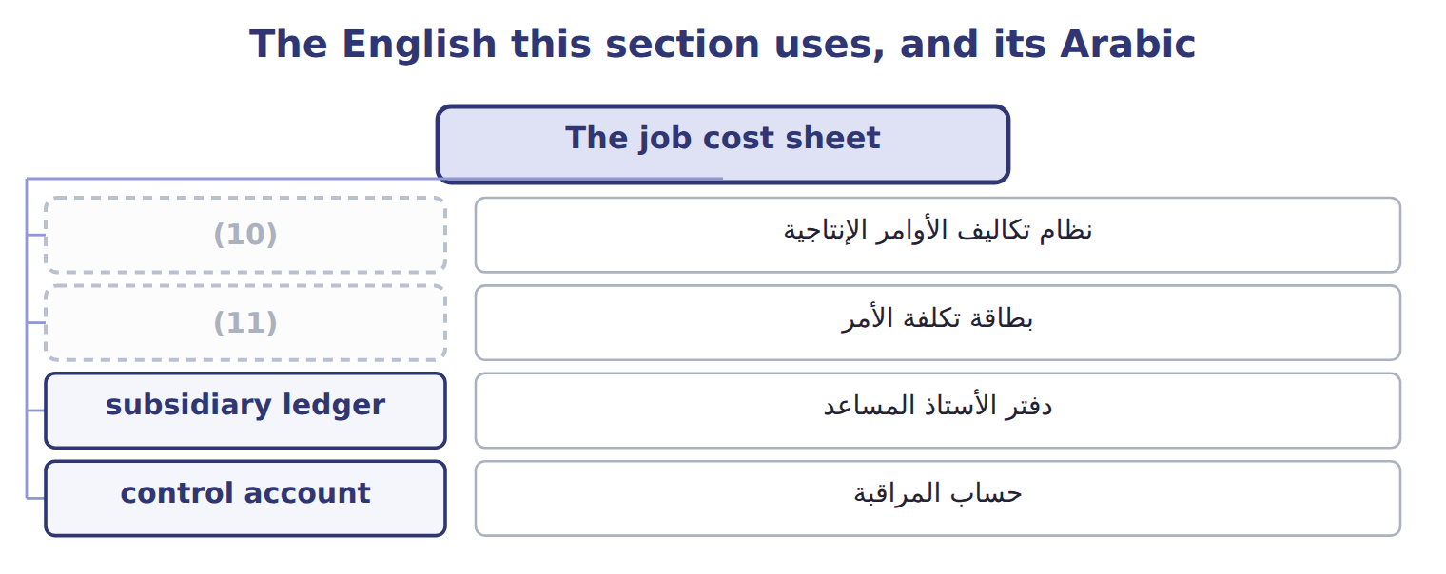
word list
job order costing · job cost sheet · بطاقة تكلفة الأمر

The English this sheet uses, and its Arabic
English (exam term) | Arabic
job order costing | نظام تكاليف الأوامر الإنتاجية
job cost sheet | بطاقة تكلفة الأمر
subsidiary ledger | دفتر الأستاذ المساعد
control account | حساب المراقبة

Answer key · 6.2 The job cost sheet

1 record | 7 private-label
2 requisitions | 8 materials
3 predetermined | 9 Direct labor (time tickets)
4 subsidiary | 10 job order costing
5 Work-in-Process | 11 job cost sheet
6 account

the summaries in full
Summary 1 A job cost sheet is the record of one job. It collects three costs: direct materials from materials requisitions, direct labor from labor time tickets, and overhead applied at the predetermined rate. The job cost sheets form a subsidiary ledger. The total of all open sheets must equal the balance of the Work-in-Process Inventory control account in the general ledger. When a job is finished, its sheet moves to the finished goods file.
Summary 2 In March 2027 job T-0303, a Barada private-label order, used direct materials of $140,000 and direct labor of $80,000. It used 4,200 machine hours. Overhead is applied at $30 per machine hour, so applied overhead is $126,000.

6.3 Recording materials and labor
Chapter 6 · section 6.3

Fill every gap. Each word list holds one word more than there are gaps.
Summary 1 gaps 1–10
A materials (1) moves materials out of Raw Materials Inventory. If the materials are (2) to a job, the debit goes to Work-in-Process Inventory and the job cost sheet. If they are indirect materials, such as cleaning (3) or machine oil, the debit goes to Manufacturing Overhead Control. Labor time (4) work the same way. Hours on a job are direct labor, debited to Work-in-Process Inventory. (5) , idle time and (6) labor are indirect labor, debited to Manufacturing Overhead Control. The credit is Wages (7) . In March, Tahini & (8) issued direct materials of $250,000 and indirect materials of $20,000. Direct labor was $150,000 and indirect labor was $40,000. Only the direct (9) reach the job cost (10) .
word list
Payable · sheets · Spreads · Work-in-Process · requisition · chemicals · Supervision · maintenance · traced · tickets · amounts

Indirect costs do not go to WIP

Summary 2 gaps 11–12
A common wrong answer debits (11) Inventory with indirect materials or indirect labor. They reach the jobs only through the (12) rate.
word list
predetermined · tickets · Work-in-Process

The English this section uses, and its Arabic
Each term sits against what it means.
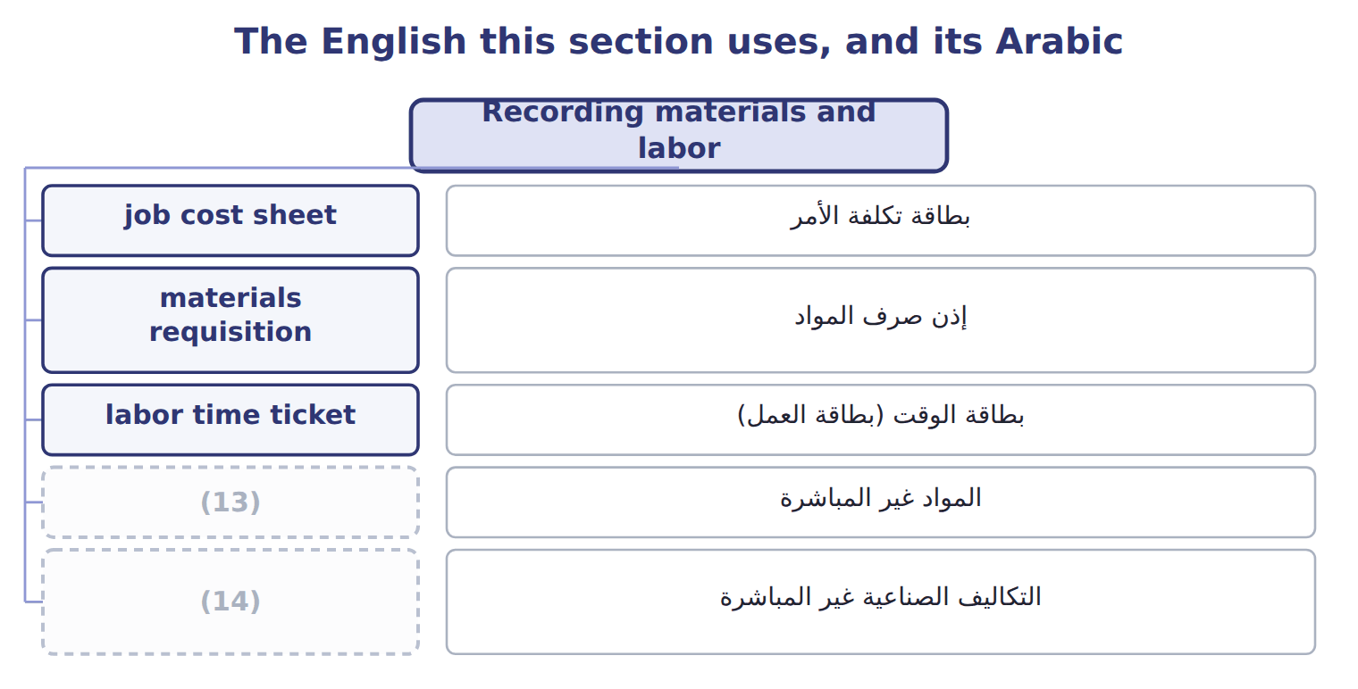
word list
indirect materials · manufacturing overhead · control account

The English this sheet uses, and its Arabic
English (exam term) | Arabic
materials requisition | إذن صرف المواد
labor time ticket | بطاقة الوقت (بطاقة العمل)
indirect materials | المواد غير المباشرة

Answer key · 6.3 Recording materials and labor

1 requisition | 8 Spreads
2 traced | 9 amounts
3 chemicals | 10 sheets
4 tickets | 11 Work-in-Process
5 Supervision | 12 predetermined
6 maintenance | 13 indirect materials
7 Payable | 14 manufacturing overhead

the summaries in full
Summary 1 A materials requisition moves materials out of Raw Materials Inventory. If the materials are traced to a job, the debit goes to Work-in-Process Inventory and the job cost sheet. If they are indirect materials, such as cleaning chemicals or machine oil, the debit goes to Manufacturing Overhead Control. Labor time tickets work the same way. Hours on a job are direct labor, debited to Work-in-Process Inventory. Supervision, idle time and maintenance labor are indirect labor, debited to Manufacturing Overhead Control. The credit is Wages Payable. In March, Tahini & Spreads issued direct materials of $250,000 and indirect materials of $20,000. Direct labor was $150,000 and indirect labor was $40,000. Only the direct amounts reach the job cost sheets.
Summary 2 A common wrong answer debits Work-in-Process Inventory with indirect materials or indirect labor. They reach the jobs only through the predetermined rate.

6.4 Applying overhead
Chapter 6 · section 6.4

Fill every gap. Each word list holds one word more than there are gaps.
Summary 1 gaps 1–10
Actual overhead is not known until the end of the year, but a job needs a cost when it is (1) . So job costing uses (2) costing: overhead is applied with a predetermined rate. For 2027 Tahini & (3) uses $30 per machine hour: $24 fixed plus $6 (4) . Applied overhead (5) the actual machine hours used by the job times the predetermined rate. The debit is (6) Inventory and the (7) is Manufacturing Overhead Applied. Actual overhead costs, such as (8) and utilities, are (9) to Manufacturing Overhead Control. The two overhead (10) rarely match during the year. The difference is under- or over-applied overhead. It stays open until year-end, when.
word list
Work-in-Process · debited · finished · Spreads · variable · depreciation · credit · normal · equals · overhead · accounts

Imputation

Summary 2 gaps 11–12
But ' (11) ' in general accounting also means posting an entry. In U.S. terms the (12) are Manufacturing Overhead Control and Manufacturing Overhead Applied.
word list
accounts · imputation · overhead

The English this sheet uses, and its Arabic
English (exam term) | Arabic
applied overhead | التكاليف غير المباشرة المحملة
predetermined overhead rate | معدل التحميل التقديري
manufacturing overhead | التكاليف الصناعية غير المباشرة

Answer key · 6.4 Applying overhead

1 finished | 7 credit
2 normal | 8 depreciation
3 Spreads | 9 debited
4 variable | 10 accounts
5 equals | 11 imputation
6 Work-in-Process | 12 accounts

the summaries in full
Summary 1 Actual overhead is not known until the end of the year, but a job needs a cost when it is finished. So job costing uses normal costing: overhead is applied with a predetermined rate. For 2027 Tahini & Spreads uses $30 per machine hour: $24 fixed plus $6 variable. Applied overhead equals the actual machine hours used by the job times the predetermined rate. The debit is Work-in-Process Inventory and the credit is Manufacturing Overhead Applied. Actual overhead costs, such as depreciation and utilities, are debited to Manufacturing Overhead Control. The two overhead accounts rarely match during the year. The difference is under- or over-applied overhead. It stays open until year-end, when.
Summary 2 But 'imputation' in general accounting also means posting an entry. In U.S. terms the accounts are Manufacturing Overhead Control and Manufacturing Overhead Applied.

6.5 Inventory values and cost of goods sold
Chapter 6 · section 6.5

Fill every gap. Each word list holds one word more than there are gaps.
Summary 1 gaps 1–7
When a job is finished, its total cost moves from (1) Inventory to Finished Goods Inventory. The total of the jobs finished in a (2) is the cost of goods (3) . When the goods are sold, the job cost moves from Finished Goods Inventory to Cost of Goods Sold. At any date, the inventory values come (4) from the job cost (5) . Open jobs make up work in process. Finished jobs not yet sold make up finished goods. The sale price never enters these (6) ; it goes to Sales (7) .
word list
finished · sheets · Work-in-Process · straight · Revenue · accounts · manufactured · period

Complete a job cost sheet

Your turn: job cost sheet for T-0304 (complete the blanks)
Every item belongs to exactly one group.
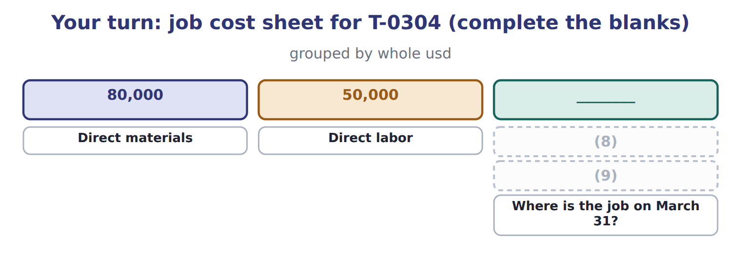
word list
Job cost at March 31 · Overhead applied: 2,500 MH × $30 · Where is the job on March 31?

The English this sheet uses, and its Arabic
English (exam term) | Arabic
cost of goods manufactured | تكلفة الإنتاج التام

Answer key · 6.5 Inventory values and cost of goods sold

1 Work-in-Process | 6 accounts
2 period | 7 Revenue
3 manufactured | 8 Overhead applied: 2,500 MH × $30
4 straight | 9 Job cost at March 31
5 sheets

the summaries in full
Summary 1 When a job is finished, its total cost moves from Work-in-Process Inventory to Finished Goods Inventory. The total of the jobs finished in a period is the cost of goods manufactured. When the goods are sold, the job cost moves from Finished Goods Inventory to Cost of Goods Sold. At any date, the inventory values come straight from the job cost sheets. Open jobs make up work in process. Finished jobs not yet sold make up finished goods. The sale price never enters these accounts; it goes to Sales Revenue.

6.6 Benefits and limitations
Chapter 6 · section 6.6

Fill every gap. Each word list holds one word more than there are gaps.
Summary 1 gaps 1–10
Job costing gives an (1) cost for each order. (2) use it to price new orders, compare the estimate with the actual cost and find (3) customers. It also gives the inventory (4) that the financial (5) need. It needs many (6) and careful (7) for every job. Overhead is still an allocation, so a poor allocation base can (8) job costs; (9) costing is one answer. It also does not suit identical units in a (10) flow. Both ASC 330 and IAS 2 accept job costs as inventory cost when they include a proper share of production overhead. Both require abnormal costs, such as abnormal spoilage or idle capacity, to be expensed rather than added to a job.
word list
Managers · activity-based · statements · unprofitable · records · compare · accurate · values · continuous · documents · distort

Job order costing and process costing
 | Job order costing | Process costing (Chapter 7)
Product | (11) | Identical units in a continuous flow (olive oil)
Cost object | The job | (12)
WIP records | One job cost sheet per job | One WIP account per department
Unit cost | (13) | Department cost ÷ equivalent units
Main benefit | Accurate cost and price for each order | (14)
Main limitation | (15) | Averages hide differences between units

word list
Job cost ÷ units in the job · Department cost ÷ equivalent units · Unique orders (private-label tahini, halva batches) · Simple records for mass production · More records; overhead is still an allocation · The process or department

Answer key · 6.6 Benefits and limitations

1 accurate | 9 activity-based
2 Managers | 10 continuous
3 unprofitable | 11 Unique orders (private-label tahini, halva batches)
4 values | 12 The process or department
5 statements | 13 Job cost ÷ units in the job
6 documents | 14 Simple records for mass production
7 records | 15 More records; overhead is still an allocation
8 distort

the summaries in full
Summary 1 Job costing gives an accurate cost for each order. Managers use it to price new orders, compare the estimate with the actual cost and find unprofitable customers. It also gives the inventory values that the financial statements need. It needs many documents and careful records for every job. Overhead is still an allocation, so a poor allocation base can distort job costs; activity-based costing is one answer. It also does not suit identical units in a continuous flow. Both ASC 330 and IAS 2 accept job costs as inventory cost when they include a proper share of production overhead. Both require abnormal costs, such as abnormal spoilage or idle capacity, to be expensed rather than added to a job.

6.7 Extended Example 6A: Tahini & Spreads, March 2027
Chapter 6 · section 6.7

Fill every gap. Each word list holds one word more than there are gaps.
Summary 1 gaps 1–12
This example (1) every cost of one month from the source (2) to the income (3) . The (4) are exam-core: the exam asks for job costs, inventory (5) and cost of goods sold. The (6) entries and (7) are for depth: they show why the (8) move. On March 1, 2027 Raw Materials Inventory was $120,000. Job T-0302 was in process at $64,000, and job T-0215 was in finished goods at $90,000. During March the (9) worked on three jobs. T-0302 (halva): direct materials $30,000, direct labor $20,000, 1,000 machine hours. T-0303 (Barada (10) tahini): direct materials $140,000, direct labor $80,000, 4,200 machine hours. Finished, not yet sold. T-0304: direct materials $80,000, direct labor $50,000, 2,500 machine hours. Still in process on March 31. Other events: materials purchased $300,000; indirect materials $20,000; indirect labor $40,000; service (11) charges $57,500; (12) $70,000; utilities $62,500; jobs T-0215 and T-0302 sold on account for $330,000.
word list
follows · calculations · statement · journal · numbers · balances · depreciation · private-label · department · T-accounts · division · documents · values

Summary 2 gaps 13–20
Classify each cost as direct or (13) . Apply overhead at the (14) rate. Record the entries, post them, prepare the (15) and check that (16) ties. Overhead (17) : 7,700 machine hours × $30 = $231,000. Job costs: T-0302 = $64,000 (18) + $30,000 + $20,000 + $30,000 = $144,000; T-0303 = $346,000; T-0304 = $205,000. Cost of goods (19) (T-0302 + T-0303) = $490,000. Cost of goods sold (T-0215 + T-0302) = $90,000 + $144,000 = $234,000. (20) overhead = $20,000 + $40,000 + $190,000 = $250,000; underapplied = $19,000.
word list
manufactured · Actual · opening · predetermined · schedules · applied · indirect · process · everything

Extended Example: general journal, March 2027
No. | Account (detail) | Debit | Credit
1 | (21) | 300,000
 | (22) |  | 300,000
2 | Work-in-Process Inventory (T-0302 30,000; T-0303 140,000; T-0304 80,000) | 250,000
 | Manufacturing Overhead Control | 20,000
 | Raw Materials Inventory |  | 270,000
3 | Work-in-Process Inventory (T-0302 20,000; T-0303 80,000; T-0304 50,000) | 150,000
 | Manufacturing Overhead Control | 40,000
 | Wages Payable |  | 190,000
4 | (23) | 190,000
 | (24) |  | 57,500
 | Accumulated Depreciation |  | 70,000
 | Accounts Payable |  | 62,500
5 | Work-in-Process Inventory | 231,000
 | (25) |  | 231,000
6 | Finished Goods Inventory | 490,000
 | Work-in-Process Inventory |  | 490,000
7 | (26) | 330,000
 | (27) |  | 330,000
8 | Cost of Goods Sold | 234,000
 | (28) |  | 234,000
 | Totals | 2,235,000 | 2,235,000

word list
Factory supervisor's wages · Raw Materials Inventory · Manufacturing Overhead Applied · Finished Goods Inventory · Accounts Payable · Manufacturing Overhead Control · Service Department Charges · Sales Revenue · Accounts Receivable

Extended Example: schedule of cost of goods manufactured and cost of goods sold
The bars are drawn to scale.
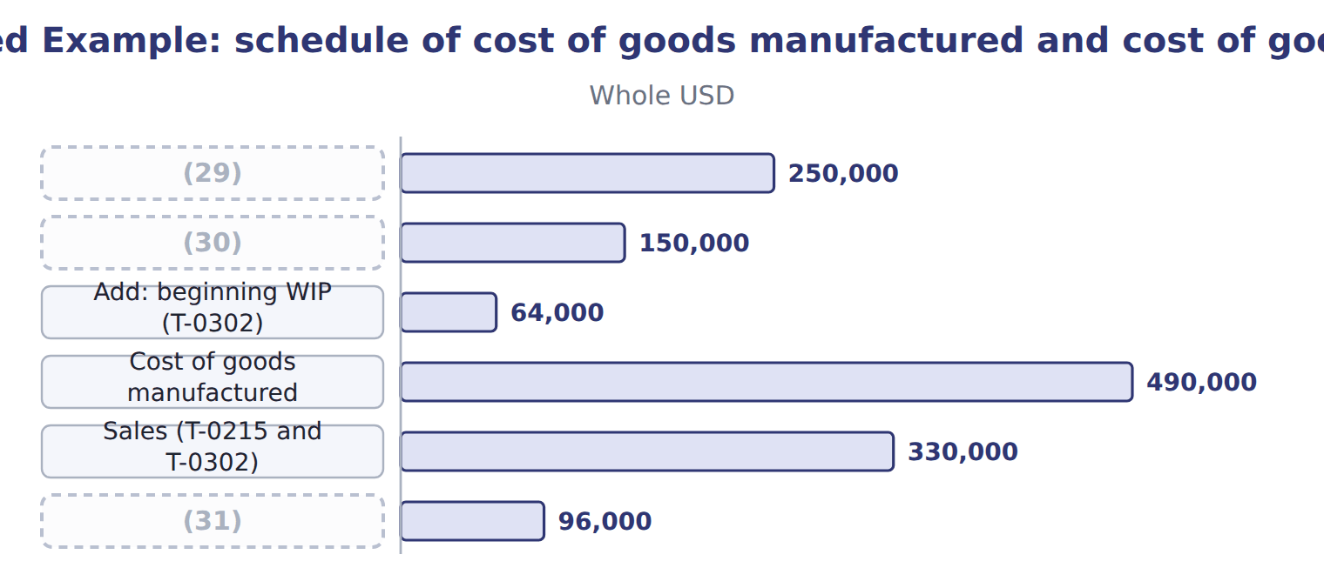
word list
Direct labor · Gross margin · predetermined overhead rate · Direct materials used

Everything ties

Summary 3 gaps 32–34
Total debits = total (32) = $2,235,000. Raw (33) : $120,000 + $300,000 − $270,000 = $150,000. Work in (34) : $64,000 + $631,000 − $490,000 = $205,000 = job T-0304. Finished goods: $90,000 + $490,000 − $234,000 = $346,000 = job T-0303.
word list
materials · process · credits · manufactured

Extended Example: job cost sheets agree with the control accounts
The bars are drawn to scale.
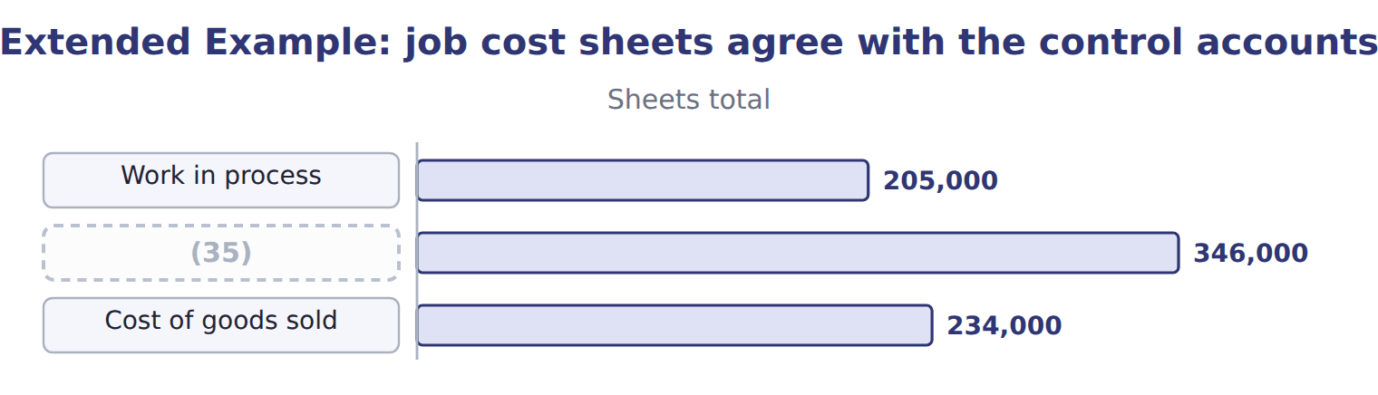
word list
Finished goods · applied overhead

Exam view

Summary 4 gaps 36–38
CMA (36) rarely ask for the entries. They give job data and ask for ending work in process, cost of goods (37) or cost of goods sold. Build the job costs first; the (38) follow from the job sheets.
word list
private-label · questions · manufactured · balances

Exam view
Tahini & Spreads · April 2027 (whole USD) | Amount
(39) : job T-0304 (from March) | 205,000
(40) : job T-0303 (from March) | 346,000
Job T-0304 in April: DM 20,000, DL 30,000, 1,500 MH — completed
(41) : DM 160,000, DL 90,000, 5,000 MH — still in process
Job T-0303 sold to Barada Wholesale on account | 470,000
(42) | 245,000
M1 | Tahini & Spreads applies overhead at $30 per machine hour. Differences are closed at year-end.

word list
Opening WIP · Job T-0305 (new) in April · Opening finished goods · April item · Actual manufacturing overhead in April

Item — Answer
Item | Answer
Overhead applied | 75,000
Job cost at March 31 | 205,000
Where is the job on March 31? | (43)

word list
Job T-0303 sold to Barada Wholesale on account · Work in process (the job is still open)

April item — Category
Every item belongs to exactly one group.
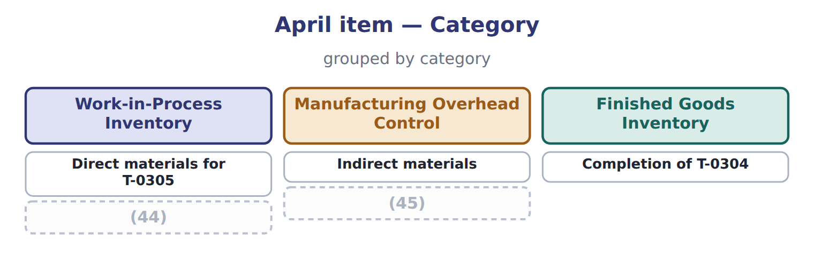
word list
job cost sheet · Factory supervisor's wages · Overhead applied to T-0305

The English this section uses, and its Arabic
Each term sits against what it means.
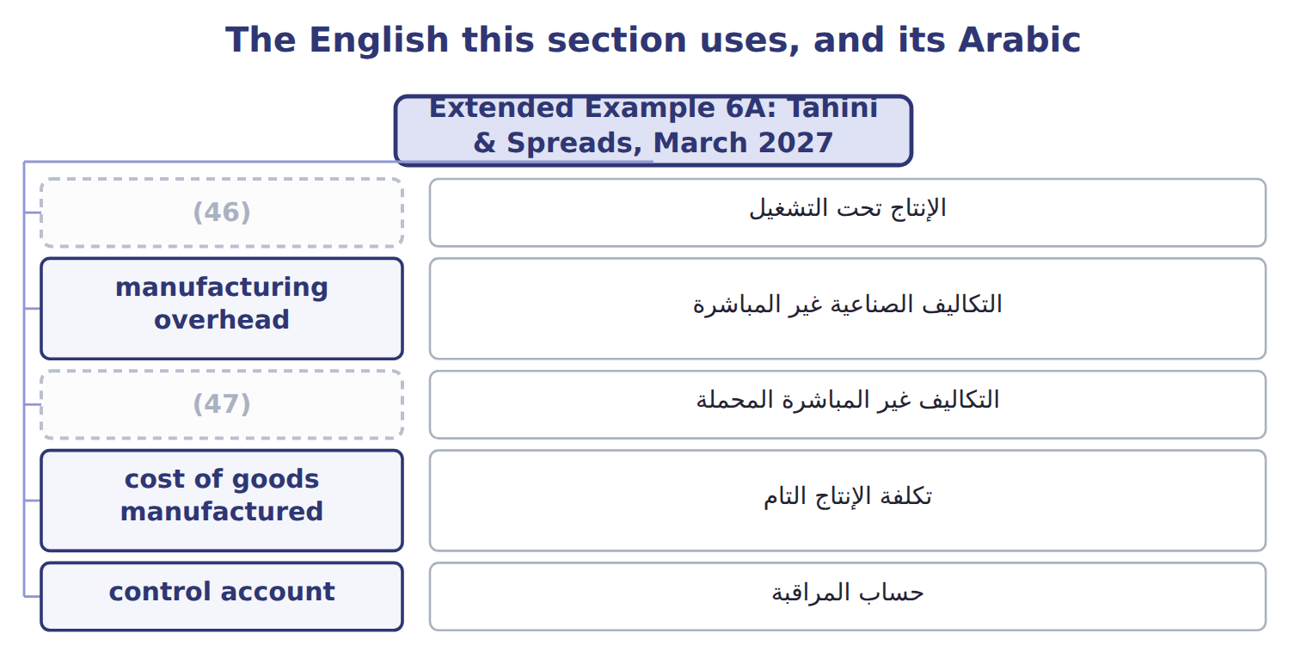
word list
applied overhead · work in process · control account

The English this sheet uses, and its Arabic
English (exam term) | Arabic
work in process | الإنتاج تحت التشغيل
manufacturing overhead | التكاليف الصناعية غير المباشرة
applied overhead | التكاليف غير المباشرة المحملة
cost of goods manufactured | تكلفة الإنتاج التام
control account | حساب المراقبة

Answer key · 6.7 Extended Example 6A: Tahini & Spreads, March 2027

1 follows | 25 Manufacturing Overhead Applied
2 documents | 26 Accounts Receivable
3 statement | 27 Sales Revenue
4 calculations | 28 Finished Goods Inventory
5 values | 29 Direct materials used
6 journal | 30 Direct labor
7 T-accounts | 31 Gross margin
8 numbers | 32 credits
9 division | 33 materials
10 private-label | 34 process
11 department | 35 Finished goods
12 depreciation | 36 questions
13 indirect | 37 manufactured
14 predetermined | 38 balances
15 schedules | 39 Opening WIP
16 everything | 40 Opening finished goods
17 applied | 41 Job T-0305 (new) in April
18 opening | 42 Actual manufacturing overhead in April
19 manufactured | 43 Work in process (the job is still open)
20 Actual | 44 Overhead applied to T-0305
21 Raw Materials Inventory | 45 Factory supervisor's wages
22 Accounts Payable | 46 work in process
23 Manufacturing Overhead Control | 47 applied overhead
24 Service Department Charges

the summaries in full
Summary 1 This example follows every cost of one month from the source documents to the income statement. The calculations are exam-core: the exam asks for job costs, inventory values and cost of goods sold. The journal entries and T-accounts are for depth: they show why the numbers move. On March 1, 2027 Raw Materials Inventory was $120,000. Job T-0302 was in process at $64,000, and job T-0215 was in finished goods at $90,000. During March the division worked on three jobs. T-0302 (halva): direct materials $30,000, direct labor $20,000, 1,000 machine hours. T-0303 (Barada private-label tahini): direct materials $140,000, direct labor $80,000, 4,200 machine hours. Finished, not yet sold. T-0304: direct materials $80,000, direct labor $50,000, 2,500 machine hours. Still in process on March 31. Other events: materials purchased $300,000; indirect materials $20,000; indirect labor $40,000; service department charges $57,500; depreciation $70,000; utilities $62,500; jobs T-0215 and T-0302 sold on account for $330,000.
Summary 2 Classify each cost as direct or indirect. Apply overhead at the predetermined rate. Record the entries, post them, prepare the schedules and check that everything ties. Overhead applied: 7,700 machine hours × $30 = $231,000. Job costs: T-0302 = $64,000 opening + $30,000 + $20,000 + $30,000 = $144,000; T-0303 = $346,000; T-0304 = $205,000. Cost of goods manufactured (T-0302 + T-0303) = $490,000. Cost of goods sold (T-0215 + T-0302) = $90,000 + $144,000 = $234,000. Actual overhead = $20,000 + $40,000 + $190,000 = $250,000; underapplied = $19,000.
Summary 3 Total debits = total credits = $2,235,000. Raw materials: $120,000 + $300,000 − $270,000 = $150,000. Work in process: $64,000 + $631,000 − $490,000 = $205,000 = job T-0304. Finished goods: $90,000 + $490,000 − $234,000 = $346,000 = job T-0303.
Summary 4 CMA questions rarely ask for the entries. They give job data and ask for ending work in process, cost of goods manufactured or cost of goods sold. Build the job costs first; the balances follow from the job sheets.

