13.1 ABC in service companies
Chapter 13 · section 13.1

Fill every gap. Each word list holds one word more than there are gaps.
Chapter 13, section by section
Each stage leads to the next.
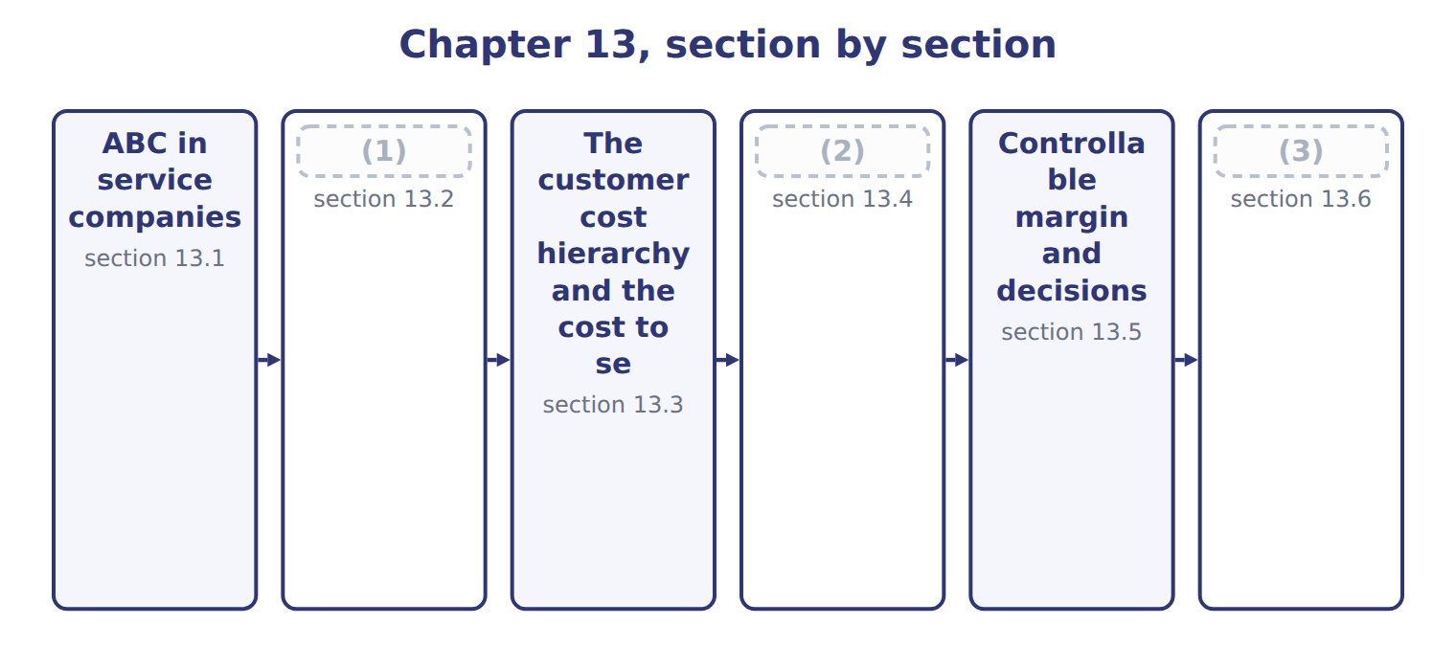
word list
Controllable margin and decisions · Measuring profitability: the issues · Customer, product-line and business-unit profi · Extended Example 13A: Al-Salam's revenue under

Summary 1 gaps 4–11
A service company has no (4) of products, but it still (5) activities: it takes orders, moves goods, answers calls and sends invoices. Most of its costs are (6) , so one volume rate can (7) cost even more than in a factory. Levant (8) , the Orontes subsidiary that (9) juices, is a good example. Its main activities are picking order lines, (10) to stops and (11) . The steps are the same as: build activity pools, choose a driver for each, compute a rate and assign cost by use. The cost objects are services or customers instead of products.
word list
performs · invoicing · overhead · inventory · distributes · delivering · activity · distort · Distribution

ABC is not only for factories

Summary 2 gaps 12–13
Banks, hospitals, airlines and (12) all use ABC. If an answer option says ABC applies only to (13) , it is wrong.
word list
distributors · Distribution · manufacturing

Answer key · 13.1 ABC in service companies

1 Measuring profitability: the issues | 8 Distribution
2 Customer, product-line and business-unit profi | 9 distributes
3 Extended Example 13A: Al-Salam's revenue under | 10 delivering
4 inventory | 11 invoicing
5 performs | 12 distributors
6 overhead | 13 manufacturing
7 distort

the summaries in full
Summary 1 A service company has no inventory of products, but it still performs activities: it takes orders, moves goods, answers calls and sends invoices. Most of its costs are overhead, so one volume rate can distort cost even more than in a factory. Levant Distribution, the Orontes subsidiary that distributes juices, is a good example. Its main activities are picking order lines, delivering to stops and invoicing. The steps are the same as: build activity pools, choose a driver for each, compute a rate and assign cost by use. The cost objects are services or customers instead of products.
Summary 2 Banks, hospitals, airlines and distributors all use ABC. If an answer option says ABC applies only to manufacturing, it is wrong.

13.2 Measuring profitability: the issues
Chapter 13 · section 13.2

Fill every gap. Each word list holds one word more than there are gaps.
Summary 1 gaps 1–3
Profit can be (1) for a product, a (2) or a business unit. Each measure raises the same (3) : which revenue, which costs, how to allocate shared costs, and which assets and values to use.
word list
therefore · questions · customer · measured

The issues in measuring profitability
Issue | Question to answer
Cost measurement | (4) : product cost only, or also the cost to serve each customer
Cost allocation | How to assign shared costs: by activity drivers, not by revenue
Revenue measurement | Revenue net of rebates, listing fees and other payments to (5) (ASC 606)
Investment measurement | Which assets each (6) uses, for return measures
Valuation | Historical cost or current value of those assets; transfer prices between units

word list
cost to serve · business unit · customers · Which costs to include

Summary 2 gaps 7–12
Under ASC 606, (7) and fees paid to a customer for shelf space reduce revenue; they are not selling (8) . A (9) revenue is (10) its net revenue. (11) cost alone hides the cost to serve, and (12) selling costs by revenue hides it again. For a business unit, the investment base and its valuation also matter, because they decide the return. A 'marge client' is a customer margin, measured after the cost to serve.
word list
therefore · expenses · Product · rebates · measure · customer's · allocating

The English this sheet uses, and its Arabic
English (exam term) | Arabic
customer profitability analysis | تحليل ربحية العملاء
business unit | وحدة الأعمال

Answer key · 13.2 Measuring profitability: the issues

1 measured | 7 rebates
2 customer | 8 expenses
3 questions | 9 customer's
4 Which costs to include | 10 therefore
5 customers | 11 Product
6 business unit | 12 allocating

the summaries in full
Summary 1 Profit can be measured for a product, a customer or a business unit. Each measure raises the same questions: which revenue, which costs, how to allocate shared costs, and which assets and values to use.
Summary 2 Under ASC 606, rebates and fees paid to a customer for shelf space reduce revenue; they are not selling expenses. A customer's revenue is therefore its net revenue. Product cost alone hides the cost to serve, and allocating selling costs by revenue hides it again. For a business unit, the investment base and its valuation also matter, because they decide the return. A 'marge client' is a customer margin, measured after the cost to serve.

13.3 The customer cost hierarchy and the cost to serve
Chapter 13 · section 13.3

Fill every gap. Each word list holds one word more than there are gaps.
Summary 1 gaps 1–6
Customer-related costs sit at (1) levels. Some are caused by each order or delivery; some by (2) one customer, such as a key (3) manager; some by a whole channel; and some by the company as a whole. The cost to serve is the cost of the (4) a customer (5) . Tahini & Spreads uses four (6) rates: $50 an order, $120 a delivery, $200 a rush order and $80 a return.
word list
activities · account · causes · different · delivery · activity · keeping

Worked example: the cost to serve Barada

Summary 2 gaps 7–8
Barada (7) 240 orders and took 120 (8) . At the four rates, its cost to serve is $31,200.
word list
deliveries · placed · channel

Worked example: the cost to serve Barada Wholesale
The bars are drawn to scale.
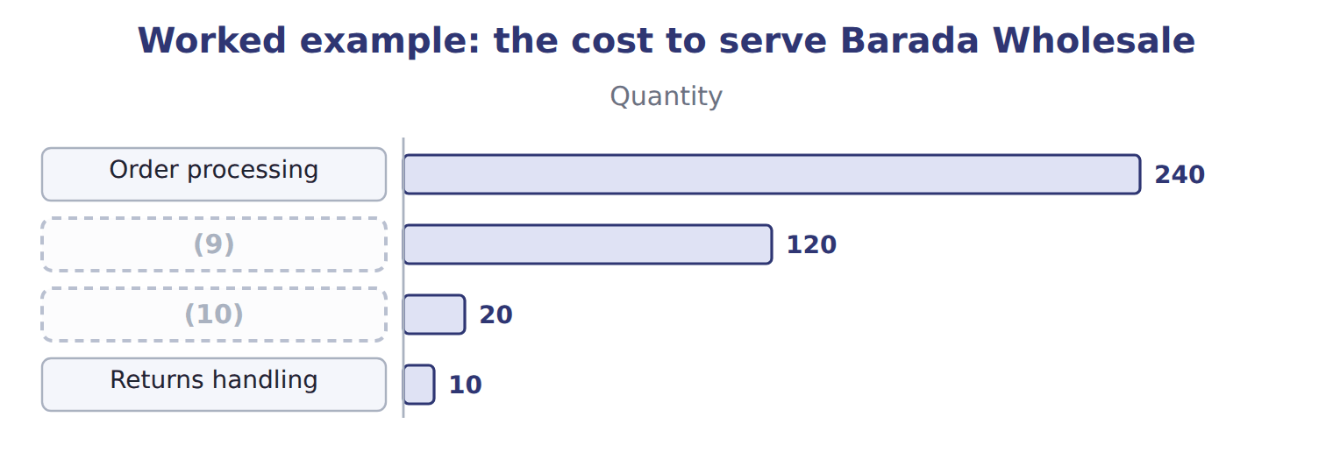
word list
Rush orders · Deliveries · whale curve

The cost to serve Qasr Hotels

Your turn: the cost to serve Qasr Hotels (complete the blanks)
The bars are drawn to scale.
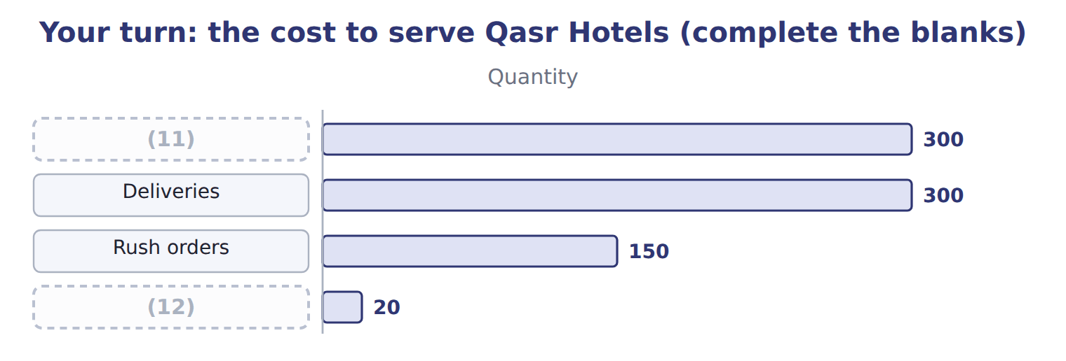
word list
Rush orders · Order processing · Returns handling

Summary 3 gaps 13–15
Qasr (13) often and asks for many rush (14) , so its cost to serve is high for its size. A (15) cost, such as Qasr's key account manager, is added after the activity costs.
word list
keeping · deliveries · customer-sustaining · orders

The English this sheet uses, and its Arabic
English (exam term) | Arabic
customer cost hierarchy | تسلسل تكاليف العملاء
cost to serve | تكلفة خدمة العميل
customer-sustaining cost | تكلفة دعم العميل

Answer key · 13.3 The customer cost hierarchy and the cost to serve

1 different | 9 Deliveries
2 keeping | 10 Rush orders
3 account | 11 Order processing
4 activities | 12 Returns handling
5 causes | 13 orders
6 activity | 14 deliveries
7 placed | 15 customer-sustaining
8 deliveries

the summaries in full
Summary 1 Customer-related costs sit at different levels. Some are caused by each order or delivery; some by keeping one customer, such as a key account manager; some by a whole channel; and some by the company as a whole. The cost to serve is the cost of the activities a customer causes. Tahini & Spreads uses four activity rates: $50 an order, $120 a delivery, $200 a rush order and $80 a return.
Summary 2 Barada placed 240 orders and took 120 deliveries. At the four rates, its cost to serve is $31,200.
Summary 3 Qasr orders often and asks for many rush deliveries, so its cost to serve is high for its size. A customer-sustaining cost, such as Qasr's key account manager, is added after the activity costs.

13.4 Customer, product-line and business-unit profitability
Chapter 13 · section 13.4

Fill every gap. Each word list holds one word more than there are gaps.
Customer profitability, Tahini & Spreads, 2027
The bars are drawn to scale.
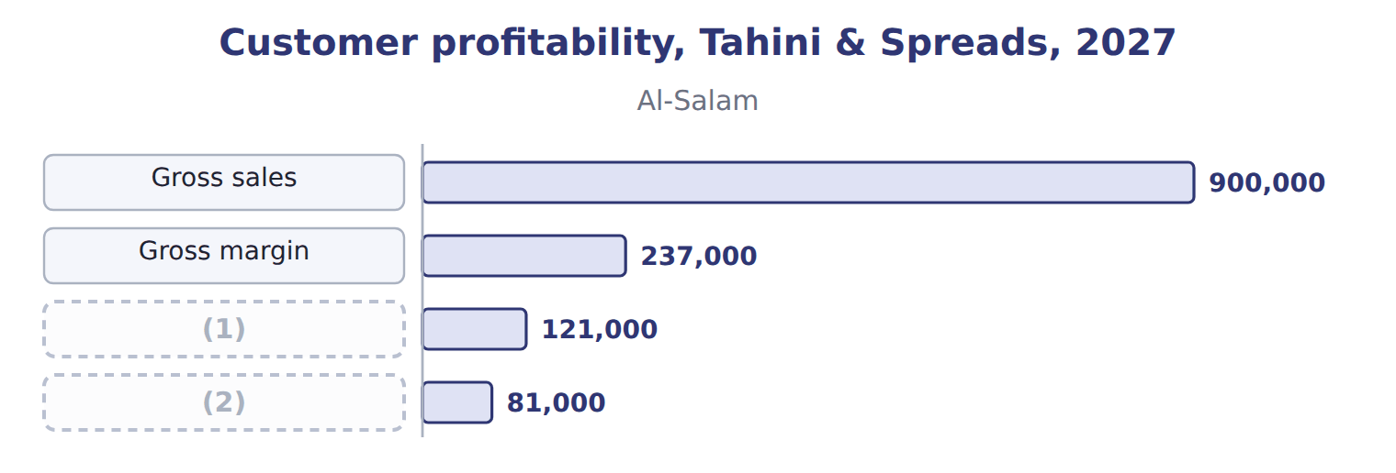
word list
Customer margin · Gross margin · Customer contribution

Summary 1 gaps 3–4
Product-line (3) uses the same logic by product. With the ABC costs of, the Pulses & Spices (4) earn a gross margin of $279,350, while za'atar loses $181,800.
word list
business · profitability · lentils

Product-line profitability: the Pulses & Spices line
The bars are drawn to scale.
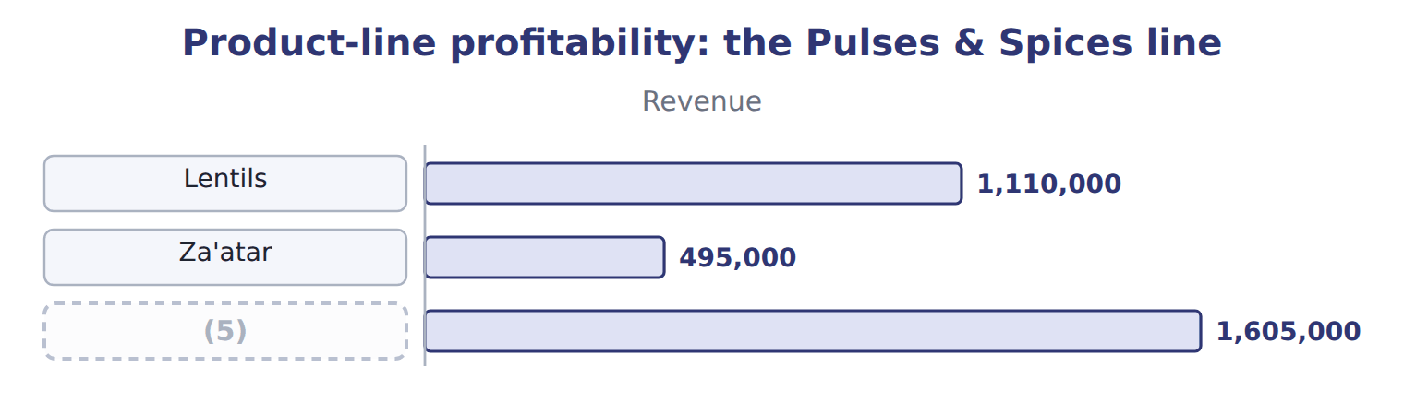
word list
customer profitability analysis · Pulses & Spices line

Summary 2 gaps 6–8
A (6) unit's profit adds all its (7) and then deducts the costs that no single customer causes. For the Tahini & Spreads sales unit, $200,000 of rent and sales (8) leaves $228,500.
word list
customers · administration · business · za'atar

Business-unit profit: the Tahini & Spreads sales unit
Tahini & Spreads sales unit, 2027 | Whole USD
Customer contribution (six customers) | 428,500
(9) | (200,000)
(10) | 228,500

word list
Distribution-centre rent and sales administration · 2027, ABC costs (whole USD) · Business-unit profit before corporate costs

The English this sheet uses, and its Arabic
English (exam term) | Arabic
whale curve | منحنى الحوت

Answer key · 13.4 Customer, product-line and business-unit profitability

1 Customer margin | 6 business
2 Customer contribution | 7 customers
3 profitability | 8 administration
4 lentils | 9 Distribution-centre rent and sales administration
5 Pulses & Spices line | 10 Business-unit profit before corporate costs

the summaries in full
Summary 1 Product-line profitability uses the same logic by product. With the ABC costs of, the Pulses & Spices lentils earn a gross margin of $279,350, while za'atar loses $181,800.
Summary 2 A business unit's profit adds all its customers and then deducts the costs that no single customer causes. For the Tahini & Spreads sales unit, $200,000 of rent and sales administration leaves $228,500.

13.5 Controllable margin and decisions
Chapter 13 · section 13.5

Fill every gap. Each word list holds one word more than there are gaps.
Summary 1 gaps 1–2
A manager should be judged only on what the manager can (1) . The (2) margin is revenue minus the costs the manager controls.
word list
influence · listing · controllable

The sales manager's report: controllable margin
Sales manager's report, 2027 | Whole USD | Controllable by the sales manager?
Net revenue | 3,266,000 | (3)
Variable cost of goods sold | (2,170,000) | (4)
Cost to serve | (507,500) | Yes (order size, delivery terms)
Key account managers | (160,000) | Yes (staffing)
Controllable margin | 428,500 | (5)
Rent and sales administration | (200,000) | No (decided centrally)
Business-unit profit | 228,500

word list
Cost of goods sold avoided · Yes (prices, discounts, rebates) · The basis for judging the sales manager · Mostly no (set by production)

Summary 2 gaps 6–8
Before (6) a customer, ask which costs would (7) go away. If the small shops were dropped, Tahini & Spreads would lose their revenue but avoid their product cost and, if the (8) shrink, their cost to serve.
word list
activities · dropping · customer · really

What changes if the small shops are dropped
If the small shops are dropped | Whole USD
(9) | (300,000)
Cost of goods sold avoided | 186,000
Cost to serve avoided (if activities shrink) | 187,000
(10) | 73,000
(11) | unchanged

word list
Rent and sales administration · Cost to serve · Change in profit · Net revenue lost

Summary 3 gaps 12–14
Dropping is the last (12) . The division can first set a minimum order size, charge for rush deliveries, or serve the shops through Levant (13) . For the hotel supply agent, (14) listing fees and rush orders may restore a profit.
word list
Distribution · cutting · revenue · option

The English this sheet uses, and its Arabic
English (exam term) | Arabic
controllable margin | الهامش القابل للرقابة

Answer key · 13.5 Controllable margin and decisions

1 influence | 8 activities
2 controllable | 9 Net revenue lost
3 Yes (prices, discounts, rebates) | 10 Change in profit
4 Mostly no (set by production) | 11 Rent and sales administration
5 The basis for judging the sales manager | 12 option
6 dropping | 13 Distribution
7 really | 14 cutting

the summaries in full
Summary 1 A manager should be judged only on what the manager can influence. The controllable margin is revenue minus the costs the manager controls.
Summary 2 Before dropping a customer, ask which costs would really go away. If the small shops were dropped, Tahini & Spreads would lose their revenue but avoid their product cost and, if the activities shrink, their cost to serve.
Summary 3 Dropping is the last option. The division can first set a minimum order size, charge for rush deliveries, or serve the shops through Levant Distribution. For the hotel supply agent, cutting listing fees and rush orders may restore a profit.

13.6 Extended Example 13A: Al-Salam's revenue under ASC 606
Chapter 13 · section 13.6

Fill every gap. Each word list holds one word more than there are gaps.
Summary 1 gaps 1–7
This example (1) the revenue from Al-Salam (2) , whose rebates and listing fees make its gross sales look larger than its real revenue. The net revenue and customer margin are (3) ; the entries are for depth. Gross sales: $900,000; rebates expected $45,000; listing fees paid $60,000. (4) : 600 orders, 500 (5) , 50 rush orders and 200 returns. Record the sales net of expected rebates, treat the listing fee as a (6) of revenue, pay the rebates, and then build (7) customer margin.
word list
exam-core · Supermarkets · deliveries · product · Al-Salam's · Activities · records · reduction

Extended Example: Al-Salam revenue journal
No. | Account (detail) | Debit | Credit
1 | (8) | 900,000
 | Sales Revenue |  | 855,000
 | (9) |  | 45,000
2 | Sales Revenue | 60,000
 | (10) |  | 60,000
3 | Refund Liability | 45,000
 | Cash |  | 45,000
 | (11) | 1,005,000 | 1,005,000

word list
Refund Liability · Totals · Cash · Invoices · Accounts Receivable

Summary 2 gaps 12–13
Net (12) $795,000 minus cost of goods sold $558,000 = gross margin $237,000. Cost to serve $116,000; customer margin $121,000; key account manager $40,000; (13) $81,000.
word list
revenue · Supermarkets · contribution

Everything ties

Summary 3 gaps 14–15
Six (14) add to $428,500; minus $200,000 gives the business unit's $228,500. (15) revenue in the ledger equals its net revenue.
word list
Al-Salam's · contributions · expected

Exam view

Summary 4 gaps 16–18
Expect revenue, (16) , fees, product costs and activity data for two or three (17) . Start from net revenue, deduct the cost to serve at the activity rates, and keep (18) costs out of each customer's margin.
word list
entries · customers · company-level · rebates

Exam view
Levant Distribution · 2027 | Supermarket chain | Small shops | Activity rate
Service fees (revenue) | 600,000 | 400,000
Order lines picked | 60,000 | 90,000 | (19)
Delivery stops | 2,000 | 8,000 | $40 per stop
Invoices | 500 | 6,000 | (20)

word list
$15 per invoice · $2 per line · Supermarket channel promotions

Item — Answer
Item | Answer
Deliveries (Qasr) | 300 × $120 = $36,000
Rush orders (Qasr) | (21)

word list
150 × $200 = $30,000 · 300 × $120 = $36,000

Cost — Category
Cost | Category
Picking order lines | (22)
Delivery stops | Order or delivery level
Invoices | Order or delivery level
Key account manager for the chain | (23)
Supermarket channel promotions | Channel level
Warehouse rent | (24)

word list
Customer level · Company level · customer profitability analysis · Order or delivery level

The English this section uses, and its Arabic
Each term sits against what it means.
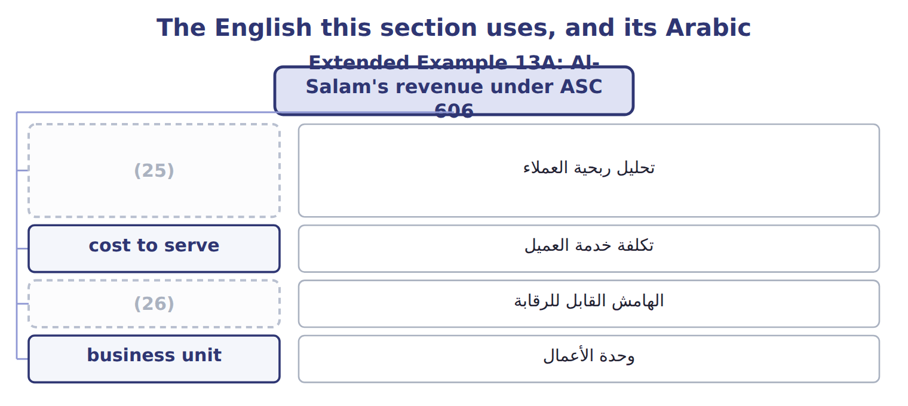
word list
customer profitability analysis · controllable margin · تحليل ربحية العملاء

The English this sheet uses, and its Arabic
English (exam term) | Arabic
customer profitability analysis | تحليل ربحية العملاء
cost to serve | تكلفة خدمة العميل
controllable margin | الهامش القابل للرقابة

Answer key · 13.6 Extended Example 13A: Al-Salam's revenue under ASC 606

1 records | 14 contributions
2 Supermarkets | 15 Al-Salam's
3 exam-core | 16 rebates
4 Activities | 17 customers
5 deliveries | 18 company-level
6 reduction | 19 $2 per line
7 Al-Salam's | 20 $15 per invoice
8 Accounts Receivable | 21 150 × $200 = $30,000
9 Refund Liability | 22 Order or delivery level
10 Cash | 23 Customer level
11 Totals | 24 Company level
12 revenue | 25 customer profitability analysis
13 contribution | 26 controllable margin

the summaries in full
Summary 1 This example records the revenue from Al-Salam Supermarkets, whose rebates and listing fees make its gross sales look larger than its real revenue. The net revenue and customer margin are exam-core; the entries are for depth. Gross sales: $900,000; rebates expected $45,000; listing fees paid $60,000. Activities: 600 orders, 500 deliveries, 50 rush orders and 200 returns. Record the sales net of expected rebates, treat the listing fee as a reduction of revenue, pay the rebates, and then build Al-Salam's customer margin.
Summary 2 Net revenue $795,000 minus cost of goods sold $558,000 = gross margin $237,000. Cost to serve $116,000; customer margin $121,000; key account manager $40,000; contribution $81,000.
Summary 3 Six contributions add to $428,500; minus $200,000 gives the business unit's $228,500. Al-Salam's revenue in the ledger equals its net revenue.
Summary 4 Expect revenue, rebates, fees, product costs and activity data for two or three customers. Start from net revenue, deduct the cost to serve at the activity rates, and keep company-level costs out of each customer's margin.

